Attitude of farmers towards Custom Hiring Centers in Madhya Pradesh and Telangana States

.

ABSTRACT

|  |
| --- |
| **Aims:** India is a predominantly agricultural country, where major breakthrough in agricultural production has occurred through the agriculture mechanization. The current study aimed to assess the attitude of farmers towards custom hiring centers.  **Study design:** Descriptive research design was adopted for the investigation.  **Place and Duration of Study:** The study was undertaken in Madhya Pradesh and Telangana States. Two erstwhile districts namely Mahabubnagar and Nalgonda districts in Telangana state and Tikamgarh and Guna districts in Madhya Pradesh were selected for the study. The study was undertaken for two years between 2021 to 2023.  **Methodology:** The districts were the four selected CHCs models in operation those districts were selected. One CHC representing each model were selected in both the districts thus making a total of 8 CHC in Telangana state and 8 CHCs in Madhya Pradesh state, thus, making a total of 16 CHC for the study.  **Results:** Majority of the respondents had neutral attitude (53.13%) towards CHCs in Telangana state. Most of the respondents (48.75%) had favourable attitude towards CHCs in Madhya Pradesh state.  **Conclusion:** Farm mechanization has the potential to significantly revolutionize agriculture in India by  providing a means of increasing farm output, bolstering livelihoods, and guaranteeing food  security. |

***Keywords:*** *Custom Hiring Center, Agricultural labour, Mechanization, Attitude Scale, Summated rating scale.*

1. INTRODUCTION

India is a predominantly agricultural country, where major breakthrough in agricultural production has occurred through the agriculture mechanization (Kamboj *et al.,* 2012). Custom hiring is a growing concept in India that has the potential to drastically transform the country's farm mechanization environment (Nissa *et al.,* 2017). In Indian agriculture, custom renting of agricultural machinery was first introduced in the 19th century (Srinivasarao *et al.,* 2013). The cost of cultivation data shows that labour accounts for more than 40 per cent of the total variable cost of production for most of the crops (Anonymous, 2011; Laxmi, and Mundinamani 2014).

It has been envisaged that farmers can benefit from technological developments in terms of large machines performing farm operations. But, these machines being costly remain out of the farmers’ reach (Sharma, 2005). Proper utilization of farm machinery saves 20-30 per cent time, 15-20 per cent seeds, 20-25 per cent fertilizers, 10-20 percent labour and an increase in cropping intensity to about 10 per cent (Singh, 2005). The unique feature of custom hiring services is that the equipment ownership costs are dispersed over a greater area (Bansal, and Mukesh 2005). Attitude refers to a complex mental state that involving collection of beliefs, feelings and values and disposition to act in certain ways. This refers to the degree of strong positive or negative effects associated with some psychological object. By psychological object we mean the feeling about custom hiring centers, which farmers could differ with respect to positive or negative effects(Likert et al., 1993). It is evident from the fact that only 40 per cent of the farmers reported the private owners as the solution of untimely availability of machinery services (Sidhu et al., 2005). Hiring of the farm machines through the Custom Hiring Centers (CHCs) rather owning would provide a viable solution, as they believed it to be the cheaper option. Custom hiring envisages promoting establishment farm machinery for hiring (Singh et al., 2013). The CHCs offer farm equipment and machinery on rental basis to farmers who cannot afford to purchase high end agriculture machineries and equipment (Singh, 2013).

Farmers have positively responded towards the scheme as they need more number of machineries like rotavator and reaper because whenever any other farmer have taken it for his farm it will not be available for others (I-WIN Advisory Services Limited, 2012). Majority of the farmers (75.00 per cent) have a moderate opinion of Custom hiring centres' services. Farmers were eager to know more about the utility and services given by the CHCs implements(Kisku, 2020). CHCs enhance access to quality tools, implements and machinery services for ensuring quick response and timely operations such as land preparation, sowing, inter-cultivation, other crop management, harvesting and post harvesting specific to existing cropping pattern of the cluster (Uday et al., 2020). It was advocated that custom hiring services have enough scope for providing better implements to their clients at competitive rates (Ranade et al., 2006; Kulkarni, 2009). The largest number of old tractor markets is a common site in the state. Some small farmers even buy a new tractor from the agency to sell them in these tractor markets, to repay any other debt (Singh and Rangi 2009).

2. methodology

The study was conducted purposively in Telangana and Madhya Pradesh states has Madhya Pradesh state has highest number of Custom Hiring Centers in the country and Telangana state was selected to study the CHCs models and easy accessibility of the investigator to the study area. Also very few studies with respect to CHCs has been conducted in this region. Based on the review and secondary sources, two erstwhile districts namely Mahabubnagar and Nalgonda districts in Telangana state and Tikamgarh and Guna districts in Madhya Pradesh were selected for the study. The districts were the four selected CHCs models in operation those districts were selected. One CHC representing each model were selected in both the districts thus making a total of 8 CHC in Telangana state and 8 CHCs in Madhya Pradesh state, thus, making a total of 16 CHC for the study. From 16 selected CHC’s jurisdiction the respondents were selected randomly. 20 farmers from each CHC jurisdiction, thus making a total of 160 farmers from 8 CHCs jurisdiction in Telangana state and 160 farmers from 8 CHC jurisdictions in Madhya Pradesh state thus making a total of 320 farmers. Hence, total sample size of present study was 320 farmers. Attitude scale was constructed to measure the attitude of farmers towards custom hiring centers.

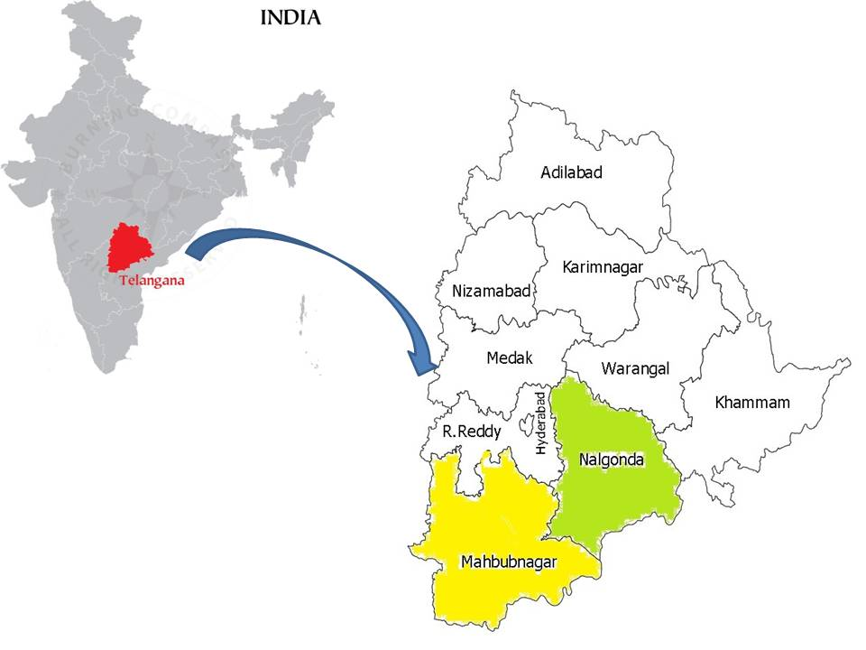

Selected districts in Telangana State, India

**Figure 1.** Map showing the study area in Telangana State.

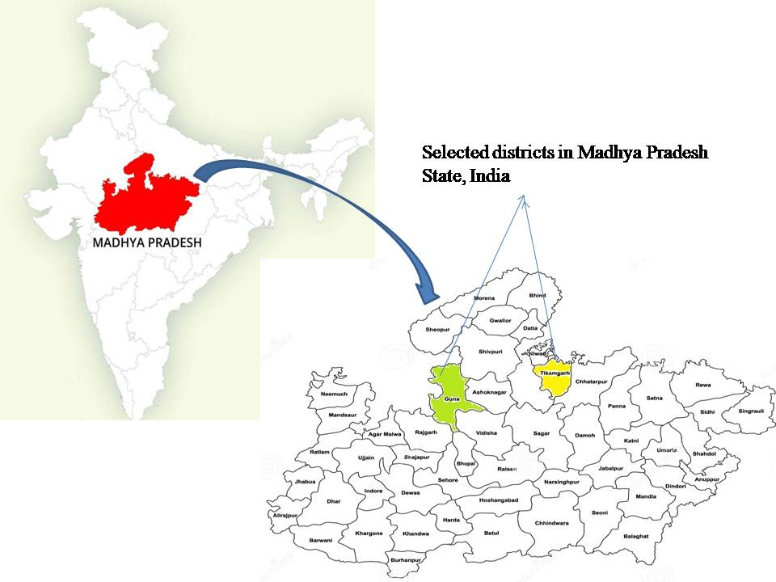

**Figure 2.** Map showing the study area in Madhya Pradesh state.

**2.1 Development Attitude Scale:** To measure the attitude of farmers towards Custom hiring centers a scale was developed. The technique for construction of attitude scale was the Likert’s technique of summated rating scale was used and scale was standardized by following the procedures described by Likert’s (Likert, 1932).

**2.2 Collection of statements:** The content of the attitude scale is composed of questions called items. Items for the scale were collected from different sources. A set of 102 statements representing the attitude of farmers towards Custom Hiring Centers were collected initially from various sources viz., literature and interaction with experts. The questions were designed to measure the attitude of farmers towards custom hiring centers. The suitability and applicability of these attitude scale items in the study areas was further validated by experts. Also, every effort was made to see that the sentences were simple, easily understood and each had only one idea.

**2.3 Editing of statements:** Each statement was edited considering the fourteen-point informal criteria suggested by Thurstone & chave (Thurstone and Chave, 1929) and Edwards and Kirkpatrick (Edwards and Kilpatrick, 1948) The statements which were ambiguous, irrelevant and not conforming to the suggested criteria was deleted. Total 75 statements were finally selected after editing for scale construction.

**2.4 Pre-Testing and Item Analysis:** The preliminary attitude scale consisting of 56 items was administered to 120 farmers. These farmers were selected based on the criteria that taking services from custom hiring centers. The farmers were asked to indicate their degree of agreement on a five-point continuum namely strongly agree, agree, undecided, disagree and strongly disagree with scores of 5, 4, 3, 2 and 1 for each positive statement and 1, 2, 3, 4 and 5 for each negative statement respectively.

**2.5 Final Selection of Items for Test:** Then the total score of each, respondent was calculated by summing of their score for all the items. For the purpose of item analysis 25 percent of respondents with highest total score and 25 percent of respondents with lowest total scores were selected. The t-test was conducted for each statement using the responses of these two groups. The statement with t value of 1.75 and above was considered for final inclusion in the scale. So total 34 statements were included in final scale.

**2.6 Reliability of the Attitude Scale:** The reliability of the attitude scale was assessed using the split half method. The selected 34 statements were administered to 120 respondents in non sample area and responses were obtained. Then scores of respondents against each statement were calculated and statements were divided into to two nearly equal halves. The common way of splitting is by odd-even method. Under Split half method Rulon and Flanagon formulae was used to estimate the internal consistency reliability. The Pearson product movement correlation coefficient between two set of scores was calculated and the “r” value of 0.83, indicating that the attitude scale was highly suitable for administration to the farmers.

3. results and discussion

Majority (53.13%) of the respondents had neutral attitude followed by favourable (30.00%) and unfavourable (16.87%) attitude towards CHC in Telangana state.The probable reason might be most of the farmers in Telangana state are not much aware of CHC as there are less number of CHC and due to less number of machinery availability in CHC. Hence majority of the farmers had neutral attitude towards CHC. The above results indicate that, there is every need on part of the government and extension agency to create awareness and educate the farmers on the benefits of the CHCs introduced in the state, therefore improvement in the attitude can be enhanced. For this purpose, special programmes, campaigns and village visits may be undertaken by the government officials.

Nearly half of the respondents (48.75%) had favourable attitude followed by neutral (35.00%) and unfavourable (16.25%) attitude towards CHC in Madhya Pradesh state. The probable reason might be that the subsidy facility under Yantradoot scheme in Madhya Pradesh especially for farm implements and machinery through training and developing him as an entrepreneur First level workers like AO’s, AEO’s, Central Institute of Agricultural Engineering (CIAE) scientists and Agriculture Engineers who share information and benefits of the programme are the reason for the favourable attitude towards the CHCs. The finding is also supported by Kumar*et al.,* 2021.

**Table 1. Distribution of respondents based on their attitude towards Custom Hiring Center Models in Telangana state (n=160)**

|  |  |  |  |  |
| --- | --- | --- | --- | --- |
| **S.No** | **Category** | **Class interval** | **Frequency** | **Percentage** |
| 1 | Unfavourable | 70-94 | 27 | 16.87 |
| 2 | Neutral | 95-118 | 85 | 53.13 |
| 3 | Favourable | 119-142 | 48 | 30.00 |
|  |  | Total | 160 | 100 |

**Table 2. Distribution of respondents based on their attitude towards Custom Hiring Center Models in Madhya Pradesh state (n=160)**

|  |  |  |  |  |
| --- | --- | --- | --- | --- |
| **S.No** | **Category** | **Class interval** | **Frequency** | **Per centage** |
| 1 | Unfavourable | 74-99 | 26 | 16.25 |
| 2 | Neutral | 100-125 | 56 | 35.00 |
| 3 | Favourable | 126-150 | 78 | 48.75 |
|  |  | Total | 160 | 100 |

Majority of the respondents strongly agreed that ease of access to CHC lead to reduction of cost and increase in crop yields (49.83%) followed by banks have to come up with hassle free loans for establishment of CHCs (48.33%), government should fix rates for farm machinery services of CHCs (47.81%) and most farmers strongly feel that, subsidy provision acts as safeguard against risk for CHC in the initial years (45.93%). Half of the beneficiaries agree that small holding farmers are no way getting benefitted with CHCs* (50.00%) followed by crop residue burning events have come down drastically with CHC services (47.50%), feel that CHCs has to be promoted in a big way for their collective ownership (44.69%) and subsidy has to be provided to CHCs for purchase of machinery by government (43.44%). CHCs are highly useful in increasing the cultivable land, cropping intensity and yield. Proper guidance and subsidy from government and first line extension system support for establishment of CHC. This indicated that respondents had favourable attitude towards the CHCs in tune with the set statements.

Here comes the percentage of statements that reflects the disagreements towards CHCs among beneficiaries. They are, 55.31 per cent of the beneficiaries disagree that feel that CHC are charging rents reasonably for farm machineries, Almost half of the respondents disagree that it is easy to get services from CHC without any procedural delays (49.37%), services of CHC maybe more useful to farm cooperatives and FPOs than to individual farmers. (47.50%) and lack of knowledge among CHC personnel in aspects of operation, maintenance and repair of equipment restricts the use of farm machinery by farmers* (46.87%). The reasons for disagreement might be that who received farm machinery on hiring basis might not be satisfied with the services in the field and its impact have developed unfavourable attitude towards CHCs. Further, few farmers might have required farm machinery implements which aren’t supplied timely and hence developed unfavourable attitude towards CHCs. Nevertheless, for all possible statements the disagree responses were low compared to agree. An overview of the above findings clearly indicated that majority of the respondents had favourable attitude towards Custom Hiring Centers.

**Table 3. Distribution of respondents based on the degree of agreement with individual attitude statements (frequency and per centage) on towards Custom Hiring Center (CHC) (N=320)**

|  |  |  |  |  |  |  |
| --- | --- | --- | --- | --- | --- | --- |
| **S.No** | **Statements** | **Frequency (%)** | | | | |
|  | | **SA** | **A** | **UD** | **DA** | **SDA** |
| 1 | I am aware of CHC and its services through media and extension activities by CHC. | 82  (25.63) | 138  (43.12) | 29  (9.06) | 35  (10.94) | 36  (11.25) |
| 2 | It is good that trainings and workshops are conducted to farmers to get to know the benefits of new technologies and services of CHC. | 72  (22.50) | 86  (26.87) | 43  (13.44) | 69  (21.56) | 50  (15.63) |
| 3 | I believe that easy access to CHC lead to reduction of cost and increase in crop yields. | 158  (49.38) | 84  (26.25) | 25  (7.81) | 21  (6.56) | 32  (10.00) |
| 4 | I feel that CHC has to be promoted in a big way for their collective ownership. | 73  (22.81) | 143  (44.69) | 32  (10.00) | 33  (10.31) | 39  (12.19) |
| 5 | In my view lack of entrepreneurial experience of manager/owner of CHC led to poor services delivery by CHC*. | 43  (13.44) | 47  (14.69) | 43  (13.44) | 102  (31.87) | 85  (26.56) |
| 6 | In my view Government should fix rates for farm machinery services of CHC. | 153  (47.81) | 78  (24.37) | 26  (8.12) | 30  (9.38) | 33  (10.31) |
| 7 | I believe that CHC reduces drudgery in all farm operations. | 86  (26.87) | 132  (41.25) | 25  (7.81) | 42  (13.13) | 35  (10.94) |
| 8 | I feel that it is easy to get services from CHC without any procedural delays. | 23  (7.19) | 43  (13.44) | 28  (8.75) | 158  (49.37) | 68  (21.25) |
| 9 | I feel that CHC are charging rents reasonably for farm machineries. | 36  (11.25) | 34  (10.62) | 27  (8.44) | 177  (55.31) | 46  (14.38) |
| 10 | I feel that availability of time bound high-quality custom hiring services are essential for the growth of agriculture in our country. | 87  (27.19) | 97  (30.32) | 35  (10.94) | 68  (21.25) | 33  (10.32) |
| 11 | I feel that use of modern implements provided by CHC have adversely affected soil health*. | 51  (15.94) | 65  (20.31) | 38  (11.87) | 101  (31.57) | 65  (20.31) |
| 12 | In my view services of CHC maybe more useful to farm cooperatives and FPOs than to individual farmers. | 30  (9.38) | 48  (15.00) | 24  (7.50) | 152  (47.50) | 66  (20.62) |
| 13 | Banks have to come up with hassle free loans for establishment of CHC. | 155  (48.44) | 82  (25.62) | 22  (6.87) | 28  (8.75) | 33  (10.32) |
| 14 | I feel that possibility of spread of disease through contaminated machines provided by CHC cannot be ruled out*. | 48  (15.00) | 61  (19.07) | 38  (11.87) | 108  (33.75) | 65  (20.31) |
| 15 | In my view establishment of CHC has resulted in farmer’s indebtedness*. | 38  (11.87) | 64  (20.00) | 35  (10.94) | 110  (34.37) | 73  (22.82) |
| 16 | I believe that crop residue burning events have come down drastically with CHC services. | 85  (26.56) | 152  (47.50) | 18  (5.62) | 30  (9.38) | 35  (10.94) |
| 17 | I feel that small holding farmers are no way getting benefitted with CHCs*. | 67  (20.94) | 160  (50.00) | 25  (7.81) | 39  (12.19) | 29  (9.06) |
| 18 | In my view with CHC services, farmer can reduce the harvest and post-harvest losses. | 138  (43.12) | 91  (28.44) | 28  (8.75) | 35  (10.94) | 28  (8.75) |
| 19 | I strongly feel that subsidy provision acts as safeguard against risk for CHC in the initial years. | 147  (45.93) | 79  (24.69) | 31  (9.69) | 32  (10.00) | 31  (9.69) |
| 20 | In my view repair and maintenance facilities are provided in CHC for my own machinery also. | 36  (11.25) | 49  (15.31) | 21  (6.56) | 143  (44.69) | 71  (22.19) |
| 21 | In my view both modern and traditional farm machineries are not available in CHC*. | 49  (15.31) | 51  (15.94) | 40  (12.50) | 99  (30.94) | 81  (25.31) |
| 22 | In my view farm operations are delayed if I depend on Custom Hiring Centers (CHC) for farm machinery or equipment*. | 53  (16.56) | 60  (18.75) | 44  (13.75) | 116  (36.25) | 47  (14.69) |
| 23 | I observed that there is no influence of CHC on income of farmers*. | 51  (15.94) | 73  (22.82) | 47  (14.68) | 80  (25.00) | 69  (21.56) |
| 24 | I observed that lack of knowledge among CHC personnel in aspects of operation, maintenance and repair of equipment restricts the use of farm machinery by farmers* | 36  (11.25) | 45  (14.06) | 27  (8.44) | 150  (46.87) | 62  (19.38) |
| 25 | In my view CHC staffs are not supportive and cooperative*. | 62  (19.38) | 128  (40.00) | 41  (12.81) | 51  (15.94) | 38  (11.87) |
| 26 | In my view CHC offer farm machinery on rent to small and marginal farmers who cannot afford owning them. | 141  (44.06) | 85  (26.57) | 28  (8.75) | 37  (11.56) | 29  (9.06) |
| 27 | In my view CHC provides employment opportunities to skilled labour and artisans. | 41  (12.81) | 55  (17.19) | 26  (8.12) | 122  (38.13) | 76  (23.75) |
| 28 | In my view subsidy has to be provided to CHCs for purchase of machinery by government. | 82  (25.62) | 139  (43.44) | 26  (8.12) | 38  (11.87) | 35  (10.94) |
| 29 | I believe that CHC are located at strategically within the radius of 5-7 kms and are within our reach. | 77  (24.06) | 92  (28.75) | 37  (11.56) | 78  (24.38) | 36  (11.25) |
| 30 | In my view CHC has made most of the farm family members idle*. | 79  (24.69) | 129  (40.31) | 22  (6.87) | 60  (18.75) | 30  (9.38) |
| 31 | I observed increase in cropping intensity in my area, after establishment of CHC. | 69  (21.56) | 119  (37.19) | 34  (10.62) | 50  (15.63) | 48  (15.00) |
| 32 | In my view there is no change in yield of crops after establishment of CHC*. | 72  (22.50) | 84  (26.25) | 47  (14.69) | 63  (19.69) | 54  (16.87) |
| 33 | I feel that CHCs are not promoting climate resilient practices and technologies among farmers*. | 52  (16.25) | 85  (26.56) | 32  (10.00) | 90  (28.12) | 61  (19.07) |
| 34 | I feel that lack of incentives by government to CHC has hindered the spread of farm mechanization*. | 54  (16.87) | 67  (20.94) | 35  (10.94) | 92  (28.75) | 72  (22.50) |

4. Conclusion

Farm mechanization has the potential to significantly revolutionize agriculture in India by pro-viding a means of increasing farm output, bolstering livelihoods, and guaranteeing food secu-rity. Majority of the respondents had neutral attitude (53.13%) towards CHCs, followed by 30.00 per cent of respondents had favourable attitude towards CHC and only 16.87 per cent of respondents had unfavourable attitude towards CHC in Telangana state. Most of the respondents (48.75%) had favourable attitude towards CHCs, followed by 35.00 per cent of respondents had neutral attitude towards CHC and only 16.25 per cent of respondents had unfavourable attitude towards CHC in Madhya Pradesh state.

**Policy implications of this study**

The findings of the present study reveal a high level of satisfaction among farmers with Custom Hiring Centers, which enabled farmers avail timely farm operations and efficient use of input resources available in CHC. This understanding can reassure policymakers to invest in such costly farm machinery. CHC promoted increase in cropping intensity wherever feasible facilitates crop residue recycling and prevents burning of residues. Policymakers can use this information to prioritize these factors in developing and promoting future farm mechanization technologies. Awareness need to be increased in order to spread the benefits of the programme among the farmers who wanted to establish CHCs. CHCs are highly useful in increasing the cultivable land, cropping intensity and yield. The outcomes of this study highlight the importance of effective technology promoters, such as KVK (Krishi Vigyan Kendra), Farmer Producer organizations (FPOs) and Non-Government Organisations (NGOs) in shaping farmers’ attitude and expectations. Policymakers can focus on strengthening and supporting these promoters to ensure the successful adoption of farm machinery available in Custom Hiring Centers.

References

1. Kamboj, P., Khurana, R. & Dixit, A. (2012). Farm machinery services provided by selected cooperative societies. *Agric Eng Int: CIGR Journal*., 14:123-133.
2. Nissa, R., Zubair, M., Ghani, I. & Jahan, N. (2017). Custom Hiring Centre: An Emerging Trend-Benefits, Constraints and Way Forward with Reference to NICRA Village in Wakharwan, District Pulwama. *International Journal of Research in Applied Natural and Social Sciences.,*  5:111-114.
3. Srinivasarao, C., Srinivas, S.D.I., Reddy, B. S., Adake, R. V. & Borkar, S. (2013). Operationalization of custom hiring centres on farm implements in hundred villages in India. Central Research Institute for Dryland Agriculture, Hyderabad, Andhra Pradesh., 88-91.
4. Anonymous, (2011). Crop husbandry, agricultural inputs, demand and supply projections and agricultural statistics for the twelfth five year plan (2012-2017). Planning commission, Government of India New Delhi, 18.
5. Laxmi, N. T. & Mundinamani S. M. (2014). Economics of production of major crops in Dharwad district. *Karnataka Journal of Agricultural Sciences.,* 27:165-169.
6. Sharma, V. K., Singh, K. & Panesar, B. S. (2005). Custom Hiring of Agricultural Machinery and its Future Scope. Status Report on Farm Mechanization in India. Department of Agriculture and Cooperation, Ministry of Agriculture, Government of India, New Delhi., 127-132.
7. Singh, J. (2005). Scope, progress and constraints of farm mechanization in India. Status of farm mechanization in India. New Delhi: Indian Agricultural Statistics Research Institute. 48-56.
8. Bansal, N. K. & Mukesh, S. (2005). Impact of Custom Hiring on Farm Mechanization in Haryana. *Report of AICRP on Farm Implement and Machinery,* CCSHAU, Hissar.
9. Likert, R, Roslow, S. & Murphy, G. (1993). A simple and reliable method of scoring the Thurstone attitude scales. *Personnel Psychology*., 46:689-690.
10. Sidhu, R. S, Bhullar A. S. & Joshi, A. S. (2005). Income, employment and productivity growth in the farming sector of Punjab: Some issues, *J Ind School Pol Econ.,* 17:59-72.
11. Singh, S., S. Kingra & Sangeet. (2013). Custom Hiring the Services of Farm Machinery in Punjab: Impact and Policies. *Indian Res. J. Ext. Edu.,* 13:45-50.
12. Singh, R. S. (2012). Custom Hiring and Scope of Entrepreneurship Development in Farm Machinery. *AMA, Agricultural Mechanization in Asia, Africa & Latin America*., 44:26-32.
13. I-WIN Advisory Services Limited (2012). Evaluation and impact assessment study of   
     yantradoot scheme in Madhya Pradesh. *Directorate of Agricultural Engineering.,* Government of Madhya Pradesh, India.
14. Kisku, U. (2020). Perception of Farmers Regarding Custom Hiring Services in Jabalpur District of Madhya Pradesh. *Jawaharlal Nehru Krishi Vishwa Vidyalaya*., Jabalpur.
15. Uday, R. B., Tamhankar, M. B., Saha, K. P. & Bargale P. C. (2020). A business model of custom hiring of agricultural machinery for enhanced farm mechanization in Madhya Pradesh. *Indian Farming.,* 70:18–22.
16. Ranade, D. H., Chourasia, M. C., Shrivastava, M. K. & Patidar, D. (2006). Improved tools and scope for their custom hiring in Malwa region – A case study. *Agricultural Engineering Today,* 30:28-31.
17. Kulkarni, S. D. (2009). Mechanization of Agriculture – Indian Scenario. Proceedings 5th APCAEM TC Meeting & Expert Group Meeting on Application of Agricultural Machinery for Sustainable Agriculture. Philippines.
18. Singh, K. & P. S. Rangi. (2006). Second Hand tractor markets in Punjab. The Punjab State Farmers Commission. November.
19. Likert, R. (1932) A technique for the measurement of attitudes. *Archives of Psychology.*
20. Thurstone, L. L. and Chave, E. G., (1929). The measurement of opinion. *J. Abnormal Social Psycho.,* 22:415-430.
21. Edwards, A. L. & Kilpatrick F. P. (1948). A technique for the construction of attitude scales. *J Appl. Psycho,.* 32:374-384.
22. Kumar, K., Meena, H. R., Kadian, K. S., Meena, B. S., Bhandari, G., & Kaur, J. (2021). Farmers’ attitude towards Custom hiring centers: An exploratory study in Punjab. *Current Journal of Applied Science and Technology*, *40*(21), 70-78.