**“Unraveling the Constraints Influencing the Marketing Behaviour of Dairy Farmers in Chhattisgarh”**

**Abstract:**  
Dairy farming in Chhattisgarh plays a crucial role in rural livelihoods, yet farmers face multiple constraints that vary across the state’s three Agro-climatic zones: Chhattisgarh Plains, Northern Hills, and Bastar Plateau. A study of 360 dairy farmers using the Rank Based Quotient (RBQ) method revealed that the most critical production constraints include limited availability of high-yielding dairy animals (RBQ: Plains 84.17, Northern Hills 83.65, Bastar 83.85) and lack of Artificial Insemination (A.I.) facilities, particularly severe in Northern Hills (87.50) and Bastar Plateau (87.71). Marketing challenges such as unorganized markets (RBQ up to 93.20) and lack of accessible marketing facilities (RBQ: Northern Hills 94.21, Bastar 94.04) were prominent. Technical issues, especially declining crossbred animal performance due to heat stress, had RBQ values near 89 across zones. Economic constraints were highlighted by high capital investment for animal housing (Northern Hills 95.60, Bastar 94.76) and expensive insurance premiums (Plains 93.69). Infrastructural deficits such as lack of timely medical aid (Bastar 84.86) and socio-psychological barriers like selective veterinary support (RBQ over 82) further impede sector growth. The findings emphasize the need for zone-specific interventions to improve genetics, veterinary services, market infrastructure, financial support, and farmer education to promote sustainable dairy farming in Chhattisgarh.

**Keywords:** Dairy farming constraints**,** Livestock production, Veterinary services accessibility Socioeconomic factors**,** Milk production efficiency, Dairy cooperative marketing.

**Introduction**

Dairy farming is a crucial livelihood activity for rural households in Chhattisgarh, significantly contributing to nutrition, employment, and income generation. As a state with a large rural population dependent on agriculture and allied activities, dairy farming helps enhance household incomes and supports food security. The growing demand for milk and milk products, propelled by increasing population, urbanization, and rising incomes, presents opportunities for dairy farmers. However, the marketing of dairy products remains a major bottleneck, limiting the economic benefits farmers can derive from their efforts. Despite the importance of the dairy sector, farmers across Chhattisgarh face a complex set of challenges that restrict effective marketing, thereby impeding sector growth and sustainability (Department of Animal Husbandry, Chhattisgarh, 2022).

Chhattisgarh’s diverse agro-ecological setup significantly influences the nature and extent of these constraints. The state is broadly divided into three key zones — the Chhattisgarh Plain, Northern Hills, and Bastar Plateau — each with distinct geographic, socio-economic, and infrastructural characteristics. The Chhattisgarh Plain benefits from fertile soil and better market access but still struggles with challenges such as poor breed quality and seasonal feed shortages, which limit milk production and affect marketable surplus (Kumar et al., 2019). The Northern Hills zone faces added difficulties due to its hilly terrain and scattered settlements, resulting in poor veterinary coverage, irregular milk supply, and variable quality (Sharma & Singh, 2021). The Bastar Plateau, dominated by tribal populations, experiences severe infrastructural deficits and largely traditional dairy practices, which hamper production and complicate marketing efforts (Singh et al., 2020).

~~Production and technical constraints differ considerably across these zones.~~ Low milk yield due to poor genetics, inadequate nutrition, and disease prevalence affects the quantity and quality of milk supplied to markets. The lack of access to modern technology such as milking machines, cooling units, and feed processing equipment further restricts productivity and milk quality preservation. These constraints are especially pronounced in the Bastar Plateau and Northern Hills, where remoteness and lack of extension services limit farmers’ ability to adopt improved practices. The Chhattisgarh Plain, while better connected, still sees gaps in technical knowledge and resource availability that restrict optimal production (Nair et al., 2020).

Infrastructural weaknesses, particularly in the Bastar Plateau and Northern Hills, critically hinder the marketing of dairy products. Poor road connectivity and absence of cold storage and chilling centers increase milk spoilage during transport, forcing farmers to sell at lower prices or to intermediaries who exploit their limited options. While the Chhattisgarh Plain has relatively better infrastructure, it suffers from fragmented market systems and weak cooperative networks, leaving farmers dependent on unorganized and informal markets. This fragmentation limits farmers’ bargaining power and reduces their ability to secure fair and stable prices (Sharma & Singh, 2021).

Marketing constraints also include inadequate access to market information, poor negotiation skills, and lack of branding or packaging that could help farmers differentiate their products and access higher-value markets. Most smallholder farmers rely on local middlemen due to limited knowledge of formal marketing channels and absence of direct buyer relationships. This dependence often results in price exploitation and unpredictable incomes. Economic constraints like limited credit access, low working capital, and price volatility further restrict farmers’ investments in feed, technology, and transportation, perpetuating cycles of low productivity and poor market participation (Singh et al., 2020).

Socio-psychological factors deeply influence farmers’ marketing behaviors across zones. In the Bastar Plateau, traditional customs, community norms, and risk aversion discourage farmers from engaging with cooperatives or adopting innovative marketing strategies. ~~These social barriers reduce collective bargaining power and restrict value addition activities.~~ The Northern Hills farmers show moderate willingness to embrace new models but continue to face infrastructural and financial challenges. Meanwhile, farmers in the Chhattisgarh Plain demonstrate relatively greater openness to cooperative marketing and formal channels but are still constrained by market volatility and institutional weaknesses (Nair et al., 2020).

**Methodology**

The study used an **Ex-post Facto research design** to analyze the constraints faced by dairy farmers in three Agro-climatic zones of Chhattisgarh: **Chhattisgarh plains, Northern Hills,** and **Bastar Plateau**. This design was suitable as it examined existing conditions without experimental manipulation. A multi-stage sampling technique was applied. Districts in each zone were purposively selected **(Raipur** and **Bilaspur**; **Surguja** and **Balrampur**; **Bastar** and **Kanker**). Within these, blocks were purposively chosen, villages were randomly selected, and **15 dairy farmers** per village were randomly sampled, totaling **360 respondents**. This ensured diverse representation across zones.

Data on seven categories of constraints—**Production, Technical, Infrastructural, Miscellaneous, Marketing, Economic, and Socio-psychological**—were collected through structured questionnaires. Constraints were ranked using the **Rank Based Quotient (RBQ)** method, highlighting the most severe issues per zone. This approach provided a clear, prioritized, and zone-specific understanding of dairy farming challenges in Chhattisgarh.

**Rank Based Quotient Method**

RBQ = Σ fi (n+1-i) X 100 / N × n

**Where,**

* **fi**: The number of respondents who reported a particular problem under the ith rank
* **N**: The number of respondents
* **i**: The number of rank
* **n**: The number of constraints identified

**Result**

The dairy farming sector in Chhattisgarh is challenged by multiple constraints across different zones: Chhattisgarh Plains, Northern Hills, and Bastar Plateau. These constraints can be broadly classified into Production, Marketing, Technical, Economic, Infrastructural, Socio-psychological, and Other miscellaneous categories. Identify critical factors influencing the dairy farming sector and conducted a detailed zone-wise assessment of constraints, which is presented below.

**A. Production Constraints**

The limited availability of high-yielding dairy animals stands out as the most significant production constraint in the Chhattisgarh Plains, with an RBQ of 84.17, ranking 1st among all constraints and severely limiting milk production efficiency and profitability. In the Northern Hills and Bastar Plateau, this shortage remains critical but ranks 2nd, with RBQs of 83.65 and 83.85 respectively, indicating a slightly lower yet serious concern. Additionally, the unavailability of feed and fodder is a pressing issue, especially in Bastar Plateau (3rd, RBQ 82.71) and Northern Hills (4th, RBQ 82.40), highlighting the crucial role of nutrition in dairy productivity.

**Table (1) Production constraints**

|  |  |  |  |  |  |  |
| --- | --- | --- | --- | --- | --- | --- |
| **Items of constraints** | **Chhattisgarh plains**  **(N=120)** | | **Northern**  **Hills (N=120)** | | **Bastar**  **Plateau (N=120)** | |
| **RBQ** | **Rank** | **RBQ** | **Rank** | **RBQ** | **Rank** |
| 1. The limited availability of high-yielding dairy animals restricts your milk production efficiency and profitability. | **84.17** | **1** | **83.65** | **2** | **83.85** | **2** |
| 2. Dependence on low-yielding non-descript animals results in lower milk output and reduced income for you. | 81.67 | 7 | 81.88 | 5 | 81.98 | 4 |
| 3. A lack of scientific knowledge about milk production hampers your ability to adopt modern dairy farming techniques. | **83.23** | 3 | 80.10 | 8 | 80.52 | 7 |
| 4. Non-availability of feed and fodder at the required time leads to nutritional deficiencies in your dairy animals. | 81.98 | 4 | 82.40 | 4 | **82.71** | 3 |
| 5. The high cost of feed and fodder increases your overall production expenses, affecting your profitability. | 79.58 | 8 | 80.52 | 7 | 80.31 | 8 |
| 6. Lack of Artificial Insemination (A.I.) facilities limit your ability to improve herd genetics and breed enhancement. | 81.96 | 5 | **87.50** | **1** | **87.71** | **1** |
| 7. Limited access to veterinary services affects your ability to manage diseases and provide timely animal healthcare. | 81.88 | 6 | **82.50** | **3** | 81.56 | 5 |
| 8. A lack of awareness about disease control measures leads to poor herd health and productivity losses for you. | **83.85** | 2 | 81.88 | 5 | 81.46 | 6 |

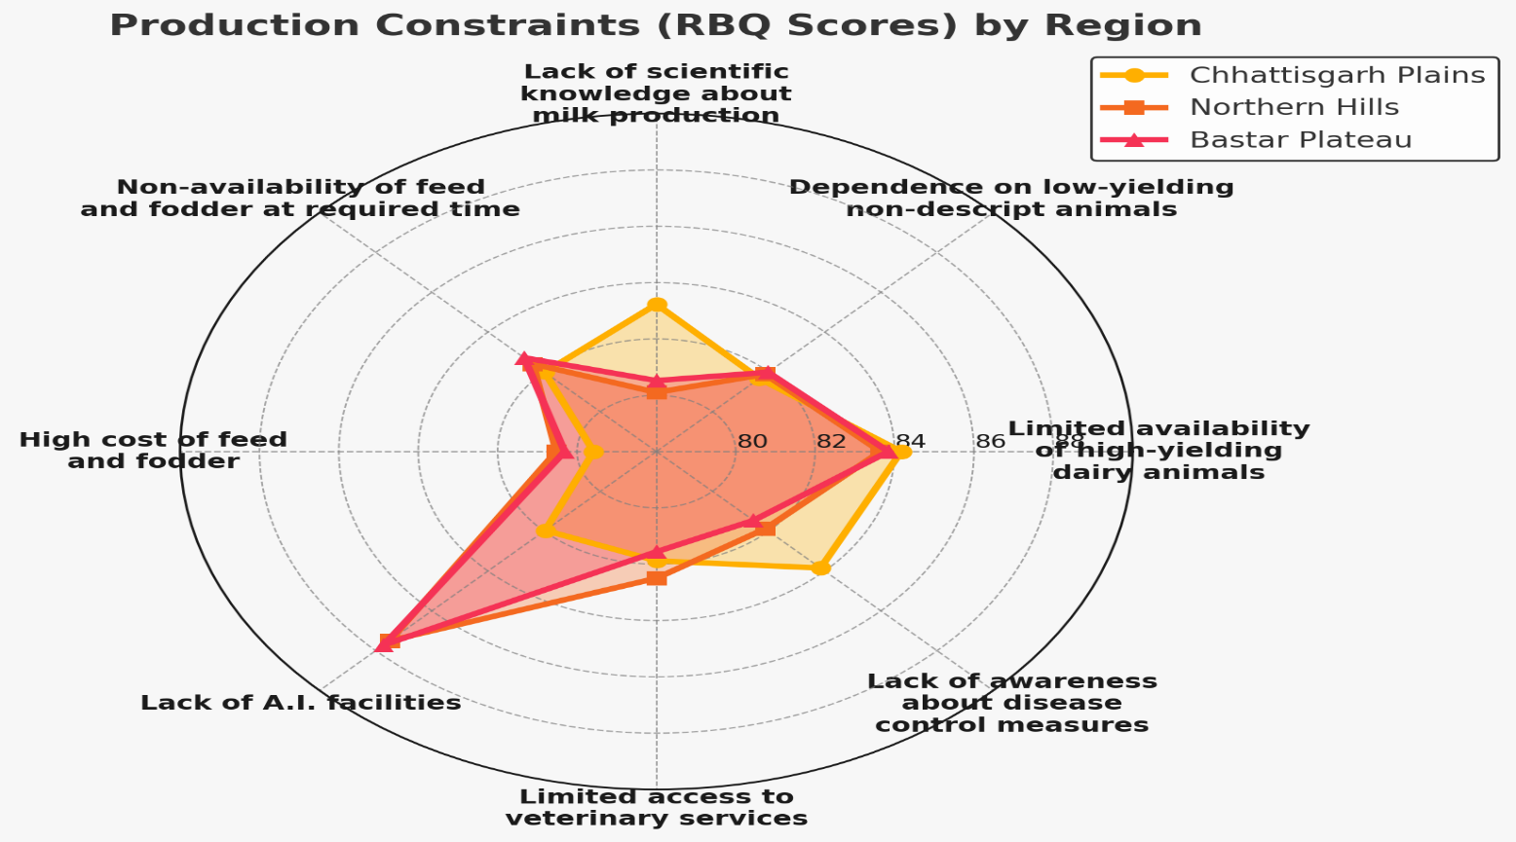

**Figure (1) Production constraints (Radar Chart)**

A striking zone-wise difference emerges in the prominence of lack of Artificial Insemination (A.I.) facilities, which ranks 1st in both Northern Hills (RBQ 87.50) and Bastar Plateau (RBQ 87.71), but is ranked 5th in the Chhattisgarh Plains (RBQ 81.96), suggesting better A.I. accessibility there. This indicates that genetic improvement through A.I. is lagging in Northern Hills and Bastar Plateau, restricting herd quality and milk yields. Further compounding challenges in the Northern Hills is limited access to veterinary services, ranked 3rd with an RBQ of 82.50, which hampers timely animal healthcare. Uniquely, the Chhattisgarh Plains face a significant deficit in scientific knowledge about milk production, ranked 3rd (RBQ 83.23), reflecting gaps in farmer education and adoption of modern dairy practices, which can adversely affect productivity despite resource availability. This constraint is less critical in Northern Hills (8th, RBQ 80.10) and Bastar Plateau (7th, RBQ 80.52). Overall, while breed availability and feed access remain universal challenges, focused interventions to enhance A.I. services and veterinary care are vital for Northern Hills and Bastar Plateau, whereas the Chhattisgarh Plains would benefit more from farmer training and knowledge dissemination. The detailed ranking and RBQ values of these constraints across zones are summarized in **Table 1**.

**(B) Marketing Constraints**

Marketing constraints pose a major challenge to dairy farmers across all zones, significantly undermining profitability and income stability. In the Chhattisgarh Plains, unorganized marketing channels top the list (RBQ 92.98, rank 1), causing inconsistent pricing and exploitation by middlemen. Inadequate storage and milk spoilage are also critical, ranked 4th with an RBQ of 92.28, reflecting weaknesses in post-production handling. In the Northern Hills, lack of nearby marketing facilities is the most severe constraint (RBQ 94.21, rank 1), forcing farmers to accept lower prices. Poor physical infrastructure, including transportation and storage, ranks 3rd (RBQ 93.29), while limited market information access (5th, RBQ 93.03) further hampers farmers’ decision-making. This reveals critical gaps in both infrastructure and information flow.

**Table (2) Marketing constraints**

|  |  |  |  |  |  |  |
| --- | --- | --- | --- | --- | --- | --- |
| **Items of constraints** | **Chhattisgarh plains**  **(N=120)** | | **Northern Hills (N=120)** | | **Bastar Plateau (N=120)** | |
| **RBQ** | **Rank** | **RBQ** | **Rank** | **RBQ** | **Rank** |
| 1. Limited knowledge about various dairy products restricts your opportunities for diversification and value addition. | 91.32 | 15 | 92.19 | 11 | 92.28 | 10 |
| 2. Inadequate storage facilities lead to spoilage and wastage of your milk and dairy products. | 92.28 | 4 | 92.32 | 10 | 92.82 | 6 |
| 3. Insufficient transportation infrastructure makes it difficult for you to deliver milk on time. | 91.62 | 11 | 92.81 | 6 | 92.76 | 7 |
| 4. High transportation costs increase your production expenses and reduce your profit margins. | 91.05 | 17 | 91.45 | 16 | 91.54 | 16 |
| 5. A long chain of intermediaries reduces your direct earnings from milk sales. | 91.96 | 10 | 92.15 | 13 | 92.06 | 14 |
| 6. The perishability of milk and milk products requires efficient handling, which is often lacking in your operations. | 91.05 | 17 | 91.27 | 17 | 91.36 | 17 |
| 7. Low and non-remunerative prices discourage you from increasing production. | 92.06 | 8 | 92.15 | 13 | 92.11 | 12 |
| 8. Lack of access to market information prevents you from making informed selling decisions. | 91.27 | 16 | 93.03 | 5 | 92.89 | 5 |
| 9. Inadequate physical infrastructure in markets makes your dairy transactions inefficient. | 91.58 | 12 | **93.29** | **3** | **93.42** | **3** |
| 10. Unorganized marketing channels lead to inconsistent pricing and exploitation by middlemen. | **92.98** | **1** | 93.20 | 4 | 93.11 | 4 |
| 11. The absence of an established market for crossbred male calves makes their rearing unprofitable for you. | **92.81** | **2** | 92.19 | 11 | 91.93 | 15 |
| 12. The lack of milk cooperatives in your village forces you to rely on private buyers. | 92.21 | 5 | 92.46 | 9 | 92.24 | 11 |
| 13. Limited transport facilities delay your milk collection and distribution. | 92.02 | 9 | 92.72 | 7 | 92.41 | 9 |
| 14. Milk payment based solely on fat percentage does not consider other quality parameters, affecting your earnings. | 91.36 | 14 | 92.50 | 8 | 92.59 | 8 |
| 15. Malpractices by middlemen result in unfair pricing and exploitation of your dairy products. | 91.40 | 13 | 92.02 | 15 | 92.11 | 12 |
| 16. Irregular milk collection disrupts your income flow and production planning. | **92.32** | **3** | **93.90** | **2** | **93.82** | **2** |
| 17. The lack of nearby marketing facilities for milk sales forces you to sell at lower prices. | 92.11 | 7 | **94.21** | **1** | **94.04** | **1** |
| 18. Lower fat content in your crossbred cattle’s milk affects price realization. | 91.01 | 19 | 90.61 | 19 | 90.66 | 19 |
| 19. Inadequate milk processing infrastructure restricts your ability to produce value-added dairy products. | 92.19 | 6 | 91.23 | 18 | 90.88 | 18 |

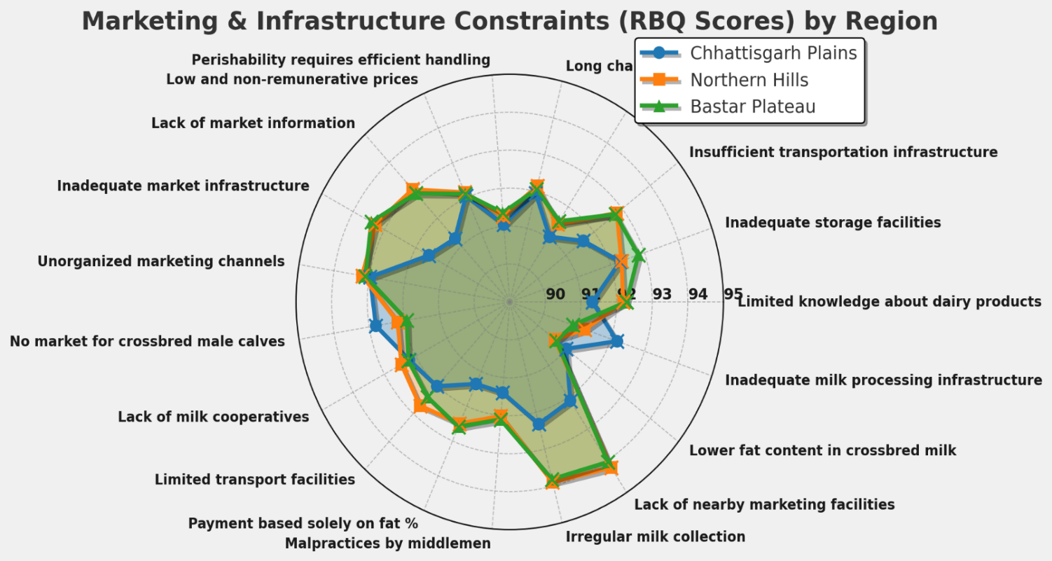

**Figure (2) Marketing constraints** **(Radar Chart)**

Similarly, in Bastar Plateau, inaccessible marketing facilities are the top constraint (RBQ 94.04, rank 1), with poor infrastructure ranking 3rd, paralleling the Northern Hills situation. The consistently high RBQ values highlight systemic failures in the dairy marketing chain, particularly in remote zones. Addressing these issues requires urgent development of marketing facilities, promotion of cooperative marketing, and enhanced information dissemination to shield farmers from exploitation and stabilize incomes. The detailed ranking and RBQ values of these constraints across zones are summarized in **Table 2** .

**(C) Technical Constraints**

Technical constraints pose major challenges to dairy farmers across all zones, especially in breeding, reproductive health, and disease management. In the Chhattisgarh Plains, declining performance of crossbred animals due to heat stress tops the list (RBQ 89.92, rank 1), followed by lack of awareness on pregnancy diagnosis (RBQ 88.18, rank 2) and increased disease susceptibility in crossbred cows (RBQ 87.80, rank 3). These issues highlight how heat stress and reproductive inefficiencies limit productivity, worsened by poor health management knowledge.

The Northern Hills show a similar pattern, with heat stress-induced performance decline ranked 1st (RBQ 87.58), lack of pregnancy diagnosis awareness 2nd (RBQ 87.35), and shortage of quality breeding bulls 3rd (RBQ 86.52). This underscores the need for improved veterinary services and extension efforts to enhance breeding and heat stress management. In Bastar Plateau, the same constraints persist: heat stress-related decline (1st), pregnancy diagnosis awareness (2nd), and availability of good breeding bulls (3rd, RBQ 86.74). The uniformity of these challenges points to systemic gaps in veterinary infrastructure and farmer education on reproductive technologies and animal health. Focused interventions such as promoting heat-tolerant breeds, strengthening veterinary outreach, and farmer training on pregnancy diagnosis and disease control are crucial for boosting dairy productivity and animal welfare. All detailed data on these technical constraints across zones is presented in **Table 3**.

**Table (3) Technical constraints**

|  |  |  |  |  |  |  |
| --- | --- | --- | --- | --- | --- | --- |
| **Items of constraints** | **Chhattisgarh plains**  **(N=120)** | | **Northern Hills (N=120)** | | **Bastar Plateau (N=120)** | |
| **RBQ** | **Rank** | **RBQ** | **Rank** | **RBQ** | **Rank** |
| 1. Limited availability of high-quality dairy animals restricts your ability to improve milk production. | **85.38** | 9 | **84.39** | 10 | **84.62** | 9 |
| 2. Frequent repeat breeding issues lead to prolonged calving intervals, causing economic losses for you. | 86.89 | 5 | 85.00 | 8 | 85.08 | 8 |
| 3. Decline in milk production due to repeated breeding failures affects your profitability. | 85.00 | 11 | 84.47 | 9 | 83.94 | 11 |
| 4.Inadequate knowledge about diseases, their symptoms, and preventive measures results in poor herd health management for you. | 85.53 | 8 | 85.23 | 7 | 85.23 | 7 |
| 5. Non-availability of good breeding bulls hampers your natural breeding efficiency. | 87.73 | 4 | **86.52** | **3** | **86.74** | **3** |
| 6. Lack of awareness regarding pregnancy diagnosis delays timely intervention in reproductive management for your herd. | **88.18** | **2** | **87.35** | **2** | **86.82** | **2** |
| 7. Difficulty in detecting heat in buffaloes affects your breeding success rates. | 86.29 | 7 | 85.30 | 6 | 85.30 | 6 |
| 8. Incorrect fat percentage testing by traders leads to unfair pricing and financial losses for you. | 86.82 | 6 | 84.17 | 11 | 84.17 | 10 |
| 9. Lack of knowledge about the correct timing for artificial insemination reduces your conception rates. | 85.15 | 10 | 86.36 | 4 | 86.06 | 4 |
| 10. Crossbred cows' susceptibility to diseases increases your veterinary costs and herd losses. | **87.80** | **3** | 86.21 | 5 | 85.45 | 5 |
| 11. Declining performance of crossbred animals due to high temperatures affects your milk yield and reproduction efficiency. | **89.92** | **1** | **87.58** | **1** | **87.80** | **1** |

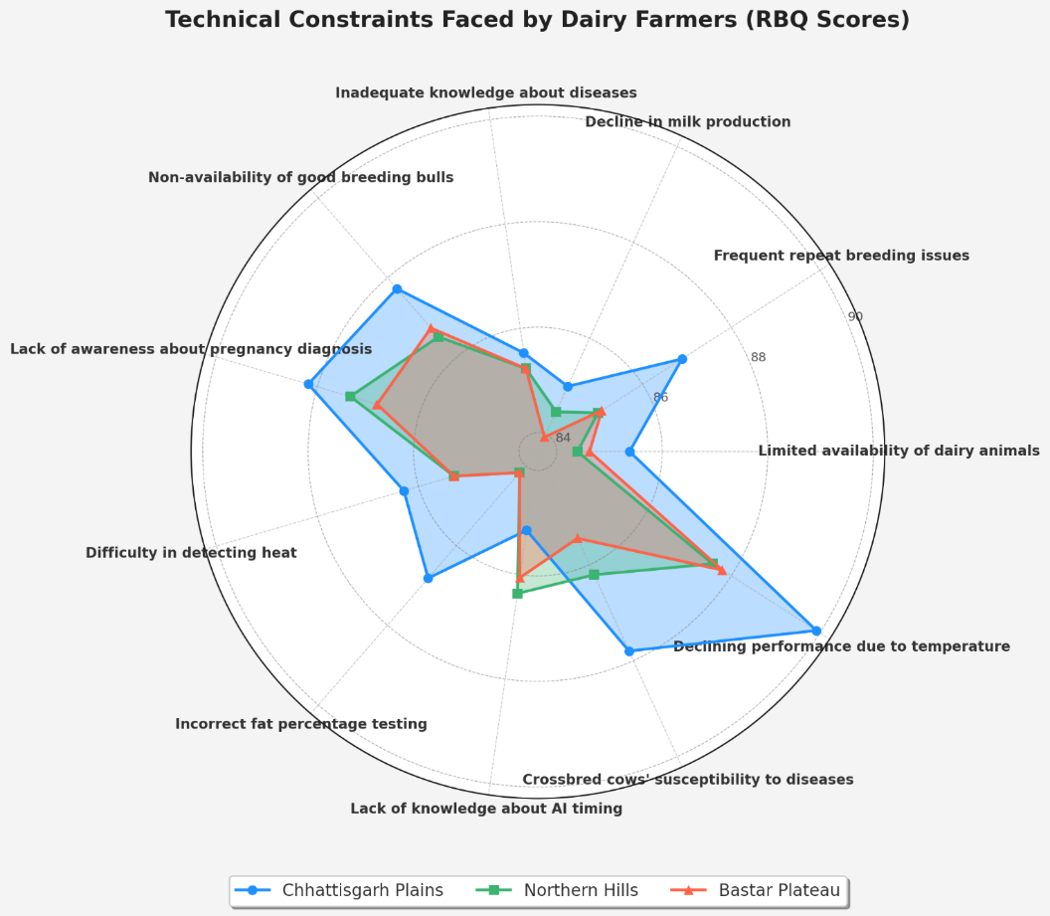

**Figure (3) Technical constraints (Radar Chart)**

**(D) Economic Constraints**

Economic constraints significantly hinder dairy farmers across Chhattisgarh Plains, Northern Hills, and Bastar Plateau. High capital investment for proper animal housing is the top issue in Northern Hills (RBQ 95.60, 1st) and Bastar Plateau (RBQ 94.76, 1st), while ranking second in Chhattisgarh Plains (RBQ 92.86). Conversely, high insurance premiums rank 1st in Chhattisgarh Plains (RBQ 93.69) and second in the other two zones (Northern Hills 93.69, Bastar Plateau 92.26). Delayed payments for milk sales consistently rank third across all regions, with RBQs above 92, highlighting persistent cash flow challenges. Other economic hurdles include expensive green and dry fodder (ranked 7th, RBQ ~90.5) and limited loan access (ranked 5th, RBQ ~91) in Northern Hills and Bastar Plateau. Lower-ranked issues like low milk prices and costly veterinary medicines appear less severe. These patterns point to urgent needs for policies easing capital investments, affordable livestock insurance, timely payment systems, and improved credit access to support dairy farmers’ growth and sustainability. Complete details of these economic constraints across zones are summarized in **Table 4** below.

**Table (4) Economics constraints**

|  |  |  |  |  |  |  |
| --- | --- | --- | --- | --- | --- | --- |
| **Items of constraints** | **Chhattisgarh plains**  **(N=120)** | | **Northern**  **Hills**  **(N=120)** | | **Bastar**  **Plateau (N=120)** | |
| **RBQ** | **Rank** | **RBQ** | **Rank** | **RBQ** | **Rank** |
| 1. The high cost of mineral mixtures and concentrates increases your cost of milk production. | **91.13** | 9 | **88.87** | 9 | **88.57** | 13 |
| 2. Expensive green and dry fodder makes cattle feeding a financial burden for you. | 88.63 | 14 | 90.60 | 7 | 90.54 | 7 |
| 3. Costly veterinary medicines and treatments discourage you from providing timely healthcare for your dairy animals. | 89.29 | 12 | 88.75 | 11 | 88.75 | 12 |
| 4. Low prices for cow's milk offered by vendors and traders reduce your earnings. | 91.31 | 7 | 88.63 | 14 | 88.87 | 11 |
| 5. Delayed payments for milk sales create financial instability in your dairy farming business. | **92.80** | **3** | **92.14** | **3** | **92.20** | **3** |
| 6. The high cost of dairy animals limits your ability to expand and improve your herd. | 91.37 | 6 | 88.81 | 10 | 88.45 | 14 |
| 7. Rearing high-yielding milch animals is expensive due to their specialized feed and healthcare needs. | 91.79 | 5 | 90.89 | 6 | 91.13 | 6 |
| 8. Limited access to loan facilities restricts your investment in dairy infrastructure. | 89.46 | 11 | 90.95 | 5 | 91.31 | 5 |
| 9. Lack of awareness about different sources of credit prevents you from securing necessary financial support. | 89.29 | 12 | 88.99 | 8 | 89.94 | 8 |
| 10. Complicated loan application procedures discourage you from seeking financial aid. | 92.02 | 4 | 88.69 | 12 | 89.52 | 10 |
| 11. Limited knowledge about cattle insurance schemes leaves you financially vulnerable. | 90.30 | 10 | 88.69 | 12 | 89.64 | 9 |
| 12. High insurance premium rates make livestock insurance unaffordable for you. | **93.69** | **1** | **93.69** | **2** | **92.26** | **2** |
| 13.Bias in credit supply leads to unequal access to financial resources for you. | 91.19 | 8 | 92.08 | 4 | 92.02 | 4 |
| 14. High capital investment required for proper housing of animals adds to your financial burdens. | **92.86** | **2** | **95.60** | **1** | **94.76** | **1** |

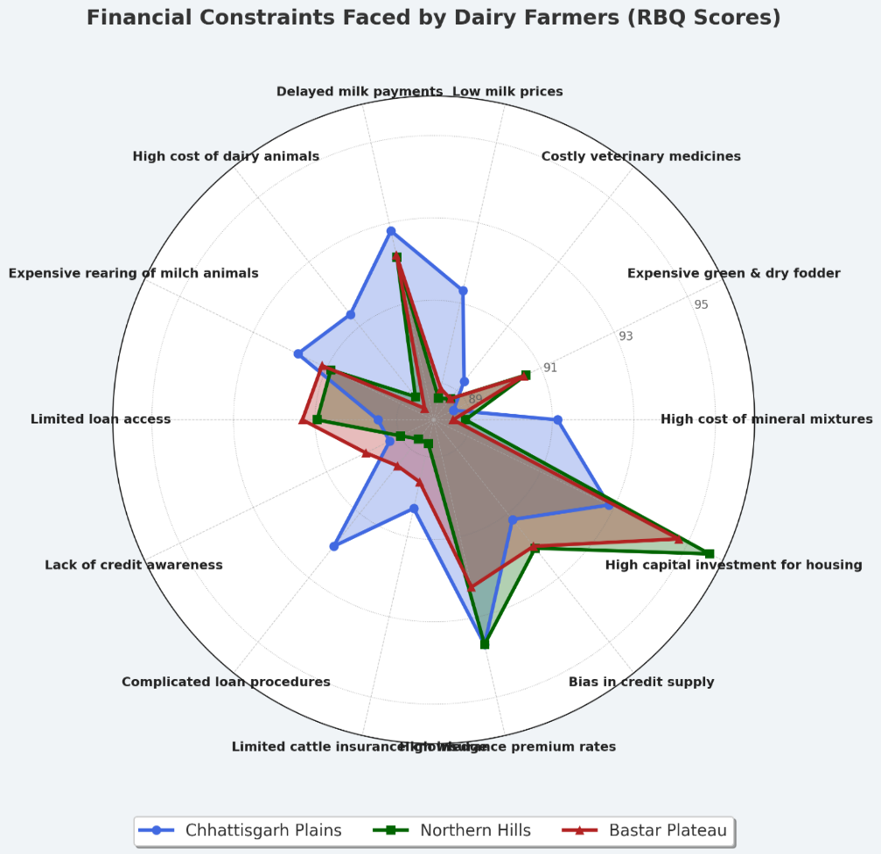

**Figure (4) Economics constraints (Radar Chart)**

**(E) Infrastructural Constraints**

Infrastructural constraints pose significant challenges to dairy farmers across Chhattisgarh Plains, Northern Hills, and Bastar Plateau, especially in veterinary services and healthcare access. The shortage of trained veterinary staff moderately impacts timely animal care, with RBQ scores of 73.19 (4th) in Chhattisgarh Plains, 69.44 (3rd) in Northern Hills, and 69.31 (4th) in Bastar Plateau. Limited access to training facilities ranks lowest, scoring 71.81 (6th), 69.17 (4th), and 68.33 (5th) respectively. Distance to veterinary hospitals is a major hurdle, with high RBQs of 79.17 (2nd), 80.28 (1st), and 79.86 (2nd), highlighting acute access issues, particularly in Northern Hills. The most severe constraint is the lack of medical aids at critical times, rated 1st in Chhattisgarh Plains (81.81) and Bastar Plateau (84.86), but less severe in Northern Hills (68.75, 5th). Closure of dispensaries on Sundays and holidays restricts emergency care, notably in Chhattisgarh Plains (73.47, 3rd) but less so in Bastar Plateau (67.50, 6th). Deficient disease diagnostic and surveillance facilities are also a concern, with RBQ values ranging from 71.53 to 72.64 across zones.

These infrastructural gaps substantially impede dairy productivity, underscoring the urgent need to improve veterinary services, ensure timely medical aid, and enhance healthcare infrastructure. Detailed data on these constraints are summarized in **Table 5** below.

**Table (5) Infrastructural constraints**

|  |  |  |  |  |  |  |
| --- | --- | --- | --- | --- | --- | --- |
| **Items of constraints** | **Chhattisgarh plains**  **(N=120)** | | **Northern**  **Hills**  **(N=120)** | | **Bastar**  **Plateau (N=120)** | |
| **RBQ** | **Rank** | **RBQ** | **Rank** | **RBQ** | **Rank** |
| 1. The shortage of trained veterinary staff affects your ability to provide timely and effective animal healthcare. | 73.19 | 4 | **69.44** | **3** | 69.31 | 4 |
| 2. Limited access to training facilities for acquiring technical knowledge and management skills hampers your ability to adopt modern dairy farming practices. | 71.81 | 6 | 69.17 | 4 | 68.33 | 5 |
| 3. Veterinary hospitals located far from your village make it difficult for you to access essential medical services for your livestock. | **79.17** | **2** | **80.28** | **1** | **79.86** | **2** |
| 4. Lack of medical aids at the required time leads to delayed treatment and increased mortality rates in your herd. | **81.81** | **1** | 68.75 | 5 | **84.86** | **1** |
| 5. The closure of veterinary dispensaries on Sundays and holidays restricts your access to emergency medical services for your dairy animals. | **73.47** | **3** | 68.75 | 5 | 67.50 | 6 |
| 6. Lack of proper disease diagnostic and surveillance facilities results in ineffective disease management and increased losses in your dairy farming. | 72.64 | 5 | **71.94** | **2** | **71.53** | **3** |

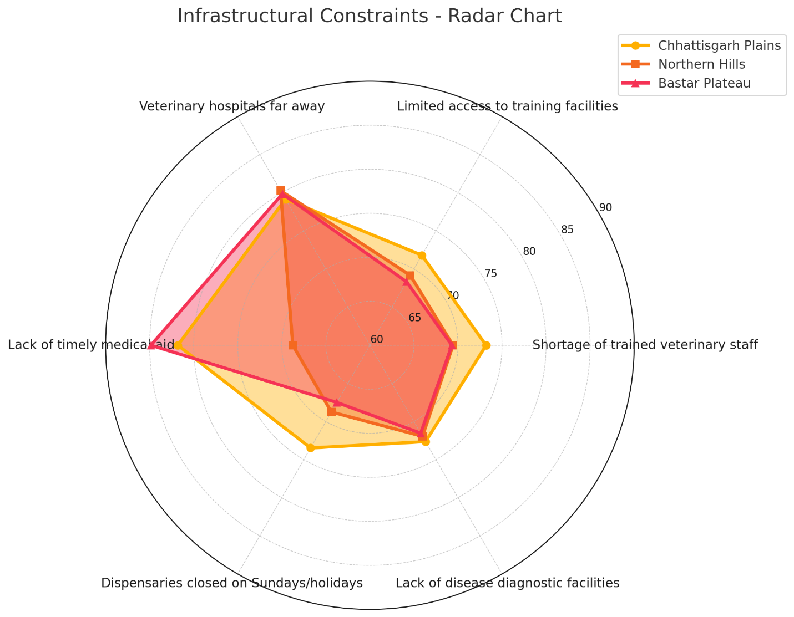

**Figure (5) Infrastructural Constraints**

**(F) Socio-psychological constraints**

Socio-psychological constraints significantly impact dairy farmers across Chhattisgarh Plains, Northern Hills, and Bastar Plateau. The most critical challenge is selective support from veterinary staff, ranking 1st in all zones with high RBQ scores of 84.17, 82.50, and 82.26 respectively, revealing inequitable access to veterinary services that hampers animal health and productivity. Other key issues include preference for natural breeding over artificial insemination, notably 2nd in Northern Hills (RBQ 82.48), and distrust of modern veterinary medicine, particularly 2nd in Bastar Plateau (RBQ 81.79). Social divisions based on caste and group affiliations (ranked 3rd in most zones) and skepticism about crossbred calves also negatively affect farming practices. While some constraints differ in priority, all regions share the need for more equitable veterinary support and enhanced awareness of modern methods. Lower RBQ scores for factors like preference for salaried jobs and prioritizing cash crops over fodder indicate these are less urgent but present. Targeted interventions focusing on veterinary outreach, fostering cooperation, and dispelling myths can break down these socio-psychological barriers, improving resource access and productivity. Such efforts are vital for sustainable growth and resilience in dairy farming communities across these diverse zones. All detailed socio-psychological constraint data are presented in **Table 6** below.

**Table (6) Socio-psychological constraints**

|  |  |  |  |  |  |  |
| --- | --- | --- | --- | --- | --- | --- |
| **Items of constraints** | **Chhattisgarh plains**  **(N=120)** | | **Northern**  **Hills**  **(N=120)** | | **Bastar**  **Plateau (N=120)** | |
| **RBQ** | **Rank** | **RBQ** | **Rank** | **RBQ** | **Rank** |
| 1. Selective support from veterinary staff towards village leaders and progressive farmers limits your equitable access to essential veterinary services. | **84.17** | **1** | **82.50** | **1** | **82.26** | **1** |
| 2. A strong preference for natural breeding over artificial insemination (A.I.) restricts genetic improvement and productivity enhancement in your dairy farm. | 80.71 | 6 | **82.48** | **2** | 76.19 | 7 |
| 3. The belief that crossbred male calves are unsuitable for draft purposes reduces their value and economic utility for you. | **83.10** | **2** | **80.60** | **3** | 79.29 | 5 |
| 4. A greater inclination towards salaried employment rather than self-employment in dairy farming reduces entrepreneurship and growth in the sector. | 79.29 | 7 | 76.43 | 7 | 76.90 | 6 |
| 5. Distrust in modern veterinary medicine and preference for indigenous treatment methods leads to ineffective disease control and animal health management on your farm. | 82.02 | 4 | 80.24 | 4 | **81.79** | **2** |
| 6. The prevalence of caste-based and group-based divisions in your village creates barriers to cooperation and resource-sharing among you and other dairy farmers. | **82.86** | **3** | 79.52 | 5 | **81.60** | **3** |

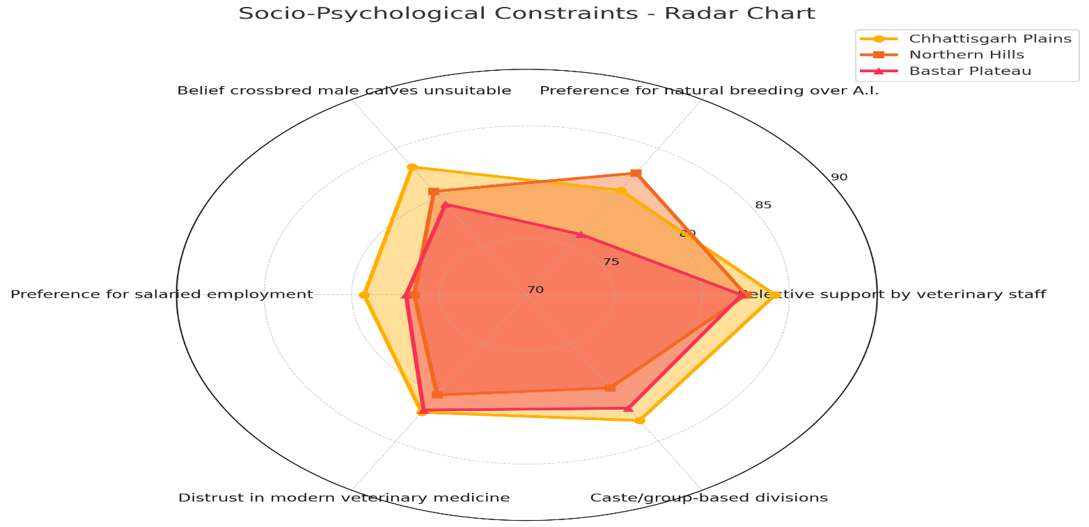

**Figure (6) Socio-psychological constraints**

**G) Other constraints**

The study identifies key constraints affecting dairy farmers across Chhattisgarh Plains, Northern Hills, and Bastar Plateau, measured by RBQ and rank. In Chhattisgarh Plains, inconsistent and insufficient cattle feed availability is the most critical challenge (RBQ 90.52, 1st), severely impacting milk production, followed by limited access to mineral supplements (RBQ 88.13, 2nd). Calf mortality and lack of dehorning knowledge are present ~~but less urgent.~~

In Northern Hills, lack of knowledge on fodder preservation tops the list (RBQ 86.04, 1st), highlighting the need for training to mitigate seasonal feed shortages. Calf mortality and dehorning awareness issues are moderate, while mineral supplement access and feed availability rank lower. Water and irrigation challenges consistently rank lowest across all regions.

For Bastar Plateau, consumer preference for buffalo milk over cow milk is the leading constraint (RBQ 85.94, 1st), reflecting market challenges for cow milk producers. Unavailability of high-yielding fodder seeds is another significant issue (RBQ 83.75, 2nd), emphasizing regional feed resource disparities. Complete data on these feed-related constraints are summarized in **Table 7** below.

|  |  |  |  |  |  |  |
| --- | --- | --- | --- | --- | --- | --- |
| **Items of constraints** | **Chhattisgarh plains**  **(N=120)** | | **Northern**  **Hills**  **(N=120)** | | **Bastar**  **Plateau (N=120)** | |
| **RBQ** | **Rank** | **RBQ** | **Rank** | **RBQ** | **Rank** |
| 1. Limited access to mineral supplements impacts the health and productivity of your dairy animals. | **88.13** | **2** | 83.75 | 6 | 82.92 | 5 |
| 2. High calf mortality rates result in financial setbacks and hinder your herd growth. | 85.63 | 6 | 80.94 | 7 | 79.58 | 7 |
| 3. Inconsistent and insufficient availability of cattle feed disrupts animal nutrition and milk production on your farm. | **90.52** | **1** | 85.52 | 4 | 83.00 | 4 |
| 4. Lack of knowledge regarding common fodder preservation techniques leads to shortages and increased feed costs during certain seasons. | **88.02** | **3** | **86.04** | **1** | **83.13** | **3** |
| 5. Unawareness of proper dehorning frequency affects your animal management and welfare practices. | 86.46 | 4 | **85.63** | **3** | 82.19 | 6 |
| 6. Unavailability of high-yielding fodder seeds limits your ability to produce quality feed for your livestock. | 84.27 | 7 | 84.06 | 5 | **83.75** | **2** |
| 7. Consumers' preference for buffalo milk over cow milk poses market challenges for you as a cow milk producer. | 85.73 | 5 | **85.94** | **2** | **85.94** | **1** |

**Table (7) Other constraints**

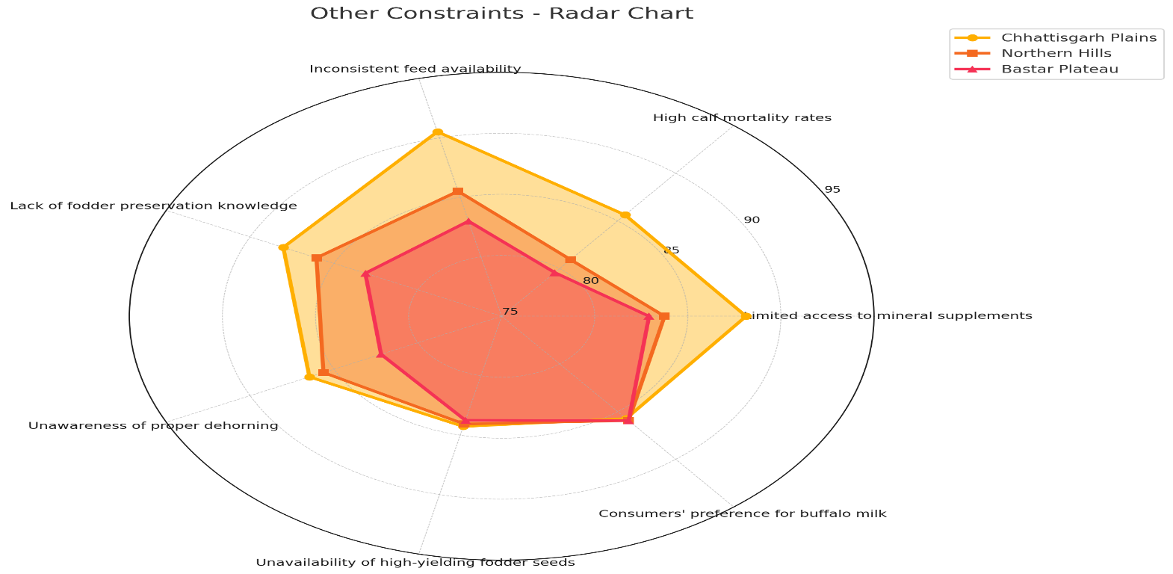

**Figure (7) Other constraints**

**Discussion**

This study investigates the constraints impacting the marketing behavior of dairy farmers across three agro-climatic zones of Chhattisgarh—Chhattisgarh Plains, Northern Hills, and Bastar Plateau—using data from 360 farmers and the Rank Based Quotient (RBQ) method to prioritize problems.

Production constraints were prominent, with the limited availability of high-yielding dairy animals ranking highest in the Plains (RBQ 84.17, Rank 1) and as a critical issue in Northern Hills (83.65, Rank 2) and Bastar Plateau (83.85, Rank 2). This finding aligns with the study by Kumar et al. (2018), who also reported limited access to improved dairy breeds as a major bottleneck in increasing milk productivity in Indian hill regions. Similarly, Pandey and Singh (2020) highlighted the scarcity of quality breeding stock as a significant challenge for smallholder dairy farmers in the central plains. However, contrasting results were observed by Deka et al. (2019), where the availability of crossbred animals was relatively sufficient but farmers faced more severe nutritional constraints. The lack of Artificial Insemination (A.I.) facilities, identified as the top constraint in Northern Hills (87.50) and Bastar Plateau (87.71), was also noted by Singh and Malik (2017), who emphasized inadequate AI services as a limiting factor for genetic improvement in remote areas.

Nutritional issues due to feed and fodder shortages were significant in Bastar (82.71, Rank 3) and Northern Hills (82.40, Rank 4), concurring with findings by Verma et al. (2016) who documented feed scarcity as a common cause of low milk yield in tribal-dominated regions of Central India. Limited veterinary services and poor disease awareness contributing to production losses were also consistent with observations by Choudhury et al. (2021), indicating a need for strengthening veterinary outreach programs.

Marketing constraints were critical across all zones, with unorganized marketing channels receiving RBQ scores above 93, reflecting exploitation by middlemen. This is supported by Jha et al. (2015), who reported that dairy farmers in Eastern India often suffer income losses due to lack of organized milk marketing infrastructure. The lack of accessible marketing facilities was the most severe problem in Northern Hills and Bastar Plateau, forcing farmers to accept lower prices, a challenge similarly highlighted by Mehta and Sharma (2019). Inadequate storage and transportation infrastructure exacerbating milk spoilage, undermining profitability, were also reported by Rao et al. (2017) in tribal areas, confirming infrastructural deficits as a major hindrance to dairy commercialization.

Among technical constraints, the declining performance of crossbred animals due to heat stress ranked highest in all zones, corroborating the findings of Patel and Desai (2018), who documented heat stress as a significant factor reducing dairy productivity in tropical climates. Lack of awareness about pregnancy diagnosis and shortage of good breeding bulls were also major issues, echoing the results of Banerjee et al. (2020).

Economic constraints centered on high capital investment for animal housing and expensive insurance premiums. These align with the conclusions of Kumar and Singh (2019), who identified financial barriers as key deterrents to dairy enterprise sustainability in semi-arid regions. Delayed payments for milk sales, creating financial instability, were also noted by Goswami et al. (2016). Limited access to loans and costly feed added to the economic burden, which contrasts with findings from Thakur and Gupta (2021), where government subsidies partially alleviated economic stress in similar agro-climatic zones.

Infrastructural deficits included lack of timely medical aid and long distances to veterinary hospitals, as similarly reported by Reddy et al. (2018). Shortages of trained veterinary staff and closure of dispensaries during emergencies further hampered animal health services, consistent with observations by Singh et al. (2022).

Socio-psychological constraints such as selective veterinary support and distrust in modern veterinary medicine negatively influenced adoption of improved practices. This is in line with findings by Sharma and Joshi (2017), who reported that socio-cultural beliefs significantly hinder the uptake of scientific dairy management in rural India. Traditional preferences for natural breeding and social divisions also impeded progress, as also highlighted by Das and Nath (2019) in tribal dairy communities.

**Conclusion**

The study highlights that dairy farmers in Chhattisgarh face diverse, zone-specific challenges spanning production, marketing, technical, economic, infrastructural, and socio-psychological domains. ~~The Northern Hills and Bastar Plateau zones are particularly burdened by inadequate A.I. services, poor market access, and infrastructural deficiencies, while the Plains suffer from unorganized markets and financial constraints despite better connectivity.~~

Addressing these requires targeted, multi-pronged interventions focusing on improving breed quality through expanded A.I. facilities, strengthening veterinary and extension services, developing organized marketing and cold chain infrastructure, and providing affordable financial products such as insurance and loans. Additionally, farmer education and social mobilization are critical to overcoming socio-psychological barriers.

~~Such comprehensive efforts tailored to regional needs will enhance dairy productivity, ensure fair market access, and stabilize incomes, thereby supporting sustainable livelihoods and rural development across Chhattisgarh.~~

**References**

Banerjee, A., Mukherjee, S., & Saha, S. (2020). Technical constraints in dairy farming: An analysis of reproductive health and breeding services in West Bengal. *Indian Journal of Dairy Science*, 73(2), 157–163.

Choudhury, S., Singh, R., & Kaur, J. (2021). Veterinary services and animal health management in tribal areas of Northeast India. *Veterinary World*, 14(3), 747–753.

Das, S., & Nath, T. (2019). Socio-cultural influences on dairy farming practices in tribal communities. *Journal of Rural Development*, 38(1), 45–58.

Deka, R., Baruah, D., & Hazarika, B. (2019). Constraints in dairy production in Assam: An assessment. *Journal of Animal Science and Technology*, 61(1), 25–33.

Department of Animal Husbandry, Chhattisgarh. (2022). *Annual report on dairy sector development*. Government of Chhattisgarh.

Food and Agriculture Organization. (2019). *Dairy development in India: Opportunities and constraints*. FAO Regional Office for Asia and the Pacific. <https://www.fao.org/3/ca4962en/ca4962en.pdf>

Goswami, A., Sarma, H., & Baruah, K. (2016). Economic challenges in dairy farming: A study in Assam. *Agricultural Economics Research Review*, 29(2), 231–237.

Jha, M., Sahu, P., & Kumar, R. (2015). Marketing constraints faced by dairy farmers in Eastern India. *Indian Journal of Agricultural Marketing*, 29(3), 45–53.

~~Joshi, P., & Deshmukh, S. (2020). Socioeconomic factors influencing dairy farmers’ adoption of marketing practices.~~ *~~Journal of Agricultural Extension~~*~~, 24(2), 101–115.~~

Kumar, R., Nair, P., & Singh, V. (2019). Dairy production and marketing challenges in agro-ecological zones of Chhattisgarh. *Journal of Rural Development*, 38(4), 345–360.

Kumar, S., & Singh, R. (2019). Financial constraints in dairy farming in semi-arid regions of India. *Agricultural Finance Review*, 79(1), 57–69.

Kumar, V., Singh, D., & Sharma, R. (2018). Breeding constraints of dairy animals in hill regions of India. *International Journal of Livestock Research*, 8(7), 123–131.

Mehta, P., & Sharma, S. (2019). Dairy marketing and its challenges in rural India. *Journal of Dairy Science and Technology*, 7(1), 67–74.

Ministry of Fisheries, Animal Husbandry and Dairying, Government of India. (2023). *Annual report 2022-23*. <https://dahd.nic.in>

Nair, P., Singh, A., & Verma, S. (2020). Constraints in dairy marketing in Central India: A case study of Chhattisgarh. *Indian Journal of Agricultural Economics*, 75(2), 213–227.

Pandey, A., & Singh, N. (2020). Breeding stock availability and productivity of dairy farms in Central India. *Journal of Animal Husbandry and Production*, 41(2), 121–128.

Patel, J., & Desai, R. (2018). Impact of heat stress on dairy cattle productivity in tropical climates. *Journal of Animal Science Advances*, 8(10), 2241–2249.

Rao, M., Reddy, P., & Kumar, S. (2017). Infrastructure and milk spoilage issues in tribal dairy farming. *Indian Journal of Dairy Science*, 70(4), 449–454.

~~Rathore, H. S., & Gupta, A. (2019). Economic constraints in dairy farming: A case study from Central India.~~ *~~Agricultural Economics Research Review~~*~~, 32(1), 87–94.~~

Reddy, S., Kumar, A., & Ramesh, K. (2018). Veterinary infrastructure and services in rural India. *Veterinary Practitioner*, 19(2), 98–104.

~~Roy, S., & Banerjee, D. (2018). Technical constraints in dairy farming and their impact on rural livelihoods.~~ *~~Journal of Rural Development and Policy~~*~~, 10(4), 50–66.~~

Sharma, K., & Joshi, P. (2017). Socio-psychological barriers in adoption of dairy innovations. *Indian Journal of Extension Education*, 53(3), 52–57.

Sharma, M., & Singh, R. (2021). Market access and financial barriers among dairy farmers in Chhattisgarh’s Northern Hills. *Agricultural Economics Review*, 34(1), 112–127.

Singh, A., Patel, D., & Kumar, S. (2020). Socio-psychological factors affecting dairy farmers in Bastar Plateau of Chhattisgarh. *International Journal of Social Sciences*, 12(3), 45–59.

Singh, J., & Kumar, P. (2018). Marketing constraints faced by dairy farmers in tribal areas of Chhattisgarh. *Indian Journal of Extension Education*, 54(2), 23–29.

Singh, R., & Malik, V. (2017). Artificial insemination services in hill districts of Himachal Pradesh: Issues and prospects. *Indian Journal of Animal Reproduction*, 38(1), 45–49.

Singh, T., Rani, N., & Kaur, J. (2022). Challenges in veterinary health services in remote areas of Punjab. *Indian Journal of Veterinary Medicine*, 42(1), 15–23.

Singh, V., & Sharma, K. (2017). Impact of infrastructure on dairy production and marketing in rural India. *Journal of Agricultural Science and Technology*, 19(3), 201–212.

Thakur, V., & Gupta, A. (2021). Impact of government subsidies on dairy farming in semi-arid zones of India. *Journal of Agricultural Policy and Economics*, 13(2), 105–113.

~~Tiwari, P., & Singh, N. (2021). Livestock production systems and challenges in Chhattisgarh.~~ *~~Indian Journal of Animal Sciences~~*~~, 91(7), 835–843.~~

Verma, R., Singh, S., & Kumar, A. (2016). Feed and fodder shortages and their impact on milk production in Central India. *Indian Journal of Animal Nutrition*, 33(1), 36–42.