**Estimation of different carbon and nitrogen sources against *Fusarium oxysporum* f. sp.**



***vasinfectum* (FOV) causing wilt disease of cotton**

##### Abstract

Cotton (*Gossypium hirsutum* L.) is a major fiber crop that contributes significantly to global economic and social development. It is often referred to as "The White Gold" or "The King of Fibers". Cotton is a major cash crop in our country and belongs to the family Malvaceae. Cotton is a historically important commercial commodity, next to food grains, and serves as the primary raw material for the thriving textile industry. Cotton production, processing, textiles, and allied industries employ approximately 42 million people and sustain their livelihoods. In this present study, seven different carbon and nitrogen sources were tested for their suitability for the growth and sporulation of *F*. *oxysporum* f. sp. *vasinfectum* of cotton. Among the different carbon source, the maximum growth was observed in glucose (345.20mg), which was followed by galactose (306.15mg), mannitol (281.10mg), fructose (270.34mg), sucrose (268.16mg), starch (257.91mg) and lactose (172.10mg).While, the poor growth was observed in control (85.38mg). For sporulation category, it was found that the fungus showed abundant (++++) sporulation in glucose, galactose and mannitol. Among the different nitrogen source, the maximum growth was observed in potassium nitrate (310.13mg) which was followed by calcium nitrate (302.30mg), urea (298.37mg), sodium nitrate (288.58mg), ammonium nitrate (272.57mg), ammonium chloride (183.45mg), ammonium oxalate (162.30mg). While, the poor growth was observed in control (59.11mg). For sporulation category, it was found that the fungus showed abundant (++++) sporulation in potassium nitrate and sodium nitrate.

**Keywords**: Cotton, *Fusarium,* Carbon, Nitrogen, Growth, Sporulation.

**Commented [mk1]:** The introduction could benefit from a clearer transition into the experimental details.

**Commented [mk2]:** Units need a space after numbers:

**Commented [mk3]:** The comma after "While" is incorrect; also "control" needs an article:

**Commented [mk4]:** For sporulation category" is awkward. Better to say:

"Regarding sporulation," or "In terms of sporulation,"

**Commented [mk5]:** The phrase **"**poor growth" could be more formal as "lowest growth" or "minimal growth."

**Commented [mk6]:** The sporulation rating **"**abundant (++++)" should be explained or defined somewhere for clarity, or use words instead of symbols for formal writing.

##### Introduction

**Commented [mk7]:** Check punctuations, space, grammatical error. Some are given in the coming comments

Cotton is a globally important crop used for both its [natural fiber](https://www.sciencedirect.com/topics/agricultural-and-biological-sciences/natural-fibre) and seed. [Fusarium wilt,](https://www.sciencedirect.com/topics/agricultural-and-biological-sciences/fusarium-wilt) caused by the fungus [*Fusarium oxysporum*](https://www.sciencedirect.com/topics/agricultural-and-biological-sciences/fusarium-oxysporum)f. sp. *vasinfectum*, is a major disease of cotton capable of causing significant economic losses. The fungus persists in soil as [chlamydospores](https://www.sciencedirect.com/topics/agricultural-and-biological-sciences/chlamydospore) and in association with the roots of susceptible, resistant and non-cotton hosts as well as in seed.

Management of [Fusarium wilt](https://www.sciencedirect.com/topics/agricultural-and-biological-sciences/fusarium-wilt) is difficult and most successfully achieved through the use of resistant cultivars and pathogen-free [cotton seed](https://www.sciencedirect.com/topics/agricultural-and-biological-sciences/cottonseed) (Cianchetta and Davis, 2015).

In India, the productivity of cotton is very low due to many constraints including diseases. Diseases are inherent compounds of the agroecosystem that must be dealt with continuously and on a knowledge basis. Cotton is affected by various diseases caused by fungi, bacteria and viruses. The most common cotton diseases reported in India are wilt (*Fusarium oxysporum* f. sp. *vasinfectum* (G.F. Atk.) W.C. Snyder & H.N. Hansen), root rots (*Rhizoctonia bataticola* Taubenh.), verticillium wilt (*Verticillium dahliae* Kleb.), anthracnose (*Colletotrichum gossypii* Southworth. or *C. capsici* (Syd.) Butler & Bisby), grey mildew (*Ramularia areola* G.F. Atk.), blackarm (*Xanthomonas campestris* pv. *malvacearum* (Pammel) Dowson), leaf blight (*Alternaria macrospora* Zimm), leaf curl (Cotton leaf curl virus), corynespora leaf blight caused by *Corynespora cassiicola* (Berk. & M. A. Curtis) C. T. Wei, boll rot and physiological disorders as para wilt, leaf reddening and sometimes leaf elongation etc. The bacterial blight is the widest spread and destructive disease reported to cause yield losses of about 10 to 30 per cent (Kalpana *et al*., 2004 and Sandipan *et al*., 2022). Losses due to alternaria leaf spot (26.6%), grey mildew (29.2%) and myrothecium leaf spot (29.1%) have been reported. Moreover, sometimes myrothecium leaf spot, caused by the fungus *Myrothecium roridum* Tode, was responsible for losses of 50 per cent in the town of Balsas in Maranhão and also been reported in the state of Mato Grosso. The symptoms of the disease can appear on the leaves and cotton bolls (Suassuna *et al*., 2006). Cotton boll rot can cause 20-30 per cent losses in productivity (Iamamoto, 2007) and a large number of pathogens were associated to cause the boll rot infection including external as well as internal pathogens (Sandipan *et al*., 2022).

**Commented [mk10]:** Missing verb; fix to: *and has also been reported.*

**Commented [mk9]:** Some sentences are very long and complex, making them difficult to read. Try to split long sentences for clarity.

**Commented [mk8]:** This sentence is vague and awkward

Among them wilt, root rot and verticillium wilt are soil borne diseases of cotton and anthracnose, grey mildew, black arm and leaf blight are foliar diseases of cotton (Ramod, 2016). Among these diseases, Fusarium wilt caused by *F. oxysporum* f. sp. *vasinfectum* (FOV) is one of the most important and serious diseases. It was the first vascular wilt described by Atkison in (1892) and this disease is still causing enormous yield losses in several parts of the world and remains a threat to cotton production (Feng *et al*., 2000). The disease is responsible for serious losses to the crop in the central and western India on a large scale and on almost all the cultivated varieties of both *G.arboreum* and *G. herbaceum*, the two indigenous species, especially in black cotton soils of Maharashtra, Madhya Pradesh, Karnataka and Gujarat. At present, the most of cultivated cultivars are susceptible to wilt disease (*F. oxysporum* f. sp. *vasinfectum*) and caused 54-60 per cent yield loss

(Anonymous, 2003) because of reduced stand, stunted growth, small balls and poor lint quality. Fusarium wilt of cotton (*Gossypium hirsutum* L. and *Gossypium barbadense* L.) caused by *Fusarium oxysporum* f. sp. *vasinfectum* W.C. Snyder & H.N. Hansen (FOV), is an important and widespread disease affecting nearly all cotton growing regions of the world. FOV is both seedborne and soilborne, and colonizes the roots and vascular system of susceptible cotton cultivars, causing root and vascular discoloration vascular wilt (Chen *et al*., 1985, Hillocks, 1992, Patel *et al*., 2021a and Davis *et al*., 1996). Discrete symptoms vary with pathogen genotype, inoculum density, cotton cultivar and plant age (Hao *et al*., 2009).



Symptoms of this wilt may appear at any stage of crop development (generally from 30 to 120 DAS), depending on inoculum density, temperature and host susceptibility. At very high inoculum density or the very beginning of infection, plants may be killed at the seedling stage itself. Usually, the first symptoms in the field appear 30-60 days after planting generally, on the onset of flowering. The pathogen colonizes in plant roots and grows systemically into the vascular tissues and proliferates within the xylem vessels eventually spreading throughout the plant. It grows out of the vascular tissues and after the death of the host, sporulates on crop residues. The disease can be recognized at the seedling stage with symptoms first appearing on the cotyledons as the darkening of veins, followed by peripheral chlorosis and necrosis before they drop. In older plants, the infection occurs as yellowing at the margin of one or more of the lower leaves. As the disease progresses within the plant more leaves develop chlorosis, which characteristically appears in patches between the main veins, the rest of the leaf remains green. Under optimal conditions, all the leaves of affected plants succumb and shed before the stem dries out (Patel *et al*., 2021 and Sain *et al*., 2023). There are six nominal races of FOV, 1, 2, 3, 4, 6 and 8 known to affect cotton worldwide (Holmes *et al.*, 2009).

##### Materials and Methods

**SOURCE ON THE GROWTH OF *Fusarium oxysporum* f*.* sp. *vasinfectum***

All the glasswares and plasticwares were soaked overnight in potassium dichromate sulphuric acid solution. After24hr glasswares were washed thoroughly in running water and rinsed with distilled water. The plasticwares were airdried and the glassware was sterilized in hot air oven at 160-180ºC for about 90min.

**Commented [mk13]:** Compound word error

**Commented [mk11]:** Check grammar

**Commented [mk12]:** Check spacing

Isolations and purification were conduct under aseptic condition of laminar air flow cabinet. Before working under the hood, the working surface was uniformly sterilized using 70 per cent alcohol. The blades, forceps, inoculation loop *etc*. was sterilized by incineration on the flame of the spirit lamp.



Seven different carbon and nitrogen source were used to find out the most suitable one for the growth and sporulation of *F*. *oxysporum* f. sp. *vasinfectum.*

To study the effect of different carbon sources on the growth and sporulation of *F. oxysporum* f. sp. *vasinfectum*, seven different carbon sources were tested. Richard's medium with five per cent carbon source was used as basal medium. The effect of each carbon source was studied by replacing the sucrose from different carbon sources in Richard's medium. The quantity of carbon compounds was determined on the basis of their molecular weight so, as to provide equivalent amount of carbon (21.05g) as was present in 50.00g of in a litre of Richard's medium. The identical control was kept with a basal medium devoid of any carbon source after that 20ml of the medium was poured in each conical flask of 100ml and autoclaved at 121.6ºC at 15 psi for 20min. These were cooled to 45ºC. Then 5mm disc of the test fungus was cut with the help of sterilized cork borer from the margin of seven days old culture grown on PDA Petri plate. One disc was placed in the centre of each conical flask. Three repetitions of each medium were maintained. After seven days of incubation period, dry mycelial weight and sporulation was recorded. The result was tabulated and the data were analysed statistically using complete randomized design.

To study the effect of various nitrogen sources on the growth and sporulation of the fungus, seven different nitrogen sources were tested in the manner similar to that of carbon sources. In this case, potassium nitrate of the Richard's medium was replaced by different nitrogen sources to provide an equivalent quantity of nitrogen (1.39g) as was present in 10.00g of potassium nitrate in a litre of Richard's medium after that 20ml of the media was poured in each conical flask of 100ml and autoclaved at 121.6ºC at 15 psi for 20min. These were cooled to 45ºC. Then 5mm disc of the test fungus was cut with the help of sterilized cork borer from the margin of seven days old culture grown on PDA Petri plate. One disc was placed in the centre of each conical flask. Three repetitions of each medium were maintained. After seven days of incubation period, dry mycelial weight and sporulation was recorded. The result was tabulated and the data were analysed statistically using complete randomized design.

**Commented [mk14]:** Include media composition

**Commented [mk15]:** What is identical crop?

**Commented [mk16]:** Mention conditions (temperature, humidity). How weight and sporulation was measured explain in detail the methodology clarifying each step)

**Commented [mk17]:** After that" is informal. Use *"Subsequently,"* or *"Then,"*. Also: *"20 mL of the medium was poured into each 100 mL conical flask and autoclaved at 121.6°C and 15 psi for 20 minutes."*

**Commented [mk18]:** Add context. The flasks were allowed to cool to 45°C under sterile conditions."

**Commented [mk19]:** Needs grammar and clarity. Correct version: *"A 5 mm disc of the test fungus was aseptically cut using a sterilized cork borer from the margin of a seven-day-old culture grown on a PDA Petri plate."*

**Table: 1 Carbon source tested for growth and sporulation of *F*. *oxysporum* f. sp. *vasinfectum***

|  |  |  |  |  |  |
| --- | --- | --- | --- | --- | --- |
| **Sr.**  **No.** | **Carbon source** | **Empirical formulae** | **Molecular wt.** | **Per cent carbon content** | **Wt. added in one litre medium (g)** |
| **MONOSACCHARIDES** | | | | | |
| T1 | Fructose | C6H12O6 | 180.16 | 40 | 52.633 |
| T2 | Galactose | C6H12O6 | 180.16 | 40 | 52.633 |
| T3 | Glucose | C6H12O6 | 180.16 | 40 | 52.633 |
| **DISACCHARIDES** | | | | | |
| T4 | Lactose | C12H22O11.H2O | 360.32 | 40 | 50.00 |
| T5 | Sucrose | C12H22O11 | 342.30 | 42.11 | 50.00 |
| **SUGAR ALCOHOL** | | | | | |
| T6 | Mannitol | C6H14O6 | 182.18 | 39.56 | 52.633 |
| T7 | Starch | C6H10O5 | 162.14 | 51.81 | 47.369 |

**Design:** Completely Randomized Design

##### Treatments: 7

**Repetitions:** 3

**Location:** Department of Plant Pathology, Post Graduate Laboratory, N. A. U., Navsari, Gujarat.

**Table: 2 Nitrogen source tested for growth and sporulation of *F. oxysporum* f.sp. *vasinfectum***

|  |  |  |  |  |  |
| --- | --- | --- | --- | --- | --- |
| **Sr.**  **No.** | **Nitrogen sources** | **Empirical formulae** | **Molecular wt.** | **Percent nitrogen**  **content** | **Wt. added in one litre**  **medium(g)** |
| **ORGANIC** | | | | | |
| T1 | Urea | NH2CONH2 | 60.06 | 46.82 | 2.984 |

|  |  |  |  |  |  |
| --- | --- | --- | --- | --- | --- |
| **INORGANIC** | | | | | |
| 1.Nitrate nitrogen | | | | | |
| T2 | Calcium nitrate | Ca(NO3)2.4H2O | 236.16 | 11.86 | 8.1 |
| T3 | Potassium nitrate | KNO3 | 101.10 | 13.85 | 10.00 |
| T4 | Sodium nitrate | NaNO3 | 84.99 | 16.47 | 8.430 |
| 2. Ammonical nitrogen | | | | | |
| T5 | Ammonium chloride | NH4Cl | 53.49 | 26.17 | 5.310 |
| T6 | Ammonium nitrate | NH4NO3 | 80.04 | 35.00 | 3.950 |
| **ORGANIC AMMONICAL NITROGEN** | | | | | |
| T7 | Ammonium oxalate | (COONH4)H2O | 142.11 | 19.70 | 7.055 |

**Design:** Completely Randomized Design

##### Treatments: 7

**Repetitions:** 3

**Location:** Department of Plant Pathology, Post Graduate Laboratory, N. A. U., Navsari, Gujarat.

##### Result and Discussion

**SOURCE ON THE GROWTH OF *Fusarium oxysporum* f*.* sp. *vasinfectum***

In the present investigation different carbon and nitrogen sources were utilized to find out which are the best source for the growth of *Fusarium oxysporum* f*.* sp. *vasinfectum*. For this purpose, seven different carbon sources from various groups of carbohydrates were investigated to determined that which carbon source is optimal for the growth of fungus.

For development and sporulation, the fungus used every carbon source examined however, the amount of use varied depending on the kind of carbon source. Maximum dry mycelium weight was observed in glucose with 345.20mg which, was followed by galactose with 306.15mg, mannitol with 281.10mg and fructose with 270.34mg, sucrose with 268.16mg. While, the least dry mycelium weight was observed in the control with 85.38mg. (Table: 3, Fig.: 1, Photograph: 1).

For sporulation category, it was found that the *F. oxysporum* f. sp. *vasinfectum* showed abundant sporulation in glucose, galactose and mannitol. Fungus produced good sporulation in

**Commented [mk21]:** Sporulation descriptions are somewhat vague — e.g., "abundant. Consider quantifying sporulation or defining these qualitative terms more precisely.

**Commented [mk20]:** Suggested Revision of a Part for Clarity

fructose and sucrose. In starch, it produced moderate sporulation while, in lactose and control it produced scanty sporulation.

From this present investigation it can be concluded that glucose and galactose were the best carbon sources, where mannitol, fructose and sucrose were good carbon source for the growth of *F. oxysporum* f. sp. *vasinfectum*.

To know the best nitrogen source for the growth and sporulation of *F. oxysporum* f. sp. *vasinfectum,* seven different nitrogen sources were tested in this study. The fungus utilized every nitrogen source examined however, the amount of use varied depending on the kind of nitrogen source. Maximum dry mycelium weight was observed in potassium nitrate with 310.13mg, which was followed by calcium nitrate with 302.30mg, urea with 298.37mg, sodium nitrate with 288.58mg and ammonium nitrate with 272.57mg while, the least dry mycelium observed in control with

59.11mg, which was followed by ammonium oxalate 162.30mg and ammonium chloride with

183.45mg (Table: 4, Fig.: 2, Photograph: 2). It was found that the *F. oxysporum* f. sp. *vasinfectum* produced abundant sporulation in potassium nitrate and sodium nitrate. Fungus produced good sporulation in calcium nitrate and

ammonium nitrate. In ammonium oxalate and urea, it produced moderate sporulation while, in control it produced scanty sporulation.

From these findings it can be concluded that potassium nitrate, calcium nitrate and urea were the best nitrogen source, where sodium nitrate and ammonium nitrate were good for growth of *F*. *oxysporum* f. sp. *vasinfectum.*

Khilare and Rafi (2011) revealed that nitrogen in the form of calcium nitrate, potassium nitrate and urea showed the maximum mycelium growth of *Fusarium oxysporum* f. sp. *ciceri* (>87.5 mm).

**Commented [mk22]:** In some places, "carbon source" is singular, elsewhere plural. Keep consistent depending on context.

**Commented [mk23]:** repetition of "different" can be avoided: "seven nitrogen sources were tested."

|  |
| --- |
| **Commented [mk24]:** awkward; better: **"**the lowest dry mycelium weight was observed in the control with 59.11 mg," |
| **Commented [mk25]:** You mention figures, tables, and  photographs but do not describe or summarize what they contain clearly. |
| **Commented [mk26]:** The phrase **"Fusarium oxysporum f. sp."**  is sometimes fully spelled, sometimes abbreviated; that's okay, but  ensure consistent italicization. |
| **Commented [mk27]:** The fungus produced good sporulation |

Malathi and Mohan (2012) conducted an experiment on the physiological and cultural variabilities among *Fusarium oxysporum* f. sp. *cepae* an isolate of onion. They found that the fungus grew the best on glucose among the different carbon sources.

Maitlo *et al.* (2017) studied that the sucrose and dextrose were the most suitable carbon sources for the growth of *Fusarium oxysporum* f. sp. *ciceris.* potassium nitrate and peptone are the best nitrogen sources for the growth of fungus.

Vasumathi and Devi (2020) reported that the glucose was the best carbon source for the growth of *Fusarium oxysporum* of groundnut crop. The fungal growth recorded with a mean

mycelium diameter of 9.00cm and mycelium dry weight of 453.40mg, in the solid and liquid media, respectively.



that, glucose and dextrose showed the maximum growth followed by lactose. From the seven nitrogen sources, potassium nitrate, calcium nitrate and urea were best for the growth of the test fungus.

Kashif *et al*. (2022) observed a physicochemical characterization of *Fusarium moniliforme* of maize crop. Fungus was tested on different carbon and nitrogen source for the growth and sporulation. Among them, glucose as a carbon source showed the highest fungal growth (11.62mm).

Menge *et al*. (2021) conducted an experiment on *Fusarium oxysporum* f. sp. *capsici* of chilli crop. The nutritional requirement of the test pathogen was carried by using the various carbon and nitrogen sources. All the seven carbon sources were significantly utilized by the pathogen. Among

|  |
| --- |
| **Commented [mk28]:** Awkward and unclear |

|  |
| --- |
| **Commented [mk29]:** Add a space before unit and clarify: |

#### Table: 3 Growth and sporulation of *Fusarium oxysporum* f*.* sp. *vasinfectum* in Richard's medium supplemented with different carbon sources after fifteen days of incubation

|  |  |  |  |  |  |
| --- | --- | --- | --- | --- | --- |
| **Sr.**  **No.** | **Carbon source** | **pH after**  **autoclaving** | **pH of**  **filtrate** | **Dry mycelial weight**  **(mg)** | **Sporulation#** |
| 1 | Fructose | 5.6 | 6.6 | 270.34 | +++ |
| 2 | Galactose | 5.7 | 7.2 | 306.15 | ++++ |
| 3 | Glucose | 5.9 | 7.5 | 345.20 | ++++ |
| 4 | Lactose | 5.6 | 6.1 | 172.10 | + |
| 5 | Sucrose | 5.5 | 6.9 | 268.16 | +++ |
| 6 | Mannitol | 5.7 | 7.5 | 281.10 | ++++ |
| 7 | Starch | 5.7 | 7.2 | 257.91 | ++ |
| 8 | Control | 5.5 | 5.3 | 85.38 | + |
| SEm± | | | | 4.70 | - |
| CD at 5% | | | | 14.21 | - |
| CV% | | | | 3.27 | - |

#Sporulation category: - Absent, + Scanty, ++ Moderate, +++ Good and ++++ Abundant

#### Table: 4 Growth and sporulation of *Fusarium oxysporum* f*.* sp. *vasinfectum* in Richard's medium supplemented with different nitrogen sources after fifteen days of incubation

|  |  |  |  |  |  |
| --- | --- | --- | --- | --- | --- |
| **Sr.**  **No.** | **Nitrogen source** | **pH after**  **autoclaving** | **pH of**  **filtrate** | **Dry mycelial weight**  **(mg)** | **Sporulation**# |
| 1 | Urea | 6.3 | 6.9 | 298.37 | ++ |
| 2 | Calcium nitrate | 5.7 | 6.1 | 302.30 | +++ |
| 3 | Potassium nitrate | 5.6 | 7.4 | 310.13 | ++++ |
| 4 | Sodium nitrate | 5.7 | 7.2 | 288.58 | ++++ |
| 5 | Ammonium chloride | 5.6 | 5.7 | 183.45 | ++ |
| 6 | Ammonium nitrate | 5.4 | 6.1 | 272.57 | +++ |
| 7 | Ammonium oxalate | 5.8 | 6.0 | 162.30 | ++ |
| 8 | Control | 5.6 | 5.5 | 59.11 | + |
|  | SEm± | | | 3.19 | - |
|  | CD at 5% | | | 9.64 | - |
|  | CV% | | | 2.35 | - |

#Sporulation category: - Absent, + Scanty, ++ Moderate, +++ Good and ++++ Abundant

**Fig.:1 Effect of different carbon source on the growth of *Fusarium oxysporum* f. sp*. Vasinfectum***

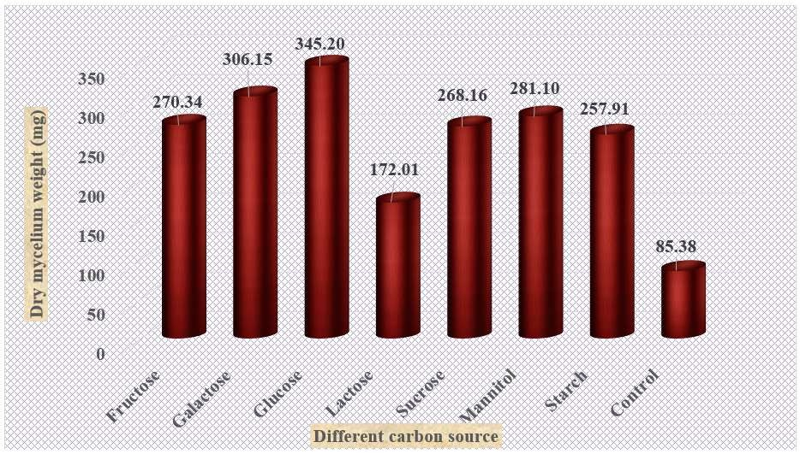

**Fig.: 2 Effect of different nitrogen source on the growth of *Fusarium oxysporum* f. sp*. vasinfectum***

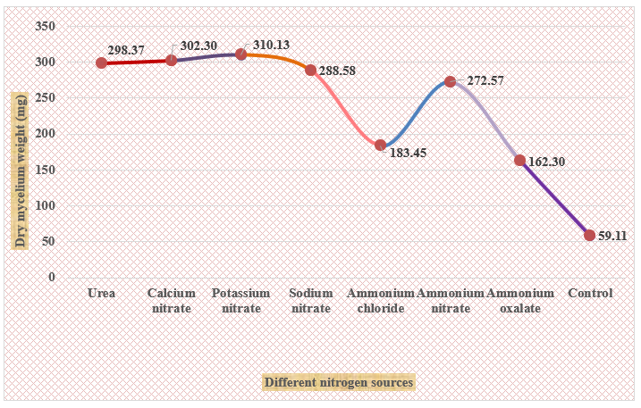

**Photograph: 1 Effect of different carban source on the growth of *Fusarium oxysporum* f. sp*. Vasinfectum***

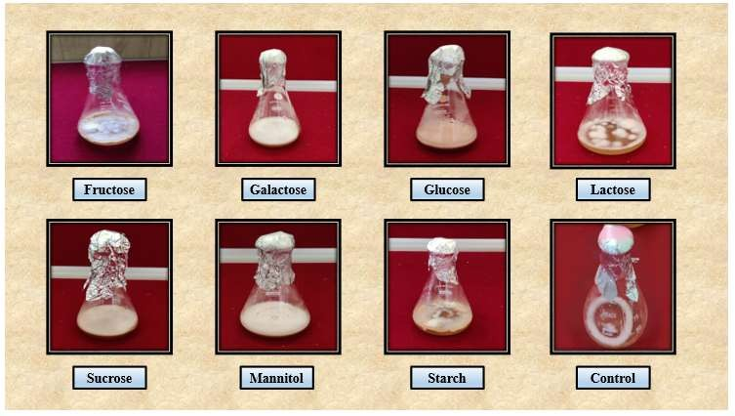

**Photograph: 2 Effect of different nitrogen source on the growth of *Fusarium oxysporum* f. sp*. Vasinfectum***

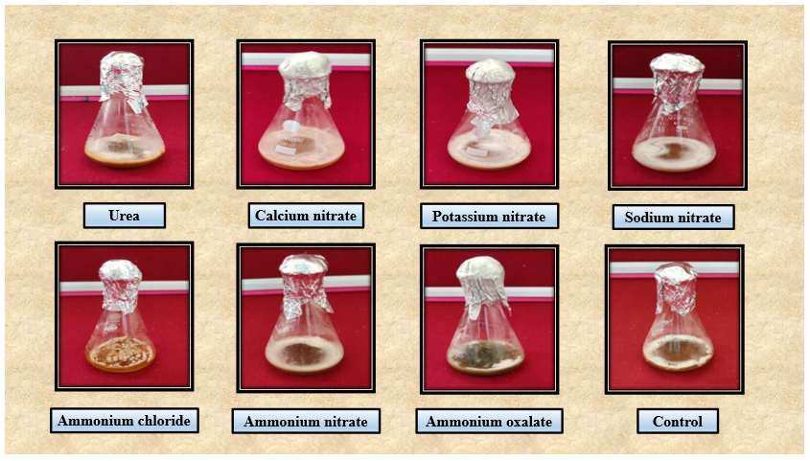



**Conclusion**

In present experiment, under *in vitro* evaluation of different carbon and nitrogen source studied, glucose as carbon source and potassium nitrate as nitrogen source supported the maximum growth and sporulation of *F*. *oxysporum* f. sp. *vasinfectum.*

**References**

Anonymous (2003). Assessment of the impact and main dynamics of cotton disease affecting in particular small scale production systems in Southern – Africa, <https://www.icac.org/projects/commonfund/seacf_disease/proj11final.pdf>



accessed on 18 June 2017 .

Chen, Q.; Ji, X. and Sun, W. (1985). Identification of races of cotton wilt Fusarium in China. *Journal of Agricultural Sciences*, **6**: 1-6.

Cianchetta, A. N., Davis, R. M. (2015). Fusarium wilt of cotton: Management strategies. Crop Protection, **73**: 40-44.

Davis, R. D.; Moore, N. Y. and Kochman, J. K. (1996). Characterization of a population of *Fusarium oxysporum* f. sp. *vasinfectum* causing wilt of cotton in Australia. *Australian Journal of Agricultural Research*,**47**(7): 1143-1156.

Feng, J.; Wen, S.; Leiyan, S. Ma.; Fenj, J.; Sun, W. J. and Shi, Cly. (2000). Analysis of physiologic races of *Fusarium oxysporum* f. sp. *vasinfectum* in China. *Mycosystema,* **19**: 45-50.

Hillocks, R. J. (1992). Fusarium wilt. In: Hillocks, R. J.(Ed.) Cotton diseases. *Melksham UK. Redwood Press Ltd*. pp.127-160.

Hao, J. J.; Yang, M. E. and Davis, R. M. (2009). Effect of soil inoculum density of *Fusarium oxysporum* f. sp. *vasinfectum* race 4 on disease development in cotton. *Plant Disease,***93**(12): 1324-1328.

Holmes, E. A.; Bennett, R. S.; Spurgeon, D. W.; Colyer, P. D.; and Davis, R. M. (2009). New genotypes of *Fusarium oxysporum* f. sp. *vasinfectum* from the Southeastern United States. *Plant Disease*, **93**(12): 98-1304.

Iamamoto, M. M. (2007). Doenças do algodoeiro. Fundação de Apoio a Pesquisa, Ensino e Extensão, Jaboticabal, Brasil, 62.



Kalpana, P., Chellamuthu, V. and Jeyalakshmi, C. 2004. Screening of cotton hybrids against bacterial blight incited by *Xanthomonas campestris* pv. *malvacearum* (Smith) Dye, *Paper presented in Inter. Symp. Strat. Sust. Cotton Prod*. – A Global Vision 3, Crop Production, 23-25 Novermber 2004, Univ. Agric. Sci., Dharwad (India), pp. 373-374.

Kashif, M.; Atiq, M.; Rajput, N. A.; Sahi, S. T.; Yaqoob, F.; Ashraf, M. and Tariq, H. (2022). Physicochemical characterization of *Fusarium moniliforme* isolated from infected maize plants from Faisalabad, Pakistan. *Plant cell biotechnology and molecular biology*, pp. 71-84.

Khilare, V. and Rafi, A. (2011). Effect of nutritional sources on the growth of *Fusarium oxysporum*

f. sp. *ciceri* causing chickpea wilt. *International Journal of Science and Nature*,**2**(3): 524- 528.

Maitlo, S.; Rajput, A. Q.; Syed, R.; Khanzada, M.; Rajput, N. and Lodhi, A. (2017). Influence of physiological factors on vegetative growth and sporulation of *Fusarium oxysporum* f. sp*. ciceris*. *Pakistan Journal of Botany*, **49**(S1): 311-316.

Malathi, S. and Mohan, S. (2012). Physiological and cultural variabilities among *Fusariumoxysporum* f. sp. *cepae*isolates in onion. *Madras Agricultural Journal*, **99**(7-9): 601-606.

Menge, Y. S.; Patil, P. D.; Gadhave, A. D.; Kore, S. K.; Giri, V. V. and Nirgude, Y. K. (2021). Study the effect of various sources of carbon, nitrogen and pH levels on growth of *Fusarium oxysporum* f. sp.*capsici. International Journal of Chemical Studies*, **9**(2): 127-130.

Patel, B. K., Sandipan, Prashant B..**,** Chawada, S. K. and Patel, R. K. (2021). Wilt: An important fungal disease of cotton under South Gujarat of India. *International Journal of Chemical Studies*., **9** (1): 296-271.



Patel, B. K.; Sandipan, P. B.; Chawada, S. K. and Patel, R. K. (2021a). Evaluation of various combi product fungicides for the control of wilt (FOV) disease of cotton under *in vitro* condition of South Gujarat (India). *International Journal of Chemical Studies*, **9**(1): 2992-2995.

Ramod, P. (2016). Studies on management of anthracnose disease of Bt – cotton caused *colletotricumcapsici.ThesisM.sc (Plant Pathology)*. The Vasantrao Naik Marathwada Krushi Vidyapeeth Prabhani.

Sain, S. K.; Monga, D.; Sabesh, M.; Prasad, Y. G.; Prakash, A. H. and Singh, R. K. (2023). Diseases and disorders of cotton: A field guide for symptombased identification and management. ICAR-AICRP on Cotton. ICAR-CICR, Regional Station, Coimbatore-641003 Tamil Nadu.

pp. 140.

Sandipan, Prashant B., Patel P. S., Patel, R. K., Chaudhari, Rameela I., Patil, P. V. and Patel, M. C. (2022). Effect of environmental factors in relationship to Bacterial leaf blight (BLB) disease development under South Gujarat of India. *Journal of Plant Development Sciences*., **14** (6): 561-567.

Sandipan, Prashant B., Patel P. S., Patel, R. K., Chaudhari, Rameela I. and Patel, M. C. (2022). Evaluation of different fungicides against boll rot and foliar diseases of cotton under South Gujarat of India. *Journal of Plant Development Sciences*., **14** (5): 491-496.

Suassuna, N. D., Chitarra, L. G., Asmus, G. L. and Inomoto, M. M. (2006). Manejo de doenças do algodoeiro. Circular Técnica, Embrapa Algodão, Campina Grande, 9724.

Vasumathi, S. and Devi, P. A. (2020). Characterization of *Fusarium oxysporum* causing wilt disease in groundnut. *Journal of Pharmacognosy and Phytochemistry*, **9**(3): 2044-2047.