Journal Name: | Journal of Scientific Research and Reports
Manuscript Number: | Ms_JSRR_136529
Title of the Manuscript: | Assessment of medicinal plants used for the management of skin diseases in Odigbo Local Government Area, Ondo State, Nigeria
Type of the Article

PART 1: Comments

 | Reviewer’s comment  Artificial Intelligence (AI) generated or assisted review comments are strictly prohibited during peer review. | Author’s Feedback (It is mandatory that authors should write his/her feedback here)
Please write a few sentences regarding the importance of this manuscript for the scientific community. A minimum of 3-4 sentences may be required for this part. | The article is significant in the scientific community because plants identified through this research could be use as a reference for herbal use specifically for skin diseases. Furthermore, for researchers, methods used in the studies could be used as a model in conducting similar studies in other places. In addition, the result could be use as evidence for the proven use of plants. Moreover, the result could be use as a foundational knowledge in making prospective drugs.
Is the title of the article suitable?  (If not please suggest an alternative title) | Suggestion: Medicinal plants used for Skin Disease management in Odigbo Local Government Area, Ondo State, Nigeria.
Is the abstract of the article comprehensive? Do you suggest the addition (or deletion) of some points in this section? Please write your suggestions here. | - No, the introductory part is long, it could be shortened.  - Suggestion:  To identify the medicinal plants use in treating skin diseases traditionally, a total of 120 respondents comprising of herb sellers, hunters, traditional medicine practitioners, farmers and ordinary community members were selected randomly from six villages for an interview. The information needed were collected using a semi-structured questionnaires utilizing local yoruba language then analysed using descriptive statistics. The study revealed that 28 plant species from 19 families were used to treat 9 different types of skin diseases either by topical application, decoction and or oral route. The most represented families are Fabaceae, Euphorbiaceae and Meliaceae. RFC ranged from 0.01 to 0.850. The most cited plant species are Cassia alata Linn. (RFC = 0.850), Ricinus communis L. (RFC = 0.5916) and Tetrapleura tetrapetra (RFC = 0.5083). The least significant family is Annonaceae (FIV= 0.005) while the most significant is Euphorbiaceae (FIV=0.943). Trees are the most used plant form while bark is the most widely used plant parts (PPV = 0.373). Decoction is the most common method of preparation. In conclusion, it was observed that the respondents have vast knowledge of the uses of the medicinal plants and that the aspect of traditional method of managing skin diseases is completely neglected and should be streamlined into the healthcare delivery system of Nigerian.
Is the manuscript scientifically, correct? Please write here. | - In the concept of research, it follows the typical content of a research, thus a scientific paper. In addition, the formula used in computations were rightfully discussed.  - While the introduction does not show strong reason why the study was conducted. The introduction could be further improved by adding additional reasons behind the study like local or regional situations.  - As to the tabulated presentation of data, it could be further improved. The tables are long and could be divided to make it understandable.  - The tables followed each other, it is suggested that discussion precedes the table or figure.  Suggestion for intro first part:  The largest human organ which covers the external part of the body is the skin. It has several functions including fluid preservation, organ protection, body shape maintenance, temperature regulation, absorption, and eliminating toxins from the body by sweat excretion (1). However, along with these functions are infections and diseases caused by fungi, bacteria, viruses and parasites occurring around the world but prevalently in the rural and tropical regions of Asia and Africa (2). And this skin disease affects all ages and gender (3). It is attributed to lack of sanitation, poverty, mal-nutrition, overcrowding, heat, humidity and allergies due to medication (4). Examples of skin diseases caused by these microorganisms include ringworm, small pox, boils, itching, rashes, chicken pox, small pox, scabies and psoriasis (5).  - Over all, there is a need for grammatical improvement of the article.
Are the references sufficient and recent? If you have suggestions of additional references, please mention them in the review form. | - Some of the references are not very recent.  - Type of referencing or format of reference are not the same for all reference:  Example:  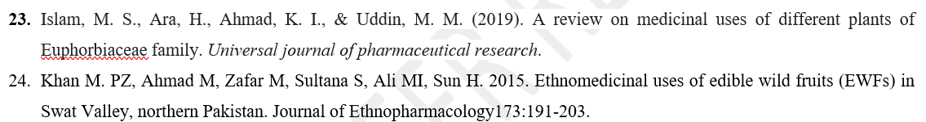  - Suggested additional reference:  Ijeabuonwu, AmalaChukwu M., Jurga Bernatoniene, and Zivile Pranskuniene. 2024. "Medicinal Plants Used to Treat Skin Diseases and for Cosmetic Purposes in Norway" Plants 13, no. 19: 2821. https://doi.org/10.3390/plants13192821  Chan, Lisa Kwin Wah, Kar Wai Alvin Lee, and Cheuk Hung Lee. 2023. "Pilot Study of Microfocused Ultrasound, Incobotulinum Toxin, and Calcium Hydroxyapatite in Triple Therapy for Skin Tightening after Weight Loss" Cosmetics 10, no. 6: 168. https://doi.org/10.3390/cosmetics10060168  - Additional references are available online
Is the language/English quality of the article suitable for scholarly communications? | - Yes, however, there is a need for further improvement of grammar
Optional/General comments | The article possess scientifical evidence.  Suggestions:  Divide table;  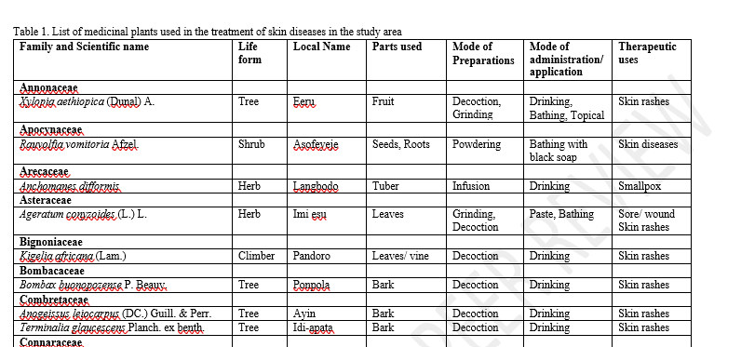  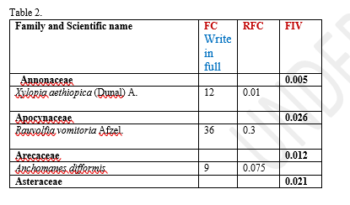  Note: put asterisk sign on high values and include legends  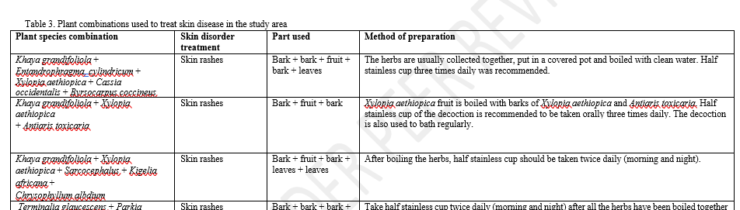

PART 2:

 | Reviewer’s comment | Author’s Feedback (It is mandatory that authors should write his/her feedback here)
Are there ethical issues in this manuscript? | (If yes, Kindly please write down the ethical issues here in detail)

Reviewer details:
Heronima d. Sanchez, Benguet State University, Philippines

