**Length-weight relationship, morphometric characters and meristic counts of an Endangered Loach, Triplophysa kashmirensis (Hora, 1922) in Kashmir Himalaya, India**

**Abstract**

The present study was conducted on the morphometry, meristic characters and length-weight relationship of *Triplophysa kashmiriensis* (Hora (1922) was carried out from September 2018 to February 2019. A total of 180 samples were collected from Dagwan and Lidder streams. Various morphometric characters showed high degree of correlation (R2) between them and the values of correlation ranged from 0.69 to 0.99. Coefficient of variation for various morphometric characteristics was found to be 20.95 % between snout length and total length, 17.65 % between eye diameter length and total length. The fin formula of the fish was found as D(I)8; A(I)5; P1(10-11); P2(7-8); C(17-18).The length-weight relationship was recorded separately for both males and females. The equations found were Log W = -5.485 + 3.167 Log L for males and Log W = -5.440 + 3.153 Log L for females and the combined equation was obtained as W = -5.491 + 3.174 log L. The value of ‘b’ obtained for the pooled data was found to be 3.174 which is significantly greater than 3 indicating a positive allometric growth in the fish.

***Keywords:*** *Triplophysa Kashmiriensis,* Allometric growth, Morphometry, Meristic, Length-Weight relationship

**1. Introduction**

Nature has bestowed the valley of Kashmir, with plenty of gifts like snow clad mountains, vast serpentine rivers etc. The valley is famous throughout the world for its waters both lentic and lotic. The lotic habitats include numerous streams like Lidder, Veshu, Dudhganga, Sindh, etc., spread throughout the valley forming tributaries of the river Jhelum that flow through the valley from south to northwest direction. All these streams harbour a number of indigenous fishes like *Schizothorax* spp., *Glyptothorax* spp., *Triplophysa* spp., etc as well as the exotic trouts i.e., *Oncorhynchus mykiss* and *Salmo trutta fario*. Inspite of the fact that most of these streams are an important fishery resource of the valley, not much is known about the ecology and biology of fishes of these habitats. The earliest report on the fishes of Kashmir is that of Heckel (1838), who reported sixteen species of fishes from the valley, thirteen of them belonging to family Cryprinidae. Since then a number of workers have reported on the ichthyofauna of the region (Kullander et al., 1999) but all the water bodies have not been explored yet and there is probability that the number of species may vary. Most fish species inhabiting this himalayan region are small in size. Their size, growth and distribution depends on environmental conditions such as water temperature, velocity of water current, nature of substratum, availability of food and their feeding habits (Yousuf et al., 2003; Bhat et al., 2010). *T. kashmiriensis* is one of the important food fish of Kashmir though commercially not so important. The fish is mostly consumed as dried fish and is very much liked by the people of rural Kashmir. The fish has been reported to occur in almost all the tributaries of river Jhelum, main river and lakes of the Kashmir but over the years due to pollution and other factors the fish population especially in water bodies of plain areas has decreased drastically (Yousuf et al., 2006; Bhat et al., 2010; Balkhi, 2007). *T. kashmiriensis* normally lives among pebbles and shingles at the bottom of the clear rocky streams but some drift into lakes among the hills and this has made these fishes secondarily modified for life in deeper waters (Hora, 1937). The comparatively bigger size of the loaches of the high altitudes may be due to the plentiful aquatic insect life and other food organisms. The *Triplophysa* species of Kashmir occuring in river Jhelum and its tributaries are also found in spring waters like Dagwan, Veerinag and Kokernag springs. Kashmir loach (Genus *Triplophysa* of sub family Nemachilinae and Family Balitoridae), locally known as ‘Ara gurun’ is a small fish having elongated and scale-less body, with eyes high on head, and inferior mouth having two rostral, and one maxillary pair of barbells. The changed trophic levels in the aquatic habitats of Kashmir due to various anthropogenic pressures has impacted the native fish species significantly and many of them have either been expelled from the system or are losing ground very fast. Natural morphometric/meristic data are of great importance for improvement of aquaculture. Morphometric and the meristic methods remains the simplest and most direct methods of species identification (Yakubu and Okunsebor (2011).

**2. Materials and methods**

The experiment was carried out in Fisheries Resource Management laboratory, Faculty of Fisheries, SKUAST-Kashmir (India). For six months, 30 specimens of *T. kashmiriensis* was collected every month from Lidder and Dagwan stream with the help of local fisherman, using traditional cast net and hand net (Plate 1). The collected samples were placed in jars containing 5% formalin and transported to FRM Laboratory at Faculty of Fisheries, Rangil. The fish samples were cleaned under running tap water, and then dried with a clean cotton cloth. After cleaning, total weight of the individuals were measured using electronic weighing balance up to the nearest 0.5 gram (Plate 7) and total length (Plate 8) was measured using digital vernier 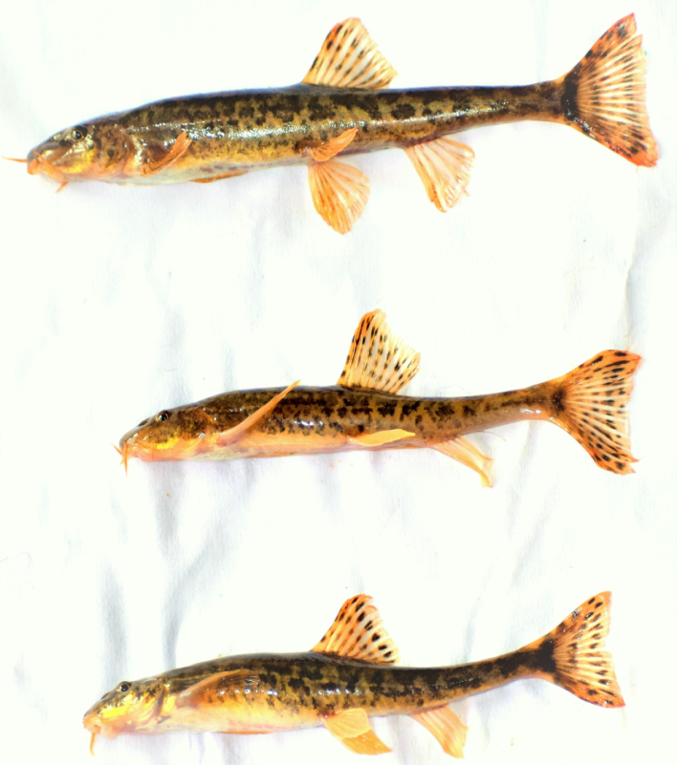caliper to the nearest 0.01 millimeter.

Plate 1. Specimens of *Triplophysa kashmiriensis*

2.2 Conventional Morphometry

Morphometric characters were measured by using Vernier Calliper to the nearest millimeter as described by Lagler et al. (1962), Laevastu (1965), Dwivedi & Menezes (1974) and Grant & Spain (1977). All measurements were taken on the left side of the fish by the same person in order to minimize the measurement bias. The following sixteen morphometric characters were measured (Plate 2): total length (TL), standard length (SL), fork length (FL), pre-dorsal length (PDL), caudal fin length (CFL), pre-anal length (PAL), pre-pelvic length (PPvL), pre-pectoral length (PPcL), head length (HL), body depth (BD), snout length (SnL), eye diameter (ED), length of the dorsal fin base (LDFB), depth of caudal peduncle (DCP), pre-orbital length (PrOL) and post-orbital length (POL).

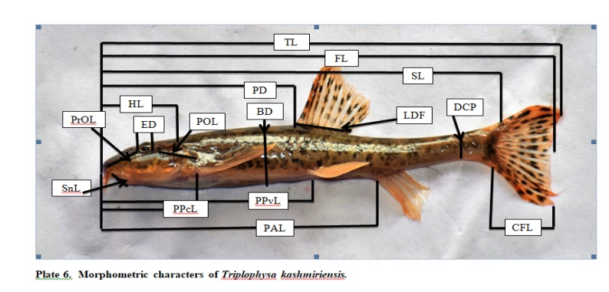

Plate 2. Morphometric characters of *Triplophysa kashmiriensis*

2.3 Meristic Characters

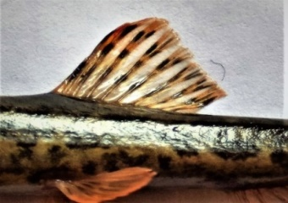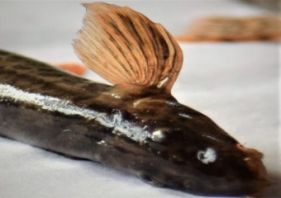The meristic counts commonly used in fish identification and taxonomic studies are counting fin ray dorsal, pectoral, ventral, anal and caudal fin rays (plate 3-6). Conventional abbreviation for the various fins in the reporting of number of fin rays are; Dorsal - D; Pectoral - P; Anal - A; Ventral - V; and Caudal - C. All true spines (simple, unbranched, unsegmented fin rays) are designated by Roman numerals whether they are stiff or flexible. Soft rays are designated by Arabic numerals.

Plate: 3 Plate: 4

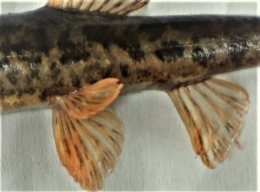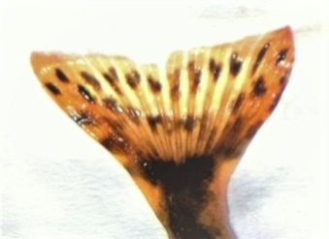

Plate : 5 Plate : 6

Plate 3-6: showing Pectoral, dorsal, caudal, pelvic and anal fins of *triplophysa kashmiriensis*

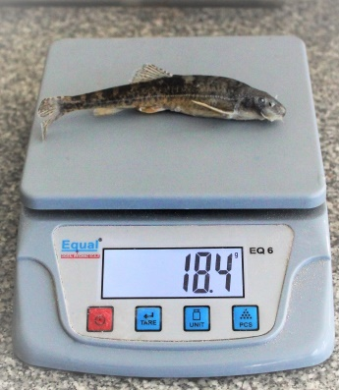 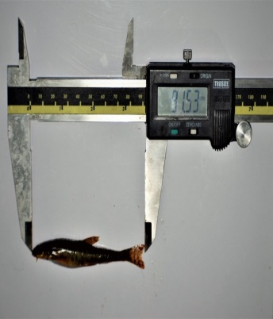

Plate:7 Plate:8

Measurement of weight Measurement of length

2.4 Length-Weight relationship

The length-weight relationship was estimated from the allometric formula proposed by Le-Cren (1951) separately for both sexes and significant differences, if any, in the slopes of the regression lines for males and females was ascertained.

W = aLb or Log W= log a + b x log L

Where, “W” is the weight of fish in g, “L” is the length of fish in mm, “a” is the intercept and “b” is the regression coefficient. “a” and “b” were estimated by following the formulae:

a $= \overline{y }-b\overline{x}$

and, b= [nΣxy - ΣxΣy]/[nΣx2-(Σx)2]

The coefficient of correlation “r” was determined to analyse the relationship between the two variables:

r = [nΣxy - ΣxΣy]/√ [nΣx2-(Σx)2][nΣy2-(Σy)2].

3. Experimental findings

The results of the present study on the morphometry, meristic characters and length-weight relationship of *Triplophysa kashmiriensis* (Hora (1922) in Kashmir Himalaya, India are as under:

3.1 Morphometry

During the present investigation on morphometry, 180 specimens of *T. kashmiriensis* were studied. The various morphometric characters of *T. kashmiriensis* are shown in Table 1. The maximum total length was recorded in the month of February (132.23 mm), while minimum was also recorded in the month of February (50.15 mm). The standard length was also recorded maximum during the month of February (124.2 mm) while minimum was also recorded in the month of February (42.86 mm). Coefficient of variation of various morphometric characteristics ranged from 17.65 % (eye diameter) to 20.95 % (snout length). The relationship between various characters i.e., total length v/s standard length, total length v/s pre dorsal length, total length v/s pre pectoral length, total length v/s pre pelvic length, total length v/s pre anal length, total length v/s head length, total length v/s snout length, total length v/s fork length, total length v/s body depth, total length v/s caudal fin length, total length v/s length of dorsal fin base, total length v/s depth of caudal peduncle, total length v/s pre-orbital length, total length v/s post-orbital length and total length v/s eye diameter are presented in Table 2 and Figure 1-15. The correlation coefficient (r) value was recorded highest between Total Length and Fork Length(0.99) and least between Total Length and Eye diameter (0.69), indicating very high degree of relationship between the characters compared (Table 2).

**33**

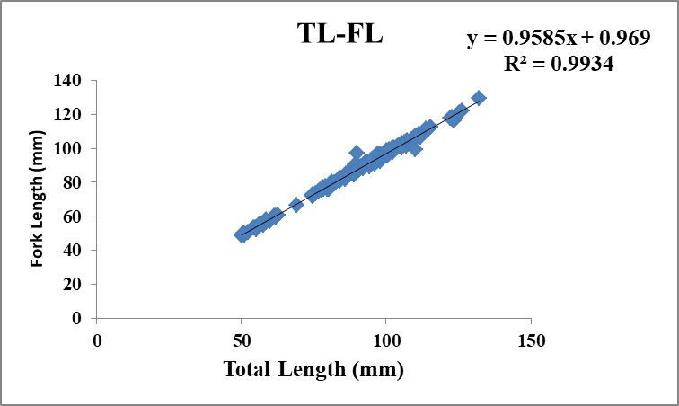

**Figure 1: Relationship between total length and fork length in *T. kashmiriensis***

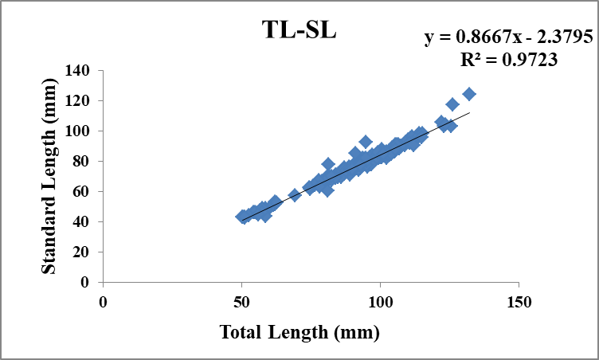

**Figure 2: Relationship between total length and standard length in *T. kashmiriensis***

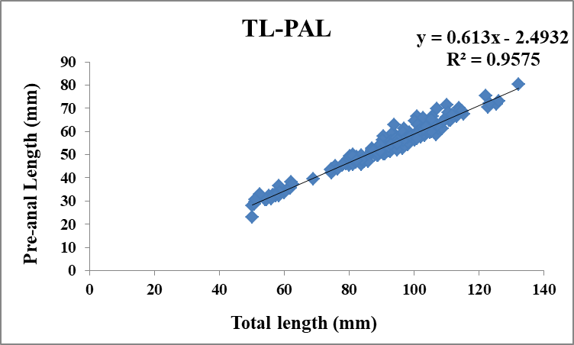

**Figure 3: Relationship between total length and pre-anal length in *T. kashmiriensis***

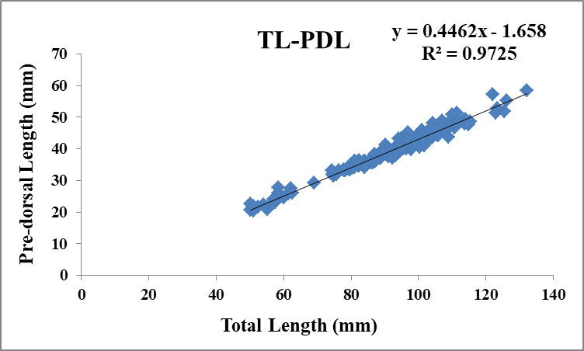

**Figure 4: Relationship between total length and pre-dorsal length in *T. kashmiriensis***

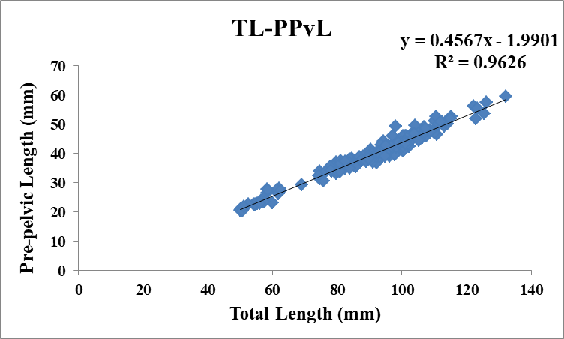

**Figure 5: Relationship between total length and pre-pelvic length in *T. kashmiriensis***

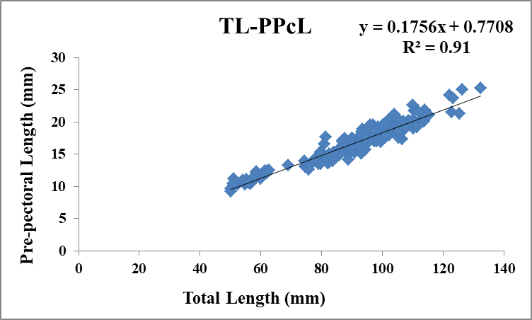

**Figure 6: Relationship between total length and pre-pectoral length in *T. kashmiriensis***

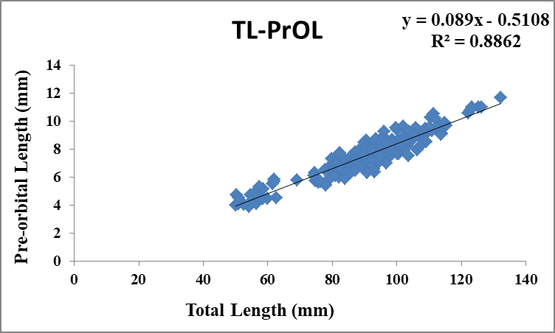

**Figure 7: Relationship between total length pre-orbital length in *T. kashmiriensis***

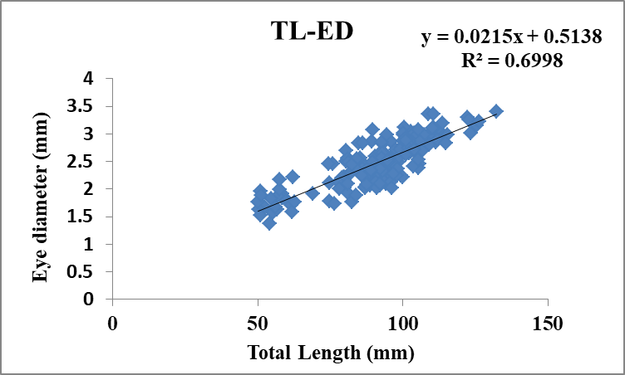

**Figure 8: Relationship between total length and eye diameter in *T. kashmiriensis***

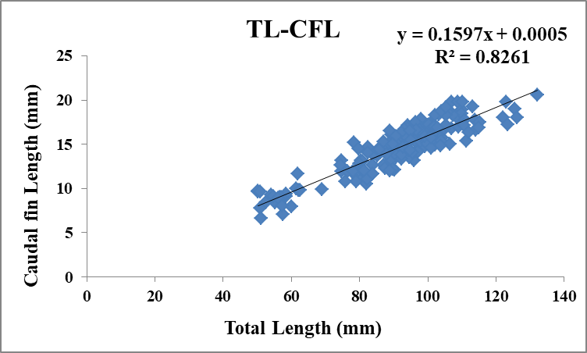

**Figure 9: Relationship between total length and caudal fin length in *T. kashmiriensis***

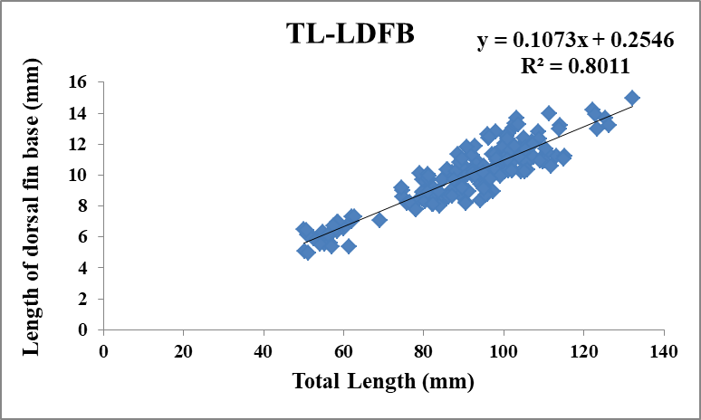

**Figure 10: Relationship between total length and length of dorsal fin base in *T. kashmiriensis***

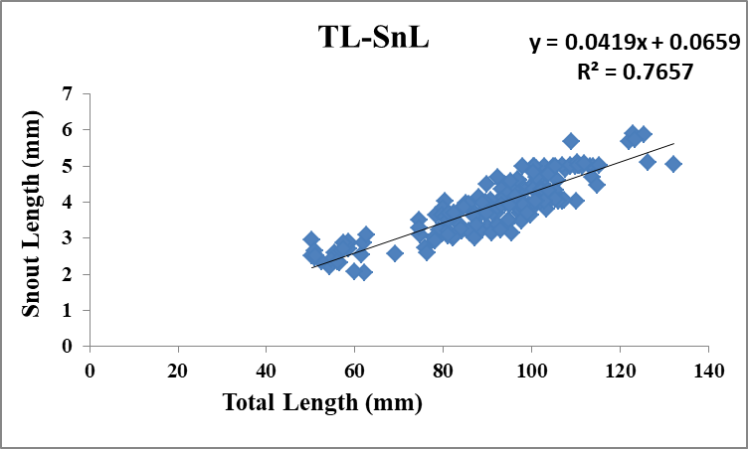

**Figure 11: Relationship between total length and snout length in *T. kashmiriensis***

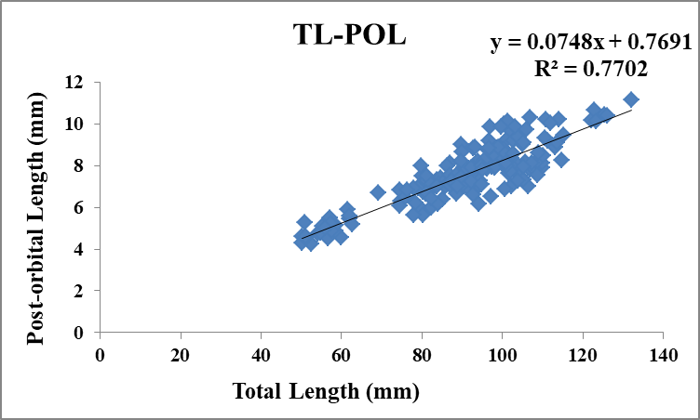

**Figure 12: Relationship between total length and post-orbital length in *T. kashmiriensis***

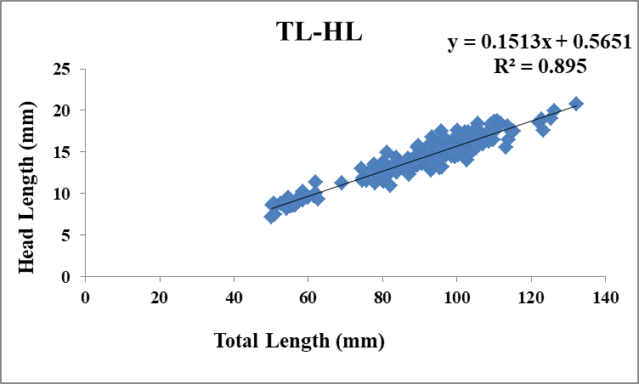

**Figure 13: Relationship between total length and head length in *T. kashmiriensis***

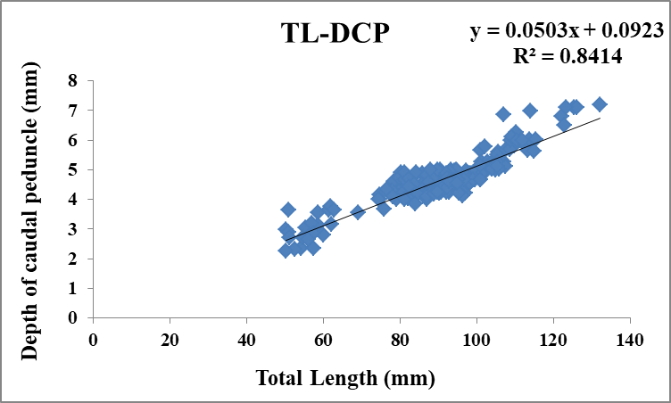

**Figure 14: Relationship between total length and depth of caudal peduncle in *T. kashmiriensis***

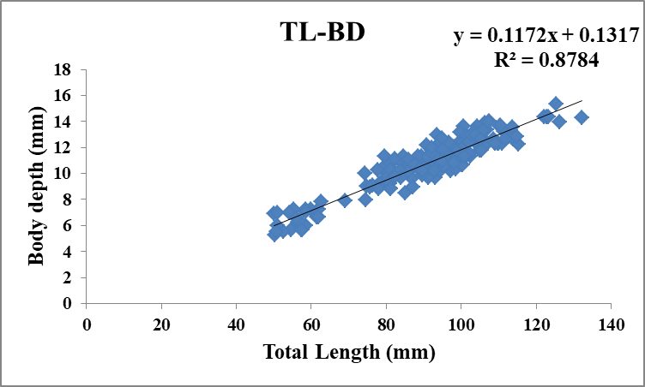

**Figure 15: Relationship between total length and body depth in *T. kashmiriensis***

**Table 1: Statistical estimates of various morphometric characters of *T. Kashmiriensis***

|  |  |  |  |  |  |  |  |
| --- | --- | --- | --- | --- | --- | --- | --- |
| **Statistical estimates** | **Range (mm)** | | **Mean (mm)** | **Median (mm)** | **Standard error** | **Standard deviation** | **Coefficcient of variation (%)** |
| **Min** | **Max** |
| Total length (TL) | 50.15 | 132.23 | 90.91 | 93.18 | 1.26 | 16.93 | 18.65 |
| Standard length (SL) | 42.86 | 124.2 | 76.41 | 78.00 | 1.11 | 14.90 | 19.50 |
| Fork length (FL) | 48.8 | 129.23 | 88.11 | 90.92 | 1.21 | 16.30 | 18.50 |
| Pre orbital length (PrOL) | 3.96 | 11.7 | 7.56 | 7.82 | 0.11 | 1.55 | 20.49 |
| Post orbital length (POL) | 4.24 | 11.13 | 7.57 | 7.64 | 0.10 | 1.94 | 19.09 |
| Pre-anal length (PAL) | 22.91 | 80.33 | 53.23 | 54.53 | 0.79 | 10.62 | 19.95 |
| Length of dorsal fin base (LDFB) | 4.95 | 14.97 | 10.00 | 10.21 | 0.15 | 2.03 | 20.30 |
| Depth of caudal peduncle (DCP) | 2.27 | 7.2 | 4.66 | 4.66 | 0.06 | 0.93 | 19.93 |
| Pre- pelvic length (PPvL) | 20.39 | 59..34 | 39.52 | 39.96 | 0.58 | 7.89 | 19.96 |
| Pre-dorsal length (PDL) | 20.34 | 58.51 | 38.90 | 39.89 | 0.57 | 7.67 | 19.71 |
| Pre-pectoral length (PPcL) | 9.26 | 25.2 | 16.73 | 17.23 | 0.23 | 3.12 | 18.65 |
| Head length (HL) | 7.18 | 20.73 | 14.31 | 14.53 | 0.20 | 2.71 | 18.93 |
| Eye diameter (ED) | 1.38 | 3.4 | 2.47 | 2.48 | 0.03 | 0.43 | 17.65 |
| Caudal fin length (CFL) | 6.61 | 20.56 | 14.52 | 15.01 | 0.22 | 2.97 | 20.51 |
| Body depth (BD) | 5.25 | 15.32 | 10.78 | 11.07 | 0.15 | 2.12 | 19.65 |
| Snout length (SnL) | 2.04 | 5.89 | 3.87 | 3.94 | 0.06 | 0.81 | 20.95 |

**Table 2: Relationship between various morphometric characters of *T. kashmiriensis***

|  |  |  |  |  |
| --- | --- | --- | --- | --- |
| **Morphometric character** | **Intercept (a)** | **Slope (b)** | **Y= a + b X** | **Correlation (R2)** |
| Total Length & Standard Length | 0.645 | 0.859 | Y = 2.3795 + 0.8667X | 0.9723 |
| Total Length & Pre-dorsal Length | 1.658 | 0.4462 | Y = 1.658 + 0.4462X | 0.9725 |
| Total Length & Pre- Pectoral Length | 0.7708 | 0.1756 | Y = 0.7708 + 0.1756X | 0.91 |
| Total Length & Pre-anal Length | 2.4932 | 0.613 | Y = 2.4932 + 0.613X | 0.9575 |
| Total Length & Head Length | 0.5651 | 0.1513 | Y = 0.5651 + 0.1513X | 0.895 |
| Total Length & Body Depth | 0.1317 | 0.1172 | Y = 0.1317 + 0.1172X | 0.8784 |
| Total Length & Pre- Pelvic Length | 1.9901 | 0.4567 | Y = 1.9901 + 0.4567X | 0.9626 |
| Total Length & Snout Length | 0.0659 | 0.0419 | Y = 0.0659 + 0.0419X | 0.7657 |
| Total Length & Eye Diameter | 0.5138 | 0.0215 | Y = 0.5138 + 0.0215X | 0.6998 |
| Total Length & Caudal Fin Length | 0.0005 | 0.1597 | Y = 0.0005 + 0.1597X | 0.8261 |
| Total Length & pre-orbital Length | 0.5108 | 0.089 | Y = 0.5108 + 0.089X | 0.8862 |
| Total Length & post-orbital Length | 0.7691 | 0.0748 | Y = 0.7691 + 0.0748X | 0.7702 |
| Total Length & fork length | 0.969 | 0.9585 | Y = 0.969 + 0.9586X | 0.9934 |
| Total Length & Length of dorsal fin base | 0.2546 | 0.1073 | Y = 0.2546 + 0.1073X | 0.8011 |
| Total Length & Depth of caudal peduncle | 0.0923 | 0.0503 | Y = 0.0923 + 0.0503X | 0.8414 |

**Table 3: Meristic characters of *Triplophysa kashmiriensis* in different length groups.**

|  |  |  |  |  |  |  |  |  |  |  |
| --- | --- | --- | --- | --- | --- | --- | --- | --- | --- | --- |
| **Meristic characters** | **Length groups (mm)** | | | | | | | | | |
| 50-60 | 61-70 | 71-80 | 81-90 | 91-100 | 101-110 | 111-120 | 121-130 | 122-131 | 123-140 |
| **Dorsal fin** | (1)8 | (1)8 | (1)8 | (1)8 | (1)8 | (1)8 | (1)8 | (1)8 | (1)8 | (1)8 |
| **Pectoral fin** | 10 | 10 | 11 | 11 | 11 | 11 | 11 | 11 | 11 | 11 |
| **Pelvic fin** | 7 | 7 | 7 | 8 | 8 | 8 | 8 | 8 | 8 | 8 |
| **Anal fin** | (1)5 | (1)5 | (1)5 | (1)5 | (1)5 | (1)5 | (1)5 | (1)5 | (1)5 | (1)5 |
| **Caudal fin** | 17 | 18 | 18 | 18 | 18 | 18 | 18 | 18 | 18 | 18 |

Note: Numbers in the parenthesis are spines while numbers outside the spine are fin rays.

3.2 Meristic counts

During the present study, five meristic characters have been counted viz; number of dorsal fin rays, pectoral fin rays, pelvic or ventral fin rays, caudal fin rays and anal fin rays. Meristic characters have definite number and count, sometimes, they vary and fall under some specific range. The meristic counts in ten (10) length groups of *T. Kashmiriensis* from Lidder and Daghwan stream are presented in Table 3. Meristic character of *Triplophysa Kashmiriensis* were recorded as; Dorsal fin rays (1)8, pectoral fin rays ranged from 10-11, pelvic fin rays ranged from 7-8, caudual fin rays ranged from 17-18 and anal fin rays was recorded as (1)5. The number of spines in dorsal fin and anal fin was recorded as one in all length groups. The above finding showed that some aspects of *T. kashmiriensis* showed similarities, while some counts showed variation.

**Fin formula calculated for *Triplophysa kashmiriensis* was found as:**

**D(I/8);A(I/5); P1(10-11); P2(7-8);C(17-18)**

**4.3 Length-Weight Relationship**

For the study of Length-Weight relationship (LWR), 180 samples of *T. kashmiriensis* Hora ranging in total length from 50-132 mm and body weight from 0.8-18.6 g were taken and the relationships were estimated separately for both males and females. The equations for males was found as Log W = -5.485 + 3.167 Log L and for females as Log W = -5.440 + 3.153 Log L. Combined equation was recorded as Log W = -5.491 + 3.174 log L. The coefficient of determination (r2) were found to be 0.964 for males, 0.916 for females and 0.951 for combined data.

The scattergram of logarithmic relation of Length-Weight has been plotted separately for males (Figure 16) and females (Figure 17). The scattergram of logarithmic relation of Length-Weight data of pooled data is plotted in Figure 18.

Pooled:  Log W = 3.174 + 5.491 Log L (R² = 0.951)

**Figure 16: Scatter diagram showing Length-Weight relationship of *Triplophysa kashmiriensis*  (Male)**

**Figure 17: Scatter diagram showing length-weight relationship of *Triplophysa kashmiriensis* (Female)**

**Figure 18: Scatter diagram showing combined length-weight relationship of *Triplophysa kashmiriensis***

**4. Discussion**

**Morphometry**

In this study, various morphometric characters compared showed high coefficient of correlation (r) values, which indicate that the morphometric characters investigated are highly correlated to each other. The ‘b’ values obtained showed highest degree of correlation between total length and fork length and lowest between total length and eye diameter. There was a significant positive correlation between growth of all other parameters with respect to total length. The correlation analysis shows that all morphometric characters change proportionally with the increase in total length of fish and the higher level of correlations of morphometric traits indicate that the whole body of the fish grows in a proportionate manner. The morphometric analyses of fish is an important key in the study of biology of fish (Hussain *et al*., 2012) and have been used extensively in identification of fish (Kullander *et al*., 1999; Yousuf *et al*., 2003). Bhat *et al*. (2010) studied the morphometric characteristics of *Schizothorax* spp. in the River Lidder of Kashmir and reported maximum growth in standard length (0.9080) and least in body depth (0.1730) with respect to the total length of the fish. They also observed a positive correlation coefficient of total length with other parameters under comparison. Shah *et al*. (2011) investigated the morphometry of farmed female rainbow trout in Kashmir and reported high level of interdependence between the fourteen morphometric characters studied. Sharma *et al*. (2014) studied the relationship of total length with other morphometric and meristic characteristics of *botia birdi* in the Indus basin and observed a significant positive correlation in all parameters with total length. Similar results were observed during the present study, as maximum correlation was observed between total length and standard length (r=0.972). Kumar *et al.* (2014) reported highest significant correlation (p<0.01) between reference length and other morphometric parameters of both sexes in Bombay duck, *Harpodon nehereus*. Bashir *et al*. (2015) reported positive and significant correlation among different morphometric traits in *Triplophysa marmorata* with total length and standard length displaying the strongest correlation (R2=0.98). Siraj *et al*. (2017) investigated morphometric characters of *Cyprinus carpio* from Dal Lake, Kashmir and reported that genetically controlled characters showed minimum range of variation, characters belonging to intermediate showed moderate range of variation while the characters belonging to environmentally controlled characters showed maximum range of variation. Qadri *et al.* (2017) reported high coefficient of correlation (r) values for various morphometric characters, with standard length showing maximum degree of correlation (R2=0.88) with total length in *S. curvifrons*. Edwin *et al*. (2018) while analysing morphometric characters of the *Threadfin Bream* observed high degree of correlation between the total length of the fish and the various other measurable lengths, similar results were found during the present study.

Idowu *et al*. (2019) while studying the morphometric characteristics of *Brycinus macrolepidotus* revealed that morphometric characters showed a proportional positive increase with increase in length of the fish while some showed variations without any relation to length of the fish. Wali *et al*. (2019) investigated eleven morphometric characters of *Oncorhynchus mykiss* and observed high level of interdependence (R2 = 0.502 to 0.876) among which standard length and pre-anal length were found to have highly significant relationship with total length (R2 = 0.876 and 0.807 respectively), reflecting thereby that the morphometric characters of fish were highly correlated.

**Meristic**

Meristic characters are the numbers of countable structures like fin rays (dorsal, pectoral, anal, caudal fin) and lateral line scales. Morphological measurements, meristic counts, shape and size provide data useful for taxonomic status (Ihssen *et al*., 1981). Meristic and morphometric analysis are important tools used to differentiate closely related species of organisms having huge similarity indices of various parameters. It is well known that morphometrics characters in fishes can show high plasticity in response to difference in the environmental conditions, such as food abundance and temperature (Agnese *et al*., 1997; Tawwab *et al*., 2005). It has been stated before that meristic counts are continuously subjected to environmental influences from fertilization up to the final count fixation or simply during the entire larval period (Taning 1952; Fowler 1970). Georgakopoulou *et al*. (2007) reported that temperature effect from the half-epiboly stage until metamorphosis is enough to permanently alter the meristic counts of many fins in sea bass juveniles. In general, fish demonstrate greater variances in morphological traits both within and between populations than other vertebrates and are more susceptible to environmentally induced morphological variations. The results of the present study showed similarities in the meristic characters except for pectoral fin, pelvic fin and caudal fin. The cause of variation in the morphometric and meristic characters may range from variability to the intraspecific which is under the influence of environmental parameters (Mwanja *et al*., 2011). The morphometric relationships between various body parts of fish can be used to assess the well-being of individuals and to determine possible difference between separate unit stocks of the same species.

In this study, the number of dorsal fin rays, anal fin rays, pectoral fin rays, pelvic fin rays and caudal fin rays were recorded as (1)8; (1)5; 10-11; 7-8 and 17-18 respectively. The number of spines measured in dorsal fin and anal fin was only one in all length groups. The variation in fin rays has been observed and fall under some specific range in all the fishes. Rehman *et al.* (2015) reported the variation in different meristic counts of silver carp. Variation in meristic characters were reported in many fishes such as in *Nematalosa nasus* (Al-Hassan, 1987), *Pseudobagrus ichikawai* (Watanable, 1998) and *Pterophyllum sclare* (Bibi *et al*., 2008). Many authors (Vladykov, 1934; Tanning, 1944; Barlow, 1961) have reported that meristic characters, exhibit plasticity under the influence of environmental factors. According to Hubbs (1922) and Tanning (1994) variation occurs in the number of rays in the unpaired fins in several species which is also related to an adaptation to movement of water of various density. Meristic variation related to temperature was studied by Al-Hassan (1987) and Sfakianakis *et al*., 2011) and genetic factors by Yousefian (2011). Hazarika *et al*. (2011) reported the meristic characters remained constant with increasing body length and weight. Usama *et al*. (2016) showed that the meristic characters were found to be valid in sex, race and species identification. Vatandoust *et al*. (2014) reported a significant difference between the means of 2 out of 17 meristic characters of Brown trout and they also reported that the overall assignments of individuals into their original groups were 43.6% and 44.9% in males and females respectively.

**Length-weight relationship**

In this study, the values of regression coefficient for the length weight relationship were estimated at 0.964, 0.916 and 0.951for the males, females and pooled data respectively. Length-weight relationships of fishes are important in fisheries biology because they allow the estimation of the average weight of the fish of a given length group by establishing a mathematical relation between the two (Beyer, 1987). Like any other morphometric characters, the Length-weight relationship can be used as a character for the differentiation of taxonomic units and the relationship changes with various developmental events in life such as metamorphosis, growth and the onset of maturity (Thomas *et al*., 2003). The Length-weight relationship of fish have significant importance in studying the growth, gonadal development and general well-being of fish population (LeCren 1951: Pauly, 1993; Nagesh *et al.,* 2004) and for comparing life history of fish from different localities (Petrakis and Stergion, 1995), Ideally, the value of 'b' usually fluctuates between 2 and 4 (Tesch, 1971), Hile (1936) and Martin (1949) revealed the value of ‘b’ between 2.5 and 4.0. Antony (1967) recorded the value of ‘b’ within a range of 2.0 to 5.4 and in majority of cases the value of ‘b’ has been found to deviate from 3 (Hile, 1936). Allen (1938) worked out that the cube law is applicable only for those species, which maintain their form and specific gravity throughout their life. The shape and the form of fish may change with time, so the length-weight relationship of most of the fish species may deviate from the cube law, the cube law does not hold good throughout the life period and the weight gain in a fish may not be always cube of its length gain (Rounsefell and Everhart 1953; Lagler, 1956). LeCren (1951) pointed out that the variation in ‘b’ value is due to environmental factors, season, food availability, sex, life stage and other physiological factors. High ‘b’ values in case of males were reported by Sunder (1984) and Yousuf *et al*. (2001). Hatikakota & Biswas (2004) and Rao & Sreeramullu (2006) reported higher values of ‘b’ in females, while higher values of ‘b’ in females were also observed by Sunder (1986), Kulshrestha *et al.* (1993).

The length weight relationship is generally determined so that if at any other time only one of these two parameters is known, the other can be computed easily by substituting the values of co-efficient ‘a’ and ‘b’. Further, values of the exponent ‘b’ provide growth pattern of fish species. When ‘b’=3, increase in weight is isometric i.e., length increases in equal proportions with body weight. When the value of ‘b’ is other than 3, weight increase is said to be allometric (positive if b > 3 and negative if b<3). Pauly (1993) stated that Length-weight relationship provides valuable information of the habitat where the fish lives while Kulbicki *et al*. (2005) stressed the importance of length-weight relationship in modelling aquatic ecosystems. Yousuf *et al*. (1992, 2001) reported the ‘b’ value for *Schizothorax niger* of Manasbal, Dal and Anchar Lakes as 3.014, 2.977 and 2.974 respectively. Bhat *et al*. (2010) reported the values of ‘b’ for *S. esocinus* (3.0034), *S. labiatus* (3.0997) and *S. plagiostomus* (2.9467) in the Lidder River of Kashmir.

Hussain *et al*. (2018) reported that the allometric coefficient 'b' in males (2.8391) was close to isometric value (≈ 3.0) than in case of females (2.6) for *Schizopygae niger.* The L-W equations were log W = -4.5996 + 2.8391 log L for males and log W = -4.0507 + 2.6073 log L for females. Mushtaq *et al*. (2018) reported that the growth pattern of *Triplophysa marmorata* was negatively allometric with 'b' value <3 (2.96). A strong correlation (0.974) was observed between the length and weight of the fish species in the lake. Wali *et al*., (2019) reported the correlation coefficient (R2) for length-weight relationship as 0.608, indicating a positive relationship between the two parameters. The value of ‘b’ was found equal to 3.028 which suggest an isometric growth pattern of *Oncorhynchus mykiss*, indicating that the fish grows with equal proportions in all dimensions. Idowu *et al*. (2019) reported regression coefficients ‘r’ values as 0.85, 0.90 and 0.78 for juveniles, sub-adults and adults respectively and the exponential value of the length-weight relationship ‘b’ was recorded as 1.03, 1.82 and 2.17 respectively indicating negative allometric growth (b<3) of *Brycinus macrolepidotus*.

The present study revealed that the fish species did not follow the cube law completely with the value of exponent ‘b’ recorded as 3.174, thus revealing positive allometric growth (b>3). Similar departures from cube law have been observed by Kumar *et al*. (1979) while studying Length-weight relationship of Brown Trout and reported that value of ‘b’ as 3.14 while as Kumar *et al.* (2012) observed W= 0.000006092 L3.13429563 for males, W=0 .000005234 L3.169965 for females of *Johnieops sina* indicating positive allometric relationships. Vishwanath and Kosygin (1999) studied the biology of *Semiplotus manipurensis* and found that the length weight equation for the fish was Log W = -5.1984+3.1508. The regression co-efficient values were 3.21 for females and 3.33 for males for Length-weight relationship, which suggested positive allometric growth for both the sexes (Gharaei 2012).

**Conclusion**

The study conducted on the morphometry, meristic, and length-weight relationship of *T. kashmiriensis* in the Kashmir Himalaya has provided valuable information regarding the morphology and characteristics of this fish species. The data generated from the study serves as a foundation for the development, proper management, and conservation efforts for this fish species in the region. The study revealed a strong correlation between various morphometric characters, indicating a high degree of interdependence among these traits. The highest correlation coefficient was observed between total length and fork length, while the lowest correlation was found between total length and eye diameter. The meristic characters, specifically the number of dorsal fin rays, pectoral fin rays, pelvic fin rays, caudal fin rays, and anal fin rays, were identified and recorded for *T. kashmiriensis.* The presence of a single spine in the dorsal and anal fins across all length groups was also observed. Furthermore, the length-weight relationship for *T. kashmiriensis* showed positive allometric growth, as indicated by the value of 'b' being greater than 3 for both sexes. The combined equation derived from the study allows for the estimation of weight based on the logarithm of length, with the specific equation being W = -5.491 + 3.174 log L. It is noteworthy that the 'b' value of 3.174 obtained from the pooled data was found to be significantly greater than 3, indicating that the weight of *T. kashmiriensis* increases at a faster rate compared to its length. Overall, this study provides valuable insights into the morphological and meristic characteristics of *T. kashmiriensis* in the Kashmir Himalaya. The length-weight relationship established in this study contributes to a better understanding of the growth pattern of this fish species and can be utilized for monitoring and managing populations in the region.

**Disclaimer (Artificial Intelligence)**

The author(s) hereby declare that no generative AI technologies, including Large Language Models (such as ChatGPT, COPILOT, etc.) and text-to-image generators, have been used in the writing or editing of this manuscript.

**References**

Agnese J.F., Teugels G.G., Galbusera P., Guyomard R., Volckaert F., 1997. Morphometric and genetic characterization of sympatric populations of *Clarias gariepinus* and *Clarias anguillaris* from Senegal. *Journal of Fisheries Biology* **50**: 1143–1157.

Al-Hassan, J. M., Thomson, M., Ali, M., and Criddle, R. S. 1987. Toxic and pharmacologically active secretions from the Arabian Gulf catfish (*Arius thalassinus*, Ruppell). *Journal of Toxicology: Toxin Reviews* **6(1):** 1-43.

Allen, K. R. 1938. Some observations on the biology of the trout (*Salmo truta*) in Windermere. *Journal of Animal Ecology* **(7)**: 333-349.

Balkhi, M.H. 2007. Fish diversity in Jammu and Kashmir and conservation measures. *Kashmir Speaks* **6**:104-115.

Barlow, G. W. 1961. Causes and significance of morphological variation in fishes. *Systematic Zoology* **10(3):** 105-117.

Bashir, A., Bisht, B.S., Iqbal Mir, J., Kumar, R. and Singh Patiyal, R. 2015. Morphological, molecular characterization and taxonomic status of *Triplophysa marmorata* and *Triplophysa kashmirensis* (Cypriniformes: Nemacheilidae) from Kashmir valley, India. *Revista de biologia* tropical **64(2)**: 473-482.

Beyer JE. 1987. On length- weight relationships. Part 1: Computing the mean weight of the fish of a given length class. *Fishbyte* **5:** 11-13.

Bhat, F.A., Balkhi, M.H., and Yousuf A.R. 2010. Fish Biodiversity in Kashmir Himalaya. **In**: biodiversity, development and poverty alleviation. *Department of botany, University of Kashmir.*

Bibi, Elizabeth Koshy, Oyyan, Selvaraj and Muniandy Sekaran 2008. Variation in meristic characters of four strains of Malaysian freshwater angelfish *Pterophyllum scalare*. *Malaysian Journal of Science* **27(1):** 69-73.

Dwivedi, S. N. and Menezes, M. R. 1974. A note on the morphometry and ecology of *Brachirus orientalis* (Bloch and Schneider) in the estuaries of Goa. *Geobios* **1**: 80-83.

Edwin Prabakaran, T., Jeyasingh Thompson, R. and Deepak Samuel, V. 2018. A comparative study on morphometric and meristic characters of *Nemipterus japonicus* (Bloch, 1791) in the coasts of India. *Iranian Journal of Fisheries Sciences* **17(1)**: 107-117.

Fowler, J. A. 1970. Control of vertebral number in teleosts-an embryological problem. *The Quarterly Review of Biology* **45(2):** 148-167.

Georgakopoulou, E., Sfakianakis, D. G., Kouttouki, S., Divanach, P., Kentouri, M., and Koumoundouros, G. 2007. The influence of temperature during early life on phenotypic expression at later ontogenetic stages in *sea bass*. *Journal of Fish Biology* **70(1):** 278-291.

Gharaei, A. 2012. Morphometric and Meristic Studies of Snow Trout *Schizothorax zarudnyi* (Nikolskii, 1897) as A Threatened Endemic Fish. *World Journal of Fish and Marine Sciences* **4**(**4**): 426-429.

Grant, C. J. and Spain, A. V. 1977. Variation in the body shape of three species of Australian *mullets* during the course of development. *Australian Journal of Marine and Fresh water Research* **28**: 723-738.

Hatikakota, G. and Biswas, S. P. 2004. Length-weight relationship and condition factor of *Oreochromis mossambicus*, from a domestic pond, Nazira, Upper Assam. **In**: *Fishery management* pp 223-232.

Hazarika, A., Borah, U. and Bordoloi, L. 2011. Studies on morphometric measurements and meristic counts of hill trout (*Barilius bendelisis*, Hamilton) from the River Buroi at the Boundary Areas of Assam and Arunachal Pradesh, India. *Indian Journal of Fundamental and Applied Life Sciences* **1(3):**194-198.

Heckel, J. J. 1838. Fische aus *Caschmir gesammelt* und *herausgegeben* von Carl Freiherrn von Hügel, beschrieben von JJ Heckel. *Wien Annals and Magazine of Natural History* (Series **8**) 1-112.

Hile, R. 1936. Age and growth of the Cisco, *Amloplitesrupestris(Refineseque*) in Nebish Lake, Wisconsin.Trans. *Wisconsin Academy of Science, Arts and Lett*ers (**33**): 189-337.

Hora, S. L. 1937. Comparison of the fish faunas of the northern and the southern faces of the Great Himalayan Range. *I bid* **39**: 241-250.

Hubbs, C. L. (1922). Variations in the number of vertebrae and other meristic characters of fishes correlated with the temperature of water during development. *The American Naturalist* **56(645):** 360-372.

Hussain, M.A., Khatun, M.A., Siddique, M.A.B., Flowra, F.A., Alam, M.M. and Sultana, S. 2012. Morphometric characters of fresh water fish *Xenentedon cancila* collected from Rajshahi City, Bangladesh. *Journal of BioScieence* **20**: 171-177.

Hussain, S., Bhat, F.A., Maqsood, H.M., Balkhi, M.H. and Najar, A. M. 2018. Morphometric relationships of length-weight and length-length in snow trout *Schizopyge niger* (Heckel, 1838) from Dal Lake, Kashmir. *Indian Journal of fisheries* **65(3):** 105-109.

Idowu, A., A Adedoyin, I., M Titilayo, O., A Quddus, A., & O Micheal, A. 2019. Morphometric and Meristic features and Length-Weight Relationship as indicators of quality of *Brycinus macrolepidotus* in Lower River Ogun, Nigeria. *Egyptian Journal of Aquatic Biology and Fisheries* **23(2)**: 433-441.

Ihssen, P. E., Booke, H. E., Casselman, J. M., McGlade, J. M., Payne, N. R., & Utter, F. M. 1981. Stock identification: materials and methods. *Canadian journal of fisheries and aquatic sciences* **38(12):** 1838-1855.

Kulbicki, M., and Bozec, Y. M. 2005. The use of butterflyfish (*Chaetodontidae)* species richness as a proxy of total species richness of reef fish assemblages in the Western and Central Pacific. *Aquatic Conservation: Marine and Freshwater Ecosystems* **15(S1):** S127-S141.

Kullander, S. O., Fang, F., Delling, B. and Ahlander, E. 1999. The fishes of Kashmir Valley. **In**: River Jhelum, Kashmir Valley, *Impacts on the Aquatic Environment* Lenart Nyman (Ed.) 99-163.

Kulshrestha, S.K., Srivastava, M., George, M.P., Saxena, R. and Tieari, A. 1993. Length-weight relationship of a major carp *Catla catla* (Ham) from two water bodies of Bhopal. **In**: *Advances in Limnology (Ed. H.R.Singh). Narendra Publishing, Delhi.* 329-392.

Kumar, B. V. V., Reddy, A. D., Choudhury, S. R., Balakrishna, C. H., Satyanaryana, Y., Nagesh, T. S. and Das, S. K. 2014. Morphometry and meristic counts of Bombay duck, *Harpodon nehereus* (Hamilton, 1822) along Sunderban region of West Bengal. India. *Proceedings of the International Academy of Ecology and Environmental Sciences* **4(3**): 95-105

Kumar, K., Sehgal, K.L. and Sunder, S. 1979. Length weight relationship and ponderal index of brown trout, *Salmo trutta fario* catches in streams of Kashmir. *Journal of Inland Fish Society of India* **11**(**1**): 56-61.

Kumar, T., Chakraborty, S.K., Jaiswar A.K., Sandhya, K.M. And Panda, D. 2012. Biometric studies on *Johnieops sina* (Cuvier, 1830) along Ratnagiri coast of Maharashtra. *Indian Journal of Fisheries* **59**(**1**): 7-13.

Laevastu, T. 1965. Manual of methods in fisheries biology. Research on fish stocks. *FAO manuals in Fisheries science* **4**: 1-51.

Lagler, K. F., Bardach, J. E. and Miller, R. R. 1962*. Ichthyology* (The study of fishes) John Wiley, New York, 545 pp.

Lagler, K.F. 1956. *Freshwater fishery biology.* Wm. C. Brown Co., Dubuque, Iowa.USA. pp 421.

Le Cren, E.D.1951. The length weight relationship and seasonal cycle in gonad weight and condition in perch (*Perca fluviatilis*). *Journal of animal ecology* **20(2**):201-219.

Martin W.R 1949. The mechanism of environmental control of body form in fishes. *University of Toronto Studies Biol. 58: Ontario Fisheries Research Laboratory* **70**:1-91.

Mushtaq, S.T., Mushtaq, S.A., Balkhi, M.H., Bhat, F.A., Abubakr, A., Qadri, S. and Farooq, I. 2018. Length-weight relationship and condition factor of *Triplophysa marmorata* from Wular Lake, Kashmir. *International Journal of Fisheries and Aquatic Studies* **6(3**): 389-391.

Mwanja MT, Muwanika V, Nyakaana S, Masembe C, Mbabazi D, Justus Rutasire J 2011. Population morphological variation of the Nile perch of East African Lakes and their associated waters. *African journal of env. Science and tech*. **5(11**): 941-949.

Naeem, M. and A. Salam, 2005. Morphometric study of fresh water bighead carp *Aristichthys nobilis* from Pakistan in relation to body size. *Pakistan Journal of Biology Sci*ence **8(5**): 759-762.

Nagesh, T.S., Jana, D., Khan, L. and Khongngain, O. 2004. Length-weight relationship and  relative condition of Indian major carps from Kuliabeel Nadia, West Bengal. *Aquaculture* **5**(1): 85-88.

Pauly D. 1993. Linear regressions in fisheries research. *Journal of the Fisheries Research Board of Canada* **30**: 409-434.

Petrakis, G. and Stergion, K.I. 1995. Weight-length relationship of 33 species in Greek waters. *Fisheries Research* **21**: 465-469.

Qadri, S., Shah, T. H., Balkhi, M. H., Bhat, F. A., Najar, A. M., Asimi, O. A., Farooq, I. and Aalia, S. 2017. Morphometric and length- weight relationship of *Schizothorax curvifrons* Heckel 1838 in river Jhelum, Kashmir, India. *Indian Journal of Animal Research* **51(3):** 453-458.

Rao, A.K.V.C.S. and Sreeramullu, K. 2006. Length-weight relationship of the Gobilid fish *Psudocrypts lanceolatus* (Bloch) and Schneider, 1801 of the Vasist Godavari Estuary, East coast in India. **In**: *Fish Management and Aquatic Environment* pp -110-135.

Rehman, F. U., Rehman, H. U., Saadia, A., Satara, A., Hassan, S., Abdul, M., and Fazal, S. 2015. Morphometric and Meristic Analysis of Silver Carp (*Hypophthalmichthys molitrix*) from Tanda Dam, District Kohat, Pakistan. *Global Veterinaria* **15(1):** 82-92.

Rounsefell, G. A., and Everhart, W. H. 1953. Fishery science: its methods and applications. Wiley.

Sfakianakis, D. G., Leris, I., Laggis, A., & Kentouri, M. 2011. The effect of rearing temperature on body shape and meristic characters in zebrafish (*Danio rerio*) juveniles. *Environmental Biology of Fishes* **92(2):** 197.

Shah, T. H., Balkhi, M. H., Najar, A. M. and Asimi, O. A. 2011. Morphometry, length weight relationship and condition factor of farmed female rainbow trout (*Oncorhynchus mykiss*) in Kashmir. *Indian Journal of Fisheries* **58(3):** 51-56.

Sharma, N. K., Mir, J. I., Pandey, N., & Singh, R. 2014. Morphometric and Meristic Characteristics of *Birdi Loach, Botiabirdi* (Chaudhuri, 1909) from a Tributary of Indus Basin, Jammu and Kashmir, India. *World Journal of Fish and Marine Sciences* **6(3):** 262-266.

Siraj, S., Masarat, S., Bashir, M., Gudoo, M. Y. and Mir, M. F. 2017. Morphometric characters of *Cyprinus carpio* collected from Dal lake, Kashmir, India. *International Journal of Fauna and Biological Studies* **4(4**): 08-11

Sunder, S. 1986. Biology of an indigenous carp *Schizothora xcurvifrons* (Heckel) from a stretch of river Jehlum with certain hydrobiological parameters. Ph.D Thesis Department of Zoology. K. U. Srinagar. India.

Sunder, S., Kumar, K. and Raina, H. S. 1984. Food and feeding habits and length weight relaitonship of *Cyprinus carpio specularis* of Dal Lake, Kashmir. *Indian Journal of Fisheries* **31(1**): 90-99.

Taning, A. V. 1944. Experiments on Meristic and Other Characters in Fishes: On the Influence of Temperature on Some Meristic Characters in Sea-trout and the Fixation-period of These Characters. *CA Reitzels Forlag.*

Taning, Å. V. 1952. Experimental study of meristic characters in fishes. *Biological Reviews* **27(2):** 169-193.

Tawwab M. A. 2005. Predation efficiency of Nile catfish, *Clarias gariepinus* (Burchell, 1922) on fry Nile tilapia *Oreochromis niloticus* (Linnaeus, 1758): effect of prey density, predator size, feed supplementation and submerged vegetation. *Turkish Journal of Fisheries and Aquatic Science* **5**: 69–74.

Tesch, F.W. 1971. Age and growth. In W. E. Ricker (Ed.), Methods for assessment of fish production in fresh waters. *Oxford: Blackwell Scientific* pp. 99–130

Thomas, J., Venu, S. and Kurup, B.M. 2003. Length-weight relationship of some deep-sea fish inhabiting the continental slope beyond 250m depth along the west coast of India*. NAGA*, *World Fish Center Quarterly* **26(2**):17-21.

Usama M. M, FahmyI. El-Gammel, Saher F. Mehanna, Samia M. El-Mahdy 2016. Study on morphometric and meristic characters of *Acanthopagrus bifuscatus* from Southern Red Sea, Egypt. *International Journal of Science and Research* **5(1**): 1735-1739.

Vatandoust, S., Abdoli, A., Anvarifar, H. and Mousavi-Sabet, H. 2014. Morphometric and meristic characteristics and morphological fario (Pisces: Salmonidae) along the southern Caspian Sea basin. *European Journal of Zoological Research* **3(2**):56-65.

Vishwanath, W. and Kosygin, L. 1999. Fishes of the cyprinid genus *Semiplotus* Bleeker 1859, with description of a new species from Manipur, India. *Journal of the Bombay Natural History Soc*iety **97(1)**: 92-102.

Vladykov, V. D. 1934. Environmental and taxonomic characters of fishes. *Transactions of the Royal Canadian Institute* **20**: 99- 144.

Wali, A., Shah, T. H., Balkhi, M. H., Bhat, B. A., Bhat, F. A., Qadri, S., and Mohamad, I. 2019. Morphometry and length-weight relationship of rainbow trout *Oncorhynchus mykiss* Walbaum, 1792 (Salmoniformes: Salmonidae) from Kashmir.

Watanabe, K. 1998. Meristic variation in the endangered bagrid catfish, *Pseudobagrus ichikawai*. *Ichthyological Research* **45(1**): 99-104.

Yakubu, A., and Okunsebor, S. A. 2011. Morphometric differentiation of two Nigerian fish species (*Oreochromis niloticus* and *Lates niloticus*) using principal components and discriminant analysis. *International Journal of Morphology* **29(4):** 1429-1434.

Yousefian M. Sharifrohani M. Hosseinzadesh- sahafi H. Laloei, Makhdoomi c. 2011. Heritability estimation for growth –related traits in juvenile wild Common carp in the south of Caspian sea. *Iranian journal of fisheries sciences* **10(4**): 740-748.

Yousuf, A. R., Bhat, F. A. and Mahdi, M. D 2006. Limnological features of river Jhelum and its important tributaries in Kashmir Himalaya with a note on fish fauna. *Journal of Himalayan Ecology and Sustainable Development* **1**: 37-50.

Yousuf, A. R., Bhat, F. A., Mehdi, D., Ali, S. and Ahangar, M. A. 2003. Food and feeding habits of *Glyposternum reticulatum* in torrential streams of Kashmir. *Journal of Research and development* **3**: 123-133.

Yousuf, A.R., Firdous, G. and Pandit, Anil, K. 2001. Length-Weight Relationship in  *Schizothorax niger* Heckel, an endemic Lacustrine fish of Kashmir. *Journal of Research and Dev*elopment **1**: 54-59.

Yousuf, A.R., Gazala, F., Balkhi, M.H. and Pandit, A.K. 1992. Studies on the length-weight relationship in some cyprinid fish in Manasbal Lake, Kashmir. **In**: *Current Trends in Fish and Fishery Biology and Aquatic Ecology* (Eds. A.R. Yousuf, M.K. Raina and M.Y. Qadri). Postgraduate Department of Zoology, the University of Kashmir, Srinagar, pp. 185-189.