Naturopathic and Herbal Education in Africa: Academic and Legal Perspectives

# ABSTRACT

The evolution of naturopathic and herbal education in Africa is gaining renewed attention amid growing global interest in integration of…….(something missing) and traditional medicine systems. This study critically examines the academic and legal dimensions shaping the current landscape of naturopathic and herbal medicine education across the continent. It provides a comprehensive analysis of institutional developments, curriculum structures, and training methodologies, highlighting emerging models that integrate indigenous healing practices with biomedical sciences. The study further explores the legal and regulatory frameworks governing the practice and education of naturopathy and herbal medicine in various African countries, identifying inconsistencies, gaps, and overlaps in policy development, implementation and recognition. Particular attention is paid to the role of national qualification frameworks, occupational standards, and accreditation mechanisms in legitimizing educational programs and professional practices. The study also assesses the implications of these developments for public health systems, healthcare delivery, and practitioner accountability. Drawing on comparative insights and case studies from leading institutions and regulatory bodies, the study underscores the urgent need for harmonized standards, legal clarity, and curriculum reform to elevate the credibility and acceptance of these disciplines within mainstream education and healthcare systems. Strategic recommendations are offered to policymakers, academic institutions, and professional associations for fostering an enabling environment that promotes quality assurance, ethical practice, and interdisciplinary integration. This study findings contribute to the ongoing discourse on African health sovereignty and the localization of knowledge systems, positioning naturopathic and herbal medicine education as a critical pillar in Africa’s pursuit of culturally relevant and sustainable healthcare solutions.

**Keywords: Naturopathic education, Herbal medicine, Africa, Legal frameworks, Traditional medicine**

**1. INTRODUCTION**

Naturopathy and herbal medicine constitute a fundamental and enduring components of African healthcare systems, deeply woven into the social, cultural, and spiritual fabric of countless communities (Ikhoyameh , *et al*., 2024; World Health Organization [WHO], 2019). Across sub-Saharan Africa, traditional health practitioners (THPs), who arein many cases herbalists, spiritual‐therapeutic healers, and community-based naturopathic practitionersremain a primary healthcare resource. In fact, in some rural regions, there may be up to 100 traditional practitioners for every formally trained doctor, making traditional medicine more accessible and affordable to local communities (Wikipedia, 2025; WHO, 2019). The African Union (AU), recognizing this potential, declared betweeb 2001 and2010 that the “Decade for African Traditional Medicine,” aiming to harness indigenous systems to broaden the reach of healthcare, provided they meet standards of safety, efficacy, and quality (Wikipedia, 2025 you need to provide page number because of direct quote).

Despite this rich heritage and widespread use, the transformation of naturopathic and herbal medicine from community practice into structured, academically grounded professions has been uneven. While some African nations have initiated pilot training programs, higher education partnerships, and regulatory frameworks, others lag in formalization and legal clarity (Ikhoyameh *et al.,* 2024; Obu. 2025). This divergence reflects variations in political will, academic capacity, and public health priorities across the continent.

**1.1 Historical and Global Context**

Globally, traditional, complementary, and integrative medicine (TCIM) has gained momentum over the last two decades. According to the WHO’s 2019 global report, 124 out of 194 member states (approximately 64%) reported having legislation or regulation governing herbal medicines, with around 43% of countries in the WHO African Region holding specific regulatory provisions (WHO, 2019). This marks significant progress but underscores the unevenness of policy adoption even within Africa. Furthermore, although national policies for TCIM are becoming more widespread, very few countries have developed legal frameworks that clearly define professional scope, educational standards, or licensing for naturopathic and herbal practitioners (WHO, 2019).

**1.2 The African Academic Landscape**

In higher education, a selected number of African countries have taken strategic steps toward formalizing naturopathic and herbal medicine education. Ghana has emerged as a pioneer. Institutions such as the Nyarkotey University College of Holistic Medicine & Technology (NUCHMT) offer competency-based TVET (Technical and Vocational Education and Training) programs and have structured curricula from certificate to postgraduate levels, integrating naturopathic principles with public health and clinical training (Nyarkotey, 2025; Ikhoyameh *et al*., 2024). NUCHMT has secured the firstever National Occupational Standard for naturopathy and holistic health and enables graduates to sit for the Professional Qualifying Examination, thereby allowing for professional registration with Ghana’s Traditional Medicine Practice Council (Nyarkotey, 2025).

In South Africa, academic offerings in naturopathy and integrated medicine exist within public universities including the University of the Western Cape School of Natural Medicine, though training predominantly remains at the undergraduate diploma or professional degree level (Ikhoyameh *et al.,* 2024). Further, south nations including Kenya, Uganda, and Nigeria have responded positively through formation of national university collaborations with private diploma colleges, and ministries of health who are piloting accredited herbal medicine training initiatives.

However, despite these advances, a harmonized continental curriculum remains elusive. Training approaches which areranging from short certificate courses in herbal materia medica to full MSc., and PhD programsdo testify both progress and fragmentation. Ghana offers diverse pathways, from the certificate (TVET‐NP, NC) through higher diplomas, Bachelor’s (BSc/BTech), and postgraduate qualifications (MTech/MSc, DTech/PhD) in naturopathy and herbal medicine (Nyarkotey, 2025). Meanwhile, Nigeria relies heavily on private training institutions with few requirements for clinical placement, and South African offerings are largely university-based, differing in scope and structure.

**1.3Legal Framing: Recognition and Regulation**

Legal recognition of naturopathy and herbal medicine varies widely across Africa. Ghana has advanced through its Traditional Medicine Practice Act (Act 575, 2000), which, while situated within a traditional herbalist framework, has provided some legal foundation for naturopathic inclusion. Thissituation has bolstered recently by proposals for an “Alternative Medicine Bill” envisaged for 2025 (Obu, 2025). Similar regulatory ecosystems exist in Gambia, where traditional healers currently operate within the Traditional Healers Registration Office under the Traditional Allied and Herbal Profession (TRAHASS), with limited recognition for naturopaths.

South Africa diverges further with a clearly defined legislative regime via the Allied Health Professions Council of South Africa (AHPCSA), which legally licenses naturopaths and delineates professional standards. Conversely, Nigeria operates without statutory regulation for naturopathy; the Federal Ministry of Health actively supports traditional medicine but lacks explicit recognition of naturopathy (African Medicines Agency, 2025). Many East African nations possess TCIM policy frameworks but lack robust legal systems to operationalize them, resulting in significant regulatory disparities. What impact on population health have all these inconsistencies?

**1.4 Challenges and Rationale for the Study**

Despite pockets of progress, African naturopathy confronts a series of challenges andthese include:

1. **Academic Standardization Gaps**: Absence of consistent curricula, disparities in program quality, and limited access to clinical training across institutions (Nyarkotey, 2025).
2. **Research Deficiencies**: Minimal infrastructure and funding for methodologies, efficacy studies, and pharmacovigilance in herbal medicine (Ikhoyameh *et al*., 2024; Nyarkotey, 2025).
3. **Professional Marginalization**: Persisting perceptions of naturopathy as non-scientific, compounded by weak recognition of practitioners within health systems.
4. **Regulatory Fragmentation**: Variation between countries in licensure, institutional mandates, and definitions of naturopathy versus traditional healing, causing legal ambiguity and overlapping duties between health and education ministries.
5. **Protection of Indigenous Knowledge**: Lack of adequate intellectual property protections and benefit-sharing arrangements (Ikhoyameh *et al.,* 2024).

Given these intersecting academic and legal deficits, a comprehensive examination of the current landscape is essential. Such analysis will contribute to policy coherence, harmonized training programs, and effective regulation of naturopathy and herbal medicine across the region. Approaches that combine education policy and legal analysis are valuable for reinforcing Africa’s health sovereignty and optimizing culturally rooted healthcare pathways.

**1.5 The aims of the Study**

Drawing on multidisciplinary insights and empirical case studies from Ghana, South Africa, Nigeria, Uganda, Kenya, and The Gambia, the aims of this study are to:

* **Examine** the historical evolution and current status of naturopathic and herbal education in Africa.
* **Map** existing curricula, accreditation processes, and institutional structures, assessing alignment with international professional standards.
* **Analyze** the legal frameworks that govern naturopathic and herbal practices, evaluating capacities for licensure, malpractice regulation, and professional scope.
* **Identify** critical gaps in training, research, regulation, and intellectual property protection and offer strategic recommendations to strengthen system coherence.

**1.6 The study Significance**

By blending academic scrutiny with legal analysis, this research seeks to foster sustainable integration of naturopathic and herbal medicine into mainstream healthcare systems rife with cultural context. Improvements in curricular rigor, professional standards, and regulatory clarity will not only protect public health but also enhance practitioner legitimacy, public confidence, and global recognition of African naturopathic systems.

**1.7 Statement of the Problem**

Despite the growing global acknowledgment of traditional, complementary, and integrative medicine (TCIM), the academic and legal formalization of **naturopathy and herbal medicine in Africa** remains fragmented and inconsistent. While indigenous healing systems have long served as primary healthcare for a significant portion of Africa’s population,particularly in rural and underserved areas (WHO, 2019),there is a pronounced disconnect between traditional practice and structured educational or legal systems. This disconnect undermines the credibility, efficacy, and integration of these health systems into formal public health and academic frameworks.

Firstly, there is no harmonized continental curriculum or qualification framework for naturopathy and herbal education across African countries. Programs vary widely in scope, content, and duration ranging from informal apprenticeship-style learning to more structured higher diploma and degree programs,resulting in significant disparities in practitioner competency (Nyarkotey, 2025; Ikhoyameh *et al.,* 2024). This lack of standardization impedes cross-border recognition of credentials and prevents the mobility of qualified practitioners within the region.

Secondly, regulatory ambiguity continues to pose challenges. Many African countries conflate naturopathy with broader traditional or complementary practices, leading to overlapping mandates among ministries of health, education, and science (WHO, 2019; Nyarkotey,. 2025). In countries like Nigeria and Uganda, there is no statutory law recognizing naturopathy as a distinct profession. In others, such as Ghana, legal provisions exist for herbalists under the Traditional Medicine Practice Act 575 (2000), but naturopaths remain excluded despite their growing presence and contribution to healthcare (Nyarkotey, 2025).

Thirdly, legal identity and protection for practitioners and indigenous knowledge remain weak. Naturopathic and herbal medicine practitioners often operate in a legal vacuum, leaving them vulnerable to accusations of quackery, lack of malpractice protection, and limited access to research funding or professional development opportunities (Ikhoyameh *et al*., 2024; WHO, 2019). Intellectual property rights for traditional medicinal knowledge are also inadequately protected, enabling exploitation and biopiracy of indigenous plant-based formulations without benefit-sharing mechanisms for local communities (UNCTAD, 2007).

Lastly, there is a lack of clinical infrastructure and research investment in naturopathic and herbal medicine across most of African countries. Few institutions are equipped to conduct rigorous scientific validation of traditional remedies, and the limited academic literature emerging from African scholars restricts global acceptance and peer-reviewed evidence of efficacy and safety (Abdullahi, 2011; Ikhoyameh *et al.,* 2024). This has contributed to the continued marginalization of these modalities within the dominant biomedical paradigm, despite their popularity and long-standing cultural legitimacy.

Without coherent academic policies, unified regulatory frameworks, and investment in research and infrastructure, the development of naturopathic and herbal medicine as viable, recognized healthcare and academic professions in Africa remains hindered. Therefore, this study is vital to identify the existing barriers and propose practical strategies for policy reform, educational standardization, and legal recognition which in turn removes the existing barriers.

**1.8. Research Objectives**

**RO1**:To critically examines the current academic structures, curriculum models, and institutional frameworks supporting naturopathic and herbal medicine education in selected African countries.

**RO2**: To analyze the existing legal and regulatory provisions governing the recognition, accreditation, and professional scope of naturopathy and herbal medicine in Africa.

**RO3:** To identify the key challenges and gaps in harmonizing academic standards and legal frameworks for naturopathic and herbal practices across the continent.

**RO4:** To recommend policy reform, legal integration, and curriculum development strategies that promote the institutionalization and legitimacy of naturopathy and herbal medicine in Africa.

**1.9. Research Questions**

**RQ1**: What are the prevailing academic models and curriculum structures for naturopathic and herbal medicine education in Africa?

**RQ2**: How do national legal frameworks regulate the practice and education of naturopathy and herbal medicine across different African countries?

**RQ3:** What are the major challenges hindering standardization, accreditation, and legal recognition of naturopathic and herbal education in Africa?

**RQ4:** What policy and institutional strategies can be adopted to strengthen the academic and legal legitimacy of naturopathic and herbal medicine across the continent?

**2. Literature Review**

**2.1 Overview of Traditional, Complementary, and Integrative Medicine (TCIM) Education and Regulation in Africa**

TCIM, encompassing both naturopathy and herbal medicine, plays a pivotal role in healthcare delivery across Africa. According to the World Health Organization (WHO, 2019), TCIM forms the bedrock of primary healthcare for many African communities, especially in rural zones. Despite its widespread use, scholarly work has repeatedly highlighted the heterogeneity of academic training pathways and the frailty of regulatory structures, which impede professional consolidation and inter-country recognition (Dunn *et al.,* 2021; WHO, 2019).

**2.2 Academic Development**

**2.2.1 Curriculum Design and Benchmarking**

Educational institutions in Africa have begun aligning naturopathic and herbal curricula with international benchmarks. Ghana’s NUCHMT offers competency-based TVET programs with structured progression from certificate to doctoral levels. These curricula are aligned with WHO recommendations and accredited by national TVET bodies (Nyarkotey, 2025).

In South Africa, complementary medicine degrees at institutions like the University of the Western Cape have been analytically compared with global standards. Results indicate a strong theoretical foundation but indicate a need for improved clinical exposure (Wendy *et al*., 2021; Dunn *et al*., 2021).

The comparative examination of Ghana’s and India’s naturopathy models has also revealed Ghana meets essential global training standards, indicating a substantial step toward global qualification comparability (Obu and Aggrey-Bluwey, 2022).

**2.2.2 Institutional Capacity Gaps**

Notwithstanding these strides, acute infrastructural weaknesses persist. Many institutions lack adequate clinical training facilities, standardized assessments, and integration with broader public health curricula (Wendy *et al*., 2021; WHO, 2019). Moreover, few African nations have supported postgraduate education or research systems to advance evidence-based practice, causing a continued reliance on informal traditional knowledge transmission.

**2.3 Legal and Regulatory Frameworks**

**2.3.1 National Policy and Legal Recognition**

Regulatory recognition of naturopathy and herbal medicine in Africa presents a fragmented landscape. South Africa’s Traditional Health Practitioners Act (2007) and oversight by the Allied Health Professions Council offer structured pathways for training, registration, and standard enforcement. Conversely, Ghana’s Traditional Medicine Practice Act (Act 575, 2000) provides a legal basis primarily for herbalists, leaving naturopaths in a legal grey zone. Legislative efforts are underway to enhance naturopathic professional recognition in Ghana (Nyarkotey, 2025). In Nigeria, Uganda, Kenya, and Gambia, TCIM is addressed in policy frameworks without robust legal enforcement or clear professional scope (Nyarkotey, 2024; WHO, 2019).

**2.3.2 Quality Assurance and Enforcement**

Even where policies exist, governments struggle with enforcement. Studies in Ethiopia reveal national regulatory bodies lack the capacity and authority for proper practice oversight, pharmacovigilance, or quality standards (Mekasha., 2025). Additionally, policy documents from the SADC and AU call for Nagoya Protocol compliance, but most national systems lag in effective enactment (Knight *et al.* 2023).

**2.4 Indigenous Knowledge, Intellectual Property, and Biopiracy**

**2.4.1 Intellectual Property Challenges**

Indigenous knowledge of African traditional medicine lacks adequate legal protection. Scholars highlight that standard IP regimes (e.g., TRIPS) are poorly suited to traditional collective knowledge: such systems often hinge on novelty, disqualification criteria, and cost, factors that disenfranchise communal medicinal traditions (Ngang, 2018; Lewinski, 2004). For instance, Cambodia and Cameroon have initiated IPR frameworks, but the protection remains inadequate (Ngang, 2018). ARIPO’s Swakopmund Protocol (2010) and OAPI’s regional IP systems aim to incorporate traditional knowledge yet struggle with member-state ratification and implementation (Wikipedia ARIPO/OAPI, 2025).

A notable case is the Hoodia cactus, where South African indigenous knowledge was patented globally without prior consent, raising ethical and legal concerns over biopiracy (Arewa, 2006; Wikipedia GLOBAL IP, 2025). These events underscore the need for African-led sui generis IP laws to protect collective community rights.

**2.4.2 International Frameworks: Nagoya Protocol & GRATK Treaty**

The Nagoya Protocol (2014) mandates prior informed consent and benefit-sharing for access to genetic resources and associated traditional knowledge, including medicinal plants (Wikipedia Nagoya, 2025). As of 2022, 48 African countries are parties to the Protocol; however, only some SADC nations and the AU have harmonized implementation strategies (SADC study, 2023; AU Practical Guidelines, 2015). Researchers note weak implementation and frequent sidelining of local communities in benefit-sharing designs (Knight *et al*., 2022).

The recently adopted WIPO GRATK Treaty (2024) presents hope by establishing global norms for disclosure in patent applications involving traditional knowledge. Signatories include many African countries, highlighting a growing legal infrastructure to safeguard indigenous medicinal knowledge (Wikipedia GRATK, 2025).

**2.5 African Regional Regulatory Harmonization**

The establishment of the African Medicines Agency (AMA) in 2021 marks an effort to unify medicine regulation across Africa, including traditional medicine (Wikipedia AMA, 2025). While AMA primarily focuses on pharmaceuticals and devices, its mandate includes harmonizing TCIM regulation. However, most TCIM regulation remains the purview of national bodies, leading to fragmented educational accreditation and legal frameworks.

**2.6 Conceptual Framework**

This study adopts an Institutional Systems Framework for integrating academic and regulatory domains:

* **Educational Inputs**: Institutional strength, curriculum [rigor?], faculty competence.
* **Legal Inputs**: National policy, professional licensure, IP protections.
* **Outputs**: Graduate competence, practitioner recognition, IP safeguarding.
* **Outcomes**: Integration into healthcare systems, regional coherence, and public trust.

By mapping these domains through comparative case analysis, the study explores how legal systems and academic structures mutually reinforce or hinder the professionalization of naturopathy and herbal medicine in Africa.

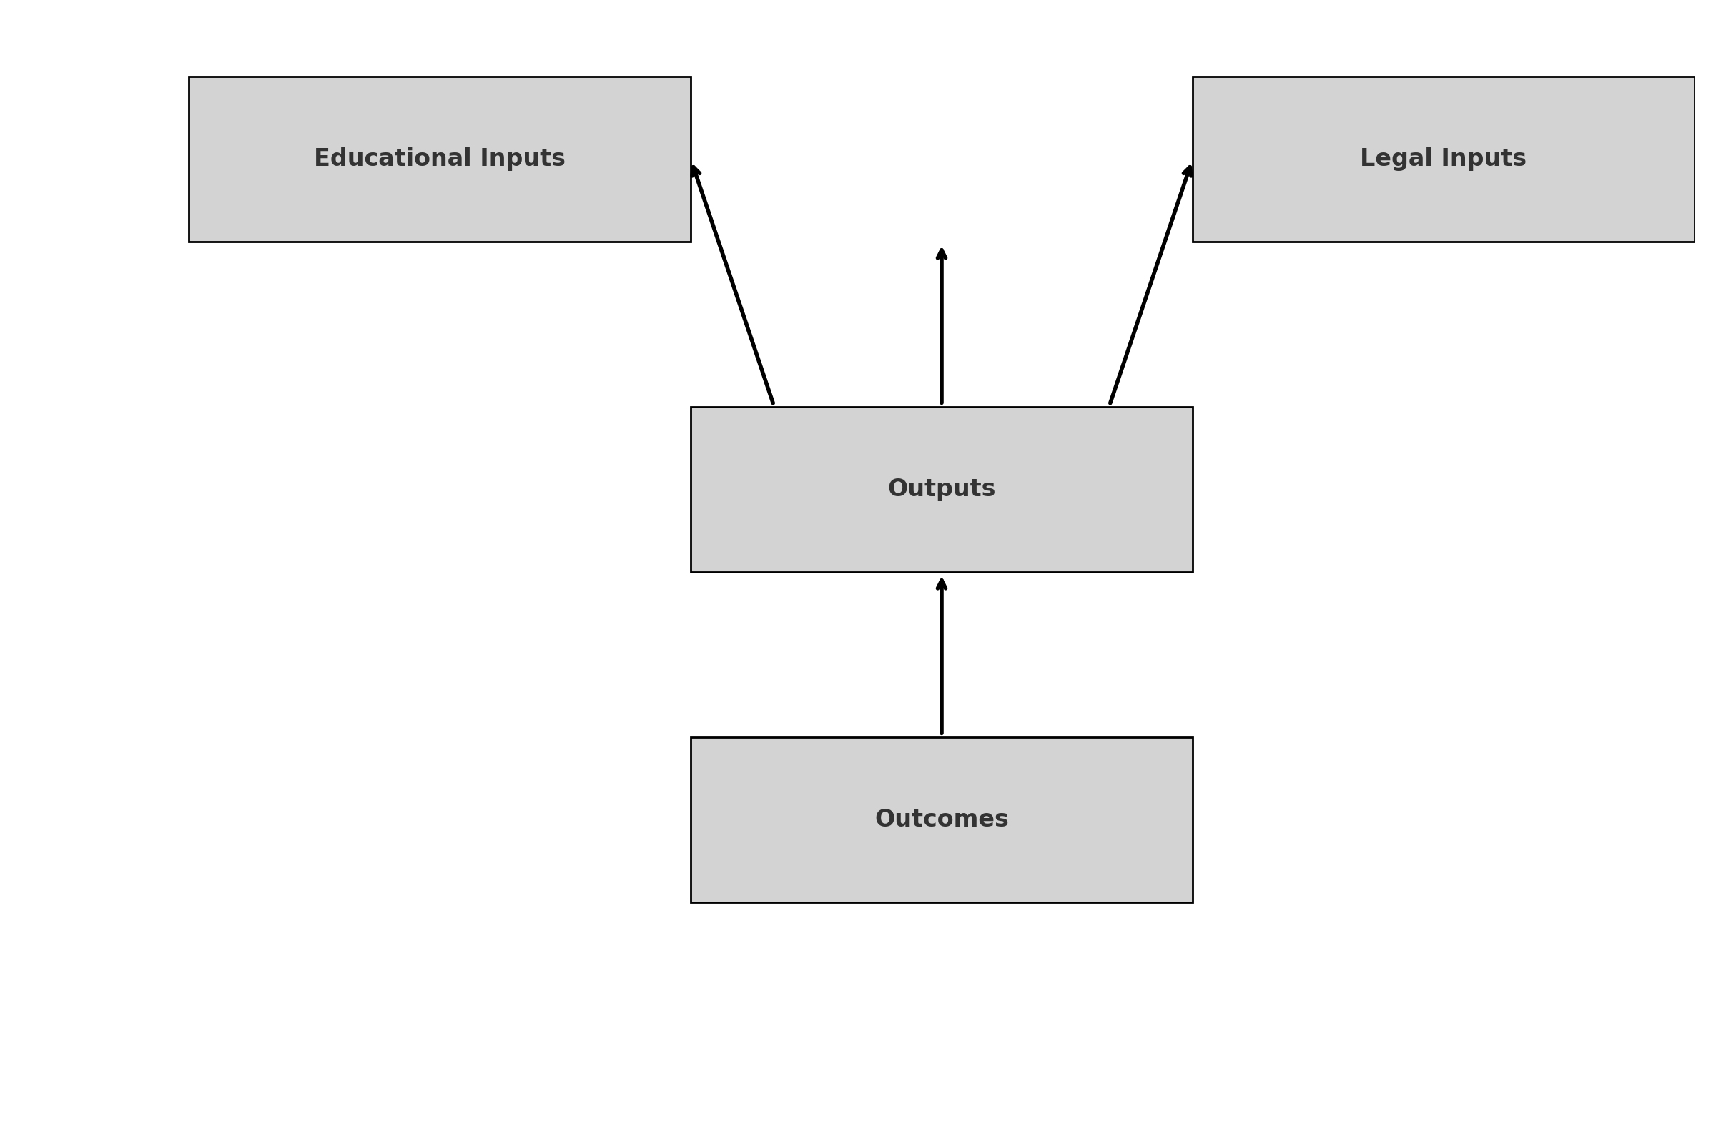

*Fig 1: Author’s Construct: presents the interaction between Educational Inputs and Legal Inputs, which flow into Outputs (e.g., competent practitioners, recognized programs), ultimately leading to Outcomes such as integration into national health systems and increased public trust.*

**2.7 Theoretical Frame: Institutional Theory & Legal Pluralism**

**2.7.1 Institutional Theory**

Derived from Scott’s framework, institutional theory explains curriculum and regulatory convergence through mimetic isomorphism. African universities in Ghana and South Africa, for instance, emulate WHO standards, showcasing academic alignment. Yet institutions with weaker governance show slower policy adoption (Scott, 2004; Dunn *et al*., 2021).

**2.7.2 Legal Pluralism and Rights-Based Analysis**

Legal pluralism acknowledges both formal statutory law and informal norms coexisting in governance. Many African countries engage in dual systems: registered TCIM under statutory law, and traditional practitioners under communal norms (Tamanaha, 2012). Rights-based discourse, particularly regarding the Nagoya Protocol and the African Charter, emphasizes community rights over medicinal knowledge and their role in redistributive justice (Ngang, 2018; Arewa, 2006).

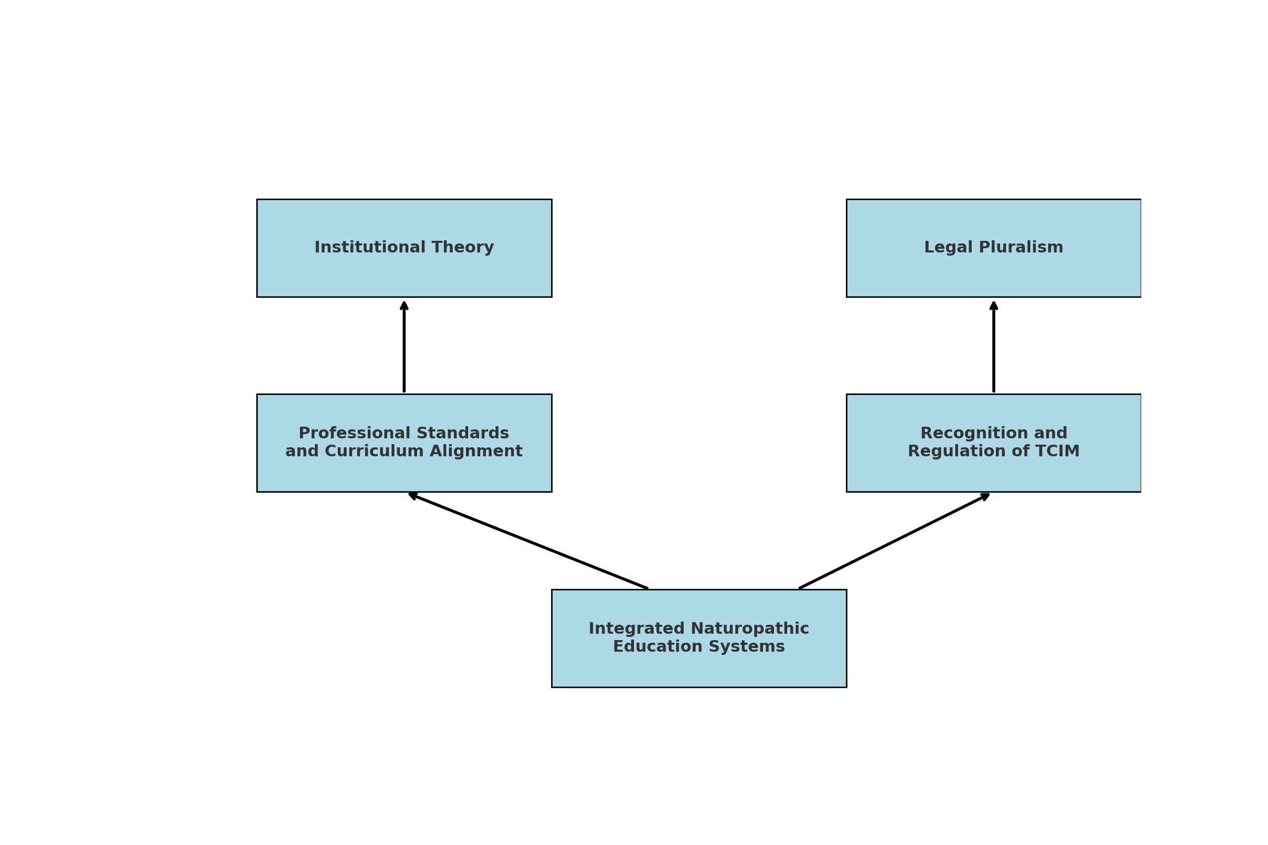

*Fig 2: Author’s Construct: The* ***Theoretical Framework*** *illustrates how* ***Institutional Theory*** *explains curriculum and professional standardization through global influence, while* ***Legal Pluralism*** *accounts for the coexistence of formal law and traditional norms—together guiding the development of integrated naturopathic education systems through aligned regulation and academic recognition.*

**2.8 Research Gaps**

Key areas identified in the literature review include:

1. **Academic Weaknesses**: Clinical training deficits and lack of cohesive postgraduate systems.
2. **Regulatory Deficiencies**: Weak enforcement of policy frameworks and misaligned institutional mandates.
3. **IP Vulnerabilities**: Biopiracy incidents and lack of consent frameworks for knowledge use.
4. **Implementation Lag**: Difficulty in turning regional treaties into effective national laws.
5. **Limited Africa-Led Research**: Few indigenous-led studies on efficacy and pharmacovigilance.

The literature review demonstrates that while Ghana and South Africa have made concrete progress in establishing academic and regulatory frameworks for naturopathic and herbal medicine, most African countries lag behind. The conceptual and theoretical lenses indicate that integrated institutional and legal approaches are essential for sustainable professionalization, public health integration, and intellectual property protection.

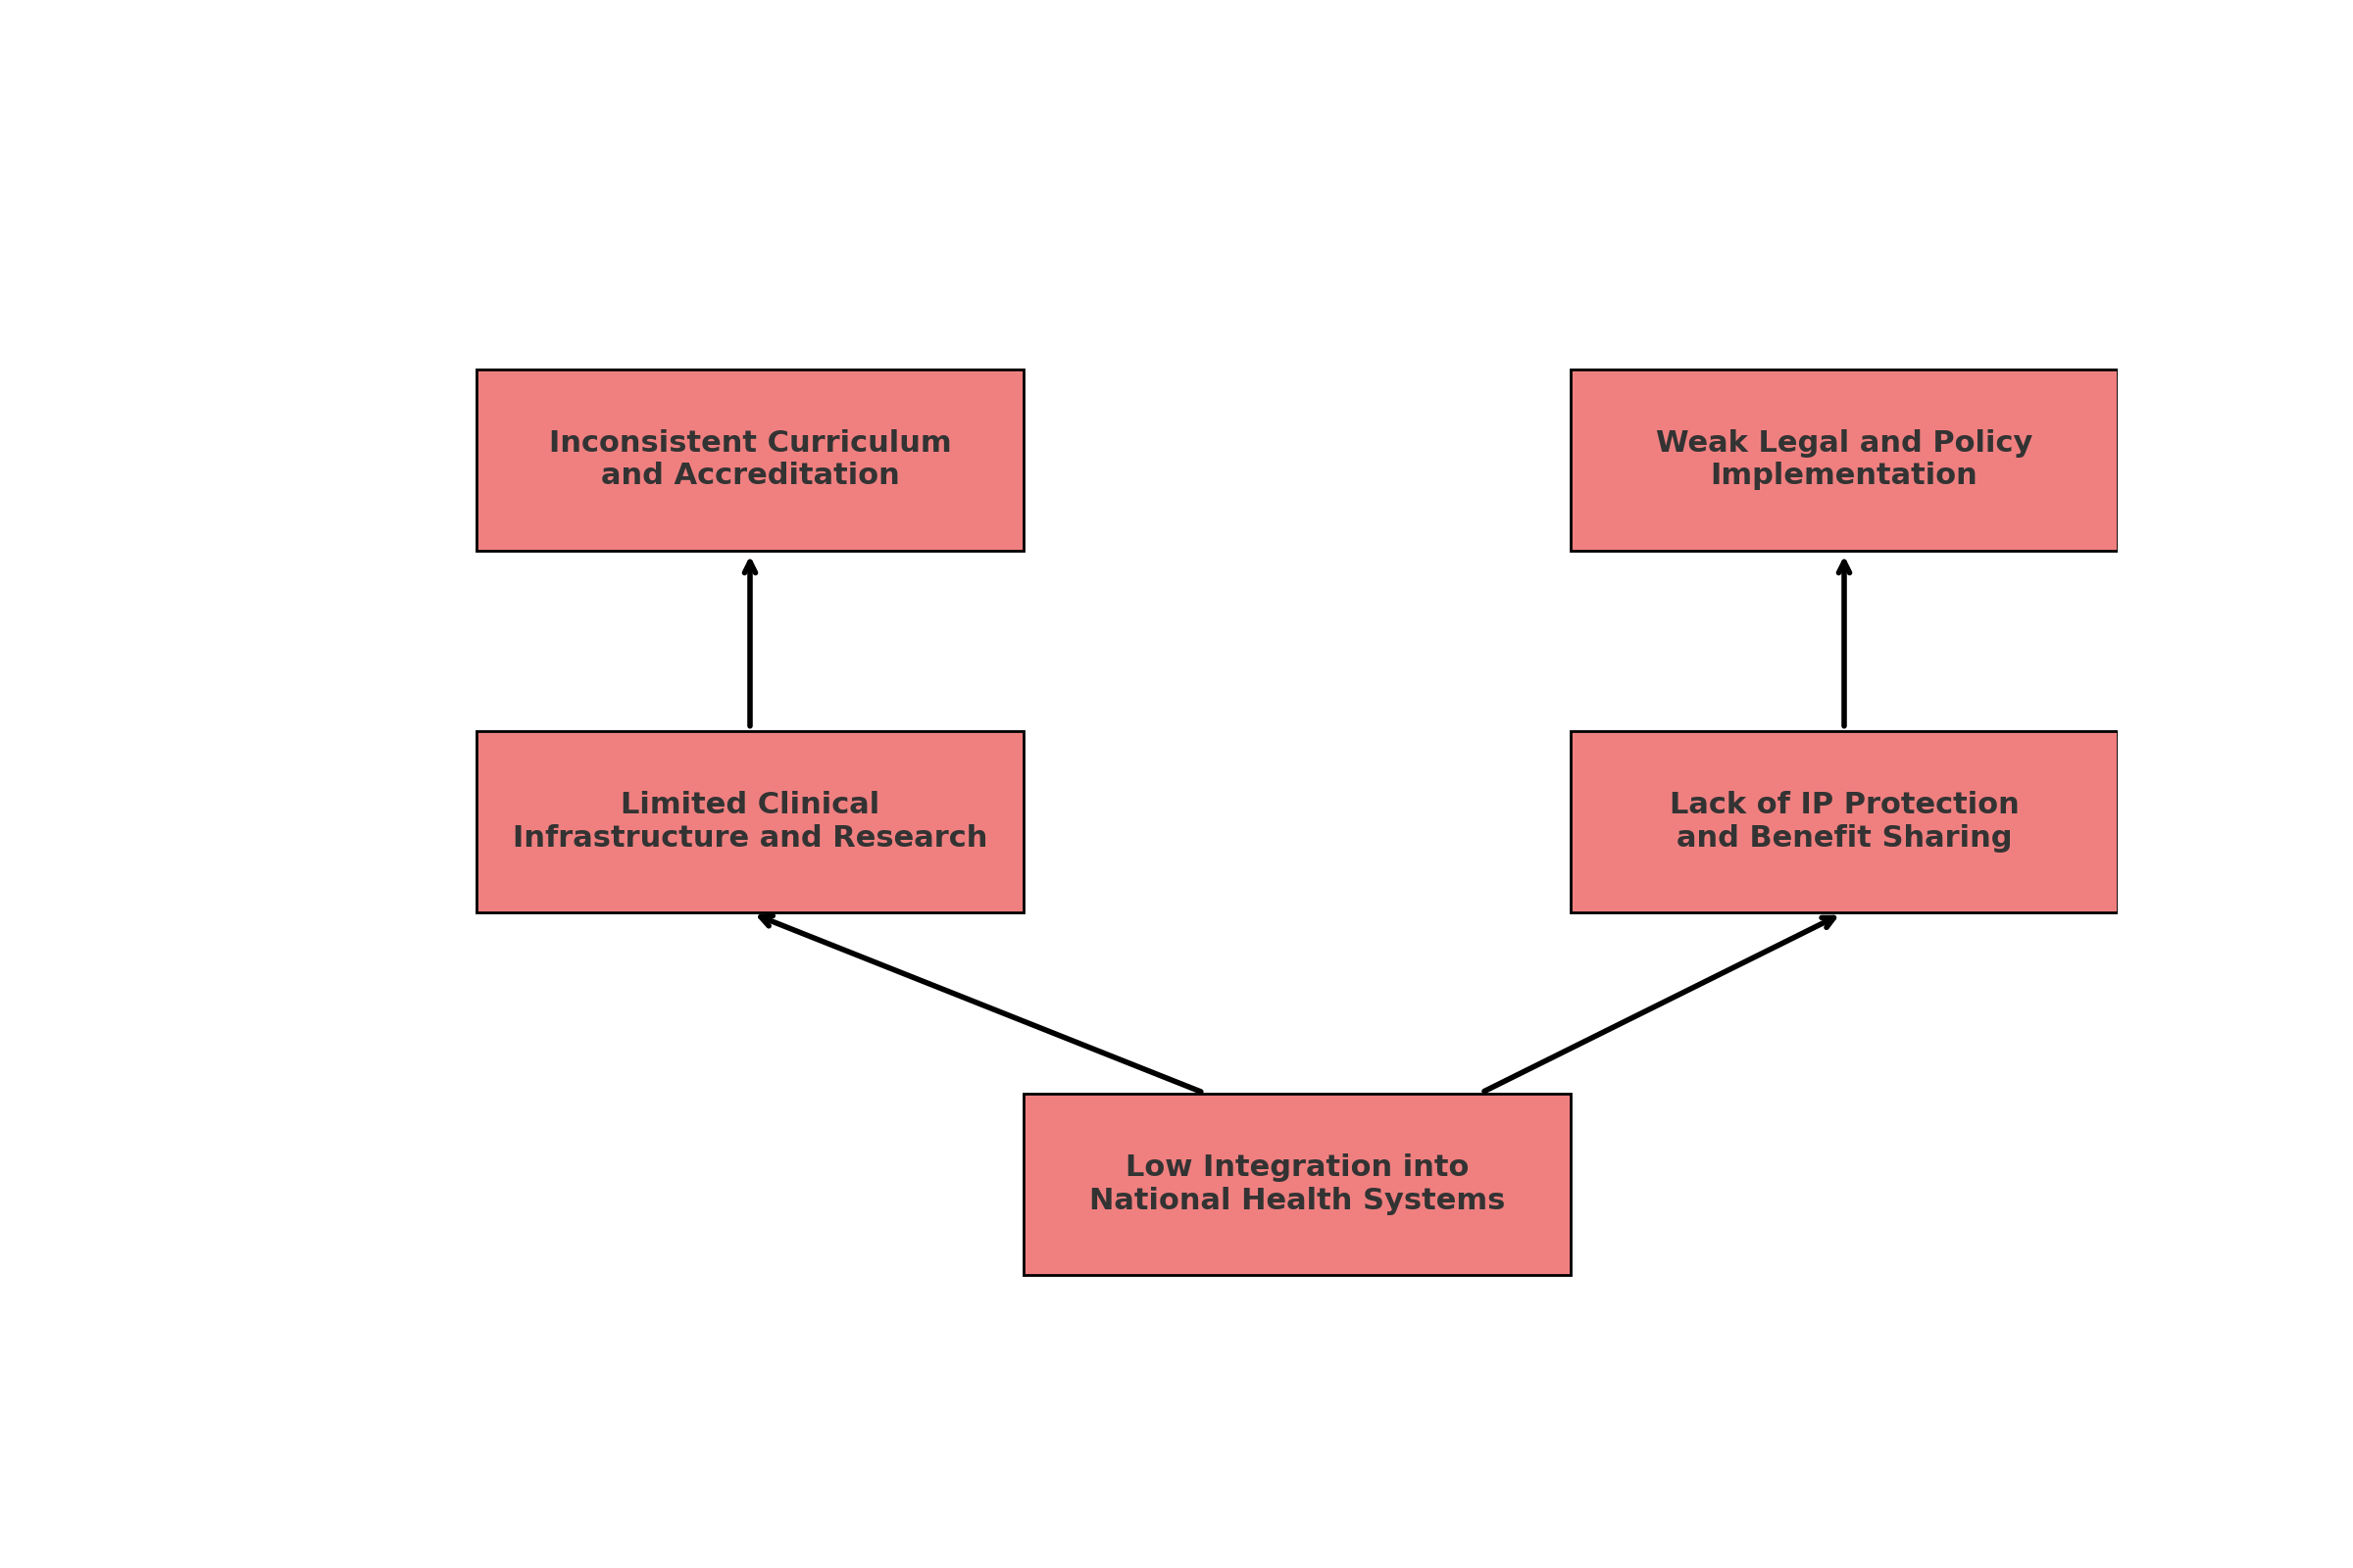

*Fig 3: Author’s Construct: The* ***Research Gaps Framework*** *illustrates five critical deficiencies—fragmented curricula, weak policy enforcement, limited clinical and research infrastructure, inadequate intellectual property protection, and poor integration into national health systems—that collectively hinder the formalization and advancement of naturopathic and herbal medicine education in Africa.*

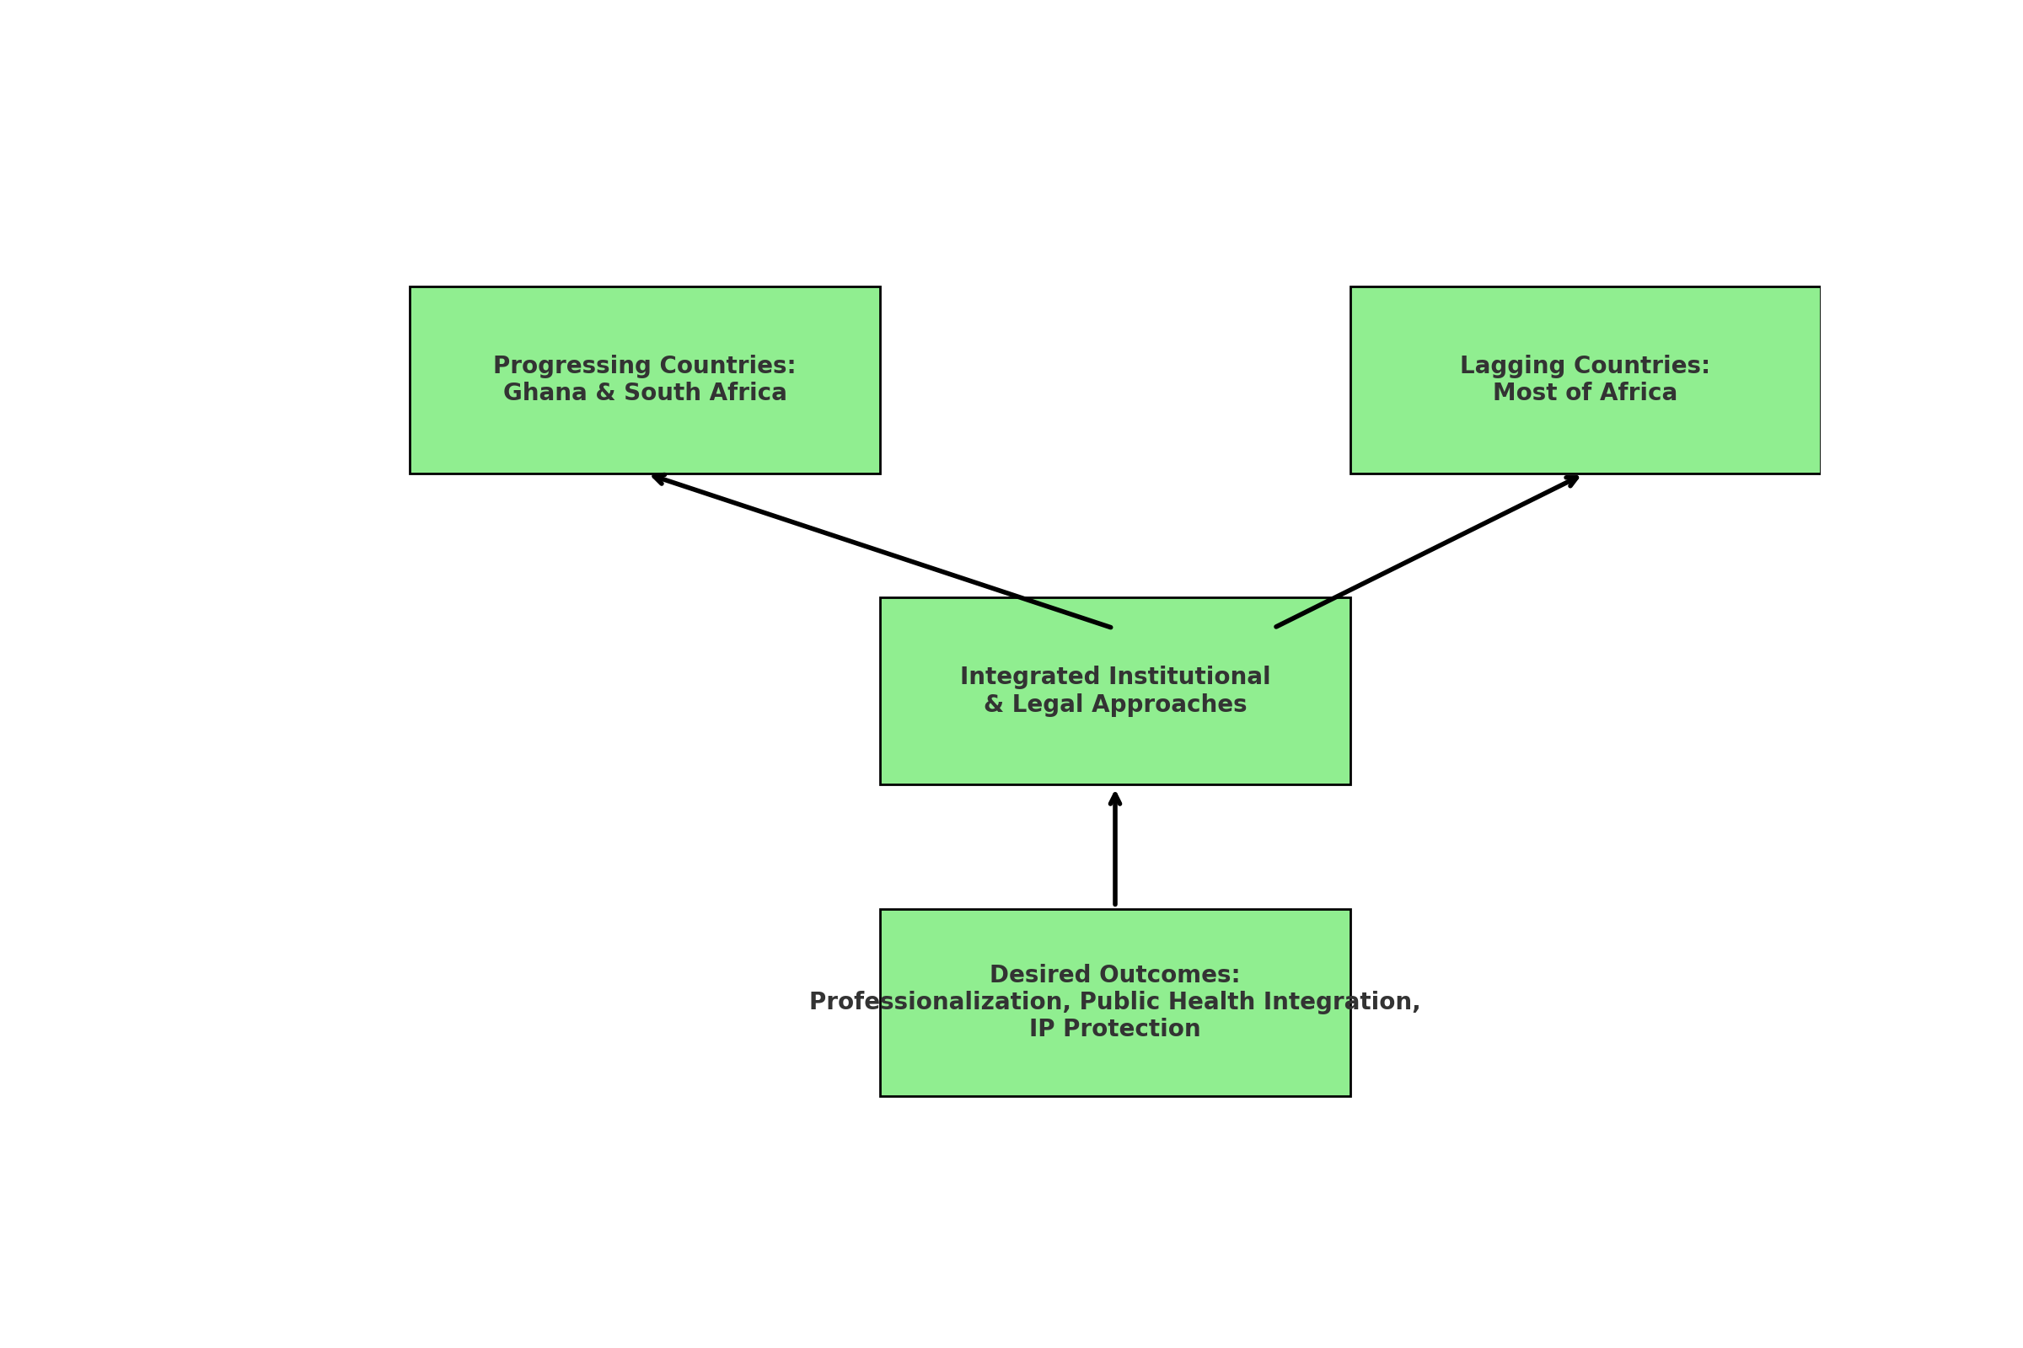

# *Fig 4: Author’s Construct: visually shows the progress in Ghana and South Africa versus lagging regions, emphasizing that integrated academic and legal approaches are necessary to achieve professionalization, health system integration, and protection of indigenous knowledge.*

**3. Methodology**

This study employed a qualitative, multi-case analysis methodology grounded in documentary research and comparative policy analysis. The approach was informed by the need to critically examine the academic and legal frameworks governing naturopathic and herbal medicine education across selected African countries, with Ghana and South Africa serving as primary reference cases. Secondary references included Nigeria, Kenya, Uganda, and Gambia. The selection of these countries was purposive, reflecting diverse trajectories in policy development, educational structuring, and legal recognition within the traditional and complementary medicine (TCM) landscape.

**3.1 Research Design**

The study followed an exploratory design integrating elements of legal doctrinal research and institutional policy review. This was justified by the absence of harmonized data across African countries and the need to contextualize fragmented systems within broader continental and international legal frameworks (Tamanaha, 2012; WHO, 2019). The research sought to trace the evolution, regulation, and institutionalization of naturopathic and herbal medicine by critically reviewing legislation, policy documents, academic curricula, and regulatory frameworks.

**3.2 Data Sources**

The data was drawn primarily from secondary sources including:

* **Academic publications** (e.g., peer-reviewed journals, monographs, and conference proceedings) relating to naturopathy, herbal education, and TCIM regulation in Africa.
* **National policy documents** and legal instruments, such as Ghana’s Traditional Medicine Practice Act (Act 575, 2000), South Africa’s Allied Health Professions Council regulations, and draft bills on alternative medicine (Obu, 2024; Obu *et al.,* 2022).
* **World Health Organization (WHO)** reports, particularly the *WHO Global Report on Traditional and Complementary Medicine* (WHO, 2019).
* **International treaties and protocols**, such as the Nagoya Protocol, ARIPO’s Swakopmund Protocol, and the WIPO Genetic Resources and Traditional Knowledge Treaty (Knight *et al.,* 2022; Ngang, 2018).
* **Institutional documents** from universities and regulatory bodies including Ghana’s CTVET, the African Medicines Agency (AMA), and university programs in Ghana and South Africa.

Each document was selected based on relevance, credibility, and its role in addressing the study’s core objectives. Official government and intergovernmental websites, university repositories, and scholarly databases (e.g., PubMed, ResearchGate) [were the primary retrieval platforms-I am not sure what this mean. But these are databases you need to provide methods you had search to search these databases for example us of search or key words and we need the list of those search words supported reasons for using them].

**3.3 Analytical Framework**

The analytical framework adopted for the study was a synthesis of Institutional Theory (Scott, 2004) and Legal Pluralism (Tamanaha, 2012). These theoretical lenses supported the dual exploration of formal academic and informal traditional systems, allowing for a comprehensive understanding of how educational and legal structures influence the professionalization of naturopathy and herbal medicine. The data analysis process included:

* **Content Analysis**: Thematic categorization of textual data to identify key trends, concepts, and gaps in legal and academic structures;
* **Comparative Analysis**: Cross-national comparisons between countries at different stages of educational and regulatory development;
* **Case Mapping**: Structuring findings according to the four research questions to assess the presence or absence of curriculum standards, legal recognition, regulatory oversight, and professional integration.

These analyses were supported by the creation of visual models and conceptual maps (e.g., input-output-outcome models, regulatory frameworks, research gap diagrams) to facilitate comparative interpretation and policy synthesis.

**3.4 Validation and Reliability**

To ensure validity, triangulation was employed by comparing findings across multiple sources, including international guidelines (WHO, 2019), national legislation, and academic research. Peer-reviewed sources were prioritized over grey literature to ensure scholarly credibility. Reliability was strengthened by referencing documented institutional experiences—such as those from Nyarkotey University College of Holistic Medicine & Technology (NUCHMT) and the University of the Western Cape—which provided grounded examples of curriculum implementation and regulatory engagement (Obu & Bluwey, 2022; Ericksen-Pereira *et al.,* 2021).

Additionally, theoretical constructs from institutional theory provided a framework to interpret policy diffusion and curriculum standardization patterns, while legal pluralism contextualized the coexistence of statutory and customary norms in TCIM regulation.

**3.5 Limitations**

The study is constrained by its reliance on secondary data, which may omit unpublished or non-digitized developments, particularly from Francophone and Lusophone African countries. Language barriers also limited access to Arabic and Portuguese documents relevant to herbal and naturopathic practices in North and Southern Africa. Future research should incorporate primary fieldwork, including interviews with policymakers, regulators, educators, and practitioners, as well as curriculum audits and legal case reviews.

**[7-is this 4 not 7?]. Findings and Discussion**

This study sought to critically examine academic structures and legal frameworks governing naturopathic and herbal education in Africa (Objective 1), analyze regulatory provisions (Objective 2), identify key gaps (Objective 3), and formulate strategic recommendations for strengthening the field (Objective 4). It was guided by four research questions addressing curriculum models, legal regulation, major challenges, and policy strategies. The following discussion interprets findings within those frameworks, drawing on existing literature, case studies from Ghana and South Africa, and comparative regional analyses.

**4.1 Academic Structures & Curriculum Models (RQ1)**

**RQ1:** *What are the prevailing academic models and curriculum structures for naturopathic and herbal medicine education in Africa?*

The findings from this study show that Ghana and South Africa emerge as leaders in formalized naturopathic education. Ghana’s Nyarkotey University College implemented competency-based curricula stretching from certificate to PhD level, aligned with WHO-recommended standards (Nyarkotey, 2025; Obu and Aggrey-Bluwey, 2022). The South Africa’s University of the Western Cape has adopted curricula modeled on international benchmarks, though concerns remain about limited clinical exposure (Wendy *et al.,* 2021; Dunn *et al*., 2021).

Yet, most African countries offer fragmented educational pathways. Nigeria, for instance, relies heavily on private colleges and informal foreign correspondence courses lacking national accreditation (Obu and Aggrey-Bluwey, 2022). Similarly, Ugandan or Kenyan programs exist at disparate diploma or certificate levels without consistent graduate development or integration into formal health systems. These differences result in wide variability—some graduates hold Bachelor’s degrees, others informal diplomas—thus hindering comparability and mobility. Such disunity aligns with earlier studies indicating curriculum disparities as a key challenge to professional cohesion (Dunn *et al.,* 2021; WHO, 2019).

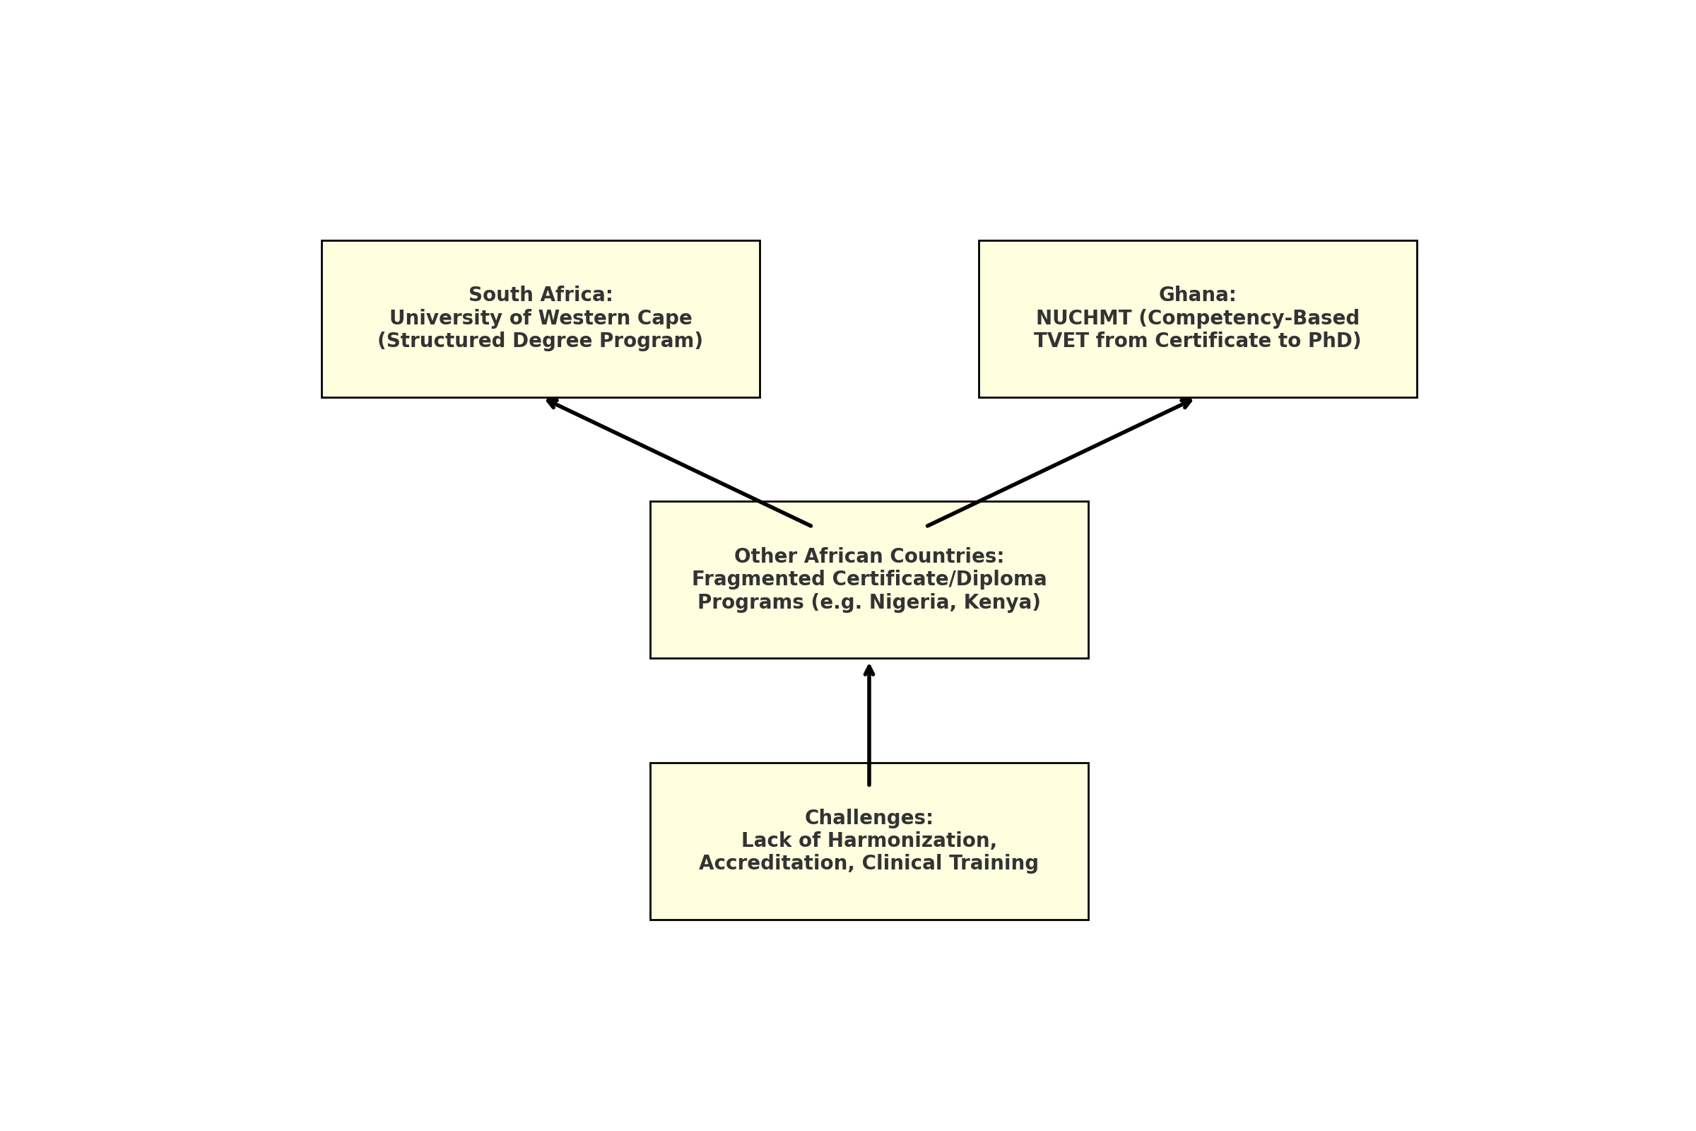

***Fig 5: Author’s Construct: This diagram compares Ghana and South Africa’s structured approaches with fragmented systems in other countries, culminating in the shared challenges.***

**4.2 Legal Frameworks & Regulation (RQ2)**

**RQ2:** *How do national legal frameworks regulate the practice and education of naturopathy and herbal medicine across different African countries?*

This study findings show that Ghana’s Traditional Medicine Practice Act (Act 575, 2000) legally registers herbalists, but naturopaths remain unregulated pending passage of the Alternative Medicine Bill (Obu et al, 2022; Nyarkotey., 2025). South Africa provides a stronger model: its Traditional Health Practitioners Act and registration via the Allied Health Professions Council (AHPCSA) explicitly cover naturopathy and herbalists under defined professional standards (Wikipedia. 2025).

However, regulatory oversight is weak in nations like Nigeria, where the Federal Ministry of Health supports TCIM but does not legally recognize naturopathy, creating a vacuum in training standards and professional oversight (WHO, 2019). Countries such as Kenya, Uganda, and The Gambia have developed TCIM policies, but enforcement is often symbolic. Research on Ethiopia highlights limited regulatory capacity, insufficient pharmacovigilance, and institutional fragmentation as hindrances to safe practice( Mekasha YT, et al., 2025; Steel et al. 2025).

These observations align with RQ2’s premise that legal recognition of naturopathy varies continentally: South Africa and Ghana show formal inclusion, whereas others rely on informal policy frameworks. As per WHO recommendations, legal frameworks should clearly define practitioner scope, standards, and accountability systems (WHO, 2019), yet such clarity is often absent beyond a few nations.

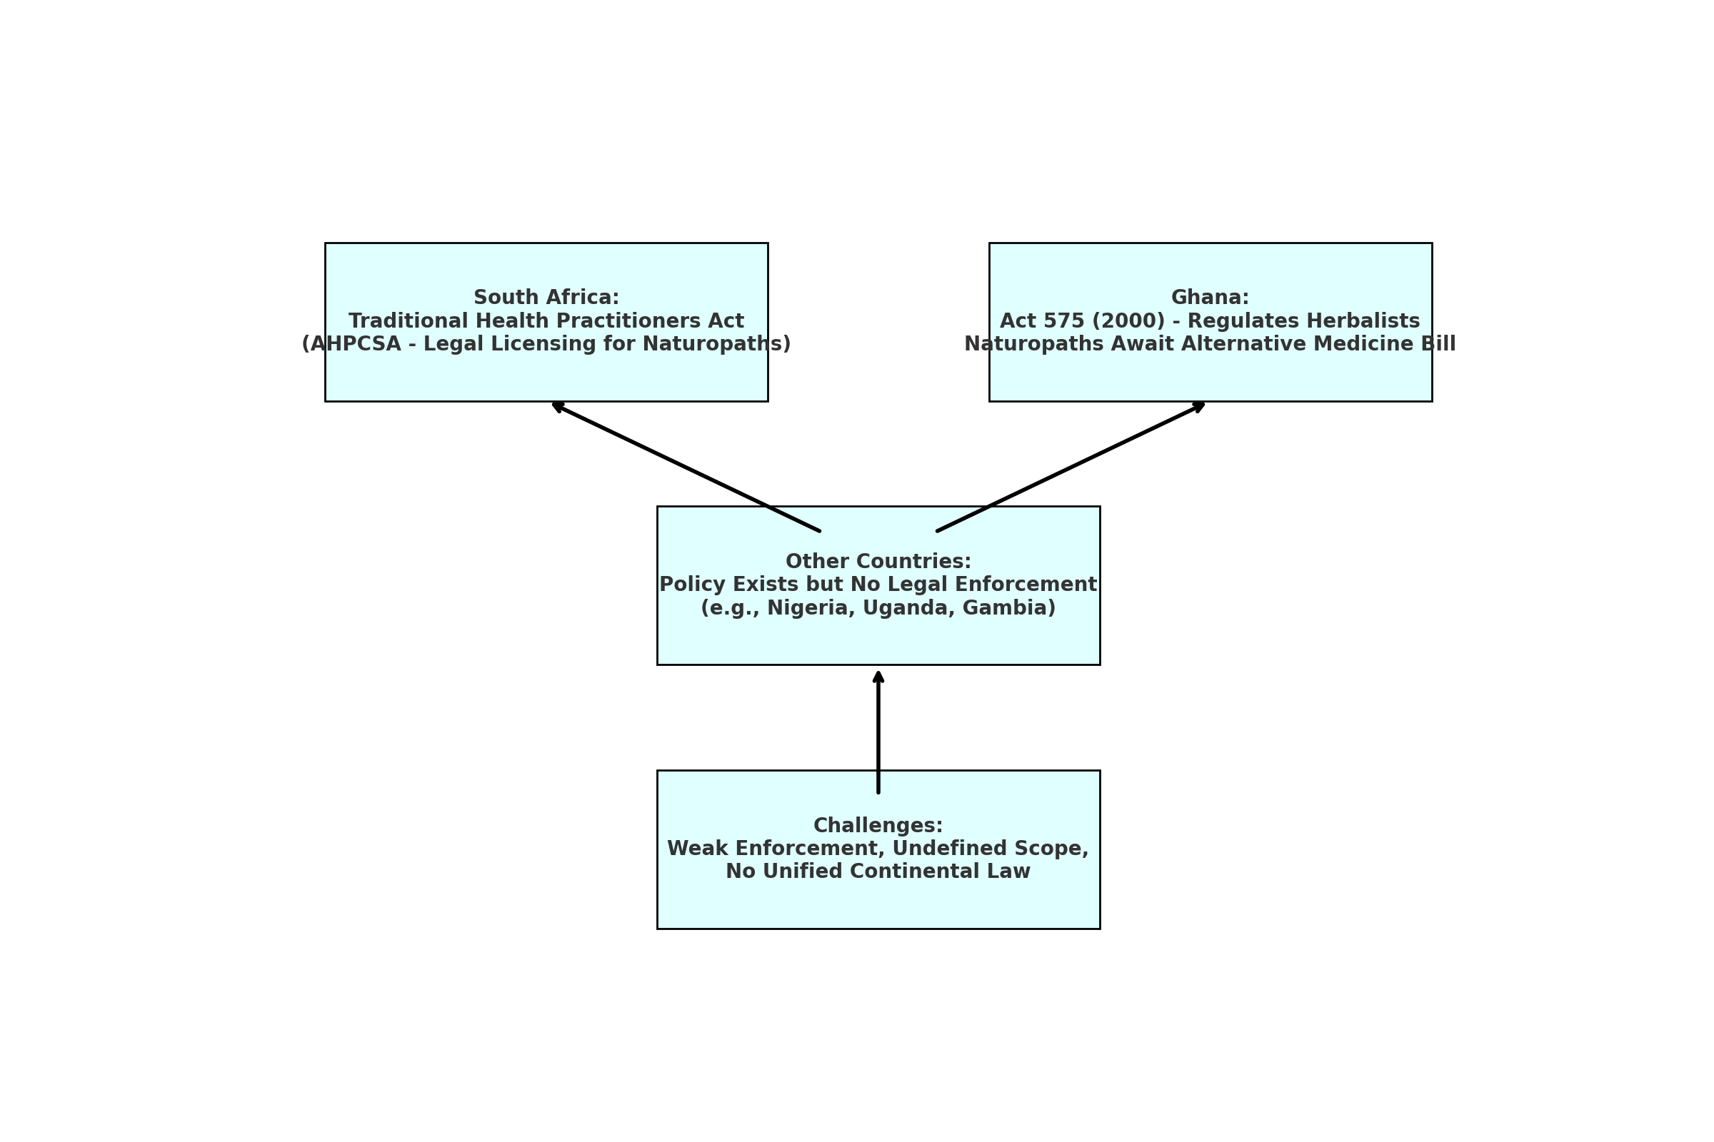

***Fig 6: Author’s Construct: This diagram contrasts South Africa and Ghana’s regulatory models with other African nations, highlighting the common challenge of legal ambiguity and enforcement gaps***

**4.3 Key Challenges Hindering Standardization (RQ3)**

**RQ3:** *What are the major challenges hindering standardization, accreditation, and legal recognition of naturopathic and herbal education in Africa?*

Three recurring challenges emerged:

1. **Curriculum Standardization Deficits**  
   Fragmented educational initiatives undermine consistency. Even Ghana’s advanced model lacks continent-wide recognition. Similarly, limited clinical training and postgraduate research create competency gaps (Wendy et al., 2021; Dunn et al., 2021; Obu R N and Bluwey L A, 2022).
2. **Regulatory Weakness**  
   Law enforcement is often superficial. Even in Ghana, ministerial regulation has been challenged legally, reinforcing the precarious nature of current regulatory structures (Obu et al, 2022). Limited continental harmonization efforts, such as through the African Medicines Agency, remain slow to integrate TCIM.
3. **Intellectual Property Gaps & Benefit-Sharing**  
   Biopiracy and lack of sui generis IP systems remain concerns. South Africa’s Hoodia case exemplifies the exploitation of indigenous knowledge under weak global IP regimes (Arewa, 2006). TRIPS and regional frameworks offer limited safeguards absent rigorous national legislation (Ngang, 2018; Adekola, T. A. (2019)
4. **Infrastructure & Research Limitations**  
   TCIM research funding remains minimal. Studies show only 0.17% of U.S. NIH funding goes to integrative medicine; Africa lags further (Raja et al. 2024). Local institutional research is scaled back, with few randomized controlled trials or clinical outcomes studies (Raja et al. 2024; Pratt and Frost, nd). The lack of trained research faculty intensifies this gap.
5. **Siloed Health Governance**  
   TCIM often operates adjunct to rather than integrated within national health systems, without public financing or inclusion in UHC benefits (Pratt and Frost, nd) Even countries with formal policies struggle to move from governance frameworks to functional health integration, reinforcing RQ3’s identification of structural barriers.

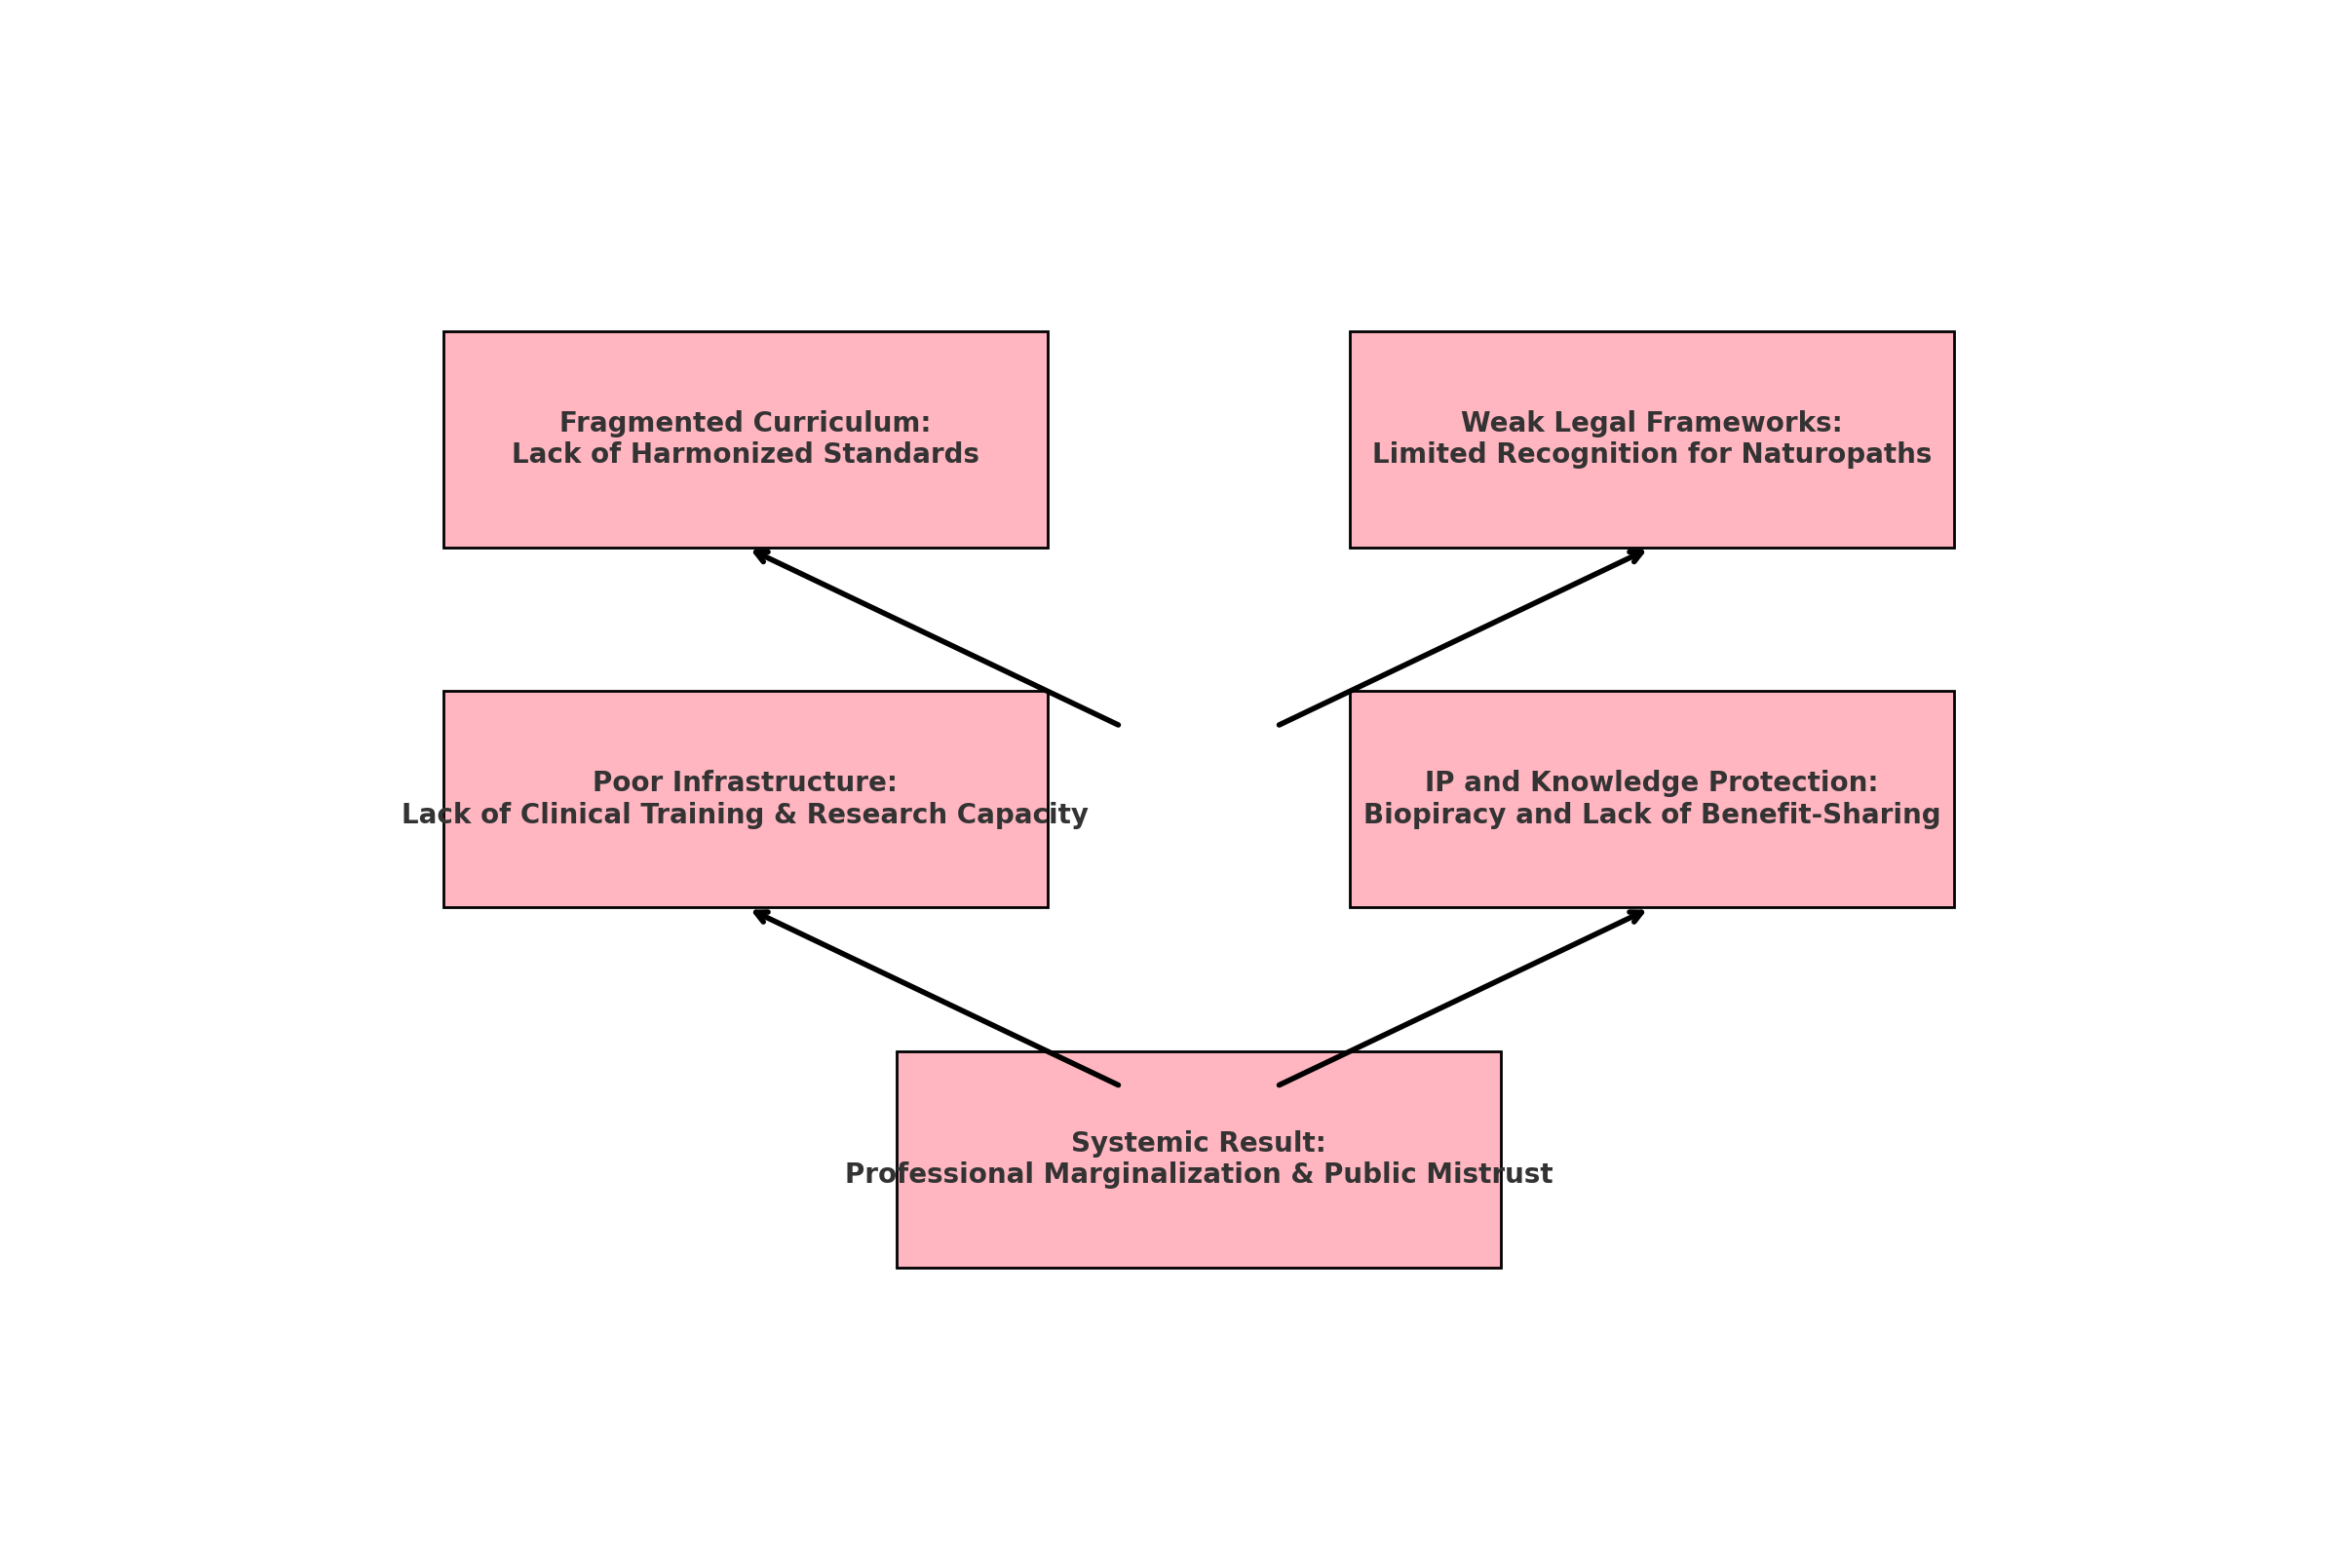*Fig 7: Author’s Construct: presents four critical challenges that funnel into the core issue of professional marginalization and public mistrust*

**4.4 Strategic Recommendations (RQ4)**

**RQ4:** *What policy and institutional strategies can be adopted to strengthen the academic and legal legitimacy of naturopathic and herbal medicine across the continent?*

**a. Harmonized Curriculum Standards & Accreditation**  
African education bodies should collaborate to develop regionally standardized accreditation frameworks. Models from Ghana’s competency-based training and South Africa’s regulatory alignment with WHO could form the basis for continental curricula spanning levels from certificate to doctoral. Institutional Theory supports such alignment by encouraging mimicry of global norms (Scott, 2004; Obu, Raphael Nyarkotey, 2024 ).

**b. Comprehensive Legal Recognition & Regulation**  
Governments must enact legislation granting naturopathy a clear professional identity, scope, and accountability through professional councils and licensure boards. Ghana’s Alternative Medicine Bill is a positive step; Nigeria could follow such models. Legal pluralism theory reinforces the need to integrate statutory recognition with traditional social norms, preserving cultural heritage while asserting legal clarity (Tamanaha, 2012).

**c. Strengthened IP Protection & Community Rights**  
To tackle biopiracy and protect indigenous knowledge, African nations should adopt sui generis IP systems acknowledging collective knowledge and benefit-sharing. Regional treaties like ARIPO’s Swakopmund Protocol and the Nagoya Protocol’s implementation could be enforced more stringently (Ngang, 2018; Knight et al., 2022).

**d. Investment in TCIM Research & Clinical Infrastructure**  
Governments and development partners should designate funding for TCIM investigations, clinical trials, and pharmacovigilance. Partnerships with WHO’s EVIPNet could enable knowledge translation from evidence to policy (Raja et al. 2024). Embedding TCIM training within broader public health and health systems curricula will cultivate future academic and regulatory leadership.

**e. Integration into National Health Systems & Financing**  
Integration requires more than policy—it calls for health budget inclusion, health insurance coverage, and patient data systems that include TCIM modalities. WHO’s report argues that TCIM must be incorporated within UHC frameworks rather than treated as siloed offerings (Pratt and Frost, nd). South Africa's AHPCSA system demonstrates structured professional regulation; similar approaches could be scaled continent-wide.

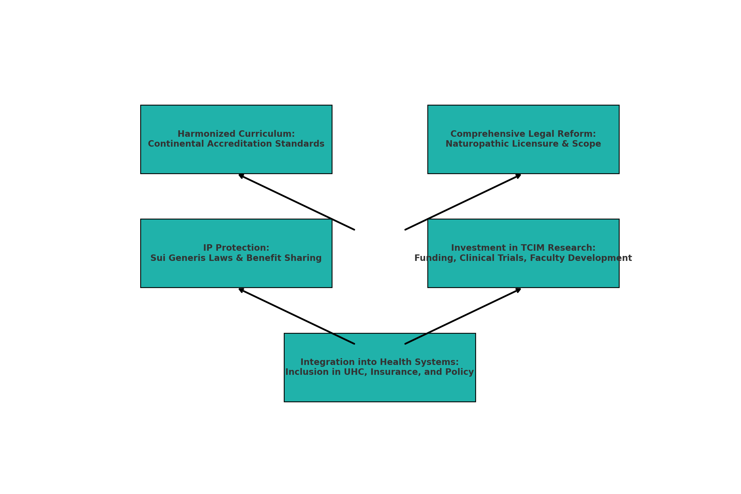

*Fig 8: Author’s Construct:**strategic recommendations to strengthen the academic and legal legitimacy of naturopathic and herbal medicine in Africa.*

**4.5 Linking Objectives, Questions, and Scholarly Evidence**

The findings across items directly address the initial objectives and research questions:

* **Academic examination (Objective 1, RQ1)** reveals pockets of excellence in Ghana and South Africa, but wider fragmentation.
* **Regulatory analysis (Objective 2, RQ2)** shows formal legal pathways exist inconsistently, with Ghana and South Africa leading while others lag.
* **Identified challenges (Objective 3, RQ3)** align with research: curriculum fragmentation, weak regulation, IP insecurity, research deficiency, and siloed healthcare inclusion.
* **Strategic recommendations (Objective 4, RQ4)** highlight frameworks for harmonization, legal reform, IP protection, research investment, and health system integration.

**4.6 Implications & Theoretical Integration**

This discussion supports the use of Institutional Theory and Legal Pluralism as analytical lenses. Institutional Theory helps explain curriculum and regulatory adoption in countries like Ghana and South Africa, whereas Legal Pluralism explains the parallel existence of traditional community norms and statutory regulation. The proposed reforms draw directly from both theories, recommending mimetic policy adoption and integrated statutory-traditional governance pathways.

**4.7 Limitations & Future Research**

The study is limited by its reliance on literature accessible in English and from independent research—that may omit French- or Arabic-language programs. Future work should employ primary empirical methods (e.g., interviews, curriculum audits), expand comparative policy reviews across West, East, and Francophone Africa, and assess the impact of real-world implementation following legislative or academic reforms.

In essence, this research underscores significant disparities across Africa in academic rigor, legal recognition, and structural integration of naturopathic and herbal education. While Ghana and South Africa offer leadership models, widespread fragmentation persists. Drawing from theoretical insights, the discussion foregrounds harmonized curricula, statutory licensure, IP protection frameworks, investment in research, and healthcare system integration as pathways to sustainable professionalization. The recommendations address the research objectives and questions, forming a robust foundation for policy and academic reform capable of transforming naturopathic and herbal medicine across Africa.

**5. Findings**

This study investigated the academic and legal status of naturopathic and herbal medicine education in Africa, using Ghana and South Africa as reference cases. The findings are presented thematically according to the four guiding research questions and objectives.

**5.1 Academic Models and Curriculum Structures**

The study found that Ghana and South Africa have made significant strides in establishing formalized, structured educational pathways in naturopathy and herbal medicine. Ghana, through institutions like Nyarkotey University College of Holistic Medicine & Technology (NUCHMT), offers competency-based curricula aligned with the Ghana TVET Qualification Framework (NTVETQF). These span from certificate levels to doctoral programs, incorporating both indigenous African healing systems and biomedical sciences. South Africa’s University of the Western Cape offers naturopathic education within its School of Natural Medicine, benchmarked against international standards.

However, in many other African countries—such as Nigeria, Kenya, and Uganda—naturopathic education remains fragmented. Programs are often delivered by unaccredited institutions or offered in informal settings without standardized curricula or national accreditation frameworks. There is a lack of clinical training infrastructure and post-graduate opportunities, creating disparities in practitioner competence and limiting professional mobility across countries.

**5.2 Legal and Regulatory Frameworks**

The legal recognition and regulation of naturopathy and herbal medicine vary significantly across the continent. South Africa has developed a mature regulatory framework through the Allied Health Professions Council of South Africa (AHPCSA), which licenses naturopaths and regulates educational standards. Ghana, although having legislation (Act 575, 2000) that governs traditional medicine and herbalism, does not yet formally regulate naturopathy. However, an Alternative Medicine Bill is currently under consideration to address this gap.

In contrast, many African countries—including Nigeria, Uganda, and The Gambia—lack statutory laws for naturopathy, even though traditional medicine is widely practiced and culturally entrenched. Regulatory ambiguity leads to overlapping mandates between ministries of health, education, and research institutions, resulting in weak enforcement, unregulated practice, and limited consumer protection. There is also a lack of unified recognition across countries, making it difficult to establish regional or continental licensing and accreditation standards.

**5.3 Challenges Hindering Standardization and Legal Recognition**

The study identified five major challenges that impede the standardization and professionalization of naturopathic and herbal medicine education in Africa:

1. **Curriculum Fragmentation**: No harmonized curriculum or accreditation framework unites the various institutions and countries. Educational standards vary widely, making cross-border recognition difficult.
2. **Weak Legal Infrastructure**: In many countries, naturopathy is not recognized as a distinct profession, leaving practitioners without a legal identity or regulatory protection.
3. **Limited Research and Clinical Capacity**: There is a notable scarcity of institutional support for clinical training and academic research. This impedes the generation of evidence-based data to validate the efficacy and safety of traditional therapies.
4. **Intellectual Property (IP) Vulnerabilities**: Indigenous knowledge systems and herbal formulas are inadequately protected under existing IP regimes. The absence of sui generis laws exposes communities to biopiracy and unethical commercial exploitation.
5. **Marginalization in Health Policy**: Naturopathy and herbal medicine are often excluded from national healthcare budgets, insurance schemes, and health information systems. This leads to systemic marginalization and perpetuates public mistrust.

**5.4 Strategic Opportunities and Policy Recommendations**

Despite the challenges revealed in this study, the current environment also presents unique opportunities to advance the institutionalization and integration of naturopathic and herbal medicine in Africa. These strategic opportunities can be leveraged by policymakers, educational institutions, and professional bodies through coordinated and multi-sectoral action.

**5.4.1. Standardized Accreditation and Curriculum Harmonization**

Africa lacks a unified educational system for naturopathy and herbal medicine. However, Ghana’s Competency-Based Training (CBT) model under the Commission for Technical and Vocational Education and Training (CTVET), and South Africa’s university-based programs serve as strong templates. These models should inform the development of:

* A **continental accreditation framework** aligned with National Qualification Frameworks (NQFs);
* A **harmonized Competency-Based Curriculum (CBC)** guided by National Occupational Standards (NOS);
* Integration of **African traditional healing systems, indigenous epistemologies, and biomedical science** in formal education.

Regional coordination through entities such as the African Union (AU), the African Medicines Agency (AMA), and the Southern African Development Community (SADC) is essential for cross-border recognition of qualifications and institutional credibility (WHO, 2019; Dunn et al., 2021).

**5.4.2. Legislative and Regulatory Reform**

Legal ambiguity remains one of the greatest barriers to professional legitimacy. Countries like Ghana and Nigeria must move beyond generic traditional medicine laws to enact **specific legislation for naturopathy and complementary medicine**. This includes:

* Enactment of **standalone Alternative Medicine Acts**;
* Establishment of **dedicated regulatory councils** for naturopathy and related disciplines;
* Clear definition of **professional scope, licensing requirements, and ethical standards**;
* Institutionalization of **inter-ministerial collaboration**, particularly among health, education, and science ministries.

Such reforms will provide legal clarity, strengthen accountability, and ensure safety in practice ( Obu, Raphael Nyarkotey, 2024; Ngang, 2018).

**5.4.3. Protection of Indigenous Knowledge and Intellectual Property**

Africa is rich in traditional knowledge, yet poor in mechanisms to protect it. To safeguard community heritage and promote benefit-sharing, countries should implement:

* Full enforcement of the **Nagoya Protocol** and the **WIPO Genetic Resources and Traditional Knowledge (GRATK) Treaty**;
* Establishment of **community-led Access and Benefit Sharing (ABS) frameworks**;
* National registries of traditional knowledge and pharmacopeia;
* Legal mechanisms for **sui generis intellectual property protection** reflecting collective ownership norms.

These actions will address biopiracy and ensure that local knowledge holders are equitably compensated (Arewa, 2006; Knight et al., 2022).

**5.4.4. Research and Clinical Infrastructure Development**

Naturopathic and herbal medicine education lacks robust research and clinical components. Strategic investments are needed to:

* Establish research funding schemes targeting TCIM clinical trials and safety studies;
* Build university-affiliated herbal clinics, laboratories, and diagnostic units;
* Support faculty development programs and North-South academic exchanges;
* Embed naturopathic and herbal medicine into national innovation and research policies.

This will enable the development of an evidence base to validate traditional systems and support integration into mainstream healthcare ( Obu et al., 2023; WHO, 2019).

**5.4.5. Integration into Public Health and Universal Health Coverage (UHC)**

To move beyond policy rhetoric, countries must institutionalize naturopathic and herbal medicine within public health delivery and financing mechanisms. This involves:

* Inclusion of TCIM services in national health insurance schemes;
* Recognition of licensed naturopathic clinics as public health service providers;
* Development of integrated referral systems between conventional and naturopathic practitioners;
* Compilation of national formularies of essential herbal medicines for safe public use.

Integration promotes patient choice, reduces costs, and improves culturally sensitive care (WHO, 2019).

**6. Development Issues**

The successful implementation of the above policy recommendations must also address several structural and systemic development challenges that currently impede progress in the field.

**6.1. Human Capital Development**

There is a serious shortage of qualified academic staff, curriculum developers, clinical supervisors, and researchers in the naturopathic and herbal medicine ecosystem. Most educators have little exposure to international best practices or interdisciplinary collaboration. Thus, efforts must be prioritized:

* Capacity-building programs for academic and clinical educators;
* International exchange fellowships and training partnerships;
* Incentive structures to retain professionals in academia.

**6.2. Institutional Infrastructure**

Many training institutions lack the physical and technological infrastructure to support comprehensive education. Essential facilities such as herbal gardens, botanical labs, libraries, diagnostic units, and simulation centers are often absent. Governments and development partners must:

* Offer capital grants for infrastructure development;
* Establish regional centers of excellence in naturopathy and herbal medicine;
* Promote digitally enabled learning systems for accessibility and scale.

**6.3. Equity and Accessibility**

Naturopathic and herbal education remains concentrated in urban centers, with limited access for rural populations and marginalized groups. Given that these groups are often the most reliant on traditional medicine, policies should:

* Introduce rural scholarship schemes and community-based training;
* Expand access through satellite campuses and mobile clinics;
* Foster public-private partnerships for outreach and inclusivity.

**6.4. Gender and Indigenous Participation**

Women and indigenous communities are the traditional custodians of African healing knowledge, yet remain underrepresented in formal regulatory and academic spaces. Development strategies should ensure:

* Gender-sensitive training models and leadership pipelines;
* Legal protections for communal knowledge and bio-cultural rights;
* Inclusive policy-making platforms that elevate indigenous voices.

**6.5. Data Systems and Monitoring**

There is limited data to assess the efficacy of naturopathic programs, patient outcomes, and the socio-economic impact of herbal medicine. As a result, policy remains speculative. Countries must:

* Integrate TCIM indicators into national health information systems;
* Establish routine program monitoring and evaluation systems;
* Collaborate regionally to build a continental TCIM observatory.

The strategic recommendations and development issues identified in this study reflect the dual necessity of policy innovation and structural reform to advance naturopathic and herbal medicine in Africa. By harmonizing academic standards, enacting robust legal frameworks, protecting indigenous knowledge, investing in infrastructure and research, and promoting inclusive participation, African states can transform a culturally rich but institutionally neglected sector into a cornerstone of holistic, resilient, and equitable healthcare systems.

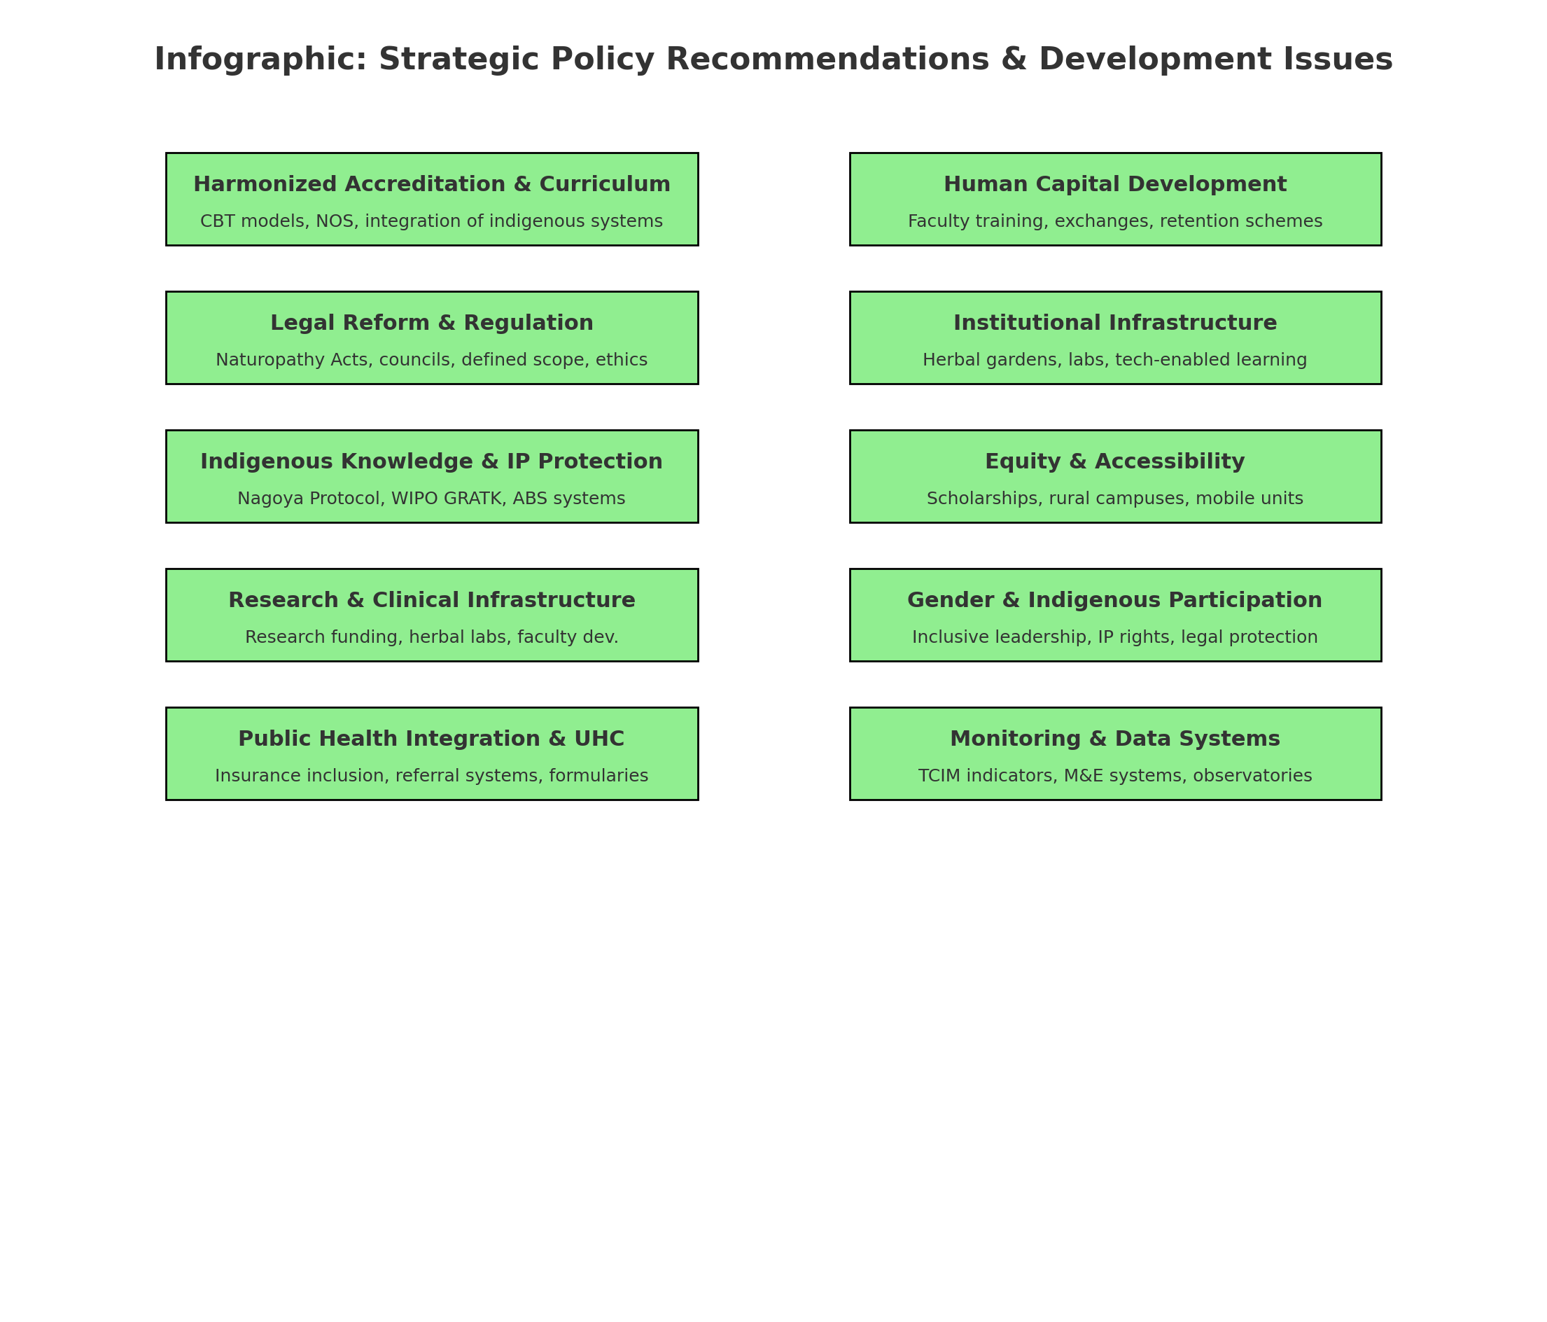

*Fig 9: Author’s Construct: Infographic summarizing the* ***Strategic Policy Recommendations and Development Issues*** *for naturopathic and herbal medicine in Africa:*

**7. Conclusion**

Africa's naturopathic and herbal medicine education landscape is undergoing a significant transformation, driven by growing public demand, institutional innovation, and policy engagement. Yet, achieving full legitimacy, academic standardization, and legal recognition remains a complex and unfinished journey. This study underscores the critical need for a coordinated, multisectoral approach involving governments, academic institutions, professional bodies, and indigenous knowledge custodians.

By integrating naturopathy and herbal medicine into formal education systems, enacting dedicated regulatory frameworks, and safeguarding traditional knowledge through appropriate intellectual property mechanisms, African countries can redefine the contours of healthcare. The continent holds the potential to establish a distinct, culturally rooted, and evidence-informed model of naturopathic healthcare—one that honors ancestral wisdom while meeting contemporary standards of quality, safety, and accountability.

Ultimately, the institutionalization of naturopathic and herbal medicine in Africa represents more than a policy or academic objective—it is a pathway toward health sovereignty, inclusive development, and the affirmation of Africa’s rich epistemological heritage in global health discourse.

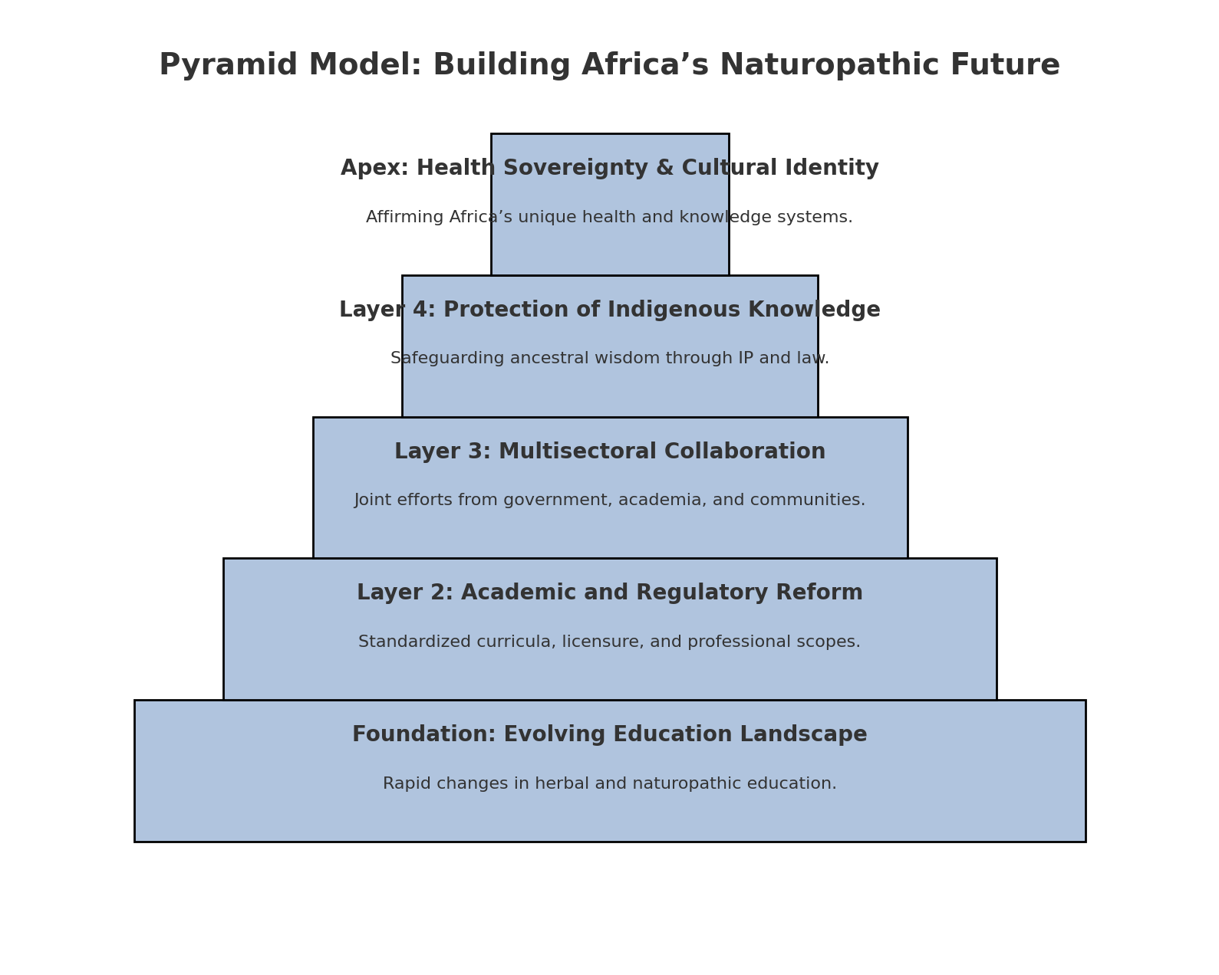

*Fig 10: Author’s Construct: This model layers the foundational needs—educational reform and regulation—up to the apex goal of achieving health sovereignty and cultural affirmation.*

**REFERENCES**

1. African Medicines Agency. (2025). African Medicines Agency. Wikipedia. <https://en.wikipedia.org/wiki/African_Medicines_Agency>
2. AU. (2015). *Practical Guidelines for the Coordinated Implementation of the Nagoya Protocol in Africa*. African Union. [jdsupra.com](https://www.jdsupra.com/legalnews/the-nagoya-protocol-regulating-research-2647225/?utm_source=chatgpt.com)[en.wikipedia.org](https://en.wikipedia.org/wiki/The_Globalization_of_Intellectual_Property_Rights?utm_source=chatgpt.com)[sciencedirect.com+2absch.cbd.int+2jdsupra.com+2](https://absch.cbd.int/api/v2013/documents/ACA06BA7-2ED4-19C0-F096-883C14068E94/attachments/AUPracticalGuidelinesOnABS_20150215_Druck.pdf?utm_source=chatgpt.com)
3. Abdullahi, A. A. (2011). Trends and challenges of traditional medicine in Africa. African Journal of Traditional, Complementary and Alternative Medicines, 8(S), 115–123. <https://doi.org/10.4314/ajtcam.v8i5S.5>
4. Arewa, O. (2006). Piracy, biopiracy, and borrowing: Culture, cultural heritage, and the globalization of intellectual property. Globalization of Intellectual Property Rights.
5. Adekola, T. A. (2019). Public health–oriented intellectual property and trade policies in Africa and the regional mechanism under Trade-Related Aspects of Intellectual Property Rights amendment. Public Health, 173, 1-4. DOI/10.1016/j.puhe.2019.04.019
6. Dunn, J.M., Steel, A.E., Adams, J. *et al.* Characteristics of global naturopathic education, regulation, and practice frameworks: results from an international survey. *BMC Complement Med Ther* **21**, 67 (2021). <https://doi.org/10.1186/s12906-021-03217-1>
7. Dr. Beth Anne Pratt and Dr. Laura J. Frost(2024), A Comparative Case Review of Governance of Traditional, Complementary and Integrative Medicine (TCIM). [cdn.who.int](https://cdn.who.int/media/docs/default-source/who-global-traditional-medicine-centre/a-comparative-case-review-of-governance-of-traditional--complementary-and-integrative-medicine-%28tcim%29.pdf?sfvrsn=f0d8a1f7_1&utm_source=chatgpt.com)
8. Ericksen-Pereira, W, Roman, N V, & Swart, R. (2021). A comparative analysis and evaluation of the naturopathic curriculum in South Africa. *African Journal of Health Professions Education*, *13*(4), 260-264. <https://doi.org/10.7196/ajhpe.2021.v13i4.1276>
9. Ikhoyameh M, Okete WE, Ogboye RM, Owoyemi OK, Gbadebo OS. Integrating traditional medicine into the African healthcare system post-Traditional Medicine Global Summit: challenges and recommendations. Pan Afr Med J. 2024 Mar 27;47:146. doi: 10.11604/pamj.2024.47.146.43011. PMID: 38933435; PMCID: PMC11204987.
10. Jasper Knight , Eleni Flack-Davison , Sidney Engelbrecht , Retha, G. Visagie , Winston Beukes e, Marizvikuru Mwale (2023) **Compliance with the Nagoya protocol in the Southern African Development Community. South African Journal of Botany. Volume 159, August 2023, Pages 302-318**
11. J Knight; E Flack-Davison; S Engelbrecht; R G Visagie, DCur; W Beukes, T Coetzee; M Mwale; D Ralefala(2022) A literature review analysis of engagement with the Nagoya Protocol, with specific application to Africa. S Afr J Bioethics Law 2022;15(2):69-74. <https://doi.org/10.7196/SAJBL.2022.v15i2.811>
12. Mekasha YT, Getahun H, Tegegne AA, Hasen G. Situational analysis and future directions for medicine retail outlets: compliance with pharmaceutical regulatory standards in Ethiopia. Front Med (Lausanne). 2025 Mar 12;12:1452875. doi: 10.3389/fmed.2025.1452875. PMID: 40166068; PMCID: PMC11956760.
13. Maheen Raja, Holger Crame , Myeong Soo Lee, L. Susan Wieland, Jeremy Y. Ng(2024) Addressing the Challenges of Traditional, Complementary, and Integrative Medicine Research: An International Perspective and Proposed Strategies Moving Forward. Perspectives on Integrative Medicine 2024;3(2):86-97. DOI: <https://doi.org/10.56986/pim.2024.06.004>
14. *Nyarkotey, P. (June 10, 2025). From Tradition to Transformation: Institutionalizing Naturopathy in Ghana through the TVET-CBT Framework. African Researchers Magazine (ISSN: 2714-2787).* [*https://www.africanresearchers.org/from-tradition-to-transformation-institutionalizing-naturopathy-in-ghana-through-the-tvet-cbt-framework/*](https://www.africanresearchers.org/from-tradition-to-transformation-institutionalizing-naturopathy-in-ghana-through-the-tvet-cbt-framework/)
15. Ngang, C. C. (2018). Intellectual property protection of African traditional medicine within the legal framework of the right to development. *University of Pretoria Law Review*. [repository.up.ac.za+1researchgate.net+1](https://repository.up.ac.za/bitstreams/7b822e33-e774-435c-87f8-603b058385fe/download?utm_source=chatgpt.com)
16. Obu R N, Bluwey L A, African naturopathic education: Ghana’s model using competency-based curriculum. ***J Prev Med Holist Health***2022;8(2):75-84
17. Obu, Raphael Nyarkotey. 2024. “A Comparative Analysis and Development of Legislative Regulatory Framework of Naturopathy and Traditional Medicines Practices in Southern Africa Region”. *Journal of Complementary and Alternative Medical Research* 25 (12):97-109. <https://doi.org/10.9734/jocamr/2024/v25i12599>.
18. Obu, P. R. N. . (2025). Legal Perspective on Traditional & Naturopathy Regulatory Framework in Africa. *Legal Perspective on Traditional & Naturopathy Regulatory Framework in Africa*, 1–52. <https://doi.org/10.9734/bpi/mono/978-93-49473-54-6>
19. Obu, R. N., Aggrey-Bluwey, L. and Osei –Attakora, S. (2022). The Practice and Regulatory Requirement for Naturopathy: Critical evaluation and effects of the Naturopathic Regulation in the Ghanaian Healthcare delivery. ADRRI Journal of Medical and Biomedical Research, Ghana: Vol. 4, No. 2 (5), Pp. 1-30, E- ISSN: 2026-6022, 30
20. Regulation and prevalence of homeopathy(2025) <https://en.wikipedia.org/wiki/Regulation_and_prevalence_of_homeopathy?utm_source=chatgpt.com>
21. Scott, W. R. (2004). Institutional theory: Contributing to a theoretical research program. In K. G. Smith, & M. A. Hitt, (Eds.), Great minds in management: The process of theory development (pp. 460-484). Oxford: Oxford University Press.
22. Steel A, Gallego-Perez DF, Ijaz N, Gall A, Bangpan M, Dos Santos Boeira L, Schveitzer MC, Chutaputti A, Mahlanza-Langer L, Pillai GKG, Posayanonda T, Sungchol K, Shankar D, Kuchenmüller T. Integration of Traditional, Complementary, and Integrative Medicine in the Institutionalization of Evidence-Informed Decision-Making: The World Health Organization Meeting Report. J Integr Complement Med. 2025 Apr;31(4):388-394. doi: 10.1089/jicm.2024.0837. Epub 2025 Jan 17. PMID: 39819104; PMCID: PMC7617372.
23. Tamanaha, B. Z. (2012). *Legal Pluralism*. Cambridge University Press
24. Wikipedia. (2025). Traditional African medicine. <https://en.wikipedia.org/wiki/Traditional_African_medicine>
25. World Health Organization. (2019). WHO global report on traditional and complementary medicine 2019. WHO.
26. World Health Organization. (2019). Traditional, Complementary and Integrative Medicine. WHO.
27. Wikipedia. (2025). Regulation and prevalence of homeopathy. [en.wikipedia.org](https://en.wikipedia.org/wiki/Regulation_and_prevalence_of_homeopathy?utm_source=chatgpt.com)
28. Wikipedia. (2025). Nagoya Protocol. [en.wikipedia.org](https://en.wikipedia.org/wiki/Nagoya_Protocol?utm_source=chatgpt.com)
29. Wikipedia. (2025). African Regional Intellectual Property Organization (ARIPO). [en.wikipedia.org+1en.wikipedia.org+1](https://en.wikipedia.org/wiki/African_Regional_Intellectual_Property_Organization?utm_source=chatgpt.com)
30. Wikipedia. (2025). Organisation Africaine de la Propriété Intellectuelle (OAPI). [en.wikipedia.org](https://en.wikipedia.org/wiki/Organisation_Africaine_de_la_Propri%C3%A9t%C3%A9_Intellectuelle?utm_source=chatgpt.com)
31. Wikipedia. (2025). African Medicines Agency.