Chloroform Fraction of Methanol Extract of Funtumia Elastica (Preuss) Stem Bark Induces Mitochondrial-Mediated Cell Death Via Mitochondrial Permeability Transition Pore Opening

Abstract
Aims: The Mitochondrial Permeability Transition (mPT) pore has become a significant target for drug development because its opening triggers cytochrome c release, ultimately leading to mitochondrial-mediated cell death. This study aimed to explore the effects of the chloroform fraction of the methanol extract of Funtumia elastica (CFFE) on mitochondrial-dependent cell death through mPT pore opening.
Methodology: The crude methanol extract (CMFE) was partitioned successively to obtain n-hexane (HFFE), chloroform (CFFE), ethyl acetate (EAFE) and methanol (MFFE) fractions. Two sets of the animals separately and equally divided into four groups were treated as follows; First set: Group I received corn oil(10 ml/kg) while groups II, III and IV received 200 mg/kg of CMFE, CFFE and MFFE, respectively. Second set: Groups I, II, III and IV were treated with corn oil(10 ml/kg), CFFE(50 mg/kg), CFFE(100 mg/kg) and CFFE(200 mg/kg), respectively. Rat liver mitochondria were isolated by differential centrifugation. The effects of the extract and fractions were investigated on mPT pore, mitochondrial ATPase (mATPase)activity, mitochondrial membrane lipid peroxidation(mLPO), Caspases 9 and 3 activation, and, hepatic DNA fragmentation. Histological examination on the liver was assessed. Data were analyzed using ANOVA at α 0.05.
Results: Oral administration of CMFE, CFFE, EAFE and MFFE at 200 mg/kg gave induction folds of 2.9, 12.3, 8.3 and 6.3, respectively, related to the control. The CFFE at 50, 100 and 200mg/kg induced pore opening by 3.7, 10.0 and 13.0 folds, respectively, related to the control. The CFFE caused significant enhancement of mATPase activity, caspases 9 and 3 activation, dose-dependent induction of hepatic DNA fragmentation, and decrease in malondialdehyde generation. Histological assessment at lower doses showed normal morphology while mild congestion was observed at the highest dose.
Conclusion: These results suggest the presence of phytochemicals in CFFE that can induce mitochondrial-dependent cell death via mPT pore opening. Further work is therefore necessary to characterize and isolate the active principle in CFFE that is responsible for this property.
Keywords: Mitochondrial permeability transition pore, Funtumia elastica, cell death.

Introduction
Mitochondrion is an intracellular organelle that is responsible for various cellular activities including ATP generation [1]. Despite its involvement in cellular energy generation, it has been implicated in programmed cell death. A key player in this event is the mitochondrial permeability transition (mPT) pore which is a protein formed under certain pathological situations such as traumatic brain injury and stroke [2]. The mPT is an increase in the permeability of inner mitochondrial membrane to ions and solutes <1.5 Kda in size. This is mediated by a channel known as mPT pore. The induction of mPT pore opening can lead to impairment of cellular bioenergetics, mitochondrial swelling, release of some proapoptotic proteins such as cytochrome c, ATP hydrolysis and cell death [3,4]. The release of cytochrome c into the cytosol triggers caspase activation and ultimately apoptosis [5,6]. Activation of caspases (initiators and effectors) are crucial to the execution of mitochondrial-mediated cell death [7]. Since the mPT pore is associated with cell death, it has become a pharmacological target for the development of drugs that are relevant in diseased conditions involving dysregulated mitochondrial-mediated cell death; such as tumors and cancers [8,9]. Certain compounds and medicinal plants have been reported to exert their chemotherapeutic potential against tumors and cancers by inducing mitochondrial permeability transition (mPT) pore opening [10,11]. Funtumia elastica is a tropical medicinal plant traditionally used in west Africa for the treatment of tumors. Decoctions of its bark and leaves have been employed to manage cancers of the skin, throat, stomach, and breast in the Ashanti region of Ghana [12]. Additionally, Funtumia elastica has been used to treat other ailments, including asthma, fungal infections, whooping cough, and hemorrhoids. Its documented pharmacological activities include antioxidant [13], anti-inflammatory, antimicrobial [12], antiplasmodial and antileishmanial [14] properties. Previous studies in our laboratory demonstrated that the methanol extract of Funtumia elastica induced mPT pore opening, enhanced mitochondrial ATPase activity, facilitated cytochrome c release, and inhibited mitochondrial lipid peroxidation in vitro. This study aims to investigate the effects of oral administration of Funtumia elastica on mitochondrial-mediated cell death through mPT pore opening.
Materials and methods
2.1 Chemicals and Reagents
The chemicals and reagents used in this study were purchased from Sigma-Aldrich Chemical Co.
and were of the highest purity grade available.
2.2 Preparation of Funtumia elastica stem bark extract
Funtumia elastica was obtained from the Botanical Garden, University of Ibadan, authentication was carried out at the Botany Department while the voucher number UIH-22465 was deposited at the herbarium. Funtumia elastic stem bark was peeled, air-dried, powdered using a blender and weighed. The dried bark powder (1000 g) was macerated in 2.5 liters of absolute methanol for 72 hours with constant shaking every 24 hours. The extract obtained was filtered and concentrated in a Rotary Pump at 40°C under pressure to obtain crude methanol extract of the stem bark of Funtumia elastica. This was further subjected to mild heating on water bath at 40 ºC to obtain a solvent-free extract (CMFE), partitioned between n-hexane, chloroform, ethylacetate and methanol using vacuum liquid chromatography technique and concentrated to dryness to obtain solvent-free n-hexane (HFFE), chloroform (CFFE), ethylacetate (EAFE) and the methanol (MFFE) fractions.
2.3 Ethical approval and experimental animal care
The animals used were cared for according to all relevant National regulations and institutional policies on animal care were adhered to. The study was approved by the Animal Care Use and Research Ethics Committee (ACUREC), University of Ibadan, Ibadan, Nigeria, and assigned the certificate number UI–ACUREC⁄038-0521/11.
2.4 Experimental Animals
Two sets of male Wistar rats weighing between 100g–120g were acclimatized and kept in standard cages with free access to rat chow and water. All the experiments have been performed in accordance with the ethical standards laid down in the 1964 Declaration of Helsinki.
2.4.1. First set
Twenty albino male rats were randomly and equally assigned into four groups. Group 1 received corn oil (10 ml/kg) while groups 2, 3 and 4 were treated with 200 mg/kg CMFE, CFFE, EAFE and MFFE, respectively. The dose was chosen based on literature search and pilot study. The animals were sacrificed after 28 days of oral treatment. The mPT assay was carried out to determine the potencies of the fractions.
2.4.2. Second set
Twenty albino male rats were equally assigned into four groups. Group 1 received corn oil, while groups 2, 3 and 4 were treated with 50, 100 and 200 mg/kg CFFE, respectively. The rats were sacrificed after 28 days of oral treatment. Histological assessment of the liver were carried out.
2.5 Tissue preparation for histopathology
Liver was used for histopathology. Ultra-thin sections were stained with Hematoxylin and eosin (H&E) for histological examinations. The histological pictures were taken using an Olympus microscope, Japan.
2.6 Isolation of rat liver mitochondria
The isolation was carried out as described by Johnson and Lardy [15], with little modification by Olorunsogo et al. [16]. All experiments with isolated mitochondria were performed within 4hr of the preparation.
2.7 Mitochondrial swelling assay
Mitochondrial Permeability Transition (mPT) was monitored following the method of Lapidus and Sokole, [17].
2.8 Determination of mitochondrial protein
This was determined according to the method of Lowry et al. [18], using bovine serum albumin as standard.
2.9 Assessment of mitochondrial FoF1 ATPase activity
The F₀F₁ Adenosine triphosphatase was carried out by a modification of the method of Olorunsogo and Malomo [19], using 2, 4 Dinitrophenol (2,4 DNP) as a standard uncoupling agent.
2.10 Estimation of inorganic phosphate released
The concentration of inorganic phosphate released following the hydrolysis of ATP was determined according to the method described by Bassir [20] and as modified by Olorunsogo and Malomo [19].
2.11 Assessment of Lipid Peroxidation
Lipid peroxidation was determined by measuring the formation of thiobarbituric acid reactive substances (TBARS) present in the test sample according to the method of Varshney and Kale [21]. Absorbance was measured against a reference blank of distilled water at 532 nm.

2.12 Analyses of caspases 9 and 3
The rat liver was used for the analyses. Caspases 9 and 3 were determined by following the manufacturer’s instruction, using CUSABIO® (Rat Caspase-9 (Casp-9) and Caspase-3(Casp-3) ELISA Kit; Catalog Number (CSB-E08863r). A microplate reader (DNM-9602 A from China) was used to read the optical density at 450 nm wavelength.
2.13 DNA Fragmentation
This was carried out according to the method of Wu et al., [22]. Absorbance was read at 620nm.
2.14 Statistical analysis of data
The data reported on mPT are representative of multiple (≥4) experiments using microsoft excel 2010. All other data were expressed as mean ± SD.

3.0 Results
Determination of intactness of the isolated
The intactness of the isolated mitochondria was determined by monitoring the swelling of the isolated mitochondria using spectrophotometer, in the absence of calcium, presence of calcium and presence of inhibitor (spermine). As depicted in figure 1, there was no conspicuous swelling of mitochondria in the absence of calcium over a period of twelve minutes. Nevertheless, the inclusion of exogenous calcium brought about large amplitude swelling of the mitochondria which was almost completely reversed by the inhibitor.
Figures
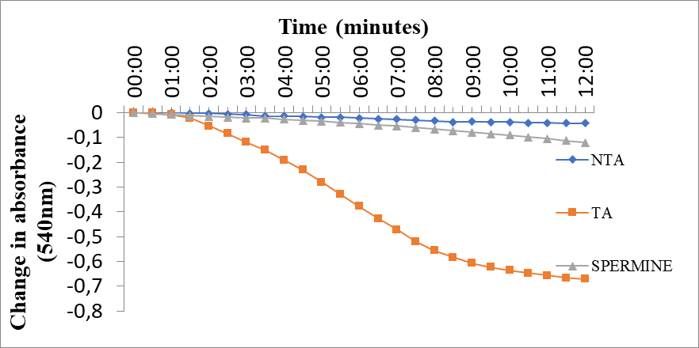
Figure 1: Calcium-induced mitochondrial permeability transition pore opening in normal rat liver mitochondria and its reversal by spermine. NTA no triggering agent (without calcium), TA triggering agent (calcium), Spermine standard inhibitor of mPT pore opening

Effects of the extract and fractions of Futumia elastica on the mPT Pore
Figure 2 depicts a representative profile of changes in absorbance of liver mitochondria of rat treated with 200 mg/kg of crude methanol stem bark extract and fractions of Funtumia elastica. The data shows the extent of induction of the various fractions. The CMFE, CFFE, EAFE and MFFE gave induction folds of 2.9, 12.3, 8.3 and 6.3, respectively, related to the control.

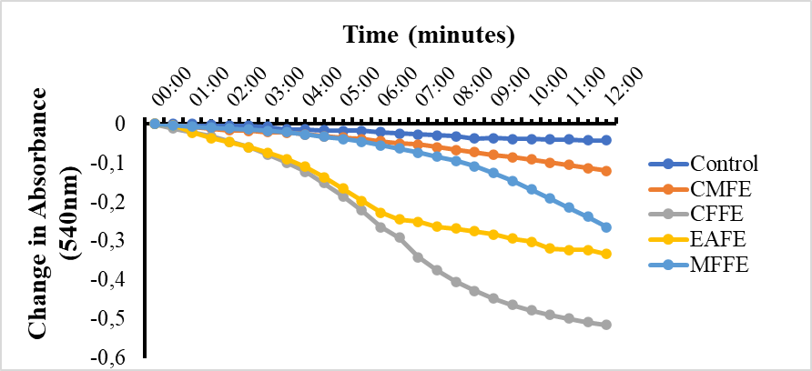
Figure 2: Representative profile showing the effects of the extract and fractions on mPT pore

CMFE: (crude methanol extract of Funtumia elastica),
CFFE: (Chloroform fraction of the methanol extract of Funtumia elastica)
EAFE: (ethyl acetate fraction of the methanol extract of Funtumia elastica)
MFFE: (methanol fraction of the methanol extract of Funtumia elastica)

Effects of CFFE on imPT pore opening
The data in Fig. 3 shows the effects of varying doses of CFFE (50, 100, 200 mg/kg) on imPT pore opening. Treatment with CFFE shows a significant dose-dependent induction of pore opening compared with the control. The CFFE at 50, 100 and 200 mg/kg caused induction folds of 3.7, 10.0 and 13.0, respectively, when related to the control.

Figure 3: Representative profile showing the effects of varying doses of CFFE on imPT pore opening after 28 days of oral treatment.

Effects of CFFE on mitochondrial F₁F₀ ATPase activity
The effects of CFFE on mitochondrial ATPase is illustrated in Fig. 4. The results indicated a significant dose-dependent enhancement of mitochondrial ATPase activity related to the control. The CFFE at doses 50, 100 and 200 mg/kg caused increase in mitochondrial ATPase activity by 20, 40, 56 %, respectively, when compared to the control.

Figure 4: Effects of varying doses of CFFE on mitochondrial ATPase activity.
The values are expressed as mean ± SD of four independent replicates. *P<0.05, **P< 0.01, ***P<0.001 compared to the control. 2,4-DNP (2,4-Dinitrophenol-classical uncoupler of oxidative phosphorylation)

Effects of CFFE on mitochondrial Lipid Peroxidation (mLPO)
The CFFE inhibited mLPO in a dose-dependent manner related to the control, as indicated in figure 5.
0.008
*
**
nmole MDA/mg protein

0.006

0.004

0.002

0.000
Control
50mg/kg
100mg/kg
200mg/kg

Doses of CFFE

Figure 5: Effects of varying doses of CFFE on Lipid peroxidation
The values are expressed as mean ± SD of four independent replicates. *P<0.05, compared to the

Effects of CFFE on caspases 9 and 3 levels
The data in figures 6 and 7 indicated a dose-dependent increase in the levels of caspases 9 (54.4, 78.8, 98.6 ng/ml) and 3 (10.1, 14.0, 22.6 ng/ml), at doses 50, 100 and 200 mg/kg, respectively, related to the control. CFFE activated caspase 9 by 50% 84%, 150% and caspase 3 by 11%, 55%, 144%, at doses 50,100 and 200 mg/kg, respectively, compared to the control.
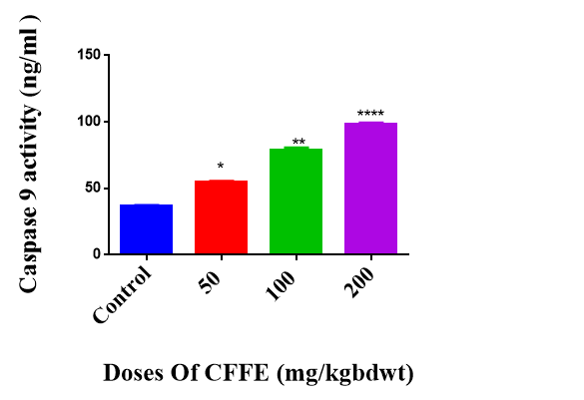
Figure 6: Effects of varying doses of CFFE on caspase 9 activity.
The values are expressed as mean ± SD of four independent replicates. *P<0.05, **P< 0.01, ****P<0.0001 compared to the control

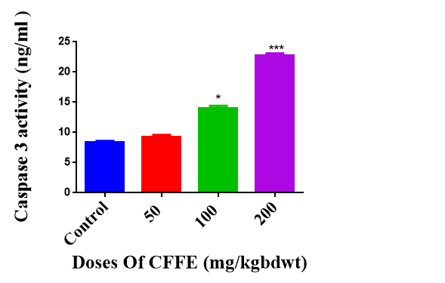
Figure 7: Effects of varying doses of CFFE on caspase 3 activity.
The values are expressed as mean ± SD of four independent replicates. *P<0.05, ***P<0.001 compared to the control.

Effect of CFFE on Hepatic DNA Fragmentation.
This is illustrated in figure 8. The results showed increase in percentage hepatic DNA fragmentation by 20, 37 and 50 % at doses 50, 100 and 200mg/kg, respectively, relative to the control.
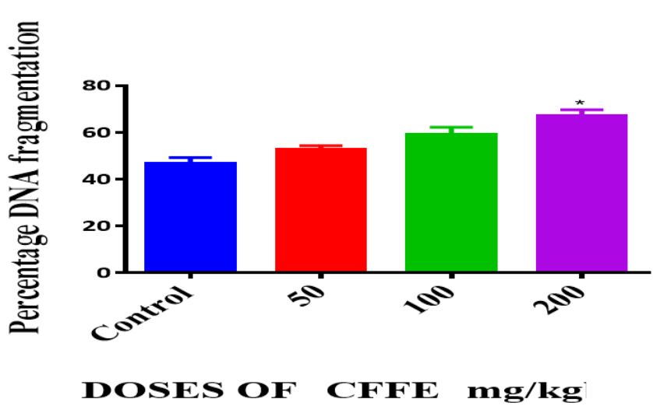

Figure 8: Effects of varying doses of CFFE on hepatic DNA fragmentation
The values are expressed as mean ± SD of four independent replicates. *P<0.05, compared to the control.

Histological examination
The results on the liver section of the control revealed normal morphology and healthy unfiltrated hepatocytes, without any pathological lesion. At doses 50 and 100 mg/kg, the hepatocytes displayed normal morphology, only with mild congestion at 100 mg/kg. At 200 mg/kg, there was mild congestion of the central venules, hepatic steatosis, while the sinusoids still showed very mild infiltration.

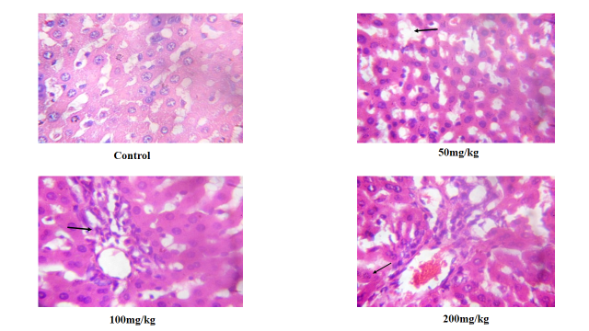
Figure 9: Representative Photomicrographs of rat liver section.
(Control): Shows the morphology of liver section of a normal rat. No lesions found, normal hepatocellular outline. (50mg/kg): Shows normal central venules without congestion. The hepatocytes with moderate infiltration by inflammatory cells and the sinusoids appear normal and not infiltrated. (100mg/kg): Shows central venules with mild congestion. Focal area of inflammatory cells aggregate, the sinusoids appear normal and not infiltrated. (200mg/kg): Shows the central venules with mild congestion, focal area shows the hepatocytes with infiltration, hepatic steatosis, the sinusoids show very mild infiltration. Magnification (X 400).

Discussion
Mitochondria play a crucial role in controlling cell death [23]. The mPT pore is now recognized as a determinant of cell survival or death [24]. This study investigated the effect of chloroform fraction of methanol extract of Funtumia elastica stem bark on mitochondrial-mediated apoptosis using rat liver. The mitochondria used in this study were intact as indicated by the calcium-induced pore opening and its reversal by spermine, a standard inhibitor of pore opening [17,26]. Having ascertained the intactness of the mitochondria used in this study, we explored the effects of the crude extract (CMFE) and its fractions (CFFE, EAFE and MFFE) on mPT pore opening. The extract and fractions caused mPT pore opening to varying degree, indicating the presence of phytochemicals in them that can interact with the pore and cause pore opening. However, CFFE was the most potent, suggesting that it contains the bioactive principle in abundance that can cause the induction of pore opening. This is comparable to the discoveries of Olowofolahan et al. [27,28], which demonstrated that chloroform fraction of methanol extract of Drymaria cordata is the most potent with respect to induction of mPT pore opening. The dose-dependent study on CFFE showed increase in induction of mPT pore with increase in dosage. This probably suggests its increase in bioavailability at the target site with increase in the dosage.
Studies have revealed that mPT pore opening instigates the release of mitochondrial factors, dissipation of membrane potential (Δψ), loss of cellular biochemical homeostasis and mitochondrial ATP hydrolysis [29,30]. The enhancement of mATP activity as a result of graded doses of CFFE treatment suggests that CFFE interacted with the mPT pore to instigate the pore opening, effecting subsequent release of some mitochondrial factors, mitochondrial ATP hydrolysis, mitochondrial energetic dysfunction and subsequently, cell death [2,31]. Studies have shown that reactive oxygen species (ROS) trigger peroxidation of mitochondrial membranes leading to cell death. Interestingly, there are compounds that can mitigate lipid peroxidation by inhibiting radical-induced oxidative damage [32]. The decrease in malondialdehyde levels as a result of CFFE treatment suggests the presence of phytochemicals in CFFE that can reduce free radical generation. Furthermore, it also suggests its physicochemical protective potential on membrane against free radical-induced damage.
The increase in levels of caspase 9 by CFFE treatment suggests that it is an inducer of mitochondrial-mediated apoptosis. Also, the increase in caspase 3 levels by CFFE indicated that activated caspase 9 caused cleavage of procaspase 3 to activate caspase 3 for subsequent downstream reaction. Caspases activation have been demonstrated to be crucial to execution of apoptotic process [7]. One of the hallmarks of apoptosis is nuclear DNA fragmentation. The CFFE caused dose-dependent increase in the hepatic DNA fragmentation, suggesting that the activated caspases by CFFE effected the activation of Deoxyribonlease (DNase) and subsequent cleavage of nuclear DNA. On the histological assessment, the CFFE did not really show any pathological lesion on the hepatocytes at the dosages used.
Based on the findings in this study, it can be suggested that chloroform fraction of methanol extract of Funtumia elastica is an inducer of mitochondrial-mediated cell death. Further work is still necessary to characterize and isolate the active principle responsible for these pharmacological potentials. This may be useful in situations that require upregulation of apoptosis.
References
- Martinez-Reyes I, Chandel NS. Mitochondrial TCA cycle metabolites control physiology and disease. Nat. Commun. 2020; 11:102.
- Halestrap AP. What is the mitochondrial permeability transition pore? Journal of Molecular and Cellulor Cardiology. 2009; 46, 821–831
3.Oh CM, Ryu D, Cho S, Jang Y. Mitochondrial Quality Control in the Heart: New Drug Targets for Cardiovascular Disease. Korean Circ. J. 2020; 50: 395–405.
4. Weinlich R, Oberst A, Beere HM, Green DR. Necroptosis in development, inflammation and disease. Nat. Rev. Mol. Cell Biol. 2017; 18:127–136.
5. Martins KR. Targeting apoptosis with dietary bioactive agents. Minireview, 117-130, membrane lipid peroxidation in human cancer (Spain); Cancer causes and Control, 2006; 15: 707-719.
6. McIlwain DR, Berger T, Mak TW. Caspase functions in cell death and disease. Cold Spring Harb. Perspect. Biol., 2013; 5; a008656. doi:10.1101/cshperspect.a008656
7. Van Opdenbosch N, Lamkanfi M. Caspases in cell death, inflammation, and disease. Immunity. 2019; 50: 1352–1364.
8 Stavrovskaya IG, Kristal BS. "The powerhouse takes control of the cell: Is the mitochondrial permeability transition a viable therapeutic target against neuronal dysfunction and death?". Free Radical Biology and Medicine. 2005; 6: 687–697.
9. Giampaolo Morciano, Natalia Naumova, Piotr Koprowski, Sara Valente, Vilma A. Sardão, Yaiza Potes, Alessandro Rimessi, Mariusz R. Wieckowski, Paulo J. Oliveira. The mitochondrial permeability transition pore: an evolving concept critical for cell life and death. Biological Reviews.2021; 96 (6): 2489-2521.
10. Kovac S, Dinkova Kostova AT, Herrmann AM, Melzer N, Meuth SG, Gorji A. Metabolic and Homeostatic Changes in Seizures and Acquired Epilepsy-Mitochondria, Calcium Dynamics and Reactive Oxygen Species. Int J Mol Sci. 2017; 18(9):1935. doi: 10.3390/ijms18091935.
- Zorov DB, Juhaszova M, Sollott SJ. Mitochondrial reactive oxygen species (ROS) and ROS-induced ROS release. Physiol Rev. 2014; 94(3):909-50. doi: 10.1152/physrev.00026.2013.
- Susin SA, Lorenzo HK, Zamzami N, Marzo I, Brenner C, Larochette N, Prevost MC, Alzari PM, Kroemer G. Mitochondrial release of caspase-2 and -9 during the apoptotic process J. Exp. Med. 1999; 189: 381–394.
- Qin ZH, Wang Y, Kikly KK, Sapp E, Kegel KB, Aronin N, DiFiglia M. Pro-caspase-8 is predominantly localized in mitochondria and released into cytoplasm upon apoptotic stimulation J. Biol. Chem. 2001; 276: 8079–8086.
- Green DR. Mitochondria and cell death: Outer membrane permeabilization and beyond. Nat Rev Mol Cell Biol. 2010; 11: 621–32.
- Johnson D, Lardy H. Isolation of liver or kidney mitochondria. Methods Enzymol. 1967; 1094–1096.
- Olorunsogo OO, Bababunmi EA, Bassir O. Uncoupling effect of N phosphonomethyl glycine on rat liver mitochondria. Biochem. Pharmacol. 1979; 27, 925–927.
- Lapidus RG, Sokolove PM. Inhibition by spermine of the inner membrane permeability transition of isolated heart mitochondria. FEBS Lett. 1993; 3: 314–318.
18. Lowry OH, Rosenbrough NJ, Farr Al, Randall RJ. Protein measurement with Folin phenol reagent. J. Biol. Chem. 1951; 193, 265–275.
19. Olorunsogo OO, Malomo SO. Sensitivity of Oligomycin-inhibited respiration of isolated rat liver mitochondria to perfluidone, a fluorinated arylalkylsulfonamide. Toxicology. 1985; 35, 231–240.
20. Bassir O. Improving the level of nutrition. West Afr. J. Biol. Appl. Chem. 1963; 7: 32–40
- Varshney R, Kale RK. Effect of calmodulin antagonists on radiation-induced lipid peroxidation in micro- somes. International Journal of Radiation Biology. 1990; 58: 773–743
22.Wu, Chin-Chung Mei-Ling Chan, Wen-Ying Chen, Ching-Yi Tsai, Fang-Rong Chang and Yang-Chang Wu DOI: 10.1158/1535-7163.MCT-05-0027.
23. Kroemer G, Galluzzi L, Brenner C. Mitochondrial membrane permeabilization in cell death. Physiological Reviews. 2007; 87: 99–163.
24. Javadov S, Karmazyn M. Mitochondrial permeability transition pore as end point to cell death and as a putative target for cardioprotection. Cellulor Physiology and Biochemistry. 2007; 20: 1–22.
25. Tait, S. W., & Green, D. R. (2010). Mitochondria and cell death: outer membrane permeabilization and beyond. Nature Reviews Molecular Cell Biology, 11, 621–632
26. Green DR, Kroemer G. The pathophysiology of mitochondrial cell death. Science 2004; 305: 626–62
- Olowofolahan AO, Adeoye OA, Offor GN, Adebisi LA, Olorunsogo OO. Induction of Mitochondrial Membrane Permeability Transition Pore Opening and Cytochrome C Release by Fractions of Drymaria cordata. Arch. Bas. App. Med., 2015; 3: 135–144.
- Olowofolahan AO, Olorunsogo OO. Induction of apoptosis in rat liver cells via caspase activation by chloroform fraction of methanol extract of drymaria cordata. Eur. J. Biomed. Pharmaceut. Sci. 2018; 5 (4): 73–83.
29.Angelin A, Bonaldo P, Bernardi P. Altered threshold of the mitochondrial permeability transition pore in Ullrich congenital muscular dystrophy. Biochimica et Biophysica acta.2008; 1777: 893–896
30. Seidlmayer LK, Gomez-Garcia MR, Blatter LA, Pavlov E, Dedkova EN. Inorganic polyphosphate is a potent activator of the mitochondrial permeability transition pore in cardiac myocytes. The Journal of General Physiology. 2012; 139: 321–331.
31. Chipuk JE, Mohammed JN, Gelles JD, Chen YY. Mechanistic connections between mitochondrial biology and regulated cell death. Developmental Cell. 2021; 56, 1221–1233
32. Ruberto G, Baratta MT, Deans SG, Dorman HJ. Planta Med. 2000; 66: 687
Brenner D, Mak TW. Mitochondrial cell death effectors. Curr Opin Cell Biol., 2009; 21: 871–877.

