***Original Research Article***

**Intrinsic Geo-Electric Characterization and Geomorphological Valuation for Groundwater Recharge Potentiality: Implications for groundwater sustainability**

**ABSTRACT**

This study investigates groundwater recharge (GWR) potential in a region characterized by varied lithology, topography, and geophysical properties by integrating geophysical parameters (resistivity, longitudinal conductance, transverse resistance, resistivity coefficient, and electrical anisotropy) with geo-morphological factors (topography and slope). Results indicate the southeastern, eastern, and central regions as primary recharge zones, characterized by permeable sandy and gravelly lithologies (100–150 ohm-m), low longitudinal conductance (0.01–0.38 S), and high transverse resistance (>7465 Ωm²). These areas, coupled with deep, weathered bedrock (notably migmatite-biotite gneiss, RC 0.41–0.99) and high anisotropy (1.50–3.06), exhibit enhanced storability, fracturing, and secondary porosity, forming critical recharge hotspots and the flat topography further facilitates infiltration. Conversely, clay-rich zones (S >0.5 S) in parts of the northeast and east; and steep southwestern ridges pose constraints due to low permeability and accelerated runoff, respectively. Despite lacking quantitative recharge estimates and local precipitation data, this study provides a robust framework for identifying recharge hotspots, offering critical insights for sustainable groundwater management in water-scarce regions. The study underscores the importance of targeted water management strategies, for optimizing GWR in less favorable areas. Recommendations include managed aquifer recharge and runoff management to enhance GWR in less permeable areas.

***Keywords: environmental sustainability; groundwater recharge; vertical electric sounding; climate change; groundwater exploitation; water management strategy***

**I recommend adapting bibliographic citations as indicated in the instructions for authors:**

**References must be listed at the end of the manuscript and numbered in the order that they appear in the text. Every reference referred in the text must also present in the reference list and vice versa. In the text, citations should be indicated by the reference number in brackets [3] (see below).**

**See:** [**https://peerreviewcentral.com/page/general-guideline-for-authors**](https://peerreviewcentral.com/page/general-guideline-for-authors)

**1. INTRODUCTION**

Water is a limited resource, unevenly distributed both spatially and temporally, and the utilization of surface water as an additional supply source necessitates extensive treatment processes, often at prohibitively high costs. In many developing nations, groundwater remains the most reliable source of potable water, except in areas affected by anthropogenic contamination **[1]** **[2]** ~~(Onana~~ *~~et al.,~~* ~~2017; Kouadio~~ *~~et al.,~~* ~~2022a)~~. Furthermore, the impact of climate change in recent years has exacerbated water scarcity and undermined population welfare, particularly in Africa. Consequently, groundwater has increasingly become a scarce and valuable resource **[3]** **[4]** ~~(Jakeman~~ *~~et al.,~~* ~~2016; Kouadio~~ *~~et al.,~~* ~~2022b).~~

However, over-reliance on groundwater can lead to excessive groundwater pumping with attendant significant issues, including sharp declines in groundwater levels, land subsidence and seawater intrusion into coastal aquifers (Jang *et al.,* 2013). Therefore, boosting groundwater recharge is generally seen as an effective solution to address the problems caused by over-extraction of groundwater. Delineating groundwater recharge zones for quality protection and quantity management is therefore a necessary task for preservation and sustainable utilization of this resource.

Primarily, groundwater is naturally recharged through precipitation. When rain falls, some of the water runs off along drains, creeks, or rivers, as surface water, while the rest infiltrates the soil and moves downward under the influence of gravity, percolating into unsaturated or saturated aquifers (Jang *et al.,* 2013). The capacity for recharge is therefore predicated on the occurrence of factors that allow for water seepage into subsurface aquifers where they can be stored and exploited.

(Jang *et al.,* 2013) suggests natural and anthropogenic factors that may influence the potential for groundwater recharge. These include natural factors such as hydraulic conductivity, lithology and surficial geology, lineaments, drainage, slope analysis, historic rainfall data and aquifer boundary conditions (Shuster *et al.,* 2007; Yeh *et al.,* 2009; Chenini *et al.,* 2010). Anthropogenic factors such as land use and land cover, while important are not intrinsic properties of the surface and subsurface rocks affecting infiltration and percolation of water into aquifers.

An in-depth understanding and quantification of groundwater recharge is problematic since recharge is highly variable both spatially and temporally. Consequently, several methods have been developed to attempt this endeavor. According to (Zomlot *et al.,* 2015) and several references cited therein, although several approaches for estimating recharge exists, uncertainty remains a significant challenge in recharge estimation. Groundwater recharge is a non-linear function influenced by factors such as hydrometeorology, land use, soil texture, slope, and the physical properties of aquifers (Zomlot *et al.,* 2015), and as a result, there has been an increasing focus on developing methods that account for the spatial-temporal variability of recharge in groundwater modeling. Of these methods, those dealing with the natural factors intrinsic to the earth layers above the aquifer are of interest to this research.

As argued by (Jang *et al.,* 2013), anthropogenic factors influencing groundwater recharge can be readily modified by landowners, whereas natural factors are considerably more resistant to human alteration. In general, intrinsic soil properties like elevated soil permeability facilitate the infiltration of surface water into the subsoil and accelerate the percolation of soil water into the groundwater system. Consequently, soil characteristics like permeability and porosity play a crucial role in determining the rate of subsoil infiltration and unsaturated soil percolation, and is the primary factor governing aquifer recharge.

(Falebita *et al.,* 2023) examined the uncertainties tied to groundwater-controlling aquifer parameters such as depth, thickness, resistivity, coefficient of anisotropy, transmissivity and yield; and provided a risk-based assessment of their distribution. This approach revealed the influence of these parameters on groundwater exploitation and management decisions in a typical basement complex. Their study highlighted the importance of understanding the complex spatial distribution of hydro-geological and aquifer-controlling factors in regulating groundwater flow and distribution.

When these parameters are assessed in the geological materials overlying an aquifer, they reveal the dynamics of fluid flow within these materials, the processes governing water infiltration into the aquifer, and help identify zones favorable for enhanced recharge. This understanding is essential for informed decision-making on groundwater recharge, as well as the sustainable management and optimal utilization of groundwater resources.

To properly manage groundwater resources, accurate information about the amount of water inputs replenishing aquifers (recharge) and the water leaving the aquifer by means of exploitation and natural discharge within the groundwater basin is needed so that the long-term behavior of the aquifer and its sustainable yield can be evaluated. As a pioneering step towards achieving this goal, the present study serves as a primal groundwater recharge research in the study area with an emphasis on intrinsic soil factors affecting recharge processes.

Fortunately, geophysical resistivity methods like Vertical Electrical Sounding (VES) can provide information on subsurface characteristics as the data obtained is mainly controlled by lithological conditions of the rock layers (Nwachukwu et al. 2019). The basic methodology of the electrical method rests on the flow of current within the rock layers and this closely mirrors fluid movement. Information on the electrical properties of the geological formations can thus provide a means of monitoring the ease of fluid flow within overburden rock layers, and thus help constrain zones favorable for groundwater recharge.

The VES method is usually considered more suitable for the subsurface investigation of geologic environments consisting of horizontal or nearly horizontal layers (Ojekunle *et al.,* 2015; Nwachukwu *et al.,* 2019). Additionally, VES provides a cost effective, rapid and nondestructive effect on the environment coupled with limited ambiguity in interpretation (Nwachukwu *et al.,* 2019). VES can also be used to constrain the thickness of lithologic layers, and is also useful in the correlation of lithological farcies? between measurements taken at various stations.

Although some research has been carried out on aspects of groundwater studies within the study area such as groundwater potential (Omali, 2014; Aku and Gani, 2015; Musa *et al.,* 2023), groundwater vulnerability and quality (Ayuba *et al.,* 2013; Chiazor *et al.,* 2016; Ayua *et al.,* 2024), there is insignificant research output on the aquifer recharge zones in the area. Information on groundwater recharge zones is important for quality protection and quantity management as well as planned interventions for mitigating the effects of over-exploitation of aquifers. Such interventions could include construction of artificial ponds or wetlands to enhance groundwater recharge such as was planned in Taiwan according to (Jang *et al.,* 2013). The present study therefore aims at utilizing the relatively cheap and fast geophysical VES method to provide information on the layer resistivity, layer thickness and lithology. In that way, a quick look evaluation of potential groundwater recharge zones will be achieved. Our study will also serve as a pivot study upon which future research can build on to investigate in greater detail and with more sophisticated methodology the groundwater recharge zones within the study area.

**1.1 Location and Geology of the Study Area**

The study area is located within Lokoja Township, and covers 60 36 E to 60 45 E and 70 44 N to 70 52 N (Figure 1) with an area of approximately 707 km². It is situated within the Guinea Savannah climate zone of West Africa, which is characterized by two primary seasons: the wet or rainy season and dry or Harmattan season. Mean yearly precipitation in Lokoja is approximately 12.14 cm (Olatunde & Isaac, 2018; Naiyeju *et al.,* 2021). The region's mean yearly temperature atypically does not fall below 30.7°C, with February and March being the peak of the hot season (Olatunde & Ukoje, 2016; Naiyeju *et al.,* 2021) and occurring at the end of the Harmattan season in January and before the start of the rainy season in April.

Geologically, the area is underlain by both basement complex and sedimentary formations (Figure 2). The western and central section is dominated by the crystalline basement complex of Precambrian origin, which includes rocks such as migmatite, migmatitic gneiss, undifferentiated granite, granite gneiss, biotite hornblende gneiss and schists. In contrast, the northeastern section is covered by Cretaceous to Recent sedimentary deposits of the southern Bida Basin. In the southern Bida Sub-Basin, exposure of sandstones and conglomerates of the Lokoja Formation directly overlies the Pre-Cambrian to Lower Paleozoic basement gneisses and schists. The Lokoja Formation is overlain by the alternating shales, siltstones, claystones and sandstones of the Patti/Ahoko Formation within the Koton-Karfi and Abaji axis. The formation was later succeeded by the clay stones, concretionary siltstones and ironstones of the Agbaja Formation (Obaje, 2009).

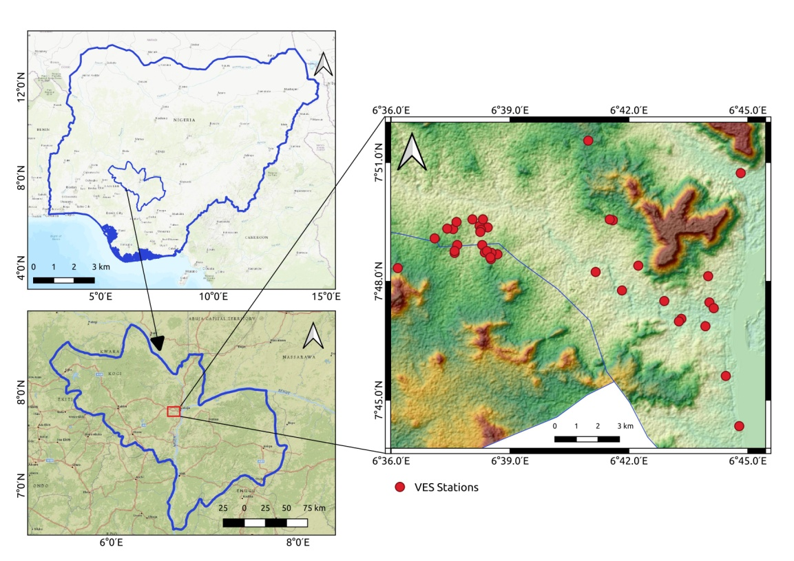

**Figure 1:** Location of the study Area, showing distribution of VES stations

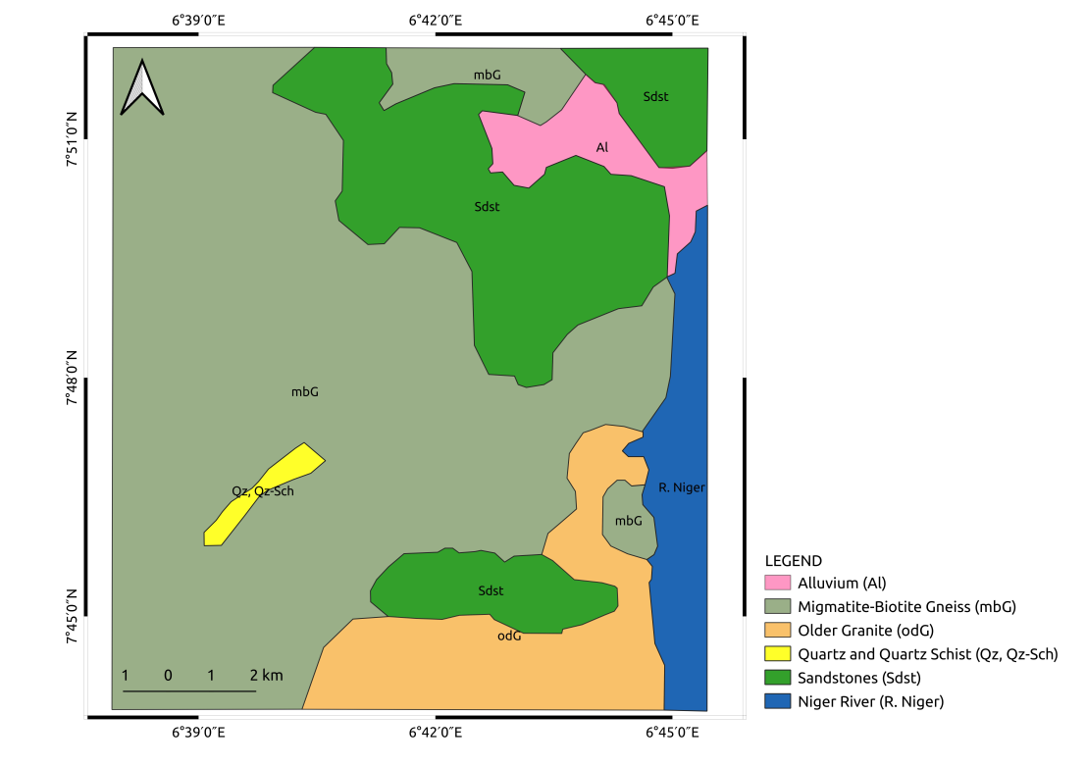

**Figure 2:** Local geology of the study Area (Modified after NGSA, 2006)

**2. MATERIALS AND METHODS**

**2.1 Data Acquisition and Processing**

The Schlumberger electrode array was used to acquire Vertical Electrical Sounding (VES) data from thirty-eight (38) stations using SAS 300C Digital Tetrameter. Current electrode separation (AB) ranged from 1 m to 120 m, with the potential electrode spacing (MN) adjusted incrementally between 1 m and 5 m for accurate measurements whenever the potential measured at a given AB spacing became noisy. Current electrode spacing was sequentially increased and the electric potential at each AB distance was measured and recorded until the maximum separation for the station was reached. Apparent resistivity (ρa) was then calculated using the below equation:

$ρ_{a}=\frac{\left(R*π{\left({AB}/2\right)}^{2}\right)}{MN}$**(1)**

Where, ρa is the apparent resistivity; AB/2 is half-current electrode spacing; R is resistance (R= V/I, with V as voltage and I as current), and MN is potential electrode spacing.

Data processing involved manual partial curve matching for initial model generation and digital inversion by computer assisted forward modeling. During the manual modeling, ρa values were plotted on bi-logarithmic graphs, smoothed, and analyzed with the semi-quantitative auxiliary point method to generate initial models of subsurface layers. The initial models where then used as input for 1D inversion using WinRESIST software, in order to refine the resistivity and thickness values of the initial model. Results were constrained on the basis of RMS error and apriority geological information of the area and outputs with RMS errors below 5% were accepted; otherwise, the curve-matching process was repeated.

For data interpretation, subsurface lithology and key layers were identified using geological data and borehole logs. Secondary parameters, such as longitudinal conductance, transverse resistance, fracture coefficient, and anisotropy, were derived as discussed in the next section.

**2.2 Secondary Electrical Resistivity Parameters**

Six representative parameters - Longitudinal Conductance (S), Transverse Resistance (T), Coefficient of Electrical Anisotropy (λ), Resistivity for the Formation (ρm), and Reflection Coefficient (RC) reflective of the characteristics of layered earth were estimated after (Kumar *et al.,* 2015).

The longitudinal conductance (S) and transverse resistance (T) are crucial for current flow parallel and perpendicular to the geo-electrical boundaries, respectively. These parameters, referred to as Dar Zarrouk parameters, are defined for a layer with thickness 'h' and resistivity 'ρ' as follows:

$S=\sum_{i=1}^{n}{\frac{h_{i}}{ρ_{i}}}$ (2)

$T=\sum_{i=1}^{n}{h_{i}ρ_{i}}$ (3)

When a geo-electrical section involves multiple layers with thicknesses h1, h2, h3,, transverse resistances T1, T2, T3, ..., and conductance S1, S2, S3, ..., the total longitudinal conductance (S) or total transverse resistance (T) must be taken into account. These are expressed as:

$S=S_{1}+S_{2}+S_{3}+.......S_{n}$**where $S_{1}=\frac{h_{1}}{ρ_{1}}$** and so on (4)

$T=T_{1}+T_{2}+T_{3}+.......T_{n}$**where $T_{1}=h_{1}ρ_{1}$** and so on (5)

In areas with homogeneous geo-electric conditions, the parameter S is directly proportional to the depth of the basement; H. Elevated values of S suggest a deeper basement, whereas lower values of S are associated with a shallower basement. Consequently, the basement topography is inversely reflected by the distribution of S values.

If the total thickness of the layers in the geo-electrical section is denoted as H, the average longitudinal resistivity, ρl, defined (Mogaji, 2016) as the fraction of total thickness of the layers (H) with the longitudinal conductance (S) is calculated as:

$ρ_{l}=\sum_{i=1}^{n}{\frac{H}{S_{i}}}$ (6)

And the average transverse resistance ρt..., defined (Mogaji, 2016) as the ratio of the total transverse resistance (T) to the total thickness of the layers (H) is given by

$ρ_{t}=\sum_{i=1}^{n}{\frac{T_{i}}{H}}$ (7)

The value of ρt is always greater than ρl, meaning that the entire section will consistently exhibit anisotropy in terms of electrical resistivity (Niwas S, Singhal DS, 1981). The coefficient of electrical anisotropy is defined (Mogaji, 2016) as the ratio of the total transverse resistivity (ρt) to the total longitudinal resistivity (ρl) as shown in equation (8):

$λ=\sqrt{\frac{ρ_{t}}{ρ_{l}}}$ (8)

Where λ is always greater than 1. The parameters λ is of considerable importance in groundwater recharge zonation as it correlates with fracture zones, especially in hard rock terrains. This parameter aids in the identification of zones which acts as selective pathways for water seepage into aquifers.

It is well established that the resistivity of geological formations is influenced not only by moisture content but also by lithological composition, with grain size being a particularly significant factor in sandy formations. Lithological composition and grain size are veritable controls on the porosity and permeability of rocks and can act as control factors for groundwater recharge potentiality. and Additionally, rocks with higher clay content typically exhibit lower resistivity values. The highest resistivity values can be observed for gravels and pebbles, and lowest resistivity are observed for clay formations. The mean value of resistivity for the formation (ρm) can be defined as

$ρ_{m}=\sqrt{ρ_{t}ρ_{l}}$**(9)**

The resistivity coefficient (RC) of the fresh basement rock in the study area were computed using the methodologies proposed by (Adeniji *et al.,* 2013) and (Nwachukwu *et al.,* 2019).

$R_{c}=\frac{ρ_{n}-ρ_{n-1}}{ρ_{n}+ρ_{n-1}}$**(10)**

**3. RESULT AND DISCUSSION**

**3.1 Field Curves**

Resistivity sounding conducted in the study area identified three main curve types: three-layer (e.g. A and K type), four-layer (e.g. HA, QH and KH), and five-layer (e.g. HAK, HKH and QHA), some of which are depicted in Figure 3 below. The variability in these curve types reflects the geological diversity typical of complex environments, as observed by (Ayua *et al.,* 2023; Ayua *et al.,* 2024) and is consistent with those obtained in areas with similar geologic conditions with the study region e.g. (Musa *et al.,* 2023).

The qualitative statistical analysis of the distribution of curve types in the study area indicated that highest occurrence (35.1%) of curve types is the H-type curve, followed by HA (16.2%) and KH and QH curve types with 10.8% occurrence each. The preceding curve types collectively made about 79.4% occurrence in the entire study area. The remaining curve types made up the remaining 21.6%. Of this percentage (21.6%), The 5-layer QHA and HKH curve-types were more dominant, accounting for 50% while K, A, HK and HAK made up the remaining 50%, with equal occurrence.

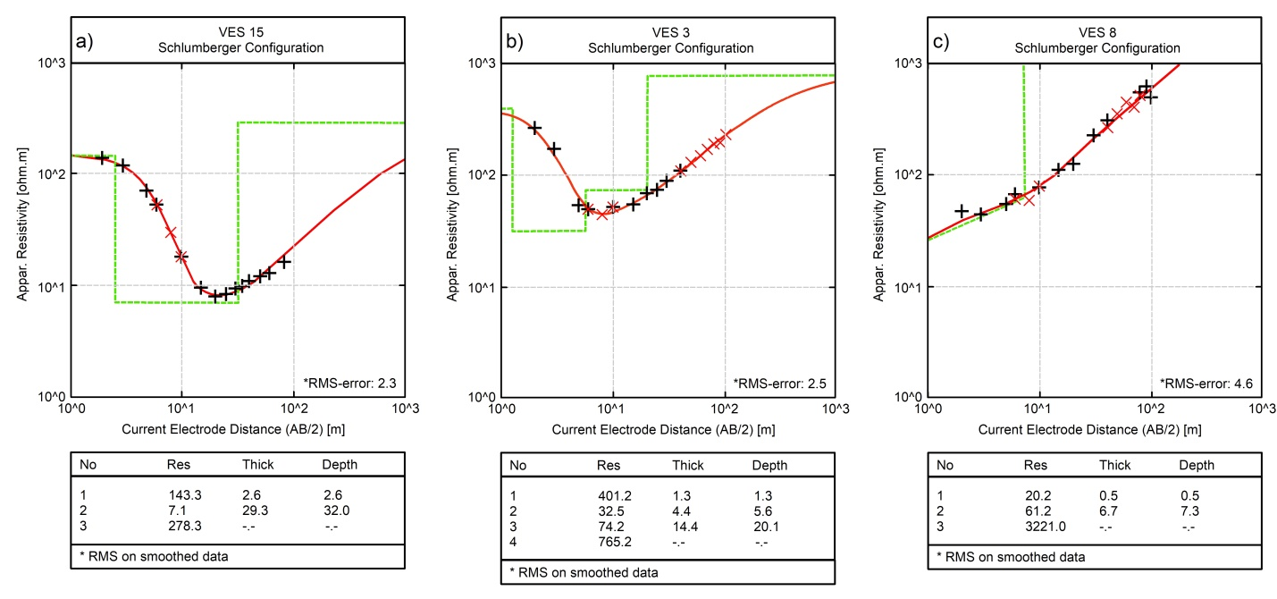**Figure 3:** Representative curve types obtained from the study area (a) 3-layer H-type Curve (b) 4-layer HA-type Curve (c) 3-layer A-type Curve. After [16]

**3.2 Geo-electric configuration and aquifer model**

Three distinct geological models were characterized: the three-layer, four-layer, and five-layer configurations. The three-layer model includes thin clay topsoil; a weathered basement rock serving as the main aquifer; and an infinite fresh or fractured basement rock below. The four-layer model features a clayey topsoil; alternating clay or laterite layers with varying properties; and a weathered or fractured basement aquifer; underlain by a competent basement rock of indeterminable thickness. The five-layer model starts with topsoil; followed by laterite/lateritic-clay; and sandy-clay/clay/weathered/fractured basement rocks (aquifer units) for the sedimentary or basement portions of the study area where applicable; and fresh basement rocks of indeterminate thickness.

**3.3 Average Resistivity**

The resistivity of geological formations is widely recognized to be influenced by both moisture content and lithological composition, with grain size playing a particularly important role in sandy formations. Figure 4 illustrates the mean resistivity distribution of the study area, with lithological classifications based on (Oni *et al.,* 2017). Lithologies with resistivity values below 100 ohm-m include clay/silt, sandy clay, and clay sand. Sandy lithologies exhibit resistivity between 100 and 150 ohm-m, while lateritic sands range from 150 to 400 ohm-m. Resistivity values exceeding 400 ohm-m are associated with laterites and competent basement rocks.

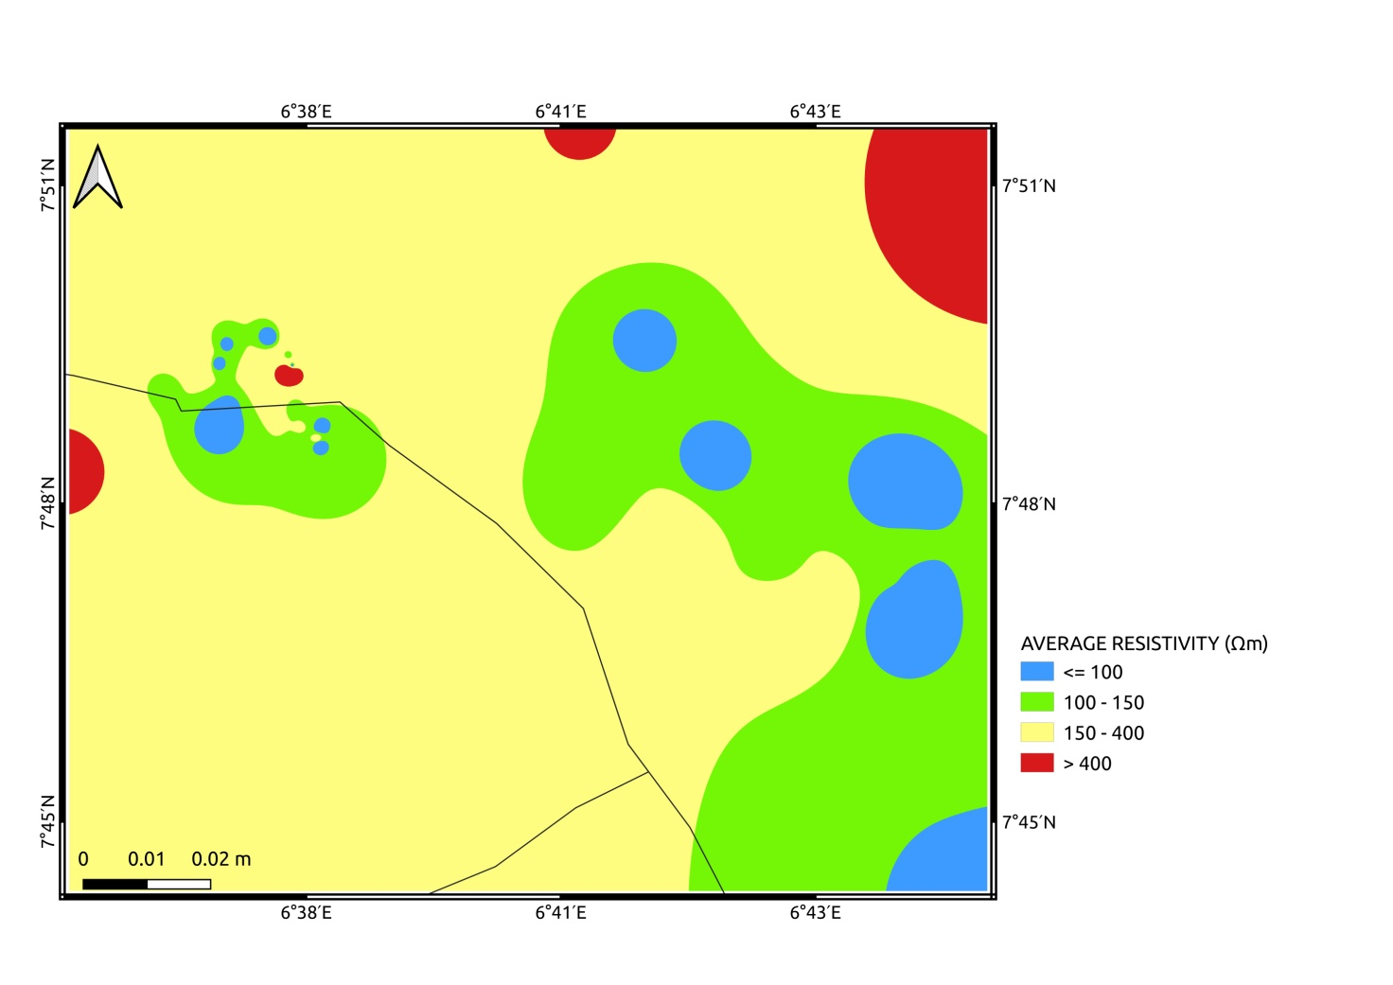

**Figure 4:** Average Resistivity distribution within the study area

Lithological characteristics significantly influence Groundwater Recharge (GWR), as different lithologies affect permeability and productivity potentials (Letz, 2021; Mengistu, 2022). Variations in lithological composition can impact groundwater storage capacity by influencing storativity, which determines the amount of water released from the geological matrix. Additionally, local micro-scale infiltration patterns, crucial to GWR, are affected by the interplay between lithological formations and land surface structures (Bloomfield *et al.,* 2011; Subramani *et al.,* 2024). Rocks with higher clay content generally display lower resistivity values, reflecting their low permeability and limited suitability for effective GWR. Similarly, while laterites may be structurally competent, they can impede water infiltration into aquifers.

Based on these considerations, the sandy, gravel, and pebble lithologies found in the southeastern, eastern, and central parts of the study area are deemed most favorable for supporting groundwater recharge.

**3.4 Depth to Bedrock**

Figure 5 shows the depth to the bedrock distribution in the study area. Deeper bedrock depths are critically important to groundwater recharge as they enhance storativity, improve permeability through weathering and fracturing, and support the development of recharge hotspots that proportionately contribute to overall groundwater supply. Storativity, a key aquifer parameter, measures the volume of water an aquifer can store or release per unit surface area per change in hydraulic head. It increases with aquifer thickness and, together with thickness, determines specific storage, which reflects the aquifer's long-term groundwater supply potential. Shallow depths near the water table, especially in fractured zones, significantly enhance storativity by providing additional pathways for water movement.

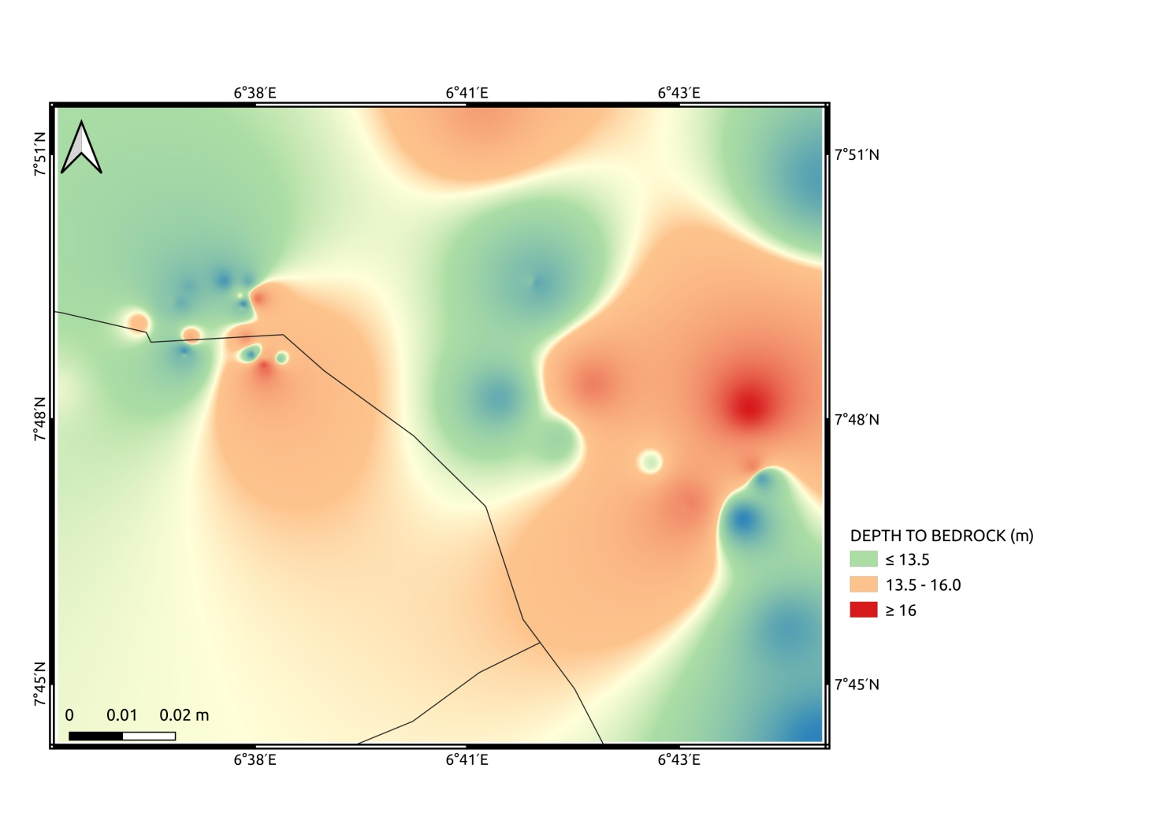

**Figure 5:** Depth to Bedrock distribution within the study area

Aquifers classified as excellent groundwater availability and recharge zones (GWARZ) typically feature a deep water table, high storativity, and strong water-holding capacity, supporting sustained groundwater supply. Bedrock permeability, influenced by weathering, fracturing, and soil depth, plays a crucial role in groundwater recharge (GWR) distribution. Highly weathered and fractured bedrock, along with thick soil cover, enhances permeability and recharge potential. These factors collectively determine the location of bedrock GWR hotspots and influence groundwater availability and sustainability across regions.

On that basis, zones with deeper bedrock depth are considered more important in considering zones of enhanced recharge. By facilitating deeper percolation, these zones reduce the impact of surface disruptions and ensure a more stable, long-term groundwater resource, particularly in areas where sustainable groundwater management is essential for meeting agricultural, domestic, and industrial water demands. The spatial occurrence of these hotspots is primarily controlled by dynamic factors that modulate recharge patterns, notably the interaction between rainstorm characteristics and the soil’s water storage capacity. Specifically, variations in soil depth influence the residence time of water in the unsaturated zone, affecting the likelihood of water reaching the underlying bedrock.

**3.5 Longitudinal Conductance (S)**

The longitudinal conductance (S) measures current flow parallel to the geo-electric boundaries which is in turn influenced by fluid flow in this direction. The study of the longitudinal conductance provides veritable information on soil properties, such as structure, texture and composition within this zone. This is significant for a clear-cut comprehension of the potentiality for groundwater presence, motility and recharge within the study area.

Longitudinal Conductance offers insights into the composition and structural characteristics of the geological formations and has been used to infer recharge potential of the regolith units (Akanbi, 2019). Areas with high S values are locations with low recharge potential, while the converse holds true for locations with low S values. Figure 6 shows the S distribution in the study area.

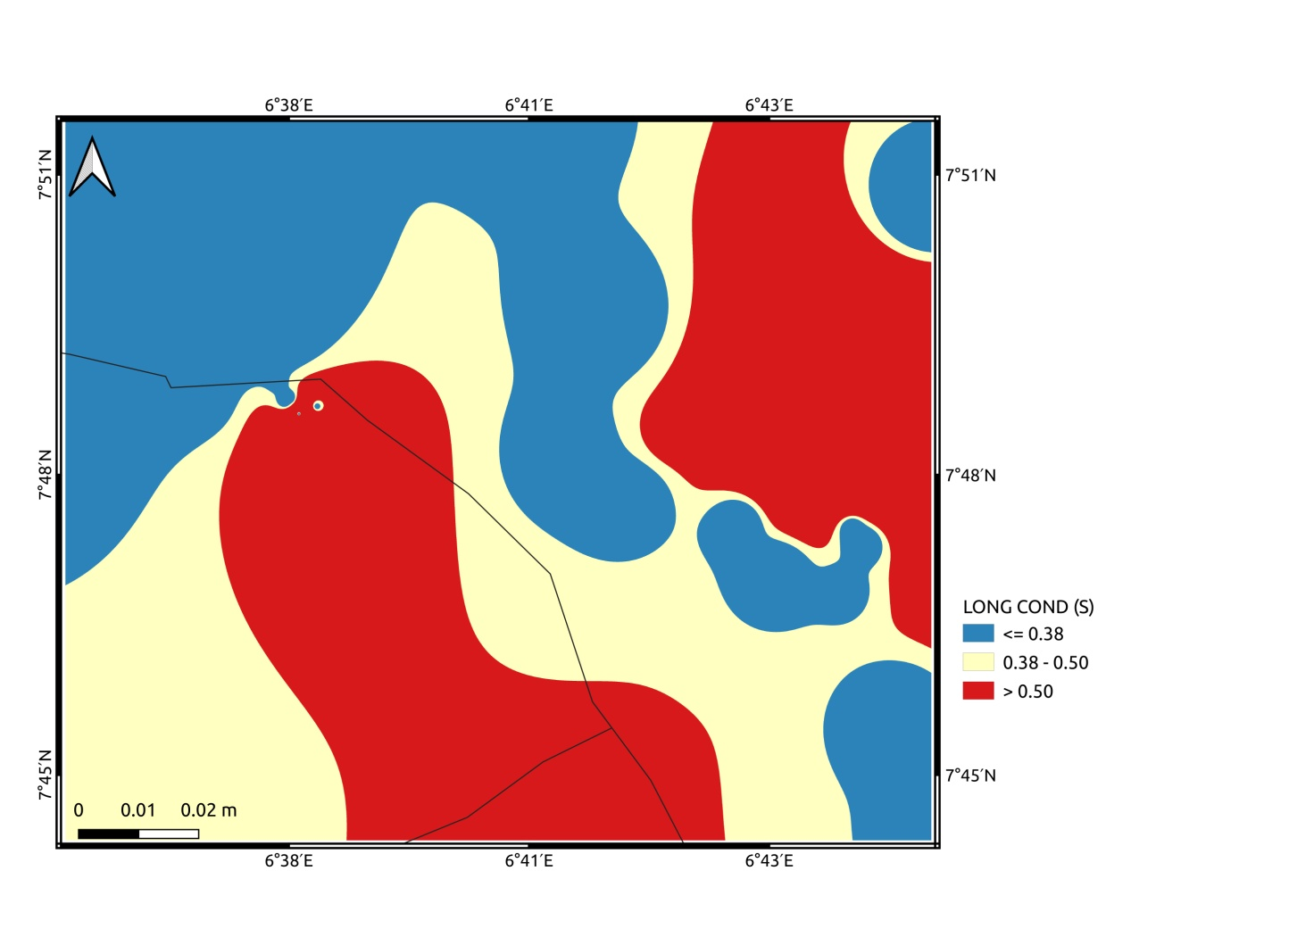

**Figure 6:** Longitudinal conductance distribution within the study area.

The study area can be divided into three broad zones of low (0.01 – 0.38 S), medium (0.38 – 0.50 S) and relatively high (> 0.5 S) longitudinal conductance. The northwestern portion, northeast, central and south east portions (blue color code) have the lowest S values indicating best zones for groundwater recharge on the basis of longitudinal conductance. Conversely, parts of the northeast and eastern portions of the study area and a limited region of high S values to the south (red colour code) have high longitudinal values indicating a preponderance of clay lithology, correspondingly lower permeability and an ensuing poor groundwater recharge potential.

Bedrock permeability is measured by the longitudinal conductance which is generally related to the clay nature of the rocks. When the volume of rainfall is high, rapid infiltration may occur, especially in areas where bedrock permeability is elevated. Shallow soils over permeable bedrock may facilitate rapid recharge, whereas deeper soils with lower permeability may delay or impede infiltration. Infiltration and retention capacities of the soils are also influenced by the magnitude and intensity of precipitation events relative to the soil’s permeability characteristics and these dictate whether rainfall contributes to deep percolation or is lost to surface runoff (Akiang *et al.,* 2024).

**3.6 Transverse Resistance**

The overburden represents the vertical distance between the aeration zone above and the saturated zone of the water table below — a crucial factor in understanding groundwater movement. Following rainfall, water infiltrates through pores and fractures in the overburden, driven by gravity, gradually percolating deeper into the soil (Akiang *et al.,* 2024). This vertical fluid movement is closely linked to Transverse Resistance. When the electric current flows perpendicular to geo-electric boundaries, the key parameter becomes transverse resistance, as opposed to longitudinal conductance, which measures current flow parallel to these boundaries (Akanbi, 2016). Transverse resistance, therefore, becomes essential for evaluating vertical fluid flow, providing a more detailed understanding of groundwater movement and recharge potential within the study area. Figure 7 shows the transverse resistance distribution in the study area.

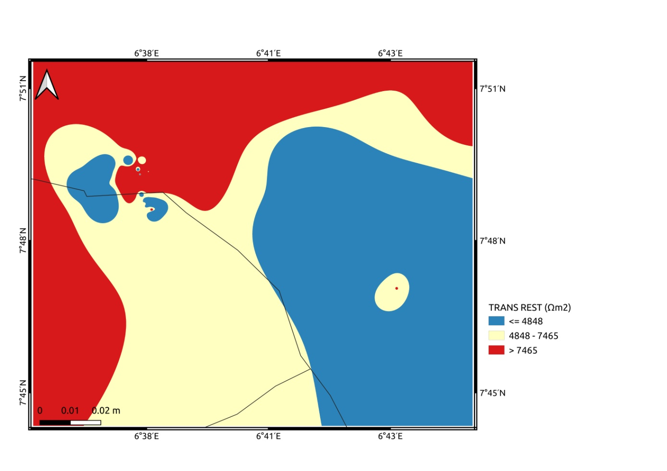

**Figure 7:** Transverse Resistance distribution within the study area.

Electric transverse resistance is a key factor in groundwater, offering valuable insights into the potential of porous media by linking fluid flow to electrical conductivity (Salem, 1999). This relationship implies that higher transverse resistance is associated with greater transmissivity and the presence of zones with high fluid potential within the subsurface materials (Salem, 1999; Gupta, 2015).

The study area is divided into three broad zones of low (< 4848 Ωm2), medium (4848 – 7465 Ωm2) and relatively high (>7465 Ωm2) transverse resistance. The eastern and south east regions of the study area (blue colour code) have the lowest S values indicating poor zones for groundwater recharge on the basis of transverse resistance. Conversely, north, northwest, northeast, southwest and western parts of the study area have high transverse resistance values (red colour code) have indicating areas with greater vertical transmissivity, thereby indicating a higher groundwater recharge potential.

Comparison of the values of transverse resistance and Longitudinal conductance shows that the transverse resistance is more than the average longitudinal resistivity. We agree with (Olubusola *et al.,* 2018) that this is an indication that the true resistivity normal to the plane of structural features is greater than the true resistivity parallel to the plane of structural features. Hence, we infer that the transverse resistance is more significant than longitudinal conductance in the discussion of groundwater recharge within the study area.

**3.7 Resistivity Coefficient (RC)**

Resistivity Coefficient is analogous to reflection coefficient in seismology. If the layer(s) directly overlying the competent basement is made of soft sediments or weathered materials, the difference in material properties creates a boundary — an "impedance mismatch." The electrical signal traveling through the overlying layers hits the basement having different electrical impedance; part of the signal is transmitted, but some of it reflects back. The strength of the reflection is dependent on the difference of the materials on either side of the geologic boundary.

Evaluation of the RC at the bedrock interface is a more reliable parameter in the identification of the nature of bedrock (Oloruntola and Adeyemi, 2014). The magnitude of the reflection coefficient indicates the amount of reflection, with a larger value indicating more reflection. Areas with low reflection coefficients represent areas where the bedrock is weathered and/or fractured (Olayinka, 1996), and this is significant for groundwater recharge.

The RC values for the entire study area ranges from -0.91 to 0.99 but considering the absolute values of RC gives 0.41 to 0.99. RC distribution within the study area (Figure 8) shows a close association with lithology. The RC within older granite has values ranging from 0.89 to 0.95 with an average of 0.92. This represents the highest average RC within the study area. The RC values for migmatite-biotite gneiss range from 0.41 to 0.99, with an average value of 0.82. Most of the study area is underlain by migmatite-biotite gneiss and has a lower average reflection coefficient compared with the older granite. The lowest RC values, and hence zones of highest basement weathering and or fracturing occur within this lithology. In the sedimentary regions, RC values range from 0.68 to 0.89, with an average value of 0.76.

Weathering intensity on the basis of our study in the major rock units are in the order of Migmatites-biotite gneiss before Granites. This implies a greater propensity for meta-sedimentary rocks to weather compared with igneous rocks. Over all, since Hydraulic conductivity and bedrock permeability are critical hydro-geological parameters governing the spatial distribution of bedrock groundwater recharge (GWR) hotspots; and these parameters are positively associated with weathered bedrock in basement complex rocks, therefore the zones of limiting RC are critical for improved GWR in the study area.

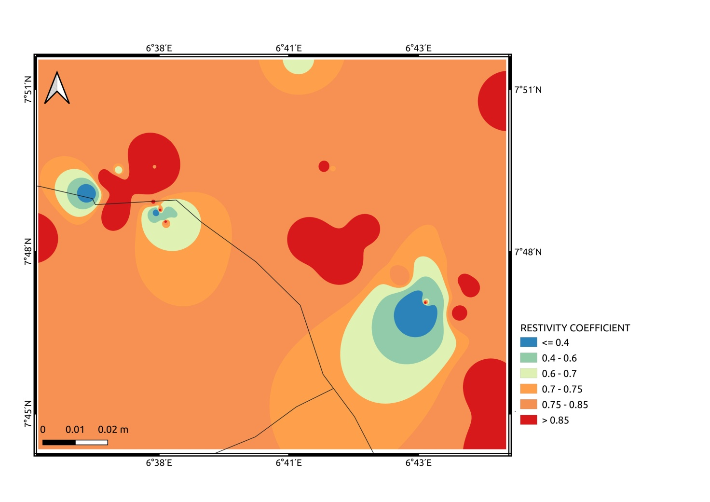

**Figure 8:** Resistivity coefficient distribution within the study area

**3.8 Coefficient of Electrical Anisotropy**

The anisotropy coefficient serves as an indirect indicator of fracturing intensity (Osinowo and Arowoogun, 2020) and quantifies variations in a rock formation’s anisotropic flow properties (Olaniyan, 2020). Within rock layers, this flow pattern may reflect either Omni-directional fracture systems or fractures at different stages of development. Fractures, faults and other curvilinear structures, collectively called lineaments, enhance groundwater infiltration and movement, thereby improving both recharge and storage potential. Areas with a higher density of lineaments, correlated with enhanced values of electrical coefficient of anisotropy generally exhibit greater groundwater recharge capacity due to increased subsurface permeability. A lower anisotropy coefficient would therefore signify reduced fracturing, correlating with lower groundwater storage potential (Osinowo and Arowoogun, 2020).

Similarly, higher anisotropic coefficient values indicate greater secondary porosity, improving water retention and multidirectional transmission within fractured rock. Conversely, a low anisotropy coefficient suggests a predominantly unidirectional fracture system, restricting fluid inflow and limiting overall transmission potential.

The anisotropy coefficient values in this study ranged from 1.03 to 3.06, with a mean value of 1.47, closely aligning with findings by (Omali, 2014) and (Olatunji et al., 2020) in proximal areas. A few anomalously high values at VES locations VES 29 (11.53), VES 20 (8.93), and VES 18 (7.05) were observed. These were due to very thin aquifer overburden, anomalously high T values or anomalously low S values leading to the ratio (ρt) to (ρl) 2-3 orders higher than the mean.

Coefficients exceeding 1.5 are generally considered high and within the study area, elevated values predominantly occur in the northern, northeastern, southeastern and southwestern regions (Figure 9). This trend may be attributed to anisotropic flow influenced by sediment characteristics and the pressure of overlying materials, which create flow channels parallel to bedding planes or weak bedding planes, laminations and fracturing within the meta-sedimentary rocks. The coefficient of anisotropy can also indicate lithological interfaces that act as weak zones for fluid migration, influencing directional porosity and permeability. Lower values in the central and southwestern regions may suggest isotropic flow, where permeability remains uniform across all directions.

In comparison with similar geological settings, the anisotropy coefficients in this study exhibited significant variability. However, result from the basement complex region aligns well with previous research. For instance, in southwestern Nigeria, the anisotropy coefficients of igneous and metamorphic basement rocks ranged from approximately 1.56 to 2.12 (Olorunfemi *et al.,* 1991), consistent with our findings (λ = 1.03 – 3.06). Subsequent studies by (Olajide *et al.,* 2022; (λ = 1.0 – 3.0) and (Olatunji et al, 2020; (λ = 1.04 - 3.80)) further corroborated these values, reporting comparable values or slightly higher values than reported by (Olorunfemi *et al.,* 1991).

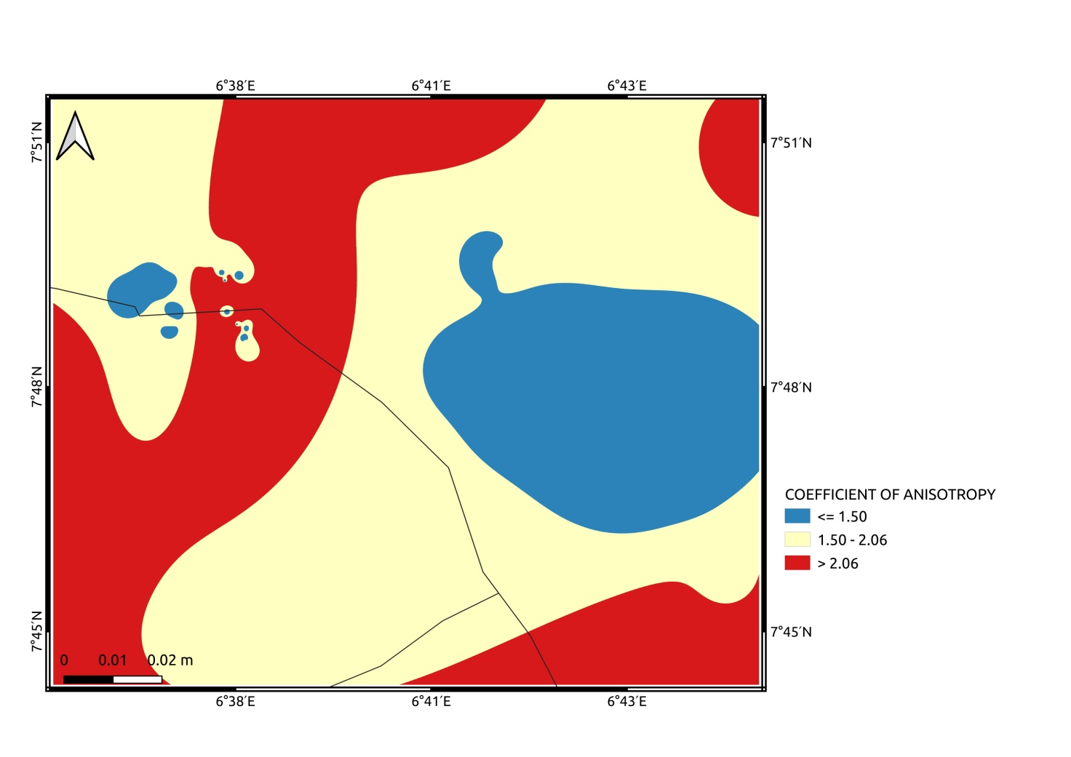

**Figure 9:** Coefficient of electrical anisotropy distribution within the study area

Anisotropy distribution within the study area shows a close association with lithology. The highest average anisotropy values occurred in the sedimentary regions where anisotropy values range from 2.39 to 2.97, with an average value of 2.68. In the basement complex, both rock types had the same average anisotropy value of 1.40. Anisotropy values for migmatite-biotite gneiss range from 1.03 to 3.06 while values in the older granite range from 1.27 to 1.57. The older granite exhibited more uniform anisotropy values indicating higher degree of homogeneity.

(Olubusola *et al*., 2018) observed that areas with high anisotropy coefficients indicate a multidirectional fracture system with varying degrees of fracturing, enhancing water retention and increasing porosity. In contrast, a lower anisotropy value corresponds to unidirectional fractures. This suggests the presence of high anisotropy coefficients represents macro-anisotropy in the region's soil structure favorable for water movement. (Yeboah-Forson, 2014) further emphasized that a highly interconnected conduit system, indicative of greater anisotropy, is crucial for groundwater modeling, as they indicate probable zones for fluid migration into aquifers, enhancing recharge. The above reinforce our choice of high anisotropy areas as favorable zones for enhanced groundwater recharge.

**3.9 Geo-morphological Characteristics**

The study area is located on a relatively flat plain positioned between the Niger River and the star-shaped Patti Hill—a prominent high plateau ridge rising to an altitude of 400 meters, prominently visible in the northeastern sector of the region (Figure 10). Additional notable ridges occur in the southwestern and western portions of the study area, exhibiting significant slope gradients, as illustrated by topographic profiles A–A’, B–B’, C–C’, and D–D’.

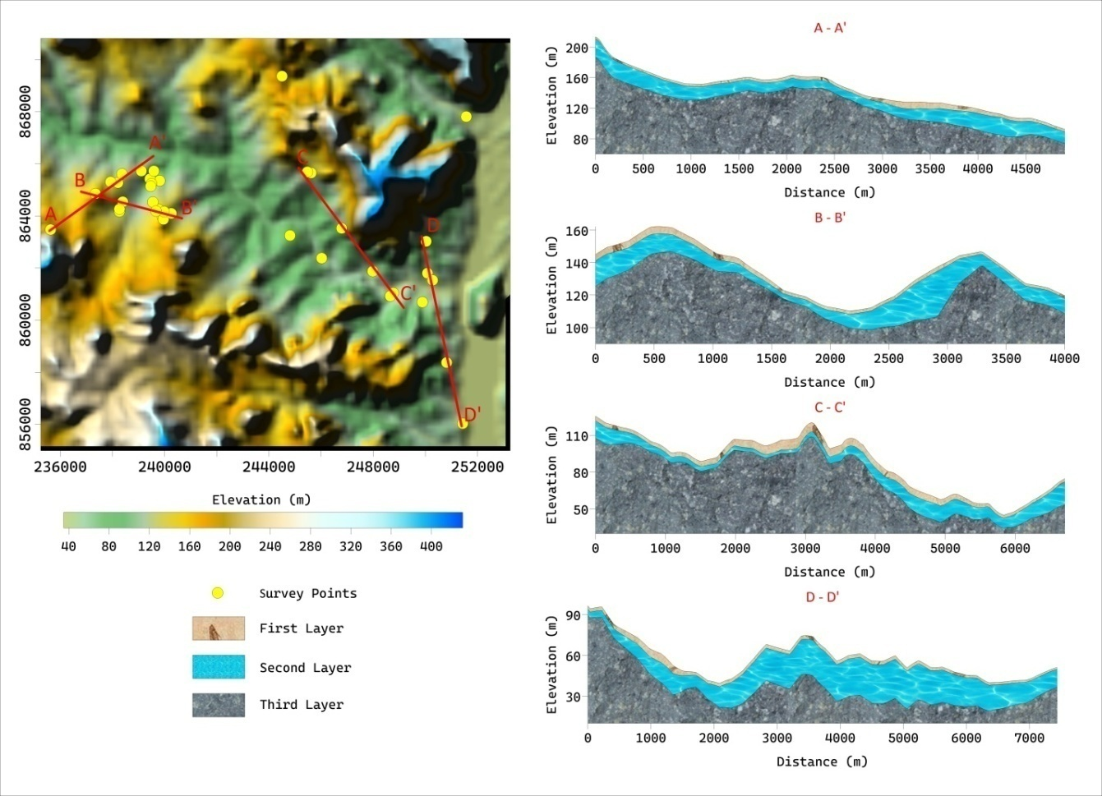

**Figure 10:** Elevation of the study area showing the topography and slopes

Slope gradient (or slope angle) is a critical geo-morphological factor influencing surface runoff and infiltration dynamics (Subramani, 2024). Flat or gently sloping terrains facilitate prolonged water residence times on the surface, promoting subsurface percolation and enhancing groundwater recharge (GWR). In contrast, steeper slopes accelerate surface runoff, thereby reducing the potential for infiltration and subsequent recharge.

Moreover, slope gradients exert indirect control over land use patterns and soil texture, both of which significantly influence recharge rates. On hill slopes, GWR rates are generally lower than in flat areas, primarily due to differences in soil texture that affect infiltration capacity. Coarser-textured soils on flat terrains typically support higher infiltration rates, whereas finer-textured soils or compacted substrates on slopes limit recharge potential.

Hydraulic conductivity, bedrock permeability, and soil depth are critical hydro-geological parameters governing the spatial distribution of bedrock groundwater recharge (GWR) hotspots, which, in turn, influence GWR variability across hill slope environments. These recharge hotspots represent localized zones of enhanced infiltration and contribute proportionately to overall groundwater recharge. According to (Subramani, 2024), approximately 30% of annual GWR can occur within just 10% of the hill slope area, underscoring their significance in regional groundwater budgets. Collectively, these factors create a heterogeneous recharge landscape, where GWR hotspots emerge as critical zones for sustaining groundwater resources in hill slope regions.

### 4. GROUNDWATER RECHARGE PROSPECTS OF THE STUDY AREA

The groundwater recharge potential of the area is defined by identifying GWR hotspots such as areas with high vertical transmissivity (corresponding to high transverse resistance values); high permeability of bedrocks (corresponding to low longitudinal conductance); composition and texture of geo-materials (presence of clays indicated by longitudinal conductance); high secondary porosity, high fault and lineaments frequency and precedence of preferential pathways for fluid percolation (corresponding to high anisotropy values and low reflection coefficient values); high regolith resistivity (100 – 400 Ωm) corresponding to sands and lateritic sands; thick regolith (corresponding to high depths to bedrock) and favorable geomorphology (corresponding to gentle slopes and flat topography).

4.1 Southeastern, Eastern, and Central Regions

These areas are dominated by sandy, gravel, and pebble lithologies with resistivity values of 100–400 ohm-m, indicating high permeability and suitability for infiltration. Sandy formations are ideal for recharge due to their coarse grain size and low clay content, which minimizes impedance to water flow. Low S values (0.01–0.38 S) in these regions suggest minimal clay content and high permeability, enhancing recharge potential. The low conductance reflects a lack of fine-grained, low-permeability materials that could impede infiltration. Although these regions have lower TR values (<4848 Ωm²), indicating poorer vertical transmissivity compared to other areas, the presence of sandy lithologies likely compensates by facilitating rapid infiltration through porous media. High anisotropy values (up to 3.06) in the southeastern region suggest significant fracturing and secondary porosity, creating preferential pathways for groundwater infiltration and storage. This enhances the area’s recharge capacity. The relatively flat terrain in these areas promotes prolonged water residence times, allowing more time for infiltration compared to steeper slopes. This is particularly advantageous during rainfall events, as water is less likely to be lost to runoff. Areas with Migmatite-Biotite Gneiss especially in the central and southwestern parts of the study area have a higher propensity for recharge due to enhanced hydraulic conductivity as migmatites weather more readily than granites. The lower average RC values (0.41–0.99, mean 0.82) in migmatite-biotite gneiss indicate significant weathering and fracturing, which increase bedrock permeability. These zones are critical for recharge, as weathered bedrock facilitates deeper percolation.

4.2 Northern, Northeastern, and Southwestern Regions

High TR values (>7465 Ωm²) in these areas indicate greater vertical transmissivity, making them highly suitable for recharge. High TR is associated with porous media and fluid potential, supporting efficient downward water movement. Elevated anisotropy coefficients in these regions (exceeding 1.0) indicate multidirectional fracture systems, enhancing secondary porosity and permeability. This is critical for recharge, as fractures act as conduits for water to reach deeper aquifers. Deeper bedrock depths especially in the northern regions are generally favorable for recharge due to increased storativity and weathering further enhancing their recharge potential. Lithology controlled propensity for elevated recharge may be directly inferred from the migmatite-gneiss rocks in the southwestern parts of the study area. Conversely, high S values (>0.5 S) in parts of these regions especially the northeastern parts indicate a predominance of clay-rich lithologies, which have low permeability and poor recharge potential. Clay impedes infiltration, causing water to be lost as runoff or retained in shallow layers. These areas may still contribute to recharge if combined with high anisotropy or deep bedrock, but their clay content is a limiting factor. Antonymously, steep slope gradients in southwestern parts accelerate surface runoff, reducing water residence time and infiltration. Despite potentially favorable lithologies or fracturing, the topography significantly limits recharge potential. These zones may still host localized recharge hotspots on gentler slopes or in fractured bedrock, but their overall contribution to GWR is likely lower than flat areas.

**4.3 Challenges for Groundwater Recharge**

Of particular concern for groundwater recharge in the study area are Clay-Rich Zones and Steep Slopes. Clay-Rich Zones inferred from high longitudinal conductance (e.g. parts of the northeast and east) are less suitable for recharge due to low permeability. These zones may require artificial recharge techniques (e.g. injection wells) to enhance GWR. The ridges in the southwestern and western parts limit recharge due to rapid runoff. Recharge enhancement strategies, such as contour trenching or check dams, could mitigate this issue.

To maximize recharge, water management strategies should focus on Protecting Recharge Hotspots. Sandy, fractured zones should be preserved from urbanization or land use changes that could reduce infiltration (e.g., paving). Also, Artificial Recharge could be encouraged by implementing managed aquifer recharge (MAR) techniques, such as recharge basins or injection wells, in less permeable areas (e.g., clay-rich zones) to enhance GWR. Runoff management can be practiced by the use of check dams, contour trenches, or infiltration ponds in steeper areas to slow runoff and promote infiltration. This will also have the added advantage of preventing erosion and incidences of landslides. Additionally, Monitoring and Modeling should be continuously undertaken by Conducting field-based hydraulic tests and hydrological modeling to quantify recharge rates and validate geophysical inferences.

#### 5. CONCLUSIONS

This study provides a comprehensive assessment of groundwater recharge (GWR) potential in a geologically heterogeneous region, integrating geophysical parameters (resistivity, longitudinal conductance, transverse resistance, resistivity coefficient, and electrical anisotropy) with geo-morphological factors (topography and slope).

The findings highlight the southeastern, eastern, and central regions as primary recharge zones, characterized by permeable sandy and gravelly lithologies (100–150 ohm-m), low longitudinal conductance (0.01–0.38 S), and high transverse resistance (> 7465 Ωm²). These areas, coupled with deep, weathered bedrock (notably migmatite-biotite gneiss, > 15 m; RC 0.41–0.99) and high anisotropy (1.50–3.06), exhibit enhanced storativity, fracturing, and secondary porosity, forming critical recharge hotspots. Flat topography further facilitates infiltration, while clay-rich zones (S > 0.5 S) and steep southwestern ridges pose constraints due to low permeability and rapid runoff, respectively.

The study underscores the importance of targeted water management strategies, such as managed aquifer recharge and runoff control, to optimize GWR in less favorable areas. Although quantitative recharge estimates and local precipitation data are needed to refine these findings, the multifactor approach offers a robust framework for delineating recharge zones.

The lack of hydraulic conductivity measurements, groundwater level data, or quantitative recharge estimates makes it challenging to fully assess the study area’s recharge capacity and provide research gaps for future studies to address and refine GWR prospects. Notwithstanding, the insights from our study are vital for sustainable groundwater management, particularly in water-scarce regions and in these climate changing times, and provide a foundation for future hydro-geological investigations to quantify recharge rates and validate geophysical inferences with field-based measurements.

**I recommend adapting bibliographic citations as indicated in the instructions for authors:**

**References must be listed at the end of the manuscript and numbered in the order that they appear in the text. Every reference referred in the text must also present in the reference list and vice versa. In the text, citations should be indicated by the reference number in brackets [3].**

**E. g., For Published paper:**

**1. Hilly M, Adams ML, Nelson SC. A study of digit fusion in the mouse embryo. Clin Exp Allergy. 2002;32(4):489-98.**

**See:** [**https://peerreviewcentral.com/page/general-guideline-for-authors**](https://peerreviewcentral.com/page/general-guideline-for-authors)

**References**

Anaba Onana, A. B., Ndam Ngoupayou, J. R., & Mvondo Ondoa, J. (2017). Analysis of crystalline bedrock aquifer productivity: Case of central region in Cameroon. *Groundwater for Sustainable Development*, 5, 66–74. https://doi.org/10.1016/j.gsd.2017.05.003

Kouadio, K. L., Liu, R., Mi, B., & Liu, C. (2022a). pyCSAMT: An alternative Python toolbox for groundwater exploration using controlled source audio-frequency magnetotelluric. *Journal of Applied Geophysics*, 201, 104647. https://doi.org/10.1016/j.jappgeo.2022.104647

Jakeman, A. J., Barreteau, O., Hunt, R. J., Rinaudo, J. D., & Ross, A. (2016). *Integrated groundwater management: Concepts, approaches and challenges*. Springer. https://doi.org/10.1007/978-3-319-23576-9

Kouadio, K.L., Kouame, L.N., Drissa, C., Mi, B., Kouamelan, K.S., Gnoleba, S.P.D.,et al.(2022b). Groundwater flow rate prediction from geo-electrical features using support vector machines. *Water Resources Research*, 58, e2021WR031623. https://doi.org/10.1029/2021WR031623

Cheng-Shin Jang, Shih-Kai Chen, Yi-Ming Kuo. (2013) Applying indicator-based geostatistical approaches to determine potential zones of groundwater recharge based on borehole data, CATENA, Volume 101, Pages 178-187. <https://doi.org/10.1016/j.catena.2012.09.003>.

Shuster, W.D., Gehring, R., Gerken, J. (2007). Prospects for enhanced groundwater recharge via infiltration of urban storm water runoff: a case study. Journal of Soil and Water Conservation 62 (3), 129–137.

Yeh, H.F., Lee, C.H., Hsu, K.C., Chang, P.H., (2009). GIS for the assessment of the groundwater recharge potential zone. Environmental Geology 58 (1), 185–195.

Chenini, I., Mammou, A.B., May, M.E. (2010). Groundwater recharge zone mapping using GIS-based multi-criteria analysis: a case study in Central Tunisia (Maknassy Basin). Water Resources Management 24 (5), 921–939.

Zomlot, Z. Verbeiren, B. Huysmans, M. Batelaan. O. (2015) Spatial distribution of groundwater recharge and base flow: Assessment of controlling factors, *Journal of Hydrology: Regional Studies,* Volume 4, Part B, Pages 349-368. https://doi.org/10.1016/j.ejrh.2015.07.005.

Falebita, D., Kasali, M. & Omolayo, A. (2023) Uncertainty analysis of aquifer parameters using deterministic and stochastic algorithms for robust groundwater exploitation decision in a basement complex region of SW Nigeria. *Model. Earth Syst. Environ.* 9, 3567–3578 https://doi.org/10.1007/s40808-023-01702-9

Nwachukwu, S., Bello, R. & Balogun, A.O. (2019). Evaluation of groundwater potentials of Orogun, South–South part of Nigeria using electrical resistivity method. *Appl Water Sci* **9**, 184 <https://doi.org/10.1007/s13201-019-1072-z>

Ojekunle V.O., Shanxiong C, Ojekunle Z.O., Oloruntola M.O., Jian L. (2015) Determination of ground water resources in Elekuro and Environs, Abeokuta: using the geoelectric method (vertical electrical sounding). In: environmental sustainability in transportation infrastructure. ASCE conference proceedings, pp 1–24

Omali. A. (2014) “Hydrogeophysical investigation for groundwater in Lokoja Metropolis, Kogi State, Central Nigeria”, *J. Geogr. Geol.*, 6 (1)  pp. 81-95

 Aku, M.O. Gani, L.I. (2015), “Geophysical investigation of the subsurface condition of the permanent site of federal university Lokoja, Kogi State”, *Int. J. Sci. Res. Publ.*, 5 (6)  pp. 2250-3153

Musa, K.O. Obasi, I.A. Auduson, A.E. Jatto, S.S. Akudo, E.O. Akpah, F. Jimoh, J.B. (2023) Integrating geoelectrical and borehole data in the characterization of basement-rock aquifers in the Lokoja area, north central Nigeria, Geo-systems and Geo-environment, 2(4).<https://doi.org/10.1016/j.geogeo.2023.100217>

Ayuba, R. Omonona, O.V. and Onwuka, O.S. Assessment of groundwater quality of Lokoja basement area, North-Central Nigeria. *J Geol Soc India* 82, 413–420 <https://doi.org/10.1007/s12594-013-0168-6>

Chiazor Stephen Ngozi-Chika, Kemah Patrick Ugbaje, Obihan Ifeanyi, and Abraham Onugba, (2013). “Assessment of Surface and Ground Water Quality in Ganaja, Lokoja, North- Central, Nigeria”. *Journal of Environment and Earth Science*, ISSN 2224-3216 (Paper) ISSN 2225-0948 (Online) Vol.6, No.2, 2016

Ayua, K.J. Alimi, G.I. Bamigbaiye, F.F., Arya J. Akbar. (2024) “Synthesizing vulnerability indices within a diverse lithological context: Corollaries for groundwater quality assurance and surface layer corrosiveness of Lokoja Geomaterials, Nigeria”. Water Practice and Technology 1 September; 19 (9): 3744–3762. <https://doi.org/10.2166/wpt.2024.201>

Olatunde, A.F. and Isaac, A., 2018. Rainfall characteristics in Lokoja from 1981 to 2015. *J Res Dev Arts Soc Sci*, *2*, pp.228-242.

Naiyeju, J.O., Oladunjoye, M.A. & Adeniran, M.A. (2024) Aquifer evaluation in parts of north-central Nigeria from geo-electrical derived parameters. *Appl Water Sci* 11, 178 x <https://doi.org/10.1007/s13201-021-01520-3>

Olatunde, A. F., & Ukoje, J. E. (2016). Perception of causes, effects and use of local adaptive measures for mitigating thermal discomfort in Lokoja, Kogi State, Nigeria. *Journal of Contemporary Urbanology*, *3*(1), 57-68.

Obaje, N.G., 2009. Geology and mineral resources of Nigeria. Springer-Verlag Berlin Heidelberg, Pp. 221. <https://doi.org/10.1007/978-3-540-92685-6>**.**

Nigeria Geological Survey Agency (NGSA) (2006) Geological and mineral resources map of Kogi State, Nigeria. Authority of the Federal Republic of Nigeria

Kumar, D.V. Ramadass, G. and Jagadish. S.V. (2015) “Delineation of Groundwater Potential Zones through Electrical Resistivity Parameters in hard rock terrain, Osmania University Campus, Hyderabad, Telangana State, India. IOSR Journal of Applied Geology and Geophysics (IOSR-JAGG) e-ISSN: 2321–0990, p-ISSN: 2321–0982.Volume 3, Issue 6 Ver.II PP 01-10. <https://doi.org/10.9790/0990-03620110>

Mogaji, K.A (2016). Geoelectrical parameter-based multivariate regression borehole yield model for predicting aquifer yield in managing groundwater resource sustainability. [Journal of Taibah University for Science](https://www.sciencedirect.com/journal/journal-of-taibah-university-for-science) 1,[0(4](https://www.sciencedirect.com/journal/journal-of-taibah-university-for-science/vol/10/issue/4)), July 2016, Pp. 584-600. <https://doi.org/10.1016/j.jtusci.2015.12.006>

Niwas, S., & Singhal, D. C. (1981). Estimation of aquifer transmissivity from Dar-Zarrouk parameters in porous media. *Journal of hydrology*, *50*, 393-399. <https://doi.org/10.1016/0022-1694(81)90082-2>

Adeniji, A. E., Obiora, D. N., Omonona, O. V., & Ayuba, R. (2013). Geoelectrical evaluation of groundwater potentials of Bwari basement area, Central Nigeria. International Journal of Physical Sciences, 8(25), pp. 1350-1361, 9 July, 2013. https://doi.org/10.5897/IJPS2013.3951

Joshua, A. K., Anthony John, I., Ikechukwu, E. D., & Ebuka, A. O. (2023). Scrutinate proclivity of regional aquifer hydraulic parameters: Apriorisms for borehole failures within parts of the middle Benue Trough, Nigeria. *Water Practice & Technology*, *18*(12), 3347-3364. <https://doi.org/10.2166/wpt.2023.211>

Oni, T. E., Omosuyi, G. O., & Akinlalu, A. A. (2017). Groundwater vulnerability assessment using hydrogeologic and geoelectric layer susceptibility indexing at Igbara Oke, Southwestern Nigeria. *NRIAG Journal of Astronomy and Geophysics*, *6*(2), 452-458. <https://doi.org/10.1016/j.nrjag.2017.04.009>

Letz, O.; Siebner, H.;Avrahamov, N.; Egozi, R.; Eshel, G.; Dahan, O. (2021) The Impact of Geomorphology on Groundwater Recharge in a Semi-Arid Mountainous Area. J. Hydrol., 603, 127029.

Mengistu, T.D.; Chang, S.W.; Kim, I.-H.; Kim, M.-G.; Chung, I.-M. (2022) Determination of Potential Aquifer Recharge Zones Using Geospatial Techniques for Proxy Data of Gilgel Gibe Catchment, Ethiopia. Water, 14, 1362

Bloomfield, J.P.; Bricker, S.H.; Newell, A.J. (2011) Some Relationships between Lithology, Basin Form and Hydrology: A Case Study from the Thames Basin, UK. Hydrol. Process., 25, 2518–2530.

Subramani, D.; Kamaraj, P.; Saravana Kumar, U.; Sabarathinam, C. (2024) Mapping of Groundwater Recharge Zones in Hard Rock Aquifer through Analytic Hierarchy Process in Geospatial Platform. Water, 16, 1484. https://doi.org/10.3390/ w16111484

Akanbi, O.A. (2019) Groundwater Recharge and Aquifer Transmissivity of Crystalline Basement Terrain, Journal of Environment and Earth Science www.iiste.org ISSN 2224-3216 (Paper) ISSN 2225-0948 (Online) Vol.9, No.10, 2019, <https://doi.org/10.7176/JEES/9-10-13>

Akiang, F.B., Amah, E.T., George, A.M., Okoli, E.A., Agbasi, O.E., Iwuoha, P.O. (2024). Hydrogeological assessment and groundwater potential study in Calabar South Local Government Area: a vertical electrical sounding (VES) approach. *Int J Energ Water Res* https://doi.org/10.1007/s42108-024-00279-y

Akanbi, O.A. (2016), Use of vertical electrical geophysical method for spatial characterisation of groundwater potential of crystalline crust of Igboora area, southwestern Nigeria, International Journal of Scientific and Research Publications, Volume 6, Issue 3, March 2016 399, ISSN 2250-3153

Salem, H.S. (1999). Determination of fluid transmissivity and electric transverse resistance for shallow aquifers and deep reservoirs from surface and well-log electric measurements, Hydrolology and Earth System Science, 3, 421–427, https://doi.org/10.5194/hess-3-421-1999, 1999

Gupta, G, Patil, SN. Padmane, ST., Erram, Vinit C and Mahajan, SH. ( 2015). Geoelectric investigation to delineate groundwater potential and recharge zones in Suki river basin, north Maharashtra. Journal of Earth System Science, 124, No. 7, October 2015, pp. 1487–1501

Olubusola, I.S., Daniel, A.A., and Oladimeji, O.K (2018). Modeling of Groundwater Yield Using GIS and Electrical Resistivity Method in a Basement Complex Terrain, Southwestern Nigeria. Journal of Geography, Environment and Earth Science International, 16(1): 1-17, 2018; Article no.JGEESI.42102 ISSN: 2454-7352. https://doi.org/10.9734/JGEESI/2018/42102

Moroof, O. Oloruntola & Gabriel O. Adeyemi (2014) Geophysical and Hydrochemical Evaluation of Groundwater Potential and Character of Abeokuta Area, Southwestern Nigeria, Journal of Geography and Geology; Vol. 6, No. 3; 2014. http://dx.doi.org/10.5539/jgg.v6n3p162

Olayinka, A. I. (1996). Non-uniqueness in the interpretation of bedrock resistivity from sounding curves and its hydrogeological implications, Water Resources. Journal of NAH, 7(1 &2), 49-55.

Osinowo, O. O., & Arowoogun, K. I. (2020). A multi-criteria decision analysis for groundwater potential evaluation in parts of Ibadan, southwestern Nigeria. *Applied Water Science*, *10*(11), 228. https://doi.org/10.1007/s13201-020-01311-2

Olatunji, J. A., Awojobi, M. O., Olasehinde, D. A., Akinrinmade, O. A., & Olasehinde, P. I. (2020). Aquifer characterization using evidences from hydro-geophysical data: a case study of Ilorin crystalline basement complex Southwestern Nigeria. *International Journal of Research and Innovation in Applied Science IJRIAS*, *5*(1), 118-127.

A. Omali, “Hydrogeophysical investigation for groundwater in Lokoja Metropolis, Kogi State, Central Nigeria”, *J. Geogr. Geol.*, 6 (1) (2014), pp. 81-95

M.O. Olorunfemi, V.O. Olarewaju, O. Alade, On the electrical anisotropy and groundwater yield in a basement complex area of S.W. Nigeria, Journal of African Earth Sciences (and the Middle East), 12(3), 1991, Pages 467-472. https://doi.org/10.1016/0899-5362(91)90138-O.

Olajide, A., Akinlalu, A. A., & Omosuyi, G. O. (2022). Indonesian Journal of Earth Sciences. *Indonesian Journal of Earth Sciences*, *2*(1), 16-32. https://doi.org/https://doi.org/10.52562/injoes.v2i1.295

Yeboah-Forson, A., Comas, X., Whitman, D.(2014). Integration of electrical resistivity imaging and ground penetrating radar to investigate solution features in the Biscayne aquifer, Journal of Hydrology http://dx.doi.org/10.1016/j.jhydrol.2014.04.045