Modeling and analysis for cassava aggregation centers within the agricultural zones in Anambra State

Abstract
The study examined the relocation and optimization of cassava aggregation centers in Anambra State's agricultural regions. Existing literature indicates that effectively relocating and allocating these centers is crucial for boosting agriculture productivity and bridging a significant knowledge gap addressed in this research. To conduct the analysis, GIS modeling and optimization tools were utilized to determine the best locations for the cassava aggregation centers. The findings highlight well-suited locations based on topography, contours, and environmental factors, facilitating optimal use of agricultural facilities in the region. It is recommended that the government applies these results to enhance the efficiency of processing centers for other agricultural products.
Keywords: Cassava; Aggregation Centre; Agriculture; Modeling; Optimization; location allocation; Geographical Information Systems (GIS)
1.1 Introduction
Cassava (is quickly emerging as a key staple for urban and rural populations (Matty et al. , 2012). The domestic consumption of cassava far exceeds local production in Africa, resulting in major imports that deplete valuable foreign exchange reserves. The demand for cassava in sub-Saharan Africa (SSA) is at twice the rate as a result of population growth, although consumption is outpacing production. Local output has failed to keep up with the increasing demand around the continent. The introduction of geographical information systems focusing on service planning represents a burgeoning field of study, leveraging Geographical Information Systems (GIS) and Spatial Decision Support Systems (SDSS). Both the public and private sectors need location analysis. Small businessesneed to find optimal plant placements to ensure that the desired market share is obtained for resurgent. Location analyses play a vital role in determining the appropriate locations for facilities such as fire stations, hospitals, and police stations. Combining service area results with location analysis helps determine which facilities will be most beneficial. Location is often regarded as a determining factor in a company's growth. Organizations can optimize their site choices to respond quickly to rising demand by using location-allocation analysis. Location-allocation can be used by customers and businesses, so they should be aware that the uses of location-allocation can differ from project to project. Restaurants and retail stores are two popular examples, while public-sector ones include hospitals, pharmacies, and emergency service stations. The planning and installation of public facilities are usually based on established planning criteria, such as the number of open spaces required per capita in a district. However, these standards often lack concrete site recommendations, the narrator says. As a result, a location-allocation scheme aimed at minimizing customer distance/time is a valuable asset in public facility planning. It can be used alongside planning procedures to help identify the correct location of these facilities. Previously, location-allocation models were limited by data availability, but advancements in land information technologies in several cities have changed this dynamic. In addition, the combination of spatial analysis and display capabilities in GIS improves the efficiency of location allocation schemes, as well as the establishment of robust public facility planning services. Remote sensing and GIS as monitoring and planning tools are of utmost importance. Tracking the number and location of changes helps prioritize infrastructure upgrades such as aggregation centers, schools, health care, and roads (Hassan et al. , 2017). Remote sensing provides a cost-effective and reliable method of assessing urban growth, as opposed to traditional surveying methods (Naik et al. , 2013; Baynard, 2013; Hassan et al. , 2017). Remote sensing effectively gathers data on the origins, properties, and locations of objects on Earth's surface and atmosphere by sensors that record electromagnetic radiation. Accordingly, it's imperative to focus on the core of GIS, analyzing and modeling techniques that solve particular problems and support essential decision-making, as well as data mining techniques that exploit the capabilities of hardware, software, and data. The geographic tools mapped to service planning are innovative, particularly regarding cassava aggregation centers, which are designed to combat the prevalence of substandard agricultural products exported by integrated millers when sourcing from farms. These centers' strategic location guarantees equitable access to all cassava-producing zones within the state. This facility will provide essential services and cater to several demand points, including storage, processing, and a single market for cassava farmers statewide. This report aims to conduct location modeling and analysis for cassava aggregation centers in Anambra State, focusing on finding optimal locations within the region's agricultural zones.
1.2 Study Area
Anambra State is a state in South-Eastern Nigeria. Its capital and seat of government are in Awka, and its major commercial Cassava locations include Ayamelum, Anambra East, Anambra West, Awka North, Ogbaru, Ihiala, Orumba North, and Orumba South. however, the state boundaries are fashioned as follows: Kogi State has a boundary in the north, Enugu has its boundary with Anambra in the East, Delta State is by the west, while Abia, Imo, and Rivers States are in the South.

2.0 Theoretical Framework
2.1 Location Modeling
Location is often regarded as the most significant factor in influencing an organizations, company, or plants success. Location can be a key to great accessibility and low fixed and overhead expenses. When a proper location is chosen, a public-sector infrastructure such as the cassava aggregation center could provide high-quality services to the numerous cassava farming, Anambra zones, and communities at a reasonable price (Ryan 2021). The use of geographical analytic methods geared towards service planning is highlighted as a hot topic of investigation, based on the use of Geographic Information Systems (GIS) and Spatial Decision Support Systems (SDSS). Accordingly, the only way to satisfy the needs of Anambra states cassava production would be to properly understand the importance of accurate location-allocation modeling and evaluation of the grain aggregation facilities, which are in accordance with the local/urban agricultural interests of Cassava cultivating groups. In this paper, the basic assumptions and theories that backed this investigation are discussed. These include location modeling, remote sensing, the use of the Global Navigation Satellite System (GNSS) to gather primary data for a Geographic Information System (GIS), and the use of GIS for location-allocation modeling.
2.2. Problem of Mapping
In this section, we will discuss the importance of using remote sensing techniques for mapping purposes.
- Acquisition of Suitable Data
Suitable satellite images are obtained from either commercial data providers or government agencies based on the mapping requirements and desired features.
- Analysis of the Image Statistics
This involves identifying image characteristics such as spatial resolution, radiometric resolution, spectral resolution, and so on.
- Image Pre-Processing
This involves picture repair and correction. Image restoration and rectification are the procedures done on images to eliminate systematic mistakes and noise generated during the scanning and transmission processes. The main pre-processing processes are the correction or elimination of radiometric aberrations, geometric distortions, noise reduction, picture resampling, and image registration. The picture resampling approach involves giving suitable brightness values to pixels in the output matrix based on the pixel values that surround their transformed positions in the image's original input matrix. Image registration is the process of superimposing an image onto a map or another picture to align the image with a map/image coordinate system.
- Image Enhancement
It brings in the activities expressed on the modified image in a utilization manner or enhances the pictorial superiority. The radiometric in addition to geometric properties of the image are habitually improved.

- Pattern Recognition and Image Classification
Picture classification categorizes picture features into land cover types or regions based on the image's reflectance properties. It is the process of transforming a visual scene into a thematic map in which regions with comparable features are represented in the same manner. There are two prime forms of classification namely, supervised classification along with unsupervised classification.
- Thematic Mapping
This is the last stage, in which various thematic information extracted from the image is displayed as maps, graphics, or tabular data. It entails representing the categorization results using an appropriate data format (vector or raster).
2.3 Coverage Distance
The demand-weighted distance objective offers a typical perspective (across the customer base) of the facility network by assessing the overall service level (indicated by access distance) given to all customers, weighted by their demand sizes. However, this may not be the ideal objective in scenarios where the worst-case service delivery to customers is the main priority. For instance, in emergency medical services, the goal is often to maximize the volume or percentage of potential demand that can be met within a specified time limit, rather than focusing on average response times. Similar issues arise in retail environments, where stores seek to attract customers situated within specific distances. In these situations, the critical factor in planning is whether a facility falls within a designated maximum distance—known as the coverage distance for each customer.
To determine if a customer is within the coverage range, denoted as dC, of a facility, we define the binary parameter aj= l(dij<d_{C}), where l(-)is the indicator function. This leads to the formulation of the set covering location model (Evans, 2017), which seeks to identify the minimum number of facilities needed to cover all customers situated within the specified coverage.
$\left[Set Covering Location\right]:\min{\sum_{jєJ}{f_{j}X_{j }}}$ (1)
s.t. $\sum_{jєJ}{a_{ij}X_{j}≥1 for i є I}$ (2)
$X_{j} є \left\{0,1\right\} for j є J$
The primary goal (1) is to reduce the number (or generally, the opening expenses) of facilities needed to meet the constraints (2) that mandate at least one facility to be active within the coverage radius of every customer location. The set covering location issues holds significant relevance in the public sector. For instance, determining the locations of services such as hospitals, emergency medical resources, police and fire stations, and educational institutions must prioritize access radius as a key factor in their planning.

More broadly, the set covering challenge involves choosing an optimal (lowest-cost) collection of subsets from a set of elements, ensuring that each element is included in at least one selected subset. In the context of facility location, the elements represent customer locations, and each viable subset of elements comprises the customers within the coverage distance of each prospective facility site. Therefore, the process of selecting among these customer subsets is analogous to choosing among potential facility locations. Moreover, the requirement that all elements be represented in the chosen subsets is interpreted as ensuring that all customers are served within the defined coverage distance from selected facilities.

The general formulation for set covering (Evans, 2017) is presented as follows. Let I denote the set of elements to be covered, and N ⊆ 2^I be a collection of feasible subsets of I. For each member R ∈ N, we define the binary decision variable Z_R to signify whether the set R is chosen or not, with an associated cost of c_R. Thus, the general set covering the problem can be expressed:$\left[General Set Covering\right]: \sum_{R∈N}{c_{R}Z_{R}}$ (3)
$s.t. \sum_{R∈N:i∈R}{Z_{R}≥1 for i ∈I}$ (4)
$Z_{R}∈\left\{0,1\right\}for R ∈N.$
Interestingly, the general set covering the problem emerges during the solution method of a subset of integrated location models with weighted-distance objectives.
Evans (2017) found that the set covering location problem requires all customers to be covered, which is acceptable for locating emergency service facilities. While this condition is often accepted for public sector services, it is observed that the marginal demand coverage for expanding the number of facilities is generally falling. Thus, in situations involving private-sector planners, it is always advantageous to exclude some consumers who are too expensive to insure.
Interestingly, the general set covering the problem emerges during the solution method of a subset of integrated location models with weighted-distance objectives.
Consider the maximum covering issue, which optimizes demand coverage within a given budget to locate facilities, as follows:
$\left[Max Convering Location\right]: \max{}\sum_{i∈I}{μ_{i}U_{i}}$ (5)
$s.t. \sum_{j∈J}{a_{ij}X_{j}≥U_{i} for i ∈I}$ (6)
$\sum_{j∈J}{X_{j}≤P}$ (7)
$U_{i}, X_{j} ∈\left\{0,1\right\} for i ∈ I, j ∈ J.$
The above-mentioned objective (5) is to maximize the volume of demand covered by the network of facilities, where the binary decision variable Ui indicates whether customer location i is covered. Constraints (6) are similar to (4) in the set coverage issue, but they provide for the flexibility of not covering certain customer locations, in which case they do not contribute to the objective (Ui = 0). Constraint (7) restricts the number of facilities to the budgeted number (P).
2.4 GIS Based Models
Open space planning is a type of facility planning; and GIS as well as location-allocation models have been extensively used in facilities planning. There are in fact three main GIS methods in facilities planning (Emil, 2016; Alireza,2014).
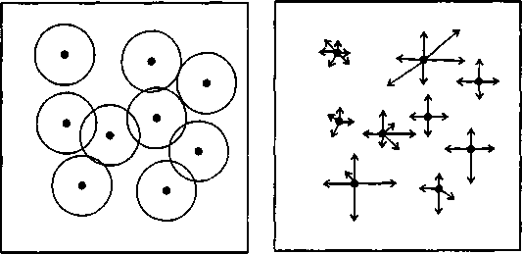
a) Buffer Zones b) Allocation (Grow Arrows

Fig. 1: Buffer Zone Modeling Analysis (Source: Navas et al., 2015)

The following methods are outlined:
i. The Buffer Zone Approach: By establishing buffers around existing facilities according to their size and capability, this method finds urban voids that are inaccessible to current services. As shown in Figure 1, buffer zone analysis does not evaluate whether the selected land is suitable for the planned facility or takes population distribution into account.
ii. The Allocation Process: This method distributes a network's population to the closest established or planned facility (ESRI, 2014). It involves population distribution and is similar to the buffer zone method. Nevertheless, this approach frequently calls for network data that might not be easily accessible in a GIS database.
iii. Analysis of Land Suitability: Land Suitability Analysis is a widely used spatial analysis tool in GIS that assesses locations according to predetermined standards for facility installation. This third approach can often be combined with the first two—appropriate locations are found using Land Suitability Analysis and then evaluated using the Allocation Method or Buffer Zones. These GIS methods do not, however, guarantee that facilities are positioned optimally.
Location-allocation (LA) models, on the other hand, are made expressly to identify the best locations for facilities. The public and private sectors have been applying these models to determine the best locations or assess existing ones since the 1960s (MirHassani and Ebrazi, 2012; Killen, 1983; Derya and Fatmagul, 2011; Navas et al., 2015). (Drezner, 2014; Birkin et al., 2017). More specifically, location-allocation models aim to identify the most effective facility locations by optimizing one or more of these objectives (Navas et al., 2015):
- minimum average/total distance,
- minimax distance,
- equal assignment,
- threshold constraint, and
- capacity Constraint
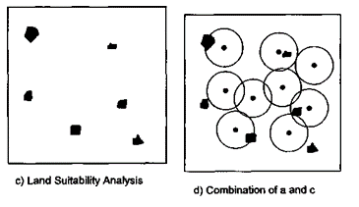
Figure 2: Analysis of Land Suitability Modeling (Source: Navas et al., 2015)

The choice of objectives in decision-making can vary greatly based on the individual preferences of those involved. Location-allocation models can be categorized into six primary types based on the methods they employ to determine optimal locations (Navas et al., 2015):
a. Exact enumeration
b. Exact analytical
c. Approximate heuristic algorithms
d. Approximate statistical algorithms
e. Exact mathematical programming
f. Approximate simulation methods
These models can function within either a continuous space or a network. However, in the context of a network, the facility locations are constrained to the vertices of the transportation system, as illustrated in Figure 2. Additionally, they can be applied to either single-facility centers or multiple centers (Yuhong et al., 2015).
Most location-allocation models focus on a single objective and are specifically designed for a single facility level. While there has been significant progress in creating models that accommodate multiple objectives (Ankan et al., 2021; Wei et al., 2016) and various facility levels (Eiselt, 1992), a significant limitation of these models in facilities planning is that the optimal locations they suggest may not always be practical. Facilities could end up in undesirable locations, such as bodies of water on roads, or land already occupied by other uses that would be expensive to demolish and relocate.

Historically, the use of location-allocation models in urban planning was constrained by data availability, particularly at district and street block levels. This landscape has shifted with the advent of land information systems in many cities, now providing essential data that was previously lacking. Consequently, this creates an excellent opportunity for integrating Geographic Information Systems (GIS) with location-allocation models, leveraging the strengths of both. Initially, optimal facility locations are identified using a location-allocation model, followed by drawing circular buffers around these sites to define acceptable areas for facility placement. Decision-makers can then evaluate potential sites that lie within or near these specified solution spaces.

In their work, Ezici et al. (2019) explored optimization models for the dynamic facility location and allocation issue. Their case study involved over 330,000 constraints and 180,000 variables, showcasing the effectiveness and efficiency of the proposed SCMP2S and MCMP2S models. When compared to the actual configuration (AS-IS) of the network, the optimal solution achieved a cost reduction of approximately €900,000 annually. The task of identifying the best location among many possibilities can be approached through various qualitative and efficient site selection techniques, including ranking procedures and economic models (Riccardo and Elisa, 2010; Stef et al., 2016). Following a critical review and evaluation of previous related studies, a gap was identified, indicating that no effort has been made to provide engineers and planners with comprehensive information regarding the selection of an appropriate location-allocation model for their specific problems, situations, and data, whereas the paper used Criteria (factor/constraint) selection for an appropriate location-allocation model.

3.1 Methodology
The technique utilized to achieve the goal of this study was especially focused on the data used, the software and hardware input, data processing, and the many methodologies used for the analyses, all of which were designed to fulfill the research's goal through the previously mentioned objectives.

3.2Data Processing
To achieve the goal of this research, several processes were carried out, including formatting the GPS coordinates collected in the field, image processing and image classification on the Landsat image, elevation and slope extraction and hydrological modeling on the SRTM DEM, and spatial analysis on farm locations, road networks, and transmission lines. The techniques used to achieve the various objectives are explored further.

3.2.1 Image Enhancement
Image enhancement was performed to improve the quality of the image as perceived by a human. This modus operandi was done to revise the original image data by increasing the amount of information for visual explanation from the data to form new image. Band permutation was used for this research. This method is most useful because many satellite images when tested on a band flaunt give inappropriate information for the image explanation. The appropriate RGB bands of the Landsat image were merged to obtaina false color composite, using band 7 (shortwave infrared), band 5 (near infrared) and band 2(blue). This procedure was done using the layer stack spatial model in Erdas Imagine see figure 3.
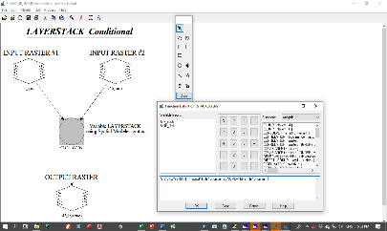
Figure 3: Layer stack spatial model

3.2.2 Development of a classification scheme
A classification scheme was established for the study area based on the framework set forth by Anderson et al. (1976). This framework outlines the criteria for an effective land use and land cover classification system that utilizes remote sensing data. According to Anderson, the system should adhere to the following principles:
1. The minimum interpretation accuracy for identifying land use and land cover categories from remote sensor data should be at least 85 percent.
2. The interpretation accuracy across different categories should be approximately uniform.
3. Results should be repeatable, with consistent outcomes from different interpreters and across different sensing times.
4. The classification system must apply to large geographic areas.
5. It should allow for the use of vegetation and other land cover types as proxies for various activities.
6. The classification must be compatible with remote sensing data collected at various times throughout the year.
7. There should be an effective use of subcategories derived from ground surveys or higher-resolution remote sensor data.
8. The system should allow for the aggregation of categories.
9. It needs to facilitate comparisons with future land use data.
10. The classification should recognize multiple uses of land whenever feasible.

While some of these criteria are relevant to land use and land cover classification in general, others specifically pertain to data interpreted from remote sensing. The goal is to achieve a level of interpretation accuracy at the first and second generalized levels that makes this data comparable in quality to other methods. For planning and management purposes, an accuracy range of 85 to 90 percent in interpretations is deemed acceptable. However, for stricter measures such as land use regulation or tax assessment, higher accuracy may be necessary, although achieving this often comes at significantly increased costs.
The accurateness of the land use data derived from remote sensing method is equivalent to that obtained through enumeration. Alongside improving interpretation techniques—such as image enhancement and signature identification—it is expected that the resolution capabilities of various remote sensing systems will also advance. In land use applications, a primary concern is determining the minimum area size that can be effectively identified with discernible land use or land cover characteristics. Such a minimal area is determined not only by the kind and features of the imaging equipment used but also by the order of "generation" of the imagery, i.e. how far the studied picture is away from the original record in the number of replication phases. The user should utilize the most recent information to determine the system's resolution specifications. the category and volume of land-use and land-cover information that may be gathered from different sensors is indomitable by their height along with resolution. It is unlikely that any one sensor or device will generate reliable data at all altitudes. Each source of remote sensing data and its use should be evaluated entirely based on its quality and characteristics. However, it is usual practice to transfer data to a base map, and regardless of the recommendations, using a base map requires extracting some additional data from such maps. Topographic maps, road maps, along with comprehensive city maps will naturally plus detail that exceed the capacity of remote sensor data. The multilayer land use and landcover categorization method presented here was created because different sensors offer data at varying resolutions depending on altitude and size. In general, the following relationships hold, assuming a 6-inch focal length camera is employed to capture airplane footage. The categorization level and attributes are provided in Table 1.

Table 1: Classification levels and data characteristics (Anderson, 1976)
Classification Level | Typical Data Characteristics
I | LANDSAT (formerly ERTS) type of data
II | High altitude data at 40,000 ft (12,400 m) or above (less than 1:80,000 scale)
III | Medium altitude data in use amid 10,000 & 40,000 ft (3,100 & 12,400 m) (1:20,000 to 1:80,000 scale)meher h
V | Low altitude data taken below 10,000 ft (3,100 m) (more than 1:20,000 scale)
Based on these classifications by Anderson et al (1976), level one classification scheme was adopted for this study.
4.1 Image Classification
Digital image classification leverage spectral information represented by digital numbers across a variety of spectral bands to classify personality pixel based on their spectral properties. In this study, we utilized a supervised classification method to categorize all pixels in a digital image into distinct land use and land cover classes.
The classification of the Landsat image occurred in ArcMap 10.5, where the image was imported into the interface as illustrated in Figure 5. Following this, we conducted the classification process using the Image Classification toolbar. The steps included:
1. Opening the Training Sample Manager from the classification toolbar.
2. Utilizing the Draw Polygon tool to create sample polygons from the image, selecting samples from each land cover and land use category.
3. Employing these training samples to generate Signature files, this formed the basis for classifying the image.
4. Finally, opting for the Maximum Likelihood classification to carry out the supervised classification.

The outcome of this classification process was a detailed land cover and land use map of the study area. This information was instrumental in analyzing the land use and land cover patterns and evaluating the suitability of some areas for establishing cassava aggregation centers.
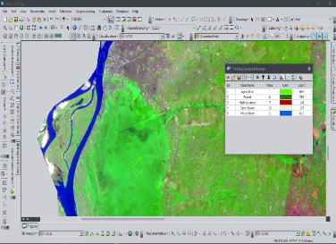

Figure 4: Image Classification on ArcMap

4.2 Criteria Selection
The criteria and conditions for establishing cassava aggregation centers were determined using Food and Agriculture Organization recommendations and the Environmental Impact Assessment Act (EIA) on cassava aggregation center placement. The following criteria (factors/constraints) (table 2) were employed in this study. Restrictions in this study identify locations where development is prohibited by municipal and governmental legislation; in this case, offset distances from these regions, such as floodplains, water bodies, protected areas, and erosion-prone areas, were examined and established as restrictions. It is critical to precisely define such areas and exclude them from the study using a limitation model.
Table 2: Criteria (Factors/Constraints)
S/N | Criterion | Factor/  Constraint | Requirement for suitability | Reason for Selection | Original Data Structure | Resolution / Feature Type
1 | Slope | Factor | Should have slope angles between 8% and 15% | The gradient influences the simplicity of both construction and upkeep. | Raster | 30m
2 | Transportation network | Factor | Should be atleast1km from the Cassava farms. | The expense of transporting Cassava is influenced by the distance of Cassava farms from the aggregation hub. | Raster | Polygon
3 | Land Cover/ Land Use | Factor | Must be barren land, shrub or open spaces | Understanding land cover and land use plays a crucial role in planning; it is regarded as a vital component in modeling and determining appropriate sites and conservation areas to steer clear of. | Raster | 30m
4 | Distance to Electricity Network | Factor | Must not be located further than 1km from Powerlines | Decreasing the expense of establishing new transmission lines. | Vector | Polygon
5 | Least Cost Distance | Factor | Must be located on the least cost area/route to and from the Cassava farms | Allowing for higher cost efficiency and savings. | Vector | Polygon
6 | Distance to Water Bodies | Factor | Located 2.5km away from water-bodies moreover it cannot be positioned on a wetland | preventing ecologically vulnerable places and preventing water contamination. | Vector | Polygon
7 | Floodplain | Constraint | 2.5km away from floodplains | Diminishing flood exposure. | Vector | Polygon
8 | Erosion prone areas | Constraint | 2.5km away from Erosion Prone Areas | Decreasing erosion susceptibility. | Vector | Polygon
9 | Proximity to Cassava farms | Factor | 2.5km within Cassava Farms | Reducing the cost of transporting cassava from fields to aggregation hubs. | Vector | Polygon

The data utilized to achieve the study goal were gathered using the criteria indicated (table 2). Land cover/land use and Protected Areas were recovered from Landsat images using image classification, while slope, flood, and erosion plains were retrieved from SRTM images. The distance to roadways, the distance to the national grid, and the distance to Cassava fields were also calculated using the Boolean distance method; these results are presented in figures 5–10.
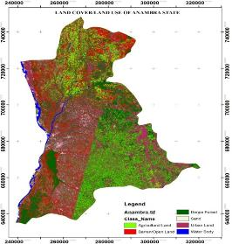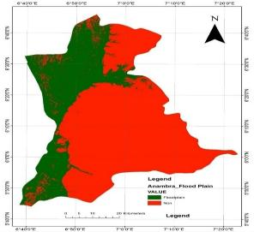
Figure 5: Landuse dataset Figure 6: Flood plain dataset

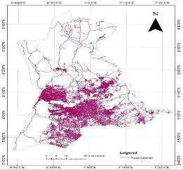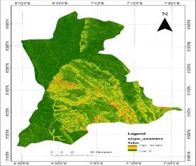
Figure 7: Road dataset Figure 8: Slope dataset

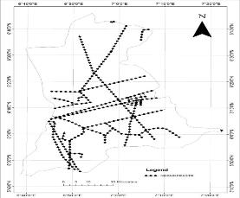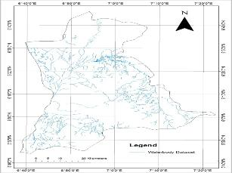
Figure 9: Electricity line dataset Figure 10: Waterbody dataset

4.3 Suitability Calculation
The weighted linear combination (WLC) model has gained popularity in recent years, and for this investigation, WLC approaches were preferred above the Boolean method. Site appropriateness was assessed by utilizing raster calculator in ArcGIS 10.5. The parameters were standardized to a continuous scale of appropriateness from the least to the most suited, thereby enabling flexibility in the site selection. The weighted linear combination equation is shown below as 6:
$S=Σwixi x Πcj$ (6)
Where:
S – is the composite suitability score
xi – factor scores (cells)
wi– Weights assigned to each factor
cj– Constraints (or Boolean factors)
Σ -- Sum of weighted factors
Π -- Product of constraints (1-suitable, 0-unsuitable)
Using the formula to calculate for Cassava aggregation center suitability in ArcGIS weighted linear combination.
S = (F1*0.35) + (F2*0.18) + (F3*0.14) + (F4*0.10) + (F5*0.07) + (F6*0.06) + (F7*0.04) + (F8*0.03) + (F9*0.01)), The output presented potential sites with the highest suitability.
Note: F1, F2, F3, F4, F5, F6, F7, F8 and F9 are thematic layers representing the constraints.
4.3.1Selecting the Suitable Sites
Every pixel in the weighted overlay result was given a value that indicated how appropriate it was for the aggregation cassava plant's location. While pixels with a value of 0 are inappropriate, those with a value of 5 are the most appropriate. The pixels with a suitability score greater than 0 were chosen as the first step in identifying the appropriate regions. As a result, each cell's output values are managed and assessed as true or false output rasters (appropriate and inappropriate). These numerical values of layers were carried out using the conditional function tool (con) in the ArcGIS raster calculator, which locates the desired area by mass.
Finally, a raster-to-polygon (cluster) analysis was performed to identify and choose acceptable areas for the cassava aggregation center.

4.3.2 Validation of results
A ground truth survey was conducted based on the collected results. This was done to ensure that the results on the ground were consistent with what was on the suitability map, so as to assess their credibility.

4.4 Reclassification and Standardization of Datasets
Deriving datasets, such as the distance to protected areas from a potential aggregation facility, marks the initial step in constructing an appropriate model. Every cell within the study area now contains a value for each input criterion. At this point, integrating the derived datasets proved to be quite challenging, underscoring the necessity for reclassification of each dataset. Different numerical systems cannot be effectively combined (ESRI, 2014). For example, it's impossible to compare a cell value representing a slope of 2˚ with another cell value indicating a distance to aggregation sites of 1,000 m in a meaningful way. By standardizing these values to a common measurement system that reflects a relative weighting scale, we can conduct analyses across the datasets and assess the suitability level for each standardized criterion.
To facilitate the combination of datasets, it was essential to standardize or transform all individual datasets into a uniform measurement scale. This scale dictated the suitability of each location (each cell) for sitting. Higher values signified more suitable locations, while lower values indicated areas that were less suitable or unsuitable.
In this research, all datasets were reclassified into four categories: (1) unsuitable areas, (2) low suitability areas, (3) moderately suitable areas, and (4) highly suitable areas. The values from the initially derived datasets were continuous and floating in nature, which necessitated reclassification to assign each range of values a discrete integer such as 1, 2, 3, or 4, based on the measurement scale, as illustrated in Figure 11.
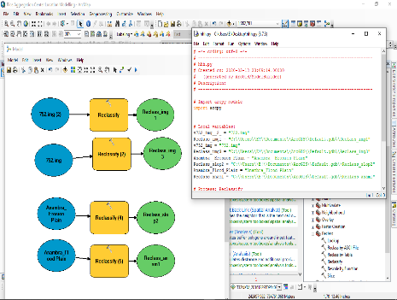
Figure 11: Reclassification and Standardization of datasets

4.5 Result of Reclassified Datasets
The derived surfaces created using Euclidean distance produced discrete values that could not simply be overlaid to determine the necessary levels of suitability for the aggregation cassava center. Therefore, all raster surfaces needed to be reclassified to a standard that enabled effective overlay. The results following reclassification are presented in Figures 12–20.
The reclassified data were structured into four levels of suitability (i.e., 1-4), with 1 representing the lowest level of suitability and 4 symbolizing the highest level. After overlaying the classified raster layers, the output cell raster with the highest index value identified the most suitable location for establishing a potential aggregation cassava center.

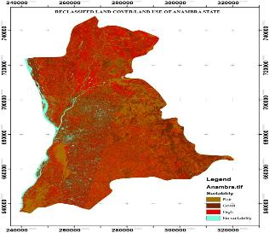
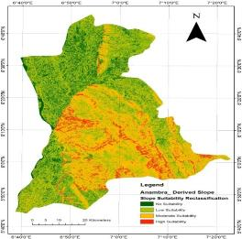

Figure 12: Reclassified landuse Figure 13: Reclassified slope

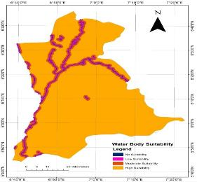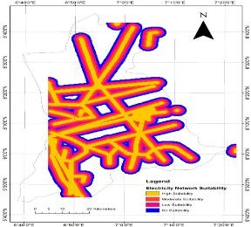
Figure 14: Reclassified proximity to waterbodyFigure 15: Reclassified proximity to Electricity lines

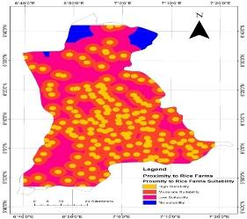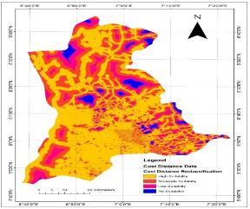
Figure 16: Reclassified proximity to Cassava farms Figure 17: Reclassified cost distance

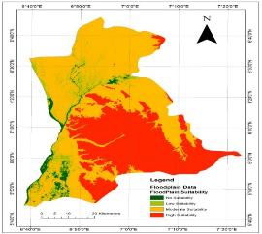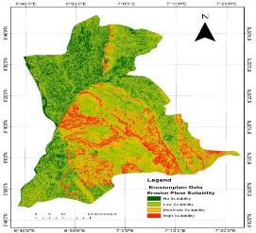
Figure 18: Reclassified floodplain Figure 19: Reclassified Erosion Plane

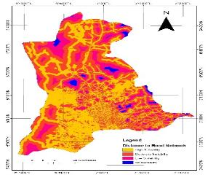

Figure 20: Reclassified Proximity to road network

4.6 Overlay and Weighting Datasets
The Weighted Overlay tool combines multiple steps of the overlay analysis process into one convenient tool. It performs the following key functions:
a. It reclassifies values in input rasters to a uniform evaluation scale, which could represent suitability, preference, or risk.
b. It applies a weight to the cell values of each input raster, reflecting their significance.
c. Finally, it sums the modified cell values to generate the output raster.
This tool is specifically designed to accept integer rasters as input, such as land use or soil type rasters. If you’re working with continuous (floating-point) rasters, they will need to be reclassified to integer values before use.
For continuous rasters, the values are typically grouped into ranges—like slope or Euclidean distance—but each range must have a single designated value for the Weighted Overlay tool to work. The Reclassify tool can assist with this process. You can choose to keep the initially assigned values for each range and assign weights in the Weighted Overlay tool later, or apply weights during the reclassification phase. Once the appropriate evaluation scale is chosen, add the raster to the Weighted Overlay. The raster’s cells will be aligned by the defined scale, allowing for weighted outputs to create the final raster.
The combination of all the weighted criteria in the overlay analysis (as shown in figure 21) in the weighted overlay table resulted in a suitability index map (figure 22) for locating a cassava aggregation center.
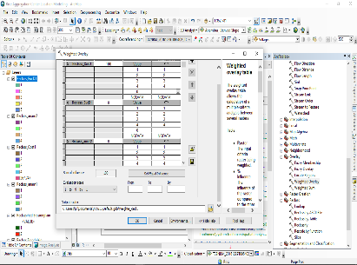
Figure 21: Weighted overlay analysis

Once the raster suitability index map was created, it was transformed into a vector format using the raster-to-polygon analysis tool. The coordinates of the centroid were calculated, facilitating the extraction of the coordinates for the identified aggregation centers, as illustrated in the accompanying figure 22.
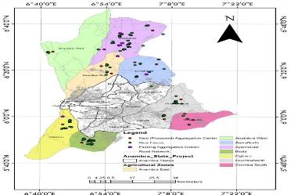

Figure 22: Located (Proposed) Aggregation Centers in Anambra State Agricultural Zones
According to the suitability map (figure 22) and subsequent ground truth, Ayamelum previously had 4 out of 7 of Anambra state's total aggregation centers, making it the zone with the highest concentration of aggregation centers to a total of 163 Cassava farms. The aggregation centers in Ayamelum's service zone encompass a minimum distance of 700m, a maximum distance of 12.7km, and an average distance of 6.7km to Cassava farms. Anambra West has no aggregation center and 20 Cassava farms, but Anambra East has one aggregation center and 18 Cassava farms, with a service zone that covers a minimum distance of 7.7km, a maximum distance of 16km, and an average distance of 11.85km from the Cassava farms. With a service zone that spans a minimum distance of 2.3 km, a maximum distance of 12.5 km, and an average distance of 7.4 km from the cassava farms, Awka North is home to one aggregation center and 33 cassava farms. For a total of 92 cassava farms, Ihiala, Orumba North, and Orumba South lacked an aggregation center. One aggregation center serves 60 cassava farms in Ogbaru, with a service zone that extends a minimum of 4 km, a maximum of 9.9 km, and an average of 6.9 km from the cassava farms. Refer to figures 23 and 24.

Figure 23: Ratio of Aggregation centers to Cassava Farms in Anambra agricultural zone
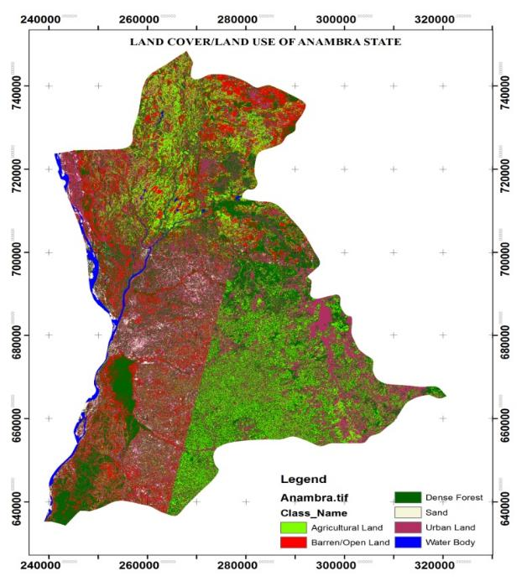
Figure 24: Ratio of Proposed aggregation locations to Cassava farms in Anambra agricultural Zone
Also, comparing the mean distances from the Cassava farms to the existing aggregation centers and the mean distances from the Cassava farms to the proposed distances, it can be seen that the mean distances have been reduced and optimized by the proposed locations. This is seen in Anambra East, which had a previous mean distance of 7.7km optimized to 2.6km by increasing the number of aggregation locations and applying the shortest route network analysis to reduce the distance. This is also evident in Ayamelem, Awka North, and Ogbaru, where the average distances from farms to aggregation sites have been reduced from 6.7km to 2.8km, 7.4km to 3.3km, and 6.9km to 3.8km, respectively. In order to determine the best locations for aggregation centers close to the cassava farms, as illustrated in figure 25, the mean distances from the zones that previously lacked aggregation centers (Anambra West, Orumba North, Orumba South, and Ihiala) were also optimized. Tables 3 and 4 present the summarized aggregation centers for actual and optimized distance in the agricultural zones.
EXISTING AGGREGATION CENTER WITH ACTUAL DISTANCES (KM) |  |  |  |  |  |  | PROPOSED/ OPTIMIZED DISTANCE (KM)
s/n | name of location | size of farm Cassava (x 10) ha | no of existing aggregation | minimum distance (km) | maximum distance (km) | mean distance (km) | no of proposed aggregation center | minimum distance (km) | maximum distance (km) | mean distance(km) | total no of aggregation center (existing + proposed)
1 | Anambra East | 18 | 1 | 7.7 | 16 | 11.85 | 2 | 1.9 | 3.4 | 2.6 | 3
2 | Anambra West | 20 | 0 | 0 | 0 | 0 | 1 | 1.7 | 2.4 | 2 | 1
3 | Ayamelum | 163 | 4 | 0.7 | 12.7 | 6.7 | 2 | 0.7 | 4.9 | 2.8 | 6
4 | Awka North | 33 | 1 | 2.3 | 12.5 | 7.4 | 2 | 2 | 4.6 | 3.3 | 3
5 | Orumba South | 6 | 0 | 0 | 0 | 0 | 2 | 2.4 | 5.8 | 4.1 | 2
6 | Orumba North | 56 | 0 | 0 | 0 | 0 | 1 | 2.3 | 4.6 | 3.4 | 1
7 | Ihiala | 30 | 0 | 0 | 0 | 0 | 1 | 1.7 | 5.5 | 3.6 | 1
8 | Ogbaru | 60 | 1 | 4 | 9.9 | 6.9 | 1 | 3.1 | 4.5 | 3.8 | 2
Table 3: Summarized aggregation centers for actual and optimized distance in the agricultural zones.

Figure 25: Mean distances from Cassava farms to existing and proposed aggregation centers.

S/N | LGA | Mean Distance to Existing Centers (km) | Mean Distance to ProposedCenters (km)
1 | Anambra East | 7.7 | 2.6
2 | Anambra West | 0 | 2
3 | Ayamelum | 6.7 | 2.8
4 | Awka North | 7.6 | 3.3
5 | Orumba South | 0 | 4.1
6 | Orumba North | 0 | 3.4
7 | Ihiala | 0 | 3.6
8 | Ogbaru | 6.9 | 3.8
Table 4: Mean distances from Cassava farms to existing and proposed aggregation centers.

Nzam, Onoia, IfiteOgwari, Aguleri, Nando, Akenu, Achalla, Ajali, Ezira, Ndiokpalaeze, Ogbakuma, and Uli are the possible sites for aggregation cassava centers in the eight agricultural zones of Anambra state, having met all requirements by weighted linear combination; table 5 provides further information.
Table 5: Proposed locations for siting Cassava aggregation centers in the agricultural zones
OBJECTID | Easting(m) | Northing(m) | LGA | Locality
1 | 246650.072 | 715444.887 | Anambra West | Nzam
2 | 266945.383 | 717166.913 | Ayamelum | Onoia
3 | 285982.481 | 732224.043 | Ayamelum | IfiteOgwari
4 | 265838.366 | 703882.710 | Anambra East | Aguleri
5 | 269774.426 | 698101.621 | Anambra East | Nando
6 | 287561.807 | 705345.575 | Awka North | Akenu
7 | 278999.568 | 706957.757 | Awka North | Achalla
8 | 297203.847 | 677560.307 | Orumba North | Ajali
9 | 290561.745 | 661816.065 | Orumba North | Ndiokpalaeze
10 | 301877.918 | 661078.054 | Orumba South | Ezira
11 | 250586.133 | 657757.003 | Ogbaru | Ogbakuba
12 | 258093.616 | 643112.254 | Ihiala | Uli

Summary
The use of location analysis to the placement of a cassava aggregation facility in Anambra State was the main focus of the study. By determining the reliability index of the classified criteria and factors for siting aggregation centers, classifying the derived criteria and factors for the siting aggregation centers according to their ranks of suitability, and using weighted linear combination to determine the location best suited for citing aggregation centers, the goal was accomplished. All of the criteria's limitations were met by the location modeling result. The findings indicated that Nzam, Onoia, Ifite Ogwari, Aguleri, Nando, Akenu, Achalla, Ajali, Ezira, Ndiokpalaeze, Ogbakuma, and Uli were suitable sites for the establishment of an aggregation cassava center.

5.2 Conclusion
Selecting cassava aggregation centers involves careful spatial decision-making, which typically includes a wide range of viable options. The application of remote sensing and GIS has proven to be highly effective, leveraging remotely sensed data to produce essential spectral and spatial information for determining suitable sites for cassava aggregation.
Using GIS as a decision-making tool, various information layers are combined while performing necessary analyses on the data. Although this GIS approach enhances objectivity in the decision-making process, there's still a degree of subjectivity in how map weights and scaling are allocated. This allows planners the flexibility to adjust the importance of each criterion based on their expertise.
The study successfully implemented spatial decision-making by evaluating multiple criteria to identify suitable locations for cassava aggregation centers in Anambra State. Ultimately, it identified thirteen sites that met all criteria, each demonstrating an optimal balance across the established factors.
References
Alireza G., Alireza T., Maryam D., and Hadi A. (2014). Zoning of co emissions in Tehran in the medium term by using third quartile as the exposure candidate. Journal of Geographic Information System, 6, 5
Anderson, E. (1976). A landuse and landcover classification system for use with remote sensor data. geological survey professional.U.S. Government Printing Office, Washington, D.C.964, 28.
Ankan, B. Sankar, K. Roy, G.and Wilhelm, W. (2021). Multi-objective linguistic-neutrosophic matrix game and its applications to tourism management: Journal of Dynamics & Games 8(2),101-118.
Birkin, M. Clarke, G. and Clarke, M. (2017). Retail location planning in an era of multi-channel growth. Routledge, 10,224.
Derya, O. and Fatmagul B. (2011). Implementation of GIS-based multicriteria decision analysis with Vb in ArcGIS, International Journal of Information Technology & Decision Making 10(06),1023-1042. DOI: 10.1142/S0219622011004695
Drezner, T. (2014). A review of competitive facility location in the plane. Logist. Res. 7, 114. DOI: 10.1007/s12159-014-0114-z
Eiselt, H.A. (1992). Location modeling in practice. American Journal of Mathematical and Management Sciences, 12(1), 3-18. DOI: 10.1080/01966324.1992.10737322
Emil G., (2016). Integrating Geographic Information System (GIS) in the education of landscape architects in Bulgaria. International Journal of Research in Agriculture and Forestry. 3(6),24-33.
Environmental Systems Research Institute, Inc. (ESRI) (2014). ArcGIS Desktop 9.3 Help. Retrieved March 21,2014 from http://webhelp.esri.com/arcgisdesktop/9.3/index.cfm?id=3996&pid=3986&topicname=data_classification.
Evans, J. (2017). Optimization algorithms for networks and graphs. CRC Press.
Ezici, B. Küçükdeniz, T. and Esnaf, Ş. (2019).Three-dimensional geographical clustering & optimization hybrid model for facility location-allocation problem.SCM System Engineering and Operations Research,10,174.
Gustavo, K. (2013). Assessing the accuracy and integrity of RTK GPS beneath high voltage power lines. A Spatial Odyssey: 42nd Australian Surveyors Congress 2001.
Hassan M. M. Jamileh T. N. Hadi K. Asghar T. and Mohammad K. (2017). Monitoring land use change and measuring urban sprawl based on its spatial forms: the case of Qom city.The Egyptian Journal of Remote Sensing and Space Science. 20(1),103-116.DOI: 10.1016/j.ejrs.2016.08.002.
Killen, J. (1983). Mathematical programming method for geographers and planners. London: Croom Helm.
Li, J. Song, C. Cao, L. Zhu, F. Meng, X. and Wu, J. (2011). Impacts of landscape structure on surface urban heat islands: a case study of Shanghai, China. Remote Sensing of Environment, 115(12), 3249-3263.
Matty D. Espérance Z. Pieter R. Maimouna N. Paul V. M. and Wim V. (2012). Consumer valuation of improved Cassava parboiling technologies in Benin; food quality and preference. 23(1),63-70. DOI: 10.1016/j.foodqual.2011.07.005.
MirHassani, S. A.andEbrazi, R. (2012). A flexible reformulation of the refueling station location problem. Transportation Science. 47(4),617-628. DOI: 10.1287/trsc.1120.0430
Naik, K. A. Rekha, B. U. and Desai, V. V. (2020). Assessing the impact of retrofitting programs on land cover usage of Belagavi Town Area Using Sentinel-2 Data. IEEE Bangalore Humanitarian Technology Conference(B-HTC),1-4DOI: 10.1109/B HTC50970.2020.9297934.
Navas, L.A. Porto, L.B. and Rosa, J.W.C. (2015). GIS as a new tool to evaluate epidemiology based on spatial analysis and clinical outcomes in acromegaly.Pituitary 18,8-15. DOI:10.1007/s11102-013-0548-3.
Riccardo, M. and Elisa G. (2010). Optimization models for the dynamic facility location and allocation problem. International Journal of Production Research. 46 (08), 2061-2086.
Ryan F. (2021): Why is location so important in real estate; Raleigh Realty, NC 27601; (919) 249-8536
Shahtahmassebi, A. Yang, N. Wang, K. Moore, N. and Shen, Z. (2013). Review of shadow detection and de-shadowing methods in remote sensing. Chin. Geogr. Sci. 23,403–420.DOI: 10.1007/s11769-013-0613-x
Stef, L. Catherine, D. Nico, V. and Mauro, B. (2016). A review of integrated supply chain network design models: key issues for vaccine supply chains.Chemical Engineering Research and Design.109, 366-384. DOI: 10.1016/j.cherd.2016.02.015.
Wei T. Qingquan L. Zhixiang F. Shih-lung S. Baoding Z. and Xiaomeng C. (2016). Optimizing the locations of electric taxi charging stations: A spatial–temporal demand coverage approach, Transportation Research Part C: Emerging Technologies. 65, 172-189. DOI: 10.1016/j.trc.2015.10.004.
Yuhong Z. Thi H. D. D. Jean C. T. and Eric D. (2015). Enhanced 3D visualization techniques in support of indoor location planning. Computers, Environment and Urban Systems. 50,15-29. DOI: 10.1016/j.compenvurbsys.2014.10.003.
Yunliang M. Jacek M. and Soheil B. (2011). A GIS-Based multicriteria decision analysis approach for mapping accessibility patterns of housing development sites: a case study in Canmore Alberta, Journal of Geographic Information System,3(1)12, DOI:10.4236/jgis.2011.31004

