**Original Research Article**

**Effect of Constant Temperatures on the Life Table of *Plutella xylostella* (Yponomeutidae; Lepidoptera) (Linnaeus)**

**Abstract**

The study was conducted to determine the effect of different temperatures (24, 28, and 32°C) on the life table of *Plutella xylostella* (Yponomeutidae; Lepidoptera) (Linn.) under the laboratory conditions (65 ± 5% relative humidity and 14 L: 10 D photoperiod). The findings revealed that the age-specific, stage-specific, and female fertility life table was significantly influenced by temperatures. The highest temperature (32°C) decreased the life cycle duration and life expectancy of *P. xylostella*, while the lowest (24°C) increased both. The survival time of immature stages decreased linearly with increasing temperature between 24°C and 32°C. The maximum survival rate and lowest mortality were found at 28°C, followed by 24°C and 32°C, respectively. The mortality was recorded highest in the egg and pupal stages at 32°C and 24°C. While within the larval stage, the maximum mortality was recorded at 1st instar (14) at 24°C and 32°C and 3rd instar (12) at 28°C. However, the maximum generation mortality was found at 32°C (0.66), followed by 24°C (0.57) and 28°C (0.48), respectively. The potential fecundity (Pf) and net reproductive rate (Ro) were highest at 28°C (316.18 and 70.54 females/female/generation) and lowest at 32°C (253.03 and 40.34 females/female/generation), while a moderate value was observed at 24°C (294.06 and 58.84 females/female/generation). Both mean and corrected generation time (Tc and τ) were shortest for 32°C (20.14 and 19.43 days) and longest for 24°C (29.93 and 28.77 days). The population of *P. xylostella* was double with a minimum time duration at 32°C (3.77 days) and a maximum at 24°C (5.09 days). The maximum monthly rate increase was found at 32°C and the minimum at 24°C, while the medium was at 28°C. Based on experimental findings, we conclude that the 28°C temperature was favourable for the growth and development of *P. xylostella*.

**Keywords:** *Plutella xylostella,* Temperature, Age-specific, stage-specific, Life table.

**Introduction**

The diamondback moth, *Plutella xylostella* (L.) (Lepidoptera: Plutellidae), is a prominent global vegetable pest (Saeed et al., 2019). It was first reported in South Africa in the early 1900s by Gunn (1917), who also studied its biology. In 1914, the diamondback moth was initially noted on cruciferous vegetables in India and is now found throughout the country on crucifers (Ahmad and Ansari, 2013). It is a significant pest of brassicaceous crops, particularly *Brassica oleracea* crops, including cauliflower, Brussels sprouts, cabbage, broccoli, and turnips, all over the world (Gautam et al., 2018). DBM larvae mine the crops during the early stage of crop development, while later stages feed on the leaves. Irregular patches occur on the leaves as a result of larval feeding, and a single larva consumes 62 to 78% of the leaves (Gangurde and Wankhede, 2009). When populations are large, this insect can result in production losses of up to 90%, and its worldwide control expenses may reach up to $4–5 billion USD (Saeed et al., 2019). DBM causes crop losses in India that total 16 million USD per year (Gautam et al., 2018). In tropical countries, for the successful control of the diamondback moth, 50 to 60 insecticide applications are used every year. Under such high selection pressure, the *P. xylostella* develop resistance against all the insecticides under field conditions (Sarfaraz et al., 2011). is attributed to its high reproductive capacity, rapid life cycle, broad host range, resistance to insecticides, and adaptability to a wide range of temperatures (Saeed et al., 2019; Furlong et al., 2013; Gu et al., 2010). The development period is affected by weather parameters, with the rate of development being quicker in warm conditions and slower in cold ones, with generations overlapping at warm temperatures (Rasool et al., 2022).

Insects are poikilothermic species that rely on ambient temperatures for survival, growth, and reproduction (Bale et al., 2002; Menéndez, 2007; Sönmez, 2022). Most insect species can survive at temperatures of about 20°C (Gillooly et al., 2002). This range promotes the most efficient development, reproduction, and survival of insects (Begon et al., 2006). As temperatures approach or surpass the optimal range, insect metabolic activity rises, affecting key biological characteristics such as development speed, number of seasonal generations, feeding patterns, survival and mortality rates, reproductive output, population density, and geographic distribution (Bale et al., 2002; Harrington et al., 2007; Hassal et al., 2007). Temperature also affects the sex ratio (Zheng et al., 2008), adult lifespan, survival, fecundity, and fertility (Infante, 2000), duration of each larval instar, and the number of instars larvae go through before reaching maturity (Aguilon and Velasco, 2015).

A comprehensive understanding of the biology and population dynamics of *P. xylostella* can be a valuable asset for its management, enabling more accurate prediction and monitoring of its population under prevailing temperature conditions and supporting timely and effective control measures. Research has been carried out to predict the life table parameters of *P. xylostella* at consistent temperatures. The life table summarizes an insect population's survival and reproductive rates over time, providing critical demographic parameters such as mortality rates, survivorship, and fecundity. Life table parameters are crucial for determining an organism's population growth potential under specific conditions. These parameters indicate the population growth rate in response to different environmental conditions. They serve as useful bioclimatic indicators for assessing the likelihood of pest populations establishing in new environments (Southwood & Henderson, 2000). Key life table parameters such as net reproductive rate, generation time, and intrinsic rate of increase reflect the biotic potential of future generations (Sauvion et al., 2005). While temperature influences life table traits, other factors such as humidity, host species, and geographical location also play significant roles in shaping these parameters (Li, 2002; McClay & Hughes, 2007; Zhou et al., 2010). The period of development from egg to first reproduction is one of the most significant life-history criteria impacting numerical changes in insect populations, and development rates are mostly governed by temperature under natural conditions (Liu et al., 2002). Therefore, this study aimed to assess how different temperature ranges influence the development and survival of *P. xylostella*.

**Materials and methods**

*P. xylostella* larvae were collected from the infested cabbage field at Department of Plant Protection, Faculty of Agricultural Sciences, Aligarh Muslim University, Aligarh, India. They were placed in rearing glass jars (15×21 cm), provided fresh cabbage leaves for feeding and kept at three different temperatures: 24 ºC, 28 ºC, and 32ºC with constant relative humidity of 65 ± 5% RH, and photoperiod of 14:10 (L:D) in the department laboratory. The full-grown larvae were relocated from rearing glass jars to another glass jars walled by blotting paper for pupation. Emerged adults were placed in rearing glass jars (15×21 cm) with a 10% honey solution-soaked cotton swab for feeding and glued zig-zag paper strips on the jar wall for resting and egg-laying. Rearing glass jars were covered by muslin cloths with the help of a rubber band.

For the life table studied, three hundred eggs were obtained from stock of each temperature and placed in a three-plastic container (400 ml) each contained 100 eggs for the replications. Hatched and unhatched eggs were counted, and first instar larvae were put into glass jars (1 liter) with fresh cabbage leaves, each containing 50 larvae. Fresh leaves were provided every day until pupation. Dead larvae were recorded and removed from glass jars every 24 hours, while abnormal pupae were counted and eliminated. Normal pupae were collected and stored in another glass jars until they emerged. One male and female were placed in a separate glass jar to examine fecundity and replicated three times. Eggs laid by a female are counted every day till death. An average number of eggs and total eggs laid by females per day were then estimated. As a result, the life table was constructed using the (Deevey, 1947) and (Southwood, 1978) methods.

X =age in days, lx = number of surviving at the beginning noted in the ‘x’ column, dx = number of dying within age interval stated in the ‘x’ column, ex = expectation of life or mean life remaining for individuals of age x, ex =Tx/lx, Lx = number of individuals alive between age x and x + I, Lx =1x+1 (x+1)/2, Tx = total number of individuals of x age units beyond the age x, Tx =lx + (lx + 1) + (lx + 2) ....................+ lw., where, lw = last age interval., mx = average number of eggs laid/female in each age interval assuming 50:50 sex ratio and computed as mx = Nx / 2 where, Nx was total natality/female offspring in each age.

Population parameters were also calculated: net reproductive rate (Ro) = lx.mx, mean length of generation (Tc) = ∑x.lx / lx.mx, intrinsic rate of increase (rm) = loge Ro/Tc, for an accurate estimate of rm (Birch, 1948) introduced some approximate to the method to minimize the experimental error in the formula suggested by (Lotka, 1925) as: ∑erm lx.mx.dx = 1, e.rm lx mx = 1 (Birch, 1948), potential fecundity (pf) = ∑ mx, doubling time (DT) = loge2 / rm.

Stage-specific life table parameters were also determined by using the formulae: apparent mortality (100 qx) = [dx / lx] x 100, survival fraction (Sx) = [lx of subsequent stage] / [lx of particular stage], mortality survivor ratio (MSR) = [mortality in particular stage] / [lx of subsequent stage], indispensable mortality (IM): = [number of adults emerged] x [MSR of particular stage], k-values = kE + kL1 + kL2 + kL3 + kL4+ kL5 + kL6 + kPP + kP, Where, kE, kL1, kL2, kL3, kL4, kL5, kL6, kPP and kP are the k-values at egg, first, second, third, fourth, fifth and six instar, pre-pupal and pupal stages. Eggs obtained in the fecundity table were kept for hatching. Hatched and unhatched eggs were recorded to begin the second generation's life table, and the method was the same.

The data were analyzed through one-way ANOVA, and multiple comparisons were also made using the Tukey’s HSD and fisher’s LSD test by R software (R-4.4.1).

**Results**

**Age-specific life table of *P. xylostella***

Age-specific life tables of *Plutella xylostella* were studied, and they were constructed at different temperature ranges (24ºC, 28ºC, and 32ºC). *P. xylostella* demonstrated the longest survival period of 38 days at 24ºC temperature, followed by 31 days at 28ºC and 22 days at 32ºC temperature. All temperature ranges showed minor significant differences in age-specific life expectancy during the early stages of development. Likewise, the 24ºC temperature had documented the longest life expectancy (16.54 days), while the 32ºC temperature had the lowest (9.99 days). A medium life expectancy was observed at 28ºC with 14.94 days. The age-specific life expectancy at all temperature ranges was high at the beginning of age and then decreased with advancing age. However, a 24ºC temperature showed a marginal gain on the 4th, 7th, and 9th days, while a 32ºC temperature showed a minor rise on the 3rd and 5th days of pivotal age. However, at 28°C, it grew irregularly on the 3rd and 6th days of pivotal age. After that time, the life expectancy gradually decreased till the end of the generation. The highest adult emergence was recorded at 28ºC with 78.57% and the lowest at 32ºC with 66.67%, while 72.97% was observed at 24ºC. Longevity of females was 11 days at 24ºC, while it decreased to 9 and 6 days at 28ºC and 32ºC, respectively (Fig. 1 & 2).

**Stage-specific life table of *P. xylostella***

The data (Table 1) showed that the apparent mortality was maximum at the pupal stage at the highest temperature of 32°C (33.33%) and minimum at 28°C (21.43%). It is slightly increased when the temperature decreases to 24°C (27.03%). While the lowest apparent mortality was recorded at the pre-pupal stage at 28℃ (2.33%), followed by 24℃ (5.13%) and 32℃ (5.71%). At the egg stage, I instar, and II instar larval stage, it was recorded equal value for both temperatures of 32℃ and 24℃ (25.00%, 18.67%, and 19.67%). However, apparent mortality was 23.00%, 11.69%, and 7.35% at 28℃ in the egg stage, I instar, and II instar larval stage. During III and IV larval stages, the highest apparent mortality was found at 28℃ with rates of 19.05% and 15.69%. While the lowest was observed at 24°C, followed by 32°C (Fig. 3).

Survival fraction was variable in different stages of *P. xylostella* at constant temperatures (24℃, 28℃, and 32℃). It was maximum in the pre-pupal stage and II larval instar (0.98 and 0.93) at 28°C, but fluctuation occurred in the survival fraction of *P. xylostella* when the temperature increased up to 32°C. Mortality survival ratio (MSR) was maximum in the pupal stage (0.50) at 32℃, 0.37 at 24℃, and 0.27 at 28℃ compared to other stages of *P. xylostella*. Indispensable mortality was also highest in the pupal stage at constant temperatures (11 at 32℃, 10 at 24℃, and 9 at 28℃). It was also higher in the egg stage. The k-value was found to be maximum in the pupal stage for 32℃ (0.18) and 24℃ (0.14), while it was highest in the egg stage for 28℃ (0.11). The generation mortality was highest at 32℃ (0.66), followed by 24℃ (0.57), while it was lowest at 28℃ (0.48) (Table 1 and Fig. 3 & 4).

**Female fertility table of *P. xylostella***

The results (Table 2 and Fig. 5) showed that the potential fecundity (Pf) was significant (F: 221.40, df: 2, 6, p<0.01) at constant temperatures. It was highest at 28°C (316 eggs/generation), followed by 294 eggs/generation at 24°C and 253.03 eggs/generation at 32°C. The net reproductive rate was also found to be highest at 28℃ (70.54 eggs/female) and significantly different (F: 178.90, df: 2, 6, p<0.01) from 32℃ (40.34) and 24℃ (58.84). The highest intrinsic rate of increase (rm) was determined at 32℃ (0.183 females/female/day), which was also significantly different (F: 125.0, df: 2, 6, p<0.01) from 28℃ (0.167 females/female/day) and 24℃ (0.136).

The finite rate of increase (λ) was significantly different at constant temperatures (F: 121.10, df: 2, 6, p < 0.01). It was 1.20 females/female/day at 32℃, 1.18 at 28℃, and 1.14 at 24℃. The mean generation time (Tc) and corrected generation time (τ) were also significantly different (F: 299.10 and 299.80, df: 2, 6, p<0.01) at constant temperatures. Both were shortest at 32℃ (20.14 and 19.43 days, respectively) and 28℃ (25.36 and 24.87 days, respectively), while it prolonged to 29.93 and 28.77 days at 24℃, respectively.

The doubling time (DT) of the population may reflect an increase in the time it took for survivors to compensate for the loss of individuals. It differed significantly (F: 124.10, df: 2, 6, p < 0.01). It was fast (3.77 days) at 32℃, 4.13 days at 28℃, and prolonged to 5.09 days at 24℃. The monthly rate of increase in population (MRI) was significantly different at constant temperatures (F: 56.10, df: 2, 6, p<0.01). It was increased to 32℃ (247.65) and gradually decreased from 28℃ (153.63) to 24℃ (59.74).

**Discussion**

Insects are ectothermic organisms, meaning that abiotic stimuli have a major impact on their biology, behaviour, and general fitness (Cui et al., 2008; Jaleel et al., 2018). Temperature has been shown to affect the survival and growth of several insect species in numerous studies (Garrad et al., 2016; Golizadeh et al., 2009; Powell and Bentz, 2009). The life table properties of *P. xylostella* under various temperature settings, however, have not been well studied. According to the current research, *P. xylostella* had the longest lifespan at the lowest temperature of 24ºC and the shortest at the highest temperature of 32ºC. These results are consistent with earlier research showing that *P. xylostella* can tolerate a broad range of temperatures, although survival is negatively impacted by temperatures above 30°C (Marchioro and Foerster 2011). Similar findings were also observed by Sabra et al. (2022), who found a reduction in longevity with increasing temperature. Age-specific life expectancy was increased at the lower temperature of 24ºC, while it decreased at 32ºC. This pattern reflects the general trend that lower temperatures tend to prolong life expectancy in *P. xylostella* and other insects (Saeed et al., 2019; Hu et al., 2024). Moreover, all temperature ranges showed a gradual decline in life expectancy, with some exceptions. This irregular pattern of increased life expectancy at specific age intervals may be related to physiological adaptations or the influence of temperature stress (Saeed et al., 2019).

The mortality of *P. xylostella* exhibited significant variability across different temperature ranges, indicating that temperature is a critical determinant of survival rates at various life stages. In the present study, the highest mortality was observed at 32°C, particularly in the egg and pupal stages, while the lowest was at 28°C. These results suggest that elevated temperatures increase mortality, particularly at critical developmental stages, which is consistent with earlier studies on temperature stress (Sales et al., 2021, and Du Plessis et al., 2020). The stage-specific survival was also influenced by varying temperatures. The lowest survival was observed at 32°C, particularly for the pre-pupal and larval stages, compared to 24°C and 28°C. Notably, higher survival rates in larval and pre-pupal stages at 28°C and 24°C suggest a positive thermal effect on survival. These findings are consistent with research indicating that temperature optima differ across life stages, influencing overall survival rates (Molon et al., 2020; Du Plessis et al., 2020; Liu et al., 2021).

The female fertility life table of *Plutella xylostella* (L.) is also influenced by constant temperatures. In the present study, the results showed that the developmental time, survival, fecundity, and reproductive capacity of female *P. xylostella* were greatly influenced by constant temperatures. These findings align with the results of Folguera et al. (2010), who also found that the development rate of pre-adults and adults varies at different temperatures. The duration of the pivotal age of females shortened at the higher temperature of 32°C, while it was longer at 24°C. The lower temperature prolonged the life span, while the higher temperature shortened it (Saeed et al., 2019). The potential fecundity (Pf) and net reproductive rate (R₀) at 28°C showed the maximum. This temperature (28°C) supported the population growth of *P. xylostella*. However, reproductive parameters dropped dramatically at the temperatures of 24°C and 32°C. Fecundity and survival clearly dropped at the highest temperature of 32°C. These results are in line with previous research by Shirai (2000), which found that *P. xylostella* fecundity is best suited to temperatures between 20 and 25°C. Nonetheless, in our investigation, the hatching percentage and fecundity both peaked around 28°C, indicating that this species prefers this temperature.

The intrinsic rate of increase (rm) has a zero value when the population is stable, a positive value when the population is rising, and a negative value when the population is declining (Stark et al., 2007a). It may be used as a measure of population vigor, which is a crucial indication of population dynamics and is regarded as a measurement of a population's capacity to expand exponentially in an unlimited environment, providing a valuable indicator of an insect's life-history characteristics (Dixon, 1987). In the present study, the intrinsic rate of increase (rm) recorded a maximum at a higher temperature of 32°C with a positive sign. While moderate and positive values were observed at 28°C, the minimum was at 24°C. The observed findings are supported by Ngowi et al. (2017), who also recorded a minimum and positive intrinsic rate of increase (rm) at lower temperatures.

The mean generation time (Tc), corrected generation time (τ), and finite rate of increase (λ) further supported these observations. As expected, λ increased while both generation times decreased with the rise in temperature to 32°C. This suggests that higher temperatures favor faster population growth with the shortest generation time (Haripriya et al., 2021). The monthly rate of increase (MRI) was greater at 32°C compared to 28°C and 24°C. The population doubling time (DT) also decreased with higher temperature regimes. These results are consistent with those reported by Haripriya et al. (2021), who found higher temperature regimes led to increased population growth rates.

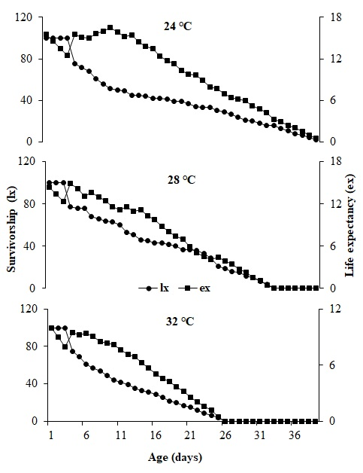

**Figure 1: Effect of constant temperatures on the survivorship(lx) and life expectancy(ex) of *P. xylostella***

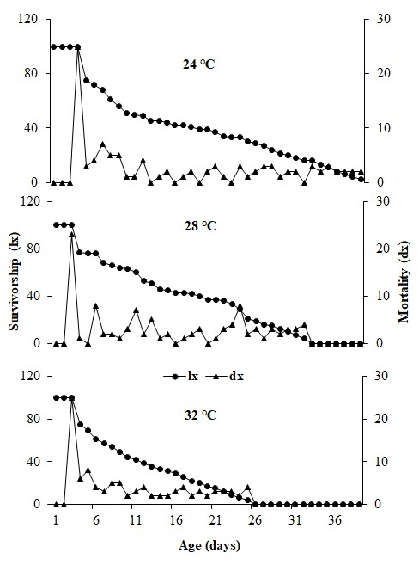

**Figure 2: Effect of constant temperature on the survivorship(lx) and mortality (dx) of *P. xylostella***

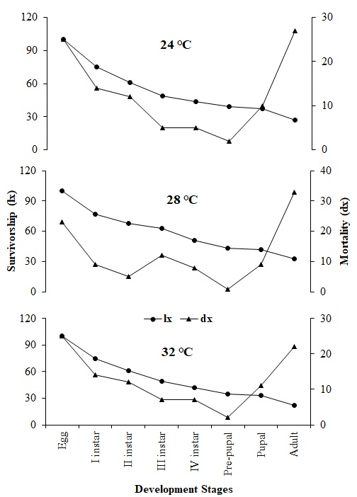

**Figure 3: Effect of constant temperatures on stage-specific survivorship (lx) and mortality (dx) of *P. xylostella***

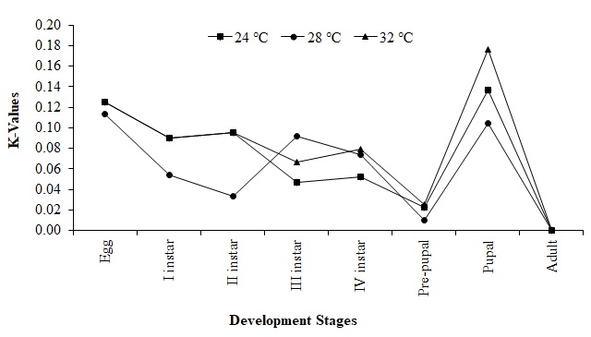

**Figure 4: Effect of constant temperatures on the stage-specific generation mortality**

**(k-value) of *P. xylostella***

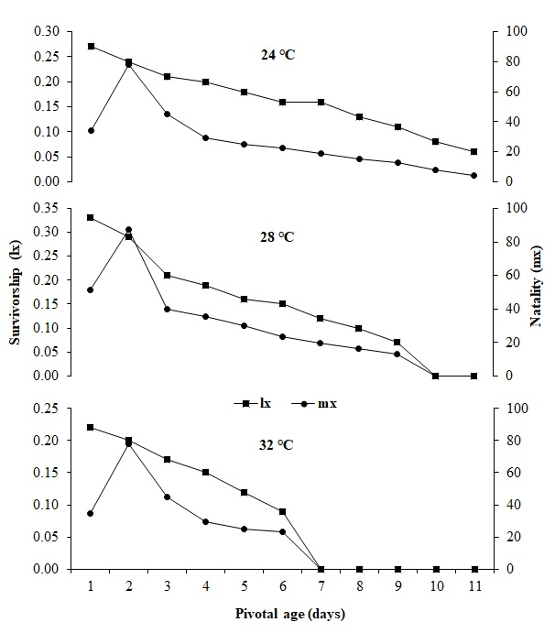

**Figure 5: Effect of constant temperatures on the female survivorship(lx) and natality(mx) of *P. xylostella***

**Table 1: Stage-specific life table of *P. xylostella* at various temperatures**

|  |  |  |  |  |  |  |  |  |
| --- | --- | --- | --- | --- | --- | --- | --- | --- |
| ***x*** | ***lx*** | ***dx*** | ***100qx*** | ***Sx*** | ***MSR*** | ***IM*** | **log (*lx*)** | **k-values** |
| **24 ℃** |  |  |  |  |  |  |  |  |
| Eggs | 100 | 25 | 25.00 | 0.75 | 0.33 | 9.00 | 2.00 | 0.12 |
| I instar | 75 | 14 | 18.67 | 0.81 | 0.23 | 6.20 | 1.88 | 0.09 |
| II instar | 61 | 12 | 19.67 | 0.80 | 0.24 | 6.61 | 1.79 | 0.10 |
| III instar | 49 | 5 | 10.20 | 0.90 | 0.11 | 3.07 | 1.69 | 0.05 |
| IV instar | 44 | 5 | 11.36 | 0.89 | 0.13 | 3.46 | 1.64 | 0.05 |
| Pre-pupal | 39 | 2 | 5.13 | 0.95 | 0.05 | 1.46 | 1.59 | 0.02 |
| Pupal | 37 | 10 | 27.03 | 0.73 | 0.37 | 10.00 | 1.57 | 0.14 |
| Adult | 27 | 27 | 100.00 | 0.00 | 0.00 | 0.00 | 1.43 | 0.00 |
|  |  |  |  |  |  |  |  | **K = 0.57** |
| **28 ℃** |  |  |  |  |  |  |  |  |
| Eggs | 100 | 23 | 23.00 | 0.77 | 0.30 | 9.86 | 2.00 | 0.11 |
| I instar | 77 | 9 | 11.69 | 0.88 | 0.13 | 4.37 | 1.89 | 0.05 |
| II instar | 68 | 5 | 7.35 | 0.93 | 0.08 | 2.62 | 1.83 | 0.03 |
| III instar | 63 | 12 | 19.05 | 0.81 | 0.24 | 7.76 | 1.80 | 0.09 |
| IV instar | 51 | 8 | 15.69 | 0.84 | 0.19 | 6.14 | 1.71 | 0.07 |
| Pre-pupal | 43 | 1 | 2.33 | 0.98 | 0.02 | 0.79 | 1.63 | 0.01 |
| Pupal | 42 | 9 | 21.43 | 0.79 | 0.27 | 9.00 | 1.62 | 0.10 |
| Adult | 33 | 33 | 100.00 | 0.00 | 0.00 | 0.00 | 1.52 | 0.00 |
|  |  |  |  |  |  |  |  | **K = 0.48** |
| **32 ℃** |  |  |  |  |  |  |  |  |
| Eggs | 100 | 25 | 25.00 | 0.75 | 0.33 | 7.33 | 2.00 | 0.12 |
| I instar | 75 | 14 | 18.67 | 0.81 | 0.23 | 5.05 | 1.88 | 0.09 |
| II instar | 61 | 12 | 19.67 | 0.80 | 0.24 | 5.39 | 1.79 | 0.10 |
| III instar | 49 | 7 | 14.29 | 0.86 | 0.17 | 3.67 | 1.69 | 0.07 |
| IV instar | 42 | 7 | 16.67 | 0.83 | 0.20 | 4.40 | 1.62 | 0.08 |
| Pre-pupal | 35 | 2 | 5.71 | 0.94 | 0.06 | 1.33 | 1.54 | 0.03 |
| Pupal | 33 | 11 | 33.33 | 0.67 | 0.50 | 11.00 | 1.52 | 0.18 |
| Adult | 22 | 22 | 100.00 | 0.00 | 0.00 | 0.00 | 1.34 | 0.00 |
|  |  |  |  |  |  |  |  | **K = 0.66** |

**Table 2: Female fertility life table of *P. xylostella* at various temperatures**

|  |  |  |  |  |  |  |  |  |
| --- | --- | --- | --- | --- | --- | --- | --- | --- |
| **Temperatures (ºC)** | ***Pf*** | ***Ro*** | ***rm*** | **λ** | ***Tc*** | ***τ*** | ***DT*** | ***MRI*** |
| 24ºC | 294.06b | 58.84b | 0.136c | 1.14c | 29.93a | 28.77a | 5.09a | 59.74c |
| 28ºC | 316.18a | 70.54a | 0.167b | 1.18b | 25.36b | 24.87b | 4.13b | 153.63b |
| 32ºC | 253.03c | 40.34c | 0.183a | 1.20a | 20.14c | 19.43c | 3.77c | 247.65a |
| *LSD* (p<0.01) | 7.45 | 3.93 | 0.0074 | 0.0088 | 0.936 | 0.042 | 0.211 | 43.41 |
| *F* | 221.40 | 178.90 | 125.0 | 121.10 | 299.10 | 299.80 | 124.10 | 56.10 |
| *df* | 2,6 | 2,6 | 2,6 | 2,6 | 2,6 | 2,6 | 2,6 | 2,6 |

***x*** = Stages, ***lx*** = No of surviving at beginning of stage, ***dx*** = Mortality, ***100qx*** = Apparent mortality, ***MSR*** = Mortality survival ratio, ***Sx*** = Survival fraction, ***IM*** = Indispensable mortality, ***Pf*** = Potential fecundity, ***Ro*** = Net reproduction rate, ***rm*** = Intrinsic rate of increase, **λ =** Finite rate of increase, ***Tc*** = Mean generation time, ***τ =*** Corrected generation time, ***DT*** *=* Doubling time, ***MRI =*** Monthly rate of increase

**Conclusion**

The current study has demonstrated that *Plutella xylostella* has the capacity to develop and reproduce at all tested temperature regimes (24°C, 28°C, and 32°C) and that temperature has a significant impact on the age-specific, stage-specific, and female fertility life table parameters. Across all life stages, the ideal temperature of 28°C promoted greater reproductive output, the lowest mortality rate, and higher survival rates, however the females also showed the highest net reproductive rate (R₀) and potential fecundity (Pf). The mean generation time (Tc), corrected generation time (τ), population doubling time (DT), intrinsic rate of increase (rm), finite rate of increase (λ), and monthly rate of population increase (MRI) all have moderate values at this temperature, whereas they were lowest at lower temperatures (24°C) and highest at higher ones (32°C). Information from this study is essential for creating new models that can simulate and forecast population dynamics. These models will be helpful in establishing the best possible management measures. The available information should then be condensed into a framework that will help us comprehend the dynamics of the *P. xylostella* population.

**References**

Aguilon, D. J. D., & Velasco, L. R. I. (2015). Effects of larval rearing temperature and host plant condition on the development, survival, and coloration of African armyworm, Spodoptera exempta Walker (Lepidoptera: Noctuidae). Journal of Environmental Science and Management, 18, 54–60.

Ahmad, T., & Ansari, M. S. (2013). Effect of mustard varieties on life table and development of diamondback moth, Plutella xylostella. Asian Journal of Plant Science and Research, 3(5), 1–6.

Bale, J. S., Masters, G. J., Hodkinson, I. D., Awmack, C., Bezemer, T. M., Brown, V. K., Butterfield, J., Buse, A., Coulson, J. C., Farrar, J., Good, J. E. G., Harrington, R., Hartley, S., Jones, T. H., Lindroth, R. L., Press, M. C., Symrnioudis, I., Watt, A. D., & Whittaker, J. B. (2002). Herbivory in global climate change research: Direct effects of rising temperature on insect herbivores. Global Change Biology, 8, 1–16.

Begon, M., Townsend, C. R., & Harper, J. L. (2006). Ecology: From individuals to ecosystems (3rd ed.). Blackwell Publishing Ltd.

Birch, L. (1948). The intrinsic rate of natural increase of an insect population. The Journal of Animal Ecology, 17(1), 15-26.

Cui, X., Wan, F., Xie, M., & Liu, T. (2008). Effects of heat shock on survival and reproduction of two whitefly species, Trialeurodes vaporariorum and Bemisia tabaci biotype B. Journal of Insect Science, 8, 24.

Deevey, E. S. (1947). Life tables for natural populations of animals. Q. Rev. Biol., 22, 283–314.

Dixon, A. F. G. (1987). Parthenogenetic reproduction and the rate of increase in aphids. *Aphids: their biology, natural enemies and control*, *2*, 269-287.

Du Plessis, H., Schlemmer, M. L., & Van den Berg, J. (2020). The effect of temperature on the development of Spodoptera frugiperda (Lepidoptera: Noctuidae). Insects, 11(4), 228-239.

Folguera, G., Mensch, J., Muñoz, L., Ceballos, S. G., Hasson, E., & Bozinovic, F. (2010). Ontogenetic stage-dependent effect of temperature on developmental and metabolic rates in a holometabolous insect. Journal of Insect Physiology, 56, 1679–1684.

Furlong, M. J., Wright, D. J., & Dosdall, L. M. (2013). Diamondback moth ecology and management: Problems, progress, and prospects. Annual Review of Entomology, 58(1), 517–541.

Gangurde, S. M., & Wankhede, S. M. (2009). Biology of diamondback moth, Plutella xylostella Linn. International Journal of Plant Protection, 2(2), 165–166.

Garrad, R., Booth, D., & Furlong, M. (2016). The effect of rearing temperature on development, body size, energetics and fecundity of the diamondback moth. Entomological Research, 106, 175–181.

Gautam, M. P., Singh, H., Kumar, S., Kumar, V., Singh, G., & Singh, S. N. (2018). Diamondback moth, Plutella xylostella (Linnaeus) (Insecta: Lepidoptera: Plutellidae), a major insect of cabbage in India: A review. Journal of Entomology and Zoology Studies, 6(4), 1394–1399.

Gillooly, J. F., Charnov, E. L., West, G. B., Savage, V. M., & Brown, J. H. (2002). Effects of size and temperature on developmental time. Nature, 417(6884), 70–73.

Golizadeh, A., Kamali, K., Fathipour, Y., & Abbasipour, H. (2009). Effect of temperature on life table parameters of Plutella xylostella (Lepidoptera: Plutellidae) on two brassicaceous host plants. Journal of Asia-Pacific Entomology, 12, 207–212.

Gu, X., Tian, S., Wang, D., Fei, G., & Wei, H. (2010). Interaction between short-term heat pretreatment and fipronil on 2nd instar larvae of diamondback moth, Plutella xylostella (Linn). Dose-Response, 8(3).

Gunn, D. (1917). The small cabbage moth (Plutella maculipennis Curtis). Bulletin, Department of Agriculture, Union of South Africa, 8, 1–10.

Haripriya, K., Kennedy, J. S., Geethalakshmi, V., & Rajabaskar, D. (2021). Influence of elevated temperature on the fitness of Diamondback moth, Plutella xylostella (L.) in cauliflower. Journal of Environmental Biology, 42, 1106-1113.

Harrington, R., Clark, S. J., Welham, S. J., Verrier, P. J., Denholm, C. H., Hullé, M., Maurice, D., Rounsevell, M. D., & Cocu, N. (2007). Environmental change and the phenology of European aphids. Global Change Biology, 13, 1550–1564.

Hassall, C., Thompson, D. J., French, G. C., & Harvey, I. F. (2007). Historical changes in the phenology of British Odonata are related to climate. Global Change Biology, 13, 933–941.

Hu, X., Wang, Z., He, K., Xie, H., & Wang, Y. (2024). Age-stage, two-sex life table, and population projection of Ostrinia furnacalis (Lepidoptera: Crambidae) at different temperatures. Journal of Economic Entomology, 117(3), 800-808.

Infante, F. (2000). Development and population growth rates of Prorops nasuta (Hym.,

Jaleel, W., Lu, L., & He, Y. (2018). Biology, taxonomy, and IPM strategies of *Bactrocera tau* Walker and complex species (Diptera; Tephritidae) in Asia: a comprehensive review. *Environmental Science and Pollution Research*, *25*, 19346-19361.

Li, D. (2002). The combined effects of temperature and diet on development and survival of a crab spider, Misumenops tricuspidatus (Fabricius) (Araneae: Thomisidae). Journal of Thermal Biology, 27(2), 83–93.

Liu, S., Chen, F. Z., & Zalucki, M. P. (2002). Development and survival of the diamondback moth (Lepidoptera: Plutellidae) at constant and alternating temperatures. Environmental Entomology, 31(2), 221–231.

Marchioro, C., & Foerster, L. (2011). Development and survival of the diamondback moth, Plutella xylostella (L.) (Lepidoptera: Yponomeutidae) as a function of temperature: Effect on the number of generations in tropical and subtropical regions. Neotropical Entomology, 40, 533–541.

McClay, A. S., & Hughes, R. B. (2007). Temperature and host-plant effects on development and population growth of Mecinus janthinus (Coleoptera: Curculionidae), a biological control agent for invasive Linaria spp. Biological Control, 40(3), 405–410.

Menéndez, R. (2007). How are insects responding to global warming? Tijdschrift voor Entomologie, 150, 355–365.

Ngowi, B. V., Tonnang, H. E. Z., Mwangi, E. M., Johansson, T., Ambale, J., Ndegwa, P. N., & Subramanian, S. (2017). Temperature dependent phenology of Plutella xylostella (Lepidoptera: Plutellidae): Simulation and visualization of current and future distributions along the Eastern Afromontane. PLoS ONE, 12, e0173590.

Powell, J. A., & Bentz, B. J. (2009). Connecting phenological predictions with population growth rates for mountain pine beetle, an outbreak insect. Landscape Ecology, 24, 657–672.

Rasool, K., Ahmad, S. B., & Yaqoob, M. (2022). Biology of diamondback moth Plutella xylostella L. on cabbage. Indian Journal of Entomology, 84(3), 604–606.

Sabra, I. M., Kandil, M. A., El-Shennawy, R. M., & Ahmed, A. F. (2022). Effect of temperature on development and life table parameters of fall armyworm Spodoptera frugiperda (Lepidoptera: Noctuidae). Journal of Plant Protection and Pathology, 13(11), 267-271.

Saeed, S., Jaleel, W., Naqqash, M. N., Saeed, Q., Zaka, S. M., Sarwar, Z. M., ... & Sharma, G. K. (2019). Fitness parameters of Plutella xylostella (L.) (Lepidoptera: Plutellidae) at four constant temperatures by using age-stage, two-sex life tables. Saudi Journal of Biological Sciences, 26(7), 1661–1667.

Sales, K., Vasudeva, R., & Gage, M. J. (2021). Fertility and mortality impact of thermal stress from experimental heatwaves on different life stages and their recovery in a model insect. Royal Society Open Science, 8(3), 201717

Sarfaraz, R. M., Dosdall, L. M., Keddie, A. B., & Myers, J. H. (2011). Larval survival, host plant preferences and developmental responses of the diamondback moth Plutella xylostella (Lepidoptera: Plutellidae) on wild brassicaceous species. Entomological Science, 14, 1–30.

Sauvion, S., Mauriello, V., Renard, B., & Boissot, N. (2005). Impact of melon accessions resistant to aphids on the demographic potential of silverleaf whitefly. Journal of Economic Entomology, 98, 557–567.

Shirai, Y. (2000). Temperature tolerance of the diamondback moth, Plutella xylostella (Lepidoptera: Yponomeutidae) in the tropics and temperate regions of Asia. Bulletin of Entomological Research, 90, 357–364.

Southwood, T. (1978). Ecological methods with particular reference to the study of insect population (2nd ed.). Chapman & Hall.

Southwood, T. R. E., & Henderson, P. A. (2000). Ecological methods (3rd ed.). Blackwell Science.

Stark, J. D., Sugayama, R. L., & Kovaleski, A. (2007). Why demographic and modelling approaches should be adopted for estimating the effects of pesticides on biocontrol agents. *Bio-Control*, *52*, 365-374.

Zheng, F. S., Du, Y. Z., Wang, Z. J., & Xu, J. J. (2008). Effect of temperature on the demography of Galerucella birmanica (Coleoptera: Chrysomelidae). Insect Science, 15(4), 375–380.

Zhou, Z. S., Guo, J. Y., Chen, H. S., & Wan, F. H. (2010). Effects of temperature on survival, development, longevity, and fecundity of Ophraella communa (Coleoptera: Chrysomelidae), a potential biological control agent against Ambrosia artemisiifolia (Asterales: Asteraceae). Environmental Entomology, 39(3), 1021–1027.

Sönmez, E. (2022). The Effect of Temperature and Nutrient on Developmental Biology and Physiology of Stored-Product Species of Coleoptera*. Sinop Üniversitesi Fen Bilimleri Dergisi, 7*(1), 81-101.