Growth and performance of Kisan Credit Card Scheme in Sultanpur District of Uttar Pradesh

Abstract:
Aim:_The purpose of the study_is to_evaluate the growth and performance of the KCC scheme with reference to the study area and constraints faced by the farmer. Study of design: This research is based on secondary data, for constraints we used purposive cum random sampling techniques will be applied for selection of respondents to deal with the investigation. Period of study:_In India and Uttar Pradesh, secondary data about Kisan Credit Cards was gathered. RBI publications were used to gather time series data on the number of KCCs issued and the amount approved under the KCC scheme for India from the scheme's inception (1998–1999) to 2023–2024. _From 2016–17 to 2023–24, data were gathered from the lead bank of the corresponding districts in the study area. Result:_In_India the KCC scheme CAGR of 20.46 per cent for KCC cards granted by RRBs. The cooperative banks granted 13.63 per cent of KCCs, compared to the commercial banks 13.96 per cent CAGR. The CAGR of 25.07 per cent for amount sanctioned by commercial banks. The cooperative banks sanctioned 17.37 per cent of KCCs, compared to the RRBs’ 30.12 per cent CAGR._The CAGR of -0.026 per cent for KCC cards granted by commercial banks. The cooperative banks granted -7.49 per cent of KCCs, compared to the RRBs’ 2.60 per cent CAGR. The CAGR of 98.85% for amount sanctioned by commercial banks. The cooperative banks sanctioned 107.02 per cent of KCCs, compared to the RRBs’ 111.38 per cent CAGR and similar result in the study area.
Conclusion:_The study reveals a mixed growth pattern in the performance of the Kisan. While commercial and cooperative banks showed relatively modest or even negative growth in KCC issuance, the amount sanctioned by these institutions, particularly commercial banks, grew substantially. These trends were similarly reflected in the study area, highlighting both progress and disparities in the implementation of the KCC scheme. The findings underscore the need to address institutional constraints and enhance outreach strategies for better scheme performance.
Keywords:_Kisan Credit Card (KCC),CAGR, Constraints, Credit, RBI & NABARD
Introduction:
_The Indian economy is grounded on husbandry, which employs over 50 of the pool and contributes significantly to GDP and pastoral livelihoods (GoI, 2022).; still, Indian growers, particularly small and borderline growers, face a number of challenges, including a lack of fiscal knowledge, a high reliance on informal sources, and limited access to timely credit. To address these issues, the Government of India introduced the Kisan Credit Card (KCC) scheme in 1998 with the thing of giving growers short- term credit in a timely and easy way.
Over the times, the KCC scheme has changed in a number of ways, including interest annuity, digitization, and the addition of affiliated businesses (similar as dairy and fishery). Indeed, with its use, questions still compass how well it works to ameliorate agrarian income and product and lessen reliance on unofficial lending. (NABARD, 2020).
In 2004, the scheme was expanded to cover growers' investment credit requirements for both confederated and non-farm conditioning, and it was reassessed in 2012 by a working group led by Shri T. M. Bhasin, CMD of Indian Bank, to simplify the scheme and promote the allocation of Electronic Kisan Credit Cards. The guidelines established by the scheme help banks apply the KCC effectively. Reserve Bank of India- Master leaflets (2018) (Missing in reference section).
The Kisan Credit Card (KCC) Scheme was launched by the Government of India in 1998 and surfaced as a transformative action aimed at furnishing affordable and timely credit to growers. The KCC scheme, eased by marketable banks, indigenous pastoral banks, and collaborative banks, was designed to address the fiscal constraints faced by growers by offering short- term loans for agrarian conditioning, including copping seeds, diseases, outfit, and other inputs. The Kisan Credit Card (KCC) Scheme was launched with the end of icing growers admit sufficient and prompt credit for their agrarian conditioning. The Government of India offers a 2-interest annuity and a 3 incitement for timely prepayment to growers, allowing them to pierce loans at a largely subsidized interest rate of 4 per time.
growers' fiscal demands have been met in large part thanks to the KCC scheme. This budget of 2025 highlights the government's desire to empower growers and raise agrarian affair by significantly raising the loan limit under the Modified Interest annuity Scheme from ₹ 3 lakh to ₹ 5 lakh. (PIB 2025)
Methodology:
The present study was based on secondary data. Secondary data regarding Kisan Credit Cards was obtained from the RBI, NABARD, and a number of financial organizations in India and Uttar Pradesh, including commercial and cooperative banks. Time series data on the quantity authorized and the number of KCCs granted under the KCC scheme for India from the scheme's launch in 1998–1999 to 2023–2024 were collected using RBI publications.Data were collected from the corresponding districts' lead bank in the study region between 2015–16 and 2023–24.
- Compound growth rate analysis:
To access credit growth for various reasons, compound growth rates were calculated.
Compound growth rates were calculated using the following exponential function.
Yt = A B^{t}e^{ut} ……………. (1)

Where
Y_{t}= Credit dispersed during time t
A= Y in the base year, T= Time period
u_{t}= Error term, B= 1+g
By taking the logarithm, equation (1) was reduced to the following form
LogYt = LogA + (Log B)t + ut ------------------- (2)
Where Log A and Log B were the parameters of the function obtained by ordinary least square method (OLS).
In the exponential: CAGR% = (Antilog (b) – 1) × 100 ---------- (3)
- Constraints in availing and use of KCC:
To identify the problem of seed by the farmers during production Constraints faced by farmers Garret ranking technique (Henry Garrett_year?) will be used. The respondent has been asked to rank the constraints and these converted into score.
Percent position = 100 x (Rij-0.5)/ Nj
Where,
Rij= Rank given for ith factor by jth individual
Nj= Number of factors ranked by jth individual
By referring to the Garrett table, the percentage position estimated will be converted into a score. Then for each factor, the scores of various respondents were added, and the mean score was calculated. The factors with the highest mean score were considered to be the most important factors.

Results and discussion:
Agency-wise Progress of KCC Scheme in India.
The Kisan Credit Card scheme has been carried out by commercial banks, cooperative banks, and regional rural banks throughout the nation (Kaur & Dhaliwal, 2018) and reports and issues from RBI and NABARD. The progress made by these organizations in terms of the number of cards issued under the KCC scheme from 1998-99 to 2023-24 is shown below.
Table 1._Agency-wise Progress of Number of Kisan Credit Card Scheme in India
Year | No. of Kisan credit card Issued (In '000)
Year | Commercial Banks | Proportion in total (%) | RRBs | Proportion in total (%) | Cooperative Banks | Proportion in total (%) | Total
1998-99 | 622 | 79.4 | 6 | 0.8 | 155 | 19.8 | 783
1999-00 | 1366 | 26.6 | 173 | 3.4 | 3595 | 70.0 | 5134
2000-01 | 2390 | 27.6 | 648 | 7.5 | 5614 | 64.9 | 8652
2001-02 | 3071 | 32.9 | 834 | 8.9 | 5436 | 58.2 | 9341
2002-03 | 2700 | 32.8 | 964 | 11.7 | 4579 | 55.6 | 8243
2003-04 | 3094 | 33.5 | 1274 | 13.8 | 4878 | 52.8 | 9246
2004-05 | 4396 | 45.4 | 1729 | 17.9 | 3556 | 36.7 | 9681
2005-06 | 4165 | 52.0 | 1249 | 15.6 | 2598 | 32.4 | 8012
2006-07 | 4808 | 56.5 | 1406 | 16.5 | 2298 | 27.0 | 8512
2007-08 | 4606 | 54.4 | 1772 | 20.9 | 2091 | 24.7 | 8469
2008-09 | 5834 | 67.9 | 1415 | 16.5 | 1344 | 15.6 | 8593
2009-10 | 5313 | 59.0 | 1950 | 21.7 | 1743 | 19.4 | 9006
2010-11 | 5582 | 54.9 | 1774 | 17.4 | 2812 | 27.7 | 10168
2011-12 | 6804 | 57.9 | 1995 | 17.0 | 2961 | 25.2 | 11760
2012-13 | 8243 | 63.5 | 2048 | 15.8 | 2691 | 20.7 | 12982
2013-14 | 8549 | 61.5 | 2179 | 15.7 | 3176 | 22.8 | 13904
2014-15 | 8324 | 64.4 | 1549 | 12.0 | 3061 | 23.7 | 12934
2015-16 | 8429 | 69.2 | 2237 | 18.4 | 1519 | 12.5 | 12185
2016-17 | 23320 | 32.6 | 12271 | 17.2 | 35883 | 50.2 | 71474
2017-18 | 23528 | 34.0 | 12193 | 17.6 | 33495 | 48.4 | 69216
2018-19 | 23633 | 35.6 | 12253 | 18.5 | 30414 | 45.9 | 66300
2019-20 | 24145 | 37.0 | 12197 | 18.7 | 28938 | 44.3 | 65280
2020-21 | 30696 | 41.6 | 12891 | 17.5 | 30183 | 40.9 | 73770
2021-22 | 26870 | 37.7 | 13348 | 18.7 | 31131 | 43.6 | 71349
2022-23 | 28290 | 38.5 | 13868 | 18.9 | 31389 | 42.7 | 73547
2023-24 | 29814 | 38.6 | 14517 | 18.8 | 32917 | 42.6 | 77248
mean | 11484.3 |  | 4951.5 |  | 11863.7 |  | 28299.6
C.V. | 90.5 |  | 110.7 |  | 115.1 |  | 103.3
CAGR% | 13.96 |  | 20.46 |  | 13.63 |  | 14.02
(Note: Figures in parentheses indicate percentage to aggregate)
(Source: NABARD Annual Reports, RBI Reports on Trend and Progress of Banking in India)
Table 1 indicated that KCCs issued by Commercial Banks, RRBs and Cooperative Banks exhibited growth tendencies with yearly fluctuations. The number of cards issued by commercial banks has grown from 622 thousand to 29814 thousand in 2023-24. From 1998-99 to 2023-24, the number of KCC cards issued by RRBs went from 6 thousand to 14517 thousand, whereas the number of KCC cards issued by Cooperative Banks increased from155 thousand in 1998-99 to 32917. In India, the cooperative banks had the largest mean number of cards issued under the KCC scheme (11863.7), followed by the commercial banks (11484.3) and RRBs (4951.5). The average value of all cards issued was 28299.6 thousand. The data also revealed a CAGR of 13.96 per cent for KCC cards granted by commercial banks. The cooperative banks granted 13.63 per cent of KCCs, compared to the RRBs’ 20.46 per cent CAGR. The proportion of total KCC cards issued by commercial banks, RRBs and Cooperative Banks is also shown in table 1.
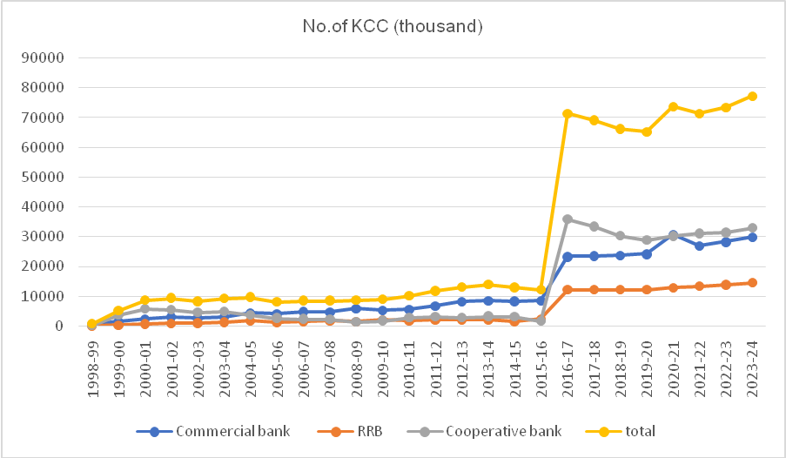
Fig 1. Agency wise Performance of number of KCCs issued in India
Table 2. Agency-wise Progress of Kisan Credit Card Scheme in India
Year | Amount Sanctioned (Rs. in crore)
Year | Commercial Banks | Proportion in total (%) | RRBs | Proportion in total (%) | Cooperative Banks | Proportion in total (%) | Total
1998-99 | 1473 | 63.8 | 11 | 0.5 | 826 | 35.8 | 2310
1999-00 | 3537 | 46.9 | 405 | 5.4 | 3606 | 47.8 | 7548
2000-01 | 5615 | 34.2 | 1400 | 8.5 | 9412 | 57.3 | 16427
2001-02 | 7524 | 29.1 | 2382 | 9.2 | 15952 | 61.7 | 25858
2002-03 | 7481 | 28.5 | 2955 | 11.2 | 15841 | 60.3 | 26277
2003-04 | 9331 | 42.8 | 2599 | 11.9 | 9855 | 45.2 | 21785
2004-05 | 14756 | 43.2 | 3833 | 11.2 | 15597 | 45.6 | 34186
2005-06 | 18779 | 39.5 | 8483 | 17.8 | 20339 | 42.7 | 47601
2006-07 | 26215 | 56.1 | 7373 | 15.8 | 13141 | 28.1 | 46729
2007-08 | 59530 | 67.4 | 8743 | 9.9 | 19991 | 22.6 | 88264
2008-09 | 39009 | 73.5 | 5648 | 10.6 | 8428 | 15.9 | 53085
2009-10 | 39940 | 69.2 | 10132 | 17.6 | 7606 | 13.2 | 57678
2010-11 | 50438 | 69.4 | 11468 | 15.8 | 10719 | 14.8 | 72625
2011-12 | 69515 | 75.8 | 11525 | 12.6 | 10640 | 11.6 | 91680
2012-13 | 101095 | 80.1 | 13260 | 10.5 | 11925 | 9.4 | 126280
2013-14 | 103710 | 76.4 | 15846 | 11.7 | 16195 | 11.9 | 135751
2014-15 | 104496 | 82.8 | 10812 | 8.6 | 10968 | 8.7 | 126276
2015-16 | 111528 | 78.6 | 12128 | 8.5 | 18325 | 12.9 | 141981
2016-17 | 158120 | 42.4 | 102420 | 27.5 | 112200 | 30.1 | 372740
2017-18 | 433120 | 64.6 | 113360 | 16.9 | 124480 | 18.6 | 670960
2018-19 | 455079 | 64.1 | 127072 | 17.9 | 127436 | 18.0 | 709587
2019-20 | 423588 | 60.8 | 136695 | 19.6 | 136735 | 19.6 | 697018
2020-21 | 456736 | 60.6 | 149416 | 19.8 | 146981 | 19.5 | 753133
2021-22 | 476271 | 50.8 | 162060 | 17.3 | 299282 | 31.9 | 937613
2022-23 | 518485 | 58.5 | 177999 | 20.1 | 189436 | 21.4 | 885920
2023-24 | 574974 | 58.6 | 197753 | 20.2 | 207678 | 21.2 | 980405
mean | 164244.0 |  | 49837.6 |  | 60138.2 |  | 274219.9
C.V. | 121.3 |  | 135.7 |  | 134.0 |  | 124.7
CAGR% | 25.07 |  | 30.12 |  | 17.37 |  | 22.73
(Note: Figures in parentheses indicate percentage to aggregate)
(Source: NABARD Annual Reports, RBI Reports on Trend and Progress of Banking in India)
Table 2 reveals that KCCs showed a growth in performance of credit sanctioned by Cooperative Banks, Commercial Banks and RRBs with slight variation in some years. The amount sanctioned by commercial banks has grown from 1473_crore to 574974_crore in 2023-24. From 1998-99 to 2023-24, the amount sanctioned by RRBs went from 11_crore to 197753_crore, whereas the amount sanctioned by Cooperative Banks increased from 826_crore in 1998-99 to 207678. In India, the commercial banks had the largest mean amount sanctioned under the KCC scheme (164244), followed by the cooperative banks (60138.2) and RRBs (49837.6). The average value of all amount sanctioned was 274219.9_ crore. The data also revealed a CAGR of 25.07 per cent for amount sanctioned by commercial banks. The cooperative banks sanctioned17.37 per cent of KCCs, compared to the RRBs’ 30.12 per cent CAGR. The proportion of total amount sanctioned by Commercial banks, RRBs and Cooperative Banks is also shown in table 2.
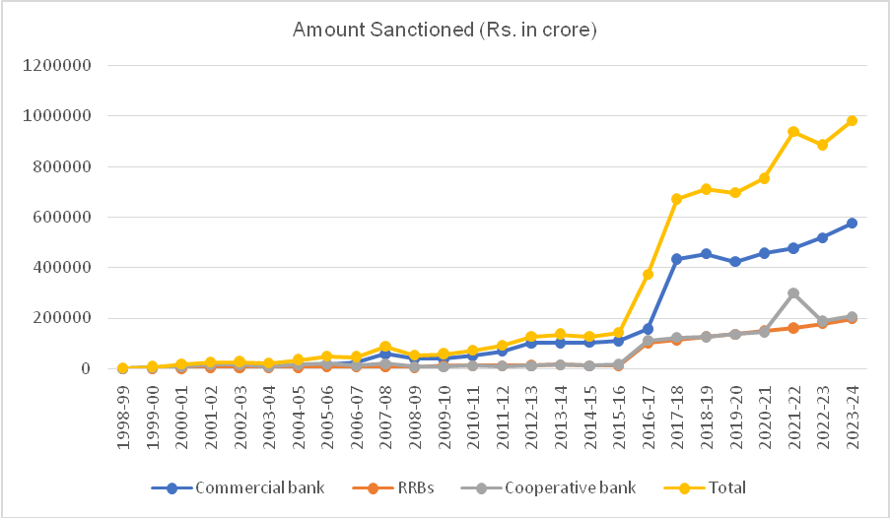
Fig 2. Agency wise Performance of amount sanctioned in India
Table 3. Agency wise number of KCCs issued in Uttar Pradesh
Year | No. of Kisan credit card Issued (In '000)
Year | Commercial  bank | Proportion in total (%) | RRB | Proportion in total (%) | Cooperative bank | Proportion in total (%) | Total
2016-17 | 4469 | 37.13 | 3136 | 26.06 | 4431 | 36.81 | 12036
2017-18 | 4226 | 35.33 | 3266 | 27.31 | 4468 | 37.36 | 11960
2018-19 | 4499 | 40.40 | 3436 | 30.85 | 3202 | 28.75 | 11137
2019-20 | 4315 | 41.77 | 3361 | 32.54 | 2654 | 25.69 | 10330
2020-21 | 5079 | 45.02 | 3541 | 31.39 | 2661 | 23.59 | 11281
2021-22 | 4272 | 40.80 | 3517 | 33.59 | 2682 | 25.61 | 10471
2022-23 | 4302 | 40.18 | 3677 | 34.35 | 2727 | 25.47 | 10706
2023-24 | 4394 | 40.25 | 3851 | 35.27 | 2673 | 24.48 | 10918
mean | 4,445 |  | 3,473 |  | 3,187 |  | 11,105
C.V. | 6.15 |  | 6.54 |  | 25.10 |  | 5.72
CAGR% | -0.026 |  | 2.60 |  | -7.49 |  | -1.57
(Note: Figures in parentheses indicate percentage to aggregate)
(Source: NABARD Annual Reports, RBI Reports on Trend and Progress of Banking in India)
Table 3 indicated that KCCs issued by Commercial Banks, RRBs and Cooperative Banks exhibited growth tendencies with yearly fluctuations. From 2016-17 to 2023-24, The number of cards issued by commercial banks has grown from 4469 thousand to 4394 thousand. From 2016-17 to 2023-24, the number of KCC cards issued by RRBs went from 3136 thousand to 3851 thousand, whereas the number of KCC cards issued by Cooperative Banks increased from 4431 thousand in 2016-17 to 2673 thousand. In Uttar Pradesh, the commercial banks had the largest mean number of cards issued under the KCC scheme (4445), followed by the RRBs (3473) and cooperative (3187). The average value of all cards issued was 11105thousand. The data also revealed a CAGR of -0.026 per cent for KCC cards granted by commercial banks. The cooperative banks granted -7.49 per cent of KCCs, compared to the RRBs’ 2.60 per cent CAGR. The proportion of total KCC cards issued by commercial banks, RRBs and Cooperative Banks is also shown in table 3.
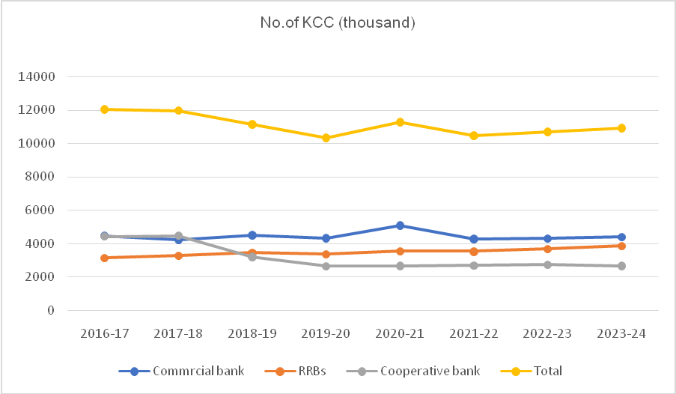
Fig 3. Agency wise Performance of number of KCCs issued in Uttar Pradesh
Table 4. Agency wise amount sanctioned in Uttar Pradesh
Year | Amount Sanctioned (Rs. in crore)
Year | Commercial bank | Proportion in total (%) | RRB | Proportion in total (%) | Cooperative bank | Proportion in total (%) | Total
2016-17 | 648.6 | 65.91 | 277.2 | 28.17 | 58.3 | 5.92 | 58.3
2017-18 | 592.1 | 62.62 | 296.8 | 31.39 | 56.7 | 6.00 | 56.7
2018-19 | 65192.2 | 60.90 | 35501 | 33.16 | 6354.6 | 5.94 | 6354.6
2019-20 | 66387.3 | 60.48 | 36976.5 | 33.69 | 6401.7 | 5.83 | 6401.7
2020-21 | 69467.22 | 58.84 | 41838.9 | 35.44 | 6759.5 | 5.73 | 6759.5
2021-22 | 70673 | 57.44 | 44986 | 36.56 | 7375 | 5.99 | 7375
2022-23 | 72202 | 56.36 | 46843 | 36.56 | 9070 | 7.08 | 9070
2023-24 | 76963 | 55.52 | 52694 | 38.01 | 8964 | 6.47 | 8964
mean | 52,766 |  | 32,427 |  | 5,630 |  | 90,822
C.V. | 61.37 |  | 63.43 |  | 63.86 |  | 62.04
CAGR% | 98.85 |  | 111.38 |  | 107.02 |  | 103.47
(Note: Figures in parentheses indicate percentage to aggregate)
(Source: NABARD Annual Reports, RBI Reports on Trend and Progress of Banking in India)
Table 4 indicate the KCCs growth in performance of credit sanctioned by Cooperative Banks, Commercial Banks and RRBs with slight variation in some years. From 2016-17 to 2023-24, The amount sanctioned by commercial banks has grown from 648.6 crore to 76963 crore. From 2016-17 to 2023-24, the amount sanctioned by RRBs went from 277.2 crore to 52694 crore, whereas the amount sanctioned by Cooperative Banks increased from 58.5 crore to 8964. In Uttar Pradesh, the Commercial banks had the largest mean amount sanctioned under the KCC scheme (52766), followed by the RRBs (32427) and Cooperative banks (5630). The average value of all amount sanctioned was 90822crores. The data also revealed a CAGR of 98.85 per cent for amount sanctioned by commercial banks. The cooperative banks sanctioned 107.02 per cent of KCCs, compared to the RRBs’ 111.38 per cent CAGR. The proportion of total amount sanctioned by Commercial banks, RRBs and Cooperative Banks is also shown in table 4.
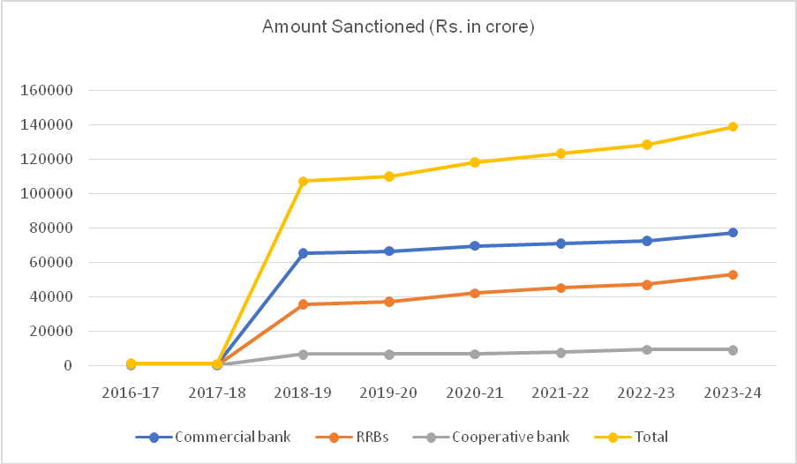
Fig 4. Agency wise Performance of amount sanctioned_Uttar Pradesh

Table 5. Agency-wise number of KCCs issued in the study area
Year | No. of Kisan credit card Issued (In '000)
Year | Commercial bank | Proportion in total (%) | RRB | Proportion in total (%) | Cooperative bank | Proportion in total (%) | Total
2016-17 | 15.032 | 58.87 | 10.437 | 40.87 | 0.067 | 0.262 | 25.536
2017-18 | 5.866 | 12.65 | 40.452 | 87.20 | 0.071 | 0.153 | 46.389
2018-19 | 8.32 | 18.00 | 37.812 | 81.82 | 0.079 | 0.171 | 46.211
2019-20 | 18.071 | 25.01 | 54.104 | 74.88 | 0.084 | 0.116 | 72.259
2020-21 | 21.387 | 35.82 | 38.252 | 64.06 | 0.074 | 0.124 | 59.713
2021-22 | 15.274 | 28.67 | 37.934 | 71.20 | 0.072 | 0.135 | 53.28
2022-23 | 26.113 | 55.12 | 21.171 | 44.69 | 0.087 | 0.184 | 47.371
2023-24 | 13.682 | 21.91 | 48.675 | 77.96 | 0.078 | 0.125 | 62.435
mean | 15.47 |  | 36.10 |  | 0.08 |  | 51.65
C.V. | 42.45 |  | 39.08 |  | 8.87 |  | 27.05
CAGR% | 8.17 |  | 8.95 |  | 2.014 |  | 8.17
(Note: figures in parentheses indicate percentage to total)
(Source: Lead bank of Sultanpur district, 2023-24, NABARD districts office, Sultanpur)
Table 5 indicated that KCCs issued by Commercial Banks, RRBs and Cooperative Banks exhibited growth tendencies with yearly fluctuations. From 2016-17 to 2023-24, The number of cards issued by commercial banks has grown from 15.032 thousand to 13.682 thousand in 2023-24. From 2016-17 to 2023-24, the number of KCC cards issued by RRBs went from 10.437 thousand to 48.675 thousand, whereas the number of KCC cards issued by Cooperative Banks increased from0.067 thousand to 0.078. In study area, the RRBs had the largest mean number of cards issued under the KCC scheme (36.10), followed by the commercial banks (15.47) and cooperative banks (8.87). The average value of all cards issued was 51.65thousand. The data also revealed a CAGR of 8.17 per cent for KCC cards granted by commercial banks. The cooperative banks granted 2.014 per cent of KCCs, compared to the RRBs’ 8.95 per cent CAGR. The proportion of total KCC cards issued by commercial banks, RRBs and Cooperative Banks is also shown in Table 5.
Fig 5. Agency wise Performance of number of KCCs issued in study area
Table 6. Agency-wise amount sanctioned in study area
Year | Amount Sanctioned (Rs. in crore)
Year | Commercial bank | Proportion in total (%) | RRB | Proportion in total (%) | Cooperative bank | Proportion in total (%) | Total
2016-17 | 26760 | 69.03 | 11935 | 30.79 | 73 | 0.188 | 38768
2017-18 | 7202 | 19.27 | 30108 | 80.55 | 69 | 0.185 | 37379
2018-19 | 10864 | 36.87 | 18522 | 62.86 | 78 | 0.265 | 29464
2019-20 | 20780 | 39.42 | 31849 | 60.42 | 80 | 0.152 | 52709
2020-21 | 9812 | 19.64 | 40069 | 80.19 | 89 | 0.178 | 49970
2021-22 | 18959 | 28.18 | 48240 | 71.71 | 71 | 0.106 | 67270
2022-23 | 32020 | 52.90 | 28443 | 46.99 | 67 | 0.111 | 60530
2023-24 | 4219 | 6.54 | 60266 | 93.39 | 45 | 0.070 | 64530
mean | 16327 |  | 33679 |  | 71.50 |  | 50077
C.V. | 60.55 |  | 46.35 |  | 17.94 |  | 27.57
CAGR% | 12.86 |  | 18.35 |  | -4.32 |  | 10.52
(Note: figures in parentheses indicate percentage to total)
(Source: Lead bank of Sultanpur district, 2023-24, NABARD districts office, Sultanpur)
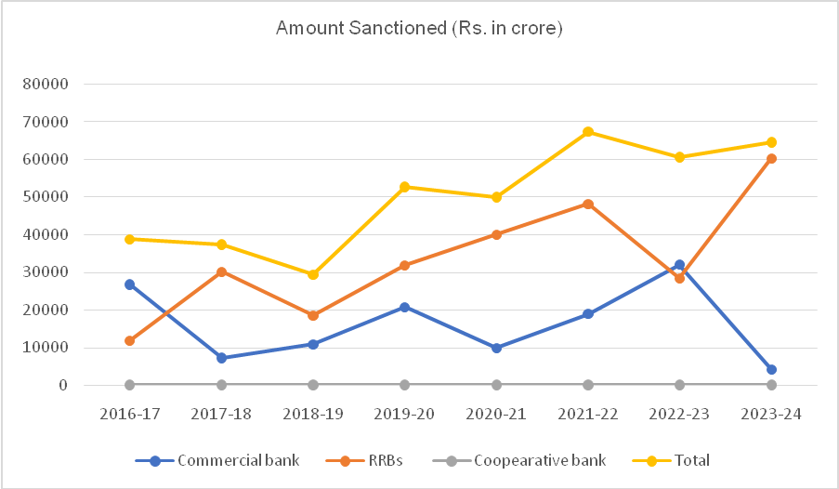
Fig 6. Agency wise Performance of amount sanctioned in study area
Table 6 indicate that KCCs showed a growth in performance of credit sanctioned by Cooperative Banks, Commercial Banks and RRBs with slight variation in some years. From 2016-17 to 2023-24, The amount sanctioned by commercial banks has grown from 26760 crore to 4219 crore. From 2016-17 to 2023-24, the amount sanctioned by RRBs went from 11935 crore to 60266 crore, whereas the amount sanctioned by Cooperative Banks increased from 73 crore to 45. In study area, the RRBs had the largest mean amount sanctioned under the KCC scheme (33679), followed by the Commercial bank (16327) and Cooperative banks (71.50). The average value of all amount sanctioned was 50077crores. The data also revealed a CAGR of 12.86 per cent for amount sanctioned by commercial banks. The cooperative banks sanctioned -4.32 per cent of KCCs, compared to the RRBs’ 18.35 per cent CAGR. The proportion of total amount sanctioned by Commercial banks, RRBs and Cooperative Banks is also shown in table.

Constraints in availing and use of KCC:
The constraints in availing and utilizing KCC loans significantly limit the scheme’s intended impact on improving access to institutional credit and enhancing agricultural productivity. Addressing these issues requires a combination of tedious paper work, high interest rate, loan not available on time, inflexibility in withdrawals, Difficulty in opening bank account, Lack of motivation from officials, Insufficient credit limit, Compulsory insurance for crops, Locational difficulty and period of limits.
Table 7. Constraints in availing and use of KCC as perceived by farmers
S. N. | Constraints | Garrett’s mean score | Rank
 | Tedious paperwork | 65.2 | I
 | High interest rate | 61.5 | II
 | Loan not available on time | 53.7 | III
 | Inflexibility in Withdrawals | 52.8 | IV
 | Difficulty in opening bank account | 50.4 | V
 | Lack of motivation from officials | 46.9 | VI
 | Insufficient credit limit | 46.5 | VII
 | Compulsory insurance for crops | 43.6 | VIII
 | Locational difficulty | 40.1 | IX
 | Period of validity | 37.3 | X
(Source: Field survey)
Conclusion:
During the period of the study, the Kisan Credit Card scheme has experienced significant growth in the terms of the number of cards issued and loan amount approved, both period and agency wise. In India, For the number of cards issued under the Kisan Credit Card program, the CAGR for Commercial Banks, RRBs and Cooperative Banks were 13.96 per cent, 20.46 per cent and 13.63 per cent, respectively. The CAGR for credit amount approved under the Kisan Credit Card program by Cooperative Banks, RRBs and Commercial Banks were 25.07 per cent, 30.12 per cent and 17.37 per cent, respectively. The study discovered that Commercial Banks sanctioned the majority share of the credit amount.
In Uttar Pradesh, For the number of cards issued under the Kisan Credit Card program, the CAGR for Commercial Banks, RRBs and Cooperative Banks were -0.026 per cent, 2.60 per cent and -7.49 per cent, respectively. The CAGR for credit amount approved under the Kisan Credit Card program by Cooperative Banks, RRBs and Commercial Banks were 98.85%,111.38% and 107.02%respectively. The study discovered that Commercial Banks sanctioned the majority share of the credit amount.
In study, For the number of cards issued under the Kisan Credit Card program, the CAGR for Commercial Banks, RRBs and Cooperative Banks were 8.17 per cent, 8.95 per cent and 2.014 per cent, respectively. The CAGR for credit amount approved under the Kisan Credit Card program by Cooperative Banks, RRBs and Commercial Banks were 12.86 per cent, 18.35 per cent and ..... per cent , respectively. The study discovered that Commercial Banks sanctioned the majority share of the credit amount.
The constraints faced by farmer in availing and perceiving in loan. Majority of farmers in the study area expressed the lengthy paper work as the major constraint followed by high interest rate (Rank II) and Loan not available on time (Rank III). The other problems were Inflexibility in Withdrawals (Rank IV), difficulty in opening bank account (Rank V), Lack of motivation from officials (Rank VI), Insufficient credit limit (Rank VII), compulsory insurance for crops (Rank VIII), locational difficulty (Rank IX) and Period of validity (Rank X).

References:
Government of India. (2022). Agricultural Statistics at a Glance. Ministry of Agriculture & Farmers Welfare.
NABARD. (2020). Status of KCC Scheme in India. NABARD Research Studies.
Hamid, M., Singh, AK. and Rahaman, I. (2024). The Kisan Credit Card Scheme in India: A Progress Review. Available at SSRN 4949900 (Incomplete and missing references in text)
Kaur, H. and Dhaliwal, NK. (2018). Progress of the Kisan Credit Card Scheme in India. Amity Journal of Agribusiness. 3(1): 26-36.
Sajane, AM., Basavaraja, H., Guledgudda, SS., Patil, BL., Mahajanshetty, SB. and Bhat, ARS. (2011). Economic evaluation of the Kisan Credit Card scheme. Karnataka Journal of Agricultural Sciences. 24(2): 173-176 (Missing references in text)
Srija, V., Chandana, K. and Ramu, G. (year ?) A STUDY ON EFFECTIVENESS OF KISAN CREDIT CARD AMONG THE BENEFICIARY FARMERS IN NALGONDA DISTRICT. (Small letter, Incomplete and Missing references in text)
Bista, DR., Kumar, P. and Mathur, VC. (2012). Progress and performance of the Kisan Credit Card scheme with a case study of Bihar §. Agricultural Economics Research Review. 25(1): 125-135. (Missing references in text)
Shivaswamy, GP., Raghavendra, KJ., Anuja, AR., Singh, KN., Rajesh, T. and Hav, HK. (2020). Impact of institutional credit on agricultural productivity in India: A time series analysis. The Indian Journal of Agricultural Sciences. 90(2): 412-417. (Missing references in text)
Bhattacharjee, P. and Sharma, A. (2021). Impact and constraints faced by the beneficiaries of Kisan Credit Card Scheme in Dimapur district of Nagaland, India. Plant Archives. 21(1): 1834-1836. (Missing references in text)
Sirisha, KK., Reddy, GR., Rao, DVS. and Rao, VS. (year?) Study of Impact and Constraints Experienced in Implementing KCC Scheme in Guntur District of Andhra Pradesh. (Incomplete and missing references in text)
Parwate, P., Sharma, M. L., & Maske, M. (2012). A study on utilization pattern of Kisan credit card (KCC) among the farmers in Raipur district of Chhattisgarh. International journal of Agronomy and Plant Production, 3(2), 54-58. (Missing references in text)
Nishad, T L., Sanjay Singh, SS., Rameshwar Kumar, RK. and Dharmendra, D. (2019). Constraints analysis in relation to the utilization of Kisan Credit Card in Rewa block of Rewa district (MP). (Incompelete and Missing references in text)
Gupta, S., Singh, S. and Kumar, P. (2018). Constraints faced by farmers in KCC holding. International Journal of Fauna and Biological Studies. 5(3): 108-110. (Missing references in text)
Murmu, RR. and Bose, DK. (2019). Constraints faced by the users and non-users of Kisan Credit Card Scheme in Deoghar district of Jharkhand. International Journal of Advances in Agricultural Science and Technology. 6(6): 1-4. (Missing references in text)

