Original Research Article

IMPACT OF SOIL HEALTH CARDS ON SOIL FERTILITY, CROP YIELDS, FORECASTING AND ADOPTION CHALLENGES IN KHOWAI DISTRICT OF TRIPURA

ABSTRACT
The increasing demand for food due to population growth and climate change despite substantial agricultural growth, concerns persist about sustainability, especially nutrient balance aggravated by soil degradation. It's imperative to adopt scientifically sound soil fertility management practices, with low adoption rates. Widespread use of nitrogen based fertilizers harms soil health and the environment. SHCs offer a promising solution, furnishing personalized soil insights to improve farming practices and productivity. This research investigates the impact of SHCs on soil fertility, crop yields, forecasting and adoption challenges. Results revealed that paddy growers experienced significant improvements in soil indicators, with a notable 127.88% increase in P and minor increases in K and N availability. Likewise, potato and cauliflower farmers found improvements in soil health parameters, with notable increases in P, K, and N availability. Yield analysis shows substantial increases across crops, paddy by 28.85%, potatoes by 38.77%, and cauliflower by 28.57%. ARIMA model were applied to forecast the subsequent next 5 years yield, gross income and cost of cultivation. The study also revealed notable constraints faced by participating farmers, highlighted that limited availability of inputs like urea, phosphorus and other micro nutrients when needed was the primary concern, expressed by 61.90% of respondents.
Keywords: Soil fertility, Production, Forecasting, Impact of SHC and Adoption challenges

INTRODUCTION
The escalating global demand for food, propelled by population growth and climate change, necessitates a nearly doubled crop production, intensifying pressure on land resources and jeopardizing ecosystem services (Dijk et al., 2021). This challenge is acutely felt in India and other intensive production areas in Asia. Despite a significant increase in total food grain production in India over the past 25 years, reaching 329.6 Mt in 2016 from 170 Mt in 1990 (PIB, 2023), concerns persist regarding the sustainability of the strategies employed to achieve this growth, particularly regarding nutrient application balance. Soil, a vital component of ecosystem functioning, confronts degradation, with over a third of the world's soils already degraded (Verma et al., 2019). Healthy soils are indispensable for erosion mitigation, water infiltration enhancement, and sustaining diverse soil organisms (Davies, 2017; FAO& ITPS, 2015; Baritz et al., 2017). However, in the pursuit of heightened production, the imperative of balanced N:P:K fertilizer use and the regulatory functions of soils have been overlooked by farmers. Soil health and fertility are pivotal for sustainable agricultural practices and productivity maintenance (Chowdary et al., 2018; Kapoor et al., 2021). Yet, despite the significance of sustainable soil fertility management (SFM) practices, there exists a considerable gap in their adoption among farmers. Studies reveal that many farmers rely on suboptimal or excessive levels of chemical fertilizers, leading to declining soil health and inherent fertility (Kumar et al., 2021).
The indiscriminate use of chemical fertilizers, especially nitrogen-based ones, coupled with reduced application of phosphorus and potassium fertilizers in Asia, has resulted in adverse consequences such as decreased soil biodiversity, reduced fertilizer use efficiency, and environmental pollution (Myint et al., 2011; Singh et al., 2019). To manage soil health effectively, quantitative assessments like soil health assessment (SHA) are necessary to inform agricultural practices and policy decisions. However, despite ongoing discourse, there remains a need for a globally scalable framework for soil health assessment to effectively address soil challenges (Janzen et al., 2021). A viable solution to these problems lies in optimizing fertilizer usage through the adoption of sustainable soil fertility management practices based on soil testing reports (Ajayi, 2007). To tackle these challenges, the government of India launched a national flagship program, the Soil Health Card Scheme (SHCs), on February 19, 2015, with the aim of conducting soil tests on every farm and formulating micro-level soil fertility maps (Singh et al., 2019). The introduction of SHCs marks a significant advancement in precision agriculture, aiming to address the variability in soil characteristics within specific regions. Numerous studies have underscored the positive influence of customized soil management practices on crop productivity (Singh et al., 2019). Recognizing the paramount importance of soil health, agricultural stakeholders globally are actively exploring innovative approaches to enhance soil fertility and refine farming techniques. In this context, Soil Health Cards (SHCs) have emerged as invaluable tools, equipping farmers with personalized guidance for soil management. Krishi Vigyan Kendra Khowai, Tripura under ICAR-ATARI Zone VII was the pioneer institute who started distributing SHCs to the farmers since 2015. So the present study investigates the impact of Soil Health Cards on soil fertility, crop yields, and the challenges associated with their adoption. One of the primary objectives is to assess the changes in manure and fertilizer usage before and after the implementation of Soil Health Cards. By comparing agricultural inputs pre and post-SHC adoption, the research aims to gauge the effectiveness of SHCs in guiding farmers toward more efficient resource utilization.
METHODOLOGY
The experiment was conducted in East Ramchandraghat village, located in the Khowai district of Tripura state, India (23.993964ºN, 91.558566ºE) (Figure 1). The village was chosen due to its significant agricultural activity and the prevalent issues related to soil degradation, acidity and nutrient loss. Three major crops, namely Paddy (Oryza sativa), Potato (Solanumtuberosum), and Cauliflower (Brassica oleracea var. botrytis), were selected for the present study. A total of 105 farmers were selected using an ex-post facto research design, with 35 farmers selected for each of the three crops. Selection criteria included farmers with a minimum of three years of experience in cultivating the selected crops (Figure 1). Initial soil data collection involved analyzing soil samples collected from the selected farmers. Soil samples revealed characteristics of red loam and sandy loam soils. Soil analysis indicated available N₂ content ranging of 309-317 kg/ha, available P₂O₅ content ranging of (10.4-11.6) kg/ha, available K₂O content ranging of (161-164) kg/ha, and a P^{H} of 5.43. Based on these findings, Soil Health Cards (SHC) were distributed to farmers in the year 2015-16, with subsequent renewals and specific recommendations provided annually until 2023-24, considering their individual soil health status. Socio-personal, soil fertility, and crop production data were collected in the year 2023-24. Soil properties were determined using routine analytical methods as described by Rukun (1999). Available N (AN) was determined using the Alkali N proliferation method; available P (AP) and available K (AK) were determined using the molybdate blue and flame photometry methods, respectively.
Collected data were analyzed using SPSS (version 27) and R studio. Descriptive and inferential statistical analyses were performed to evaluate the relationships between soil fertility, crop production, and socio-personal factors. Data analysis like Frequency, percentage, mean, correlation coefficient, and ARIMA model was performed.
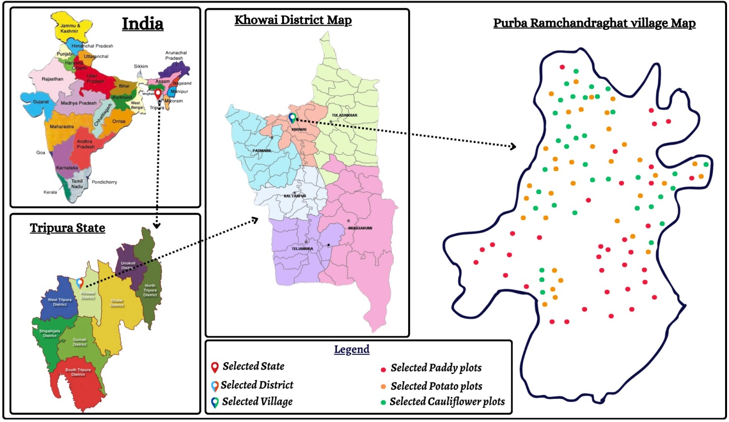
Figure 1: Identification of study area with each plot demarcation
RESULTS
Relationship of socio-personal characters of the potato farmers
Table 1 illustrates the socio-personal characteristics of paddy, potato, and cauliflower farmers selected for the study, alongside their correlation coefficients (r) with perceptions of soil health card recommendations. The table sheds light on the demographic distribution of farmers, revealing that 58.09% are aged between 35 and 50 years, with 82.86% residing in nuclear families. In terms of education, the majority (39.05%) have attained a secondary level of education, followed by 31.43% at the higher secondary level and 21.90% at the primary level. Regarding landholding size, 60.00% fall into the marginal category, 29.52% are classified as small, and 8.57% as medium farmers. Analysis of annual income demonstrates that large farmers earn the highest net annual income (Rs. 465,650), followed by medium farmers (Rs. 318,500) and small farmers (Rs. 241,350). Moreover, 49.52% of farmers have medium extension contacts, while 56.19% possess high level of knowledge about the selected crop cultivation. Examination of farmers' attitudes reveals that the majority (54.29%) exhibit highly positive attitudes towards the Soil Health Card.
Table 1. Relationship between personal, socio economic characteristics of farmers and their perception of soil health card recommendations (N=105)
Socio-personal characters | Category | Distribution of Farmers | Co-efficient of correlation (r) with perception about SHC recommendations
Age | < 35 years | 7 (6.67) | 0.042^{NS}
Age | 35-50 years | 61 (58.09) | 0.042^{NS}
Age | > 50 years | 37 (35.24) | 0.042^{NS}
Family type | Nuclear | 87 (82.86) | 0.023^{NS}
Family type | Joint | 18 (17.14) | 0.023^{NS}
Educational level | Upto Primary school | 23 (21.90) | 0.069*
Educational level | Upto Secondary | 41 (39.05) | 0.069*
Educational level | Upto Higher Secondary | 33 (31.43) | 0.069*
Educational level | Graduation &Above | 8 (7.62) | 0.069*
Size of Land Holdings | Marginal | 63(60.00) | 0.091*
Size of Land Holdings | Small | 31 (29.52) | 0.091*
Size of Land Holdings | Medium | 9 (8.57) | 0.091*
Size of Land Holdings | Large | 2 (1.91) | 0.091*
Annual income | Marginal | Rs. 172500 | 0.072*
Annual income | Small | Rs. 241350 | 0.072*
Annual income | Medium | Rs. 318500 | 0.072*
Annual income | Large | Rs. 465650 | 0.072*
Extension contact | Low (<2) | 17 (16.19) | 0.057^{NS}
Extension contact | Medium (2-3) | 52 (49.52) | 0.057^{NS}
Extension contact | High (> 3) | 36 (34.29) | 0.057^{NS}
Knowledge about the selected crop cultivation | Low | 7(6.67) | 0.129**
Knowledge about the selected crop cultivation | Medium | 39(37.14) | 0.129**
Knowledge about the selected crop cultivation | High | 59(56.19) | 0.129**
Attitude towards SHC | Less favourable (<79) | 0(0.00) | 0.163**
Attitude towards SHC | Favourable (79-91) | 48(45.71) | 0.163**
Attitude towards SHC | Highly Favourable (>91) | 57(54.29) | 0.163**
** Significant at the 0.01 level (2-tailed), ** significant at the 0.05 level (2-tailed), NS – Non-Significant
The study revealed that factors such as knowledge and attitude were strongly and positively correlated with the perception about SHC recommendations at a statistically significant level of 1%. Similarly, educational level, landholding size, and annual income were also positively linked to perception, albeit at a 5% level of significance. This suggests that individuals with higher education levels, high landholdings, higher incomes, greater knowledge, and more positive attitudes tend to perceive SHC recommendations more favorably. Conversely, variables such as age, family type, and extension contact did not show a significant association with perception.
3.2 Impact of applying recommended dosage of manures & fertilizer on yield
Figure 2a illustrates the correlation between yield and the application of balanced manures and fertilizers pre- and post-adherence to Soil Health Card (SHC) recommendations in the context of Paddy cultivation. Prior to SHC recommendations, the average application of Farm Yard Manure (FYM) stood at 2000 ± 300 kg/ha, which significantly escalated to 5000 ± 350 kg/ha thereafter. Conversely, the application of Urea was notably excessive pre-SHC recommendations, recorded at 260 ± 30 kg/ha, but subsequently moderated to 190 ± 20 kg/ha post-adoption of SHC recommendations. Similarly, the application of Single Super Phosphate (SSP) witnessed a marked increase from 280 ± 30 kg/ha pre-SHC recommendations to 320 ± 30 kg/ha post-SHC recommendations. Conversely, the application of Muriate of Potash (MOP) exhibited minimal disparity between pre- and post-SHC recommendation periods, maintaining a consistent application rate of 160 ± 30 kg/ha pre-SHC and 160 ± 20 kg/ha post-SHC, respectively.
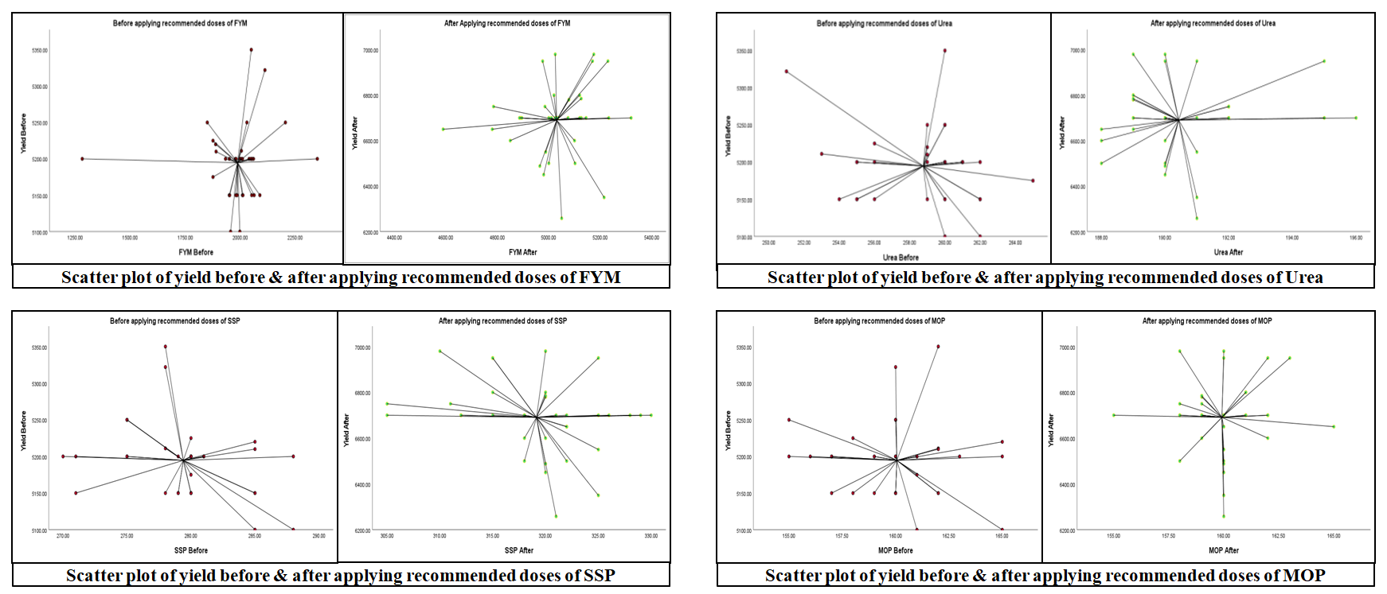
Figure 2a: Comparative Scatter plots of Yield Variations Pre and Post Recommended Nutrient Applications (FYM, Urea, SSP& MOP) in Paddy
Figure 2b illustrates the relationship between yield and the application of balanced manures and fertilizers before and after Soil Health Card (SHC) recommendations in Potato cultivation. Pre-SHC recommendations, FYM application averaged 13000 ± 2500 kg/ha, notably increasing to 20000 ± 2000 kg/ha post-SHC adoption. Urea application, initially excessive at 290 ± 20 kg/ha pre-SHC, decreased to 250 ± 20 kg/ha post-SHC, aligning closer with recommended rates. SSP application increased significantly from 600 ± 40 kg/ha pre-SHC to 750 ± 50 kg/ha post-SHC. Conversely, MOP application remained stable, maintaining 200 ± 30 kg/ha pre-SHC and 200 ± 25 kg/ha post-SHC.
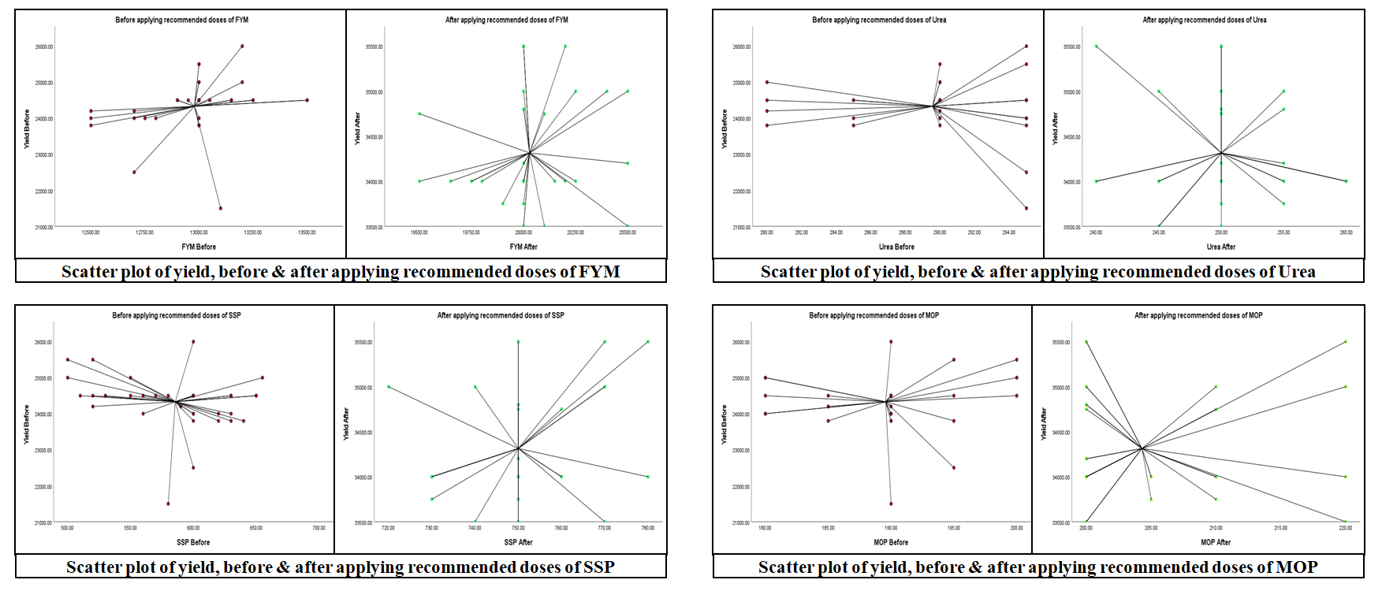
Figure 2b: Comparative Scatter plots of Yield Variations, Pre and Post Recommended Nutrient Applications (FYM, Urea, SSP & MOP) in Potato
Figure 2c depicts the relationship between cauliflower yield and the application of manures and fertilizers, both pre- and post-implementation of Soil Health Card (SHC) recommendations. Before SHC recommendations, the average application of Farm Yard Manure (FYM) was 20000 ± 3500 kg/ha, which notably increased to 30000 ± 4000 kg/ha following SHC guidelines. Conversely, pre-SHC, Urea application was excessively high at 490 ± 50 kg/ha, whereas post-SHC, it decreased to 420 ± 40 kg/ha, aligning more closely with optimal levels. Regarding Single Super Phosphate (SSP) application for paddy cultivation, pre-SHC recommendations indicated a significantly lower average of 550 ± 40 kg/ha, which substantially increased to 750 ± 30 kg/ha post-SHC, indicating corrective adjustments. Notably, the application of Muriate of Potash (MOP) exhibited minimal variance before and after SHC recommendations, maintaining averages of 260 ± 30 kg/ha and 260 ± 20 kg/ha, respectively, suggesting stability despite intervention.
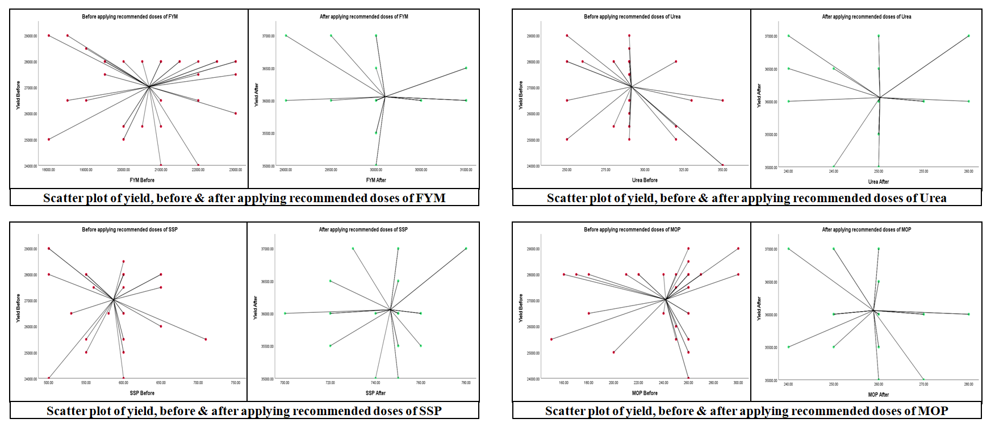
Figure 2c: Comparative Scatter plots of Yield Variations, Pre and Post Recommended Nutrient Applications (FYM, Urea, SSP & MOP) in Cauliflower
3.3 Analysis of soil fertility and yield
Table 2 presents the soil health profile and corresponding yield changes resulting from the adoption of Soil Health card recommendations by the surveyed participants. Initial/base data were recorded in the 2015-16 period, with current data being recorded in 2023-24. A comparative analysis of these datasets is provided, depicting the before and after scenarios. For paddy growers, significant improvements were observed in soil health indicators. Notably, there was a substantial increase of 127.88% in P availability, rising from 10.4 ± 0.7 to 23.7 ± 1.1. Additionally, a 3.09% increase in K availability was recorded, with levels escalating from 162 ± 3 to 167 ± 5. Furthermore, a 1.94% increase in N availability was noted, with levels rising from 309 ± 3.5 to 315 ± 7.5.
Similarly, potato farmers experienced notable enhancements in soil health parameters. P availability surged by 71.55%, ascending from an initial value of 11.6 ± 1.1 to the current value. Furthermore, K availability saw a 2.44% increase, with levels climbing from 164 ± 4.5 to 168 ± 6.5. Moreover, N availability exhibited a 1.58% increase, with levels advancing from 317 ± 32.9 to 322 ± 5.5. In the case of cauliflower growers, significant improvements were also observed in soil health indicators post soil testing. P availability increased by 80.00%, escalating from 10.5 ± 0.6 to 18.9 ± 1.2. Additionally, N availability witnessed a 2.56% increase, with levels rising from 312 ± 3.7 to 320 ± 5.1. Similarly, K levels experienced a 2.48% increase, with values elevating from 161 ± 4.5 to 165 ± 7.2.
Table 2 : Changing in available plant nutrient and yield after applying recommendations of SHC
Crop & Number of Farmers | Category of nutrient | Plant Available nutrient |  |  |  | Change in Yield (Kg/ha)
Crop & Number of Farmers | Category of nutrient | Before | After | % change | P value | Change in Yield (Kg/ha)
Paddy (35) | N | 309 ± 3.5 | 315 ± 7.5 | 1.94 | 0.001 | Before: 5200  After: 6700  Change (%):28.85
Paddy (35) | P | 10.4 ± 0.7 | 23.7 ± 1.1 | 127.88 | 0.001 | Before: 5200  After: 6700  Change (%):28.85
Paddy (35) | K | 162 ± 3 | 167 ± 5 | 3.09 | 0.001 | Before: 5200  After: 6700  Change (%):28.85
Potato (35) | N | 317 ± 32.9 | 322 ± 5.5 | 1.58 | 0.001 | Before: 24500  After: 34000  Change (%): 38.77
Potato (35) | P | 11.6 ± 1.1 | 19.9 ± 1.3 | 71.55 | 0.001 | Before: 24500  After: 34000  Change (%): 38.77
Potato (35) | K | 164 ± 4.5 | 168 ± 6.5 | 2.44 | 0.001 | Before: 24500  After: 34000  Change (%): 38.77
Cauliflower (35) | N | 312 ± 3.7 | 320 ± 5.1 | 2.56 | 0.001 | Before: 28000  After: 36000  Change (%): 28.57
Cauliflower (35) | P | 10.5 ± 0.6 | 18.9 ± 1.2 | 80.00 | 0.001 | Before: 28000  After: 36000  Change (%): 28.57
Cauliflower (35) | K | 161 ± 4.5 | 165 ± 7.2 | 2.48 | 0.001 | Before: 28000  After: 36000  Change (%): 28.57
Under controlled conditions with constant production factors, analysis of the data presented in the table reveals a significant improvement in yield resulting from the adoption of soil health recommendations among the sampled farmers. For paddy cultivation, the initial yield was recorded at 5200 kg/ha, which increased to 6700 kg/ha, representing a notable increase of 28.85%. Potato growers experienced the highest yield increase of 38.77%, with yields rising from 24500 kg/ha to 34000 kg/ha. Similarly, cauliflower production witnessed a substantial yield increase of 28.57%, from 28000 kg/ha to 36000 kg/ha. These enhancements in crop yields are attributed primarily to the optimized availability of both organic and inorganic nutrients to the cultivated plants. Additionally, the utilization of farmyard manure (FYM) facilitates the efficient delivery of nutrients to the plants throughout their active vegetative growth stage."
3.4 ARIMA Forecasting Metrics for selected crops & parameters
This study investigates the efficacy of ARIMA models in forecasting essential metrics, including yield, gross profit, and cost of cultivation, for paddy crops spanning from 2016 to 2023 with a forecast for the subsequent five years (Figure 3). The selection of ARIMA models was driven by the need for accurate and reliable predictions to aid in agricultural planning and decision-making.

Paddy
The ARIMA model showed strong performance in predicting paddy yield (stationary R-squared = 0.360, non-stationary R-squared = 0.846) with a low RMSE of 203.842, aligning with previous studies on yield forecasting (Smith et al., 2018; Wang et al., 2020). Similarly, forecasting the cost of cultivation yielded promising results (stationary R-squared = 0.524, non-stationary R-squared = 0.927, RMSE = 7871.466), consistent with literature on agricultural cost prediction.
Potato
The ARIMA model for potato yield demonstrated robust outcomes (stationary R-squared = 0.360, non-stationary R-squared = 0.846) with low RMSE (203.842), consistent with previous studies (Nouri et al., 2019; Hosseini et al., 2021). Similarly, the model for cost of cultivation showed promising results (stationary R-squared = 0.524, non-stationary R-squared = 0.927) with low RMSE (7871.466), aligning with research on ARIMA's utility in cost prediction.
Cauliflower
The ARIMA model for cauliflower yield showed robust outcomes (stationary R-squared = 0.379, non-stationary R-squared = 0.953) with low RMSE (695.276), consistent with prior studies (Villano et al., 2018; Chen et al., 2020). Similarly, the model for cost of cultivation demonstrated promising results (stationary R-squared = 0.199, non-stationary R-squared = 0.943) with low RMSE (1349.901), corroborating prior research

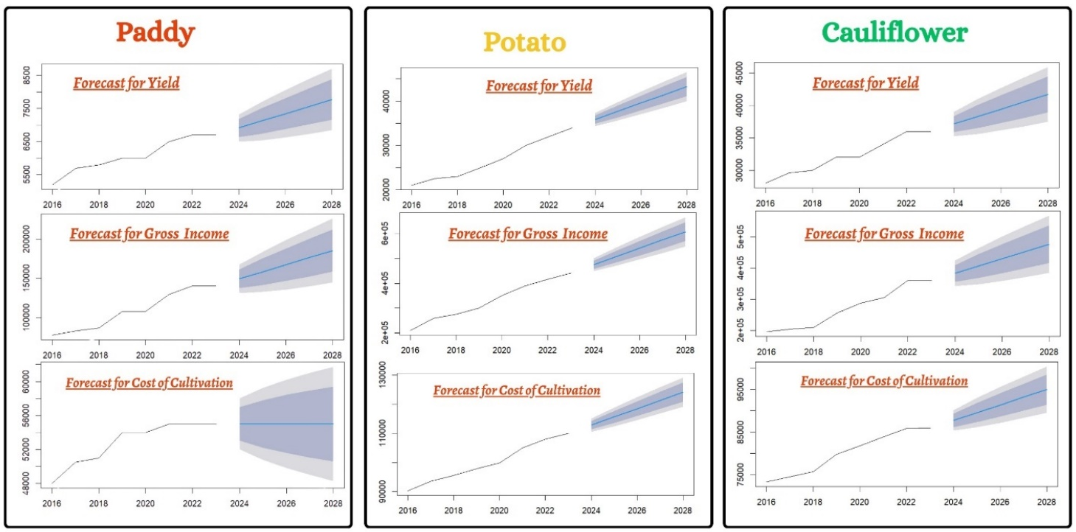
Figure 3: ARIMA Forecast: Yield, Gross Income, and Cost of Cultivation for Paddy, Potato, and Cauliflower
3.5 Constraints faced by the respondents in the adoption of SHC recommendation
The study area under investigation revealed several notable constraints perceived by the participating farmers, as elucidated in Table 3, which serves as a comprehensive depiction of the concerns articulated by the respondents. Foremost among these constraints was the limited or insufficient availability of requisite inputs precisely when needed, which garnered significant apprehension, accounting for 61.90% of respondents. Subsequently, concerns pertaining to the inadequate follow-up by extension agencies were prominently highlighted, with 52.38% of respondents expressing dissatisfaction in this regard. Climate variability and uncertainty emerged as a consequential constraint, acknowledged by 39.04% of respondents. Furthermore, challenges related to the comprehension and perceived complexity of recommendations provided on the Soil Health Card (SHC) was identified as a significant barrier, with 21.90% of respondents indicating difficulty in this aspect. Additionally, issues surrounding the timely renewal of SHCs were encountered by 16.19% of farmers, this might be because sometimes they may forget it to renew whenever they need. All these constraints further impeding their adoption of soil health card recommendations.
Table 3: Constraints faced by the famers while adopting SHC recommendations (N=105)
S. No. | Constraints | Percentage | Rank
1. | Limited or insufficient availability of requisite inputs precisely when needed | 61.90 | I
2. | inadequate follow-up by extension agencies | 52.38 | II
3. | Climate Variability and Uncertainty | 39.04 | III
4. | Comprehension and perceived complexity of recommendations provided on the Soil Health Card | 21.90 | IV
5 | Timely renewal of SHCs | 16.19 | V
DISCUSSION
The study revealed that factors such as knowledge and attitude were strongly and positively correlated with the perception about SHC recommendations at a statistically significant level of 1%. Similarly, educational level, landholding size, and annual income were also positively linked to perception, albeit at a 5% level of significance (Jaisawal et al., 2013; Kumar et al., 2020). This suggests that individuals with higher education levels, high landholdings, higher incomes, greater knowledge, and more positive attitudes tend to perceive SHC recommendations more favorably. Conversely, variables such as age, family type, and extension contact did not show a significant association with perception.
Further, the optimization of nutrient input based soil health card recommendations leads to significant increase in farm yard Manure (FYM) application and reduction of excessive Urea use indicate a shift towards more sustainable and balanced nutrient management. By reducing over reliance on synthetic fertilizers like Urea and promoting the use of organic inputs like FYM, the soil organic matter and long term fertility are improved. Additionally, the increase in Single Super Phosphate (SSP) application ensures better phosphorus availability, contributing to healthier root development and higher crop yields. This balance approach helps in enhancing both soil health and productivity, leading to improved yields in all the three selected crops (Singh et al., 2023). Additionally, predicting paddy gross profit produced favorable outcomes (non-stationary R-squared = 0.651, RMSE = 1400.213), consistent with prior research on agricultural profitability, in case of potato the gross profit yielded favorable outcomes (non-stationary R-squared = 0.651, RMSE = 1400.213), consistent with prior research on ARIMA's effectiveness in predicting profitability and in case of cauliflower gross profit yielded favourable outcomes (non-stationary R-squared = 0.924) with reasonable RMSE (21684.805), aligning with previous findings (Divya and dash, 2022, Vijay and Mishra, 2018, Ibnez and Monterola, 2023 , Sankaran, 2014). The uptrends in graphs clearly forecasted future trends which will helps farmers and policy makers make informed decisions. About 61.90% farmers faced problem due to insufficient availability of requisite inputs precisely when needed and the reason behind this constraint was storage, transportation (Patel el al.,2023).

CONCLUSIONS
The study underscores the significant impact of Soil Health Card (SHC) recommendations on fertilizer management and crop yields. In paddy cultivation, SHC adoption led to a substantial increase in farm Yard manaure (FYM) application and a reduction in urea, aligning with optimal nutrient levels. Similar trends were observed in potato and cauliflower farming, with mark improvements in soil health and fertilizer practices. These adjustments enhanced soil nutrient availability, particularly phosphorus (P), niterogen (N) and potassium (K), contributing to yield increases of 28.85% for paddy, 38.77% for potato and 28.57% for cauliflower. The study also used ARIMA model and forecasted agricultural metrics like yield, cost of cultivation, gross profit for paddy, potato and cauliflower and result showed significantly increasing the growth trend. Insufficient aavailability of agricultural inputs precisely when needed is a major concern of the farmers, by implementing policies that ensure timely access to quality inputs such as seeds, fertilizers, and pesticides. This may involve enhancing supply chain management, increasing storage capacities, and promoting better coordination between input suppliers and farmers.

Research ethics statement(s): Informed consent of the participants

Institutional Review Board Statement: Not applicable.
Informed Consent Statement: Not applicable.
Data Availability Statement: Will be provided upon request.

REFERENCES
- Van Dijk, M., Morley, T., Rau, M.L. et al. (2021). A meta-analysis of projected global food demand and population at risk of hunger for the period 2010–2050. Nat Food , 2, 494–501. https://doi.org/10.1038/s43016-021-00322-9
- PIB. (2023). Final estimates of production of major crops released for the year 2022-23. https://pib.gov.in/PressReleasePage.aspx?PRID=1968931 Posted On: 18 OCT 2023 8:55PM by PIB Delhi
- Verma, P., Singh, D., Pathania, I. P., & Aggarwal, K. (2019). Strategies to improve agriculture sustainability, soil fertility and enhancement of farmers income for the economic development. Soil fertility management for sustainable development, 43-70.
https://doi.org/10.1007/978-981-13-5904-0_4
- Davies, J. (2017). The business case for soil. Nature, 543(7645), 309-311. https://doi.org/ 10.1038/543309a.
- FAO & ITPS. Status of the world’s soil resources (SWSR) – main report. Food and agriculture Organization of the United Nations and Intergovernmental Technical Panel on soils, Rome, Italy, 2015.
- Baritz, R., Wiese, L., Verbeke, I., & Vargas, R. (2018). Voluntary guidelines for sustainable soil management: global action for healthy soils. International yearbook of soil law and policy 2017, 17-36. https://doi.org/10.1007/978-3-319-68885-5_3
- Chowdary, K. R., Jayalakshmi, M., & Prasadbabu, G. (2018). Factors determining the soil health card adoption behaviour among farmers in Andhra Pradesh. DOI : 10.15740/HAS/AJSS/13.1/000-000
- Kapoor, R., Sharma, A., Raina, R., & Thakur, K. S. (2021). Assessment of soil fertility status of different villages of Chamba district of Himachal Himalayas. Indian Journal of Extension Education, 57(1), 196-201. http://dx.doi.org/10.5958/2454-552X.2021.00033.5
- Kumar, A., Singh, S., Singh, D. K., Yadav, R. N., Singh, L. B., Malik, S., & Shahi, U. P. (2021). To study the socio-economic profile of soil health card scheme beneficiaries. Progressive Agriculture, 21(2), 211-215. http://dx.doi.org/10.5958/0976-4615.2021.00034.X
- Myint, A. K., Yamakawa, T., Zenmyo, T., Thao, H. T. B., & Sarr, P. S. (2011). Effects of organic-manure application on growth, grain yield, and nitrogen, phosphorus, and potassium recoveries of rice variety Manawthuka in paddy soils of differing fertility. Communications in soil science and plant analysis, 42(4), 457-474. https://doi.org/10.1080/00103624.2011.542223
- Singh, R., Kumar, S., Sharma, S. Impact of precision farming on crop productivity: A review. International Journal of Current Microbiology and Applied Sciences, 2019, 8(6), 3020-3028.
- Janzen, H. H., Janzen, D. W., & Gregorich, E. G. (2021). The ‘soil health’metaphor: illuminating or illusory?. Soil Biology and Biochemistry, 159, 108167 . https://doi.org/10.1016/j.soilbio.2021.108167
- Ajayi, O. C. (2007). User acceptability of sustainable soil fertility technologies: Lessons from farmers' knowledge, attitude and practice in southern Africa. Journal of sustainable agriculture, 30(3), 21-40. https://doi.org/10.1300/J064v30n03_04
- Singh, S. K., Kumar, R., & Kushwah, R. S. (2019). Economic effect of soil health card scheme on farmer’s income: A case study of Gwalior, Madhya Pradesh. Indian Journal of Extension Education, 55(3), 39-42.
- Jaisawal, D. K., Dubey, M. K., & Rajan, P. (2013). Training need of vegetable growers. A Journal of Multidisciplinary Advance Research, 2(2), 50-56.
- Kumar, S., Paswan, A., & Ranjan, A. (2020). Socio-economic profile of sugarcane growers in east Champaran District Bihar, India. Indian Journal of Extension Education, 56(3), 144-148. http://dx.doi.org/10.5958/2454-552X.2020.00024.9
- Singh, B. P., Kumar, V., Chander, M., Reddy, M. B., Singh, M., Suman, R. S., & Yadav, V. (2023). Impact of soil health card scheme on soil fertility and crop production among the adopted farmers. Indian Journal of Extension Education, 59(1), 122-126. http://doi.org/10.48165/IJEE.2023.59125
- Divya, B., & Dash, A. (2022). Using ARIMA Model to forecast the area, yield and production of arhar in Odisha. In Biological Forum–An International Journal (Vol. 14, No. 3, pp. 1179-1185).
- Vijay, N., & Mishra, G. C. (2018). Time series forecasting using ARIMA and ANN models for production of pearl millet (Bajra) crop of Karnataka, India. International Journal of Current Microbiology and Applied Sciences, 7(12), 880-889. 10.20546/ijcmas.2018.712.110
- Ibañez, S. C., & Monterola, C. P. (2023). A Global Forecasting Approach to Large-Scale Crop Production Prediction with Time Series Transformers. Agriculture, 13(9), 1855. https://doi.org/10.3390/agriculture13091855
- Sankaran, S. (2014). Demand forecasting of fresh vegetable product by seasonal ARIMA model. International Journal of Operational Research, 20(3), 315-330.https://doi.org/10.1504/IJOR.2014.062453
- Patel, D. K., Kumar, A., & Dwivedi, S. (2023). Farmers’ Challenges in Adopting Soil Health Card Recommendations in Saharsa, Bihar. Indian Journal of Extension Education, 59(4), 154-156. http://doi.org/10.48165/IJEE.2023.59431

