Hepatoprotective Effects of Monoon longifolium (False Ashoka) Seed Extract Against Lead Acetate–Induced Liver Damage in Adult Female Wistar Rats

ABSTRACT
The seed of Monoon longifolium is known to possess antioxidant and hepatoprotective properties. This study investigated the protective effects of its methanolic seed extract against lead acetate-induced liver damage in adult female Wistar rats. Thirty-nine rats were randomly assigned to six groups. Group A (control) received standard feed and water; Group B received 500 mg/kg of the extract alone; Group C was administered 50 mg/kg of lead acetate; Group D received both 500 mg/kg of extract and 50 mg/kg of lead acetate; Group E was given 1000 mg/kg of extract alongside 50 mg/kg of lead; and Group F received 50 mg/kg of lead for 14 days, followed by 500 mg/kg of extract for another 14 days. Parameters assessed included oxidative stress marker (MDA), antioxidant enzyme (SOD), liver function enzymes (AST, ALT, ALP), and histopathological changes. The results showed a reduction in relative liver weight in lead-exposed groups. Biochemical analysis revealed decreased serum levels of ALP, ALT, and AST, a slight decrease in SOD, and an elevation in MDA levels. Histological examination showed hepatic degeneration, intrahepatic and intravenous inflammation, and moderate fatty changes. These findings suggest that Monoon longifolium seed extract exhibits antioxidant and hepatoprotective effects against lead-induced hepatic injury.
Keywords: Liver function, Hepatoprotection, Monoon longifolium seed, lead acetate toxicity
1.0 INTRODUCTION
Medicinal plants have served as a vital source of healing for communities across the globe for millennia and continue to be the primary mode of healthcare for approximately 85% of the world’s population (Abayomi et al., 2013; Ahmed, 2016). Beyond their traditional uses, these plants are also central to modern pharmacology, contributing to about 80% of all drug discoveries (Bauer & Bronstrup, 2014). Among the various areas of medicinal plant research, the search for natural compounds with hepatoprotective potential has garnered significant interest.
Monoon longifolium (commonly known as Polyalthia longifolia Sonn.), a member of the family Annonaceae, is one such plant with promising therapeutic value. Native to India and widely distributed across Africa, Southeast Asia, Australia, and New Zealand, M. longifolium—often referred to as the false Ashoka or Street tree—is valued for its aesthetic appeal and environmental benefits, such as noise pollution reduction (Vishala et al., 2021). Traditionally, various parts of the tree have been used to manage diverse health conditions. Pharmacological studies have reported its hepatoprotective, anti-inflammatory, antimicrobial, hypoglycemic, antihyperglycemic, anti-ulcer, antidiabetic, and antioxidant effects (Oyeyemi et al., 2020; Vishala et al., 2021).
The bioactivity of M. longifolium is attributed to a rich profile of secondary metabolites, including steroids, flavonoids, alkaloids, and clerodane diterpenes isolated from its leaves, bark, and roots (Vishala et al., 2021; Firdous et al., 2022). In particular, its antioxidant properties are largely dependent on the presence of phenolic compounds such as flavonoids. Previous studies have demonstrated a significant reduction in liver enzymes—ALT and AST—after administration of methanolic and aqueous extracts of P. longifolia, indicating its hepatoprotective effect (Oyeyemi et al., 2020).
Lead (Pb) is a persistent environmental contaminant known for its severe hepatotoxic effects. Upon ingestion, lead is absorbed through the intestinal tract, enters systemic circulation, and undergoes first-pass metabolism in the liver, where it inflicts oxidative damage and impairs vital cellular processes (Andjelkovic et al., 2019; Nwakanma et al., 2014; García-Niño & Pedraza-Chaverri, 2014; Abdelhamid et al., 2020). Oxidative stress is a key mechanism of Pb toxicity, disrupting the balance between prooxidants and antioxidants, which leads to lipid peroxidation, mitochondrial dysfunction, DNA damage, and apoptosis (Dobrakowski et al., 2017).
Despite the broad pharmacological potential of M. longifolium, little is known about its role in mitigating lead-induced hepatotoxicity. This study, therefore, aims to evaluate the protective and curative effects of the methanolic seed extract of Monoon longifolium on lead acetate-induced liver damage in adult female Wistar rats.

2.0 Materials and Methods
2.1 Procurement of Lead Acetate
Lead acetate trihydrate (analytical grade) in powdered form was purchased from Ezeaku Chemical Store, Nnewi, Anambra State, and dissolved in distilled water to achieve the desired concentration of 50 mg/kg.
2.2 Plant Material and Extract Preparation:
Fresh seeds of Monoon longifolium were purchased from the Onu-Ebonyi market in Izzi Local Government Area, Ebonyi State, Nigeria. The seeds were air-dried under shade and ground into coarse powder. A quantity of 50 g of the powdered seed was soaked in 250 ml of 98% methanol and left to stand for 48 hours with intermittent shaking. After maceration, the solution was first sieved using a porcelain cloth and then filtered through Whatman No. 1 filter paper. The filtrate was concentrated into a solid extract using a rotary evaporator and stored in a refrigerator until required for use (Ovie et al., 2023).
2.3 Ethical Approval
Ethical approval for this study was obtained from the Ethical Committee of the Department of Anatomy, Faculty of Basic Medical Sciences, Nnamdi Azikiwe University, Nnewi Campus (Ref No: ANA/EA/UG/AS/07/10/2024). All procedures involving animals were conducted in accordance with the Guide for the Care and Use of Laboratory Animals prepared by the National Academy of Sciences and published by the National Institutes of Health (NRC, 2011).
2.4 Procurement and Housing of Experimental Animals
A total of thirty-nine adult female Wistar rats were obtained from Ela’s Animal Farm, Oko, Anambra State. The animals were acclimatized for two weeks in the Animal House of the Anatomy Department, Nnamdi Azikiwe University, Nnewi Campus. They were housed under standard laboratory conditions, including room temperature, 60–80% relative humidity, and a 12-hour light/dark cycle. Animals were fed with standard rat chow and had access to water ad libitum. All animal handling and procedures followed the guidelines of the Ethical Committee, College of Health Sciences, Nnamdi Azikiwe University.
2.5 Experimental Design
The experimental animals were randomly divided into six experimental groups, designated A through F, with each group comprising six adult female Wistar rats. Group A served as the normal control and received standard rat feed and clean water ad libitum for the duration of the study. Group B was administered 500 mg/kg of Monoon longifolium seed extract orally for 28 consecutive days. Group C received 50 mg/kg of lead acetate orally for 28 days to induce hepatic toxicity. Group D was co-administered 50 mg/kg of lead acetate and 500 mg/kg of the extract concurrently for 28 days. Group E received a higher dose of the extract (1000 mg/kg) alongside 50 mg/kg of lead acetate for the same duration. Group F was subjected to 50 mg/kg of lead acetate alone for the first 14 days, followed by a 14-day treatment with 500 mg/kg of the extract to assess its post-exposure therapeutic effect. All administrations were carried out once daily via oral gavage using a flexible cannula to ensure accurate dosing and minimize stress to the animals.
2.6 Preparation of Tissues and Serum for Biochemical Assay
Twenty-four hours after the final administration, the animals were anesthetized using chloroform in a well-ventilated chamber. Blood samples were collected promptly via ocular puncture using capillary tubes, and the samples were allowed to clot. Serum was then separated by centrifugation and stored appropriately for subsequent biochemical analyses, including liver function tests and oxidative stress marker assessments. The liver of each animal was carefully excised, blotted dry, and weighed to determine relative organ weight. Thereafter, liver tissues were fixed in 10% formal saline for subsequent histopathological evaluation.
2.7 Biochemical Assay
Biochemical analyses were conducted to evaluate liver function and oxidative stress. The liver function enzymes assessed included alanine aminotransferase (ALT), aspartate aminotransferase (AST), and alkaline phosphatase (ALP). Antioxidant activity was determined by measuring the level of superoxide dismutase (SOD), while oxidative stress was assessed through the quantification of malondialdehyde (MDA) levels in liver tissue. All parameters were analyzed using standard spectrophotometric techniques, following the protocol described by Asenuga et al. (2022).
2.8 Histopathological Studies
Liver samples fixed in formalin were rinsed with 70% ethanol, dehydrated through graded concentrations of ethanol, and embedded in paraffin. Sections were cut serially using a rotary microtome, stained with hematoxylin and eosin (H&E), and observed under a light microscope (Drury, 1976).
2.9 Statistical Analysis
Data were analyzed using the Statistical Package for the Social Sciences (SPSS), version 23. Results were expressed as mean ± standard error of the mean (S.E.M). Liver function parameters (ALT, AST, and ALP), oxidative stress markers (MDA and SOD), and relative liver weights were analyzed using one-way analysis of variance (ANOVA), followed by a post hoc LSD test to determine intergroup differences. Changes in body weight (initial vs final) within each group were analyzed using the paired Student’s t-test. A p-value of less than 0.05 was considered statistically significant.

3.0 RESULT

3.1Effect of the Extract and Lead Acetate on the Body Weight
Table 1.0 shows the initial and final body weights of rats in different treatment groups, with comparisons made to the control group (Group A). All groups showed weight gain, but the degree varied. Group A (Control) had a final mean weight of 148.90 g. Group B (extract only) showed a slight increase compared to the control (+2.23 g), while Group C (lead only) had a noticeable decrease (−11.47 g), though not statistically significant (p = 0.315).
Groups D and E (lead plus extract) also had lower final weights compared to the control, with Group D showing the largest drop (−16.42 g). Group F, which received extract after lead exposure, had a final weight close to the control (−2.54 g). None of the differences in final weight between the groups and the control were statistically significant (p > 0.05).

Table 1.0 Effect of the Extract and Lead Acetate on the Body Weight.
Group | Initial Weight (Mean ± SEM) | Final Weight (Mean ± SEM) | Difference vs. Control (Final Weight, g) | P-value vs. Control
A (Control) | 118.50 ± 0.44 | 148.90 ± 7.14 | — | —
B | 130.06 ± 1.92 | 151.13 ± 4.15 | +2.23 | 0.812
C | 123.36 ± 0.65 | 137.43 ± 4.37 | −11.47 | 0.315
D | 111.33 ± 1.77 | 132.48 ± 6.17 | −16.42 | 0.164
E | 139.91 ± 2.62 | 148.52 ± 2.59 | −0.38 | 0.973
F | 106.13 ± 5.25 | 146.36 ± 6.73 | −2.54 | 0.866
Values are expressed as Mean ± SEM (n = 6 per group). Group A served as the control. "Difference vs. Control" represents the change in final body weight compared to Group A. P-values were calculated using one-way ANOVA followed by post hoc comparison with the control group. Differences were considered statistically significant at P < 0.05.

3.2 Effect of the Extract and Lead on The Relative Organ weight of The Liver
The relative liver weights across all groups showed no statistically significant difference compared to the control group (p > 0.05). Although Group C (lead only) had the lowest mean value (3.78 ± 0.17) and Group F (lead followed by extract) had the highest (4.70 ± 0.24), these variations were not significant (Table 2.0).

Table 2.0: Showing the Effect of the Extract and Lead on The Relative Organ weight of The Liver.

Group | Mean ± S.E.M | P-value vs Control
Control (A) | 4.45 ± 0.97 | —
Group B | 4.04 ± 0.31 | 0.518
Group C | 3.78 ± 0.17 | 0.301
Group D | 3.79 ± 0.43 | 0.341
Group E | 3.96 ± 0.25 | 0.443
Group F | 4.70 ± 0.24 | 0.684
Note: Values are expressed as mean ± standard error of the mean (S.E.M). P-values reflect comparisons with the control group using one-way ANOVA followed by post hoc LSD test.

3.3 Effect of the Extract and Lead Acetate on the AST, ALT, and ALP Levels
As shown in Table 3.0, The control group had a mean AST value of 40.67 ± 1.33 U/L. Groups B and C showed no significant differences (p = 0.363 and p = 0.235, respectively). Groups D, E, and F had significantly lower AST levels compared to the control group (p = 0.000 for all three).
The control group recorded an ALT level of 12.00 ± 0.58 U/L. No significant differences were observed in Groups B, C, D, or E (p > 0.05). However, Group F showed a significantly higher ALT level (24.00 ± 2.08 U/L; p = 0.005).
The mean ALP level in the control group was 106.45 ± 4.02 U/L. Groups B and C showed no significant changes (p = 0.389 and 0.457, respectively). Groups D, E, and F had significantly reduced ALP levels (p = 0.004, 0.003, and 0.004, respectively).

Table 3.0 Effect of the Extract and Lead Acetate on the Liver functions test Levels.

 |  | Mean±Std. Error | P Vae
AST (u/l) | Control (Group A) | 40.67±1.33
 | Group B | 37.33±2.96 | 0.363
 | Group C | 29.67±7.75 | 0.235
 | Group D | 18.67±0.88 | 0.000
 | Group E | 17.00±1.00 | 0.000
 | Group F | 18.00±1.00 | 0.000
ALT (u/l) | Control (Group A) | 12.00±0.58
 | Group B | 11.67±0.33 | 0.643
 | Group C | 15.00±0.88 | 0.309
 | Group D | 11.67±0.88 | 0.767
 | Group E | 13.67±2.19 | 0.502
 | Group F | 24.00±2.08 | 0.005
ALP (u/l) | Control (Group A) | 106.45±4.02
 | Group B | 99.22±6.34 | 0.389
 | Group C | 96.32±11.63 | 0.457
 | Group D | 81.79±0.88 | 0.004
 | Group E | 79.71±1.64 | 0.003
 | Group F | 83.92±0.63 | 0.004
Data was analyzed using One-way ANOVA and values were considered significant at p < 0.05*

3.4 Effect of the Extract and Lead Acetate on SOD and MDA Levels
As shown in Table 4.0, the hepatic superoxide dismutase (SOD) level in the control group (A) was lower than that of the lead-only group (C), which had the highest mean SOD value of 14.85 U/mg. In comparison, the treatment groups—D, E, and F—showed reduced SOD levels of 12.78, 9.93, and 9.77 U/mg, respectively. The decrease in SOD levels among the treated groups suggests a reduced oxidative burden due to the antioxidant effect of the extract.
In contrast, the liver malondialdehyde (MDA) levels were highest in the lead-only group (C), with a mean value of 0.77 nmol/g, indicating elevated lipid peroxidation. Groups D, E, and F, which received both lead acetate and the extract, had lower MDA levels of 0.67, 0.57, and 0.57 nmol/g, respectively. The lowest MDA level observed in Group E suggests that the extract may have helped to reduce oxidative stress and lipid damage in the liver.

3.5 Table 4.0: Effect of the Extract and Lead Acetate on SOD and MDA Levels.

 |  | Mean±Std. Error | P Value
SOD (u/mg) | Control (Group A) | 14.65±0.02
 | Group B | 14.39±0.43 | 0.592
 | Group C | 14.85±0.12 | 0.169
 | Group D | 12.78±1.16 | 0.181
 | Group E | 9.93±0.74 | 0.003
 | Group F | 9.77±0.44 | 0.000
MDA (nmol/gr) | Control (Group A) | 0.55±0.01
 | Group B | 0.52±0.01 | 0.643
 | Group C | 0.57±0.03 | 0.309
 | Group D | 0.67±0.05 | 0.767
 | Group E | 0.77±0.02 | 0.502
 | Group F | 0.77±0.02 | 0.005
Data was analyzed using One-way ANOVA and values were considered significant at p < 0.05*

3.6 Effect of the Extract and Lead Acetate on Liver Histoarchitecture
The liver sections from the control group and Group B (administered 500 mg/kg of Monoon longifolium methanolic seed extract) displayed normal hepatic architecture, characterized by intact hepatic lobules, centrally located central veins, distinct portal triads, active hepatocytes, and well-preserved cytoplasm (Plates 1 and 2). In contrast, Group C (lead acetate only) exhibited mild intrahepatic hemorrhage and moderate fatty changes, indicating hepatocellular damage (Plate 3). Group D (co-treated with lead acetate and 500 mg/kg extract for 28 days) showed severe hepatic degeneration, moderate intrahepatic inflammation, fatty changes, and clumping of hepatocytes (Plate 4). However, Groups E and F (co-treated with lead acetate and 1000 mg/kg extract or post-treated with 500 mg/kg extract, respectively) demonstrated moderate hepatoprotection, with only mild intrahepatic inflammation and fatty changes observed (Plates 5 and 6).
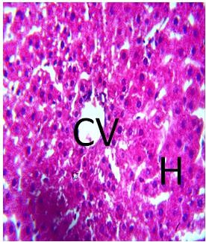
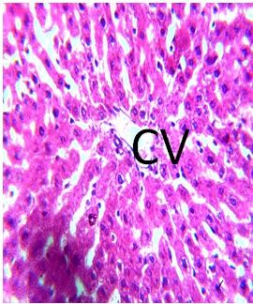
Plate 1.0: Photomicrograph of group A section of liver (x400) (H/E) shows normal hepatic architecture with central vein (CV) and well outlined active hepatocyte (H) and perfused cytoplasm.

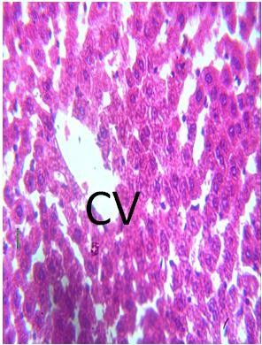
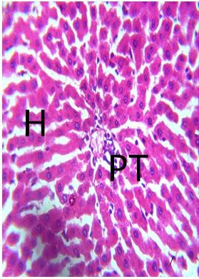

Plate 2.0: Photomicrograph of group B section of liver administered with extract only (x400) (H/E) shows hepatic with central vain (CV) and portal triad (PT) with well outlined active hepatocyte (H) and perfused cytoplasm.

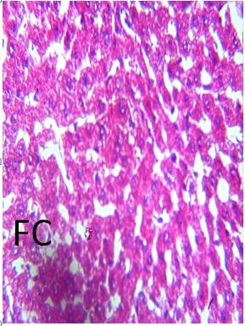
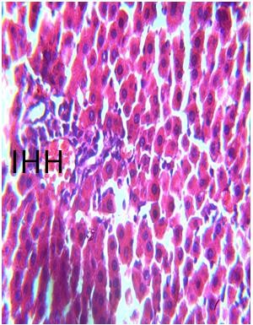
Plate 3.0: Photomicrograph of group C section of liver induced with lead only (x400) (H/E) shows mild intra hepatic hemorrhage (IHH), moderate fatty changes (FC).

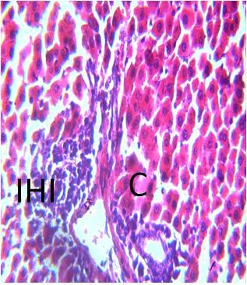
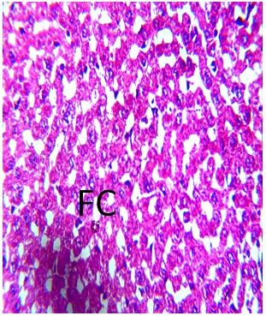
Plate 4.0: Photomicrograph of group D section of liver administered extract and induced with lead (x400) (H/E) shows severe degeneration with moderate intra hepatic inflammation (IHI), severe fatty changes (FC) moderate clumping (C) of the hepatocyte.

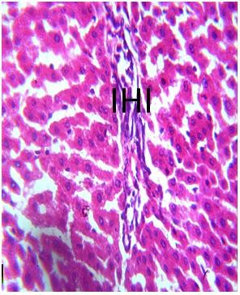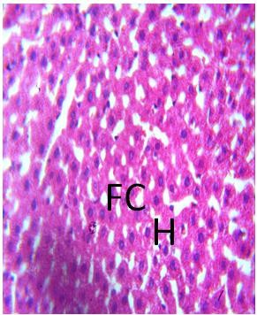
Plate 5.0: Photomicrograph of group E section of liver administered with extract 28 day and induced with lead (x400) (H/E) shows moderate protection with mild intra hepatic inflammation (IHI) and mild fatty changes (FC).

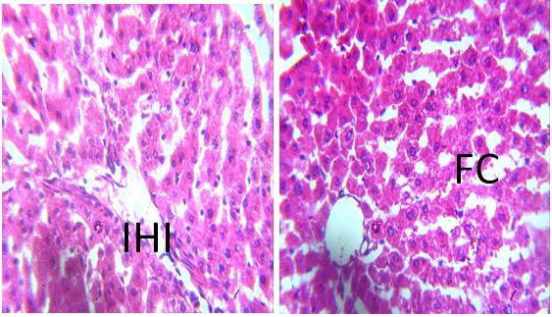
Plate 6.0: Photomicrograph of group F section of liver induced with lead for 14 days, and administered with extract for another 14 days(x400) (H/E) shows mild to moderate protection with mild intra hepatic inflammation (IHI) and moderate fatty changes (FC)

4.0 DISCUSSION
Growth rate is a key indicator of health in experimental animals. Although lead toxicity is often associated with reduced growth and altered organ weights (Busari et al., 2021), administration of lead acetate in this study had no significant effect on overall body weight. Similarly, co-administration with Monoon longifolium extract did not produce notable changes. This may be attributed to the nutritional and antioxidant properties of Monoon longifolium, which could counteract the catabolic effects of lead. In contrast, lead acetate significantly reduced relative liver weight compared to controls. This finding differs from reports by Ghazanfarpour et al. (2019) and Abdel et al. (2020), who observed increased liver weights. The observed reduction may reflect hepatic degeneration seen in histological assessments.
Co-administration of the extract mitigated this reduction in liver weight, particularly at the 500 mg/kg dose, possibly due to higher levels of phenolic compounds with antioxidant activity. These compounds function by scavenging free radicals, inhibiting ROS-producing enzymes, and upregulating endogenous antioxidant pathways (Oyeyemi et al., 2020).
The liver, being a primary site for xenobiotic metabolism, is especially vulnerable to heavy metal toxicity (Laamech et al., 2017; Nabil et al., 2020; Ofoego et al., 2025). Lead exposure has been shown to alter liver enzyme levels and tissue structure (Nabil et al., 2020). In this study, lead acetate significantly elevated serum AST, ALT, and ALP, as well as oxidative stress markers (MDA and SOD). Increased enzyme levels suggest hepatocellular injury and membrane damage due to lipid peroxidation (Laamech et al., 2017; Abdelhamid et al., 2020). The elevated MDA confirms oxidative membrane damage, while increased SOD levels likely represent a compensatory antioxidant response.
Treatment with Monoon longifolium extract significantly reduced MDA levels in a dose-dependent manner and improved antioxidant status, suggesting its potential in reducing oxidative stress. Histological findings supported this, with extract-treated groups showing reduced inflammation, fatty changes, and necrosis, indicating structural preservation. These findings suggest that Monoon longifolium offers hepatoprotection, likely via its antioxidant mechanisms.

5.0 CONCLUSION
This study demonstrates the hepatotoxic effects of lead acetate, evidenced by reduced liver weight, elevated biochemical markers, oxidative stress, and histopathological alterations. However, co-treatment or post-treatment with Monoon longifolium methanolic seed extract mitigated these effects, highlighting its potential hepatoprotective and antioxidant properties.

References
- Abayomi, A., Akinyemi, A. J., & Oboh, G. (2013). Medicinal plants and their traditional uses in Africa: A review. Journal of Medicinal Plants Research, 7(48), 3562–3572.
- Abdel, M. G., Hassan, E. A., & Khalil, S. R. (2020). Histopathological and biochemical evaluation of lead-induced liver and kidney damage in rats and the protective role of garlic. Toxicology Reports, 7, 1707–1716.
- Abdelhamid, F. M., Abd El-Haleim, E. A., & Mahmoud, A. A. (2020). Mitigating effects of rosemary and honey against lead-induced hepatotoxicity. Environmental Science and Pollution Research, 27, 15264–15275.
- Ahmed, M. (2016). Medicinal plants used in traditional medicine by the ethnic people of Gilgit-Baltistan, Pakistan. Journal of Ethnobiology and Ethnomedicine, 12, 45. https://doi.org/10.1186/s13002-016-0113-2
- Andjelkovic, M., Buha Djordjevic, A., Antonijevic, E., Antonijevic, B., Stanic, M., & Bulat, Z. (2019). Toxic effect of chronic exposure to low doses of lead on rat liver. Environmental Science and Pollution Research, 26, 35557–35568.
- Asenuga, E. R., Olorunnisola, O. S., & Akinyemi, A. J. (2022). Antioxidant and hepatoprotective activities of Ocimum gratissimum in experimental rats. Biochemistry Research International, 2022, 1–9.
- Bauer, A., & Bronstrup, M. (2014). Industrial natural product chemistry for drug discovery and development. Natural Product Reports, 31(1), 35–60. https://doi.org/10.1039/c3np70058e
- Busari, M. A., Salawu, M. O., & Omotosho, O. E. (2021). Protective effect of Allium sativum against lead acetate-induced hepatorenal toxicity in rats. African Journal of Biomedical Research, 24(1), 85–91.
- Dobrakowski, M., Boroń, M., Jakubowski, M., Birkner, E., & Kasperczyk, S. (2017). The effect of chronic exposure to lead on antioxidant parameters and expression of apoptosis-related proteins in the rat liver. Toxicology Research, 6, 897–905.
- Drury, R. A. B., & Wallington, E. A. (1976). Carleton’s Histological Technique (4th ed.). Oxford University Press.
- Firdous, S., Tiwari, K., & Khan, M. Y. (2022). Clerodane diterpenoids and other phytoconstituents from Polyalthia longifolia with biological activities. Phytochemistry Reviews, 21, 235–257.
- García-Niño, W. R., & Pedraza-Chaverri, J. (2014). Protective effect of curcumin against heavy metals-induced liver damage. Food and Chemical Toxicology, 69, 182–201.
- Ghazanfarpour, M., Ziaei, S., & Abdollahi, M. (2019). Lead toxicity and oxidative stress: The role of natural antioxidants in protection. Toxicology and Industrial Health, 35(12), 797–811.
- Laamech, J., Elguendouz, S., & Elamine, Y. (2017). Role of oxidative stress in lead-induced toxicity and protective effect of natural antioxidants. International Journal of Innovation and Applied Studies, 19(4), 753–760.
- Nabil, R., Abo-Elghiet, N., & Ahmed, M. (2020). Evaluation of hepatoprotective effect of some medicinal plant extracts against lead-induced hepatic injury. Journal of Applied Pharmaceutical Science, 10(3), 88–95.
- NRC (National Research Council). (2011). Guide for the Care and Use of Laboratory Animals (8th ed.). National Academies Press.
- Nwakanma A.A, Idaguko A., Nwozor C.M, Ofoego U.C, Okafor I.J, Ibemenuga E. (2014). A Histological and Histochemical Study of the Cerebral Cortex Following Acute Lead Poisoning in Wistar Rats. Journal of Agriculture and Veterinary Sciences, 6(1), pp 93-105.
- Ofoego, U. C., Mokwe, R. O., Enemuo, I. C., Ekwujuru, E. U., Ofoego, A. N., & Ezeagu, D. K. (2025). Protective role of Corchorus olitorius (ewedu) leaf in mercury chloride-induced liver damage. World Journal of Pharmacy and Pharmaceutical Sciences, 14(4), 14–27.
- Ovie, E. D., Okonkwo, U. C., & Anyanwu, G. C. (2023). Phytochemical screening and antimicrobial evaluation of methanolic seed extract of Monoon longifolium. International Journal of Herbal Medicine, 11(2), 66–72.
- Oyeyemi, I. T., Okelue, B. N., & Akinlolu, A. A. (2020). Hepatoprotective effect of methanolic extract of Polyalthia longifolia on carbon tetrachloride-induced liver damage in rats. Journal of Complementary and Integrative Medicine, 17(1). https://doi.org/10.1515/jcim-2019-0062
- Vishala, M., Das, B., & Basha, S. K. (2021). Polyalthia longifolia: A versatile plant with diverse pharmacological properties. Journal of Pharmacognosy and Phytochemistry, 10(3), 1125–1130.

