Metagenomics of Sugarcane Rhizosphere for Sustainable Productivity in the Changing Environment: A Review
Abstract
Sugarcane (Saccharum officinarum L.) is one of the most valuable cash crops globally. However, continuous monoculture practices, excessive fertilizer application, and soil disruption due to various economic activities have led to the degradation of soil quality, ultimately impacting crop productivity. The rhizosphere is the area where plant roots and soil connect and this zone consist of many different microbes that boost crop productivity by making nutrients accessible, synthesizing growth regulating hormones, and preventing growth of pathogenic microbes. Generally culturable microbes get well characterized and documented while non culturable micobes get neglected in different studies. Hence in the present review article an emphasis is given to explain the roles played by uncultured microbial populations, particularly in rhizosphere. The functions of Bradyrhizobium, Pseudomonas, Streptomyces, and Burkholderia in pathogen control, phosphate solubilization, nitrogen fixation, and phytohormone synthesis, have been highlighted. The advances in metagenomics such as 16S rRNA gene sequencing and analysing function genes, have greatly increased our ability to understand microbial diversity and their role in crop productivity. Further, metagenomic studies of of rhizospheric microbiomes have a great potential in increasing the efficiency of sugarcane productivity without detriment to natural resources, by developing bioinoculants and biocontrol agents.

Keywords: Bioinformatics, Microbial Diversity, Metagenomics, Rhizosphere, Sustainable Agriculture, Sugarcane (Saccharum officinarum).

- Introduction
In tropical and subtropical nations, sugarcane (Saccharum officinarum L.) is a major cash crop that provides raw materials for sugar mills and other related industries. Over 26 million hectares area under for sugarcane farming globally. The leading countries in sugarcane cultivation are Brazil, India, Thailand, and China (Anna Herforth et al., 2020). Brazil has utilized sugarcane to generate ethanol as a sustainable energy resource (Vandenberghe et al., 2022). Sugarcane cultivation considerably contribute to the income of millions of farming households and finally the Indian economy (Vinayaka & Prasad, 2024). The sugar business is a major agro-based sector in the country, employing over a million individuals and significantly contributing to rural economies (Solomon, 2016). Nonetheless, sugarcane farming has numerous challenges, including a reduction in soil nutrients, limited water availability, and infestations by various pests and pathogens (Srivastava, 2012).
A dynamic mix of biotic and abiotic variables influences sugarcane's overall production and performance. Among the biotic factors are pests, pathogens, and competing plant species. Insect pests, including borers, aphids, and root grubs, inflict direct physical harm to plant tissues, diminishing photosynthetic efficiency and compromising overall plant vitality (Kumar et al., 2024). A diverse array of pathogens, encompassing fungus, bacteria, and viruses, are accountable for significant diseases such as red rot, smut, wilt, leaf scald, and mosaic, all of which impair plant health and restrict cane quality and output (Kumar et al., 2024). These pathogens disrupt physiological processes, damage vascular tissues, and affect sugar accumulation. The presence of nematodes around the root area hinders the roots’ ability to absorb water and nutrients which causes the plant to grow poorly and be more at risk of secondary infections. Major diseases in sugarcane such as red rot, smut, wilt, leaf scald and mosaic, are mainly caused by pathogens such as fungi, bacteria and viruses and all of these can destroy sugarcane health and limit its production (Kumar et al., 2024). Because of these pathogens, normal physiology get disturbed, vascular supply is damaged and the buildup of sugar happens. Weed competition in the early growth stages significantly hinders access to vital resources such as nutrients, light, and moisture, while also acting as alternative hosts for pests and diseases. The aggregate effect of these biotic pressures can result in significant reductions in cane yield and quality if not managed properly

Abiotic stresses are equally influential in determining sugarcane productivity. Temperature fluctuations, particularly prolonged heat or cold spells, adversely affect sugarcane metabolism and developmental stages, disrupting photosynthesis, tillering, and weakening the plan overall resilience and growth (Kumar et al., 2024). In addition to the weather conditions, the soil health and condition of the play a major and much less recognized role in sugarcane’s growth and development. Rhizosphere, the regions close to plant roots play a crucial role in defining how well plants withstand temperature, water scarcity and weather extremes (Abru et al., 2021).
The rhizosphere is located where a plant’s roots reach the soil and supports the plant’s good bacteria for nutrients, immune system and growth. Most of the connections here ensure the nutrient cycling, roots growths and defence against disease. The healthy growth and proper nutrition of sugarcane depend on nitrogen-fixing, phosphate-solubilizing and PGPR bacteria (Abbaszadeh-Dahaji et al., 2017). The enzymes, hormones and antibiotics made by soil microbes help the roots become sturdy and safe from disease (Lamizadeh et al., 2016). Maintaining the rhizosphere helps retains soil structure, allows for better access to water and optimizes where organic materials are found. If microbial diversity is reduced in the soil, the roots of plants may not grow properly and the crops productivity will be reduced (Lamizadeh et al., 2016). The role of agricultural practises and increasing urbanization and infrastructure growth on physiochemical properties of the soil, impact on rizosphere and long-term crop productivity is summarized.

- Soil Properties and Their Impact on Sugarcane Growth
  - Soil Physical Factors
Soil properties greatly influence how nutrients, microbes, and vitality are involved in sugarcane production. (Khoiri et al., 2021). The solubility of nutrients in soil is primarily influenced by soil pH, which subsequently affects essential elements such as nitrogen, phosphorus, and potassium. Tropical plants need the pH of their nutrient solution to be between 6.5 and 7.5 (Kingston, n.d.) Another helpful property is organic carbon which aids the microbial community in fixing nitrogen and solubilizing phosphorus. (Pantelides et al., 2023). Because sugarcane has a long development phase, the water-holding capacity guarantees a constant and gradual flow of water to the roots, especially under drought conditions (Augustine et al., 2015). Chemical fertilizers diminish organic matter content, negatively impact microbial activity, and lead to nutrient depletion, thereby compromising soil health.
  - Soil Dynamics
    - Impact of Industrial growth on Topsoil Demand
India's fast urbanization and industrialization have raised demand for topsoil, a resource necessary for brick production, building, and land reclamation. Large-scale government projects like Smart Cities, industrial corridors, and roads have sped up the building of infrastructure and frequently require topsoil from rural areas. Farmers, particularly in places with low economic status, perceive the selling of topsoil as an immediate financial remedy, particularly during adverse crop seasons or economic hardship. The allure of immediate harvest may entice some; however, the loss of topsoil ultimately poses significant challenges to the land's sustainability.
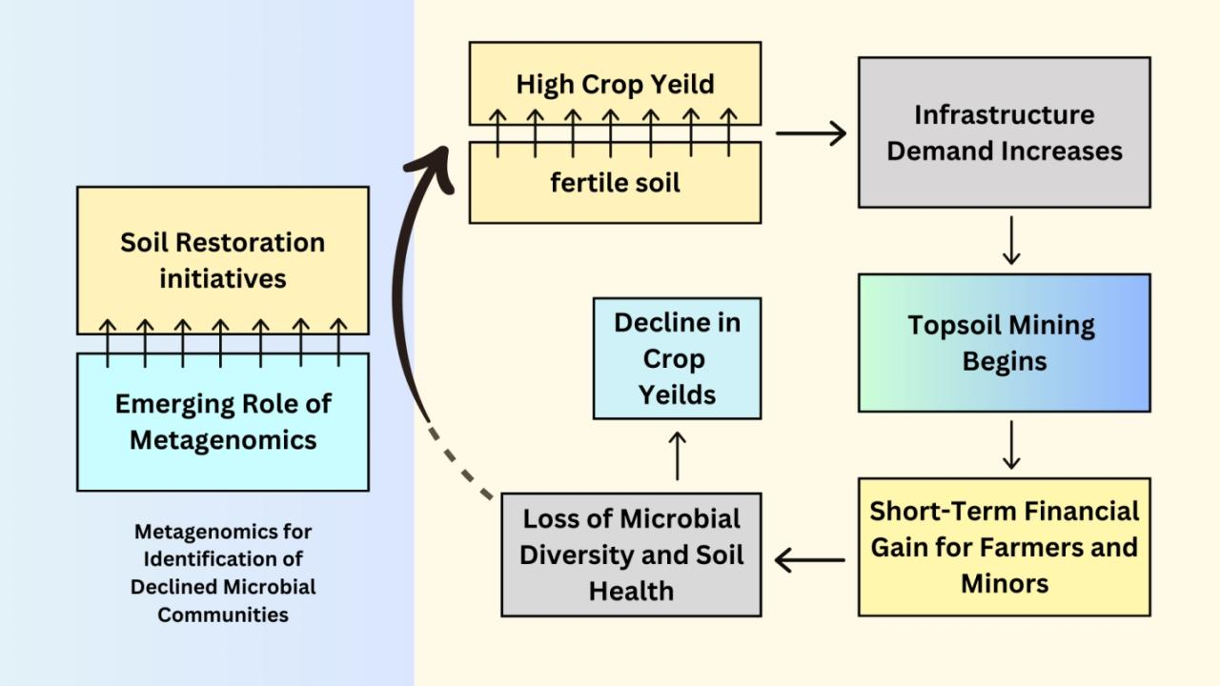
FIG 1: The Impact of Industrial Expansion on Topsoil Demand and how Bioeconomy supports in Providing Sustainable Solutions for Farmers

    - Indiscriminate Use of Fertilizers
The widespread and unregulated practice of using chemical fertilizers in vast fields has disrupted the natural soil microbiome, particularly in an intense sugarcane cultivation. Not only can excess nitrogen and phosphorus inputs cause leaching and nutrient imbalances, but they are also preventing essential native microbial communities important for nutrient cycling. Beneficial bacteria such as Rhizobium, Azospirillum, and Pseudomonas, they play important roles such as nitrogen fixation and phosphorus solubilization among others are usually overshadowed or suppressed in chemically enriched environments. This imbalance leaves the soil weakens the soil’s self-renewing capacity and increases the dependence on external inputs. It degrades soil health over time and lowers the long-term productivity. The metagenomic proof demonstrates the decline in the levels of functional genes such as nifH and phoD in over fertilized soils; this points out to the ecological cost of chemical overdependence (Liu et al., 2021).

    - Continuous Irrigation
Continuous irrigation systems through surface flooding or uncontrolled drip systems result in waterlogging and consequent reduced oxygen availability in the soil. An anaerobic environment significantly impacts aerobic microbial populations and alters the nature of the rhizosphere microbiome. Excessive irrigation leads to salinization, particularly in dry and semi-arid regions where salts concentrate in the root zones.
Elevated soil salinity, as seen by increased electrical conductivity (EC), adversely impacts microbial enzyme performance and diminishes nutrient uptake efficiency in plants. Functional metagenomic profiling reveals profile shows that genes associated with the synthesis of siderophores and stress tolerance are less expressed in continuously irrigated fields, thus indicating that functionality levels of the microbial environment is impaired under hydrological stress (Pang et al., 2021).

    - Ratoon Cropping
Ratoon cropping results in microbial exhaustion and progressive soil fatigue, despite its economic benefits of lower planting costs and faster crop turnover. Beneficial soil organisms decline as a result of repeated regrowth cycles that do not adequately replenish organic matter and microbial diversity (Pang et al., 2021). This approach weakens the rhizosphere's resistance and gives opportunistic and occasionally harmful bacteria the upper hand. Ratooning, according to research, causes a reduction in genes (like those for nitrogen, phosphates and fungi) that benefit the roots.

    - Monoculture
Cultivating only sugarcane for several years can reduce the range of microbial species, particularly the population of the Streptomyces and mycorrhizal fungi become less common. When the soil is too uniform in microbial diversity and microbes involved in nutrient cycles, disease defence and enduring stress tolerance declines., it is difficult to stop pests, diseases and stress caused by environmental factors (Liu et al., 2021). since Maintaining diversity by using intercropping, cover crops and crop rotation helps keep microbes in balance and ensures the farm is productive over time (Gao et al., 2019).

    - Global Environmental Changes
With the climate moving towards warmer environments, new patterns of rainfall, more CO₂, more droughts or floods are getting observed. These environmental changes have also changed the composition and actions of rhizosphere microbes. These environmental changes also change the root exudates production and the way beneficial microbes stick to the roots (Naylor et al., 2020). Also, changes in environmental conditions can turn off microbial genes responsible for getting nutrients, dealing with stresses and preventing infection by pathogens. Further, when things become very hot and dry, microbes need to build osmolytes such as trehalose and proline, but production of all these osmolarities depends on microbial community composition and how much active the microbes are. Both metagenomics and meta-transcriptomics help spot changes in microbial groups and allow agriculture scientists to deal with these uncertainties (Q. Liu et al., 2021).

- Sugarcane Rhizosphere Metagenomic for microbial Diversity and Dynamics
Rhizosphere
It is the area of soil near plant roots that is affected by root exudates and is crucial to the link between plants and soil (Niu et al., 2021). It includes a range of microbes, for example bacteria, fungi, actinomycetes and archaebacteria. Some bacterial species Burkholderia, Pseudomonas and Rhizobium found in the rhizosphere help plants by converting nitrogen, providing access to phosphate and a speed up growth of both the roots and shoots by producing phytohormones (S. R. Singh et al., 2021).. There are certain fungi, like Trichoderma and mycorrhizal species which cling to the roots of plants and help them uptake more phosphorus and guard against diseases (Devi et al., 2020). Among Several plant growth-promoting traits of Streptomyces provide to plants, one is production of antibiotics that manage or minimize the numbers of harmful microorganisms in the soil, therefore increasing the likelihood of plant survival (Yadav et al., 2021).
Since microbes reduce the need for chemicals, rhizosphere microorganisms ought to be considered natural biofertilizers (Kumar et al., 2024). Nitrogen-fixing bacteria increase the amount of nitrogen available to plants and improve their efficiency in using it (Singh et al., 2023). Many times, phosphorus is found as insoluble phosphate rock, but certain microorganisms that solubilize phosphorus allow plants to absorb that phosphorus, so fewer synthetic fertilizers are needed (Rizvi et al., 2021). These microbial communities improve the way plants absorb nutrients, especially iron which promotes healthy plant growth (S. R. Singh et al., 2021).
Better soil, microbial, and root health help sugarcane farmers achieve higher and sustainable production (Yin et al., 2019). Using metagenomics helps find out how soil bacteria around plant roots are affected by chemicals and understand the roles they have in the rhizosphere (Ameen et al., 2024). Because of metagenomics, researchers today can observe the variety and activity of microorganisms in the rhizosphere of sugarcane. Many culture-based techniques are limited, because it’s sometimes impossible to grow a diverse range of microbe groups. Most microbes, whether they are cultured or not, can have their genetic material accessed by metagenomics This conclusion was discussed by Khoiri et al. in 2021 (Khoiri et al., 2021). It involves finding DNA from microbes at random in environmental samples and having technology that can process a huge amount of sequence data. (Khoiri et al., 2021). Studies based on metagenomics reveal the details of soil structure and the important microbes for plant health and sugarcane production.
Deep understanding of the fundamental structural, species, and functional characteristics of the microbial ecosystem for plant health and productivity has been made possible by the application of metagenomics to sugarcane rhizosphere research. Metagenomics involves the sequencing of genetic targets that are conserved within a microbial community, such as the universally conserved 16S rRNA gene, which is utilized for bacterial identification (Wani et al., 2024). According to Moneda et al. (2022), the microbial taxa that culture-based methods were unable to identify were discovered because the targeting of this particular marker allows classification down to the genus and species level. Additional significant functional gene markers include genes linked to siderophore synthesis, phoD for phosphorus metabolism, and nifH for nitrogen fixation (Wani et al., 2024). These have been used to pinpoint the metabolic roles of a variety of microorganisms in the sugarcane plant's rhizosphere (Li et al., 2017). Gene markers provide useful information on the advantageous effects of bacteria on plants and their general health, as well as the ability to evaluate the metabolic capacity of the microbial assemblages involved (Klindworth et al., 2013).
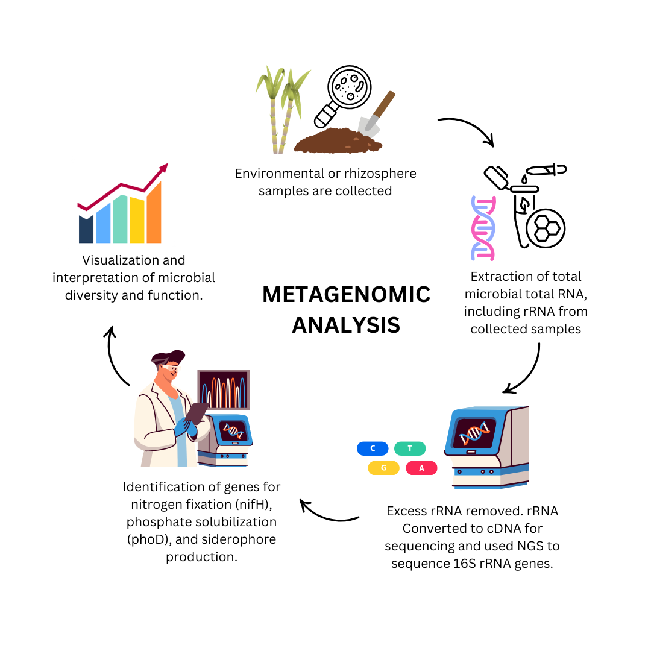
FIG 2: The Role of Metagenomics in Exploring Unculturable Microbes (The figure displays why metagenomics lets us find microbes and their traits that culture-based tools cannot detect. The process points out important steps in analysis: gathering DNA, sequencing it, annotating results and examining their functions.)
The use of metagenomics shows that microbial taxa that help and are required for sugarcane growth are most abundant in the rhizosphere. These bacteria generally participate in the nitrogen cycle (Monenda et al., 2022). Because of the strong reactivity of these species, sequencing soil samples from the sugarcane rhizosphere has shown the presence of nifH gene sequences (Moneda et al., 2022). Metagenomics studies have shown that Bacillus and Pseudomonas are some of the bacteria that help neutralize (solubilize) phosphates. Li et al. (2020) point out that these bacteria use organic acids to release phosphorus into plant roots, so the plant can more easily absorb them. Looking at the activities of the phoD gene in sugarcane rhizosphere, it was clear that high-productivity soils had more active phosphorus pathways, suggesting the bacteria made phosphorus more accessible.
The other main group in the sugarcane microbial community are the actinomycetes and Streptomyces is the main genus of actinomycetes. Because they can produce antibiotics that help defend plants from diseases, they play an important role in agriculture (Li et al., 2020). Through metagenomic studies Abdellatif and colleagues found that actinobacteria in sugarcane soil produce high numbers of genes that produce antimicrobials. (Abdellatif et al., 2024). Similarly Ansari et al. (2024), has found that high-productive soils contain more genes associated with antibiotic formation, proving that actinomycetes help in maintaining disease resistant soil (Ansari et al., 2024). It has also been noticed by scientists that specific strategies employed by microbes can change the productivity levels of various soil types. The number of microbes and genes in soil tends to be higher in highly productive soils than in others (Ansari et al., 2024). Genes from plants with Mycorrhizal Symbiosis can tolerate stress and nutrition loss better (Pang et al., 2021). Lower soil productivity and sugarcane yield are features of low-productivity soils, mainly because they have less active and diverse microbes (Ansari et al., 2024).
The current understanding of sugarcane rhizosphere microbial prospecting has been improved by metagenomics, which expands on microbial taxa, functional genes, and metabolic pathways. Particularly important for agricultural sustainability are the discovery and identification of non-culturable microbes as well as the clarification of their roles in nitrogen fixation, phosphate solubilization, antibiotic synthesis, and siderophore synthesis. Some of its benefits have also been challenged for suggesting that producing biofertilizers and microbial inoculants might boost sugarcane yield significantly while reducing the need for fertilizers made of chemicals. Future efforts to enable the dynamic display of these microbial entities surrounding changing environmental relations and gene expression must continue to prioritize metatranscriptomics and metaproteomics (Ameen et al., 2024).

  - The Challenges of Uncultured Microbes
Among the plethora of microorganisms present in rhizosphere, many remain uncultured under current laboratory conditions and the culture media available. However, these microbes may be crucial for plant development, disease prevention, and nutrient cycling, are found in soil ecosystems. In the sugarcane rhizosphere also, where plant roots interact with microbial communities, these uncultured bacteria are particularly significant. Finding and analyzing microbes without culturing them, revealing their presence even without being directly observed and learning about their roles in converting nitrogen and breaking down organic matter has all been made possible by metagenomics studies. Through metagenomics we can monitor change in number as well as type of both culturable as non-culturable microbes, in the changing soil conditions due to efferent environmental factors and economic activities (Streit & Schmitz, 2004). Further, studying gene expression of soil microbe’s, meta-transcriptomics allows us to measure changes in the different biochemical pathways leading to survival and multiplication of microbial communities and their impact on sugarcane production. Hence, metagenomics and meta-transcriptomics methods can be used to develop biofertilizers to promote sustainable farming and deal with problems such as soil deterioration and deficiency of nutrients in the different type of soil and environmental conditions (Mendes et al., 2017).

  - Rhizosphere Dynamics and Microbial Diversity
Root exudates with substances like sugars and organic acids entice special bacteria to nearby soil and influence their actions there (Niu et al., 2021). Carrying out studies using metagenomic data, scientists have found out that in the rhizosphere bacteria, fungi, actinomycetes and archaea team up to support the sugarcane plant by boosting uptake of nutrients, managing stress and suppressing harmful microbes (Mokrani et al., 2020).

    - Bacterial Contributions: In the rhizosphere of sugarcane, the frequent bacterial species are Burkholderia, Azospirillum, Bradyrhizobium and Pseudomonas and they are very important for both plant growth and nutrient usage (Gupta et al., 2022). Because of their shape, Burkholderia and Azospirillum are able to contribute in nitrogen fixation and show more effective versions of nitrogenase and nifH genes (P. Singh et al., 2023). Organic acids made by Pseudomonas meet the needs of the soil phosphates, as they are used by plants (Pan et al., 2023). Further. they make chemicals called siderophores that gather Fe³⁺ ions which means they take the iron away from pathogens (P. Singh et al., 2023).

    - Fungal Roles in Plant Growth and Defense: Glomus and Trichoderma species which are mycorrhizae, help plants by occupying the area near plant roots and boosting the of essential nutrient and water (Mokrani et al., 2020). Mycorrhizal Glomus species help plants take up phosphorus when soil nutrients are low. Trichoderma uses hydrolytic enzymes and antifungal compounds to stop Fusarium and Pythium. When stress hits, gibberellin-producing fungi work to build the biomass of sugarcane by turning on ways to deal with drought, so these fungi matter in managing biotic stress (Niu et al., 2021).

    - Actinomycetes and Pathogen Suppression: Facultative bacteria, for example Streptomyces, can suppress pathogens such as Rhizoctonia and Verticillium by producing antibiotic and chemical compounds (Yadav et al., 2021). Further, Such bacteria digest various complex molecules found in the soil, improving availability in the soil (Pantelides et al., 2023). Indicating the importance of bacteria in keeping up the health of rhizospheres by cycling nutrients and preventing infections (Pantelides et al., 2023).

    - Archaea and Specialized Functions: Even though archaea are rarer than bacteria in the rizosphere, they are important in handling nitrogen and producing methane in the absence of oxygen (Pang et al., 2021). Because of their ability to break down nitrogen and control greenhouse gas emissions, Methanosarcina and Nitrosopumilus are valuable for maintaining productive soils (Chen et al., 2024).

    - Phytohormone Production: Indole-3-acetic acid (IAA) and other types of auxins, gibberellins and cytokinins, are made by some species of bacteria, helping plants to develop more effectively. Boosted root development and increased nutrient absorption have been noticed thanks to IAA in Azospirillum and Burkholderia (Nong et al., 2022). Increasing cytokinin levels supports shoot growth and tillering which in turn produces a larger harvest. It has also been observed that water stress encourages Trichoderma and similar fungi to release gibberellin which helps plants manage the stress from low water (Pang et al., 2021).

    - Stress Tolerance and Abiotic Interactions: Many stresses such as salinity, drought and high metal concentrations, can be coped with by rhizosphere microorganisms by using different adaptation strategies. For better water use efficiency in dry conditions, Bacillus releases Osmo-protectants called proline and trehalose (Gupta et al., 2020). Further, some bacterial species help sugarcane growth by reducing salt absorption in roots and keeping the internal salt levels well balanced under high salinity conditions. Moreover, Certain bacteria reduce heavy metal concentrations in the soil, enabling effective sugarcane cultivation on suboptimal soils (Niu et al., 2021).

    - Siderophore Production
The micronutrient iron is generally lacking in soils, mainly due to how poorly it dissolves and becomes available. Plant-usable iron is made available through the use of siderophores which are produced by Streptomyces and Pseudomonas. According to Pang et al. (2021) and Singh et al. (2021), along with helping plants absorb nutrients, genes involved in siderophores play a critical role in maintaining sugarcane health and shielding it against harmful fungi and bacteria in soil.

    - Metabolic Synergy and Microbial Interactions: Many different microbial species in the rhizosphere symbiotic complex boost how soil and plants are used. Treating nutritional availability with both NFB and PSB is shown by Gupta et al. (2020) to do better than treating with either alone. Glomus interacting with Pseudomonas in the soil makes the rhizosphere stable, increases its nutrient levels and improves its productivity (Pradhan et al., 2023). Examining productive soils through metagenomics shows that lots of diversity exists in microbial genes of nitrogenase, phosphate-solubilizing and siderophore which implies that having various metabolic activities is important for the health of sugarcane fields (Nong et al., 2022).

  - Abundance of Uncharacterized Microbes Identified
Metagenomic analysis enables the observation of all microbial taxa, including uncultured and unidentified species, a feat unattainable by only culture-dependent approaches (Nong et al., 2022). Certain unidentified bacteria can execute distinctive actions and contain specific enzymes that facilitate nutrient cycling and safeguard plants within the sugarcane root ecosystem (Table 1; Fig 2). Metagenomic analyses of sugarcane rhizospheres comprise many unidentified Proteobacteria. These bacteria are crucial to nitrogen fixation, phosphate solubilisation, and siderophore synthesis, among other functions (Pradhan et al., 2023). Further, unidentified Ascomycota represent additional uncharacterized species within the fungal communities of sugarcane rhizospheres. Metagenomic data can be used to identify gene clusters associated with the generation of secondary metabolites (Abdellatif et al., 2024; Barka et al., 2016). Antibacterial properties of novel actinomycetes have the capacity to protect soil and plant health from these diseases.

Table 1 : Abundance and Dominant and Uncharacterized Microbial Taxa in Sugarcane Rhizosphere
Microbial Group | Dominant Taxa | Uncharacterized Taxa | Functional Role
Bacteria | Burkholderia,  Azospirillum | Unclassified Pr)oteobacteria | Phosphate Solubilization, Nitrogen Fixation  (Bergmark et al., 2012)
Fungi | Trichoderma, Glomus | Unknown Ascomycota | Biocontrol  Phosphorus Uptake  (Devi et al., 2020
Actinomycetes | Streptomyces | Unidentified  Actinomycetes | Pathogen Suppression,  Antibiotic Production  (Li et al., 2020)
Archaea | Methanosarcina, Nitrosopumilus | Novel Euryarchaeota | Nitrogen Cycling, Methane Metabolism,  (Offre et al., 2013)

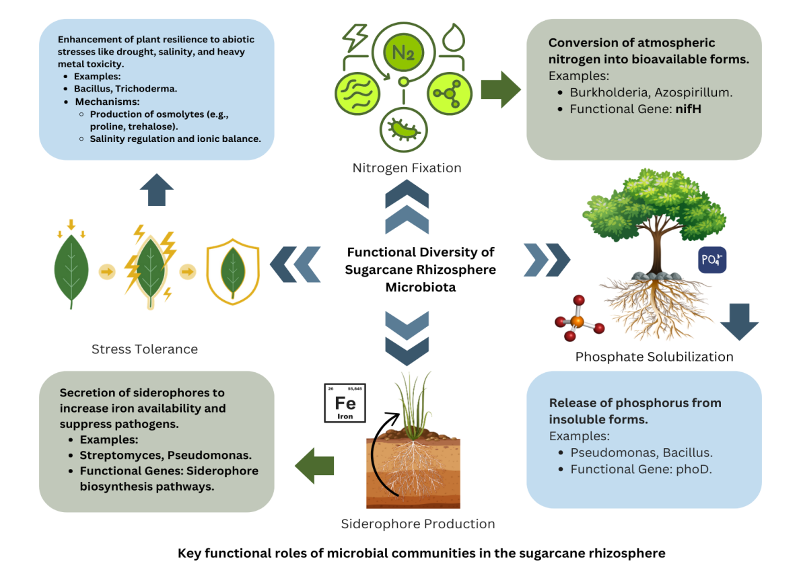

FIG 3: Functional Diversity of Sugarcane Rhizosphere Microbiota (The rhizosphere's sugarcane microbial populations' functional diversity is illustrated in this figure, with focus given to functions such siderophore production, phosphate solubilization, nitrogen fixation, and stress tolerance.)

  - Rhizosphere Microbiota Sugarcane and Other Crop
In particular, the rhizosphere microbiota of sugarcane differs greatly from that of short-term crops, rice, wheat and maize (Fig 3). Sugarcane which is often cultivated a perennial crop, releases a major amount of root exudates while it is growing. Among the components of exudates are sugars, amino acids, organic acids and various secondary metabolites which attract given species of microorganisms (Pahalvi et al., 2021). These exudates' nature and amount are very different from those of short-term crops, which enhances the nutrient-rich environment that supports a diverse microbial community in terms of both structure and function.
Comparative metagenomic analysis of cereals showed notable differences in bacterial and fungal composition, including differences in gene richness and unique functional traits (Pantelides et al., 2023). They found that the sugarcane rhizosphere had higher levels of nitrogen-fixing bacteria, specifically Burkholderia and Azospirillum, but not in the rice and wheat rhizospheres. These bacteria rely on the nifH gene to help atmospheric nitrogen become usable ammonia (a form that plants use) (Pantelides et al., 2023; Gupta et al., 2022). However, in the rhizospheres of cereals, nitrogen-fixing organisms are scarce, and natural nitrogen is not abundant; chemical sources are most important. In sugarcane soil, both Pseudomonas and Streptomyces bacteria which make siderophores, have become more common. By releasing iron in the area around plant roots, siderophores also do away with pathogenic bacteria by outcompeting them (Cornelis et al., 2011; Scavino et al., 2013). They found a significant drop in siderophore genes in the metagenomics of both rice and wheat rhizospheres which may weaken iron absorption and disease defence in the crops.
Sugarcane being perennial helps build solid and dependable groups of microbes within the soil. Abundant root exudation makes many microbes redundant and sugarcane rhizobacteria show good resistance to drought, salt and pathogen attack. (Bardgett & Van Der Putten, 2014). Conversely, short-cycle crops like rice and wheat demonstrate less microbial stability due to their shorter growth duration and smaller root radii compared to cereals (Bardgett & Wardle, 2003). Notable differences in archaeal communities exist within sugarcane rhizospheres, with a more significant syntrophic connection observed among the methanogenic archaeal species Methanosarcina in saturated soils. Since well-drained cereal crop soils do not significantly enhance anaerobic settings, it is linked to methane metabolism and nitrogen cycling in anaerobic circumstances, which are relatively limited (Coyotzi Alcaraz, 2014).
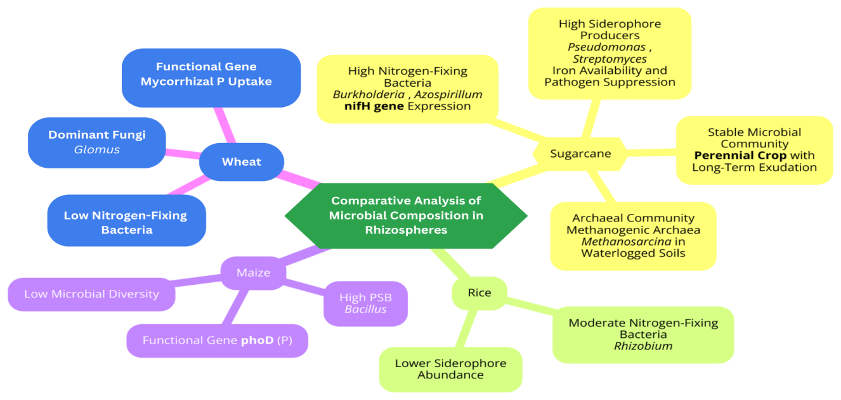

FIG 4: Comparative Analysis of Microbial Composition in Sugarcane vs. Other Crops (This figure shows the differences in the microbial abundance, composition, and key functional genes found in the rhizospheres of wheat, rice, maize, and sugarcane. It highlights how abundant siderophore-producing and nitrogen-fixingsiderophore-producing bacteria found in sugarcane.)
  - Sugarcane Rhizosphere of High vs. Low Productivity Soils
The microbiota of the sugarcane rhizosphere differs from that of other plant rhizosphere investigations. Among the cereal and annual crops are maize, wheat, and rice. The physico-chemical state of the soil's nutrient status, as well as the actions taken during soil management, all have an impact on the composition, diversity, and functional potential of high and low-productivity soil. (S. R. Singh et al., 2021; Solomon, 2016; Verma et al., 2022). High microbial divaricate density is typically linked to soil with high productive capacity, which enhances plant growth, nutrient cycling rate, and foundation stress resistance. Conversely, the low soil productivity is linked to the microbial population's lower heterogeneity, which in turn affects the fields' output. (Ahmed et al., 2024).
Highest productivity through the use of PGPR such as Burkholderia, Azospirillum and Rhizobium, calls for a carbon-rich environment and as little phosphorus as possible. The bacteria make it possible for nitrogen gas to turn into materials plants can use (Bergmark et al., 2012). Phosphate-solubilizing bacteria such as Bacillus and Pseudomonas help make insoluble phosphate more easily available to plants which is crucial in agriculture since it mitigates a major nutrient deficiency (Gupta et al., 2020). Because of the unique extra layers, the soil provides a place for mycorrhizal fungi to thrive which provides additional phosphate, results in more water access and improves how soil holds together (Pradhan et al., 2023). Soil structure affects how well soil suppresses diseases because of Streptomyces and actinomycetes’ activities in releasing antibiotics and enzymes (Niu et al., 2021). This is just one way these bacteria share work to help nutrients, roots and soil remain healthy for good plant growth.
In contrast, soils with poor productivity led to a decrease in the population of these beneficial bacteria. The principal reasons contributing to microbiological fascism in these soils are ongoing sugarcane cultivation and excessive reliance on synthetic fertilisers. Various studies have qualified that this task leads to an increase in stress-resistant and opportunistic bacteria that bring little benefit to the plant. One example is (Krishan K. Verma et al., 2025) which stated that continually planting the same crop leads to fewer nitrogen-fixing bacteria, while dangerous microorganisms increase. Such changes reduce how nutrients are recycled in soil which makes it less fertile and crops more prone to disease and unusual stress.
Use of metagenomic approaches has discovered differences in the way microbes function in high-yield and low-yield soil environments. The high-productivity soils contained many genes that contribute to useful functions such as the genes that allow nitrogen fixation (nifH), metabolize phosphate (phoD) and make siderophore. Because of these genes, nutrients recirculate and are used more effectively, increasing sugarcane production immediately (Ahmed et al., 2024). Because low-productivity soils have fewer working genes, fewer nutrients are available and plant growth is not supported (Yadav et al., 2021). The activity of microbial communities in soil and their enzyme production are increased in very productive soils. According to the authors, microorganisms in soil are helpful for the plant’s health and the expansion of the soil’s fertility (H. B. Li et al., 2017).
Because of different environmental conditions and management approaches, soil types differ. Mainly, soils contain a pH nearly neutral, good suitable moisture and a healthy amount of organic carbon for microorganisms to thrive (kumar et al 2024). When soils are not very productive, they often have a wrong pH balance, less organic carbon and cannot hold water very well; this results in fewer and less active microbes (Pantelides et al., 2023).
According to Liu and his co-researchers (2017), adding organics to low-yielding soils makes the soil microbes with beneficial genes more abundant. Kumar et al. (2024) explain that choosing different crops to grow in a rotation of farm fields results in better and more balanced health of the soil’s microorganisms. Intensive agriculture can be controlled with these approaches and water waste in sugarcane fields can be reduced (Kumar et al., 2024).
Likewise, challenges with weak soil productivity can be addressed with special measures, among them are adding microbes, applying biofertilizers and increasing organic matter. Examining soil metagenomics may help identifiaction of useful microbes that work better and improve soil fertility (Kumar et al., 2024).

- Applications in Sustainable Agriculture
Rhizosphere microbiomes could act as a large source for boosting sustainable sugarcane farming. Some microbes like Rhizobium and Azospirillum help plants by changing inaccessible atmospheric nitrogen into a type they can use (Gupta et al., 2020). Bacillus and Pseudomonas species too help make phosphorus available for plants by solubilising solid phosphates. Pantelides et al., 2023 have stated that PSB helps sugarcane roots uptake more phosphorus, thereby reducing the need for a lot of chemical phosphate fertilisers. Rhizosphere bacteria also generate biocontrol substances, that increases plant defences by making and releasing antifungal and antibacterial agents.. Moneda et al. (2022) study showed Trichoderma-based biopesticides helped to reduce sugarcane root rot by 40%. These bio-fertilizer highly environment friendly and help crop plants against different stresses (Pradhan et al., 2023). Mokrani et al(2020), reported positive impact of application of bacterial cultures in sugarcane cultivation under drought conditions. Developments in metagenomics-based fertilisers and inoculants customized to for target soil and crop combination can benefit sustainable farming. The fertilisers can be created with a special mix to match both the soil and the crops grown in each region. Scavino et al. (2013) and Gupta et al. (2022) clearly point out that performing metagenomic analysis can help identify microorganisms with specific features that increase the performance of biofertilizers and biopesticides in sugarcane agriculture. For microbial ecologists and those working in biotechnology, the diversity among rhizosphere microbes provides a major opportunity to increase crop productivity and develop sustainable farming.
Exploring the rhizosphere microbiome will help India’s sugarcane sector benefit in many areas. Microbial technology helps solve important problems in farming such as a lack of soil nutrients and pest infestations, without harming the environment when sugarcane is grown (Jiang et al., 2012). Still, microbial inoculants and biofertilizers are available, but the use of these strategies is limited by a lack of awareness and access for farmers (Niu et al., 2021). This would be the first case of using such technology for sugarcane management and it could greatly revolutionize the way crops are grown economically and with new ideas.

- Challenges and Knowledge Gaps
Promoting the utilization of rhizosphere microbial abundance for agricultural sustainability is subject to several limitations. The primary concern is that the proof-of-concept shown in laboratory settings has substantial limitations regarding its applicability to real-world scenarios, as managing and addressing soil heterogeneity and its response to external conditions and indigenous microbial communities is necessary for the effectiveness of microbial inoculants in crops (Chen et al., 2024). It is generally observed that microorganisms that work well in controlled environments are susceptible to competition and experience reduced efficiency in a variety of field conditions (Gupta et al., 2022), and that nitrogen-fixing and phosphate-solubilizing bacteria are unable to develop strong growth under variable environmental conditions. Presently. no globally accepted techniques exist for the development and usage of microbial inoculants. According to (Moneda et al., 2022), this has led to inconsistency in the efficacy of microbial products due to changes in formulation and storage, so farmers have lost trust in their performance. Morover, metagenomic assessment cannot be performed on a broad scale, particularly in developing nations, due to the substantial expenses linked to sophisticated DNA sequencing methodologies (R. Li et al., 2020). Further, it remains insufficient to assign an accurate functional annotation for increasingly complex species, including a comprehensive microbiological reference database.
It is noticeable that presently we lack information on how microbes sense and respond to environmental challenges. According to Niu et al. (2021), there is little information available about how microbes respond to drought, salinity and conditions that break the link between plants and their microbes. This calls for standardized processes, technology that is easy to use and research efforts linking metagenomic experiments with functional research, to tackle the lack of knowledge (Moneda et al., 2022).

- Future Directions
It is important to use advanced and interdisciplinary techniques to analyse microbial communities in the sugarcane rhizosphere, as this can meet present needs and improve agricultural production efficiency. There is potential in using techniques like metagenomics, metatranscriptomics, proteomics and metabolomics. This integrative approach is used to study how microbes are useful, behave and change their ways in different changing environment. Niu et al. (2021) point out that metatranscriptomics can help study how microbes respond to drought and salinity stress which is important for growing stress-resistant microbial populations.
Hence, one must carry out field-based testing of microbial inoculants in several types of farming environments. Due to variations in the physical and microbial habitats of the soil, field recovery of microbiological counts is typically lower than laboratory measurements (Chen et al., 2024). Long-term research that accounts for these characteristics will facilitate a deeper knowledge of how to improve microbial application and its stability. Recent metagenomic analyses have introduced the notion of precision agriculture, which necessitates the provision of site-specific and crop-specific molecular and genotypic inoculants, as well as individualised bio-amendments (Chen et al., 2024). Access to microbial genomics and the availability of genomic information, coupled with standardised annotation tools and pipelines, will enhance functional profiles (Pan & Cai, 2023).
Synthetic biology research holds promise for creating microbial communities with improved functional characteristics. To solve agricultural issues like nutrient-deficient soils or pest infestations or improve crop stability and soil fertility, these designer consortia could be precisely created for particular agricultural issues such as pest problems or nutrient-deficient soils (Mokrani et al., 2020). It highlightes the importance of how microbial traits might work together depending on environmental conditions.

- Conclusion
The sugarcane rhizosphere represents a diverse and transient microbial habitat crucial for augmenting yield, quality, and overall soil health in the context of sustainable agriculture. Different studies have provided extensive insights into phosphate-mobilizing, nitrogen-fixing, siderophore-producing, and phytohormone-synthesizing microorganisms. These bacteria are highly beneficial for nutrient cycling, stress tolerance, and disease suppression, serving as the essential basis for innovative eco-friendly technologies, including, biopesticides, biofertilizers, and microbial consortia.
Translating laboratory experiment results to field applications remains a difficulty due to variability in soil properties, chemical reactions, environmental conditions, and inadequate understanding of microbial responses. These challenges indicate the necessity for innovative and high-throughput technologies, including standardised techniques for meticulous experimental design, ongoing cost reduction of sequencing technologies, and the development of integrative multi-omics approaches. Enhanced longitudinal studies in the field and targeted microbiological interventions can further bridge the divide between theory and practice.
Incorporating the complexity of the microbial population in the rhizosphere into agricultural systems might reduce pesticide usage, improve crop yields, and address the emerging challenge of sustainable food supply for the increasing global population. Integrative methodologies, coordinated research projects, and the shift to a philotectonic perspective will explain the abilities of microbial diversity in order to improve sugarcane output, simultaneously defining the post-industrial future as an ideal basis for sustainable agriculture.

References

Abbaszadeh-Dahaji, P., Omidvari, M., & Ghorbanpour, M. (2017). Increasing phytoremediation efficiency of heavy metal-contaminated soil using PGPR for sustainable agriculture. In Plant-Microbe Interaction: An Approach to Sustainable Agriculture (pp. 187–204). Springer Singapore. https://doi.org/10.1007/978-981-10-2854-0_9
Abdellatif, A. A. M., Gebily, D. A. S., Elmaghraby, M. M. K., Sahu, P. K., Thakur, B., & Kaur, S. (2024). Transforming Roles of Actinobacteria in Sustainable Agriculture: From Soil Health and Plant Productivity Perspective. In Metabolomics, Proteomics and Gene Editing Approaches in Biofertilizer Industry (pp. 299–338). Springer Nature Singapore. https://doi.org/10.1007/978-981-97-2910-4_16
Abru, S., Taha Junaid Khan, M., Ali Haider, S., Rasheed, T., Bashir, Q., Abdul wahab, A., Ahmed, F., & Jawad Abdullah, M. (2021). International Journal of Advanced Research in Biological Sciences Impact of biotic and abiotic factors on sugarcane production: A case study of Tehsil. Int. J. Adv. Res. Biol. Sci, 8(10), 86–95. https://doi.org/10.22192/ijarbs
Ahmed, M., Tóth, Z., & Decsi, K. (2024). The Impact of Salinity on Crop Yields and the Confrontational Behavior of Transcriptional Regulators, Nanoparticles, and Antioxidant Defensive Mechanisms under Stressful Conditions: A Review. In International Journal of Molecular Sciences (Vol. 25, Issue 5). Multidisciplinary Digital Publishing Institute (MDPI). https://doi.org/10.3390/ijms25052654
Ameen, F., Bhat, S. A., & Kumar, V. (n.d.). Microbial Bioremediation and Multiomics Technologies for Sustainable Development: Recent Trends. https://www.researchgate.net/publication/375747793
Anna Herforth, Yan Bai, Aishwarya Venkat, Kristi Mahrt, Alissa Ebel, & Willam A. Masters. (2020). Cost and affordability of healthy diets across and within countries (Food and Agriculture Organization of the United Nations Rome, Ed.; 9th ed.).
Ansari, W. A., Kumar, M., Krishna, R., Singh, A., Zeyad, M. T., Tiwari, P., Kumar, S. C., Chakdar, H., & Srivastava, A. K. (2024). Influence of rice-wheat and sugarcane-wheat rotations on microbial diversity and plant growth promoting bacteria: Insights from high-throughput sequencing and soil analysis. Microbiological Research, 278. https://doi.org/10.1016/j.micres.2023.127533
Augustine, S. M., Ashwin Narayan, J., Syamaladevi, D. P., Appunu, C., Chakravarthi, M., Ravichandran, V., Tuteja, N., & Subramonian, N. (2015). Overexpression of EaDREB2 and pyramiding of EaDREB2 with the pea DNA helicase gene (PDH45) enhance drought and salinity tolerance in sugarcane (Saccharum spp. hybrid). Plant Cell Reports, 34(2), 247–263. https://doi.org/10.1007/s00299-014-1704-6
Bardgett, R. D., & Van Der Putten, W. H. (2014). Belowground biodiversity and ecosystem functioning. In Nature (Vol. 515, Issue 7528, pp. 505–511). Nature Publishing Group. https://doi.org/10.1038/nature13855
Bardgett, R. D., & Wardle, D. A. (2003). Herbivore-Mediated Linkages between Aboveground and Belowground Communities (Vol. 84, Issue 9).
Barka, E. A., Vatsa, P., Sanchez, L., Gaveau-Vaillant, N., Jacquard, C., Klenk, H.-P., Clément, C., Ouhdouch, Y., & van Wezel, G. P. (2016). Taxonomy, Physiology, and Natural Products of Actinobacteria. Microbiology and Molecular Biology Reviews, 80(1), 1–43. https://doi.org/10.1128/mmbr.00019-15
Bergmark, L., Poulsen, P. H. B., Al-Soud, W. A., Norman, A., Hansen, L. H., & Sørensen, S. J. (2012). Assessment of the specificity of Burkholderia and Pseudomonas qPCR assays for detection of these genera in soil using 454 pyrosequencing. FEMS Microbiology Letters, 333(1), 77–84. https://doi.org/10.1111/j.1574-6968.2012.02601.x
Chen, Q., Song, Y., An, Y., Lu, Y., & Zhong, G. (2024). Mechanisms and Impact of Rhizosphere Microbial Metabolites on Crop Health, Traits, Functional Components: A Comprehensive Review. In Molecules (Vol. 29, Issue 24). Multidisciplinary Digital Publishing Institute (MDPI). https://doi.org/10.3390/molecules29245922
Cornelis, P., Wei, Q., Andrews, S. C., & Vinckx, T. (2011). Iron homeostasis and management of oxidative stress response in bacteria. In Metallomics (Vol. 3, Issue 6, pp. 540–549). https://doi.org/10.1039/c1mt00022e
Coyotzi Alcaraz, S. V. (2014). Bacterial diversity and denitrifier communities in arable soils.
Devi, R., Kaur, T., Kour, D., Rana, K. L., Yadav, A., & Yadav, A. N. (2020). Beneficial fungal communities from different habitats and their roles in plant growth promotion and soil health. In Microbial Biosystems (Vol. 5, Issue 1, pp. 21–24). Arab Society for Fungal Conservation. https://doi.org/10.21608/MB.2020.32802.1016
Gao, X., Wu, Z., Liu, R., Wu, J., Zeng, Q., & Qi, Y. (2019). Rhizosphere Bacterial Community Characteristics over Different Years of Sugarcane Ratooning in Consecutive Monoculture. BioMed Research International, 2019. https://doi.org/10.1155/2019/4943150
Gavilanes, F. Z., Amaral, H. F., García, M. C., Araujo-Junior, C. F., Zanão Júnior, L. A., Nomura, R. B. G., & Andrade, D. S. (2021). Interactions Between Edaphoclimatic Conditions and Plant–Microbial Inoculants and Their Impacts on Plant Growth, Nutrient Uptake, and Yields (pp. 591–633). https://doi.org/10.1007/978-981-15-8999-7_22
Gupta, A., Singh, R., Vandana, P., Singh, K., & Sharma, D. (2020). Enhancing crop productivity with salt‒tolerant PGPR: a step towards sustainable farming. Vegetable Research, 0(0), 1–17. https://doi.org/10.48130/vegres-0024-0032
Gupta, A., Singh, U. B., Sahu, P. K., Paul, S., Kumar, A., Malviya, D., Singh, S., Kuppusamy, P., Singh, P., Paul, D., Rai, J. P., Singh, H. V., Manna, M. C., Crusberg, T. C., Kumar, A., & Saxena, A. K. (2022). Linking Soil Microbial Diversity to Modern Agriculture Practices: A Review. In International Journal of Environmental Research and Public Health (Vol. 19, Issue 5). MDPI. https://doi.org/10.3390/ijerph19053141
Huang, W., Lu, Y., Chen, L., Sun, D., & An, Y. (2021). Impact of pesticide/fertilizer mixtures on the rhizosphere microbial community of field-grown sugarcane. 3 Biotech, 11(5). https://doi.org/10.1007/s13205-021-02770-3
Jiang, Z. P., Li, Y. R., Wei, G. P., Liao, Q., Su, T. M., Meng, Y. C., Zhang, H. Y., & Lu, C. Y. (2012). Effect of Long-Term Vinasse Application on Physico-chemical Properties of Sugarcane Field Soils. Sugar Tech, 14(4), 412–417. https://doi.org/10.1007/s12355-012-0174-9
Khoiri, A. N., Cheevadhanarak, S., Jirakkakul, J., Dulsawat, S., Prommeenate, P., Tachaleat, A., Kusonmano, K., Wattanachaisaereekul, S., & Sutheeworapong, S. (2021). Comparative Metagenomics Reveals Microbial Signatures of Sugarcane Phyllosphere in Organic Management. Frontiers in Microbiology, 12. https://doi.org/10.3389/fmicb.2021.623799
Kingston, G. (n.d.). Mineral Nutrition of Sugarcane.
Klindworth, A., Pruesse, E., Schweer, T., Peplies, J., Quast, C., Horn, M., & Glöckner, F. O. (2013). Evaluation of general 16S ribosomal RNA gene PCR primers for classical and next-generation sequencing-based diversity studies. Nucleic Acids Research, 41(1). https://doi.org/10.1093/nar/gks808
Krishan K. Verma, Xiu-Peng Song, Munna Singh, Renato de Mello Prado, Jian-Ming Wu, & Yang-Rui Li. (2025). SUGARCANE CULTIVATION AND MANAGEMENT Challenges and Opportunities.
Lamizadeh, E., Enayatizamir, N., & Motamedi, H. (2016). Isolation and Identification of Plant Growth-Promoting Rhizobacteria (PGPR) from the Rhizosphere of Sugarcane in Saline and Non-Saline Soil. International Journal of Current Microbiology and Applied Sciences, 5(10), 1072–1083. https://doi.org/10.20546/ijcmas.2016.510.113
Levy-Booth, D. J., Prescott, C. E., & Grayston, S. J. (2014). Microbial functional genes involved in nitrogen fixation, nitrification and denitrification in forest ecosystems. In Soil Biology and Biochemistry (Vol. 75, pp. 11–25). Elsevier Ltd. https://doi.org/10.1016/j.soilbio.2014.03.021
Li, H. B., Singh, R. K., Singh, P., Song, Q. Q., Xing, Y. X., Yang, L. T., & Li, Y. R. (2017). Genetic diversity of nitrogen-fixing and plant growth promoting Pseudomonas species isolated from sugarcane rhizosphere. Frontiers in Microbiology, 8(JUL). https://doi.org/10.3389/fmicb.2017.01268
Li, R., Pang, Z., Zhou, Y., Fallah, N., Hu, C., Lin, W., & Yuan, Z. (2020). Metagenomic analysis exploring taxonomic and functional diversity of soil microbial communities in sugarcane fields applied with organic fertilizer. BioMed Research International, 2020. https://doi.org/10.1155/2020/9381506
Liu, Q., Zhao, X., Liu, Y., Xie, S., Xing, Y., Dao, J., Wei, B., Peng, Y., Duan, W., & Wang, Z. (2021). Response of Sugarcane Rhizosphere Bacterial Community to Drought Stress. Frontiers in Microbiology, 12. https://doi.org/10.3389/fmicb.2021.716196
Liu, Z., Rong, Q., Zhou, W., & Liang, G. (2017). Effects of inorganic and organic amendment on soil chemical properties, enzyme activities, microbial community and soil quality in yellow clayey soil. PLoS ONE, 12(3). https://doi.org/10.1371/journal.pone.0172767
Mendes, L. W., Braga, L. P. P., Navarrete, A. A., Souza, D. G. de, Silva, G. G. Z., & Tsai, S. M. (2017). Using Metagenomics to Connect Microbial Community Biodiversity and Functions. In Metagenomics: Current Advances and Emerging Concepts. Caister Academic Press. https://doi.org/10.21775/9781910190593.06
Mokrani, S., Nabti, E. H., & Cruz, C. (2020). Current advances in plant growth promoting bacteria alleviating salt stress for sustainable agriculture. Applied Sciences (Switzerland), 10(20), 1–27. https://doi.org/10.3390/app10207025
Moneda, A. P. C., de Carvalho, L. A. L., Teheran-Sierra, L. G., Funnicelli, M. I. G., & Pinheiro, D. G. (2022). Sugarcane cultivation practices modulate rhizosphere microbial community composition and structure. Scientific Reports, 12(1). https://doi.org/10.1038/s41598-022-23562-6
Naylor, D., Sadler, N., Bhattacharjee, A., Graham, E. B., Anderton, C. R., Mcclure, R., Lipton, M., Hofmockel, K. S., & Jansson, J. K. (2020). Annual Review of Environment and Resources Soil Microbiomes Under Climate Change and Implications for Carbon Cycling. https://doi.org/10.1146/annurev-environ-012320
Niu, H., Pang, Z., Fallah, N., Zhou, Y., Zhang, C., Hu, C., Lin, W., & Yuan, Z. (2021). Diversity of microbial communities and soil nutrients in sugarcane rhizosphere soil under water soluble fertilizer. PLoS ONE, 16(1 January). https://doi.org/10.1371/journal.pone.0245626
Nong, Q., Malviya, M. K., Solanki, M. K., Solanki, A. C., Lin, L., Xie, J., Mo, Z., Wang, Z., Song, X. P., Huang, X., Rai, S., Li, C., & Li, Y. R. (2022). Sugarcane Root Transcriptome Analysis Revealed the Role of Plant Hormones in the Colonization of an Endophytic Diazotroph. Frontiers in Microbiology, 13. https://doi.org/10.3389/fmicb.2022.924283
Pahalvi, H. N., Rafiya, L., Rashid, S., Nisar, B., & Kamili, A. N. (2021). Chemical Fertilizers and Their Impact on Soil Health. In Microbiota and Biofertilizers, Vol 2 (pp. 1–20). Springer International Publishing. https://doi.org/10.1007/978-3-030-61010-4_1
Pan, L., & Cai, B. (2023). Phosphate-Solubilizing Bacteria: Advances in Their Physiology, Molecular Mechanisms and Microbial Community Effects. In Microorganisms (Vol. 11, Issue 12). Multidisciplinary Digital Publishing Institute (MDPI). https://doi.org/10.3390/microorganisms11122904
Offre, P., Spang, A., & Schleper, C. (2013). Archaea in biogeochemical cycles. Annual review of microbiology, 67(1), 437-457.
Pang, Z., Tayyab, M., Kong, C., Liu, Q., Liu, Y., Hu, C., Huang, J., Weng, P., Islam, W., Lin, W., & Yuan, Z. (2021). Continuous sugarcane planting negatively impacts soil microbial community structure, soil fertility, and sugarcane agronomic parameters. Microorganisms, 9(10). https://doi.org/10.3390/microorganisms9102008
Pantelides, I. S., Stringlis, I. A., Finkel, O. M., & Mercado-Blanco, J. (2023). Editorial: Organic amendments: microbial communities and their role in plant fitness and disease suppression. In Frontiers in Plant Science (Vol. 14). Frontiers Media SA. https://doi.org/10.3389/fpls.2023.1213092
Pradhan, A., Wakchaure, G. C., Shid, D., Minhas, P. S., Biswas, A. K., & Reddy, K. S. (2023). Impact of residue retention and nutrient management on carbon sequestration, soil biological properties, and yield in multi-ratoon sugarcane. Frontiers in Sustainable Food Systems, 7. https://doi.org/10.3389/fsufs.2023.1288569
Rizvi, A., Ahmed, B., Khan, M. S., Umar, S., & Lee, J. (2021). Sorghum-Phosphate Solubilizers Interactions: Crop Nutrition, Biotic Stress Alleviation, and Yield Optimization. In Frontiers in Plant Science (Vol. 12). Frontiers Media S.A. https://doi.org/10.3389/fpls.2021.746780
Satyanarayana, T., Das, S. K., & Johri, B. N. (2019). Microbial diversity in ecosystem sustainability and biotechnological applications: Volume 2. soil & agroecosystems. In Microbial Diversity in Ecosystem Sustainability and Biotechnological Applications: Volume 2. Soil & Agroecosystems. Springer Singapore. https://doi.org/10.1007/978-981-13-8487-5
Singh, P., Singh, R. K., Li, H. B., Guo, D. J., Sharma, A., Verma, K. K., Solanki, M. K., Upadhyay, S. K., Lakshmanan, P., Yang, L. T., & Li, Y. R. (2023). Nitrogen fixation and phytohormone stimulation of sugarcane plant through plant growth promoting diazotrophic Pseudomonas. Biotechnology and Genetic Engineering Reviews. https://doi.org/10.1080/02648725.2023.2177814
Singh, S. R., Yadav, P., Singh, D., Shukla, S. K., Tripathi, M. K., Bahadur, L., Mishra, A., & Kumar, S. (2021). Intercropping in Sugarcane Improves Functional Diversity, Soil Quality and Crop Productivity. Sugar Tech, 23(4), 794–810. https://doi.org/10.1007/s12355-021-00955-x
Solomon, S. (2016). Sugarcane Production and Development of Sugar Industry in India. In Sugar Tech (Vol. 18, Issue 6, pp. 588–602). Springer India. https://doi.org/10.1007/s12355-016-0494-2
SRIVASTAVA, A. K. (2012). Sugarcane production: Impact of climate change and its mitigation. Biodiversitas, Journal of Biological Diversity, 13(4), 214–227. https://doi.org/10.13057/biodiv/d130408
Streit, W. R., & Schmitz, R. A. (2004). Metagenomics - The key to the uncultured microbes. In Current Opinion in Microbiology (Vol. 7, Issue 5, pp. 492–498). https://doi.org/10.1016/j.mib.2004.08.002
Vandenberghe, L. P. S., Valladares-Diestra, K. K., Bittencourt, G. A., Zevallos Torres, L. A., Vieira, S., Karp, S. G., Sydney, E. B., de Carvalho, J. C., Thomaz Soccol, V., & Soccol, C. R. (2022). Beyond sugar and ethanol: The future of sugarcane biorefineries in Brazil. Renewable and Sustainable Energy Reviews, 167, 112721. https://doi.org/10.1016/j.rser.2022.112721
Verma, K. K., Song, X. P., Budeguer, F., Nikpay, A., Enrique, R., Singh, M., Zhang, B. Q., Wu, J. M., & Li, Y. R. (2022). Genetic engineering: an efficient approach to mitigating biotic and abiotic stresses in sugarcane cultivation. In Plant Signaling and Behavior (Vol. 17, Issue 1). Taylor and Francis Ltd. https://doi.org/10.1080/15592324.2022.2108253
Vinayaka, & Prasad, P. R. C. (2024). AI-Enhanced Remote Sensing Applications in Indian Sugarcane Research: A Comprehensive Review. In Sugar Tech (Vol. 26, Issue 3, pp. 609–628). Springer. https://doi.org/10.1007/s12355-024-01409-w
Wani, A. K., Rahayu, F., Alkahtani, A. M., Alreshidi, M. A., Yadav, K. K., Parnidi, Fauziah, L., Murianingrum, M., Akhtar, N., Mufidah, E., Supriyadi, Rahayu, D. M., & Singh, R. (2024). Metagenomic profiling of rhizosphere microbiota: Unraveling the plant-soil dynamics. Physiological and Molecular Plant Pathology, 133, 102381. https://doi.org/10.1016/j.pmpp.2024.102381
Wu, Q., Chen, D., Zhou, W., Zhang, X., & Ao, J. (2022). Long-term fertilization has different impacts on bacterial communities and phosphorus forms in sugarcane rhizosphere and bulk soils under low-P stress. Frontiers in Plant Science, 13. https://doi.org/10.3389/fpls.2022.1019042
Yadav, A. N., Kaur, T., Devi, R., Kour, D., Yadav, A., Dikilitas, M., Usmani, Z., Yadav, N., Abdel-Azeem, A. M., & Ahluwalia, A. S. (2021). Biodiversity and Biotechnological Applications of Industrially Important Fungi: Current Research and Future Prospects (pp. 541–572). https://doi.org/10.1007/978-3-030-67561-5_17

