Original Research Article

Prevalence and Molecular Identification of Fungal from Edible Frog (Hoplobatrachus occipitalis) captured in the shallows of MAN City, Côte d’Ivoire

.
ABSTRACT

Aims: Frogs are a popular source of protein in the western region of Côte d'Ivoire. But they are still caught in the natural environment in water of dubious quality that may contain pathogenic micro-organisms such as fungi. The aim of this study was to isolate and identify the fungal community present on frog skin.
Study design: A frog sample was taken and fungal isolation and identification were performed.
Place and Duration of Study: The study was carried out in Man (Western Côte d’Ivoire) during June to October 2024.
Methodology: The method involved capturing frogs Hoplobatrachus occipitalis at three sites in marshy areas of Man town (Sites A, B and C). A total of 60 frogs were captured, 20 frogs per site, to determine the fungal community. Swabs were taken from the frogs' skin and isolates of the fungi were isolated on Sabouraud medium containing chloramphenicol. These purified strains were identified by macroscopic and microscopic observations at 10X and 40X magnification. Subsequently, molecular identification by Polymerase Chain Reaction (PCR) was carried out to confirm the strains using the ITS gene.
Results: The results of this study showed that the rate of frog contamination was 61.7% and three fungal genera were observed. These were Aspergillus sp, Rhizopus sp and Mucor sp. Aspergillus was the most commonly observed (82.3%). Fungal contamination of frog was high for Aspergillus sp species; 51.6% for Aspergillus niger, 35% for Aspergillus terreus and 21.6% for Aspergillus fumigatus. PCR confirmed that these sources belonged to the fungal genus, with the appearance of a 590 bp band after electrophoresis.
Conclusion : Considering the high consumption of frogs in this part, these results raise questions about the measures to be taken to ensure the production of healthy frogs.

Keywords: Frog, Skin, Fungal, Côte d’Ivoire

1. INTRODUCTION

Frogs play a crucial role in many areas. Environmentally, they are considered indicators and contribute significantly to various ecosystems (Fatima et al., 2025). Indeed, many amphibian species serve as ecological sentinels. Their presence or absence provides insights into the health of ecosystems and habitats, essential to humanity (Hamoumi & Himmi, 2010). Amphibians are a vital link in the wetland food pyramid. Adult anurans are insectivores, helping regulate populations of pest insects such as mosquitoes and flies. They play a key role in balancing the food web by feeding on insects while also serving as prey for numerous many avian and mammalian species (Waqas et al., 2018). Additionally, frog meat is a protein source consumed in many countries, including Côte d’Ivoire (Tohe et al., 2014 ; Ble et al., 2022;). In these countries, the most eaten and appreciated part is the frog's leg (the fleshy hind legs), which is compared to that of chickens (Douglas & Amezie, 2017). Research has also focused on the use of frog meat in infant food production (Rodrigue et al., 2014).
Despite their their ecological and nutritional importance, amphibians are among the most threatened groups of vertebrates in the world, with around a third of known species in danger, leading to their decline in certain regions of Africa. Key threats include chemical pollution, overharvesting for human consumption, urbanization, and, notably, pathogenic microorganisms (Culp et al., 2007 ; Coulibaly & Zigui, 2021 ; Codjo et al., 2021). Several fungal diseases, such as chytridiomycosis, chromomycosis, mucormycosis, and saprolegniasis, affect frogs But the most devastating is chytridiomycosis, caused by Batrachochytrium dendrobatidis, which causes high mortality rates in amphibian populations around the world (Kim et al., 2008).
In West Africa, studies on dried Hoplobatrachus occipitalis in Nigeria revealed contamination by fungal genera like Penicillium sp., Aspergillus sp., Rhizopus sp., Mucor sp., and Fusarium sp. (Douglas & Amezie, 2017). Toxigenic fungi in food products pose serious health risks to humans and animals while also degrading market quality, causing significant economic losses (Hissein et al., 2017).
In Côte d'Ivoire, despite numerous studies carried out on the H. occipitalis species of frog, which is the most widely consumed and prized, little is known about its contamination by fungal. Existing microbiological studies have focused solely on parasites and bacteria (Dadié et al., 2017 ; Ble et al., 2021; Oungbe et al., 2023). Further research to identify pathogenic fungal species in these frogs is critical for disease control, ensuring safe meat production, and assessing mycotoxin risks for consumers. The aim of this study is to isolate and identify the fungal community present on frog skin using culture and molecular analysis.
2. material and methods

2.1. Collection area

This study was carried out in the Tonkpi region, specifically in the town of Man. Rainfall in this region is wet, varying between 1600 and 2500 mm per year. There are two main seasons in the area: the rainy season, which lasts from April to October, and the dry season, which begins in November and ends in March. It is a mountainous area situated between 7°24'45"North and 7°33’13” West. It is a very hilly region, with areas ranging from medium slopes to altitudes of over 1,000 m. Agriculture is the mainstay of the economy of the local population, most of whom are Yacouba. Farming is practised on ferralitic soils of average chemical fertility, hydromorphic soils in the lowlands and mineral soils in mountainous regions. The average annual temperature ranges from 24.8°C to 28.5°C (Ahoussi et al., 2012).
2.2. Sampling method
This study was conducted in the western part of Côte d'Ivoire in the Tonkpi region. A total of 60 adult Hoplobatrachus occipitalis frogs (Fig. 1) were collected in the marshy areas of Man town using fishing arrows. The frogs were collected in the shallows at three different sites named Site A, B and C (Fig. 2) and at each site, 20 frogs were collected. The frogs were collected at night between 9 p.m and midnight using the method described by Ble et al. (2022). The captured frogs were placed in polyethylene bags containing hydrogen peroxide and then transported to the analysis laboratory under aseptic conditions. In the laboratory, a swab was taken from the body of each frog using a cotton swab. The parts swabbed were the dorsal side, ventral side and limbs.

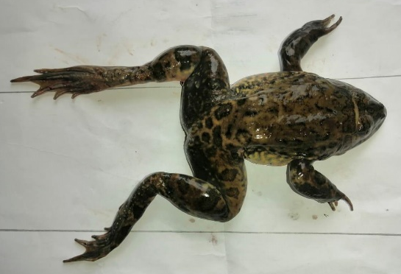

Fig. 1. Specimen of H. occipitalis frog captured in the shallows
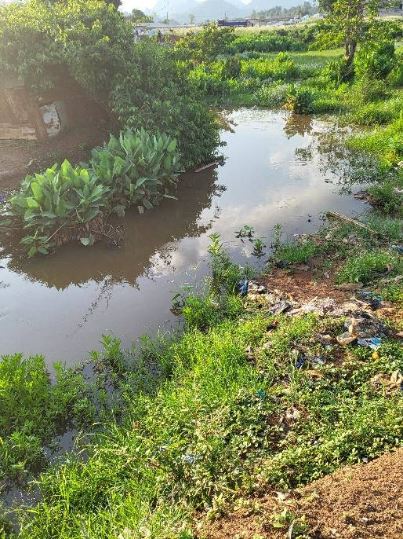

Fig. 2. Swampy area (Site C) for catching frogs in the city of MAN

2.3. Phenotypic and molecular identification of fungal
For mycological examination, swab samples were cultured on Saboraud Dextrose Agar (SDA) supplemented with 10 µg/ml chloramphenicol in Petri dishes. The dishes were incubated at 30°C for 3 to 7 days according to the method of Ouattara et al. (2023) and daily observations were made. The mycelia collected were purified on SDA agar after several successive inoculations.
The macroscopic identification of the pure strains obtained was carried out with the naked eye based mainly on characteristics such as the texture of the thallus, the growth rate, the appearance of the aerial mycelium, the colour and the colour of the thallus. For microscopic identification, a few spores and a mycelial fragment at the margin of the thallus of the pure strain were removed using a sterile platinum loop and then placed on an object slide in a drop of physiological water. The whole was covered with a coverslip and observed under the 10X and 40X objectives of the light microscope (Foba et al., 2023).

2.4. DNA extraction
DNA was extracted from fungal isolates using the method described by Manonmani et al. (2005). DNA was extracted using 0.5 g of fungal mycelia harvested from pure cultures freshly grown on Sabouraud medium with chloramphenicol. The mycelium was ground well in a mortar and then transferred to 700 µL of Phosphate Buffered Saline (PBS) for a series of freezing/thawing in liquid nitrogen. Next, 500 µL of the fungal suspension was added to 500 µL of lysis buffer (1.4 M NaCl, 20 mM EDTA, 100 mM Tris-HCL) and incubated at 55°C for 3 h in a dry bath. To the lysate, 500 µL of phenol-chloroform-alcohol-isoamyl was added. The tubes were centrifuged at 13,000 rpm for 10 min at 4°C. The upper aqueous phase was recovered in a new sterile 2 mL Eppendorf tube. To this upper aqueous phase, 1/10th of 3 M sodium acetate and 500 µL of ice-cold absolute ethanol were added and stored at -80°C for 2 h. The tubes were centrifuged at 13,000 rpm for 20 min at 4°C. Then 1 mL of ice-cold 70% ethanol was added to the pellet. The tubes were centrifuged at 13,000 rpm for 10 min at 4°C. The pellet was dried in a dry water bath at 56°C for 2 h. The DNA obtained was dissolved in 50 µL of H₂O free water and stored at -20°C for further analysis.
2.5. Molecular confirmation by ITS
Confirmation of the strains was carried out using the molecular biology technique, the Chain Plymerisation Reaction (PCR) targeting the ITS (Internal Transcribed Spacer) region described by Sudharsan et al. (2017). This target region was used to confirm that the isolates belonged to the fungal kingdom using the ITS1 and ITS4 primer pair, which amplifies a region 590 bp in size (Table 1).
PCR was performed in a final volume of 25 μL. The reaction medium consisted of 10.25 μL of Nuclease free water (Ambion), 5 μL of 5X buffer, 1.5 μL of 25 mM MgCl₂ (Promega Corporation, Madison, USA), 0.5 μL of 10 mM dNTPs, 1 μL of each 10 mM primer, 0.25 μL of Go Tag® G2 Flexi DNA polymerase 5 U/µL (Promega Corporation, Madison, USA) and 5 μL of DNA. Amplification was performed in the Gene Amp PCR-system 9700 thermal cycler (Applied Biosystems). The amplification programme included an initial denaturation phase at 95°C for 5 min, followed by a 35 cycle phase comprising denaturation at 95°C for 30 s, hybridisation at 50°C for 30 s and elongation at 72°C for 1 min. This programme ended with a final elongation phase at 72°C for 3 min. All PCR products were revealed on a Doc EZ® imaging gel (Bio-Rad) after electrophoresis at 2% agarose gel containing Syber Safe (Invitrogen).
Table 1 : Primers used for PCR confirmation of Fungal

Cible | Primers | Sequence (5’-3’) | Size | Reference
Fungal Souche | ITS 1 | TCCGTAGGTGAACCTGCGG | 590 bp | Sudharsan et al. (2017)
Fungal Souche | ITS 2 | TCCTCCGCTTATTGATATGC | 590 bp | Sudharsan et al. (2017)

3. results and discussion

3.1 Fungal isolated and level of contamination of frog

A total of 79 fungal isolates were obtained. Morphological identification revealed that these isolates belonged to three fungal genera: Aspergillus sp., Rhizopus sp., and Mucor sp. The genus Aspergillus sp. represented 82.27% of the isolates (Fig. 3).
This study conducted on H. occipitalis frogs showed a relatively high contamination rate. Out of the 60 frogs analyzed, the fungal contamination rate was 61.7% (37/60). Frogs were more contaminated by Aspergillus niger (51.6%) followed by Aspergillus terreus (35%) (Fig. 4).
The presence of these molds on fresh frog skins confirms the unsanitary conditions of the water and the frogs' capture environment in this locality. During capture of frog, we witnessed the level of unsanitary conditions was high at all three sites. These waters contained all kinds of rubbish with a nauseating odor, characteristic of the pollution of these environments. These findings align with those of Fatima et al. (2025), who isolated the same fungi with a predominance of A. niger (60%) in the Kasur District of Pakistan. Similarly, Foba et al. (2023) reported a 51% infection rate of Aspergillus niger in fish from the Sassandra River in Côte d'Ivoire. Additionally, Douglas & Amezie (2017) isolated five other fungal species not found in this study on dried H. occipitalis from various Nigerian markets, including Penicillium notatum, Fusarium sp., Saccharomyces sp., and Candida sp. Adebayo-Tayo et al. (2015) found that smoked Aubria sp. frogs were colonized by 15 fungal species across six genera, with A. niger (20%) being the most abundant. These authors linked this contamination to poor storage conditions and the exposure of smoked frogs in different markets. In contrast, Kim et al. (2008), working in Korea, reported frog infections primarily caused by Saprolegnia australis, Saprolegnia diclina, and Cladosporium cladosporioides.
The diversity in fungal contamination observed across studies can be attributed to several factors. According to Kueneman et al. (2014) and Bletz et al. (2017), the composition of amphibian skin mycobiota may be influenced by environmental factors, including temperature and habitat disturbance. Amphibian environments are thus considered potential reservoirs for recruiting skin microbes (Fatima et al., 2025). Andreza et al. (2022) also highlighted that nutrients from amphibian mucous secretions, along with metabolic processes and humidity, create optimal conditions for microbial persistence and growth.
Frogs are widely consumed in this region of Côte d'Ivoire by the Yacouba, Wobé, and Guéré peoples, prized for their organoleptic qualities. However, the presence of zoonotic pathogenic fungi such as Aspergillus niger poses a public and animal health risk. This organism causes human and animal infections, including skin infections and tissue damage (aspergillomas), and produces mycotoxins in food consumed by humans and livestock (Douglas & Amuzie, 2017). Notably, the pathogenicity of Aspergillus has been documented in multiple studies, highlighting its production of highly toxic aflatoxins (Imane et al., 2012; Ouattara et al., 2023). Furthermore, certain Mucor sp. are considered opportunistic pathogens in animals, including humans (Andreza et al., 2020).

Fig. 3. Fungal genera isolated in frog H. occipitalis

Fig. 4. Level of contamination of H. occipitalis by fungal

3.2. Distribution of fungal species according of collection sites
Table 2 shows the distribution of fungi in different capture areas. Site C was the site where all species of fungi were found. This high presence would be due to the fact that this site seemed to be more polluted than the other two in terms of water quality and the environment. In addition, the genus Aspergillus sp. was found at all sites. These results confirm those of Falvey & Stréifel (2012) who revealed that it is almost impossible for an environment to be completely free of Aspergillus spores and this would make exposure to this fungus difficult to avoid.
At sites A and C we also observed a greater diversity of plants in the capture water. Note that Aspergillus conidia can be deposited on the skin of frogs by air because of their light appearance and ease of dispersal, and their presence according to Fatima et al. (2019) may be greater in habitats with greater plant diversity as shown by the results of this study.
The results showed that the contamination rate varied from one site to another. This rate was higher at Site C (70%) followed by Site B (60%). However, statistical analyses show that these rates are not linked to the amphibian sampling site (Chi square = .987; P = .610). These results suggest that frog fishermen should be warned about their choice of fishing grounds. These results indicate the need to warn frog fishermen about the choice of catching areas. In addition, it suggests that measures should be taken to promote the introduction of raniculture in this high-consumption area to avoid contamination from these pathogenic micro-organisms.

Table 2: Distribution of fungal species according collection site

Capturing Site |  | Fungal species |  |  |  |  | Rate of contamination
Site A | A. niger |  | A. terreus | A. fumigatus | Rhizopus sp | Micor sp
Site A | + |  | + | + | - | - |  | 55%
Site B | + |  | + | - | - | - |  | 60%
Site C | + |  | + | + | + | + |  | 70%

3.4. Molecular confirmation of Fungal
The confirmation of these microorganisms as belonging to fungal genera was achieved through molecular identification using PCR (Polymerase Chain Reaction) targeting the ITS gene. The primers revealed the presence of a 590 bp molecular weight band, confirming that the isolated strains belong to the fungal. The result of the gel is shown in figure 5.
The current result aligns with findings from Ouattara et al. (2023), where molds isolated from Moringa also produced a 590 bp band. In contrast, Ashraf et al. (2020) reported a slightly different molecular weight of 595 bp in their fungal isolates in fish Oreochromis niloticus. This variation in band size may be attributed to differences in the primers used across studies.

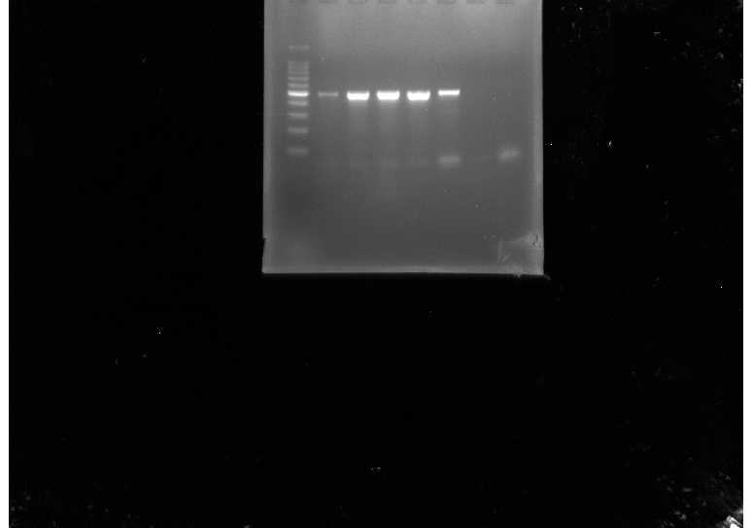
M 1 2 3 4 T+ T-
Its gene (590 bp)

Fig. 5. Electrophoretic profile of the ITS gene in Fungal amplification product on a 2% agarose gel
Lane 1, 2, 3 and 4 : positive sample for Fungal ; M= 100 bp molecular marker; positive test strains; T⁺ positive control; T⁻: negative control

4. Conclusion

This research on the fungal of the frog H. occipitalis in Côte d'Ivoire is, to our knowledge, the first data on these amphibians. The overall contamination rate was 61.7%. The skin of frogs harbors fungal species such as Aspergillus niger, Aspergillus terreus, Aspergilus fumigatus, Rhizopus sp. and Mucor sp. which are all pathogenic and this would constitute a public health problem. This study only examined the prevalence of fungi. Furthermore, future research should further examine the production of toxins in these strains isolated from frogs.

References

Adebayo-Tayo, B., Folahanmi, A., Olubusola, O., & Kayode, O. (2015). Mycoflora, Mycotoxin contamination and proximate mineral composition of smoke-dried frog (Aubria sp.) (Konko) sold in Ibadan, Oyo State, Nigeria. Turkish Journal of Agriculture - Food Science and Technology, 3(11), 894-903.
Ahoussi, E. K., Keumean, N. K., Kouassi, M. A., & Kof, B.Y. (2018). Study of the hydrogeochemical and microbiological characteristics of drinking water in the peri-urban area of ​​the city of Man: case of the village of Kpangouin (Côte d’Ivoire). International Journal Biological Chemistry Science, 11(6), 3018-3033.
Andreza, D.S.P., Daniel D.S.G., Vanessa, D.S.B., Nathan, S.D.S., Eveleise, S.M.C., & Ricardo, A.K.R. (2020). Fungal community on skin tissue of amphibians collected in the Santarém region, Pará, Brazil. Brazilian Journal of Development, 6(10), 82336-82356.
Ashraf, A.T., Fatma, I.H., Eman, M.M., & Marwa, R.H. (2020). Isolation and Molecular Identification of Aspergillus species from Cultured Nile Tilapia (Oreochromis niloticus). Benha Veterinary Medical Journal, 38(2), 136-140.
Ble, Y.C., Atobla, K., Bohoussou, K.H., & Adjehi, D. (2021). Detection of act and alt Enterotoxin genes in Aeromonas strains isolated from Hoplobatrachus occipitalis frogs intended for human consumption in Côte d'Ivoire. American Journal of Microbiological Research, 9(2), 50-53.
Ble, Y.C., Zouh-Bi, Z.F., Kouadio, K.N., & Dadie, A. (2022). Gears and Modes of Exploitation of Edible Frogs in the Peri-Urban Localities of Man, Côte d'Ivoire. Asian Research Journal of Agriculture, 15(4), 238-244.
Bletz, M. C., Perl, R. B., & Vences, M. (2017). Skin microbiota differs drastically between co occurring frogs and newts. Royal Society Open Science, 4(4),1-15. http://dx.doi.org/10.1098/rsos.170107
Codjo, L., Attakpa, E. Y., Boko, C. K., Fayalo, S. S., Tohozin, R., Pelebe, E.O.R., & Toko, I.I. (2022). Bacteria pathogens of the edible frog Hoplobatrachus occipitalis (Gunther, 1858) in the hydrographic basins of Benin. Microbiology Research International,10(1),1-9. http://dx.doi.org/10.30918/MRI.101.21.021
Coulibaly, N.D., & Zigui, B. (2021). Exploitation and threat traits of frogs of socio-economic interest in the Ganzourgou province of Burkina Faso, West Africa. International Journal of Biological and Chemical Sciences, 15(3), 1090-1103. https://doi.org/10.4314/ijbcs.v15i3.19
Culp, C.E., Falkinham, J.O., & Belden, L.K. (2007). Identification of the natural bacterial microflora on the skin of eastern newts, bullfrog tadpoles and redback salamanders. Herpetologica, 63(1), 66-71.
Dadié, A., Blé, Y.C., Kouadi, N.N., Fantodji, A., & Koffi, M.D. (2017) .Prevalence, serotype and presence of invasion gene in Salmonella isolated from frog meat obtained from western region of Côte d’Ivoire. International Journal of Applied Microbiology and Biotechnology Research, 5(2), 75-81.
Douglas, S.I., & Amuzie, C.C. (2017). Microbiological Quality of Hoplobatrachus occipitalis (Amphibia, Anura) Used as Meat. International Journal of Current Microbiology and Applied Sciences, 6(6), 3192-3200. https://doi.org/10.20546/ijcmas.2017.606.376
Falvey, D. G., & Streifel, A. J. (2007). Ten-year air sample analysis of Aspergillus prevalence in a university hospital. Journal of Hospital Infection, 67(1), 35-41.
Fatima, A., Fareeha, I., Amina, A, Rufsha, S.C., Shahbaz, A., Rabia, R., Maryam, S., Ghulam, Q., Nimra, K., Faiqa, Z., Mudasar, H., Sehresh, G., Mohsin, M., & Waqas, A. (2025). Isolation and identification of fungal species from the skin of Bull frog (Hoplobatrachus tigerinus): prevalence and ecological implications. Journal of Wildlife and Biodiversity, 9(1), 123-135. https://doi.org/10.5281/zenodo.14634885
Foba, F.S.I., Coulibaly, I., Kra, K.A., Kouassi, K.C., & Konate, I. (2023). Isolation and Identification of Fungal Strains from Fresh and Smoked Fish from the Sassandra River in Côte d’Ivoire. Biotechnology Journal International, 27(3), 1-7.
Hamoumi, E. R. & Himmi, O. (2010). Distribution and inventory of amphibian populations in the wetland complex of lower Loukkos (Larache, Morocco). Bulletin de l’Institut Scientifique, 32 (2), 95-100.
Hissein, O.A., Abdelsalam, T., Adama, S., Bakary, T., Lawane, I.A., Hama, C., Traore, Y., & Savadogo, Aly. (2019). Isolation and characterization of fungal strains from fish / dried fish from lake fitri to Chad. American Journal of Innovative Research and Applied Sciences, 2(4), 155-160.
Imane, K., & Mouhamed, S. (2012). Isolation of some fungi that pollute the irrigation water of the Faculty of Agriculture of the University of Baghdad, Iraqi Journal of Agricultural Science, 43(2), 76-84.
Kim, S., Ahn-Heum, E., Daesik, P., & Nam-Yong, R. (2008). Detection of Infectious Fungal Diseases of Frogs Inhabiting in Korea. Mycobiology, 36 (1), 10-12.
Kueneman, J.G., Parfrey, L.W., Woodhams, D.C., Archer, H.M., Knight, R., & Mckenzie, V. J. (2014). The amphibian skin‐associated microbiome across species, space and life history stages. Molecular Ecology, 23(6), 1238-1250.
Manonmani, H.K., Anand, S., Chandrashekar, A., & Rati, E.R. (2005). Detection of aflatoxigenic fungi in selected food commodities by PCR. Process Biochemistry, 40, 2859-2864.
Oungbe, K.V., Jean-Yves, G., · & N’douba, V. (2023). Specific Diversity of Helminth Parasites of the Edible Frog Hoplobatrachus occipitalis (Günther, 1858) in Agricultural Landscapes in the South-East of Ivory Coast, Africa. Acta Parasitologica, 1-8. https://doi.org/10.1007/s11686-023-00674-1
Rodrigues, E., Seixas Filho, J.T., Mello, S.C.R.P., Castagna, A.A., Marcos, A. S., & Silva, U.P. (2014). Frog meat microbiota (Lithobates catesbeianus) used in infant food. Food Sci. Technol, Campinas, 34(1), 51-54.
Sudharsan, S., Malka, B., Varda, Z., Moshe, K., Anatoly, T., Elazar, Q., & Edward, S. (2017). Rapid Détection and Identification of Mycotoxigenic Fungi and Mycotoxins in Stored Wheat. Grain. Toxins, 9, 302-317. https://doi.org/10.3390/toxins9100302
Tohé, B., Kouamé, N. G., Assemian, N. E., Gourène, G., & Rödel, M. O. (2014). Dietary Strategies of the Giant Swamp Frog Hoplobatrachus occipitalis in Degraded areas of Banco National Park (Ivory Coast). International Journal of Scientific Research and Reviews, 3 (2), 34-46.
Waqas, A., Arshad, J., Ali, H., & Syed, M.B. (2018). Diversity and habitat preferences of amphibians and reptiles in Pakistan: a review. Journal of Asia-Pacific Biodiversity, 11, 173-187. https://doi.org/10.1016/j.japb.2018.01.009
Zhang Y.J., Zhang S., Liu X.Z., Wen H.A., & Wang M. 2010. A simple method of genomic DNA extraction suitable for analysis of bulk fungal strains. Lett Appl Microbiol, 51, 114-118.

