Vegetative and floral characters of different strawberry cultivars growing in low polytunnels under Shivalik foothills

# ABSTRACT

The present investigation was carried out on fifteen genotypes of strawberry (*Fragaria × ananassa* Duch.) to ascertain the extent of variability present in the material and association among different traits. On the basis of results it is concluded that ‘Sweet Sensation’ had the highest plant height (48.57 cm), plant spread (20.66 cm) and flower size (2.86 cm). ‘Shimla Delicious’ recorded maximum leaf area (177.72 cm2) and Fern recorded maximum number of runners (15.03) and days of runner formation (207.73 days). However, petal length (1.18 cm) was recorded highest in Elyana and highest petal breadth was recorded in Chandler (1.09 cm). The highest number of stamens was observed in Florida Beauty (25.88) and maximum number of sepals were recorded in Sweet Charlie (13.15).

# INTRODUCTION

The cultivated strawberry (*Fragaria* ***×*** *ananassa* Duch.) is the most intriguing, delectable, and refreshing fruit in the Rosaceae family. *Fragaria virginiana* and *Fragaria chiloensis*, two wild strawberries, were crossed to create the cultivated strawberry. It is a perennial herbaceous plant that may be grown economically in a range of climates, from temperate to tropical. Due to its genetic diversity, high degree of heterozygosity and wide range of environmental adaptation, it is one of the most commonly grown fruit crop. The strawberry plants have fibrous roots and a crown from which basal leaves grow. The leaves are complex, with three saw toothed and hairy leaflets. Flowers are borne in small clusters on slender stalks that arise from the axils of the leaves, similar to surface-creeping stems, and are normally white but can be crimson. An older plant's root system becomes woody and the "mother" crown sends out runners that touch the ground and root, allowing the plant to grow vegetatively. Botanists classify the strawberry fruit as a “accessory fruit” rather than a true berry.

The strawberry cultivation has now extended in regions that are characteristically temperate to sub-tropical plains to high altitudes in tropical regions and even in the desert-like areas of Israel. Being a shallow rooted crop, both crop damage and plant mortality can occur during dry seasons. Strawberry cultivation recently received some impetus in India with large business houses setting up a number of agro-based establishments primarily aimed at large

scale production of strawberry fruits. This herbaceous annual fruit crop can also be grown easily in kitchen gardens as well as on roof-top gardens and pots. It is regarded as a valuable food in the diet of millions of people around the globe and is in special demand by the fruit processing industries for preparing jams, ice cream, candy, toffee, and other products. A number of potential, high yielding cultivars such as Selva, Addie, Etna, Sweet Charlie, Douglas, Fern, Chandler, Camarosa, Florida Beauty, Elyana, Winter Dawn, Sweet Sensation and Sweet Ann have been introduced into India from Europe and North America. Farmers in the vicinity of Delhi and in the states of Haryana, Punjab, Maharashtra, Karnataka, Uttar Pradesh, Jharkhand and Chhattisgarh are profitably cultivating strawberries during the winter months, obtaining their planting materials from the hills of Himachal Pradesh and Uttarakhand. Besides the income from strawberry fruits, growers in the hills, thus, can also earn by producing planting material for winter plantings in subtropical areas.

# MATERIAL AND METHOD

The present investigation entitled was carried out at the Experimental Farm of Regional Horticultural Research and Training Station, Dhaulakuan (Sirmaur), Dr. Yashwant Singh Parmar University of Horticulture and Forestry, Nauni, Solan, Himachal Pradesh, during the years 2022-2023 and 2023-2024.

The height of plants was measured with a measuring scale from the crown level to the apex of primary leaves and the trait was expressed in centimeters (cm). Plant spread was measured in both the directions i.e. East-West (E-W) and North- South (N-S) and the mean was taken as the actual plant spread. The plant spread was expressed in centimeters (cm). The leaf area of different strawberry cultivars was recorded with the help of the leaf area meter (LI- COR 3000) and the values were expressed as average leaf area per leaf in square centimeters (cm2). The number of runner that each cultivar produced was counted before uprooting the plant for fresh plantation. The days to runner formation was recorded from day of planting to the day of first runner formation. The flower size was recorded by measuring the distance across the tips of two opposite petals. Petal length was determined with the help of measuring scale from the base to the distal end and the trait was expressed in centimeters (cm). The period between the dates of planting to the date of first flower opening in each cultivar was recorded for calculating the days taken to flowering. The date of opening of first flower and the date of opening of last flower in each cultivar was recorded to estimate the duration of flowering period.

# RESULTS AND DISCUSSIONS

The scope of improvement of any crop depends upon the magnitude of genetic variability present in the available germplasm. Greater the variability in the available germplasm, better would be the chances of selecting superior genotypes (Simmonds, 1962).

**VEGETATIVE CHARACTERISTICS**

Results pertaining to vegetative characteristics are presented in Table-1. Plant height observed significant variation ranging from 16.06 cm in Etna to 48.57 cm in Sweet Sensation. The significant variation in plant height among different strawberry cultivars can be attributed to the genetic variation and their positive/ negative correlation with soil and prevailing environment which may have influenced the plant growth characteristics (Li et al. 1993). Cultivar Sweet Sensation recorded highest plant spread 20.66 cm and lowest was recorded in cultivar Sweet Charlie 10.45 cm. The variation in plant spread of different cultivars may be attributed to the genetic makeup coupled with agro- climatic conditions. The findings are in close agreement with Flanagan et al. (2020) who evaluated thirteen strawberry cultivars in Coastal Virginia and observed that Sweet Charlie had maximum (22.7 cm) canopy diameter. Gu et al. (2017) evaluated strawberry cultivars under high-tunnel and organic management in North Carolina and observed variation in varietal response. The maximum leaf area presented in Table 2 was observed in cultivar Shimla Delicious (177.72 cm2) followed by Addie (172.36 cm2) and minimum was observed in Chandler (111.49 cm2). Different cultivars of strawberries have different genetic potential for leaf size and number. Some are naturally bred for more vigorous vegetative growth which include larger leaf area. It is overall a combination of genetics and local growing conditions. The differences in leaf characters indicated that different strawberry germplasm are not same and the trait may be genetically controlled. Similar observations have been recorded in different strawberry cultivars at Ludhiana, (Punjab) conditions (Kaur et al. 2017). Number of runners was recorded highest in Fern (15.03) and lowest was recorded in Sweet Ann which was at par with Sweet Sensation (8.05). Similar trend was observed in number of days of runner formation after planting Fern observed maximum (207.73) and minimum in Winter Dawn (164.98). The differences in runner production per plant may be due to the differences in the genotypic makeup of different strawberry cultivars and prevailing agro-climatic conditions. The poor runner formation in some cultivars like Sweet Ann, Sweet Sensation may be due to the insufficient day length prevailing in winters of northern India (Smeets,1955 and Rao and Lal, 2010). Although cultivars have a threshold level

for leaf production, but variation may occur primarily due to management practices especially the soil nutrient status as well as the inbuilt capacity of the cultivar to produce runners.

**FLORAL CHARACTERISITCS**

Results pertaining to vegetative characteristics are presented in Table-3. The maximum flower size was observed in cultivar Sweet Sensation (2.86 cm) whereas minimum flower size was recorded in Camarosa (2.25 cm). The flower size seems to have increased in primary flowers due to the favourable environmental conditions such as increase in the temperature and sun light. With the initiation of secondary flowers, the flower size decreases in all the strawberry cultivars

**Table 1: Effect of growing conditions on the plant spread and plant height of strawberry cultivars**

|  |  |  |  |  |  |  |  |
| --- | --- | --- | --- | --- | --- | --- | --- |
| **Cultivar** | **Growing condition** | **Plant spread (cm)** | | | **Plant height (cm)** | | |
| **Open field** | **Polytunnel** | **Mean** | **Open field** | **Polytunnel** | **Mean** |
| Addie | | 11.20 | 11.23 | 11.21 | 17.52 | 18.54 | 18.03 |
| Camarosa | | 18.54 | 19.31 | 18.92 | 38.86 | 41.91 | 40.38 |
| Chandler | | 13.34 | 12.96 | 13.15 | 17.52 | 18.03 | 17.78 |
| Doughlas | | 11.05 | 11.81 | 11.43 | 16.13 | 16.13 | 16.13 |
| Elyana | | 10.77 | 11.18 | 10.97 | 40.13 | 41.53 | 40.83 |
| Etna | | 10.80 | 10.54 | 10.67 | 15.37 | 16.76 | 16.06 |
| Fern | | 10.92 | 11.43 | 11.18 | 16.89 | 16.89 | 16.89 |
| Florida Beauty | | 10.80 | 10.69 | 10.74 | 29.59 | 31.62 | 30.61 |
| Jutogh Special | | 10.42 | 10.94 | 10.68 | 27.30 | 29.84 | 28.57 |
| Selva | | 10.80 | 10.65 | 10.72 | 17.40 | 21.08 | 19.24 |
| Shimla Delicious | | 10.54 | 10.85 | 10.70 | 24.13 | 27.81 | 25.97 |
| Sweet Ann | | 19.82 | 20.45 | 20.13 | 40.01 | 42.41 | 41.21 |
| Sweet Charlie | | 10.47 | 10.43 | 10.45 | 16.00 | 16.51 | 16.25 |
| Sweet Sensation | | 19.99 | 21.34 | 20.66 | 46.99 | 50.16 | 48.57 |
| Winter Dawn | | 18.97 | 19.56 | 19.26 | 41.66 | 42.54 | 42.10 |
| **Mean** | | 13.23 | 13.55 |  | 27.03 | 28.78 |  |
| **CD (0.05)** | **Cultivar**  **Growing condition**  **Cultivar × Growing condition** | |  | **1.81**  **4.96**  **7.02** |  |  | **0.46**  **1.27**  **1.80** |

The differences in flower size among different strawberry cultivars have been related to varietal characteristics (Negi et al. 2018). The perusal of data presented in Table-3. It was found that the petal length ranged from 1.18 cm to 0.78 cm and petal breadth ranged from 1.09 cm to 0.89 cm. The highest petal length was observed in cultivar Elyana, whereas, maximum petal breadth was observed in cultivar Chandler. Differences in petal length and breadth may

be related to genetic makeup of the cultivars. Chawla and Singh (2020) reported maximum petal length (0.88 cm) in cv. E1-13#32, followed by Camarosa (0.87 cm) and E1-13#31 (0.87 cm) (Negi et al. 2018). The cultivar Belrubi registered maximum (1.19 cm) petal length.

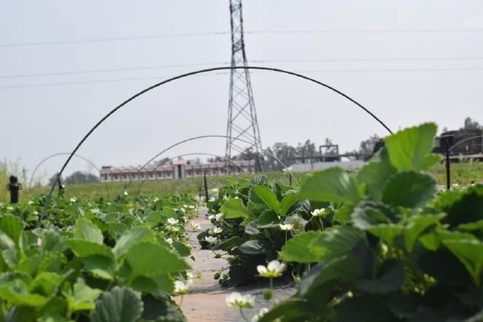

**Fig 1 : Vegetative and floral growth in cultivar Shimla Delicious**

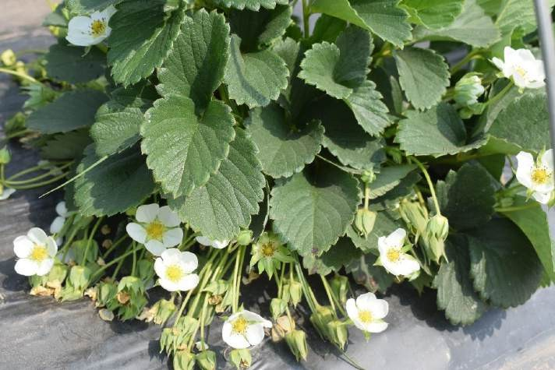

**Fig 2 : Flowering in cultivar Sweet Sensation**

**Table 2: Effect of growing conditions on the leaf characteristics of strawberry cultivars**

|  |  |  |  |  |  |  |  |  |  |
| --- | --- | --- | --- | --- | --- | --- | --- | --- | --- |
| **Growing condition**  **Cultivar** | **Leaf Area (cm2)** | | | **Number of runners per plant** | | | **Days of runner formation after planting** | | |
| **Open field** | **Polytunnel** | **Mean** | **Open field** | **Polytunnel** | **Mean** | **Open field** | **Polytunnel** | **Mean** |
| Addie | 170.81 | 173.91 | 172.36 | 12.50 | 15.30 | 13.90 | 195.80 | 187.30 | 191.55 |
| Camarosa | 152.71 | 166.65 | 159.68 | 9.80 | 10.30 | 10.05 | 173.60 | 171.00 | 172.30 |
| Chandler | 111.85 | 111.14 | 111.49 | 10.80 | 11.15 | 10.98 | 181.30 | 177.30 | 179.30 |
| Doughlas | 148.67 | 149.21 | 148.94 | 10.30 | 15.50 | 12.90 | 194.00 | 191.30 | 192.65 |
| Elyana | 135.55 | 138.97 | 137.26 | 9.50 | 11.45 | 10.48 | 170.95 | 170.80 | 170.88 |
| Etna | 153.67 | 159.81 | 156.74 | 8.95 | 12.30 | 10.63 | 192.60 | 187.60 | 190.10 |
| Fern | 158.65 | 157.34 | 157.99 | 13.10 | 16.95 | 15.03 | 210.30 | 205.15 | 207.73 |
| Florida Beauty | 119.83 | 118.02 | 118.92 | 10.10 | 10.80 | 10.45 | 190.15 | 182.45 | 186.30 |
| Jutogh Special | 170.90 | 169.95 | 170.43 | 11.65 | 14.65 | 13.15 | 202.45 | 193.30 | 197.88 |
| Selva | 141.70 | 141.39 | 141.54 | 10.80 | 13.15 | 11.98 | 206.80 | 190.30 | 198.55 |
| Shimla Delicious | 177.68 | 177.76 | 177.72 | 11.65 | 14.10 | 12.88 | 197.45 | 202.45 | 199.95 |
| Sweet Ann | 119.15 | 121.27 | 120.21 | 8.30 | 7.80 | 8.05 | 183.60 | 175.60 | 179.60 |
| Sweet Charlie | 146.64 | 145.28 | 145.96 | 11.65 | 14.30 | 12.98 | 182.30 | 175.45 | 178.88 |
| Sweet Sensation | 125.25 | 124.77 | 125.01 | 7.45 | 8.65 | 8.05 | 175.65 | 172.00 | 173.83 |
| Winter Dawn | 132.80 | 136.90 | 134.85 | 9.15 | 10.30 | 9.73 | 162.00 | 167.95 | 164.98 |
| **Mean** | 144.38 | 146.15 |  | 10.38 | 12.44 |  | 187.93 | 183.33 |  |
| **CD (0.05)** |  |  |  |  |  |  |  |  |  |
| **Cultivar** |  |  | **1.81** |  |  | **0.46** |  |  | **0.75** |
| **Growing condition** |  |  | **4.96** |  |  | **1.27** |  |  | **1.46** |
| **Cultivar× Growing condition** |  |  | **7.02** |  |  | **1.80** |  |  | **2.93** |

**Table 3: Effect of growing conditions on the flower size and petal size of strawberry cultivars**

|  |  |  |  |  |  |  |  |  |  |  |
| --- | --- | --- | --- | --- | --- | --- | --- | --- | --- | --- |
| **Cultivar** | **Growing condition** | **Flower Size (cm)** | | | **Petal length (cm)** | | | **Petal breadth (cm)** | | |
| **Open field** | **Polytunnel** | **Mean** | **Open field** | **Polytunnel** | **Mean** | **Open field** | **Polytunnel** | **Mean** |
| Addie | | 2.51 | 2.58 | 2.54 | 0.88 | 0.91 | 0.90 | 0.91 | 0.93 | 0.92 |
| Camarosa | | 2.25 | 2.24 | 2.25 | 1.09 | 1.03 | 1.06 | 0.90 | 0.90 | 0.90 |
| Chandler | | 2.29 | 2.25 | 2.27 | 0.91 | 0.88 | 0.90 | 1.09 | 1.09 | 1.09 |
| Doughlas | | 2.58 | 2.55 | 2.57 | 0.78 | 0.81 | 0.80 | 1.01 | 1.03 | 1.02 |
| Elyana | | 2.78 | 2.80 | 2.79 | 1.20 | 1.16 | 1.18 | 0.94 | 0.94 | 0.94 |
| Etna | | 2.82 | 2.78 | 2.80 | 1.11 | 1.07 | 1.09 | 1.00 | 1.01 | 1.00 |
| Fern | | 2.69 | 2.72 | 2.70 | 1.15 | 1.08 | 1.12 | 0.94 | 0.95 | 0.94 |
| Florida Beauty | | 2.74 | 2.79 | 2.77 | 1.07 | 1.02 | 1.05 | 0.90 | 0.91 | 0.90 |
| Jutogh Special | | 2.70 | 2.73 | 2.71 | 1.08 | 1.11 | 1.10 | 1.05 | 1.06 | 1.05 |
| Selva | | 2.58 | 2.64 | 2.61 | 1.15 | 1.10 | 1.13 | 0.88 | 0.90 | 0.89 |
| Shimla Delicious | | 2.65 | 2.67 | 2.66 | 1.04 | 0.98 | 1.01 | 1.03 | 1.04 | 1.03 |
| Sweet Ann | | 2.75 | 2.83 | 2.79 | 0.95 | 0.91 | 0.93 | 0.93 | 0.94 | 0.93 |
| Sweet Charlie | | 2.78 | 2.80 | 2.79 | 0.98 | 0.96 | 0.97 | 1.00 | 1.01 | 1.00 |
| Sweet Sensation | | 2.88 | 2.84 | 2.86 | 1.01 | 1.06 | 1.04 | 0.96 | 0.97 | 0.97 |
| Winter Dawn | | 2.76 | 2.36 | 2.56 | 0.86 | 0.94 | 0.91 | 0.95 | 0.97 | 0.96 |
| **Mean** | | 2.65 | 2.64 |  | 1.01 | 1.00 |  | 0.96 | 0.97 |  |
| **CD (0.05)** | **Cultivar**  **Growing condition**  **Cultivar × Growing condition** | |  | **0.07**  **0.02**  **0.03** |  |  | **0.03**  **0.04**  **0.03** |  |  | **0.05**  **0.01**  **0.02** |

plate 1 : Variation in flower size in different strawberry cultivars

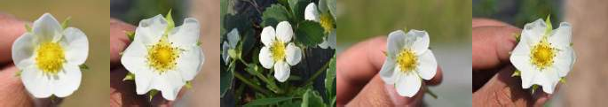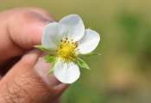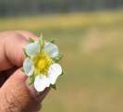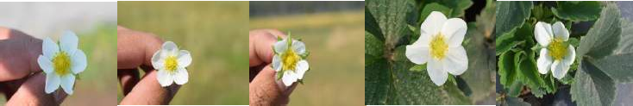

**Sweet Ann**

**Sweet Sensation**

**Elyana**

**Selva**

**Fern**

**Sweet Charlie**

**Douglas Camarosa Winter Dawn Florida Beauty Shimla Delicious Jutogh Special**

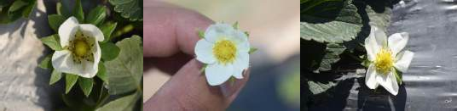

**Chandler Etna Addie**

Number of stamens presented in Table- 4 ranged from highest (25.88) in cultivar Florida Beauty to lowest (21.15) in Camarosa. This attribute may be directly associated with the varietal characters. Difference among number of stamens of different strawberry cultivars may be due to the progeny difference. The increase in number of stamens may increase with in time periods because of the change in agro-climatic condition such as increase in day length and sun light (Bradford et al. 2010). The number of sepals ranged from 13.15 to 9.15, the highest being recorded in cultivar Sweet Charlie and lowest in cultivar Fern. The number of sepals increased with favourable environmental conditions such as increase in temperature and sun light for primary flower growth and it decreases with the initiation of secondary flower.

**Table 4: Effect of growing conditions on number of stamens and sepals of strawberry cultivars**

|  |  |  |  |  |  |  |
| --- | --- | --- | --- | --- | --- | --- |
| **Growing condition**  **Cultivar** | **Number of stamens** | | | **Number of sepals** | | |
| **Open field** | **Polytunnel** | **Mean** | **Open field** | **Polytunnel** | **Mean** |
| Addie | 22.50 | 22.65 | 22.58 | 11.65 | 11.80 | 11.73 |
| Camarosa | 21.50 | 20.80 | 21.15 | 11.15 | 11.50 | 11.33 |
| Chandler | 23.30 | 22.65 | 22.98 | 10.50 | 11.80 | 11.15 |
| Doughlas | 22.85 | 23.10 | 22.98 | 11.65 | 12.65 | 12.15 |
| Elyana | 22.85 | 21.80 | 22.33 | 10.80 | 10.70 | 10.75 |
| Etna | 21.50 | 21.95 | 21.73 | 11.50 | 12.50 | 12.00 |
| Fern | 22.30 | 22.80 | 22.55 | 8.80 | 9.50 | 9.15 |
| Florida Beauty | 24.80 | 26.95 | 25.88 | 10.80 | 10.95 | 10.88 |
| Jutogh Special | 24.00 | 23.30 | 23.65 | 9.00 | 9.80 | 9.40 |
| Selva | 23.65 | 22.65 | 23.15 | 9.65 | 10.10 | 9.88 |
| Shimla Delicious | 24.45 | 22.95 | 23.70 | 12.00 | 11.50 | 11.75 |
| Sweet Ann | 22.30 | 24.45 | 23.38 | 9.65 | 12.30 | 10.98 |
| Sweet Charlie | 21.70 | 22.65 | 22.18 | 12.65 | 13.65 | 13.15 |
| Sweet Sensation | 22.67 | 26.95 | 24.81 | 12.15 | 12.65 | 12.40 |
| Winter Dawn | 21.65 | 21.30 | 21.48 | 10.95 | 10.65 | 10.80 |
| **Mean** | 22.80 | 23.13 |  | 10.86 | 11.47 |  |
| **CD (0.05)**  **Cultivar 0.56 0.34**  **Growing condition 1.55 0.93**  **Cultivar × Growing condition 1.55 1.33** | | | | | | |

# CONCLUSION

From this study it was concluded that from all the 15 strawberry cultivars Sweet Sensation was found to be better and it was also found that cultivation of strawberry cultivars in low polytunnels was better in comparison to open sheet with vigorous growth of plant and higher in yield.

**DISCLAIMER**

Authors hereby declare that NO generative AI technologies such as Large Language Models (Chat GPT, COPIOLOT, etc) and text-to-image or editing of this manuscript.

**REFERENCES**

Bradford E, Hancock J E and Warner R M. 2010. Interactions of temperature and photoperiod determine expression of repeat flowering in strawberry. *Journal of the American Society for Horticultural Science*.135:102-107.

Chawla W and Singh S K. 2020. Evaluation of different strawberry genotypes for flower characters under Punjab conditions*. Journal of Pharmacognosy andPhytochemistry*.9(5):834-837.

Flanagan R D, Samtani J B, Manchester M A, Romelczyk S, Johnson C S, Lawrence W and Pattison J. 2020. On-farm Evaluation of Strawberry Cultivars in Coastal Virginia. *Horticulture Technology*.30(6):789-796.

Gu S, Guan W and Beck J E. 2017 Strawberry cultivar evaluation under high tunnel and organic management in North Carolina. *HortTechnology*.27:84-92.

Kaur A, Singh R and Singh H. 2017. Evaluation of strawberry cultivars for growth and yield characteristics in sub-tropical region of Punjab. *International Journal of Advanced Research*.5(3):257-264.

Li F. 1993. Fruit misshaping of strawberries: over-visiting. *Fruitteelt*.6(2):27-29.

Negi D, Sharma G, Thakur K, Singh D and Sajwan P. 2018. Pollination studies in Strawberry (*Fragaria x ananassa* Duch). *International Journal of Agriculture Sciences*.10(5):5227- 5230.

Rao V K and Lal B. 2010. Evaluation of promising strawberry genotypes under Garhwal Himalayan conditions*. Indian Journal of Horticulture*.67(4):470-474.

Simmonds NM. Variability in crop plants, its use and conservation. Botanical Review. 1962; 37:422-465.

Smeets L. 1955. Runner formation in strawberry plants in autumn and winter. *Euphytica*. 4(3): 240-244.