Vegetative and floral characteristics of different strawberry cultivars growing in low polytunnels under Shivalik foothills

# ABSTRACT

The present investigation was carried out on fifteen genotypes of strawberry (*Fragaria × ananassa* Duch.) to ascertain the extent of variability present in the material and the association among different traits. Based on results it is concluded that ‘Sweet Sensation’ had the highest plant height (48.57 cm), plant spread (20.66 cm), and flower size (2.86 cm). ‘Shimla Delicious’ recorded the maximum leaf area (177.72 cm2) and Fern recorded the maximum number of runners (15.03) and days of runner formation (207.73 days). However, the petal length (1.18 cm) was recorded highest in Elyana, and the highest petal breadth was recorded in Chandler (1.09 cm). The highest number of stamens was observed in Florida Beauty (25.88) and the maximum number of sepals was recorded in Sweet Charlie (13.15).

# INTRODUCTION

The cultivated strawberry (*Fragaria* ***×*** *ananassa* Duch.) is the most intriguing, delectable, and refreshing fruit in the Rosaceae family. *Fragaria virginiana* and *Fragaria chiloensis*, two wild strawberries, were crossed to create the cultivated strawberry. It is a perennial herbaceous plant that may be grown economically in a range of climates, from temperate to tropical (Khan et al. 2020). Due to its genetic diversity, high degree of heterozygosity, and wide range of environmental adaptation, it is one of the most commonly grown fruit crops (Khan et al. 2021). The strawberry plants have fibrous roots and a crown from which basal leaves grow. The leaves are complex, with three saw-toothed and hairy leaflets. Flowers are borne in small clusters on slender stalks that arise from the axils of the leaves, similar to surface-creeping stems, and are normally white but can be crimson. An older plant's root system becomes woody and the "mother" crown sends out runners that touch the ground and root, allowing the plant to grow vegetatively. Botanists classify the strawberry fruit as an “accessory fruit” rather than a true berry.

Strawberry cultivation has now extended in regions that are characteristically temperate to sub-tropical plains to high altitudes in tropical regions and even in the desert-like areas of Israel. Being a shallow-rooted crop, both crop damage and plant mortality can occur during dry seasons. Strawberry cultivation recently received some impetus in India with large business houses setting up several agro-based establishments primarily aimed at large

scale production of strawberry fruits. This herbaceous annual fruit crop can also be grown easily in kitchen gardens as well as in roof-top gardens and pots. It is regarded as a valuable food in the diet of millions of people around the globe and is in special demand by the fruit processing industries for preparing jams, ice cream, candy, toffee, and other products. Many potential, high-yielding cultivars such as Selva, Addie, Etna, Sweet Charlie, Douglas, Fern, Chandler, Camarosa, Florida Beauty, Elyana, Winter Dawn, Sweet Sensation, and Sweet Ann have been introduced into India from Europe and North America. Farmers in the vicinity of Delhi and the states of Haryana, Punjab, Maharashtra, Karnataka, Uttar Pradesh, Jharkhand, and Chhattisgarh are profitably cultivating strawberries during the winter months, obtaining their planting materials from the hills of Himachal Pradesh and Uttarakhand. Besides the income from strawberry fruits, growers in the hills, thus, can also earn by producing planting material for winter plantings in subtropical areas.

# MATERIAL AND METHOD

The present investigation was carried out at the Experimental Farm of Regional Horticultural Research and Training Station, Dhaulakuan (Sirmaur), Dr. Yashwant Singh Parmar University of Horticulture and Forestry, Nauni, Solan, Himachal Pradesh, during the years 2022-2023 and 2023-2024.

The height of plants was measured with a measuring scale from the crown level to the apex of primary leaves and the trait was expressed in centimeters (cm). Plant spread was measured in both directions i.e. East-West (E-W) and North-South (N-S) and the mean was taken as the actual plant spread. The plant spread was expressed in centimeters (cm). The leaf area of different strawberry cultivars was recorded with the help of the leaf area meter (LI-COR 3000) and the values was expressed as average leaf area per leaf in square centimeters (cm2). The number of runners that each cultivar produced was counted before uprooting the plant for fresh plantation. The days to runner formation were recorded from the day of planting to the day of the first runner formation. The flower size was recorded by measuring the distance across the tips of two opposite petals. Petal length was determined with the help of measuring scale from the base to the distal end and the trait was expressed in centimeters (cm). The period between the dates of planting to the date of the first flower opening in each cultivar was recorded for calculating the days taken to flowering. The date of opening of the first flower and the date of opening of the last flower in each cultivar was recorded to estimate the duration of the flowering period.

# RESULTS AND DISCUSSIONS

The scope of improvement of any crop depends upon the magnitude of genetic variability present in the available germplasm. The greater the variability in the available germplasm, the better would be the chances of selecting superior genotypes (Simmonds, 1962).

**VEGETATIVE CHARACTERISTICS**

Results about vegetative characteristics are presented in Table 1. Plant height observed significant variation ranging from 16.06 cm in Etna to 48.57 cm in Sweet Sensation. The significant variation in plant height among different strawberry cultivars can be attributed to the genetic variation and their positive/ negative correlation with soil and the prevailing environment which may have influenced the plant growth characteristics (Li et al. 1993). Cultivar Sweet Sensation recorded the highest plant spread 20.66 cm and lowest was recorded in cultivar Sweet Charlie 10.45 cm. The variation in plant spread of different cultivars may be attributed to the genetic makeup coupled with agro-climatic conditions. The findings are in close agreement with Flanagan et al. (2020) who evaluated thirteen strawberry cultivars in Coastal Virginia and observed that Sweet Charlie had a maximum (22.7 cm) canopy diameter. Gu et al. (2017) evaluated strawberry cultivars under high-tunnel and organic management in North Carolina and observed variation in varietal response. The maximum leaf area presented in Table 2 was observed in the cultivar Shimla Delicious (177.72 cm2) followed by Addie (172.36 cm2) and the minimum was observed in Chandler (111.49 cm2). Different cultivars of strawberries have different genetic potential for leaf size and number. Some are naturally bred for more vigorous vegetative growth which includes a larger leaf area. It is overall a combination of genetics and local growing conditions. The differences in leaf characters indicated that different strawberry germplasm are not the same and the trait may be genetically controlled. Similar observations have been recorded in different strawberry cultivars at Ludhiana, (Punjab) conditions (Kaur et al. 2017). The number of runners was recorded as highest in Fern (15.03) and lowest was recorded in Sweet Ann which was at par with Sweet Sensation (8.05). A similar trend was observed in the number of days of runner formation after planting Fern observed maximum (207.73) and minimum in Winter Dawn (164.98). The differences in runner production per plant may be due to the differences in the genotypic makeup of different strawberry cultivars and prevailing agro-climatic conditions. The poor runner formation in some cultivars like Sweet Ann, and Sweet Sensation may be due to the insufficient day length prevailing in winters of northern India (Smeets,1955 and Rao and Lal, 2010). Although cultivars have a threshold levelfor leaf production, but variation may occur primarily due to management practices especially the soil nutrient status as well as the inbuilt capacity of the cultivar to produce runners.

**FLORAL CHARACTERISTICS**

Results about vegetative characteristics are presented in Table 3. The maximum flower size was observed in the cultivar Sweet Sensation (2.86 cm) whereas the minimum flower size was recorded in Camarosa (2.25 cm). The flower size seems to have increased in primary flowers due to favorable environmental conditions such as the increase in the temperature and sunlight. With the initiation of secondary flowers, the flower size decreases in all the strawberry cultivars.

**Table 1: Effect of growing conditions on the plant spread and plant height of strawberry cultivars**

|  |  |  |  |  |  |  |  |
| --- | --- | --- | --- | --- | --- | --- | --- |
| **Cultivar** | **Growing condition** | **Plant spread (cm)** | | | **Plant height (cm)** | | |
| **Open field** | **Polytunnel** | **Mean** | **Open field** | **Polytunnel** | **Mean** |
| Addie | | 11.20 | 11.23 | 11.21 | 17.52 | 18.54 | 18.03 |
| Camarosa | | 18.54 | 19.31 | 18.92 | 38.86 | 41.91 | 40.38 |
| Chandler | | 13.34 | 12.96 | 13.15 | 17.52 | 18.03 | 17.78 |
| Doughlas | | 11.05 | 11.81 | 11.43 | 16.13 | 16.13 | 16.13 |
| Elyana | | 10.77 | 11.18 | 10.97 | 40.13 | 41.53 | 40.83 |
| Etna | | 10.80 | 10.54 | 10.67 | 15.37 | 16.76 | 16.06 |
| Fern | | 10.92 | 11.43 | 11.18 | 16.89 | 16.89 | 16.89 |
| Florida Beauty | | 10.80 | 10.69 | 10.74 | 29.59 | 31.62 | 30.61 |
| Jutogh Special | | 10.42 | 10.94 | 10.68 | 27.30 | 29.84 | 28.57 |
| Selva | | 10.80 | 10.65 | 10.72 | 17.40 | 21.08 | 19.24 |
| Shimla Delicious | | 10.54 | 10.85 | 10.70 | 24.13 | 27.81 | 25.97 |
| Sweet Ann | | 19.82 | 20.45 | 20.13 | 40.01 | 42.41 | 41.21 |
| Sweet Charlie | | 10.47 | 10.43 | 10.45 | 16.00 | 16.51 | 16.25 |
| Sweet Sensation | | 19.99 | 21.34 | 20.66 | 46.99 | 50.16 | 48.57 |
| Winter Dawn | | 18.97 | 19.56 | 19.26 | 41.66 | 42.54 | 42.10 |
| **Mean** | | 13.23 | 13.55 |  | 27.03 | 28.78 |  |
| **CD (0.05)** | **Cultivar**  **Growing condition**  **Cultivar × Growing condition** | |  | **1.81**  **4.96**  **7.02** |  |  | **0.46**  **1.27**  **1.80** |

The differences in flower size among different strawberry cultivars have been related to varietal characteristics (Negi et al. 2018). The perusal of data is presented in Table 3. It was found that the petal length ranged from 1.18 cm to 0.78 cm and petal breadth ranged from 1.09 cm to 0.89 cm. The highest petal length was observed in cultivar Elyana, whereas, maximum petal breadth was observed in cultivar Chandler. Differences in petal length and breadth may

be related to the genetic makeup of the cultivars. Chawla and Singh (2020) reported maximum petal length (0.88 cm) in cv. E1-13#32, followed by Camarosa (0.87 cm) and E1-13#31 (0.87 cm) (Negi et al. 2018). The cultivar Belrubi registered a maximum (1.19 cm) petal length.

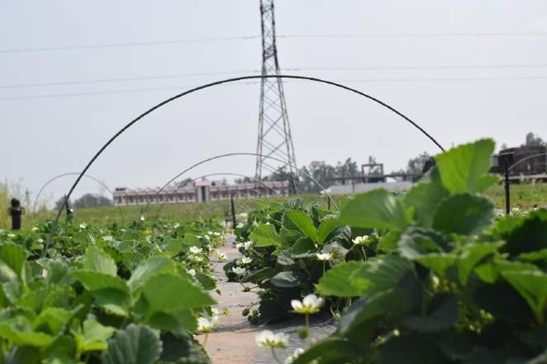

**Fig 1: Vegetative and floral growth in cultivar Shimla Delicious**

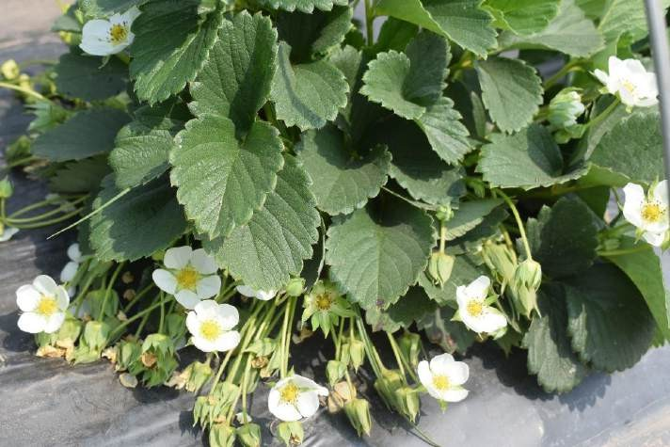

**Fig 2: Flowering in cultivar Sweet Sensation**

**Table 2: Effect of growing conditions on the leaf characteristics of strawberry cultivars**

|  |  |  |  |  |  |  |  |  |  |
| --- | --- | --- | --- | --- | --- | --- | --- | --- | --- |
| **Growing condition**  **Cultivar** | **Leaf Area (cm2)** | | | **Number of runners per plant** | | | **Days of runner formation after planting** | | |
| **Open field** | **Polytunnel** | **Mean** | **Open field** | **Polytunnel** | **Mean** | **Open field** | **Polytunnel** | **Mean** |
| Addie | 170.81 | 173.91 | 172.36 | 12.50 | 15.30 | 13.90 | 195.80 | 187.30 | 191.55 |
| Camarosa | 152.71 | 166.65 | 159.68 | 9.80 | 10.30 | 10.05 | 173.60 | 171.00 | 172.30 |
| Chandler | 111.85 | 111.14 | 111.49 | 10.80 | 11.15 | 10.98 | 181.30 | 177.30 | 179.30 |
| Doughlas | 148.67 | 149.21 | 148.94 | 10.30 | 15.50 | 12.90 | 194.00 | 191.30 | 192.65 |
| Elyana | 135.55 | 138.97 | 137.26 | 9.50 | 11.45 | 10.48 | 170.95 | 170.80 | 170.88 |
| Etna | 153.67 | 159.81 | 156.74 | 8.95 | 12.30 | 10.63 | 192.60 | 187.60 | 190.10 |
| Fern | 158.65 | 157.34 | 157.99 | 13.10 | 16.95 | 15.03 | 210.30 | 205.15 | 207.73 |
| Florida Beauty | 119.83 | 118.02 | 118.92 | 10.10 | 10.80 | 10.45 | 190.15 | 182.45 | 186.30 |
| Jutogh Special | 170.90 | 169.95 | 170.43 | 11.65 | 14.65 | 13.15 | 202.45 | 193.30 | 197.88 |
| Selva | 141.70 | 141.39 | 141.54 | 10.80 | 13.15 | 11.98 | 206.80 | 190.30 | 198.55 |
| Shimla Delicious | 177.68 | 177.76 | 177.72 | 11.65 | 14.10 | 12.88 | 197.45 | 202.45 | 199.95 |
| Sweet Ann | 119.15 | 121.27 | 120.21 | 8.30 | 7.80 | 8.05 | 183.60 | 175.60 | 179.60 |
| Sweet Charlie | 146.64 | 145.28 | 145.96 | 11.65 | 14.30 | 12.98 | 182.30 | 175.45 | 178.88 |
| Sweet Sensation | 125.25 | 124.77 | 125.01 | 7.45 | 8.65 | 8.05 | 175.65 | 172.00 | 173.83 |
| Winter Dawn | 132.80 | 136.90 | 134.85 | 9.15 | 10.30 | 9.73 | 162.00 | 167.95 | 164.98 |
| **Mean** | 144.38 | 146.15 |  | 10.38 | 12.44 |  | 187.93 | 183.33 |  |
| **CD (0.05)** |  |  |  |  |  |  |  |  |  |
| **Cultivar** |  |  | **1.81** |  |  | **0.46** |  |  | **0.75** |
| **Growing condition** |  |  | **4.96** |  |  | **1.27** |  |  | **1.46** |
| **Cultivar× Growing condition** |  |  | **7.02** |  |  | **1.80** |  |  | **2.93** |

**Table 3: Effect of growing conditions on the flower size and petal size of strawberry cultivars**

|  |  |  |  |  |  |  |  |  |  |  |
| --- | --- | --- | --- | --- | --- | --- | --- | --- | --- | --- |
| **Cultivar** | **Growing condition** | **Flower Size (cm)** | | | **Petal length (cm)** | | | **Petal breadth (cm)** | | |
| **Open field** | **Polytunnel** | **Mean** | **Open field** | **Polytunnel** | **Mean** | **Open field** | **Polytunnel** | **Mean** |
| Addie | | 2.51 | 2.58 | 2.54 | 0.88 | 0.91 | 0.90 | 0.91 | 0.93 | 0.92 |
| Camarosa | | 2.25 | 2.24 | 2.25 | 1.09 | 1.03 | 1.06 | 0.90 | 0.90 | 0.90 |
| Chandler | | 2.29 | 2.25 | 2.27 | 0.91 | 0.88 | 0.90 | 1.09 | 1.09 | 1.09 |
| Doughlas | | 2.58 | 2.55 | 2.57 | 0.78 | 0.81 | 0.80 | 1.01 | 1.03 | 1.02 |
| Elyana | | 2.78 | 2.80 | 2.79 | 1.20 | 1.16 | 1.18 | 0.94 | 0.94 | 0.94 |
| Etna | | 2.82 | 2.78 | 2.80 | 1.11 | 1.07 | 1.09 | 1.00 | 1.01 | 1.00 |
| Fern | | 2.69 | 2.72 | 2.70 | 1.15 | 1.08 | 1.12 | 0.94 | 0.95 | 0.94 |
| Florida Beauty | | 2.74 | 2.79 | 2.77 | 1.07 | 1.02 | 1.05 | 0.90 | 0.91 | 0.90 |
| Jutogh Special | | 2.70 | 2.73 | 2.71 | 1.08 | 1.11 | 1.10 | 1.05 | 1.06 | 1.05 |
| Selva | | 2.58 | 2.64 | 2.61 | 1.15 | 1.10 | 1.13 | 0.88 | 0.90 | 0.89 |
| Shimla Delicious | | 2.65 | 2.67 | 2.66 | 1.04 | 0.98 | 1.01 | 1.03 | 1.04 | 1.03 |
| Sweet Ann | | 2.75 | 2.83 | 2.79 | 0.95 | 0.91 | 0.93 | 0.93 | 0.94 | 0.93 |
| Sweet Charlie | | 2.78 | 2.80 | 2.79 | 0.98 | 0.96 | 0.97 | 1.00 | 1.01 | 1.00 |
| Sweet Sensation | | 2.88 | 2.84 | 2.86 | 1.01 | 1.06 | 1.04 | 0.96 | 0.97 | 0.97 |
| Winter Dawn | | 2.76 | 2.36 | 2.56 | 0.86 | 0.94 | 0.91 | 0.95 | 0.97 | 0.96 |
| **Mean** | | 2.65 | 2.64 |  | 1.01 | 1.00 |  | 0.96 | 0.97 |  |
| **CD (0.05)** | **Cultivar**  **Growing condition**  **Cultivar × Growing condition** | |  | **0.07**  **0.02**  **0.03** |  |  | **0.03**  **0.04**  **0.03** |  |  | **0.05**  **0.01**  **0.02** |

plate 1: Variation in flower size in different strawberry cultivars

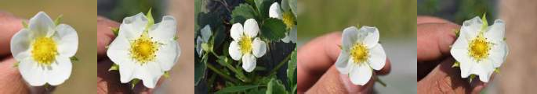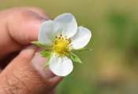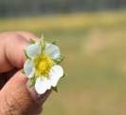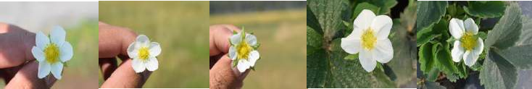

**Sweet Ann**

**Sweet Sensation**

**Elyana**

**Selva**

**Fern**

**Sweet Charlie**

**Douglas Camarosa Winter Dawn Florida Beauty Shimla Delicious Jutogh Special**

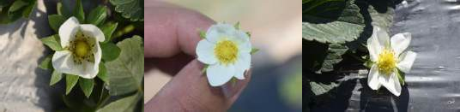

**Chandler Etna Addie**

The number of stamens presented in Table 4 ranged from the highest (25.88) in cultivar Florida Beauty to the lowest (21.15) in Camarosa. This attribute may be directly associated with the varietal characters. Differences among the number of stamens of different strawberry cultivars may be due to the progeny difference. The increase in number of stamens may increase within periods because of the change in the agro-climatic condition such as the increase in day length and sunlight (Bradford et al. 2010). The number of sepals ranged from 13.15 to 9.15, the highest being recorded in the cultivar Sweet Charlie and the lowest in the cultivar Fern. The number of sepals increased with favorable environmental conditions such as the increase in temperature and sunlight for primary flower growth and it decreased with the initiation of the secondary flower.

**Table 4: Effect of growing conditions on number of stamens and sepals of strawberry cultivars**

|  |  |  |  |  |  |  |
| --- | --- | --- | --- | --- | --- | --- |
| **Growing condition**  **Cultivar** | **Number of stamens** | | | **Number of sepals** | | |
| **Open field** | **Polytunnel** | **Mean** | **Open field** | **Polytunnel** | **Mean** |
| Addie | 22.50 | 22.65 | 22.58 | 11.65 | 11.80 | 11.73 |
| Camarosa | 21.50 | 20.80 | 21.15 | 11.15 | 11.50 | 11.33 |
| Chandler | 23.30 | 22.65 | 22.98 | 10.50 | 11.80 | 11.15 |
| Doughlas | 22.85 | 23.10 | 22.98 | 11.65 | 12.65 | 12.15 |
| Elyana | 22.85 | 21.80 | 22.33 | 10.80 | 10.70 | 10.75 |
| Etna | 21.50 | 21.95 | 21.73 | 11.50 | 12.50 | 12.00 |
| Fern | 22.30 | 22.80 | 22.55 | 8.80 | 9.50 | 9.15 |
| Florida Beauty | 24.80 | 26.95 | 25.88 | 10.80 | 10.95 | 10.88 |
| Jutogh Special | 24.00 | 23.30 | 23.65 | 9.00 | 9.80 | 9.40 |
| Selva | 23.65 | 22.65 | 23.15 | 9.65 | 10.10 | 9.88 |
| Shimla Delicious | 24.45 | 22.95 | 23.70 | 12.00 | 11.50 | 11.75 |
| Sweet Ann | 22.30 | 24.45 | 23.38 | 9.65 | 12.30 | 10.98 |
| Sweet Charlie | 21.70 | 22.65 | 22.18 | 12.65 | 13.65 | 13.15 |
| Sweet Sensation | 22.67 | 26.95 | 24.81 | 12.15 | 12.65 | 12.40 |
| Winter Dawn | 21.65 | 21.30 | 21.48 | 10.95 | 10.65 | 10.80 |
| **Mean** | 22.80 | 23.13 |  | 10.86 | 11.47 |  |
| **CD (0.05)**  **Cultivar 0.56 0.34**  **Growing condition 1.55 0.93**  **Cultivar × Growing condition 1.55 1.33** | | | | | | |

# CONCLUSION

From this study, it was concluded that from all the 15 strawberry cultivars Sweet Sensation was found to be better and it was also found that cultivation of strawberry cultivars in low polytunnels was better in comparison to open sheet with the vigorous growth of the plant and higher in yield.

**DISCLAIMER**

Authors hereby declare that NO generative AI technologies such as Large Language Models (Chat GPT, COPIOLOT, etc) and text-to-image or editing of this manuscript.

**REFERENCES**

Bradford E, Hancock J E and Warner R M. 2010. Interactions of temperature and photoperiod determine expression of repeat flowering in strawberry. *Journal of the American Society for Horticultural Science*.135:102-107.

Chawla W and Singh S K. 2020. Evaluation of different strawberry genotypes for flower characters under Punjab conditions*. Journal of Pharmacognosy andPhytochemistry*.9(5):834-837.

Flanagan R D, Samtani J B, Manchester M A, Romelczyk S, Johnson C S, Lawrence W and Pattison J. 2020. On-farm Evaluation of Strawberry Cultivars in Coastal Virginia. *Horticulture Technology*.30(6):789-796.

Gu S, Guan W and Beck J E. 2017 Strawberry cultivar evaluation under high tunnel and organic management in North Carolina. *HortTechnology*.27:84-92.

Kaur A, Singh R and Singh H. 2017. Evaluation of strawberry cultivars for growth and yield characteristics in sub-tropical region of Punjab. *International Journal of Advanced Research*.5(3):257-264.

Khan AU, Choudhury MAR, Tarapder SA, Maukeeb ARM, and Ema IJ. 2020. Status of Mango Fruit Infestation at Home Garden in Mymensingh, Bangladesh. *Current Research in Agriculture and Farming*. 1(4): 35-42. Doi: <http://dx.doi.org/10.18782/2582-7146.119>.

Khan AU, Ema IJ, Afsana AS and Khan AU. 2021. Home Garden and Women Participation: A Mini Review. *Current Research in Agriculture and Farming*. 2(4): 46-52. Doi: http://dx.doi.org/10.18782/2582-7146.152.

Li F. 1993. Fruit misshaping of strawberries: over-visiting. *Fruitteelt*.6(2):27-29.

Negi D, Sharma G, Thakur K, Singh D and Sajwan P. 2018. Pollination studies in Strawberry (*Fragaria x ananassa* Duch). *International Journal of Agriculture Sciences*.10(5):5227- 5230.

Rao V K and Lal B. 2010. Evaluation of promising strawberry genotypes under Garhwal Himalayan conditions*. Indian Journal of Horticulture*.67(4):470-474.

Simmonds NM. Variability in crop plants, its use and conservation. Botanical Review. 1962; 37:422-465.

Smeets L. 1955. Runner formation in strawberry plants in autumn and winter. *Euphytica*. 4(3): 240-244.