Minireview Article SEA BUCKTHORN: A REVIEW ON THE HIDDEN TREASURE OF THE
TEMPERATES

Abstract

Sea buckthorn (Hippophae rhamnoides L.) is one of the most common yet underutilized dioecious fruit crops of the temperate region. This plant is known as the gold mine of the cold deserts due to its exceptional winter hardiness and multiple uses. It is a potential functional food which is rich in nutritional and medicinal values and holds the potential to emerge as a future food cum medicinal crop. Traditionally, the crop is used as a folk medicine, fence, wind break, firewood and fodder. The fruits are rich in tannins, flavonoids, sterols, carotenoids, tocopherols and lipids. The cultivation of sea buckthorn is low demanding and it is seen growing wild in the valleys, riverbanks, slopes and mountains in the temperate regions. Though extensive research and developmental activities are progressing, commercial cultivation and popularization of sea buckthorn is still in the nascent stage. An enhancement in the production aspects of this crop can be a boon to the horticulture industry. [Add 1-2 sentences of Challenges of sea buckthorn cultivation with solutions to overcome]
Key words: sea buckthorn, cultivation, horticulture, production. [Add 1-2 more keywords related to paper]

Introduction
Sea buckthorn (Hippophae spp.) is a small temperate deciduous shrub which has been used as a source of folk medicine, fodder, firewood etc. by the people of temperate regions. It is native to Europe and Asia and is distributed throughout the temperate regions of China, Mongolia, Russia, Northern Europe, Canada and India. In India, it is distributed throughout the temperate tracts of Leh-Ladakh, Lahaul-Spiti valleys of Himachal Pradesh, Nathula in Sikkim, Chamoli and Badrinath regions of Uttarakhand and Arunachal Pradesh. The crop is known as the “gold mine of the cold deserts” due to its exceptional winter-hardy nature and multiple uses. The local names of the crop include Brahmaphal, Chharma, Chuk, Tare, Leh berry, Sea berry, Ladakh gold etc. The concept of food in the present-day world has witnessed a shift from survival, hunger satisfaction and malnutrition to food that promotes better health and well-being. Sea buckthorn being an under-

utilized fruit crop belonging to the Elaeagnaceae family, is identified as a potential future food with immense medicinal importance [1].
The basic chromosome number is twelve. The genus Hippophae is classified into six species namely, Hippophae tibetana, Hippophae rhamnoides, Hippophae gyantsensis, Hippophae salicifolia, Hippophae neurocarpa and Hippophae litangensis. Important cultivars include Shafa, Zafarani, Tozlayan, Oblepikha, Zyryanka, Indian Summer, Siberian Wonder etc. Reports stated that the species are known for their symbiotic association with the bacterium Frankia and their ability to fix nitrogen (180 kg nitrogen ha⁻¹ year⁻¹) [2].

Photo 1: Sea buckthorn

Botany, growth and development of sea buckthorn

Sea buckthorn is a small deciduous thorny shrub with 2–5 m height. It has smooth or often cracking bark which is brown in colour. The shrubs are thorny. Leaves are silver-greyish and linear or lanceolate in shape. The crop is dioecious in nature and the male inflorescence consists of 4-6 apetalous flowers. Pollen is released in large quantities when temperature reaches 6-10℃. The female inflorescence usually consists of one single apetalous flower with one ovary and one ovule. Flowers are tiny and yellowish in colour. Fruits are small yellowish-orange coloured berries with single seed. The fruits are non-climacteric and are borne on past-season growth.

Flower bud initiation occurs in the month of March, followed by flowering in April. Fruit-set starts by mid-August and the fruits become ready for harvest by September-October. [add 1-2 sentences related to growth and development aspect with references to make it paragraph]

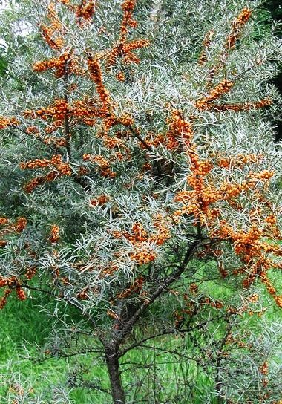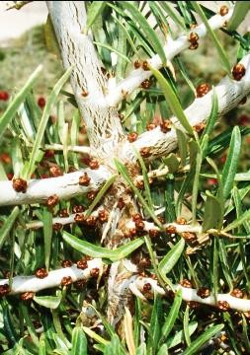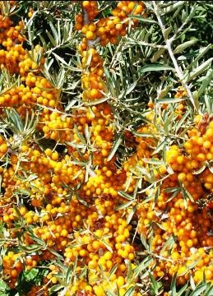

Photo 2- Sea buckthorn shrub
Photo 3 - Male plant Photo 4 -Female plant

Cultivation

Sea buckthorn is a low demanding shrub which can be seen growing wild in the mountain valleys, slopes, riverbanks etc. at an altitude 2000 m above mean sea level. An annual precipitation of 400-600 mm is beneficial for its growth. It grows well in sandy loam soils with a pH of 6-7 and can tolerate a temperature range of -40℃ to +40℃. However, the seedlings show scorching effect above 30℃ [3]. The crop cannot be brought to the tropical plains as it requires low temperature for flowering and fruit set. High humidity and water-logged conditions are not suitable for its growth. Sea buckthorn is mainly propagated by hardwood cuttings of pencil thickness. Other methods of propagation include seeds and suckers. Though the seeds can retain their viability upto three years, they usually germinate within 5-10 days depending upon the environmental conditions. Spring is the best time for planting sea buckthorn in the field. It has a pre-bearing period of three years [4]. The rooted cuttings are planted at a spacing of 3 x 1 m [5]. Being a dioecious crop, a male: female ratio of 1:8 is maintained while planting for getting better yield [6]. The crop responds well towards phosphorus application and micronutrient supplementation.
Moderate crown pruning is recommended annually before the flower bud initiation. Severe pruning affects the yield detrimentally as the fruits are borne on the past-season’s growth. The general approach of pruning varies with different climatic conditions, spacing and other factors. In Ladakh, pruning is done in the month of March before the shrubs start sprouting. Early-winter pruning is followed in three-year old branches to encourage rejuvenation and to prevent premature senescence in sea buckthorn [4]. Harvesting is done traditionally by beating the bush or cutting the branches and then threshing them when the green fruits turn soft, juicy and deep yellow-orange or red colour. [add the sub heading like soil, climatic requirement, spacing, pruning, harvesting etc

to discuss the cultivation]
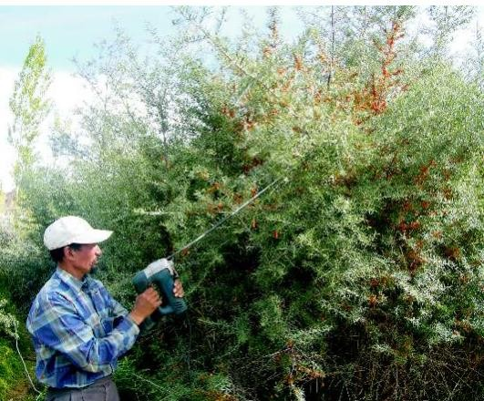
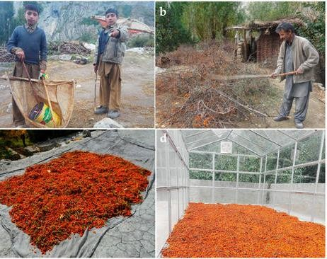

Photo 5 - Berry harvest using vibrators Photo 6 - Traditional harvest and primary
processing

Chemical composition

Sea buckthorn holds significant importance in both nutraceutical and pharmaceutical realms due to its natural ability to carry various beneficial compounds such as carotenoids and b- Lactoglobulin [7]. Additionally, key flavonoids found in sea buckthorn include isorhamnetin, quercetin, and kaempferol [8]. This fruit is an abundant reservoir of polyphenols and phytochemicals including tocopherols, carotenoids, and organic acids. Its berries are notably rich in antioxidants, vitamins, proteins, carbohydrates, amino acids, phytosterols, flavonoids, and essential elements like iron, calcium, and phosphorus. The exceptionally high concentrations of both hydrophilic antioxidants (flavonoids, tannins, phenolic acids, and ascorbic acid) and lipophilic antioxidants (primarily carotenoids and tocopherols) in sea buckthorn demonstrate its remarkable significance [9]. The juice of sea buckthorn is abundant in different free amino acids. Eighteen different types of free amino acids in Chinese sea buckthorn juice [10].

Table 1. Major phytochemical compounds in sea buckthorn [11,12]

Composition | Concentration in pulp oil (mg/100g)
Vitamin E | 171
Vitamin K | 54-59
Carotenoids | 300-870

Total acids | 38
Total sterols | 721
Vitamin C | 400

Table 2. Proximate chemical composition [4,13]

Sl.  No. | Parameter | Observation
1. | Moisture (%) | 83.94
2. | Energy (kcal/100g) | 62.9
3. | Total sugars (%) | 2.86
4. | Titrable acidity (%) | 2.64-4.54
5. | pH | 2.63-2.98
6. | TSS (%) | 10.15-14.80

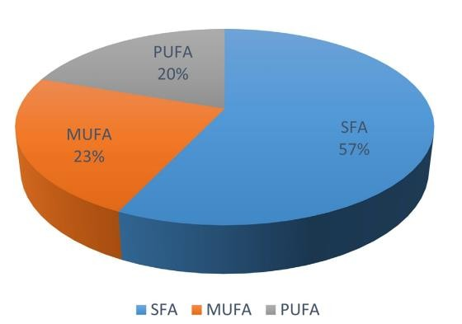

Fig 1: Chemical profiling of sea buckthorn oil

SFA: saturated fatty acids
MUFA: monounsaturated fatty acids PUFA: polyunsaturated fatty acids

Health benefits
Inhabitants of the cold deserts have been using different parts of sea buckthorn (fruit,

leaf, twig, roots and thorns) in traditional folk medicines. It has versatile neutraceutical and pharmaceutical importance. Hiporamin is a new phytochemical medicine that has been discovered through a comprehensive chemical examination of active fractions from sea buckthorn leaves. It possesses a broad range of antiviral and antibacterial activity. Findings by Patra et al., 2022 [14] proved the free radical scavenging nature of sea buckthorn extracts. According to Ma et al. (2022) [15], sea buckthorn polysaccharides exhibited positive effects on lipid metabolism in high fat diet mice by activating the brown adipose tissues. Nowak et al. (2022) [16] successfully demonstrated the antibacterial activity of sea buckthorn juice against a wide range of both gram positive and gram negative bacteria. According to Korkus et al. (2022) [17], sea buckthorn pulp containing 13.4-51.8% palmitoleic acid promoted glucose induced insulin secretion (GSIS) through Ca²⁺ mobilization and thereby helping in reducing the blood sugar levels. Balkrishna et al., in 2019 [18] studied the effect of sea buckthorn oil in modulation of psoriasis and associated inflammation in vitro and revealed that it inhibited the reactive nitrogen species and down regulated NF-κB protein, thereby healing the inflammations. Skalski et al. (2019) [19] reported that the isorhamnetin and its two derivatives isolated from the phenolic fraction of sea buckthorn berries had antioxidant, anti-platelet and anti-coagulant properties and were potential compounds for prevention and treatment of cardiovascular diseases. Gupta and Flora (2006) [20], reported that the fruit extracts of sea buckthorn played protective role against arsenic-induced oxidative injury. The protective role of sea buckthorn seed oil against lethalities caused by sulphur dioxide inhalation were also reported by Ruan et al. (2003) [21].
Using various animal models and clinical trials, the preventive and therapeutic benefits of sea buckthorn against wounds, burns, scalds, ulcers, and mucosal injuries have also been thoroughly studied [22]. Adaptogens are herbal compositions that can improve mental clarity, physical stamina, and the body's general stress tolerance [23]. Rats were used to test the adaptogenic potential of sea buckthorn leaf extract utilizing animal model [24]. The findings indicated that leaf extract supplementation decreased the oxidative stress in rats' liver and muscle.

Indian scenario
In India, sea buckthorn covers an area of about 13,000 ha. The yield is approximately 600 tonnes per year. But this is only less than 5% of the total sea buckthorn available in the country. In a study conducted by Stobdan and Phunchok (2017) [5], it was observed that 0.8% population of Ladakh (farmers, berry collectors and processors) was benefited from sea buckthorn industry.

Their net income increased from 0.2 crores in 2004 to 2.4 crores in 2015. They estimated that the projected income for the year 2030 would be 20 crores. The major institutes working on sea buckthorn in India include Defence Research and Development Organisation (DRDO), Department of Biotechnology (DBT) and Indian Council of Agricultural Research (ICAR) in collaboration with its research institutes, Indian Council of Medical Research (ICMR) and Non- governmental organisations (NGOs). The Defence Institute of High Altitude Research (DIHAR) selected 187 genotypes having an yield more than 5 kg. Out of these, 6 elite genotypes were identified and their mass propagation through hardwood cuttings were started.

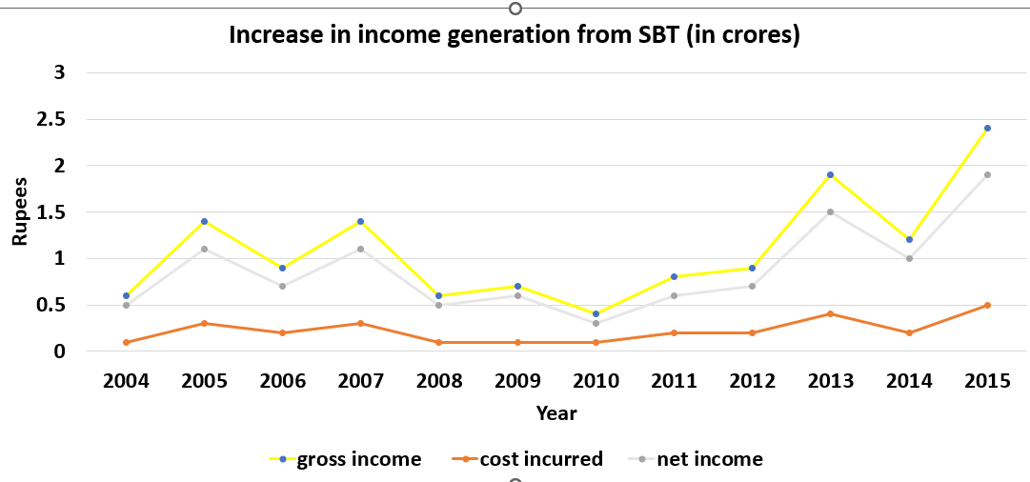

Fig 2: Increase in income generation from sea buckthorn (in crores) [5]

Post-harvest handling and uses: [Discuss Post-harvest handling and uses in two different headings]
Arimboor et al., (2006) [25] detailed a comprehensive approach for processing berries in order to extract pulp, oil and juice. Initially, fresh berries stored in cold conditions were washed with water to eliminate contaminants, followed by blanching at 80℃ to deactivate enzymes and aid in the extraction of juice and oil in subsequent phases. The berries, now cleaned and blanched, were then introduced into a mechanical screw press with a capacity of 100 kg h⁻¹ for dehydration. The press, with a compression ratio of approximately 10, regulated pressure through back-pressure control to extract around 80% of the total water content along with oil and suspended solids. The leftover residue consisted of fibrous press cake containing intact seeds. To enhance the overall yield, extraction was conducted in three stages. Initially, fresh berries were processed, followed by two subsequent stages where warm water (60℃) equivalent to 25% of the residue's weight was

added. The juices obtained from all three pressings were combined and subjected to clarification. This involved heating the pooled juice to 80℃ with stirring in a stainless-steel steam-jacketed kettle for 60 minutes. During clarification, orange/red-colored pulp oil was observed to float on the surface, while suspended solids settled at the bottom. The clarified juice was then hot-filtered through muslin cloth to remove debris and solids, forming sludge. This sludge was mixed with hot water (in a ratio of 1:2), and the resulting liquid phase containing residual oil was combined with the initial juice. Consequently, the liquid fraction was separated into juice containing pulp oil and solid sludge. The juice with pulp oil underwent centrifugation using a continuous centrifuge to isolate the components (clear juice, orange/red pulp oil, and residual solids as sludge). The fibrous cake with seed was dried in a crossflow drier and separated into fibrous residue and seeds manually.
There are a number of commercially available products based on sea buckthorn which include dried berries, tea, powder, oil, capsules, puree, juice, cosmetic products etc. The berries, squeezed juice, or pulp can all be used to extract the pigment known as "sea buckthorn yellow" [26]. Even the leaves are used occasionally in preparation of sea buckthorn tea.
According to Li and Wang (1998) [27], the plant is said to have significant therapeutic potential and may be helpful in treating skin conditions brought on by bed rest, duodenal and stomach ulcers, cardiovascular illnesses, and maybe the formation of some malignancies. Because of these advantages, sea buckthorn products—especially its oils—are in demand for both cosmetic and therapeutic uses.

Sea buckthorn is used in a wide variety of products, including food additives, oils, juices, candies, cosmetics, and shampoos [28]. The fruits of sea buckthorn are among the healthiest berries available, and the leaves (which average 15% protein) can be fed to pets and animals. It is helpful in soil conservation, because of its deep root system, particularly on brittle slopes [29].

Conclusion
Though there are the researches and development progressing, the sea buckthorn industry is still in the nascent stage. Poor market linkage due to interference of middle men and lack of value addition are the major threats for the industry [5]. Other constraints include lack of knowledge on superior cultivars, quality planting material, production and breeding aspects. Sea buckthorn berries' primary disadvantages are their extremely short harvest season and high moisture content, which prevents them from being used to create value-added goods [30]. Proper drying technologies, storage and promotion of its cultivation can be a boon to the industry and can be a

source of livelihood for the local population. Proper interventions and policies from government, standardization of production technology, production of quality planting material of promising cultivars etc. are some of the ways towards popularizing the crop. Sea buckthorn is a potential functional food rich in nutrients and medicinal values. Popularization and domestication of the crop can be a solution to many lifestyle diseases not only in the temperate but also in the tropics.

References

- Kumar A, Kumar P, Sharma A, Sharma DP, Thakur M. Scientific insights to existing know- how, breeding, genetics, and biotechnological interventions pave the way for the adoption of high-value underutilized super fruit Sea buckthorn (Hippophae rhamnoides L.). South African Journal of Botany.2022; 145: 348-359.

- Jike Z, Xiaoming Z. Progress of study on Frankia in nodules of Seabuckthorn. Hippophae. 1992; 2: 4-10.

- Li TSC, Schroeder WR. Sea Buckthorn (Hippophae rhamnoides L.): A multipurpose plant. HortTechnology. 1996; 6(4): 370-380.

- Dhillon WS. Fruit Production in India. Narendra Publishing House, Delhi. 2013.

- Stobdan T, Phunchok T. Value Chain Analysis of Sea buckthorn (Hippophae rhamnoides L.) in Leh Ladakh, Annual Report. Directorate of Arecanut and Spices Development, Kozhikode. 2017.

- Wolf D, Wegert F. Experience gained in the cultivation, harvesting and utilization of sea buckthorn. Cultivation and utilization of wild fruit crops. Bernhard Thalacker Verlag GmbH &Co. KG, Bernhard. 1993.

- Aprodu I, Ursache FM, Turturică M, Râpeanu G, Stănciuc N. Thermal stability of the complex formed between carotenoids from sea buckthorn (Hippophae rhamnoides L.) and bovine β- lactoglobulin. Spectrochimica Acta Part A: Molecular and Biomolecular Spectroscopy. 2017; 173: 562-571.

- Tian R, Wang H, Xiao Y, Hu P, Du R, Shi X et al. Fabrication of nanosuspensions to improve the oral bioavailability of total flavones from Hippophae rhamnoides L. and their comparison with an inclusion complex. AAPS PharmSciTech. 2020; 21: 1-14.

- Ciesarová Z, Murkovic M, Cejpek K, Kreps F, Tobolková B, Koplík R, et al. Why is sea buckthorn (Hippophae rhamnoides L.) so exceptional? A review. Food Research International. 2020; 133: 109170. Kindly check

- Chen T. Studies of the biochemical composition of Hippophae and its quality assessment in Gansu Province. Hippophae. 1988; 1: 19-26.

- Zeb A. 2004. Chemical and nutritional constituents of sea buckthorn juice. Pakistan Journal of Nutrition. 2004; 3(2): 99-106.

- Gutzeit D, Baleanu G, Winterhalter P, Jerz G. Vitamin C content in sea buckthorn berries (Hippophae rhamnoides L. ssp. rhamnoides) and related products: A kinetic study on storage stability and the determination of processing effects. Journal of Food Science. 2008; 73(9): C615-C620.

- Ercisli S, Orhan E, Ozdemir O, Sengul M. The genotypic effects on the chemical composition and antioxidant activity of sea buckthorn (Hippophae rhamnoides L.) berries grown in Turkey. Scientia Horticulturae. 2007; 115(1): 27-33.

- Patra BR, Borugadda VB, Dalai AK. Microwave-assisted extraction of sea buckthorn pomace and seed extracts as a proactive antioxidant to stabilize edible oils. Bioresource Technology Reports. 2022; 17: 100970.

- Ma Z, Sun Q, Chang L, Peng J, Zhang M, Ding X et al. A natural anti-obesity reagent derived from sea buckthorn polysaccharides: Structure characterization and anti-obesity evaluation in vivo. Food Chemistry. 2022; 375: 131884.

- Nowak D, Gośliński M, Kłębukowska L. Antioxidant and antimicrobial properties of selected fruit juices. Plant Foods for Human Nutrition. 2022; 77(3): 427-435.

- Korkus E, Dąbrowski G, Szustak M, Czaplicki S, Madaj R, Chworoś A et al. Evaluation of the anti-diabetic activity of sea buckthorn pulp oils prepared with different extraction methods in human islet EndoC-betaH1 cells. NFS Journal. 2022; 27: 54-66.

- Balkrishna A, Sakat SS, Joshi K, Joshi K, Sharma V, Ranjan R et al. Cytokines driven anti- inflammatory and anti-psoriasis like efficacies of nutraceutical sea buckthorn (Hippophae rhamnoides) oil. Frontiers in Pharmacology. 2019; 10: 1186.

- Skalski B, Lis B, Pecio Ł, Kontek B, Olas B, Żuchowski J et al. Isorhamnetin and its new derivatives isolated from sea buckthorn berries prevent H2O2/Fe–Induced oxidative stress and changes in hemostasis. Food and Chemical Toxicology. 2019; 125: 614-620.

- Gupta R, Flora SJ. Protective effects of fruit extracts of Hippophae rhamnoides L. against arsenic toxicity in Swiss albino mice. Human Experimental Toxicology. 2006; 25: 285–295.
- Ruan A, Min H, Meng Z, Lü Z. Protective effects of Sea buckthorn seed oil on mouse injury induced by sulfur dioxide inhalation. Inhalation Toxicology.2003; 15: 1053–1058.

- Gupta A, Upadhyay NK. Sea buckthorn (Hippophae rhamnoides L.) seed oil: usage in burns, ulcers and mucosal injuries. In: Preedy, V.R., Watson, R.R., Patel, V.B. (Eds.), Nuts and Seeds in Health and Disease Prevention. Academic Press (Elsevier), London. 2011; 1011–1018.

- Brekhman II. Man and Biologically Active Substances. Pergamon Press, Oxford. 1980.

- Ramachandran U, Divekar HM, Grover SK, Srivastava KK. New experimental model for evaluation of adaptogenic products. Journal of Ethnopharmacology. 1990; 29: 275–281.

- Arimboor R, Venugopalan VV, Sarinkumar K, Arumughan C, Sawhney RC. Integrated processing of fresh Indian sea buckthorn (Hippophae rhamnoides) berries and chemical evaluation of products. Journal of the Science of Food and Agriculture. 2006; 86: 2345-2353.

- Beveridge T, Li TS, Oomah BD, Smith, A. Sea buckthorn products: manufacture and composition. Journal of agricultural and food chemistry.1999; 47(9): 3480-3488.

- Li TSC, Wang LCH. 1998. 1. GINSENG. Functional foods: biochemical and processing aspects 1. 1998: 329.

- Schroeder WR, Yao Y. Sea buckthorn: A promising multipurpose crop for Saskatchewan. PFRA Shelterbelt Centre. 1995

- Suryakumar G, Gupta A. Medicinal and therapeutic potential of Sea buckthorn (Hippophae rhamnoides L.). Journal of ethnopharmacology, 2011; 138(2): 268-278.

- Bal LM, Meda V, Naik SN, Satya S. Sea buckthorn berries: A potential source of valuable nutrients for nutraceuticals and cosmoceuticals. Food research international. 2011; 44(7), 1718- 1727.

