Original Research Article
Evaluation of antimicrobial resistance, biofilm formation and virulence factors in Staphylococcus pseudintermedius recovered from canine pyoderma

ABSTRACT
The present investigation was carried out with an objective to isolate and identify Staphylococcus pseudintermedius, to evaluate their antibiogram patterns, to detect virulence genes and to evaluate biofilm formation in S. pseudintermedius isolated from canine pyoderma cases. The investigation was carried out on 104 skin swabs collected from clinical cases of canine pyoderma. Through the conventional and Molecular methods 82 (78.84%) isolates were identified as Staphylococcus. Out of 82 isolates of Staphylococcus, 68 isolates were identified as S. pseudintermedius. In the present study higher percentage of susceptibility was observed for doxycycline (80.88%), levofloxacin (61.76%) and clindamycin (57.35%), while higher resistance was recorded against ampicillin (95.59%), amikacin (72.06%) and erythromycin (45.59%). In the present study, 46 (67.64%) isolates were identified as a Multi Drug Resistant (MDR) isolate. In the present study lukF, lukS, siet and seC virulence gene were targeted to detect their presence in S. pseudintermedius isolates through PCR. Out of the 68 S. pseudintermedius isolates lukF, lukS, siet and seC gene were detected in 63 (92.65%), 63 (92.65%), 65 (95.59%) and 8 (11.76%) isolates, respectively. In the present study micro titer plate assay was used to detect the biofilm formation in S. pseudintermedius isolates. Out of 68 S. pseudintermedius isolates, 46 (67.65%) were non biofilm former, 19 (27.94%) were weak biofilm former and 3 (4.41%) were moderate biofilm former. Molecular detection of biofilm gene was carried out through PCR by targeting icaA and icaD gene. Out of the 68 S. pseudintermedius isolates 46 (67.65%) were yielded 134 bp amplicon of icaA gene, while 45 (66.18%) were yielded 166 bp amplicon of icaD gene.
Keywords: Biofilm, Multidrug resistance, Pyoderma, Virulence gene
Introduction:
Pyoderma is a cutaneous infection caused by pus-forming (pyogenic) bacteria. One of the principal bacteria that colonize the skin and mucous membranes of dogs is Staphylococcus pseudintermedius. It is an opportunistic pathogen that can cause canine pyoderma in up to 92% of cases and is prevalent in 46-92% of healthy canines (Lynch and Helbig, 2021). Please mention some characterized clinical signs with references
One of the biggest global issues in both human and veterinary health is the rise of antibiotic-resistant bacterial infections. Due to higher morbidity, mortality, and treatment costs associated with untreated infections, it has considerable negative health effects. As a result of the indiscriminate use of multiple antibiotics over time, multi-drug-resistant staphylococcal strains have developed, which are either caused by changes in the genes that encode target proteins or by the acquisition and accumulation of genes that confer antibiotic resistance (Silva et al. 2021). Evidence of the zoonotic transmission of S. pseudintermedius from dogs to humans has been reported (Pitchenin et al. 2017). The potential for horizontal gene transfer from the dog-to-owner strain could lead to an increase in multi-drug-resistant bacteria in the future, making it harder for humans to cure bacterial diseases (Lai et al. 2022).
The virulence and antibiotic resistance factors that S. pseudintermedius either possesses or may acquire from other bacteria during co-colonization influence its pathophysiology and clinical significance. The presence of several enzymes (coagulase, thermonuclease, proteases), toxins (cytotoxin, exfoliative toxin, enterotoxin, leukocidins, haemolysin), and adhesion factors (clumping factor, protein A, biofilm forming proteins) can increase the pathogenicity of S. pseudintermedius (Hritcu et al. 2020).
Biofilms are bacterial communities made up of cells that are reversibly linked together and fixed in a self-producing polymeric matrix (Andrade et al. 2022). Biofilm is a virulence factor of S. pseudintermedius that promotes the adherence of bacteria to host surfaces. Some bacteria, such the species of Staphylococcus and Pseudomonas, have the capacity to develop biofilm, which could make their infections more resistant to antibiotics (Chan et al. 2019).
*Where the study aim?
MATERIALS AND METHODS
Where the ethical approval?
Please add dogs mentioning the case history including clinical signs; date of infection; received treatment. Are all dogs from the same locality?
Samples collection: A total of 104 skin swabs from clinical cases of canine pyoderma presented at Veterinary Clinical Complex (VCC), Veterinary College, Kamdhenu University (KU), Navsari were collected aseptically and transported to the laboratory by placing it in the sterile container on the same day of sampling by maintaining cold chain.
Bacterial isolation and identification: All the skin swabs were cultured for primary isolation. Initially, swabs were cultured onto 5% sheep blood agar for 18 hours at 37℃. After reading colony morphology, the colonies were again streaked on Mannitol Salt Agar plates and incubated further at 37℃ for 18 hr. to obtain a pure culture. Then gram staining performed followed by catalase and oxidase test. (References?)
Molecular identification of Staphylococcus Genus and S. pseudintermedius: The genomic DNA of bacterial cultures were extracted by method described by Chitra et al. (2015) with slight modifications. Briefly, four to five colonies were suspended in 200 μl Nuclease Free Water (NFW) and boiled at 100°C for 10 min. Then the tubes were cooled immediately by placing them on the ice. Later, they were centrifuged at 10000 rpm for 10 min and the supernatant was used as template in the amplification. The primers targeting 16S rRNA gene of Staphylococcus Genus and nuc gene of S. pseudintermedius as detailed in Table 1 were used for molecular detection of Staphylococcus Genus and S. pseudintermedius. The PCR cycling condition was kept as follow: initial denaturation at 95ºC for 5 minutes followed by 35 cycles of denaturation at 94ºC for 30 second, annealing at 54ºC for Staphylococcus Genus and 60ºC for S. pseudintermedius for 30 second, extension at 72ºC for 30 second with a final extension step at 72ºC for 10 minutes using thermal cycler (Applied Biosystems, USA).
Antimicrobial susceptibility testing: The antibiotic-susceptibility profile of S. pseudintermedius isolates was prepared using the disc diffusion method on Mueller-Hinton agar plate Zones of inhibition were measured and compared with zone size interpretative table as per the guidelines by Clinical and Laboratory Standards Institute. Total 7 antimicrobials from various antibiotic classes viz., Amikacin (AK, 30 mcg), Ampicillin (AMP, 10 mcg), Cefpodoxime (CPD, 10 mcg), Clindamycin (CD, 2 mcg), Doxycycline (DO, 30 μg), Erythromycin (E, 15 mcg), Levofloxacin (LE, 5 mcg) were used to perform antimicrobial susceptibility testing.
Microtiter plate assay for biofilm formation: The experiment was performed using polystyrene flat bottom microtiter plates based on the techniques described by Ebrahimi et al. (2013). The mean optical density (OD) of the negative control +3 standard deviations of negative control was considered as the cut-off (ODc). The biofilm producers are categorized as: Non biofilm former: ODs ≤ ODc, Weak biofilm former: ODc < ODs ≤ 2 × ODc, Moderate biofilm former: 2 × ODc < ODs ≤ 4 × ODc, Strong biofilm former: ODs > 4 × ODc, Where ODc = cut-off OD and ODs = Mean OD of sample.
Molecular detection of virulence and biofilm genes: PCR was carried out for detection of virulence and biofilm associated genes using primer sequences as detailed in Table 2. The PCR cycling conditions were kept as follow: initial denaturation at 95ºC for 5 minute followed by 35 cycles of denaturation at 94ºC for 30 second, annealing at 57ºC for lukF & lukS gene, 55ºC for seC gene, 56ºC for siet & icaD and 60ºC for icaA gene for 30 second, extension at 72ºC for 30 second with a final extension step at 72ºC for 10 minutes using thermal cycler (Applied Biosystems, USA).
Dendrogram and Heatmap: Dendrograms and heatmap were generated in R using hierarchical clustering in the base stats package on Euclidean distance matrices representing ABST interpretations for each antibiotic (where 0 = resistant, 0.5 = intermediate, 1 = susceptible) and for virulence and biofilm genes (where 0= absent, 1= present). (Reference?)
RESULTS AND DISCUSSION
Isolation and prevalence of S. pseudintermedius: Based on cultural isolation and identification from 104 skin swabs, total 82 Staphylococcus isolates were recovered. All the 82 Staphylococcus isolates yielded desired 370 bp amplicon of 16S rRNA gene. Out of 82 molecularly confirmed Staphylococcus isolates, 68 (82.93%) isolates yielded 99 bp amplicon of nuc gene, specific for S. pseudintermedius. In the present study higher prevalence (82.93%) of S. pseudintermedius was recorded. Similar results were observed by Kawakami et al. (2010), Ravens et al. (2014), Mustak et al. (2020) and Lai et al. (2022).
Antimicrobial susceptibility testing results: Hhigher percentage of susceptibility was detected for doxycycline (80.88%), levofloxacin (61.76%) and clindamycin (57.35%), while higher resistance for all the isolates was recorded for ampicillin (95.59%), amikacin (72.06%) and erythromycin (45.59%). It was found that 46 (67.64%) isolates were resistant to more than 3 class of antibiotics which were considered as a Multi Drug Resistant (MDR) isolate. Heatmap and dendrogram showed the pattern of antibiotic susceptibility test (Fig. 1). In this study higher sensitivity was observed against doxycycline, levofloxacin and clindamycin. Similar findings were obtained by Dziva et al. (2015), Van Damme et al. (2020) and Abusleme et al. (2022). Contrast findings were mentioned by Stefanetti et al. (2017), Lai et al. (2022), Park et al. (2018) and Srednik et al. (2023) (what is your comment on this contrast?). In the current study higher resistance was observed against ampicillin, amikacin and erythromycin in similarity to what determined by Huerta et al. (2011), Stefanetti et al. (2017), Chitra et al. (2018), Bertelloni et al. (2021), Lai et al. (2022), Park et al. (2018) and Tabatabaei et al. (2019). Compared to present study, different results were reported by Gonzalez-Dominguez et al. (2020), Meroni et al. (2019), Mustak et al. (2020) and Abusleme et al. (2022). How do you explain this difference?
Microtiter plate assay: To detect biofilm formation ability of S. pseudintermedius isolates, micro titer plate assay was performed. Out of 68 S. pseudintermedius isolates, 46(67.65%) were non biofilm former, 19(27.94%) were weak biofilm former and 3(4.41%) were moderate biofilm former. No sample was observed as strong biofilm producer (Fig. 2). In present study, lower prevalence of biofilm formation was recorded by microtiter plate assay. Contrary to our findings, higher prevalence was reported by Singh et al. (2013) and Jantorn et al. (2021) (what is your explanation?). Low prevalence of biofilm producing S. pseudintermedius in the geographical area we investigated presents a positive sign for animal health.
Detection of virulence and biofilm genes: In the present study four virulence genes viz., lukF, lukS, siet and seC gene were targeted to check virulence of S. pseudintermedius isolates. Out of 68 S. pseudintermedius isolates 63 isolates were amplified at 572 bp amplicon of lukF gene, 63 isolates were amplified at 503 bp amplicon of lukS gene, 65 isolates were amplified at 359 bp amplicon of siet gene and 8 isolates were amplified at 271 bp amplicon of seC gene. The entire results are summarized in Table 3. Among S. pseudintermedius isolates, virulence genes lukF, lukS, and siet were found to be more abundant, but seC was found to be less prevalent. These came in agreement with previous studies carried out by Tanabe et al. (2013), Couto et al. (2016), Pitchenin et al. (2017) and Hritcu et al. (2020). Out of 68 S. pseudintermedius isolates 6(8.82%) were found positive for all the four virulence genes. All 68(100%) isolates were found positive for at least one virulence gene screened in the present study. The study of virulence genes of S. pseudintermedius is helpful for understanding the molecular basis of pathogenesis of S. pseudintermedius causing pyoderma. In present study two biofilm associated gene viz. icaA and icaD were targeted to check its presence in S. pseudintermedius isolates. Out of the 68 S. pseudintermedius isolates 46 were yielded 134 bp amplicon of icaA gene, while 45 were yielded 166 bp amplicon of icaD gene. Heatmap and dendrogram showed different pattern of detected virulence and biofilm genes (Fig. 3). In present study we reported high prevalence of biofilm associated genes. Similar kind of findings were observed by Singh et al. (2013) and Meroni et al. (2019). In present study prevalence of biofilm associated gene is high but microtiter plate assay results show low prevalence of biofilm forming S. pseudintermedius. The reason might be these isolates harboring biofilm producing genes but they lack gene expression.
Overall, this study reported higher prevalence of multidrug resistant bacteria and higher prevalence of virulence genes, which shows significant therapeutic and infection control challenges. Pleas try to avoid repeated words like in the present study
Conclusion??

REFERENCES
Abusleme F, Galarce N, Quezada-Aguiluz M, Iraguen D and Gonzalez-Rocha, G. 2022. Characterization and antimicrobial susceptibility of coagulase-positive Staphylococcus isolated in a veterinary teaching hospital in Chile. Revista Argentina de microbiologia 54(3): 192-202.
Andrade M, Oliveira K, Morais C, Abrantes P, Pomba C, Rosato A E and Costa S S. 2022. Virulence Potential of Biofilm-Producing Staphylococcus pseudintermedius, Staphylococcus aureus and Staphylococcus coagulans Causing Skin Infections in Companion Animals. Antibiotics 11(10): 1339.
Becker K, Roth R and Peters G. 1998. Rapid and specific detection of toxigenic Staphylococcus aureus: use of two multiplex PCR enzyme immunoassays for amplification and hybridization of staphylococcal enterotoxin genes, exfoliative toxin genes, and toxic shock syndrome toxin 1 gene. Journal of Clinical Microbiology 36(9): 2548-2553.
Bertelloni F, Cagnoli G and Ebani V V. 2021. Virulence and antimicrobial resistance in canine Staphylococcus spp. isolates. Microorganisms 9(3): 515.
Chan W Y, Hickey E E, Page S W, Trott D J and Hill P B. 2019. Biofilm production by pathogens associated with canine otitis externa, and the antibiofilm activity of ionophores and antimicrobial adjuvants. Journal of Veterinary Pharmacology and Therapeutics 42(6): 682-692.
Chitra M A, Jayanthy C and Nagarajan B. 2015. Detection and sequence analysis of accessory gene regulator genes of Staphylococcus pseudintermedius isolates. Veterinary World 8(7): 902.
Chitra M A, Jayanthy C and Nagarajan B. 2018. Virulence genes detection and antimicrobial susceptibility of Staphylococcus pseudintermedius isolates from canine skin infection in Chennai, India. Proceedings of the National Academy of Sciences, India Section B: Biological Sciences 88: 355-361.
Couto N, Belas A, Oliveira M, Almeida P, Clemente C and Pomba C. 2016. Comparative RNA-seq-based transcriptome analysis of the virulence characteristics of methicillin-resistant and-susceptible Staphylococcus pseudintermedius strains isolated from small animals. Antimicrobial Agents and Chemotherapy 60(2): 962-967.
Dziva F, Wint C, Auguste T, Heeraman C, Dacon C, Yu P and Koma L M. 2015. First identification of methicillin-resistant Staphylococcus pseudintermedius strains among coagulase-positive staphylococci isolated from dogs with otitis externa in Trinidad, West Indies. Infection Ecology and Epidemiology 5: 29170.
Ebrahimi A, Moatamedi A, Lotfalian S and Mirshokraei P. 2013. Biofilm formation, hemolysin production and antimicrobial susceptibilities of Streptococcus agalactiae isolated from the mastitis milk of dairy cows in Shahrekord district, Iran. Veterinary Research Forum: An International Quarterly Journal 4(4): 269.
Futagawa-Saito K, Sugiyama T, Karube S, Sakurai N, Ba-Thein W and Fukuyasu T. 2004. Prevalence and characterization of leukotoxin-producing Staphylococcus intermedius in isolates from dogs and pigeons. Journal of Clinical Microbiology 42(11): 5324-5326.
Gonzalez-Dominguez M S, Carvajal H D, Calle-Echeverri D A and Chinchilla-Cardenas D. 2020. Molecular Detection and Characterization of the mecA and nuc Genes from Staphylococcus Species (S. aureus, S. pseudintermedius, and S. schleiferi) Isolated from Dogs Suffering Superficial Pyoderma and Their Antimicrobial Resistance Profiles. Frontiers in Veterinary Science 7: 376.
Hritcu O M, Schmidt V M, Salem S E, Maciuca I E, Moraru R F, Lipovan I, Mareş M, Solcan G and Timofte D. 2020. Geographical Variations in Virulence Factors and Antimicrobial Resistance Amongst Staphylococci Isolated from Dogs from the United Kingdom and Romania. Frontiers in Veterinary Science 7: 414.
Huerta B, Maldonado A, Ginel P J, Tarradas C, Gomez-Gascon L, Astorga R J and Luque I. 2011. Risk factors associated with the antimicrobial resistance of staphylococci in canine pyoderma. Veterinary Microbiology 150(3-4): 302-308.
Jantorn P, Heemmamad H, Soimala T, Indoung S, Saising J, Chokpaisarn J and Saeloh D. 2021. Antibiotic resistance profile and biofilm production of Staphylococcus pseudintermedius isolated from dogs in Thailand. Pharmaceuticals 14(6): 592.
Kawakami T, Shibata S, Murayama N, Nagata M, Nishifuji K, Iwasaki T and Fukata T. 2010. Antimicrobial susceptibility and methicillin resistance in Staphylococcus pseudintermedius and Staphylococcus schleiferi subsp. coagulans isolated from dogs with pyoderma in Japan. The Journal of Veterinary Medical Science 72(12): 1615-1619.
Lai C H, Ma Y C, Shia W Y, Hsieh Y L and Wang C M. 2022. Risk Factors for Antimicrobial Resistance of Staphylococcus Species Isolated from Dogs with Superficial Pyoderma and Their Owners. Veterinary Sciences 9(7): 306.
Lautz S, Kanbar T, Alber J, Lämmler C, Weiss R, Prenger‐Berninghoff E and Zschock M. 2006. Dissemination of the gene encoding exfoliative toxin of Staphylococcus intermedius among strains isolated from dogs during routine microbiological diagnostics. Journal of Veterinary Medicine, Series B, 53(9): 434-438.
Lynch S A and Helbig K J. 2021. The complex diseases of Staphylococcus pseudintermedius in canines: where to next?. Veterinary Sciences 8(1): 11.
Martineau F, Picard F J, Ke D, Paradis S, Roy P H, Ouellette M and Bergeron M G. 2001. Development of a PCR assay for identification of staphylococci at genus and species levels. Journal of Clinical Microbiology 39(7): 2541-2547.
Meroni G, Soares Filipe J F, Drago L and Martino P A. 2019. Investigation on antibiotic-resistance, biofilm formation and virulence factors in multi drug resistant and non multi drug resistant Staphylococcus pseudintermedius. Microorganisms 7(12): 702.
Mustak I B, Mustak H K, Saricam S, Ustun T and Erdem A E. 2020. Frequency of Staphylococcus pseudintermedius in canine skin infections and antibiotic resistance profiles of the recovered isolates. Etlik Veteriner Mikrobiyoloji Dergisi 31(2): 127-132.
Park J H, Kang J H, Hyun J E and Hwang C Y. 2018. Low prevalence of mupirocin resistance in Staphylococcus pseudintermedius isolates from canine pyoderma in Korea. Veterinary Dermatology 29(2): 95–e37.
Pitchenin L C, Brandão L N S, Rosa J M A, Kagueyama F C, da Silva Alves A, Rocha Í S M and Dutra V. 2017. Occurrence of toxin genes in Staphylococcus pseudintermedius from diseased dogs and other domestic and wild species. The Journal of Infection in Developing Countries 11(12): 957-961.
Proietti P C, Stefanetti V, Hyatt D R, Marenzoni M L, Capomaccio S, Coletti M and Passamonti F. 2015. Phenotypic and genotypic characterization of canine pyoderma isolates of Staphylococcus pseudintermedius for biofilm formation. Journal of Veterinary Medical Science 77(8): 945-951.
Ravens P A, Vogelnest L J, Ewen E, Bosward K I and Norris J M. 2014. Canine superficial bacterial pyoderma: evaluation of skin surface sampling methods and antimicrobial susceptibility of causal Staphylococcus isolates. Australian Veterinary Journal 92(5): 149-155.
Silva V, Oliveira A, Manageiro V, Caniça M, Contente D, Capita R, Alonso-Calleja C, Carvalho I, Capelo J L, Igrejas G and Poeta P. 2021. Clonal Diversity and Antimicrobial Resistance of Methicillin- Resistant Staphylococcus pseudintermedius isolated from Canine Pyoderma. Microorganisms 9(3): 482.
Singh A, Walker M, Rousseau J and Weese J S. 2013. Characterization of the biofilm forming ability of Staphylococcus pseudintermedius from dogs. BMC Veterinary Research 9(1): 1-6.
Srednik M E, Perea C A, Giacoboni G I, Hicks J A, Foxx C L, Harris B and Schlater L K. 2023. Genomic Features of Antimicrobial Resistance in Staphylococcus pseudintermedius isolated from Dogs with Pyoderma in Argentina and the United States: A Comparative Study. International Journal of Molecular Sciences 24(14): 11361.
Stefanetti V, Bietta A, Pascucci L, Marenzoni M L, Coletti M, Franciosini M P and Casagrande Proietti P. 2017. Investigation of the antibiotic resistance and biofilm formation of Staphylococcus pseudintermedius strains isolated from canine pyoderma. Veterinaria Italiana 53(4): 289-96.
Tabatabaei S, Najafifar A, Badouei M A, Salehi T Z, Tamai I A, Khaksar E and Ghazisaeedi F. 2019. Genetic characterisation of methicillin-resistant Staphylococcus aureus and Staphylococcus pseudintermedius in pets and veterinary personnel in Iran: new insights into emerging methicillin-resistant S. pseudintermedius (MRSP). Journal of Global Antimicrobial Resistance 16: 6-10.
Tanabe T, Toyoguchi M, Hirano F, Chiba M, Onuma K and Sato H. 2013. Prevalence of staphylococcal enterotoxins in Staphylococcus pseudintermedius isolates from dogs with pyoderma and healthy dogs. Microbiology and Immunology 57(9): 651-654.
Van Damme C M, Broens E M, Auxilia S T and Schlotter Y M. 2020. Clindamycin resistance of skin derived Staphylococcus pseudintermedius is higher in dogs with a history of antimicrobial therapy. Veterinary Dermatology 31(4): 305-e75.
Table (1): Staphylococcus Genus specific (16S rRNA) primer sequences
Primer (5’ to 3’) | Target gene | Product size | Reference
F: GGCCGTGTTGAACGTGGTCAAATCA  R: TIACCATTTCAGTACCTTCTGGTAA | 16S  rRNA | 370bp | Martineau et al. (2001)
F: TGATGCAGCTTTTCCGTATG  R: AAAGATGGGCAAGATGAACG | nuc | 99bp | Gonzalez-Dominguez et al. (2020)

Table (2): Virulence and biofilm gene specific primer sequences for S. pseudintermedius
Primer (5’ to 3’) | Target gene | Product size | Reference
F: CCTGTCTATGCCGCTAATCCA  R: AGGTCATGGAAGCTATCTCGA | luk-F | 572 bp | Futagawa-Saito et al. (2004)
F: TGTAAGCAGCAGAAAATGGGG  R: GCCCGATAGGACTTCTTACAA | luk-S | 503 bp | Futagawa-Saito et al. (2004)
F: ATGGAAAATTTAGCGGCATCTGG  R: CCATTACTTTTCGCTTGTTGTGC | siet | 359 bp | Lautz et al. (2006)
F: CTCAAGAACTAGACATAAAAGCTAGG  R: TCAAAATCGGATTAACATTATCC | seC | 271 bp | Becker et al. (1998)
F: ACTGTTTCGGGGACAAGCAT  R: ATTGAGGCTGTAGGGCGTTG | icaA | 134 bp | Proietti et al. (2015)
F: CGTTAATGCCTTCTTTCTTATTGCG  R: ATTAGCGCACATTCGGTGTT | icaD | 166 bp | Proietti et al. (2015)

Table (3): Distribution of virulence genes in S. pseudintermedius (n=68)
Virulence genes | Positive (no.) | Percentage
lukF | 63 | 92.65 %
lukS | 63 | 92.65 %
siet | 65 | 95.59 %
seC | 8 | 11.76 %
lukF+lukS+siet+seC | 6 | 8.82 %
lukF+lukS+siet | 57 | 83.82 %
lukF+lukS+seC | 7 | 10.29 %
lukS+siet+seC | 7 | 10.29 %
lukF+siet+seC | 6 | 8.82 %
lukF+lukS | 59 | 86.76 %
lukF+siet | 60 | 88.24 %
lukF+seC | 7 | 10.29 %
lukS+siet | 61 | 89.71 %
lukS+seC | 8 | 11.76 %
Siet+seC | 7 | 10.29 %

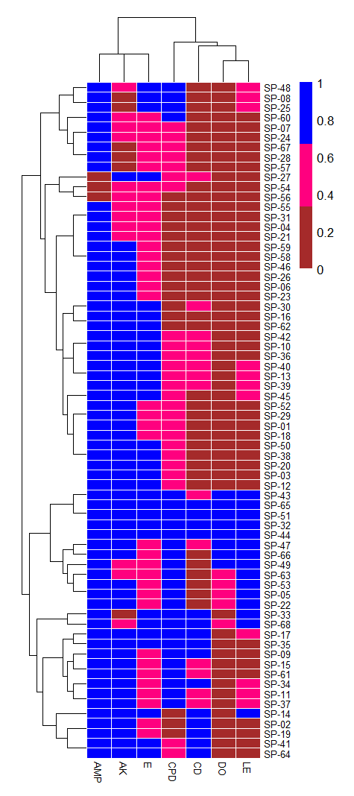

Sensitive
Intermediate
Resistant

AMP = ampicillin
AK = amikacin
CPD = cefpodoxime
CD = clindamycin
DO = doxycycline
E = erythromycin
LE = levofloxacin

Fig. (1): Heatmap and dendrogram of the antibiogram profiles of
S. pseudintermedius isolates
(where 0 = susceptible, 0.5 = intermediate, and 1 = resistant)

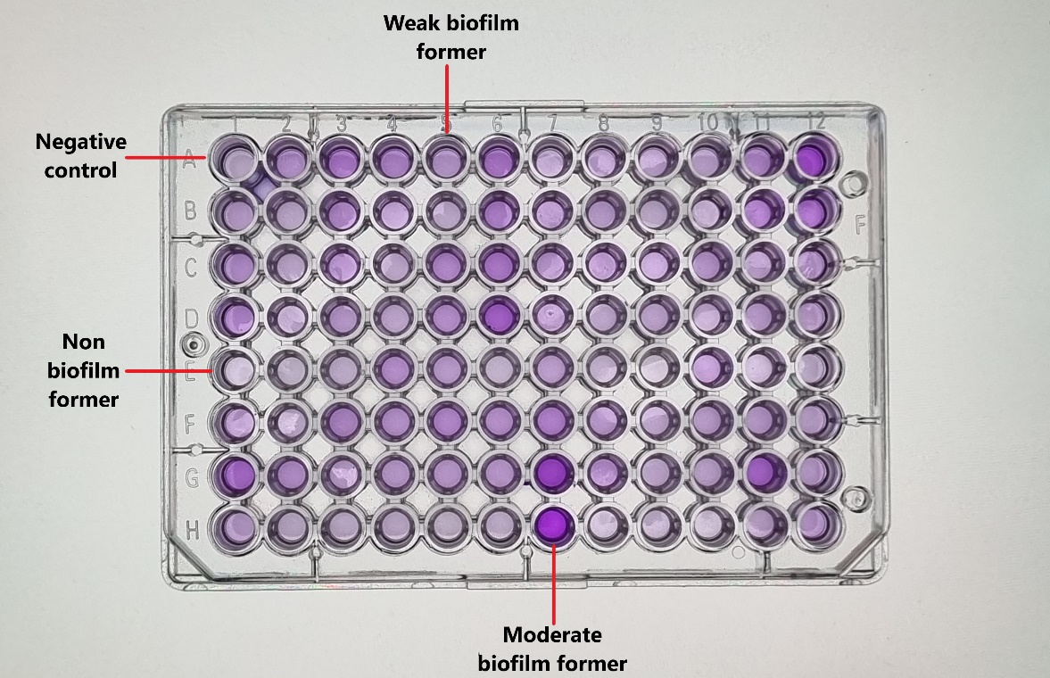

Present
Absent

Fig. (2); Microtitre plate assay for biofilm formation

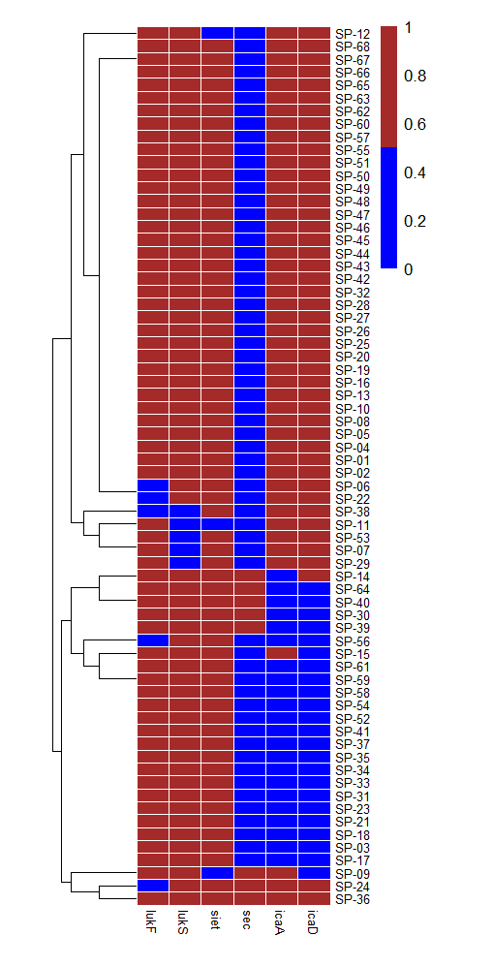

Fig. (3): Heatmap and dendrogram of the virulence and biofilm genes detected in S. pseudintermedius isolates (where 0 = absent, 1 = present)

