Screening of Faba Bean (Vicia faba L. major Harz) Genotypes from Diverse Agro-Climatic Regions of Kashmir Valley against Root-Rot Caused by Fusarium Solani
Abstract
Faba bean is an annual legume crop, which plays an important role in the food security for humans and animals, and is widely adapted than other major legume crops, to severe climatic and weather conditions. However, its production is constrained by a variety of biotic factors. Diseases such as root rot significantly reduce faba bean yield . We evaluated 47 faba bean genotypes for yield and resistance to Fusarium root rot. Some genotypes exhibited both high yield and resistance to Fusarium root rot . The resistance reaction of genotypes was tested by screening the genotypes under greenhouse conditions. Heavy selection pressure (inoculum load) was put on the genotypes by spraying a spore concentration of 2×10⁶ spores/ml. Out of forty-seven genotypes, seven genotypes were found resistant, twenty-six were intermediate and fourteen were susceptible to Fusarium solani. The percentage contribution of different characters towards divergence revealed that maximum contribution was from days to 50% flowering (14.5%), followed by pod length (12.4%), days to 80% maturity (11.4%), seed yield per plant (11.3%). Mahalanobis D² analysis grouped the genotypes into sixteen distinct clusters . Cluster I was largest among all the clusters containing eighteen genotypes, followed by cluster III having Seven genotypes, followed by cluster II, IV, V, VI, VII, VIII, IX and X having 2 genotypes each, followed by XI, XII, XIII. IX, X, XI each have one genotype. Promising genotypes with resistance to root rot identified in the present study can serve as donors for transfer of root rot resistance into genotypes which are high yielding but are root rot susceptible.
Keywords: Resistant, Susceptible, Diversity, Clusters, Root Rot, Genetic Divergence

1. Introduction
Pulses are a major source of protein for the vegetarian population of India and complement staple cereals by providing essential amino acids, vitamins, and mineral . They contain 22–24% protein, which is twice that of wheat and three times that of rice . Pulses provide significant nutritional and health benefits and are known to reduce the risk of diseases such as colon cancer and cardiovascular diseases [1, 2].
Faba bean plays an important role in crop rotation, mixed and inter-cropping system and (Vicia faba L.) is an annual legume that originated in the Oriental Mediterranean region and [3-5]. It is widely cultivated for human food, animal feed, fodder etc. Currently, faba beans are cultivated in more than 60 countries of the world. Faba bean (Vicia faba L.) is one of the oldest crops cultivated in the Near East region and has been grown for both its fresh pods and dry seeds.
Faba bean does not take well-deserved places due to the consumer habit. The number of registered varieties has been very limited depending on the insufficient faba bean breeding programs programms. One of the two fundamental rules in plant breeding is to create or to exploit genetic variation and the other is selection of appropriate plants. The most efficient way to overcome the biotic and abiotic limitations to faba bean production is to develop varieties suitable to the environments in which faba beans are cultivated. It is undoubted that the genetic variation/diversity made by introduction, hybridization or mutation must be revealed to select the genotypes resistant to both pests and disease or adapted to environmental conditions such as temperature and soil. This has become more relevant due to changing climatic scenario where there is a risk of disease outbreaks and insect pests if atmospheric conditions become congenial for the epiphytotic conditions.
Faba bean has been recognized as a potential grain legume by the National Agricultural Research System. It has also been identified as one of the eight major food legumes by the Consultative Group on International Agricultural Research Programme (CGIAR). In Bihar, it has become a traditional legume crop. It is also being grown on small scale and has been included in the All India Coordinated Research Network on Potential crops scale in Jharkhand, Eastern Uttar Pradesh, Chhattisgarh, Odisha, Madhya Pradesh and Haryana. Genetic variability in global faba bean germplasm is quite high which is attributed to its intermediate crossing system between autogamy and allogamy and wide geographic distribution [6, 7].
Faba bean is a partially allogamous plant with a chromosome numbers (2n = 2x = 12) than other species in genus Vicia L. [8]. However, the nuclear genome of faba bean is remarkably large (13,000 Mb, [9]. The degree of genetic diversity can reflect the level of genetic progress in future breeding programs. Therefore, evaluation of faba bean genetic diversity is of great significance for breeding programs [10-13].
Despite all its economic and cultural importance, faba bean production is subjected to a wide range of biotic constraints. Diseases such as root rot cause the yield reduction in faba beans. It is the most important disease of faba beans, causing up to 70% farm yield loss. This pathogen attacks both roots and stem base; resulting in dramatic losses in germination percentage. This fungus can survive in different shapes either as mycelium or as spores in infected plant tissues. When favorable conditions prevail and severe infection occurs, the disease can cause complete crop loss [14]. Although there are management options such as rotation with non-susceptible crops, good soil drainage and use of disease free or fungicide treated seeds, none of these can contain the disease adequately in the field. So, Integrated management is the most promising alternative to control the disease. Thus, there is a need to identify and select faba bean lines that produce high yield and have inbuilt resistance to root rot using resistant varieties is the most inexpensive and sustainable management option for the control of faba bean root roots.
The main aim of the current study was to identify root-rot resistant genotypes.
2. Materials and methods
2.1 Plant material
47 faba bean genotypes were collected from different agro-climatic conditions and were purified for evaluation . A set of 47 faba bean genotypes (Table 1) were evaluated to investigate their resistance to Fusarium root rot, caused by Fusarium solani (Mart.) Sacc. The investigation was undertaken during 2020 in the greenhouse at the Faculty of Agriculture, SKUAST –K, Wadura, Sopore, Jammu and Kashmir.

Table 1. List of 47 Germplasm lines of Faba bean utilized in the research and the place from where they were collected:
S. No | Germplasm | Colour |  | Place of collection
1 | SKUA-VFB 1 (a) |  | Beige (light – greyish yellowish brown) |  | HMT, SRINAGAR
2 | SKUA-VFB 1 (b) |  | Black |  | HMT, SRINAGAR
3 | SKUA-VFB 1 (c) |  | light brown |  | HMT, SRINAGAR
4 | SKUA-VFB 2 (a) |  | light brown |  | ZANIGAM, BEERWAH
5 | SKUA-VFB 2 (b) |  | dark brown |  | ZANIGAM, BEERWAH
6 | SKUA-VFB 3 (a) |  | Beige |  | TULMULLA, GANDERBAL
7 | SKUA-VFB 4 (a) |  | Beige |  | SHIRMAL, SHOPIAN
8 | SKUA-VFB 4 (b) |  | dark brown |  | SHIRMAL, SHOPIAN
9 | SKUA-VFB 4 (c) |  | Black |  | SHIRMAL, SHOPIAN
10 | SKUA-VFB 5 (a) |  | Brown |  | ANANTNAG
11 | SKUA-VFB 5 (b) |  | dark brown |  | ANANTNAG
12 | SKUA-VFB 6 (a) |  | Light brown |  | SAIL, BUDGAM
13 | SKUA-VFB 7 (a) |  | Dark brown |  | BAGH E MEHTAB, SRINAGAR
14 | SKUA-VFB 7 (b) |  | Light brown |  | BAGH E MEHTAB, SRINAGAR
15 | SKUA-VFB 7 (c) |  | Beige |  | BAGH E MEHTAB, SRINAGAR
16 | SKUA-VFB 8 (a) |  | Beige |  | PALHALAN, PATTAN, BARAMULLA
17 | SKUA-VFB 8 (b) |  | Black |  | PALHALAN, PATTAN, BARAMULLA
18 | SKUA-VFB 8 (c) |  | light brown |  | PALHALAN, PATTAN, BARAMULLA
19 | SKUA-VFB 8 (d) |  | light brown |  | PALHALAN, PATTAN, BARAMULLA
20 | SKUA-VFB 9 (a) |  | Beige |  | LITTER, PULWAMA
21 | SKUA-VFB 9 (b) |  | Black |  | LITTER, PULWAMA
22 | SKUA-VFB 10 (a) |  | Beige |  | BEERWAH, BUDGAM
23 | SKUA-VFB 11 (a) |  | Beige |  | REDBUGH, HANDWARA, KUPWARA
24 | SKUA-VFB 11 (b) |  | light brown |  | REDBUGH, HANDWARA, KUPWARA
25 | SKUA-VFB 12 (a) |  | light brown |  | WATERHAIL, BUDGAM, KUPWARA
26 | SKUA-VFB 12 (b) |  | Beige |  | WATERHAIL, BUDGAM
27 | SKUA-VFB 13 (a) |  | dark brown |  | PETHZANIGAM, BUDGAM
28 | SKUA-VFB 13 (b) |  | light brown |  | PETHZANIGAM, BUDGAM
29 | SKUA-VFB 14 (a) |  | Beige |  | QUMROO ARIZAL, BUDGAM
30 | SKUA-VFB 15 (a) |  | Green |  | SAIL, BUDGAM
31 | SKUA-VFB 16 (a) |  | light brown |  | SADIPORA, BEERWAH
32 | SKUA-VFB 16 (b) |  | dark brown |  | SADIPORA, BEERWAH
33 | SKUA-VFB 17 (a) |  | Beige |  | HANDWARA
34 | SKUA-VFB 17 (b) |  | light brown |  | HANDWARA
35 | SKUA-VFB 17 (c) |  | dark brown |  | HANDWARA
36 | SKUA-VFB 18 (a) |  | Violet |  | MALPORA, BUDGAM
37 | SKUA-VFB 19 (a) |  | Green |  | MAGAM, BUDGAM
38 | SKUA-VFB 20 (a) |  | Beige |  | CHARIHARA, BUDGAM
39 | SKUA-VFB 20 (b) |  | Violet |  | CHARIHARA, BUDGAM
40 | SKUA-VFB 21 (a) |  | Green |  | RAWATHPORA, BUDGAM
41 | SKUA-VFB 22 (a) |  | Green |  | KHAN SAHIB, BUDGAM
42 | SKUA-VFB 22 (b) |  | Violet |  | KHAN SAHIB, BUDGAM
43 | SKUA-VFB 23 (a) |  | light brown |  | ARIPANTHAN, BUDGAM
44 | SKUA-VFB 23 (b) |  | Black |  | ARIPATHAN, BUDGAM
45 | SKUA-VFB 24 (a) |  | dark brown |  | MAZHAMA, BUDGAM
46 | SKUA-VFB 25 (a) |  | Green |  | GANDERBAL
47 | SKUA-VFB 26 (a) |  | Green |  | DIALGAM, ANANTNAG

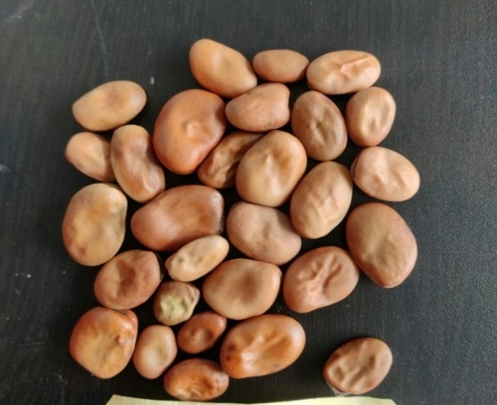 | 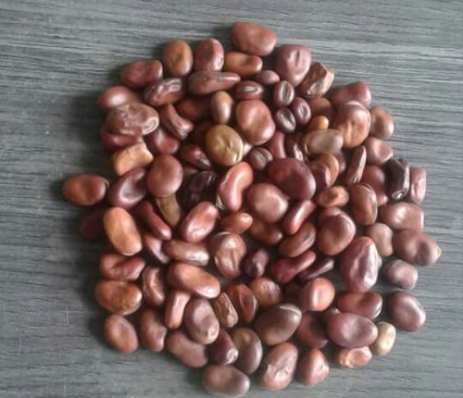 | 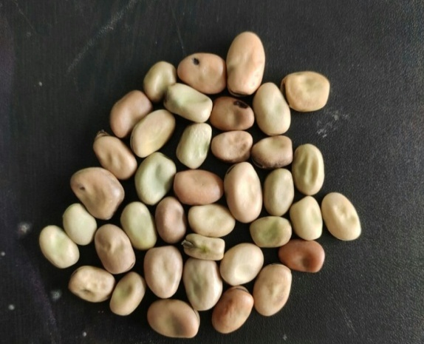
SKUA-VFB-106(a) | SKUA-VFB-107(a) | SKUA-VFB-108(a)
Fig 1. Variation in seed shape and seed coat colour
2.2 Isolation and identification of the causal pathogen
Samples were collected from naturally diseased faba bean plants, showing typical symptoms of root rot. The infected parts were then sliced into tiny pieces of 0.5 cm and surface disinfected with 2 % hypochlorite solution for 2 mins, washed couple of times in sterile distilled water and dried between sterile filter paper sheets. They were then placed on Petri dishes Then, they are placed in petri dishes containing potato Dextrose Agar (PDA) and incubated in the dark. The developed fungal colonies were purified by single-spore isolation. Identification of the isolates were carried out on 5-12 days old culture based on morphological features of mycelia (culture) and spores as well as culture appearances, the resulting isolates were recognized as Fusarium solani (Fig. 1a) [15] and all the genotypes were inoculated in the greenhouse. The categorization of genotypes was then based on disease intensity as per below given 1 to 9 disease scale of [16] which they have used for similar studies in bean. The fungi produce greyish- brown to black infection on feeder roots and progresses gradually towards the main root, Symptoms on foliage are also progressive, ranging from yellow leaves to pronounced yellowing of the top growth and severe stunting. Plants affected by root rot rarely branched and their roots and the basal portion of the stem were brown when cut open longitudinally. The resistance reaction of genotypes was tested by screening the genotypes under greenhouse conditions. Heavy selection pressure (inoculum load) was put on the genotypes by spraying a spore concentration of 2×10⁶ spores/ml. Identification of the isolates were carried out on 5-12 days old culture based on the morphological features of mycelia and spores as well as cultural characteristics. The isolates were identified as Fusarium solani . This pathogen produces colonies that are white and cottony. However, instead of developing a pink or violet centre like most Fusarium species, F. solani becomes blue-green or bluish brown. Fusarium solani colonies are low-floccose, loose, slimy and sporadic. On PDA, this fungus grows rapidly, but not as rapidly as Fusarium oxysporium. Fusarium solani produces asexual spores (microconidia and macroconidia). Its sexual state is Nectria haematococca (Ascomycete). It produces chlamydospores and overwinters as mycelium or spores in infected or dead tissues or seed. The categorization of genotypes was done based on disease intensity as per below given 1 to 9 disease scoring scale used for similar studies in bean as shown in (Table 2).
Table 2: Scale for assessment of disease severity in greenhouse.

Score | Description | Response
1 | No visible symptoms | Resistant
3 | 1 to 10 % of symptomatic leaves (leaves with mild chlorosis and wilting) | Resistant
5 | 11 to 25 % of symptomatic leaves (leaves with moderate chlorosis and wilting) | Intermediate
7 | 26 to 50 % of symptomatic leaves (leaves with severe chlorosis and wilting) | Susceptible
9 | Dead or severely infected plant | Susceptible

The screening of 47 genotypes for presence of characteristic symptoms of root rot was done under greenhouse conditions.
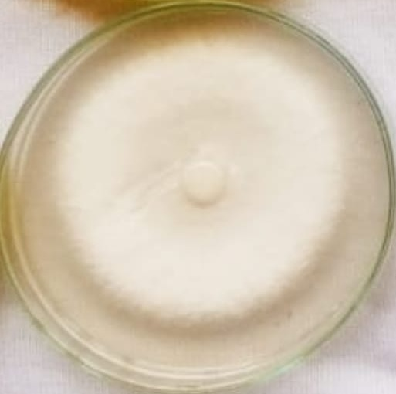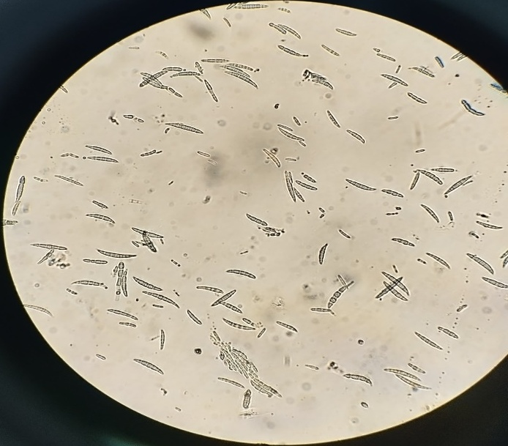
Fig.1a Culture and Spores of the Fusarium solani
  - Genetic Divergence
[17] D² analysis was used for assessing genetic divergence among the test genotypes involving quantitative characters. The D² values were obtained as the sum of squares of the differences between pairs of corresponding uncorrelated (s) values of any two uncorrelated genotypes [18]. Tocher method was employed to group the genotypes into clusters [19]. Genetic distance between clusters is equal to the square root of average D².
3. Results
3.1. Disease Resistance
Reactions of faba bean cultivars for resistance to Fusarium root rot under greenhouse conditions. It adversely affected faba bean production in many ways. Infect the seedlings prior to or shortly after emergence resulting in damping-off and death of the seedlings. It causes yield reduction of about 70% and in severe conditions causes complete yield loss. The root systems of adult plants may become severely diseased as shown in Figure 4, resulting in yellowing of the basal leaves, stunting of the plants and lower yields Occasionally there are no above‐ground symptoms, but a red discoloration can be seen on the root exterior and in the vascular system.
Out of forty-seven genotypes seven genotypes viz SKUA-VFB-102, SKUA-VFB-124, SKUA-VFB-122(a), SKUA-VFB-111(b), SKUA-VFB-120, SKUA-VFB-100(c), SKUA-VFB-104(b) show complete resistance to root rot, and twenty six genotypes viz SKUA-VFB-107(a), SKUA-VFB-107(d), SKUA-VFB-107(b), SKUA-VFB-105, SKUA-VFB-106(a), SKUA-VFB-119(a)(b), SKUA-VFB-106(b), SKUA-VFB-122(b), SKUA-VFB-125(a), SKUA-VFB-121(b), SKUA-VFB-116(a), SKUA-VFB-116(c), SKUA-VFB-111(a), SKUA-VFB-101(b), SKUA-VFB-108(a), SKUA-VFB-108(b), SKUA-VFB-110(b), SKUA-VFB-114, SKUA-VFB-112(a), SKUA-VFB-100(a), SKUA-VFB-100(b), SKUA-VFB-110(a), SKUA-VFB-117, SKUA-VFB-104(a), SKUA-VFB-123, SKUA-VFB-125(b) were intermediate to root rot and rest fourteen genotypes were susceptible to root rot as shown in (Table 3) and (figures 2 and 3). Our results coincide with those of [20]. Fusarium solani is one of the most isolated soils borne pathogens causing root rot and black rot in faba beans worldwide with yield reduction upto 45% [21, 22]. They found that black root rot (Fusarium solani) is known to cause great yield losses in faba bean, especially in the highlands of Ethopia. These results also coincide with that of [23].
Table 3: Categorization of genotypes for reaction to root rot pathogen
Scale | Category | Genotypes | No. of genotypes
1-4.9 | Resistant | SKUA-VFB-102, SKUA-VFB-124, SKUA-VFB-122(a), SKUA-VFB-111(b), SKUA-VFB-120, SKUA-VFB-100(c), SKUA-VFB-104(b) | 7
5-6.9 | Intermediate | SKUA-VFB-107(a), SKUA-VFB-107(d), SKUA-VFB-107(b), SKUA-VFB-105, SKUA-VFB-106(a), SKUA-VFB-119(a), SKUA-VFB-106(b), SKUA-VFB-122(b), SKUA-VFB-125(a), SKUA-VFB-121(b), SKUA-VFB-116(a), SKUA-VFB-116(c), SKUA-VFB-111(a), SKUA-VFB-101(b), SKUA-VFB-108(a), SKUA-VFB-108(b), SKUA-VFB-110(b), SKUA-VFB-114, SKUA-VFB-112(a), SKUA-VFB-100(a), SKUA-VFB-100(b), SKUA-VFB-110(a), SKUA-VFB-117, SKUA-VFB-104(a), SKUA-VFB-123, SKUA-VFB-125(b) | 26
7-9 | Susceptible | SKUA-VFB-116(b), SKUA-VFB-101(a), SKUA-VFB-113, SKUA-VFB-112(b), SKUA-VFB-109, SKUA-VFB-103(b), SKUA-VFB-103(c), SKUA-VFB-103(a), SKUA-VFB-107(c), SKUA-VFB-106(c), SKUA-VFB-119(b), SKUA-VFB-115, SKUA-VFB-118, SKUA-VFB-121(a) | 14

Fig. 2: Graphical representation of screening for root rot resistance in Vicia faba L.

Fig. 3: Graphical representation of screening for root rot resistance in Vicia faba L.

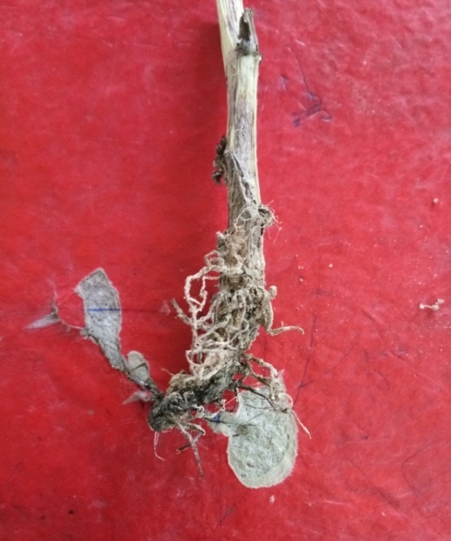

Fig. 4: Disease symptoms of Fusarium Solani
3.1.1 Genetic Divergence
Genetic diversity existing within and between groups of germplasm is important, and particularly, useful in proper choice of parents for realizing higher heterosis and obtaining useful recombinants. D² statistics are useful for estimating the genetic divergence in plant breeding experiments.
3.1.2 Clustering pattern of genotypes
Using Torcher’s method, all 47 genotypes were grouped into 16 clusters (Table 4). Cluster pattern indicated that cluster Ist was among the largest one having 18 genotypes followed by cluster III with 7 genotypes, Cluster II, IV, V, VI, VII, VIII, IX, X with 2 genotypes each and cluster XI, XII, XIII, XIV, X, XI with 1 genotype each. Grouping genotypes into different clusters from various regions showed genetic and regional diversity were related to each other.
Therefore, selection of diverse parents for genetic diversity-based hybridization programs would be more useful than regional diversity. Our observations are in close harmony with findings found by [24, 25].

Table 4: Clustering pattern of genotypes (Vicia faba)
Cluster No. | No. of genotypes | Genotypes
I | 18 | SKUA- VFB-107(d), SKUA- VFB-122(b), SKUA- VFB-101(b), SKUA- VFB-106(a), SKUA- VFB-100(c), 107(c), 116(b), 124, 103(b), 100(b), 118, 112(b), 112(a), 104(a), 104(b), 109, 102, 105
II | 2 | 108(b), 100(a)
III | 7 | 110(a), 103(c), 115, 110(b), 114, 123,117
IV | 2 | 116(c), 125(a)
V | 2 | 107(a), 101(a)
VI | 2 | 106(c), 108(a)
VII | 2 | 111(b), 113
VIII | 2 | 106(b), 121(b)
IX | 2 | 103(a), 125(b)
X | 2 | 121(a), 119(a)
XI | 1 | 107(b)
XII | 1 | 122(a)
XIII | 1 | 116(a)
XIV | 1 | 111(a)
XV | 1 | 120
XVI | 1 | 119(b)

4. Discussion
In the present study all the 47 genotypes were screened against the root rot in the greenhouse. Samples were collected from naturally diseased faba bean plants, showing typical symptoms of root rot. The infected parts were then sliced into tiny pieces of 0.5 cm and surface disinfected with 2 % hypochlorite solution for 2 min, washed couple of times in sterile distilled water and dried between sterile filter paper sheets. Then, they are placed in petri dishes containing potato Dextrose Agar (PDA) and incubated in the dark. The developed fungal colonies were purified by single-spore isolation. Identification of the isolates were carried out on 5-12 days old culture based on morphological features of mycelia and spores as well as culture appearances, the resulted isolates were recognized as Fusarium solani [26] and all the genotypes were inoculated in the greenhouse. The categorization of genotypes was done then based on disease intensity as per below given 1 to 9 disease scoring scale of Pastor Corrales and Abawi which they have used for similar studies in bean. The fungi produce greyish- brown to black infection on feeder roots and progresses gradually towards the main root, Symptoms on foliage are also progressive, ranging from yellow leaves to pronounced yellowing of the top growth and severe stunting. Plants affected by root rot rarely branched and their roots and the basal portion of the stem were brown when cut open longitudinally. The resistance reaction of genotypes was tested by screening the genotypes under greenhouse conditions. Heavy selection pressure (inoculum load) was put on the genotypes by spraying a spore concentration of 2×10⁶ spores/ml. Out of forty seven genotypes seven genotypes viz., SKUA-VFB-102, SKUA -VFB-124, SKUA-VFB-122(a), SKUA-VFB-111(b), SKUA-VFB-120, SKUA-VFB-100(c), SKUA-VFB-104(b) show complete resistance to root rot, and twenty six genotypes viz., SKUA-VFB-107(a), SKUA-VFB-107(d), SKUA-VFB-107(b), SKUA-VFB-105, SKUA-VFB-106(a), SKUA-VFB-119(a) (b), SKUA-VFB-106(b), SKUA-VFB-122(b), SKUA-VFB-125(a), SKUA-VFB-121(b), SKUA-VFB-116(a), SKUA-VFB-116(c), SKUA-VFB-111(a), SKUA-VFB-101(b), SKUA-VFB-108(a), SKUA-VFB-108(b), SKUA-VFB-110(b), SKUA-VFB-114, SKUA-VFB-112(a), SKUA-VFB-100(a), SKUA-VFB-100(b), SKUA-VFB-110(a), SKUA-VFB-117, SKUA-VFB-104(a), SKUA-VFB-123, SKUA-VFB-125(b) were intermediate to root rot and rest fourteen genotypes were susceptible to root rot. Our results coincide with that of [20] They evaluated 30 faba bean genotypes for two consecutive years and recorded data on incidence and severity of disease. Seeds of the accessions were sown in single and double rows. Mortality was recorded at emergence, seedling, podding and maturity. Results showed that 10 of the accessions (EHO7005, EHO7017, EHO7019, EHO7020, EHO7022, EHO7024, EHO7025, EHO7026, OBSE and GEBELECHO) were found to be moderately susceptible while the remaining 20 showed highly susceptible reactions. The moderately susceptible access may be considered for further improvement.
Fusarium solani is one of the most isolated soils borne pathogens causing root rot and black rot in faba bean worldwide with yield reduction upto 45% [27, 28] They found that black root rot (Fusarium solani) is known to cause great yield losses in faba bean, especially in the highlands of Ethiopia. These results also coincide with that of [29]
4.1 Genetic Divergence
Based on the divergence study, 47 faba bean genotypes involved in the present study were grouped into 16 clusters. Clustering pattern revealed the presence of considerable amount of genetic diversity in this material. In general, intra cluster distances were relatively lower than inter cluster distances showing the genotypes included within a cluster were genetically less diverse than the genotypes included in different clusters [30,31]. Cluster pattern indicated that cluster I was among the largest one having 18 genotypes followed by cluster III with 7 genotypes, Cluster II, IV, V, VI, VII, VIII, IX, X with 2 genotypes each and cluster XI, XII, XIII, XIV, X, XI with 1 genotype each.
4.1.1 Intra and inter cluster distances
The average intra and inter cluster D² values are given in Table 5. Intra-cluster D² scores vary from zero (cluster XI, XII, XIII, XIV, X and XVI) to 30.36 (cluster X). The highest intra-cluster distance was reported in cluster X (30.36) indicating genetic architecture of the genotypes present in clusters is variable. Intra-cluster distance was zero in clusters XI, XII, XIII, XIV X and XVI as they comprise only one genotype. The maximum inter-cluster distance of 192.7 was found between cluster XI and IV followed by 164.0 between the clusters XI and VII. The intra cluster distance ranged from 15.18 in cluster II to 30.36 in cluster X. The intra cluster distance in cluster XI, XII, XIII, XIV, XV, XVI was zero as each cluster contained one genotype. The highest inter- cluster gap (192.7) was found between cluster XI and IV suggesting that the genotypes included in those clusters may have completely different genetic makeup from each other. For improvement of faba bean, genetic diversity based on inter-cluster distances was appropriate. The genotypes grouped into diverse clusters can be selected as desirable parents for recovery of best segregants in hybridization programs. In general, intra cluster distances were relatively lower than inter cluster distances showing the genotypes included within a cluster were genetically less diverse than the genotypes included in different clusters. The inter-crossing of genotypes belonging to clusters (IV and XII) and clusters (X and I) may result in wide variation for efficient and effective selection process for seed yield.

Table 5: Average intra cluster (Diagonal) and inter cluster (Above Diagonal) distance values in Faba bean

4.1.2. Relative contribution of traits towards total genetic divergence
The usefulness of D² statistics was further demonstrated by its application in estimating the percentage contribution of individual traits to the total genetic (Figure 5). The contribution of 14 traits in faba bean genotypes as percent are given in Table 6. The evaluation of per cent contribution of various characters towards the expression of total genetic divergence indicated that the maximum contribution towards genetic diversity was contributed by days to 50 % flowering (14.5 %, days to 80 % maturity (11.4 %), plant height (5.7%), pod length (12.4 %), seed yield plant⁻¹ (11.3 %), seed index (6.3%), number of seeds pod⁻¹ (5.6 %), leaf width (5.5 %), leaf length (5.5%), number of pods node⁻¹ (5.2 %), pod width (4.5 %), pods plant⁻¹ 4.6% number of flowers inflorescence⁻¹ (3.6 %) and number of stems from main stem (3.8 %) contributed less towards less diversity. The need for parental diversity in optimum magnitude to obtain superior genotypes for recovery of transgressive segregants has also been repeatedly emphasized.
Table 6: Relative contribution of fourteen traits towards total diversity of faba bean (vicia faba)

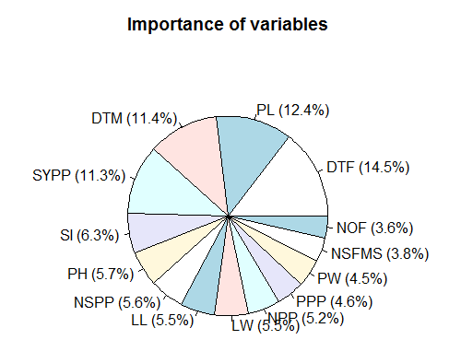

Figure 5: Frequency of fourteen traits towards total genetic diversity
5. Conclusion
Out of forty seven genotypes seven genotypes viz SKUA-VFB-102, SKUA-VFB-124, SKUA-VFB-122(a), SKUA-VFB-111(b), SKUA-VFB-120, SKUA-VFB-100(c), SKUA-VFB-104(b) show complete resistance to root rot, and twenty six genotypes viz SKUA-VFB-107(a), SKUA-VFB-107(d), SKUA-VFB-107(b), SKUA-VFB-105, SKUA-VFB-106(a), SKUA-VFB-119(a)(b), SKUA-VFB-106(b), SKUA-VFB-122(b), SKUA-VFB-125(a), SKUA-VFB-121(b), SKUA-VFB-116(a), SKUA-VFB-116(c), SKUA-VFB-111(a), SKUA-VFB-101(b), SKUA-VFB-108(a), SKUA-VFB-108(b), SKUA-VFB-110(b), SKUA-VFB-114, SKUA-VFB-112(a), SKUA-VFB-100(a), SKUA-VFB-100(b), SKUA-VFB-110(a), SKUA-VFB-117, SKUA-VFB-104(a), SKUA-VFB-123, SKUA-VFB-125(b) were intermediate to root rot and rest fourteen genotypes were susceptible to root rot. These resistant genotypes can serve as donors for transfer of root rot resistance into genotypes which are high yielding but are root rot susceptible. These resistant genotypes/ donors can effectively be used in developing mapping population for root rot resistance.

References
[1] C. Yude, H. Kaiwei, L. Fuji, Y. Jie, The potential and utilization prospects of kinds of wood fodder resources in Yunnan, Forestry Research 6 (1993) 346-350.
[2] A.K. Jukanti, P.M. Gaur, C. L. Gowda, R. N. Chibbar, Nutritional quality and health benefis of chickpea (Cicer arietinum L.): a review. British Journal of Nutrition 108 (2012) S11-S26.
[3] J. R. Harlan, Ethiopia: A Center of Diversity, Economic Botany. 23 (1969) 309-314.
[4] J. I. Cubero, On evolution Vicia faba L. ,Theoretical and Applied Genetics. 45 (3) (1974) 47-51.
[5] P. Hanelt and D. Mettin, Biosystematics of the genus Vicia L. (Leguminosae), Annual Review of Ecology and Systematics. 20(1) (1989) 199-223.
[6] T. T. Nagash, A. Asfaw, G. Tilahum, K. Mulat, S. S. Woldemarium, Evaluation of faba bean (Vicia faba L.) varieties against chocolate spot (Botrytis fabae) in North Gonder, Ethopia. African Journal Agriculture Research. 10(30) (2015) 20984-20988.
[7] P. Sharifi, 2015. Genetic variation for seed yield and some of agro- morphological traits in faba bean (Vicia faba L.) genotypes. Acta Agriculturae Slovenica 105(1) (2015) 73-83.
[8] S. N. Raina, Y. Ogihara, 1995. Ribosomal DNA repeat unit polymorphism in 49 Vicia species, Theoretical and Applied Genetics 90 (1995) 477–486.
[9] J.S. Johnston, M. D. Bennett, A. L. Rayburn, D. W. Galbraith, H. J. Price, 1999. Reference standards for determination of DNA content of plant nuclei, American Journal of Botany 86 (1999) 609–613.
[10] I. Z. Backouchi, M. Aouida, N. Khemiri, M. Jebara, Genetic diversity in Tunisian populations of faba bean (Vicia faba L.) based on morphological traits and molecular markers, Genetics and Molecular Research 14(3) (2015) 7587-7596.

[11] W. W. Hou, X. J. Zhang, J. B. Shi, Y. J. Liu, 2015. Genetic diversity analysis of faba bean (Vicia faba L.) germplasms using sodium dodecyl sulfate-polyacrylamide gel electrophoresis, Genetics and Molecular Research. 14(4) (2015) 13945-13953.
[12] A. Ouji, M. Naouari, M. Mouelhi, Y.M. Ben, Yield and yield components of faba Bean (Vicia faba L.) as influenced by supplemental. (2017).
[13] N. A. R. Tahir, 2015. Identification of genetic variation in some faba bean (Vicia faba L.) genotypes grown in Iraq estimated with RAPD and SDS-PAGE of seed proteins, Indian Journal of Biotechnology. 14 (2015) 351-356
[14] T. Negusse A. Seid, G. Dereje. T. Tesfaye, and F Chemeda, Research on diseases of food legumes, Increasing crop production through improved plant protection- Vol. I. Proceedings of the 14th Annual conference of the plant protection society of Ethiopia. (2008)
[15] K. H Domsch, W. Gams, and T. Anderson, Compendium of soil fungi. IHW Verlag, Eching, Germany, Technology in Engineering and Science. (2007) (1) 2348-7550.
[16] C. Pastor, M. A. and Abawi, G.S, Reactions of selected bean germplasm to infection by Fusarium oxysporium f. sp. Phaseoli, Plant Diseases. 71 (1987) 990-993.
[17] P. C. Mahalanobis, 1936. On the generalized distance in statistics, Proceedings of National Institute of Sciences. 2 (1936) 49-55.
[18] C. R. Rao, Multivariate analysis: An indispensable tool in statistical and in applied research, Sankhya. 22 (1960) 317 -338.
[19] C. R. Rao, 1952. Advanced Statistical Methods in Biometrical Research. John Wiley and Sons, New York. (1952) 236-272.

[20] B. Habtegebriel, and A. Boydom, Screening of faba bean Lines against black root rot Caused by Fusarium solani, Agricultural Research & Technology. 13(1) (2018) 555872.
[21] B. Bekele, G. G Muhammed. and T. Belayneh, Faba bean and field pea diseases research. In: Ali K (ed) Food and Forage Legumes: Progress and Prospects, Progress of the Workshop on Food and Forage Legumes. (2003) 221-227.
[22] E. Belete, Ayalew, A. and S. Ahmed, Anta-gonistic effect of native Bacillus isolates against black root rot of faba bean, African Crop Science Journal. 23 (3) (2015) 249-259.
[23] B. Habtegebriel, A. Boydom, Screening of faba bean Lines against black root rot Caused by Fusarium solani, Agricultural Research & Technology. 13(1) (2018) 555872.
[24] P. Kumar, J. S Hooda, B. Singh, S. Preeti, and S. K. Bishnoi, Genetic diversity and relationship study in faba bean genotypes of Indian and exotic origin, The Bioscan. 11(3) (2016) 2003-2006.
[25] S. K. Bishnoi, Genetic diversity in relation to heterosis and combining ability in faba bean (Vicia faba L.). Ph.D. thesis submitted to CCS Haryana Agricultural University, Hisar. (2016)
[26] K. H. Domsch, W. Gams, T. Anderson, Compendium of soil fungi. IHW Verlag, Eching, Germany, Technology in Engineering and Science. 1 (2007) 2348-7550.
[27] B. Bekele, G. G. Muhammed, T. Belayneh, Faba bean and field pea diseases research. In: Ali K (Ed) Food and Forage Legumes: Progress and Prospects, Progress of the Workshop on Food and Forage Legumes. (2003) 221-227.
[28] E. Belete, A. Ayalew, S. Ahmed 2015. Anta-gonistic effect of native Bacillus isolates against black root rot of faba bean, African Crop Science Journal. 23(3) (2015) 249-259.
[29] B. Habtegebriel. and A. Boydom, Integrated management of faba bean black root rot (Fusarium solani) through varietal resistance, drainage and adjustment of planting time, Journal of Plant Pathology and Microbiology. 7(7) (2016) 1-4.
[30] M. Fikreselassie, and H. Sebok, Genetic variability on seed yield and related traits of elite faba bean (Vicia faba L.) genotypes, Pakistan Journal of Biological Sciences. 1(6) (2012): 103-123.
[31] P. Sharifi, and H. Aminpana, A study on the genetic variation in some of faba bean genotypes using multivariate statistical techniques, Tropical Agriculture. 91(2) (2014).

