Genetic Evaluation for Variability, Heritability and Genetic Advance in Cucumber (Cucumis sativus L.) Genotypes

ABSTRACT
Cucumber (Cucumis sativus L.), an economically vital vegetable crop in India, exhibits extensive genetic diversity, making it a prime candidate for genetic enhancement. The present study was conducted during the zaid season of 2023–2024 at the Vegetable Research Farm, Acharya Narendra Deva University of Agriculture and Technology, Ayodhya, using 24 diverse cucumber genotypes in a Randomized Block Design with three replications. Significant differences among genotypes were observed for all 16 quantitative traits, indicating the presence of substantial genetic variability. Traits such as number of primary branches per plant, node number bearing first staminate flower, and ascorbic acid content showed high genotypic and phenotypic coefficients of variation. High heritability estimates coupled with high genetic advance as a percentage of the mean were recorded for ascorbic acid, TSS, fruit yield per plant, number of primary branches, and fruit yield per hectare, suggesting additive gene action and effectiveness of direct selection. Genotypes VRCU-2249, Pusa Uday, and Arka Veera outperformed the standard check (Pant Khira-1) in yield, indicating their potential utility in future breeding programs aimed at yield enhancement. The results underscore the importance of exploiting genetic variability for the genetic improvement of cucumber.
Keywords: Cucumber, genetic variability, heritability, genetic advance, PCV, GCV, yield improvement.
- INTRODUCTION
Cucumber (Cucumis sativus L.), a member of the Cucurbitaceae family, is an economically and nutritionally important vegetable crop widely cultivated in tropical and subtropical regions. Originating in India, cucumber exhibits considerable genetic diversity in both vegetative and fruit traits, making it a valuable crop for genetic improvement. As a vegetable crop, cucumber is of great economic importance. In India, cucumber is grown over an area of 139 million hectares, with an annual production of 2050 metric tons (Ministry of Agriculture and Farmer Welfare, 2023-24). While in Uttar Pradesh cucumber is grown in an area of 4.58 million hectares, with an annual production of 118.67 metric tons (Ministry of Agriculture and Farmer Welfare, 2023-24). Despite its significance, cucumber remains underexploited in terms of breeding potential, partly due to the complex quantitative nature of many economically important traits. Understanding genetic variability, heritability, and trait associations is essential for effective selection and yield enhancement. Parameters such as genotypic and phenotypic coefficients of variation, heritability estimates, and genetic advance offer valuable insights for identifying superior genotypes.
--
- MATERIALS AND METHODS
The present investigation was carried out during the zaid season of 2023-2024 at the Vegetable Research Farm, Acharya Narendra Deva University of Agriculture and Technology, Kumarganj, Ayodhya (U.P.), Twenty-four, diverse cucumber genotypes, viz., VRCU-2203, VRCU-2213, VRCU-2217, VRCU-2236, VRCU-2244, VRCU-2249, NDCU-23-1, NDCU-23-2, NDCU-23-3, NDCU-23-4, NDCU-23-5, NDCU-23-7, NDCU-23-8, NDCU-23-9, NDCU-23-10, NDCU-23-11, NDCU-23-12, NDCU-23-13, NDCU-23-14, Arka Veera, Gujarat Cucumber -1, Pusa Uday, Punjab Naveen, Pant Kheera-1 were planted in Randomized Block Design with three replications. Individual replication consisted of ten plants per genotype, of which five representative plants each were selected and tagged for recording observations. The climatic conditions were moderate and suitable for cucumber cultivation. The soil at the experimental site was sandy loam with average fertility level and slightly alkaline in nature with p^{H} 8.5. Spacing followed was 1.5m x 0.6 m. All the cultural practices were carried out as per the package of practices.
Analysis of variance (ANOVA) for individual characters was done on the basis of mean values, as per Panse and Sukhatme (2000). Components of variance, heritability and genetic advance were estimated as per Burton and Devane (1953), Falconer (1981) and Johnson et al (1955), respectively.
- RESULTS AND DISCUSSION
Genetic variability is a pre-requisite for a successful breeding program in any crop species, and a critical survey of the available genetic variability is essential before initiating an improvement program (Haussmann et al, 2004). A close proximity in the phenotypic and genotypic coefficients of variability was observed, indicating little influence of environment on expression of the various traits studied. Analysis of variance for various quantitative characters revealed that mean squares were significant for all the traits under study, indicating an existence of sufficient genetic variability for all the plant characters studied, and the variation due to replication was non-significant (Table-1).
Table: 1 Analysis of variance (mean squares) for sixteen characters in cucumber.
S.  No. | Traits | Source of variation
S.  No. | D.F | Replication | Treatments | Error
S.  No. | D.F | 2 | 23 | 46
1. | Days to first staminate flower anthesis | 3.23 | 35.67** | 4.86
2. | Days to first pistillate flower anthesis | 8.99 | 42.89** | 5.29
3. | Node number bearing first staminate flower | 4.96 | 15.99** | 4.76
4. | Node number bearing first pistillate flower | 0.063 | 0.227** | 0.094
5. | Days to first fruit harvest | 0.080 | 0.437** | 0.107
6. | Number of primary branches per plants | 0.013 | 0.006** | 0.002
7. | Number of nodes per vine | 6.24 | 125.10** | 9.69
8. | Fruit length (cm) | 0.227 | 0.820** | 0.165
9. | Fruit diameter(cm) | 0.012 | 0.037** | 0.011
10. | Average fruit weight(g) | 2.46 | 10.76** | 0.89
11. | Vine length(m) | 0.80 | 9.41** | 0.74
12. | No of fruits per plant | 2.50 | 20.93** | 6.36
13. | Fruit yield per plant (kg) | 134.16 | 6107.09** | 507.88
14. | Fruit yield per hectare(q) | 478.83 | 2871.56** | 213.52
15. | T.S.S | 0.247 | 0.987** | 0.167
16. | Ascorbic acid(mg/100g) | 0.216 | 3.889** | 0.235

Days required for opening of the first staminate flower exhibited a high variability among the traits studied, ranging from 34.60 to 45.27 in Punjab Naveen and NDCU-23-13, respectively, with a general mean of 39.65. Mean days required for opening of the first pistillate flower was 45.30, which ranged from 37.20 (Punjab Naveen) to 51.27 days (Gujarat cucumber -1). Mean node number at which first staminate flower was 4.87, with ranged from 3.37(Punjab Naveen) to 6.75(NDCU-23-10). Mean node number at which first pistillate flower was 9.11, with ranged from 8.54(Punjab Naveen) to 10.22(VRCU-2236). Mean days to first fruit harvest was 54.99 days, ranging from 44.87 days (Punjab Naveen) to 60.07 (NDCU-23-13). Mean number of primary branches per plant was 3.03, with ranged from 2.00 (VRCU-2244) to 4.30 (NDCU-23-13). Mean number of nodes per vine was 18.67, with maximum number of nodes 22.49 seen in (VRCU-2244) and the least number of nodes 15.92 in Punjab Naveen. Minimum fruit length was recorded in Pant Khira -1(14.36 cm) and maximum in VRCU-2203 (20.92 cm), with an overall mean of 17.66 cm. Mean diameter of fruit was 3.74 ccm,which ranged from 2.91 cm in NDCU-23-3 to 4.75 cm in Arka Veera. Average fruit weight was recorded minimum in NDCU-23-8 (131.29 g) and maximum in VRCU-2203 (187.88 g), with a mean value of 165. 43g.Vine length ranging from 2.35 m in NDCU-23-11 to 2.78 m in Arka Veera, with a mean value of 2.64 m. Number of fruit per plant ranging from 6.13 in VRCU-2213 to 9.35 VRCU-2249, with a mean value of 7.83. Mean value of TSS was 3.40, with ranged from 2.92 (NDCU-23-3) to 4.24 (Pant Khira-1). Mean Ascorbic acid was 3.94, ranging from 3.14 to 4.97 in NDCU-23-11. Fruit yield per plant ranged from 0.95 kg in NDCU-23-1 to 1.63 kg in VRCU-2249 with a mean of 1.29 kg. Mean of fruit yield q/ha was 144.16, ranging from 108.13 NDCU-23-11 to 184.87 VRCU-2249.
Table: 2 Estimates of range, grand mean, phenotypic coefficient of variation (PCV), genotypic coefficient of variation (GCV), heritability in broad sense, genetic advance (Ga) and genetic advance in per cent of mean for fourteen characters of cucumber
Sr.  No  . | Traits | Range |  | Grand Mean | GCV % | PCV % | h²  (Broad  Sense) % | Genetic Advance | Gen.  Adv. as  % of  Mean
Sr.  No  . | Traits | Lowest | Highest
1. | Days to first male flower appear | 34.60 | 45.27 | 39.65 | 8.08 | 9.81 | 67.89 | 5.44 | 13.72
2. | Days to first female flower appear | 37.20 | 51.27 | 45.30 | 7.81 | 9.32 | 70.30 | 6.11 | 13.50
3. | Node no at which first male flower appears | 3.37 | 6.75 | 4.87 | 20.06 | 22.16 | 81.94 | 1.82 | 37.41
4. | Node no at which first female flower appears | 8.54 | 10.22 | 9.11 | 5.06 | 7.47 | 45.88 | 0.64 | 7.06
5. | Days to first fruit harvest | 44.87 | 60.07 | 54.99 | 6.73 | 8.38 | 64.41 | 6.12 | 11.121
6. | No of primary branches | 2.00 | 4.30 | 3.03 | 22.93 | 24.78 | 85.65 | 1.32 | 43.72
7. | Number of nodes per vine | 15.92 | 22.49 | 18.67 | 7.86 | 10.16 | 59.82 | 2.34 | 12.52
8. | Fruit length (cm) | 14.36 | 20.92 | 17.66 | 9.04 | 11.73 | 59.35 | 2.53 | 14.34
9. | Fruit diameter (cm) | 2.91 | 4.75 | 3.74 | 11.51 | 13.94 | 68.14 | 0.73 | 19.56
10. | Average Fruit weight(g) | 131.29 | 187.88 | 165.43 | 7.91 | 9.90 | 63.83 | 21.55 | 13.02
11. | Vine length (m) | 2.35 | 2.78 | 2.64 | 3.29 | 6.12 | 28.87 | 0.10 | 3.64
12. | No of fruit per plant | 6.13 | 9.35 | 7.83 | 9.86 | 13.51 | 53.33 | 1.16 | 14.84
13. | T.S.S | 2.92 | 4.24 | 3.40 | 9.38 | 9.44 | 98.67 | 0.65 | 19.19
14. | Ascorbic acid | 3.14 | 4.97 | 3.94 | 14.67 | 14.68 | 99.85 | 1.19 | 30.20
15. | Fruit yield per plant(kg) | 0.95 | 1.63 | 1.29 | 11.98 | 12.77 | 87.92 | 0.30 | 23.14
16. | Fruit yield (q/ha) | 144.16 | 184.87 | 144.16 | 11.98 | 13.06 | 84.23 | 32.66 | 22.66

  - GENOTYPIC AND PHENOTYPIC COEFFICIENT OF VARIATION
The phenotypic coefficient of variation was observed lowest in vine length (6.12%) while it was highest in no. of primary branches (24.78%), followed by node no. at which first staminate flower appears (22.16%) and Moderate estimate of PCV was observed in ascorbic acid (14.68%),fruit diameter (13.94%), no. of fruit per plant (13.51%), fruit yield q/ha (13.06%) fruit yield per plant (12.77%),fruit length (11.73%),number of nodes per vine (10.16%).
Genotypic coefficient of variation was recorded minimum in vine length (3.29%) whereas it was maximum in number of primary branches (22.93%), followed by node number first male flower appears (20.06%), moderate estimate of GCV was recorded in ascorbic acid (14.67%), fruit yield per plant (kg) (11.98%), fruit yield q/ha (11.98).
In general, the phenotypic coefficient of variation was higher than the genotypic coefficient of variation for all the characters which are under the study indicated that environment played very crucial role in the expression of these characters. High magnitude of the PCV than the GCV shows additive gene expression.
Similar, results have been reported by Deepak et al. (2020) that no. of primary branches (PCV 15.17% and GCV 11.97%) ,node number at which first female flower appear (PCV 29.48% and GCV 28.64%), Appearance of first male flower ( PCV 7.63% and GCV 4.62%), Appearance of first female flower (PCV 6.33% and GCV 3.13%), days to first fruit harvesting (PCV 5.59% and GCV 2.70%), number of fruit per plant (PCV 11.24% and GCV 7.94%), fruit length (16.39% to 15.18%), fruit diameter (23.85% and PCV 20.86%), average fruit weight (PCV 14.17% and GCV 12.47%), fruit yield per plant (PCV 19.16% and 15.28%) demonstrating a wide range of genetic variability for these traits.
A perusal of the result revealed that estimates of phenotypic coefficient of variation were higher than genotypic coefficient of variation indicating relative effect of environment along with genotype in governing these traits (Table 2). The estimates of PCV and GCV were high for node no at which first male flower appears and number of fruits per plant indicating considerable amount of variability and ample scope of improvement through selection (Table 2). However, the PCV and GCV were moderate for fruit diameter, fruit weight, internodal length, vine length, fruit yield per plant and ascorbic acid suggesting that there are less chances of improvement through direct selection. Bhagwat et al. 2016 obtained high PCV for number of fruits per plant and fruit yield per plant in cucumber genotypes in Karnataka. Pushpalatha et al. 2016, Rajawat and Collis 2017 and Kandasamy [33] obtained similar results, high genotypic coefcient of variation was observed for number of fruits per plant and fruit yield per plant.

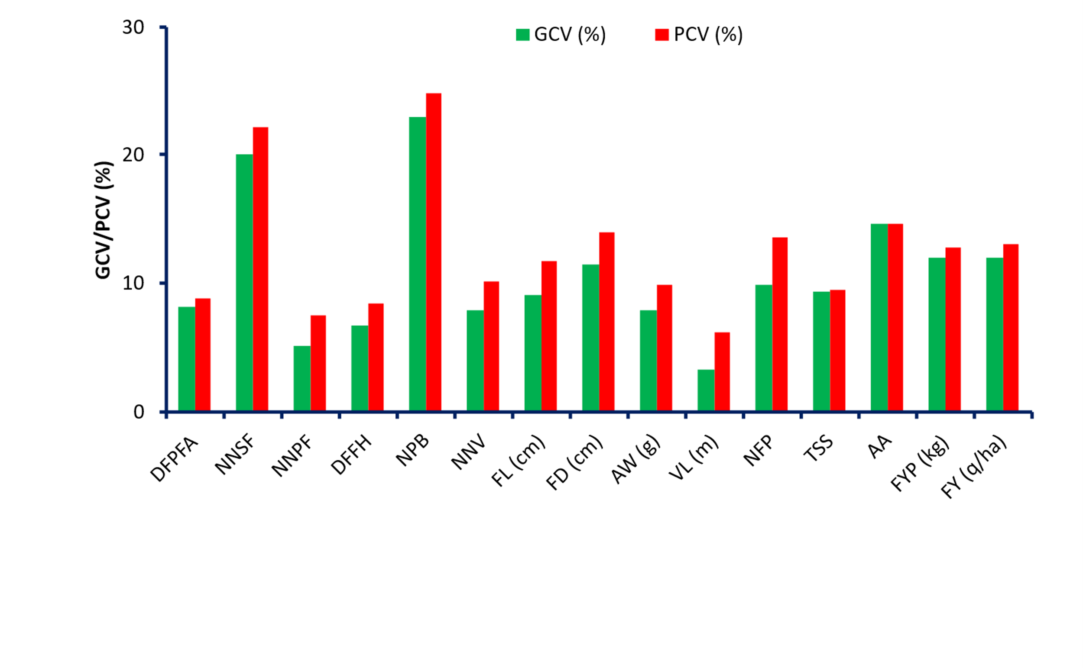
Fig. 1. Effect of phenotypic coefficient of variation (PCV) and genotypic coefficient of variation (GCV) for fourteen characters of cucumber

  - HERITABILITY AND GENETIC ADVANCE
Heritability was estimated with genetic advance to assess the extent of improvement in an individual trait. High estimates of heritability (>80%) was recorded in characters i.e. Ascorbic acid (99.85 %) followed by TSS (98.67%) followed by fruit yield per plant(kg) (87.92%), number of primary branches per plant (85.65%), fruit yield (q/ha) (84.23%). Apart from this moderate heritability (>60% to <80%) were recorded in days to first pistillate flower appear (70.30%) followed by fruit diameter (68.14%), days to first staminate flower appear (67.89%), days to first fruit harvest (64.41%), and average fruit weight (g)(63.83%). Low heritability (<60%) was recorded in fruit length (59.35%) followed by number of fruits per plant (53.33%), node no. at which first pistillate flower (45.88%) and vine length (28.87%).
Similar result in high heritability also reported by Deepak et al. (2022). They recorded high heritability (>80%) in node number at which first female flower appeared (94%), fruit length (85%). Moderate h² (>60% to <80%) was recorded in fruit diameter (76%), and average fruit weight (71%). Low heritability (<60%) was found in number of fruits per plant (49%), appearance of first male flower (36%) and appearance of first female flower (24%).
High heritability (> 80 %) coupled with high genetic advance in per cent of mean (> 20%) were recorded for Ascorbic acid (99.85% and 30.20%) followed by TSS (98.67% and 19.19%) followed by fruit yield per plant kg (87.92% and 23.14%), Number of primary branches per plant (85.65% and 43.72%), fruit yield q/ha (84.23% and 22.66%). Node number bearing first staminate flower (81.94 and 37.41%). indicating that these traits were little influenced by environment. Thus, required low selection intensity for improvement.
Highest value of genetic advance in percent of mean was shown by number of primary branches (43.72) whereas least value was observed in vine length (3.64). The character which observed very high estimates of genetic advance was fruit yield per hectare (32.66) and lowest genetic advance was reported for vine length (0.10).
Similar results were also reported by Yadav et al. (2023). They recorded high genetic advance as per cent of mean in node number to first male flower (76.97%) followed by fruit yield (q/ha) (64.03%), fruit yield per plant (64.01%), node number to first female flower (61.18%). Low genetic advance in per cent of mean found in days to first harvest (3.58%) followed by days to first female flower (5.38%).
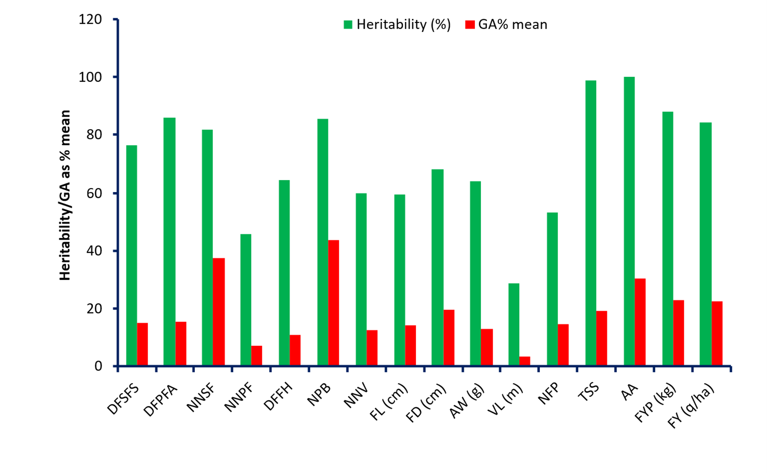
Fig. 2. Effect of Heritability (%) and genetic advance in per cent of mean for fourteen characters of cucumber
The ratio of genotypic to phenotypic variation is known as heritability due to broad sense. It is an excellent indicator of character inheritance from parents to the next generation (Falconer, 1981). The precision with which a genotype may be recognised by its phenotypic performance is referred to as heritability. Indeed, heredity encompasses both additive and non-additive effects in a wide sense (Hanson et al., 1956). High amount of heritability indicates that those traits are less influenced by environment and maximum portion of variance was contributed by the genotype and therefore, selection based on phenotype will be useful while low heritability signs towards more influence of environment and less heritable to next generation (Yadav et al., 2012). Genetic advance is the result of a direct connection between heritability and responsiveness to selection. The most successful condition for selection is strong genetic advance combined with high heritability estimates (Larik et al., 2000). When heritability is employed to compute genetic advance, it shows the degree of gain in a particular character under a given selection pressure, its usefulness rises. Hence, genetic advance is an essential selection criterion that helps breeders in their selection process. High to moderate heritability and genetic gain was observed for fruit length, fruit diameter, fruit weight, vine length, number of fruits per plant, fruit yield per plant and ascorbic acid amongst the cucumber genotypes which indicated possible improvement by direct selection. Similar results for high heritability in cucumber were observed by Kumar et al. 2008 and Gaikwad et al. 2011 and Veena et al. 2012 for fruit length and number of fruits per plant. Choudhary et al. 2015 obtained similar results of high heritability for fruit weight, fruit diameter and fruit yield per plant. Kumar et al. 2008 and Veena et al. 2012 obtained similar results of high genetic gain for fruit length, fruit diameter and number of fruits per plant in cucumber. Pal et al. (2016) obtained high heritability for fruit yield per plant.
- CONCLUSION
Knowledge of genetic variability assessed via estimation of coefficient of variation, heritability (broad sense) and genetic advance, were of paramount importance in formulating trait-specific breeding. In the present study, cucumber genotypes VRCU-2249 (184.87) followed by Pusa Uday (166.77), Arka Veera (163.77), NDCU-23-14 (161.33), NDCU-23-2 (161.10), Punjab Naveen (160.84), Gujarat Cucumber-1 (157.89),NDCU-23-7 (153.55), NDCU-23-4 (150.76), VRCU-2236 (146.21), NDCU-23-1 (145.26) q/ha were found significant over best check Pant Khira -1(144.33) q/ha can be utilized in breeding programmers. The estimates of PCV and GCV were moderate for fruit diameter, fruit weight, vine length, fruit yield per plant and ascorbic acid. Similarly, high to moderate heritability and genetic gain was observed for fruit length, fruit diameter, fruit weight, vine length, number of fruits per plant, fruit yield per plant and ascorbic acid amongst the studied genotypes which indicates high transmission of these traits to the next generation. This shows that selection mostly focused on fruit weight, number of fruits per plant, fruit length and fruit yield (q/ha) would ultimately enhance the fruit yield of cucumber.

REFERENCES
Bhagwat, A., Srinivasa, V., Bhammanakati, S. & Shubha A.S. (2018). Genetic variability studies in cucumber (Cucumis sativus L.) genotypes under hill zone of Karnataka. International Journal of Chemical Studies, 6, 925–8. https://www.researchgate.net/publication/353406445
Burton, G.W. & Dewane, E.V.M. (1953). Estimating heritability in tall fescue (Festuca arundinacea L.) from replicated clonal material. Agronomy Journal, 45, 478 481. doi:10.2134/agronj1953.00021962004500100005x
Choudhary, H., Singh, D.K. & Damke, S.R. (2015). Genetic variability study in Cucumis sativus var. hardwickii: key to cucumber improvement. International Journal of Basic and Applied Agricultural Research, 13, 340–3.
Deepak, A.B. Pramila, K.P. & Gupta, R.K. (2020). Assessment of Genetic Variation and Genetic Divergence in Cucumber (Cucumis sativus L.). International Journal of Current Microbiology and Applied Sciences, Special Issue-11, 2644-2653. https://www.ijcmas.com/special/11/A.%20B.%20Deepak,%20et%20al.pdf
Falconer, D.S. (1981). Introduction to quantitative genetics. Second edition, London Longman Group Ltd., Longman House, Harrow, England, pp. 350.
Gaikwad, A.G., Musmade, A.M., Dhumal, S.S. & Sonawane, H.G. (2011). Variability studies in cucumber (Cucumis sativus L.). Ecology, Environment and Conservation. 17(4), 799-802. at: https://www.researchgate.net/publication/263926003
Hanson, C.H. & Robinson, C.R.E. (1956). Biometrical studies of yield in segregating populations of Korean Leaspedeza. Agronomy Journal, 48, 268–72. https:// doi.org/10.2134/agronj1956.00021962004800060008x.
Haussmann, B.I.G., Parzies, H.K., Presterl, T., Susic, Z. and Miedaner, T. (2004). Plant genetic resources in crop improvement. Plant Genetic Resources, 2, 3-21 DOI:10.1079/PGR200430
Johnson, H.W., Robinson, H.F. & Comstock, R.E. (1955). Genetic and environmental variability in soyabean. Agronomy Journal, 47, 314-318.
Kandasamy, R. (2017). Variability studies in cucumber (Cucumis sativus L.). Asian Journal Horticulture. 12, 84–7. https://doi.org/10.15740/HAS/TAJH/12.1/ 84-87.
Kumar, A., Kumar, S. & Pal, A.K. (2008). Genetic variability and characters association for fruit yield and yield traits in cucumber. Indian Journal of Horticulture, 65 (4), 423-428.
Ministry of Agriculture and Farmer Welfare,2023-24: Area and Production of Horticulture Crops for 2023-24 (Final Advance estimates) https://agriwelfare.gov.in/en/StatHortEst
Pal, S., Sharma, H.R., Rai, A.K. & Bhardwaj, R.K. (2016). Genetic variability, heritability and genetic gain for yield and quality traits in cucumber (Cucumis sativus L.). The Biobrio - An International Quarterly Journal of Life Sciences, 11,1985–90. https://www.researchgate.net/publication/312580400
Panse, V.G. & Sukhatme, P.V. (2000). Statistical methods for agricultural workers. Publication and Information, Division of ICAR, New Delhi.
Pushpalatha, N., Anjana:a, M., Deva:a, V. & Pitchaimuthu, M. (2016). Genetic variability and heritability for growth and yield in cucumber (Cucumis sativus L.). Journal of Horticultural Sciences, 11(1), 33-36. https://doi.org/10.24154/jhs.v11i1.100
Rajawat, K.S. & Collis, J.P. (2017). Genetic variability, Heritability and Genetic advances analysis for quantitative and qualitative traits in Cucumber (Cucumis sativus L.). Journal of Pharmacognosy and Phytochemistry, 6(4), 882-885. https://www.phytojournal.com/archives/2017/vol6issue4/PartM/6-4-286-511.pdf
Veena, R., Sidhu, A.S., Pitchaimuthu, M. & Souravi, K. (2012). Genetic evaluation of cucumber (Cucumis sativus L.) genotypes for some yield and related traits. Electronic Journal of Plant Breeding, 3, 945–8. https://www.cabidigitallibrary.org/doi/pdf/10.5555/20123342944
Yadav, Y.C., Kumar, S. and Singh, R. (2012). Studies on genetic variability, heritability and genetic advance in cucumber (Cucumis sativus L.). HortFlora Research Spectrum, 1, 34–7. https://www.phytojournal.com/archives/2020/vol9issue5/PartG/9-4-344-676.pdf

