**Original Research Article**

**Scientific Validation of Indigenous Technical Knowledge for Eco-Friendly Management of Sucking Pest Complex Using Standardized Screening Protocols**

**Abstract**

Indigenous Technical Knowledge (ITK) are widely emerging and discussed concept of recent trends in Agriculture. ITK is a practice of using Naturally available or derived products of Nature are used to solve the problems pertaining in Agriculture and Allied activities. ITK method of pest control is effective way to control pest than using of conventional pesticides. The continuous usage of conventional pesticides on specific pest causes Pest Resistance,Pest Resurgence and Outbreak of Secondary Pest. This situation can be avoided or prevented in case of following ITK practices and in turns increases farmers profit and output. The ITK Practices also reduces Environmental contamination, Health hazards to humans, animals and other non-target Natural Enemies and reduction in quality and quantity of grains in food production. The sucking pest are polyphagous pest and destructive creatures of all cultivated crop plants throughout the world. This study reveals that successful utilization of ITK practices for management of sucking pest such as White fly, Thrips, Aphids and Mealy bugs etc. These ITK Practices can be Impregnated as effective control measures for sucking pest in Integrated Pest Management (IPM).

**Key words:**Indigenous Technical Knowledge, Sucking pests, Integrated pest management.

**Introduction**

Indigenous Technical Knowledge (ITK) represents an emerging paradigm in sustainable agriculture. ITK involves the application of nature-derived products and traditional practices to address agricultural challenges, particularly pest management. This study highlights the efficacy of ITK in managing sucking pests such as whiteflies, thrips, aphids and mealybugs. Compared to synthetic pesticides, ITK methods offer multiple advantages including reduced environmental impact, prevention of pest resistance, and improved crop health. This paper highlights practical ITK implementations from farmers in Tamil Nadu, India, and suggests their integration into formal Integrated Pest Management (IPM) programs(Dash and Mishra2022).

Sustainable agriculture increasingly relies on environmentally sound pest management strategies to combat challenges such as pesticide resistance, resurgence of pests, and degradation of ecological balance. Indigenous Technical Knowledge (ITK), traditionally used by farming communities, offers valuable insights into such sustainable practices. ITK refers to locally adapted and time-tested methods based on natural resources to manage weeds, pests, and diseases effectively without causing ecological harm (Sannigrahi, 2013).Sucking pests such as whiteflies (*Bemisiatabaci*), thrips (*Thripidaespp*.), Aphids (*Aphis spp.*) and mealybugs (*Pseudococcidae spp.*) damage crops by piercing and sucking sap, leading to wilting and yield loss (Rani*et al*., 2020). Unlike synthetic pesticides, which pose risks of environmental contamination and non-target species toxicity, ITK-based practices use biodegradable and locally available materials like garlic, tobacco, neem, and chilli (Abubakar*et al*., 2022). ITK not only suppress pest populations but also encourage natural predator presence and biodiversity (Angon*et al*., 2023).

**Materials and Methods**

This study adopted a qualitative and field-based approach to explore the efficacy and application of Indigenous Technical Knowledge (ITK) in pest management, particularly targeting sucking pests. The work involved a combination of primary data collection from local farming communities in Tamil Nadu (Madurai) and evaluating these practices for scientific validation (Table 1).The districts of Madurai were purposively selected due to their active engagement in organic farming and consistent use of ITK by local farmers. These areas also represent diverse agro-climatic conditions, ranging from dry plains to semi-humid zones, enabling an understanding of ITK practices across different crop ecosystems.Informal focus group discussions were conducted with over 6 blocksto gather detailed knowledge of ITK practices. The interactions focused on, types of pests observed (thrips/aphids/whiteflies/mealybugs), Materials used for pest management, Preparation and application methods, Perceived efficacy and crop outcomes. The pest infestation sick plots were created and consistently ITK practices were applied during the crop cycle. The efficacy of practices was qualitatively assessed based on, visual pest damage score and presence of pest population (per plant counts).Control plot without any ITK approaches or Pesticide Spray were grown for basic comparative purposes. The ITK number has been given for each pest for easy representation (Table 1). The list of crops grown for evaluation of various sucking pest complex is given in table 2. The screening procedure was adopted from Marullo*et al*., 2021 for thrips screening.The scoring procedure was adopted fromBabura and Mustapha (2012)for aphids screening. The screening procedure was adopted from Mathulwe*et al*., 2022 for mealybugs screening. The screening procedure was adopted fromYadav*et al*., 2022 for whitefly screening. The scoring procedures based on pest population is tabulated from table 3 to table 6.

**Table 1. Selected ITK practices for screening**

|  |  |  |
| --- | --- | --- |
| **S. No.** | **ITK Practice** | **ITK Number** |
| 1. | Onion and garlic juice 10 ml per liter | ITK 1 |
| 2. | Extract of garlic 5 kg + tobacco 250 gm + 500 gm chilly in 10 lit of water | ITK 2 |
| 3. | Spraying of castor oil mixed with neem paste 10 ml per litre of water | ITK 3 |
| 4. | Neem Seed Kernal Extract (NSEK) @ 5ml per Litre of water | ITK 4 |
| 5. | 1 kg cow dung, 1 liter of cow urine, 30 gm of lime are mixed with 10 liters of water and then kept for one month for fermentation | ITK 5 |
| 6. | No ITK or Chemical spray | Control |

**Table 2. Sucking pests complex screening in various crops**

|  |  |  |  |
| --- | --- | --- | --- |
| **S. No.** | **Crop** | **Scoring for Sucking Pests** | **ITK evaluated** |
| 1. | Tomato | Whitefly, Thrips and Mealybugs | ITK 1, ITK 2, ITK 3, ITK 4, ITK 5 and Control |
| 2. | Chilli | Thrips and Aphids | ITK 1, ITK 2, ITK 3, ITK 4, ITK 5 and Control |
| 3. | Brinjal | Aphids, Whitefly and Mealybugs | ITK 1, ITK 2, ITK 3, ITK 4, ITK 5 and Control |
| 4. | Bhendi | Aphids and Whitefly | ITK 1, ITK 2, ITK 3, ITK 4, ITK 5 and Control |

**Table 3. Scoring Scale for Mealybugs**

|  |  |  |
| --- | --- | --- |
| **Score** | **Pest Load** | **Symptoms** |
| 0 | No mealybugs | Healthy |
| 1 | 1–10 mealybugs/plant | Light infestation on stem/shoots |
| 2 | 11–50 mealybugs/plant | Moderate infestation, visible cottony masses |
| 3 | 51–100 mealybugs/plant | Wilting of branches, leaf drop, mild sooty mold |
| 4 | >100 mealybugs/plant | Severe infestation; stunting, yellowing, heavy sooty mold |

**Table 4. Scoring Scale for Aphids**

|  |  |  |
| --- | --- | --- |
| **Score** | **Aphid Count per Plant** | **Plant Symptoms** |
| 0 | No aphids | Healthy plant |
| 1 | 1–10 aphids | No visible damage |
| 2 | 11–25 aphids | Mild yellowing, slow growth |
| 3 | 26–50 aphids | Leaf curling, reduced vigor |
| 4 | 51–100 aphids | Severe curling, distorted growth |
| 5 | >100 aphids | Plant stunting, sticky honeydew, reduced yield potential |

**Table 5. Scoring Scale for Whitefly**

|  |  |  |
| --- | --- | --- |
| **Score** | **Pest Incidence** | **Symptom Description** |
| 0 | No whiteflies observed | Healthy plant |
| 1 | 1–5 adults per plant | No visible symptoms |
| 2 | 6–10 adults per plant | Slight yellowing, no curling |
| 3 | 11–20 adults per plant | Moderate yellowing and leaf curling |
| 4 | 21–30 adults per plant | Distinct curling and stunting |
| 5 | >30 adults per plant | Severe leaf curling, stunting, and yellowing |

**Table 6. Scoring Scale for Thrips**

|  |  |  |
| --- | --- | --- |
| **Score** | **Pestload** | **Description** |
| 0 | No thrips | Healthy plant, no symptoms. |
| 1 | 1–5 thrips | Slight presence; no visible damage. |
| 2 | 6–10 thrips | Initial feeding symptoms on leaves or flowers; curling or silvering begins. |
| 3 | 11–20 thrips | Damage on 25–50% of plant area; distorted buds or flowers. |
| 4 | 21–50 thrips | Damage on >50% of plant; leaves curling, flower drop, stunted growth. |
| 5 | >50 thrips | Heavy damage, yield loss, flower/bud abortion, necrosis. |

**Results and Discussion**

Farmers reported high efficacy of ITK formulations in reducing the population of sucking pests like whiteflies, aphids, thrips, and mealybugs. One of the most frequently cited and effective practices involved the mixture of 5 kg garlic, 250 g tobacco, and 500 g chili, ground and soaked overnight, filtered, and diluted for foliar application.The repellent and insecticidal effect of this mixture is likely due to the synergistic action of organosulfur compounds (from garlic), nicotine alkaloids (from tobacco), and capsaicinoids (from chilli). Similar mechanisms have been supported by Isman (2006), who noted botanical extracts as natural alternatives with neurotoxic or feeding deterrent effects.Application every 7–10 days maintained low pest incidence and prevented major viral outbreaks, particularly Yellow Mosaic Virus (YMV), which is vector-transmitted. Farmers observed reduced leaf curling, stunted growth, and sticky honeydew residues in treated plots compared to chemically treated plots.

In tomato (Table 7a and 7b), the evaluated ITK treatments showed varied effectiveness against whitefly, thrips, and mealybugs. For whiteflies, ITK 2 (score 1) showed the best suppression, indicating very low pest presence with no visible symptoms. ITK 4 scored 4, indicating a high infestation with pronounced yellowing and leaf curling, whereas the control recorded the maximum score of 5, indicating severe damage and pest buildup. For thrips, ITK 2 again was the most effective with a score of 1, showing no visible damage, while ITK 1 and ITK 4 scored 3, indicating moderate infestation with leaf curling and distortion. The control scored 5, confirming severe thrips damage including flower drop and necrosis. Regarding mealybugs, ITK 3 was the most effective (score 1), with only slight stem infestations, while ITK 4 and ITK 5 (score 3) showed moderate damage with wilting and leaf drop. Overall, ITK 2 consistently performed best across pests, indicating strong potential for managing sucking pests in tomato (Figure 1). These practices were in acceptance with Shanmugam*et al.,* 2024 and Ramasamy and Ravishankar (2018) were also reported the sucking pest management using ITK practices.

In chilli (Table 8a and 8b), both aphids and thrips were assessed. For aphids, ITK 5 showed the highest control efficacy (score 1), indicating minimal infestation and no visible symptoms. ITK 1 and ITK 2 both scored 2, representing mild yellowing and slow growth. ITK 3 and 4 scored 3, indicating leaf curling and reduced vigor. The control plot had a score of 5, suggesting severe aphid infestation with stunted growth and honeydew formation. For thrips, ITK 2 was again the most effective treatment (score 1), preventing visible damage. ITK 1 and ITK 4 scored 3 and 4 respectively, showing moderate to high levels of damage. The control once again showed maximum infestation (score 5), with heavy thrips population causing bud abortion and stunting. ITK 2 showed superior performance for both aphids and thrips, followed by ITK 5 (Figure 2). The following ITK practices were in accordance with KulandaivelChellappan*et al*., 2024 and Halder*et al*., 2018.

In brinjal (Table 9a and 9b), infestation levels of whiteflies, aphids, and mealybugs were examined. ITK 2 was most effective against whiteflies (score 1), reflecting minimal adult population and no symptom development. ITK 1, 3, and 5 recorded scores of 2, indicating early yellowing but no severe curling. ITK 4 scored 3, and the control again scored 5, reflecting heavy pest load and severe plant damage. Against aphids, all ITKs (1 to 5) scored similarly between 2 and 3, indicating mild to moderate infestations, while the control registered the highest score of 5. Regarding mealybugs, ITK 3 was most effective with a score of 1, meaning light infestation limited to stem or shoot. ITK 4 and 5 showed higher scores (3), indicating wilting and sooty mold development. The data suggest that while ITK 2 performed best for whiteflies, ITK 3 was more effective against mealybugs (Figure 3). The obtained results were similar to reports of Nayak*et al*., 2021 and Abubakar*et al*., 2023.

In bhendi (Table 10a and 10b), the focus was on whitefly and aphid infestation. Against whiteflies, ITK 2 showed the best results (score 1), signifying low adult presence without symptoms. ITK 1, 3, 5 scored 2, indicating slight yellowing. ITK 4 scored 3, representing moderate damage, and the control plot scored 5, showing severe curling and stunting. For aphids, ITK 5 emerged as the most effective (score 1), limiting infestation and preventing damage symptoms. All other ITKs scored 2 or 3, while the control plot again reached the maximum score of 5. These results underline the effectiveness of ITK 2 for whiteflies and ITK 5 for aphids in bhendi, supporting their use in eco-friendly pest management strategies (Figure 5). Similar reports have been generated by Devi*et al*., 2023 andElango*et al*., 2020.

**Table 7a. Scoring based on pest population for significant sucking pest complex of tomato**

|  |  |  |  |  |  |  |
| --- | --- | --- | --- | --- | --- | --- |
| **Tomato** | **ITK 1** | **ITK 2** | **ITK 3** | **ITK 4** | **ITK 5** | **Control** |
| **Whitefly** | 2 | 1 | 2 | 4 | 2 | 5 |
| **Thrips** | 3 | 1 | 2 | 3 | 2 | 5 |
| **Mealybugs** | 2 | 2 | 1 | 3 | 3 | 4 |

**Table 7b. SuckingPest Load Interpretation for Tomato under Different ITK Treatments**

|  |  |  |  |
| --- | --- | --- | --- |
| **Tomato** | **Whitefly** | **Thrips** | **Mealybugs** |
| **ITK 1** | Moderate (9 adults) | Moderate (20 thrips) | Moderate (27/plant) |
| **ITK 2** | Low (2 adults) | Low (1 thrips) | Moderate (36/plant) |
| **ITK 3** | Moderate (8 adults) | Moderate (11 thrips) | Light (8/plant) |
| **ITK 4** | High (23 adults) | Moderate (15thrips) | High (73/plant) |
| **ITK 5** | Moderate (8 adults) | Low–Moderate (6 thrips) | High (76/plant) |
| **Control** | Very High (37 adults) | Very High (59thrips) | Very High (105/plant) |

**Figure 1. Graphical representation of sucking pests in Tomato**

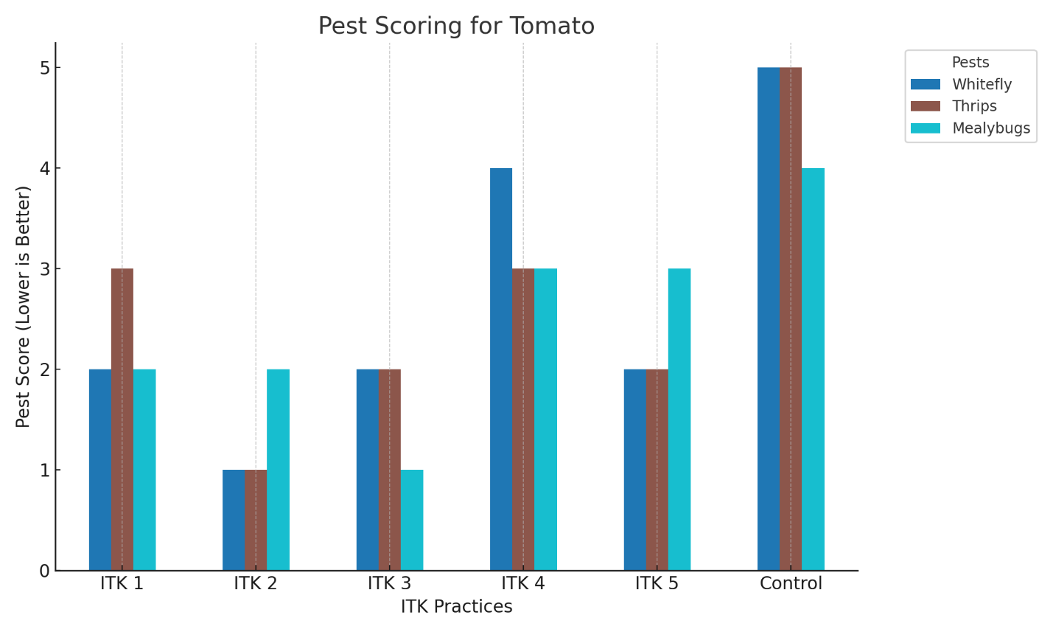

**Table 8a. Scoring based on pest population for significant sucking pest complex of chilli**

|  |  |  |  |  |  |  |
| --- | --- | --- | --- | --- | --- | --- |
| **Chilli** | **ITK 1** | **ITK 2** | **ITK 3** | **ITK 4** | **ITK 5** | **Control** |
| **Aphids** | 2 | 2 | 3 | 3 | 1 | 5 |
| **Thrips** | 3 | 1 | 2 | 4 | 2 | 5 |

**Table 8b. SuckingPest Load Interpretation for Chilli under Different ITK Treatments**

|  |  |  |
| --- | --- | --- |
| **Chilli** | **Aphids** | **Thrips** |
| **ITK 1** | Moderate (20 aphids) | Moderate (13 thrips) |
| **ITK 2** | Moderate (23 aphids) | Low (4thrips) |
| **ITK 3** | Leaf curling (29 aphids) | Moderate (12 thrips) |
| **ITK 4** | Leaf curling (35 aphids) | High (26thrips) |
| **ITK 5** | Low (10 aphids) | Moderate (16thrips) |
| **Control** | Severe (112/plant) | Very High (61thrips) |

**Figure 2. Graphical representation of sucking pests in chilli**

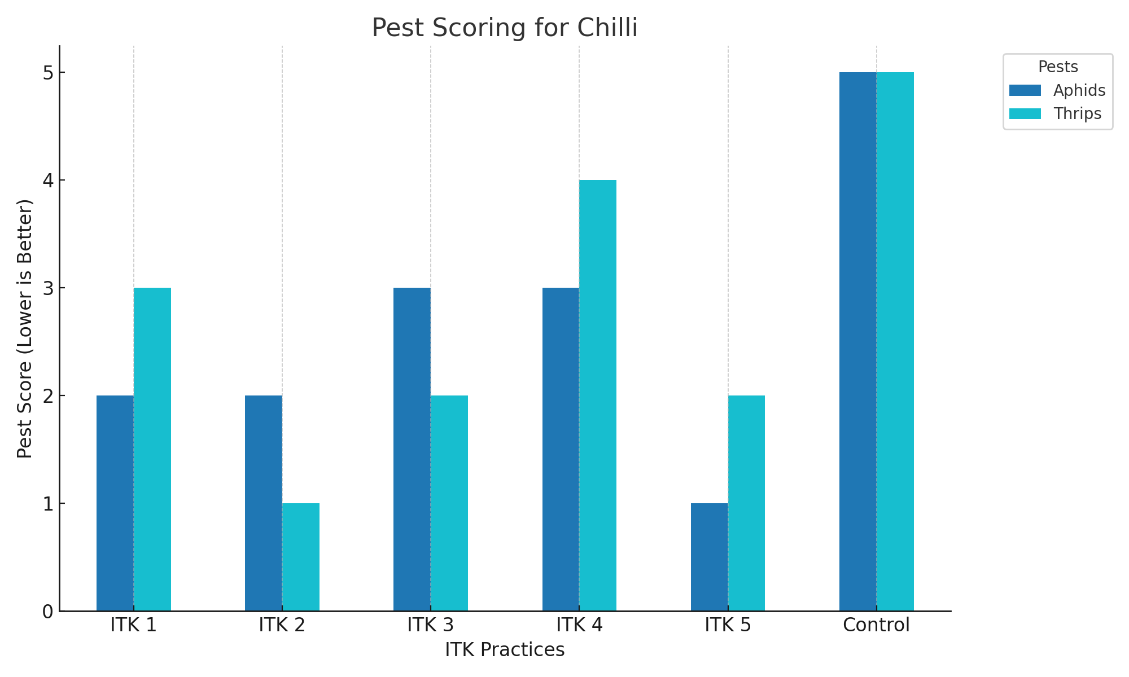

**Table 9a. Scoring based on pest population for significant sucking pest complex of brinjal**

|  |  |  |  |  |  |  |
| --- | --- | --- | --- | --- | --- | --- |
| **Brinjal** | **ITK 1** | **ITK 2** | **ITK 3** | **ITK 4** | **ITK 5** | **Control** |
| **Whitefly** | 2 | 1 | 2 | 3 | 2 | 5 |
| **Aphids** | 2 | 2 | 2 | 3 | 2 | 5 |
| **Mealybugs** | 2 | 2 | 1 | 3 | 3 | 4 |

**Table 9b. SuckingPest Load Interpretation for Brinjal under Different ITK Treatments**

|  |  |  |  |
| --- | --- | --- | --- |
| **Brinjal** | **Whitefly** | **Aphids** | **Mealybugs** |
| **ITK 1** | Moderate (6adult) | Moderate (23 adult) | Moderate (11–50 adult) |
| **ITK 2** | Low (5 adult) | Moderate (25 adult) | Moderate (34 adult) |
| **ITK 3** | Moderate (10 adult) | Moderate (21 adult) | Low (7 adult) |
| **ITK 4** | High (12 adult) | Leaf curling (26 adult) | High (62 adult) |
| **ITK 5** | Moderate (8 adult) | Moderate (24 adult) | High (58 adult) |
| **Control** | Very High (36 adult) | Severe (108 adult) | Very High (178 adult) |

**Figure 3. Graphical representation of sucking pests in Brinjal**

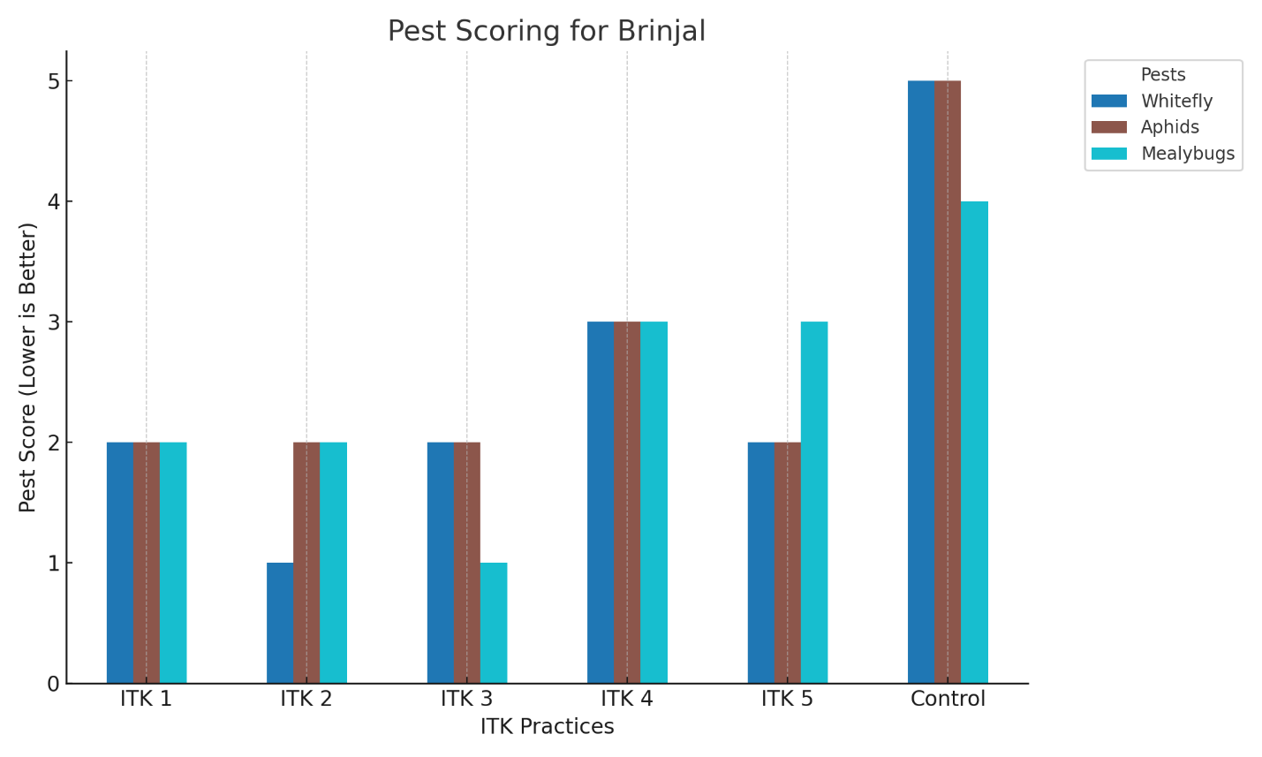

**Table 10a. Scoring based on pest population for significant sucking pest complex of Bhendi**

|  |  |  |  |  |  |  |
| --- | --- | --- | --- | --- | --- | --- |
| **Bhendi** | **ITK 1** | **ITK 2** | **ITK 3** | **ITK 4** | **ITK 5** | **Control** |
| **Whitefly** | 2 | 1 | 2 | 3 | 3 | 5 |
| **Aphids** | 2 | 2 | 2 | 3 | 1 | 5 |

**Table 10b. Sucking Pest Load Interpretation for Bhendi under Different ITK Treatments**

|  |  |  |
| --- | --- | --- |
| **Bhendi** | **Whitefly** | **Aphids** |
| **ITK 1** | Moderate (6 adult) | Moderate (22 adult) |
| **ITK 2** | Low (3 adult) | Moderate (20 adult) |
| **ITK 3** | Moderate (7 adult) | Moderate (25 adult) |
| **ITK 4** | High (12 adult) | Leaf curling (32 adult) |
| **ITK 5** | High (15 adult) | Low (4adult) |
| **Control** | Very High (39 adult) | Severe (164 adult) |

**Figure 4.Graphical representation of sucking pests in Bhendi**

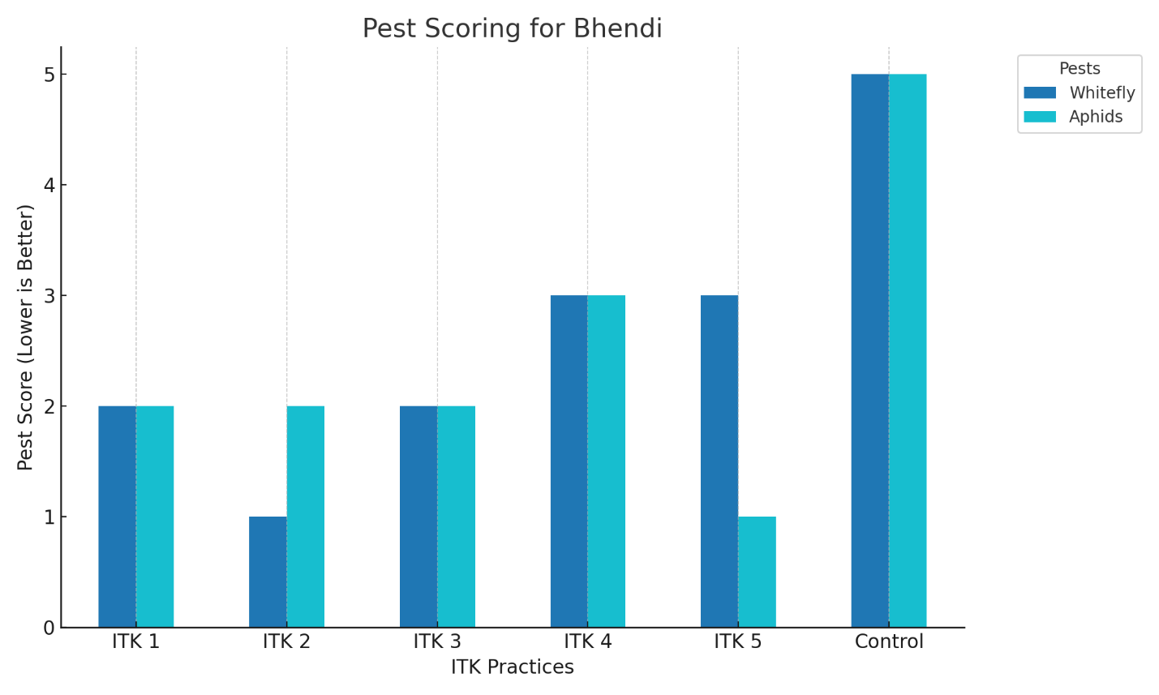

Based on the comparative assessment of different Indigenous Technical Knowledge (ITK) formulations across various vegetable crops, ITK 2—comprising garlic (5 kg), tobacco (250 gm), and chilli (500 gm) extracts in 10 liters of water—emerged as the most consistently effective treatment against both thrips and whiteflies. It achieved the lowest pest scores in tomato, chilli, brinjal, and bhendi, indicating minimal pest incidence and negligible visible damage. For the management of mealybugs, ITK 3, which involves spraying castor oil mixed with neem paste (10 ml per liter), showed superior efficacy by significantly reducing pest loads and preventing symptoms like cottony masses and wilting in tomato and brinjal. In the case of aphids, ITK 5—prepared by fermenting cow dung (1 kg), cow urine (1 liter), and lime (30 gm) in 10 liters of water—was the most effective, particularly in chilli and bhendi, where it consistently recorded the lowest infestation scores. ITK 2 also performed relatively well against aphids, showing consistent moderate control across crops. These findings highlight the potential of select ITK formulations as reliable, eco-friendly alternatives for managing key sucking pests in vegetable cultivation (Figure 5)**.**

**Figure 5. Overall scoring representation of sucking pests on various crops**

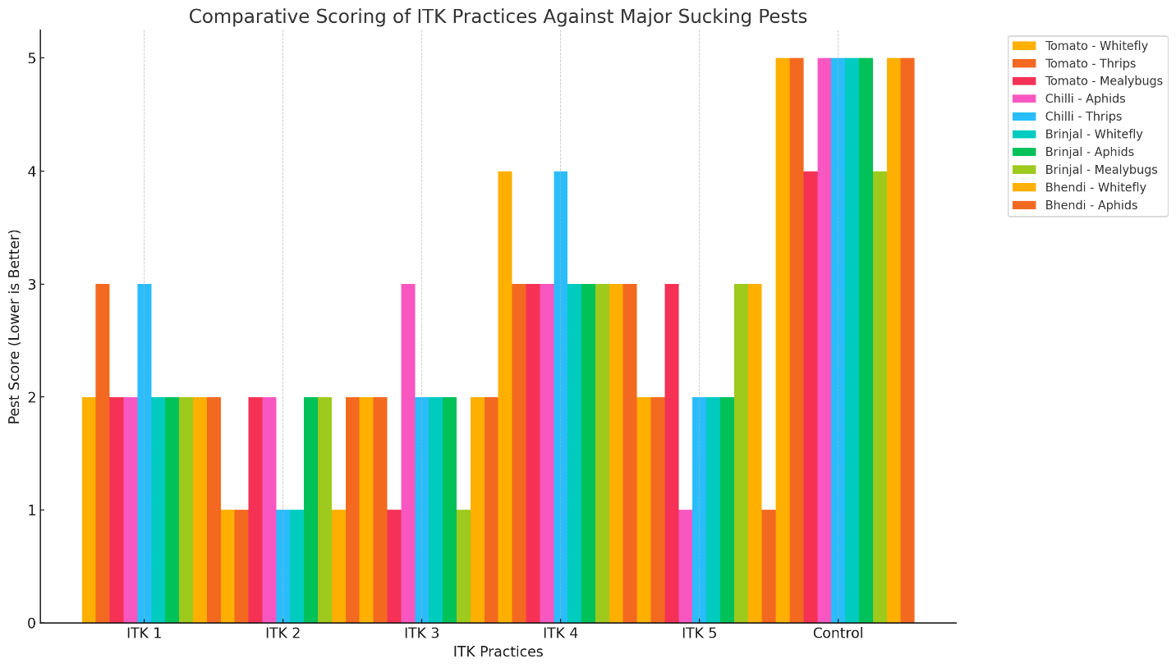

**Conclusion**

ITK-based pest management is a viable alternative to chemical pesticides, offering ecological and economic benefits. The integration of these traditional practices into modern IPM frameworks can promote sustainable agriculture. Research institutions and extension systems should collaborate with local communities to validate, refine, and disseminate effective ITK practices, thereby enhancing food security and environmental health.

The study demonstrates the efficacy of various Indigenous Technical Knowledge (ITK) formulations in managing sucking pest complexes in vegetable crops such as tomato, chilli, brinjal, and bhendi. Among the tested formulations, ITK 2 (garlic, tobacco, and chilli extract) emerged as the most broadly effective treatment, showing superior control of thrips and whiteflies across all crops. ITK 3 (castor oil + neem paste) proved most successful in reducing mealybug populations, while ITK 5 (fermented cow dung, urine, and lime) was the most effective against aphids. The untreated control plots consistently exhibited the highest pest infestation scores, validating the necessity of intervention. The integration of ITKs into pest management practices provides an eco-friendly, cost-effective, and sustainable approach for farmers, especially under low-input or organic farming conditions. This study supports the promotion and scientific validation of traditional pest control knowledge, contributing to both sustainable agriculture and the preservation of indigenous wisdom.

**References**

Abubakar, M., Koul, B., Chandrashekar, K., Raut, A., & Yadav, D. (2022). *Whitefly (Bemisiatabaci) Management (WFM) Strategies for Sustainable Agriculture: A Review. Agriculture 2022, 12, 1317* Not Italic.

Abubakar, M., Yadav, D., Koul, B., & Song, M. (2023). Efficacy of eco-friendly bio-pesticides against the whitefly Bemisiatabaci (Gennadius) for sustainable eggplant cultivation in Kebbi State, Nigeria. *Agronomy*, *13*(12), 3083.

Angon, P. B., Mondal, S., Jahan, I., Datto, M., Antu, U. B., Ayshi, F. J., & Islam, M. S. (2023). Integrated pest management (IPM) in agriculture and its role in maintaining ecological balance and biodiversity. *Advances in Agriculture*, *2023 remove* (1), 5546373.

Babura, S. R., & Mustapha, Y. (2012). Screening for development of host plant resistance to infestation by aphid (Aphis craccivora Koch) in cowpea (Vigna unguiculata [L] Walp). *Bayero Journal of Pure and Applied Sciences*, *5*(1), 44-47.

Dash, D. & Mishra, P. (2022). Chapter 20 Indigenous practices for pest control and marketability of the produce for development of sustainable agriculture. In R. Soni, D. Suyal& R. Goel (Ed.), *Plant Protection: From Chemicals to Biologicals* (pp. 549-572). Berlin, Boston: De Gruyter.

Devi, Y. M., Oinam, T., Singh, N. A., &Sorokkhaibam, S. (2023). Chapter-9 Use of ITK (Indigeneous Technical Knowledge) in Mixed Farming. *Chief Editor*, 147.

Elango, K., Sobhana, E., Sujithra, P., Bharath, D., & Ahuja, A. (2020). Traditional agricultural practices as a tool for management of insects and nematode pests of crops: An overview. *Journal of Entomology and Zoology Studies*, *8*(3), 237-245.

Halder, J., Pandey, M. K., Singh, N., Rai, A. B., & Singh, B. (2018), March). Perceived effectiveness of indigenous technological knowledge (ITK) of insect and vertebrate pests management in Eastern Uttar Pradesh, India. In *Proceedings of the Zoological Society* (Vol. 71, pp. 9-16). Springer India.

KulandaivelChellappan, S., Nallusamy, A., & SADASIVAM, S. N. (2024). Exploratory study on ITK practices prevailing in Pudukkottai district, Tamil Nadu. *Indian Journal of Traditional Knowledge (IJTK)*, *23*(1), 16-24.

Mahapatro, G. K., &Sreedevi, K. (2014). Indigenous approaches for the management of termite and white grub in upland rice.

Marullo, R., Bonsignore, C. P., &Vono, G. (2021). Thrips: a review of sampling methods in relation to their habitats. *Bulletin of Insectology*, *74*(2).

Mathulwe, L. L., Malan, A. P., &Stokwe, N. F. (2022). Laboratory screening of entomopathogenic fungi and nematodes for pathogenicity against the obscure mealybug, Pseudococcusviburni (Hemiptera: Pseudococcidae). *Biocontrol Science and Technology*, *32*(4), 397-417.

Nayak, S. B., Rao, K. S., &Mekala, S. (2021). Management of important insect-pest of eggplant (Solanum melongena l.). *Solanum Melongena: Production, Cultivation and Nutrition*, 300-322.

Ramasamy, S., & Ravishankar, M. (2018). Integrated pest management strategies for tomato under protected structures. In *Sustainable Management of Arthropod Pests of Tomato* (pp. 313-322). Academic Press.

Rani, A. T., Vasudev, K., Pandey, K. K., & Singh, B. (2020). Sucking pests of vegetable crops. *Sucking Pests of Crops*, 307-340.

Sannigrahi, N. Exploration of ITK with the self help group-a cost effective technique to develop digital databases for sustainable agriculture.

Shanmugam, S. P., Murugan, M., Shanthi, M., Elaiyabharathi, T., Angappan, K., Karthikeyan, G., ... & Srinivasan, R. (2024). Evaluation of integrated pest and disease management combinations against major insect pests and diseases of tomato in Tamil Nadu, India. *Horticulturae*, *10*(7), 766.

Yadav, R. K., Jayanthi, K., Kumar, S., Kumar, M., Ponnam, N., & Reddy, M. (2022). Evaluation of chilli genotypes and understanding biochemical basis of whitefly (BemisiatabaciGenn.) resistance. *South African Journal of Botany*, *151 Not Italic*, 433-444.