Effects of Dietary Inclusion of Neem LeafcPowder (Azadirachta indica) on Carcass traits, Immunomodulatory and Profitability of Broiler Japanese Quail (Coturnix coturnix japonica)

Abstract
A feeding trial was conducted to discern the influence of dietary inclusion of neem (Azadirachta indica) leaf powder on carcass characteristics, cut-up parts, weights of organs, processing losses, nutrient composition of muscles, sensory characteristics of breast and thigh meat, serum immunological status and production cost parameters of broiler Japanese quail (Coturnix coturnix japonica). A total 144 day-old Japanese quail chicks were procured and randomly divided into four treatment groups with three replications having twelve (12) chicks in each in a completely randomized design. Quail chicks of treatment T₁ (control) were fed basal diet (starter and finisher diet), as per ICAR (2013) specification, whereas in treatment groups T₂, T₃ and T_{4,} basal diet was incorporated with 0.25% neem leaf powder, 0.50% neem leaf powder, 1.0% neem leaf powder, respectively. Statistical analysis was conducted using SPSS version 20. ANOVA, followed by Duncan’s Multiple Range test was used for multiple comparisons. The results obtained that a non-significant (P≥0.05) difference was noticed in the dressing percentage with and without giblet, cut-up parts, giblet (%live weight), sensory attributes of meat and processing losses of the broiler Japanese quail fed diet incorporated with different level of neem leaf powder. The nutrient composition of breast and thigh muscles in terms of crude protein, ether extract and total ash percentage (on %DM basis) were differed non-significantly (P≥0.05) different amongst different treatment groups. Quail birds fed diets incorporated with 1.0% neem leaf powder gave group significantly (P<0.05) higher serum immunoglobulin concentration as compared to control. Higher profitability was found in NLP @ 0.50% group when all the birds were sold at market price. It can be concluded that inclusion of 0.50% neem leaf powder in their diets had significant positive influence on economical production of the broiler Japanese quail.
Keywords: Carcass characteristics, Finisher diet, Immunomodulation, Japanese quail, Neem leaf powder, Starter diet, Production cost
1. INTRODUCTION
A variety of non-nutritive feed additives mostly antibiotics are used in broiler production to improve the overall performance and immune status by eliminating stress. Some of these additives are recommended for chemotherapeutic and prophylactic purpose, while other are reported to have growth promoting effect. Continuous use of sub therapeutic levels of such feed additives in feed may result in the presence of their residues in animal products and the development of drug resistant microorganisms in humans. Antibiotics growth promoters have been banned in developed countries. This ban on the use of synthetic feed additives has triggered intensive research to find and develop alternative strategies to maintain health and performance in intensive poultry production system. Several beneficial chemical compounds in medicinal plants, which play an important role in improving production and immune system of birds against different diseases and have strong medicinal value and could be effectively utilized as natural growth promoters to replace antibiotics and other synthetic feed additives.
Azadirachta indica, commonly known as neem, has attracted worldwide attention in recent years, owing to its wide range of medicinal properties. Neem has been extensively used in Ayurveda, Unani and homoeopathic medicine and has become a cynosure of modern medicine (Subapriya and Nagini, 2005). Neem elaborates a vast array of biologically active compounds that are chemically diverse and structurally complex. More than 140 compounds have been isolated from different parts of neem. All parts of the neem tree-leaves, flowers, seeds, fruits, roots and bark have been used traditionally for the treatment of inflammation, infections, fever, skin diseases and dental disorders. Neem leaves and its constituents have been demonstrated to exhibit immunomodulatory, anti-inflammatory, antihyperglycaemic, antiulcer, antimalarial, antifungal, antibacterial, antiviral, antioxidant, antimutagenic and anticarcinogenic properties (Subapriya and Nagini, 2005). Based on these medicinal properties a study was planned to explore the effects of inclusion of neem leaves on the immunity, carcass traits and economical production of the broiler Japanese quail.
2. MATERIALS AND METHODS
2.1 Experimental Location
The experimental trial was conducted to discern the effect of dietary inclusion of Neem leafcpowder (Azadirachta indica) on carcass characteristics, cut-up parts, weights of organs, processing losses, nutrient composition of muscles, sensory characteristics of meat, serum immunological status, and production cost parameters of the broiler Japanese quail. The entire study was conducted at Instructional Poultry Farm (I.P.F.) and Department of Animal Nutrition, College of Veterinary and Animal Sciences, G.B. Pant University of Agriculture and Technology, Pantnagar located at latitude of 28⁰53’24” North, longitude of 77⁰34’27” East at an altitude of 243.84 meters above Mean Sea Level.
2.2 Experimental Birds and Housing Management
For this experimental trial, one hundred forty four (144 Nos.), day-old Japanese quail chicks were procured and randomly divided into four treatment groups with three replications having twelve (12) chicks in each in a completely randomized design. These chicks were reared at Instructional Poultry Farm (I.P.F), Nagla, Govind Ballabh Pant University of Agriculture and Technology, Pantnagar. Japanese quail were reared in a cage system using standard management and health care practices. The feeding trial lasted for 42 days viz., 0-21 days (starter phase) and 21-42 days (finisher phase). Ad libitum feed and clean fresh water were provided in suitable troughs to all quail chicks during the experimental feeding trial. Adequate light (for 18 hours) and proper ventilation was provided to the all quail chicks during throughout the trial period. Health of the experimental stock and mortality rate were closely observed and recorded daily.
2.3 Ethical approval
The experiment protocol was approved by ‘Institutional Animal Ethics Committee (IAEC)’, Govind Ballabh Pant University of Agriculture and Technology, Pantnagar, India.
{Approval no.:330/GO/Re/SL/01/CPCSEA/3/1/2001}

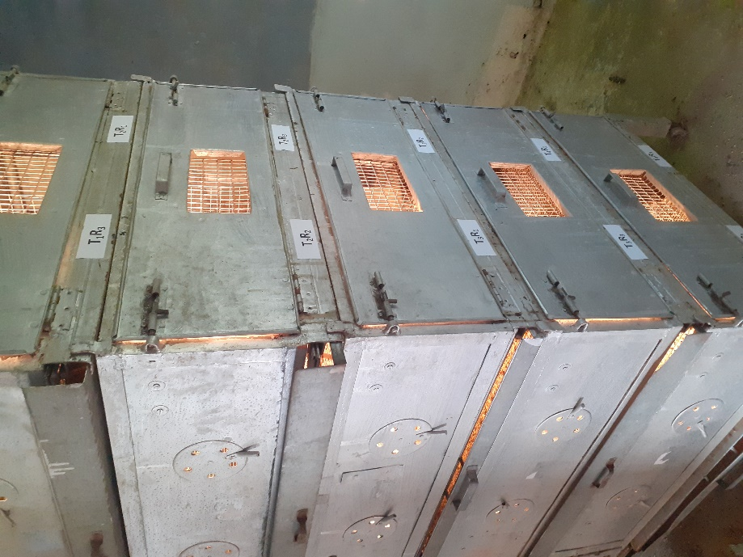
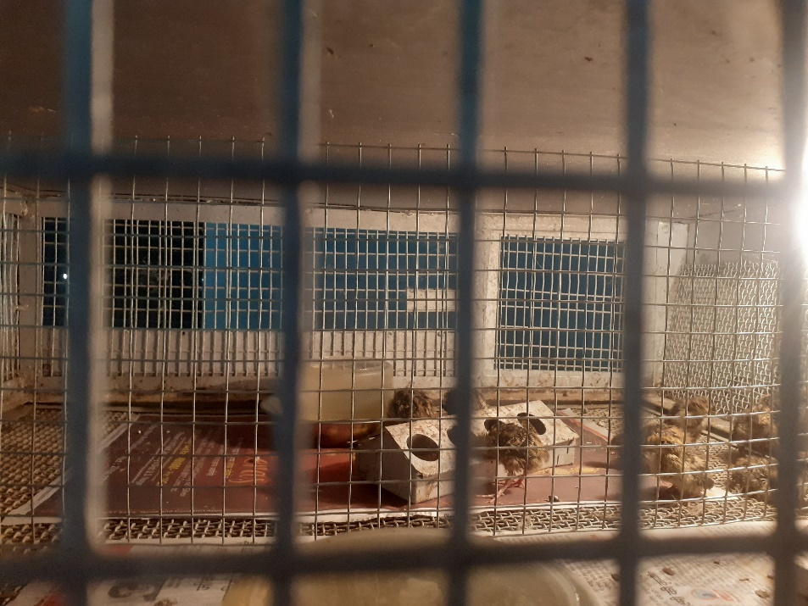
Pic1: Japanese quail chicks reared in cage system
2.4 Procurement of Neem leaves and preparation of leaf powder
Neem (Azadirachta indica) leaves were collected from the trees in the local area of Pantnagar in the month of November 2021. The cut branches were spread out on a concrete floor and allowed to dry for a period of 5-6 days under well-aerated shade. The leaves were then separated from the twigs manually before oven drying. The leaves were then kept into hot air oven at 50⁰C for 3-4 hours to make them crispy for easy blending. The dried leaves were then run through a hammer mill sieve with a size of 4-5mm to produce the neem leaf powder (NLP) and then stored in air tight polythene bags in a cool and dry place to prevent it from moisture.
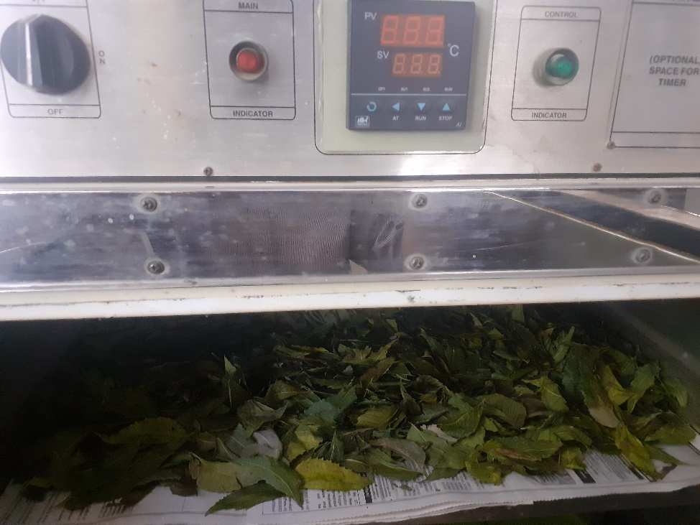
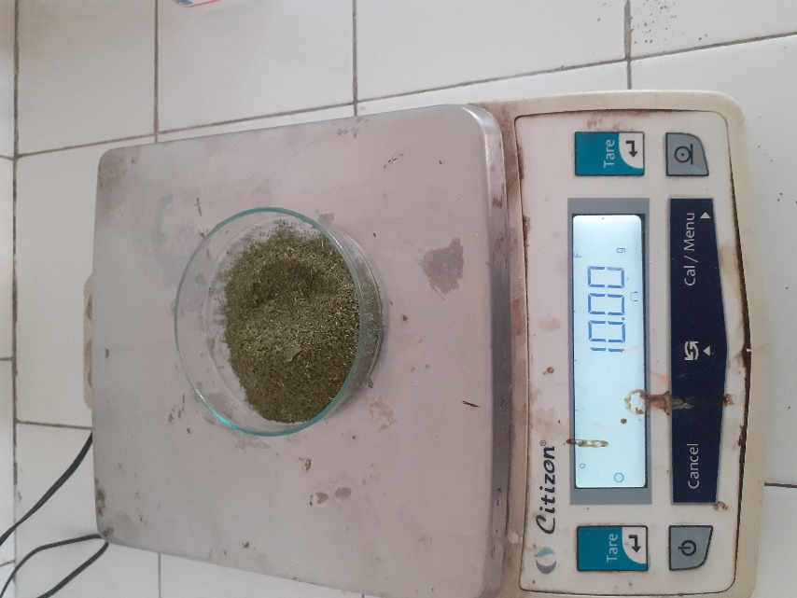
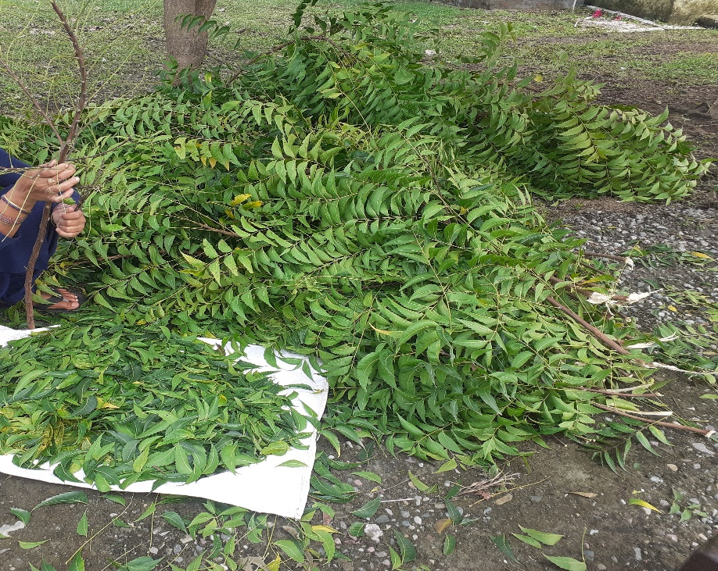

Pic 2: Processing of neem leaves to make neem leaf powder
2.5 Procurement of feed ingredients and supplements
Feed ingredients required for the formulation of the experimental ration were procured from the feed unit and all the ingredients were ground in feed mill before mixing at feed unit of the Instructional Poultry Farm (IPF), GBPUAT, Pantnagar.
2.6 Experimental design and treatments:
Groups | Treatment | No. of birds/ replicate | No. of replicates | Total No. of birds
T₁ | Control (Basal ration) | 12 | 03 | 36
T₂ | Basal ration with 0.25% neem leafcpowder | 12 | 03 | 36
T₃ | Basal ration with 0.50% neem leafcpowder | 12 | 03 | 36
T₄ | Basal ration with 1.0 % neem leafcpowder | 12 | 03 | 36

2.7 Experimental diet
For the experiment, two types of basal diets were prepared to meet the nutrient requirement of Japanese quail, i.e., starter (0-3 weeks) and finisher (3-6 weeks) as per ICAR (2013) presented in Table 1. While determined chemical analysis was conducted by the method of AOAC, (2005).
Table1: Ingredient composition used for formulation of broiler Japanese quail (starter and finisher) basal diet
Ingredients (%) | Japanese quail diet
Ingredients (%) | Starter (0-3 weeks) | Finisher (3-6 weeks)
Yellow Maize | 42.00 | 55.00
Soybean meal (Solvent extracted) | 33.00 | 24.00
Deoiled Groundnut cake | 15.00 | 11.00
Rice polish | 08.00 | 08.00
Dicalcium phosphate | 01.00 | 01.00
Lysine | 00.20 | 00.20
DL-methionine | 00.10 | 00.10
Choline chloride | 00.05 | 00.05
Mineral and Vitamin mixture | 00.20 | 00.20
Common salt | 00.30 | 00.30
Hepatocare | 00.10 | 00.10
Coccidiostats | 00.05 | 00.05
Total | 100.00 | 100.00
Chemical composition (% DM basis ) (calculated)
Crude Protein (%) | 25.12 | 20.73
Metabolisable Energy (kcal/kg) | 2851.45 | 2954.05
2.8 Carcass Quality Traits
For the carcass trait assessments, three representative broiler Japanese quail from each replicate of all treatment groups were euthanized at the conclusion of the 42th days of the experimental trial to evaluate carcass characteristics, cut-up parts, weights of organs, processing losses, nutrient composition of muscles, sensory characteristics of meat in broiler Japanese quails. A 12-hour fasting period was enforced prior to slaughter. Prior to the slaughter procedure, each broiler birds were weighed individually. The euthanasia process involved cervical dislocation to ensure humane treatment of the birds. Following dislocation, complete exsanguinations was performed by making an incision in the jugular vein to facilitate thorough blood drainage. After complete bleeding, weight ofcthe bled carcass was recorded. The weight was again recorded after defeathering using hot water (at 50- 55°C). Head and shank were removed by giving cuts at atlanto- occipital and hock joints, respectively and their respective weights were taken. Thereafter, a horizontal cut was applied posterior to keel bone. Breast was pushed forward to expose the viscera, which was then pulled out. Weight ofc the carcass was then recorded as dressed yield by the following formula:
Dressing yield:
$$Dressing Yield (\%)=\frac{ Dressed weight (g) }{ Pre-slaughtered live weight (g) }x100$$
The weight of different cut up parts viz., thigh, breast, drumstick, back, neck and wings were recorded by separating them from carcass. Individual weight ofcvarious organs viz., gizzard, liver, heart and spleen were recorded. The sensory quality of meat samples was evaluated by meat descriptive analysis method (Keeton and feeding, 1984). The representative meat samples from breast and thigh muscles were collected during slaughtering; there proximate analysis (moisture, crude protein, ether extract and total ash percentage) on %DM basis was performed at Animal Nutrition department, C.V.A.Sc., Pantnagar as per AOAC (2005) specification.
2.9 Serum total immunoglobulin
The humoral response (serum total immunoglobulin concentration) was estimated by zinc sulphate turbidity test. (McEvan et al, 1969).
2.10 Economics of broiler Japanese quail production
The cost ofcfeed was calculated considering the actual purchase prices of the feed ingredients and feed additives used in the preparation ofcthe experimental feed (Japanese quail starter and Japanese quail finisher). The average body weight ofcthe birds was calculated as per the observation recorded at the end ofc42 days of experiment.
2.11 Statistical Analysis
The data were presented as means ± standard error (SE). Statistical analysis was conducted using SPSS version 20. ANOVA, followed by Duncan’s Multiple Range test was used for multiple comparisons. Statistical differences were determined at the 5% level of significance.
3. RESULTS AND DISCUSSION:
3.1 Chemical composition (%DM basis) of experimental diet fed to broiler Japanese quail
The proximate composition (%DM basis) of basal experimental diets fed to Japanese quail starter and finisher chicks is presented in Table 2. Basal diet was formulated iso-nitrogenous and iso-caloric for Japanese quail starter and finisher to meet out the nutritional requirements as per ICAR (2013) recommendation.
Table 2: Chemical composition (%DM basis) of experimental diet fed to broiler Japanese quail
Attributes (%) | Broiler Japanese quail diet
Attributes (%) | Starter (0-3 weeks) | Finisher (3-6 weeks)
Organic matter | 93.18 | 92.52
Crude protein | 25.02 | 21.44
Ether extract | 4.24 | 4.56
Crude fibre | 4.96 | 4.34
Total ash | 6.82 | 7.48
Acid insoluble ash | 1.72 | 1.48
Nitrogen-free extract | 58.96 | 62.18
Metabolizable energy (kcal/kg) calculated | 2900 | 2950

3.2 Carcass characteristics (% live weight)
The average dressing percentage, cut-up parts, organ weights and processing losses of broiler Japanese quail of different treatment groups due to incorporation of varying levels of neem leaf powder in the diets is presented in Tables 3 and expressed as percent of pre-slaughter live weight.

Table 3: Average values of dressing percentage, cut-up parts, organ weight, and processing losses (% live weight) of broiler Japanese quail during finisher phase (at 6 weeks of age) fed diets incorporated with Neem leaf powder

Attributes |  | Treatments/ Carcass Characteristics (% live weight)
 |  | T1 | T2 | T3 | T4 | P-value
Dressing percentage without giblet (%) |  | 66.18±0.50 | 67.16±0.82 | 66.52±0.62 | 68.10±0.81 | 0.256
Dressing percentage with giblet (%) |  | 71.62±0.49 | 72.71±0.82 | 72.05±0.60 | 73.68±0.87 | 0.226
Cut-up parts (% live weight)
Neck | 3.30±0.11 |  | 3.31±0.11 | 3.32±0.04 | 3.31±0.05 | 0.999
Back | 19.86±0.09 |  | 19.92±0.04 | 20.08±0.18 | 20.01±0.19 | 0.716
Breast | 22.94±0.12 |  | 22.99±0.13 | 22.99±0.25 | 22.98±0.15 | 0.997
Thigh | 10.17±0.16 |  | 9.99±0.29 | 10.05±0.22 | 10.30±0.11 | 0.740
Drumstick | 8.56±0.07 |  | 8.69±0.24 | 8.65±0.13 | 8.84±0.15 | 0.668
Organ weights (% live weight)
Heart |  | 0.66±0.05 | 0.73±0.05 | 0.70±0.04 | 0.72±0.03 | 0.655
Liver |  | 2.18±0.03 | 2.20±0.07 | 2.21±0.06 | 2.23±0.05 | 0.931
Gizzard |  | 2.60±0.05 | 2.62±0.07 | 2.63±0.06 | 2.63±0.07 | 0.991
Processing losses (% live weight)
Feather |  | 8.27±0.10 | 8.45±0.09 | 8.30±0.06 | 8.39±0.11 | 0.496
Head |  | 4.78±0.06 | 4.91±0.07 | 4.92±0.05 | 4.96±0.08 | 0.269
Shank |  | 1.94±0.06 | 2.10±0.09 | 1.97±0.04 | 2.12±0.12 | 0.316
{T₁ : Control; T₂: Basal diet with Neem leaf powder (0.25%); T₃: Basal diet with Neem leaf powder (0.5%); T₄ : Basal diet with Neem leaf powder (1.0%)

Results observed that a non-significant (P≥0.05) difference was noticed in the dressing percentage with and without giblet, cut-up parts, giblet (% live weight) and processing losses of the broiler Japanese quail fed diet incorporated with different level of neem leaf powder during 42th days of study period.
Dressing Percentage
76
74
72
70
68
66
64
62
60
T1
T2
T3
T4
Treatment
Dressing percentage without giblet
Dressing percentage with giblet

Pic 3: Average dressing percentage of broiler Japanese quail during finisher phase diets incorporated with varying levels of neem leaf powder

These results for dressing percentage, weight of heart, liver and gizzard are in agreement with Shiahab et al. (2017) who observed non significant differences in dressing percentage, relative weight of viscera internal edible and relative weight of the heart, gizzard and liver among the treatments supplemented with varying levels of neem leaf powder compared with the control group. Similarly, Hossain et al. (2021) reported that dressing parameters of broiler chicken were not significantly affected by supplementation of neem leaf powder (NLP). Dressing percentage was not influenced using Neem leaf meal @ 0%, 1.5%, 2.0% and 2.5% (Bonsu et al., 2012). Likewise Almamury, (2024) observed that broilers fed with 2-3.5 g/kg NLP had a smaller breast size compared to the control group, while thigh weight increased linearly. The gizzard's weight showed a linear increase. Other organ weights did not differ significantly.
3.3 Chemical Composition of Meat (Breast and Thigh Muscles)
The average crude protein, ether extract and total ash (%DM basis) percentage of broiler Japanese quail meat (breast and thigh muscles) in different treatments groups are presented in Table No. 4. The results were observed that the nutrient composition of breast and thigh muscles in terms of crude protein, ether extract and total ash percentage (on %DM basis) were differed non-significantly (P≥0.05) different amongst different treatment groups of broiler Japanese quail fed diet with neem leaf powder (NLP) at 42th days of experimental period.

Table 4: Average values of meat composition (on % DM basis) of broiler Japanese quail fed diets incorporated with varying levels of neem leaf powder

Attributes (%) |  | Treatments
 |  | T1 | T2 | T3 | T4 | P-value
Breast Muscle
Crude protein |  | 82.22±1.56 | 81.79±0.95 | 81.67±1.81 | 80.61±1.81 | 0.901
Ether extract |  | 10.94±0.74 | 10.47±0.63 | 9.65±0.50 | 9.76±1.62 | 0.767
Total Ash |  | 5.47±0.45 | 5.65±0.53 | 5.44±0.35 | 5.78±0.31 | 0.933
Thigh Muscle
Crude protein | 73.82±1.57 |  | 73.04±1.67 | 72.41±1.04 | 72.18±1.84 | 0.877
Ether extract | 19.76±1.44 |  | 18.46±1.81 | 18.58±0.69 | 19.66±1.72 | 0.882
Total Ash | 6.24±0.36 |  | 6.32±0.70 | 6.17±0.48 | 6.37±0.36 | 0.992

{T₁ : Control; T₂: Basal diet with Neem leaf powder (0.25%); T₃: Basal diet with Neem leaf powder (0.5%); T₄ : Basal diet with Neem leaf powder (1.0%)
3.4 Sensory characteristics of meat of broiler Japanese quail
Panel rating for appearance, flavor, juiciness, texture of broiler breast and thigh meat are given in Table 5. The results indicated that the breast and thigh meat from the experimental treatments had non-significantly (P≥0.05) effect on sensory attributes of meat.
Table 5: Average values for sensory characteristics of meat of Japanese quail fed diets incorporated with varying levels of neem leaf powder
Attributes | Treatment |  |  |  | P-value
Attributes | T1 | T2 | T3 | T4 | P-value
Appearance | 6.25±0.41 | 6.63±0.26 | 6.13±0.22 | 6.88±0.30 | 0.308
Flavour | 6.13±0.40 | 6.38±0.18 | 6.25±0.25 | 6.75±0.37 | 0.531
Juiciness | 6.13±0.52 | 6.25±0.25 | 6.75±0.25 | 6.63±0.32 | 0.551
Texture | 6.38±0.26 | 6.13±0.40 | 6.38±0.38 | 6.50±0.19 | 0.864
Overall acceptability | 6.00±0.38 | 6.38±0.32 | 6.50±0.27 | 6.75±0.16 | 0.354
{T₁ : Control; T₂: Basal diet with Neem leaf powder (0.25%); T₃: Basal diet with Neem leaf powder (0.5%); T₄ : Basal diet with Neem leaf powder (1.0%)

3.5 Serum Immunoglobulin Concentration
Table (6) shows the effect of feeding different levels of neem leaf powder on serum immunoglobulin concentration. There was significant (P<0.05) difference in serum IG concentration. Quail birds fed diets incorporated with 1.0 % neem leaf powder gave group significantly (P<0.05) higher serum IG concentration as compared to control.
Table 6. Average value of total immunoglobulin in broiler Japanese quail fed diets incorporated with varying levels of neem leaf powder

Attributes | Treatments |  |  |  | P Value
Attributes | T1 | T2 | T3 | T4 | P Value
Total Immunoglobulin (g/L) | 2.67±0.02 ^{b} | 2.70±0.02 ^{ab} | 2.72±0.01 ^{ab} | 2.76±0.02 ª | 0.011

a and b mean values bearing different alphabets in superscript in a row differ significantly

This result was inline with finding of Shiahab et al. (2017) who mentioned that guinea fowl incorporated with 2g neem leaf powder had significantly (P<0.05) higher serum immunoglobulin concentration as compared control group. Likewise Durrani et al. (2005) reported that neem leaves infusion had better immunomodulatory response against infectious bursal disease as compared to control.
3.6 Cost Benefit Analysis:
The average values of economics of broiler Japanese quail production in terms of feed cost per kg weight gain (Rs.) for 42th days of feeding trial fed diets incorporated with neem leaf powder are presented in Table 7.
Table 7: Economics of Japanese quail production fed diet incorporated with neem leaf powder
Parameters | Treatments
Parameters | T1 | T2 | T3 | T4 | P Value
Initial body weight (g) | 4.22±0.15 | 4.39±0.20 | 4.11±0.15 | 4.56±0.20 | 0.362
Body weight at 42nd day (g)* | 186.33±0.63 ^{ab} | 195.06±0.87 ^{c} | 189.67±1.20 ^{b} | 184.83±0.58 ª | 0.001
Average body weight gain (g)* | 182.11±0.53 ^{ab} | 190.67±0.82 ^{c} | 185.56±1.33 ^{b} | 180.28±0.78 ª | 0.001
Average feed intake (g)* | 630.74±4.84 ^{ab} | 638.76±3.41 ^{b} | 642.49±3.14 ^{b} | 618.75±1.98 ª | 0.006
Total feed cost (Rs.)* | 16.77±0.13 ^{ab} | 16.98±0.09 ^{b} | 17.09±0.08 ^{b} | 16.45±0.06 ª | 0.006
Feed cost/ Kg weight gain (Rs.) | 92.11±0.84 | 89.08±0.82 | 92.11±0.56 | 91.26±0.69 | 0.060
Selling Price (Rs.) | 80.00±0.00 | 80.00±0.00 | 80.00±0.00 | 80.00±0.00 | 1.000
Profit (Rs.) * | 51.23±0.13 | 51.02±0.09 | 50.91±0.08 | 51.18±0.06 | 0.006
{T₁ : Control; T₂: Basal diet with Neem leaf powder (0.25%); T₃: Basal diet with Neem leaf powder (0.5%); T₄ : Basal diet with Neem leaf powder (1.0%)
a, b and c mean values bearing different alphabets in superscript in a row differ significantly, *(P<0.05)
Higher profitability was found in NLP @ 0.50 % group when all the birds were sold at market price. These findings is supported by Mostofa et al. (2013), who reported that neem leave extract supplementation in the broiler rations may be useful for the safe, economical and efficient production of broiler.
4. CONCLUSION:
Based on the findings of the present study, it can be concluded that dietary inclusion of varying level of neem leaf powder (NLP) had no influence on carcass characteristics. NLP@ 1.0 % had significant positive influence on immunomodulatory response and NLP @ 0.50% had significant economical production of broiler Japanese quail. To increase overall performance 0.50% neem leaf powder can be used as safe and cost effective natural feed addition in broiler Japanese quail.

REFERENCES:
Almamury, A. (2024). Effects of dietary supplementation of neem leaf powder (Azadirachta Indica) on growth performance, carcass characteristics and serum biochemical parameters of broilers. European Journal of Ecology, Biology and Agriculture, 1(5), 3-15.
AOAC. (2005). Official Methods of Analysis. Hornitz, W. Ed. Washington, Association of Analytical Chemists. 18th Edn. Washington, D.C., USA.
Bonsu, F.R. K., Kagya-Agyemang, J. K., Kwenin, W. K. J. & Zanu, H. K. (2012). Medicinal response of broiler chickens to diets containing neem (Azadirachta indica) leaf meal, haematology and meat sensory analysis. World Applied Sciences Journal, 19(6), 800-805.
Durrani, F. R., Chand, N., Jan, M., Sultan, A., Durrani, Z. & Akhtar, S. (2008). Immunomodulatory and growth promoting effects of neem leaves infusion in broiler chicks. Sarhad Journal of Agriculture, 24(4), 655-660.
Hossain, M. E., Siddiqua, M. T. & Hossain, M. M. (2021). Dietary inclusion of neem leaf powder on growth performance, blood biochemical parameters and profitability of broilers. Bangladesh Journal of Animal Science, 50(2), 114-122.
ICAR, (2013). Nutrient requirement of Japanese quail. Central Avian Research Institute (CARI), Izatnagar, Bareilly, Uttar Pradesh, India.
Keeton, J.T. & Feeding, E. A. A. (1984). Comparison of non meat proteins, sodium tripolyphosphate and processing temperatures effects on physical and sensory properties of frankfurters. Journal of Food Science, 49, 1462-1465.
Khatun, S., Mostofa, M., Alom,F., Uddin, J., Alam, M.N. & Moitry, N.F. (2013). Efficacy of tulsi and neem leaves extract in broiler production. Bangladesh Journal of Veterinary Medicine, 11(1), 1-5.
Kramer, C. Y. (1957). Extension of multiple range tests to group correlated adjusted means. Biometrics., 13, 13-18.
Mc Evans, A. D., Fischer, W., Selman, I.F. & Perihale, W.J. (1969). A turbidity test for estimation of immunoglobulin levels in neonatal calf serum. Clinica Chima Acta, 27, 155-163.
Shihab, I. M., AL-Zuhariy, T. B. M., Abdullah, S.M. & Mutar, S.S. (2017). Impact of supplementation neem powder (Azadirachta indica) to diet broiler in immunological, physiological and productive traits. Advances in Environmental Biology, 11(3), 44-51.
Snedecor, G. W. & Cochran, W. B. (1994). Statistical methods. 8thed. The lowa state.

Subapriya, R. & Nagini, S. (2005). Medicinal properties of neem leaves: A review, Current Medicinal Chemistry - Anti-Cancer Agents, 5(2), 149-156.

