*Original Research Article*

Emerging threat of Cucumber mosaic virus: A case study from Biswanath, Assam

ABSTRACT

|  |
| --- |
| **Aims:** The study focused on monitoring the occurrence of cucurbit mosaic disease in Biswanath district of Assam. A survey was conducted to record the disease incidence and symptomatology and further serological characterization of the virus associated with the disease.  **Study design:** Round roving survey to record disease incidence, symptomatology and DAS- ELISA for representative samples  **Place and Duration of Study:** Biswanathi, Assam, India (2022-2024).  **Methodology**: The study was conducted in five sites of Biswanath district, viz.; Garehagi, Kamalia No. 5, Kamalia No. 4, Pabhoi and Experimental plot, BNCA during September 2023 to November 2024. The goal was to identify symptoms, collect cucumber samples for serological diagnosis, and assess the incidence of cucurbit mosaic disease through a roving survey across farmers' fields. Leaves from different growth stages were tested using DAS-ELISA for presence of cucurbit mosaic virus (CMV).Infection severity was classified as severe (>75 per cent), moderate (>50 per cent), or mild (<50 per cent).  **Results**: Various symptoms of cucurbit mosaic disease were observed. At No. 4 Kamalia, symptoms included mosaic patterns, leaf roughness, curling, yellowing, mottling, vein clearing, and deformed leaves. Garehagi showed mosaic patterns, leaf curling, mottling, chlorosis, and deformed leaves. No. 5 Kamalia and Pabhoi exhibited similar symptoms. In the experimental plot at Biswanath College of Agriculture, additional symptoms included deformed fruits. These findings highlighted the diverse symptom expression of cucurbit mosaic disease across different locations. The highest disease incidence of 89.23 per cent was observed at No. 4 Kamalia; followed by 50.84 per cent in Garehagi; 45.13 per cent in the Experimental plot, BNCA; 43.33 per cent in Pabhoi and 38.09 per cent in No. 5 Kamalia village  **Conclusion**: The widespread occurrence of cucurbit mosaic disease in this region has been a major reason for yield losses, causing a serious threat to farmers' economic and agricultural sustainability. |

*Keywords: Biswanath; Cucumber mosaic virus; DAS-ELISA; disease incidence; serology*

1. INTRODUCTION

Diseases and pests are one of the major threats to cucurbit crops leading to **significant economic losses**. Among these, **cucurbit mosaic disease** is one of the most **severe** diseases of cucurbit crps worldwide. More than one viruses are associated with this disease including **Cucumber mosaic virus (CMV), Watermelon mosaic virus (WMV), Zucchini yellow mosaic virus (ZYMV), Pumpkin yellow vein mosaic virus (PYVMV), and Papaya ring spot virus-watermelon strain (PRSV-W)** (**Biswas and Ghosh 2018, Kumar et al. 2008**). Amongst these, **CMV alone** can result in **up to 100 per cent yield loss** (**Khan et al. 2015**).

Cucumber mosaic disease, caused by the **Cucumber mosaic virus (CMV)**, is one of the most **damaging and widespread threats** to **cucurbit production** (**Myti et al. 2014**). The **Cucumber mosaic virus (CMV)** was first reported in **1916** by **Doolittle and Jagger**, who identified it in **cucumber and other Cucurbitaceae plants** (**Doolittle 1916; Jagger 1916**). Today, **CMV is one of the most widespread plant viruses**, affecting a wide range of **agricultural and horticultural crops** in **temperate and tropical regions** worldwide. In **India**, CMV was first recorded by **Raychaudhuri and Varma in 1975**, who also identified ***Myzus persicae*** and ***Aphis gossypii*** as its **aphid vectors.**

CMV belongs to the **Cucumovirus genus** within the **Bromoviridae family** and is known for its **extensive host range**, infecting **over 1,000 plant species from 85 different families** (**Roossinck 2001**). This disease is a **global concern** due to its **highly infectious nature**, typically leading to **10–20 per cent yield loss** and, in severe cases, causing **total crop failure (100 per cent loss)** in cucurbits. Its **widespread impact** makes it a **major challenge** for farmers worldwide.

In India cucurbits are generally grown during summer (January to March) and rainy season (June to July). In hills it is sown in April-May. Among the North-Eastern states of India, Assam is one of the major cucurbits growing states (Anon 2020). The mosaic disease in cucurbits has a worldwide occurrence and it has also been recorded from many cucurbit growing areas of Assam causing huge economic loss.

In Assam, cucurbit mosaic disease in pumpkin crop was documented by Gogoi et al. (2023) with disease incidence of 35.71 and 52.38 per cent from Jorhat and Golaghat district, respectively. Dey et al. (2023), reported cucurbit mosaic disease incidence of 90.91 per cent in Sonitpur district, 66.67 per cent in Biswanath district, 14.29 per cent in Jorhat district, 11.00 per cent in Sivasagar district and 25.00 per cent in Dibrugarh district of Assam on various cucurbit crops through molecular assay.

2. material and methods

Survey on cucurbit mosaic disease incidence and symptomatology was carried out in five locations within the Biswanath district; *viz.,* Garehagi, Kamalia no.5, Kamalia no.4, Pabhoi and Experimental plot Biswanath College of Agriculture (BNCA). Plants were inspected for symptoms, and leaf samples were randomly collected from suspected cucurbit mosaic infected plants through a roving survey conducted across farmers' fields in the surveyed regions. Garehagi is positioned at 26.71516˚ latitude and 93.146053˚ longitude, Kamalia no.5 at 26.686527˚ latitude and 93.141925˚ longitude, Kamalia no.4 at 26.6939˚ latitude and 93.128647˚ longitude, Pabhoi at 26.815098º latitude and 93.150771º longitude and Experimental plot BNCA at 26.724746 º latitude and 93.136277 longitude respectively. The survey took place from **September 2023 to November 2024**. The primary objective was to **identify disease symptoms associated with mosaic disease, collect cucumber samples for serological diagnosis in the laboratory, and assess the incidence of cucurbit mosaic disease in the Biswanath district.**

Samples were obtained from crops at different **growth stages**, including **vegetative, flowering, and maturity**. To ensure sample preservation, they were carefully **wrapped in aluminum foil, placed in paper bags, and stored at 4ºC** in the laboratory. The presence of Cucumber mosaic virus (CMV) in leaf samples from the surveyed areas and the experimental plot was confirmed using DAS-ELISA in the Plant Virology Laboratory, Department of Plant Pathology, Assam Agricultural University (AAU), Jorhat. The DAS-ELISA method, widely used for serological identification of plant pathogens, follows four essential phases and was performed according to the protocol established by Clark and Adams (1977).

Leaves and twigs were examined for CMV symptoms, and disease incidence was recorded from the surveyed locations. All plants in each plot were assessed for symptoms and categorized as severe (more than 75 per cent infected), moderate (more than 50 per cent infected), or mild (less than 50 per cent infected) (Dey et al. 2023).

Per cent disease incidence of cucurbit mosaic disease was calculated as follows-

$$\text{Disease incidence }\left(\text{\%}\right)\text{=}\frac{\text{Number of infected plants}}{\text{Total number of plants observed }}\text{x 100}$$

Aphid populations were counted on the **top, middle, and bottom sections** of randomly selected cucumber plants from various plots in the surveyed area. The **average aphid count per plant** was calculated, and the vector population was categorized as **low (<10 aphids per leaf), medium (>10 aphids per leaf), and high (>20 aphids per leaf)** following the method described by **Mishra and Nath (2015).**

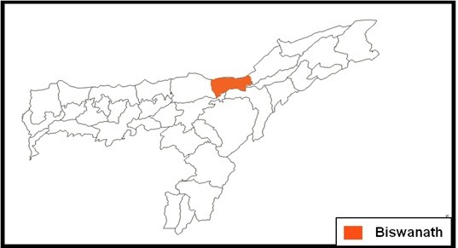

**Fig. 1. Map of Assam showing the surveyed district**

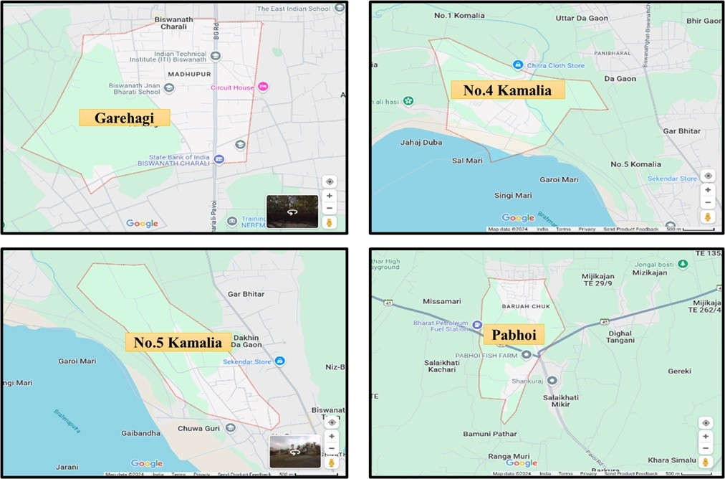

**Fig. 2. Map of the surveyed areas of Biswanath district**

3. results and discussion

In the surveyed areas of Biswanath district, various symptoms of cucurbit mosaic disease were observed. At No.4 Kamalia, symptoms included mosaic patterns, increased leaf roughness, upward curling of leaf margins, yellowing, severe mottling, vein clearing, puckering, and small, crinkled, deformed leaves [Fig. 3 (a-h)]. In Garehagi, mosaic patterns, upward curling, mottling, leaf chlorosis, and small, crinkled, deformed leaves were noted [Fig. 4 (a-d)]. Similarly, at No.5 Kamalia and Pabhoi, characteristic symptoms included mosaic patterns, upward curling, mottling, leaf chlorosis, and small, crinkled, deformed leaves [Fig. 5 (a-b)]. In the experimental plot at Biswanath College of Agriculture, characteristic symptoms observed were leaf roughness, severe mottling and yellowing, mosaic patterns, puckering, upward curling, vein clearing, small crinkled leaves, and deformed fruits [Fig.6 (a-h)]. These observations highlighted the diverse symptom expression of cucurbit mosaic disease under different field conditions in cucurbit crops.

Among the surveyed locations, the highest disease incidence of 89.23 per cent was observed at No. 4 Kamalia village; followed by 50.84 per cent in Garehagi; 45.13 per cent in the Experimental plot, BNCA; 43.33per cent in Pabhoi and 38.09 per cent in No. 5 Kamalia village (Table 1). The severity of mosaic symptoms varied from mild to moderate and severe, with No. 4 Kamalia showing the most severe symptoms. Garehagi, Experimental plot BNCA, and Pabhoi displayed moderate symptoms, while No. 5 Kamalia exhibited only mild infection (Table 2).

Aphids were the primary vectors identified in the surveyed areas and experimental plot. The aphid species observed were Aphis gossypii and Myzus persicae. The vector population was highest in No. 4 Kamalia, medium in Garehagi, and low in No. 5 Kamalia, Pabhoi, and the experimental plot BNCA (Table 2).

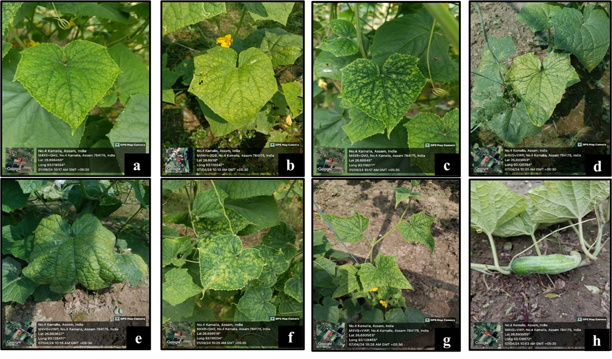

**Fig. 3. Symptoms observed on cucumber fields of No.4 Kamalia. (a) upward curling of leaf margins (b) yellowing (c) severe mottling (d) vein clearing (e) puckering of leaves (f) mosaic and increased leaf roughness (g) small crinkled and deformed leaves (h) deformed fruit**

**h**

**g**

**f**

**c**

**e**

**d**

**b**

**a**

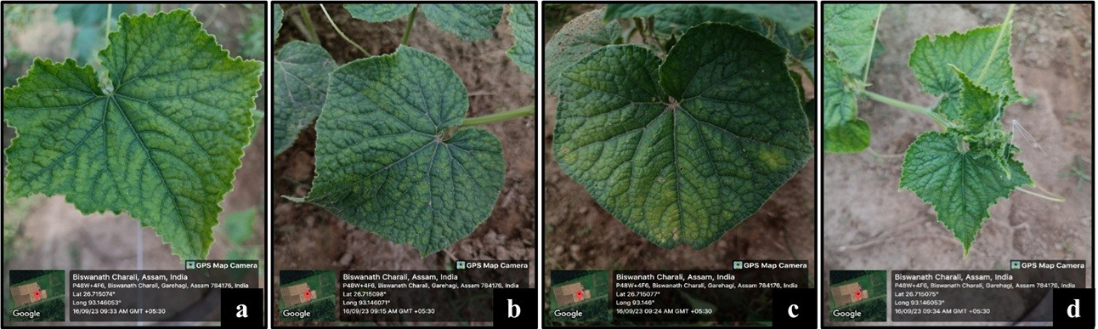

**Fig. 4. Symptoms observed on cucumber fields in the surveyed areas of Garehagi. (a) mosaic and upward curling of leaves**

**(b) mottling (c) leaf chlorosis (d) small crinkled deformed leaves**

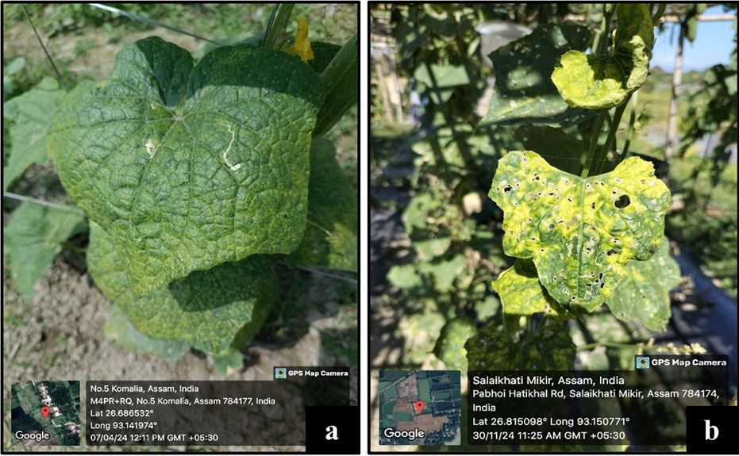

**Fig. 5. Symptoms observed on cucumber fields in the surveyed areas of No.5 Kamalia and Pabhoi. (a) mosaic and puckering of  
 leaves (b) severe mottling and mosaic**

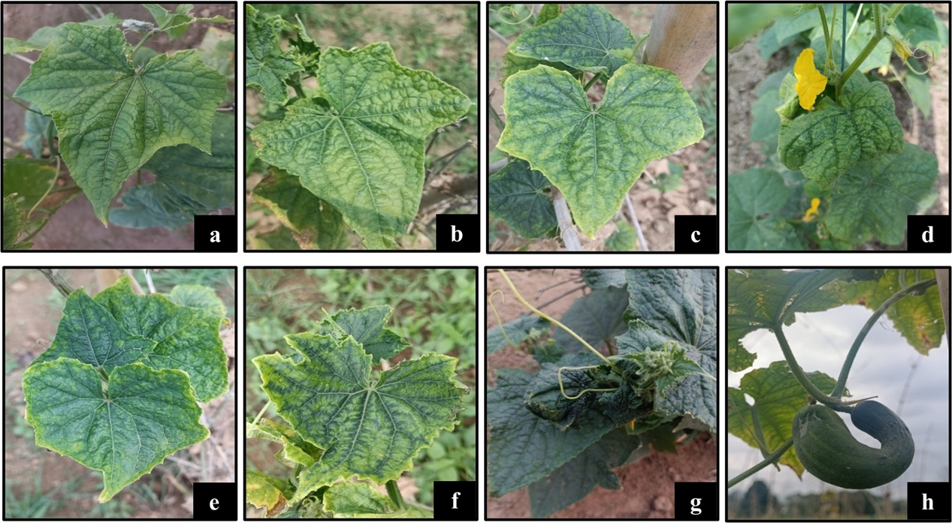

**Fig. 6. Different symptoms of cucumber mosaic virus observed in the experimental research plot. (a) leaf roughness (b) severe mottling and yellowing (c) mosaic pattern on leaf (d) puckering of leaves (e) upward curling (f) vein clearing (g) small crinkled leaves (h) deformed fruit**

**Table 1. Incidence of cucurbit mosaic disease on cucumber crops in Biswanath district**

|  |  |  |  |
| --- | --- | --- | --- |
| Locations(Villages) | Total no. of plants | No. of infected plants | Disease incidence (%) |
| Garehagi | 59 | 30 | 50.84 |
| No.4 Kamalia | 130 | 116 | 89.23 |
| No.5 Kamalia | 42 | 16 | 38.09 |
| Pabhoi | 60 | 26 | 43.33 |
| Expt plot, BNCA | 144 | 65 | 45.13 |

*NB: Surveyed area variable*

**Table.2 Severity of cucurbit mosaic symptoms and vector population on cucumber**

|  |  |  |
| --- | --- | --- |
| Locations (Villages) | Severity of symptoms | Vector population |
| Garehagi | ++ | **\*\*** |
| No.4 Kamalia | +++ | **\*\*\*** |
| No.5 Kamalia | *+* | **\*** |
| Expt plot, BNCA | + | **\*** |
| Pabhoi | + | **\*** |

*(+) = Mild (Less than 50%), (++) = Moderate (50-75%), (+++) = Severe (75% and more)*

*(*) = Low (<10 aphid per leaf), (**) = Medium (>10 aphid per leaf), (***) = High (>20 aphid per leaf)*

**Table 3. DAS-ELISA values for leaf extracts of samples collected from surveyed area of Biswanath district**

|  |  |  |  |  |
| --- | --- | --- | --- | --- |
| Locations | Mean ELISA for all positive samples | Maximum ELISA value | Minimum ELISA value | ELISA value for positive control |
| Kamalia villages (no. 4 and no. 5) | 0.143 | 0.153 | 0.132 | 0.150 |
| Experimental plot, BNCA | 0.178 | 0.238 | 0.126 | 0.150 |
| Garehagi | 0.141 | 0.152 | 0.131 | 0.150 |
| Pabhoi | 0.140 | 0.150 | 0.130 | 0.150 |

4. Conclusion

Mosaic disease poses a significant challenge to cucurbit cultivation in Assam, leading to substantial yield losses and economic impact on farmers. Cucumber mosaic virus (CMV) is a widespread pathogen that significantly impacts both the quality and yield of cucurbits. Symptom observation from the surveyed areas and experimental plot revealed a range of distinct symptoms associated with cucurbit mosaic disease. The vector incidence study identified aphids as the primary vectors responsible for transmitting the virus. Due to wide host range, management of CMV is challenging however, eco-friendly integrated management approaches have proven to be effective in reducing disease incidence with minimal environmental impact, making them promising and sustainable alternatives to chemical treatments.

Consent (whereever applicable)

Consent from all the authors were taken before submitting this manuscript.

Ethical approval (whereever applicable)

This manuscript is ethically approved by all the authors.

**DISCLAIMER (ARTIFICIAL INTELLIGENCE)**

The author(s) declare that no generative AI technologies, such as Large Language Models (e.g., ChatGPT, COPILOT, etc.) or text-to-image generators, have been used during the writing or editing of this manuscript.

References

Anonymous. (2020).Pumpkin Cultivation. Horticulture Guruji, [https://www.horticultureguruji.in/pumpkin cultivation/](https://www.horticultureguruji.in/pumpkin%20cultivation/).

Biswas, M.K., Ghosh, T. (2018). Natural incidence of mosaic disease of pumpkin (*Cucurbita moschata*) and its management through avoidance. Bionature, 38 (2), 96-104.

Clark, M.F., Adams, N.A. (1977). Characteristics of the microplate method of enzyme-linked immunosorbent assay for the detection of plant viruses. Journal of General Virology, 34(4),475-483.

Dey, P., Routhu, G. K., Borah, M., Kalita, M. K., Bora, B., Nath, P. D., Mishra, R. (2023) Incidence and detection ofcucumbermosaicdisease in Assam. The Pharma Innovation, 12 (2), 1723-1727*.*<https://doi.org/10.22271/tpi.2023.v12.i2u.18652>.

Doolittle, S. P. (1916). A new infectious mosaic disease of cucumber. Phytopathology, 6 (2), 145-147.

Gogoi, K., Borah, M., Nath, P. D., Mishra, R. (2023) Incidence and molecular characterization of cucumber mosaic virus in Pumpkin crop from Assam. The Pharma Innovation, 12(10), 1531-1535.

Jagger, I.C. (1916). Experiments with the cucumber mosaic disease. Phytopathology, 6 (2), 148-151.

Khan A.A., Ahmad Z., Begum F. (2015). Varietal reaction of cucumber against cucumber mosaic virus. American Journal of Plant Science, 6 (7), 833-838.

Kumar, Y., Hallan, V., Zaidi, A.A. (2008). Molecular characterization of a distinct bipartite Begomovirus species infecting tomato in India. Virus Genes,37 (3), 425-431.

Mishra, R., Nath, P. D. (2015). Incidence and detection of Potato virus Y on potato crop in Jorhat District of Assam by DAS-ELISA. Indian Phytopathology, 68 (4), 467-469.

Myti, S., Shabbir, A.K., Akhter, S., Uddin, A., Kamruzzaman, M., Faruq, M.O., Biswas, G. C. (2014). Identification of the most prevalent and spatially disperse virus on chilli at Northern and Eastern part of Bangladesh. International Journal of Biological Science5, 40-49. [*https://doi.org/10.3923/ijbs.2014.40.49*](https://doi.org/10.3923/ijbs.2014.40.49).

Raychaudhuri, M. and Varma, A. (1975). Virus diseases of cucurbits in Delhi. *In*: Proceedings of the 62nd Indian Science Congress, Part III (p. 74).

Roossinck, M.J. (2001). Cucumber mosaic virus, a model for RNA virus evolution. Molecular Plant Pathology, 2(2), 59-63.