Original Research Article
Genetic divergence analysis in chickpea (Cicer arietinum L.) genotypes.
Abstract:
Chickpea (Cicer arietinum L.), a crucial pulse crop for food security and sustainable agriculture, exhibits substantial genetic divergence, which is essential for selecting diverse parents in breeding programs. This study assessed 40 chickpea genotypes during the Rabi season of 2021–22 at the Oil Seed Research Farm, Chandra Shekhar Azad University of Agriculture and Technology, Kanpur, using Mahalanobis D² statistics to determine genetic diversity. The genotypes were categorized into distinct clusters, demonstrating considerable genetic variability. Intra-cluster distances varied from 29.409 to 54.147, while the highest inter-cluster distance (D=54.147) was recorded between Cluster III and Cluster VII, indicating significant genetic differentiation. Traits such as the number of branches per plant (13.21%), plant height (11.92%), and the number of seeds per pod (11.54%) were the most influential in contributing to divergence. The study identified promising genotypes with desirable traits across different clusters, suggesting their potential use as parental lines for hybridization. The high inter-cluster divergence observed highlights the potential for obtaining high-yielding and stress-tolerant varieties through crossbreeding of genetically diverse genotypes. These results provide valuable insights into chickpea breeding strategies aimed at improving productivity, resilience, and adaptability to various environmental conditions.
Keywords- Cicer arientinum L, Diversity, Genotypes, traits, yield, Country???
Introduction
Chickpea (Cicer arietinum L.) is a vital grain legume, believed to have originated in Southeastern Turkey and Syria, with India and the Mediterranean regions recognized as key centers of domestication (Ahmad et al., 2005). It belongs to the Fabaceae family and includes two cultivated species: Cicer arietinum and Cicer songaricum. The cultivated chickpea is further classified into two major types—desi, characterized by small, dark, rough-coated seeds, and kabuli, which has large, white, smooth-coated seeds. Commonly known as Bengal gram or Egyptian pea, chickpea is an essential source of plant-based protein, carbohydrates, essential minerals, and amino acids, playing a significant role in global food security, particularly in developing nations (Dixit et al., 2019). It is consumed in various forms, such as dhal, flour, and tender leaves, which are used as vegetables.
India is the largest producer of chickpea, covering a cultivation area of 28.83 million hectares and yielding 25.72 million tonnes in 2020 –21 (FAO, 2019). Rajasthan and Madhya Pradesh are the leading chickpea-producing states. Despite its high production, India struggles with productivity challenges, highlighting the need for varietal improvement through advanced breeding methods and genetic resource management (Singh et al., 2021). Chickpea seeds are nutritionally rich, containing approximately 23% protein, 64% carbohydrates, and essential minerals such as phosphorus (340 mg/100 g), calcium (190 mg/100 g), and iron (7 mg/100 g), making them an integral part of vegetarian diets and traditional medicine (Dubey & Srivastava, 2007). Additionally, chickpea contributes to sustainable agriculture by improving soil fertility through nitrogen fixation and enhancing nutrient availability in the soil (Upadhyaya et al., 2002). Understanding genetic divergence in chickpeas is fundamental for developing high-yielding and stress-resilient varieties. Genetic divergence analysis helps identify diverse parental lines that can be utilized in breeding programs to enhance yield potential, disease resistance, and abiotic stress tolerance (Rao, 1952). The study of genetic divergence enables breeders to classify genotypes into distinct clusters, thereby facilitating targeted hybridization strategies (Murthy & Arunachalam, 1966).. By understanding genetic divergence, breeders can make informed decisions regarding germplasm selection, thereby accelerating chickpea improvement programs and contributing to global food security (Kumar et al., 2020).

Material and Methods

Material
Genotypes | Origine/characteristics??? | Genotypes | Origine/characteristics???

The 40 genotypes were grouped into seven clusters. Among these seven clusters, cluster (I) was comprised of genotypes. IPC-1374, IPC-1376, IPV-1379, JG-1751, JG-1759. the cluster (II) comprising largest genotype, KGD-2012, KGD-2013, KGD-2015, GNG-2171, KWR-108, KGD-1168, PUSA-418, KGD-1813. Cluster (III) comprising KGD-1918, IPC-1380, JG-1774, KGD-1819. Cluster (IV) comprising JG-1746, KPG-59, KGD-1815, KGD-1821, RVG-203, KGD-1913, KGD-1921, KGD-1923, K-850. cluster (V) comprising KGD-2011, KGD-1913, KGD-2017, GNG-2144, PUSA-397, KGD-1817, RVG202, KGD1918. Cluster (VI) Avrodhi, Pusa391. cluster (VII) KGD-1915, KGD-1917, KGD-1919, Radhey.
Methods
The present study was conducted at the Oil Seed Research Farm of Chandra Shekhar Azad University of Agriculture and Technology, Kanpur (Uttar Pradesh), during the Rabi season of 2021–22 to assess genetic divergence among 40 diverse genotypes of chickpea (Cicer arietinum L.). The experiment was laid out in a randomized block design (RBD) with three replications.
Observations were recorded on five randomly selected plants per genotype for key morphological and yield-related traits, including days to 50% flowering, plant height, days to maturity, number of branches per plant, number of pods per plant, number of seeds per pod, biological yield per plant, 100-seed weight, seed size, harvest index, grain yield per plant, seed yield per plant, and biological yield per plant. Genetic divergence among genotypes was estimated using the Mahalanobis D² statistic (Mahalanobis, 1936), and Tocher’s clustering method (Rao, 1952) was employed to classify the genotypes into distinct clusters.
Data analysis: ???
Statistical analyses were performed using appropriate biometrical techniques to identify diverse genotypes suitable for breeding programs. Tocher's method was followed to group the entries into different clusters considering the estimated D values.
Results and discussion
The result of cluster groups???
Intra- and Inter-Cluster Divergence
The intra-cluster distance ranged from 29.409 to 54.147, with the highest intra-cluster distance observed in Cluster VII (54.147) and the lowest in Cluster III (29.409). The highest inter-cluster distance (54.147) was noted between Clusters III and VII, indicating a high degree of genetic divergence, while the lowest inter-cluster distance was observed within Cluster III (29.409). The presence of high inter-cluster distances suggests significant genetic variability, which is beneficial for hybridization programs to create superior recombinants (Singh et al., 2018). Similar findings were reported by Sharma et al. (2020), who observed substantial genetic divergence among chickpea genotypes, particularly for yield-related traits.

Cluster Means for Different Traits
Significant variation was observed in cluster means for different agronomic traits. The earliest flowering was recorded in Cluster I (82.35 days), while Cluster III had the latest flowering (92.81 days). The highest plant height (125.37 cm) was observed in Cluster II, while Cluster VII recorded the lowest plant height (105.00 cm). The number of branches per plant ranged from 3.33 (Cluster VI) to 4.33 (Cluster II), highlighting a potential for selection based on plant architecture. Pod number per plant is a crucial trait for yield improvement, and Cluster VII recorded the highest pod number (71.33 pods per plant), while Cluster IV had the lowest (64.00 pods per plant). Seed yield per plant, a key determinant of productivity, was highest in Cluster VII (18.33 g) and lowest in Cluster III (9.16 g). Similar results were reported by Patel et al. (2021), where genotypes with higher pod numbers also exhibited greater seed yield. The biological yield per plant showed substantial variation, with Cluster VII recording the highest value (26.33 g), suggesting its potential for biomass improvement. The 100-seed weight, which affects market preference and productivity, ranged from 64.57 g (Cluster VII) to 37.71 g (Cluster III). A higher 100-seed weight is often associated with better grain filling and nutritional quality (Verma et al., 2017). The harvest index, indicating partitioning efficiency, was highest in Cluster IV (29.17%) and lowest in Cluster III (23.42%), supporting previous findings that clusters with high seed yield often exhibit a better harvest index (Mishra et al., 2019).
Trait Contribution to Genetic Divergence
The relative contribution of each trait to total genetic divergence revealed that the number of branches per plant (13.21%), plant height (11.92%), seeds per pod (11.54%), and number of pods per plant (10.64%) contributed the most to overall diversity. Other important contributors included 100-seed weight (9.74%), biological yield (8.97%), and days to flowering (8.85%). Traits such as harvest index (8.33%) and seed yield per plant (7.95%) contributed relatively less. These results suggest that selection for pod number, seed weight, and plant architecture can enhance genetic improvement strategies. Previous studies by Kumar et al. (2020) also identified pod number and 100-seed weight as key contributors to genetic diversity in chickpea.
Cluster-Wise Genetic Diversity
Cluster I consisted of five genotypes (IPC 1374, IPC 1376, IPC 1379, JG 1751, and JG 1769), with the highest mean value for days to maturity (125.37 days) and the lowest for the number of seeds per pod (1.33). This cluster exhibited moderate genetic diversity and could be useful for breeding programs focused on improving maturity traits. Similar findings were reported by Singh et al. (2018), where genotypes with late maturity showed promising yield stability under varying environmental conditions. Cluster II comprised eight genotypes (KGD 2012, KGD 2013, KGD 2015, GNG 2171, KWR 108, KGD 1168, PUSA 418, and KGD 1813), characterized by the highest days to 50% flowering (95.67 days) and a relatively low number of seeds per pod (2.00). This indicates that the genotypes in this cluster could be valuable for developing early-maturing chickpea varieties. Studies by Kumar et al. (2020) emphasized the importance of selecting early-flowering genotypes to escape terminal drought stress in chickpea cultivation. Cluster III included four genotypes (KGD 1918, IPC 1380, JG 1774, and KGD 1819), which had the lowest number of branches per plant (3.33) and were among the shortest plants, with an average plant height of 105.00 cm. This cluster had the smallest intra-cluster divergence, suggesting that these genotypes share a high degree of genetic similarity. Sharma et al. (2020) also observed that clusters with low plant height and branch number tend to exhibit reduced intra-cluster divergence due to genetic closeness. These genotypes may be useful for breeding programs aiming to develop compact plant types suitable for high-density planting. Cluster IV comprised nine genotypes (JG 1774, KPG 59, KGD 1815, KGD 1821, RBG 203, KGD 1913, KGD 1923, KGD 1921, and K 850) and exhibited the lowest number of pods per plant (64.00) and seeds per pod (1.33). Despite these limitations, this cluster recorded a high harvest index (29.17%), indicating good partitioning efficiency of assimilates towards seed development. Similar observations were made by Patel et al. (2021), who found that some genotypes with a lower number of pods compensated with efficient biomass partitioning, ultimately resulting in stable yields. Cluster V consisted of eight genotypes (KGD 2011, KGD 1913, KGD 2017, GNG 2144, PUSA 397, KGD 1817, RBG 202, and KGD 1918). It had the highest 100-seed weight (64.57 g) and biological yield per plant (26.23 g) but exhibited lower values for days to 50% flowering (81.33 days), plant height (125.55 cm), harvest index (23.42%), and grain yield (11.80 g per plant). These genotypes could be useful for breeding large-seeded chickpea varieties, a trait that is often preferred in commercial markets. Verma et al. (2017) also emphasized the economic importance of seed size, reporting that genotypes with high seed weight often show better consumer preference and market value. Cluster VI contained two genotypes (Avrodhi and PUSA 391) and had moderate values for plant height (39.13 cm) and 100-seed weight (37.71 g), but recorded the lowest number of branches per plant (4.33). The limited number of genotypes in this cluster suggests that it consists of relatively uniform accessions. Similar clustering of genetically close genotypes was observed by Mishra et al. (2019), who reported that traditional varieties often cluster together due to a narrow genetic base. Cluster VII included four genotypes (KGD 1915, KGD 1917, KGD 1919, and Redhey) and was the most promising cluster, exhibiting the highest number of pods per plant (71.33), 100-seed weight (64.57 g), and seed yield per plant (18.33 g). This indicates that genotypes in this cluster could be excellent candidates for yield improvement programs. Studies by Singh et al. (2018) and Kumar et al. (2020) also found that clusters with high pod numbers and seed weight tend to contribute significantly to yield enhancement in chickpea breeding.
Conclusion
The genetic divergence analysis among the 40 chickpea genotypes revealed significant variability, indicating a broad genetic base that can be effectively utilized for crop improvement. The study highlighted the importance of traits such as number of branches per plant, plant height, number of seeds per pod, and number of pods per plant as major contributors to genetic divergence. The presence of considerable inter-cluster distances suggests that crossing genetically diverse genotypes could result in heterotic progeny with improved agronomic traits. The findings emphasize that selecting genetically diverse parents based on key yield-contributing traits can enhance breeding efficiency and accelerate genetic gains in chickpea. The observed variability also suggests the potential for developing improved cultivars with higher yield, larger seed size, and better adaptability to diverse environmental conditions. These results provide a valuable foundation for chickpea breeding programs aimed at enhancing productivity and resilience, while further molecular studies could offer deeper insights into the genetic relationships among these genotypes.

Table 1: Estimates of average Intra (diagonal value) and Inter (below diagonal value) cluster distance in chickpea genotypes

 | Cluster I | Cluster II | Cluster III | Cluster IV | Cluster V | Cluster VI | Cluster VII
Cluster I | 37.669
Cluster II | 70.657 | 36.634
Cluster III | 100.886 | 75.262 | 29.409
Cluster IV | 241.266 | 106.784 | 150.593 | 48.743
Cluster V | 195.496 | 95.841 | 115.937 | 82.769 | 40.846
Cluster VI | 439.518 | 309.187 | 384.030 | 267.093 | 145.116 | 35.487
Cluster VII | 170.807 | 125.410 | 293.937 | 187.378 | 150.443 | 274.700 | 54.147

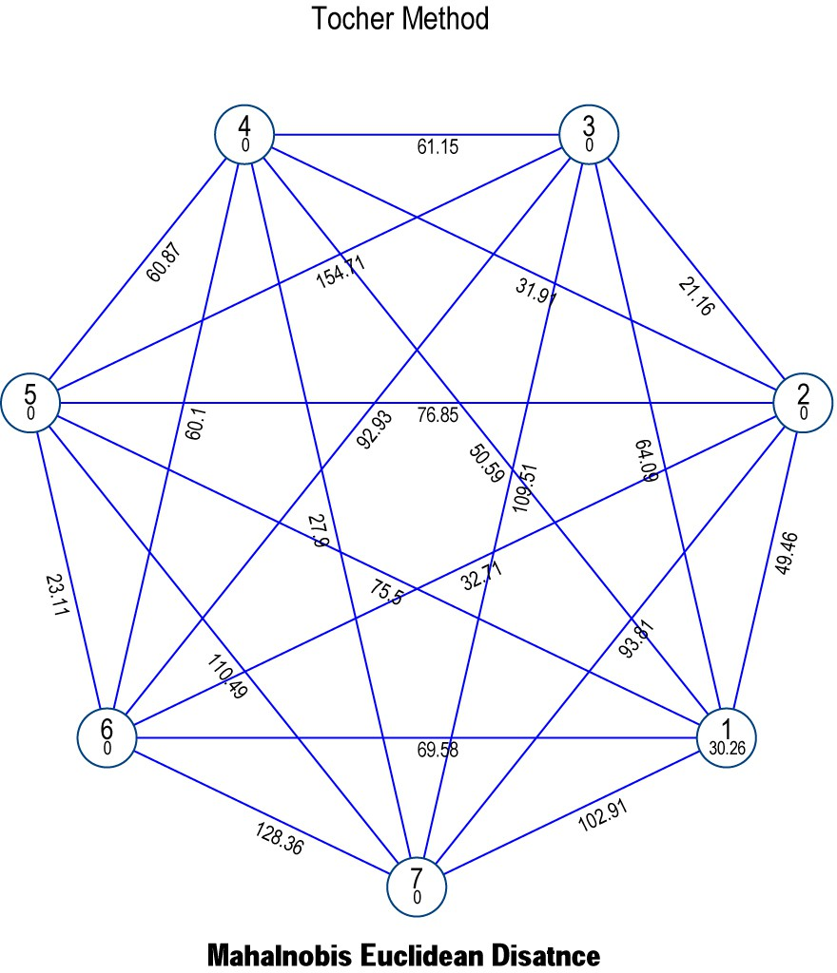
Fig 1. Mahalnobis Euclidean Distance

Table 2: Cluster mean forty characters in chickpea genotypes

Characters | Days to 50%  flowering | plant height (cm) | Days to maturity | No of branches per plant | No of pods  per plant | No of seeds  per pod | Biological yield (g/plant) | 100  seed  weight (g) | Harvest index (%) | Grain yield (g/plant)
Cluster I | 82.35 | 36.92 | 119.85 | 3.49 | 69.88 | 1.53 | 20.33 | 57.47 | 26.40 | 15.14
Cluster II | 90.00 | 32.97 | 125.37** | 4.33** | 68.00 | 2.00** | 16.14 | 50.36 | 23.42* | 11.80*
Cluster III | 92.00 | 39.13** | 125.00 | 3.67 | 70.33 | 1.33 | 17.84 | 37.71* | 24.38 | 9.16
Cluster IV | 91.33 | 35.42 | 115.33 | 4.00 | 64.00* | 2.00 | 20.33 | 60.33 | 29.17** | 17.63
Cluster V | 81.33* | 25.55* | 115.00 | 4.00 | 69.00 | 1.67 | 24.35 | 61.39 | 28.72 | 17.62
Cluster VI | 84.33 | 26.33 | 122.00 | 3.33* | 66.67 | 1.33* | 11.41* | 49.47 | 25.28 | 12.44
Cluster VII | 95.67** | 37.73 | 105.00* | 3.67 | 71.33** | 1.00 | 26.23** | 64.57** | 28.38 | 18.33**
**indicate maximun mean value: *indicate minimun mean value

Table 3: Contribution of each character to the total divergence
S. No | Character | Time ranked Ist | Percent contribution
1 | Days to 50% flowering | 69 | 8.85%
2 | Plant height (cm) | 93 | 11.92%
3 | Days to maturity | 69 | 8.85%
4 | No of branches per plant | 103 | 13.21%
5 | No of pods per plant | 83 | 10.64%
6 | No of seeds per pod | 90 | 11.54%
7 | 100 seed weight | 76 | 9.74%
8 | Biological yield per plant (g) | 70 | 8.97%
9 | Harvest index (%) | 65 | 8.33%
10 | Grain yield (g/plant) | 62 | 7.95%

References
Ahmad, F., Gaur, P. M., & Croser, J. (2005). Chickpea (Cicer arietinum L.). In Genetic Resources, Chromosome Engineering, and Crop Improvement (Vol. 1, pp. 185-216). CRC Press.
Dixit, G. P., Srivastava, R., & Singh, N. P. (2019). Role of chickpea in food and nutritional security. Legume Research, 42(5), 633-640.
Dubey, P. P., & Srivastava, J. P. (2007). Nutritional and medicinal significance of chickpea. Indian Journal of Agricultural Sciences, 77(3), 174-178.
FAO. (2019). Food and Agriculture Organization of the United Nations, Statistical Yearbook. Retrieved from http://www.fao.org.
Kumar, R., Pandey, A., & Sharma, P. (2020). Genetic divergence in chickpea (Cicer arietinum L.) genotypes under irrigated conditions. Legume Research, 43(4), 567-573.
Kumar, S., Gupta, S., Chaturvedi, S. K., & Kumar, J. (2020). Genetic diversity studies in chickpea using multivariate analysis. Legume Research, 43(1), 10-16.
Mahalanobis, P. C. (1936). On the generalized distance in statistics. Proceedings of the National Institute of Sciences (India), 2, 49-55.
Mishra, A. K., Sharma, A., & Verma, R. (2019). Estimation of genetic parameters and divergence in chickpea. Indian Journal of Genetics and Plant Breeding, 79(2), 241-248.
Murthy, B. R., & Arunachalam, V. (1966). The nature of genetic divergence in relation to breeding system in crop plants. Indian Journal of Genetics and Plant Breeding, 26, 188-198.
Patel, V. R., Jadhav, B. D., & Mehta, D. R. (2021). Genetic variability, heritability, and genetic advance in chickpea (Cicer arietinum L.). Journal of Agricultural Sciences, 57(3), 389-397.
Rao, C. R. (1952). Advanced Statistical Methods in Biometric Research. John Wiley & Sons, New York.
Sharma, H. K., Singh, P., & Yadav, R. (2020). Genetic divergence for quantitative traits in chickpea (Cicer arietinum L.). Legume Science, 2(1), 12-18.
Singh, A., Kumari, R., & Yadav, D. (2018). Morphological and genetic diversity analysis in chickpea genotypes. Journal of Crop Science, 7(4), 134-142.
Singh, K. B., Malhotra, R. S., & Halila, M. H. (1981). Breeding for disease resistance in chickpea. Euphytica, 30(3), 705-711.
Singh, N. P., Amaranth, S., & Singh, R. K. (2021). Nutritional significance and genetic improvement in chickpea. Journal of Agricultural Science and Technology, 23(2), 115-127.
Upadhyaya, H. D., Bramel, P. J., & Singh, S. (2002). Development of a chickpea core collection using geographic distribution and quantitative traits. Crop Science, 42(1), 236-240.
Verma, P., Singh, N. K., & Rathore, A. (2017). Variability and genetic divergence in chickpea (Cicer arietinum L.). Plant Archives, 17(1), 563-570.

