Original Research Article

Bioremediation of Heavy Metals from Crude Oil Contaminated Soil: The Effect of Brewery Effluent Fertigation

ABSTRACT
The application of biostimulants to crude oil contaminated soils enhances the proliferation of indigenous soil microorganisms. Brewery effluent (BE), one of the largest breweries wastes in volume, is scarcely used as a biostimulant despite its rich rate-limiting nutrient content. This study evaluated the effect of BE on the proliferation of hydrocarbon utilizing microbes and their potential in the removal of heavy metals from crude oil contaminated soil. Simulated crude oil contaminated soil was fertigated with various volumes of BE giving soil-crude oil-BE mix ratios of 8:1:0, 8:1:0.5, 8:1:1, and 8:1:1.5 and labelled, reactors A, B, C, and D respectively. The experimental setup was a complete randomized block design of 4-triplicate reactors including the control (A). The treatment lasted for 60 days. Soil samples were analyzed for electrical conductivity (EC), pH, and hydrocarbon utilizing microbes using standard analytical methods. Heavy metals including Cd, Cr, Cu, Ni, Pb, and Zn were also analyzed by Atomic Absorption Spectrophotometer. Results of the study showed that soil pH, EC, and heavy metal percentage removal increased with treatment duration and volume of BE. The order of microbial count for the soil samples was similar to metal removal efficiency ($D>C>B>A)$ indicating that increased microbial population increased chemosorption active sites for heavy metal biosorption. The order of removal efficiency for individual metals was $Ni>Cd>Pb>Zn>Cu>Cr$with 99.5%, 98.4%, 87.5%, 79.9%, 79.6% and 75.6% respectively. This suggests that BE is a good biostimulant for bioremediation of heavy metals in crude oil-contaminated soil.

Keywords: Biostimulant, Bioremediation, Heavy Metals, Biosorption.

1. INTRODUCTION

Heavy metals are naturally occurring elements that have high atomic masses and relatively low rates of decay but can also be released into the environment through various anthropogenic activities. One major source of heavy metal pollution in the environment is the petroleum industry during oil and gas exploration, refining, and transportation. Heavy metals in soil are of great concern due to their toxicity, persistence, and bioaccumulation potential. Their toxicity in soil depends on their concentration, chemical composition, and mobility. High concentrations of heavy metals in soil can lead to direct toxicity, which affects the growth and development of plants by inhibiting enzymatic activities [1]. It is reported that copper (Cu) toxicity reduces the chlorophyll content in plants, leading to reduced photosynthesis and growth inhibition. Similarly, lead (Pb) toxicity in soil can result in reduced root elongation and plant biomass production, leading to stunted growth and early senescence [2]. Duration of exposure to heavy metals can also impact their toxic effects. Acute exposure to high concentration of heavy metals can cause serious health effects, whereas chronic exposure to low concentration may lead to long-term health effects. Clarkson et al. [3] explained that chronic mercury (Hg) exposure can lead to neurotoxicity, whereas acute exposure can cause respiratory and renal dysfunction. Heavy metal toxicity is also dependent on the chemical species of the metal. For instance, Pb toxicity is highest in its organic form, tetraethyl lead, which was widely used as an anti-knocking agent in gasoline. Hg toxicity is also dependent on its organic form, with the organic methylmercury being the most toxic [3]. The mobility of heavy metals in the soil is another important factor that determines their toxicity. Heavy metals can undergo various processes, such as adsorption, desorption, and precipitation, leading to variations in their mobility and bioavailability in soil. Asmoayet al. [4] reported that the high toxicity of Cd and Ni in plants is due to their easy mobility in soil, whereas the reduced toxicity of zinc (Zn) and iron (Fe) is due to their high adsorption capacity on soil particles. Furthermore, heavy metals in crude oil-contaminated soils can interact with other contaminants, such as polycyclic aromatic hydrocarbons (PAHs), leading to increased toxicity. According to Udoetok et al. [5], Cd and Pb can accumulate in the leaves of plants growing in crude oil-contaminated soils and interact with PAHs, leading to reduced biomass accumulation. Similarly, the interaction of Cu with PAHs increases the toxicity of the soil and reduces microbial activity in the soil.
The use of physical and chemical approaches including soil replacement, thermal desorption, and soil washing for heavy metal remediation is gradually being discouraged owing to their inherent limitations, non-sustainability, and negative impacts on the environment [6]. Bioremediation is a sustainable alternative towards mitigating heavy metal pollution. It involves the use of plants or microorganisms or both to immobilize heavy metals through biosorption/bioaccumulation and biomineralization/bioleaching. Bioremediation provides eco-friendly and cost-effective methods of cleaning up contaminated sites by biostimulation or bioaugmentation [7]. Whereas bioaugmentation involves the introduction of specific microorganisms usually chosen based on their ability to solubilize or immobilize heavy metals, biostimulation involves stimulating and enhancing the proliferation of indigenous microorganisms in the soil to solubilize or immobilize heavy metals. This can be achieved by adding rate-limiting nutrients, oxygen, or other necessary substances to enhance microbial growth. The major sources of rate-limiting nutrients include organic and inorganic fertilizers. Other sources include organic waste from food and beverage industries including the brewery industry.
Globally, beer is the fifth most consumed drink. In 2018, over 1.94 billion hectoliters of beer were produced globally making the brewery industry one of the industries with significant economic importance [8,9]. The large production of beer is synonymous with the generation of huge number of organic wastes in the form of brewery spent grain (BSG), brewery spent hops/hot trub (BSH), brewery spent yeast (BSY), and brewery effluent [10]. Although studies have shown reuse of the first three aforementioned wastes in animal feed production and as food ingredients or additives [11,12,10] further studies in recent times have also shown the possibility of the reuse of these wastes (BSG, BSH, and BSY) as biostimulants in bioremediation of crude oil polluted soils [13,14], However, brewery effluent (BE) which is one of the largest breweries wastes in volume is scarcely reused.
Brewery effluent contains various organic and inorganic compounds including carbohydrates, protein, hops, yeast, and cleaning chemicals [15]. These organic compounds contribute to the high biological oxygen demand (BOD) and chemical oxygen demand (COD) of brewery effluent, and if not properly treated and disposed , it could pose environmental challenges such as eutrophication, groundwater contamination and oxygen depletion [16,17]. Even when treated, this waste tends to increase the capital cost of production of brewery products. There is therefore a need for alternative management processes such as reuse. A study investigated brewery effluent as a resource rather than a waste product. The study found out that the organic matter present in the effluent can be used for biogas production through anaerobic digestion [18]. Another study focused on the effectiveness of bacterial strains isolated from the brewery effluent and municipal sludge in the removal of heavy metals from contaminated soil [19]. The study reported that the bacterial strains could remove up to 98% of Cu, Pb, and Zn from the contaminated soil. However, literature is scarce in the use of this effluent as a fertigation process for heavy metal removal in crude oil polluted soils despite its considerable level of rate limiting nutrients (nitrogen, phosphorus, and potassium) required by microorganisms involved in the degradation of pollutants.
The aim of this study is to elucidate the effect of brewery effluent on the proliferation of hydrocarbon utilizing bacteria and fungi (HUB/HUF) and hence the efficacy of the HUB/HUF in the removal of heavy metals from crude oil-polluted soil. This study's findings could lead to the development of a new sustainable approach that can help mitigate the challenges posed by brewery waste management and soil contamination. The results of this study will contribute to knowledge about the use of effluents rich in organic content for fertigation during bioremediation of soils, especially for the removal of heavy metals from contaminated soil.

2. MATERIAL AND METHODS

2.1 Study Area
This study was carried out in the Research Farm of Rivers State University, Port Harcourt in the Niger Delta region of Nigeria as shown in Figure 1. The Niger Delta region of Nigeria is Africa’s largest wetland and Nigeria’s major oil producing area and is inundated with oil spills traceable to accidental and deliberate leaks due to equipment failure and vandalism [20].
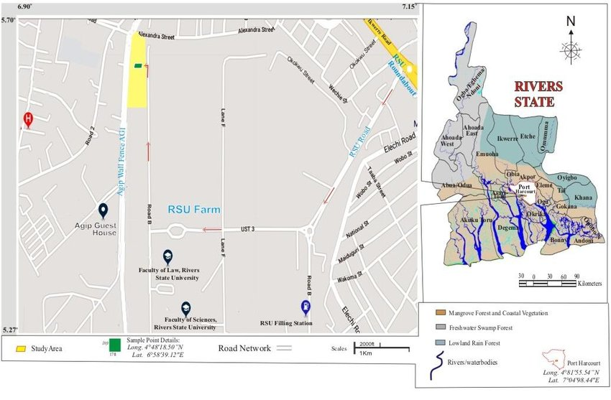
Fig 1: Research Farm of Rivers State University[21]

2.2 Soil Sampling and Textural Classification
Soil samples were collected randomly from the Research Farm of Rivers State University using clean shovel at depths of 0-30cm. Afterward, the soil samples were thoroughly mixed and screened to eliminate stones, roots and leaves as well as create a composite sample. The soil particle size distribution (PSD) was determined using hydrometer method with sodium hexametaphosphate as the dispersing agent. Soil texture was determined according to the United States Department of Agriculture (USDA) soil textural classification scheme [22].
2.3 Simulation of Soil Contamination and Treatment
Bonny light Crude oil sample was collected from an anonymous international oil company in the Niger Delta region to simulate crude oil contaminated soil. A fixed mass of 4,000g of soil was blended with 500g of crude oil and allowed to incubate for 3 days. Samples of the contaminated soil were collected for analysis of heavy metal concentration prior to treatment with the brewery effluent (BE). The BE sample was obtained from a brewery industry in Port Harcourt, Rivers State, Nigeria. BE sample was representative of an entire batch and collected in clean and sterile containers to avoid contamination. BE was analyzed to ascertain Nitrogen, Phosphorus, and Potassium (NPK) values which is essential to understand its potential as a valuable biostimulant. Total N was determined using Total kieldahl digestion method. P and K analysis were determined using the colorimetric and flame photometry methods respectively.

2.4. Experimental Setup
The experimental setup was a randomized complete block design (RCBD) consisting of brewery effluent blended with crude oil contaminated soil in duplicate. The treatment options of a fixed mass of soil (4000g) and crude oil (500g) blended with different proportions of BE are shown in Table 1. The experimental setup included 4 treatments, each with 2 replicates, resulting in a total of 12 treatment reactors for soils contaminated with crude oil. These treatments were labelled B, C, and D, with A designated as the control. Soil aeration was enhanced by tilling twice a week using a trowel. Soil treatment lasted 60 days.
Table 1: Proportion of the experimental material blend
Reactor | Material blend proportion | Material blend ratio
A (Control) | 4000 g soil sample + 500 g of crude oil + 0 g of BE | 8:1:0
B | 4000 g soil sample + 500 g of crude oil + 250 g of BE | 8:1:0.5
C | 4000 g soil sample + 500 g of crude oil + 500 g of BE | 8:1:1
D | 4000 g soil sample + 500 g of crude oil + 750 g of BE | 8:1:1.5

2.5 Soil Sample Analysis
Soil samples were collected and analyzed every 15 days interval for soil pH, electrical conductivity and concentration of heavy metals including Cd, Cr, Cu, Ni, Pb, and Zn. Soil pH and electrical conductivity were determined using a multimeter. An already standardized pH meter electrode was immersed in a beaker containing a soil-water suspension, with constant stirring. Soil pH readings were recorded from the multimeter display, after which the electrode was rinsed with distilled water before the next soil pH determination. Similarly, the conductivity probe was immersed into the supernatant liquid of the soil-water suspension and readings recorded. Thereafter, the conductivity probe was cleaned with distilled water and immersed into a beaker of distilled water. Atomic Absorption Spectroscopy was used in the analysis of concentration of the studied heavy metals in the soil samples.
2.6 Statistical Analysis
Results were subjected to statistical analysis using Analysis of Variance (one way ANOVA) to test whether the effect of the different mix ratios of BE applied to crude oil contaminated soil were statistically significant. Simple percentages were used to express contaminant reduction efficiency as calculated using equation (1).
$\% removal efficiency=\frac{C_{i}-C_{f}}{C_{i}}×100$ (1)

Where $C_{i} and C_{f}$ are initial and final concentration of heavy metal.

2.7 Microbial analysis of Brewery Effluent (BE) and Soil Samples
2.7.1 Hydrocarbon Utilizing Bacteria (HUB) Count
HUB and HUF counts (were done using the vapour phase method on mineral salt agar (MSA) according to Mills et al. [23] as modified by Okpokwasili and Odokuma [24]. MSA was composed of 0.29g of KCl, 10g of NaCl, 0.42g of MgS0₄.7H₂0, 0.42g of NH₄NO₃, 1.25g of K₂HPO₄, 0.83g of KH₂PO₄ and 15g of agar all dissolved in one litre of distilled water and autoclaved at 121ºC for 15mins.
The HUB of soil samples was performed using a ten-fold serial dilution with normal saline. One milliliter of the sample was added to test tubes containing 9 ml of normal saline. Then, 1 ml was transferred from the first tube to a second test tube containing 9 ml of normal saline, creating a 10⁻¹ dilution. This process was repeated up to the 10⁻¹⁰ dilution. Aliquots of 0.1 ml from the 10⁻³ dilution were inoculated onto MSA plates in triplicates using the spread plate method. Sterile Whatman No. 1 filter papers, soaked with Bonny light crude oil, were aseptically placed on the inside lid of each plate and kept inverted. The plates were then incubated at 37°C for 24-48 hours. After the incubation period, the plates were enumerated. The filter paper, saturated with crude oil, served as the sole source of carbon and energy.
2.7.2 Hydrocarbon Utilizing Fungi (HUF) Count
HUF counts for the samples were determined by aseptically diluting 1.0g of the soil sample in nutrient broth. A 0.1ml aliquot of the 10⁻⁴ dilution was transferred onto triplicate Bushnell-Hass (mineral salt) agar plates, which were supplemented with 0.05% (v/v) streptomycin. To screen for fungi, sterile Whatman filter papers soaked in crude oil were aseptically placed on the lids of the inoculated Bushnell-Hass agar plates. After inoculation, the plates were incubated at 30ºC for 14 days. Colonies were counted after the incubation period.

3. RESULTS AND DISCUSSION
3.1 Physico-Chemical Properties of the Uncontaminated Soil
The physico-chemical properties of the uncontaminated soil as stated in Table 2 suggest that the uncontaminated soil is slightly acidic according to the soil pH classification of Duram [25]. This is considered normal for tropical rainforest soils [26]. The electrical conductivity (EC) of the uncontaminated soil as shown in Table 2 is low, suggesting no salinity problems. Based on the USSL Staff [27] description of soil EC in relation to plant growth, and the United State Department of Agriculture (USDA) guidelines for soil textural classification as shown in Figure 2, the uncontaminated soil was a non-saline, sandy loam soil with low organic matter content (22%). This suggests that the soil was not fertile for crop production without soil amendments.
Table 2: Physiochemical properties and Textural Classification of uncontaminated soil
Physiochemical properties |  | Particle Size distribution
pH | 6.01 | Sand | 60.01%
Electrical Conductivity | 40µS/cm | Silt | 31.70%
Organic matter content | 22% | Clay | 5.49%
Moisture content | 0.86% | Textural Class | Sandy Loam

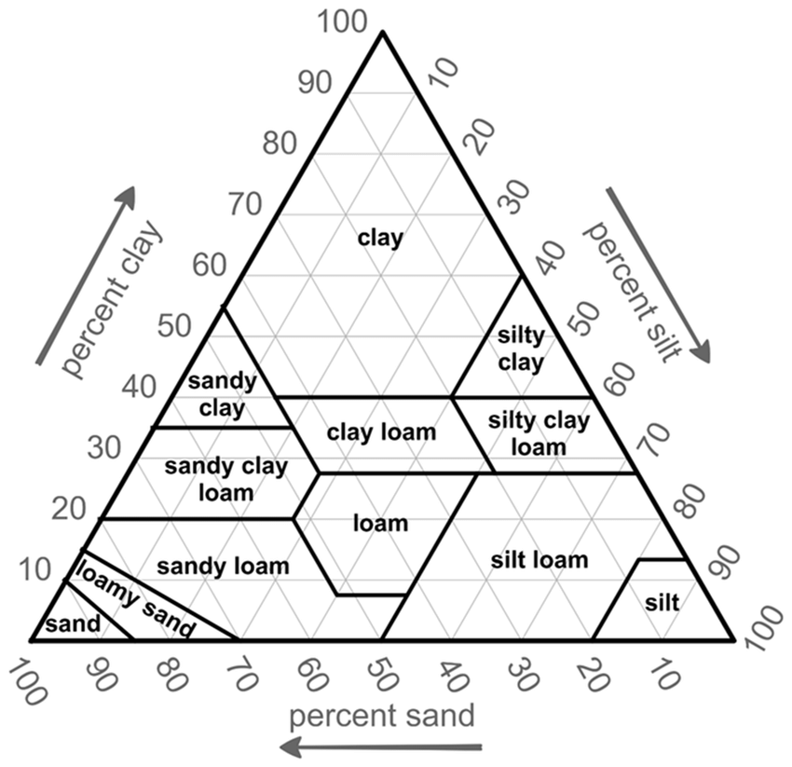
Fig 2:USDA Soil Textural Classification.

3.2 Characterization of Brewery Effluent (BE)
Table 3 shows the NPK content as well as the HUB and HUF count of the BE. The nitrogen, phosphorus, and potassium (NPK) values showed that $K>P>N$. The values of N and P were similar to other works [28,29,30]. The higher content of K was expected, as it is one of the principal ions present in brewing water. It is required for creation of a salty flavor effect, yeast growth and inhibition of certain mash enzymes [31]. BE is often characterized with the presence of microbes especially bacteria and fungi [32]. Result of BE analysis showed a higher HUB count (3.74 × 10³ Cfu/ml) than HUF count (1.89×10² Cfu/ml).
Table 3: NPK Values of the Brewery Effluent
Parameters | Values
Nitrogen (mg/l) | 4.72
Phosphorus (mg/l) | 53.80
Potassium (mg/l) | 362.95
HUF (Cfu/ml) | 1.89×10²
HUB (Cfu/ml) | 3.74×10³

3.3 Characteristics of Crude Oil Contaminated Soil and BE Treated Soil
3.3.1 pH of Crude Oil Contaminated and BE Treated Soil
The pH of contaminated soil (A) and BE treated soils (B, C, and D) were presented in Figure 3. Prior to crude oil contamination, the composite soil pH was 6.01 (Table 2). However, with crude oil contamination, the soil pH decreased slightly by 4.7%. Although the slight decrease in soil pH is similar to the works of Devatha et al. [33] and Njoku et al. [34], it is dissimilar to others [35,36,37]. This discrepancy may be due to difference in the soil type [37] and duration of contamination.
The gradual increase in soil pH for the naturally attenuated soil (A) explains the effect of duration on soil pH. It was observed that after the initial decrease in soil pH from 6.01 to 5.73, the naturally attenuated soil pH improved from 5.73 to a maximum of 5.84, 5.89, 6.24, and 6.42 for 15, 30, 45, and 60 days respectively (Figure 3), leaving the soil slightly acidic. The phenomenon of initial decrease followed by a steady increase in soil pH due to crude oil contamination is similar to the work of Zhao et al. [38].
Sudden alteration of the soil chemical properties, microbial count, and enzymatic activities occurred with crude oil contamination that resulted in the initial decrease in soil pH value [39]. However, the microbial community tend to gradually acclimatized to their new environment (crude oil polluted soil) and this was successively followed with increase enzymatic activities that resulted in increase in soil pH. The linear plot of naturally attenuated soil pH over HUB/HUF (Figure 4) supports this explanation.

Fig 3: Effect of BE treatment duration on soil pH

Fig 4: pH changes during natural attenuation (reactor A)

With BE fertigation of the crude oil contaminated soil (B, C, and D), the increase in soil pH was further enhanced. The soil pH for B, C, and D improved from 5.73 to a maximum of 6.8, 6.86 and 6.93 for 60 days of treatment respectively (Figure 3), bringing the treated soil to near neutral soil pH classification. The linear relationship between HUB/HUF counts and BE treated soil pH as shown in Figure 5 supports the fact that BE fertigation stimulated microbial growth in the soil. An increase in microbial population led to increased enzymatic activities and hence increase pH value.

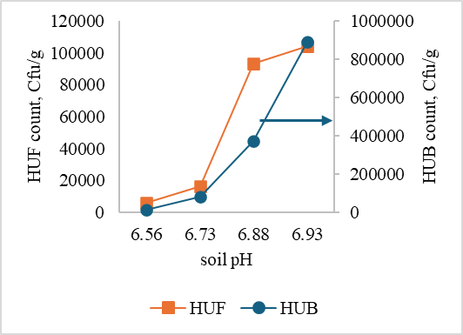

Fig 5: The effect of BE treatment on Hydrocarbon Utilizing Bacteria and Fungi (reactor D)

3.3.2 EC of Contaminated and BE Treated Soil
Soil EC is a good indicator of soil salinity and soil nutrient availability. It was observed that crude oil contamination increased soil EC by 39.8% (40 - 66.5mS/cm) (Table 2 and Figure 6). Crude oil contains hydrocarbons and ions that could bound on soil particles that increased the EC of the contaminated soil. Further increase in soil EC was observed with BE treatment of the crude oil contaminated soil. A direct relationship was also observed between soil EC and treatment duration as well as between soil EC and volume of BE. This is similar to earlier studies where soil EC increased with concentration of biostimulant [40].
High concentration of exchangeable cations in BE especially but not limited to potassium (K) alone increased soil EC level with respect to soil-BE ratio. The BE used in this work had high K content as shown in Table 3 which could have enhanced the soil total K similar to the work of Narasimha et al. [41] where the soil total K increased by 2 to 3 folds when sugar and dairy industry effluent was used to irrigate a soil. The accumulation of exchangeable cations in the soil matrix with BE treatment increased soluble salts in the soil and consequently increased the EC value of treated soil. Also, microbial abundance in soil is often accompanied by enzyme secretion that facilitates solubilization and mineralization of nutrients including phosphate and organic nitrogen compounds that increases soil EC. Figures 7 and 8 show the direct correlation between microbial (HUB and HUF) abundance and treatment duration as well as volume of BE. The increase in microbial count with treatment duration is similar with the work of Ayotamuno et al. [42].

Fig 6: Effect of BE treatment duration on soil pH

Fig 7: Effect of BE treatment duration on HUB count in crude oil polluted soil.

Fig 8: Effect of BE treatment duration on HUF count in crude oil polluted soil.

3.4 Heavy Metal Removal Efficiency
As presented in Table 4, the crude oil contaminated soil had heavy metal concentrations higher than the permissible limits of the World Health Organization (WHO) and Department of Petroleum Resources (DPR) of Nigeria for agricultural soil except Cu. This implies that the soil required remediation which was the essence of BE fertigation. The fertigation process enhanced suitable conditions for microbial proliferation resulting in the increase in HUB and HUF population in the soil. Within the 60 days of remediation, HUB and HUF counts increased significantly ($P<0.05)$from an initial count of $1.65×{10}^{2}$ and $1.03×{10}^{2}$Cfu/g (soil sample A, day 1) to a maximum count of $8.92×{10}^{5}$ and $1.04×{10}^{5}$Cfu/g respectively in soil sample D (Figures 7 and 8). Soil HUB population was higher than HUF population and this is similar to the work of Sumathi et al. [39]. Higher HUB/HUF count translated into higher heavy metal removal through several methods including biosorption, bioaccumulation, biotransformation and bioleaching.

Table 4: Permissible limits of heavy metals in soil according to DPR and WHO
Heavy metals | Symbol | Initial Concentration in polluted soil (mg/kg) | DPR (ppm) | WHO (mg/kg)
Cadmium | Cd | 1.28 | 0.8 | 0.003
Chromium | Cr | 13.59 | 100 | 0.1
Cupper | Cu | 9.32 | 36 | 10
Nickel | Ni | 0.84 | 35 | 0.05
Lead | Pb | 6.49 | 85 | 0.1
Zinc | Zn | 5.02 | 140 | 0.6

Bacteria are regarded as the most exceptional biosorbents among all other microbes due to their high surface-to-volume ratio, numerous chemisorption active cell membranes sites, widespread presence, and ability to grow under diverse conditions [43]. Some chemosorption active sites in bacteria cell wall include amino (-NH₂), carboxyl (-COOH), sulfate (-${SO}_{4}^{2-})$, and phosphate (-${PO}_{4}^{3-}$) groups with carboxyl group as the most abundant [44]. The negatively charged functional groups facilitate electrostatic interactions between the positively charged heavy metal ions, resulting in the removal of heavy metal ions. Figures 9 – 14 showed that a linear relationship exists between heavy metal removal efficiency and both the volume of BE applied and duration of treatment. Therefore, the highest removal efficiency occurred on day 60 and for the experimental material blend of 8:1:1.5 (soil sample D). The metal found to be removed the most was Ni with a percentage removal of 99.5% followed by Cd, 98.4%, Pb, 87.5%, Zn, 79.9%, Cu, 79.6% and the least was Cr, with 75.6% removal efficiency. The over 90% removal of Ni and Cd was due to their high mobility in soil. Although their high mobility at high concentrations has been attributed to their high toxicity in plants [4], in bioremediation, the high mobility is beneficial for effective removal.

Fig 9: Effect of applied volume of BE and duration of treatment on Cd removal efficiency

Fig 10: Effect of applied volume of BE and duration of treatment on Cr removal efficiency

Fig 11: Effect of applied volume of BE and duration of treatment on Cu removal efficiency

Fig 12: Effect of applied volume of BE and duration of treatment on Ni removal efficiency

Fig 13: Effect of applied volume of BE and duration of treatment on Pb removal efficiency

Fig 14: Effect of applied volume of BE and duration of treatment on Zn removal efficiency

4. CONCLUSION

In this study, brewery effluent (BE) was used as a biostimulant for the remediation of heavy metals in crude oil contaminated soil. BE is rich in limiting nutrients (NPK), which created favorable conditions for the growth of hydrocarbon-utilizing bacteria and fungi while also enhancing the soil pH and electrical conductivity. The proliferation of HUB and HUF within 60 days resulted in effective removal of Cd, Cr, Cu, Ni, Pb, and Zn. Heavy metal removal efficiency was linearly related to remediation duration and volume of BE applied. Ni and Cr removal efficiencies were the highest and least at 99.5% and 75.6 % respectively. The study recommends the reuse of BE in bioremediation of crude oil contaminated soil as a new and sustainable approach to mitigate the challenges posed by brewery effluent management.

COMPETING INTERESTS

Declaration of competing interest should be placed here. All authors must disclose any financial and personal relationships with other people or organizations that could inappropriately influence (bias) their work. Examples of potential conflicts of interest include employment, consultancies, honoraria, paid expert testimony, patent applications/registrations, and grants or other funding. If no such declaration has been made by the authors, SDI reserves to assume and write this sentence: “Authors have declared that no competing interests exist.”.

REFERENCES
[1] T.K. Ideriah, G.H. Farrah, & N.J. Pickering, (2010). Effects of heavy metal pollution on plant growth and health: A review. Agricultural Research and Reviews, 3(5), 401-411.

[2] G. Chen, J. Li, H. Han, & X. Wang, (2022).Physiological and Molecular Mechanisms of Plant Responses to Copper Stress. Int. J. Mol. Sci. 23, 12950. https://doi.org/10.3390/ijms232112950

[3] T.W. Clarkson, G. Magos, & P. Chadwick, (2003).An overview of the toxicology of inorganic mercury and methylmercury compounds. Mercury and human health, 1-30.

[4] A.S.A. Asmoay, S.A. Salman, A.M. El-Gohary, & H.S. Sabet, (2019). Evaluation of heavy metal mobility in contaminated soils between Abu Qurqas and Dyer Mawas Area, El Minya Governorate, Upper Egypt. Bulletin of the National Research Centre. 43(88):1-13. https://doi.org/10.1186/s42269-019-0133-7

[5] O.A. Udoetok, J.A. Amuche, & F.O. Igwe, (2011). Effect of crude oil contamination on the growth and nutrient content of maize (Zea mays L.). Journal of Environmental Protection, 2(06), 697-702.
[6] X. Zheng, H. Lin, D. Du, G. Li, O. Alam, Z. Cheng, X. Liu, S. Jiang, & J. Li, (2024). Remediation of heavy metals polluted soil environment: A critical review on biological approaches. Ecotoxicology and Environmental Safety, 284, 1-25. https://doi.org/10.1016/j.ecoenv.2024.116883
[7] A.O. Adebusoye, O.O. Olayinka, A.O.A. Ige, O.O. Awosanya, & A.O. Oladimeji, (2017). Bioremediation of heavy metals in contaminated soils: A review of principles and applications. Water, Air, & Soil Pollution, 228(10).

[8] G. Conway, (2019). Beer and brewing. In Encyclopedia of food and health (pp. 53-56). Oxford Academic Press.

[9] Kirin Holdings Company. (2019). Kirin group environmental report 2019. Tokyo, Japan: Kirin Holdings Company.
[10] K. Rachwał, A. Waśko, K. Gustaw, & M. Polak-Bereck, (2020). Utilization of brewery wastes in food industry. PeerJ. 8:e9427 http://doi.org/10.7717/peerj.9427
[11] A.O. Olajire, (2012). Brewers spent grain: A versatile source of bioactive compounds with health-promoting properties. Journal of Brewing and Distilling, 119(3-4), 113-122.
[12] V.I. Kaur, & P.K. Saxena, (2004). Incorporation of brewery waste in supplementary feed and its impact on growth in some carps. Bioresource Technology. 91:101–104 http://doi:10.1016/S0960-8524(03)00073-7

[13] Chattaraj S., Mitra, D., Ganguly, A., Thatoi, H. & P.K. Das Mohapatra, (2024). A critical review on the biotechnological potential of Brewers’ waste: Challenges and future alternatives. Current Research in Microbial Sciences. 6:100228. https://doi.org/10.1016/j.crmicr.2024.100228

[14] Strizhenok, A.V., Korelskiy, D.S. & Y. Cho, (2021). Assessment of the efficiency of using organic waste from the brewing industry for bioremediation of oil-contaminated soils. Journal of Ecological Engineering. 22(4): 66-77. https://doi.org/10.12911/22998993/133966

[15] A. Uygur, & F. Kargi, (2004). Biological treatment of brewery wastewater using a rotating biological contactor (RBC). Journal of Hazardous Materials, 112(1-2), 145-152

[16] C.J. Brouckaert, B. De Wilde, & W. Verstraete, (2004). Sustainable brewery effluent treatment: Processes and technologies. Desalination, 160(3), 251-267.

[17] I. Odlare, S. Aslanzadeh, & B.H. Svensson, (2015). Brewery wastewater treatment: A review of the state-of-the-art and emerging technologies. Journal of Cleaner Production, 112, 225-237.

[18] A.L. Tchmango, F.L. Oliveira, & S. Garcia-Segura, (2017). Anaerobic digestion of brewery spent grain: A review. Bioresource Technology, 227, 122-133.

[19] I.N. Maduwuba, (2021). Bioremediation of heavy metal-contaminated soil using bacterial strains isolated from brewery effluent and municipal sludge. Environmental Science and Pollution Research, 28(14), 7999-8015.

[20]. A.A. Kadafa, (2012). Oil exploration and spillage in the Niger Delta of Nigeria. Civil and Environmental Research. 2(3):38-51

[21] D.N. Ogbonna, I.K. EEkweozor, R.R. Nrior, & F.E. Ezinwo, (2019). Evaluation of organic nutrient supplements and bioaugmenting microorganisms on crude oil Polluted Soils. Current Journal of Applied Science and Technology. 38(6): 1-19. https://doi.org/10.9734/CJAST/2019/v38i630395

[22] United States Department of Agriculture (USDA) (2009). Soil texture triangle. In Field book for describing and sampling soils (pp. 102-103). National Soil Survey Center, Lincoln, NE
[23] G.L. Mills, W.A. Adamse, and J.W. Ratcliffe. (1978). Development of a multipurpose medium for marine hydrocarbon degrading microorganisms. Journal of Applied Microbiology 45:231-237.

[24] Okpokwasili, N.C. &Odokuma, K.E. (1990). Characterization of the hydrocarbon-utilizing microflora of some Nigerian rivers. Water Research 24:1619-1625.

[25] A.Duram, (1983).Soil pH classification.In Soil classification and management (pp. 127-132).Springer, Dordrecht.

[26] Y. Fujii, (2014).Tropical rainforest soils.In Encyclopedia of soil science (pp. 2394-2396).CRC Press.

[27] United States Salinity Laboratory Staff (USSL Staff) (1954).Diagnosis and improvement of saline and alkali soils. USDA Handbook 60.

[28] A.M. Enitan, J. Adeyemo, S. Kumari, F.M. Swalaha, & F. Bux, (2015). Characterization of Brewery Wastewater composition. International Journal of Environmental and Ecological Engineering. 9(9):1073-1076. http://scholar.waset.org/1307-6892/10002210

[29] W. Parawira, I. Kudiata, M.G. Nyandoroh, & R. Zvauya, (2005). A study of industrial anaerobic treatment of opaque beer brewery wastewater in a tropical climate using a full-scale UASB reactor seeded with activated sludge. Process Biochemistry, 40: 593-599.

[30] U.E. Inyang, E.N. Bassey, & J.D. Inyang, (2012). Characterization of brewery effluent fluid. Journal of Engineering and Applied Sciences. 4: 67-77.

[31] D. Styburski, K. Janda, I. Baranowska-Bosiacka, A. Lukomska, K. Dec, M. Goschorska, B. Michalkiewicz, P. Zietek, & I. Gutowska, (2018). Beer as a potential source of macroelements in a diet: the analysis of calcium, chlorine, potassium, and phosphorus content in a popular low-alcoholic drink. European Food Research and Technology. 244:1853–1860 https://doi.org/10.1007/s00217-018-3098-0

[32] R. Kowsalya, C.M. Noorjahan, C.M. Karrunakaran, M. Deecaraman, & M. Vijayalakshmi, (2010). Physico-chemical characterization of brewery effluent and its degradation using native fungus Aspergillus niger. Journal of Industrial Pollution Control. 26(2): 171-176.
[33] C.P. Devatha, A.V. Vishal, & J.P.C. Rao, (2019). Investigation of physical and chemical characteristics on soil due to crude oil contamination and its remediation. Applied Water Science. 9(89): 1-10. https://doi.org/10.1007/s13201-019-0970-4
[34] K.L. Njoku, M.O. Akinola, & B.O. Oboh, (2008). Does crude oil affect the pH, moisture and organic matter content of soils? Ecology Environment and Conservation. 14(4):731-736

[35] N.E. Etukudoh, O.A. Essien, O.E. Udo. & T.O. Payou, (2021). Effect of crude oil pollution on soil properties and performance of maize (Zea mays L) in coastal plain sand South Eastern Nigeria. International Journal of Agricultural Research and Food Production. 6 (1): 49-61

[36] L.C. Agim, H.I. Amos, A.F. Osisi, H.N. Okoli, & N. T. Egboka, (2021). Lethality of Crude Oil Contamination on Properties of Soil and Growth Parameters of Maize (Zea mays L.). International Journal of Environmental Sciences & Natural Resources. 28 (3): 1-11

[37] U.C. Okafor, (2023). Evaluation of the Impact of Crude Oil Contamination on Soil's Physicochemical Characteristics, Micro-flora and Crop Yield. Tropical Aquatic and Soil Pollution. 3(1): 24-35 https://doi.org/10.53623/tasp.v3i1.132

[38] T. Zhao, Y.M. Lozano, & M.C. Rilling, (2021). Microplastics increase soil pH and decrease microbial activities as a function of microplastic shape, polymer type, and exposure time. Frontiers in Environmental Science. 9(675803):1-14. https://doi.org/10.3389/fenvs.2021.675803

[39] T. Sumathi, A. Janardhan, A. Srilakhmi, D.V.R. Sai Gopal, & G. Narasimha, (2012). Impact of indigenous microorganisms on soil microbial and enzyme activities. Archives of Applied Science Research, 4(2):1065-1073. www.scholarsresearchlibrary.com

[40] E. Alayu, & S. Leta, (2020). Brewery sludge quality, agronomic importance and its short-term residual effect on soil properties. International Journal of Environmental Science and Technology. 17:2337-2348. https://doi.org/10.1007/s13762-020-02630-2

[41] G. Narasimha, G.V.A.K., Babu, & B.R. Reddy, (1999). Physico-chemical and biological properties of soil samples collected from soil contaminated with effluents of cotton ginning industry. Journal of Environmental Biology. 20:235-239

[42] M.J. Ayotamuno, R.B. Kogbara, S.O.T. Ogaji, & S. D. Probert, (2006). Bioremediation of a crude oil polluted agricultural-soil at Port Harcourt, Nigeria. Journal of Applied Energy. 83(4):1249-1259.

[43] K.K. Sodhi, L.C. Mishra, C.K. Singh, & M. Kumar, (2022). Perspective on the heavy metal pollution and recent remediation strategies. Current Research in Microbial Science. 3(100166); 1-10. https://doi.org/10.1016/j.crmicr.2022.100166

[44] H. Tang, G. Xiang, W. Xiao, Z. Yang, & B. Zhao, (2024). Microbial mediated remediation of heavy metals toxicity: mechanisms and future prospects. Frontiers in Plant Science. 15:1420408. https://doi.org/10.3389/fpls.2024.1420408

