Original Research Article

Physico-chemical properties of formulated and spray-dried protein drink powder

ABSTRACT

A study was conducted on the formulation of protein drink powder from moth bean and kodo millet. The grains of moth bean and kodo millet underwent a series of processes, including soaking, sprouting, drying, roasting, pulverizing, and blending. Slurries ranging from 0% to 100% were prepared, and the protein drink powder with the most favorable formulation (specifically, 60% sprouted moth bean flour and 40% sprouted kodo millet flour) was selected based on sensory evaluations. The identified best-formulated protein drink powder such as bulk density, moisture content, water activity, protein, fat, fiber, ash and carbohydrate was determined, resulting in values of 0.416 g/mL, 5.16 %, 0.33, 17.15 %, 1.48 %, 5.12 %, 2.40 % and 62.76 %, respectively. The best-formulated protein drink powder was subjected to a spray-drying process with varying temperatures (140, 150 &160 °C) and feed rates (9, 10 & 11 rpm). The optimized protein drink powder obtained from this process (temperature of 149 °C and feed rate of 10 rpm) resulted in 11.32 % of protein, 0.42 % of fat, 4.66 % of fiber, 2.59 % of ash and 70.56 % of carbohydrate. It was observed that the quality of the powder had not deteriorated during the storage period of 90 days.

Keywords: Moth bean, Kodo millet, Soaking, Sprouting, Roasted

1. INTRODUCTION
Grain legumes occupy an important place in human nutrition, especially in the dietary
pattern of low-income groups of people in developing countries. Legumes, considered as
poor man's meat, is generally a good source of slow-release carbohydrates and is rich in
proteins. Legumes are normally consumed after processing, which not only improves
palatability of foods but also increases the bioavailability of nutrients, by inactivating trypsin
and growth inhibitors and haemagglutinins. (Tharanathan and Mahadevamma 2003).

The moth bean (Vigna aconitifolia), an underutilized legume, is recognized as a potential protein and nutrient source. Worldwide, people primarily from underdeveloped nations cultivate and consume mature moth bean seeds. (Siddhuraju et al., 2005).

Moth bean (Vigna aconitifolia), also known by various names such as dew bean, haricot mat, Indian moth bean, mat bean, matte bone, math, moth, moth gram, matki, or Turkish gram, originates from the Indian subcontinent and is primarily grown in India and Pakistan (Singhal et al., 2003). Regular consumption of moth beans is linked to preventing cardiac diseases, diabetes and obesity. The review focuses on the nutritional bioavailability and health benefits of moth bean seeds (Gupta et al. (1998)). Germination notably decreased phytic acid and polyphenol content, (Negi et al. (2008)).

Moth bean (Vigna aconitifolia L.), a significant member of the Fabaceae family, for its rich nutritional composition. Moth bean is a drought-tolerant legume, offering protein, carbohydrates, fatty acids, minerals, vitamins, antioxidants and polyphenols. (Gupta et al. (1998)). Deshmukh and Pawar (2020) reported moth bean, after germination protein, iron and vitamin C increased with a decrease in trypsin inhibitor activity (Deshmukh and Pawar (2020)).
The spray dryer operating conditions and response variables are very important to produce the maximum powder efficiency and yield. These response variables were selected as they were important indicators of microsphere functionality and process efficiency. Factors that can significantly affect the spray drying process and product characteristics include the feed rate, atomizing wheel speed, dryer inlet and outlet air temperatures and drying air humidity. Spray dryer inlet temperatures had a more direct effect on the drying process, with droplet drying rates positively related to inlet air temperatures used (Phisut, 2012).

Millets are the major source of energy and protein for millions of people. It has been reported that, millet has many nutritious and medical functions (Obilana and Manyasa, 2002; Yang et al., 2012). Millet based foods and beverages are known worldwide and are still part of the major diet in most of the countries (Obilana and Manyasa, 2002; Amadou et al., 2011). Kodo millet, (Paspalum scrobiculatum L.) one of the ancient grains of the world, originated from Africa and was domesticated in India a few thousand years ago is a draught resistant plant. It belongs to the family Poaceae. cereal and legume flours to enhance nutritional value, palatability, and functionality. Kodo grains comprise protein 8.35 %, fat 1.45 %, carbohydrate 65.65 % and ash 2.95 %. It can be regarded as a cereal nutrient. Kodo millet grain contains 8.3 % protein of which the major protein is glutelin (Sudharshana et al., 1988).
Kodo millet has the highest free radical (DPPH) quenching activity followed by great millet (sorghum) and finger millet (Hegde and Chandra, 2005). Due to elevated antioxidant content it protects against oxidative stress and retaining glucose concentrations in type-2 diabetes. Dietary enhancement with phenolic acid-rich food products has been shown to impart antimutagenic, antiglycemic and antioxidant characteristics, which can be utilized in the development of health products (Friedman, 1997; Shobana et al., 2007).
Shelf life is typically described as a specific duration following processing and packaging, during which a food product achieves a predetermined level of quality under specified storage conditions (Nicoli, 2012). This established quality standard is essential for making the product suitable for consumption. The analysis of shelf life is a widely employed method to assess the quality and stability of a particular food item throughout its storage period. Indeed, a meticulous examination of shelf life guarantees that consumers enjoy a high-quality food experience (Tian et al., 2019). In the food industry, it is common to convert liquid products into powder to facilitate easier transportation, preservation, and storage (Nnaedozie et al., 2019).

2. MATERIAL AND METHODS
An investigation was conducted to formulate protein drink powder from moth bean and kodo millet by blending it with other ingredients. This chapter gives information on all experimental materials used and the different scientific methods employed during this investigation on physico-chemical properties of formulated and spray dried protein drink powder.
2.1 Raw materials
The main raw materials used for the development of protein drink products were moth bean and Kodo millet. Moth bean and kodo millet were procured directly from the Regional Cooperative Organic Farmer’s Association Federation Limited, Davanagere, Karnataka, India. The other ingredients used in the study like jaggery, cardamom, etc., were procured from local supermarkets. The samples were cleaned thoroughly packed in polyethylene bags and stored at ambient temperature
Table 1: Equipment and Machines

Sl.no | Name of equipment/machine | Source of supply
01 | Pulveriser | Centre of Excellence for Nutri-cereals, GKVK
02 | Kodo -dehuller | Centre of Excellence for Nutri-cereals, GKVK
03 | Tray Dryer | Post-harvest Engineering and Technology, UAS GKVK
04 | Spray Dryer | Dept of Processing and Food  Engineering, COAE, GKVK

2.2 Preparation of Moth Bean Flour
The moth bean malt was prepared by following the standard procedure as described by Mankotia and Modgil (2003). Moth bean grains were steeped in potable tap water for 12 hrs. The grain water ratio was 1: 3. The soaked grains were tied in a muslin cloth and allowed to germinate at an ambient temperature of 25±2 ºC. Grains were sprinkled with water. It took 24 hrs for the grains to germinate. When the sprouts were 1-2 cm long, germinated grains (Plate No. 1) were dried in a cabinet drier at 50±3 ºC for 12 hrs and roasted for 5 minutes at 95 ºC. The roasted samples were milled to pass through a 40-mesh sieve.

2.3 Preparation of Kodo Flour
The Kodo malt was prepared by following the standard procedure as described by Sharma, S., and Sharma (2021). Kodo Millet seeds (250 g) were soaked in water for germination at 27 ˚C for 12 h, and the water was changed frequently to prevent the excessive growth of microorganisms. The millet seeds were then allowed to germinate at room temperature, i.e., 27±2 ˚C for 48 h. After germination (Plate No. 2), the seeds were dried at a moderate temperature not exceeding 75 ˚C in an oven, and sprouted grains were later dried to a final moisture content of nearly 10-12%. These grains were then roasted uniformly at 70-80 ˚C by using a conventional toasting pan and ground.

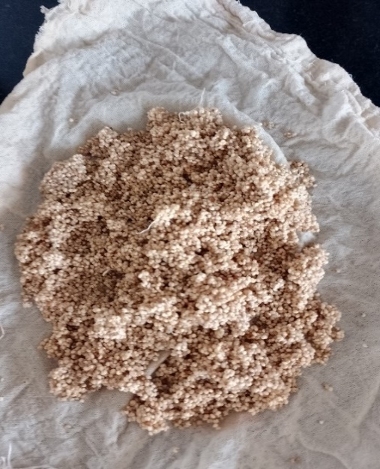
Plate No. 2: Sprouted kodo millet
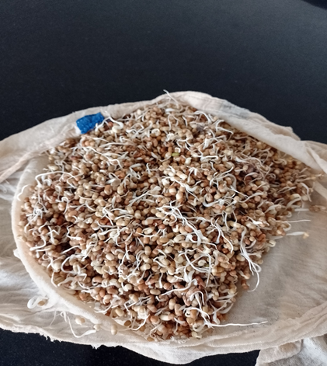
Plate No. 1: Sprouted moth bean

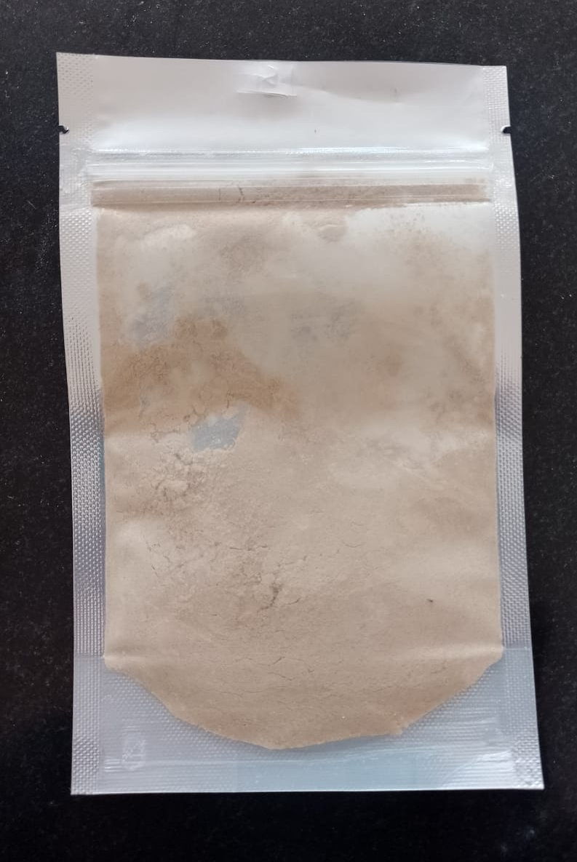
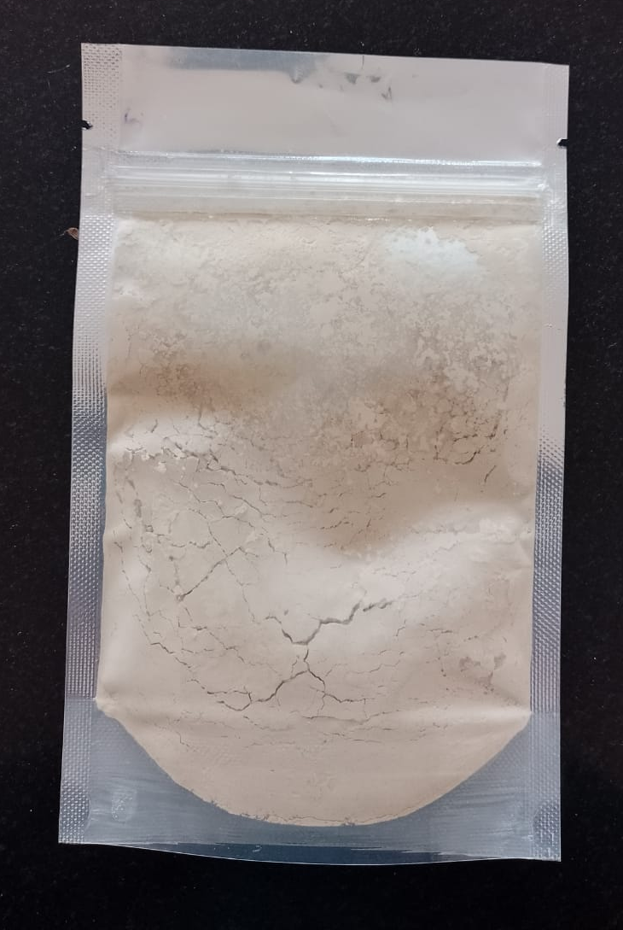

Plate No. 4: Spray dried protein drink powder
Plate No. 3: Formulated protein drink powder

2.4 Formulation of moth bean flour and Kodo millet flour blends for protein drink powder production
Initially, composite blends were prepared by combining different levels of germinated and decorticated kodo millet flour and germinated moth bean flour to develop protein drink powder. Formulation with 100 % germinated moth bean flour was taken as control. Table 2 presents formulations for the preparation of protein drink powder.

Table 2: Formulations used for the preparation of protein drink powder from MF and KF blending
Formulations | Level of flours in composite  blend (MF + KF) |  | Composite blend (%) | Water  (ml/20g)
Formulations | GMF (%) | GKF (%) | Composite blend (%) | Water  (ml/20g)
T₁ | 100 | 0 | 100 | 200
T₂ | 90 | 10 | 100 | 200
T₃ | 80 | 20 | 100 | 200
T₄ | 70 | 30 | 100 | 200
T₅ | 60 | 40 | 100 | 200
T₆ | 50 | 50 | 100 | 200
T₇ | 40 | 60 | 100 | 200
T₈ | 30 | 70 | 100 | 200
T₉ | 20 | 80 | 100 | 200
T₁₀ | 10 | 90 | 100 | 200
T₁₁ | 0 | 100 | 100 | 200
GMF – Germinated Moth bean flour, GKF – Germinated Kodo millet flour
2.5 Spray dried protein drink powder
The formulated protein drink powder (Plate No. 3) was spray dried to achieve best quality product, the spray dryer was operated at predetermined spray drying conditions at different inlet air temperatures (140, 150 and 160 ℃) different feed rate (9, 10 and 11 rpm). The Spray dried protein drink powder was collected from stainless steel cyclone in a metalized polyester packaging material. It was packed in a pouch and stored at room temperature for further analysis.

2.6 Analysis of Powder Properties
2.6.1 Bulk density and pH:
The bulk density of the best formulated protein drink powder obtained from different treatments was measured according to the procedure described by Caparino et al. (2012) and Lebrun et al. (2012). The pH of best formulated protein drink powder was measured by using a digital pH meter (Model: MICROPRO, Lab mate) by following the standard method (Arab et al., 2011).
2.6.2 Water activity:
For the water activity determination (Hygro Lab C1 bench-top meter), the powder was filled in the disposable cups of the water activity meter and the sample drawer knob was turned to the open position and the drawer was opened. The prepared sample was then placed in the drawer. Checked the top lip of the cup to make sure that it was free from sample residue (an overfilled sample cup may contaminate the chamber’s sensors). After placing the sample, a reading was noted on the LCD of the water activity meter.
2.6.3 Colour:
Bench-top spectrophotometer (Model: Konica Minolta; spectrophotometer CM-5) was used for the measurement of colour of formulated protein drink powder. It works on the principle of focusing the light and measuring energy reflected from the sample across the entire visible spectrum. The 3-dimensional scale L*, a* and b* was used.
2.6.4 Proximate composition:
methods. Physicochemical methods characterized the fresh avocado pulp, according to the official (AOAC 2000) method, through the determination of moisture, protein, fat, and ash contents in triplicate for each sample. Carbohydrates were obtained by difference 100% - (%protein +% moisture +% lipid +% ash) (Sadasivam Manickam et al.,1992).
2.7 Storage studies of the spray-dried protein drink powder
The storage studies were done to determine the shelf-life effect of the prepared protein drink powder. The optimized product was stored in a metalized polyester pouch (MP) for three months at ambient conditions. Samples were analyzed periodically at 0, 15, 30, 45, 60, 75, and 90 days for physicochemical parameters.

2.8 Assessment of physicochemical parameters of protein drink powder during storage.
The physicochemical parameters of Protein drink powder, such as moisture content, pH, bulk density, water activity, overall acceptability, and microbial analysis using the standard methods AOAC (2000) and FSSAI (2012), during storage.
2.9 Statistical analysis
The data for the storage studies, such as moisture content, bulk density, water activity, pH, color values, microbial analysis, and sensory properties of developed products, were statistically analyzed according to the design CRD to determine the significant differences in the responses during storage.
Fig 1. Flow chart for the preparation of formulated Protein drink powder
Kodo millet
Moth bean

Cleaning and Grading
Cleaning and Grading

Soaking(12h) and Sprouting(24h)
Soaking(12h) and Sprouting(48h)

Drying(12h) and Roasting (5 min)

Drying(12h) and Dehulling

Roasting(5min) and Grind

Grind

blend

Cook

Spray drying

3. RESULTS AND DISCUSSION
3.1 Physico-chemical properties Formulated Protein powder and Spray dried protein powder.
3.1.1 Bulk density:
The average bulk density value of formulated Protein powder and spray dried protein powder (Plate No. 4) was found to be 0.571 g/cc and 0.416 g/cc as shown in (Table 3). Compared to formulated Protein powder, the spray dried protein powder was found to be more due to evaporation of moisture and the high drying rate obtained at higher drying temperatures produces a higher ratio of surface to volume for the spray dried capsules, thus causing lower bulk density of the powders Karaaslan et al. (2014). Similar results obtained by (Shruti et al., 2022) where the the bulk density of the malted milk powder ranged from 0.381 to 0.422 g/mL.. Similar result that to be found (Dantas et al. 2018) For bulk density, values is 0.377 g/cm³ in spray dried avocado powder drink with maltodextrin.
3.1.2 Moisture and Water activity:
The average value of moisture in formulated protein powder and spray dried protein powder were 5.37 and 4.67 %, respectively and the average value of water activity in formulated Protein powder and spray dried Protein powder were 0.33 and 0.23, respectively as shown in (Table 3). The decreased in moisture content and water activity in spray dried powder might be due to exposure of sample to the higher driving force of heat in the spray dryer. Similar results are obtained Pandey et al. (2020) reported that the moisture content of the powder immediately after drying was found to be 2.9 per cent of spray-dried butter fruit milk shake with maltodextrin.
3.1.3 Color:
The average color values of the formulated protein powder was found to be 88.82 ( L* ), 0.96 ( a* ) and 12.53 ( b* ) While compared to spray dried protein powder were 87.82 (L*), 1.24 (a*) and 11.67 (b*) this results are in line with the views of (Abilasha et al., 2008) and color value varied in spray dried powder mighty be due to incorporation milk and caramelization of honey in the drying process.
3.1.4 pH:
The average value of pH in formulated protein powder and spray dried protein powder were 5.72 and 5.78, respectively shown in (Table 3) the pH powder varied might be due to addition of skim milk powder. Similar results were obtained (Pandey et al., 2020) analyzed the pH of spray dried butter fruit milk shake powder added with Maltodextrin had pH of 6.71 and classified as acid food.
3.1.5 Proximate composition:
The average value of moisture, protein, fat, fibre, ash and carbohydrate in formulated Protein powder and spray dried Protein powder were 5.37, 17.15, 1.48, 5.12, 2.40, 62.76 and 4.67, 11.32, 0.42, 4.66, 2.59, 70.56%, respectively shown in (Table 3). While formulated protein powder, the spray dried protein powder obtained a lower value in proximate composition and the in-moisture content and water activity and fat and fibre in spray dried protein powder might be due to exposure of the sample to the higher driving force of heat in the spray dryer. Similar results are obtained Pandey et al. (2020) reported that the protein content was found to be 17.2 per cent of spray-dried butter fruit milk shakes with maltodextrin. Priyanka et al. (2018), reported that the fat content was found to be 0.46 percent of spray-dried mango milk powder.
Table 3. Physico-chemical properties of Protein drink powder.
Physico-chemical properties |  | Formulated Protein powder | Spray-dried protein powder
Bulk density (g/cc) |  | 0.571 | 0.416
Water activity |  | 0.33 | 0.23
Color | L* | 88.82 | 87.82
Color | a* | 0.96 | 1.24
Color | b* | 12.53 | 11.67
Moisture content (%) |  | 5.37 | 4.67
Protein (%) |  | 17.15 | 11.32
Total carbohydrate (%) |  | 62.76 | 70.56
Fat (%) |  | 1.48 | 0.42
Ash (%) |  | 2.40 | 2.59
Crude Fibre (%) |  | 5.12 | 4.66
pH |  | 5.72 | 5.76

3.2 Storage Studies of optimized spray dried protein drink powder.
Table 4. Effect of storage days on moisture content, water activity, bulk density and pH of spray dried protein drink powder.

Packaging material | Storage period | Moisture content | Water activity | Bulk density | pH
Metalized polyester | 0 | 4.67 | 0.231 | 0.416 | 5.78
Metalized polyester | 15 | 4.75 | 0.261 | 0.422 | 5.51
Metalized polyester | 30 | 4.83 | 0.272 | 0.433 | 5.38
Metalized polyester | 45 | 4.92 | 0.31 | 0.455 | 5.11
Metalized polyester | 60 | 5.21 | 0.327 | 0.469 | 5.07
Metalized polyester | 75 | 5.36 | 0.348 | 0.481 | 5.02
Metalized polyester | 90 | 5.47 | 0.359 | 0.498 | 5.01
Metalized polyester | CD@5% | 0.441 | 0.027 | 0.039 | N/A
Metalized polyester | SEm ± | 0.145 | 0.009 | 0.013 | 0.152
CD: Critical Difference, SEm ±: Standard Error of mean

For a three-month storage period the moisture content was initially 4.67 per cent. The moisture content steadily increased during the course of the storage period shown in Fig 2. At the end of the three-month storage period, it was shown to have grown from 4.67 to 5.47 per cent it is due to ingress of jaggary which cause the hygroscopic in nature which leads to increase the moisture content over a time in packaged material and moisture revealed that the packaging material and storage time had a significant (P≤ 0.05) impact on the moisture content of spray dried protein drink powder product. These values are consistent with the (vennila et al., 2020).
The water activity was increased slightly due to ingress changes of chemical during storage values are shown above (Table 4) which varied from 0.231 to 0.359 shown as in Fig 3. Similar results obtained by progressive increase in the water activity of instant mango milk shake powder ranging from 0.241on 0th day to 0.330 on 90th day (Singham et al. 2014).
For a three-month storage period the bulk density was initially 0.416 g/cc. The bulk density steadily increased during the course of the storage period as shown in Fig 4. At the end of the three-month storage period, it was shown from 0.416 to 0.498 g/cc. bulk density revealed that the packaging material and storage time had a significant (P≤ 0.05) impact on the bulk density of Spray dried protein drink powder product. Similar results obtained by Priyanka (2018) were observed Bulk density of mango milk powder increased with the storage period while initially it was observed that 0.71 then gradually increased during storage Moist powder exhibited higher angle of repose (mainly due to cohesion), despite the fact that the angle of internal friction usually decreases with increase in moisture level.
After every 15 days of storage for three months, the pH of spray dried protein drink powder samples packaged in metalized polyester packing film was evaluated as shown in Fig 5. For a three-month storage period, the water pH was initially 5.78. The pH steadily decreased during the course of the storage period. At the end of the three-month storage period, it was shown from 5.78 to 5.01. pH revealed that the packaging material and storage time had a significant (P≤ 0.05) impact on the pH of Spray dried protein drink powder product. Similar results obtained by Priyanka (2018) there was progressive slightly decrease in the pH of instant mango shake powder by spray drying ranging from 6.08 on 0th day to 5.70 on the 90th day.

Fig 2. Effect of moisture content on storage days Fig 3. Effect of moisture content on storage days

Fig 4. Effect of on bulk density storage days Fig 5. Effect of on pH storage days
3.3 Effect of packaging material and storage days on sensory characteristics
The sensory acceptability of the spray dried protein powder was assessed on each withdrawal for 15-day intervals and recorded in terms of color, appearance, consistency, flavour, mouth feel and overall acceptability during three months storage period.
3.3.1 Effect of storage on sensory scores of Spray dried protein drink powder stored in metalized polyester (mp) film
The sensory scores for the optimized protein drink powder product were stored in metalized polyester packaging cover are presented in Table 5. It was observed that, with increasing storage period, mean sensory sores for overall acceptability of the protein drink powder declined from 8.4 to 6.4 at the end of the storage period, the sensory scores for color, appearance, consistency, flavor, mouth feel and overall acceptability of protein drink powder product was rated as 8.20, 8.3, 8.4, 8.1, 8.5 and 8.4, respectively. The highest average overall acceptability was observed at 0, 1 and 2 months of storage indicating that protein drink powder was acceptable up to two months of storage. Decreasing trends (p < .05) were observed for all the sensory attributes like, color, appearance, consistency, flavor, mouth feel and overall acceptability of products during storage.

Table 5: Effect of packaging material and storage days on sensory characteristics of spray dried protein drink powder.

Packaging material | Storage days | Color | Appearance | Consistency | Flavor | Mouth feel | OA
Metalized polyester film | 0 | 8.2 | 8.3 | 8.4 | 8.1 | 8.5 | 8.4
Metalized polyester film | 15 | 8 | 8.1 | 8.2 | 7.9 | 8.3 | 8
Metalized polyester film | 30 | 7.7 | 7.8 | 7.9 | 7.5 | 7.7 | 7.8
Metalized polyester film | 45 | 7.5 | 7.6 | 7.7 | 7.4 | 7.4 | 7.5
Metalized polyester film | 60 | 7.3 | 7.3 | 7.4 | 7.2 | 7.2 | 7.3
Metalized polyester film | 75 | 7 | 7.1 | 7.2 | 7 | 7.1 | 7
Metalized polyester film | 90 | 6.7 | 6.8 | 6.9 | 6.8 | 6.6 | 6.4
Metalized polyester film | CD@5% | 0.6562 | 0.6644 | 0.673 | 0.6503 | 0.662 | 0.657
Metalized polyester film | Sem ± | 0.2166 | 0.219 | 0.222 | 0.2144 | 0.218 | 0.216
CD: Critical Difference, Sem ±: Standard Error of mean

3.4 Effect of packaging material and storage days on microbial load
The microbiological analysis was carried out for the protein drink powder packed in metalized polyester packaging film using the Total plate count (TPC) method.
3.4.1 Effect of microbial load on spray dried protein drink powder during storage days
Microbial load was calculated in terms of cfu/g and presented in Table 6. During the storage period of three months yeast and molds were detected and Coliforms were found to be absent. The bacterial count was found to increase in the range of Nil to 2.4 Χ 10⁴ cfu/g. Yeast and mold were not detected up to first month of storage period. From the 75th day of storage, yeast and molds were detected in the range of 1.3 X 10⁰ to 2.5 Χ 10⁰ cfu/g and 1.2 X 10⁰ to 2.6 Χ 10⁰ respectively. It was clear that, bacterial count and fungal count increased during storage days.
The TPC load of protein drink powder kept in metalized polyester pouches at ambient storage conditions increased significantly (p ≤ .05) from 0 to 3.1 Χ 10⁴ cfu/g. This higher bacterial count could be due to the adverse conditions of storage environment (temperature and relative humidity), which facilities the rapid entry of moisture inside the protein drink powder sample and subsequently enhances the bacterial count of the product.
(Barooah et al., 2018) Similar to the results of the bacterial count, the fungal count of the banana milkshake powder samples also increased significantly from the third month of the storage period. 0 days of preparation at an interval of 30 days the findings of the study revealed a significant increase in the microbial load in banana milkshake powder from 30 days of storage at 5% probability level up to 90 days. At 0 days the cfu count depicted a non-significant increase in the packaging materials. At 30 days, the microbial load was found to increase significantly (F=4.7931) from 0 to 0.40×10⁻⁶ cfu/ mL.
(Priyanka et al., 2018) reported in Mango milkshake powder no visible microbial growth was seen till 30th day of storage followed by an increasing trend in the microbial growth from 60th to 90th day of storage. Maximum microbial growth noticed was 3.45±.06 log10 cfu/mL which was well within permissible limits as given by FSSAI (2011).
Table 6: Effect of storage on microbial load of formulated protein drink powder sample stored in metalized polyester (MP) film
Storage period (days) | Microbial load
Storage period (days) | TPC  (104 cfu/g) | Yeast (100 cfu/g) | Mold (100 cfu/g) | Coliforms  (100 cfu/g)
0 | Nil | Nil | Nil | Nil
15 | Nil | Nil | Nil | Nil
30 | Nil | Nil | Nil | Nil
45 | Nil | Nil | Nil | Nil
60 | Nil | Nil | Nil | Nil
75 | 2.1 | 1.3 | 1.2 | Nil
90 | 2.4 | 2.5 | 2.6 | Nil
CD@5% | 0.1523 | 0.0933 | 0.0948 | -
Sem ± | 0.0502 | 0.0307 | 0.0312 | -

Conclusion:
The results indicated that the spray drying method demonstrated satisfactory capability in drying and protein drink powder with the desired properties. spray dried powder has a higher amount of protein, fat, ash, and crude fibre but its low moisture content and water activity indicate that it has a longer shelf life with a low wettability time and is instantaneously soluble in water. The qualitative and quantitative properties of protein drink powder were found to be more desirable at 150°C and 10 rpm. Further increases in drying air temperature result in higher energy consumption and have a detrimental effect on the quality of the protein drink powder. However, the drying efficiency was significantly dependent on factors such as inlet air temperature and feed flow rate. Developed spay dried protein drink powder is a healthy alternative, storageable, and reasonable. The qualitative and quantitative properties of protein drink powder were found to be more desirable at 150°C and 10 rpm. Further increases in drying air temperature result in higher energy consumption and have a detrimental effect on the quality of the protein drink powder. During storage of 90 days, results show progressively acceptable and sensory and microbial analyses were analyzed. Further research is needed for can be tried with different flavors and various value-added food products can be made by incorporating protein drink powder with milk to increase the protein content.

REFERENCES:

ABHILASHA, K.R., 2018, Optimization of process parameters of spray drying for production of pineapple juice powder (Doctoral dissertation, University of Agricultural Sciences, GKVK.).
AMADOU, I., AMZA, T., SHI, Y.H. AND LE, G.W., 2011. Chemical analysis and antioxidant properties of foxtail millet bran extracts. Songklanakarin J. Sci. Technol., 33(5).
ANANDHARAMAKRISHNAN, C., RIELLY, C.D. AND STAPLEY, A.G.F., 2007, Effects of process variables on the denaturation of whey proteins during spray drying. Dry. Technol., 25 (5):799-87.
AOAC ASSN. OF OFFICIAL ANALYTICAL CHEMISTS. 2000. Coffee and tea. In: Official methods of analysis. 17th ed. Gaithersburg, Md.: AOAC.
ARAB, A. A., SALEM, A. F. M. AND ARAB, E. A., 2011, Physico-chemical properties of natural pigments (anthocyanin) extracted from Roselle calyces (Hibiscus subdariffa). J. Am. Sci., 7(7): 445-456.
ARAB, A. A., SALEM, A. F. M. AND ARAB, E. A., 2011, Physico-chemical properties of atural pigments (anthocyanin) extracted from Roselle calyces (Hibiscus subdariffa). J. Am. Sci., 7 (7):445-456.
BAROOAH, N., DAS, P., BAROOAH, M.S., SETH, D.K. AND DUTTA, P., 2018, Storage studies on spray dried ripe banana powder produced by response surface methodology. Int. J. Curr. Microbiol. Appl. Sci., 7:1922-33.
BORA, P.S., NARAIN, N., ROCHA, R.V. AND PAULO, M.Q., 2001, Characterization of the oils from the pulp and seeds of avocado (cultivar: Fuerte) fruits. Grasas y aceites, 52 (3-4): 171-174.
CAPARINO, O. A., TANG, J., NINDO, C. I., SABLANI, S. S., POWERS, J. R. AND FELLMAN, J. K., 2012, Effect of drying methods on the physical properties and microstructures of mango (Philippine Carabao var.) powder. J. Food Eng., 111(1): 135-148.
DANTAS, D., PASQUALI, M.A., CAVALCANTI-MATA, M., DUARTE, M.E. AND LISBOA, H.M., 2018, Influence of spray drying conditions on the properties of avocado powder drink. Food chemistry., 266: 284-291.
DANTAS, R., HAVET, F. AND SAMPAIO, R.M., 2018. Minimum density of identifying codes of king grids. Discrete Math., 341(10):2708-2719.
DESHMUKH, B.A. AND PAWAR, V.S., 2020. Effects of different pretreatments on physicochemical and anti-nutritional quality of moth bean. J Pharmacogn Phytochem, 9(1):1965-1968.
FRIEDMAN, M., 1997. Public schools: Make them private. Education Economics, 5(3):341-344.
FSSAI, 2012, Manual of methods of analysis of foods, microbiological testing. 94- 96
GUPTA, N., SHRIVASTAVA, N., SINGH, P.K. AND BHAGYAWANT, S.S., 1998. Phytochemical evaluation of moth bean (Vigna aconitifolia L.) seeds and their divergence. Biochem. Res. Int., 1998.
HEGDE, P.S. AND CHANDRA, T.S., 2005. ESR spectroscopic study reveals higher free radical quenching potential in kodo millet (Paspalum scrobiculatum) compared to other millets. Food Chem., 92(1):177-182.
KARAASLAN, İ. AND DALGIÇ, A.C., 2014, Spray drying of liquorice (Glycyrrhiza glabra) extract. J. Food Sci. Technol., 51(11): 3014-3025.
LEBRUN, P., KRIER, F., MANTANUS, J., GROHGANZ, H., YANG, M., ROZET, E., BOULANGER, B., EVRARD, B., RANTANEN, J. AND HUBERT, P., 2012, Design space approach in the optimization of the spray-drying process. Eur. J.Pharm. Biopharm., 80(1): 226-234
MANKOTIA, K. AND MODGIL, R., 2003. Effect of Soaking Sprouting and Cooking on Physico-Chemical Properties of Moth Beans (Vigna aconitifolia). Journal of Human Ecology, 14(4):297-299.
NEGI, A., BOORA, P. AND KHETARPAUL, N., 2008. Effect of domestic processing and cooking methods on some antinutritional factors of moth bean. J. dairy. foods home sci., 27(2):114-119.
NICOLI, M. C., 2012, Shelf - life assessment of food. New York, NY: CRC Press.
NNAEDOZIE, C.C., SANDERS, C., MONTES, E.C., FORNY, L., NIEDERREITER, G., PALZER, S. AND SALMAN, A.D., 2019. Investigation of rehydration of food powder mixtures. Powder Technology, 353, pp.311-319.
OBILANA, A.B. AND MANYASA, E., 2002. Millets. In ‘Pseudocereals and less common cereals: grain properties and utilization potential’(PS Belton and JRN Taylor eds). Springerverlag, Berlin Heidelberg New York:177-217.
ORHEVBA, B.A. AND JINADU, A.O., 2011, Determination of physico-chemical properties and nutritional contents of avocado pear (Persea americana M.). Proc. 11th Intl. Conf., Nigerian Institution of Agricultural Engineers (NIAE).
PANDEY, A., ARUNACHALAM, K., THADANI, R. AND SINGH, V., 2020. Forest degradation impacts on carbon stocks, tree density and regeneration status in banjoak forests of Central Himalaya. Ecol. Res., 35(1):208-218.
PHISUT, N., 2012, Spray drying technique of fruit juice powder: some factors influencing the properties of product. Int. Food Res. J., 19(4): 1297-1306
PRIYANKA 2018., Development of Processing Technology for Instant Mango Shake Powder Food Sci. Technol, CCSHAU, Hisar., 2018.
SADASIVAM, S. AND MANICKAM, A., 1992, Biochemical methods for agricultural sciences. Wiley eastern limited.
SHARMA, S. AND SHARMA, N., 2021. Preparation of probiotic-enriched functional beverage of Kodo millet (Paspalum scrobiculatum) a nutritionally enriched absolute new product for commercialization. J. pharmacogn. phytochem., 10(1):752-758.
SHOBANA, S. AND MALLESHI, N.G., 2007. Preparation and functional properties of decorticated finger millet (Eleusine coracana). J. Food Eng., 79(2):529-538.
SIDDHURAJU, P. AND BECKER, K., 2005. Nutritional and antinutritional composition, in vitro amino acid availability, starch digestibility and predicted glycemic index of differentially processed mucuna beans (Mucuna pruriens var. utilis): an under-utilised legume. Food chemistry, 91(2), pp.275-286.
SINGHAL, R. AND SHARMA, A.K., 2003. Genetic divergence in moth bean (Vigna aconitifolia (Jacq.) Marechal). Annals of Arid Zone, 42(2):197-200.
SUDHARSHANA L, MONTEIRO PV AND RAMACHANDRA G (1988). Studies on the proteins of kodo millet (Paspalum scrobiculatum). J. Sci. Food Agric., 42(4): 315-323.
THARANATHAN, R.N. AND MAHADEVAMMA, S., 2003. Grain legumes—a boon to human nutrition. Trends in Food Science & Technology, 14(12), pp.507-518.
TIAN, H. X., ZHANG, Y. J., CHEN, C., QIN, L., XIAO, L. Z., MA, H. R., & YU, H. Y. (2019). Effects of natural ingredients on the shelf life of chicken seasoning. Food Chemistry, 293, 120–126.
VENNILA, T., MANJULA, A., KUMARAVEL, V., MUNEESWARAN, T. AND
SUNDARARAJU, S., 2020. Biosorption of nickel ions using fungal biomass Penicillium sp. MRF1 for the treatment of nickel electroplating industrial effluent. Biomass Conversion and Biorefinery, 1-10.
YANG, X., ZHANG, J., PERRY, L., MA, Z., WAN, Z., LI, M., DIAO, X. AND LU, H., 2012. From the modern to the archaeological: Starch grains from millets and their wild relatives in China. J. Archaeol. Sci., 39(2):247-254.

