***Case report***

**Reversal of Osseodisintegration: An asset for Implantology**

**Abstract**

**Background:** Implant stability is a critical factor for long term success of implant restorations. Screw loosening in dental implants, a common mechanical complication, can lead to implant or screw fracture due to inadequate occlusal force distribution and potential osseointegration and implant restoration failure. Factors like inadequate preload, inappropriate implant position, variations in screw design, non-passive fit of the prosthesis, tension on the abutment, and occlusal discrepancy can contribute to this problem.  **Case Description:** The paper presents a case of single implant restoration in which recurrent screw loosening had drastically decreased implant stability. It was managed by unloading the implant for a certain period of time after which adequate implant stability was achieved to restore implant function again. Implant stability was checked using a resonance frequency analyzer. Implant failure was prevented by timely intervention. **Conclusion:** There is sparse literature regarding the effect of recurrent screw loosening on implant stability. The present report will help in understanding this phenomenon and its management. **Clinical Significance:** Success of the implant depends upon the status of peri-implant supporting tissues and biomechanical factors. The effect of micromotion indicated that the micromotion would induce fibrous tissue encapsulation. Despite this subsequent immobilization may lead to a reverse tissue differentiation.

**Keywords**- Screw loosening, implant stability, implant stability quotient, dental implant, resonance frequency analysis, fretting, screwmentable crown

1. **INTRODUCTION**

Long term success of implant restorations depends on the maintenance of bone-implant interface. After implant osseointegration, the reasons for implant failure are either biomechanical or biological. Biomechanical factors include overload and non-passive prosthesis fit while biological factors involve plaque-induced infection (Kourtis et al, 2004). Due to biomechanical factors, screw loosening is the common cause that affects implant osseointegration known as “osseodisintegration” (Tonetti M.S., 1998). Screw loosening may result in implant overload and further implant fracture if not managed timely. Thus, it can affect implant stability during initial healing periods or in immediate/early loading stage. To measure implant stability, Resonance frequency analysis (RFA) is the most commonly used technique in clinical practice. RFA is performed by measuring the response of an implant-attached piezo-ceramic element to a vibration stimulus frequency in the range of 5–15 kHz (Atsumi, 2007). The mean value is then reflected as the parameter, implant stability quotient (ISQ) that ranges from 0 to 100. RFA can be used at any stage to measure implant stability after implant placement. The primary implant stability measured at the time of implant placement is an indicator of osseointegration and deciding factor for loading protocols. It has been studied that if ISQ value is more than 49 delayed loading protocol should be followed and those with values higher than 54 can be loaded immediately. ISQ value in the range of 55–80 has been found optimal for implant success (Nedir R et al, 2004). RFA can analyse implant stability which cannot be evaluated clinically. Factors such as implant position, implant location, arch- maxillary/mandibular, bone grafting, implant length (length of the exposed threads and abutment height), implant shape and diameter; and bone quality and quantity affect ISQ values (Meredith N et al, 1996). Implant position is considered as a potential factor that influence the ISQ values. It has been reported that the ISQ values of implants are generally higher in the mandible (mean ISQ value=59.8) when compared to implants placed in maxilla (mean ISQ value= 55) (Huang H et al, 2020). In a study by Huang H et al it was found that bone grafting during surgery indeed is negatively correlated to ISQ values (Huang H et al, 2016). However, other studies showed that there was no significant differences between bone grafted and non-bone grafted cases (Al-Khaldi et al and Rasmusson, L, 2012). In several other clinical studies it was found that with the increase of the size of the bone defects, the ISQ values decreased (Tözüm et al, 2008 and Ersanli et al, 2008). A cut-off ISQ value for implant stability has been proposed at 47. ISQ values for successfully osseointegrated implants have been reported to vary from 57 to 82 ISQ, with a mean of 69 ISQ after one year of loading. This shows that late failures of osseointegrated implants can be caused by a combination of poor bone quality, mechanical trauma to the bone and overloading forces. These data suggest that implants with an ISQ <40 they are irretrievably lost with no possibility of saving them, while implants with an ISQ <56 require longer healing period before manipulation (Nedir, R et al, 2004). In this case report, a case of repeated screw loosening in single implant restoration in maxillary left canine position that had caused osseodisintegration has been explained with its management.

1. **CASE DESCRIPTION**

A 48 years old female patient reported to the Department of Prosthodontics with chief complaint of missing tooth in upper left front region of the jaw. Detailed medical and dental history of patient was recorded. Patient’s oral hygiene status was fine but caries index score was high. On clinical examination maxillary left canine (23) was congenitally missing and left first premolar (24) was grossly decayed. (Figure 1A and B). Radiographic examination (intra-oral periapical radiograph) was done for 24 evaluation. Patient was advised extraction of 24 due to poor prognosis. Different treatment options were explained to the patient for replacing missing tooth. Patient gave consent for implant prosthetic rehabilitation. Immediate implant placement and delayed loading was planned. Diagnostic impressions and models were made. After dentascan evaluation, implant of size 4.2 X 10 mm (ADIN Dental Implant System Ltd., Israel) was finalized. Surgical procedure was started under aseptic conditions and local anesthesia. After crevicular incision around 24 and adjacent teeth, full thickness mucoperiosteal flap was reflected and atraumatic extraction of 24 was performed. Osteotomy was prepared in sequential manner according to the surgical guidelines to place the implant. Bone grafting was done around implant and labially using xenograft (Cerabone) as there was thin buccal bone after extraction and jumping distance of more than 2mm around implant. PRF membrane and collagen membrane (Periocol) was placed over implant site to secure the bone graft at place (Figure 1C to E). Flap was closed and suturing was done. Post-operative instructions were given to the patient. Antibiotic regimes and analgesic were prescribed to patient for five days. Patient was advised to use 0.2% chlorhexidine gluconate mouth wash. Suture removal was done after one week. IOPA examination was done after four months and stage II surgery was performed. Implant stability was checked using RFA (Osstell mentor device, Gotenberg, Sweden) and ISQ was 52 bucco-lingually and 63 mesiodistally (mean57.5) at the time of second stage surgery (Figure 2 A and B). A well- keratinized gingival collar can be seen around implant after two weeks of second stage (Figure 2 C). Implant level open tray impression was made using polyvinyl-siloxane impression material (GC Flexceed; Addition Silicone, India) for the fabrication of screw retained PFM (porcelain fused to metal) crown. Definitive crown was delivered with implant protected occlusion (Figure 2 D and E). After 1 week, patient reported with screw loosening. Retightening of screw was done. Patient again reported with screw loosening after 1 month but was late in reporting by one week. ISQ was checked after retrieving definitive crown, the ISQ values were very low -30 bucco-lingually and 46 mesiodistally (mean 38). It was decided to unload the prosthesis, definitive crown was removed and healing screw was placed. Post-operative IOPA radiograph was evaluated (Figure 3 A to C). Patient was recalled after 3 months of unloading for follow-up but patient did not report due to personal reasons. Patient reported after 8 months of implant unloading. Clinical examination was uneventful and ISQ was 59 bucco-lingually and 72 mesiodistally (mean 65.5). Implant was loaded with screwmentable porcelain fused to metal crown (Figure 3 D to F). It has been more than 6 years of follow-up, no problem was encountered.

1. **DISCUSSION**

Osseointegration is defined as a direct contact between the implant surface and the surrounding bone tissue therefore it makes mobility possible to occur at the bone-implant interface. Primary mobility may be seen in early osseointegration phase that is reversible and after completion of osseointegration phase mobility of the implant is the cardinal sign of implant failure (Gao, S et al, 2012 and Carlsson, L et al, 1986). Implant stability is directly related to osseointegration. If there is any effect on implant integration, it affects the implant stability that is most commonly checked by RFA. On clinical evaluation based on Health Scale for Dental Implants, the present case comes under Group III implant quality scale -Survival **(compromised survival**) (Carl E. Misch, 2015).Clinically, presence of little bit mobility and decreased ISQ values have shown implant at risk. The reason might be early loading as the present case was of immediate implant placement with GBR. Ideally in maxilla, osseointegration phase is of 6 months but in the present case loading was done at 4 months as implant stability was adequate for loading. The micromovements resulting from early loading of dental implants should be avoided in order to not disturb the osseointegration process in initial healing periods. Decrease in ISQ may also be attributed to biomechanical forces related to implant site (canine- premolar region) (Huang H et al, 2020). Recurrent screw loosening and patient has not reporting timely after screw loosening might have resulted in overload at implant bone interface. Treatment protocol indicated for group II implants is stress reduction and this was applied for Group III in order to save the implant. Removal of definitive prosthesis minimised the overload and improved ISQ values. Definitive prosthesis design was screwmentable and adequate preload was maintained to further reduce the risk of screw loosening in future. According to Perona et althe implant’s mobility is divided into macromobility, micromobility and micron-mobility (Perona, P, 1992). Macromobility (more than 0.5 mm) can be observed by naked eye, which means failure of osseointegration. But micromobility (0.1–0.5 mm) cannot be observed by naked eye, and need to be checked by specific instruments like RFA. Micron-mobility (0.1 mm) in dental implant cannot be checked by most of the specific instruments (Gao, S.S et al, 2012).When, the mobility amplitude is less than 100 mm, the micromotion is called fretting. Fretting refers to a special wear process that occurs at the contact area between two materials under load and subject to minute relative motion by vibration or some other force (Buchert, P. K et al, 1986). According to the definition, fretting would occur inevitably at dental implant-bone interface during mastication (the alternating occlusal force). It will impact more in case of screw loosening and resulting undue forces may cause implant fracture or implant failure. It exists during the process of developing micromobility and the immediate loading of the early stage. It completely cannot be checked by naked eye, the effect is always ignored (Gao, S.S et al, 2012 ). Also screw loosening is not appreciated by patients initially, affecting the implant bone interface. The in-vitro studies related to screw loosening and implant stability are very scarce that mimic real oral environment and most of the in-vivo studies explored the micromotion’s effect on the implant/bone interface. The in-vivo research on the effect of micromotion indicated that the micromotion produced by early loading would induce fibrous tissue encapsulation but also subsequent immobilization may lead to a reverse tissue differentiation (Uhthoff, H. K., & Germain, J. P, 1977 and Søballe, K et al, 1992 and Akagawa, Y et al, 1986).This might be the reason of regaining of implant stability in the present case. Branemark et al stated that the stress-free situation during the healing period seems to be mandatory to achieve osseointegration (Akagawa, Y et al, 1986). Further researches proposed that micromovements at the bone/implant interface are tolerated up to a certain threshold called ‘tolerated micromotion’ and beyond this, results in a ‘deleterious micromotion.’ In general, the fretting damage in tissue level can be repaired by the living tissue to some extent. But when the fretting damage exceeds the repair ability of the living tissue, bone resorption or implant loss or other negative biological reaction would take place (Gao, S. S et al, 2012). In the present case, prosthetic screw was tightened with adequate torque to achieve the optimum preload. Preload is the contact force clamping together the abutment and the implant. Optimum preload of a screw is generated when the screw is elongated at the level not exceeding its yield strength. Ideally the preload should be 75% of the yield strength or 65% of the screws fracture strength. Settling occurs as the rough spots flatten under load, since they are the only contacting surface when the initial tightening torque is applied (Bakaeen, L. G et al, 2001). When the settling effect is greater than the elastic elongation of the screw, screw loosening occurs due to the reduction in forces that holding the two surfaces together. 2–10 % of the initial preload is lost as a result of settling within the first few seconds or minutes after tightening. Therefore, the screw should be retightened after 10 min to regain the lost preload due to settling that was also done in the present case (K-T Yao et al, 2011 and Krishnan, V et al, 2014). Other important factors regarding implant survival or the longevity of the implant supported prosthesis are centering the direction of occlusal forces on implant, by decreasing the cuspal inclination, narrowing the buccolingual width of the crown and reducing the cantilevers. Beside this case, reversal of osseodisintegration has been seen in 2 more cases in which there was mobility observed at the time of stage-II using RFA. At that time healing abutment was not placed and implant was left submerged for next 3-4 months. In both cases, satisfactory osseointegration has been achieved as confirmed by ISQ values. Therefore, in some cases more time is required for osseointegration to be completed due to underlying local or systemic factors.

1. **CONCLUSION**

Implant abutment screw loosening is the one of the most common cause that affects the implant stability and implant bone interface. Adequate preload and optimum selection of loading protocol, prosthesis type, occlusal scheme with regular follow up is essential to manage screw loosening, early clinical intervention and management of screw loosening is a must to ensure success of implant restoration. Also from the present case it can be concluded that the osseodisintegration after implant loading can be reversed by unloading the implant for a certain period of time. The long-term clinical and histological studies are required to validate this method that to what extent of implant mobility this technique can be used.

**CONSENT**  As per the international standards, patient written consent has been collected and preserved by the author(s). **ETHICAL APPROVAL** As per international standard or university standard guideline participant consent and ethical approval has been collected and preserved by the authors.

**REFERENCES**

# Kourtis, S. G., Sotiriadou, S., Voliotis, S., & Challas, A. (2004). Private practice results of dental implants. Part I: survival and evaluation of risk factors--Part II: surgical and prosthetic complications. *Implant dentistry*, *13*(4), 373–385.

# Tonetti M.S. (1998). Risk factors for osseodisintegration. *Periodontology*. 17:55–62.

Atsumi, M., Park, S. H., & Wang, H. L. (2007). Methods used to assess implant stability: current status. *The International journal of oral & maxillofacial implants*, *22*(5), 743–754.

Nedir, R., Bischof, M., Szmukler-Moncler, S., Bernard, J. P., & Samson, J. (2004). Predicting osseointegration by means of implant primary stability. *Clinical oral implants research*, *15*(5), 520–528.

Meredith N, Alleyne D, Cawley P. (1996).Quantitative determination of the stability of the implant-tissue interface using resonance frequency analysis.*Clinical oral implants research*,  7(3):261-267.

Huang H, Wu G, Hunziker E.(2020). The clinical significance of implant stability quotient (ISQ) measurements: A literature review. *Journal of Oral Biology and Craniofacial Research*, 10(4):629-638.

Huang H., Wismeijer D., Shao X., Wu G.(2016) Mathematical evaluation of the influence of multiple factors on implant stability quotient values in clinical practice: a retrospective study. *Therapeutics and Clinical Risk Management*,12:1525–1532.

Al-Khaldi, N., Sleeman, D., & Allen, F. (2011). Stability of dental implants in grafted bone in the anterior maxilla: longitudinal study. *The British journal of oral & maxillofacial surgery*, *49*(4), 319–323.

 Rasmusson, L., Thor, A., & Sennerby, L. (2012). Stability evaluation of implants integrated in grafted and nongrafted maxillary bone: a clinical study from implant placement to abutment connection. *Clinical implant dentistry and related research*, *14*(1), 61–66.

Tözüm, T. F., Turkyilmaz, I., & McGlumphy, E. A. (2008). Relationship between dental implant stability determined by resonance frequency analysis measurements and peri-implant vertical defects: an in vitro study. *Journal of oral rehabilitation*, *35*(10), 739–744.

Ersanli, S., Karabuda, C., Beck, F., & Leblebicioglu, B. (2005). Resonance frequency analysis of one-stage dental implant stability during the osseointegration period. *Journal of periodontology*, *76*(7), 1066–1071.

# Scarano, A., Carinci, F., Quaranta, A., Iezzi, G., Piattelli, M., & Piattelli, A. (2007). Correlation between implant stability quotient (ISQ) with clinical and histological aspects of dental implants removed for mobility. *International journal of immunopathology and pharmacology*, *20*(1 Suppl 1), 33–36.

# Gao, S. S., Zhang, Y. R., Zhu, Z. L., & Yu, H. Y. (2012). Micromotions and combined damages at the dental implant/bone interface. *International journal of oral science*, *4*(4), 182–188.

# Carlsson, L., Röstlund, T., Albrektsson, B., Albrektsson, T., & Brånemark, P. I. (1986). Osseointegration of titanium implants. *Acta orthopaedica Scandinavica*, *57*(4), 285–289.

# Carl E. Misch.Dental Implants Prosthetics, 2nd Edition 2015.

# Perona, P. G., Lawrence, J., Paprosky, W. G., Patwardhan, A. G., & Sartori, M. (1992). Acetabular micromotion as a measure of initial implant stability in primary hip arthroplasty. An in vitro comparison of different methods of initial acetabular component fixation. *The Journal of arthroplasty*, *7*(4), 537–547.

# Buchert, P. K., Vaughn, B. K., Mallory, T. H., Engh, C. A., & Bobyn, J. D. (1986). Excessive metal release due to loosening and fretting of sintered particles on porous-coated hip prostheses. Report of two cases. *The Journal of bone and joint surgery. American volume*, *68*(4), 606–609.

# Uhthoff, H. K., & Germain, J. P. (1977). The reversal of tissue differentiation around screws. *Clinical orthopaedics and related research*, (123), 248–252.

# Søballe, K., Hansen, E. S., B-Rasmussen, H., Jørgensen, P. H., & Bünger, C. (1992). Tissue ingrowth into titanium and hydroxyapatite-coated implants during stable and unstable mechanical conditions. *Journal of orthopaedic research : official publication of the Orthopaedic Research Society*, *10*(2), 285–299. Akagawa, Y., Hashimoto, M., Kondo, N., Satomi, K., Takata, T., & Tsuru, H. (1986). Initial bone-implant interfaces of submergible and supramergible endosseous single-crystal sapphire implants. *The Journal of prosthetic dentistry*, *55*(1), 96–100.

# Bakaeen, L. G., Winkler, S., & Neff, P. A. (2001). The effect of implant diameter, restoration design, and occlusal table variations on screw loosening of posterior single-tooth implant restorations. *The Journal of oral implantology*, *27*(2), 63–72.

# K-T Yao, H-C Kao, C-K Cheng, H-W Fang, S-W Yip, M-L Hsu.(2011) The effect of clockwise and counterclockwise twisting moments on abutment screw loosening. *Clinical oral implants research*, 23(10):1181–1186.

# Krishnan, V., Tony Thomas, C., & Sabu, I. (2014). Management of abutment screw loosening: review of literature and report of a case. *Journal of Indian Prosthodontic Society*, *14*(3), 208–214.

FIGURES

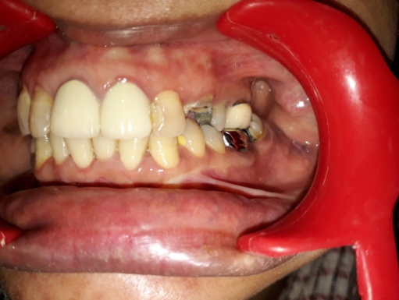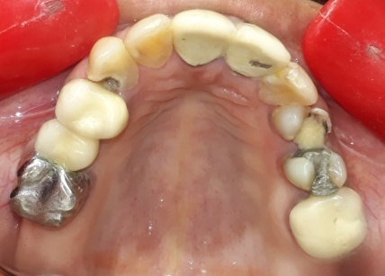

BA

AA

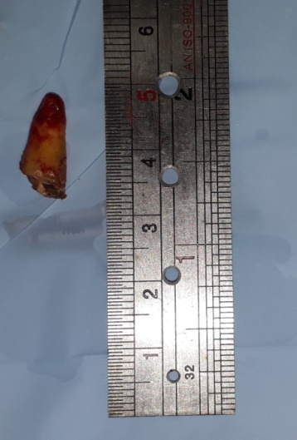

CA

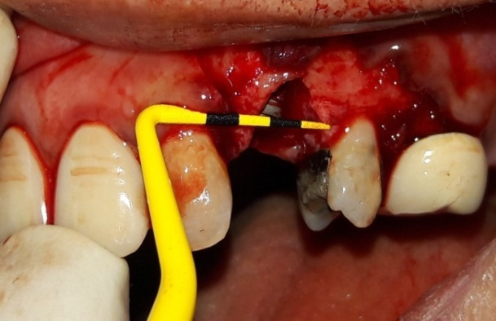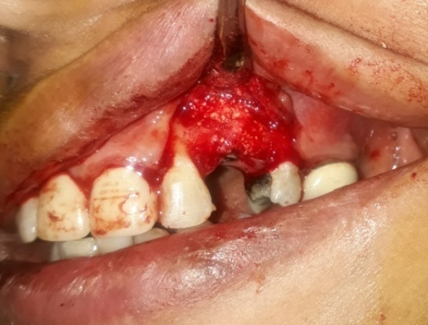

EA

D

Figure1. (A) and (B) Showing grossly decayed 24 (C) Atraumatic extraction done (D) Implant placement done and Hu-Friedy probe was used to check jumping distance around implant (E) Bone grafting done and collagen membrane placed to cover the implant.

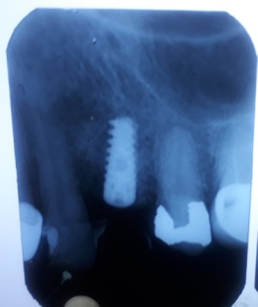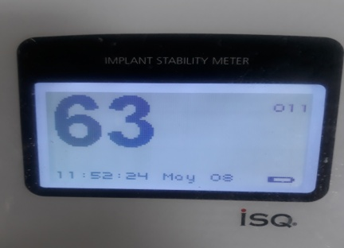

BA

AA

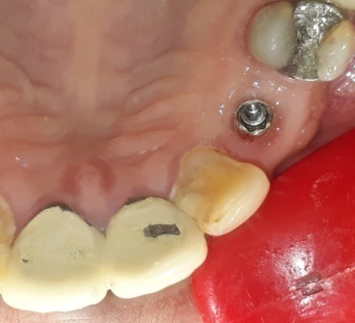

CA

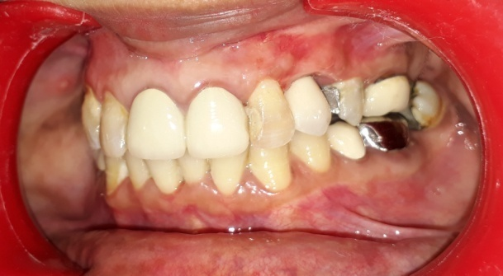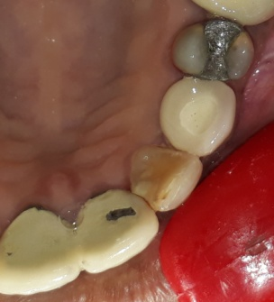

DA

EA

Figure 2. (A) IOPAR done after 4 months (B) Showing ISQ measurement mesiodistally (C) showing well-keratinized gingival collar around implant after 1 week of second stage surgery (D) and (E) Definitive crown.

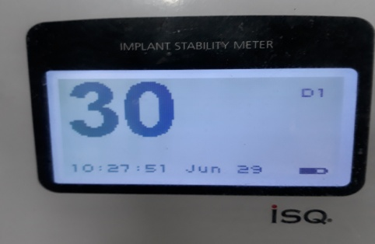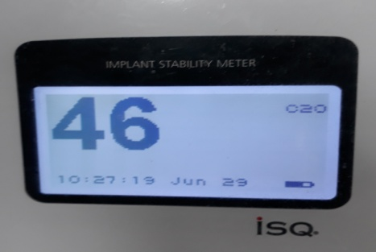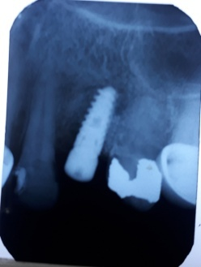

CA

BA

AA

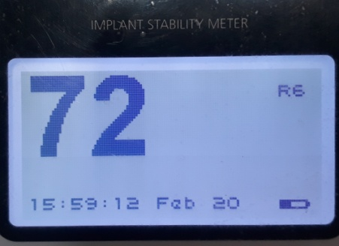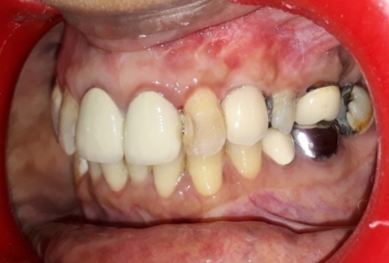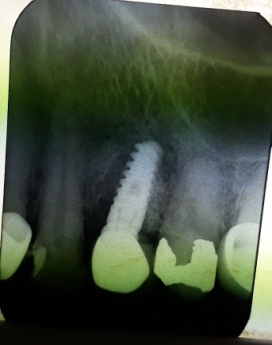

FA

EA

DA

Figure 3.(A) and (B) ISQ values buccolingually and mesiodistally after 1 month of loading (c) IOPAR after 8 months (D) ISQ value after 8 months of unloading (E) Definitive prosthesis delivered with implant protected occlusion (F) Post-op IOPAR