***Original Research Article***

**IDENTIFICATION OF CRITICAL PHOSPHORUS LEVEL CHANGE IN RED SOIL BY INFLUENCE OF DIFFERENT ORGANIC MATERIAL IN BLACK GRAM *(Vigna mungo L.)***

**ABSTRACT**

Phosphorus fixation refers to the process by which phosphorus (P) becomes unavailable for plant uptake by reacting with soil minerals. In soils, phosphorus is primarily fixed by forming insoluble compounds with aluminum (Al) and iron (Fe) in acidic soils, or with calcium (Ca) in alkaline soils. This process reduces the effectiveness of phosphorus fertilizers because the fixed phosphorus cannot be easily taken up by plants. Laterite soils are rich in iron and aluminum oxides. Phosphorus reacts with these oxides to form insoluble compounds like iron phosphate (FePO₄) and aluminum phosphate (AlPO₄), making phosphorus unavailable to plants. Laterite soils are often acidic, which increases the solubility of iron and aluminum, promoting the formation of insoluble phosphorus compounds. Organic matters like vermicompost, poultry manure, cow dung manure etc. are converting insoluble phosphorus to soluble phosphorus by soil microorganisms through mineralization, influenced by temperature, moisture, and microbial activity. The release rate depends on the type of organic matter and its decomposition rate. Organic materials with low carbon content mineralize more quickly. Compost, manure, and biochar are types of organic matter that provide steady phosphorus release and improve soil physical properties.A field experiment was carried out at the Campus Farm of M. S. Swaminathan School of Agriculture, Centurion University of Technology and Management, Paralakhemundi, during the summer of 2025.( the sentance go to abstract beginning) what about treatment details and best treatment indicate the abstract.

***Keywords*:***Phosphorus level; Crop growth rate; Red soil; Black gram cultivation; Organic material.*

1. **INTRODUCTION**

Soil provides water, nutrients, and favorable conditions for plant growth. It maintains biodiversity, yields crop, partitions water, filters and buffers, and cycles nutrients(Pal et al., 2020, Doran & Zeiss, 2000).Red soil can be red, yellow, grey, or even black. Weathering of old crystalline and metamorphic rocks, such as acid granites and gneisses, quartzitic, results in its formation. It is aluminous and siliceous with loose quartz used as sand. It is strong in potassium and has a loamy texture. It has a dark, rich lower layer and a sandy, porous upper layer. It covers 10.6% of India's land area, including Tamil Nadu, Uttar Pradesh Karnataka, Maharashtra, eastern Andhra Pradesh and Madhya Pradesh, Orissa, Chhattisgarh, West Bengal, Jharkhand, south Bihar, eastern Rajasthan, Manipur, Assam, Nagaland, Mizoram and Tripura. Red soils are considered as essential in soil categorization systems due to their extensive coverage in many parts of the world and the numerous opportunities for agricultural output. This type of soil, which covers 61.5 million hectares, is mostly found in the southern and semi-arid parts of India. They are mostly classified as Rhodustalfs (Luvisols) that are constituents of the Alfisol order. It has characteristics marked by high clay content and typically occurs in karstic surroundings( Adhikary et al., 2016 & 2021, Liankai et al., 2020).

It is evident that the soils have a low CEC and little organic matter. The soils may turn lateritic increasing depth. This indicates that when exposed to alternating soaking and drying, the highly iron-enriched subsoil becomes sufficiently hard to form bricks. Red soil contains a wide variety of microorganisms, including beneficial bacteria and fungus, which can aid to enhance soil structure and nutrient availability for plants. These soils frequently experience significant water erosion and loss of nutrients as a result of heavy rainfall. Key limitations for farming on these soils include: significant soil erosion resulting in nutrient loss, poor water retention which causes regular drought situations, lack of N, P, and K, limited P availability due to high P fixation(Wilson, 2004).

This kind of soil that usually grows under warm, moist climates. They grow in deciduous conditions and are generally found in mixed forests (Dewangan et al., 2022& Adhikary et al., 2019).

As a leading cause of decreased crop yields, soil acidification poses a grave danger to terrestrial ecosystems around the world(Hao et al., 2019). More than 50% of the world's arable land is located on acidic soils, which make up around 30% of the entire land region(Kochian et al., 2015). An essential agricultural practice that lime can neutralize soil acidity, raise soil pH, improve nutrient availability, add calcium (Ca2+) for plants to absorb, and reduce the elemental toxicity of some minerals, particularly in topsoil(Li et al., 2019). Soil pH reflects several chemical features of the soil. It significantly affects soil element conversion, microbial activity, nutrient availability, and crop growth(AciegoPietri& Brookes, 2008). Soil acidification is a major issue in modern high-input, high-output agriculture, limiting local production and negatively impacting environmental quality(Xie et al., 2019). Excessive sulphur dioxide and nitrogen oxide emissions have caused soil acidification(Čakmak et al., 2014). The quantity of decaying matter in soil affects its acid buffer capacity(Shen et al., 2021).

Excessive P accumulation in soil has expanded soil P pools, and soil P has become an environmental hazard, producing eutrophication of surface water systems. Soil P fractions vary depending on mineral composition, particle size, and cultivation level(Yan et al., 2020).In order to make sure crops have enough phosphorus, farmers often use too much fertilizer, which can lead to serious eutrophication by extract into lower ground and surface of water. Instead than continuously applying excess quantity of P fertilizer, it would be more sustainable to boost crops' ability to gather soil P efficiently(Ao et al., 2014).Applying farm manure, also known as green manure, is a proven strategy for restoring agricultural production on these soils by enhancing their physical, chemical, and biological qualities. Phosphorus insufficiency is a major constraint on agricultural productivity in red soil regions. Improving the chemical and biochemical measure of P availability is crucial for increasing crop productivity on red soils. Soil microbial biomass stores more phosphorus than above-ground plant biomass(Chen et al., 2000).Under acidic circumstances, soil minerals such as iron oxides, aluminum oxides, and kaolinite fix P, making it unavailable for crops. Therefore, it's crucial to study the impact of soil acidity on P availability. Metal ions, organic materials, and clays can all bind to soil phosphate(Zhou et al., 2018).

The leaching of red soil, desiliconization, and iron-rich aluminisation have a significant fixing effect on phosphorus, lowering its bioavailability. The red soil region has 35% greater phosphorus fertilizer application rates than the national average. Excessive use of chemical fertilizers poses a significant environmental risk and raises production costs. The use of green manure in crop cultivation is critical for securing food availability, benefiting the natural environment and conserving energy. Green manure addition dramatically enhances accessible phosphorus levels in arable soils. By adding organic matter and nitrogen, the crops improve the fertility and health of the soil.

Comparing black gram with several other legume crops, the yield is low. There are numerous reasons why black gram yields are lower, but one of the most important ones is fertilizer management, which affects both growth and output. The addition of sufficient and balanced nutrients can have a significant impact on the development, growth, and production of this crop, depending on soil fertility and quality(Akter, 2021). The crop is resistant to severe climatic conditions and increases soil fertility by fixing atmospheric nitrogen. Continuous use of inorganic fertilizers such as ammonium sulfate and sulfur-coated urea has resulted in soil acidity. Reduced soil aggregate stability Reduced soil respiration, contamination of subsurface water, and declining earthworm populations. Vermicompost contains abundant nitrogen, phosphorous, potassium (NPK), micronutrients, enzymes, and growth regulators. Vermicompost treatment affects soil types and plant nutrition, especially for field crops. Pulses grown in various tropical soils have not been extensively researched (Reddy at al., 2022 &Ranganathan, L. S. ,2008).Using phosphatic fertiliser improves seed germination, root growth, early blooming, and fruit. Black gram roots efficiently absorb nutrients, resulting in higher nutrient content in the seed(Chatterjee et al., 2020).

Nutrient management has a considerable impact on crop output and growth, with nitrogen (N), phosphorus (P), and potassium (K) being the most critical nutrients. Chemical fertilisers, organic manure, and biofertilizers help support agriculture by increasing crop yields while maintaining soil health. Farmyard manure (FYM) is an essential organic resource for Indian farmers. Combining fertiliser, farmyard manure, and vermicompost can boost black gram crop output. Rhizobium culture can enhance black gram growth. To maintain soil health and moisture availability, water management practices including precision irrigation, thorough ploughing, and organic matter inclusion are necessary. Integrated Pest Management (IPM) approaches, including as biological controls, resistant cultivars, and targeted pest management, reduce crop loss and the need for chemical pesticides. Nutrient management is essential for meeting crop nutritional needs, promoting healthy development, and maximising yield potential across growth stages(Kadyan et al., 2024). Its extensive root system and leaf cover prevent soil erosion and successfully combat with weeds. Black gram can be grown as a single crop on moisture-rich soils, as a catch crop, sequential crop, or mixed crop. India is the major producer and user of black gram(Maitra at al., 2020 &Nargund et al., 2024).

1. **MATERIAL AND METHODS**

The study titled “Identification of critical phosphorus level change in red soil by influence of different organic material in black gram” was carried out at the Campus Farm of M. S. Swaminathan School of Agriculture, Centurion University of Technology and Management, Paralakhemundi, during the summer of 2025. In this chapter, we provide a detailed account of the materials, experimental procedures, and techniques that were employed during the investigation.The field experiment was conducted during summer season of 2025 at M.S Swaminathan School of Agriculture, Centurion University of Technology and Management, Paralakhemundi campus. Geographically the experimental site was located at 18.80°North latitude and 84.13°East longitude with an altitude of 145 m above the mean sea level under typical sub-humid and sub-tropical climatic conditions. It lies in the agroclimatic zone of Northern and Eastern ghat of Odisha state, India.The climate information were collected from meteorological laboratory of M.S Swaminathan School of Agriculture, Centurion University of Technology and Management, Paralakhemundi, Odisha. During the crop growth season, the greatest and lowest temperatures measured from 26.5°C to 38.9°C and 12.3°C to 27.4°C, respectively. In this cropping season had a total rainfall of 128.6 mm. At that period of crop growing, the relative humidity ranged from 75.71 % to 95.9 % in morning and 33.86 % to 64.9 % in afternoon hours. The direct solar exposure hours ranged from 10.30 to 3.00 hours. The daily evaporation rate remained minimum of 1.5 mm day-1 and maximum of 7.06 mm day-1 during crop growth period.The

study was performed by adopting a completely randomized design (CRD) and its comprises ten treatments which were replicated nine in 90 pots**.**At first the land was cultivated two times using a farm machinery attached with cultivator for primary tillage. The 90 pots were placed in the field with hands by manually. The 1.5 kg of red soil was placed into the pots respectively.The recommended fertilizer dose of 20:40:20 kg N: P205:K2O ha-1 was applied to the black gram crop to the specific treatments. In the recommended dose of fertilizer, 33 mg N, 187.5 mg P2O5 and 25 mg K2O were used as urea, single superphosphate and muriate of potash respectively for each 90 pots.The source of manures were vermicompost, poultry manure and cow dung manure in the nutrient management treatment as 3 level of treatment. For the treatment specification of @10ton/ha, 20ton/ha, 30ton/ha vermicompost containing 5, 7, 15, 22.5gm of vermicompost were applied as basal 7-10 days before sowing as a T1, T2, T3, @10 ton/ha, 20 ton/ha,30 ton/ha poultry manure, containing 5, 7, 15, 22.5gm of poultry manure were applied as basal 7-10 days before sowing as a T4, T5,T6, @10 ton/ha, 20 ton/ha, 30ton/ha cow dung manure containing 5, 7, 15, 22.5gm of cow dung manure were applied as basal 7-10 days before sowing as a T7, T8, T9.On December 02,2024, the seed were planted in the pot, with 10 number of seeds being utilized within each pots.To estimate the amount of accessible nitrogen in red soil, the basic potassium permanganate technique used by Subbaiah and Asija in 1959 was improved.Excessive alkaline 0.32 ml potassium permanganate, which is made alkaline with 25 percent sodium hydroxide solution (NaOH) was applied to 2.5 grams of red soil. Boric acid trapped the released ammonia, which was then measured by titration against a standard 0.02 M H2SO4. The available N content in kg ha-1 was computed using titrate value.With the use of 0.05 M NaHCO3, the soil's accessible phosphorus concentration was determined.Using a UV spectrophotometer, the chloromolybdic blue color method was used to determine the phosphorus concentration. At 660 nm, the blue colour’s intensity was measured. The amount of available phosphorus was calculated and reported in kilograms per hectare (Jackson, 1973).As Jackson (1973) explains, neutral normal ammonium acetate was used to extract the available potassium content. A flame photometer was used to measure the extract's potassium content.

1. **RESULT AND DISCUSSION**

The observations on growth attributes, number of leaves, number of nodule and phosphorus in each pot were recorded. In this chapter, the findings of the experiment due to various treatments are presented under different heads.

At 15, 30, 45, and 60 days, the effect of organic manure on black gram plant elevation was substantial, after sowing, were shown in the (Table 1 and fig 1). The obtained data highlighted threetreatmentsof theOrganic matterswiththree levelsinCompletely Randomized design (CRD).At 15 Days after sowing, the highest plant length (3.7 cm) was obtained in T2 (Vermicompost at 10 tons/ha), after which in T7 (Poultry manure at 30 tons/ha) with 3.5 cm. The control (T1) showed the lowest recorded height (2.5 cm). At this stage, the average plant height was 3.11 cm, with C.D. of 0.214. At 30 DAS, the top plant height of 6.0 cm was recorded in T4 (Vermicompost @ 30 ton/ha), where as a height of 5.0cm was measured in control. The treatments T2, T3, T6, T8, T9, and T10 all showed similar development, ranging from 4.0 cm to 5.1 cm. The mean plant height of 4.91 cm was observed and C.D. of 0.134 was noted, suggesting that the treatments differed considerably. At 45 DAS, the largest plant height of 9.0 cm was reported in T2 and T4, while the least height of 7.0 cm was seen in T3, T5, T6, T9 and T10. A height of 7.5 cm was measured in the control(T1). At this stage, the average height was 7.6 cm, with a C.D. of 0.262. At 60 DAS, plant heights appeared more constant across treatments. The largest plant height of 9.0 cm was obtained in T1, T2, T4, T6, T8, T9, and T10, whereas slightly lower value showed in T3, T5, and T7. The average height 8.85 cm was recorded at this stage, with a C.D. of 0.247.

The (Table 2 and fig 2) presented the data for the number of leaves at 15, 30, 45, 60, DAS, and throughout the harvesting time. This given data also showed a significant difference regarding the treatment of organic matter. At 15 DAS, no differences found between the treatments. Including the control condition(T1), all treatments recorded 3 leaves in each plant, resulting for a mean of 3.0. As the C.D. was not apply at this phase, the data revealed homogeneity across all treatments during early seedling development.After 30 DAS, variation were noticed. An average of 5 leaves per plant yielded by the majority of treatments such as T2, T3, T4, T5, T6, and T9, including the control (T1). However, fewer leaves of 3 were recorded in T7 (poultry manure at 30 tons per hectare) compared to T8 and T10, where 4 leaves were noted. An average number of 4.6 leaves was observed, with a C.D. of 0.202, indicating a substantial difference between treatments at this stage.At 45 DAS, a substantial variation in the quantity of leaves was observed. The highest number of leaves 7 was recorded in T7, while only 3 leaves were observed in treatment T6, T8, T9, and T10. A moderate leaf count ranging from 5 to 6 was recorded in the other treatments. The mean number of leaves was maintained at 4.6, and a C.D. of 0.195 was noted, indicating significant differences among these treatments.After 60 DAS, clearer disparities between treatments were observed. The highest number of leaves 7 was recorded in T3 and T8, while the fewest (5) were noted in T6 and T9. Intermediate results ranging from 6 to 6 leaves were obtained from the other treatments. A total mean of 6 leaves per plant was recorded, and a C.D. of 0.160 was observed, indicating that the effects of treatment on leaf growth were statistically significant at this stage.

The data on the number of root nodules per plant at 45 and 60 days after sowing (DAS) showed substantial variations between the organic treatments in the (table 3 and fig 3). At 45 days after sowing, the number of nodules per plant ranged from 6 to 15. The highest number of nodules 15 recorded in T9 (cow dung manure @ 20 ton/ha). Both T4 and T6 were shown to develop 12 nodules per plant. The smallest number of nodules 6 was observed in the reference treatment (T1). Under the other treatments condition T2, T3, T5, T7, T8, and T10 showed intermediate numbers of nodules, ranging from 8 to 10. The average number of nodules was observed to be 10, and the C.D. was calculated as 0.367. After 60 DAS, a significant increase in nodule production was observed across all treatments, with values ranging from 10 to 24 nodules per plant. The highest number of nodules 24 was recorded in T9, followed by 19 in T8 and 18 in T7. Although previously among the top performers at 45 DAS, T2 was found to have the fewest nodules 10 among all groups. The control treatment (T1) was observed to have only 12 nodules, which was lower than the overall average of 15.3. At this time, the C.D. was calculated to be 0.159, indicating that the effects of the treatments were still statistically significant at this later stage of growth.

The data recorded after chemical analysis of black gram, analyzed statistically and presented in (Table 4 and fig 4). The impact of various organic treatments on soil phosphorus content at different time points after sowing (15, 30, 45, and 60 DAS). At 15 DAS, the greatest phosphorus concentration (60 kg/ha) was recorded in T6 (poultry manure @ 20 ton/ha), followed by T5 (38 kg/ha). The lowest values, ranging from 10 to 20 kg P₂O₅ per unit area, were observed in the control (T1) and cow dung treatments (T8 to T10). At this moment, the mean phosphorus content across all treatments was found to be 26.2 kg/ha with a C.D. of 1.502 kg/ha. After 30 DAS, considerably higher phosphorus levels at 60 kg/ha were recorded in T7 (poultry manure @ 30 ton/ha) compared to the other treatments. Similarly, high phosphorus levels were maintained by other poultry manure and vermicompost treatments, whereas low levels were observed in the control and cow dung treatments. The overall mean phosphorus content was recorded as 22.5 kg/ha. At 45 DAS, most treatment showed a decrease in phosphorus content, with the highest level (50 kg/ha) being maintained by T7, followed by T4 and T5. The phosphorus content in the control treatment (T1) was reduced to 8 kg/ha. The average phosphorus level was recorded at 18.9 kg/ha, with a C.D. of 0.374 kg/ha. At 60 DAS, all treatments demonstrated a significant decrease in phosphorus content. The highest phosphorus content (35 kg/ha) was observed in T7, while the minimum value (6. kg/ha) was observed in the control (T1). The mean dosage across treatments was recorded as 14.9 kg/ha, with a C.D. of 0.419 kg/ha.(include each characters references )

1. **CONCLUSION**

The potted experimentation was performed in the Campus Farm of M. S. Swaminathan School of Agriculture, Centurion University of Technology and Management, Paralakhemundi throughout the summer session in 2025. To investigate the influence of the organic based manure on black gram growth as well as the change in phosphorus level in red soil. This research trial consisted of aspects like organic management in 3 different levels such as Control treatment, vermicompost, poultry manure and cow dung manure. The data were properly gathered and collated before being given to statistical evaluation. The scientific study was carried out using fully Randomized assigned Design with nine replications. Different growth characters, or yield contributing characters, number of leaves number of nodule and phosphorus level in red soil were substantially controlled through the use of various organic based fertilizer the highest growing plant was cultivated from treatment T2 and T4, vermicompost at 10 and 30 tons per hectare, whereas the smallest plant 2.5 was taken from standard condition at 15 DAS. At 15DAS the same amount of leaves during the early growth stage. the most leaves at the later phases of the growth cycle in treatment T3 (Vermicompost @ 20 ton/ha) and T8 (Cow dung @ 10 ton/ha).Nodulation was observed to be better in treatments containing poultry manure and higher doses of vermicompost compared to the control. The cow dung manure considerably boosted root nodule production at 45 and 60 DAS, particularly when administered at 20 tonnes per hectare T9. The impact of various organic treatments on soil phosphorus content at different time points after sowing. The highest phosphorus content of 60 was recorded in T6 and T7, while the lowest value (6 kg/ha) was observed in the control (T1).

**REFERENCE ( follow the journal format )**

AciegoPietri, J. C., & Brookes, P. C. (2008). Relationships between soil pH and microbial properties in a UK arable soil. *Soil Biology and Biochemistry*, *40*(7), 1856–1861. https://doi.org/10.1016/j.soilbio.2008.03.020

Akter, S. (n.d.). *INFLUENCE OF ORGANIC MANURE, PHOSPHORUS-POTASSIUM ON GROWTH, YIELD AND SEED QUALITY OF BLACKGRAM*.

Adhikary, R., Pal, A. and De, S.K., 2021. Effect of Application of Different Quality Water through Pitcher Irrigation and Tillage Types on Tomato Production and Soil Properties of Coastal Saline Soil of West Bengal. *Indian Journal of Agricultural Research*, *55*(6).

Ao, J., Chen, Z., Wu, M., Lu, X., Huang, Z., & Liao, H. (2014). Phosphorus fractions of red soils in guangdong province of south China and their bioavailability for five crop species. *Soil Science*, *179*(10–11), 514–521. <https://doi.org/10.1097/SS.0000000000000087>

Adhikary, R., & Pal, A. (2019). Geotextile and its Importance in Agriculture: A Review Study. *IJBS*, *6*(2), 61-63.

ADHIKARI, N., DISHA, A., MAHATA, A.P., PAL, A., ADHIKARI, R., SARDAR, M., SAHA, A., BAURI, S.K., TARAFDAR, P. and DE, S.K., 2016. Efficient use of jute agro textiles as soil conditioner to increase chilli productivity on Inceptisol of West Bengal. *Journal of Soil and Water Conservation*, *15*(3), pp.242-245.

Čakmak, D., Beloica, J., Perović, V., Kadović, R., Mrvić, V., Knežević, J., &Belanović, S. (2014). Atmospheric deposition effects on agricultural soil acidification state - Key study: Krupanj Municipality. *Archives of Environmental Protection*, *40*(2), 137–148. https://doi.org/10.2478/aep-2014-0022

Chen, G. C., He, Z. L., & Huang, C. Y. (2000). Microbial biomass phosphorus and its significance in predicting phosphorus availability in red soils. *Communications in Soil Science and Plant Analysis*, *31*(5–6), 655–667. https://doi.org/10.1080/00103620009370467

Doran, J. W., & Zeiss, M. R. (2000). Soil health and sustainability: managing the biotic component of soil quality. In *Applied Soil Ecology* (Vol. 15).

Hao, T., Zhu, Q., Zeng, M., Shen, J., Shi, X., Liu, X., Zhang, F., & de Vries, W. (2019). Quantification of the contribution of nitrogen fertilization and crop harvesting to soil acidification in a wheat-maize double cropping system. *Plant and Soil*, *434*(1–2), 167–184. https://doi.org/10.1007/s11104-018-3760-0

Kadyan, M., Kumari, M., Pandey, A., & Kumar, K. (2024). The Strategies Used in the Cultivation Practices of Black Gram (Vigna mungo L.) in Summer Season. *Vigyan Varta*, *5*(12), 46–50. https://indiaagronet.com/indiaagronet/crop%20info

Kochian, L. V., Piñeros, M. A., Liu, J., & Magalhaes, J. V. (2015). Plant adaptation to acid soils: The molecular basis for crop aluminum resistance. *Annual Review of Plant Biology*, *66*, 571–598. https://doi.org/10.1146/annurev-arplant-043014-114822

Liankai, Z., Hongbing, J., Shijie, W., Gang, L., Xiuming, L., Xiao, W., QuocDinh, N., &DaiTrung, N. (2020). Geochemical implications of rare earth elements in terra rossa in tropical karst area: A case study in northern Vietnam. *Applied Sciences (Switzerland)*, *10*(3). https://doi.org/10.3390/app10030858

Li, Y., Cui, S., Chang, S. X., & Zhang, Q. (2019). Liming effects on soil pH and crop yield depend on lime material type, application method and rate, and crop species: a global meta-analysis. *Journal of Soils and Sediments*, *19*(3), 1393–1406. <https://doi.org/10.1007/s11368-018-2120-2>

Maitra, S., Shankar, T., Palai, J.B., Sairam, M., Pal, A. and Gaikwad, D.J., 2020. Cultivation of gerbera in polyhouse. *Protected cultivation and smart agriculture, New Delhi Publishers*, pp.219-26.

Nargund, M. I., Singh, R., Singh, A., Pazhanisamy, S., & Sarkar, S. (2024). *How to cultivate productive and profitable Urd bean (Black gram) in Summer Season*. *11*(10), 442–448. [www.indianfarmer.net](http://www.indianfarmer.net)

Pal, A., Adhikary, R., Bera, M., De, S.K. and Sardar, M., 2020. Application of Different Geotextile in Soil to Improve the Soil Health in Humid and Hot Sub Humid Region of West Bengal, India. *Int. J. Curr. Microbiol. App. Sci*, *9*(6), pp.2812-2818.

Reddy, D.P., Pal, A. and Reddy, M.D., 2022. Effect of nitrogen levels on yield of rice varieties during kharif in South Odisha. *Crop Research*, *57*(3), pp.108-112.

Shen, Y., Zhang, Z., & Xue, Y. (2021). Study on the new dynamics and driving factors of soil pH in the red soil, hilly region of South China. *Environmental Monitoring and Assessment*, *193*(5). <https://doi.org/10.1007/s10661-021-09080-4>

Wilson, M. J. (2004). *NATURE AND PROPERTIES OF RED SOILS OF THE WORLD v C BALIGAR(I) N K F AGERIA (2) H ESW*.

Xie, E., Zhao, Y., Li, H., Shi, X., Lu, F., Zhang, X., & Peng, Y. (2019). Spatio-temporal changes of cropland soil pH in a rapidly industrializing region in the Yangtze River Delta of China, 1980–2015. *Agriculture, Ecosystems and Environment*, *272*, 95–104. https://doi.org/10.1016/j.agee.2018.11.015

Yan, X., Yang, W., Chen, X., Wang, M., Wang, W., Ye, D., & Wu, L. (2020). Soil phosphorus pools, bioavailability and environmental risk in response to the phosphorus supply in the red soil of Southern China. *International Journal of Environmental Research and Public Health*, *17*(20), 1–16. https://doi.org/10.3390/ijerph17207384

Zhou, X., Xu, M., Wang, B., Cai, Z., &Colinet, G. (2018). Changes of Soil Phosphorus Fractionation According to pH in Red Soils of China: An Incubation Experiment. *Communications in Soil Science and Plant Analysis*, *49*(7), 791–802. https://doi.org/10.1080/00103624.2018.1435676

**Table1 Impact of Organic matters on height of the plant height (cm) of Black gram at different stages of development**

|  |  |  |  |  |  |
| --- | --- | --- | --- | --- | --- |
| **Sl. No** | **Treatments** | **Height of the Plant (15DAS)** | **Height of the Plant (30DAS)** | **Height of the Plant (45DAS)** | **Height of the Plant (60DAS)** |
| 1 | T1-Control | 2.5 | 5 | 7.5 | 9 |
| 2 | T2-Vermicompost@10ton/ha | 3.7 | 4 | 9 | 9 |
| 3 | T3-Vermicompost@20ton/ha | 3.1 | 5 | 7 | 8.5 |
| 4 | T4-Vermicompost@30ton/ha | 3 | 6 | 9 | 9 |
| 5 | T5-Poultry manure@10ton/ha | 3 | 4.5 | 7 | 8.5 |
| 6 | T6-Poultry manure@20ton/ha | 3 | 5 | 7 | 9 |
| 7 | T7-Poultry manure@30ton/ha | 3.5 | 4.5 | 8 | 8.5 |
| 8 | T8-Cow dung manure@10ton/ha | 3.2 | 5 | 7.5 | 9 |
| 9 | T9-Cow dung manure@20ton/ha | 3 | 5.1 | 7 | 9 |
| 10 | T10-Cow dung manure@30ton/ha | 3.1 | 5 | 7 | 9 |
|  | **Mean** | **3.11** | **4.91** | **7.6** | **8.85** |
|  | **C.D.** | **0.214** | **0.134** | **0.262** | **0.247** |
|  | **SE (m)** | **0.067** | **0.042** | **0.082** | **0.077** |
|  | **SE(d)** | **0.095** | **0.059** | **0.116** | **0.11** |
|  | **C.V.** | **2.965** | **1.206** | **1.52** | **1.232** |

**Table 2 Impact of Organic matters on count of leaves of Black gram at different growth stages**

|  |  |  |  |  |  |
| --- | --- | --- | --- | --- | --- |
| **Sl. No** | **Treatments** | **Total leaves/ Plant (15DAS)** | **Total leaves / Plant (30DAS)** | **Total leaves / Plant (45DAS)** | **Total leaves / Plant (60DAS)** |
| 1 | T1-Control | 3 | 5 | 5 | 6 |
| 2 | T2-Vermicompost@10ton/ha | 3 | 5 | 6 | 6 |
| 3 | T3-Vermicompost@20ton/ha | 3 | 5 | 5 | 7 |
| 4 | T4-Vermicompost@30ton/ha | 3 | 5 | 5 | 6 |
| 5 | T5-Poultry manure@10ton/ha | 3 | 5 | 6 | 6 |
| 6 | T6-Poultry manure@20ton/ha | 3 | 5 | 3 | 5 |
| 7 | T7-Poultry manure@30ton/ha | 3 | 3 | 7 | 6 |
| 8 | T8-Cow dung manure@10ton/ha | 3 | 4 | 3 | 7 |
| 9 | T9-Cow dung manure@20ton/ha | 3 | 5 | 3 | 5 |
| 10 | T10-Cow dung manure@30ton/ha | 3 | 4 | 3 | 6 |
|  | **Mean** | **3** | **4.6** | **4.6** | **6** |
|  | **C.D.** | **N/A** | **0.202** | **0.195** | **0.160** |
|  | **SE (m)** | **0.045** | **0.063** | **0.061** | **0.050** |
|  | **SE(d)** | **0.063** | **0.089** | **0.087** | **0.071** |
|  | **C.V.** | **2.067** | **1.907** | **1.833** | **1.150** |

**Table3 Impact of Organic matters upon the total number of nodules of Black gram at various stages of growth**

|  |  |  |  |
| --- | --- | --- | --- |
| **Sl. No** | **Treatments** | **No. of nodules/ Plant (45DAS)** | **No. of nodules / Plant (60DAS)** |
| 1 | T1-Control | 6 | 12 |
| 2 | T2-Vermicompost@10ton/ha | 10 | 10 |
| 3 | T3-Vermicompost@20ton/ha | 8 | 15 |
| 4 | T4-Vermicompost@30ton/ha | 12 | 11 |
| 5 | T5-Poultry manure@10ton/ha | 9 | 13 |
| 6 | T6-Poultry manure@20ton/ha | 12 | 15 |
| 7 | T7-Poultry manure@30ton/ha | 10 | 18 |
| 8 | T8-Cow dung manure@10ton/ha | 8 | 19 |
| 9 | T9-Cow dung manure@20ton/ha | 15 | 24 |
| 10 | T10-Cow dung manure@30ton/ha | 10 | 16 |
|  | **Mean** | **10** | **15.3** |
|  | **C.D.** | **0.367** | **0.159** |
|  | **SE (m)** | **0.115** | **0.050** |
|  | **SE(d)** | **0.163** | **0.071** |
|  | **C.V.** | **1.601** | **0.457** |

**Table 4 Effect of Organic matters on Phosphorus level in soil of Black gram at different growth stages**

|  |  |  |  |  |  |
| --- | --- | --- | --- | --- | --- |
| **Sl. No** | **Treatments** | **Phosphorus soil/ pot (15DAS)** | **Phosphorus soil/ pot (30DAS)** | **Phosphorus soil/ pot (45DAS)** | **Phosphorus soil/ pot (60DAS)** |
| 1 | T1-Control | 20 | 10 | 8 | 6 |
| 2 | T2-Vermicompost@10ton/ha | 31 | 15 | 12 | 10 |
| 3 | T3-Vermicompost@20ton/ha | 32 | 20 | 18 | 15 |
| 4 | T4-Vermicompost@30ton/ha | 31 | 30 | 25 | 20 |
| 5 | T5-Poultry manure@10ton/ha | 38 | 25 | 22 | 20 |
| 6 | T6-Poultry manure@20ton/ha | 60 | 28 | 24 | 20 |
| 7 | T7-Poultry manure@30ton/ha | 15 | 60 | 50 | 35 |
| 8 | T8-Cow dung manure@10ton/ha | 10 | 15 | 12 | 10 |
| 9 | T9-Cow dung manure@20ton/ha | 15 | 12 | 10 | 8 |
| 10 | T10-Cow dung manure@30ton/ha | 10 | 10 | 8 | 5 |
|  | **Mean** | **26.2** | **22.5** | **18.9** | **14.9** |
|  | **C.D.** | **1.502** | **0.529** | **0.374** | **0.419** |
|  | **SE (m)** | **0.471** | **0.166** | **0.117** | **0.131** |
|  | **SE(d)** | **0.666** | **0.235** | **0.166** | **0.186** |
|  | **C.V.** | **2.656** | **1.034** | **0.867** | **1.237** |

**Figure 1 Impact of Organic matters on total plant growth in cm of Black gram during various development stages**

**Figure 2 Impact of Organic matters on total amount of leaves of Black gram at various growth stage**

**Figure 3 Effect of Organic matters on Number of nodules of Black gram at different growth stages**

**Figure 4Effect of Organic matters on Phosphorus level in soil of Black gram at different growth stages**

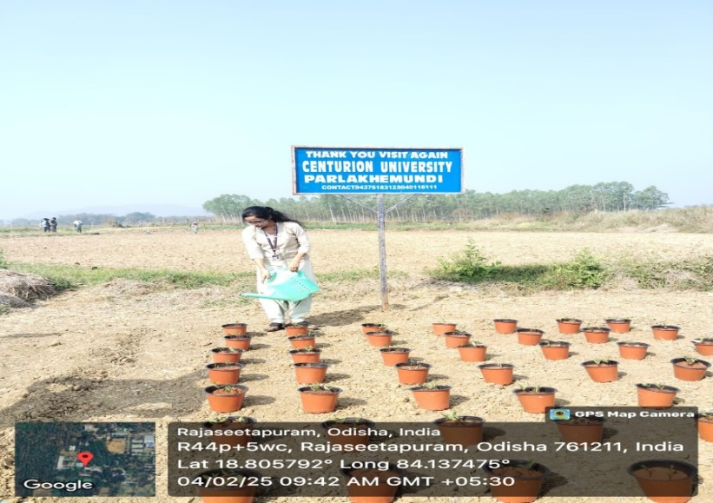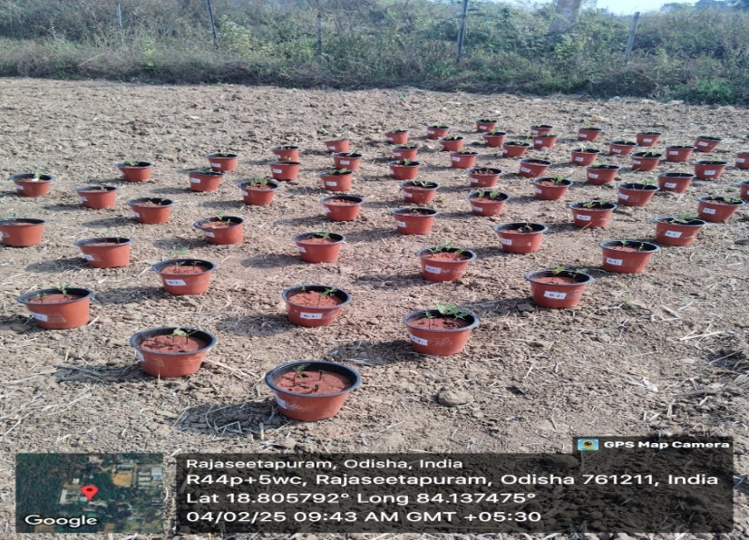**Figure 5 Experimental setup of potted plants in field**

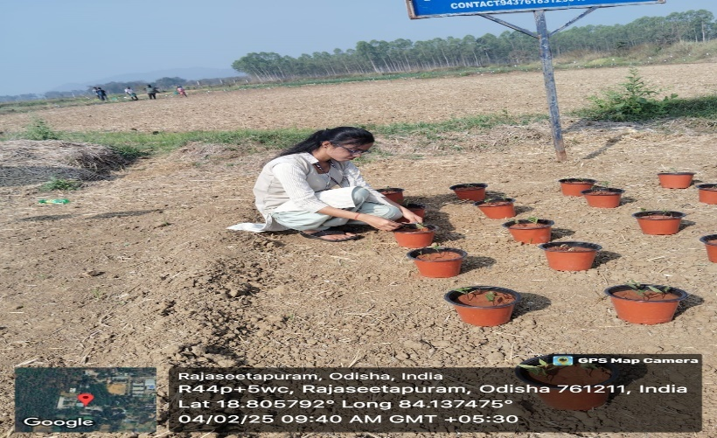**Figure 6 Watering in the pots**

**Figure 7 Measurement of plant height**

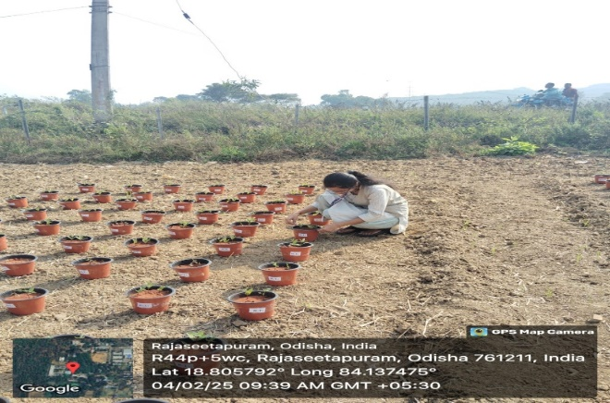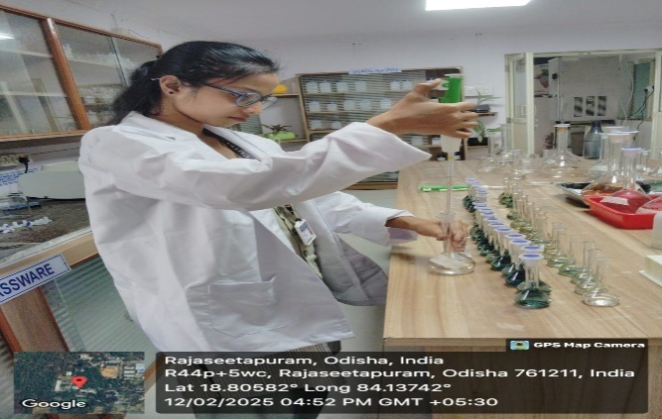**Figure 8 Observing potted plant after 30 DAS**

**Figure9 Estimation phosphorus in red soil**

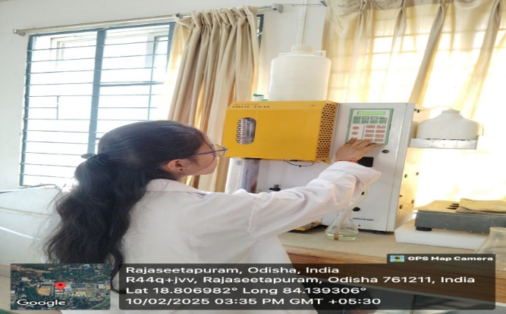

**Figure 10 Estimation Nitrogen in red soil**

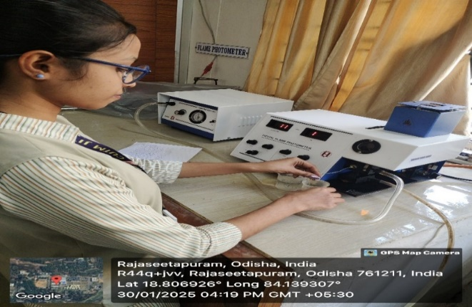

**Figure 11Estimation Potassium in red soil**