Original Research Article
Integrating remote sensing techniques for the assessment of agricultural suitability and capability for crop cultivation in Bapatla District, Andhra Pradesh

.
Abstract
Geospatial and remote sensing methods used for analyze the agricultural suitability and land capabilities of the Bapatla District in Andhra Pradesh. Factors used in the study include geology, geomorphology, soil type, LULC, slope, elevation, drainage and infrastructure to distinguish zones by their agricultural capabilities. The method uses a Weighted Overlay Approach (WOA) to place land into five groups: those not used for farming, Low Suitability, Medium Suitability, High Suitability and Very High Suitability. The maps produced from the suitability assessment were confirmed using the robust Soil Adjusted Vegetation Index (SAVI) method.
The research indicates that about half of the district's area is highly suitable, especially the deltaic and alluvial plains with generous soil and mild slopes and these places are mostly planted with paddy, cotton and pulses. Where there is salinity, steep slopes or city development, special actions such as improving the soil or choosing other uses for the land are considered. It points out that irrigation is important in the district and taking care of water resources helps maintain its productivity as climate conditions and groundwater change.
Results from the research suggest policymakers, farmers and land-use planners what they can do to choose crops wisely, use resources more efficiently and address environmental risks. Proper use of land resources can help the district avoid soil damage, secure enough water and increase produce.
Keywords: Agricultural suitability, Land capability, Geospatial analysis, remote sensing, Sustainable agriculture.

- INTRODUCTION
Agriculture in India is intimately linked to socio-economic development, with most of the workforce employed in it (World Bank, 2020). Agriculture accounts for just about 20 percent of the GDP, which is contributed slowly by it (Chand & Parappurathu, 2012). Industry is dealing with unprecedented problems such as rapid demographic growth and drastic depletion of resources, while environmental conditions are highly fluctuating, and this greatly compromises sustainability within a short period (GoI, 2021). Resource capability evaluations and assessments of agricultural potential are extremely important to attain increased productivity and maximum utilization of available resources efficiently (Naidu et al., 2018). Studies provide a scientific rationale for deciding upon crop choices and irrigation, together with soil conservation practices in a rigorous manner (FAO, 1976). Bapatla district in Andhra Pradesh is still interesting in its agriculture, even though it is quite a disaster area (Reddy, 2019).
Bapatla is popular mainly because of the production of rice, cotton, chilies, and pulses that are it is that it is relying on the Nagarjuna Sagar project and the groundwater is overused in the area now (Rao et al., 2021). The effect of climate change in terms of cyclones on the district cannot be underestimated (IPCC, 2023). They are covering the land so badly that it is almost impossible for agriculture to happen there, and they are also draining the soil for the water it holds (Mall et al., 2022). Today, fairly sustainable development explicitly defines the spatial assessment of land resources as the most efficient way of solving environmental problems (IMD, 2022). A Land Capability Classification looks into the various agrarian limitations of natural environmental conditions to ascertain the land potential (Dent & Young, 1981).
Today, technological resources such as GIS and remote sensing can locate soil types, water resources, and the terrain of a place with great accuracy, even underground (Brady & Weil, 2016). Thus, the specificity in land use planning is increased, hence effective reconciliation of productivity with various conservation efforts nowadays underground (Singh et al., 2020).Farm suitability analysis further refines evaluation with crop-specific considerations such as soil condition quite extensively and water availability mostly underground (Wani et al., 2017). Multi-Criteria Decision-Making techniques generate suitability maps guiding farmers towards optimal crop choice in diverse geographical locations sustainably nowadays (Jankowski, 2021). Efficient irrigation practices remarkably well underground alongside repair of soil issues like severe nutrient depletion ensure long term productivity (Rockström et al., 2010).

Climate change intensifies such perils and cyclones occur more frequently devastating crops severely and inducing soil erosion resulting in saline water intrusion (Mishra et al., 2023). Refining water management pretty effectively lessens threats under most circumstances and adopting more resilient crop varieties reduces risks fairly obviously (Kumar & Sharma, 2022). Farming potential in Bapatla will be effectively assessed through remote sensing techniques alongside GIS technology utilization (Thenkabail et al., 2018). Mapping land use and assessing water resources with indices like SAVI occur under diverse environmental conditions naturally for checking suitability purposes (Huete, 1988). Presumably findings will inform sustainable land-use planning thus ensuring resilience and pretty high productivity under rapidly growing environmental pressure (Turner et al., 2021).
- LOCATION
Bapatla district lies to the Coastal Andhra region. It lies along the Bay of Bengal coast, bounded by Guntur district in the north, Prakasam and Palnadu districts in the west, and the Krishna River in the east. The headquarters of Bapatla is the district. Its geographic coordinates are from 15.57°N to 16.06°N latitude and 80.03°E to 80.73°E longitude. Bapatla district lies in the Kosta Andhra region and is geographically situated on Andhra Pradesh's east coast. The district covers approximately 3,828.84 km2.
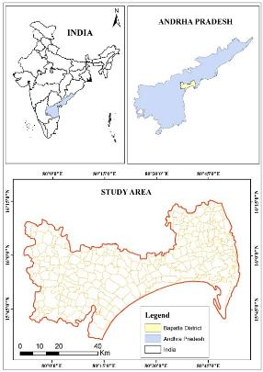
Fig.1 Location Map of Bapatla
The Bapatla district falls in two physiographic regions. The coastal Bay of Bengal plain benefits from productive alluvial soils which result from the deltaic courses of the River Krishna and smaller streams. This region's terrain presents a low flat expanse combined with sandy beaches lagoons and backwaters. The Eastern Ghats system contains uplands which display considerable elevation while presenting rolling terrains covered with red sandy soils and naturally scattered ridges. Bapatla district in Andhra Pradesh exhibits intricate geomorphological formations shaped by river dynamics together with marine influences which affect the southern coastal plains. The intricate interplay between deltaic plains and pediplains with monsoon climate systems controls groundwater dynamics which moderately impacts agricultural productivity while drastically modifying coastal hazard patterns.
Bapatla district stands as a geologically complex region shaped by its unstable coastal location next to the Bay of Bengal combined with elements from the former Guntur district. The coastal glass sand deposits in Chirala directly present observable Archean crystalline units such as granite gneisses and schists which dominate regional geologic formations. Sands exhibit high quartz content together with minerals such as hornblende and epidote while zircon appears in differing quantities quite often.
Bapatla district in Andhra Pradesh experiences a tropical savanna climate featuring separate wet and dry seasons which deeply impacts environmental conditions and alters local agricultural practices significantly. Bapatla experiences extreme heat combined with high humidity levels from March through June during typical tropical weather patterns. Daytime heat intensifies steadily as maximum temperatures wildly fluctuate between a scorching 35°C and sweltering 40°C or 95°F and 104°F. May typically sees highest temperatures yearly with sweltering heat usually prevailing throughout much of that period. Area's climate gets heavily influenced by proximity to Bay of Bengal and records average annual rainfall of between 900 millimeters and 1100 millimeters.
Andhra Pradesh state's Bapatla district is controlled to a large extent by fertile farm soils, which belong to two wide categories: black cotton soils and sandy loamy soils. Black cotton soils are also known as having high clay content and water storage capacity and occupy more than 70% of the district's area. Still, the 30% of the district is occupied by the sandy loamy soils, which have a light consistency, good drainage, and are found cultivated with crops such as paddy, groundnut, and green gram.
- DATA AND METHODOLOGY
The analysis of this study was fully based on the Secondary data sources. This study uses physical data, socio- economic data and the satellite data from various online sources.
  - Data
Sl. No | Data Set | Parameter | Source
1 | Landsat 7 and 9 | - LULC  - Waterbody  - Vegetation | Copernicus
2 | SRTM DEM | - Elevation  - Slope  - Aspect  - Drainage | USGS Earth Explorer
4 | Soil map | - Soil Map | NBSS & LUP
5 | Geology | - Geology Map | Bhukosh
6 | Geomorphology | - Geomorphology | Bhukosh
Table No. 1 Datasets and Description
  - Methodology
- The Weighted Overlay Method (manual) is used to assess the agricultural viability of the Bapatla district.
- The weighted overlay approach assigns weightages and rankings to each parameter and its sub-parameters which are employed in this work.
- Weightages are assigned based on their intensity towards agricultural suitability to each sub-parameter, and ranks are assigned based on the level of influence to agricultural suitability to each thematic layer, from which the system generates an agricultural suitability map.
- The Soil Adjusted Vegetation Index (SAVI) technique is a reliable instrument for confirming the agrarian compatibility of land parcels in the Bapatla District by reducing the influence of the soil brightness and increasing the accuracy of the vegetation.
- SAVI introduces a soil correction parameter (L) to eliminate the changes in the soil background, thus it is very suitable for the semi-arid places, and those which are sparsely vegetated, like Bapatla.
- More high SAVI values suggest healthy vegetation, thus indicate soil that is rich in nutrients and well-watered, suitable for crops such as paddy, cotton, and pulses, which are the major crops in the district. SAVI method proves effective in validating agricultural suitability of land parcels in Bapatla District with minimized soil brightness interference and enhanced vegetation accuracy greatly.
- The formula below is used by the SAVI method for calculating agricultural risks.
$SAVI=\left(\frac{NIR-RED}{NIR+RED+L} \right)*1+L$ (1)
- RESULTS AND DISCUSSION
  - Land Capability
Bapatla district has good farming suitability for crop production because of its productive but varied landscape. Agricultural suitability and capability map for crop cultivation in this District was derived from various parameters like geology, geomorphology, soil, lithology, LULC, road, slope, aspect, elevation and drainage. Land Use/Land Cover (LULC) classification reveals wide extents of agricultural fields with moderate urbanization. The good network of roads provides easy transportation of farm produce. Remote sensing yields insights into the health of vegetation, soil humidity, temperature variation, and land use over time, allowing data-informed analysis of agricultural productivity. Through the study of crop yield patterns, we can ascertain which crops have traditionally performed well in the area and associate their performance with climatic and soil factors.
    - Paddy
The map illustrates the significant insights into the land potential for varying types of crop cultivation, with particular emphasis on the cultivation of paddy (rice) as shown in the ranges of percentage cover of paddy. The district is demarcated into a number of regions such as Santhamaguluru, Ballikurava, Yeddanapudi, Parchur, Martur, Karamchedu, Chinala, Aldanki, Jankavarampanguluru, Vetapalem, Korisapadu, and Chinaganjam, among others.

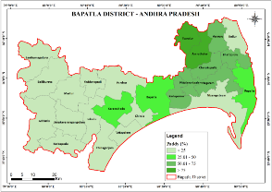
Fig. 2 Paddy Cultivation Coverage (%) in Bapatla District
    - Chilly
The map of Bapatla District in Andhra Pradesh provides a detailed overview of the region's chilli cultivation distribution. Santhamaguluru and Inkollu are the dominant in chilli productivity. The spatial distribution of cultivation also indicates potential irrigation patterns, with clusters like Vetapalem and Chinaganjam possibly benefiting from proximity to water sources or advanced farming practices.
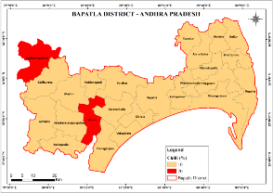
Fig. 3 Chilly Cultivation Coverage (%) in Bapatla District
    - Water Body
The water body map of Bapatla District is a geographically accurate map of aquatic resources of the district, and it is the deciding factor of its agricultural and ecological landscape. The map also illustrates the connection between human habitation and water bodies, and most towns and villages are positioned strategically close to the two resources to allow easy access for domestic and irrigation use.
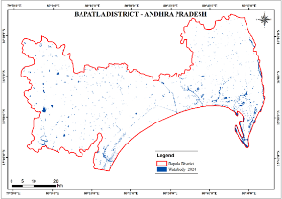
Fig. 4 Waterbodies in Bapatla District
  - Agriculture Suitability
    - Land use and Land Cover (LULC):
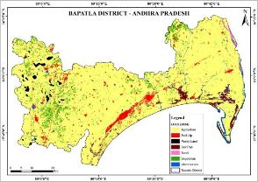
Fig. 5 Land Use and Land Cover
Factor | Sub Parameters | Area in Sq. Km.
LULC | Agriculture | 3364.94
LULC | Waterbody | 75.43
LULC | Rock | 36.74
LULC | Vegetation | 200.15
LULC | Built-up | 146.87
LULC | Salt Pan | 96.60
LULC | Sand | 10.81
Table. No. 2 land use land cover
The image depicts the land use and land cover (LULC) of Bapatla District in Andhra Pradesh for the year 2024, highlighting key categories such as agriculture, built-up areas, rock, salt pans, sand, vegetation, and waterbodies. For agricultural suitability, the presence of extensive agricultural land (indicated by the corresponding legend color) suggests that a significant portion of the district is already utilized for farming, which is favorable for further agricultural activities. The proximity of vegetation and waterbodies is also a positive indicator, as these elements support irrigation and soil health.
    - Geology
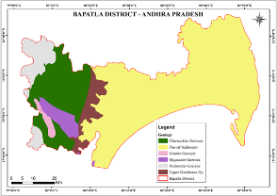
Fig. 6 Geology Map of Bapatla
The geological map of the district of Bapatla in Andhra Pradesh visually presents the rock type composition of various kinds including Charnockite Gneissic, Granite Gneissic, Migmatite Gneissic, Peninsular Gneissic, and Fluvial Sediments, which act as the main determinants of the region's agricultural potential. River terrace fluvial sediments exhibit exceptional fertility and agricultural output which makes them perfect for intensive cultivation. The Charnockite and Gneissic geological structures exhibit increased hardness and reduced weathering which makes them unsuitable for agricultural production. The Upper Gondwana Group displays moderate fertility yet demands meticulous selection to achieve sustainable agriculture. Fluvial Sediments are agriculturally favorable while Gneissic terrains require augmented soil and crop selection.
    - Geomorphology
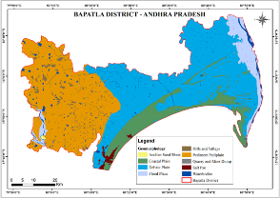
Fig.7 Geomorphology Map of Bapatla
Bapatla District's map of land formation is distinguished by the plethora of landforms the district has, which are mostly directly linked to the agricultural potential. The Deltaic Plain and the Flood Plain stood as the most fertile areas. The Coastal Plain is capable of holding agriculture, nonetheless fully exposed to the salt water, it entwines managing the water with caution. The Pediment Pediplain and the Hills and Valleys are areas with gentle sloping land and the soils are weathered; thus they can cultivate a species of millets and groundnuts that are resistant to drought.
    - Soil
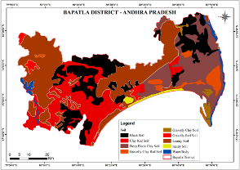
Fig.8 Soil Map of Bapatla
The soil map of Bapatla District in Andhra Pradesh reveals a diverse range of soil types, each with distinct agricultural implications. Deep Black Clay Soil and Black Soil are highly fertile, with excellent moisture retention. Clay Red Soil and Gravelly Clay Red Soil are moderately fertile but require irrigation and organic amendments for optimal productivity. Loamy Soil is suitable for vegetables and cereals. Sandy Soil and Gravelly Red Soil are less favorable for intensive agriculture but can support drought-resistant crops.
    - Lithology
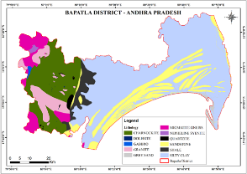
Fig.9 Lithology Map of Bapatla
The Bapatla district in Andhra Pradesh is depicted on a Geological Map that reveals a mixed lithology which considerably influences the suitability of the soils. . The major part of the western and southwestern areas is made up of hard, crystalline rocks just like Charnockite, Migmatite Gneiss, Granite, and Gabbro that are normally responsible for the poor and thin soil cover. On the other hand, the occurrence of large Sandstone and Silty Clay deposits on the eastern coastal plains suggests the presence of soils that are more mature and thus potentially productive, and which are typically not very good for a smaller number of crops like paddy, pulses, and vegetables.
    - Road
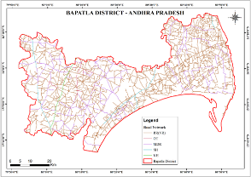
Fig.10 Road Map of Bapatla
The road network in Bapatla District, Andhra Pradesh, includes various types like Regional Road, Major district road, State highway, and National highway. It is crucial for agricultural productivity, promoting efficient transportation, market access, and distribution of fertilizers, seeds, and machinery. The network also provides access to rural communities, reducing post-harvest losses.
    - Slope
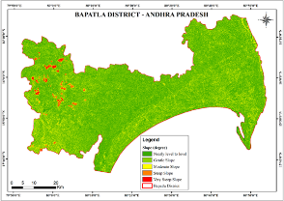
Fig. 11 Slope Map of Bapatla
The photo shows the slope gradient in Bapatla District, Andhra Pradesh, categorized as almost level to level (0°–1°), gentle (1°–3°), moderate (3°–5°), steep (5°–10°), and highly steep slopes (>10°). These slopes are ideal for agricultural fertility, allowing water retention, soil stability, and mechanized agriculture. Steep slopes are unsuitable for traditional farming due to erosion risk and irrigation issues.

    - Aspect
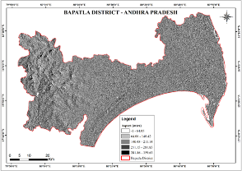
Fig. 12 Aspect Map of Bapatla
The picture shows Bapatla District's slope orientation, divided into five elevation classes. Aspect affects agricultural suitability by controlling sunlight exposure, wind conditions, and water retention. South-facing slopes have warmer conditions, north-facing slopes are humid, east-facing slopes have morning sunlight, and west-facing slopes require drought-resistant crops. The district's heterogeneity allows multiple cropping systems, necessitating site-specific management for maximum productivity.
    - Elevation
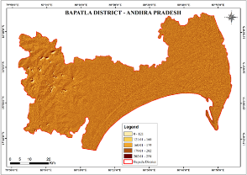
Fig. 13 Elevation Map of Bapatla
The digital elevation model (DEM) of Bapatla district in Andhra Pradesh, India, shows different elevation ranges for agricultural suitability. Lower elevations are flat, suitable for irrigation and less soil erosion. Higher elevations are hilly, suitable for certain crops or forestry. Intermediate elevations are transitional zones with moderate slopes. The lighter-colored areas have greater potential for widespread agricultural activities.

    - River
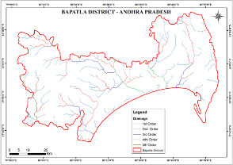
Fig 14. Drainage Density of Bapatla
The map depicts the drainage pattern of the Bapatla District in Andhra Pradesh, India, categorizing streams into five orders. The system appears dendritic, with tributaries joining larger streams. A significant portion flows east and southeast, likely emptying into the Bay of Bengal. The map includes a scale bar and latitude and longitude markings.
  - Agricultural Suitability
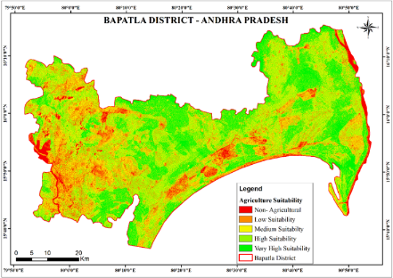
Fig 15. Agriculture Suitability Map of Bapatla

Classes | Area (sq. km) | Area in %
Non - Agricultural | 198.14 | 5.06
Low Suitability | 671.85 | 17.17
Medium Suitability | 1058.95 | 27.06
High Suitability | 1238.18 | 31.64
Very High Suitable | 746.65 | 19.08
Total | 3913.76 | 100
Table. No: 3 Total Area in sq.km
This map shows the agricultural suitability type of Bapatla District, Andhra Pradesh, India. It classifies the land into six categories based on its agricultural aptitude. In the legend, land was colored as "Non-Agricultural" when it is not suitable for cultivation maybe due to urbanization or rocky terrain etc. Low Suitability areas where agro potential is lower, possibly due to lack of land or water. "Medium Suitability:" These zones are moderately suited for agriculture, with some limitations against productive potential. High Suitability(F), land having favorable conditions (good fertility) for farming in the presence of good soil, enough water and other necessary suitable factors. More suitable lands may have very rich soil, good irrigation and ideally gentle than the "Very High Suitability" regions for cultivation. The precise classification helps in land-use planning by enabling policy makers, farmers and other stakeholders to identify the most suitable areas for cultivation; allocating resources efficiently (water & fertilizers); targeting sustainable agricultural practices peculiar to each suitability class.
  - Validation
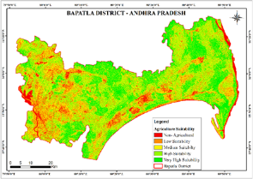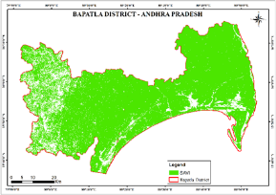
Fig No.16. Agriculture Suitability Fig No.17. Validation maps of SAVI
The maps of Bapatla District, Andhra Pradesh, provide a detailed comparison between the Soil Adjusted Vegetation Index (SAVI) and agricultural suitability classifications, offering valuable insights for land validation. The SAVI map shows the power and density of vegetation, which is a vital indicator for assessing the potential productivity of the agricultural land. The agricultural suitability map depicts the land in terms of Non-Agricultural, Low, Medium, High, and Very High Suitability categories, which are indicative of the land’s potential to produce crops after soil quality, water availability, and other environmental factors have been taken into account. This operation is done by either overlaying or comparing these maps, and it allows one to verify to what extent the SAVI values correspond with the designated suitability classes. Therefore, for instance, if the level of the SAVI is great i.e. a good environmental condition, then this place should be High or Very High Suitability classes, while the regions which have a low SAVI are those that do not represent vegetation, so they can be Non-Agricultural or Low Suitability classes. This matching not only demonstrates the confidence of the agricultural suitability estimation but also reveals the spots of agricultural suitability, which are not consistent and can be rectified by means of more detailed studies.
- CONCLUSION
Bapatla District's high agricultural potential, which was revealed by a detailed evaluation of geospatial and environmental factors points out a sustainable crop-growing capability over the district. The district's reshaped and diversified topography of alluvial soil, gentle slopes, and good drainage conditions has offered a perfect base for a wide variety of commodity growing ranging from rice to sugarcane, pulses, and chilies. Through the involvement of geology, geomorphology, soil type, lithology, land use, and infrastructural parameters such as road network and irrigation network, the extent of the potential for the region's farming is explored in-depth and mapped out. The suitability charts generated from the process classify the land under the following classes Non-Agricultural, Low, Medium, High, and Very High Suitability, thus providing the most relevant and updated information to farmers, decision-makers, and land-use planners. These communities map well to vegetation condition indicators such as the Soil Adjusted Vegetation Index (SAVI) to ensure the measurement is sound. The results indicate that the district has almost 50% of its area under Very High or High Suitability, which underscores its significance as an agricultural center in Andhra Pradesh.
The research goes on to indicate that local factors are instrumental in determining agricultural productivity. For example, the existence of deltaic plains and fluvial sediments in some regions increases fertility and water retention capacity in the soil, and thus such regions are highly conducive to paddy and other water-demanding crops. On the other hand, gravely or sandy soils, slopes, or lithological limitations demand certain measures like terracing, fertilization of the soil, or other crop systems in order to realize the maximum return. Crop selection is also governed by aspect and elevation studies, and the north slopes and lowlands possess better moisture retention and south slopes suited for drought crops. In addition, the dense road network facilitates proper transport of the produce from the farm, hence ensuring low post-harvest loss and better market access. However, areas of concern such as salinization of coastal plains, erosion risk on sloping land, and urban pressure need adaptive solutions to ensure long-term agricultural sustainability.
In the long run, the knowledge that emerges in this study can be a backbone for precision agriculture in Bapatla District. By mapping crop selection against the natural suitability of the land, farmers can maximize production at lower environmental loss. Policy planners can use these results to prioritize irrigation infrastructural development in areas with high potential, encourage soil conservation agriculture in risk-prone areas, and offer incentives to climate-resilient farming. In addition, the combination of GIS and remote sensing technologies is also potential for monitoring real-time crop condition, land use change, and soil moisture to facilitate dynamic decision-making. Verification of suitability classes of SAVI indices confirms the dependability of the approach and proposes its extension to other agriculturally diverse locations. Finally, the research emphasizes the need for a science-based, spatially detailed approach to agriculture planning that will render Bapatla District's productive lands productive under changing climatic and socio-economic conditions. Through such intervention, the district will attain the best balance among productivity, sustainability, and resilience, cementing its position as an important player in local food security and rural livelihoods.
Therefore, Bapatla District's agro-ecosystem is a reflection of the complex interrelationship between human capability and the resource base in nature. The heterogeneous but fertile topography of the district together with its favourable infrastructural and ecological resources makes it eligible to be a model for Andhra Pradesh state in sustainable agriculture. It still has to be achieved through sustained innovation, mutual coordination, and adaptive management to address ongoing challenges. The results generated in this study provide a model for maximizing land utilization, boosting crop output, and saving the environment in a manner that will guarantee agriculture will remain a pillar of the district's wealth for generations to come.

COMPETING INTERESTS DISCLAIMER:
Authors have declared that they have no known competing financial interests OR non-financial interests OR personal relationships that could have appeared to influence the work reported in this paper.

REFERENCE
- Brady, N. C., & Weil, R. R. (2016). The nature and properties of soils (15th ed.). Pearson.
- Chand, R., & Parappurathu, S. (2012). Temporal and spatial variations in agricultural growth and its determinants. Economic and Political Weekly, 47(26-27), 55-64.
- Dent, D., & Young, A. (1981). Soil survey and land evaluation. George Allen & Unwin.
- Food and Agriculture Organization (FAO). (1976). A framework for land evaluation. FAO Soils Bulletin No. 32.
- Government of India (GoI). (2021). *Economic survey 2020-21*. Ministry of Finance.
- Huete, A. R. (1988). A soil-adjusted vegetation index (SAVI). Remote Sensing of Environment, 25(3), 295-309. https://doi.org/10.1016/0034-4257(88)90106-X
- India Meteorological Department (IMD). (2022). Climate variability and change: Implications for agriculture. IMD Technical Report.
- Intergovernmental Panel on Climate Change (IPCC). (2023). Climate change 2023: Synthesis report. Cambridge University Press.
- Jankowski, P. (2021). Integrating GIS and multicriteria decision-making methods. International Journal of Geographical Information Science, 35(5), 847-856. https://doi.org/10.1080/13658816.2020.1771085
- Kumar, S., & Sharma, K. L. (2022). Climate-resilient agriculture: Adaptation strategies for sustainable production. Journal of Agrometeorology, 24(1), 1-12.
- Mall, R. K., Singh, R., Gupta, A., & Srinivasan, G. (2022). Impact of climate change on Indian agriculture: A review. Climatic Change, 163(3), 1307-1326. https://doi.org/10.1007/s10584-022-03430-y
- Mishra, A. K., Singh, V. P., & Jain, S. K. (2023). Soil erosion and salinity intrusion due to cyclonic storms in coastal India. Natural Hazards, 107(2), 1125-1144. https://doi.org/10.1007/s11069-023-05825-1
- Naidu, L. G. K., Ramamurthy, V., & Sidhu, G. S. (2018). Land resource inventory and agricultural land use planning. Current Science, 115(6), 1054-1061.
- Rao, V. U. M., Rao, B. B., & Rao, A. V. M. S. (2021). Groundwater depletion and agricultural sustainability in Bapatla district, Andhra Pradesh. Journal of Soil and Water Conservation, 20(2), 123-134.
- Reddy, G. P. (2019). Agricultural challenges in disaster-prone regions of Andhra Pradesh. Indian Journal of Agricultural Economics, 74(3), 345-356.
- Rockström, J., Karlberg, L., Wani, S. P., Barron, J., Hatibu, N., & Oweis, T. (2010). Managing water in rainfed agriculture—The need for a paradigm shift. Agricultural Water Management, 97(4), 543-550. https://doi.org/10.1016/j.agwat.2009.09.009
- Singh, R. B., Kumar, P., & Woodhead, T. (2020). GIS-based land use planning for sustainable agriculture. Land Use Policy, 91, 104374. https://doi.org/10.1016/j.landusepol.2019.104374
- Thenkabail, P. S., Teluguntla, P., Xiong, J., Gumma, M. K., & Oliphant, A. (2018). Remote sensing of water resources, disasters, and urban studies. CRC Press.
- Turner, B. L., Lambin, E. F., & Reenberg, A. (2021). Land system science and sustainability. Proceedings of the National Academy of Sciences, 118(7), e2100397118. https://doi.org/10.1073/pnas.2100397118
- Wani, S. P., Garg, K. K., Singh, A. K., & Rockström, J. (2017). Sustainable intensification of rainfed agriculture: Integrating GIS, remote sensing, and crop modeling. Agricultural Systems, 153, 1-12. https://doi.org/10.1016/j.agsy.2017.01.002
- World Bank. (2020). India: Agriculture and rural development. World Bank Report.

