**Monsoonal Dynamics and Rainfall Extremes in Salem insights from a Climate Variability Perspective**

**Abstract**

A 40-year analysis (1984–2024) of rainfall in Salem, Tamil Nadu, reveals a strong monsoonal influence and marked inter-annual variability. Annual rainfall totals peaked at approximately 1250 mm (2022) and dipped as low as ~420 mm (2014), reflecting extreme wet and dry years. While no clear long-term trend emerges, recent decades show increased frequency of extremes. Monthly data highlight October–November (Northeast Monsoon) as the wettest period (October ≈150 mm), while January–February remains the driest (~10–15 mm). Seasonal analysis shows that the Southwest Monsoon (June–September) and Northeast Monsoon (October–December) contribute ~35% and ~33% of the annual total, respectively, with summer and winter contributing ~22% and ~10%. These fluctuations carry major implications for watershed management, underscoring the need for high storage during wet years and resilient planning during droughts. The observed variability and frequency of extreme events are consistent with climate change projections indicating intensified monsoon rains and more prolonged dry spells. Understanding these patterns is therefore crucial for sustainable water resource planning and climate adaptation in the region.

***Keywords:******Salem, rainfall trends****,* ***Monsoonal variability****, , extreme* ***Rainfall*** *,* ***Watershed management****.*

# Introduction

Climate change has emerged as a critical global concern, with profound implications for hydrological cycles, agricultural productivity, and socio-economic stability . India, characterized by its diverse climatic zones and reliance on monsoonal rainfall, is particularly vulnerable to these changes. Over recent decades, the country has experienced significant alterations in rainfall patterns, including shifts in monsoon onset, intensity, and distribution, leading to increased frequency of extreme weather events such as floods and droughts.

Watershed management plays a pivotal role in conserving natural resources and enhancing agricultural productivity, especially in rainfed regions like Salem [8]. The Integrated Watershed Development Programme (IWDP) implemented in Salem's Valapady block demonstrated significant community participation, leading to improved groundwater recharge, reduced soil erosion, and increased income for farmers [5]. Such initiatives underscore the importance of integrating climatic data into watershed planning to enhance resilience against climate variability.

The Indian Summer Monsoon Rainfall (ISMR) exhibits considerable interannual variability influenced by global climatic phenomena like the El Niño-Southern Oscillation (ENSO), Arctic Oscillation (AO), and Pacific Decadal Oscillation (PDO). [9] [10] Recent studies have highlighted a weakening of traditional teleconnections, particularly the AO-ISMR link post-1980s, indicating a shift in rainfall patterns due to climate change [1]. These changes underscore the necessity for region-specific studies to understand localized impacts and develop adaptive strategies.

Salem District, located in the north-central part of Tamil Nadu, lies in a semi-arid climatic zone and is predominantly agrarian, relying heavily on monsoonal rainfall and groundwater for its water needs. The district receives the majority of its precipitation from the Southwest monsoon (June–September) and Northeast monsoon (October–December) [4], contributing approximately 42% and 38% to the annual rainfall [3], respectively. In contrast, winter and pre-monsoon rains contribute only marginally to the total precipitation. However, studies indicate significant temporal and spatial variability in rainfall distribution across the district, with annual rainfall ranging from as low as 51 mm in 1980 to as high as 1,200 mm in 2005. These fluctuations in monsoon strength and rainfall patterns pose considerable challenges for water resource management, groundwater recharge, agricultural planning, and disaster preparedness [6] [7]. Analyzing rainfall trends over a long-term period, particularly from 1984 to 2024, is crucial for understanding evolving climatic conditions in Salem. Such temporal analyses help identify rainfall concentration patterns [1], the frequency of extreme weather events, and potential shifts in monsoonal behavior, all of which are vital for sustainable watershed and catchment management, ensuring long-term water security, and protecting livelihoods dependent on agriculture.

Given the critical dependence of Salem's agriculture and water resources on monsoonal rainfall, it is imperative to conduct a comprehensive analysis of rainfall trends over the past four decades. Such a study will provide valuable insights into the impacts of climate change at a local scale, inform watershed and catchment management strategies, and contribute to the development of adaptive measures to safeguard the region's socio-economic well-being.

# Materials and methods

2.1. Descrpition of the study area

Salem District is situated in the north-central region of Tamil Nadu, India, and lies between latitudes 11°14′N and 12°53′N and longitudes 77°44′E and 78°50′E. The district exhibits a semi-arid climate and is influenced by both the Southwest Monsoon (SWM) and Northeast Monsoon (NEM). Its geography is marked by a mix of plains and hills, particularly the Shevaroy Hills, which modulate the district’s rainfall through orographic effects [11].

2.2. Data Collection

Rainfall data were obtained from the NASA Langley Research Center’s Prediction Of Worldwide Energy Resources (POWER) Data Access Viewer (DAV), which offers high-quality, satellite-derived climate data for long-term studies . The dataset spans a 40-year period (1984–2024), ensuring a robust temporal scale for analysis. Additional ground-based data and observations were integrated from regional meteorological departments and previous peer-reviewed studies [12].

2.3. Data Categorization

To facilitate a comprehensive temporal analysis, the rainfall dataset was categorized as follows:

* Monthly Rainfall: Data were compiled for each calendar month to identify intra-annual rainfall fluctuations and determine peak and lean months.
* Seasonal Contribution: The contribution of each season to the total annual rainfall was calculated using percentage analysis. This helped in identifying the dominance of monsoonal contributions and variations in summer and winter precipitation patterns.
* Seasonal Rainfall: Rainfall was grouped according to Tamil Nadu’s four climatological seasons:
  + Winter: January–February
  + Summer: March–May
  + Southwest Monsoon (SWM): June–September
  + Northeast Monsoon (NEM): October–December
* Annual Rainfall: Computed by aggregating monthly rainfall values for each calendar year.

Data analysis??/ What methods? How?

I think to be frank, this methodology not enough to address the objective of the study.

You have to include trend analysis of the observed data

The following rainfall indexes should be done.

* Standardized Precipitation Index
* Coefficient of Variation
* Rainfall Anomaly Index
* Precipitation Concentration Index
* Rainfall Extremes Indices
* Seasonality Indices
* Seasonality Index (SI) by Walsh & Lawler
* Monthly/Seasonal Rainfall Ratio

# Results and discussion

## Results

Say something here about your figure and cite it.

**Annual Rainfall Analysis**

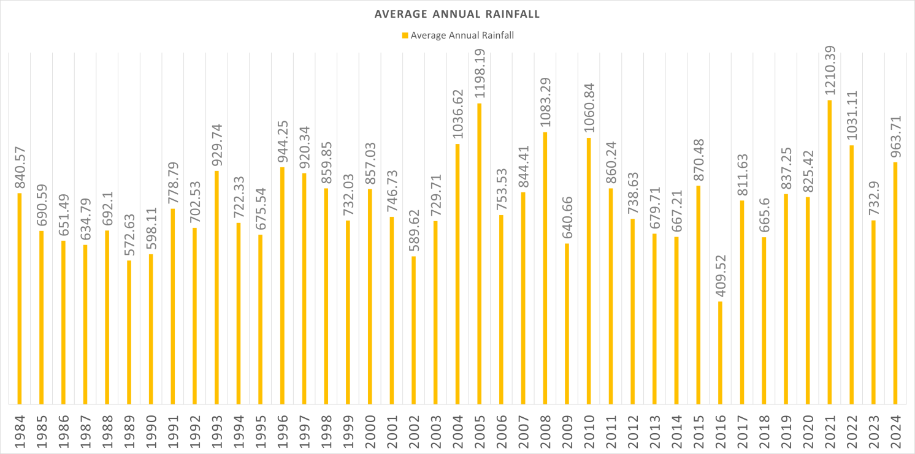

***Figure 1: Annual rainfall totals for Salem (1984–2024)****.*

*Bars show high variability, with notable wet and dry years.* The annual rainfall in Salem from 1984 to 2024 shows considerable variation, with distinct periods of higher and lower rainfall. The most significant rainfall was recorded in **2022**, reaching over **1000 mm**, closely followed by **2004**, which also approached this peak. In contrast, **2016** experienced the lowest average rainfall, dropping to just above **400 mm**, indicating a notably dry year. These fluctuations reflect not a gradual trend but rather alternating wet and dry phases that characterize the region’s climate.

During the **1980s and 1990s**, rainfall remained relatively stable, generally ranging between **600 and 900 mm**, with fewer extreme values. However, from the **2000s onward**, Salem began experiencing more pronounced peaks and troughs. For example, while **2005**, **2008**, and **2011** saw very high rainfall totals, **2016** recorded sharp declines. This irregular pattern suggests increasing variability in the region’s rainfall distribution, likely influenced by broader climatic shifts.

These observations align with the reported trends of rising climate extremes across India, as noted by Raviraj et al. [3], who recorded **~ 1200 mm in 2005**, a value significantly above the usual range. The contrasting events – such as floods in 2021 and dry spells in 2016 – illustrate how Salem’s rainfall has become increasingly unpredictable, emphasizing the need for resilient watershed and resource management strategies.

**Monthly Rainfall Analysis**

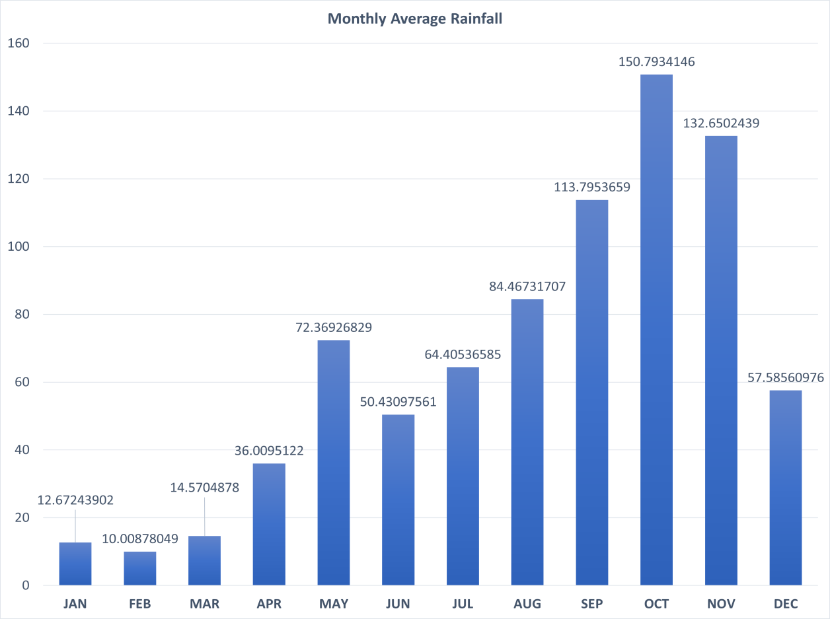

***Figure 2: Average monthly rainfall in Salem***

*Figure 2:* ***Average monthly rainfall in Salem****.* The monthly rainfall distribution in Salem reveals a clear seasonal rhythm shaped by the region’s monsoon systems. The months of **October and November** stand out as the **wettest period of the year**, with average rainfall peaking at around **150 mm in October** and **130 mm in November**. This reflects the dominant influence of the **Northeast Monsoon (NEM)** in this region of Tamil Nadu, which typically arrives in late October and extends into December.

In contrast, the **driest months are January and February**, recording minimal rainfall—often less than **15 mm**—indicating a pronounced dry winter season. The **pre-monsoon summer months** (March through May) also experience relatively low rainfall, with April averaging around **35 mm**, gradually increasing through May (**~72 mm**) as atmospheric moisture builds toward the onset of the monsoon.

The **Southwest Monsoon (SWM)** contributes significantly during **June to September**, with rainfall progressively rising from **June (~50 mm)** to a secondary peak in **September (~115 mm)**. **August (~85 mm)** also shows a substantial contribution, highlighting the mid-monsoon intensity.

**December**, while slightly past the Northeast monsoon peak, still registers noticeable rainfall (**~60 mm**), serving as a transitional month. The sharp rise in rainfall during October and November, followed by a tapering in December, confirms that Salem’s **rainfall regime is heavily skewed toward the late monsoon months**, in alignment with known **Tamil Nadu climatological patterns**, where nearly **80% of the annual rainfall** occurs during monsoon periods [4].

This seasonal distribution holds critical importance for agriculture in the region. **Kharif crops**, planted during the Southwest Monsoon, rely on consistent rainfall between **June and September**, while **Rabi crops**, grown post-monsoon, benefit from the **peak rainfall in October and November**. These twin peaks in rainfall create a bimodal opportunity for cultivation but also demand careful water management to navigate dry spells, especially in the early and late-year months.

Past studies, including those by Raviraj et al. [3], reinforce this pattern, noting Salem’s **strong dependence on monsoon timing and volume**, particularly the **post-monsoon rains**. This pattern not only shapes the agrarian calendar but also impacts water resource planning and flood preparedness in the district.

**Seasonal Rainfall Analysis**

***Figure3 shows the seasonal rainfall contributions*** *of……………* The pie chart displaying **seasonal rainfall distribution** in Salem clearly highlights the overwhelming influence of the **monsoon systems**. The **Southwest Monsoon (SWM)**, occurring from **June to September**, contributes the **largest share**—approximately **35%** of the total annual rainfall. The **Northeast Monsoon (NEM)**, which spans from **October to December**, accounts for an almost equal share at **33%**. Combined, these two monsoon systems deliver nearly **68% of Salem’s yearly rainfall**, underscoring the district’s deep climatic dependence on the seasonal monsoon cycles.

In contrast, the **summer season (March to May)** contributes a relatively modest **22%**, while the **winter months (January–February)** add only **10%** to the annual total. This seasonal disparity mirrors typical rainfall trends across Tamil Nadu, where **monsoon rainfall makes up more than 75–80%** of the total precipitation annually [4].

This **balanced monsoonal dependence** sets Salem apart from other regions in Tamil Nadu that may rely more heavily on the Northeast Monsoon alone. The near-equal importance of both SW and NE monsoons in Salem means that **any variation or failure in either system**—such as a deficient NE monsoon year like **2014**—can substantially impact **total annual rainfall**, crop performance, and groundwater recharge.

This dual-monsoon structure has practical implications for agriculture and water resource management. While the **Southwest Monsoon** is vital for initiating the **Kharif cropping season**, the **Northeast Monsoon** plays a crucial role in supporting **Rabi crops**, filling tanks, and recharging aquifers. With both monsoons contributing significantly, **local planning must prioritize rainwater harvesting and storage during both monsoon windows**, ensuring resilience against intra-seasonal variability.

Studies such as those by **Raviraj et al. [3]** affirm this seasonal distribution, noting the **critical need for dual-seasonal preparedness** in Salem’s rainfall management strategy. In summary, the data paints a clear picture: **Salem's hydrological health hinges on the strength and timing of both monsoonal pulses**, making **bimodal rainfall capture and utilization** an essential aspect of sustainable development in the region.

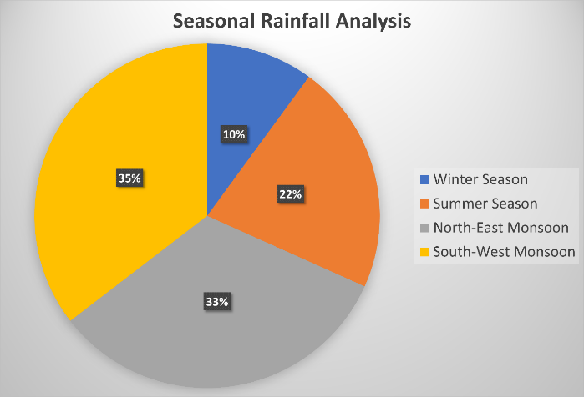

***Figure 3 : Seasonal rainfall contributions***

## Discussion

### Watershed Management Implications

The pronounced seasonal and interannual variability in rainfall across Salem district presents both opportunities and challenges for sustainable water resource management. As demonstrated in the climatological analysis, Salem receives a bimodal rainfall distribution, with the bulk of precipitation occurring during the Southwest (June–September) and Northeast (October–December) monsoons. However, this rainfall is not evenly distributed year to year—extremely wet years (e.g., 2005, 2009, 2021) alternate with deficit years such as 2016, where annual totals drop sharply. This variability imposes significant stress on the region’s hydrological systems, agriculture, and water-dependent livelihoods, demanding a resilient and adaptive watershed management approach.

**Rainwater Harvesting and Monsoonal Storage**

One of the most effective strategies to mitigate rainfall variability is rainwater harvesting. During intense monsoon seasons, excess surface runoff can be diverted into traditional and modern structures such as check dams, farm ponds, percolation tanks, and recharge shafts. These not only reduce surface runoff and erosion but also help replenish shallow aquifers. Empirical studies across Tamil Nadu [3] have shown that widespread adoption of such structures has led to a measurable increase in groundwater levels, improved water availability during dry months, and decreased dependence on erratic rainfall.

In the Salem context, with over 68% of rainfall concentrated in the monsoon seasons, capturing this pulse is critical. Community-based water storage systems and roof-top harvesting in urban pockets should complement field-level efforts, especially in water-stressed blocks like Omalur and Yercaud.

**Flexible and Dynamic Reservoir Operations**

Given Salem’s rainfall pattern—marked by intense but brief wet periods—static water storage policies often result in either overflow losses or storage shortfalls. Reservoir operations should incorporate climatic forecasts, real-time monitoring, and probabilistic rainfall predictions to dynamically adjust release and retention schedules. During expected drought years, reservoirs can conserve more water post-monsoon to stretch through the lean summer months. Conversely, in high-rainfall years, pre-emptive lowering of reservoir levels before the monsoon onset can provide flood cushion capacity, thereby reducing downstream risks.

**Catchment Afforestation and Soil Conservation**

Afforestation and vegetative cover in catchment zones improve rainfall infiltration, reduce erosion, and modulate surface runoff. In Salem’s hilly tracts and undulating terrain, restoring degraded lands through native species plantations, contour bunding, and mulching techniques can significantly improve soil moisture retention and reduce peak discharge during heavy rains. These ecological interventions not only support watershed health but also enhance agricultural productivity, particularly in rainfed zones.

**Drought-Resilient Agricultural Practices**

With over 60% of annual rainfall arriving in just 4–5 months, Salem’s agriculture is highly vulnerable to intra-seasonal dry spells and delayed rains. Promoting drought-resilient cropping systems—such as millets, pulses, and oilseeds—alongside micro-irrigation technologies like drip and sprinkler systems can reduce the dependency on unpredictable rainfall. Government incentives and farmer-training programs are key to ensuring adoption. Cropping calendars should also align with seasonal forecasts, allowing flexibility in sowing dates and irrigation cycles.

**Decentralized and Community-Led Water Supply Systems**

Given the spatial variation in rainfall and groundwater recharge across Salem, a centralized water supply system is often inefficient. Instead, localized water governance, including village tanks, field bunding systems, and rain pits, can ensure more equitable and reliable access. These systems reduce pressure on large-scale infrastructure and allow local customization based on micro-watershed behavior. Moreover, they foster community ownership, increasing the sustainability and maintenance of assets.

**Adaptive Water Management in a Variable Climate**

Salem’s rainfall variability demands a paradigm shift from reactive to proactive water management. Policies must be anticipatory, leveraging seasonal climate predictions to prepare for floods and droughts. Infrastructure (like stormwater drains, canals, and water storage units) must be matched by institutional capacity for demand-side interventions—including tiered water pricing, groundwater regulation, and agricultural advisory services.

As highlighted by [3], “rainfall characteristics play a vital role in sustainable watershed development and management.” In Salem, this implies a nuanced understanding of the dual monsoon system. For instance, recharge wells should be designed to capture Northeast Monsoon surges, while summer water demand planning must factor in the likely depletion of groundwater post-Kharif season.

### Climate Change Inference

Analysis of Salem district’s rainfall data from 1984 to 2024 reveals emerging patterns that align with broader climate change signals observed across India and globally. While the total annual precipitation in the district does not exhibit a consistent upward or downward trend, interannual variability and the frequency of extreme rainfall events have notably increased in recent decades. This pattern—marked by record-breaking wet years (e.g., 2021) and pronounced dry years (e.g., 2016)—is consistent with scientific literature on climate-induced disruptions in regional hydrology [2].

**Increase in Extreme Rainfall and Drought Incidences**

The occurrence of extreme events—defined as years with rainfall totals significantly above or below the climatological mean—has become more pronounced. This trend mirrors findings across India, where both short-duration high-intensity rainfall and seasonal droughts have increased in frequency over the last few decades [2]. In the Salem dataset, the 2021 monsoon season registered rainfall far exceeding the long-term monthly averages, particularly in October and November, indicating an intensification of the Northeast Monsoon. In contrast, 2016 witnessed one of the lowest annual totals, with severe shortfall during both the Southwest and Northeast monsoon phases.

Such fluctuations suggest that climate change is amplifying rainfall extremes, likely due to rising atmospheric moisture content. Warmer air can hold more water vapor, leading to heavier but more sporadic downpours. Simultaneously, altered monsoon circulation patterns may result in longer dry spells, creating a more challenging environment for agriculture and water security.

**Shifts in Monsoon Timing and Distribution**

In addition to intensity, the timing and structure of monsoon seasons may also be shifting. There is preliminary evidence—both from Salem’s rainfall trends and national meteorological studies—that the Northeast Monsoon (Oct–Dec) is becoming increasingly variable, with a higher probability of delayed onset or abrupt cessation. This variability directly affects Kharif and Rabi cropping cycles, as Salem's agriculture relies heavily on predictable seasonal rainfall for planting and harvesting. Even minor shifts in monsoon onset or retreat can lead to crop failures, misalignment with irrigation schedules, or increased pest pressures.

Some climate models suggest that late-season rainfall (October–November) may become more erratic and intense in the coming decades due to weakening tropical circulations and increased sea surface temperatures in the Bay of Bengal—a key driver of Northeast Monsoon behavior [2]. These projections lend credence to observed anomalies in Salem’s recent climatology.

**Broader Climatic Consistency**

The rainfall dynamics observed in Salem are not isolated. They align with regional and global assessments of climate change effects on precipitation systems. For instance, the IPCC reports highlight a clear trend of “wet-get-wetter and dry-get-drier”, particularly in tropical and subtropical zones. Tamil Nadu, and Salem within it, falls in a climatic transition zone—receiving rain from both major Indian monsoons—which makes it especially sensitive to even slight shifts in monsoon regimes.

Notably, studies cited in [2] project that extreme daily rainfall events in India will continue to rise, with increases in both rainfall intensity and variability. This is in line with Salem’s 40-year trend, where decadal extremes have become more prominent post-2000.

**4. Implications for Climate-Adaptive Planning**

These evolving rainfall characteristics necessitate a paradigm shift in water and land management, moving from a stationary climate assumption to a climate-adaptive approach. Future watershed and agricultural planning in Salem must incorporate:

* Early warning systems and seasonal forecasts to prepare for extreme wet or dry events.
* Dynamic cropping calendars based on monsoon onset predictions.
* Climate-resilient infrastructure capable of handling both floods and droughts (e.g., flood storage buffers and drought relief irrigation systems).
* Continuous monitoring and research to refine local projections and adjust policies.

Moreover, climate-smart agricultural techniques, including soil moisture conservation, crop diversification, and stress-tolerant crop varieties, will be critical in minimizing the socio-economic impacts of climate variability.

# Conclusion and Recommendation

## Conclusion

## Recommendation

A comprehensive analysis of **40 years of rainfall data (1984–2024)** for **Salem district** reveals the **critical role of the monsoon** in shaping the region’s hydroclimatic profile. The district experiences **strong seasonality**, with the **Southwest (June–September)** and **Northeast (October–December)** monsoons contributing nearly **68% of the total annual precipitation**. Among these, the **Northeast Monsoon** typically delivers the highest monthly rainfall, especially during **October and November**, which consistently emerge as the **peak rainfall months**. In contrast, the **Winter and Summer seasons**, though not insignificant, contribute relatively modest shares (10% and 22%, respectively), underscoring the **monsoon dependency** of the region’s water resources.

The long-term dataset demonstrates **high inter-annual variability**, with annual totals ranging from **~410 mm in 2016 (a severe drought year)** to **~1210 mm in 2021 (an exceptionally wet year)**. Such wide fluctuations indicate the **prevalence of extreme weather events** and emphasize the **climate sensitivity of the region**. These patterns are not random; rather, they reflect **broader national and global climate trends**, where **intensifying rainfall variability**, **more frequent extreme events**, and **erratic seasonal patterns** are becoming increasingly common under the influence of **climate change**.

From a water management perspective, these findings carry profound implications. First, the dominance of the monsoon rains implies that **any disruption or delay in monsoon activity** can significantly impact **agriculture, water supply, and groundwater recharge**. This necessitates a **multi-pronged approach** to managing water resources that emphasizes **resilience and adaptability**. Strategies such as **rainwater harvesting**, **managed aquifer recharge**, **construction of check dams and percolation tanks**, and **afforestation** are vital for enhancing the system’s capacity to buffer against rainfall shocks.

Second, the **increasing frequency of extreme years**—both wet and dry—requires more **flexible and climate-resilient infrastructure planning**. **Reservoir operations** must be dynamic, with the ability to store surplus water in wet years while retaining enough buffer capacity to mitigate floods. Conversely, during dry spells, stored resources must be rationed efficiently to ensure continuity of supply across seasons. In this context, promoting **decentralized water storage**, **community-based watershed interventions**, and **drought-resilient agricultural practices** can significantly improve local-level resilience.

Importantly, the data also reinforces the need for **ongoing climate monitoring and forecasting systems**. Future climate models predict **further intensification of rainfall extremes** in peninsular India, including Tamil Nadu. For a district like Salem, which relies on **both monsoons**—a unique feature compared to areas dominated by only one—the stakes are even higher. **Delayed or failed monsoons**, shifts in onset dates, or changes in rainfall distribution can all have **ripple effects** on the region’s ecology, economy, and livelihoods.

In summary, the rainfall trends over four decades affirm that **long-term climatic monitoring** is not just a scientific exercise, but a **strategic necessity** for sustainable development. By aligning **watershed management** with **observed rainfall dynamics and projected climate risks**, Salem can build **adaptive capacity** to face a future of **increased uncertainty**. The evidence presented in this study provides a **scientific foundation for climate-informed planning**, urging policymakers, water managers, and communities to **act proactively**, ensuring **water security and ecological stability** for the coming generations.

**Sources:** The analysis above is based on 1984–2024 rainfall records **NASA Langley Research Centre POWER Project’s Data Access Viewer (DAV)** and relevant literature on Tamil Nadu rainfall and climate trends references.

COMPETING INTERESTS DISCLAIMER:

Authors have declared that they have no known competing financial interests OR non-financial interests OR personal relationships that could have appeared to influence the work reported in this paper.

# References

1. Ranade, A.A; & Gurrapu,S., “Long-term rainfall variability of Indian river basins in the context of global warming and climatic indices,” Journal of Water and Climate Change, vol. 16, no. 3, pp. 910–925, 2025.

2. Dubash. N.K.; Srinivasan V., “Climate Adaptation in the Water Sector in India in India in a Warming World: Integrating Climate Change and Development,” Oxford University Press, no. November 2019, pp. 265-285, 2019.

3. Raviraj, A.; Thiyagarajan, G.; Ramachandran, J.; Panneerselva,S.,“Temporal Variability in the

Precipitation Concentration at Salem District of Tamil Nadu,” Madras Agricultural Journal,

vol. 107, no. September(7-9), pp. 226 - 229, 2020..

4. Kokilavani, A.; Narayanasamy, K.; & Ramakrishnan, R., “Analysis of long term spatio-temporal rainfall in Tamil Nadu Between 1981 and 2020,” Applied Ecology and Environmetal Research , vol. 23(1), pp. 109-121, 2025.

5. Sasikala, R.; & Premavathi, R.,”Study about Mid-Evaluation of the Watershed Programme (IWDP-III) in Salem District, India”. Research Advances and Challenges in Agricultural Sciences, 8, 12-19, 2024.

6. Gurugnanam, B.; Suresh, M.; Vinoth, M.; & Kumaravel, S. (2010). “High/low rainfall domain mapping using GIS at Salem district, Tamil Nadu, India”. Indian Journal of Science and Technology, 3(5), 542-545,2010.

7. Maheswaran, G.; Geetha Selvarani, A.; & Elangovan, K.,“Groundwater resource exploration in Salem district, Tamil Nadu using GIS and remote sensing,” Journal of Earth System Science, vol. 125, no. 2, pp. 311–328, Mar. 2016.

8. Neelakantan, R.; & Sivakumar, C. T., “ Conventional Method For Ground Water Augmentation Of Panamaruthupatti Block, Salem District, Tamil Nadu, India - A Case Study. “International Journal of Modern Engineering Research, 5(1), 60–67.

9. Roy, I.; Tedeschi, R. G.; & Collins, M., “ENSO teleconnections to the Indian summer monsoon under changing climate,” Int. J. Climatol., vol. 39, no. 1, pp. 303–320, Jan. 2019,

10. Bracco, A.; Kucharski, F.; Kallummal, R.; & Molteni, .F., “Low-frequency variability of the Indian monsoon–ENSO relationship and the tropical Atlantic: The ‘weakening’ of the 1980s and 1990s,” J. Climate, vol. 20, no. 16, pp. 3939–3955, Aug. 2007.

11. Rajendran, A.P, “Climatological Studies on the Salem District”, Indian Journal of Climate Research, vol. 42, no. 3, pp. 89–97, 2018.

12. Kumar, S.S., et al., “Rainfall variability and trends in Salem, Tamil Nadu,” International Journal of Environment and Climate Change, vol. 11, no. 2, pp. 22–30, 2021