Effect of vegetable rapeseed and olive oil-based waxes on the post-harvest preservation of mangoes in Côte d'Ivoire

Abstract: Côte d'Ivoire is the third largest supplier of mangoes to the European Union. However, its export to the European market is prone to significant losses due to its perishable nature. This problem prompted this study, which aims to improve the quality of mangoes exported to cold rooms by coating them with wax based on vegetable oils. For this purpose, Kent variety mangoes were coated with different doses of wax based on vegetable oils: Rapeseed + Olive 100g/l and of Scholar Max 230 SC as a reference product. The treatments evaluated during this study are treatment T0: Untreated control, treatment T1: Scholar Max 230 SC at 0.15%, treatment T2: wax based on vegetable oils at 10%, T3 treatment: wax based on vegetable oils at 15%, T4 treatment: wax based on vegetable oils at 5% and T5 treatment: Combination of the wax based on vegetable oils at 10% and the reference product, at 0.15%. The treated fruits were stored at 8°C for 15 days in a cold room to mimic export conditions. The evaluations were extended to 6 days after the fruits were removed from the cold room. The results revealed that the weight loss as well as the coloring of the fruits were uniform for all treatments. While the loss of firmness was lower with the fruit coated with wax based on vegetable oils at 5%. The soluble sugar content, pH and titratable acidity were identical to those of the uncoated fruits. It appears that the coating at wax based on vegetable oils at 5% before cold storage helps maintain the quality of the fruit. To reduce losses during export, coating with wax based on vegetable oils at 5% could be recommended.
Keywords: Mango, conservation, post-harvest, fruit coatings, wax

INTRODUCTION
The mango tree (Mangifera indica L.) is a tropical plant cultivated for its fruit, which is rich in vitamins A, C and B, as well as minerals. The mango plays an important role in developing tropical countries. In Côte d'Ivoire, mango production is predominant in the north of the country due to suitable climatic conditions (Kouamé et al., 2020 ; Pugnet, 2018). Mango is the 3rd most important cash crop in this region, after cotton and cashew nuts. Nationally, mango is the 3rd most important export fruit, after banana and pineapple (Coulibaly, 2022). The volume of mango exports has risen steadily, from 10,179 tonnes in 2011 to more than 32,881 tonnes in 2021 (Pugnet, 2018 ; Coulibaly, 2022). More than 95% of export volumes are destined for the European market (Pugnet, 2018). This performance by the mango sector has put Côte d'Ivoire in 1st place in Africa among mango exporting countries and in 3rd place among countries supplying the European market (Pugnet, 2018). This fruit represents a major financial windfall for the inhabitants of this part of the country. However, the main difficulty with this activity in Côte d'Ivoire and Cameroon is preserving the fruit (Yikoa et al., 2022; Kouamé et al., 2020). Post-harvest losses have been estimated at 30-35% of total production, equivalent to CFAF 3.3% billion (OBAM-CI, 2019). Transpiration, mechanical injury, high respiration and ethylene production make the fruit perishable (Wang et al., 2009). To reduce post-harvest losses, preservation by drying and processing into juice, syrup and jam is envisaged (Kanté-Traoré et al., 2017). However, the export of fresh fruit remains the sector's most important source of foreign currency. The European market is the main outlet for Côte d'Ivoire mangoes (Pugnet, 2018). Also, cold-stored fruit ripens quickly when returned to room temperature (Bissardon, 1999). This is a problem for fresh fruit exporting countries like ours, which must maintain the quality of the fruit on offer. Quality is a competitive factor on international markets. It is therefore more urgent than ever to put in place processes capable of extending the fruit's shelf life while preserving its organoleptic quality. Numerous techniques have been developed over the years to extend the shelf life of fruit and vegetables from their place of production to the consumer. Tropical fruit and vegetables are particularly sensitive to cold (Raimbault, 2011).
Several studies, including the more recent one by Silué (2022), have shown that chemical treatment using hexanal can delay the ripening of mangoes. However, the current trend is to use a coating product that meets environmental, social, ecological and human requirements in order to ensure consumer safety. It was with this in mind that this study was initiated. It involved coating mango fruit of the ‘Kent’ variety with a Vegetable oil-based wax. The aim of this work was to determine the effective dose of Vegetable oil (Vegetable oil-based wax) on the post-harvest preservation of mangoes for export.
2. MATERIALS AND METHODS
2.1 Experimental site

The trial was conducted at two experimental sites. Firstly, at the TROPIC MANGO packaging station in Korhogo (Côte d'Ivoire) where different doses of Vegetable oil-based wax and Scholar Max 230 SC were applied to the mango fruit. Then, in Abidjan in the cold room of the AGRED-CI research centre at 8°C in order to mimic export conditions.

2.2 Equipment

2.2.1. Plant material

Mangoes of the Kent variety, size 9, intended for export to Europe were used for this experiment. These mangoes came from a mango orchard that had not been treated with fungicides during the last two months before harvest (from flowering to fruit harvest).
2.2.2. Biological product to be tested

A vegetable oil-based wax is a food additive used to preserve fresh fruit after harvesting. It is made from 100g/l rapeseed and olive oils.

2.2.3. Chemical product
SCHOLAR Max 230 SC (Fludioxonil: 230 g/l) contains 1,2-benzisothiazolone-3-one at 0.019%, or 2-bromo-2-nitropropane-1,3-diol at 0.03% as a preservative. It is a fungicide used for the control of post-harvest fungal diseases of stone and seed fruits and sweet potatoes. In this test, SCHOLAR Max 230 SC is used as the reference product.

2.3. Methods

2.3.1. Treatments and experimental set-up
The experimental set-up consisted of six treatments with 11 replicates (11 boxes/treatment, i.e. 70 fruits/treatment). Each box contained 6 to 7 fruit of size 9.
Four doses of vegetable oil-based wax were tested in comparison with a reference control, SCHOLAR MAX 230 SC, and an untreated control, as follows :
- Treatment 0 (T0): Untreated control, washed with chlorinated water ;
- Treatment 1 (T1): Scholar Max 230 SC reference product at a dose of 0.15% ;
- Treatment 2 (T2): vegetable oil-based wax at 10% ;
- Treatment 3 (T3): vegetable oil-based wax at 15% ;
- Treatment 4 (T4): vegetable oil-based wax at 5% ;
Treatment 5 (T5): Combination of vegetable oil-based wax at 10% and the reference product, Scholar Max 230 SC at 0.15%.

2.3.2. Trial conduct and data collection
- Preparing the spray mixture
To prepare the sprays, the designated doses of the two products were first diluted in a quantity (7 to 10 l) of water contained in a bucket. Dilution and homogenisation of the mixture was facilitated by the use of a plunge blender - STPE-871 P. The well-homogenised mixture was made up to 50 litres and poured into the mechanical tank at the TROPIC MANGO fruit packing station.
- Application of products and packaging of mangoes
The various treatments T1, T2, T3, T4 and T5 were applied by spraying in the mechanical line at TROPIC MANGO's fruit packing station. The treated fruit was then dried using the ventilation system included in the packaging line, and sorted to eliminate damaged fruit. After treatment, the mangoes were packed in export cartons, which were then coded according to treatment. The mass of each batch of fruit was then determined before being placed in cold storage at 8°C for 15 days to simulate sea transport. On leaving the cold room, the fruit was stored at 22°C for 6 days.

2.3.3. Parameters assessed
Observations and assessments were carried out on removal from cold storage after 15 days of storage and every other day for 6 days, i.e. 21 days of experimentation. They focused on the loss of mass, firmness, appearance, health, soluble sugar content, titratable acidity, sugar/acidity ratio and pH of the mangoes.
Weight of fruit
The mass of the fruit was assessed by weighing it on a digital scale. The mass displayed was recorded in grams. The quotient of the mass of one fruit over the total mass of fruit per treatment was used to obtain the average fruit mass.
Individual weight sum
Average weight of fruit =
Total weight of fruit per treatment

Firmness of fruit
An ‘Arbalète’ type penetrometer with a tip 1 cm long and 0.5 cm in diameter was applied to the skin or pericarp of the fruit. The resistance to the penetration force of the tip in the pulp, which represents the penetrometric hardness or firmness of the fruit, is noted and expressed in kilograms per square centimetre (kg/cm2). The firmness of whole fruits was measured at 4 points in the middle of the fruit (two lateral, one dorsal and one ventral) and the average value was calculated for each fruit.

Evolution of colour
Changes in the external appearance of the fruit concerned the colour of the fruit skin and phytotoxicity (browning). Observations were made as the fruit entered and left the cold room, using a mango skin colouring guide (Figure 1).
Figure 1: Mango colour index
Health status
In terms of health, the antifungal activity of the product and treatment doses was assessed by looking at the number of infected fruits and the intensity of anthracnose symptoms on each fruit.
Soluble dry extract
The soluble dry extract of each juice was measured using an ATAGO PR1 digital refractometer. To do this, a few drops of fruit juice were poured onto the surface of the prism. The value was read directly on the screen. The dry extract content is expressed in Brix degrees. It indicates the fruit juice's soluble sugar content in grams of sucrose per 100 ml of extract. The soluble dry extract content also corresponds to the refractometric index (RI) according to the method of Alavoine et al. (1986).

pH and titratable acidity
The pH and titratable acidity were determined according to the method described by AOAC (2000). A quantity of 10 g of sample (me) was diluted in 100 ml of distilled water, then the mixture was filtered through filter paper (Whatman). The pH of the filtrate was read directly using a Benchtop/mV metter pH meter (210). To determine the titratable acidity, 10 ml of the filtrate was titrated with a solution of NaOH (0.1N) in the presence of 3 drops of phenolphthalein until the colour changed to pink. The titratable acidity was determined according to the following equation:
𝑁 × 𝑉𝑒𝑞 × 10000
𝑇 (𝑚𝑒𝑞/100𝑔) =
𝑚𝑒 × 𝑉𝑜

V0 : volume (mL) of test sample
Veq : volume (mL) of NaOH (0.1 N) added at equivalence
me : mass (g) of sample
N : normality of the NaOH (0.1N) solution
AT : Titratable acidity

Flavour index
The flavour index (FI) is the ratio of soluble dry extract (SDE) to titratable acidity (TA). It is calculated using the following formula :
𝐼𝑅
𝐼𝑆 = 𝐴𝑇

IR : refractometric index (Brix degree), TA : titratable acidity

2.3.4. Data analysis
The data collected was processed using STATISTICA 7.1 software. An ANOVA was used to highlight the effect of the treatments studied. In the event of a significant treatment effect, the Newman-Keuhls test for comparison of means was used to distinguish between the different homogeneous groups of treatments compared. A principal component analysis (PCA) was then performed to distinguish the groups of treatments according to all the parameters.

3. RESULTS
3.1. Results

3.1.1. Weight loss
Loss of fruit mass was noted and was generally low for all treatments, including the controls. In fact, compared with the initial mass, fruit stored for 15 days at 8°C had a mass loss of around 7 to 9%. However, this loss was not significantly different from one treatment to another (Figure 2).

Figure 2 : Loss of fruit mass after 21 days, depending on treatment.
Treatment 0 (T0): Untreated control, washed with chlorinated water; Treatment 1 (T1): Scholar Max 230 SC reference product at 0.15%; Treatment 2 (T2): wax based on vegetable oils at 10%; Treatment 3 (T3): wax based on vegetable oils at 15%; Treatment 4 (T4): wax based on vegetable oils at 5%; Treatment 5 (T5): Combination of the wax based on vegetable oils at 10% and the reference product, Scholar Max 230 SC at 0.15%.
Error bars topped by the same letters are statistically identical according to the Newman-Keuls test at the α=0.05 threshold.

3.1.2. Firmness of fruit
The firmness of the treated fruit varied from 4.76 to 2.74 kg from the time it left the cold room to the end of the experiments (Table 1). Fruit from treatment T3 (the wax based on vegetable oils 15%) was the least firm, with an average value of 3.29 kg. On the other hand, treatment T5 (3.74 kg) recorded fruit with the same firmness as the reference treatment T1 (3.70 kg). This firmness was statistically identical to that of treatments T2 and T4 (Table 1). Regarding the rate of loss of firmness, fruit from treatment T4 showed the lowest rate (8.29%), followed by those from treatment T5 (18.82%). The reference treatments T1, T0 and T2 showed a high rate of loss of firmness (37.61%, 39.53% and 37.61% respectively).

Table 1: Firmness of mangoes after treatment as a function of time (days)
Treatment | Firmness (kg) |  |  |  | Loss of firmness (%)
Treatment | 16 days | 18 days | 20 days | Average | Loss of firmness (%)
T0 | 4,38 a | 2,94 b | 2 ,68 b | 3,34 b | 39,53 c
T1 | 4,76 a | 3,36 ab | 2,97ab | 3,70a | 37,61 c
T2 | 4,25 a | 3,20 ab | 2,91 ab | 3,45ab | 31,53 c
T3 | 3,75 b | 3,39 ab | 2,74 ab | 3,29 b | 26,93 bc
T4 | 3,62 b | 3,50 a | 3,32 a | 3,49 ab | 8,29 a
T5 | 4,25a | 3,51 a | 3,45 a | 3,74 a | 18,82 b
p | 0,001 | 0,001 | 0,001 | 0,001 | 0,001
Treatment 0 (T0): Untreated control, washed with chlorinated water; Treatment 1 (T1): Scholar Max 230 SC reference product at 0.15%; Treatment 2 (T2): wax based on vegetable oils at 10%; Treatment 3 (T3): wax based on vegetable oils 15%; Treatment 4 (T4): wax based on vegetable oils at 5%; Treatment 5 (T5): Combination of wax based on vegetable oils at 10% and the reference product, Scholar Max 230 SC at 0.15%.
In the same column, the figures followed by the same letter are statistically identical according to the N-Keuls test at the threshold α=0.05 ; 16, 18 and 20 days after treatment.

3.1.3. External aspects of the fruit
Figure 3 shows the mangoes from the different treatments on day 20 of the experiment. The colour index shown in Figure 3 shows that fruit from treatment T2 gave the lowest index (3.90) at 16 days of treatment. At the same date, treatments T5 and T1 had statistically identical and higher indices, with an average close to 4.7 (Figure 4). In other words, between 50 and 70% of the fruit surface was coloured. From the 18th day after treatment, i.e. the 2nd day of exposure to room temperature, fruit from all treatments recorded a statistically identical colouration index greater than 5. Also on the 20th day after treatment, the colour index was significantly identical for all treatments (Figure 4).
In addition, fruit from the different treatments showed symptoms of skin browning at varying rates (Figure 5). Treatments T1, T2, T3 and T5 induced significantly higher levels of browning than treatment T4, which was similar to the untreated control. The highest phytotoxicities were recorded on fruit treated with T2, T3 and T5 respectively.
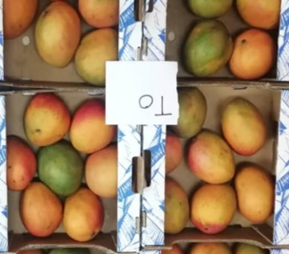 | 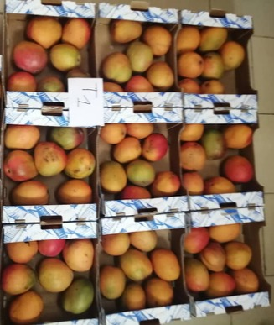 | 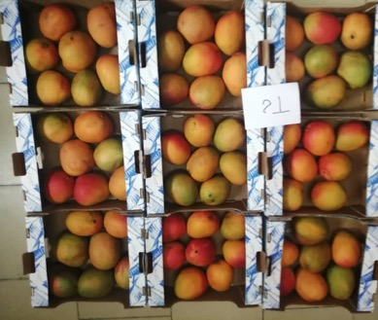
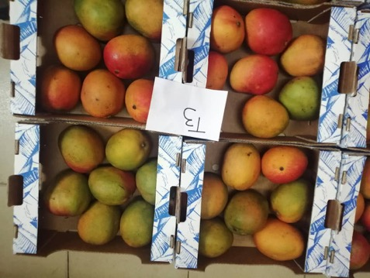 | 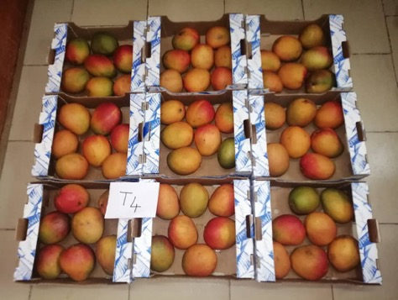 | 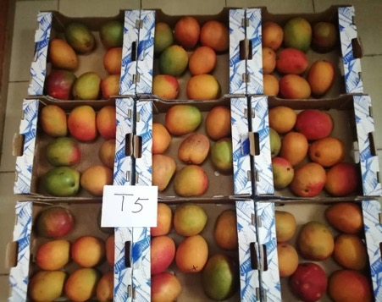
Figure 3: Colouration of mangoes 20 days after treatment
Treatment 0 (T0): Untreated control, washed with chlorinated water; Treatment 1 (T1): Scholar Max 230 SC reference product at 0.15%; Treatment 2 (T2): wax based on vegetable oils at 10%; Treatment 3 (T3): wax based on vegetable oils at 15%; Treatment 4 (T4): wax based on vegetable oils at 5%; Treatment 5 (T5): Combination of wax based on vegetable oils at 10% and the reference product, Scholar Max 230 SC at 0.15%.

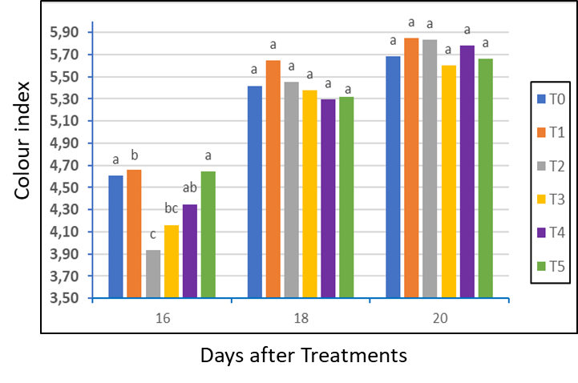
Figure 4: Changes in fruit skin colour after treatments.
Treatment 0 (T0): Untreated control, washed with chlorinated water; Treatment 1 (T1): Scholar Max 230 SC reference product at 0.15%; Treatment 2 (T2): wax based on vegetable oils at 10%; Treatment 3 (T3): wax based on vegetable oils at 15%; Treatment 4 (T4): wax based on vegetable oils at 5%; Treatment 5 (T5): Combination of wax based on vegetable oils at 10% and the reference product, Scholar Max 230 SC at 0.15%. 16, 18 and 20 days after treatment

Figure 5: Average browning rate of treated fruit.
Treatment 0 (T0): Untreated control, washed with chlorinated water; Treatment 1 (T1): Scholar Max 230 SC reference product at 0.15%; Treatment 2 (T2): wax based on vegetable oils at 10%; Treatment 3 (T3): wax based on vegetable oils at 15%; Treatment 4 (T4): wax based on vegetable oils at 5%; Treatment 5 (T5): Combination of wax based on vegetable oils at 10% dose and the reference product, Scholar Max 230 SC at 0.15%.
Error bars topped by the same letters are statistically identical according to the Newman-Keuls test at the α=0.05 threshold.

3.1.4. Impact of anthracnose on treated fruit
Symptoms of anthracnose were observed on fruit subjected to the different treatments and at varying rates depending on the storage time (Figure 6).
Anthracnose spots were observed on the 18th day after treatment on 2.33% of fruit in treatments T2 and T5, and 01.16% of fruit in treatment T3. By day 20 of the trial, the incidence of the disease had risen sharply and the disease was observed in fruit from all treatments at varying rates too. Thus, the highest rate of infected fruit (33.77%) was obtained with treatment T3 (wax based on vegetable oils at 15%), identical to those of the untreated control and the reference treatment. Treatments with wax based on vegetable oils at 10%, wax based on vegetable oils at 5%, and the one combining 10% wax based on vegetable oils at 0.15% with SCHOLAR (T5) induced the lowest rate of infection.
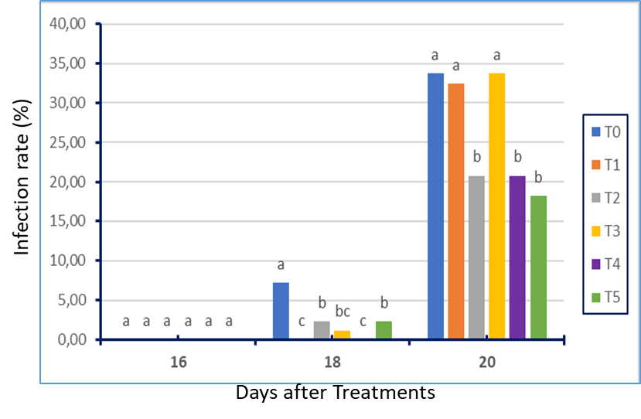
Figure 6: Impact of anthracnose on mangoes during storage.

Treatment 0 (T0) : Untreated control, washed with chlorinated water ; Treatment 1 (T1): Scholar Max 230 SC reference product at 0.15%; Treatment 2 (T2): wax based on vegetable oils at 10%; Treatment 3 (T3): wax based on vegetable oils at 15%; Treatment 4 (T4): wax based on vegetable oils at 5%; Treatment 5 (T5): Combination of wax based on vegetable oils at 10% and the reference product, Scholar Max 230 SC at 0.15%. 16, 18 and 20 days after treatment

3.1.5. Influence of treatments on biochemical parameters

3.1.5.1. Soluble sugar levels
The soluble sugar levels obtained in the treated mangoes ranged from 20.17 to 21.57 °Brix (Figure 7). Treatment T3 (wax based on vegetable oils at 15%) and treatment T4 (wax based on vegetable oils at 5%) induced soluble sugar levels statistically close to that of the untreated control, T0. However, the reference treatment T1 had the lowest sugar level (20.2 °Brix). T2 and T5 gave the highest soluble sugar levels at 21.5 °Brix.

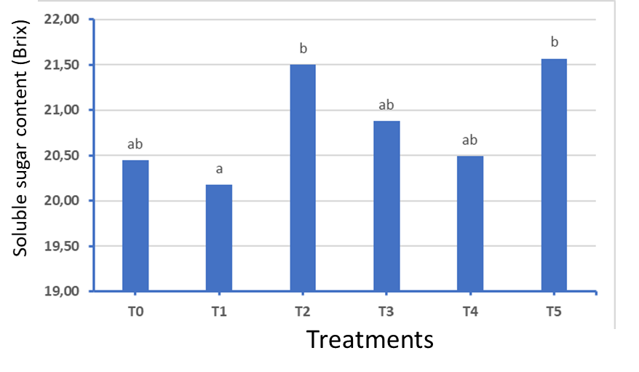
Figure 7 : Soluble sugar levels in fruit according to treatment.

Treatment T0: Untreated control, washed with chlorinated water; Treatment T1: Scholar Max 230 SC reference product at 0.15%; Treatment T2: wax based on vegetable oils at 10%; Treatment T3: wax based on vegetable oils at 15%; Treatment T4: wax based on vegetable oils at 5%; Treatment T5: Combination of wax based on vegetable oils at 10% and the reference product, Scholar Max 230 SC at 0.15%.

3.1.5.2. Titratable acidity
The average titratable acidity of treated mangoes ranged from 7.13 to 9.90 mEq.10-2 g (Figure 8). Analysis of Figure 8 shows that the treatments did not significantly influence fruit acidity (p> 0.05).

Figure 8: Titratable acidity of mangoes according to treatment.

Treatment T0: Untreated control, washed with chlorinated water; Treatment T1: Scholar Max 230 SC reference product at 0.15%; Treatment T2 : wax based on vegetable oils at 10%; Treatment T3: wax based on vegetable oils at 15%; Treatment T4: wax based on vegetable oils at 5% ; Treatment T5: Combination of wax based on vegetable oils at 10% and the reference product, Scholar Max 230 SC at 0.15% .

Error bars topped by the same letters are statistically identical according to the Newman-Keuls test at the α=0.05 threshold.

3.1.5.3. pH
The pH of the fruit varied according to the treatments (Figure 9). The 5% (T4) and 15% (T3) doses of wax based on vegetable oils produced the highest pH, with values of 6.15 and 6.32 respectively. These pH values are much higher than those of the reference control (4.70) and the untreated control (4.67).

Figure 9 : pH of mangoes according to treatment

Treatment T0: Untreated control, washed with chlorinated water; Treatment T1: Scholar Max 230 SC reference product at a dose of 0.15%; Treatment T2: wax based on vegetable oils at 10%; Treatment T3: wax based on vegetable oils at 15%; Treatment T4: wax based on vegetable oils at 5%; Treatment T5: Combination of wax based on vegetable oils at 10% and the reference product, Scholar Max 230 SC at 0.15% . Error bars topped by the same letters are statistically identical according to the Newman-Keuls test at the α=0.05 threshold.

3.1.5.4. Sugar/acidity ratio of processed mangoes (flavour index)
Figure 10 shows the sugar/acidity ratio (flavour index) of the fruit as a function of the treatments. The analysis showed that the treatments had a significant effect on the flavour index. Treatments T2 (wax based on vegetable oils at 10%), T3 (wax based on vegetable oils at 15%) and T5 (wax based on vegetable oils at 10%+Scholar 0.15%) showed higher sugar/acidity ratios than the other treatments. Treatments T0, T4 (wax based on vegetable oils at 5%) and T1 (reference control) had the lowest values. However, these were statistically identical (values between 2 and 2.5).

Figure 10 : Rapport sucre/acidité des mangues par traitement
Treatment T0: Untreated control, washed with chlorinated water; Treatment T1: Scholar Max 230 SC reference product at a 0.15%; Treatment T2: wax based on vegetable oils at 10%; Treatment T3: wax based on vegetable oils at 15%; Treatment T4: wax based on vegetable oils at the 5% dose; Treatment T5: Combination of wax based on vegetable oils at 10% and the reference product, Scholar Max 230 SC at 0.15% dose. Error bars topped by the same letters are statistically identical according to the Newman-Keuls test at the α=0.05 threshold.

Figure 11: Changes in the sugar/acidity ratio of mangoes according to treatments
Treatment T0 : Untreated control, washed with chlorinated water ; Treatment T1: Scholar Max 230 SC reference product at 0.15%; Treatment T2 : wax based on vegetable oils at 10%; Treatment T3: wax based on vegetable oils at 15%; Treatment T4: wax based on vegetable oils at 5%; Treatment T5: Combination of wax based on vegetable oils at 10% and the reference product, Scholar Max 230 SC at 0.15%.

3.1.5.5. Screening treatments using principal component analysis
The variables studied in this evaluation were projected onto a factorial plane (1x3). Factors 1 and 3 (Figure 12) contribute approximately 66.58% of the total variance of the individuals (treatments). The scatterplot reveals three distinct treatment groups. Group 1, consisting of treatment T4 (wax based on vegetable oils at 5%) characterised by good fruit firmness, low phytotoxicity and low incidence of anthracnose on treated mangoes after 15 days in the cold followed by 6 days at room temperature. Group 2 includes treatment T2 (wax based on vegetable oils at 10%) ; treatment T3 (wax based on vegetable oils at 15%) and treatment T5 (Combination of wax based on vegetable oils at 10%) and the reference product, Scholar Max 230 SC at 0.15%, characterised by a loss of fruit firmness, high phytotoxicity and a high incidence of anthracnose for T2 and T3. Group 3, made up of the two controls T0 and T1 (reference), with a high incidence of anthracnose and loss of firmness. In this group, the T1 treatment stood out for its high level of browning (phytotoxicity).

Figure 12: Projection of treatments onto a principal component distribution plan
Correlation circle (a) and treatment dispersion (b)

4- DISCUSSION
The mango sector, which is very much in evidence in the northern region of Côte d'Ivoire, is dominated by traditional production, mainly for export. In Côte d'Ivoire, as in Cameroon, this activity is the preserve of men and enables them to meet the needs of their families (Yikoa et al., 2022 ; Kouamé et al., 2020). This activity is prone to difficulties inherent in the perishable nature of the fruit, which leads to considerable losses during storage and export. This study aims to maintain the quality of exported fruit by coating it with a wax based on rapeseed and olive oils.
In this study, after storage of the fruit in a cold room maintained at 8°C for 15 days, the results showed an equal loss of mass for all treatments, in the order of 7 to 9% of the fruit six days after removal from the cold room. In fruit, weight loss is a non-physiological mechanism that causes the fruit to soften as a result of water loss through transpiration. Thus, weight loss suggests that the coatings tested have no effect on fruit duckweed activity. This result differs from that of Thai (2000), who obtained a lower weight loss for mangoes treated with coatings based on carnauba wax (Copernicia prunifera).
Fruit treated with the different doses of a wax based on vegetable oils, showed improved firmness compared with the reference and untreated controls. This suggests that the product, and especially the 5% and 10% doses coupled with the reference product (Scholar Max 230 SC) at 0.15%, preserves mango firmness. In this way, the product maintains factors likely to lead to changes in the physical characteristics of the fruit, such as the epidermis and slows down starch hydrolysis by inhibiting phospholipase D activity (Cheema et al., 2018). Coating fruit with wax based on vegetable oils, in this case at 15%, as well as hexanal, is said to have favourable properties for maintaining membrane integrity (Silué, 2022).
The color and firmness of the fruit is an important element, since it is the one that most reflects the quality of the fruit, and so it is of the utmost importance to keep it attractive. Among the treatments tested, the 5% dose of wax based on vegetable oils produces the best-holding mangoes. In addition to inhibiting chlorophyllase synthesis, the product also inhibits epidermal chromoplast synthesis (Thai, 2000).
Browning was lowest in untreated fruit and in fruit treated with the 15% product.
Fruit can be affected by a number of microbial diseases such as bacteriosis, but in this study it was the symptoms of anthracnose that were monitored. Results relating to the severity of infection showed that, on fruit treated with the reference product, or with wax based on vegetable oils and controls, anthracnose symptoms developed. However, the product is said to have an antifungal effect, as at 5 ; 15 and the 10% of wax based on vegetable oils + Scholar Max 230 SC treatment at 0.15%, the infection rate was lower. This reduction in the rate of infection by the coating product was also reported by Kouamé et al. (2021), following application of essential oils of Cymbopogon citratus and Melaleuca quinquenervia L. As hypothesized by Houssain et al. (2014), this low infection rate can be explained by the high level of phenolic compounds found in unripe fruit. Seen from this angle, the coating would have slowed mango ripening.
In terms of soluble sugar content, the various wax based on vegetable oils treatments did not alter the soluble sugar content of the fruit compared with the control (T0). On the other hand, compared with the T1 reference treatment, only the 10% and 15% doses maintained a similar content. This result implies a comparable hydrolysis rate for all treatments.
Fruit pH levels in treatments T3 and T4 are close to 7, while those treated with T0, T1 and T5 are below 5. This result indicates that fruit pH is sensitive to treatment. The 10% (T3) and 15% (T4) doses of wax based on vegetable oils reduce pulp pH, thus improving mouthfeel, compared with the untreated control. The variation in pH according to treatment was reported by Silué (2022). However, following the application of hexanal, no significant variation in pH was observed. The taro (Colocasia esculenta) starch-based coating of mangoes, carried out by Kassé (2015), also did not affect the pH of the mangoes. Thus, the lack of effect of coating on fruit pH fluctuation in this study is consistent with previous studies.
In fruit juices, acidity results from the conversion of sugars into lactic acids by microorganisms (Aissaoui and Dahmouni , 2021; Al-Zoreky, 2009). In fruit, on the other hand, ripening is accompanied by a decrease in titratable acidity and pH due to the use of organic acids as substrates for respiration, gluconeogenesis and the biogenesis of aromatic compounds (Preethi et al., 2018). In this study, titratable acidity and soluble sugar content were similar to those of the reference treatment as well as the control treatment. This result implies that coating with a vegetable oil-based wax (T2, T3, T4, T5) like the reference coating product does not block the activity of the enzyme that hydrolyses polysaccharides into soluble sugars (Gill et al., 2016). This result is similar to that of Kassé (2015).
According to principal component analysis, treatment T2 (wax based on vegetable oils 5%) induced good fruit firmness, low phytotoxicity and low incidence of anthracnose in treated mangoes after 15 days in the cold followed by 6 days at room temperature. This treatment would therefore be more suitable for preserving fruit for export.

5- CONCLUSION
A study of the efficacy of wax based on vegetable oils applied at four doses (5 ; 10 ; 15 and 10% combined with SCHOLAR at 0.15%) on the post-harvest preservation of mango, compared with an untreated control and a reference control at 0.15% SCHOLAR, produced some very interesting results. On the one hand, treatments with wax based on vegetable oils at 10%, 15% and the combination wax based on vegetable oils 10%+Scholar 0.15% induced a loss of fruit firmness, high phytotoxicity and a incidence of anthracnose. On the other hand, mangoes treated with 5% of wax based on vegetable oils are quite firm, with low browning symptoms and low incidence of anthracnose after 15 days at 8°C followed by 6 days at room temperature. Scholar alone induces not only a high incidence of anthracnose and loss of firmness, but also browning of the fruit after removal from the storage room.
In view of these results, wax based on vegetable oils at 5% homogenized in water and applied as a fruit spray can be recommended for registration in Côte d'Ivoire, for post-harvest mango preservation. This dose controls anthracnose symptoms in post-harvest mango preservation over a 21-day period.

REFERENCES
Kouamé L.M., Kouamé K.A., Ouattara L., N’guéssan K.F., Alloue W.M., Dje K.M. (2020). Constraints related to the production and marketing of mangoes (Mangifera indica) in Côte d’Ivoire: the case of varieties exported to Europe. Afrique Science, 17 (3): 16–27
Pugnet, V. (2018) Country Fact Sheet, Mango in Côte d’Ivoire. Producer Fact Sheet, in FRuiTROP No. 255, March/April 2018, 78–83.
Coulibaly B. (2022). Study on agricultural financing: the case of the mango sector in Côte d’Ivoire. HortiFresh Program in West Africa. 25p
Yikoa B.N., Nzossié E.J.F., and Temple L. (2022). The emergence of a fruit marketing activity in Ngaoundéré: between opportunities and constraints. Annals of the University of Moundou, Series A-FLASH, 9 (1): 35–55.
Wang B., Wang J., Feng X., Lin L., Zhao Y., and Jiang W. (2009). Effects of 1-MCP and exogenous ethylene on fruit ripening and antioxidants in stored mango. Plant Growth Regul, 57, 185–192.
Kanté-Traoré H., Sawadogo-Lingani H., Seogo I., Kaboré D., and Dicko M.H. (2017). Mango processing processes and level of awareness of quality standards by production units in Burkina Faso. International Journal of Biolocal and Chemical Science 11 (1): 195-207
Bissardon F. (1999). Postharvest Physiology and Cold Storage of Mango. Engineering Dissertation: IARC: Ecole nationale supérieure des industries agricoles et alimentaires, Montpellier, France. 21 p.
Raimbault A. (2011). Internal Browning of Pineapple (Ananas comosus (L). M) Induced by Postharvest Cold Treatment: Physiopathology, Development of Molecular Tools, Gene Expression, and Enzymatic Activities Involved in Protein Catabolism. PhD from the University of Paris Est CRETEIL-VAL DE MARNE. 202p
Silue Y. (2022). Improving the Cold Storage of “Kent” Variety Mangoes from Côte d’Ivoire. PhD Thesis, Agricultural Sciences. University of Avignon; Nangui Abrogoua University (Abidjan), Ivory Coast, 144 p.
OBAM-CI. (2019). In: Analysis of the Value Chain of Processed Fruits in Burkina Faso, Mali, and Ivory Coast, CBI, Ivory Coast. pp. 42-44
AOAC. (2000). Official Methods 942.15 Acidity (titratable) of Fruit Product Read with AOAC Official Preparation of Test Sample 149.17, th ed.
Thai T. H. (2000). Effect of Different Coatings on the Fresh Storage Characteristics of Mango. Montpellier: ENSIA-SIARC, 111 p. Master's Thesis: Mediterranean and Tropical Agri-Food Engineering: National School of Agricultural and Food Engineering, 76 p.
Cheema A., Padmanabhan P., Subramanian J., Blom T and Paliyath G. (2018). Improving quality of greenhouse tomato (Solanum lycopersicum L.) by pre- and postharvest applications of hexanal-containing formulations. Postharvest Biology and Technology, 95: 13–19.
Hossain Md.A., Rana Md.M., Kimura Y. and Roslan H.A. (2014). Changes in biochemical characteristics and activities of ripening associated enzymes in mango fruit during the storage at different temperatures. BioMed Research International, 2014: 1-11.
Kouame K. G., Kouame K. D.; Kassi K. F. J-M and Kone D. (2021). Post-Harvest Control of Anthracnose of Mango (Mangifera indica L. var Kent) Using Essential Oils Extracted from Two Aromatic Plants (Cymbopogon citratus (D C) Stapf. and Melaleuca quinquenervia L.) of the Ivorian Flora. Int.J.Curr.Microbiol.App.Sci. 10(11): 277-293
Kasse, M. (2015). Improving the preservation of 4th-range mangoes by using a coating, an antimicrobial treatment, and modified atmosphere packaging. Doctoral thesis. Cheikh Anta Diop University of Dakar, Senegal, 98 p.
Aissaoui I. and Dahmouni A. (2021). Use of pomegranate (Punica granatum) peel extract to extend the shelf life of fresh orange juice. Master's thesis, Mohamed El Bachir El Ibrahimi B.B.A. University, Algeria.21p
Al-Zoreky N. S. (2009). Antimicrobial activity of pomegranate (Punica granatum L.) fruit peels. International Journal of Food Microbiology,134(3):244-248.
Preethi P., Soorianathasundaram K., Sadasakthi A., Subramanian K.S., Paliyath G. and Subramanian J. (2018). Influence of Hexanal formulation on storage life and post-harvest quality of mango fruits. JEB 39, 1006–1014.
Gill K.S., Dhaliwal H.S., Mahajan B.V.C., Paliyath G and Boora R.S. (2016). Enhancing postharvest shelf life and quality of guava (Psidium guajava L.) cv. Allahabad Safeda by pre-harvest application of hexanal containing aqueous formulation. Postharvest Biology and Technology 112:224–232.

