**EFFECT OF SUPPLEMENTING OVIRICH® ON CARCASS CHARACTERISTICS OF WHITE LEGHORN LAYERS**

**ABSTRACT**

A feeding trial was conducted to discern the influence of dietary incorporation of Ovirich**®** on carcass characteristics, cut-up parts, and weights of organs parameters of White leghorn Layers. A total 90 white leghorn layers (22 weeks age) were randomly distributed into three treatments of 30 layer birds per treatment with three replicates of 10 birds in each. White leghorn layer of treatment T1 (control group) were fed a basal diet whereas in treatment group T2 and T3 basal diet was supplemented with 0.75 kg and 1.0 kg of Ovirich**®** supplement per ton of basal feed, respectively. Significant differences (P≤0.05) were noted in the relative organ weights, carcass proximate composition and sensory evaluation of the experimental birds. It was concluded that inclusion of Ovirich**®** in White leghorn diet has effect on carcass characteristics.

Keywords: Carcass characteristics; dressing percentage; Ovirich; White leghorn layer

**1 . INTRODUCTION**

In animal husbandry, poultry is defined as birds raised commercially or domestically for meat, eggs and feathers. According to BasicAnimal Husbandry Statistics (2024**)**, the total poultry population in India is 851.81 million which has increased up by 16.81% from last census. The egg production in India has achieved record number of 142.77 billion in the year 2023-2024, the egg production has increased by 3.17% compared to the year 2022-23. The meat production in India has achieved record production of 10.25 million tons in the year 2023-2024, increased by 4.95% as compared to previous year.

Since ancient times, medicinal plants have been utilized as therapeutic agents for health management and disease treatment due to their health-enhancing properties and bioactive components (Locatelli *et al.,* 2014).Ovirich**®**supplement has beneficial phytogenic molecules from *Capparis spinosa* (Caper bush), *Terminalia arjuna* (Arjuna tree), *Cichorium intybus* (Chicory), *Solanum nigrum* (Black nightshade), *Tamarix gallica, Achillea millefolium* and *Andrographis paniculata*. It also contains some essential minerals like Organic Chromium, Zinc fortified with other minerals viz. (Calcium, Phosphorus, Manganese, Cobalt, Selenium) and Yeast complex. This supplement has shown effect on haematological parameters in layer birds (Rahal et al, 2024).The current study was conducted to evaluate the effect of dietary incorporation of Ovirich**®** on carcass characteristics, cut-up parts, and weights of organs parameters of White leghorn layer broiler.

**22. MATERIALS AND METHODS**

**2.1 Experimental Location**

The experimental trial was conducted to discern the effect of dietary incorporation of Ovirich**®** on carcass characteristics, cutup parts, and weights of organs parameters of white leghorn layer bird. The entire study was conducted at Instructional Poultry Farm (I.P.F.) and Department of Animal Nutrition, College of Veterinary and Animal Sciences, G.B. Pant University of Agriculture and Technology, Pantnagar which is located at latitude of 28053’24” North, longitude of 77034’27” East at an altitude of 243.84 meters above Mean Sea Level.

**2.2 Experimental Birds and Housing Management**

Feeding trial of 14 weeks duration was conducted on ninety white leghorn (22 weeks age), who after procurement were randomly distributed into three treatment groups with 30 hens per treatment having three replicates of 10 birds each.The experiment was conducted at Instructional Poultry Farm, Nagla, Pantnagar. The experimental layers were housed in deep litter with 16 hours of lighting facility under proper managemental condition. The birds were leg banded individually for identification and were weighed individually before allocating to each treatment groups. The diet offered daily and residue left till next day was weighed and recorded. Birds were provided *ad libitum* fresh water throughout the experimental period. The managemental conditions were similar for different treatment groups.

**2.3 Procurement of Ovirich®**

Ovirich**®**supplement was sourced from Aminorich Nutrients B.V., Roorkee, Uttarakhand.

**2.4 Procurement of Feed Ingredients and Supplements**

Feed ingredients required for the formulation of the experimental ration were procured from the feed unit and all the ingredients were ground in feed mill before mixing at feed unit of the Instructional Poultry Farm (IPF), GBPUAT, Pantnagar.

**2.5 Experimental Design and Treatments**

### Chart 1.Experimental design and treatments

|  |  |  |  |  |
| --- | --- | --- | --- | --- |
| Groups | Treatment | No. of birds/ replicate | No. of replicates | Total no. of birds |
| T1 | Control (Basal ration) | 10 | 03 | 30 |
| T2 | Basal ration with 0.75Kg Ovirich®/ton feed | 10 | 03 | 30 |
| T3 | Basal ration with 1Kg Ovirich® /ton feed | 10 | 03 | 30 |

### Chart 2.Experimental Diet

|  |  |
| --- | --- |
| Ingredients | %Composition |
| Yellow Maize | 57.05 |
| GNC-Solvent Extracted | 8.50 |
| Soyabean Meal | 16.50 |
| De-oiledRicebran | 7.0 |
| Rice Polish | 5.0 |
| MarblePowder | 3.0 |
| TraceMineralMixture | 0.10 |
| Dicalcium Phosphate | 1.0 |
| DL-Methionine | 0.35 |
| CholineChloride | 0.05 |
| Hepatocare | 0.10 |
| CommonSalt | 0.40 |
| Vitamin Premix | 0.10 |
| ToxinBinder | 0.05 |
| Multi-Enzyme | 0.05 |
| Coccidio-stat | 0.05 |
| Lysine | 0.70 |
| Total | 100.00 |
| Chemical composition(% DM) calculated | |
| CrudeProtein(%) | 18.13 |
| Metabolisable Energy(Kcal/Kg) | 2743.55 |
|  |  |

**2.6 Experimental Diet**

Standard basal diets for laying birds were prepared by mixing the feed ingredients to meet the nutrient requirements of birds as per specific recommendations of BIS (2007). Proximate composition of experimental feed and meat was analysed using AOAC (2003).

**2.7 Carcass Quality Traits**

At the end of the feeding trial, a representative sample of three hens from each treatment group was selected for further analysis of carcass traits and to conduct an organoleptic test on the meat. These hens were fasted for 12 hours with access to water before being sacrificed. Each hen was weighed prior to sacrifice. They were bled by severing the jugular vein and then euthanized through cervical dislocation. The carcass weight was recorded after the bleeding process and again after the feathers were removed using hot water. The head and shank were excised at the atlantooccipital and hock joints, respectively, and their weights were noted. The keel bone was cut horizontally at the back, and the viscera, located beneath the breast, were extracted by moving the breast forward. The dressed yield percentage was calculated by subtracting the weight of blood, feathers, head, shank, and viscera from the live weight of the hen. The carcass was then divided into distinct parts, including the thigh, breast, drumstick, back, neck, and wings, each of which was weighed separately. Internal organs such as the spleen, liver, gizzard, ovary and heart were isolated, and the gall bladder was removed from the liver. The gizzard was opened to separate its contents, and the epithelial linings were removed. The individual weights of the gizzard, liver, heart, and spleen were recorded. Femur length, pelvic width and diameter of largest ovarian follicle was measured.

### 2.8 Ovarian follicle distribution

Ovarian follicle distribution was assessed by counting the number of large white follicle, small white follicle, large yellow follicle and small yellow follicle each individually.

### 2.9 Sensory evaluation of meat

To evaluate the sensory qualities of the meat samples, the meat descriptive analysis method recommended by Keeton and Eddy (2004**)** was utilized. Hen meat from each replicate of all groups was cooked in a 1.5% saline solution and served warm to a panel of judges for sensory evaluation. The panel comprised eight semi-trained judges, selected from postgraduate students and teaching staff at the College of Veterinary and Animal Sciences. The judges assessed the meat quality based on appearance, flavor, texture, juiciness, and overall acceptability. An 8-point hedonic scale was used to rate the sensory attributes. Meat samples from each group were served on separate, clearly labeled plates with randomly generated three-digit codes. To cleanse their palates between samples, panelists were provided with green tea. The samples were presented in a random order, and the judges rated them on the hedonic scale for color, flavor, texture, juiciness, and overall acceptability. A score of 5 or lower was considered the cut-off for acceptance for all sensory attributes.

**2.10 Statistical Analysis**

Statistical analysis was done using SPSS software package (IBM SPSS Statistics 21).

**3. RESULTS AND DISCUSSION**

The average carcass characteristics, the relative weight of cut-up parts, and the relative weight of body organs of birds slaughtered at the end of the experimental period has been depicted in Table 1 to Table 8.

### Carcass traits

As indicated in Table 1 the average blood loss for treatment groups T1, T2 and T3 after supplementation period was recorded as 5.20±0.005, 5.28±0.005 and 5.51±0.005, respectively. Similarly, the average feather loss for these groups was 5.82±0.005, 5.88±0.005 and 5.93±0.005, respectively. Significant differences (P≤0.05) were observed in the average blood and feather loss among the different treatment groups. Average dressing yield values showed significant differences (P≤0.05) between treatment groups. The dressing yield for groups T1, T2 and T3 was 51.23±0.005, 53.27±0.005 and 54.24±0.005, respectively, with T3 exhibiting the highest value. Moreover, all dressing yield values showed significant differences (P<0.05) when compared individually across the groups.

### Table 1. Average Carcass Traits of the laying birds after supplementation period

|  |  |  |  |  |
| --- | --- | --- | --- | --- |
| Parameter | T1 | T2 | T3 | *P*-Value |
| Blood loss (%) | 5.20c±0.005 | 5.28b±0.005 | 5.51a±0.005 | <0.01 |
| Feather loss (%) | 5.82c±0.005 | 5.88b±0.005 | 5.93a±0.005 | <0.01 |
| Dressing yield (%) | 51.23c±0.005 | 53.27b±0.005 | 54.24a±0.005 | <0.01 |
| Average Weight of Birds (g) | 1314.53c±0.39 | 1327.52b±0.15 | 1333.85a±0.38 | <0.01 |

*Mean values bearing different superscripts (a,b,c) within a row differ significantly from each other (P<0.05).*

**3.2 Cut-up Parts and Weights of Organs**

Table 2 reveals that the average relative thigh weight at the end of the feeding trial for treatment groups T1, T2 and T3 was recorded as 7.81±0.005, 8.05±0.005 and 8.22±0.005, respectively, with significant differences (P≤0.05) observed among different treatment groups. The average relative drumstick weight showed a significant difference (P≤0.05) among treatment groups, with values as 7.37±0.005, 7.48±0.005 and 7.64±0.005 for T1, T2 and T3, respectively. The T3 group had higher values compared to the other groups. Significant differences (P≤0.05) were noted between T1 and T2, T2 and T3 and also between T1 and T3. For relative breast weight, T1, T2 and T3 recorded values were 14.12±0.005, 14.27±0.005 and14.43±0.005, respectively. Significant difference (P≤0.05) was observed among treatment groups with T3 having statistically higher values than the other groups. The average relative back weight for T1, T2 and T3 was recorded as 9.70±0.05, 9.83±0.005 and 9.96±0.005, respectively, while the relative wings weight was 9.04±0.005, 9.17±0.005 and 9.35±0.005, respectively. Significant differences (P≤0.05) were observed in the relative back and wings weight among the treatment groups. The relative neck weight values showed significant differences (P≤0.05) among supplemented groups compared to control group, with T1, T2 and T3 recording values of 2.90±0.05, 3.04±0.005 and 3.13±0.005, respectively. The relative head weight showed significant differences (P≤0.05) among treatment groups, with T1, T2 and T3 recording values of 4.07±0.005, 4.12±0.005 and 4.19±0.005, respectively. The relative shank weight showed significant differences (P≤0.05) among treatment groups, with T1, T2 and T3 recording values of 3.29±0.005, 3.32±0.005 and 3.37±0.005, respectively.

### Table 2: Average Relative cut up parts of the laying birds after supplementation period

|  |  |  |  |  |
| --- | --- | --- | --- | --- |
| Parameter (%) | T1 | T2 | T3 | *P*-Value |
| Thigh | 7.81c±0.005 | 8.05b±0.005 | 8.22a±0.005 | <0.01 |
| Drumstick | 7.37c±0.005 | 7.48b±0.005 | 7.64a±0.005 | <0.01 |
| Breast | 14.12c±0.005 | 14.27b±0.005 | 14.43a±0.005 | <0.01 |
| Back | 9.70c±0.05 | 9.83b±0.005 | 9.96a±0.005 | <0.01 |
| Wings | 9.04c±0.005 | 9.17b±0.005 | 9.35a±0.005 | <0.01 |
| Neck | 2.9b±0.05 | 3.04a±0.005 | 3.13a±0.005 | <0.01 |
| Head | 4.07c±0.005 | 4.12b±0.005 | 4.19a±0.005 | <0.01 |
| Shank | 3.29c±0.005 | 3.32b±0.005 | 3.37a±0.005 | <0.01 |

*Mean values bearing different superscripts(a,b,c)within a row differ significantly from each other (P<0.05).*

The average relative spleen weight (Table 3) at the end of the feeding trial for treatment groups T1, T2 and T3 was recorded as 0.081±0.005, 0.082±0.05 and 0.082±0.005, respectively. Statistical analysis revealed no significant differences (P≥0.05) in relative spleen weight among the treatment groups. At the end of the feeding trial, the average relative giblet weight for treatment groups T1, T2 and T3 was 6.73±0.057, 6.84±0.005 and 6.88±0.046, respectively. The average relative heart weight for these groups was recorded as 0.58±0.005, 0.59±0.005 and 0.59±0.005, respectively. Similarly, the average relative gizzard weight was 3.3±0.057, 3.37±0.005 and 3.39±0.005, respectively. Statistical analysis indicated no significant differences (P≥0.05) in relative giblet, heart, and gizzard weight among the treatment groups. The average relative liver weight for treatment groups T1, T2 and T3 was 2.85±0.005, 2.88±0.005 and 2.90±0.057, respectively, with no significant differences (P≥0.05) observed among the treatment groups. Average relative ovary weight for treatment groups T1, T2 and T3 was 2.87±0.005, 2.91±0.005 and 2.97±0.005, respectively. Significant differences (P≤0.05) were observed in the relative ovary weight among the different treatment groups.

### Table 3. Average relative organ weight of the laying birds after supplementation period

|  |  |  |  |  |
| --- | --- | --- | --- | --- |
| Parameter (%) | T1 | T2 | T3 | *P*-Value |
| Spleen | 0.081±0.005 | 0.082±0.05 | 0.082±0.005 | 0.422 |
| Giblet | 6.73±0.057 | 6.84±0.005 | 6.88±0.046 | 0.108 |
| Heart | 0.58±0.005 | 0.59±0.005 | 0.59±0.005 | 0.422 |
| Gizzard | 3.3±0.057 | 3.37±0.005 | 3.39±0.005 | 0.220 |
| Liver | 2.85±0.005 | 2.88±0.005 | 2.90±0.057 | 0.599 |
| Ovary | 2.87c±0.005 | 2.91b±0.005 | 2.97a±0.005 | <0.01 |

*Mean values bearing different superscripts (a,b,c) within a row differ significantly from each other(P<0.05).*

Umami *et al.* (2023**)** reported improved carcass quality due to supplementation of fresh chicory (5%, 10%, and 15%) in hybrid duck. Chicory supplementation increased the body weight of hybrid ducks. Carcass percentage is directly proportional to body weight, where increasing body weight tends to produce a high carcass percentage as well (Gariglio *et al.,* 2021). Saleh *et al.* (2020)reported increased ovary weight due to organic Mn, Zn, and Cu supplementation in laying hens. Trace minerals might be involved in regulating ovarian follicular development in laying hens. Manganese regulates hormones participating in ovarian follicular development, egg production ,and bone metabolism in broiler breeder hens (Xie *et al.* 2014).

Non-significant difference (P≥0.05) on carcass characterstics and cut-up parts were reported by Mathivanan *et al.* (2006)on feeding Panchagavya and *Andrographis paniculata* in broilers.

### Chemical Composition of Meat

The mean chemical composition values (% DM basis) of the layer bird’s breast and thigh muscles at the end of the feeding trial, influenced by the supplementation of Ovirich**®** across various treatment groups, are presented in Table 4 and 5.The dry matter (%) of the thigh muscle (Table 4) for treatment groups T1, T2 and T3 at the end of the feeding trial was 25.66±0.034, 25.7±0.057 and 25.73±0.017, respectively. The crude protein (%) was recorded as 78.53±0.017, 78.59±0.023 and 78.67±0.040 for T1, T2 and T3, respectively. The ether extract (%) for the respective treatment groups was 13.14±0.023, 13.15±0.023 and 13.13±0.017. No significant differences (P≥0.05) were observed in dry matter and ether extract % but significant differences (P≥0.05) were observed in crude protein % among the control (T1) and treatment (T3) group. However, the total ash (%) of the thigh muscle in treatment groups T1, T2 and T3 was 4.34±0.034, 4.37±0.034 and 4.41±0.011, respectively. Organic matter (%) of the thigh muscle in treatment groups T1, T2 andT3 was 95.66±0.034, 95.63±0.034 and 95.59±0.011, respectively. Statistically, no significant differences (P≥0.05) were found among T1, T2 and T3 group for total ash and organic matter.

### Table 4. Average Thigh Proximate composition of the laying birds on % Dry Matter basis after supplementation period

|  |  |  |  |  |
| --- | --- | --- | --- | --- |
| Parameter(%) | T1 | T2 | T3 | *P*-Value |
| DM | 25.66±0.034 | 25.7±0.057 | 25.73±0.017 | 0.506 |
| CP | 78.53b±0.017 | 78.59ab±0.023 | 78.67a±0.040 | 0.037 |
| EE | 13.14±0.023 | 13.15±0.023 | 13.13±0.017 | 0.210 |
| TA | 4.34±0.034 | 4.37±0.034 | 4.41±0.011 | 0.304 |
| OM | 95.66±0.034 | 95.63±0.034 | 95.59±0.011 | 0.304 |

*Mean values bearing different superscripts (a,b,c) within a row differ significantly from each other(P<0.05).*

The dry matter (%) of the breast muscle (Table 5) for treatment groups T1, T2 and T3 at the end of the feeding trial was 28.35±0.028, 28.43±0.017and 28.5±0.028, respectively. The crude protein (%) was recorded as 80.54±0.023, 80.69±0.023 and 80.86±0.023 for T1, T2 and T3, respectively. The ether extract (%) for the respective groups was 14.37±0.011, 14.23±0.017 and 14.09±0.011. Significant differences (P≤0.05) were observed in dry matter among the control (T1) and treatment (T3) group. Significant differences (P≤0.05) were observed in crude protein and ether extract % among different treatment groups. However, the total ash (%) of the breast muscle of T3 group differed significantly from T1 and T2 with values of 4.18±0.017, 4.24±0.017 and 4.35±0.028 in T1, T2 and T3, respectively. Organic matter (%) of the thigh muscle in treatment groups T1, T2 and T3 was 95.82±0.017, 95.76±0.017 and 95.65±0.028, respectively. Statistically, significant differences (P≤0.05) were found among supplemented group (T2 and T3) compared to control but no significant difference was noted between T2 and T3 groups.

### Table 5 Average Breast Proximate composition of the laying birds on % Dry Matter Basis after supplementation period

|  |  |  |  |  |
| --- | --- | --- | --- | --- |
| Parameter (%) | T1 | T2 | T3 | *P*-Value |
| DM | 28.35b±0.028 | 28.43ab±0.017 | 28.5a±0.028 | 0.017 |
| CP | 80.54c±0.023 | 80.69b±0.023 | 80.86a±0.023 | <0.05 |
| EE | 14.37a±0.011 | 14.23b±0.017 | 14.09c±0.011 | <0.05 |
| TA | 4.18b±0.017 | 4.24b±0.017 | 4.35a±0.028 | 0.004 |
| OM | 95.82b±0.017 | 95.76a±0.017 | 95.65a±0.028 | 0.004 |

*Mean values bearing different superscripts (a,b,c) within a row differ significantly from each other (P<0.05).*

### Sensory evaluation

The sensory evaluation of breast meat at the end of the feeding trial as affected by the supplementation of Ovirich**®** in various treatment groups has been depicted in Table 6 which show impact on the physical attributes of meat, including appearance, flavour, juiciness, texture, tenderness, and overall acceptability. The appearance of breast meat in different treatment groups T1, T2 and T3 at the end of the feeding trial was 7.16±0.011, 7.18±0.011 and 7.19±0.011, respectively. The flavour in different treatment groups T1, T2 and T3 was 7.09±0.011, 7.12±0.011 and 7.14±0.011, respectively. The appearance did not differ significantly (P≥0.05) among different treatment groups but flavour differed significantly (P≤0.05) between control (T1) and (T3) treatment groups. The juiciness of breast meat in the treatment groups T1, T2 and T3 at the end of the metabolic trial was recorded as 6.58±0.011,6.64±0.011 and 6.66±0.011, respectively. The juiciness showed significant differences (P≤0.05) among the control (T1) and supplemented treatment (T3) groups, with the highest value in the T3 group. The texture of breast meat in the same treatment groups T1, T2 and T3 was 6.80±0.011,6.83±0.011 and 6.85±0.011, respectively. The texture differed significantly (P≤0.05) between the control (T1) and treatment (T3) group. The overall acceptability of breast meat was 7.32±0.011, 7.36±0.011 and 7.38±0.011 for T1, T2 and T3, respectively, with significant differences (P≤0.05) observed among the control(T1) and supplemented treatment groups. Krol *et al*. (2017)reported that Chromium source did not affect sensory evaluation of breast muscles. Chromium as chloride slightly improves taste and juiciness of the meat. Inclusion of chromium-enriched yeast improves flavour and tenderness.

### Table 6 : Sensory evaluation of breast meat at the end of the feeding trial

|  |  |  |  |  |
| --- | --- | --- | --- | --- |
| Parameter | T1 | T2 | T3 | *P*-Value |
| Appearence | 7.16±0.011 | 7.18±0.011 | 7.19±0.011 | 0.422 |
| Flavour | 7.09b±0.011 | 7.12ab±0.011 | 7.14a±0.011 | 0.058 |
| Juiciness | 6.58b±0.011 | 6.64a±0.011 | 6.66a±0.011 | 0.007 |
| Texture | 6.80b±0.011 | 6.83ab±0.011 | 6.85a±0.011 | 0.058 |
| Overall Acceptance | 7.32b±0.011 | 7.36a±0.011 | 7.38a±0.011 | 0.027 |

*Mean values bearing different superscripts (a,b,c) within a row differ significantly from each other (P<0.05).*

### Bone length, Pelvic width, Ovarian follicle diameter and Ovarian follicle distribution

1. **Average Femur bone length, Pelvic width and largest follicle diameter of the laying birds**

The average relative femur bone length, pelvic width and largest follicle diameter (Table 7) at the end of the feeding trial for treatment groups T1, T2 and T3 was recorded as 7.66±0.088, 7.73±0.088 and 7.86±0.033; 4.063±0.013, 4.083±0.016 and 4.09±0.005; 2.988±0.15, 3.141±0.017 and3.198±0.013, respectively. Statistical analysis revealed no significant differences (P≥0.05) in relative femur bone length, pelvic width and largest follicle diameter among different treatment groups. Non-significant differences (P≥0.05) in tibia bone length have been reported by EL-Faham *et al*. (2014). Vishwanath *et al*. (2021**)** reported increase in pelvic width of layer birds on including Himlay® in the diet.

### Table 7: Average Femur bone length, Pelvic Width and largest follicle diameter of the laying birds after supplementation period

|  |  |  |  |  |
| --- | --- | --- | --- | --- |
| Parameter(cm) | T1 | T2 | T3 | *P*-Value |
| Femur length | 7.66±0.088 | 7.73±0.088 | 7.86±0.033 | 0.462 |
| Pelvic width | 4.063±0.013 | 4.083±0.016 | 4.09±0.005 | 0.236 |
| Largest follicle diameter | 2.988±0.15 | 3.141±0.017 | 3.198±0.013 | 0.321 |

1. **Average Ovarian follicle distribution of the laying birds**

The average relative ovarian follicle distribution ie. large white follicle, small white follicle, large yellow follicle and small yellow follicle (Table 8) at the end of the feeding trial for treatment groups T1, T2 and T3 was recorded as 15.33±0.8,16.66±0.8 and 17.66±0.8**;** 32.66±1.45,35.66±0.88 and 38.33±0.88**;** 3.66±0.33,4.33±0.33 and 4.66±0.33**;** 5.33±0.33, 6.33±0.33 and 7.00±0.57, respectively. Statistical analysis revealed no significant differences (P≥0.05) in large white follicle and large yellow follicle among the treatment groups but significant differences (P≤0.05) were noted in small white follicle and small yellow follicle among the control (T1) and treatment (T3) group (Plate 1- 3). Increase in follicle number has been reported by Vishwanath *et al.* (2021).Phytoactives could augment hepatocyte function in the liver (metabolism) and reproductive tracts (estrogen) by improving vitellogenin synthesis, which then stimulates the deposition of egg yolk in the developing follicles, resulting in increased egg production (Saraswati et al. 2013a; Saraswati et al. 2013b).

### Table 8: Average Ovarian follicle distribution of the laying birds after supplementation period

|  |  |  |  |  |
| --- | --- | --- | --- | --- |
| **Parameter (No.)** | **T1** | **T2** | **T3** | ***P*-Value** |
| **LWF** | 15.33±0.8 | 16.66±0.8 | 17.66±0.8 | 0.250 |
| **SWF** | 32.66b±1.45 | 35.66ab±0.88 | 38.33a±0.88 | 0.031 |
| **LYF** | 3.66±0.33 | 4.33±0.33 | 4.66±0.33 | 0.178 |
| **SYF** | 5.33b±0.33 | 6.33ab±0.33 | 7.00a±0.57 | 0.086 |

Mean values bearing different superscripts (a,b,c) within a row differ significantly from each other (P<0.05).

**Ovarian follicles in different treatment groups**

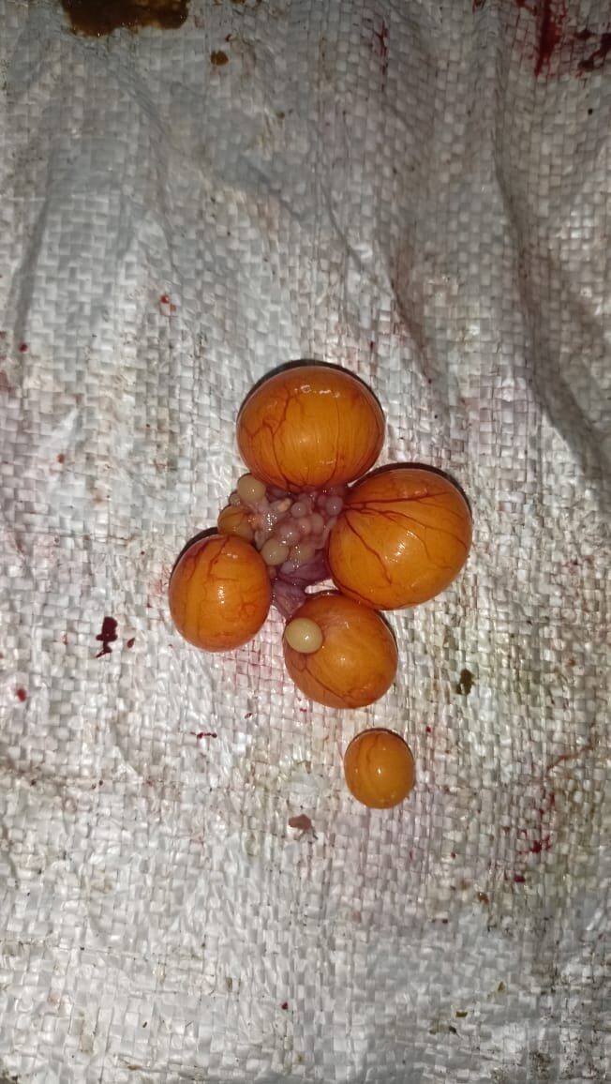 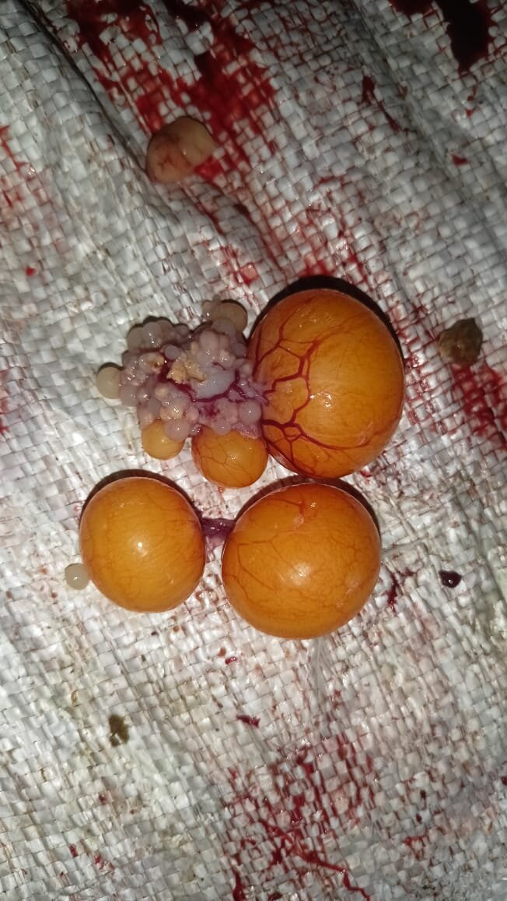 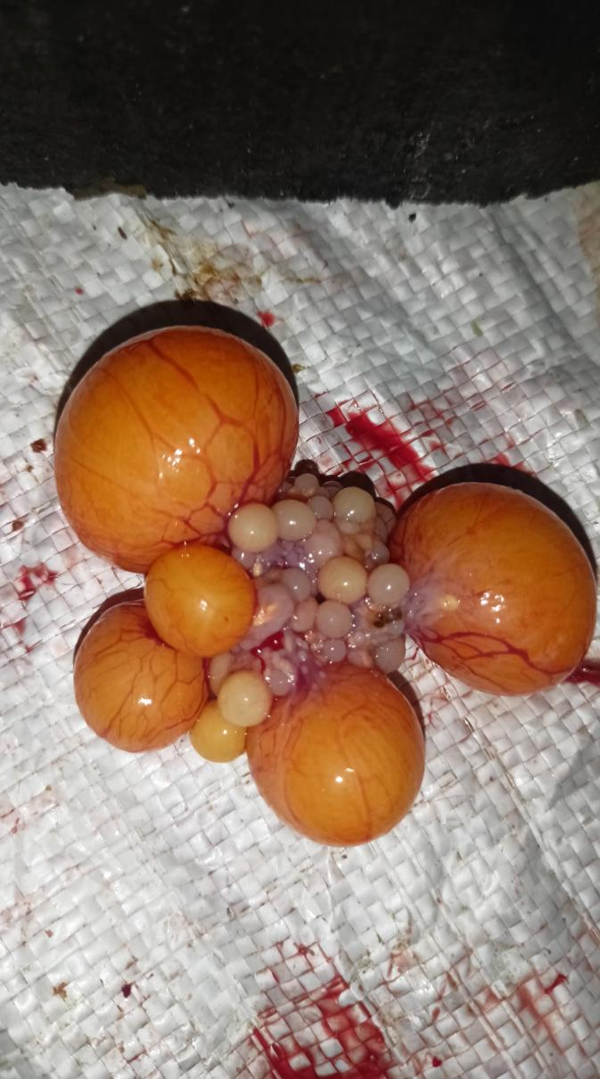

**Plate 1: Treatment 1 Plate 2 : Treatment 2 Plate 3: Treatment 3**

**4. CONCLUSION**

Ovirich**®** supplement can be used in White leghorn layer diet as it affects carcass quality.

**5. FUTURE SCOPE**

Ovirich**®** supplement may be tried in other poultry species. vague

**ETHICAL APPROVAL**

The experiment was conducted in strict compliance with the guidelines of ‘Institutional Animal Ethics Committee (IAEC)’, GBPUAT, Pantnagar, India.

**DISCLAIMER (ARTIFICIAL INTELLIGENCE)**

Author(s) hereby declare that NO generative AI technologies such as Large Language Models (ChatGPT, COPILOT, etc) and text-to-image generators have been used during writing or editing of this manuscript.

**REFERENCES**

AOAC. 2003. Official methods of Analysis. *Association of Official Analytical Chemists*. 17th Edn. Washington, DC.

BIS. 2007**.** Indian Standard: Poultry Feeds- Specification, IS-1374 *Bureau of Indian Standards*, 5threv., Bahadur Sah Zafar Marg, Manaka Bhawan, New Delhi.

El-Faham, A. I., Ali, N. G. and El-Maaty, H. M. 2014.Effect of using some natural feed additives to substitute antibiotic growth promoters on performance and blood parameters of broilers. *Egyptian Poultry Science*, 34(111): 735-750.

Gariglio, M., Dabbou, S., Gai, F., Trocino, A., Xiccato, G., Holodova, M., Gresakova, L., Nery, J., Oddon, S.B., Biasato, I. and Gasco, L. 2021.Black soldier fly larva in Muscovy duck diets: Effects on duck growth, carcass property, and meat quality. *Poultry Science*, 100(9): 101303.

Keeton, J.T. and Eddy, S.M. 2004**.** Chemical methods for decontamination of meat and poultry. *Preharvest and Post harvest Food Safety: Contemporary Issues and Future Directions*: 317–336.

Król, B., Słupczyńska, M., Kinal, S., Bodarski, R., Tronina, W. and Mońka, M. 2017.Bioavailability of organic and inorganic sources of chromium in broiler chicken feeds. *Journal of Elementology.*, 22(1).

Locatelli, C., Melucci, D. and Locatelli, M. 2014. Toxic metals in herbal medicines: A review. *Current Bioactive Compounds*, 10(3): 181–188.

Mathivanan, R., Edwin, S. C., Amutha, R. and Viswanathan, K. 2006.*Panchagavya* and *Andrographis paniculata* as alternatives to antibiotic growth promoter on broiler production and carcass characteristics. *International Journal of Poultry Science*, 5(12): 1144-1150.

Rahal,Anshu,Vinod Garjola,Ripusudan Kumar,B.C.Mondal and Meena Mrigesh(2025).Effect of Ovirich on blood chemistry in white leghorn Layer. Archieves of Current Research International 25(2)213-20.

Saleh, A. A., Eltantawy, M. S., Gawish, E. M., Younis, H. H., Amber, K. A., Abd El-Moneim, E. A. and Ebeid, T. A. 2020. Impact of dietary organic mineral supplementation on reproductive performance, egg quality characteristics, lipid oxidation, ovarian follicular development, and immune response in laying hens under high ambient temperature. *Bioliogical Trace Element Research.*, 195: 506-514.

Saraswati,T.R., Manalu,W.,Ekastuti,D. R.and Kusumorini,N. 2013a.Increased egg production of Japanese quail (*Coturnixjaponica*) by improving liver function through turmeric powder supplementation.*International Journal of Poultry Science*,12:601-614.

Saraswati, T. R., Manalu, W., Ekastuti, D. R. and Kusumorini, N. 2013b.The role of turmeric powder in lipid metabolism and its effect on quality of the first quail’s egg. *Journal Indonesian tropical Animal Agriculture*, 38: 123-130.

### Umami,N.,Rahayu, E. R. V., Suhartanto, B.,Agus,A., Suryanto, E.and Rahman,

M. M. 2022**.** Effect of *Cichorium intybus* on production performance, carcassquality and blood lipid profile of hybrid duck. *Animal Bioscience*, 36(1): 84.

Vishwanath, B. G., Ellusamy, B. and Paramesh, R. 2021**.** Evaluation of the effectiveness of phytogenic feed additive on hatchable egg production performance inCobb430Ybreedersunderfieldconditions.*Vet.Res.Notes*,1(3):23.

Xie, J., Tian, C., Zhu, Y., Zhang, L., Lu, L. and Luo, X. 2014**.** Effects of inorganic and organic manganese supplementation on gonadotropin-releasing hormone-I and follicle-stimulating hormone expression and reproductive performance of broiler breeder hens. *Poult. Sci.*, 93: 959-969.