**THE CROPPING SYSTEM AND THE FARMING DIVERSITY OF THE SPINACH GROWN IN BURKINA FASO**

**ABSTRACT**

**Aim**: This study was initiated to gain insight into the diversity and management of spinach on farms in Burkina Faso.

**Place and Duration of Study**: The study took place in the production garden sites in the different communes (in Kossodo, Manga, Loumbila, Tanghin and Saaba). It took place during the dry (October-January) and wet seasons (May/August).

**Methodology:** A semi-structured interview guide was used for the respondents A survey carried out on the production sites in Kossodo, Manga, Loumbila, Tanghin and Saaba enabled to show that spinach plays an important role both in terms of food supply and economic benefits.

**Results:** Cultivation practices are not very diversified, depending on the farmer's endogenous knowledge and financial resources. Spinach is mainly grown on beds in rotation with other crops such as *Corcorus sp* and *Cleome sp*. Organic fertilizer is the main substance of soil fertilization.

**Conclusion**: There are three morphotypes of spinach: green, red and what is commonly known as Bobo spinach. The majority of producers are women (98%). Red spinach and Bobo spinach are produced on 16% of the sites surveyed.

**Keywords: Spinach, *Spinacia oleracea* L, morphotype, Bobo-Dioulasso, Burkina Faso**

1. **INTRODUCTION**

The economy of the majority of African countries is essentially based on agriculture [1]. Gardening, an important foundation in this agriculture, contributes to the food supply by providing proteins, vitamins and minerals that are essential to any cereal-based diet (Millogo [2][3]. Today, gardening has become one of the most important sources of income in several African countries [4]. It employs mostly women who provide for their daily needs [5]. However, with the introduction of exotic vegetables from temperate regions to the African continent, most African vegetables have long been neglected (Abukutsa, 2010[4]. These vegetables have been marginalized by research and policy-makers and have not been taken into account in national agricultural programmes. In Burkina Faso, to achieve food sovereignty, the government has focused mainly on cash crops (especially cotton) or cereal crops (rice, sorghum, millet, maize) and, more recently, Jatropha sp as a source of agro-biofuel [6]. Strategies for contributing to food sovereignty rarely take into account secondary crops, including gardening products and spinach in particular. Spinach (*Spinacia oleracea* L.) is an annual or biennial vegetable of the Chenopodiaceae or Amaranthaceae family grown as a garden crop. In Burkina Faso, it is highly prized for its high protein, fiber, vitamins A, B1, B2, C, E and mineral content [7][8][9]. However, it remains a neglected and marginalized species among researchers and is not taken into account in agricultural programmes. Moreover, spinach production remains very low and does not meet national demand. In scientific terms, no studies have been carried out on the management and farming diversity of spinach. In order to lay the scientific foundations for the development of the species, a survey ethnobotanical survey has been carried out. The aim is to find out how spinach is grown. Specifically, it consists of identifying the characteristics of spinach management and farming diversity.

1. **MATERIALS AND METHODS**

**2.1 Study area**

The study was carried out in the following communes: Ouagadougou (Kossodo, Saaba, Kamboinsé), Loumbila, Kaya and Manga. These areas are known for their high vegetable production in Burkina Faso (Figure 1).

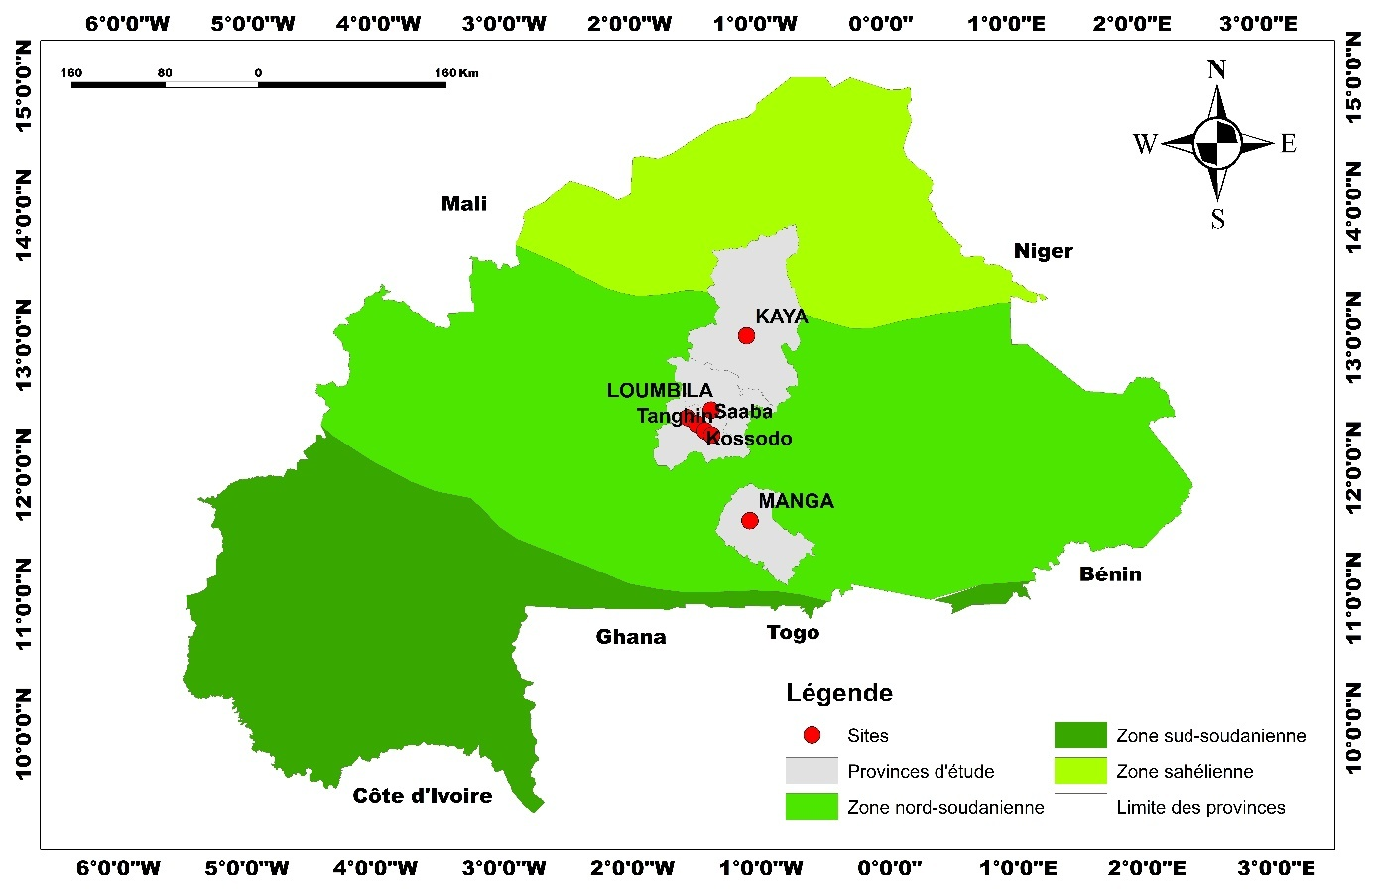

**Figure 1: Exploration sites for spinach production**

**2.2** **Methodology**

The study took place in the production garden sites in the different communes. A semi-structured interview guide was used for the respondents. The data collected were about vegetable material (origin of seeds, local names, production cycle and production period, cultivation techniques), different uses (food, medicinal, cultural, socio-economic) and seed conservation methods. The formal survey was based on a random sample of forty-eight growers.

**2.3 Statistical analysis**

The averages of the quantitative data were calculated using Excel software. The rate of producers with the different morphotypes was estimated using the formula, f = S/N x 100.

S designates the number of people growing a given morphotype and N is the total number of growers surveyed.

1. **RESULTS AND DISCUSSION**

**3.1 Distribution of producers by gender on the sites and cultivation practices**

Of all the visited sites, only Loumbila and Kossodo each had one male grower, i.e. 2% of growers, meaning that 98% of growers were women.

In all the surveyed areas, cultivation is carried out on beds. The length of the beds varies according to the availability of arable land. They vary from 2 to 10m in length and 12m in width (Figure 2).

Seedlings are sown with a daba at a distance of 15 to 30 cm between stakes. Large-scale production starts at the beginning of May for consumption. Seed is grown after September. Organic fertilizer is the fertilizer used to improve arable land. This fertilizer is applied after ploughing before the beds are put in place. The amount of applied fertilizer depends on its availability from the farmer.

The monoculture per bed is observed on all sites (Figure 3). This practice is backed up by crop rotation (spinach-amaranth or cabbage).

Weeding is carried out as needed from the first weeks of development. After development, it is difficult to get into the beds for weeding, as the stems cannot be cut.

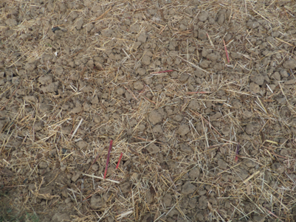 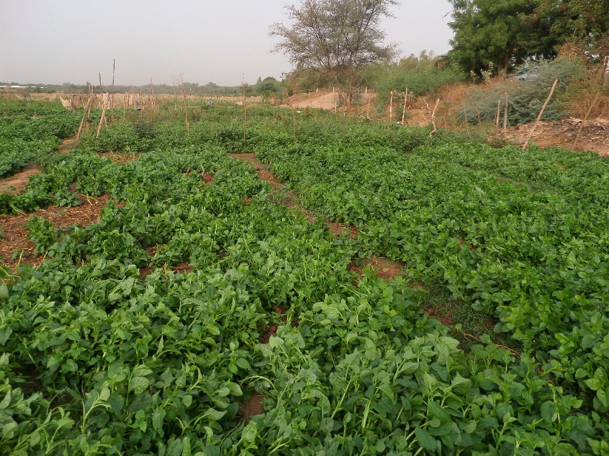

**Figure2 :** Amended bed of organic fertiliser **Figure3**: Green spinach beds

**3.2 Farming diversity of the spinach**

In all the surveyed areas in Burkina Faso, the plants have the same name: "spinach". However, there is diversity within the plants grown. This diversity is dominated by green spinach, which is found on all the growers' sites. At the Kossodo site, growers have a single morphotype that they call 'kienga' spinach, which means green. The same applies to growers in Kaya, Saaba, Loumbila and Manga. In the Shifra vegetable garden at Tanghin, we observed three morphotypes (Figure 4), green spinach (Figure 4A), red spinach (Figure 4B) and the spinach commonly known as Bobo-dioulasso spinach (Figure 4C). The latter was also observed at the Kamboinsé site.

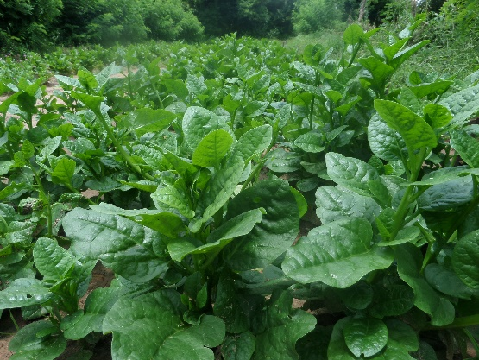 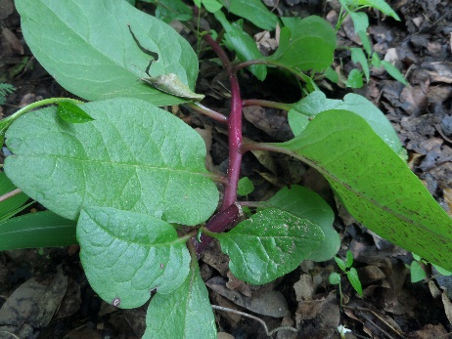 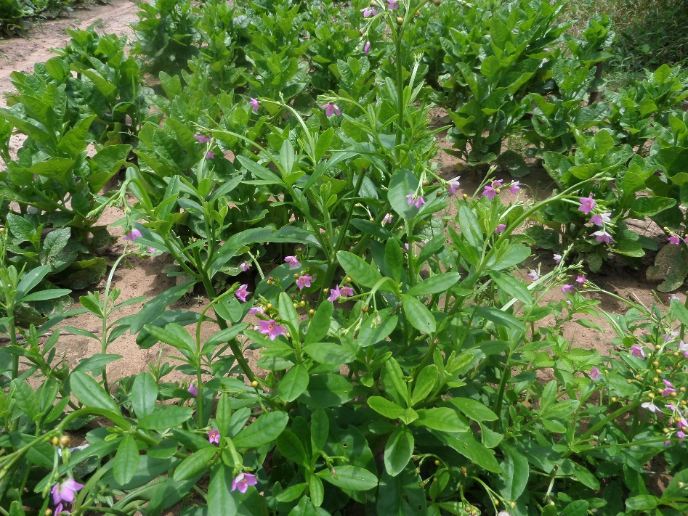

**A: Green spinach B: Red spinach C: Bobo spinach**

**Figure 4: Different morphotypes of spinach grown in Burkina Faso**

**3.3 Seed acquisition and conservation**

Growers acquire seeds either by exchange or purchase. Spinach seed generally consists of seeds. These are stored in plastic cans or bags. Spinach seedlings are also used as seed, with cuttings taken by growers. Bobo spinach has no available seeds. As the fruits are dehiscent, the seeds fall out before harvesting. As a result, only the regeneration of young plants provides new seeds for the next season. The main difficulty with the production is harvesting. This is because harvesting is done leaf by leaf along the stem. Spinach is sold at the grower's garden per bed at a value of between 6,000 and 20,000 CFA francs, depending on the harvest period, the market and the size of the beds. They are sold every fortnight during the harvest. The main use is for human consumption. At the end of the harvest, the old and dry stalks are pulled up for animal feed.

**3.4 Discussion**

According to the FAO [10], the most striking phenomenon is the feminisation of agriculture in some African countries. Women, who traditionally do most of the work in the agricultural sector, have become the backbone through their increasing predominance over men and their contribution to the food supply, i.e. 60-80% of continental production [11]. This situation of feminisation is also experienced in Burkina Faso, at the level of vegetable crops and more specifically in spinach production. The results of our study showed that women account for 98% of spinach production at the sites surveyed.

This phenomenon is not confined to Burkina Faso.[12]. pointed out in 2019 that in the Democratic Republic of Congo, women are responsible for around 80% of food production. This situation could be explained by the resilience linked to security crises, where men are more affected. It is also because cultivation does not require any physical effort for most of the farming practices.

Most of the production takes place during the rainy season. This practice shows that Burkina Faso's agriculture is generally still dependent on rain. However, crops are also grown during the dry season. This period is tiresome because of the cost of fuel for pumping water.

The crop is grown on beds using organic fertilizer. However, rotation techniques are also used. This growing system shows that organic manure is a good one for growing spinach. This practice ensures that the leaves are well preserved for marketing. When plants are treated with other fertilizers, rotting accelerates [13].

Morphological diversity is limited to three, where green spinach is predominant. This could be explained by the fact that it is either the only morphotype that is known or the most productive. This preference for green vegetables has also been noted for cleome, with a proportion of 75% [5][14]. Red spinach and Bobo spinach were found on the Tanghin site. Growers would have introduced these spinach varieties to diversify production. The Passore area is a model of this increase in varietal diversity where growers only have a single yam morphotype. As growers travel, they introduce new varieties to increase diversity, hence the presence of two new boussa and waogo varieties [14]. The scarcity of the two morphotypes (red and Bobo) is thought to be due to the absence of seeds on local markets and also to a lack of knowledge about the latter. The seed here is therefore the basis for the popularization of any species. Generally speaking, green is the most well-known, as highlighted by the diversity of spinach [15].

1. **CONCLUSION**

This study revealed the presence of three spinach morphotypes in Burkina Faso (green, red and Bobo spinach). Green spinach is grown in all the surveyed areas. Red spinach and Bobo spinach are only found in the gardens of Tanghin and Kamboinsé. The cultivation system is still traditional, and organic manure is used to improve the soil. Cultivation practices are based on planting beds. At harvest time, the produce is sold per bed and renewed every fortnight.

**REFERENCES**

**1- FAO, 2012. The State of Food and Agriculture.**

**2- Millogo-Rasolodimby J., 2001. Humans, Climate, and Plant Food Resources in Periods of Subsistence Crisis During the 20th Century in Burkina Faso. Doctoral Thesis, University of Ouagadougou, pp. 249.**

**3- Nana R., Zombre G., Tamini Z., and Sawadogo M., 2009. Effect of Water Regime on Off-Season Okra Yields. Science and Nature Vol. 6(2): 107–116.**

**4- Abukutsa, M.O.O., 2010. African Indigenous Vegetables in Kenya: Strategic Repositioning in the Horticulture Sector. Second Inaugural Lecture of the Jomo Kenyatta University of Agriculture and Technology. 5- Kiébré Z., 2016. Study of the Genetic Diversity of a Collection of White Caya (Cleome Gynandra L.) from Burkina Faso. Single Doctoral Thesis, University of Ouagadougou (Burkina Faso), pp. 139.**

**6- Nanéma R. K., 2010. Study of the Agromorphological Variability of Solenestomon Rotundifolius (POIR J.K. MORTON) and the Phylogenetic Relationships Between Its Different Morphotypes Cultivated in Burkina Faso. Thesis, University of Ouagadougou, UFR/SVT. 122 pp., 2010.**

**7- Gupta K. and Wagle D.S., 2008. Nutritional and Antinutritional Factors of Green Vegetables. J. Agric. Food Chem., 36, 3, 472-474. 8- Holland, B., Unwin, I.D. & Buss, D.H., 2011. Vegetables, herbs and spices. The fifth supplement to McCance & Widdowson’s The Composition of Foods. 4th Edition. Royal Society of Chemistry, Cambridge, United Kingdom. 163 pp.**

**9- FAO, 2013. The State of Food Insecurity in the World.**

**10- FAO, 2014. The State of Food and Agriculture 2014**

**11- Muadi Kashiba, Madeleine. 2019: Roles of women market gardeners in household food security. Case study of the Kasebu site in the city of Mbujimayi in the Democratic Republic of Congo. Faculty of Economic, Social, Political and Communication Sciences, Université catholique de Louvain, 2019. Prom.: Charlier, Sophie; Kambala**

**12- TIAMA1Djakaridia*, Nerbéwendé SAWADOGO1, Koussao SOME2, Mounirou YOLOU3, Pauline BATIONO KANDO1, Jeanne ZOUNDJIHEKPON3, Mahamadou SAWADOGO1, Jean-Didier ZONGO1 (Tiama et al, 2018). Effect of Mineral Fertilization on the Organoleptic Quality of "Nyù" Yams from Passoré in Burkina Faso.**

**13- Kiébré M., 2018. Study of the Genetic Diversity of the Corchorus Olitorius L. (Corchorus Olitorius L.) of Burkina Faso. Doctoral Thesis, Ouagadougou University, Prof. Joseph KI-ZERBO, pp. 127.**

**14- TIAMA Djakaridia, 2016. Genetic Diversity of Dioscorea sp. Yams from Burkina Faso: "Yùyà du Passoré." Single Doctoral Thesis, Ouagadougou University, Prof. Joseph KI-ZERBO, Genetics and Plant Breeding. pp. 171.**

**15- Mazollier C., Sassi A., GRAB. May 2011. Study of Spinach Varieties in Organic Winter Cultivation under Cover, pp. 8, (sheet No. 03.02.02.13).**