Case report

Sarcoidosis with cardiac localization: About 03 cases

ABSTRACT:
Background: Cardiac involvement in sarcoidosis is a serious localization that needs to be recognized, that’s why we report three cases of cardiac sarcoidosis, each with a different clinical presentation.
Case presentation: In the first patient, cardiac involvement was revealed by exertional dyspnea and palpitations, which led to transthoracic echocardiography (TTE) showing 30% left ventricular dysfunction. In the second patient, cardiac localization was discovered following lipothymic malaise associated with complete atrioventricular block, for which a Pacemaker was implanted. In the third patient, the workup for atypical precordialgia revealed signs of cardiac sarcoidosis. Magnetic resonance imaging (MRI) revealed abnormalities compatible with cardiac localization of sarcoidosis in the first patient, presenting with left ventricular dysfunction on TTE. In the second patient, it showed no abnormalities, while in the thirdrd, it was not performed. Positron emission tomoscintigraphy (PET/CT) in all three patients revealed signs of metabolic hyperactivity in the 1st and 3rd patients. In the 2nd patient, who presented with atrioventricular block (AVB), the scan showed no abnormalities, and the diagnosis of cardiac sarcoidosis was based solely on the presence of atrioventricular conduction disorder. All our patients benefited from long-term corticosteroid therapy, associated for the first patient with courses of methotrexate due to the presence of left ventricular dysfunction. The latter also received background treatment for chronic heart failure. After a follow-up of 11, 4 and 2 years respectively for the first, second and third patients, the evolution was favorable, with stable left ventricular function in the first patient and no symptomatological worsening in all three patients.
Conclusion: Cardiac sarcoidosis is a serious localization that needs to be detected on the basis of a clinical workup, complemented by imaging with cardiac MRI or PET scan, in order to confirm the diagnosis and propose specific treatment.
Key words: Sarcoidosis; cardiac localization

INTRODUCTION:

Sarcoidosis is a systemic granulomatosis of unknown cause characterized by the presence of epithelioid and gigantocellular granulomas without caseous necrosis [1]. The prevalence of cardiac involvement varies from 2% to 75% [2]. Cardiac involvement corresponds to heterogeneous infiltration of the myocardium by granulomas, leading to myocardial fibrosis. It can be asymptomatic or lead to severe heart failure (HF), including rhythm and conduction disorders or sudden death. Heart disease is the leading cause of death in patients with sarcoidosis in Japan, and second only to lung disease in the USA [3,4].
These three observations describe this particular case of cardiac sarcoidosis.

CASE PRESENTATION 1:

Mrs C-A aged 35, with no cardiovascular risk factors, has been treated since 2009 for systemic sarcoidosis with medial cardiac and ocular involvement, and is on long-term corticosteroid therapy. Cardiac involvement was discovered in the course of an initial symptomatology of palpitations, which led to a cardiovascular workup showing ventricular hyperexcitability. The patient was initially started on Sotalol 160mg/day. For the past 2 years, she has reported exertional dyspnea associated with the development of left ventricular dysfunction, with a left ventricular ejection fraction (LVEF) evaluated at 30% on trans-thoracic echocardiography (TTE). Magnetic resonance imaging (MRI) revealed abnormalities consistent with anterolateral, anterior, inferior and apical myocardial localization of sarcoidosis, with foci of fibrosis. LVEF on MRI was 30%. Positron emission tomoscintigraphy (PET scan) confirmed the cardiac involvement, showing pathological fixation at the apex, rising slightly on the anterior and inferior walls of the left ventricular, associated with active lymph node and median involvement (Fig.1). Because of the left ventricular systolic dysfunction and ventricular hyperexcitability, the patient was treated for sarcoidosis with corticosteroids and methotrexate (MTX), and an implantable cardiac defibrillator (ICD) was prescribed.

CASE PRESENTATION 2:

Mrs P.K aged 65, with cardiovascular risk factors such as hypertension under medical treatment, was treated for stage III malignant melanoma, operated on twice in 2003 and 2012. Since 2003, she has been treated for systemic sarcoidosis (pulmonary, bone and visceral) on long-term corticosteroid therapy. In 2017, she developed symptomatic complete atrioventricular block (AVB), for which a pacemaker (PM) was implanted. On TTE, the heart chambers are neither dilated nor hypertrophied, left ventricular function is without abnormality and pulmonary pressures are normal. MRI showed no abnormalities. The PET scan did not reveal any suspicious pathological hypermetabolic focus in the entire volume explored (Fig.2).

CASE PRESENTATION 3:

Patient K.L aged 54 with cardiovascular risk factors of diabetes on Insulin, dyslipidemia and hypertension on medical treatment, followed for pulmonary and cutaneous sarcoidosis in internal medicine. She presented to the cardiology department with atypical precordialgia associated with NYHA (New York Heart Association) stage III dyspnoea, for which the clinical examination was unremarkable. On TTE, the heart chambers were neither dilated nor hypertrophied, and there were no signs of left ventricular dysfunction or pulmonary arterial hypertension. The PET scan showed pathological cardiac staining predominantly in the lateral, apical and septal walls of the left ventricular. Intense and diffuse pathological lymph-node fixation above and below the diaphragm, associated with active bone lesions, was noted (Fig.3). The patient remained on long-term corticosteroid therapy.

DISCUSSION:

Cardiac involvement is the second most common cause of death due to sarcoidosis in Western countries [3]. Its prevalence has been estimated at 5% in clinical studies [4] and 25% in autopsy studies, suggesting significant under-diagnosis [5]. Granulomatous infiltration has a predilection for the left ventricular free wall, septum and conduction pathways located there [6,7]. Involvement of the right ventricle probably reflects more extensive infiltration and is responsible for a poor prognosis [8]. It may also mimic arrhythmogenic right ventricular dysplasia (ARVD). Involvement of the pericardium, coronary arteries and heart valves is exceptional. Clinical, electrical and echocardiographic signs are not proportional to the degree of infiltration, but depend on the location of granulomas and the formation of fibrous scars [9-11].
According to the literature, when patients with diagnosed sarcoidosis show signs of cardiac involvement, other causes of heart disease must be ruled out, in particular ischemic and hereditary causes, and it is advisable to carry out a coronary artery study after the age of 40-50 or in the presence of cardiovascular risk factors. It is suggested that cardiac damage be detected by a clinical examination involving targeted questioning, an electrocardiogram (ECG), cardiac echocardiography and a holter-ECG. Our three patients are being followed for extracardiac sarcoidosis. In the first patient, dyspnea and palpitations were the revealing signs, in the second patient, lipothymic malaise revealed aAVB, while in the third patient, cardiac involvement was suggested by atypical precordialgia. An international consensus of experts has proposed that cardiac involvement in sarcoidosis should be detected by clinical signs, 12-lead ECG and echocardiography [12].
The electrical abnormalities considered were a complete bundle branch block (BBC), the presence of an unexplained Q wave in at least 2 leads, an ABV (Mobitz II) or 3rd degree. In our second patient, cardiac damage was revealed by a complete ABV, for which a pacemaker was implanted. Conduction disorders are the most frequent manifestation of cardiac sarcoidosis. They are found in 47 to 91% of cases, most often in young subjects. Conduction disorders and ventricular arrhythmias are responsible for 50% of deaths [13]. Echocardiographic abnormalities include abnormal segmental kinetics, aneurysms, basal septal thickening or LVEF below 40%. In the presence of any of these abnormalities, further cardiac imaging is recommended, including MRI and/or 18-fluorodeoxyglucose (FDG) PET scan, and electrophysiological investigation should be discussed. This was the case in our patients, all three of whom underwent PET scans, and two of whom underwent MRI. The 1st patient had severe LV (left ventricular) dysfunction with an LVEF of 30% discovered on TTE and confirmed by MRI.
Cardiac MRI can show 3 types of abnormalities: kinetic and morphological (focal thickening or thinning, ventricular dilatation), intramyocardial edema (T2 hyper-signal of the wall) and late contrast (typically linear or nodular subepicardial, transmural, heterogeneous within the wall). These abnormalities differ from those seen in ischemia due to large-truncus involvement, which consist of subendocardial contrast with normal thickness or thinning of the myocardium, systematized to a coronary territory. T2 mapping enables segment-by-segment study of wall edema, which is thought to reflect potentially reversible granulomatous infiltration. Although not unambiguous, late contrast enhancement is associated with non-reversible fibrosis. The study of late enhancement should at best be coupled with a study of the myocardial T2 signal by mapping in order to detect the presence of acute inflammatory lesions (myocardial edema) [14]. None of these MRI findings is specific for cardiac sarcoidosis. Cardiac MRI in our first patient showed abnormalities consistent with anterolateral, anterior, inferior and apical myocardial localization of sarcoidosis, 30% LVEF with foci of fibrosis. In the second patient, no abnormalities were detected. In the third patient, it was not performed.
The question of whether cardiac MRI should be performed as a first-line procedure is currently unresolved. PET scans are useful for detecting active granulomatous lesions. It provides additional information by highlighting the active nature of these lesions and assessing the persistence or disappearance of inflammation, as well as residual myocardial viability and contractility after treatment. It can also be used to guide therapy and assess its efficacy [15]. The sensitivities and specificities of this examination are 90% and 81% versus 75% and 78% for MRI in the detection of cardiac involvement in sarcoidosis. In our first patient, PET scan confirmed cardiac involvement, showing pathological fixation at the apex, rising slightly on the anterior and inferior walls of the LV, associated with active medial lymph node involvement. In the second patient, no suspicious pathological hypermetabolic focus was noted. In the third patient, pathological cardiac staining predominated in the lateral, apical and septal walls of the LV, with intense and diffuse pathological lymph node staining above and below the diaphragm, associated with active bone lesions. Myocardial biopsy is not very sensitive in diagnosing cardiac involvement in sarcoidosis, due to the heterogeneous nature of the infiltration. The risks involved are not negligible. If granulomas are found in the myocardium, it is important to ensure that they are epithelioid and gigantocellular, and that there is no caseous necrosis suggestive of tuberculosis. Rare known causes of granuloma in the myocardium (helminthiasis, treponematoses, rheumatoid arthritis, vasculitis, tumours and lymphomas) must be ruled out [16]. None of our patients benefited from an endomyocardial biopsy to confirm histologically the diagnosis of cardiac sarcoidosis.
Recognized prognostic factors are NYHA class, dilatation and left ventricular dysfunction below 50%, the presence of a rhythm disturbance BAV or positive programmed ventricular pacing and late enhancement on MRI [17]. The evolutionary profile of our patients is favorable despite the presence of LV dysfunction evaluated at 30% in the 1st patient and the presence of a complete AVB in the 2nd patient, for whom the latter benefited from pacemaker implantation.
Treatment of cardiac damage in sarcoidosis involves both immunosuppression and management of heart failure or rhythm disorders. With corticosteroids, AVB improves in 47% of cases, LVEF stabilizes or improves, and this benefit seems to disappear when LVEF is below 50%. Rhythm disorders are probably related more to fibrous scarring than to granulomatous lesions, which explains their low sensitivity to steroids [18]. There is no consensus on the dose and duration of corticosteroid therapy. A dosage of 1mg/kg/d is generally prescribed, and most authors agree on a minimum duration of treatment of 24 months [19]. It is accepted that the implantation of an automatic defibrillator should be carried out independently of immunomodulator treatment, and without delay once the decision to implant the device has been taken. The indications are similar to those for other heart diseases, although there is no formally demonstrated benefit on survival in cardiac sarcoidosis [20]. None of the immunosuppressive drugs used in sarcoidosis have been shown to improve survival or prevent cardiac events, despite their widespread use and early recommendation in this indication [21]. Alongside corticoids, other immunosuppressive agents have also been used, in particular azathioprine and cyclophosphamide. Infliximab has been used successfully to treat refractory cardiac disease in sarcoidosis. It should be remembered, however, that severe impairment of LVEF is a contraindication to the prescription of anti-TNF alpha because of the risk of worsening heart failure [22]. All our patients are on long-term corticosteroid therapy. The decision was made to implant an ICD in the first patient, who presented with 30% LV dysfunction and ventricular hyperexcitability.
After a follow-up of 11, 4 and 2 years respectively in the first, second and third patients, the evolution was always favorable, with stable left ventricular dysfunction in the first patient and no symptomatological worsening in all three patients.

CONCLUSION:

Cardiac involvement in sarcoidosis is a serious localization that needs to be recognized. Screening for cardiac involvement in the presence of systemic sarcoidosis involves questioning and physical examination, 12-lead ECG and echocardiography. Cardiac MRI and PET scans can be used to confirm the diagnosis of cardiac sarcoidosis, but are not routinely recommended as a first-line treatment. Treatment combines immunosuppressive and cardiological measures, the indications of which are difficult to codify in the absence of controlled studies.

List of Abbreviations :

- TTE: Transthoracic echocardiography
- PET/CT: Positron emission tomoscintigraphy
- AVB: Atrioventricular block
- HF: Heart failure
- LVEF: Left ventricular ejection fraction
- ICD: Implantable cardiac defibrillator
- NYHA: New York Heart Association
- ARVD: Arrhythmogenic right ventricular dysplasia
- BBC: Bundle branch block
- FDG: fluorodeoxyglucose
- LV :left ventricular

IMAGES

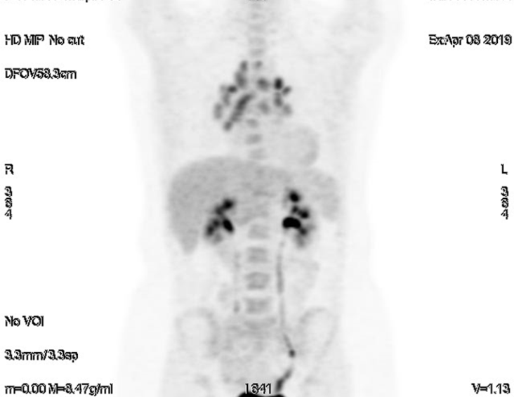
Fig1. 18 FDG scintigraphy of the first patient showing supra- and subdiaphragmatic gonglionic fixation

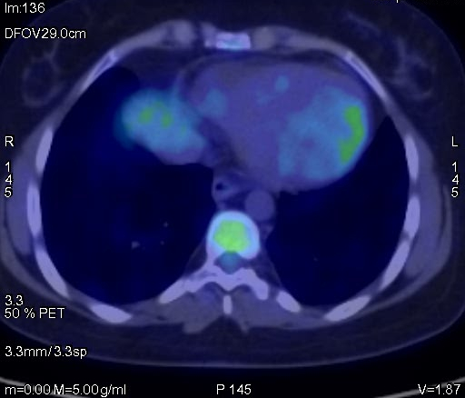
Fig2. 18FDG positron emission tomoscintigraphy (PET scan) of the first patient showing left ventricular cardiac fixation and peribronchial hilar glands.

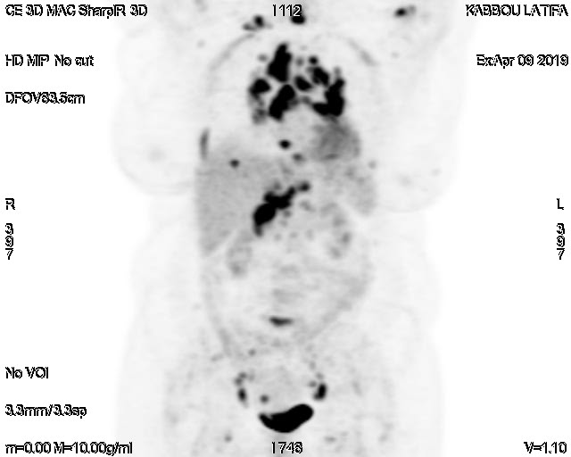
Fig3. 18 FDG scintigraphy of the third patient showing subdiaphragmatic and supradiaphragmatic lymph node fixation.

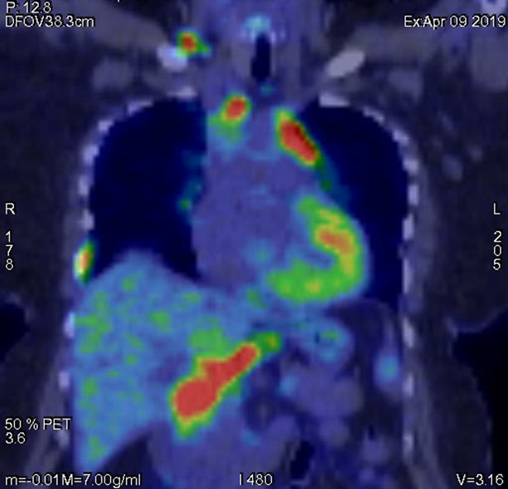
Fig4. PET scan of the third patient showing cardiac and extracardiac fixation in connection with supra- and subdiaphragmatic adenopathies.
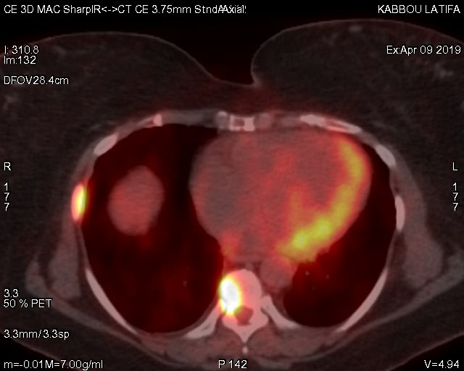
Fig5. PET scan of third patient showing left ventricular cardiac fixation and vertebral and costal bone fixation
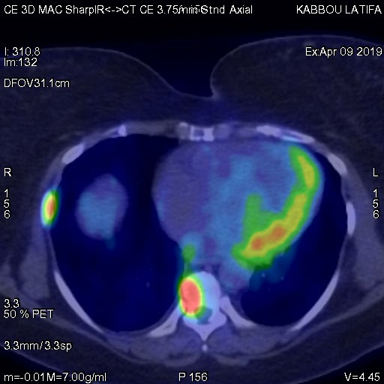
Fig6. PET scan of third patient showing vertebral and costal bone fixation with left ventricular cardiac fixation

Declarations:
Ethics approval and consent to participate: Not applicable
Consent for publication : Not applicable
Availability of data and material: Not applicable

REFERENCES

1. Statement on sarcoidosis. Joint Statement of the American Thoracic Society(ATS), the European Respiratory Society (ERS) and the World Association ofSarcoidosis and Other Granulomatous Disorders (WASOG) adopted by the ATSBoard of Directors and by the ERS Executive Committee, February 1999. Am JRespir Crit Care Med 1999;160(2):736–55.
2. Valeyre D, Prasse A, Nunes H, Uzunhan Y, Brillet PY, Muller-Quernheim J. Sar-coidosis. Lancet 2014;383(9923):1155–67.
3. Gideon NM, Mannino DM. Sarcoidosis mortality in the United States1979–1991: an analysis of multiple-cause mortality data. Am J Med1996;100(4):423–7.
4. Iwai K, Tachibana T, Takemura T, Matsui Y, Kitaichi M, Kawabata Y. Pathologicalstudies on sarcoidosis autopsy. I. Epidemiological features of 320 cases in Japan.Acta Pathol Jpn 1993;43(7–8):372–6.
5. Roberts WC, Chung MS, Ko JM, Capehart JE, Hall SA. Morphologic features ofcardiac sarcoidosis in native hearts of patients having cardiac transplantation.Am J Cardiol 2014;113(4):706–12.
6. Matsui Y, Iwai K, Tachibana T, Fruie T, Shigematsu N, Izumi T, et al. Cli-nicopathological study of fatal myocardial sarcoidosis. Ann N Y Acad Sci1976;278:455–69.
7. Roberts WC, McAllister Jr HA, Ferrans VJ. Sarcoidosis of the heart. A clinicopa-thologic study of 35 necropsy patients (group 1) and review of 78 previouslydescribed necropsy patients (group 11). Am J Med 1977;63(1):86–108.
8. Blankstein R, Osborne M, Naya M, Waller A, Kim CK, Murthy VL, et al. Cardiacpositron emission tomography enhances prognostic assessments of patientswith suspected cardiac sarcoidosis. J Am Coll Cardiol 2014;63(4):329–36.
9. Chia PL, Subbiah RN, Kuchar D, Walker B. Cardiac sarcoidosis masquera-ding as arrhythmogenic right ventricular cardiomyopathy. Heart Lung Circ2012;21(1):42–5.
10. Tavora F, Cresswell N, Li L, Ripple M, Solomon C, Burke A. Comparisonof necropsy findings in patients with sarcoidosis dying suddenly from car-diac sarcoidosis versus dying suddenly from other causes. Am J Cardiol2009;104(4):571–7.
11. Aubart F, Diebold B, Dhote R, Weinmann P, Valeyre D. [Cardiac sarcoidosis]. RevMal Respir 2003;20(6 Pt 3):S45–9.
12. Kim JS, Judson MA, Donnino R, Gold M, Cooper Jr LT, Prystowsky EN, et al.Cardiac sarcoidosis. Am Heart J 2009;157(1):9–21.
13. Sharma OP, Maheshwari A, Thaker K. Myocardial sarcoidosis. Chest1993;103(1):253–8.
14. Perry A, Vuitch F. Causes of death in patients with sarcoidosis. A morphologicstudy of 38 autopsies with clinicopathologic correlations. Arch Pathol Lab Med1995;119(2):167–72.
15. Silverman KJ, Hutchins GM, Bulkley BH. Cardiac sarcoid: a clinicopatholo-gic study of 84 unselected patients with systemic sarcoidosis. Circulation1978;58(6):1204–11.
16. Soejima K, Yada H. The work-up and management of patients with apparent orsubclinical cardiac sarcoidosis: with emphasis on the associated heart rhythmabnormalities. J Cardiovasc Electrophysiol 2009;20(5):578–83.
17. Greulich S, Deluigi CC, Gloekler S, Wahl A, Zurn C, Kramer U, et al. CMR imagingpredicts death and other adverse events in suspected cardiac sarcoidosis. JACCCardiovasc Imaging 2013;6(4):501–11.
18. Mehta D, Lubitz SA, Frankel Z, Wisnivesky JP, Einstein AJ, Goldman M, et al.Cardiac involvement in patients with sarcoidosis: diagnostic and prognosticvalue of outpatient testing. Chest 2008;133(6):1426–35.
19. Patel MR, Cawley PJ, Heitner JF, Klem I, Parker MA, Jaroudi WA, et al.Detection of myocardial damage in patients with sarcoidosis. Circulation2009;120(20):1969–77.
20. Milman N, Andersen CB, Mortensen SA, Sander K. Cardiac sarcoidosis and hearttransplantation: a report of four consecutive patients. Sarcoidosis Vasc DiffuseLung Dis 2008;25(1):51–9.
21. Zaidi AR, Zaidi A, Vaitkus PT. Outcome of heart transplantation in patients withsarcoid cardiomyopathy. J Heart Lung Transplant 2007;26(7):714–7.
22. Chang TI, Chi NH, Chou NK, Tsao CI, Yu HY, Chen YS, et al. Isolated cardiacsarcoidosis in heart transplantation. Transplant Proc 2012;44(4):903–6.

