**Ethnopharmacological Survey of Medicinal Plants Used for Managing Geriatric Diseases in Selected Regions of India**

**Abstract**

Geriatric diseases pose a significant global challenge. The overreliance on allopathic medications has led to the neglect of traditional medicinal plants and their potential side effects. The present study aims to improve the use of local medicinal plants in managing geriatric diseases. Authors have documented the traditional use of 30 local medicinal plants for treating health problems such as hypertension, diabetes, dementia, and osteoporosis. This study also explored the bioactive compounds responsible for their therapeutic properties. Furthermore, it highlights the importance of the sustainable use and conservation of local resources, promoting a holistic approach to the healthcare of older people.

**Keywords:** Medicinal plants, age-related ailments, hypertension, diabetes, dementia, osteoporosis, therapeutic applications, sustainable use

**Introduction**

The world's population is aging rapidly, with the number of people aged 65 and older projected to triple by 2050 (Noto, 2023). As people age, their bodily functions gradually decline, increasing their susceptibility to stress and age-related diseases. With increasing age, people often experience a decline in health conditions due to chronic illnesses and reduced physiological function. Chronic diseases and reduced bodily functions impact their ability to perform everyday tasks and maintain independence. Older adults are more likely to develop chronic conditions such as hypertension, diabetes, cancer, chronic lung diseases, heart diseases, stroke, arthritis, osteoporosis, and neurological disorders such as Alzheimer's disease, dementia, Parkinson's disease, and psychiatric conditions such as depression. These conditions can significantly hamper an individual's quality of life, making everyday activities more challenging and often requiring medical intervention and management (IIPS and UNPF, 2023). In contrast, active aging is about embracing a lifestyle that promotes physical, social, and mental well-being, enabling individuals to age healthily and maintain their quality of life (Annapuranam, 2025). Age-related ailments, such as hypertension, diabetes, dementia, and osteoporosis, are becoming increasingly prevalent, posing significant challenges to healthcare systems worldwide (Jaul and Barron, 2017). In recent years, researchers have extensively explored natural plant compounds (Al-Tohamy *et al*., 2018) for their potential to combat aging and age-related diseases. These compounds have shown promise as antioxidants, antiglycating agents, and neuroprotective agents. In particular, medicinal plants contain valuable components that may help prevent oxidative stress, inflammation, neurodegeneration, and glycation, which are key factors in the aging process. Studies have demonstrated that various plant metabolites can effectively regulate aging and delay the onset of age-related diseases (Babich *et al*., 2022a). Neurological problems such as dementia have also been common in older people in recent years and are expected to increase in the number of people affected by it in the years to come. Traditional medicine, which relies on the use of medicinal plants, has been used for centuries to treat various health conditions, including age-related ailments (Rizvi *et al*., 2022). Medicinal plants are a vital component of traditional medicine, offering a rich source of bioactive compounds with potential therapeutic applications (Wang *et al*., 2023). Many medicinal plants have been used for centuries in traditional healthcare practices to treat age-related ailments, with some plants demonstrating significant pharmacological activity (Babich *et al*., 2022b). Despite their potential, the use of medicinal plants in traditional medicine is often based on anecdotal evidence, and further research is needed to fully explore their therapeutic potential. This study aims to document the traditional use of medicinal plants for treating age-related ailments, highlighting their potential therapeutic applications and emphasizing the need for further research into their pharmacological properties.

**Methodology**

The present study employed a comprehensive literature search and analysis of existing studies on the traditional use of medicinal plants in treating geriatric diseases (Kumar, 2025). A systematic search was conducted using major databases, including PubMed, Scopus, Web of Science, and Google Scholar, with specific keywords. Data were extracted using a standardized form and analyzed using descriptive statistics and narrative synthesis (Jena *et al*., 2025). For photographs of medicinal plants, authors have carried out a field survey in Odisha, Himachal Pradesh, and Bihar. Some photographs are presented in the paper (Plate 1; Figure 2).

**Results and discussion**

The present study documented 30 local medicinal plants used in traditional medicine to treat various geriatric diseases. The results are presented in the table. The study revealed that the most commonly used plant parts are leaves (36%), followed by whole plants (16%), stems, bark, and rhizomes (6% each), among others (Figure 1). The mode of preparation and administration varies, with decoctions, infusions, and powders being the most common methods. The results also revealed that the majority of the plants investigated in the field are used to treat age-related ailments such as hypertension, diabetes, dementia, and osteoporosis. *Bidens pilosa* and *Tribulus terrestris* are used to treat hypertension, whereas *Gymnema sylvestre* is used to treat diabetes (Table 1). Medicinal plants such as *Bacopa monnieri*, *Withania somnifera*, *Pleurolobus gangeticus*, *Huperzia serrata* and *Gingko biloba* are used as traditional therapeutics to treat common neurological diseases and disorders such as dementia, Alzheimer’s disease, Huntington’s disease and Parkinson’s disease. The phytochemical constituents present in these plants include saponins, tannins, terpenoids, amino acids, polyphenols, anthocyanins, triterpenes, anthocyanins, resins, tartaric acid, formic acid, etc. *Celastrus paniculatus* and *Prinsepia utilis* are used in rheumatic problems. *Bidens pilosa* and *Catharanthus roseus* are used to treat hypertension; *Terminalia arjuna* is used to treat cardiac problems. Numerous age-related diseases and disorders are traditionally treated via the use of numerous medicinal plants, as indicated in Table 1, along with their origins and phytochemical constituents, which may help alleviate these difficulties, as shown in Table 2. The most popular plants used to cure geriatric diseases are discussed below.

**Table 1:** Important medicinal plants used to treat geriatric diseases

|  |  |  |  |
| --- | --- | --- | --- |
| **Botanical Name** | **Family** | **Part(s) & Mode of Use(s)** | **Reference(s)** |
| *Achyranthes aspera* | Amaranthaceae | Leaf decoction is used gastric problems. | Kumari *et al.,* (2024) |
| *Aegle marmelos* | Rutaceae | Leaf decoction or leaf paste is used to treat cataract. | Choudhary *et al.,* (2021) |
| *Andrographis paniculata* | Acanthaceae | Leaf decoction is used to treat diabetes and during cold and fever. | Devi *et al.,* (2022) |
| *Bacopa monnieri* | Plantaginaceae | Leaves are used to treat dementia caused due to Alzheimer’s disease. | Basheer *et al.,* (2022) |
| *Bidens pilosa* | Asteraceae | Decoction, maceration, or powder are used in hypertension. | Kuo *et al.,* (2021) |
| *Catharanthus*  *roseus* | Apocynaceae | Decoction of roots and leaves is prescribed against hypertension and diabetes. | Kumari *et al.,* (2024) |
| *Celastrus paniculatus* | Celastraceae | Root powder is given to treat rheumatism. Seed oil is used to treat joint pain. | Deodhar and Shinde, (2015) |
| *Centella asiatica* | Apiaceae | Leaf extract is effective in reducing oxidative stress in the brains of Parkinson’s patients. | Sissique *et al.,* (2014) |
| *Cissus quadrangularis* | Vitaceae | Stem helps to maintains bone homeostasis and ultimately reduces or prevents bone loss in osteoporosis. | Nath *et al.,* (2024) |
| *Crocus sativus* | Iridaceae | Flowers help to treat disorders of the nervous system. | Perry *et al.,* (2011) |
| *Curculigo orchioides* | Hypoxidaceae | Rhizomes are utilized to strengthen bones and tendons, which helps prevent osteoporosis. It is also used treatment of piles. | Present study; Bhukta *et al.,* (2023) |
| *Curcuma longa* | Zingiberaceae | Rhizome is used as a therapeutic agent in treatment of various eye diseases such glaucoma, cataract etc. | Liu *et al.,* (2017) |
| *Euphorbia hirta* | Euphorbiaceae | Whole plant infusion is used as eye drop to treat glaucoma. | Devi *et al.,* (2022) |
| *Ginkgo biloba* | Ginkgoaceae | Seeds are used in traditional Chinese medicine to manage dysfunctions of the heart and lungs. Leaves are used widely for dementia. | Yuan *et al.,* (2017) |
| *Gymnema sylvestre* | Apocynaceae | Three to four leaves are eaten daily in the morning to treat diabetes. | Devi *et al.,* (2022) |
| *Huperzia serrata* | Lycopodiaceae | Whole plant used for the treatment of memory loss. | Perry *et al.* (2011) |
| *Murraya koenigii* | Rutaceae | Decoction of leaves is used in diarrhea and to maintain blood sugar level. | Kumari *et al.,* (2024) |
| *Panax ginseng* | Araliaceae | It is used as tonic and helps in prolonging youthfulness. | Perry *et al.,* (2011) |
| *Pleurolobus gangeticus* | Fabaceae | Root is used to treat dementia. | Mahajan and Kumar, (2015) |
| *Prinsepia utilis* | Rosaceae | Seed oil is used for massaging  rheumatic joints. | Kumari *et al.,* (2024) |
| *Psidium guajava* | Myrtaceae | Consuming fruit helps to reduce and maintain high blood pressure. | Kumari *et al.,* (2024) |
| *Punica granatum* | Lythraceae | Consuming fruit with luke warm water helps to maintain blood sugar levels. | Kumari *et al.,* (2024) |
| *Ricinus communis* | Euphorbiaceae | Poultice of  leaves used in  bruises and swollen joints. | Kumari *et al.,* (2024) |
| *Syzygium cumini* | Myrtaceae | The bark is used in  digestive problems, astringent to the  bowels and has anthelmintic activity. | Kumari *et al.,* (2024) |
| *Terminalia arjuna* | Combretaceae | Bark powder is administered twice daily to treat coronary artery disease. | Dwivedi *et al.,* (2014) |
| *Tinospora cordifolia* | Menispermaceae | The alcoholic extract possesses cardioprotection against ischemia‒reperfusion induced myocardial injury. The stem decoction is also taken to boost immunity. | Sharma *et al.,* (2011); Present study |
| *Tribulus terrestris* | Zygophyllaceae | It has a significant antihypertensive effect both systolic and diastolic blood pressure. | Murthy *et al.,* (2000) |
| *Urtica dioica* | Urticaceae | Leaf extract helps in maintaining the blood glucose level. | Kumari *et al.,* (2024) |
| *Withania somnifera* | Solanaceae | Root juice is taken after the meal in night to treat Alzheimer’s disease. Plant extract is also effective against other neurogenerative disorders such as Huntington's and [Parkinson's disease](https://www.sciencedirect.com/topics/pharmacology-toxicology-and-pharmaceutical-science/parkinsons-disease). | Dar and Ahmad, (2020) |

**Figure 1:** Frequencies of plant parts utilized for medicinal purposes

**Table 2:** Phytochemical constituents of the medicinal plantsused to treatgeriatric diseases

|  |  |  |  |
| --- | --- | --- | --- |
| **Medicinal Plant** | **Part** | **Phytochemical constituents** | **Source(s)** |
| *Achyranthes aspera* | Leaves | Flavonoids, saponins and tannins | Das *et al.,* (2012) |
| *Aegle marmelos* | Leaves | γ-sitosterol, β-sitosterol, [rutin](https://www.sciencedirect.com/topics/pharmacology-toxicology-and-pharmaceutical-science/rutin), glycosides, marmeline, halfordiol, aegelin, marmesinin, phenyl ethyl cinnamamides and [lupeol](https://www.sciencedirect.com/topics/pharmacology-toxicology-and-pharmaceutical-science/lupeol) | Sarkar *et al.,* (2020) |
| *Andrographis paniculata* | Leaves | Saponins, tannins, terpenoid and steroids | Kasarkar *et al.,* (2025) |
| *Bacopa monnieri* | Leaves | Saponins, tannins, flavonoids, steroids terpenoids and glycosides | Singh, (2012) |
| *Bidens pilosa* | Whole plant | Flavonoids, steroids, triterpenoids, tannins and phenols | Son *et al.,* (2022) |
| *Catharanthus roseus* | Leaves | Alkaloids, flavonoids, sterols, saponins, amino acid, polyphenols and anthocyanins. | Sharma *et al.,* (2024) |
| *Celastrus paniculatus* | Seeds | Alkaloids (celapanin, celapanigin, celapagin, celastrine and paniculatine), palmitic acid, phytol, erucic acid, trans- β-copaene and linalool | Ali *et al.,* (2020) |
| *Centella asiatica* | Whole plant | Terpenoid alcohols, aromatic amine, alcohols, alkanes, caryophyllene and steroids. | Naidu *et al.,* (2023) |
| *Cissus quadrangularis* | Leaves and stem | Tannins, phenol flavonoids, triterpenoids, phytosterols, glycosides, saponins, and alkaloids | Hamid and Patil (2023) |
| *Crocus sativus* | Flowers | Fatty acid, apocarotenoids (crocetin, crocin, picrocrocin and safranal), flavonols quercetin, kaempferol, isorhamnetin glycosides), anthocyanins (delphinidin 3-O-glucoside, delphinidin 3,7-diglucoside, petunidin 3-O-glucoside and malvidin-O-glycoside) | Bakshi *et al.,* (2022) |
| *Curculigo orchioides* | Rhizomes | Alkaloids, flavonoids, phenols and tannins | Saxena *et al.,* (2022) |
| *Curcuma longa* | Rhizomes | Saponins, terpenoids, glycosides, tannins, and alkaloids | Javed *et al.,* (2020) |
| *Euphorbia hirta* | Whole plant | Alkaloids, flavonoids, saponins, tannins, terpenoids, quinones and coumarins | Haruna *et al.,* (2023) |
| *Gingko biloba* | Leaves | flavonoids (Quercetin, Rutin, Kaempferol, Isorhamnetin), terpene trilactones (ginkgolides and bilobalide) | Okhti *et al.,* (2021) |
| *Gymnema sylvestre* | Leaves | Triterpene saponins, anthraquinones, pentatriacontane, phytin, resins, tartaric acid, flavones, hentriacontane, formic acid, butyric acid, lupeol | Tiwari *et al.,* (2014) |
| *Huperzia serrata* | Whole plant | Alkaloids, terpenoids, volatile oils, and flavonoids | Chu *et al.,* (2025) |
| *Murraya koenigii* | Leaves | Alkaloids, flavonoids, saponins, phenolics and tannins | Arif *et al*., (2024) |
| *Panax ginseng* | Not mentioned | Polysaccharides, ginsenosides, peptides, polyacetylenic alcohols and fatty acids | Ru *et al.,* (2015) |
| *Pleurolobus gangeticus* | Not mentioned | Alkaloid, flavonoids, saponins, phospholipids, phenols glycolipids, sterols, and flavone glycosides | Sahu *et al.,* (2025) |
| *Prinsepia utilis* | Not mentioned | Alkaloids, flavonoids, phenolics, and terpenoids | Prakash *et al.,* (2024) |
| *Psidium guajava* | Fruit | Glycosides, flavanoids, alkaloids, saponins, vitamin, carbohydrate, aminoacid | Joseph *et al.,* (2016) |
| *Punica granatum* | Peel | Tannins, flavonoids, alkaloids, phenols, flavonoids, alkaloids and steroids | Noreen *et al.,* (2025) |
| *Ricinus communis* | Leaves | Alkaloids, triterpenoids and glycosides | Aneja *et al.,* (2024) |
| *Syzygium cumini* | Bark | Terpenoids, alkaloids, catechins, phenols, quinones, saponins and tannins | Jagetia, (2017) |
| *Terminalia arjuna* | Bark | Phytosterol, lactones, flavonoids, phenolic compounds, tannins and glycosides | Mandal *et al.,* (2013) |
| *Tinospora cordifolia* | Leaves and stem | Flavonoids, amino acids, diterpines, protein, saponins and carbohydrates | Chahande *et al.,* (2024) |
| *Tribulus terrestris* | Whole plant | Tannins, saponins, flavonoids, terpenoids, phenolic compounds, reducing sugars and alkaloids | Verma *et al.,* (2025) |
| *Urtica dioica* | Not mentioned | Flavonoids, tannins, scopoletin, sterols, fatty acids, polysaccharides, isolectins and sterols | Asgarpanah and Mohajerani, (2012) |
| *Withania somnifera* | Roots | Alkaloids, amino acids, steroids, volatile oil, starch, reducing sugars, glycosides, hentriacontane, dulcitol and withaniol | Uddin *et al.,* (2012) |

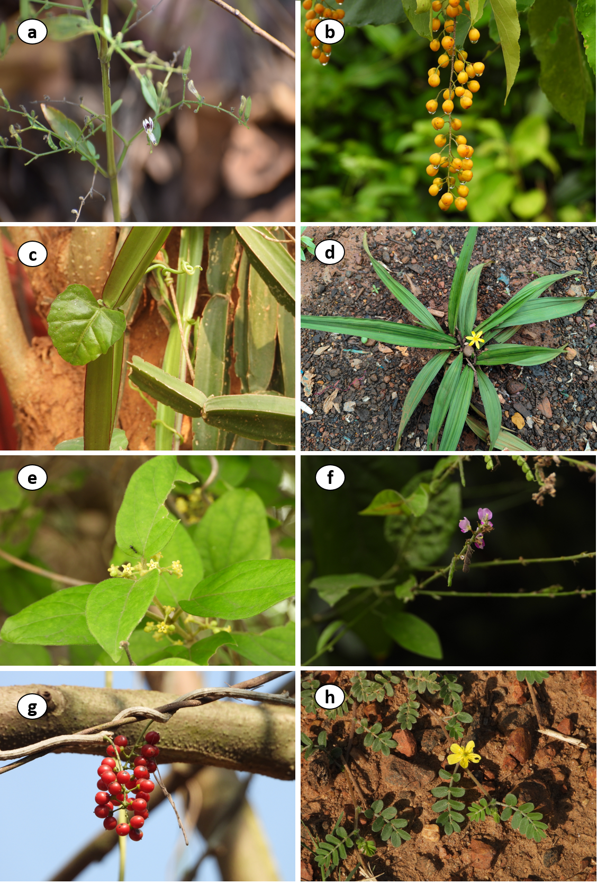

**Plate 1:** Some common plants used to treat geriatric diseases: a) *Andrographis paniculata,* b) *Celastrus paniculatus*, c) *Cissus quadrangularis*, d) *Curculigo orchioides*, e) *Gymnema sylvestre*, f) *Pleurolobus gangeticus,* g) *Tinospora cordifolia*, and h) *Tribulus terrestris*

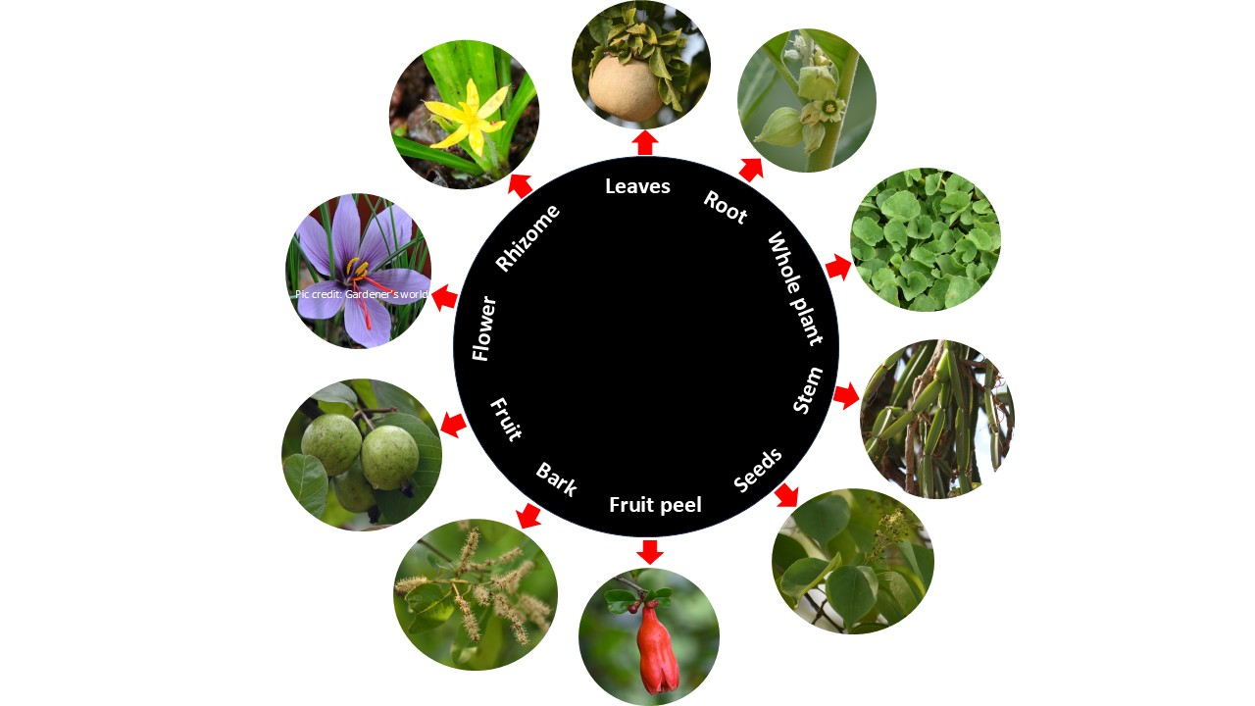

**Figure 2:** Plants with different parts used to treat geriatric diseases

**CONCLUSION**

The present study highlighted the use of 30 local medicinal plants for managing geriatric diseases. In the present study, uses and their bioactive compounds are provided, and baseline data for further advanced work are also given. This study also draws attention to the use of local plant resources in a sustainable manner and for conservation.

**Disclaimer (Artificial intelligence)**

Authors hereby declare that for data collection, photographs and illustration, no AI technologies are used. For grammar check, Meta A1 is used.

**REFERENCES**

Ali M, Sultana S and Mir SR. (2020). Chemical constituents from the seeds of *Celastrus paniculatus* Willd., leaves of *Caesalpinia bonduc* (L.) Roxb. And root barks of *Premna mollissma* Roth. European Journal of Pharmaceutical and Medical Research. 7(3): 418-427.

Aneja P, Guleria R, Thakur Y, Devi B, Thakur S, Kumari S and Sharma Palvi. (2024). Extraction of phytoconstituents from Castor leaves and evaluation of its antibacterial activity. Journal of Pharmaceutical Research. 13(11): 1073-1080.

Annapuranam K. (2025). Challenges of older adults in India: A Qualitative study of Institutional Care, preferences and Government Initiatives. Research on Aeging and Social Policy. 13(1): 1-20.

Arif MAA, Warsito SH, Lamid M, Lokapirnasari WP, Khairullah AR, Ayuti SR, Sugito, Hermawan IP, Widodo OS and Gangil R. (2024). Phytochemical Analysis of Curry Leaf Extract (*Murraya koenigii* L.) as a Potential Animal Feed and Medicinal Ingredient. Pharmacognosy Journal. 16(2): 471-477.

Asgarpanah J and Mohajerani R. (2012). Phytochemistry and pharmacologic properties of *Urtica dioica* L. Journal of Medicinal Plants Research 6(46): 5714-5719.

Babich O, Larina V, Ivanova S, Tarasov A and Poyydysh. (2022a). Phytotherapeutic Approaches to the Prevention of Age-Related Changes and the Extension of Active Longevity. Molecules. 27(2276). DOI: 10.3390/molecules27072276

Babich O, Larina V, Ivanova S, Tarasov A, Povydysh M, Orlova A, Strugar J and Sukhikh S. (2022b). Phytotherapeutic Approaches to the Prevention of Age-Related Changes and the Extension of Active Longevity. Molecules. 27(7):2276. doi: 10.3390/molecules27072276.

Bakshi RA, Sodhi NS, Wani IA, Khana ZS, Dhillona B and Gani A. (2022). Bioactive constituents of saffron plant: Extraction, encapsulation and their food and pharmaceutical applications. Applied Food Research. 2(1): 100076. DOI: [10.1016/j.afres.2022.100076](https://doi.org/10.1016/j.afres.2022.100076)

Basheer A, Agarwal A, Mishra B, Gupta A, Padma Srivastava MV, Kirubakaran R and Vishnu V. (2022). Use of *Bacopa monnieri* in the Treatment of Dementia Due to Alzheimer Disease: Systematic Review of Randomized Controlled Trials Interactive Journal of Medical Research.11(2):e38542.

Bhukta P, Ranajit SK, Sahu PK and Rath D. (2023). Phytochemistry and pharmacology of *Curculigo orchioides* Gaertn: A review. Journal of Applied Pharmaceutical Science. 13 (10): 83-91.

Chahande ND, Patil VN and Ganjiwale RO. (2024). Phytochemical analysis of stem and leaves extracts of *Tinospora cordifolia* (Thunb.) Miers. World Journal of Advanced Research and Reviews. 24(01): 1808–1813.

Choudhary S, Chaudhary G and Kaurav, H. (2021). *Aegle marmelos* (Bael Patra): An ayurvedic plant with ethnomedicinal value. International journal of research in ayurveda and pharmacy. 12: 147–156.

Chu Z, Sun Q, Mao M, Wu Y, Yu Le, Xu J, Liu K, Qin L and Zhu B. (2025). Pharmacology, phytochemistry, and traditional uses of *Huperzia serrata* (Thunb. ex Murray) Trev. [Fitoterapia](https://www.sciencedirect.com/journal/fitoterapia). 106304. DOI: 10.1016/j.fitote.2024.106304

Dar NJ and Ahmad M. (2020). Neurodegenerative diseases and Withania somnifera (L.): An update. Journal of Ethnopharmacology. 256: 112769.

Das AK, Bigoniya P and Verma NK. (2012). Gastroprotective effect of Achyranthes aspera Linn. leaf on rats. Asian Pacific Journal of Tropical Medicine. 197-201.

Deodhar AK and Shinde NW. (2015). *Celastrus paniculatus*; medicinal and pharmacological properties: a review. International Journal of Development Research. 5(9): 5526-5531.

Devi R, Sinha D, Mukherjee S, Kumar S and Mishra S. (2022). Plants used in old age problems. In book: *Medico-Biowealth of India Vol. V.* Ambika Prasad Research Foundation, Odisha, India.

Dwivedi S and Chopra D. (2014). Revisiting *Terminalia arjuna* - An Ancient Cardiovascular Drug. Journal of traditional and complementary medicine. 4(4):224-31. doi: 10.4103/2225-4110.139103.

Hamid HS and Patil S. (2023). A Phytochemical and pharmacological review of an Indian plant: Cissus quadrangularis. Medical Sciences Forum. 21(20). 1-6.

Haruna SY, Isah AM, Garba AA, Alkali M, Magaji B and Zubairu MS. (2023). Phytochemical Constituents and Physicochemical Properties ofMedicinal Plant (*Euphorbia hirta*) Leaves. International Journal of Modern Chemistry. 15(1): 30-34.

International Institute for Population Sciences & United Nations Population Fund (IIPS & UNPF). (2023). *India Ageing Report 2023, Caring for Our Elders: Institutional Responses*. United Nations Population Fund, New Delhi.

Jagetia GC. (2017). Phytochemical Composition and Pleotropic Pharmacological Properties of Jamun, *Syzygium cumini* Skeels. Journal of Exploratory Research in Pharmacology. 2(2):54-66.

Jaul E and Barron J. (2017). Age-Related Diseases and Clinical and Public Health Implications for the 85 Years Old and Over Population. Front Public Health. 5:335. doi: 10.3389/fpubh.2017.00335.

Javed M, Shoaib M, Iqbal Z, Khan A, Hussain S and Amjad M. (2020). Phytochemical and Biological Studies on Curcuma longa L. in Pattoki (Kasur), Pakistan. Proceedings of the Pakistan Academy of Sciences: B. Life and Environmental Sciences 57 (2): 59-66.

Jena N, Rout S, Mishra S and Kumar S. (2025). Evaluation of quantitative ethnobotanical uses in Mayurbhanj district, Odisha, India. Journal of Biodiversity and Conservation. 9(1): 1-29.

Joseph L, George M, Singh G and Mathews P. (2016). Phytochemical investigation on various parts of *Psidium guajava*.Annals of Plant Sciences 5(2): 1265-1268.

Kasarkar AR, Jadhav SV and Kulkarni SG. (2025). Preliminary phytochemicals analysis of Andrographis paniculata (Burm. F.) Wall. Journal of Medicinal Plants Studies.13(2): 252-254.

Kumar S. (2025). Data collection from literature for biological sciences, medicinal plants research, ethnobotany, and pharmacology: a methodological overview. Journal of Biodiversity and Conservation. 9(2): 167-169.

Kumari M, Puri S and Radha. (2024). Ethnobotanical Survey of Medicinal Plants used by Native Inhabitants of Protected Area of District Solan, Himachal Pradesh. Indian Journal of Ecology. 51(1): 45-52.

Kuo TF, Yang G, Chen TY, Wu YC, Minh HTN, Chen LS, Chen WC, Huang MG, Liang YC and Yang WC. (2021). *Bidens pilosa*: Nutritional Value and Benefits for Metabolic Syndrome. Food Frontiers 2: 32–45.

Lerose V, Ponticelli M, Benedetto N, Carlucci V, Lela L, Tzvetkov NT, Milella L. (2024). *Withania somnifera* (L.) Dunal, a Potential Source of Phytochemicals for Treating Neurodegenerative Diseases: A Systematic Review. Plants. 13(6):771. <https://doi.org/10.3390/plants13060771>.

Liu XF, Hao JL, Xie T, Mukhtar NJ, Zhang W, Malik TH, Lu CW, Zhou DD. (2017). Curcumin, A Potential Therapeutic Candidate for Anterior Segment Eye Diseases: A Review. Frontiers in Pharmacology. 8:66. doi: 10.3389/fphar.2017.00066.

Mahajan KK and Kumar SD. (2015). Antiamnesic Activity of Extracts and Fraction of *Desmodium gangeticum*. Journal of Pharmaceutical Technology, Research and Management. 3(1): 67–77.

Mandal S, Patra A, Samanta A, Roy S, Mandal A, Mahapatra TD, Pradhan S, Das K and Nandi DK. (2013). Analysis of phytochemical profile of Terminalia arjuna bark extract with antioxidative and antimicrobial properties. Asian Pacific Journal of Tropical Biomedicine. 12: 960-966.

Murthy AR, Dubey SD and Tripathi K. (2000). Anti-hypertensive effect of Gokshura (*Tribulus terrestris* Linn.) a clinical study. Ancient Science of Life. 19(3-4):139- 145.

Naidu JR, Sreenivasan S and Thangaranjan R. (2023). Phytochemical and Chemical Characterization of *Centella Asiatica* and *Cymbopogan Citratus* Extracts. Bioequivalence & Bioavailability International Journal. 7(2): 1-17.

Nath R, Kar BK, Dhadiwal RK, Daftary GV, Khemnar BM and Patil NN. (2024). Role of *Cissus quadrangularis* in bone loss pathologies. International Journal of Orthopaedics Sciences. 10(1): 196-201.

Noreen S, Hashmi B, Aja PM and Atoki AV. (2025). Phytochemicals and pharmacology of pomegranate (*Punica granatum* L.): nutraceutical benefits and industrial applications: a review. Frontiers in Nutrition. 12:1528897. DOI: 10.3389/fnut.2025.1528897.

Noto S. (2023). Perspectives on Aging and Quality of Life. Healthcare (Basel). 11(15):2131. doi: 10.3390/healthcare11152131.

Okhti A, Abdalah M and Hanna DB. (2021). Phytochemical structure and Biological Effect of *Ginkgo biloba* leaves: A review. International Journal of Pharmaceutical Research. 13(2): 1138-1143.

Parul Sharma, Nancy Singla, Ramandeep Kaur and Urvashi Bhardwaj. (2024). A review on phytochemical constituents andpharmacological properties of *Catharanthus roseus* (L.) G. Don. Journal of Medicinal Plants Studies. 12(3): 131-156.

Perry E and Howes MJR. (2011). Medicinal Plants and Dementia Therapy: Herbal Hopes for Brain Aging?. CNS Neuroscience and Therapeutics. 683-698.

Prakash S, Radha, Puri S, Dhumal S, Kumar S, Senapathy M and Kumar M. (2024). Phytochemical Riches, Bioactivities, and Clinical Potential of *Prinsepia utilis* Royle: A Comprehensive Review. Chemistry & Biodiversity. e202401625. DOI: 10.1002/cbdv.202401625

Rizvi SAA, Einstein GP, Tulp OL, Sainvil F and Branly R. (2022). Introduction to Traditional Medicine and Their Role in Prevention and Treatment of Emerging and Re-Emerging Diseases. Biomolecules. 12(10):1442. doi: 10.3390/biom12101442.

Ru W, Wang D, Xu Y, He X, Sun YE, Qian L, Zhou X and Qin Y. (2015). Chemical constituents and bioactivities of *Panax ginseng* (C. A. Mey.) Wenwen. Drug Discoveries & Therapeutics. 9(1): 23-32.

Sahu SS, Mishra R and Joshi RK. (2025). Phytochemical, pharmacological and biotechnological dimensions of the medicinal under‑shrub, Pleurolobus gangeticus (L.) -current updates and future prospects. 2:80. Discover Plants. DOI: 10.1007/s44372-024-00068-1

Sarkar T, Salauddin M and Chakraborty R. (2020). In-depth pharmacological and nutritional properties of bael (*Aegle marmelos*): A critical review. Journal of Agriculture and Food Research. 2(100081). DOI: 10.1016/j.jafr.2020.100081

Saxena HO, Parihar S, Pawar G, Rao R, Kumar H and Kumar S. (2022). Phytochemical Screening and Variation Studies in Secondary Metabolite Contents in Rhizomes of *Curculigo orchioides* from Madhya PradeshState of India. Chemical Science Review and Letters. 11 (42): 151-158.

Sharma AK, Kishore K, Sharma D, Srinivasan BP, Agarwal SS, Sharma A, Singh SK, Gaur S and Jatav VS. Cardioprotective activity of alcoholic extract of *Tinospora cordifolia* (Willd.) Miers in calcium chloride-induced cardiac arrhythmia in rats. Journal of Biomedical Research. 25(4):280-6. doi: 10.1016/S1674-8301(11)60038-9.

Sharma P, Singla N, Kaur R and Bhardwaj U. (2024).

Siddique YH, Naz F, Jyoti S, Fatima A, Khanam S, Rahul, Ali F, Mujtaba SF and Faisal M. (2014). Effect of *Centella asiatica* Leaf Extract on the Dietary Supplementation in Transgenic Drosophila Model of Parkinson's Disease. Parkinsons Dis. 2014:262058. doi: 10.1155/2014/262058.

Singh SK. (2012). Phytochemical analysis of leaf callus of *Bacopa Monnieri* L. Journal of Scientific and Research Publications. 2(9): 1-3.

Son NH, Tuan NT and Tran TM. (2022). Investigation of chemical composition and evaluation of antioxidant, antibacterial and antifungal activities of ethanol extract from *Bidens pilosa* L. Food Science and Technology. 42(e22722): 1-8.

Tiwari P, Mishra BN, Sangwan NS. (2014). Phytochemical and pharmacological properties of Gymnema sylvestre: an important medicinal plant. BioMed Research International. 830285. DOI: 10.1155/2014/830285

Uddin Q, Samiulla L, Singh VK and Jamil SS. (2012). Phytochemical and Pharmacological Profile of *Withania somnifera* Dunal: A Review. Journal of Applied Pharmaceutical Science. 02 (01): 170-175.

Verma RK, Rout S and Kumar S. (2025). Phytochemical analysis of whole plant of *Tribulus terrestris* L. Plants and Secondary Metabolites. Vol. 5. Ambika Prasad Research Foundation, Odisha.

Wang H, Chen Y, Wang L, Liu Q, Yang S, Wang C. (2023). Advancing herbal medicine: enhancing product quality and safety through robust quality control practices. Front Pharmacol. 14:1265178. doi: 10.3389/fphar.2023.1265178.

Yuan Q, Wang C, Shi J and Lin Z. (2017). Effects of *Ginkgo biloba* on dementia: An overview of systematic reviews. Journal of Ethnopharmacology. 195: 1-9. <https://doi.org/10.1016/j.jep.2016.12.005>

Al-Tohamy, R., Ali, S. S., Saad-Allah, K., Fareed, M., Ali, A., El-Badry, A., ... & Rupani, P. F. (2018). Phytochemical analysis and assessment of antioxidant and antimicrobial activities of some medicinal plant species from Egyptian flora. Journal of Applied Biomedicine, 16(4), 289-300.