**Original Research Article**

**Teaching Where Numbers Don’t Add Up: Lived Realities of Educators Teaching Students with Math Difficulties**

**Abstract**

Mathematics learning difficulties in early education present persistent challenges for both students and teachers. This study aimed to determine the lived realities of educators teaching students with math difficulties. This qualitative study, grounded on constructivist learning theory, used seven in-depth interviews at Tagawisan Elementary School to explore the lived experiences of educators teaching students with addition difficulties. Four major themes emerged: challenges in teaching addition, adaptive strategies, personal and professional growth, and advice and future orientation. These themes reveal the obstacles teachers face, the creative and flexible approaches they employ, the emotional and professional development they experience, and their recommendations for improving practice. The findings affirm that knowledge is actively co-constructed by teachers and students through meaningful interaction, underscoring the importance of adaptability, empathy, and continuous learning in mathematics education.

***Keywords:****mathematics difficulties, teacher experiences, addition, qualitative research, adaptive strategies, constructivist theory*

**Introduction**

Mathematics education in early schooling is vital for developing students’ logical reasoning and problem-solving skills; however, many learners face challenges and anxiety with basic concepts such as addition, which complicates teaching and learning (Research Group for Mathematics Learning and Instruction, 2021; Future Directions for Mathematics Education Research, Policy, and Practice, 2023). Recent research highlights the effectiveness of diverse, evidence-based teaching strategies—including cooperative learning and technology integration—combined with culturally responsive pedagogy to enhance student engagement and equity in mathematics education (Cardino & Ortega-Dela Cruz, 2020; OECD, 2025). Addressing both cognitive and affective factors is essential to foster positive mathematical identities and create inclusive, supportive learning environments for all students (The Royal Society, 2023; Future Directions for Mathematics Education Research, Policy, and Practice, 2023).

Globally, mathematics learning difficulties remain a persistent issue across diverse educational systems (OECD, 2019; Theron, 2025). The latest PISA results from 2022 reveal an unprecedented drop in mathematics performance, with the OECD average score falling by nearly 15 points compared to 2018, highlighting widespread struggles with basic arithmetic and the impact of factors such as math anxiety and disruptions caused by the COVID-19 pandemic (OECD, 2023; World Economic Forum, 2023). Recent systematic reviews and global analyses emphasize that challenges such as insufficiently trained teachers, inadequate resources, and negative socio-cultural attitudes toward mathematics continue to hinder student achievement, underscoring the urgent need for effective instructional strategies and robust support systems for both students and educators worldwide (Theron, 2025).

Locally, challenges with basic addition among elementary learners are well-documented. Cabrestante and Lopez (2023) found that various mathematics intervention strategies—including Think-Pair-Share, Individualized Student Activity, Drill and Practice, Peer Mentoring, Games, Learners Activity Sheets, ICT-Based Mentoring, and Home Visitation—were significantly related to their extent of implementation and were effective in improving students’ mathematics performance. The study recommends institutionalizing these strategies into the curriculum to better support learners facing difficulties in mathematics. Similarly, Sabando (2022) identified that intervention strategies such as repetition, timed-testing, and problem-solving techniques were perceived by elementary mathematics teachers as effective in enhancing learners’ fundamental, computational, and word problem-solving skills. Collectively, these findings highlight persistent difficulties with basic addition that require teachers to continuously innovate and seek appropriate resources to improve learning outcomes.

If the challenges faced by students with mathematics learning difficulties and the experiences of their teachers remain unaddressed, the consequences could be far-reaching. Students may continue to struggle with foundational skills like addition, leading to persistent gaps in mathematical understanding that hinder academic progress and limit future educational and career opportunities. Moreover, math anxiety disrupts working memory and reduces the use of effective problem-solving strategies, particularly in children with high cognitive capacity, further impeding achievement (Scheibe et al., 2023; Cuder et al., 2023). Teachers, without adequate support and resources, may experience increased stress, burnout, and reduced effectiveness, which can exacerbate student learning difficulties and widen achievement gaps (Colorado Department of Education, 2025; Education Week, 2025). This underscores an urgent need to explore and understand the lived experiences of teachers who support these learners, as their insights are critical for developing adaptive instructional strategies, guiding targeted professional development, and informing policies that foster inclusive, equitable, and supportive learning environments.

This study aimed to explore the lived experiences of educators teaching students who have difficulties in addition. This study was anchored on Piaget’s Constructivist Learning Theory, which posits that learners actively construct knowledge through experience and interaction (Piaget, 1972). We believe that understanding grows from hands-on engagement and that teaching strategies must be tailored to each learner’s developmental stage. This perspective shapes our interpretation of both the challenges and the successes described by teachers. It also informs our belief that adaptive, student-centered instruction is essential for supporting learners with math difficulties.

This study assumed that the lived experiences of teachers can be authentically captured and analyzed through qualitative interviews (ontological). We assumed that knowledge about effective strategies and challenges can be constructed collaboratively between researchers and participants (epistemological). The research process is iterative and reflexive, with meaning emerging through dialogue and thematic analysis (methodological). The study was grounded in constructivist theory (theoretical lens), and values patience, empathy, and adaptability as cultural norms within the teaching profession.

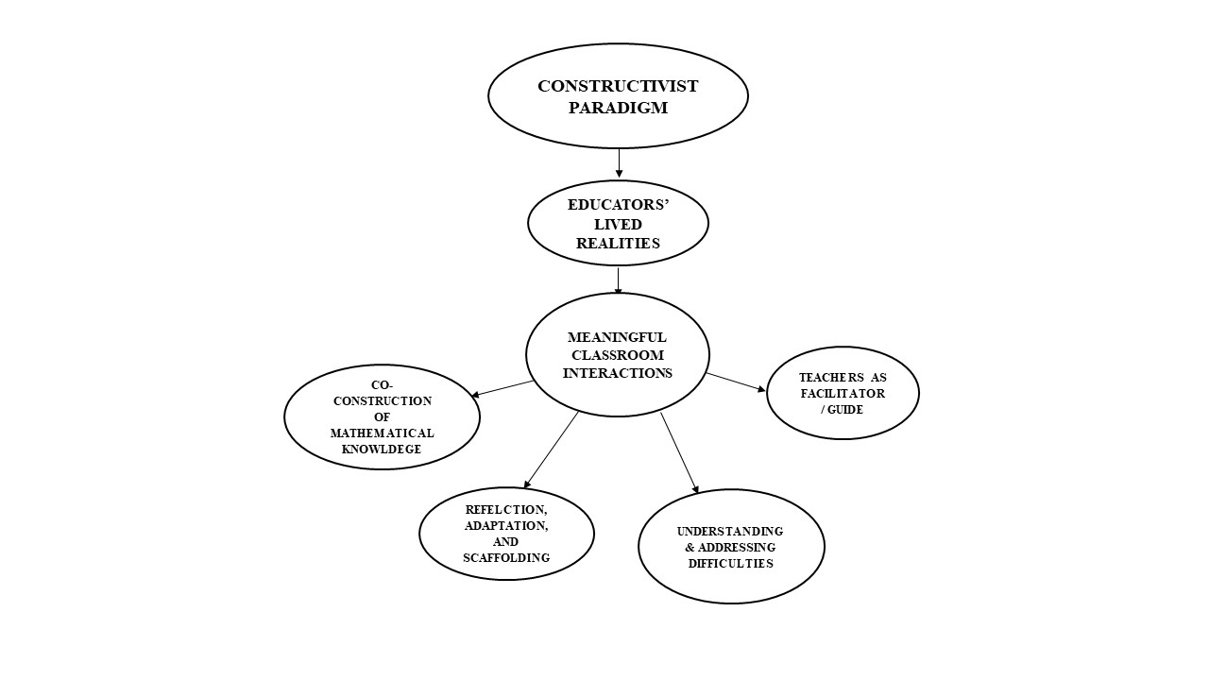

*Figure 1 Paradigm of Educators’ Lived Realities*

**Methodology**

In this study, we adopted a qualitative phenomenological research design, using in-depth, semi-structured interviews to capture the nuanced experiences of elementary teachers. We believe that a qualitative approach is best suited to uncovering the rich, subjective realities of educators as they navigate the challenges of teaching students with addition difficulties. By engaging directly with teachers, we aimed to gain authentic insights into their strategies, emotions, and professional growth (Creswell & Poth, 2018).

The research was conducted at Tagawisan Elementary School, a public school where teachers routinely encounter learners with diverse mathematical abilities. The study utilized purposive sampling to select seven teachers who have direct experience teaching students with addition difficulties. The participants were chosen for their willingness to share their insights and their varied levels of teaching experience. This approach ensured that the data reflected a range of perspectives, from novice to more seasoned educators (Palinkas et al., 2015).

We conducted one-on-one interviews with each participant, allowing for open-ended responses and the opportunity to probe deeper into their experiences. The small, focused sample size enabled a detailed exploration of each teacher’s unique journey.

The interview guide was designed to elicit detailed narratives about the teachers’ experiences. Data were gathered through in-depth interview, semi-structured conversations with selected knowledgeable participants. Each interview was audio-recorded and transcribed verbatim to ensure accuracy. Data were analyzed using thematic analysis (Braun & Clarke, 2006). We began by reading and re-reading the transcripts to immerse ourselves in the data. Initial codes were identified, and these were then grouped into broader themes and sub-themes. We used the interview data reviews. The iterative process allowed themes to emerge organically, reflecting the complexity of teachers’ lived experiences.

To ensure trustworthiness, we employed several strategies: member checking (participants reviewed their transcripts for accuracy), and reflexivity (acknowledging our own biases as researchers). Confidentiality was maintained throughout, and participants were assured that their insights would be used solely for research purposes. These measures helped to mitigate potential harm and ensure that the findings authentically represented the participants’ voices (Lincoln & Guba, 1985).

**Results**

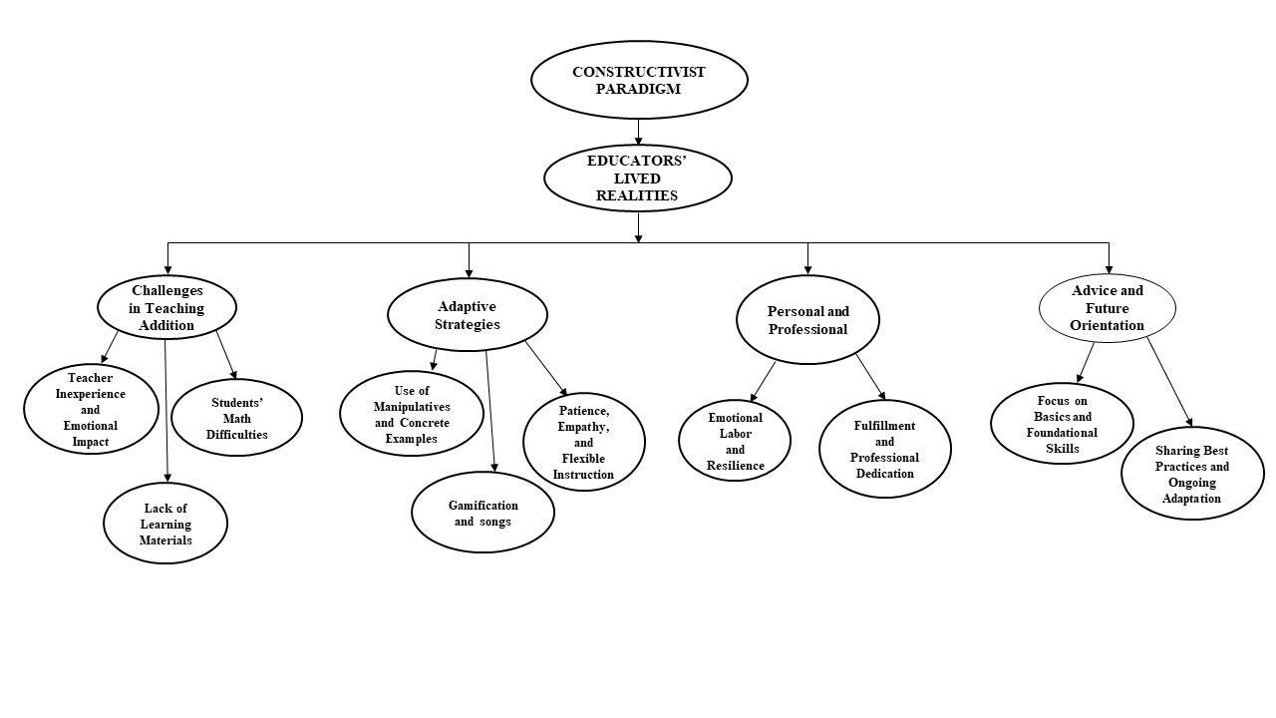The modified paradigm that emerged from this study centers on the dynamic, reciprocal relationship between teacher and learner. Teachers construct meaning through their daily interactions with students, adapting their strategies in response to learners’ needs and emotional states. The process is iterative and collaborative, with both teacher and student contributing to the learning journey.

*Figure 2 Modified Paradigm of Educators’ Lived Realities*

Figure 2 presents the four emergent themes and corresponding sub-themes derived from the lived experiences of teachers instructing students with difficulties in addition. This thematic map provides a structured representation of the challenges, strategies, growth, and advice shared by participants, offering valuable insights into effective teaching practices in early mathematics instruction.

TABLE 1. The four emergent themes and corresponding sub-themes

|  |  |
| --- | --- |
| **Major Themes** | **Sub-themes** |
| **Challenges in Teaching Addition** | Student Difficulties |
| Teacher Inexperience and Emotional Impact |
| Lack of Learning Materials |
| **Adaptive Strategies** | Patience, Empathy, and Flexible Instruction |
| Use of Manipulatives and Concrete Examples |
| Gamification and songs |
| **Personal and Professional Growth** | Emotional Labor and Resilience |
| Fulfillment and Professional Dedication |
| **Advice and Future Orientation** | Focus on Basics and Foundational Skills |
| Sharing Best Practices and Ongoing Adaptation |

**Challenges in Teaching Addition**

**Student Difficulties.** Students often struggle with recalling basic addition concepts and experience math anxiety, which impedes learning and engagement.

*“May problema sila sa pag-recall ng mga dating discussion. Nahihirapan silang intindihin ang math concepts. May mga estudyante na may math anxiety, kaya iniiwasan nila ang math-related na mga sitwasyon.” (IDI-3)*

(“They have trouble recalling information from previous discussions. They are having trouble understanding mathematical concepts. Some of them have mathematics anxiety, which leads them to avoid math-related situations.”)

**Teacher Inexperience and Emotional Impact**. Teachers expressed feelings of impatience and self-doubt, highlighting the emotional toll of supporting struggling learners.

*“Sa personal, para sa akin, ito ay hamon. Sa propesyonal, bilang guro, kailangan ng maraming pasensya, dedikasyon, at passion sa pagtuturo.” (IDI-1)*

(“Personally, for me, it is a challenge. Professionally, as a teacher, it needs a lot of patience, dedication, and passion in teaching.”)

**Lack of Learning Materials.** Limited access to appropriate learning materials and resources further complicates teaching addition effectively.

*“Mag lisod ko produce og learning materials kay daghan pako gi gastohan.” (IDI-7)*

(“I find it difficult to produce learning materials because I have many other expenses.”)

**Adaptive Strategies**

**Use of Manipulatives and Concrete Examples**. Educators emphasized hands-on learning with manipulatives and real-life examples to make abstract concepts tangible.

“Ang ginagamit ko ay mga concrete manipulatives o physical objects tulad ng counters o blocks. Nakakatulong ito para makita ng mga estudyante ang addition bilang pagsasama-sama.” (IDI 4)

(“What I usually use is setting an example by the use of concrete manipulatives or using physical objects like counters or blocks. It will help the learners visualize addition as a combining process.”)

**Patience, Empathy, and Flexible Instruction**  
Teachers highlighted the importance of patience and empathy, adapting instruction to meet individual student needs and emotional states.

Bawat estudyante ay may kanya-kanyang uniqueness. Bilang guro, gagamit ako ng iba’t ibang methods at strategies para matulungan sila.” (IDI 7)

(“Every student is unique in their own ways. As a teacher, I will use different methods and strategies to migrate those learners.”)

**Gamification and songs** Educators used educational games and songs to make learning more engaging and enjoyable, helping students retain mathematical concepts through interactive and musical experiences.

“Magpatukar mi ug kanta para malingaw sila, para motivated.” (IDI 5)

(We play songs so they enjoy and stay motivated.)

**Personal and Professional Growth**

**Emotional Labor and Resilience**. The emotional labor involved in supporting struggling students was significant, requiring resilience and self-care.

“Personally, for me, it exhibits challenge. And professionally, being a teacher, it needs a lot of patience, dedication, and passion in teaching.” (IDI 2)

**Fulfillment and Professional Dedication**. Despite challenges, teachers found fulfillment in small victories and remained dedicated to their students’ growth.

“Kapag nakikita ko na naiintindihan na ng estudyante, sulit ang lahat ng effort.” (IDI 1)

(“When I see a student finally get it, it makes all the effort worthwhile.”)

**Advice and Future Orientation**

**Focus on Basics and Foundational Skills**. Teachers advised prioritizing foundational skills and scaffolding instruction to build confidence.

“Kapag ine-expect natin na alam na nila ang addition, pero wala silang basic skills. Kailangang tutukan ang basics.” (IDI 4)

(“When we expect students to know addition but they lack basic skills, we need to focus on the basics.”)

**Sharing Best Practices and Ongoing Adaptation**. Educators recommended regular sharing of strategies and ongoing professional development to foster adaptive teaching practices.

“As a teacher, I will use different methods and strategies to migrate those learners.” (IDI 6)

**Discussions**

Students often face significant challenges in recalling basic addition concepts, which is compounded by the prevalence of math anxiety that negatively affects their engagement and learning. Research indicates that math anxiety reduces working memory capacity and hinders problem-solving abilities, leading to avoidance behaviors that further impede skill acquisition (Suárez-Pellicioni, Núñez-Peña, & Colomé, 2020; Namkung, Peng, & Lin, 2022). These cognitive and emotional barriers create a cycle of difficulty that must be addressed to improve foundational math skills and foster positive attitudes toward mathematics (Namkung et al., 2022).

Teachers supporting students with addition difficulties frequently experience emotional strain, including feelings of impatience, self-doubt, and stress. Such emotional labor can affect their teaching effectiveness and contribute to burnout if not properly managed (Polacco, Zsoldos-Marchiș, & Dekel, 2023; Education Week, 2025). Additionally, teachers’ own math anxiety can inadvertently influence students’ attitudes and performance, underscoring the importance of professional development that equips educators with strategies to manage both their own and their students’ anxieties (Mihăescu et al., 2025; Education Week, 2025).

Limited access to appropriate instructional materials poses a significant challenge for teaching addition effectively. Despite resource constraints, educators employ adaptive strategies such as using manipulatives, concrete examples, gamification, and flexible instruction to make abstract concepts more accessible and engaging. These approaches have been shown to reduce math anxiety and improve conceptual understanding, particularly when combined with patience and empathy tailored to individual learner needs (Polacco, Zsoldos-Marchiș, & Dekel, 2023).

Teachers demonstrate resilience and derive professional fulfillment from witnessing student progress, despite the emotional demands of supporting struggling learners. Emphasizing foundational skills and scaffolding instruction are critical strategies for building student confidence. Continuous sharing of best practices and ongoing professional development enable teachers to adapt their methods effectively to diverse learner needs. These insights highlight the necessity of systemic support to empower teachers in their professional growth and in addressing students’ mathematical challenges (Polacco, Zsoldos-Marchiș, & Dekel, 2023; Mihăescu et al., 2025).

**References**

Braun, V., & Clarke, V. (2006). Using thematic analysis in psychology. *Qualitative Research in Psychology, 3*(2), 77–101. [https://dl1.cuni.cz/pluginfile.php/1195620/mod_folder/content/0/Braun%20and%20Clarke%2020 06%20Thematic%20analysis.pdf](https://dl1.cuni.cz/pluginfile.php/1195620/mod_folder/content/0/Braun%20and%20Clarke%2020%0906%20Thematic%20analysis.pdf)

Cardino, J. M., Jr., & Ortega-Dela Cruz, R. A. (2020). Understanding learning styles and teaching strategies towards improving mathematics teaching and learning. *LUMAT: International Journal on Math, Science and Technology Education.* <http://dx.doi.org/10.31129/LUMAT.8.1.1348>

Colorado Department of Education. (2025, April 29). *Supporting struggling learners in mathematics.* <https://www.cde.state.co.us>

Cabrestante, J., & Lopez, E. (2023). Extent and effectiveness of mathematics intervention strategies: Their relationship to the academic performance of students. *Psychology and Education: A Multidisciplinary Journal*, 8, 1176–1200. <https://ejournals.ph/article.php?id=20693>

Creswell, J. W., & Poth, C. N. (2018). *Qualitative inquiry and research design: Choosing among five approaches* (4th ed.). SAGE Publications. <https://www.worldcat.org/title/983779110>

Cuder, A., Živković, M., Doz, E., Pellizzoni, S., & Passolunghi, M. C. (2023). The relationship between math anxiety and math performance: The moderating role of visuospatial working memory. *Journal of Experimental Child Psychology.* https://arts.units.it/retrieve/7dae14fe-92c5-45d0-b9d8- e7a16ca281f1/1-s2.0- S0022096523000644-main.pdf

Education Week. (2025, May 5). *5 ways teachers can support students with math anxiety.* <https://www.edweek.org>

Kilpatrick, J., Swafford, J., & Findell, B. (Eds.). (2001). *Adding it up: Helping children learn mathematics.* National Academy Press. <https://doi.org/10.17226/9822>

Lincoln, Y. S., & Guba, E. G. (1985). *Naturalistic inquiry.* <https://books.google.com/books?id=2oA9aWlNeooC>

Mihăescu, D., Bologa, L., & Bîclea, D. (2025). Breaking the cycle of math anxiety: Empowering pre- service teachers with evidence-based strategies. *INTED2025 Proceedings.* <https://library.iated.org/view/MIHAESCU2025BRE>

Namkung, J. M., Peng, P., & Lin, X. (2022). The mediating role of working memory in the relationship between math anxiety and math performance: A meta-analysis. *Frontiers in Psychology, 12*, 798090. <https://www.frontiersin.org/articles/10.3389/fpsyg.2021.798090/full>

OECD. (2019). *PISA 2018 results (Volume I): What students know and can do.* OECD Publishing. <https://doi.org/10.1787/5f07c754-en>

OECD. (2023). *PISA 2022 results: First results since the pandemic show unprecedented drop in maths and reading performance.* <https://www.oecd.org/pisa/publications>

OECD. (2025). *Future-focused mathematics curricula: Empowering learners for the 21st century* (Policy brief). <https://www.oecd.org/education>

Palinkas, L. A., Horwitz, S. M., Green, C. A., Wisdom, J. P., Duan, N., & Hoagwood, K. (2015). Purposeful sampling for qualitative data collection and analysis in mixed method implementation research. *Administration and Policy in Mental Health and Mental Health Services Research, 42*(5), 533– 544. <https://doi.org/10.1007/s10488-013-0528-y>

Piaget, J. (1972). *The psychology of the child* (H. Weaver, Trans.). Basic Books. (Original work published 1969)

Polacco, D., Zsoldos-Marchiș, I., & Dekel, R. (2023). Perspectives of teachers on the signs and causes of mathematics anxiety. *Acta Didactica Napocensia, 16*(2), 129–143. <https://adn.reviste.ubbcluj.ro/papers/article_16_2_10.pdf>

Research Group for Mathematics Learning and Instruction. (2021). *Cultivating future mathematical minds: Investigating learning and teaching processes from early childhood to adulthood.* [https://ppw.kuleuven.be/onderwijskunde/en/wog-2024/snr2024-rg-math-instruction-and- learningin.pdf](https://ppw.kuleuven.be/onderwijskunde/en/wog-2024/snr2024-rg-math-instruction-and-%09learningin.pdf)

Sabando, N. A. (2022). Intervention strategies utilized by elementary mathematics teachers and their perceived effectiveness in enhancing learners’ performance. *Psychology and Education: A Multidisciplinary Journal*, 5(1), 281–292. <https://scimatic.org/storage/journals/11/pdfs/704.pdf>

Scheibe, D. A., Was, C. A., Dunlosky, J., & Thompson, C. A. (2023). Metacognitive cues, working memory, and math anxiety: The regulated attention in mathematical problem solving (RAMPS) framework. *Journal of Intelligence, 11*(6), 117. <https://doi.org/10.3390/jintelligence11060117>

Suárez-Pellicioni, M., Núñez-Peña, M. I., & Colomé, À. (2020). Math anxiety and working memory updating. *Frontiers in Psychology, 11*, 669. <https://www.frontiersin.org/articles/10.3389/fpsyg.2020.00669/full>

Theron, H. (2025). Global trends in contributing factors to mathematics performance in secondary schools: Lessons for South Africa 2015–2024. *International Journal of Learning, Teaching and Educational Research, 24*(1), Article 14. <https://doi.org/10.26803/ijlter.24.1.14>

The Royal Society. (2023). *Maths education must integrate quality EdTech faster to thrive in a data-centric future* [Report]. UCL Institute of Education. [https://www.ucl.ac.uk/ioe/news/2023/sep/maths- education-must-integrate-quality-edtech-faster-thrive-data-centric-future](https://www.ucl.ac.uk/ioe/news/2023/sep/maths-%09education-must-integrate-quality-edtech-faster-thrive-data-centric-future)

World Economic Forum. (2023, December 10). *OECD PISA results: Maths and reading skills in ‘unprecedented drop’.*