Original Research Article
Comparative life table analysis of Plutella xylostella (L.) (Lepidoptera: Plutellidae) on different brassica hosts

Abstract
The study was conducted to determine the effect of different brassica hosts (cabbage, cauliflower, and red cabbage) on the life table of Plutella xylostella (Yponomeutidae; Lepidoptera) (Linn.) under the laboratory conditions (26 ± 2°C temperature, 65 ± 5% relative humidity, and 14 L:10 D photoperiod). The findings revealed that the age-specific, stage-specific, and female fertility life table was significantly influenced by brassica hosts. The longest survival and shortest life expectancy were observed on red cabbage, while the shortest survival was on cabbage and the longest life expectancy on cauliflower. The maximum survival rate and lowest mortality were found on cabbage, followed by cauliflower and red cabbage, respectively. The mortality was recorded highest in the pupal stage on all hosts. While within the larval stage, the maximum mortality was recorded at the 1st instar on red cabbage and the 3rd instar on cabbage and cauliflower. However, the generation mortality was increased on red cabbage while decreased on cabbage and cauliflower. The potential fecundity (Pf) and net reproductive rate (Ro) were highest on cabbage (105.99 and 23.55 females/female/generation), followed by cauliflower (77.58 and 15.50 females/female/generation), and lowest on red cabbage (12.79 and 3.57 females/female/generation). However, both mean and corrected generation time (Tc and τ) were shortest for cabbage (24.97 and 24.78 days) and longest for red cabbage (31.46 and 31.45 days). The population of P. xylostella was double with a minimum time duration on cabbage (5.48 days), while the maximum time duration was on red cabbage (17.12 days). The intrinsic rate of increase, finite rate of increase, and monthly rate of increase were found to be maximum on cabbage and minimum on red cabbage, while medium on cauliflower. Based on experimental findings, we conclude that the cabbage was a favorable host for the growth and development of P. xylostella, followed by cauliflower.

Keywords: Plutella xylostella, Brassica hosts, Age-specific, stage-specific, Life table

Introduction
The Brassicaceae family contains 325 genera and 3740 species, including 73 identified species from the genus Brassica (Neik et al., 2020). The six most important brassica species include three diploids (B. rapa, B. nigra, and B. oleracea) and three amphiploids (B. juncea, B. napus and, B. carinata) (Li et al., 2019). Despite increasing household wealth, brassicas are a vital, affordable source of vitamins and minerals. Many small-scale farmers make a living off of brassica cultivation, relying on nearby metropolitan markets (Machekano et al., 2017).

Plutella xylostella (L.) (Lepidoptera: Plutellidae), the diamondback moth, is one of the most destructive vegetable pests in the world. It was initially documented in South Africa in the early 1900s by Gunn (1917), who also investigated its biology. The diamondback moth first appeared on crucifer crops in India in 1914, and it is currently found across the country (Ahmad and Ansari, 2013). It is a major pest of brassicaceous crops worldwide, specifically Brassica oleracea crops, which include cabbage, cauliflower, broccoli, brussels sprouts, and turnips (Gautam et al., 2018). Larval feeding produces direct damage, which may have a substantial impact on crop quality and, in heavy infestations, plant survival. The presence of larval excrement in commercial products causes indirect harm (Ramirez, 2022).

Plutella xylostella (L.) larvae mine the crops during the early stage of crop development, while later stages feed on the leaves. Irregular patches occur on the leaves as a result of larval feeding, and a single larva consumes 62 to 78% of the leaves (Gangurde and Wankhede, 2009). At high population levels, this pest is thought to cause up to 90% yield losses, and managing it costs 4-5 billion US dollars globally (Saeed et al., 2019). They cause crop losses in India that total 16 million USD per year (Gautam et al., 2018). Due to its very short life cycle, P. xylostella produces numerous generations in most environments within a year. In tropical areas, it can complete up to 14 generations in a year and is a terrible nuisance (Wainwright et al., 2020). For the successful control of P. xylostella, 50 to 60 insecticide applications are used every year in tropical countries. Under such high selection pressure, they have developed resistance against all the insecticides under field conditions (Sarfaraz et al., 2011). This is because of its high fecundity, quick generation time, variety of hosts, resilience to pesticides, and capacity to endure a broad range of temperatures (Saeed et al., 2019; Furlong et al., 2013; Gu et al., 2010). Certain cultivars may restrict plant damage if they have characteristics that decrease oviposition, larval nutrition, and survival, or they may have plant defences (Razmjou et al. 2014, Fathipour et al. 2019).

Brassicaceous plants contain volatile chemical substances (isoprene, terpenes, alkanes, alkenes, alcohols, and esters) and secondary metabolites (glucosinolates) that are toxic and unattractive to specific herbivores (Agrawal 2000, Agrawal and Kurashige 2003, Vuorinen et al. 2004). Plutella xylostella is a Brassicaceae specialist that relies on glucosinolates to locate hosts, stimulate oviposition, and initiate feeding (Gupta and Thorsteinson, 1960; Sarfraz et al., 2006). It prefers to lay eggs on glossy cabbage due to the dark green colour of the leaves as opposed to waxy cultivars (Eigenbrode et al., 1991; Hamilton et al., 2005). Some of these compounds may not prevent larval feeding (Wittstock et al. 2004), while others may affect the attractiveness or rejection of host plants for female P. xylostella oviposition (Agerbirk et al. 2003). P. xylostella may have a preference for particular brassicaceous plants (Li et al. 2000; van Loon et al. 2002), and variations in these chemicals may account for increased rates of reproduction and population expansion on favoured hosts (Chahil and Kular 2013).

The species and quality of host plants that insects interact with determine their growth and stability. Furthermore, the dynamics of insect pest populations can also be influenced by the variety of host plants. When acting as hosts for various insects, different plant species show varying degrees of suitability. More favourable host plants are those that promote faster development and increased insect reproduction (Keerthi & Suroshe, 2024). Due to the need to lessen the dependency on broad-spectrum insecticides, behavioural manipulation has gained importance as a method of controlling insect pests during the past 30 years. Although a lot of research has been done on how host plant quality features affect P. xylostella performance, very little of it has been researched about the life cycle and population growth parameters of this pest in India.
Sarfraz et al. (2006, 2007) described the resistance of some cultivated Brassicaceae to this pest. Golizadeh et al. (2009) examined the life tables of P. xylostella on cauliflower, two cabbage varieties, kohlrabi, and canola, concluding that cauliflower and cabbage were the best host plants for P. xylostella reproduction and survival. In order to create integrated pests management (IPM) for a specific brassica crop, growers will need to have a complete knowledge of these parameters as well as the resistance-susceptibility traits of brassicaceous crops to P. xylostella. The most effective method for examining how host plants affect insect pest fitness is to compare the life table factors, and demographic variables are commonly used in this process (Patel et al., 2017). As a result, the purpose of this study was to determine how brassicaceous crops, which are grown annually in India, affect the performance and life table parameters of P. xylostella.

Materials and methods
Plutella xylostella larvae were collected from the infested cabbage field at the Department of Plant Protection, Faculty of Agricultural Sciences, Aligarh Muslim University, Aligarh, India. They were placed in three separate rearing glass jars (15 × 21 cm), provided fresh cabbage, cauliflower, and red cabbage leaves for feeding in each jar, and kept at a constant temperature and relative humidity of 26 ± 2°C and 65 ± 5% RH, with a photoperiod of 14:10 (L:D) in the department laboratory. The full-grown larvae were relocated from rearing glass jars to other glass jars walled by blotting paper for pupation. Emerged adults were placed in rearing glass jars (15×21 cm) with a 10% honey solution-soaked cotton swab for feeding and glued zig-zag paper strips on the jar wall for resting and egg-laying. Rearing glass jars were covered by muslin cloths with the help of a rubber band.

For the life table studied, three hundred eggs were obtained from stock of each brassica host (cabbage, cauliflower, and red cabbage) and placed in three plastic containers (400 ml), each containing 100 eggs for the replications, total of 9 plastic containers required. Hatched and unhatched eggs were counted, and first instar larvae were put into glass jars (1 liter) with fresh cabbage, cauliflower, and red cabbage leaves, each containing 50 larvae. Fresh leaves were provided every day until pupation. Dead larvae were recorded and removed from glass jars every 24 hours, while abnormal pupae were counted and eliminated. Normal pupae were collected and stored in another glass jar until they emerged. One male and one female were placed in a separate glass jar to examine fecundity and made a batch of ten pairs and replicated three times. Eggs laid by a female are counted every day till death. An average number of eggs and total eggs laid by females per day were then estimated. As a result, the life table was constructed using the (Deevey, 1947) and (Southwood, 1978) methods.

Age-specific life table parameters were determined by using the formulae: x = age in days, lx = number of surviving at the beginning noted in the ‘x’ column, dx = number of dying within age interval stated in the ‘x’ column, ex = expectation of life or mean life remaining for individuals of age x, ex =Tx/lx, Lx = number of individuals alive between age x and x + 1, Lx =1x+1 (x+1)/2, Tx = total number of individuals of x age units beyond the age x, Tx =lx + (lx + 1) + (lx + 2) ....................+ lw., where, lw = last age interval., mx = average number of eggs laid/female in each age interval assuming 50:50 sex ratio and computed as mx = Nx / 2 where, Nx was total natality/female offspring in each age.
Population parameters were also calculated: net reproductive rate (Ro) = lx.mx, mean length of generation (Tc) = ∑x.lx / lx.mx, intrinsic rate of increase (rm) = loge Ro/Tc, for an accurate estimate of rm (Birch, 1948) introduced some approximate to the method to minimize the experimental error in the formula suggested by (Lotka, 1925) as: ∑e^{rm} ^{lx.mx.dx} = 1, e.rm lx mx = 1 (Birch, 1948), potential fecundity (Pf) = ∑ mx, doubling time (DT) = loge2 / rm.
Stage-specific life table parameters were also determined by using the formulae: apparent mortality (100qx) = [dx / lx] x 100, survival fraction (Sx) = [lx of subsequent stage] / [lx of particular stage], mortality survivor ratio (MSR) = [mortality in particular stage] / [lx of subsequent stage], indispensable mortality (IM): = [number of adults emerged] x [MSR of particular stage], k-values = k_{E} + k_{L1} + k_{L2} + k_{L3} + k_{L4}+ k_{L5} + k_{L6} + k_{PP} + k_{P}, Where, k_{E}, k_{L1}, k_{L2}, k_{L3}, k_{L4}, k_{L5}, k_{L6}, k_{PP} and k_{P} are the k-values at egg, first, second, third, fourth, fifth and six instar, pre-pupal and pupal stages. Eggs obtained in the fecundity table were kept for hatching. Hatched and unhatched eggs were recorded to begin the second generation's life table, and the method was the same.
The data were analyzed through one-way ANOVA, and multiple comparisons were also made using the Tukey’s HSD and fisher’s LSD test by R software (R-4.4.1).

Results
Age-specific life table of Plutella xylostella
Age-specific life tables of Plutella xylostella were studied, and they were constructed at different brassica hosts (cabbage, red cabbage, and cauliflower). The P. xylostella demonstrated the longest survival period of 35 days at red cabbage, followed by 30 days at cauliflower and 29 days at cabbage. The age-specific mortality (dx) was found to be maximum during the incubation period; afterwards, it fluctuates till the last day. The maximum mortality was observed on red cabbage, followed by cauliflower and cabbage. The mortality rate on red cabbage was maximum during the age of 6th to 9th days, while mortality was high during 23th to 25th days on cauliflower. All hosts showed significant differences in age-specific life expectancy during the early stages of development. The longest life expectancy was observed on cauliflower (31.06 days), while the lowest was on red cabbage (27.55 days). A medium life expectancy was observed on cabbage with 29.44 days. The age-specific life expectancy at all temperature ranges was high at the beginning of age and then decreased with advancing age. However, the life expectancy of cabbage showed a marginal gain on the 4th and 9th days, while red cabbage showed a minor rise on the 6th, 9th, and 18th days of pivotal age. However, for cauliflower, it grew irregularly on the 4th and 9th days of pivotal age. After that time, the life expectancy gradually decreased till the end of the generation. The highest adult emergence from pupae was recorded at cauliflower with 78.26% and the lowest at red cabbage with 57.69%, while 73.33% was observed at cabbage. Longevity of females was 8 days at red cabbage and cauliflower, while it decreased to 7 days at cabbage (Fig. 1 & 2).

Stage-specific life table of Plutella xylostella
The data (Table 1) showed that the apparent mortality was maximum at the pupal stage on the red cabbage (42.31%) and minimum on the cabbage (27.91%). It is slightly increased when fed on cauliflower (32.61%). The lowest apparent mortality was recorded at the pre-pupal stage (0.00% on cabbage and 4.17% on cauliflower), while the IV larval instar on red cabbage was 3.45%. At the egg stage, it was recorded as maximum for red cabbage (26.0%), followed by cauliflower and cabbage (16.0% and 15.0%). However, apparent mortality was 40.54%, 18.18%, and 19.44% on red cabbage for I, II, and III instar larval stages. When P. xylostella was reared on cabbage and cauliflower, the apparent mortality from I to IV larval stages was found to be in the range of 12.0% to 17.46% (Fig. 3).

Survival fraction was variable in different stages of P. xylostella on all brassica hosts (cabbage, red cabbage, and cauliflower). It was maximum and equal value in the pre-pupal stage for cabbage and cauliflower (0.96), but fluctuation occurred in the survival fraction of P. xylostella when feeding on red cabbage (0.97 at IV larval instar and 0.93 at the pre-pupal stage). Mortality survival ratio (MSR) was maximum in the pupal stage (0.73) on red cabbage, 0.48 on cauliflower, and 0.36 on cabbage compared to other stages of P. xylostella. Indispensable mortality was also highest in the pupal stage for all brassica hosts (15 for cauliflower, 12 for cabbage, and 11 for red cabbage). It was also higher in larval stages. The k-value was found to be maximum in the pupal stage for red cabbage (0.24), followed by cauliflower (0.17) and cabbage (0.11). The generation mortality was highest on red cabbage (0.82), followed by cauliflower (0.51), while it was lowest on cabbage (0.48) (Fig. 5).

Female fertility life table of Plutella xylostella
The results (Table 2) showed that the potential fecundity (Pf) was significant (F: 267.80, df: 2, 6, p<0.01) on all brassica hosts (cabbage, red cabbage, and cauliflower). It was highest on cabbage (105.99 eggs/generation), followed by 77.58 eggs/generation on cauliflower and 12.79 eggs/generation on red cabbage. The net reproductive rate was also found to be highest on cabbage (23.55 eggs/female) and significantly different (F: 76.73, df: 2, 6, p<0.01) from red cabbage (3.57) and cauliflower (15.50). The highest intrinsic rate of increase (rm) was determined on cabbage (0.1265 females/female/day), which was also significantly different (F: 165.90, df: 2, 6, p<0.01) from cauliflower (0.1091 females/female/day) and red (0.0405) (Fig. 5).

The finite rate of increase (λ) was significantly different on all hosts (F: 106.20, df: 2, 6, p<0.01). It was 1.13 females/female/day on cabbage, 1.12 on cauliflower, and 0.104 on red cabbage, respectively. The mean generation time (Tc) and corrected generation time (τ) were also significantly different (F: 70.36 and 44.34, df: 2, 6, p<0.01) on all brassica hosts. Both were shortest on cabbage (24.97 and 24.78 days, respectively) and cauliflower (25.11 and 25.05 days, respectively), while it prolonged to 31.46 and 31.45 days on red cabbage, respectively (Table 2).

The doubling time (DT) of the population may reflect an increase in the time it took for survivors to compensate for the loss of individuals. It differed significantly (F: 43.95, df: 2, 6, p < 0.01). It was fast (5.48 days) for cabbage, 6.35 days for cauliflower, and prolonged to 17.12 days for red cabbage. The monthly rate of increase in population (MRI) also significantly differed on all brassica hosts (F: 100.30, df: 2, 6, p < 0.01). It was increased on cabbage (44.53) and gradually decreased from 26.41 to 3.37 on cauliflower and red cabbage (Table 2).

Discussion
Herbivorous insects' ability to adapt to new host plants is largely determined by insect population parameters that are impacted by the host plant, including survival, development time, and reproduction (Saeed et al., 2010). Progeny survival, development time, and fecundity all increase with adaptability (Awmack & Leather, 2002; Roitberg et al., 2001). There are numerous studies that demonstrate how different hosts affect the survival and development of various insects, but there are not many that examine the life table characteristics of P. xylostella at different hosts. The current study evaluated P. xylostella's performance on different brassicaceous hosts and observed notable variations in population, reproductive, and biological parameters (Golizadeh et al., 2009; Yang et al., 2021; Keerthi & Suroshe, 2024). The results showed that P. xylostella had the longest survival on cabbage, followed by cauliflower, and the shortest on red cabbage. Charleston and Kfir (2000) and Ansari et al. (2010), who also noted that the maximum survival on cabbage, corroborate these findings. Age-specific life expectancy increased in cabbage and cauliflower but decreased in red cabbage. This difference was most likely caused by the parents consuming different food sources containing specific chemicals during the larval stage. These outcomes are consistent with those of Jafary-Jahed et al. (2019), who found that insects had higher survival rates on host plants that contained higher levels of glucosinolate. Furthermore, with a few exceptions, the life expectancy of all brassica hosts declined gradually. This irregular pattern of increased life expectancy at specific age intervals could be attributed to various hosts and their nutrient content.

P. xylostella mortality showed notable variation among hosts, suggesting that hosts play a crucial role in determining survival rates at different phases of life. In the current study, red cabbage showed the highest mortality, especially in the egg and pupal stages, while cabbage showed the lowest. These findings imply a connection between the demonstrated resistance to P. xylostella and the low levels of glucosinolate in various Brassica hosts. These hosts are thought to be the least appropriate for P. xylostella larvae (Sarfraz et al. 2007, Nikooei et al. 2015). Additionally, different hosts affected the stage-specific survival (egg, larval, pupal, and adult stages). Compared to cauliflower and cabbage, red cabbage had the lowest survival rate. These results are in line with studies showing that P. xylostella development and survival can be impacted by the host plant's morphological characteristics and nutritional quality (Keerthi et al., 2024; Jafary-Jahed et al., 2019; Marchioro & Foerster, 2014).

Adults emerged from the tested hosts with varying oviposition periods and fecundity, with cabbage having the longest oviposition period and highest fecundity, followed by cauliflower, and red cabbage having the shortest and lowest. The discrepancies showed that host plant traits are not comparable (Gholizadeh et al. 2009). Because the study was conducted in a controlled environment and the hosts used for the investigation were different, the longevity of the adults reported in this study was relatively shorter (Awmack and Leather 2002; Winkler et al. 2005). In the study, the highest potential fecundity was found in cabbage, followed by cauliflower, and the lowest in red cabbage. Compared to red cabbage, cauliflower and cabbage seemed to be better suited for oviposition. The low number of eggs laid on a plant may have been influenced by the more indirect route of reduced fecundity caused by larval feeding on nutritionally poor plants (Hamilton et al. 2005). However, prior research has documented comparable fecundity values on various hosts (Gholizadeh et al. 2009; Keerthi et al., 2024; Jafary-Jahed et al., 2019; Marchioro & Foerster, 2014). The biological and reproductive parameters of P. xylostella on brassica hosts observed in this study may be due to significant differences in nutritional quality, host plant physiology, and biochemical constituents (Keerthi et al., 2024; Jafary-Jahed et al., 2019; Marchioro & Foerster, 2014). Additionally, the biochemical makeup of the plant, such as the levels of myrosinase and glucosinolate in the leaves of brassicaceous hosts, may influence resistance and susceptibility to insects (Björkman et al., 2011; Das Laha et al., 2024; Jafary-Jahed et al., 2019).

The population parameters of P. xylostella indicate the combined influence of the biological traits. The demographic characteristics of P. xylostella and the host plants in our investigation differed significantly. Other researchers have noted that feeding on different host plants has an impact on P. xylostella population expansion, similar to our study (Gholizadeh et al. 2009). The results of this study indicate that red cabbage has the lowest net reproduction rate, finite rate of increase, and intrinsic rate of increase. According to Polat-Akköprü et al. (2015) and Atlihan et al. (2017), insects with lower rm and Ro values on any given host plant are less suitable for their population expansion. Finite rate of increase values and a high intrinsic rate of increase are shown in the high Ro value for cabbage. According to Kocourek et al. (1994) and Southwood and Henderson (2000), the intrinsic rate of increase (rm) is a suitable indicator for assessing an insect's performance on various host plants and the resistance of the host plant because it reflects a variety of factors, including fecundity, survival, and generation time, and it accurately summarizes an animal's physiological characteristics in relation to its capacity to increase.

The intrinsic rate of increase (rm) has a zero value when the population is stable, a positive value when the population is rising, and a negative value when the population is declining (Stark et al., 2007). It may be used as a measure of population vigour, which is a crucial indication of population dynamics and is regarded as a measurement of a population's capacity to expand exponentially in an unlimited environment, providing a valuable indicator of an insect's life-history characteristics (Dixon, 1987). In present study the intrinsic rate of increase (rm) recorded positive value on the all-tested hosts. Similar result observed by Golizadeh et al. (2009) and Jafary-Jahed et al. (2019). The generation time and population doubling time decreased on cabbage compared to cauliflower and red cabbage, while monthly rate of increase increased. It may be due to variations in nutritional quality, host plant physiology, and biochemical constituents (Keerthi et al., 2024; Jafary-Jahed et al., 2019: Marchioro & Foerster, 2014).
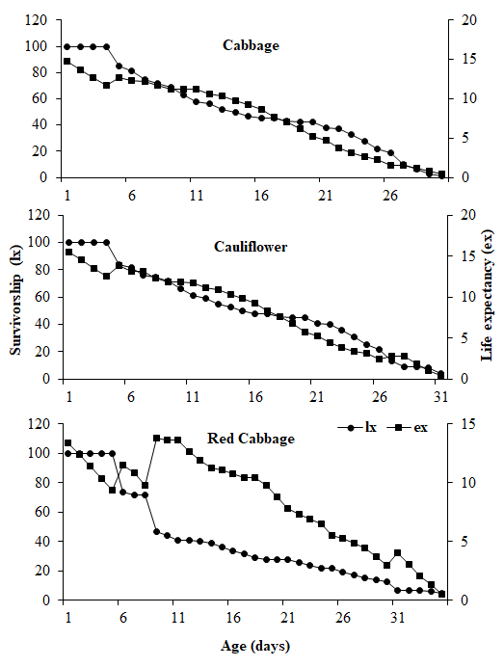
Figure 1: Effect of different brassica hosts on the survivorship (lx) and life expectancy (ex) of P. xylostella
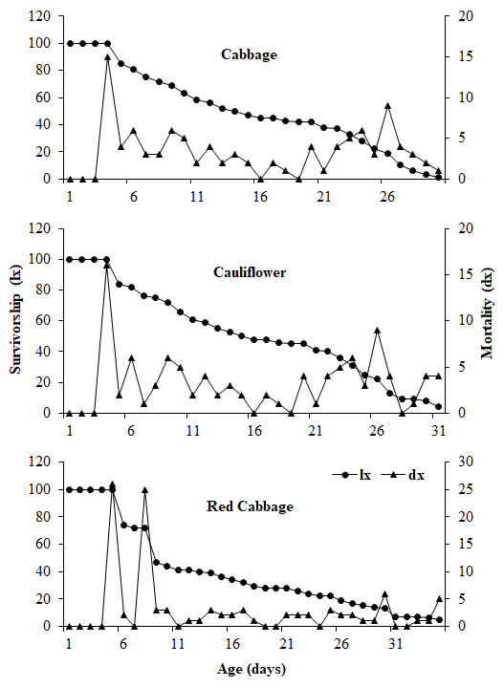
Figure 2: Effect of different brassica hosts on the survivorship (lx) and mortality (dx) of P. xylostella
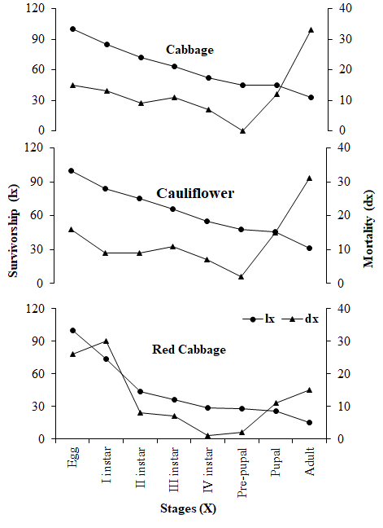
Figure 3: Effect of different brassica hosts on stage-specific survivorship (lx) and mortality (dx) of P. xylostella

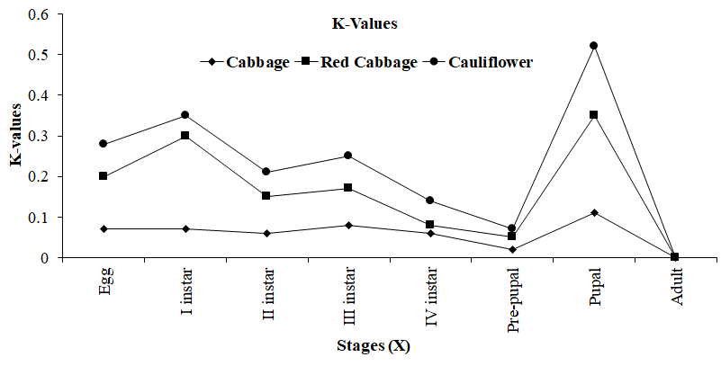
Figure 4: Effect of different brassica hosts on the stage-specific generation mortality
(k-value) of P. xylostella

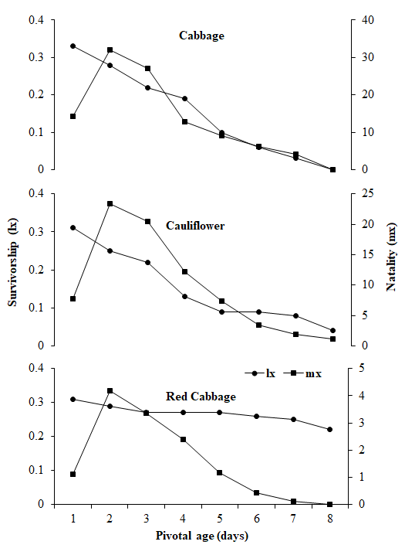
Figure 5: Effect of different brassica hosts on the female survivorship(lx) and natality(mx) of P. xylostella

Table 1: Stage-specific life table of P. xylostella at various Brassica hosts
X | lx | dx | 100qx | Sx | MSR | IM | log (lx) | k-values
Cabbage
Eggs | 100 | 15 | 15.00 | 0.85 | 0.18 | 5.82 | 2.00 | 0.07
I instar | 85 | 13 | 15.29 | 0.85 | 0.18 | 5.96 | 1.93 | 0.07
II instar | 72 | 9 | 12.50 | 0.88 | 0.14 | 4.71 | 1.86 | 0.06
III instar | 63 | 11 | 17.46 | 0.83 | 0.21 | 6.98 | 1.80 | 0.08
IV instar | 52 | 7 | 13.46 | 0.87 | 0.16 | 5.13 | 1.72 | 0.06
Pre-pupal | 45 | 0 | 0.00 | 0.96 | 0.00 | 0.00 | 1.65 | 0.02
Pupal | 45 | 12 | 27.91 | 0.77 | 0.36 | 12.00 | 1.63 | 0.11
Adult | 33 | 33 | 96.97 | 0.00 | 0.00 | 0.00 | 1.52 | 0.00
 |  |  |  |  |  |  |  | K = 0.48
Red Cabbage
Eggs | 100 | 26 | 26.00 | 0.74 | 0.35 | 5.27 | 2.00 | 0.13
I instar | 74 | 30 | 40.54 | 0.59 | 0.68 | 10.23 | 1.87 | 0.23
II instar | 44 | 8 | 18.18 | 0.82 | 0.22 | 3.33 | 1.64 | 0.09
III instar | 36 | 7 | 19.44 | 0.81 | 0.24 | 3.62 | 1.56 | 0.09
IV instar | 29 | 1 | 3.45 | 0.97 | 0.04 | 0.54 | 1.46 | 0.02
Pre-pupal | 28 | 2 | 7.14 | 0.93 | 0.08 | 1.15 | 1.45 | 0.03
Pupal | 26 | 11 | 42.31 | 0.58 | 0.73 | 11.00 | 1.41 | 0.24
Adult | 15 | 15 | 100.00 | 0.00 | 0.00 | 0.00 | 1.18 | 0.00
 |  |  |  |  |  |  |  | K = 0.82
Cauliflower
Eggs | 100 | 16 | 16.00 | 0.84 | 0.19 | 5.90 | 2.00 | 0.08
I instar | 84 | 9 | 10.71 | 0.89 | 0.12 | 3.72 | 1.92 | 0.05
II instar | 75 | 9 | 12.00 | 0.88 | 0.14 | 4.23 | 1.88 | 0.06
III instar | 66 | 11 | 16.67 | 0.83 | 0.20 | 6.20 | 1.82 | 0.08
IV instar | 55 | 7 | 12.73 | 0.87 | 0.15 | 4.52 | 1.74 | 0.06
Pre-pupal | 48 | 2 | 4.17 | 0.96 | 0.04 | 1.35 | 1.68 | 0.02
Pupal | 46 | 15 | 32.61 | 0.67 | 0.48 | 15.00 | 1.66 | 0.17
Adult | 31 | 31 | 100.00 | 0.00 | 0.00 | 0.00 | 1.49 | 0.00
 |  |  |  |  |  |  |  | K = 0.51

Table 2: Female fertility life table of P. xylostella at various Brassica hosts
Temperatures (ºC) | Pf | Ro | r_{m} | λ | Tc | τ | DT | MRI
Cabbage | 105.99ª | 23.55ª | 0.1265ª | 1.13ª | 24.97^{b} | 24.78^{b} | 5.48^{b} | 44.53ª
Red Cabbage | 12.79^{c} | 3.57^{c} | 0.0405^{c} | 1.04^{c} | 31.46ª | 31.45ª | 17.12ª | 3.37^{c}
Cauliflower | 77.58^{b} | 15.50^{b} | 0.1091^{b} | 1.12^{b} | 25.11^{b} | 25.05^{b} | 6.35^{b} | 26.41^{b}
LSD (p<0.01) | 10.22 | 3.895 | 0.0121 | 0.0163 | 1.629 | 2.039 | 3.221 | 8.054
F | 267.8 | 76.73 | 165.90 | 106.20 | 70.36 | 44.34 | 43.95 | 100.30
df | 2,6 | 2,6 | 2,6 | 2,6 | 2,6 | 2,6 | 2,6 | 2,6
x = Stages, lx = No of surviving at beginning of stage, dx = Mortality, 100qx = Apparent mortality, MSR = Mortality survival ratio, Sx = Survival fraction, IM = Indispensable mortality, Pf = Potential fecundity, Ro = Net reproduction rate, r_{m} = Intrinsic rate of increase, λ = Finite rate of increase, Tc = Mean generation time, τ = Corrected generation time, DT = Doubling time, MRI = Monthly rate of increase

Conclusion
The current study found that Plutella xylostella can develop and reproduce in all examined Brassica hosts (cabbage, cauliflower, and red cabbage), and that these hosts have a substantial influence on the age-specific, stage-specific, and female fertility tables. Compared to all hosts, cabbage promoted greater reproductive output, the lowest mortality rate, and higher survival rates throughout all life stages. Females also demonstrated the highest net reproductive rate (R₀) and potential fecundity (Pf). The population doubling time (DT), mean generation time (Tc), and corrected generation time (τ) were all longer on red cabbage and shorter on cabbage. The intrinsic rate of increase (rm), finite rate of increase (λ), and monthly rate of population increase (MRI) were all higher on cabbage, but lower on red cabbage. Furthermore, these variables demonstrated modest values on cauliflower. The findings of this study are critical for developing new models capable of simulating and forecasting population dynamics. These models will be useful in determining the most effective management methods. The relevant data should then be condensed into a framework to assist us understand the dynamics of the P. xylostella population.

References
Agerbirk, N., Olsen, C. E., Bibby, B. M., Frandsen, H. O., Brown, L. D., Nielsen, J. K., & Renwick, J. A. A. (2003). A saponin correlated with variable resistance of Barbarea vulgaris to the diamondback moth Plutella xylostella. Journal of Chemical Ecology, 29, 141–1433.
Agrawal, A. A. (2000). Specificity of induced resistance in wild radish: Causes and consequences for two specialists and two generalist caterpillars. Oikos, 89, 493–500.
Agrawal, A. A., & Kurashige, N. S. (2003). A role for isothiocyanates in plant resistance against the specialist herbivore Pieris rapae. Journal of Chemical Ecology, 29, 1403–1415.
Ahmad, T., & Ansari, M. S. (2013). Effect of mustard varieties on life table and development of diamondback moth, Plutella xylostella. Asian Journal of Plant Science and Research, 3(5), 1–6.
Atlihan, R., Kasap, İ., Özgökçe, M. S., Polat-Akköprü, E., & Chi, H. (2017). Population growth of Dysaphis pyri (Hemiptera: Aphididae) on different pear cultivars with discussion on curve fitting in life table studies. Journal of Economic Entomology, 110(4), 1890–1898.
Awmack, C. S., & Leather, S. R. (2002). Host plant quality and fecundity in herbivorous insects. Annual Review of Entomology, 47(1), 817–844.
Bernays, E. A., & Chapman, R. F. (2007). Host-plant selection by phytophagous insects (Vol. 2). Springer Science & Business Media.
Björkman, M., Klingen, I., Birch, A. N., Bones, A. M., Bruce, T. J., Johansen, T. J., ... & Stewart, D. (2011). Phytochemicals of Brassicaceae in plant protection and human health–Influences of climate, environment and agronomic practice. Phytochemistry, 72(7), 538–556.
Chahil, G. S., & Kular, J. S. (2013). Biology of Pieris brassicae (Linn.) on different Brassica species in the plains of Punjab. Journal of Plant Protection Research, 53, 53–59.
Das Laha, S., Kundu, A., & Podder, S. (2024). Impact of biotic stresses on the Brassicaceae family and opportunities for crop improvement by exploiting genotyping traits. Planta, 259(5), 97.
Dixon, A. F. G. (1987). Parthenogenetic reproduction and the rate of increase in aphids. In Aphids: Their biology, natural enemies and control (Vol. 2, pp. 269–287). Elsevier.
Eigenbrode, S. D., Stoner, K. A., Shelton, A. M., & Kain, W. C. (1991). Characteristics of glossy leaf waxes associated with resistance to diamondback moth (Lepidoptera: Plutellidae) in Brassica oleracea. Journal of Economic Entomology, 84(5), 1609–1618.
Fathipour, Y., Kianpour, R., Bagheri, A., Karimzadeh, J., & Hesseininaveh, V. (2019). Bottom-up effects of Brassica genotypes on performance of diamondback moth, Plutella xylostella (Lepidoptera: Plutellidae). Crop Protection, 115, 135–141.
Furlong, M. J., Wright, D. J., & Dosdall, L. M. (2013). Diamondback moth ecology and management: Problems, progress, and prospects. Annual Review of Entomology, 58(1), 517–541.
Gangurde, S. M., & Wankhede, S. M. (2009). Biology of diamondback moth, Plutella xylostella Linn. International Journal of Plant Protection, 2(2), 165–166.
Gautam, M. P., Singh, H., Kumar, S., Kumar, V., Singh, G., & Singh, S. N. (2018). Diamondback moth, Plutella xylostella (Linnaeus) (Insecta: Lepidoptera: Plutellidae), a major insect of cabbage in India: A review. Journal of Entomology and Zoology Studies, 6(4), 1394–1399.
Golizadeh, A., Kamali, K., Fathipour, Y., & Abbasipour, H. (2009). Life table of the diamondback moth, Plutella xylostella (L.) (Lepidoptera: Plutellidae) on five cultivated brassicaceous host plants. Journal of Agricultural Science and Technology, 11, 115–124.
Gu, X., Tian, S., Wang, D., Fei, G., & Wei, H. (2010). Interaction between short-term heat pretreatment and fipronil on 2nd instar larvae of diamondback moth, Plutella xylostella (Linn). Dose-Response, 8(3). https://doi.org/10.2203/dose-response.09-034.Gu
Gunn, D. (1917). The small cabbage moth (Plutella maculipennis Curtis). Bulletin, Department of Agriculture, Union of South Africa, 8, 1–10.
Hamilton, A. J., Endersby, N. M., Ridland, P. M., Zhang, J., & Neal, M. (2005). Effects of cultivar on oviposition preference, larval feeding and development time of diamondback moth, Plutella xylostella (L.) (Lepidoptera: Plutellidae), on some Brassica oleracea vegetables in Victoria. Australian Journal of Entomology, 44(3), 284–287.
Jafary-Jahed, M., Razmjou, J., Nouri-Ganbalani, G., Naseri, B., Hassanpour, M., & Leppla, N. C. (2019). Life table parameters and oviposition preference of Plutella xylostella (Lepidoptera: Plutellidae) on six brassicaceous crop plants. Journal of Economic Entomology, 112(2), 932–938.
Keerthi, M. C., & Suroshe, S. S. (2024). Effect of host plants on the fitness and demographic parameters of the diamondback moth, Plutella xylostella (L.) using age-stage, two-sex life tables. Journal of Plant Diseases and Protection, 131(1), 143–154.
Kocourek, F., Havelka, J., Beránková, J., & Jarosik, V. (1994). Effect of temperature on development rate and intrinsic rate of increase of Aphis gossypii reared on greenhouse cucumbers. Entomologia Experimentalis et Applicata, 71(1), 59–64.
Li, G., Lv, H., Zhang, S., Li, F., Zhang, H., Qian, W., Fang, Z., & Sun, R. (2019). TuMV management for Brassica crops through host resistance: Retrospect and prospects. Plant Pathology, 68(6), 1035–1044.
Li, Q., Eigenbrode, S. D., Stringham, G. R., & Thiagarajah, M. R. (2000). Feeding and growth of Plutella xylostella and Spodoptera eridania on Brassica juncea with varying glucosinolate concentrations and myrosinase activities. Journal of Chemical Ecology, 26, 2401–2419.
Machekano, H., Mvumi, B. M., & Nyamukondiwa, C. (2017). Diamondback moth, Plutella xylostella (L.) in Southern Africa: Research trends, challenges and insights on sustainable management options. Sustainability, 9(2), 91.
Marchioro, M., & Foerster, L. A. (2014). Preference–performance linkage in the diamondback moth, Plutella xylostella, and implications for its management. Journal of Insect Science, 14(1), 85.
Neik, T. X., Amas, J., Barbetti, M., Edwards, D., & Batley, J. (2020). Understanding host–pathogen interactions in Brassica napus in the omics era. Plants, 9(10), 1336.
Nikooei, M., Fathipour, Y., Jalali Javaran, M., & Soufbaf, M. (2015). How different genetically manipulated Brassica genotypes affect life table parameters of Plutella xylostella (Lepidoptera: Plutellidae). Journal of Economic Entomology, 108, 515–524.
Patel, N., Godhani, P., & Gohel, V. (2017). Bionomics of aphid, Lipaphis erysimi (Kaltenbach) on cauliflower. The Bioscan, 12, 39–42.
PD, G. (1960). Food plant relationship of diamondback moth (Plutella maculipennis (Curt.)): II. Sensory regulation of oviposition of the adult female. Entomologia Experimentalis et Applicata, 3, 305–314.
Polat-Akköprü, E. R., Atlıhan, H., Okut, H., & Chi, H. (2015). Demographic assessment of plant cultivar resistance to insect pests: A case study of the dusky-veined walnut aphid (Hemiptera: Callaphididae) on five walnut cultivars. Journal of Economic Entomology, 108, 378–387.
Razmjou, J., Naseri, B., & Hemati, S. A. (2014). Comparative performance of the cotton bollworm, Helicoverpa armigera (Hübner) (Lepidoptera: Noctuidae) on various host plants. Journal of Pest Science, 87, 29–37.
Roitberg, B. D., Boivin, G., & Vet, L. E. M. (2001). Fitness, parasitoids, and biological control: An opinion. The Canadian Entomologist, 133(3), 429–438.
Saeed, R., Sayyed, A. H., Shad, S. A., & Zaka, S. M. (2010). Effect of different host plants on the fitness of diamond-back moth, Plutella xylostella (Lepidoptera: Plutellidae). Crop Protection, 29(2), 178–182.
Saeed, S., Jaleel, W., Naqqash, M. N., Saeed, Q., Zaka, S. M., Sarwar, Z. M., ... & Sharma, G. K. (2019). Fitness parameters of Plutella xylostella (L.) (Lepidoptera: Plutellidae) at four constant temperatures by using age-stage, two-sex life tables. Saudi Journal of Biological Sciences, 26(7), 1661–1667.
Sarfaraz, R. M., Dosdall, L. M., Keddie, A. B., & Myers, J. H. (2011). Larval survival, host plant preferences and developmental responses of the diamondback moth Plutella xylostella (Lepidoptera: Plutellidae) on wild brassicaceous species. Entomological Science, 14, 1–30.
Sarfraz, M., Dosdall, L. M., & Keddie, B. A. (2006). Diamondback moth–host plant interactions: Implications for pest management. Crop Protection, 25(7), 625–639.
Sarfraz, M., Dosdall, L. M., & Keddie, B. A. (2007). Resistance of some cultivated Brassicaceae to infestations by Plutella xylostella (Lepidoptera: Plutellidae). Journal of Economic Entomology, 100, 215–224.
Soufbaf, M., Fathipour, Y., Zalucki, M. P., & Hui, C. (2012). Importance of primary metabolites in canola in mediating interactions between a specialist leaf-feeding insect and its specialist solitary endoparasitoid. Arthropod-Plant Interactions, 6, 241–250.
Southwood, T. R. E., & Henderson, P. A. (2000). Ecological methods (3rd ed.). Blackwell Science.
Stark, J. D., Sugayama, R. L., & Kovaleski, A. (2007). Why demographic and modelling approaches should be adopted for estimating the effects of pesticides on biocontrol agents. BioControl, 52, 365–374.
van Loon, J. J. A., Wang, C. Z., Nielsen, J. K., Gols, R., & Qiu, Y. T. (2002). Flavonoids from cabbage are feeding stimulants for diamondback moth larvae additional to glucosinolates: Chemoreception and behaviour. Entomologia Experimentalis et Applicata, 104, 27–34.
Vuorinen, T., Reddy, G. V. P., Nerg, A. M., & Holopainen, J. K. (2004). Monoterpene and herbivore-induced emissions from cabbage plants grown at elevated atmospheric CO₂ concentration. Atmospheric Environment, 38, 675–682.
Wainwright, C., Jenkins, S., Wilson, D., Elliott, M., Jukes, A., & Collier, R. (2020). Phenology of the diamondback moth (Plutella xylostella) in the UK and provision of decision support for Brassica growers. Insects, 11(2), 118.
Winkler, K., Wäckers, F. L., Stingli, A., & Van Lenteren, J. C. (2005). Plutella xylostella (diamondback moth) and its parasitoid Diadegma semiclausum show different gustatory and longevity responses to a range of nectar and honeydew sugars. Entomologia Experimentalis et Applicata, 115(1), 187–192.
Wittstock, U., Agerbirk, N., Stauber, E. J., Olsen, C. E., Hippler, M., Mitchell-Olds, T., Gershenzon, J., & Vogel, H. (2004). Successful herbivore attack due to metabolic diversion of a plant chemical defense. Proceedings of the National Academy of Sciences of the United States of America, 101, 4859–4864.
Yang, F. Y., Chen, J. H., Ruan, Q. Q., Wang, B. B., Jiao, L., Qiao, Q. X., ... & You, M. S. (2021). Fitness comparison of Plutella xylostella on original and marginal hosts using age-stage, two-sex life tables. Ecology and Evolution, 11(14), 9765–9775.

