Original Research Article
Influence of Coffee Biochar on Growth of Arabica Coffee Seedlings

ABSTRACT

Biochar is a porous and carbon-rich product obtained from the thermal disintegration of solid agricultural waste biomasses in an oxygen-limited atmosphere. In recent years, the subject of biochar has increasingly becoming popular worldwide due to its potential to improve the soil fertility and several studies have demonstrated the benefits of soil application of biochar in various crops. However, reports on the application of biochar in coffee farming is rather very limited. Thus, a study was undertaken to assess the influence of biochar application on the growth of arabica coffee seedling. In the present study, biochar obtained from coffee cherry husk (a waste biomass obtained while dehusking of cherry coffee) was used for the nursery trial. The biochar produced using an electric biomass pyrolyzer at 500°C for one hour was incorporated into the nursery potting medium (NPM). The experiment consisted of six treatments: T₀ (standard NPM-control), T₁ (standard NPM+1% biochar), T₂ (standard NPM+2% biochar), T₃ (standard NPM+3% biochar), T₄ (standard NPM+4% biochar) and T₅ (standard NPM+5% biochar). The treatments were imposed in a completely randomized design with five replications per treatment and fifty seedlings per replication. The growth of arabica seedling was assessed in-terms of shoot length, root length, fresh shoot biomass, fresh root biomass, dry shoot biomass and dry root biomass. The results indicated that growth of arabica coffee seedlings was found to be superior in T₃ (potting medium with 3% biochar) and T₄ (potting medium with 4% biochar) as compared to other treatments (T_{0,} T_{1,} T_{2,} T₅). Further, the availability of nutrients (nitrogen, phosphorous and potassium) was found to be higher in biochar treated soil when compared to soil from control treatment (T₀). These results suggest that biochar at the rate of 3% to 4% improves the growth of arabica coffee seedlings through modifying the physicochemical properties of soil, as evidenced by the changes in the pH, electrical conductivity, organic carbon content and nutrient status.

Keywords: Coffee, Cherry husk, Biochar, Coffee seedlings, Sustainability, Circular economy

1. INTRODUCTION

Coffee is one of the most important agricultural crops and also the second most traded commodity in the world. In India, coffee is one of the prime horticultural crops and grown to an extent of 4.70 lakh hectares (Arabica-2.42 lakh hectares; Robusta-2.28 lakh hectares) with the total production of 3.43 lakh metric tonne of commercial coffee bean in 2022-23 crop year (Anonymous, 2024).

Coffee processing is accountable for the production of a huge quantity of different kinds of solid waste biomasses viz., fresh coffee pulp (FCP), cherry husk (CH), parchment husk (PH) spent coffee ground (SCG) and coffee sliver skin (CSS). The global coffee industry generates about 39 million tons of solid waste biomasses each year (Anonymous, 2025). Whilst, in India around eight lakh tonnes of solid waste biomasses are produced yearly from coffee processing (Anonymous, 2024). The FCP is an ideal substate for the production of organic manure (compost or vermi-compost) while other solid waste biomasses viz., CH, PH, SCG and CSS are converted into fuel briquettes or fuel pellets.

In recent years, biochar has become increasingly popular worldwide due to its potential to improve soil fertility. Biochar is produced from the combustion of various solid agricultural waste biomasses under no oxygen condition and considered as soil ameliorant. Biochar is rich in carbon content, and its application in soil is reported to influence several physico-chemical attributes of soil (bulk density, porosity, water holding capacity, acidity, cation exchange capacity, electrical conductivity and nutrient level) and also the microbial community structure (Akgul, 2017). Biochar is used as a management tool to control various plant diseases (Navdeep & Adesh, 2020), plant parasitic nematode (Dwi & Niken, 2017) and substitute in the potting medium to grow plants at nursery level (Tian et al., 2012; Vaughn et al., 2013; Zhang et al., 2014; Dispenza et al., 2016; Nieto et al., 2016; Gopinandhan et al., 2025).

The biological degradation of solid waste biomasses resulting from coffee processing is very changeling due to the presence of toxic metabolites such as alkaloids (caffeine), tannins and polyphenols. Conversion of such a recalcitrant biological waste into biochar appears to be a viable alternative for the management of coffee-derived-waste-biomasses. Although several studies on biochar have been focussed on its application in the soil system of various crops (Elmer & Pignatello, 2011; De Tender et al., 2016; Eber et al., 2018; Tássia et al., 2019; Zamriyetti and Mufriah, 2020; Ma et al., 2024; Yesil et al., 2024), limited reports are available about its application in coffee farming (Sanchez-Reinoso et al., 2022; Sanchez-Reinoso et al., 2023^{ab}; Zeyin et al., 2023). Furthermore, reports relating to influence of biochar on the growth of coffee seedlings are also scanty (Samuel et al., 2019; Herviyanti et al., 2020; Jessica et al., 2022; Leta et al., 2022). Samuel et al. (2019), Jessica et al. (2022) and Leta et al. (2022) studied the synergistic effect of biochar along with poultry manure, biofertilizer and top soil respectively on growth of coffee seedlings. Whilst, Herviyanti et al. (2020) studied the influence of graded doses of biochar (0.5%, 1%, 1.5% and 2%) and reported that addition of biochar up to 2% has not shown any significant increase in growth coffee seedlings. As there is only limited knowledge on the effect of biochar on the growth of the coffee seedling, the current study was undertaken to assess the influence of graded doses of biochar application (1% to 5%) on the growth of coffee seedlings.

2. MATERIAL AND METHODS

2.1 Location

The experiment was carried out in a poly house nursery available at the research farm in central coffee research institute (CCRI) located at Chikkamagaluru district in Karnataka state (India) during 2024-25 season. CCRI is located in the southern hill zone of Karnataka state at 13⁰34 north latitude and 75⁰48 east longitudes with an elevation of 825 meter above mean sea level. The research station receives an annual average rainfall of 2,500 mm spanned over 4 to 5 months from June to September with a total annual rainy day ranging from 113 to 133 days. In general, the temperature and relative humidity ranges from 18⁰C to 34⁰C and 60% to 90%, respectively.

2.2 Production of Biochar

The coffee husk (CH) was collected from a coffee curing factory established at Chikkamagaluru district in Karnataka state (India). The biochar from CH was prepared using a lab-scale biomass pyrolyzer. The temperature of the furnace was ramped at a rate of 10⁰C in 60 minutes to the reach pyrolysis holding temperature (500⁰C). Then, the temperature was continued for 2 hours. The pyrolyzer was allowed to cool at an average rate of approximately 30⁰C in 60 minutes. Then, the biochar was grounded to pass through 2 mm test sieve (M/s. Techno Instruments Company, Bangalore, India) and the fine biochar powder was used for the nursery trail.

2.3 Imposition of Experimental Treatments

The preparation of potting medium started with the sieving of sun-dried jungle soil and well-rotted farm yard manure (FYM). The potting medium consisted of sieved jungle soil (JS), farm yard manure (FYM) and sand at the ratio of 6:2:1. The fine biochar powder was mixed to the nursery mixture according to the treatment level. The treatments included in the current study were T_{o} (control treatment - potting medium with JS:FYM:sand), T₁ (potting medium with JS:FYM:sand + 1% biochar), T₂ (potting medium with JS:FYM:sand + 2% biochar), T₃ (potting medium with JS:FYM:sand + 3% biochar), T₄ (potting medium with JS:FYM:sand + 4% biochar) and T₅ (potting medium with JS:FYM:sand + 5% biochar). The treatments were imposed in a completely randomized design (RCBD) with five replications per treatment and fifty seedlings per replication.

The biochar enriched potting medium was filled up into the nursery bags (one liter capacity polybag of 22.5 x 15 cm size with 150-gauge thickness and six to eight holes of 3 mm size at the bottom half of the polybag to drain the excess water). The potting medium was dampened with water and filled into nursery bags firmly. The bags were arranged within the rectangular frames of wooden reapers (ten to twelve bags per row). These frames are held in position with wooden props driven firmly into the ground at regular distances.

The sprouted seedling of Coffea arabica (Arabica coffee variety no.13) were transplanted from the germination bed to polybags. After transplanting, the seedlings were maintained following the recommended nursery management practices. Two seedlings from each replication were sampled for analysis purpose (totalling to ten seedlings per treatment) on every two months up to six months.

2.4 Biometric Analysis of Arabica Coffee Seedlings

The biometric parameters such as shoot length (SL), root length (RL), fresh shoot biomass (FSB), fresh root biomass (FRB), dry shoot biomass (DSB) and dry root biomass (DRB) were determined following the procedure detailed in Kalyanikumari et al. (2017).

2.5 Physico-Chemical and Nutrient Analysis

A representative soil samples were collected from all the treatments after six months of seedlings growth in the polybag nursery. The air-dried soil samples were analysed for pH, EC, percent organic carbon following standard protocols (Jackson, 1973; Walkley and Black, 1934).

The mineral nutrient content in biochar samples were determined in triplicates following standard methodologies (Tripathi, 1993). The total nitrogen content was determined by standard micro-Kjeldahl digestion system (samples digested with concentrated sulphuric acid and sulphate mixture) and distillation method. The total phosphorous content (as P₂O₅) was estimated by microwave digestion system (Anton Paar Multiwave Go Plus) using concentrated nitric acid followed by its estimation through spectrophotometric method (vanadophosphomolybdate). The total potassium content (as K₂O) was quantitated by microwave digestion system (Anton Paar Multiwave Go Plus) using concentrated nitric acid followed by its estimation through flame photometric method.

2.6 Statistical Analysis

The data were subjected to analysis of variance (ANOVA) to test statistically significant differences between treatments following the Agress software package (version 3.01 data entry module and version 7.01 ANOVA package for researchers).

3. RESULTS AND DISCUSSION

The data on various growth indices viz, shoot length (SL), root length (RL), fresh shoot biomass (FSB), fresh root biomass (FRB), dry shoot biomass (DSB) and dry root biomass (DRB) recorded in the present investigation exhibited that the growth of coffee arabica seedlings gradually increased as the period of growth prolonged, regardless of treatments (Fig 1a, 1b, 1c, 1d, 1e and 1f).

3.1 Influence of Biochar on Above Ground Biomass in Six-Month-Old Arabica Seedling

Among the six variables evaluated, T₄ treatment (potting medium with 4% biochar) recorded the highest shoot length (38.4 ± 1.81 cm) followed by T₃ treatment (potting medium with 3% biochar) with the second highest shoot length of 37.0 cm (± 3.06 cm) which were statistically (CD = 0.05) on par to each other (Fig 1a). In the remaining four treatments (T₀, T_{1,} T₂ & T₅), though there were numerical differences in shoot length values between these variables, no statistically significant variation (CD = 0.05) found in shoot length values between these variables. The lowest shoot length value of 22.7 cm (± 1.43 cm) registered in T₅ treatment (potting medium with 5% biochar).

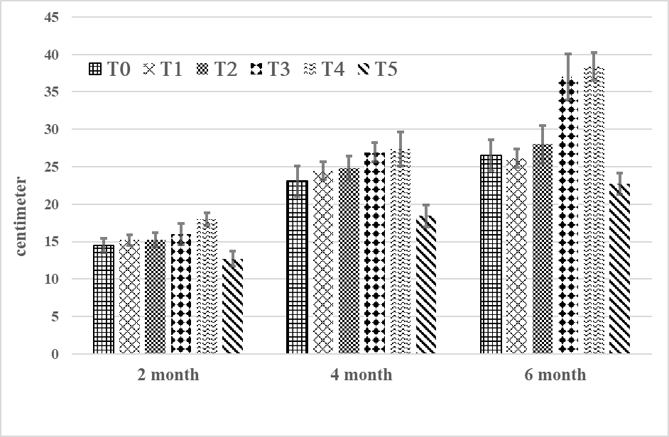
Fig 1a. Influence of biochar on shoot length of arabica seedling

Data on fresh shoot biomass (Fig 1b) revealed that the highest fresh shoot biomass seen in T₄ treatment (17.15 ± 0.81 gram) followed by T₃ treatment (17.12 ± 1.42 gram) and these two treatments were statistically on par with each other (CD = 0.05). The least fresh shoot biomass observed in T₅ treatment (8.32 ± 0.53 gram).

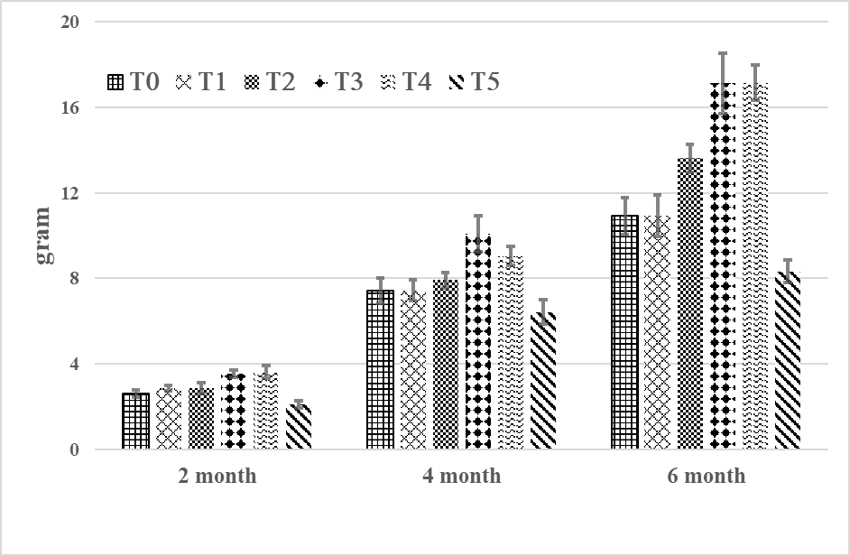
Fig 1b. Influence of biochar on fresh shoot biomass of arabica seedling
Regarding dry shoot biomass (Fig 1c), the highest dry shoot biomass observed in T₃ treatment (4.12 ± 0.04 gram) followed by T₄ treatment (4.08 ± 0.36 gram) and these two variables were statistically on par to each other (CD = 0.05). Similar to fresh shoot biomass data, the least dry shoot biomass observed in T₅ treatment (2.65 ± 0.17 gram).

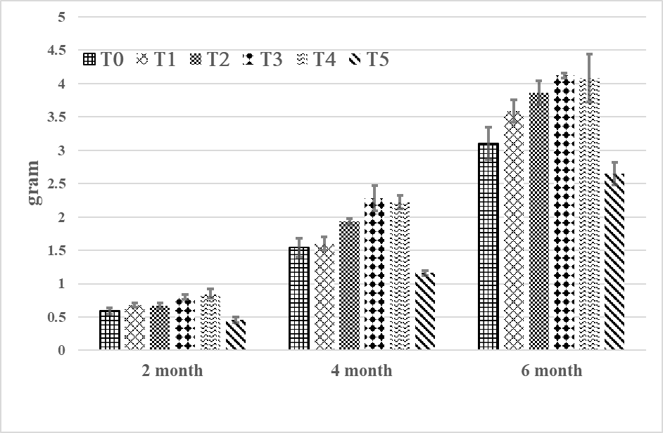
Fig 1c. Influence of biochar on dry shoot biomass of arabica seedling

Several studies have attempted to standardize the optimal dosage of biochar to improve the seedling growth of various plant species. Application of biochar at the rate of 1% provided the most benefit to the growth of Centaurea cyanus seedling as compared to control seedling (Fedeli, 2024), 2% biochar improved the growth of Moringa oleifera seedling (Tassia et al., 2019), 5% biochar promoted the growth of granadilla seedling (Tatiana et al., 2022) and 10% biochar improved the growth of cucumber seedling (Ma et al., 2024). In the current study, arabica seedling challenged with 3% and 4% of biochar exhibited superior growth indices, as compared to other biochar treatments (1%, 2% and 5% biochar) as well as control treatment (T₀) indicating 3% to 4% of biochar seemed to be ideal range for the superior growth of arabica seedling. This result was in conformity with the findings of Herviyanti et al. (2020) who reported that addition of biochar up to 2% did not shown any significant increase in the growth of arabica coffee seedling.

3.2 Influence of Biochar on Below Ground Biomass in Six-Month-Old Arabica Seedling

Regarding root length (Fig 1d), T₄ treatment (potting medium with 4% biochar) registered the highest root length (22.16 ± 1.7 cm), as compared to other treatments followed by T₃ treatment (20.1 ± 0.95 cm), and T₂ (18.86 ± 0.61 cm) which were statistically on par to each other (CD = 0.05). As in case of shoot length, the lowest root length value recorded in T₅ (13.93 ± 0.88 cm).

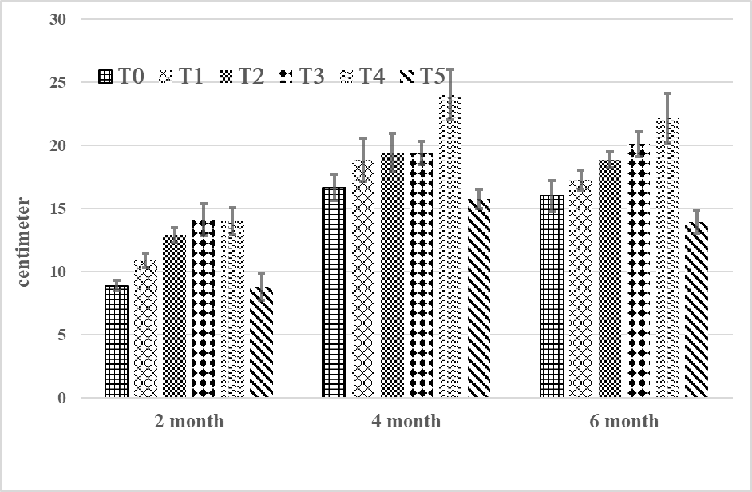
Fig 1d. Influence of biochar on root length of arabica seedling

Concerning the fresh root biomass (Fig 1e), T₃ treatment (potting medium with 3% biochar) showed comparatively the highest fresh root biomass (2.34 ± 0.11 gram) followed by T₄ (2.17 ± 0.20 gram) which were statistically in the same cluster (CD = 0.05). The T₅ treatment shown the least fresh root biomass of 1.16 gram (± 0.10 gram).

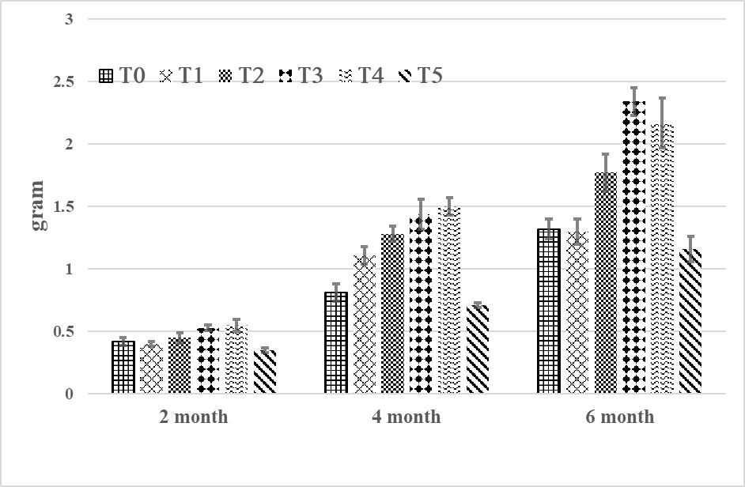
Fig 1e. Influence of biochar on fresh root biomass of arabica seedling
Perusal of data on dry root biomass (Fig 1f) revealed that T₄ treatment showed statistically highest (CD = 0.05) dry root biomass (0.65 ± 0.03 gram) followed by T₃ treatment (0.55 ± 0.05 gram) and the least dry root biomass observed in T₅ treatment (0.21 ± 0.03 gram).

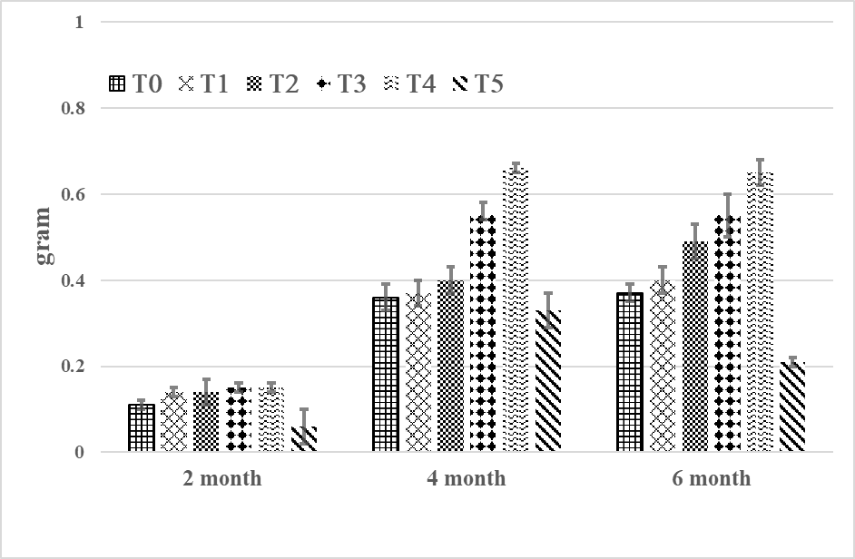
Fig 1f. Influence of biochar on dry shoot biomass of arabica seedling

In the present study, arabica seedlings defied with 3% and 4% of biochar registered higher level of below ground biomass when compared to other treatments (T_{o}, T₁, T₂ and T₅) which was in concurrence with the findings of the Elmer et al. (2011) who reported that application of biochar at 3% increased the root biomass of asparagus plants. Furthermore, Mirac et al. (2024) observed significant root development in arugula (Eruca vesicaria) and garden cress (Lepidium sativum) plants with 2 tons of biochar per hectare.

The poor performance of arabica seedling in T₅ treatment (potting medium with 5% biochar) may probably due to the alkalinisation of the potting medium which was in good agreement with the report of Dispenza et al. (2016) who observed that the poor performance of ornamental Euphorbia plant in growth substrate containing excess biochar due to alkaline pH of the growth medium. Furthermore, Barotni et al. (2010) and Samuel et al. (2019) reported that over application of biochar resulted in a general reduction of biomass due to changes in the physico-chemical properties of soil.

3.3 Influence of Biochar on Physico-Chemical Properties of Soil Cropped with Arabica Seedling

Analysis of soil sample collected from all the six treatments after six months of arabica seedling growth under nursery condition indicated (Fig 2) that the soil sample from T₅ treatment showed the highest pH value (6.97 ± 0.04), EC value (0.67 ± 0.03 dsm⁻¹) and organic carbon content (4.68 ± 0.14%). While, soil sample from the T₀ treatment recorded the least pH value (6.03 ± 0.25), EC value (0.34 ± 0.02 dsm⁻¹) and organic carbon content (3.63 ± 0.34%).

Regarding pH, the trend observed in the current study was similar to those of Agnieszka et al. (2020) who reported that biochars (that are intended for soil amendment) are generally alkaline in nature and external addition of such biochar tend to increase the pH of the soil system depending on the quantity added. The EC ranges observed in the current study were well within the acceptable range of 0.2 and 0.8 dS/m for the growth of coffee which ensures sufficient nutrient availability. The EC value increased with the increasing level of biochar added to the potting medium and similar results were outlined by Li et al. (2018). The increase in EC is primarily due to the release of soluble salts when biochar reacts with water. Concerning the organic carbon (OC) content, the organic carbon content surged with the increasing addition of biochar and these results were in agreement with those of Jiabin et al. (2024).

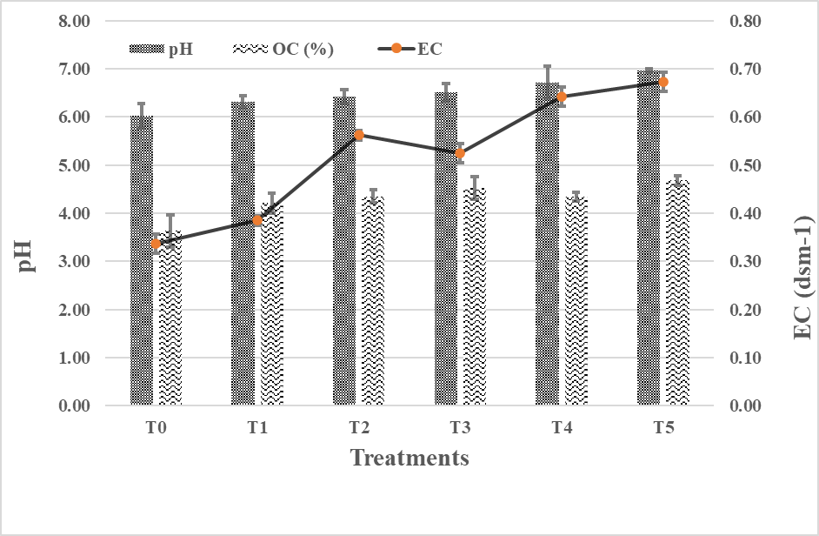
Fig 2. Influence of biochar on the physicochemical properties of soil

3.4 Influence of Biochar on Nutrient Status of Soil Cropped with Arabica Seedling

Analysis of soil samples for nutrient content showed that soil samples collected from T₅ treatment showed the highest nutrient values (N-343.23 ± 4.21 ppm; P-520.45 ± 4.13 ppm; K- 1191.47 ± 1.79 ppm), whilst, soil sample from the T₀ treatment recorded the least nutrient values (N-173.23 ± 2.72 ppm; P-373.17 ± 2.32 ppm; K-279 ± 1.53 ppm). These data indicated that increased application of biochar resulted in higher level of nutrient availability in the soil (Fig 3). This result was in good agreement with the findings of several authors who have reported that application of biochar increased the level of nutrient like phosphorous, potassium and nitrogen in the soil (Noyce et al., 2017; Lusiba et al., 2017). Biochar is capable of retaining the nutrients and thereby prevents leaching of nutrients from the soil. However, retention capacity of the biochar depends on its porosity and specific surface area.
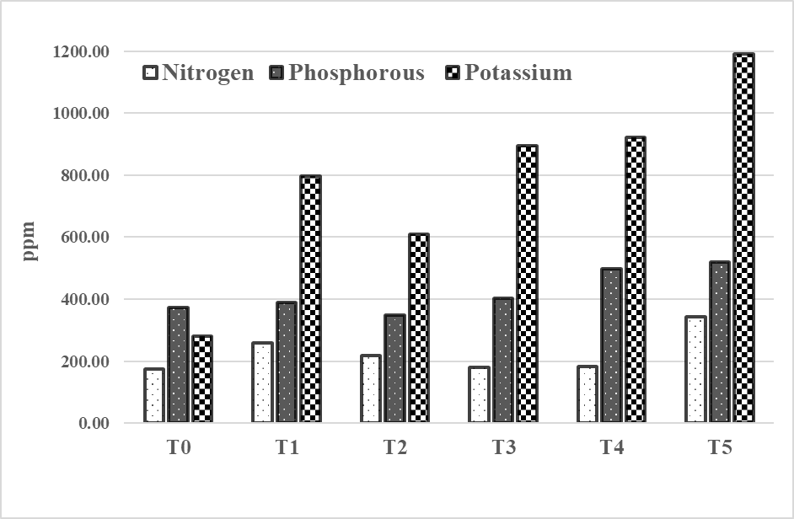
Fig 3. Influence of biochar on the nutrient status of soil cropped with arabica seedling

4. CONCLUSION

The findings of current study clearly revealed that application of biochar at the rate of 3% to 4% in the potting mixture proved superior growth of arabica coffee seedling and excess application resulted in reduced growth of seedling. Application of biochar at optimal rates (3% to 4%) maintained the pH level at ideal range (optimal pH for coffee is around 6.5) and also improved the nutrient availability in the soil which could be the probable reasons for the superior performance of the growth arabica seedling. As biochar being regarded as a sustainable soil improver, optimization of biochar application rate and frequency of application for each crop variety are of paramount importance for the better performance of plant growth.

ACKNOWLEDGEMENT

Authors are grateful to Ministry of Commerce and Industry, Government of India (GoI) for the financial support under the scheme on Integrated Coffee Development Programme (ICDP) - Research and Development for Sustainable Coffee Production.

COMPETING INTERESTS

Authors have declared that no competing interests exist

AUTHORS’ CONTRIBUTIONS

‘Author A’ designed the study, did the literature search and wrote the manuscript. ‘Author B’ and ‘Author C’ attended data collection and statistical analysis. ‘Author D’ analysed soil samples for physico-chemical analyses. All authors read and approved the final manuscript.
DISCLAIMER (ARTIFICIAL INTELLIGENCE)

The authors hereby declare that the generative AI technology, ChatGPT was used during the revision of this manuscript to enhance its clarity and coherence.

COMPETING INTERESTS DISCLAIMER:
Authors have declared that they have no known competing financial interests OR non-financial interests OR personal relationships that could have appeared to influence the work reported in this paper.

REFERENCES

1. Anonymous (2024). Database on coffee published by coffee board of India, Karnataka, India.

2. Anonymous (2025). International Coffee Organization: Historical data on the global coffee trade. London, England.

3. Akgul, G. (2017). Biochar: Production and usage areas. RTEU. Journal of Engineering Science and Technology, 5 (4), 485 - 499.

4. Navdeep, S., & Adesh, K. (2020). Plant disease management through biochar - A review. International Journal of Current Microbiology Applied Science, 11, 3499-3510.

5. Dwi, S.R., & Niken, P.S. (2017). Development of Pratylenchus coffeae in biochar applied soil, coffee roots and its effect on plant growth. Pelita Perkebunan, 33, 24-32. https://doi. 10.22302/iccri.jur.pelitaperkebunan.v33i1.251

6. Tian, Y., Sun, X., Li, S., Wang, H., Wang, L., Cao, J., & et al. (2012). Biochar made from green waste as peat substitute in growth media for Calathea rotundifolia cv. fasciata. Science Horticulture, 143, 15 -18.

7. Vaughn, S. F., Kenar, J. A., Thompson, A. R., & Peterson, S. C. (2013). Comparison of biochars derived from wood pellets and pelletized wheat straw as replacements for peat in potting substrates. Industrial Crops Production, 51, 437- 443.

8. Zhang, L., Sun, X., Tian, Y., & Gong, X. (2014). Biochar and humic acid amendments improve the quality of composted green waste as a growth medium for the ornamental plant Calathea insignis. Science Horticulture, 176, 70 -78.

9. Dispenza, V., De Pasquale, C., Fascella, G., Mammano, M. M., & Alonzo, G. (2016). Use of biochar as peat substitute for growing substrates of Euphorbia × lomi potted plants. Spanish Journal of Agriculture Research, 14, e0908. doi.org/10.5424/sjar/2016144-9082.

10. Nieto, A., Gasco, G., Paz-Ferreiro, J., Fernandez, J.M., Plaza, C., & Mendez, A. (2016). The effect of pruning waste and biochar addition on brown peat based growing media properties. Science Horticulture, 199, 142-148.

11. Gopinandhan, T.N., & B.B. Channabasamma (2025). Evaluating biochar as a potting mixture substitute: Impacts on coffee seedling growth and soil properties. Journal of Experimental Agriculture International, 47, 114-122.

12. Elmer, W. H., & Pignatello, J. J. (2011). Effect of biochar amendments on mycorrhizal associations and Fusarium crown and root rot of asparagus in replant soils. Plant Diseases, 95, 960-966.
13. De Tender, C., Haegeman, A., Vandecasteele, B., Clement, L., Cremelie, P., Dawyndt, P., & et al. (2016). Dynamics in the strawberry rhizosphere microbiome in response to biochar and Botrytis cinerea leaf infection. Frontiers in Microbiology, 7, 2062.

14. Eber, L. H., Cesar, Y. F., Rubén, A., José, L. S., Mónica M. G., Riitta L. K. & et al. (2018). Biochar based on residual biomasses and its influence over seedling emergence and growth in vivarium of Capparis scabrida (Sapote). Scientia Agropecuaria, 9 (4), 569 – 577

15. Tássia, F. S. N. S., Idamar, D. S. L., André, Q.D.A., Maria, I.D.S.G., Camila, A.F., Ingrid, L.R.G & et al (2019). Substrates formulated with biochar for seedling production of moringa oleifera Lam. Journal of Agricultural Science, 11 (4), doi:10.5539/jas.v11n4p515

16. Zamriyetti, S. M., & Mufriah, D. (2020). Effects of type of biochar and dolomite-Coffee compost application on characteristic of soybean germination. International Conference on Agriculture, Environment and Food Security. Earth and Environmental Science, 454, 012177. doi:10.1088/1755-1315/454/1/012177.

17. Ma, G., Shi, Q., Wu, Y., Liu, Y., Han, L., Hu, J. & et al (2024). Effects of biochar on the growth and physiological and mechanical properties of cucumber plug seedlings before and after transplanting. Agriculture, 14, 2012. https://doi.org/10.3390/ agriculture 14112012

18. Yeşil, Z. B. & Koç, İ. (2024). Effects of drought and biochar treatments on some morphological and physiological parameters in Turkish hazelnut seedlings. Menba Journal of Fisheries Faculty, 10 (3), 211-222. doi.10.58626/menba.1569118.

19. Sanchez-Reinoso, A.D., Lombardini, L., & Restrepo-Díaz, H. (2022). Physiological behaviour and nutritional status of coffee (Coffea arabica L. var. Castillo) trees in response to biochar application. The Journal of Agriculture Science, 160, 220-234. https://doi.org/10.1017/S0021859622000338.

20. Sánchez-Reinoso, A.D., Colmenares-Jaramillo, A., Lombardini, L., & Restrepo-Díaz, H. (2023ª). Physiological response of Castillo el Tambo coffee plants to biochar and chemical fertilization applications. Chilean Journal of Agriculture Research 83, 307-319. https://doi:10.4067/S0718-58392023000300307.

21. Sanchez-Reinoso, A.D., Avila-Pedraza, E.A., Leonardo, L., & Restrepo-Diaz, H. (2023^{b}). The application of coffee pulp biochar improves the physical, chemical, and biological characteristics of soil for coffee cultivation. Journal of Soil Science and Plant Nutrition, https://doi.org/10.1007/s42729-023-01208-4.

22. Zeyin, J., Yuqiang. L., Xiaogang, L., Wenyan, S., Haidong, W., Jiaping, L. & et al (2023). Combined application of coffee husk compost and inorganic fertilizer to improve the soil ecological environment and photosynthetic characteristics of arabica coffee. Agronomy, 13, 1212. https://doi.org/10.3390/agronomy13051212

23. Samuel, F.B., Ajebesone, F.N., Tata, P.N., & Tsi, E. A. (2019). Influence of biochar and poultry manure on weed infestation and growth of arabica coffee (Coffea arabica) seedlings. Current Research in Agriculture Science, 6, 9-19 https://doi.10.18488/journal.68.2019.61.9.19
24. Herviyanti, H., Maulana, A., Prima, S., Aprisal, A., Crisna, S.D., & Lita, A.L. (2020). Effect of biochar from young coconut waste to improve chemical properties of ultisols and growth coffee [Coffea arabica L.] plant seeds. Earth and Environmental Science, 497, 012038, https://doi.10.1088/1755-1315/497/1/012038.

25. Jessica, E.C.C., Andrea, K.L.T., Holger, G.S., Galo, A.C.C., & Ángel, F.C.S. (2022). Growth and quality of arabica coffee plants with the application of biochar and biofertilizers in the nursery. Chilean Journal of Agriculture Animal Science ex Agro-Ciencia, 38, 3-14. https://doi.org/10.29393/CHJAAS38-1CCJA50001.

26. Leta, A., Gezahegn, B., & Taye, K. (2022). Effects of pot sizes and biochar base media composition on nutrient uptake of coffee (Coffea arabica L.) seedlings in South Ethiopia. World Journal of Agriculture and Soil Science 8, WJASS.MS.ID.000678. https://doi. 10.33552/WJASS.2022.08.000678

27. Kalyanikumari, G., Jadeja, C., & Patel, S.T. (2017). Evaluation of seed quality parameters of chilli cultivars collected from different locations of Gujarat, India. Plant Archives, 17, 94-98.

28. Jackson, M L. (1973). Soil chemical analysis. Prentice Hall of India Pvt. Ltd. New Delhi
29. Walkley, A. J. & Black, C. A. (1934). An examination of the method for determination of soil organic matter and a proposed modification of the chromic acid titration method. Soil Science, 37, 29-38.

30. Tripathi, N. (1993). Analysis of fertilizers for major and micronutrients. In: Tandon, H.L., (ed.), Methods of analysis of soils, plants, waters and fertilizers. Published by fertilizer development and consultation organization New Delhi pp. 117-143.

31 Fedeli, R., Fiaschi, T., de Simone, L., Angiolini, C., Maccherini, S., Loppi, S. & et al., (2024). Low concentrations of biochar improve germination and seedling development in the threatened arable weed Centaurea cyanus. Environments, 11, 189. https://doi.org/10.3390/environments11090189

32 Tatiana, C.P.E., Adalberto, R.C. & Camilo, A. L. (2022). Effect of biochar use as a substrate on granadilla (Passiflora ligularis Juss.) growth parameters. Agronomy Colombia, 40(1), doi: 10.15446/agron.colomb.v40n1.98112

33. Mirac, N.C., Emine, E.O., Hilal, S., Şeyma, G, Hüseyin, K.O. & Atakan, O. (2024). The effect of biochar obtained from waste filter coffee grounds on plant germination. International Journal of Agriculture Environment Food Science, 8 (3), 561-570 DOI: https://doi.org/10.31015/jaefs.2024.3.9

34. Dispenza, V., De Pasquale, C., Fascella, G., Mammano, M.M. & Alonzo, G (2016). Use of biochar as peat substitute for growing substrates of Euphorbia × lomi potted plants. Spanish Journal of Agriculture Research, 14 (4) e0908. http://dx.doi.org/10.5424/sjar/2016144-9082.

35. Baronti, S., Alberti, G., Delle Vedove, G., Di Gennaro, F., Fellet, G., Genesio, L., & et al., (2010). The biochar option to improve plant yields: first results from some field and pot experiments in Italy. Italian Journal of Agronomy, 5, 3-11. http://dx.doi.org/10.4081/ija.2010.3.

36. Samuel, F.B., Ajebesone, F.N., Tata, P.N. & Tsi, E.A. (2019). Influence of biochar and poultry manure on weed infestation and growth of arabica coffee seedlings. Current Research in Agriculture Science, 6, 9-19.

37. Agnieszka, T., Zofia, S. & Patrycja, B. (2020). Biochar physiochmeical properties: pyrolysis temprature and feedstock kind effetcs. Review Environment Science Biotechnology, 19, 191-215.

38. Li, S. & Shangguan, Z. (2018) Positive effects of apple branch biochar on wheat yield only appear at a low application rate, regardless of nitrogen and water conditions. Journal of Soils and Sediments, 10, 1 - 9. https ://doi.org/10.1007/s1136 8-018-1994-3

39. Jiabin, W., Youqing, Li., Juan Li., Wei, Y., Qi, Y., & et al., (2024). A 2-year pure biochar addition enhances soil carbon sequestration and reduces aggregate stability in understory conditions. Scientific Reports, 14, 30122, https://doi.org/10.1038/s41598-024-81232-1

40. Noyce, G.L., Jones, T., Fulthorpe, R. & Basiliko, N. (2017) Phosphorus uptake and availability and short-term seedling growth in three Ontario soils amended with ash and biochar. Canadian Journal of Soil Science, 97, 678 - 691. https ://doi.org/10.1139/cjss-2017-0007

41. Lusiba, S., Odhiambo, J. & Ogola, J. (2017) Effect of biochar and phosphorus fertilizer application on soil fertility: soil physical and chemical properties. Archives of Agronomy and Soil Science, 63, 477 - 490. https ://doi.org/10.1080/03650 340.2016.12184 77

*********

