**SOIL INSECT-PESTS OF POTATO IN RAINFED UPLAND SITUATION OF BISWANATH, ASSAM, INDIA**

**ABSTRACT**

# A field experiment was conducted at the experimental farm for PG research, Biswanath College of Agriculture, Biswanath, Assam Agricultural University, to investigate the various soil insect pests of potato. During this experiment, four insect pests from three different orders and four families were recorded as soil insect pests of potato. Tell us the importance of your study and mention the final result. Kindly include more references throughout the manuscript.

# .

# Key words: Potato, soil insect-pests, haulm cut, damaged tubers.

**Introduction**

Potato (*Solanum tuberosum* L.) is the most important cash crop that belongs to the family Solanaceae. In addition to rice, wheat and maize, potatoes are the fourth most significant food crop in the world (Singh *et al*., 2018). It is nutritionally rich in vitamin C and B1 and minerals. It is also a good source of carbohydrates (20.6%), protein (2.1%), fat (0.3%), crude fibre (1.1%) and ash (0.9%). It has also industrial value for potato starch (Farina) in textile mills and alcohol industry (Singh *et al*., 2018). Potato has been identified as the food for future by Food and Agricultural Organization of the united nations (*Twenty steps towards hidden treasure, CPRI, Shimla*, Dec. 2008). It is a low calorie food and its protein has a biological value almost equal to eggs or milk (Ezekiel *et al*., 1999).

More than 100 species of insect pests attack potato plants that lowers yields and prevent~~s~~ potato crops from producing to their full potential (Chandel *et al*., 2013). The soil dwelling insect-pests can seriously reduce plant establishment, plant populations and subsequent yield potential. Insect pests account for 16% of the crop losses of potato worldwide (Oerke *et al*., 1994), and reductions in tuber yield and quality can be between 30 and 70% for various insect pests (Raman and Radcliffe, 1992). Insect pests that attack the potato crop during the growing phase are especially cut worm, red ant, termite, white grub, mole cricket and potato tuber moth, which generally damage the leaves, stems, roots, tubers, etc. (Kishore and Misra, 1988).

**Materials and methods**

The field experiments were carried out at the ~~P~~post graduate experimental plot, Biswanath College of Agriculture, Biswanath Chariali, Assam, during *rabi* season of 2022-23. The experiment was carried out in three plots of 3.0 m × 3.0 m by maintaining a distance of 1.5 m by following all recommended agronomic package and practices with variety Kufri pokhraj, which was sown on first fortnight of October, 2022. The crop was regularly monitored from the date of sprouting for appearance of pests and observations ~~record~~ on soil borne insect was taken at different stages *viz*., seedling stage and active growing / vegetative stage, tuber formation stage, maturity stage to till the harvesting of the crop.

**Results and discussion**

**Soil insect pests of potato during 2022-2023**

During the investigation, four number of soil insect pests were observed on the experimental plot of potato crop from seedling stage to harvesting. The soil insect pests recorded on the potato are described in Table~~s~~ 1. In addition to these soil insect pests, brinjal shoot and fruit borer, *Leucinodes orbonalis* Guenee (Lepidoptera: pyralidae), was also observed as minor pest ~~which~~ that infested the true potato seeds during the investigation period.

**Cutworm*, Agrotis ipsilon* Hufnagel (Lepidoptera: Noctuidae)**

The forewing of the cut worm moth is pale brown to dark purplish brown towards costal end and the hind wing is whitish brown. Antenna of male moth is bipectinate and ~~&~~ filliform in female. Moths generally appeared after dusk and they laid creamy white, dome-shaped eggs singly on the lower surface of the leaves. Newly emerged cutworm larva is yellowish brown in colour. The full-grown larva is dark brown with a plump and greasy body (Fig.1a).The pupa is dark brown in colour (Fig.1b). The damage symptoms of caterpillars observed on newly transplanted crop on 17th December, 2022 and remained active throughout the period. A s~~S~~imilar trend of results was ~~were~~ also reported by Butani and Jotwari (1984), who observed the damage by cut worm larvae during the late winter seasons, which was directly related with the mean temperature coupled with dry season and low rainfall. The young caterpillars feed on foliage of plants and the larvae came out at night and cut down the young plants or seedlings at ~~the~~ ground level which is called haulm cut and fed on tender parts of plants (Fig.1c).The cut worm larvae caused damage by making deep irregular holes on potato tubers (Fig.1d).

**Whitegrub, *Holotrichia* spp. Fab. (Coleoptera : Scarbaeidae)**

White grubs larvae were observed at the time of harvesting and their symptoms were visible only after harvesting of the underground tubers. Previously, Singh (1987) also observed the damaged tubers of white grubs during the harvesting of the crop. The adult~~s~~ beetle is dark brown, resides on the soil and lays egg in the soil, which is white and almost round in shape. The young grubs are ‘C’ shaped and whitish yellow in colour with an orange head and were found undersurface of soil during harvesting of the crops (Fig.2a and b). The white grub larvae damaged potato tubers by making two or three shallow irregular holes on potato tubers (Fig.2c). Similar trend of results ~~were~~ was also reported by Chandel *et al.,* 2003 who also observed two or three shallow irregular holes by second instar grubs in tubers and circular and irregular cavities by third instars grubs in potatoes.

**Red ant *Dorylus orientalis* westwood (Hymenoptera: Formicidae)**

Red ants are social insects with queen, female workers and males. The queen is brown and wingless. Males are reddish-brown to dark brown and have two membranous wings (Fig. 3a and b). They live in a nest, usually built 1.5–2 m under the ground. Adults have winged forms.

Red ants were observed during the crop growth period on 24th January, 2023. The damage symptoms caused by red ants as distinct minute holes on the surface of the potato skin (Fig. 3c). Appearance of red ants ~~were~~ was observed on potato crops after tuber formation stage from the first week of January and remained active up to February and their activity was significantly influenced by the rise of atmospheric temperature. These results are in conformity with ~~that~~ those of Kishore *et al.* (1989, 1990) who also observed that the red ant appeared during December and remained active up to April. The damaging symptoms were generally observed in the tuber development stage and continued till harvesting stage. The damage was generally influenced by the atmospheric conditions, as the incidence of red ants was less during the winter period and dormancy was observed during that period.

**Wire worms, *Agriotes* spp*.* L.** (**Coleoptera: Elateridae**).

Wire worms are the soil-dwelling larvae of click beetles. Potato wire worms look~~s~~ like thin earthworms and are about 25 mm long, consisting of three pairs of forward facing tiny and very short legs at the front, which are more like mouthparts than legs (Fig. 4a-b). They feed on root systems;~~,~~ damaged plants showed wilting leaves. Larvae feed the potato tubers by creating tunnels (Fig. 4c).

Wire worm was first recorded on 20th January, 2023 i.e. from the third week of January. Both tubers and roots were damaged by wire worm. As a result of the attack on ~~of~~ the root, wilting of plant was detected as a major symptom for wire worm. They were identified by wilting of plants in the field, which is the typical symptom of attack by this pest. Generally, wire worm~~s~~ incidence in potato was severe when the crop was followed by cereals, fallow grass land in cropping sequences, Chandel and Chandla~~,~~ (2003).

**Brinjal fruit and shoot borer, *Leucinodes orbanalis* (Guene). (Lepidoptera: Pyralidae**)*.*

During the present investigation, it was observed that the true potato seeds were also infested by some insects (Fig. 5a). These true potato seeds were collected from the field and kept in the laboratory for emergence of the pest.After emergence, it was confirmed that the true potato seed was infested by brinjal shoot and fruit borer larva. The moth of *L*. *orbanlis* is dirty white. Fore wings with dull yellow black and brown markings and hind wings carry black lines. The female is bigger than male. Antennae filiform (Fig.5b).

**CONCLUSION**

From the present investigation, it can be concluded that out of four recorded soil pests the cut worm was recorded as the most serious pest that infested the crop from seedling to maturity stage of potato crop.

**REFERENCES**

Butani, D. K. and Jotwari, M. G. (1984). Insects in Vegetables. Colour Publications, Mumbai, India.

Chandel, R.S. and Chandla, V.K. (2003). Managing tuber damaging pests of potato. *Ind. Hort.,***48**: 15–17.

Chandel, R. S.; Chandla .V. K.; Verma K. S., and Pathania. M., (2013). Insect Pests of Potato in India: Biology and Management. *J Orient ins.,* **56** (2) 245-270.

Chandel, R. S.; Chandla, V.K. and Sharma,A. (2003). Population dynamics of potato white grub in Shimla hills, *J. Ind. Potato Ass*., **30** (1-2):151-152.

Chandel, R. S.; Chandla .V. K.;Verma K.S. and Pathania. M. (2013). Insect Pests of Potato in

Ezekiel, R.; Verma S. C.; SukumarN. P. and Shekhawat G.S.(1999). A gudie book to potato

Kishore, R. and Misra , S.S. (1988). Impact of different planting dates on the incidence of cut worm on potato crop. Bull*. Entomol*., **29:**223–225.

Kishore, R.; Ram G. and Misra S. S. (1990) . Red ant, *Dorylus orientalis* Westwood an insect pest of potatoes in Bihar. *J. Entom. Res.,* **14**(1)87-88.

Kishore, R.; Ram, G. and Mishra, S.S. (1989). Red ant, *Dorylus orientalis* Westwood- an insect pest of potatoes in Bihar. National Seminar on Current Facets in Potato Research. 13th-15th December, 1989. At Central Potato Research Station, Modipuram, Meerut, UP, India.

Oerke, E. C.; Dehne , H. W.; Schonbeck, F. and Weber, A. (1994). Crop Production and Crop Protection-Estimated Losses in Major Food and Cash Crops. Elsevier Science, Amsterdam, pp 808.

Raman. K. and Raddiffe, E. B. (1992). Pest aspects of potato production part 2. Insect pests. In: Harris PM (Ed). The potato crop: The scientific basis for Improvement (2ndEdn). Chapman and Hall, Londan, UK, PP-476-506.

Singh. S., Singh. P., Singh. R., (2018). Modern techniques of raising field crops: *Book chapter (Second edition), ISBN-*13 978-81-204-

**Table 1. Soil insect pests recorded on potato (var. kufri pokhraj) crop during 2022 -2023**

|  |  |  |  |  |
| --- | --- | --- | --- | --- |
| Common name | Scientific name | Order : Family | Feeding site | Status |
| Cut worm | *Agrotis ipsilon* (Hafnagel) | Lepidoptera:  Noctuidae | Leaf, tender shoot, tuber | Major |
| White grub | *Holotrichia* spp*.* | Coleoptera:  Scarabaeidae | Rootlets, root, tuber | Minor |
| Red ant | *Dorylus orientalis*  (Westwood) | Hymenoptera:  Formicidae | Tuber | Occasional pest |
| Wire worm | *Agriotes obscures* L | Coleoptera: Elateridae | Root, tuber | Occasional pest |
| Brinjal shoot and fruit borer | *Leucinodes orbanalis* (Guene) | Lepidoptera  Pyralidae | True potato seed | Minor pest |

|  |  |
| --- | --- |
| **D:\MSc\Msc 3rd semester\Research activiies\photos\photo from Nirmali maam mob\21 feb,2023\potato cut worm.jpg** |  |
| 1. **Cutworm larvae** | **b. Cutworm pupa** |
|  |  |
| **c. Haulm cut** | **d. Tuber damaged by cutworm larvae** |

**Fig. 1 a-d: Cutworm and their damage symptom**

|  |  |
| --- | --- |
| **C:\Users\91957\Desktop\thesis work JKD\PPT photo\White grub\w grub.jpg** |  |
| **a. White grub larve** | **b. White grub in field during harvesting** |

**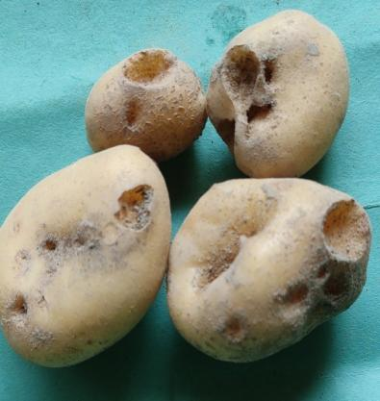**

**c. Damaged potato tuber by white grub**

**Fig. 2 a-c: White grub and their damage symptom**

|  |  |
| --- | --- |
| **C:\Users\91957\Desktop\thesis work JKD\PPT photo\Red ant\20230221_124915.jpg** |  |
| **a Red ant in potato field** | **b. Red ant infested potato field** |
|  | |

**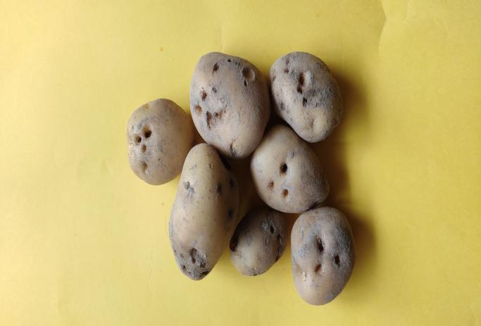**

1. **Red ant damaged potato**

**Fig.3 a-c: Red ant and their damage symptom**

|  |  |
| --- | --- |
|  |  |
| **a. wire worm in potato** | **b. wire worm in experimental field** | |
|  |  | |

**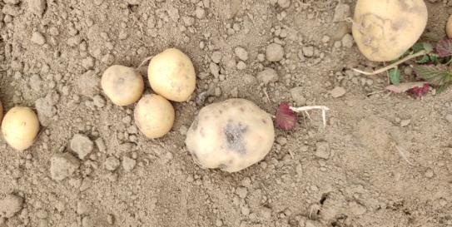**

**c.Wire worm damaged potato**

**Fig.4 a-c: wire worm and their damage symptom**

|  |  |
| --- | --- |
|  |  |
| **a. Adult moth of brinjal shoot and fruit borer.** | **b. True potato seed infested by brinjal shoot and fruit borer** |

**Fig.5 a-b: Adult borer brinjal shoot and fruit borer and True potato seed infested by Brinjal shoot and fruit**