**Original Research Article**

**Prevalence and Burden of Needle stick Injuries Among Healthcare Workers in a Catholic Hospital, Ghana: A Mixed-Methods Study.**

**Abstract**

**Background:** Needlestick injuries (NSIs) are a significant occupational hazard for healthcare workers (HCWs), particularly in low- and middle-income countries like Ghana. These injuries pose serious risks of bloodborne infections and result in substantial psychological and economic burdens. In Ghana, the burden of NSIs remains underreported, exposing HCWs to infections and significant psychosocial and economic challenges.

**Objective:** This study aimed to determine the prevalence of NSIs among HCWs at Catholic Hospital, Battor, and to assess the associated economic and psychological impacts.

**Methods:** A mixed-methods cross-sectional study was conducted among 203 HCWs involved in direct patient care. Quantitative data were collected via structured questionnaires and analyzed using STATA 14, while qualitative data were obtained through in-depth interviews with eight HCWs who had experienced NSIs and were analyzed thematically.

**Results:** The prevalence of NSIs among respondents was 34.16%, with the majority of cases (75.36%) occurring among nurses and midwives. Workplace pressure was found to be the only statistically significant risk factor (p < 0.001). Despite the availability of post-exposure prophylaxis (PEP), only 42.55% of NSIs were formally reported. The economic burden primarily stemmed from increased food intake during PEP, with associated costs ranging from GHC 500 to GHC 1000. Psychologically, many HCWs experienced fear, anxiety, insomnia, and emotional distress, with some contemplating job resignation due to repeated exposures.

**Conclusion:** NSIs are prevalent and underreported at Catholic Hospital, Battor, leading to notable economic and psychological consequences. Addressing workplace pressure, improving reporting systems, and providing adequate post-exposure support are critical in mitigating the burden of NSIs among HCWs in Ghana.

**Keywords:** Needlestick injuries, healthcare workers, psychological impact, economic burden, Ghana, post-exposure prophylaxis, occupational health

**1. Introduction**

Needlestick injuries (NSIs) are a frequent and significant occupational risk encountered by healthcare workers globally. NSIs are defined as penetrating stab wounds from needles or other sharp objects that may result in exposure to blood or other potentially infectious material(Bharti et al., 2022; Shenoy M et al., 2025). NSIs are common accidents in the healthcare environment and are harmful as they facilitate the transmission of blood-borne diseases.

Globally, over 2 million occupational exposures to sharp injuries occur annually among 35 million healthcare workers (HCWs) (Aliyo et al., 2024). These exposures contribute significantly to the transmission of bloodborne diseases like Human Immunodeficiency Virus (HIV), Hepatitis B and C infections, especially in sub-Saharan Africa where occupational health systems are often inadequate. In a study by (Bharti et al., 2022; Li et al., 2024a), healthcare workers (HCWs) face significant risks from percutaneous occupational exposure, with 37% of hepatitis B (HBV), 39% of hepatitis C (HCV), and 4.4% of HIV infections attributed to such exposure. In developing countries, 40–60% of HBV infections among HCWs are linked to occupational hazards whiles the proportion is less than 10% in developed countries, largely due to widespread vaccination coverage (Hosseinipalangi et al., 2022). The effects of these injuries extend beyond physical harm, significantly affecting the psychological well-being of healthcare workers. This can negatively influence their job performance. Today, most healthcare facilities recognize the significance of needlestick injuries and view them as key indicators for enhancing infection prevention and control practices. As a result, standard operating procedures have been established to help prevent the occurrence of such injuries (Alfulayw et al., 2021a; Bouya et al., 2020; Negash et al., 2024). Despite this effort, there are incidents of these injuries reported from India and various countries (Bharti et al., 2022; Shenoy M et al., 2025). A study conducted in Saudi Arabia estimated an annual rate of 3.2 sharps injuries per 100 occupied beds across 52 Ministry of Health hospitals(Abalkhail et al., 2022). Centres for Disease Control and Prevention (CDC) estimates that nearly 385,000 needles and sharps-related injuries occur every year to HCWs in the United States (Hosseinipalangi et al., 2022).

In Ghana, a study by (Tawiah et al., 2024b, 2024c), which aims to determine the prevalence and predisposing factors of NSIs among healthcare support staff in the Greater Accra region was high as compared to other regions. Similarly, (Kumah et al., 2020), conducted a study on the prevalence and risk factors associated with needlestick injuries (NSIs) among nurses at the Accident and Emergency Department of Komfo Anokye Teaching Hospital in Kumasi, Ghana, reported a 47% prevalence of needlestick and sharps injuries. Of these, 33.6% were specifically due to needlestick injuries. A leading causative factor of NSIs include high workload, mental stress, fatigue due to prolonged work hours, lack of supervision, and a casual attitude of senior staff( Aliyo et al., 2024).

In Ghana, data on needlestick and sharps injuries are scarce, with underreporting and poor documentation posing significant challenges(Obirikorang et al., 2019a, 2019b; Tawiah et al., 2024a). This lack of reliable data makes it difficult for authorities to assess the true impact of these occupational exposures and develop effective policy responses. When incidents go undocumented, the issue is easily overlooked, potentially becoming a silent yet serious health hazard.

Despite the availability of post-exposure prophylaxis (PEP) and training in infection prevention and control (IPC), NSIs persist due to factors such as high workloads, poor staffing, inadequate safety protocols, and underreporting. In Ghana, there is a dearth of reliable data on the prevalence of NSIs, making it difficult to inform policy and protect HCWs effectively. This study seeks to bridge this data gap by assessing the prevalence and burden of NSIs at Catholic Hospital, Battor, a major referral facility in Ghana’s Volta Region.

**2. Methods**

**2.1 Study Design and Setting:** This cross-sectional study was carried out at Catholic Hospital, Battor, a 245-bed referral hospital with a wide range of medical services and a high patient turnover rate. The hospital serves several adjoining districts, increasing HCWs’ workload and exposure risk.

**2.2 Study Population:** The study targeted HCWs engaged in direct patient care, including nurses, midwives, doctors, physician assistants, laboratory technicians, and ward assistants.

**2.3 Sampling and Sample Size:** A total of 250 HCWs were eligible, of which 203 participated, yielding a response rate of 81.2%. Census sampling was employed.

**2.4 Data Collection:** A structured, pretested questionnaire collected data on demographics, NSI history, reporting practices, and associated risk factors. Qualitative data were collected through semi-structured interviews with eight HCWs who had experienced NSIs.

**2.5 Data Analysis:** Quantitative data were entered into Excel and analyzed using STATA 14. Chi-square tests were used to identify associations between NSIs and demographic or workplace factors. A chi-square test was used to examine the association between needle stick injuries and sociodemographic factors. Statistical significance was set at p < 0.05 with a 95% confidence interval. Qualitative data were transcribed and analyzed thematically.

### **2.6** **Ethical Consideration**

Ethical approval for the study was obtained from the Ensign College of Public Health Ethics Review Board. Additional permission was secured from the heads of the healthcare facilities. Informed assent was obtained from all participants after the study’s purpose was explained. Those who consented indicated their agreement by ticking a designated box. Participation was entirely voluntary, and respondents were informed of their right to withdraw from the study at any point without any consequences. No financial or material incentives were provided to avoid introducing response bias.

**2.7. Study limitation**

The focus on a single hospital restricts the ability to apply the findings broadly across other healthcare facilities in Ghana. Information obtained through self-reporting may be influenced by memory lapses or intentional omission. Furthermore, the small number of participants in the qualitative interviews may have constrained the richness of insights. Lastly, the absence of observational techniques means that the accuracy of reported behaviors could not be independently verified.

**3. Results**

**3.1 Demographics:** Participants had a mean age of 31.2 years; 68% were female. Nurses and midwives formed the largest group (70.8%). Most had received IPC training (92.5%) and had less than 10 years of work experience.

**Table 1: Socio Demographic Characteristics of Respondents, N=203**

|  |  |  |  |  |  |
| --- | --- | --- | --- | --- | --- |
| **Characteristics** | **Frequency** | **Percentage** | **Mean** | **Min** | **Max** |
| **Age** |  |  | 31.2 | 19 | 59 |
| **Years of work experience** |  |  | 6 | 1 | 39 |
| **>10yrs**  **11-20yrs**  **<20yrs** | 175  13  11 | 87.94  6.53  5.53 |  |  |  |
| **Hours of work daily** |  |  | 7.7 | 1 | 12 |
| **Gender:**  Male  Female | 65  138 | 32  68 |  |  |  |
| **Education**  Middle/JHS/Sec  Undergraduate  Postgraduate | 52  142  8 | 25.74  70.3  3.93 |  |  |  |
| **Work Category**  Doctors/Dentist/PA  Nurses & Midwives  Laboratory Technicians  Ward Assistants | 9  143  7  43 | 4.46  70.79  3.47  21.29 |  |  |  |
| **IPC**  Trained  Not Trained | 186  15 | 92.54  7.46 |  |  |  |

**3.2** **Prevalence of NSIs:** During the study, healthcare workers reported various occupational injuries. Cuts (50%) and blood splashes (53.2%) were the most common incidents. Other injuries included bruises (11.33%), abrasions (3.45%), and sharps-related wounds (5.43%). About 37.44% experienced glove tears while handling sharps. Needlestick injuries were reported by 34.16% of respondents, with varying frequencies, but only 42.55% of these cases were formally reported.

Figure 1: **Prevalence of NSIs**

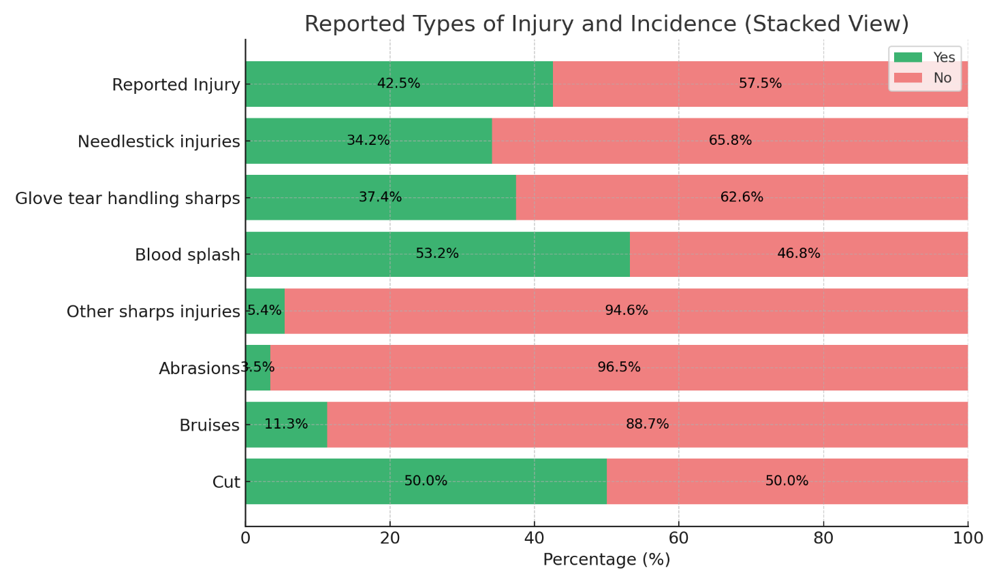

**3.3** **Risk Factors:** the diagram below shows a relationship between risk factors and their association with NSIs. Workplace pressure was the only statistically significant factor associated with NSIs (p < 0.001). Other factors such as fatigue, recapping, and glove tears were noted but did not reach statistical significance.

Figure 2: **Risk Factors for NSIs**

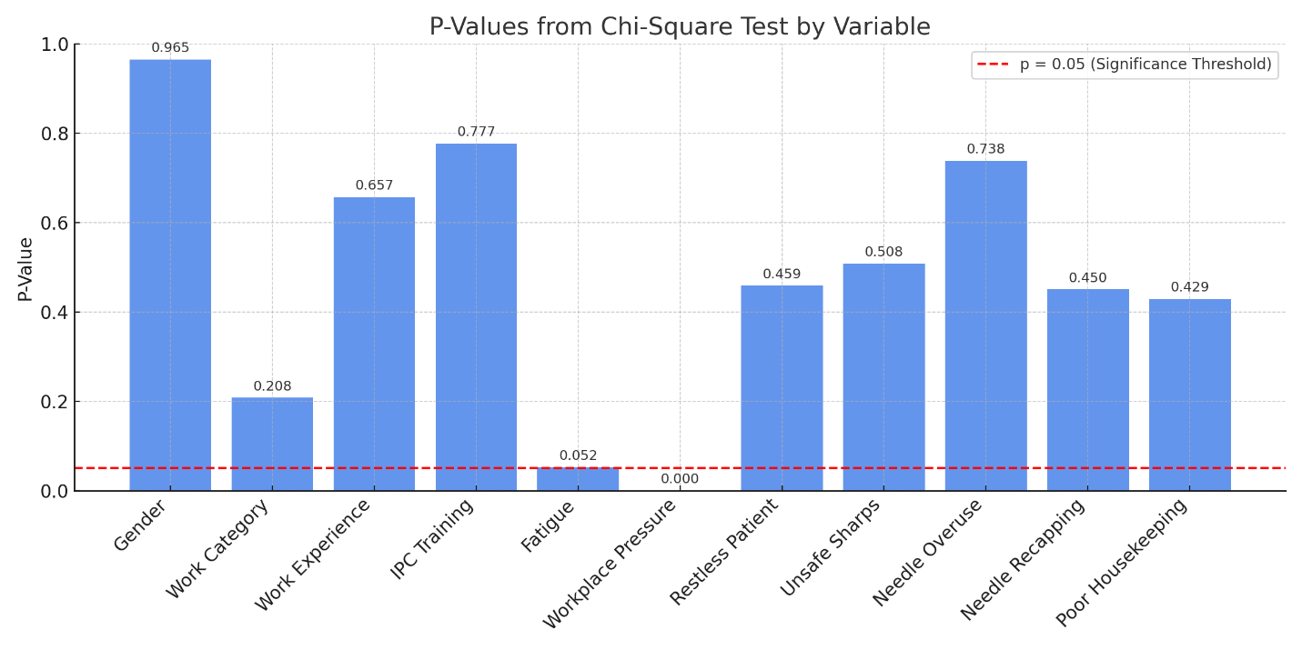

**3.4 Economic Burden:** Respondents expressed different views about the cost of management of post exposure prophylaxis. One respondent said taking care of themselves after the incident was not expensive. A 36-year-old midwife with 16 years of working experience said “*It did not cost me so much even though I was craving for more milo beverages*”. ( P2 midwife, 36 years with 16 years working experience).

However, several interviewees expressed high cost when taking the prophylaxis. Some were able to estimate the cost incurred during the treatment. Most of this high cost of living was spent on food:

“*It cost me a lot because I have to eat much. I sometimes wake up at dawn to eat. I used to eat twice a day but now I have to eat three or four times a day. I spent over GHC500.00 during the period of taking the drugs”* (P5 Nurse, 25 years, and 3 years working experience).

“*I spent over GHC 600.00 on food items. This is because I couldn’t prepare food for myself*” said (P3, a female nurse, 25 years old with 5 years working experience.) A male orderly, (P8 40 years old with 4 years’ work experience) also said “*I spent over GHC 1000.00 due to the additional food items”*.

**3.5 Psychological Impact:** Respondents expressed varied forms of feelings whiles on the post exposure prophylaxis. Some of them expressed fear during the period.

*“I taught I will be infected with the HIV and cried the whole day thinking my “world” was over because the patient was HIV positive. Because of the way I was frightened, next time I will quite the job anytime I get another prick”* was what a ( P3, female nurse, aged 25 with 5 years working experience expressed).

*“I was afraid initially but have to accept it. The drug made me sexually weak”,* (P8, orderlies, 40-year-old)

Besides, some of the respondents also experienced anxiety as expressed by a respondent, “*I was not comfortable most especially in the first instance. Because I did not know the status of the patient. Even though the person was later negative, I was still not happy within myself. This was because the condition has a window period”.* ( P2 Midwife 36 years old)

*“I was traumatized and threw my gloves away without continuing serving the medications to the rest of the patients*” (P4 , Nurse 26 years old with 5 years working experience)

**4. Discussion**

This study confirms that NSIs are a prevalent and pressing issue at Catholic Hospital, Battor. The prevalence rate of 34.16% aligns with other African studies but is lower than figures reported in parts of Asia and Europe(Alfulayw et al., 2021c; Aliyo et al., 2024; Tsegaye Amlak et al., 2023) and even by(Kumah et al., 2020) in Kumasi, Ghana. Workplace pressure emerged as the most significant risk factor for NSIs in this study, consistent with findings from Komfo Anokye Teaching Hospital, where 53.1% of nurses identified work pressure as a major contributing factor(Kumah et al., 2020).

The most significant risk factor identified was workplace pressure, which aligns with findings by (Kaweti & Feleke, 2024), who emphasized that excessive workloads, long shifts, and emotional fatigue significantly contribute to NSI occurrences. Similarly, in India, Bharti et al., (2022) observed that overburdened nurses were at higher risk due to hurried procedures and inadequate recovery time between shifts. Shift schedules and work pressure have been shown to contribute significantly to the rate of percutaneous injuries among healthcare workers in Ghana(Tawiah et al., 2025).

Underreporting of NSIs remains a persistent and worrying issue. In this study, only 42.55% of NSI cases were formally reported. This underreporting mirrors the 31.9% figure reported by (Kumah et al., 2020)and is echoed globally. Studies in Ethiopia and India have attributed underreporting to fears of stigma, perceived insignificance of minor injuries, and lack of knowledge regarding reporting protocols(Aliyo et al., 2024; Bharti et al., 2022; Shenoy M et al., 2025). A recent study in Ghana by (Tawiah et al., 2025b) emphasized that many HCWs were unaware of formal reporting systems or lacked access to standardized documentation procedures.

The economic burden faced by HCWs post-injury was primarily due to increased dietary demands necessitated by antiretroviral therapy (ART) and the disruption of regular routines. Costs incurred during post-exposure prophylaxis (PEP) ranged from GHC 500 to GHC 1000, a significant amount given average income levels. These findings are consistent with those from Poku et al., (2025a), who found that occupational injuries impose financial strain not only through direct medical costs but also through increased food consumption and loss of productivity. Although medication costs were absorbed by the hospital, the indirect costs were borne solely by the affected HCWs, compounding their economic vulnerability.

Beyond economics, psychological impact was profound and multifaceted. HCWs reported fear of HIV infection, anxiety over patient status, insomnia, and trauma. This aligns with the work of Hosseinipalangi et al. (2022), who noted that the psychological effects of NSIs can persist for months and contribute to job dissatisfaction and burnout. The fear of HIV seroconversion, particularly when patient status is unknown or within the window period, creates sustained emotional distress (Li et al., 2024b).

Furthermore, some respondents reported contemplating job resignation, a phenomenon reported in a similar context by Bouya et al. (2020), who found that repeated exposures to NSIs can significantly reduce job commitment and morale. Alfulayw et al. (2021c) highlighted that failure to address these psychological effects can lead to long-term workforce attrition, especially among nurses and junior staff.

Another emerging concern is institutional culture and response. Studies suggest that institutional apathy toward NSIs exacerbates the problem. A lack of feedback on reported cases, absence of psychological counseling, and punitive environments contribute to silence and fear among HCWs (Negash et al., 2024). Developing a non-punitive, supportive reporting environment has been recommended by CDC and WHO best practice guidelines, yet implementation remains slow in many LMICs including Ghana.

Infection Prevention and Control (IPC) training, although received by over 90% of respondents in this study, appears insufficient in translating knowledge into consistent practice. This points to a potential gap between training and behavior, likely influenced by systemic stressors such as understaffing, inadequate supervision, and time constraints. This observation is supported by Bharti et al. (2022) and Shenoy et al. (2025), who called for more practical, context-specific IPC drills and routine refreshers to foster muscle memory and reinforce safe practices.

**5. Conclusion**

The study revealed that needlestick injuries (NSIs) are common among healthcare workers at Catholic Hospital, Battor, with a 34.16% prevalence, particularly affecting nurses and midwives. Workplace pressure, underreporting, significant economic costs, and psychological distress such as fear and anxiety were key findings. Despite available post-exposure interventions, many HCWs lacked support and proper reporting channels.

To address these issues, the study recommends: strengthening non-punitive reporting systems, improving staffing levels, offering regular IPC training, providing post-exposure support, enforcing safety policies, and increasing institutional and governmental investment in occupational health. Routine research and surveillance are also needed to inform long-term prevention strategies.

Consent for publication

Not applicable

Data Availability

Data used to support this study are available from the corresponding author upon request.

Conflicts of Interest

The authors declared that they have no competing interests.

Disclaimer (Artificial intelligence)

Authors at this moment declare that generative AI (ChatGPT) has been used during the editing of manuscripts.

REFERENCE

Abalkhail, A., Kabir, R., Elmosaad, Y. M., Alwashmi, A. S. S., Alhumaydhi, F. A., Alslamah, T., Almoammar, K. A., Alsalamah, Y. A., & Mahmud, I. (2022). Needle-Stick and Sharp Injuries among Hospital Healthcare Workers in Saudi Arabia: A Cross-Sectional Survey. *International Journal of Environmental Research and Public Health*, *19*(10). https://doi.org/10.3390/ijerph19106342

Alfulayw, K. H., Al-Otaibi, S. T., & Alqahtani, H. A. (2021a). Factors associated with needlestick injuries among healthcare workers: implications for prevention. *BMC Health Services Research*, *21*(1). https://doi.org/10.1186/S12913-021-07110-Y

Alfulayw, K. H., Al-Otaibi, S. T., & Alqahtani, H. A. (2021b). Factors associated with needlestick injuries among healthcare workers: implications for prevention. *BMC Health Services Research*, *21*(1). https://doi.org/10.1186/S12913-021-07110-Y

Alfulayw, K. H., Al-Otaibi, S. T., & Alqahtani, H. A. (2021c). Factors associated with needlestick injuries among healthcare workers: implications for prevention. *BMC Health Services Research*, *21*(1), 1074. https://doi.org/10.1186/S12913-021-07110-Y<SPAN

Alfulayw, K. H., Al-Otaibi, S. T., & Alqahtani, H. A. (2021d). Factors associated with needlestick injuries among healthcare workers: implications for prevention. *BMC Health Services Research*, *21*(1). https://doi.org/10.1186/S12913-021-07110-Y

Aliyo, A., Insights, T. G.-E. H., & 2024, undefined. (2024). Prevalence and Risk Factors of Needlesticks and Sharp Injuries Among Healthcare Workers of Hospital in Bule Hora, West Guji Zone, Ethiopia. *Journals.Sagepub.Com*, *18*. https://doi.org/10.1177/11786302241272392

Bharti, P. P., Singh, N. P., Bajpai, P. K., Rani, V., Jain, P. K., & Khan, A. (2022). Prevalence of needle stick injuries, its associated factors and awareness among nursing staff at tertiary care hospital of North India. *Indian Journal of Community Health*, *34*(1), 54–59. https://doi.org/10.47203/IJCH.2022.V34I01.011

Bouya, S., Balouchi, A., Rafiemanesh, H., Amirshahi, M., Dastres, M., Moghadam, M. P., Behnamfar, N., Shyeback, M., Badakhsh, M., Allahyari, J., Mawali, A. Al, Ebadi, A., Dezhkam, A., & Daley, K. A. (2020). Global prevalence and device related causes of needle stick injuries among health care workers: A systematic review and meta-analysis. *Annals of Global Health*, *86*(1). https://doi.org/10.5334/AOGH.2698

Hosseinipalangi, Z., Golmohammadi, Z., Ghashghaee, A., Ahmadi, N., Hosseinifard, H., Mejareh, Z. N., Dehnad, A., Aghalou, S., Jafarjalal, E., Aryankhesal, A., Rafiei, S., Khajehvand, A., Nasab, M. A., & Kan, F. P. (2022). Global, regional and national incidence and causes of needlestick injuries: a systematic review and meta-analysis. *Eastern Mediterranean Health Journal*, *28*(3), 233–241. https://doi.org/10.26719/EMHJ.22.031

Kaweti, G., & Feleke, T. (2024). Prevalence and associated factors of needlestick and sharp object injuries among healthcare workers in Ethiopia: a systematic review and meta-analysis. *Frontiers in Epidemiology*, *4*, 1385417. https://doi.org/10.3389/FEPID.2024.1385417/BIBTEX

Kumah, A., Agortimevor, H., Akakpo, F., Akpeke, H., Azi, G., & Gblende, E. (2020). Prevalence and Risk Factors Associated with Needle Sticks and Sharp Injuries among Nurses at the Accident and Emergency Department of Komfo Anokye Teaching Hospital, Kumasi-Ghana. *International Journal of Research in Nursing*, *11*(1), 47–53. https://doi.org/10.3844/ijrnsp.2020.47.53

Li, X., He, Q., & Zhao, H. (2024a). Situation and associated factors of needle stick and sharps injuries among health-care workers in a tertiary hospital: a cross-sectional survey. *BMC Health Services Research*, *24*(1). https://doi.org/10.1186/s12913-024-11439-5

Li, X., He, Q., & Zhao, H. (2024b). Situation and associated factors of needle stick and sharps injuries among health-care workers in a tertiary hospital: a cross-sectional survey. *BMC Health Services Research*, *24*(1), 1–7. https://doi.org/10.1186/S12913-024-11439-5/TABLES/2

Negash, F. B., Hailemichael, A., Haileslassie, E., Hawaz, E., Zerai, S., Tesfamariam, Z., & Lebahati, L. (2024). Prevalence, response and associated factors of needlestick injury among health care workers in Orotta National Referral Hospital, Eritrea. *BMC Health Services Research*, *24*(1). https://doi.org/10.1186/S12913-024-11255-X

Obirikorang, C., Opoku, S. K., Obirikorang, Y., Acheampong, E., Yorke, J., Donkoh, E. T., Chidera, C., Sarpong, D., Anto, E. O., Issahaku, R., Appeaning, M., Nelson, C., Batu, E. N., Amakwah, B., Asamoah, E. A., Amoah, B., & Afraine, B. O. (2019a). Awareness and Occupational Exposures to Needlestick Injuries among Healthcare Workers: A Quantitative Assessment in a Ghanaian Metropolis. *Global Journal on Quality and Safety in Healthcare*, *2*(3), 70–77. https://doi.org/10.4103/JQSH.JQSH_9_19<SPAN

Obirikorang, C., Opoku, S. K., Obirikorang, Y., Acheampong, E., Yorke, J., Donkoh, E. T., Chidera, C., Sarpong, D., Anto, E. O., Issahaku, R., Appeaning, M., Nelson, C., Batu, E. N., Amakwah, B., Asamoah, E. A., Amoah, B., & Afraine, B. O. (2019b). Awareness and Occupational Exposures to Needlestick Injuries among Healthcare Workers: A Quantitative Assessment in a Ghanaian Metropolis. *Global Journal on Quality and Safety in Healthcare*, *2*(3), 70–77. https://doi.org/10.4103/JQSH.JQSH_9_19

Poku, C. A., Ahulu, A. A., Otomo, J., Hagan, D., Dwumfour, C. K., Issifu, J. S., & Dzomeku, V. (2025). Occupational injuries, mental workload and coping strategies among the nursing workforce in the Eastern Region of Ghana: a multi-centre study. *Springer*, *24*(1). https://doi.org/10.1186/S12912-025-02738-1

Shenoy M, S., Vangara, H., Rego, J. E., Saldanha, I., Lobo, G., Kassim, S., Baliga, S., R, P. M., & Rao, P. (2025). Trends of needle stick injuries among health care workers in a tertiary care center in South India. *Clinical Epidemiology and Global Health*, *31*, 101903. https://doi.org/10.1016/J.CEGH.2024.101903

Tawiah, P. A., Appiah-Brempong, E., Okyere, P., Adu-Fosu, G., Ashinyo, M. E., Edziah, F. S., Amesimeku, E. D., & Appiah Baffoe, P. (2025a). Prevalence and predictors of percutaneous injuries among health workers in Ghana: a cross-sectional study. *Frontiers in Public Health*, *13*. https://doi.org/10.3389/FPUBH.2025.1561098

Tawiah, P. A., Appiah-Brempong, E., Okyere, P., Adu-Fosu, G., Ashinyo, M. E., Edziah, F. S., Amesimeku, E. D., & Appiah Baffoe, P. (2025b). Prevalence and predictors of percutaneous injuries among health workers in Ghana: a cross-sectional study. *Frontiersin.Org*, *13*. https://doi.org/10.3389/FPUBH.2025.1561098/FULL

Tawiah, P. A., Appiah-Brempong, E., Okyere, P., & Ashinyo, M. E. (2024a). Exposure to needlestick injury among healthcare support staff in Greater Accra, Ghana: a cross-sectional study. *Bmjpublichealth.Bmj.Com*, *2*, 681. https://doi.org/10.1136/bmjph-2023-000681

Tawiah, P. A., Appiah-Brempong, E., Okyere, P., & Ashinyo, M. E. (2024b). Splash of body fluids among healthcare support staff in Ghana: a cross-sectional study. *SAGE Open Medicine*, *12*. https://doi.org/10.1177/20503121241234473

Tawiah, P. A., Appiah-Brempong, E., Okyere, P., & Ashinyo, M. E. (2024c). Splash of body fluids among healthcare support staff in Ghana: a cross-sectional study. *SAGE Open Medicine*, *12*. https://doi.org/10.1177/20503121241234473

Tsegaye Amlak, B., Tesfa, S., Tesfamichael, B., Abebe, H., Zewudie, B. T., Mewahegn, A. A., Chekole Temere, B., Terefe, T. F., GebreEyesus, F. A., Tsehay, T., & Solomon, M. (2023). Needlestick and sharp injuries and its associated factors among healthcare workers in Southern Ethiopia. *SAGE Open Medicine*, *11*. https://doi.org/10.1177/20503121221149536<SPAN