***Sonerila gigantea* (Melastomataceae) – A new species from Western Ghats, India.**

**ABSTRACT**

The *Sonerila gigantea* is a new acaulescent species found in Mallalli Falls, Kodagu District, Karnataka, India, part of the Western Ghats. This species has distinguishable characteristics from the genus *Sonerila* worldwide. *S. gigantea* compared with *Sonerila wallichii* Benn. & *Sonerila grandis* Ridl. The species shown differ in several characteristics described in a table form with taxonomic keys and even explained micro morphology characters like Pollen and Seed. The present report deliberates on the new species *Sonerila gigantea* from the Western Ghats, India.

*Keywords****:*** *Acaulescent, Giant habit, Kodagu, Stemless Sonerila, White patches.*

1. **INTRODUCTION:**

The Melastomataceae Juss. is one of the Neotropic widely distributed family in the world which comprises 169 accepted genera (Kew Royal Botanical Garden, POWO, 2024) and currently has about 5,858 species (Ulloa *et al*., 2022), The leaf character shows acrodromous venation, making it easy to identify as Melastomataceae (Hicky 1973). The tribe Sonerilae (Melastomataceae) occurs in Southeast Asia and Madagascar, with few species from Neotropic regions (Renner 1993). The genus *Sonerila* Roxb., a complex genus in Melastomataceae, explained in the Old World, is represented by 180 taxa (Cellinese, 1997). Genus *Sonerila* in India reported about 50 species and one variety (about 86%) out of 43 species endemic to the Western Ghats (Resmi *et al*., 2021). In Karnataka, 15 *Sonerila* species have been reported, including the *Sonerila talbotii* Giri & Nayar, *Sonerila raghaviana* Ratheesh, Sunil, Nandakumar & Shaju and Sonerila bababudangiriensis Karadakatti & Kakkalameli, which are endemic to the state (Saldanha 1984; Giri & Nayar 1986; Ratheesh *et al*., 2014; Sanjappa & Sringeswara 2019; Ravikumar *et al*., 2021; Karadakatti & Kakkalameli 2024; Karadakatti & Kakkalameli 2025). The present studies express the morphology (Macro & Micro) and the diversity of rare plant new species *Sonerila gigantea* from Kodagu District, Karnataka, the region itself from the Western Ghats. Reporting species compared with *Sonerila wallichii* Benn. & *Sonerila grandis* Ridl (Ridley 1946). The other micromorphology, like seed and pollen parameters, is discussed using SEM (Fig. 4) (Patel *et al*., 1984; Girish & Nayar 1986; Bhattacharya *et al*., 2006).

1. **MATERIALS AND METHODS:**

The characteristics are explained using taxonomic shreds of evidence, herbarium specimens and web-based specimens (Ridley 1946). The collected pollens were stored with 70 % alcohol to follow the further procedure. The species were analysed using a Scanning Electron Microscope to describe the micro-morphological characteristics like Pollen and Seed parameters (Patel *et al*., 1984; Girish & Nayar 1986; Bhattacharya *et al*., 2006). The coordinates were marked using Garmin – GPS Etrex 10 and later graphed using QGIS 3.28.2 software to create a delimited data map showing species location (Fig. 1).

* 1. **Study area:** The *Sonerila gigantea* was collected from Near Kallahalli Tea Estate, Mallalli Falls Road, Kodagu, Karnataka, India (12°40'20.0" N 75°46'22.9" E) elevation of about 1050 m. Well-grown on hill slopes and adapted to shady and wet soil (Fig. 1).

1. **RESULT AND DISCUSSION:**

**Taxonomic treatment:**

***Sonerila gigantea*** **Karadakatti & Kakkalameli sp nov.,**

The species can be easily distinguished by its habit, leaf size and texture of the lamina, inflorescence, flower, fruit, Pollen shape and size and even the seed texture. *S. gigantea* resembles *S. grandis* Ridl. and *S. wallichii* Benn. from Karnataka, the key characteristics of the above-mentioned.

**Typus:** INDIA, Karnataka, Kallahalli Tea Estate, Mallalli Falls Road, Kodagu District, 12°40'20.0" N 75°46'22.9" E. 1050 m. 19.09.2024, Prashant Karadakatti & Siddappa B Kakkalameli. M009, (*holo* UASB5782).

**Figs. 2 & 3.**

Herb, Perennial, erect, c. 32 cm tall. Acaulescent tuber measures about 1.5 – 2 cm diameter, spherical, brown. Roots-branched flesh white to pale green from the lower to the upper. Leaves are 10 – 18 cm wide, 15 – 30 cm height with petiole, 6 nerved, veins pinnate, three pairs from the base, 1 – 2 pairs from midrib above; lamina dark green dorsal side white spotted patches associated with small spines or papillae scattered measured about 0.5 – 1 mm, pale green at ventral side, glabrous, sparsely gland-dotted, toothed margins, serrate, leaf base orbicular with equal base and cordate; Petioles 10 – 25 cm long, claret tinge at the base to pale green at the tip, glabrous, sub-scapose. Inflorescence, 2 – 4, bostryx cyme, 2 – 5 cm long, 20 – 40 flowered, unbranched; peduncle 20 – 32 cm long, claret tinge to pale green, glabrous, angular; bracts and bracteoles not prominent. Flowers trimerous 1.5 – 2 cm; pedicel sub-angular, 1 – 1.5 cm longer, pale green, gland-tipped trichomes; Hypanthium campanulate, 1.5 – 2 cm, three-lobed, pale green base, gland-tipped trichomes; Petals three, 0.5 – 1.2 cm, polypetalous, oblongate, stellate and acute apex, pink adaxial, abaxial vanishes, dark pink midrib; Sepals parrot green, 1 – 3 mm, polysepalous, gland-tipped trichomes; Stamens 3 alternate to petals, filaments measured about 4 – 7 mm, pale pink, glabrous; Anthers three, yellow, beaked at apex, glabrous, 3 – 6 mm anther lobes dorsifixed, cordate at base, Deeply beaked; Ovary inferior, style filiform 6 – 8 mm, dark pink, glabrous, many carpels; Fruits capsule, pale green, 1 – 1.5 cm, gland-tipped trichomes, sometimes glabrous; Seeds numerous, obovoid and pusticulate.

**Flowering and Fruiting:** August to November

**Habitat:** Hill slopes, water stream, misty places, associated with *Sonerila wallichii* Benn, *Commelina indehiscens* E. Barnes, *Adiantum* sp L.

**Distribution:** Coorg, Karnataka, India 1050 MSL elevation from 3444 ft (Present Record).

**Etymology:** The specific epithet refers to the plant being a giant or big individual (gigantic/gigantea) compared to the existing *Sonerila* species in the world, except the species reported from the country Indonesia is *Sonerila grandis* Ridl. hitherto the plant described with the word using the biggest habit. However, it shows a lot of variations in morphology, with the present report on *Sonerila gigantea*. The plant is located on Mallalli Falls Road, Coorg District, Karnataka, India.

**Specimen examined:** INDIA, Karnataka, Kallahalli Tea Estate, Mallalli Falls Road, Kodagu District, 12°40'20.0"N 75°46'22.9"E. 1050 m. 19.09.2024, Prashant Karadakatti & Siddappa B Kakkalameli. UASB5782

**Conservation Status:** The surveyed regions from Kodagu District, Karnataka, India, reveal that *Sonerila gigantea* exists in only one mentioned regions, which is on the way Mallalli Falls Near Kallahalli Tea Estate. Fewer populations are found near the water stream on road cuts (Slopes). The species were found within a 50 m range. Rarely found, hence, this species may be categorised under Data Deficient (DD) due to the lack of knowledge on its distribution (IUCN Standards and Petition Committee 2024).

**Note:** As per Ridley 1946, *Sonerila grandis* Ridl. from Indonesia & *Sonerila repens* Stapf & King. Malaysia has since had the biggest population in the world. The evidence says the individual is about nearly 20 cm maximum, and the present reporting *Sonerila gigantea* from India is about 30 cm and somehow exceeds (Table 1).

**3.1. Micro Morphology:**

**3.1.1. Pollen Morphology**

In the Pollen NPC classification by Erdtman 1969, all parameters included Number, Position and Characters (NPC). *Sonerila gigantea* pollen grains usually have a Triangular obtuse, convex shape at the polar view, the equatorial view shows a non-angular, elliptic, truncate, obtuse and an aperture Heterocolpate. Approximately 16 – 18 × 13 – 15 µm, small fibrous structures on the pollen surface are striate-reticulate. (Fig. 4).

**3.1.2. Seed Morphology**

The *Sonerila gigantea* seeds are numerous, ellipsoid, 490 – 525 × 175 – 215 µm, brown to dark brown, raphe remains out with dorsal surface tubercle, well-differentiated smaller and larger tubercles, from micropyle to dorsal shows small pusticles with larger tubercles, large tubercles measure about 24 × 26 µm in upper view, 10 – 24 × 6 – 12 µm in side view, small tubercles measures about 2 – 4 × 2 – 4 µm. less exposed testa cells, margins undulated with each other, about 30 – 35 × 20 – 30 µm (Fig. 4).

* 1. **Dichotomous Key Characters of Sonerila in Karnataka:**

|  |  |  |
| --- | --- | --- |
| **1a.** | With stem | **2** |
| **1b.** | Without stem | **6** |
| **2a** | Well adapted to the rocks | ***S. konkanensis*** |
| **2b** | Well adapted to the soil | **3** |
| **3a** | Inflorescence one in each individual | ***S. bababudangiriensis*** |
| **3b** | Inflorescence more than one in each individual | **4** |
| **4a** | Unequal leaf base with dense pubescent | ***S. cannanorensis*** |
| **4b** | Unequal leaf base with less pubescent | **5** |
| **5a** | Habit less branched | ***S. talbotii*** |
| **5b** | Habit more branched | ***S. versicolor* var *axillaris*** |
| **6a** | Tuberous | **7** |
| **6b** | Non tuberous | ***S. wallichii*** |
| **7a** | Habit within 25 cm | **8** |
| **7b** | Habitat more than 25 cm | ***S. gigantea*** |
| **8a** | Inflorescence unbranched | **9** |
| **8b** | Inflorescence branched | ***S. veldkempiana*** |
| **9a** | More than two inflorescences in each individual | **10** |
| **9b** | Only two inflorescences in each individual | ***S. gadgiliana*** |
| **10a** | Leaf with less papillae | **11** |
| **10b** | Leaf with dense papillae | ***S. raghaviana*** |
| **11a** | Flowers more than 6 in each inflorescence | ***S. scapigera*** |
| **11b** | Flowers up to 6 in each inflorescence | ***S. rotundifolia*** |

**COMPETING INTERESTS DISCLAIMER:**

Authors have declared that they have no known competing financial interests OR non-financial interests OR personal relationships that could have appeared to influence the work reported in this paper.

**REFERENCE:**

Bhattacharya K., Majumdar, M. R., & Bhattacharya, S. G. (2006). A textbook of palynology. Bijay Publications. 51 – 74.

Cellinese, N. (1997). Notes on the systematics and biogeography of the *Sonerila* generic alliance (Melastomataceae) with a special focus on fruit characters. Tropical Biodiversity, 4(1), 83-93.

Erdtman, G. (1969). Handbook of palynology: morphology-taxonomy-ecology: an introduction to the study of pollen grains and spores. 21 – 37.

Giri, G. S., & Nayar, M. P. (1986). A new species of *Sonerila* (Melastomataceae) from India. Journal of Japanese Botany, 61(11), 344-348.

Hickey, L. J. (1973). Classification of the architecture of dicotyledonous leaves. American journal of botany, 60 (1), 17-33. DOI: <https://doi.org/10.1002/j.1537-2197.1973.tb10192.x>.

Karadakatti, P., & Kakkalameli, S. B. (2024). *Sonerila konkanensis* Resmi & Nampy (Melastomataceae)–an addition to the flora of Karnataka, India. Journal of Threatened Taxa, 16 (5), 25279-25282. DOI: <https://doi.org/10.11609/jott.8882.16.5.25279-25282>.

Karadakatti, P. & S.B. Kakkalameli (2025). *Sonerila bababudangiriensis* (Melastomataceae), a new species of herb from the Western Ghats of India. Journal of Threatened Taxa 17(4): 26917–26922. <https://doi.org/10.11609/jott.9636.17.4.26917-26922>

Patel, V. C., Skvarla, J. J., & Raven, P. H. (1984). Pollen characters in relation to the delimitation of Myrtales. Annals of the Missouri Botanical Garden, 858-969.

World Checklist of Melastomataceae, Plants of the world online. Kew Royal Botanic Garden (POWO). 2024. URL: <https://powo.science.kew.org/taxon/urn:lsid:ipni.org:names:30374374-2/general-information> (Accessed 26 January 2025).

Ratheesh, M. K., Narayanan, C. N., Sunil, M. K., Nandakumar, T., Shaju, V., Mini, K.T., Satheesh, & Balakrishnan, V. (2014). *Sonerila raghaviana* sp. nov. (Melastomataceae), a new species from southern Western Ghats of Karnataka, India. Int. J. of Adv. Res. 2 (10) 772-777.

Ravikumar, K., Tangavelou, A, C., & Page, N. (2021). Seed Plants of Karnataka – A Concise Dictionary. Foundation for revitalization of local health traditions trans-disciplinary university (FRLHT-TDU), Bengaluru. National Biodiversity Authority Chennai. 836.

Ridley, H. N. (1946). Additions to the flora of Borneo and other Malay Islands: XIX. Kew Bulletin, 1(1), 31-43.

Saldanha, C. J. (1984). Flora of Karnataka, Oxford & IBH Publishing Co. Pvt. Ltd., New Delhi. Calcutta. Vol. II: 37 – 46.

Sanjappa. M., & Sringeswara. A. N. (2019). Flora of Karnataka a checklist. Karnataka Biodiversity Board. Vol. 2. 495 - 497.

Ulloa Ulloa, C., Almeda, F., Goldenberg, R., Kadereit, G., Michelangeli, F. A., Penneys, D. S., & Veranso-Libalah, M. C. (2022). Melastomataceae: global diversity, distribution, and endemism. In Systematics, evolution, and ecology of Melastomataceae Cham: Springer International Publishing. (pp. 3-28).

**Table 01.** Comparison of the morphological characteristics of *Sonerila gigantean*, *Sonerila wallichii* & *Sonerila grandis*.

|  |  |  |  |
| --- | --- | --- | --- |
| **Parts** | ***Sonerila gigantean*** Karadakatti & Kakkalameli. | ***Sonerila wallichii*** Benn. | ***Sonerila grandis*** Ridl. |
| **Habit** | Herb measured 32 cm | Herb measured 15 – 18 cm | Herb measured 19 cm |
| **Root / Tuber** | Small tuber 1.5 – 2 cm diameter, brown in color. | Non–Tuberous | Non-tuberous. |
| **Leaf** | Lamina 10 – 18 cm wide, 15 – 30 cm height, 6-nerved, glabrous petiole, dark green dorsal side with claret tinge spines or papillae scattered measured about 1 – 3 mm, claret at ventral side, glabrous, densely gland-dotted, toothed margins, serrate, leaf base slightly orbicular with equal base and cordate. | Parrot green 4–10 cm wide, 3–14 cm long, 4–6 nerved, four pairs  from the base, 4–12 pairs from the midrib, sparsely gland-tipped  trichomes. | Green 5.5 – 14 cm wide, 13 – 18 cm long, 7-nerved, transverse nerves up to 30, glabrous petiole 5 – 9 cm long. Short bristles on the dorsal side, glabrous at the ventral, denticulate, serrate margins, ovate acuminate, acute with rounded cordate base. |
| **Inflorescence** | 2 – 4 inflorescence from each, unbranched, bostryx cyme, small gland-dotted trichomes, 2 – 5 cm long, 20 – 40 flowered | Two to three inflorescences from each individual, unbranched,  scorpioid cyme, 2–5 from each habit, and 5–18 flowers. | 2 - 3 inflorescence from each individual, branched, axillary cyme, glabrous, 5 – 9 from each habit and 20 – 22 flowers. |
| **Flower** | 1.5 – 1.8 cm, trimerous, pink. | 1.5–2 cm, trimerous, rarely tetramerous, moderate pink. | 8 mm, trimerous, moderate pink. |
| **Peduncle** | Angular, 20 – 30 cm long claret tinge to pale green & glabrous. | Quadrangular, 5–18 cm long pale green to white at tip with glandtipped  trichomes. | Angular, 7.5 cm long, glabrous. |
| **Petals** | Three, pale pink 0.5 – 1.2 cm | Moderate pink to dark pink; 4–10 mm ovate-oblong & acuminate  glandular hairs on abaxial midrib. | Three, pink, 4 mm. |
| **Fruit** | Long capsule, angular, glabrous at pedicel, 1.5 × 0.6 cm. | Capsule short, angular, gland-tipped trichomes, 0.5 × 0.7 cm. | Long capsule, obconical, angular, glabrous, densely minute punctate 5 × 4 mm. |

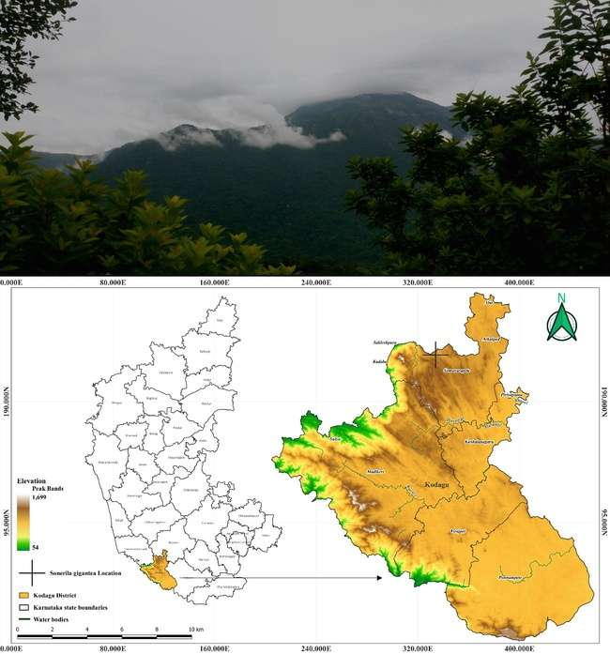

**Figure 1.** *Sonerila gigantea* Upper image landscape of species origin, Lower image species location Map. (Drawn using the software QGIS 3.28.2 version).

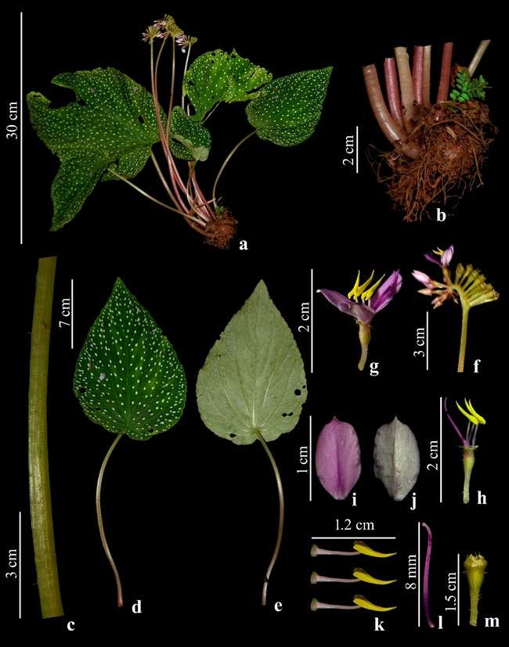**Figure 2.** ***Sonerila gigantea***. **a.** Habit, **b.** Tuber, **c.** Petiole, **d.** Leaf dorsal, **e.** Leaf ventral, **f.** Inflorescence, **g.** Flower, **h.** Hypanthium, **i.** Petal dorsal, **j.** Petal ventral, **k.** Anthers, **l.** Gynaoecium, **m.** Fruit.

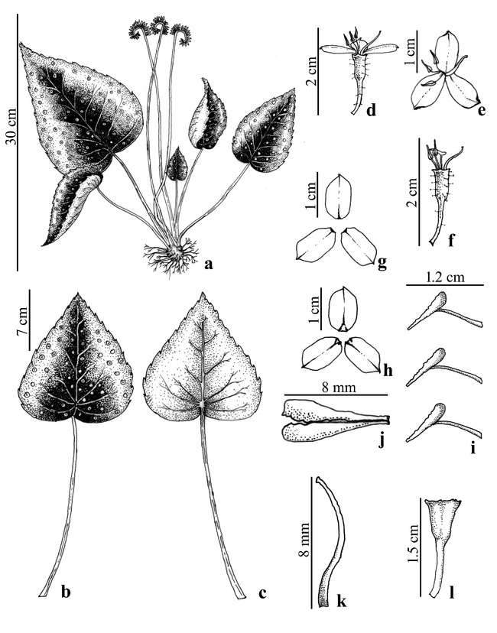**Figure 3.** ***Sonerila gigantea***. **a.** Habit, **b.** Leaf dorsal, **c.** Leaf ventral, **d.** Flower side view, **e.** Flower front view, **f.** Hypanthium, **g.** Petal abaxial, **h.** Petal adaxial, **i.** Anthers, **j.** Anther lobe, **k.** Gynoecium, **l.** Fruit.

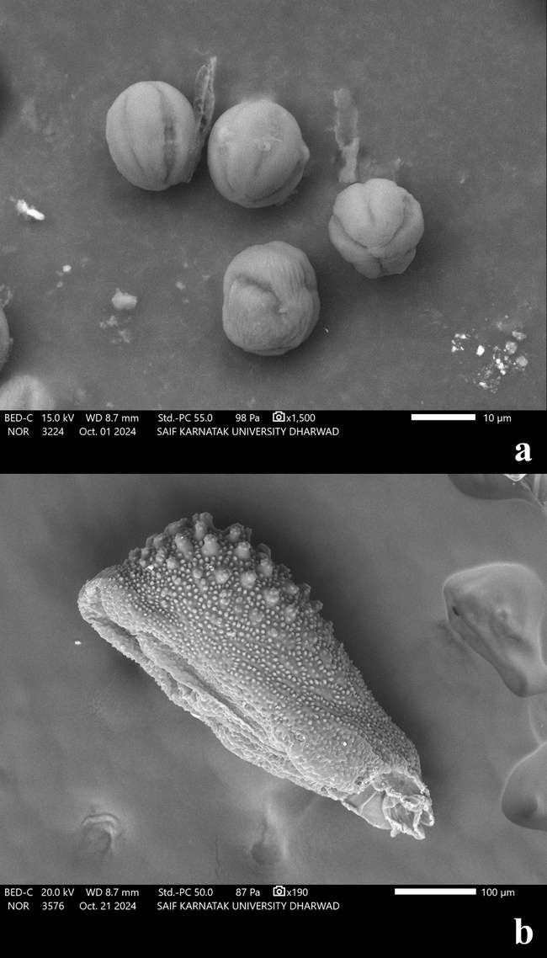

**Figure 4.** ***Sonerila gigantean.*** Scanning Electron Microscope Images **a.** Pollen grains & **b.** Seed.