Journal Name: | Asian Journal of Probability and Statistics
Manuscript Number: | Ms_AJPAS_137134
Title of the Manuscript: | Non-Parametric Estimation of the Posterior Distribution in Monitoring Primary School Enrollment in Mt. Elgon Region, Kenya
Type of the Article

PART 1: Comments

 | Reviewer’s comment  Artificial Intelligence (AI) generated or assisted review comments are strictly prohibited during peer review. | Author’s Feedback (It is mandatory that authors should write his/her feedback here)
Please write a few sentences regarding the importance of this manuscript for the scientific community. A minimum of 3-4 sentences may be required for this part.

Is the title of the article suitable?
(If not please suggest an alternative title)

Is the abstract of the article comprehensive? Do you suggest the addition (or deletion) of some points in this section? Please write your suggestions here.

Is the manuscript scientifically, correct? Please write here.
Are the references sufficient and recent? If you have suggestions of additional references, please mention them in the review form.

Is the language/English quality of the article suitable for scholarly communications?

Optional/General comments | Non-Parametric Estimation of the Posterior Distribution in Monitoring Primary School Enrolment in Mt. Elgon Region, Kenya  - The paper is well structured but need some clarity.  Abstract:  - Remove extra closing parenthesis after grades.  - Breaking of words should be avoided.  - Alignment issues and formatting is there.  Introduction:  - Check the citation formatting in the below given sentence, use proper citation format.  - The list of monitoring challenges must be given in bulletin.  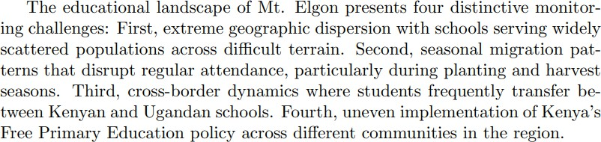  Methodology:  - Justify how missing values from 12% of grade 7records affect the analysis.  - Grammatical mistakes should be avoided.  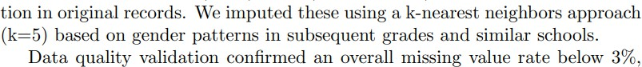  References:  - Check all the references are properly citated.

PART 2:

 | Reviewer’s comment | Author’s Feedback (It is mandatory that authors should write his/her feedback here)
Are there ethical issues in this manuscript? | (If yes, Kindly please write down the ethical issues here in details)

Reviewer details:
R. Jayasree, Avinashilingam University for Women, India

