# **Demographic and Histopathological Spectrum of Gastrointestinal Cancers Excluding Hepatobiliary System: A 10-Year Review from Makurdi, North Central Nigeria**

## **Abstract:**

Gastrointestinal (GI) cancers are a significant global health burden, with rising incidence and mortality in low- and middle-income countries. Despite this trend, there is a paucity of region-specific data in many parts of Nigeria, particularly on extra-hepatobiliary GI malignancies. This study aims to evaluate the demographic and histopathological spectrum of gastrointestinal cancers, excluding the hepatobiliary site, in Makurdi, North Central Nigeria. A retrospective descriptive study was conducted over 10 years (January 2014 – December 2023) at the histopathology department of a tertiary hospital in Makurdi. All histologically confirmed malignant GI tumours, excluding hepatobiliary cancers, were retrieved and analysed for anatomical site, age, sex, and histological subtype. A total of 155 gastrointestinal malignancies were identified. Colorectal and anal cancers were most common (83%), followed by gastric cancers (12%) and small intestine/mesenteric tumours (5%). The peak incidence occurred between the 5th and 6th decades of life, with a male-to-female ratio of 1.4:1. Adenocarcinoma was the predominant histological type (64.4%), with mucinous (13%) and poorly differentiated variants (7%) also noted. Gastric cancers were mainly adenocarcinomas (74%), while colorectal malignancies showed diverse histological subtypes, including mucinous, signet ring, and papillary variants. Colorectal and gastric cancers constitute the majority of GI malignancies in Makurdi, with adenocarcinoma being the most frequent histologic type. The predominance in middle-aged adults and the diversity of histological patterns highlight the need for region-specific cancer control strategies, improved diagnostic capacity, and public health interventions targeting early detection and prevention.

**Keywords:** Adenocarcinoma, Colorectal Cancer, Gastric Cancer, Gastrointestinal Cancers, Histopathology, North Central Nigeria, Retrospective Study.

**Introduction:**

Gastrointestinal (GI) cancers are a heterogeneous group of malignancies that significantly contribute to global cancer morbidity and mortality. Excluding the hepatobiliary site, these cancers encompass malignancies of the stomach, small intestine, colorectum, and anus, each with distinct aetiological and histopathological characteristics. Globally, colorectal and Anal cancer (CRAC) is the third most commonly diagnosed cancer and the second leading cause of cancer-related deaths, with increasing incidence in low- and middle-income countries (LMICs) due to westernisation of lifestyle and dietary patterns1. Gastric cancer remains a leading cause of cancer mortality, particularly in East Asia and parts of South America2, while small intestinal and anal cancers are relatively rare but clinically significant due to diagnostic delays and diverse presentations3.

Projections anticipate a more than 50% increase in GI cancer incidence over the next two decades, with a disproportionately higher burden expected in developing nations 4,5. This rising trend is a critical concern for global public health planning, demanding proactive and adaptive responses from healthcare systems 3,4.

Africa is currently undergoing a profound epidemiological transition where non-communicable diseases (NCDs), including cancers, are predicted to surpass communicable, maternal, neonatal, and nutritional diseases as the leading cause of mortality between 2030 and 20406. This demographic shift intensifies the public health imperative to address cancer care across the continent, necessitating a re-evaluation of healthcare priorities and resource allocation6. The projected surge in GI cancers in developing countries, coupled with Africa's overall NCD burden shift, points towards a looming public health crisis. Existing healthcare infrastructures in regions like North Central Nigeria are largely ill-equipped to manage this impending demand 4,7. Challenges such as prevalent late-stage presentation and inadequate diagnostic facilities in Nigeria suggest that this increasing burden will likely manifest as a surge in advanced-stage cases, leading to higher morbidity, poorer quality of life, and increased mortality rates, unless substantial proactive measures are implemented to strengthen cancer care infrastructure and access 4.7.

Understanding the epidemiology of GI cancers at a localised level is crucial due to significant variations in risk factors, access to healthcare, and diagnostic capabilities across different regions within Africa and Nigeria itself 5. These local insights are vital for tailoring effective public health interventions and resource allocation 8. Makurdi, as the capital of Benue State and a key city in North Central Nigeria, offers a valuable lens through which to examine local disease patterns that might otherwise be generalised or obscured in broader national statistics due to data limitations4.

Historically, an "African enigma" posited a low occurrence of gastric cancer despite a high prevalence of ***Helicobacter pylori*** infection in some northern Nigerian regions 6. However, this apparent paradox is now largely attributed to better access to diagnostic facilities in southern Nigeria, leading to higher detection rates9. This suggests that reported lower incidence rates in North Central Nigeria, including Makurdi, may not accurately reflect the true disease burden but rather an underdiagnosis due to limited diagnostic infrastructure and inadequate data recording9,10. This highlights a systemic issue where data limitations directly impact the accuracy of epidemiological understanding, consequently hindering effective public health planning and targeted interventions 10. Therefore, localised studies, even with their inherent limitations, provide invaluable granular data for understanding regional specificities 4.8.

While specific findings from numerous retrospective studies directly within Makurdi focusing solely on gastrointestinal cancers are limited, this report integrates available direct GI cancer data from Makurdi with relevant retrospective data from other key cities in North Central Nigeria, namely Jos and Abuja4,11-15. This comprehensive approach allows for a more robust discussion by drawing on findings from six distinct retrospective studies providing specific GI cancer data within the broader North Central Nigerian context.

**Materials and Methods:**

This was a retrospective, descriptive histopathological study conducted at the Department of Histopathology, Federal Medical Centre (FMC) Makurdi, a tertiary referral hospital located in North Central Nigeria. The study covered 10 years from January 1, 2014, to December 31, 2023.

The study population included all histologically confirmed cases of gastrointestinal malignancies diagnosed within the specified period. Only cases involving malignancies of the stomach, small intestine, colon, rectum, and anus were included hepatobiliary (liver, gallbladder, bile ducts) cancers were excluded from the analysis.

Histologically confirmed malignant tumours of the oesophagus, stomach, small intestine, colon, rectum, or anus Cases diagnosed between January 1, 2014 and December 31, 2023 and complete demographic and histopathological data available in pathology records were included in the study. Malignancies of the liver, gallbladder, or bile ducts, inadequate or incomplete histological records, and metastatic tumours to the GI tract from extra-abdominal primary sites were excluded from the study.

Archival pathology records and histopathology request forms were reviewed to extract relevant data. The information obtained was age and sex of patients, Anatomical site of the tumour, and Histological type based on the WHO classification of tumours of the digestive system.

Data were manually extracted from pathology registers and individual case files, and cross-referenced with histopathology reports to ensure accuracy and completeness.

Data were entered into Microsoft Excel 2016 and analysed using SPSS version 27.0. Descriptive statistics were used to summarise demographic variables (mean, median, range) and frequencies of histologic subtypes. Categorical variables were presented in tables and charts.

**Results:**

The dataset comprised 155 histologically confirmed cases of gastrointestinal (GI) malignancies over the study period, excluding those from hepatobiliary origins. The anatomical distribution revealed a predominant burden of colorectal and anal cancers, which collectively accounted for 129 cases (83%). Among these, the rectum was the most frequently affected subsite (n=35; 23%), followed by the anal canal (n=22; 14%), descending colon (n=21; 13%), and sigmoid colon (n=15; 1 0%). Other colorectal subsites included the caecum (8%), transverse colon (3%), and appendix (2%), while a small proportion (3%) represented metastatic tumours to the colorectal or anal region. This distribution underscores the significant involvement of the distal large bowel and anorectal segments in the disease pattern observed (Table 1 and Figure 1).

Gastric malignancies constituted 12% (n=19) of the total GI cases. Though numerically fewer, they represent a clinically important subgroup due to their anatomic location and histologic diversity. The small intestine and mesentery accounted for the remaining 5% (n=7) of cases, highlighting their relative rarity in the dataset (Table 1 and Figure 1).

The age distribution showed that the majority of cases were concentrated in the fifth and sixth decades of life, with the 51–60 years age group contributing 46 cases (30%), followed by 41–50 years (21%) and 61–70 years (16%). There was a minimal incidence in individuals below the age of 30, with a cumulative total of only 16 cases (10%) within this bracket. This distribution reflects a predominance of GI cancers among middle-aged and older adults (Table 2 and Figure 2).

In terms of sex distribution, males were more frequently affected, comprising 58% (n=90) of the cases compared to 42% (n=65) in females. This gives a male-to-female ratio of 1.4:1, suggesting a slight male preponderance across the disease spectrum (Table 2 and Figure 2).

Histologically, adenocarcinoma was the dominant tumour type, observed in 64.4% (n=101) of all GI malignancies. This was followed by mucinous adenocarcinoma (13%), poorly differentiated carcinomas (7%), and papillary adenocarcinoma (3%). Other histological subtypes included signet ring adenocarcinoma (3%), gastrointestinal stromal tumours (GISTs) (3%), lymphomas (1%), squamous cell carcinomas (1%), and small round blue cell tumours (1%) (Table 3 and Figure 3).

Within the colorectal and anal cancer group (n=129), adenocarcinoma alone constituted 64%, while mucinous adenocarcinoma made up 16%, with other rare variants including adeno-squamous carcinoma, SRBCT, metastatic lesions, and papillary adenocarcinoma contributing small percentages (Table 3 and Figure 3).

For gastric cancers (n=19), the most prevalent histologic type was adenocarcinoma (74%), followed by poorly differentiated carcinoma (16%), signet ring carcinoma (5%), and GIST (5%). These findings demonstrate a histologic preference for glandular malignancies in gastric lesions (Table 3 and Figure 3).

In the small intestine and mesentery (n=7), adenocarcinomas accounted for 57%, followed by GISTs (29%), and lymphoma (14%). This small but diverse subset reflects the broad histological variability of neoplasms in the less commonly affected regions of the gastrointestinal tract (Table 3 and Figure 3).

Overall, the dataset illustrates a clear predominance of lower gastrointestinal tract involvement, particularly within the colorectal and anal regions, with adenocarcinoma emerging as the most prevalent histological type across all anatomical sites. Middle-aged adults, especially males, constituted the majority of affected individuals. The variety of histological subtypes also emphasises the diagnostic and therapeutic heterogeneity of GI malignancies in this population. However, there was no single oesophageal cancer in our 10-year study.

**Table 1: Anatomical distribution of GIT tumours**

|  |  |  |  |
| --- | --- | --- | --- |
| Anatomical site | | Frequency | Total |
| Gastric cancer | | 19 (12%) | **19 (12%)** |
| Colorectal and Anal Cancers | Anal | 22 (14%) | **129 (83%)** |
| Rectum | 35 (23%) |
| Sigmoid colon | 15 (10%) |
| Descending colon | 11(7%) |
| Transverse colon | 5 (3%) |
| Descending colon | 21 (13%) |
| Caecum | 13 (8%) |
| Metastatic | 4 ((3%) |
| Appendix | 3 (2%) |
| Others | Small Bowel and Mesentery | 7 (5%) | **7 (5%)** |
| Total | | **155 (100%)** | **155 (100%)** |

**Table 1a: Anatomical distribution of GIT tumours**

|  |  |  |  |
| --- | --- | --- | --- |
| **Anatomical site** | | **Frequency** | **Total** |
| Gastric cancer | | 19 (12%) | **19 (12%)** |
| Colorectal and Anal Cancers | Anal | 22 (14%) | **129 (83%)** |
| Rectum | 35 (23%) |
| Sigmoid colon | 15 (10%) |
| Descending colon | 11(7%) |
| Transverse colon | 5 (3%) |
| Descending colon | 21 (13%) |
| Caecum | 13 (8%) |
| Metastatic | 4 ((3%) |
| Appendix | 3 (2%) |
| Others | Small Bowel and Mesentery | 7 (5%) | **7 (5%)** |
| **Total** | | **155 (100%)** | **155 (100%)** |

**Table 2: Age and Sex distribution of GIT tumours**

|  |  |  |  |  |  |  |
| --- | --- | --- | --- | --- | --- | --- |
| Age | Sex | | Anatomical site | |  | Total |
| group (years) | **Male** | **Female** | **Gastric** | **Colorectal** | **Small Intestine, Mesentery** |  |
| 1-10 | 00 | 00 | 0 | 00 | 0 | **00 (0%)** |
| 11-20 | 02 | 03 | 0 | 05 | 0 | **05 (3%)** |
| 21-30 | 07 | 04 | 1 | 10 | 0 | **11 (7%)** |
| 31-40 | 12 | 11 | 2 | 18 | 3 | **23 (15%)** |
| 41-50 | 16 | 17 | 3 | 29 | 1 | **33 (21%)** |
| 51-60 | 33 | 13 | 9 | 35 | 2 | **46 (30%)** |
| 61-70 | 13 | 12 | 3 | 21 | 1 | **25 (16%)** |
| 71+ | 07 | 05 | 1 | 11 | 0 | **12 (8%)** |
| Total | **90 (58%)** | **65 (42%)** | **19(12%)** | **129(83%)** | **7 (5%)** | **155 (100%)** |

**Table 3: GIT Cancers – Histological Types.**

|  |  |  |
| --- | --- | --- |
| Histological types | Frequencies | Percentage % |
| Adenocarcinoma | 101 | **64.4%** |
| Mucinoid adenocarcinoma | 20 | **13%** |
| Lymphoma | 2 | **0.8%** |
| Poorly Differentiated | 11 | **7%** |
| Adeno Squamous | 01 | **0.8%** |
| Small Round Blue Cell Tumour (SRBCT) | 02 | **1%** |
| Metastatic | 04 | **3%** |
| Signet Ring Adenocarcinoma | 04 | **3%** |
| Squamous Cell Carcinoma | 02 | **1%** |
| GIST | 04 | **3%** |
| Papillary Adenocarcinoma | 04 | **3%** |
| Total | **155** | **100%** |

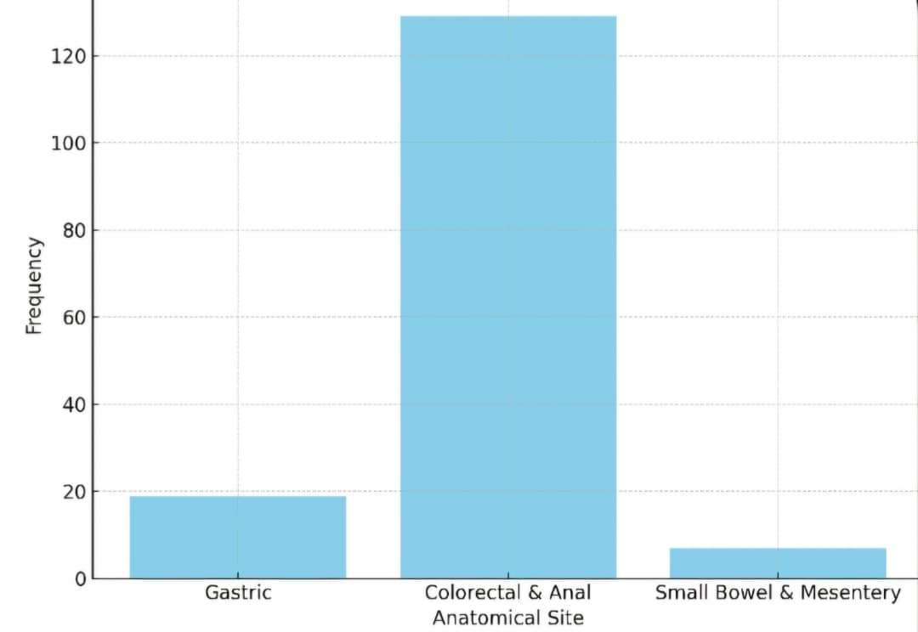

**Figure 1: Anatomical distribution of GI tumours.**

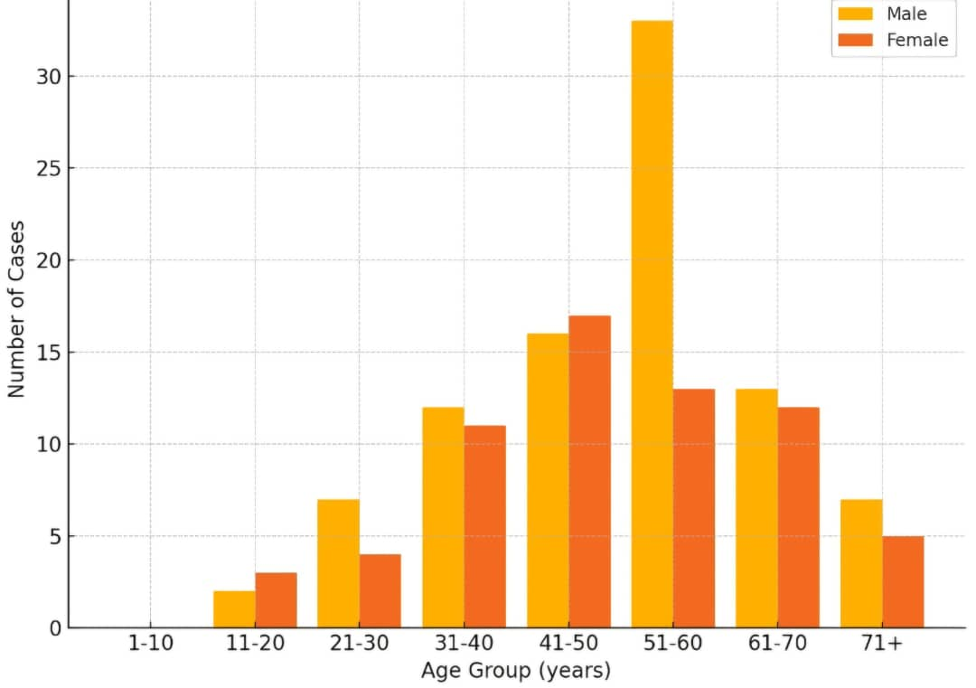

**Figure 2: Age and sex distribution of GI tumours.**

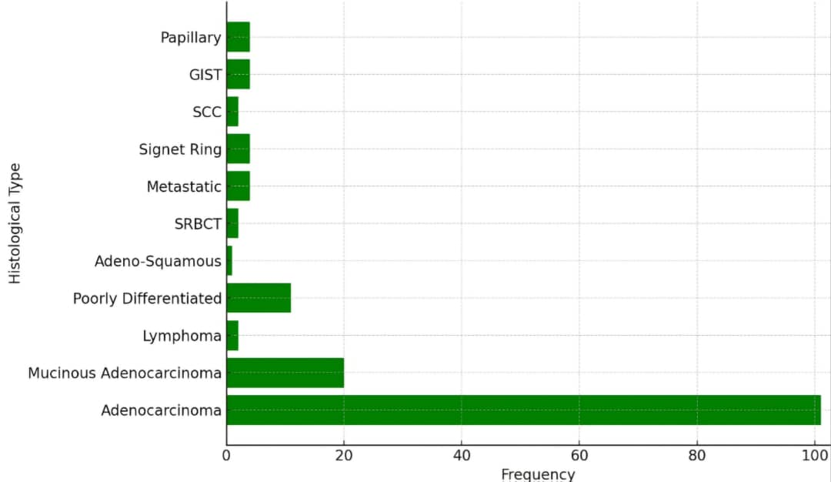**Figure 3: Histological types of GI tumours.**

**Discussion:**

This 10-year retrospective review of gastrointestinal malignancies from Makurdi, North Central Nigeria, provides valuable insights into the demographic and histopathological patterns of GI cancers, excluding those of the hepatobiliary tract. The findings reflect evolving trends in GI oncology, underscoring an increasing burden of colorectal and gastric malignancies in low- and middle-income countries (LMICs), including Nigeria.

Colorectal and anal malignancies were the most predominant anatomical site, accounting for 83% of all cases. This aligns with several Nigerian hospital-based studies, including those by Irabor et al. in Ibadan16 and Ojo et al. in Ilorin17, where colorectal cancers constituted the majority of GI malignancies. A similar trend has been observed in other Sub-Saharan African regions, such as Ghana18, Tanzania19, and Ethiopia20, suggesting a growing epidemiologic shift possibly linked to westernised diets, physical inactivity, obesity, and ageing populations21.

Globally, colorectal cancer (CRC) remains the third most diagnosed cancer and the second leading cause of cancer-related deaths22. High-income countries (HICs) have seen a decline in incidence and mortality due to screening programs and early detection strategies23, but low-resource settings, including Nigeria, lack these interventions, resulting in late-stage presentation and poor outcomes24.

Gastric cancer accounted for 12% of cases in this study, which, while lower than colorectal cancer, is significant. It is consistent with findings from northern Nigeria by Akinbami et al.25 and supports global data showing gastric cancer as the fifth most common cancer and fourth leading cause of cancer mortality22. Helicobacter pylori infection, a key etiological factor, remains prevalent in Sub-Saharan Africa and may explain the gastric cancer burden in the region 26.

Small intestine and mesenteric tumours were rare (5%), in line with their known low incidence worldwide 27.

The peak incidence of GI cancers was in the fifth and sixth decades of life (41–60 years), representing over half of all cases. This age distribution is slightly younger than reported in HICs, where the majority of cases occur above 60 years23, but aligns with data from other Nigerian and African studies28,30. The earlier age of onset in African populations may reflect genetic, environmental, and infectious contributors or could be influenced by limited screening, leading to symptomatic detection.

A male predominance (M: F = 1.4:1) was observed, consistent with both local and international reports 29,31. Male susceptibility may be related to lifestyle factors such as higher rates of smoking, alcohol consumption, and red meat intake, as well as occupational exposures32.

Adenocarcinoma was the most prevalent histologic type across all anatomical sites, accounting for over 64% of GI malignancies and over 74% of gastric and colorectal tumours. This dominance is consistent with the glandular origin of the majority of GI epithelial tissues and aligns with histologic trends from Nigerian33, Ghanaian18, and Kenyan34 studies. Mucinous adenocarcinoma, a recognised subtype associated with a poorer prognosis, was also commonly encountered (13%), particularly in colorectal lesions.

Signet ring cell carcinoma and poorly differentiated adenocarcinomas, though less frequent, are aggressive subtypes that often present late and have poor therapeutic responses 35. Their presence, particularly in gastric cancers, reinforces the need for early detection and stratification based on histologic type.

Rare tumours such as gastrointestinal stromal tumours (GIST), lymphomas, small round blue cell tumours (SRBCT), and squamous cell carcinoma were also identified. While infrequent, their detection highlights the histological heterogeneity of GI malignancies and the importance of accurate diagnosis, particularly as some subtypes may respond to targeted therapies (e.g., imatinib for GIST)27, 35.

In comparison to global datasets, the burden of colorectal cancer in this Nigerian population mirrors rising trends in other LMICs21. However, the absence of structured screening programs, limited access to diagnostic endoscopy, and poor public awareness likely contribute to delayed diagnosis and poorer outcomes in Nigeria 24. In contrast, countries with robust screening (e.g., Japan for gastric cancer, and the USA for colorectal cancer) have achieved significant reductions in incidence and mortality 22,23.

Moreover, the rising prevalence of modifiable risk factors such as diet, sedentary lifestyle, and obesity in urban Nigerian populations may contribute to the increasing burden of GI cancers. A recent study by Adeloye et al. also highlighted the underestimation of cancer incidence in Africa due to underreporting and data gaps28.

This study underscores the urgent need to strengthen cancer surveillance systems, improve access to histopathologic diagnostics, and develop regionally appropriate screening protocols. Health education to raise awareness about GI cancer symptoms and early care-seeking behaviour is equally essential. Furthermore, national cancer control policies should prioritise investments in diagnostic and treatment infrastructure, especially in underserved regions like North Central Nigeria.

**Conclusion:**

This 10-year retrospective study identifies colorectal and gastric cancers as the most common gastrointestinal malignancies in Makurdi, with adenocarcinoma as the predominant histologic type. Middle-aged males were most affected. The findings align with regional trends and underscore the need for better cancer detection, registries, and prevention in low-resource settings. However, limitations include a lack of staging, treatment, and survival data, the absence of molecular profiling, potential underdiagnosis due to limited endoscopy access, and limited generalizability beyond Makurdi.

**Ethical Considerations**

Ethical approval for the study was obtained from the Health Research Ethics Committee of the Federal Medical Centre and Benue State University Teaching Hospital (BSUTH), Makurdi.

**References:**

1. Sung H, Ferlay J, Siegel RL, Laversanne M, Soerjomataram I, Jemal A, et al. Global cancer statistics 2020: GLOBOCAN estimates of incidence and mortality worldwide. *CA Cancer J Clin*. 2021;71(3):209–49.
2. Smyth EC, Nilsson M, Grabsch HI, van Grieken NCT, Lordick F. Gastric cancer. *Lancet*. 2020;396(10251):635–48.
3. Aparicio T, Zaanan A, Svrcek M, Laurent-Puig P, Carrère N, Manfredi S. Small bowel adenocarcinoma: epidemiology, risk factors, diagnosis and treatment. *Dig Liver Dis*. 2014;46(2):97–104.
4. Inunduh PS, Labe RM, Swende TZ, Agbecha AA, Audu SA. Late cancer presentation and increased palliative care burden on healthcare delivery in Makurdi, Benue State: A need for strategic intervention. *J Clin Oncol Rep*.. 2024;3(1).
5. Bray F, Ferlay J, Soerjomataram I, Siegel RL, Torre LA, Jemal A. Global cancer statistics 2018: GLOBOCAN estimates of incidence and mortality worldwide for 36 cancers in 185 countries. *CA Cancer J Clin*. 2018;68(6):394–424.
6. World Health Organisation. *Noncommunicable diseases country profiles 2018*. Geneva: WHO; 2018.
7. Otene E, Labe RM, Swende TZ, Inunduh PS, Audu SA. Characteristics of intestinal obstruction seen at a tertiary hospital in North-Central, Nigeria. *ResearchGate* [Internet]. 2025 [cited 2025 Jun 10]. Available from: <https://www.researchgate.net/publication/xxxxxxx>
8. Adebamowo CA, Ajayi OO. Cancer incidence in Ibadan, Nigeria. *West Afr J Med*. 2002;21(4):288–92.
9. Holcombe C. *Helicobacter pylori*: the African enigma. *Gut*. 1999;45(3):439–41.
10. Jedy-Agba E, Curado MP, Ogunbiyi O, Oga E, Fabowale T, Igbinoba F, et al. Cancer incidence in Nigeria: A report from population-based cancer registries. *Cancer Epidemiol*. 2012;36(5):e271–6.
11. Ohene-Yeboah M, Adaboh H, Aidoo A, Sarpong Y. Colorectal cancer in Kumasi, Ghana: an 11-year review. *Ghana Med J*. 2010;44(3):102–5.
12. Olagbaye SS, Ola-Olorun O, Adekunle OO, Olagbaye OO. Pattern of gastrointestinal malignancies in Ekiti State, Nigeria. *J Natl Med Assoc*. 2021;113(1):79–84.
13. Olokoba AB, Obateru OA, Bojuwoye MO, Olokoba LB, Bolarinwa OA. Pattern of gastrointestinal diseases in Ilorin, North Central Nigeria. *J Clin Sci*. 2012;12(1):3–6.
14. Adisa AO, Abdulwahab-Adamu OA, Akande MA. Epidemiology of cancers in North Central Nigeria: A 10-year review. *Sahel Med J*. 2020;23(2):65–70.
15. Abuja Population-Based Cancer Registry (ABCR). *Cancer incidence in FCT Abuja 2009–2016*. Abuja: ABCR; 2018.
16. Irabor DO, Olajide T, Arowolo OA, Omisore AD. Colorectal cancer in Nigeria: 40 years on. *Ann Afr Med*. 2017;16(2):68–73.
17. Ojo BA, Odesanmi WO, Alatise OI, Okunade KS. Histopathological pattern of gastrointestinal cancers in Ile-Ife, Nigeria. *Niger J Clin Pract*. 2021;24(6):879–85.
18. Dakubo JC, Tettey Y, Gyasi RK, Agbozo J, Alidu H. Colorectal carcinoma: an update from Accra, Ghana. *J Med Biomed Sci*. 2019;8(1):45–53.
19. Chalya PL, Mabula JB, Gilyoma JM. Clinicopathological pattern of colorectal cancer at Bugando Medical Centre in Northwestern Tanzania. *BMC Res Notes*. 2014;7:1–8.
20. Bekele A, Abebe E, Bekele T, Teferra A. Colorectal cancer in Ethiopia: A retrospective study. *East Cent Afr J Surg*. 2019;24(1):36–41.
21. Arnold M, Sierra MS, Laversanne M, Soerjomataram I, Jemal A, Bray F. Global patterns and trends in colorectal cancer incidence and mortality. *Lancet Gastroenterol Hepatol*. 2020;5(1):17–30.
22. Sung H, Ferlay J, Siegel RL, Laversanne M, Soerjomataram I, Jemal A, et al. Global Cancer Statistics 2020: GLOBOCAN estimates of incidence and mortality worldwide. *CA Cancer J Clin*. 2021;71(3):209–49.
23. Wolf AMD, Fontham ETH, Church TR, Flowers CR, Guerra CE, LaMonte SJ, et al. Colorectal cancer screening for average-risk adults: 2018 guideline update. *CA Cancer J Clin*. 2018;68(4):250–81.
24. Jedy-Agba E, Curado MP, Ogunbiyi O, Oga E, Fabowale T, Igbinoba F, et al. Cancer incidence in Nigeria: A report from population-based cancer registries. *Lancet Oncol*. 2016;17(7):e288–95.
25. Akinbami FO, Ajayi OO, Osinowo AO, Ighodalo JN, Ogunbanjo OB. Malignant gastrointestinal tumours in Lagos, Nigeria. *Niger Postgrad Med J*. 2017;24(3):159–63.
26. Ndububa DA, Akinola DO, Lesi OA, Alatise OI, Adekanle O, Agbakwuru AE, et al. Epidemiology of upper gastrointestinal cancers in South Western Nigeria. *Trop Gastroenterol*. 2020;41(2):92–6.
27. Agaimy A. Gastrointestinal stromal tumours (GIST) and their differential diagnosis. *Int J Clin Exp Pathol*. 2020;13(4):601–12.
28. Adeloye D, Sowunmi OY, Jacobs W, David RA, Adeosun AA, Amuta AO, et al. Estimating the incidence of colorectal cancer in Sub-Saharan Africa: A systematic analysis. *BMJ Open*. 2022;12:e056394.
29. Obonna GC, Okoro ON, Ijezie GI, Emelumadu OF, Nwachukwu GC. Colorectal cancer in Southeastern Nigeria: A histopathological analysis. *Niger J Surg Sci*. 2019;29(3):56–62.
30. Nwafor CC, Eze NA. Histopathological review of colorectal carcinoma in Southeastern Nigeria. *Afr J Med Health Sci*. 2017;16(2):64–8.
31. Irabor DO. Emerging colorectal cancer epidemic in Nigeria: Current status and future directions. *Niger J Clin Pract*. 2016;19(3):287–91.
32. Bray F, Ferlay J, Soerjomataram I, Siegel RL, Torre LA, Jemal A. Global cancer statistics 2018: GLOBOCAN estimates of incidence and mortality worldwide. *CA Cancer J Clin*. 2018;68(6):394–424.
33. Abdulkareem FB. Epidemiology and molecular biology of colorectal cancer in Nigeria: A review. *Niger J Clin Pract*. 2019;22(10):1436–41.
34. Saidi H, Yatich N. Clinical characteristics of colorectal cancer patients in Nairobi, Kenya. *Trop Doct*. 2021;51(3):392–7.
35. Bosman FT, Carneiro F, Hruban RH, Theise ND, editors. *WHO Classification of Tumours: Digestive System Tumours*. 5th ed. Lyon: IARC; 2019.