***Original Research Article***

**Socio-economic Status of slum people among the municipalities ofPurba Medinipur, West Bengal.**

**______________________________________________________________**

**Abstract**

The growth and development of slums in the urban area is one of the important issues for the urban local bodies (ULB’s). Almost one billion people live in slums, around the world, which is more typically overcrowded, polluted, and lack of basic amenities. The work attempts to assess the Socio-economic status both qualitatively and quantitatively. Primary and secondary data have been used to fulfil the objectives. The collected data have been analyzed and GIS techniques have been used for cartographic presentation.The study is concentrated on all slum pockets *among the* municipalities of Purba Medinipur (Haldia, Egra, Contai,Tamralipta(Tamluk), andPanskura) of West Bengal*.*The Weightage value, composite index and standard deviation, have been used to determine the Socio-economic status slum dwellers. This study used firstly 20 variables under 3 major dimensions such as Demographic profile, Economic status and Housing and Amenities, secondly 9 variables such as Family Size(X1), Education level(X2), Occupational pattern(X3), Monthly income(X4), Type of Houses(X5), Average no. of room(X6), Road type(X7), Drinking wate(X8), and Sanitation(X9)have been chosen to find out the developmental status of the municipalities in terms of their present pattern. Owing to bad hygienic conditions and Economic status of slums of municipalities of Purbamedinipur are not at a satisfactory level. According to the findings of primary survey, the majority of Slum Households Rank of Egra municipality are Lacking in Housing Condition, Infrastructure and Amenities. Slums socioeconomic status good in Pankura and Tamralipto Municipality among the five Municipalities of Purba Medinipur. Municipalities of Purba Medinipur achieved first. Older municipalities quality of life of slum dwellers is comparatively better than newer municipalities.

**Keywords: Urbanization, slum dwellers, Socio-economic status, development.**

1. **Introduction:**

The word 'Slum' means a densely or heavily populated area in the city (Hossain, S. 2013). Slum is a most critical parts of the cities, most of slum dwellers belongs to in or near poverty (Stokes, C. J. 1962). In the early age of industrial revaluation, slums were formed near the factories' gates, which were not so far from the center of the cities. But nowadays, most of the slums are growing up at the center of the cities (Kumar, P. 2010). Slum dwellers belong to in or near the poverty line with illiteracy and worse health status, they are low earners. They are deprived of proper formal education facilities as well as job facilities. For this reason, slum dwellers are involved in informal labour which inhibits them more earning. They work in harmful environment, which forces them to work in informal sectors (Tiwari, N., & Singh, M. K. 2021; Joshi, S. 2005; and, Alamgir, M. S. et al. 2009).Lower socio-economic Status leads them to an ailing life. Due to lower socio-economic Status, the living conditions of slum dwellers are very poor than rural dwellers. They are most affected by communicable diseases and also, they have to face malnutrition (Ameratunga, S. et. al. 2006: andKamruzzaman, M., & Hakim, M. A. 2015). In developing countries Most of them are living below the poverty line. They do not achieve a good source of income. There is inadequate safe drinking water, the basic human need (Ompad, D. C. et. al. 2007; and,Kamruzzaman, M., & Hakim, M. A. (2016). Unfortunately, most of the slums suffer from lack of safe water. Although, public water supply is available in some slum areas but the quality of water is not satisfactory. The unhygienic sanitation system is common in slums (Panda, P. et al. 1993). Slum roads are narrow and unpaved, Slum dwellers have to face water login, which is a very common problem in the rainy season in slum areas. This condition is very unhygienic for slum dwellers, which causes a various number of contagious diseases(Kaviarasu, S. J., & Xavier, G.G 2015). Lack of landownership is a vital problem for the slum dwellers. The slum houses are built on government encroachment land or public land, or marginal land parcels like roadways, railway setbacks and undesirable wetland land. They usually use the abandoned land for their settlement. They are vulnerable to water logging areas and insecure environments (Siegel, C., et al. 1997)and Kamruzzaman, M. 2015). Socio-economic factors are very important components in the study of any society, such as a slum. Social factors such as gender, religion, Caste, Age group, Family size, Marital Status, Level of education, etc give us an idea about the society or person's goal. The family's economic Status depends on social factors such as educational attainment, Size of family, monthly income, savings, etc. The word Socioeconomic Status is generally used to define factors about a person's lifestyle, including the type of family, Education, occupation, income, housing, etc. Socioeconomic Status and social class determine life chances. Major representations of life chances are controlled fertility and huge child mortality (Bollen, K. A. et al. 2015; and Kimani-Murage, E. W., & Ngindu, A. M. 2007). According to the 2011 census, there were 25 slum wards, which means the slum population is distributed in most of the 25 wards out of 26 wards of Haldia municipality. The most important demographic and economic characteristics are discussed in the actual distribution of the slum population in different wards. Literacy and education are vital indicators that flow all changes and progress; among the slum population, the literacy rate is woefully low (Khan, M. Z., & Dassi, A. 1998). The objective of the work is to understand the socioeconomic status of slum dwellers in five municipalities of Purba Medinipur.

1. **Objectives:**
2. To study the over-all socio-economic pattern of the municipalities of Purba Medinipur District.
3. To find out the developmental status of the municipalities in terms of their present pattern.

**3. Data base and Methodology:**

3.1 The Study area

Purba Medinipur, the southernmost district of the Burdwan Division of West Bengal, extending over area of 4,151.64 square kilometres, is situated between the parallels of 21°36'35˝ N and 22°57'10˝ N latitudes and meridians of 86°33'50˝ E and 88°12'40˝ E longitudes. It was formed on 1st January, 2002 after the partition of former Medinipur district into Purba Medinipur and Paschim Medinipur which lies at the northern and western border of it. The state of Odisha is at the south-west border whereas the Bay of Bengal lies in the south; the Hooghly River and South 24 Parganas district to the east and Howrah district to the north-east. The head-quarter is located at Tamluk. It has four Sub-division namely Tamluk, Contai, Haldia and Egra, 25 Blocks, 21Police Stations, 5 Municipalities, 223-gram Panchayat and 11,796 villages. The district can be reached from Kolkata by NH-6 via Howrah which enters the district at Kolaghat on The Rupnarayan River. The South-Eastern railway lines from Howrah station enters the district at Kolaghat and leave the district at Khirai station. The geological formation of the district is alluvial, which occupies the whole north and central part, but in the south and east gradually gives way to the ordinary alluvial. The drainage system of Purba Medinipur district is consisting of river Hooghly and its tributaries (Rupnarayan, Rasulpur and Haldi). Others importance rivers are Kasai, Kaliaghai, Subarnarekha. The soil of the Purba Medinipur district can be divided into two major groups – alluvial soil and coastal soil. The climatic characteristics of Purba Medinipur district is hot and humid type but the climatic pattern of north and west is very different from east and south. The eastern and southern part of the district is influenced by cyclones which originate over the Bay of Bengal. The northern and western part being characterized by dry heat in the hot weather and a moderate rainfall. Purba Medinipur district has 5.34 percent of the area and 5.58 percent of the total population of West Bengal. As per census 2011, the district has 5.58 percent of population which is 5,095,875. The average population density is 1076 people per square kilometre in 2011. The decadal growth rate from 1991 to 2001 13.02 and is 17.21 from 2001 to 2011.

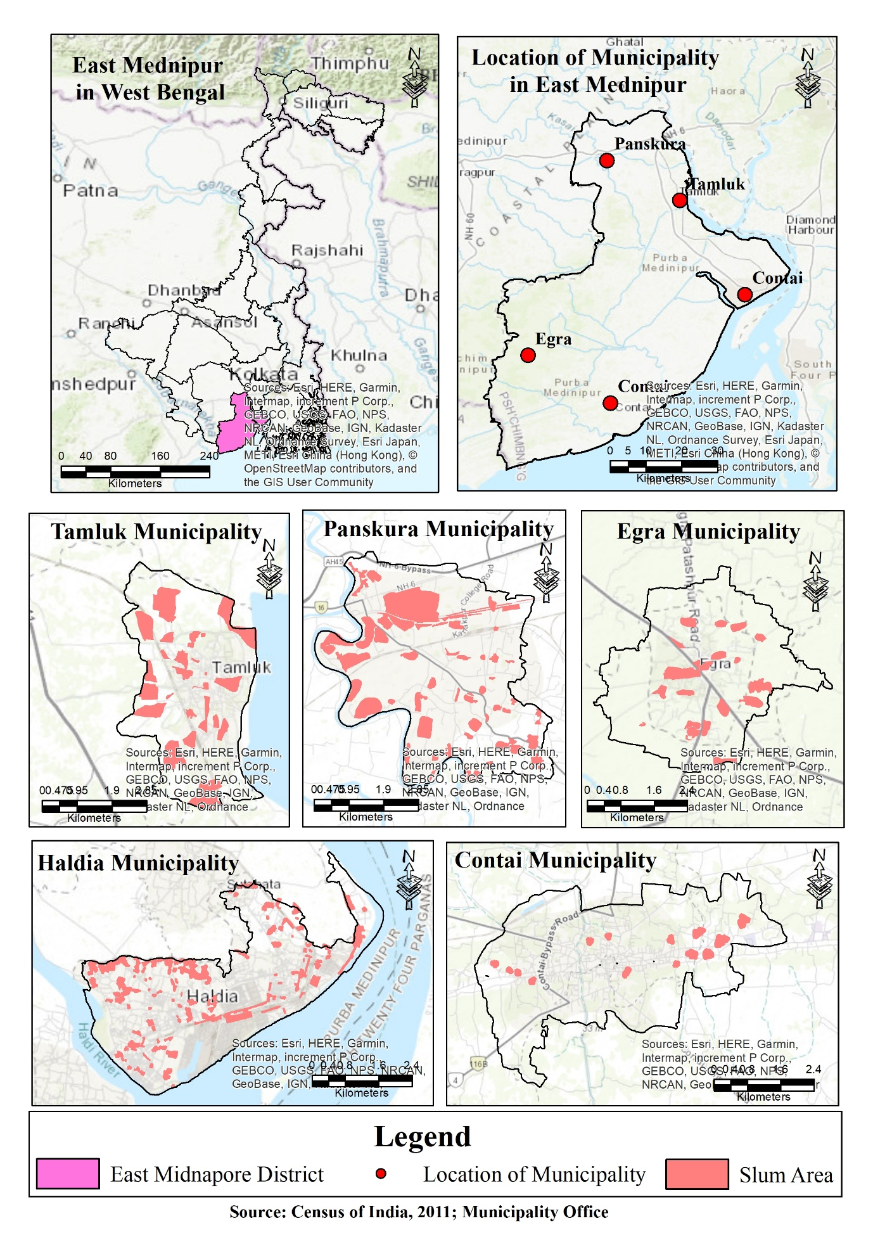Figure 1: Location of the Study area

**2.1.2. General Geographical Description of municipalities**

The Purba Medinipur district comprises with 25 blocks four sub-divisions (Tamluk, Contai,Egra, Haldia) and five Municipalities. Five Municipalities are Tamluk, Contai,Egra, Haldia and Panskura. Purba Medinipur district headquarters name is Tamluk**.**

Table-1 General Geographical Description of municipalities.

|  |  |  |  |  |  |
| --- | --- | --- | --- | --- | --- |
| Name of  Municipalities | Location | Year of  Establishment | Area (sq. km) | No of wards | Total  Population |
| Tamralipta | 22.22’ N  88.45’ E | 1864 | 17.86 | 20 | 65312 |
| Contai | 21.78’ N  87.75’ E | 1958 | 17.25 | 20 | 92226 |
| Egra | 21.09’ N  87. 53’ E | 1993 | 17 | 14 | 30148 |
| Haldia | 22.02’ N  88.04’ E | 1997 | 102 | 29 | 200762 |
| Panskura | 22.45’ N  88.70’ E | 2002 | 20 | 17 | 57932 |

Table-2 Slum information of the Municipalities of Purba Medinipur.

|  |  |  |  |  |  |  |  |
| --- | --- | --- | --- | --- | --- | --- | --- |
| Name of  Municipalities | Area (sq km) | No.of wards | Total  Population | No of slum pockets | Total slum population | Percentage  Of slum population | Percentage of population engaged in main or marginal works |
| Tamralipta | 17.86 | 20 | 65312 | 115 | 29603 | 45.87 | 35 |
| Contai | 17.25 | 20 | 92226 | 174 | 16461 | 21.234 | 33 |
| Egra | 17 | 14 | 30148 | 62 | 23299 | 77.28 | 34 |
| Haldia | 102 | 29 | 200762 | 131 | 48873 | 22.34 | 30 |
| Panskura | 20 | 17 | 57932 | 60 | 33022 | 57 | 34 |

**Tamluk Municipality:** Purba Medinipur district headquarters name is Tamluk**.** Tamluk is also an admistrative town. Tamluk municipality establishment on the year 1956. It is located at [22.22° North latitudes and 88.55°](http://tools.wmflabs.org/geohack/geohack.php?pagename=Panskura&params=22.42_N_87.7_E_) East longitudes. Tamluk town is situated the right bank of stream Rupnarayan. Soil is loamy and very fertile. The low-lying marshy area was filled up by depositional reworking of the streams Hoogly and Rupnarayan.Tamluk also well connected with south easernt railways and Naional highway (NH- 41). Total area is 17.86 square kilometre. Average temperature varies from 21.8° Celsius to 32.5° Celsius. This municipality is influenced by cyclones which originate over the Bay of Bengal, during June to September. The normal rainfall is 1252.32 mm. Habar, palm, coconut and siris trees are the common vegetation. The Contai Municipality has 65312 populations as per Census of India 201and. Slum population is 29603. Now-a-days, Tamluk is famous for health purpose. District hospital medical college and huge numbers of Nursing home plays a vital role for health of the whole district.

**Contai Municipality:** Contai municipality took its birth on 1958. It is located at [21.47° to 22.78° North latitudes and 87.45°](http://tools.wmflabs.org/geohack/geohack.php?pagename=Panskura&params=22.42_N_87.7_E_) to 87.75° East longitudes. From sea bech town Digha to Contai urban area distance is about 30 kilometers only. It is one of the well-known tourism center of west Bengal as well as Eastern India. The soil type of Contai Municip1lity is Saline-Alkaline. Total area is 14.56 square kilometre. Average temperature varies from 21.8° Celsius to 32.5° Celsius. This municipality is influenced by cyclones which originate over the Bay of Bengal, during June to September. The normal rainfall is 1252.32 mm. Casurina, palm, coconut and cashew nut trees are the common vegetation. The Contai Municipality has 92,226 populations as per Census of India 2011. Population of Children with age of 0-6 is 8440. Cashew nut Processing industry and salt processing industry is famous now in Contai.

**Egra Municipality:** It was established on 9th June, 1993. Egra is the headquarters of Egra subdivision. Egra is located at 21.9°N to 87.53°E. As per [2011 Census of India](https://en.wikipedia.org/wiki/2011_Census_of_India), Egra had a total population of 30,148 of which 15,291 (51%) were males and 14,857 (49%) were females. Population below 6 years was 3,241. The total number of literates in Egra was 23,447 (87.14 % of the population over 6 years). Egra Municipality is spread over an area of 17.21 sq Km where the population is 30,035. It has 20 slums cluster including 62 slum pockets. The total slum area & population are 1.62 Sq.Km& 14690 respectively. These people do not have proper access to basic services due to infrastructure deficiency. Slum infrastructure improvement plan has been taken up in this background.

**Haldia Municipality:** Haldia Municipality was established on 9th June, 1997. From an unknown small village, it has today turned up into an important industrial town of west Bengal. Haldia confluence area is situated between two river Hooghly and Haldi and125 kilometer from capital city of Bengal. Now a days Haldia is a major port and a focal point for industrial development in west Bengal. Agricultural land transformed into a industrial land and which boost the industrial economy. It is also a port based industrial town. Port development is directly related to municipality growth and development.The present work covers the Haldia municipality area with a population of 200827 in 2011. There are twenty-six wards. Population below 6 years was 21,945. In Haldia Municipality, environmental quality is very poor due to industrial up gradation. Alkali soil (with salt) is found in this municipality.

**Panskura Municipality:** Panskura municipality is located at [22.25° to 22.42° North latitudes and 87.7°](http://tools.wmflabs.org/geohack/geohack.php?pagename=Panskura&params=22.42_N_87.7_E_) to 87.42° East longitudes. It has an average elevation of 7 meters (26 feet). It is lies between Kolkata to Khargapur road (National highway- 6). The district is enclosed by Kolaghat block in the north, Kasai River in the west. Panskura municipality came into existence on 8th June, 2002 with seventeen wards (17) and the total area is 17.08 sq km. There are nearly flat rolling plains in the East, Alluvial and Deltaic plains along the rivers plains in the South. The climate of the district is tropical. Average temperature varies from 25.5° Celsius to 38.6° Celsius. The normal rainfall is 1752.6 mm.Total urban population is57932 with 29740 male and28192 female in 2011 census. Children population is 6943, which is shared 11.98 percent of total population. Gender ratio is very satisfactory level. Literacy rate of Panskura municipality is 84.97 percent, which is higher than state level average of 76.26 percent. 89.91 percent and 79.77 percent male and female are literate. 11743 houses covered with proper basic amenities like water and sewerage. It is also authorized to build roads within Municipality limits and impose taxes on properties coming under its jurisdiction.

**3.2 Selection of the Variables**

In a study of municipalities socio economic status, components are very vital: material well-being, health, education and literacy, participation in the productive sphere, and participation in the social sphere (Stewart, K.,2002). The present study deals with the Socio – economic status of the slum dwellers of municipalities of Purba Medinipur, which is basically dependent on several selective objective indicators of Socio – economic status, as it is easily available, quantifiable and obviously relevant to the present work. The most essentialcomponentsselected for thepurposeare Demographic profile, Economic status, Housing and Amenities, which are derived mainly from sample households of the slum areas in the study area. Each component is further sub-divided into several variables which basically explain the result using

the indicator.

|  |  |
| --- | --- |
| Components | Variables References |
| Demographic Profile | Gender ratio Mondal et al. (2021), |
| Family Size Martinez et al. (2008), Moser (1998), |
| Age structure Kamruzzaman et al. (2016) |
| Marital status Haq et al. (2009) |
| Caste composition Sydunnaher et al. (2018) |
| Educational status Liu and Li, (2016) |
| Economic Status | Economic activity Ehrenpreis (2006), Mondal et al. (2021), |
| Monthly income McClelland and |
| Monthly saving Macdonald (1998), Panthil et al. (2015) |
| Land tenure Mitlin and Satterthwaite (2002 |
| Economic level (APL/BPL) Kamruzzaman et al. (2016) |
| Housing and Amenities | Types of houses Majale (2006), |
| Roof types Mitlin and Satterthwaite (2002), |
| Average number of rooms Alder (1995), |
| Source of drinking water D Das (2007), Krishnanet al.(2020) |
| Latrine facility Tanni et al. (2014), |
| Sewage facility Jha et al. (2014), Haq et al. (2009). |
| Waste dumping Kamruzzaman et al. (2016) |
| Types of roads Sydunnaher et al. (2018) |
| Status of electric facilities Krishnan et al.(2020) |

**Table 3: Selection of the overall variables**

**3.3 Criteriafortheselectionofstudyarea:**

Thestudyslumswerechosenbasedontwocriteria:

1. Firstly, three wards have been chosen of each municipality of purba Medinipur based on higher, medium and lower concentration of slum population in relation to the entire population of the ward.

(b) Secondly, three slum related wards are chosen depending on the distance from core area of each Municipalities. One slum was chosenthecity’sheart. Other slums were chosen from the give space each word peri-urban area, which has a medium densityofdevelopmentthanthecentralarea. Last one slum was chosen from longest distance coverage ward in municipality. Total fifteen wards selected from five municipalities. According tothemunicipality’s reportanddiscussionswithlocaladministrators(councillors from those wards), 1780 householdshave been established in these fifteen slums. Rashpukurjhupri( S.c -125), ward no- 11 of Haldia municipality has highest number of slum dwellers, as well as slum household.

**3.4 Samplingandsamplingsize:**

In Municipal authorities of purba Medinipur estimate that there are 1780 total households in fifteen slums (Census of India, 2011). total of 1780 slum dwellers householdwereselectedusingtheformulabelow (Yamane 1973).

*n*=*N*/1+*Ne*2 (1)

whereNisthehousehold’ssize(1780)andeisthelevel of precision (here ± 5 per cent precision level) assuming 95 per cent confidence level and p = 0.5. After getting the sample size of 326 using the above equation (Eq. 1). Here authorsusedYamane’sformulaforsamplesize.

selection as the numbers of HHs in the slums of municipalities of PurbaMedinipur are known and not infinite in nature.The slum wise sample size has been determined (Table 2)using a proportionate allocation approach using Eq. 2.

*n*1= *n*\*(*N*1/*N*) (2)

where*n1*= samplesizeforselected,*n* = totalsample size, *N*1 = selected slum households and *N* = Total householdsoftheselectedslums.Forexample,incase of Rashpukurjhupri(SC -125), ward no- 11 of Haldia municipality slum, the sample size has been found= [326*(420/1780)] = 76.92 = 77. Minimum ten household surveys should be done in each small slum area or ward.so total sample is 348 households. Detailed list of surveyed households from each selected slum have been given intable no. 4

**Table** **4****:**Sample size of Municipalities of Purba Medinipur:

|  |  |  |  |  |
| --- | --- | --- | --- | --- |
| Name of Municipality | Ward no | Slum Name / any three slums of each municipality | Household | No of Sample |
| Haldia | 13 | RashpukurJhupri (S.C.-125) | 420 | 77 |
|  | 16 | Geondab Paschim Para (S.C.-071 | 137 | 27 |
|  | 19 | howanipur Culvert Colony (S.C.-132) | 10 | 10 |
| Tamralipta | 9 | Balbal Para | 210 | 38 |
|  | 10 | Rail Colony Para (S.C.-023 | 157 | 29 |
|  | 16 | Sweeper Colony Bastee (S.C.-018) | 47 | 10 |
| Contai | 3 | Mansatala Para (Paschim) | 67 | 12 |
|  | 8 | Barik Para | 43 | 11 |
|  | 4 | Nakku Para | 19 | 10 |
| Egra | 6 | GiriparaAdibasi Colony | 110 | 20 |
|  | 13 | Sitala Mandir Para | 169 | 31 |
|  | 7 | Majhi Para | 17 | 10 |
| Panskura | 2 | KanakpurModhya bandh | 117 | 21 |
|  | 9 | Muslim para | 81 | 15 |
|  | 17 | Tilandapur Harijan Mali &Madhyapara | 92 | 17 |

**3.5 Datacollectionmethod:**

Both Primary and secondary used in this study. The field survey was conducted among notified slums of all municipalities of purba Medinipur. Secondary data have been collected from District statistical Hand book, public reports, Census of India and also all municipalities office. Primary data have been collected through structured questionnaires. The survey has been done by random sampling survey method. Slum households were surveyed from each ward by random survey methods. Slum pockets selection processes will be taken on the basis of high and low population pocket in a municipality ward. All the analyses have been representing in GIS environment through Arc GIS. To find out the Socio-economic status of slum dwellers, three components have been used, such as Demographic profile, Economic status and Housing and Amenities. After finalization of the questionnaire, household survey has been conducted on 348 households in fifteen different slums of municipalities of Purba Medinipur (**Table** **2**).

3.6. **Data Processing & Analysis**:

The prefilled-up schedules were scrutinized after the completion of field work & the data was tabulated for analysis. The obtained data was analysed by Statistical and Cartographic techniques. Statistical measures like, Composite index, standard deviation technique (Bracy,1952 Singh and Rana P.B. Singh, 1979) has been used to determining the Socio-economic status of slum dwellers. Data was also represented with the help of several cartographic techniques under GIS platform through Arc GIS.

**4. Methodology**

This study used 20 variables under 3 dimensions in first objective and second objective fulfilled with 9 variables. To fulfil the objective composite weight age and standard deviations technique have been used. The weight age of a particular variable is given based upon the degree of its influence the slums socio economic status. Highest weight age values (3) were given to the variables which determine a good Socio-economic status and lowest weight age (1) value were given for a poor Socio-economic status. All raw values of particular indicators have been selected as percentage value. Then the percentage value of a Individual indicators have been multiplying with selected weightage value **(**Haldia Municipality, Weightage value of Pucca indicators = (Share of household in particular indicators (Pucca) X Weightage value 3 (Table 1))/100). After that all the individual indicator’s weightage value have been as sum value in the particular parameter (Housing Condition). To calculate the composite index based on nine variables such as Family Size(X1), Education level(X2), Occupational pattern(X3), Monthly income(X4), Type of Houses(X5), Average no. of room(X6), Road type(X7), Drinking wate(X8), and Sanitation(X9)have been chosen to find out the developmental status of the municipalities in terms of their present pattern. To analysis the present socio-economic status, individual parameter score has been analysed as comparatively in municipality wise and also represent in GIS environment. Finally, the whole sums of selected parameters score in individual Municipality wise, have been categorised as good, medium and poor condition based on the composite score of Socio-economic status.

**5. Result and Discussion:**

**Demographic Status of slum dwellers:**

Slum regions are the common phenomenon in India as well as all over the world (Khan, M. I. 2013; Kamruzzaman, M., & Hakim, M. A. 2015; Kimani-Murage, E. W., & Ngindu, A. M. 2007; and Khan, M. Z., & Dassi, A. 1998)These are the product of socio- economic conditions of a particular social system inhibiting the physical, mental, moral and social development of the individuals ( Tripathi SC and Arora V. 2010)

The bar chart (**Fig. 2(a)**) depicts the share of male and female populations among slum dwellers across five municipalities: Haldia, Tamluk, Contai, Egra, and Panskura. The blue bar represents males for each municipality, while the red bar represents females. In Haldia, the population distribution is fairly balanced, with males slightly higher than females. Tamluk also shows a balanced distribution, with males having a marginally higher share than females. In Contai, a noticeable gender gap exists, with males significantly exceeding females, indicating a larger male population. Egra shows a similar trend as Tamluk, with nearly equal representation of both genders but with a minor male majority. Lastly, Panskura displays a slight male majority over females. Overall, the chart indicates that in most municipalities, the male share of the population is slightly higher than the female share, with the most prominent disparity observed in Contai. The data highlights the variations in gender distribution across these regions, emphasizing the gender dynamics among slum dwellers in these municipalities (Fig. 1).

The bar chart (**Fig. 2(b**) illustrates the distribution of family sizes among slum households across five municipalities: Haldia, Tamluk, Contai, Egra, and Panskura. The family sizes are categorized into four groups: 0-3 members (blue bars), 4-5 members (red bars), 6-8 members (green bars), and more than 8 members (purple bars). In all municipalities, the most prevalent

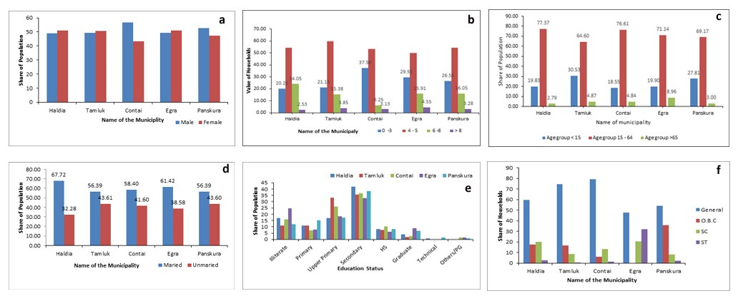

Fig: 2 (a) Genderratio(b) Family size. (c)Age structure(d)Maritial status(e)Education status(f)Caste Composition.

family size is 4-5 members, as shown by the dominant red bars, with Contai having the highest proportion (37.50%). Families with 0-3 members make up a significant share across all municipalities, notably in Contai (37.50%) and Panskura (26.55%). Households with 6-8 members represent a smaller proportion, with a relatively higher percentage in Haldia (24.05%) and Panskura (16.05%). The proportion of families with more than 8 members is the lowest in all areas, with percentages remaining below 4%, highlighting that larger family sizes are rare. Overall, the chart indicates that medium-sized families (4-5 members) are predominant among slum dwellers, with a noteworthy portion of smaller families (0-3 members), and relatively fewer large families (6-8 members or more). The data suggests a trend toward moderate family sizes in the slum communities of these municipalities (**Fig.2**).

The bar chart (**Fig. 2(c**) displays the age structure of slum dwellers across five municipalities: Haldia, Tamluk, Contai, Egra, and Panskura. The age groups are divided into three categories: under 15 years (blue bars), 15-64 years (red bars), and over 65 years (green bars). The age group 15-64 constitutes the majority across all municipalities, with percentages above 64%, peaking at 77.37% in Haldia and 76.61% in Contai, indicating a predominantly working-age population. The share of the population under 15 years is notable in Tamluk (30.53%) and Panskura (27.81%), reflecting a younger demographic, while Haldia, Contai, and Egra have lower proportions of this age group (18-20%). The age group over 65 years consistently represents a small fraction of the population across all municipalities, with percentages below 9%, highlighting a limited elderly demographic in these slum areas. The data reveals a strong presence of the working-age group (15-64), a significantly younger population under 15 years in some regions, and a minimal representation of the elderly population. This age distribution suggests a workforce-driven population structure with emerging youth but a relatively small elderly segment among slum dwellers in these municipalities.

The bar chart (**Fig. 2(d)** illustrates the marital Status of slum dwellers across five municipalities: Haldia, Tamluk, Contai, Egra, and Panskura. The blue bars represent the proportion of married individuals, while the red bars represent unmarried individuals. In all municipalities, the married population constitutes the majority, with Haldia having the highest proportion of married individuals at 67.72%, followed by Egra (61.42%) and Contai (58.40%). The remaining municipalities, Tamluk and Panskura, have a similar share of married individuals at 56.39%. The proportion of unmarried individuals is highest in Haldia (32.28%) and lowest in Egra (38.58%), indicating that a considerable segment of the population remains unmarried

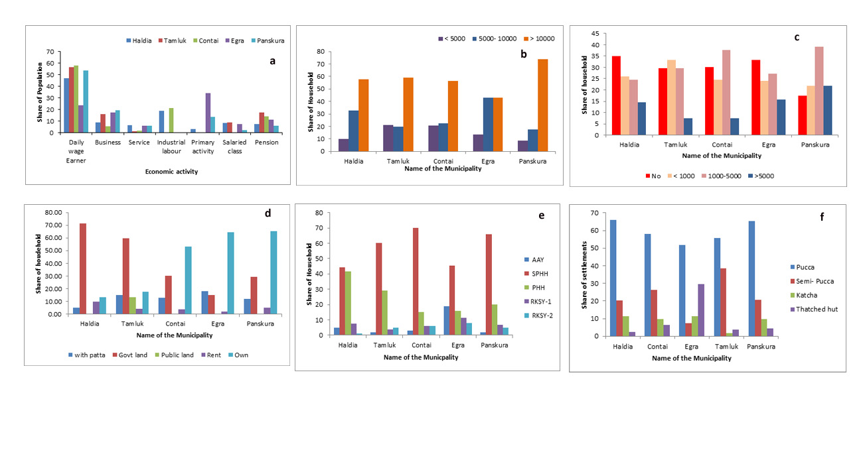Fig:3(a)…Economic activity (b)Monthly income. (c)Monthly Saving. (d)Land tenure. (e) type Ration cards(f)Type of Houses.

across all areas. The data suggests a dominant marriage trend among slum dwellers, with a consistent pattern of more married than unmarried individuals in each municipality. This distribution may reflect cultural or socio-economic factors that encourage marriage within these communities. Overall, the chart highlights the predominance of marriage as a social status among slum populations across the surveyed municipalities, with variations in the proportions of married and unmarried individuals across different regions.

The bar chart (**Fig.2(e)** represents the educational Status of slum dwellers across five municipalities: Haldia, Tamluk, Contai, Egra, and Panskura. The categories range from illiterate to various levels of formal education, including primary, upper primary, secondary, higher secondary (HS), graduate, technical, and others/postgraduate (PG). Across all municipalities, the most common level of education attained is secondary, with significant shares in Haldia, Egra, and Panskura, all nearing 35-40%. A noticeable number of individuals also have upper primary education, especially in Tamluk and Contai. Illiteracy rates are relatively high, with Egra and Tamluk showing a notable percentage of illiterate individuals. The representation of individuals with higher secondary education is moderate across all municipalities. However, the share of graduates and those with technical education is minimal, indicating limited access to higher education in these communities. Other categories, such as technical education and others/PG, show very low percentages, revealing that only a small portion of the population has advanced qualifications. Overall, the chart highlights that while secondary education is prevalent, a substantial segment of slum dwellers has either no education or only primary to upper primary levels, with higher education being rare across these municipalities.

Here, the households are categorized as General (blue bars), OBC (red bars), SC (green bars), and ST (purple bars) (**Fig.2(f**). In all municipalities, the General category dominates, especially in Contai and Tamluk, where over 70% of the households fall under this group. Haldia also has a significant general population, although it is more diverse than Tamluk and Contai. The presence of OBC households is notable in Haldia and Panskura, constituting a sizeable share, while being minimal in other areas. SC households are visible across all municipalities but are more prominent in Egra and Haldia, indicating a relatively higher representation of this group in these areas. ST households are minimally represented in most municipalities, with a noticeable presence only in Egra. Panskura displays a more balanced distribution among the categories, with significant portions of General, OBC, and SC households. Overall, the chart reveals that the General category is predominant across all municipalities, with varying degrees of representation for OBC, SC, and ST households, indicating diversity in the caste composition of slum dwellers across these regions.

The analysis of six bar charts provides insights into the socio-demographic patterns among slum dwellers across five municipalities: Haldia, Tamluk, Contai, Egra, and Panskura. The gender distribution shows a slight male majority across all regions, most prominent in Contai. Family size predominantly falls within 4-5 members, highlighting a trend towards moderate-sized families. The age structure is dominated by the working-age group (15-64 years), with Haldia and Contai having the highest shares, while the elderly population remains minimal. Marital Status reflects a majority of married individuals in all municipalities, with Haldia leading this trend. Educational attainment is primarily at the secondary level, especially in Haldia, Egra, and Panskura, while illiteracy and minimal higher education highlight a lack of access to advanced learning. The caste distribution is majorly composed of the General category across all areas, with notable OBC presence in Haldia and Panskura and higher SC representation in Egra and Haldia, whereas ST representation remains low. Collectively, the charts depict a workforce-driven demographic with moderate family sizes, a high marriage rate, limited educational advancement, and predominant caste composition of General households among slum dwellers across these regions.

**Economic Status of Slum dwellers in Different Municipality of Purba Medinipur:**

The bar chart (**Fig. 3(a**) depicts the economic activities of slum dwellers across five municipalities: Haldia, Tamluk, Contai, Egra, and Panskura. The activities are categorized into daily wage earners, business, service, industrial labor, primary activity, salaried class, and pension. The majority of the population in all municipalities are daily wage earners, with Haldia, Tamluk, and Contai having over 50% in this category, indicating a significant reliance on daily labor. Primary activities, such as agriculture or related work, are prominent in Egra, representing a notable share of the population. Business and service occupations are present across all municipalities but in smaller proportions compared to daily wage earners, with Tamluk showing a relatively higher involvement in business. Industrial labor is notably higher in Haldia, aligning with its industrial landscape, while it is minimal in other municipalities. The salaried class represents a small segment of the population, with a slightly higher proportion in Tamluk and Panskura. Pensioners constitute a very minor share across all municipalities, indicating that very few slum dwellers are retired. Overall, the chart highlights that daily wage earning is the primary economic activity among slum dwellers, with variations in other activities like business, primary activity, and salaried work across different municipalities.

The bar chart (**Fig. 3(b**) presents the monthly income distribution among slum households across five municipalities: Haldia, Tamluk, Contai, Egra, and Panskura. The income categories are divided into three brackets: less than 5,000 (purple bars), 5,000-10,000 (blue bars), and more than 10,000 (orange bars). Across all municipalities, the majority of households fall into the income bracket of over 10,000, with Panskura showing the highest share in this category (around 75%). Tamluk, Contai, and Egra also exhibit a significant portion of households earning more than 10,000, indicating a similar trend. The 5,000-10,000 income brackets are well represented in Haldia and Egra, making up around 30-35% of the households, suggesting a considerable middle-income segment in these municipalities. However, the lowest income bracket (less than 5,000) is least represented across all areas, particularly in Panskura and Tamluk, where it accounts for a minimal share of the households. Overall, the chart indicates that a significant proportion of slum households in all municipalities earn over 10,000 per month. This suggests an upward trend in household income among the slum dwellers in these areas, with variations in income distribution across different municipalities.

The bar chart (**Fig. 3(c**) illustrates the monthly saving scenarios of slum households across five municipalities: Haldia, Tamluk, Contai, Egra, and Panskura. Savings are categorized into four brackets: no savings (red bars), less than 1,000 (light orange bars), 1,000-5,000 (pink bars), and more than 5,000 (blue bars). In all municipalities, a significant portion of households report having no savings, with Haldia and Contai showing the highest share in this category. Households saving less than 1,000 per month are consistently represented across all municipalities, particularly in Tamluk and Panskura. Savings between 1,000 and 5,000 are most prevalent in Contai and Panskura, indicating a moderate saving ability among a notable segment of the population in these areas. Households saving more than 5,000 per month represent the smallest proportion across all municipalities, with a slightly higher presence in Panskura. Overall, the data suggests that while a significant number of slum households cannot save or have minimal savings, a considerable group saves between 1,000 and 5,000 monthly, particularly in Panskura and Contai, reflecting variations in financial saving capacity across these municipalities.

The bar chart (**Fig. 3(d**) presents the land tenure status of slum households across five municipalities: Haldia, Tamluk, Contai, Egra, and Panskura. The categories include households with "patta" (legal land titles) residing on government land, public land, rented land, and owned land. In Haldia and Tamluk, the majority of households reside on government land, accounting for over 60% of the share. Contai and Egra show a different pattern, where a significant portion of households own their land, representing the highest category for both municipalities. In Panskura, the trend is predominantly towards land ownership, with nearly 70% of households owning their land. Households with legal titles ("patta") are present in moderate numbers across all municipalities but do not constitute the majority in any. Public land occupancy is relatively minimal, with a noticeable presence only in Tamluk. The proportion of households renting land is small across all municipalities, with slightly higher numbers in Contai and Egra. Overall, the chart highlights diverse land tenure patterns among slum dwellers, with government land residence being prevalent in Haldia and Tamluk and land ownership being dominant in Contai, Egra, and Panskura, suggesting varied access to secure housing tenure across different municipalities.

The bar chart (**Fig. 3(e**) illustrates the distribution of ration cards among slum households across five municipalities: Haldia, Tamluk, Contai, Egra, and Panskura. The ration card types include Antyodaya Anna Yojana (AAY), State Priority Household (SPHH), Priority Household (PHH), Rajya Khadya Suraksha Yojana-1 (RKSY-1), and RKSY-2. The SPHH category (red bars) dominates across all municipalities, with the highest prevalence in Contai and Panskura, where more than 70% of households hold this card type. In Tamluk, over 60% of households possess SPHH cards, while Haldia and Egra have a slightly lower share. PHH cards (green bars) constitute the second most common type, particularly in Tamluk and Haldia, where they account for a significant portion of households. The RKSY-1 and RKSY-2 categories (purple and teal bars, respectively) have a smaller presence across all municipalities, with a slightly higher representation in Egra. The AAY cards (blue bars) have minimal distribution, with the lowest share across all areas. Overall, the chart suggests that SPHH is the most widespread type of ration card among slum dwellers in these municipalities, while PHH is moderately represented, and other types like RKSY-1, RKSY-2, and AAY are less common.The SPHH card (red bars) is the most prevalent across all municipalities, with the highest representation in Contai and Panskura, where over 70% of households hold this type of card. Tamluk also shows a significant share of SPHH holders (above 60%), while Haldia and Egra have lower yet prominent shares. The PHH card (green bars) is the second most common type, particularly in Tamluk and Haldia, where a notable portion of households hold this card. Egra and Panskura have a moderate share of PHH holders. The RKSY-1 (purple bars) and RKSY-2 (teal bars) cards are less common across all areas, with a slightly higher presence in Egra. The AAY card (blue bars) has minimal distribution among households, consistently being the least represented category. The chart indicates that SPHH cards dominate the ration card distribution among slum households, with PHH as the next prevalent type, while AAY and RKSY categories have limited presence across all municipalities.

The analysis of six bar charts reveals economic and socio-economic patterns among slum dwellers across five municipalities: Haldia, Tamluk, Contai, Egra, and Panskura. Daily wage earners across all regions dominate economic activities (Fig.3(a), with significant primary activities in Egra and notable business involvement in Tamluk. Income distribution (Fig. 3(b) shows a majority earning over ₹10,000 per month, particularly in Panskura, while fewer households fall below ₹5,000, suggesting an upward trend in slum household incomes. Savings (Fig.3(c) indicate that many households have no or minimal savings, particularly in Haldia and Contai, though some in Panskura and Contai save between ₹1,000 and ₹5,000 monthly. Land tenure status (Fig. 3(d) varies, with Haldia and Tamluk residents mostly on government land, while Contai, Egra, and Panskura show higher land ownership. Ration card distribution (Fig. 3(e& f) is largely dominated by the State Priority Household (SPHH) cards across all municipalities, especially in Contai and Panskura, followed by Priority Household (PHH) cards, particularly in Tamluk and Haldia. The less common AAY and RKSY-1 & 2 cards show minimal presence. Overall, the charts suggest economic dependence on daily wages, growing incomes, limited savings, diverse land tenure, and widespread access to ration cards among slum dwellers.

**Housing and Amenities Status:**

The bar chart (**Fig. 3(f**) illustrates the distribution of different housing types among slum dwellers in five municipalities: Haldia, Contai, Egra, Tamluk, and Panskura. The types of houses are categorized as Pucca (blue bars), Semi-Pucca (red bars), Katcha (green bars), and Thatched huts (purple bars). Across all municipalities, Pucca houses—permanent structures made with durable materials—are predominant, with over 60% of the settlements being Pucca

in Haldia, Tamluk, and Panskura and slightly lower in Contai and Egra. Semi-Pucca houses, which are partly permanent structures, are the second most common type, with a significant share in Tamluk and moderate representation in Haldia, Contai, and Panskura. Katcha houses, built with temporary or non-durable materials, are notably present in Egra and Panskura but constitute a minor share in other municipalities. Thatched huts, characterized by temporary materials like straw or leaves, are most prevalent in Egra, where they represent a sizable portion of the housing, but they are minimal in Tamluk and Panskura. Overall, the chart shows that Pucca housing is the dominant type of settlement among slum dwellers, suggesting a trend towards more stable housing structures, while Semi-Pucca, Katcha, and Thatched huts are less common but vary across municipalities.

The bar chart (**Fig. 4(a**) illustrates the types of roofs used in slum households across five municipalities: Haldia, Contai, Egra, Tamluk, and Panskura. The roof types are categorized as thatched/grass (blue bars), concrete (red bars), asbestos (green bars), tiles/tin (purple bars), and tarpaulin (teal bars). In Haldia, tiles/tin roofs are the most common, representing over 80% of the households, with thatched/grass and asbestos as minor components. Contai has a predominant use of concrete roofs (around 70%), indicating a more permanent roofing structure, with asbestos being the second most common material. Egra displays a balanced distribution, with concrete and asbestos roofs sharing a significant portion, and tiles/tin also contribute notably. In Tamluk, tiles/tin is the most common roof type, accounting for around 50% of households, with concrete roofs as the second largest category. Panskura exhibits a different pattern, with a strong prevalence of concrete roofs (around 70%), followed by tiles/tin. Tarpaulin roofs are minimally present across all municipalities, indicating limited use of this temporary material. Overall, the chart highlights that the choice of roofing varies significantly across municipalities, with concrete and tiles/tin being the dominant materials in most areas, reflecting a mix of semi-permanent and permanent roofing structures among slum households.

The bar chart (**Fig. 4(b**) illustrates the average number of rooms per house among slum households across five municipalities: Haldia, Contai, Egra, Tamluk, and Panskura. The categories include one-room (blue bars), two-room (red bars), three-room (green bars), and four-room (purple bars) houses. In all municipalities, the predominant type is two-room houses, particularly in Tamluk (around 65%), Haldia (over 50%), and Contai (close to 50%). This suggests that most slum households in these areas live in moderately sized dwellings. Egra has a significant share of one-room houses (over 40%), indicating a prevalence of smaller living spaces. Panskura shows a more balanced distribution among two-room, three-room, and four-room houses, suggesting a greater variety in house sizes. Three-room houses are more common in Panskura and Contai compared to the other municipalities. In contrast, four-room houses represent a very small share across all areas, indicating that larger houses are rare among slum dwellers. Overall, the chart highlights that two-room dwellings are the most typical size for slum households across most municipalities, with a notable presence of one-room houses in Egra and varied room sizes in Panskura. The data suggests varying living conditions, with smaller homes being more prevalent.

The analysis of three bar charts highlights housing characteristics among slum dwellers in Haldia, Contai, Egra, Tamluk, and Panskura. Housing types (Fig. 3(f) show a predominance of Pucca (permanent) houses across all municipalities, particularly in Haldia, Tamluk, and Panskura. Semi-Pucca houses are the second most common, notably in Tamluk, while Katcha and thatched huts are minimal, with Egra showing higher shares of these temporary structures. Roof types (Fig. 4(a) vary significantly, with tiles/tin and concrete being the most common materials; Haldia prefers tiles/tin, while Contai and Panskura predominantly use concrete. Asbestos and thatched roofs have a moderate presence, and tarpaulin is rarely used. Room size distribution (Fig. 4(b) shows two-room dwellings as the most common across all municipalities, especially in Tamluk, Haldia, and Contai. Egra has a higher share of one-room houses, indicating smaller spaces, while Panskura has more variety with two, three, and four-room houses. Overall, the charts depict a trend toward stable housing with moderate space, though room sizes and roofing vary across municipalities.

**Water and Sanitation conditions of slums in different Municipalities:**

The bar chart (**Fig. 4(c**) depicts the primary sources of drinking water among slum households across five municipalities: Haldia, Contai, Egra, Tamluk, and Panskura. The sources are categorized as public taps (brown bars), individual taps (orange bars), and tube wells (red bars). In Tamluk and Panskura, individual taps are the most common source of drinking water, serving over 50% of households, suggesting a higher level of individual water access in these areas. Egra and Contai also have a significant share of individual taps, though less than Tamluk and Panskura.

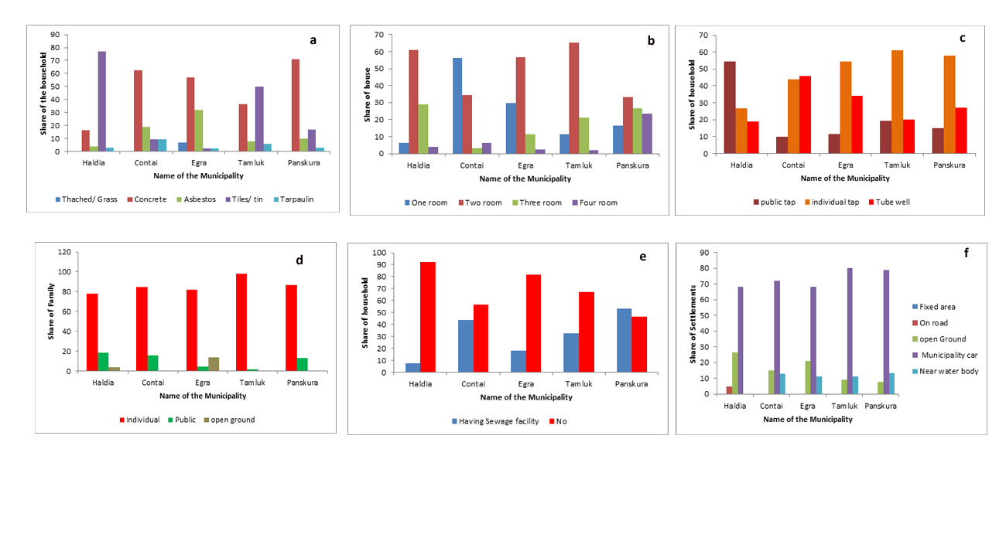Fig:4(a)Roof types. (b)Number of rooms(cSources of drinking water(d)Latrine facility(e)Sewage facility(f)Waste dumping facilities.

Tube wells are prevalent in Egra and Contai, accounting for nearly 50% and 40% of households, respectively, indicating reliance on groundwater sources in these municipalities. Haldia displays a relatively balanced distribution among public taps, individual taps, and tube wells, with public taps being the most common source. Public taps have a modest representation across all municipalities, providing water to approximately 20-30% of households, with the highest share in Haldia. Overall, the chart suggests that the primary source of drinking water varies across municipalities, with individual taps being dominant in Tamluk and Panskura, while tube wells are prominent in Egra and Contai, and a more balanced water source distribution is seen in Haldia.

The bar chart (**Fig. 4(d**) illustrates the share of families using different types of latrine facilities—individual, public, and open ground—across five municipalities: Haldia, Contai, Egra, Tamluk, and Panskura. It is evident that individual latrine facilities dominate across all municipalities, with the highest shares observed in Contai and Tamluk, reaching nearly 100%. Haldia and Egra also show high shares of individual latrines, although slightly lower than the other municipalities. Public latrine usage is minimal, with a noticeable share only in Haldia and Panskura. Egra exhibits a unique pattern where a considerable share of families still relies on open ground as their primary latrine facility. This trend is negligible or absent in other municipalities. In contrast, open-ground usage is not prominent in most municipalities, highlighting a shift towards more private facilities. Overall, the chart indicates a strong preference for individual latrines across all regions, with limited reliance on public or open-ground options. However, some regional disparities exist, particularly in Egra, where open defecation remains a significant practice. The chart reflects varied levels of access to and utilization of sanitation facilities by slum dwellers across different municipalities.

The bar chart (**Fig. 4(e**) presents the proportion of households with and without sewage facilities across five municipalities: Haldia, Contai, Egra, Tamluk, and Panskura. It reveals a significant lack of sewage facilities in most municipalities, with the majority of households having no access to such infrastructure. Haldia shows an almost complete absence of sewage facilities, with nearly 90% of households lacking access. Contai and Panskura fare slightly better, with around 40-50% of households having sewage facilities, yet a significant share remains without access. Egra and Tamluk display similar patterns, where the share of households without sewage facilities substantially outweighs those with access, with nearly 80% and 60%, respectively, lacking such facilities. The chart highlights the stark disparity in sanitation infrastructure, with only a minority of households across these municipalities having adequate sewage systems. This lack of sewage facilities suggests potential sanitation and waste management challenges for slum dwellers. This underscores the need for improved infrastructure to enhance public health and living conditions. The variability in access across the municipalities points to unequal Development and prioritization of sewage facility provision in these regions.

The bar chart (**Fig. 4(f**) illustrates the waste dumping practices across five municipalities: Haldia, Contai, Egra, Tamluk, and Panskura, by categorizing the dumping areas as fixed areas, on the road, open ground, municipality car, and near water bodies. The dominant practice in all municipalities is waste dumping via municipality cars, accounting for over 70% of settlements in each region. This trend indicates a reliance on formal waste collection services provided by the municipality. Dumping on open grounds is the second most prevalent practice in most municipalities, with Haldia, Contai, and Egra showing that around 20-30% of waste is being disposed of in such areas. A small proportion of waste is dumped in fixed areas across all municipalities, with Tamluk and Panskura having slightly higher shares. Disposing of waste near water bodies is relatively low, indicating limited environmental contamination through this means. Roadside dumping is minimal and only noted in Haldia, representing a very small fraction. Overall, the chart suggests that while formal waste collection by municipality cars is the primary mode of disposal, there are notable shares of waste dumping in open grounds, highlighting a need for improved waste management solutions to minimize environmental impacts and promote better sanitation practices in these municipalities.

The analysis of the four bar charts highlights the variations in basic water and sanitation facilities among slum households across Haldia, Contai, Egra, Tamluk, and Panskura. Drinking water sources (Fig. 4(c) vary across regions, with individual taps being prevalent in Tamluk and Panskura, while tube wells serve as a primary source in Egra and Contai. Haldia displays a balanced distribution among public taps, individual taps, and tube wells. Sanitation facilities (Fig. 4(d) show a strong preference for individual latrines across all municipalities, especially in Contai and Tamluk. However, Egra stands out with a considerable share of families relying on open ground for latrine use, contrasting the overall trend towards private facilities. Sewage facilities (Fig. 4(e) are significantly lacking, with most municipalities showing a majority without access. Haldia has the highest share of households lacking sewage infrastructure, while Contai and Panskura are slightly better. Egra and Tamluk also need more sewage systems for a large portion of their households. Waste disposal (Fig. 4(f) is primarily managed through municipality cars, reflecting formal waste collection. Open-ground dumping is notable but less prevalent, indicating areas for improved waste management. Collectively, these charts reveal challenges in access to drinking water, sanitation, sewage, and waste disposal, pointing to 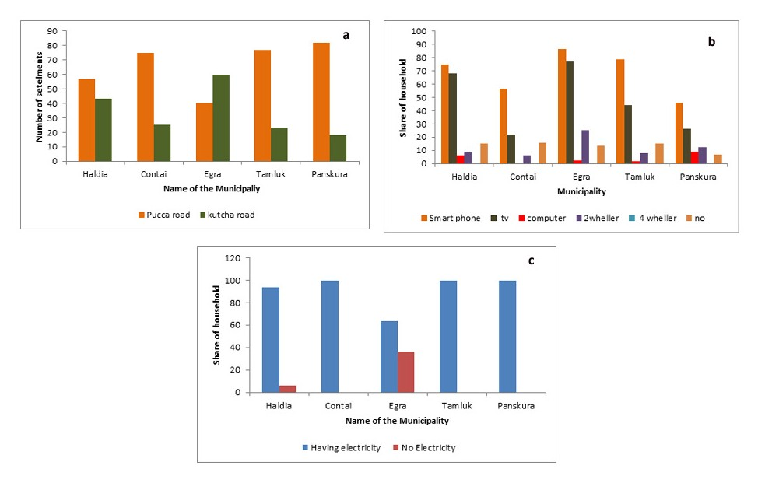infrastructure disparities across the municipalities.

Fig:5(a)Types ofroad(b)Status of basic amenities(c)Status of electric facilities

The bar chart (**Fig. 5(a**) compares the types of roads—pucca (paved) and kutcha (unpaved)—across five municipalities: Haldia, Contai, Egra, Tamluk, and Panskura. Across all municipalities, pucca roads have a higher prevalence, indicating a relatively well-developed infrastructure. Panskura and Contai have the highest number of pucca roads, with settlements numbering around 80, while their kutcha road numbers remain significantly lower. Tamluk also displays a notable disparity between Pucca and Kutcha roads, favoring the former by a wide margin. Egra has a more balanced distribution between the two types of roads, but still shows a higher count of pucca roads. Haldia exhibits the smallest difference between pucca and kutcha roads, indicating a more even distribution, though pucca roads still predominate. The overall trend reveals that, while paved roads are more common across these municipalities, unpaved roads persist, particularly in Haldia and Egra. This suggests that while infrastructural Development is advanced in these regions, certain areas still rely on kutcha roads, indicating potential for further road improvement and infrastructure Development in the municipalities.

The bar chart (**Fig. 5(b)** provides an overview of the ownership of basic amenities, such as smartphones, TVs, computers, two-wheelers, and four-wheelers, among households in five municipalities: Haldia, Contai, Egra, Tamluk, and Panskura. Smartphones and TVs are the most commonly owned amenities across all municipalities, with smartphones having a slightly higher share in most areas. Haldia and Egra show a particularly high ownership rate for both smartphones and TVs, reaching around 80%. Tamluk and Panskura also have substantial smartphone ownership but slightly lower TV ownership. Contai exhibits the lowest ownership of both smartphones and TVs compared to other municipalities. Two-wheeler ownership is moderate across the municipalities, with Egra having the highest share at around 40%, indicating a reliance on this mode of transport. In contrast, all regions have minimal four-wheeler ownership, reflecting lower car access among slum dwellers. Computer ownership is also very low, ranging from 10% to 20%, suggesting limited access to digital devices for activities beyond mobile use. The category labeled as "no" indicates households lacking access to these basic amenities, which is particularly notable in Contai and Panskura. Overall, the chart highlights a strong preference for smartphones and TVs, with limited access to computers and four-wheelers among slum dwellers in these municipalities.

The bar chart (**Fig. 5(c**) compares the availability of electricity among households in five municipalities: Haldia, Contai, Egra, Tamluk, and Panskura. A majority of households in all municipalities have access to electricity, with nearly 100% coverage in Haldia, Contai, Tamluk, and Panskura. These municipalities show negligible shares of households without electricity, indicating a strong and almost universal electric infrastructure. Egra is an exception, where around 60% of households have electricity, and approximately 40% remain without access, representing a significant gap in electric facility coverage. This disparity highlights Egra as an outlier compared to other municipalities, suggesting a need for infrastructure development to bridge this gap. Overall, the chart reflects that most slum dwellers across these regions enjoy reliable access to electricity, except for a notable deficiency in Egra. The nearly complete provision of electric facilities in Haldia, Contai, Tamluk, and Panskura points to successful efforts in extending electrical infrastructure to slum areas, enhancing living conditions and access to amenities dependent on power.

The analysis of three bar charts reveals infrastructural and amenity patterns among slum households across five municipalities: Haldia, Contai, Egra, Tamluk, and Panskura. Road types (Fig. 20) indicate a dominance of pucca (paved) roads across all areas, particularly in Panskura and Contai, with fewer kutcha (unpaved) roads. However, Haldia and Egra show a more balanced presence of both road types, suggesting potential for further infrastructure development. Ownership of basic amenities (Fig. 5(a) shows a high prevalence of smartphones and TVs, particularly in Haldia and Egra, with moderate ownership in Tamluk and Panskura, while Contai has the lowest. Two-wheelers are moderately owned, especially in Egra, but four-wheelers are rare across all municipalities. Computer ownership is low, suggesting limited access to digital devices beyond mobile phones. The "no amenities" category is notably high in Contai and Panskura. Access to electricity (Fig.5(b) is nearly universal in all municipalities except Egra, where around 40% lack access, indicating a need for infrastructure improvement. Overall, the data depict a trend toward well-developed roads, widespread smartphone and TV ownership, and strong access to electricity, with notable gaps in Egra's infrastructure and limited access to computers and four-wheelers among slum communities.

**Conclusion:**

The analysis across multiple bar charts highlights socio-demographic and infrastructural patterns among slum dwellers in five municipalities: Haldia, Tamluk, Contai, Egra, and Panskura. There is a slight male majority, moderate family sizes (4-5 members), a predominance of working-age populations, and high marriage rates. Secondary education is the most common, but higher education is limited. The caste composition is mainly General, with notable OBC and SC representation. Economically, daily wage earners are prevalent, with most households earning over ₹10,000 per month, although savings are generally low. Housing is primarily pucca, with varied roof types and two-room dwellings are common. Drinking water primarily comes from individual taps or tube wells, and while individual latrines are standard, sewage facilities are lacking in most areas. Waste disposal mainly relies on municipal cars and road infrastructure is largely paved (pucca). Amenities like smartphones and TVs are widely owned, but computers and four-wheelers are rare. Electricity is almost universally available except in Egra. Overall, the charts reflect a demographic with moderate living conditions, a workforce-oriented economy, limited savings, and significant disparities in infrastructure and amenities across the municipalities.

**References:**

Alamgir, M. S., Jabbar, M. A., & Islam, M. S. (2009). Assessing the livelihood of slum dwellers in Dhaka city. *Journal of the Bangladesh Agricultural University*, *7*(2), 373-380.

Alder, G. (1995). Tackling poverty in Nairobi's informal settlements: developing an institutional strategy. *Environment and Urbanization*, *7*(2), 85-108.

Ameratunga, S., Hijar, M., & Norton, R. (2006). Road-traffic injuries: confronting disparities to address a global-health problem. *The lancet*, *367*(9521), 1533-1540.

Banerjee, A., & Dawn, D. S. (2020). Preparation of Crop Calendar on Mangalbari Town under Matiali Block, Jalpaiguri District. *Agriculture Journal IJOEAR*, *6*(12), 10.

Bollen, K. A., Glanville, J. L., Stecklov, G. (2001): "Socioeconomic Status andClass in Studies of Fertility and Health in Developing Countries", AnnualReview of Sociology, Vol. 27, p. 153-85

Cloutier, M. M., Baptist, A. P., Blake, K. V., Brooks, E. G., Bryant-Stephens, T., DiMango, E., ... & Walsh, C. G. (2020). 2020 focused updates to the asthma management guidelines: a report from the National Asthma Education and Prevention Program Coordinating Committee Expert Panel Working Group. *Journal of Allergy and Clinical Immunology*, *146*(6), 1217-1270

Ehrenpreis,D.(2006).Whatispoverty?Conceptsandmeasures. Poverty in Focus 9, International Policy Centre for Inclu- sive Growth. Available at: <https://ideas.repec.org/p/ipc/ifocus/9.html>. Accessed 5 Oct 2018.

Haq, R. (2009). Measuring human wellbeing in Pakistan: Objective versus subjective indicators.

Haq, R., & Zia, U. (2013). Multidimensional wellbeing: An index of quality of life in a developing economy. *Social indicators research*, *114*, 997-1012

Hossain, S. (2013). Migration, urbanization and poverty in Dhaka, Bangladesh. *Journal of the Asiatic Society of Bangladesh (hum.)*, *58*(2), 369-382.

Jargoskym,P.(2014).Thespatialdimensionofinequality.The cities paper. citiespapers.ssrc.org/the- spatial-dimensions- of-inequality. Accessed 24 June 2018.

Jha, D., & Tripathi, V. (2014). Quality of life in slums of Varanasi city: A comparative study. *Transactions*, *36*(2).

Joshi, S. (2005). Marriage, Migration and Labor market in slum areas. *Nagarlok*, *37*(3), 34-49.

Kaibarta, S., Mandal, S., Mandal, P., Bhattacharya, S., & Paul, S. (2022). Multidimensional poverty in slums: an empirical study from urban India. *GeoJournal*, *87*(Suppl 4), 527-549.

Kamruzzaman, M. (2015). Child victimization at working places in Bangladesh. *American Journal of Applied Psychology*, *4*(6), 146-159.

Kaviarasu, S. J., & Xavier, G. G. The Status of Living Place and the Health Condition of Women in the Slum of Chennai City, Tamil Nadu.

Kamruzzaman, M., & Hakim, M. A. (2015). Child criminalization at slum areas in Dhaka city. *American Journal of Psychology and Cognitive Science*, *1*(4), 107-111.

Kamruzzaman, M., & Hakim, M. A. (2015). Socio-economic status of child beggars in Dhaka City. *Journal of Social Sciences and Humanities*, *1*(5), 516-520.

Kamruzzaman, M., & Hakim, M. A. (2016). Livelihood status of fishing community of Dhaleshwari river in central Bangladesh. *Int. J. Bioinform. Res. Appl*, *20*, 2-86.

Kimani-Murage, E. W., & Ngindu, A. M. (2007). Quality of water the slum dwellers use: the case of a Kenyan slum. *Journal of Urban Health*, *84*, 829-838.

Khan, M. I. (2013). Social changes in contemporary Bangladesh. *Journal of the Asiatic Society of Bangladesh (Hum.)*, *58*(2), 263-276.

Khan, M. Z., & Dassi, A. (1998). *Road to Dignity: Socio-economic Rehabilitation of Valmikis*. Concept Publishing Company.

Kumar, P. (2010). Declining number of slums: Nature of urban growth. *Economic and Political Weekly*, 75-77.

Majale, M.(2008).Employment creationthroughparticipatory urban planning and slum upgrading:The case of Kitale,

McClelland, A., & Macdonald, F. (1998). The social conse- quences of unemployment. Report for the Business Council of Australia. across developing world cities, 1990–2003. *Habitat International, 32*(1), 86–108.

Mitlin,D.,&Satterthwaite,D.(2002).Howthescaleandnature of urban poverty are under-estimated—the limitations of the US $1 a day poverty line. [http://citeseerx.ist.psu.edu/viewdoc/download?](http://citeseerx.ist.psu.edu/viewdoc/download). Accessed 15 Sept 2018.

Martinez,J.,Mboup,G.,Sliuzas,R.,&Stein,A.(2008).Trends in urban and slum indicators

Moser,C.N.(1995).Urbansocialpolicyandpovertyreduction.*EnvironmentandUrbanization,7*(1), 159–171.

Mondal, A., Kundu, S., & Mukhopadhyay, A. (2012). Rainfall trend analysis by Mann-Kendall test: A case study of north-eastern part of Cuttack district, Orissa. *International Journal of Geology, Earth and Environmental Sciences*, *2*(1), 70-78.

Mondal, M., Paul, S., Bhattacharya, S., & Biswas, A. (2020). Micro-level assessment of rural societal vulnerability of coastal regions: An insight into Sagar Island, West Bengal, India. *Asia-Pacific Journal of Rural Development*, *30*(1-2), 55-88.

Mondal, M., Halder, S., Biswas, A., Mandal, S., Bhattacharya, S., & Paul, S. (2022). Socio-demographic backwardness in cyclone prone coastal villages: An Insight from Indian Sundarban. *Safety in extreme environments*, *4*(1), 13-33.

Mondal, S. (2020). Modeling the spatial pattern of household quality of living in West Bengal: An approach of hotspot and cluster analysis. *Modeling Earth Systems and Environment*, *6*(2), 833-851.

Mondal, S. (2020). Modeling the spatial pattern of household quality of living in West Bengal: An approach of hotspot and cluster analysis. *Modeling Earth Systems and Environment*, *6*(2), 833-851.

Moser, C. O. (1998). The asset vulnerability framework: Reassessing urban poverty reduction strategies. *World Development, 26*(1), 1–19.

Ompad, D. C., Galea, S., Caiaffa, W. T., &Vlahov, D. (2007). Social determinants of the health of urban populations: methodologic considerations. *Journal of Urban Health*, *84*, 42-53.

Panda, P., Benjamin, A. I., & Zachariah, P. (1993). Health status of under-fives in a Ludhiana slum. *Health and Population-Perspectives and Issues*, *16*(3&4), 133-141.

Satterthwaite, D. (1989). The Under-estimation of urban pov- ertyinlowandmiddle-incomenations.In:Workingpaper onpovertyreductioninurbanareas14.HumanSettlement Programme, International Institute for Environment and Development (IIED). Funded by DFID and SIDA. <http://pubs.iied.org/pdfs/9322IIED.pdf>.Accessed24June2018.

Siegel, C., Davidson, A., Kafadar, K., Norris, J. M., Todd, J., & Steiner, J. (1997). Geographic analysis of pertussis infection in an urban area: a tool for health services planning. *American Journal of Public Health*, *87*(12), 2022-2026.

Stokes, C. J. (1962). A theory of slums. *Land economics*, *38*(3), 187-197.

Tanni, T. T., Hasan, M. J., Azad, A. K., & Bakali, B. (2014). State of the environment in slum area: a case study on Khora slum, Khulna. Journal of Environmental Science and Natural Resources, 7(1), 295-304.

Tripathi SC and Arora V. Law Relating to Woman and Children, Allahabad: Central Law Publication, 2010.

Tiwari, N., & Singh, M. K. (2021). Problems of Education in Slums of Delhi. *Int J Edu Sci*, *32*(1-3), 43-56.

UNDP.(2013).HumanDevelopmentReport,2013.NewYork. <http://hdr.undp.org/sites/default/files/reports/14/hdr2013_en_complete.pdf>. Accessed 24 June 2018.

UN-Habitat(UNHumanSettlementsProgramme).(2016).*SDG goal 11 monitoring framework*. Nairobi: UN-Habitat.

UNICEF (The United Nations Children’s Fund). (2008). Ban- gladesh.[www.unicef.org/bangladesh/cbg_](http://www.unicef.org/bangladesh/cbg_)(18.10.08).pdf. Accessed 24 June 2018.

UnitedNations.(2015).TheMillenniumDevelopmentGoals Report2015.Geneva:UnitedNations.<http://www.un.org/millenniumgoals/2015_MDG_Report/pdf/MDG%202015%20rev%20(July%201).pdf>.Accessed26June 2018.

UNSD (United Nation Statistics Division). (2005). Handbook on poverty statistics: Concept, methods and policy use. Specialprojectonpovertystatistics.<https://unstats.un.org/unsd/methods/poverty/pdf/UN_Book%20FINAL%2030%20Dec%2005.pdf>. Accessed 3 Sept 2018.

Yamane, T. (1973). Statistics: An introductory analysis.

Zhou, M., Wang, H., Zhu, J., Chen, W., Wang, L., Liu, S., ... & Liang, X. (2016). Cause-specific mortality for 240 causes in China during 1990–2013: a systematic subnational analysis for the Global Burden of Disease Study 2013. *The Lancet*, *387*(10015), 251-272.