**Population dynamics of *Hydrocynus forskahlii* (Cuvier, 1819) from Roseires Reservoir, Sudan.**

**Abstract**

This study examines the growth, mortality, and recruitment patterns of *H. forskahlii* in Sudan's Roseires Reservoir. From November 2021 to November 2022, 675 specimens were collected, with total lengths ranging from 14.3 cm to 57 cm and an average length of 30.599 ± 10.167 cm. Growth parameters, derived from the Von Bertalanffy equation, yielded an asymptotic length of 58.8 cm and a growth coefficient of 0.260 year⁻¹. Mortality analysis showed a total mortality rate of 0.69 year⁻¹ (natural mortality: 0.58 year⁻¹; fishing mortality: 0.11 year⁻¹). Two recruitment peaks were identified in March and October. The exploitation rate (0.17 year⁻¹) indicates under-exploitation at sustainable fishing pressure. The length-weight relationship revealed negative allometric growth. Measures for improved fishery practices based on the findings of the studywere recommended.

**Keywords:** *Hydrocynus forskahlii*, population dynamics, length, mortality-weight relationship, recruitment, fishery management.

**Introduction**

The Characidae family represents one of the most diverse groups of freshwater teleosts, with global distribution across tropical and neotropical basins (van der Laan, 2019&Cesar*et. al.,* 2004). Within this family, the genus *Hydrocynus* includes three species in Sudanese waters: *H. brevis*, *H. vittatus*, and *H. forskahlii* (Mahmoud *et. al.*, 2024; Abdalla and Adam, 2024& Bailey, 1994), though some surveys report only *H.brevis* and *H. forskahlii* (Neumann *et. al*., 2016).

Globally, Hydrocynus forskahlii (African tigerfish) supports artisanal and commercial fisheries, contributing to food security and livelihoods across African river basins (Tsvenda *etal*., 2024). It is a key species in the Roseires Reservoir and Nile tributaries in Sudan, providing protein and income for local communities (Hamza, 2014). Its ecological role as an apex predator also helps maintain aquatic ecosystem balance (Olaosebikan & Raji, 2013). Sustainable fishery management is critical for economic stability and biodiversity conservation in the region (FAO, 2022).

As an apex predator, *H. forskahlii* exhibits consistent piscivorous feeding patterns across its range, primarily consuming fish (particularly *Alestes spp*.) with occasional crustaceans and insects (Dalu *et al.*, 2012; Hagar, 2019). While its feeding ecology is well-documented in other African regions (Dadebo and Mengistou, 2008; Olojo *et al*., 2003), Sudanese populations remain understudied except for localized reports (Hagar, 2019; Pekkola, 1919).

Population dynamics provides critical data on growth, mortality, and reproduction, helping assess fish stock health and sustainability.Understanding recruitment patterns ensures fishing regulations align with breeding cycles, preventing overexploitation.Estimating mortality rates (natural vs. fishing-induced) guides harvest limits to maintain balanced ecosystems.Analyzing size and age structure supports science-based quotas, ensuring long-term fishery productivity and food security.

Growth parameters of *H. forskahlii*from the von Bertalanffy model varied across regions: asymptotic length (*L*∞) ranged from 52–65 cm, while the growth coefficient (*K*) was 0.2–0.38 year¹ (Ethiopia and Zambezi Basin: Dadebo and Mengistou, 2008; Tsvenda *et al.,* 2024). Mortality rates in Lake Turkana, Kenya, included a total mortality (*Z*) of 0.73 year⁻¹ and fishing mortality (F) of 0.11 year⁻¹ (Sarah *et al.,* 2011). The length-weight relationship consistently indicated negative allometry (*b* < 3), with b = 2.8 in Ethiopia (Dadebo & Mengistou, 2008) and 2.7–2.9 in West Africa (Roux*et. al.*, 2018).

Spawning occurs in the rainy season (March-October). Fecundity ranges from 10,000 to 45,000 eggs/female (White Nile, Sudan and Oyan Reservoir, Nigeria; Hagar, 2019; Olojo *et al.*, 2003). Recruitment is bimodal, being linked to flood pulses (Lake Kariba, Zimbabwe; Dalu *et al*., 2012).

Despite its ecological and economic importance, comprehensive data on *H. forskahlii* population dynamics in Sudanese reservoirs remain lacking. This study addresses this gap through the first systematic assessment of growth, mortality, and reproduction parameters in Roseires Reservoir, providing critical baseline data for sustainable fisheries management.

**Materials and Methods**

**Study area**:

The Roseires Dam is located on the Blue Nile River in Sudan (Fig. 1) and serves as a critical water storage facility for agricultural irrigation and hydroelectric power generation. Situated approximately 550 km from Khartoum, the dam was initially constructed in 1966. A second phase of construction raised its height from 68 m to 78 m, increasing storage capacity from 3.0 billion m³ to 7.3 billion m³. The reservoir now supports local fisheries, providing livelihoods, employment, and income for nearby communities. Fish samples were collected from four designated sites (Table 1).

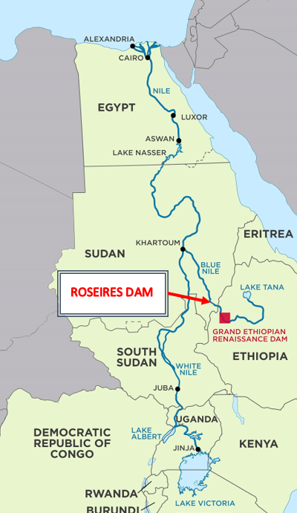

Fig. 1. Roseires Dam in Sudan, Africa (11°47′53″N 34°23′15″E﻿ / ﻿11.79806°N 34.38750°E﻿ / 11.79806; 34.38750). From Ayn network (https://3ayin.com/en/sudan-authorities-support-while-affected-communities-fear-africas-largest-dam/)

**Table 1. The coordinates of the fish sampling sites in Roseires Reservoir (Blue Nile, Sudan) and the distance from the Damazin City.**

|  |  |  |  |
| --- | --- | --- | --- |
| **Site** | **Distance (km)** | **Coordinate** | **Elevation (m)** |
| **Awal Bab** | 4 | 11°45'14"N 34°21'51"E | 487 |
| **EL Regiba** | 16 | 11°38'39"N 34°20'51"E | 497 |
| **Kirma** | 43 | 11°41'09"N 34°30'35"E | 506 |
| **Wad EL Mahi** | 80 | 11°25'27"N 34°40'17"E | 507 |

**Samples collection:**

A total of 675 fish specimens were collected monthly from the four sites (Table 1) between November 2021 and November 2022. Gillnets with stretched mesh sizes of 2 cm, 4 cm, 6 cm, and 8 cm were used, with lengths of 50 m, 90 m, 95 m, and 100 m and depths of 2 m, 4 m, and 4.5 m, respectively (Table 2). Fish identification followed Neumann *et. al*., (2016). Total length (TL) was measured to the nearest 1.0 mm from the snout tip to the end of the caudal fin using a measuring board. Body weight was recorded to the nearest 1.0 g using a digital balance (FRUIT 2000B).

**Table 2. Specifications of gillnets used for fish sampling.**

|  |  |  |  |
| --- | --- | --- | --- |
| **Gear No.** | **Length (m)** | **Depth (m)** | **Mesh size (cm)** |
| **2** | 50 | 2 | 2 |
| **12** | 90 | 4 | 4 |
| **12** | 95 | 4 | 6 |
| **12** | 100 | 4.5 | 8 |

**Length-Weight Relationship:**

The length-weight relationship for *H. forskahlii* was determined using the Le Cren equation:  
Log (W) = log (a) + b log (L) where:

W: represents total weight, L: total length, *a*: the intercept, and *b*: the regression coefficient.

**Growth Parameters:**

The von Bertalanffy growth model was applied to estimate growth patterns, with key parameters including asymptotic length (*L∞*) and growth coefficient (*K*) derived from the von Bertalanffy growth function:

Lt =*L∞* (1-e-k(t-t0)).

**The theoretical age at zero length (t0)**was calculated as:

log10 (−*t*0) = − 0.3922 − 0.2758 × log10 *L∞*− 1.038 × log10*K*. (Pauly, 1979).

**Longevity T*max***was estimated as 3/*K* + *t*0*.*

**The growth performance index (*ϕ* ′)**

was calculated as:

*ϕ* ′ = 2 *log10L∞* + log10 K. (Moreau *et al*., 1986)

**Mortality Parameters:**

The total annual instantaneous mortality rate (Z) was estimated using length-converted catch curves. Natural mortality (M) was calculated following Pauly (1980):

log10M = - 0.0066 - 0.279 × log10*L*∞+ 0.6543 × log10K + 0.4634 × log10T.

Where: M = instantaneous natural mortality, *L∞* asymptotic length, “T” mean surface temperature (24.5 °C), and “*K*” = growth rate.

**Fishing mortality (F)** was derived as (Beverton & Holt, 1957):

F = Z – M.

**The exploitation rate (E)** was obtained using (Gulland, 1971):

E = F/Z.

**Relative Yield and Biomass per Recruit:**

The model by Pauly & Soriano (1986) was used to predict Y′/R, while relative biomass per recruit (B′/R) was estimated following Gayanilo et al. (2005). Key reference points included:

**Maximum exploitation rate** (E*max*),

**Exploitation rate at 10% virgin biomass** (E0.1),

**Exploitation rate at 50% virgin biomass** (E0.5).

**Length at First Capture,***Lc*​,was determined using Beverton and Holt's equation:

*Lc* = *L̄*-*K* × (*L∞* - *L̄*) ÷ Z. Beverton and Holt, (1957).

Where: *L̄* = mean length of the fish catch; K = growth coefficient; L∞ = asymptotic length; and = the total mortality.

**The age at first capture (*t****c*) was determined from the estimated growth parameters (*L∞*, *K*, and *t*0) using the ELEFAN I method following Gayanilo *et. al*., (2005).

**Recruitment Patterns** were analyzed using FiSAT’s "Percent of sample total" option. when the samples had dissimilar sizes.

**Maximum fishing effort (F*max*)** was determined as:

0.67×*K*/0.67-*L*c (Hoggarth *et. al*., 2006).

**The precautionary limit reference point (F*limit*)** was set at:

⅔×M (Patterson, 1992).

**Precautionary target reference point (F*opt*)** was calculated as:

0.4×M (Pauly, 1984).

**Virtual Population Analysis:**

Structured virtual population analysis was conducted using FiSAT II software, incorporating parameters such as *L∞*​, *K*, M, and *F*. Biological reference points were derived Beverton and Holt’s model (1992).

**Optimum cohort biomasslength** was calculated as:

*Lopt*= *L∞* × (3÷3 + M÷*K*).

**Data Analysis:**

Length-weight relationships were analyzed in Microsoft Excel, while population parameters were estimated using FiSAT (Gayanilo *et al*., 1996; Pauly & Morgan, 1987).

**Results**

**Fish size:** A total of 675 specimens of *Hydrocynus forskahlii* were collected monthly from four sites between November 2021 and October 2022. The total length of the specimens ranged from 14.3 cm to 57 cm, with a mean length of 30.599 ± 10.167 cm.

**Growth Parameters:** Length-frequency analysis, conducted using the ELEFAN module in FiSAT, provided growth parameters based on the von Bertalanffy growth function (VBGF). The estimated asymptotic length (*L*∞) was 58.8 cm, with a growth coefficient (K) of 0.260 yr.⁻¹ and a theoretical age at zero length (t0 of -0.273 years. The VBGF equation for H. forskahlii was:

*Lt* = 58.8×(1−e−0.26(t+0.272))

This growth curve is illustrated in Fig. 2 and summarized in Table 3.

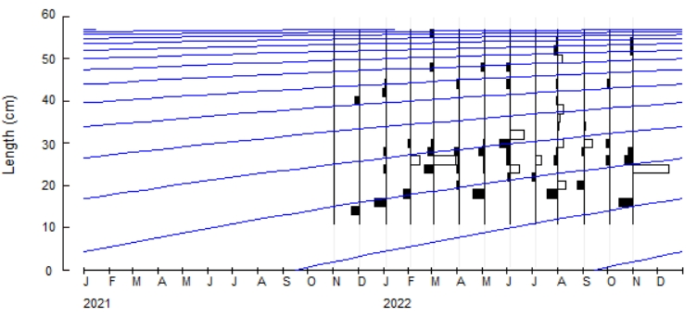

**Fig. 2. Von Bertalanffy growth curve for H. forskahlii in Roseires Reservoir.**

**The length-weight relationship** of *H. forskahlii* showed a strong correlation (*r =* 0.786). This relationship indicates a negative allometric growth pattern, characterized by a b-value of 2.553, as depicted in Fig. 3.

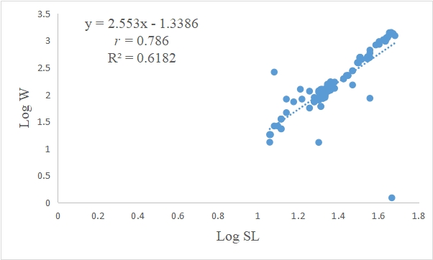

**Fig. 3. Length-weight relationship of *H. forskahlii* in Roseires reservoir.**

**Mortality and Exploitation Rates:** Mortality parameters were estimated as follows:

Total mortality (Z): 0.69 yr.⁻¹.

Natural mortality (M): 0.58 yr.⁻¹.

Fishing mortality (F): 0.11 yr.⁻¹.

Exploitation rate (E): 0.17 yr.⁻¹.

**The growth performance index (*ϕ* ′):** was 2.954 (see Table 3). The length-converted catch curve and mortality estimates are presented in Fig. 4.

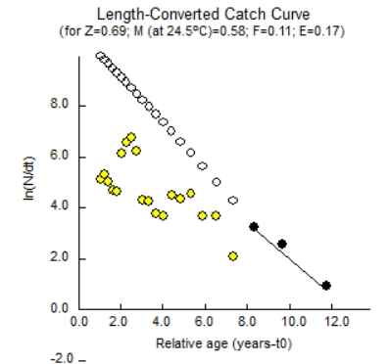

**Fig. 4. Von Bertalanffy growth curve (a) (*L∞*= 58.8 cm; K = 0.260 yr.-1) overlaid on length-frequency distribution, and (b) linearized length-converted catch curve for *H. forskahlii* in Roseires reservoir.**

**Recruitment Pattern:***H. forskahlii* demonstrated two recruitment peaks that occurred in March during the dry season and October during the rainy season. This pattern is illustrated in Fig. 5.

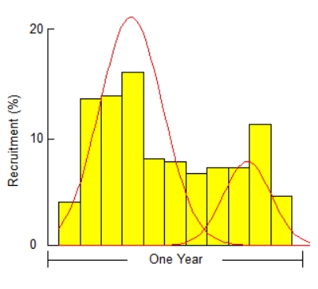

**Fig. 5. Recruitment pattern of *H. forskahlii* in Roseries reservoir.**

**Length at first capture (*L*c)**, estimated from the **probability of capture** for *H. forskahlii*, was 14.3 cm. The lengths corresponding to vulnerability at 25%, 50%, and 75% were 14.94 cm, 21.10 cm, and 22.60 cm, respectively (Fig. 6 and Table 3).

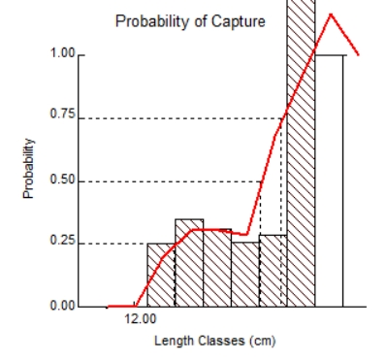

**Fig. 6. The probability of capture of *H. forskahlii* in the Roseries reservoir obtained from the selective curve.**

**Relative Yield and Biomass per Recruit (Y/R):** The maximum (Y/R) occurred at an exploitation rate (E*max*) of 0.499. The exploitation rates corresponding to 10% and 50% of the maximum Y/R (E01 and E05) were 0.418 and 0.312, respectively. The ratio of length at first capture to asymptotic length (*Lc*/*L∞*) was calculated as 0.05, and the probability distribution of length showed *M*/*K* equal to 0.260. Additionally, the length at optimum cohort biomass (*Lopt*) was determined to be 33.72 cm (Fig. 7 and Table 3).

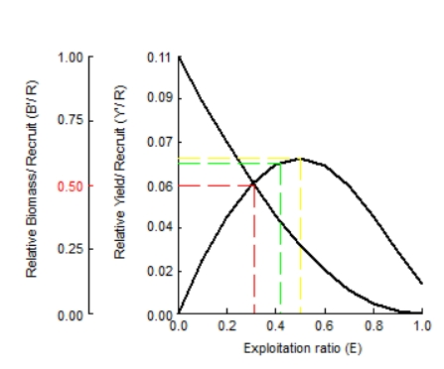

**Fig. 7. Beverton and Holt's relative yield per recruitment (Y/R) and biomass per recruit (B/R) for the *H. forskahlii* in Roseires reservoir.**

**Population Structure and Mortality Patterns:** Population dynamics analysis revealed that younger age classes had higher abundances, which declined progressively with age due to natural mortality (predation, disease, environmental factors) and fishing pressure. The length-structured virtual population analysis (VPA) for H. forskahlii is presented in Fig. 8, illustrating:

**Survival rates** (green): Decline with increasing age/size.

**Natural mortality** (purple): Highest in smaller length classes, decreasing as fish grow.

**Fishing mortality** (yellow): Begins at 14.3 cm, peaks at 28 cm, and declines in larger size classes due to reduced abundance (red line).

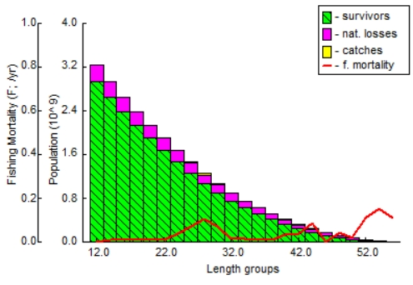

**Fig. 8. Length-structured virtual population analysis (VPA) of *H. forskahlii* in Roseires Reservoir, showing survival (green), natural mortality (purple), and fishing mortality (yellow).**

The fisheriesreference points (Fmax, Flimi ,Fopt) and growth parameters (L∞, K, t0) are summarized in Table 3.

**Table 3. Key biological parameters of *H. forskahlii* in Roseires Reservoir, Sudan.**

|  |  |  |  |
| --- | --- | --- | --- |
| **Parameters** | **Estimated values** | **Parameters** | **Estimated values** |
| ***L∞* (cm)** | 58.8 | **E** | 0.17 |
| ***K*-1** | 0.260 | **E0.1** | 0.418 |
| **t0** | -0.273 | **E0.5** | 0.312 |
| **Phi ꝋ** | 2.954 | **E*max*** | 0.499 |
| **Z** | 0.69 | ***L25*** | 14.94 |
| **M** | 0.58 | ***L50*** | 21.10 |
| **F** | 0.11 | ***L75*** | 22.60 |
| ***Lc/L∞*** | 0.05 | ***Lopt*** | 33.72 |
| **M/K** | 0.260 | **Z/K** | 2.65 |
| **F*max*** | 0.387 | ***L*c** | 14.3 |
| **F*limit*** | 0.210 | **T*max*** | 11.27 |
| **F*opt*** | 0.232 |

**Discussion**:

**Growth and Population Dynamics of *Hydrocynus forskahlii* in Roseires Reservoir**

**Fish size**

In the current study, the total length of *H. forskahlii* ranged from 14.3 cm to 57 cm, with an average of 30.599 ± 10.167 cm. This measurement was slightly greater than that recorded in Nigeria's Yobe River (Segun *et. al.*, 2022) and comparable to findings by Hagar (2019). The maximum reported length for this species is 78.0 cm SL (Paugy *et al*., 2003).

**Growth Parameters**

In this study, the growth parameters derived from the von Bertalanffy growth model for *H. forskahlii* were as follows: the asymptotic length (*L*∞) was 58.8 cm with a growth coefficient (*K*) of 0.260year-1 and a theoretical length at age zero (*t*0) of -0.273 years. The *L*∞ obtained in this study exceeds the 52.40 cm reported by Gagiano (1997) for *H. vittatus* in the Olifants River and the 56.06 cm in the Letaba River (South Africa). The growth coefficient (*K*) in this study is lower than the 0.387 - 0.449 year-1 obtained by Gagiano (1997). Payne &McCarton (1985) reported *L*∞ = 39.2 cm and K = 0.56 yr.⁻¹ for *Hydrocynusspp*. in the Rufiji River (Tanzania). Gerber *et. al*., (2009) studied *H. vittatus* in the Okavango Delta (Botswana) and reported asymptotic length growth coefficients and t0 for males as 73.8 cm 0.159yr-1 and -1.89, respectively, while females had 57.1 cm 0.2791 and -1.43. These differences may be attributed to variations in species and geographical areas. However, it must be realized that, when comparing von Bertalanffy growth parameters (*L*∞ and *K*) across studies, their cumulative effect-expressed through the “growth performance index ϕ′” (ϕ′ = 2 log *L*∞ + log *K*) provides a more robust metric than individual values, as it integrates both asymptotic size and growth rate into a single standardized measure (Pauly & Munro, 1984; Moreau *et. al*., 1986). For *H. forskahlii*, the ϕ′ value of 2.954 obtained in the present study aligns closely with estimates from Ethiopia (ϕ′ ≈ 2.92; Dadebo & Mengistou, 2008) and the Zambezi Basin (ϕ′ ≈ 3.05; Tsvenda *et. al*., 2024), suggesting consistent growth efficiency despite regional variations in *L*∞ (52–65 cm) and *K* (0.2–0.38 yr.⁻¹). This approach mitigates biases from isolated parameter comparisons, as *K* and *L*∞ are often inversely correlated (Pauly, 1979), and highlights ecological adaptations to local conditions (e.g., reservoir productivity, temperature).

In the present study, the length-weight relationship of *H. forskahlii* had a strong correlation; the b-value of 2.553 indicated negative allometric growth. Such growth was also reported by Segun *et. al*., (2022) for the same species in the River Yobe (Nigeria).

In the current study, the total mortality (Z) was estimated at 0.69 yr.⁻¹, the natural mortality (M) at 0.58 yr.⁻¹, and the fishing mortality (F) at 0.11 yr.⁻¹. The very high mortality rate of 84% (Z = 0.851) for tigerfish during their first growth season highlights the advantage of faster growth rates and critical lengths to evade predation (Balon, 1971 & Van Zyl, 1992). Gagiano (1997) reported total mortality rates of Z = 1.488 in the Olifants River and Z = 1.067 in the Letaba River with exploitation rates of 34.4% and 22.6%, respectively. Van Zyl (1992) noted high mortality rates for tigerfish in the Okavango River (Botswana), Z = 0.851, and in Lake Kariba, Z = 0.557, according to Balon (1971), but Dansoko (1975) reported Z = 2.58. Variations in mortality rates within the same species may be attributed to the influence of ecological factors and differing fishing techniques.

The exploitation rate, E = 0.17, obtained in the present study is half of that reported in the Olifants River at 34.4% but slightly lower than the rate in the Letaba River at 22.6% for *H. vittatus* (Gagiano, 1997), and below the theoretical optimum rate of 0.50.

Analysis of the probability of capture revealed that the length at first capture (*L*c) for *H. forskahlii* was 14.3 cm, with vulnerable lengths at 25%, 50%, and 75% of the catch being 14.94 cm, 21.10 cm, and 22.60 cm, respectively. The maximum relative yield per recruit (Y/R) was observed at an exploitation rate (E*max*) of 0.5, while the exploitation rates corresponding to 10% and 50% of the maximum Y/R (E01 and E05) were estimated at 0.418 and 0.312, respectively.

The length at first catch estimated in this study was 14.3 cm. *H. forskahlii* exhibited two recruitment peaks occurring in March during the dry season and in October during the rainy season. Badenhuizen (1967) in his two-year study of *Hydrocynus vittatus* in Lake Kariba (Zambia) observed four generations within this time frame. Breeding occurred annually, coinciding with the rainy season, starting at age two with a breeding size of 35 cm, indicating two recruitment periods. Gagiano (1997) also noted two cohorts of tigerfish species (*H. vittatus*) in the Olifants River and Letaba River (South Africa), which aligns with our findings in this study.

In this study, the ratios *L*c/*L*∞ and *M*/*K* were estimated at 0.05 and 0.260, respectively. The calculated length for optimal cohort biomass or yield prior to recruitment (*Lopt*) was 33.72 cm. The potential longevity T*max* for *H. forskahlii*of 11.27 years is similar to that reported for *H. vittatus* in Lake Bangweulu and the Zambezi River by Griffith (1975) and Winemiller and Kelso-Winemiller (1994), respectively. This longevity is greater than the 9 years reported for the same species in Lake Kariba by Winemiller and Kelso-Winemiller (1994) but less than the 20 years observed for *H. vittatus* in the Okavango Delta (Botswana) according to Gerber *et al*. (2009). These differences in longevity may be attributed to species-specific traits, levels of exploitation, and various biological and ecological factors.

**Comprehensive Assessment of *Hydrocynus forskahlii* Fishery in Roseires Reservoir shows the following points:**

Asymptotic length (*L*∞ = 58.8 cm) and growth coefficient (*K* = 0.26 yr.⁻¹) indicate moderate growth, typical for this species in African reservoirs (Dadebo & Mengistou, 2008).

Length at first capture (*L*c = 14.3 cm) is significantly smaller than optimal cohort biomass length (*Lopt* = 33.72 cm) and the average length of the fish (30.599 cm), indicating early harvest before peak reproductive value.

The probability of capture increases sharply at 21.1 cm (*L*50), suggesting gear selectivity targets smaller fish.

Natural mortality (M = 0.58 yr.⁻¹) dominates over fishing mortality (F = 0.11 yr.⁻¹), especially for smaller fish (Total mortality Z = 0.69 yr.⁻¹), reflecting that high natural losses limit population resilience. Relative Yield per Recruit (Y/R) peaks at E = 0.5, but current effort (E = 0.17) harvests only ~34% of the potential yield. Biomass per Recruit (B/R) shows significant virgin biomass remains, supporting increased effort.

**Recommendations for Managing *H. forskahlii* Fishery in Roseires Reservoir:**

**Reference points:**

**Flimit** (0.210 yr.⁻¹): Absolute upper limit to prevent overfishing.

**Fopt** (0.232 yr.⁻¹): Target for sustainable yield.

**Fmax** (0.387 yr.⁻¹): Theoretical maximum effort (risky).

**Control Effort:** Gradually raise effort toward F*opt* (0.232 yr.⁻¹) to optimize yield without exceeding F*limit* (0.210 yr.⁻¹).

**Size-Limit Regulations:** Increase minimum capture size toward *L*50 (21.1 cm) to protect juveniles and improve spawner biomass.The identification of two distinct recruitment peaks offers valuable information for *timing* conservation efforts and fishing regulations.

**Gear Selectivity Adjustments:** Use larger mesh sizes to shift *L*c closer to *Lopt* (33.72 cm), enhancing yield quality.

**Seasonal closure:** Protect March and October recruitment pulses with seasonal closures if effort increases.

**Risks and Uncertainties**

High Natural Mortality limits stock resilience.

Early Harvest (*L*c<*Lopt*) reduces long-term yield potential.

Regional Variability in growth/mortality suggests local adaptations; management should be reservoir-specific.

**Conclusion**

The Roseires Reservoir *H. forskahlii* population shows **moderate growth** and **high natural mortality**, with **underutilized fishing potential**. However, **early harvest** and **gear selectivity threaten long-term sustainability**. Adopting **size limits**, **seasonal closures**, and **effort controls** could **optimize yield** while **conserving the stock**.

**References**:

Abdalla, M. Y. M. and Adam, A. E. (2024). Diversity and Distribution of Ichthyofauna in the Inland Waters of Sudan: A Review. *Asian J. Res., Zool.,* Vol., 7(3): 1-13. DOI: <https://doi.org/10.9734/ajriz/2024/v7i3151>.

Badenhuizen, T. R. (1967). Some notes on the population dynamics of *Hydrocynus vittatus* (Castelnau) in Lake Kariba. *Hydrobiologia*, 30(3-4), pp.527-540. DOI: [10.1007/BF00964031](https://ui.adsabs.harvard.edu/link_gateway/1967HyBio..30..527B/doi:10.1007/BF00964031).

Bailey, R. G. (1994). A guide to the fishes of the river Nile in the Republic of Sudan. *J. Nat., Hist*., Vol., 28:937-970.

Balon, E. K. (1971). Replacement of *Alestesimberi* (Peters, 1852) by *A. lateralis* (Boulenger, 1900) in Lake Kariba, with ecological notes. *Fish., Res., Bull.,* Zambia. Vol., 5: 119-162.

Beverton, R. (1992). Patterns of reproductive strategy parameters in some marine teleost fishes. *Journal of Fish Biology, 41*, 137–160.

Beverton, R. J., & Holt, S. J. (1957). *On the dynamics of exploited fish populations* (Vol. 11). Springer Science & Business Media. ISBN 94-011-2106-0.

Cesar, E. M.; Francisco, A. M. and Vangil, P. S. (2004). Feeding habits of fish from a stream in the savanna of Central Brazil, Araguaia Basin. Neotropical Ichthyology, 2(1): p 37-44.

Dadebo, E. and Mengistou, S. (2008). Feeding habits, ontogenetic dietary shift and some aspects of reproduction of the tigerfish *Hydrocynus forskahlii* (Cuvier 1819) (Pisces: Characidae) in Lake Chamo, Ethiopia. *Ethiopian Journal of Biological Sciences*, *7*(2), pp.123-137.

Dalu, T., Clegg, B.R.U.C.E., Marufu, L.I.G.H.T.O.N.E. and Nhiwatiwa, T. (2012). The feeding habits of an introduced piscivore, *Hydrocynus vittatus* (Castelnau 1861) in a small tropical African reservoir. *Pan-American Journal of Aquatic Sciences*, *7*(2), pp.85-92.

Dansoko, F.D., 1975. Contribution a l'etude de la biologie des hydrocyom dans le delta central du Niger. *In*: Welcomme, R. L. (1979). Fisheries ecology of floodplain rivers. Longman, London.

FAO. 2022. The State of Food and Agriculture 2022. Leveraging automation in agriculture for transforming agrifood systems. Rome, FAO.<https://doi.org/10.4060/cb9479en>.

Gagiano, C. L. (1997). An ecological study on the Tiger-fish *Hydrocynus vittatus* in the Olifants and Letaba Rivers with special reference to artificial reproduction. M. Sc., thesis, Department of Zoology, Faculty of Science, Rand Afrikaans University. 117 pp.

Gayanilo, F. C., Sparre, P., & Pauly, D. (1996). *FAO-ICLARM Fish Stock Assessment Tools (FISAT) Software Package User’s Manual*. Food & Agriculture Organization.

Gayanilo, F., Sparre, P., & Pauly, D. (2005). *FAO-ICLARM stock assessment tools II: Revised version: User’s guide*. FAO Computerized Information Series on Fish.

Gerber, R., Smit, N.J., Pieterse, G.M. and Durholtz, D. (2009). Age estimation, growth rate and size at sexual maturity of tigerfish *Hydrocynus vittatus* from the Okavango Delta, Botswana. *African J. Aquat., Sci.*, Vol., 34(3), pp.239-247. DOI: <https://doi.org/10.2989/AJAS.2009.34.3.5.981>.

Griffith, J. S. (1975). Annulus formation and growth of tigerfish, *Hydrocynus vittatus*, in Lake Bangweulu, Zambia. *Trans., American Fisher., Soc*., 104: 499–505. DOI: [doi.org/10.1577/1548-8659(1975)104<499:AFAGOT>2.0.CO;2](https://doi.org/10.1577/1548-8659(1975)104%3c499:AFAGOT%3e2.0.CO;2).

Gulland, J. (1971). Science and fishery management. *ICES Journal of Marine Science, 33*, 471–477.

Hagar, E. A. (2019). Predator Prey Relationship of *Hydrocynus forskalii* (Cuvier 1819) in White Nile Reservoir around Kosti and Eljabalain Area. *Journal of Aquatic Science and Marine Biology*, *2*(4), pp.1-6.

Hamza, W.(2014). The Nile fishes and fisheries. *Biodiversity-the dynamic balance of the planet. Rijeka, Intech*, pp.349-370.<http://dx.doi.org/10.5772/57381>.

Hoggarth, D. D., Abeyasekera, S., Arthur, R. I., Beddington, J. R., Burn, R. W., Halls, A. S., Kirkwood, G. P., McAllister, M., Medley, P., Mees, C. C., et al. (2006). *Stock assessment for fishery management: A framework guide to the stock assessment tools of the Fisheries Management and Science Programme*. Food & Agriculture Organization. ISBN 92-5-105503-3.

Le Cren, E. D. (1951). The length-weight relationship and seasonal cycle in gonad weight and condition in the perch (*Perca fluviatilis*). *Journal of Animal Ecology*, 201–219.

Mahmoud, Z. N., Hagar, E. A. and Abdalla, M. Y. M. (2024). Fish diversity in the Nile system and ephemeral water bodies in Sudan: Records and a review. *Inter. J. Fisher., Aquat., Stud.*, Vol., 12(1): 1-8. DOI:https://doi.org/10.22271/fish.2024.v12.i4a.2938.

Moreau, J., Bambino, C. and Pauly, D. (1986). Indices of overall growth performance of 100 Tilapia (Cichlidae) populations. *In*: Maclean JL, Dizon LB, Hosillos LV, editors. The First Asian Fisheries Forum. Asian Fisheries Society; c1986. p. 201-206.

Neumann, D. Obermaier, H. and Moritz, T. (2016). Annotated Checklist for fishes of the Main Nile Basin in the Sudan and Egypt based on recent specimens’ records (2006-2015). *Cybium*. Vol., 40(2):287-317.

Olaosebikan, B. D.&Raji, A. (2013). Field guide to Nigerian freshwater fishes. *Federal College of Freshwater Fisheries Technology*, New Bussa, Revised Edition, pp. 73–74.

Olojo, E.A.A., Olurin, K.B. and Osikoya, O.J. (2003). Food and feeding habits of *Synodontis nigrita* from the Osun River, SW Nigeria. Vol. 26(4):21-24.

Patterson, K. (1992). Fisheries for small pelagic species: An empirical approach to management targets. *Reviews in Fish Biology and Fisheries, 2*, 321–338.

Pauly D, Morgan GR. (1987). editors. Length-based methods in fisheries research. ICLARM Conference Proceedings 13. ;468.

Pauly, D. (1979). Gill size and temperature as governing factors in fish growth: A generalization of von Bertalanffy’s growth formula.

Pauly, D. (1980). On the interrelationships between natural mortality, growth parameters, and mean environmental temperature in 175 fish stocks. *ICES Journal of Marine Science, 39*, 175–192.

Pauly, D. (1984). *Fish population dynamics in tropical waters: A manual for use with programmable calculators*. ICLARM.

Pauly, D. and Munro, J.L. (1984). ICLARM's activities in tropical stock assessment: 1979-1984, and beyond. <https://hdl.handle.net/20.500.12348/3462>.

Pauly, D., & Soriano, M. (1986). Some practical extensions to Beverton and Holt’s relative yield-per-recruit model. In *Asian Fisheries Society Proceedings* (pp. 491–496).

Payne, A. I. and McCarton, B. (1985). Estimation of population parameters and their application to the development of fishery management models in two African rivers. *J. Fish Biol.*, Vol., 27: 263-277. DOI: <https://doi.org/10.1111/j.1095-8649.1985.tb03247.x>.

Pekkola, W. (1919). Notes on the habits, breeding and food of some White Nile Fishes. Sudan and Records V. (2): p 112-121. <https://www.jstor.org/stable/41715836>.

Roux, F., Steyn, G., Hay, C. and Wagenaar, I., (2018). Movement patterns and home range size of tigerfish (Hydrocynus vittatus) in the Incomati River system, South Africa. *Koedoe: African Protected Area Conservation and Science*, Vol., 60(1), pp.1-13. DOI: <https://doi.org/10.4102/koedoe.v60i1.1397>.

Sarah, A. M. G.; Fenton P. D. C.; Colleen, O. R.; Paul, H. S. Maarten, J. W. C. (2011). Cryptic Diversity of African Tigerfish (Genus *Hydrocynus*) Reveals Palaeogeographic Signatures of Linked Neogene Geotectonic Events. *PLoS ONE*. Vol., (6): 12. DOI: <https://doi.org/10.1371/journal.pone.0028775>.

Segun, A.D.S., Ijabo, O.S. and Yusuf, B. (2022). Length-Weight Relationship and Condition Factor of *Hydrocynus forskahlii* (Cuvier, 1819) in River Yobe, Northeast, Nigeria*. Aceh J. Anim., Sci.*,Vol., 7 (2): 53–58. DOI: 10.13170/ajas.7.2.23519.

Tsevenda, C. A., Annune, P. A. P. A., Olufeagba, S. O. and Ataguba, G. A. (2024). Food and Feeding Habits of Three Selected Fish Species of Lower River Benue, Benue State, Nigeria. *Nigerian J. Fisher., Aquacul.*, Vol., 12(1): 1-15.

van der Laan, R., (2019). Freshwater fish list. *Almere, the Netherlands*. pp.1112.

Van Zyl, B. J., (1992). 'N Visekologieseondersoek van die Okavango-enKuneneriviere met spesialeverwysingnavisontginning. *Ph.D thesis.* University of Johannesburg (South Africa).

Von Bertalanffy, L. (1957). Quantitative laws in metabolism and growth. *Quarterly Review of Biology,* Vol., 32: 217–231.

Winemiller, K. O. and Kelso-Winemiller, L. C. (1994). Comparative ecology of the African pike, *Hepsetusodoe*, and tigerfish, *Hydrocynus forskahlii*, in the Zambezi River floodplain. *J. Fish Biol*., Vol., 45: 211–225. DOI: <https://doi.org/10.1111/j.1095-8649.1994.tb01301.x>.