***Original Research Article***

**Influence of Peer Pressure and School Environment on Academic Performance of Secondary School Students in Ijebu East Local Government Area, Ogun State, Nigeria**

**Abstract**

This study investigates how peer pressure and the school environment affect the academic performance of secondary school students in Ijebu East Local Government Area, Ogun State, Nigeria. Using a descriptive survey design, data were collected from 114 randomly selected senior secondary students across four public schools. A structured questionnaire assessed students’ perceptions of peer influence and school conditions. Analysis with SPSS version 23 revealed that 90.3% of students acknowledged peer pressure’s influence on their academic performance, often prioritizing peer approval over academic duties. While positive aspects of the school environment such as clean classrooms, safety, and good facilities were seen as supportive of learning, students also identified significant challenges, including poor infrastructure like inadequate laboratories, libraries, and utilities. The study found that the combined effects of peer pressure and environmental deficiencies negatively impact academic outcomes. To address these issues, the study recommends peer mentorship programmmes, improved infrastructure, continuous teacher training, and enhanced student support services such as counseling and feedback mechanisms. These strategies aim to build a more conducive school environment and encourage positive peer influence. The study highlights the importance of a comprehensive approach involving educators, parents, and policymakers to foster academic success among students.

**Keywords:** Peer Pressure, School Environment, Academic Performance, Secondary School Students. Ijebu East**.**

**1. Introduction**

Academic performance is a primary concern in education, serving as a benchmark for school effectiveness. It reflects how well students meet learning objectives and is commonly assessed through grades, GPA, standardized test scores, assignments, projects, and participation in school activities. Strong academic performance is linked to better economic prospects and social stability, making it a key focus for parents, educators, and policymakers.

Academic achievement refers to the attainment of specific educational goals within a set timeframe. It includes not only cognitive ability but also traits like self-control, discipline, and productivity. The type of school a student attends significantly shapes their academic experience. A school is more than a physical space, it plays a crucial role in academic, emotional, and social development.

Thapa, Cohen, Guffey, and Higgins-D’Alessandro (2013) argue that school climate significantly influences student outcomes, including academic achievement and behavioral development. A positive school environment is characterized by supportive relationships, a sense of safety, and a culture of learning and equity. According to Wang and Degol (2016), such an environment boosts student participation, reduces absenteeism and bullying, and supports consistent academic engagement.

Teacher-student and peer relationships are essential in fostering a sense of belonging and motivation (Cornell & Huang, 2016). Additionally, physical conditions—like clean facilities, good lighting, ventilation, and well-equipped libraries and laboratories—also contribute to student success. The U.S. Department of Education (2014) highlights that well-maintained school buildings positively affect both student health and teacher retention. Effective school administration, including resource and facility management, is also critical and can have a greater impact on teaching quality than individual educators.

Peer pressure, whether direct or indirect refers to the influence exerted by peers to conform to group behaviors or expectations. It can be either negative, leading to risky behavior and distraction from studies, or positive, fostering motivation and collaboration. A student’s academic performance can be shaped by the attitudes of their peers; for example, associating with dropouts may lower motivation, while being among academically driven peers may enhance it. Peer influence and school environment are thus interconnected factors that affect academic achievement. However, despite extensive research, the interaction between these two variables is not fully understood in all contexts. This study aims to explore the combined impact of peer pressure and school environment on the academic performance of secondary school students in Ijebu East Local Government Area, Ogun State, Nigeria.

**1.2 Statement of the Problem**

Academic performance among secondary school students in Ijebu East Local Government Area of Ogun State has shown fluctuating trends, raising concerns among educators, parents, and policymakers. Two key factors that may influence students' academic outcomes are peer pressure and the school environment. Peer pressure can lead students to engage in either positive or negative behaviours, while the quality of the school environment including physical facilities, teacher support, and discipline can significantly impact learning. Despite the recognition of these factors, there is a lack of empirical studies specifically examining their impact on academic performance in this region. Therefore, this study aims to investigate the extent to which peer pressure and the school environment affect the academic performance of secondary school students in Ijebu East LGA.

* 1. **Research Objectives**

1. To examine the influence of peer pressure on the academic performance of secondary school students in Ijebu East Local Government Area.
2. To assess the impact of the school environment on students' academic performance.
3. To determine the combined influence of peer pressure and the school environment on academic performance among secondary school students in the area.

**1.4. Research Questions**

1. How does peer pressure affect the academic performance of secondary school students in Ijebu East LGA?
2. What is the impact of the school environment on the academic performance of students in Ijebu East LGA?
3. To what extent do peer pressure and the school environment jointly influence students' academic performance in the region?

**1.5. Research Hypotheses**

1. H₀₁: Peer pressure has no significant effect on the academic performance of secondary school students in Ijebu East LGA.
2. H₀₂: The school environment does not significantly affect the academic performance of students in Ijebu East LGA.
3. H₀₃: Peer pressure and the school environment do not jointly have a significant effect on students' academic performance in Ijebu East LGA.

**2. Literature Review**

**Peer Pressure and Its Impact on Academic Performance**

Peer pressure is a common social phenomenon, especially among adolescents and young adults. It refers to the influence exerted by peers to conform to group norms, values, or behaviors. While it is often linked with negative behaviors such as substance abuse and delinquency, peer pressure can also result in positive outcomes like academic motivation and social bonding (Brown, 2020; Steinberg & Monahan, 2007).

Adolescence is a particularly vulnerable stage for peer influence, as individuals are forming their social identities. The adolescent brain is highly sensitive to social rewards, making peer approval especially influential during this period (Casey et al., 2010). Research indicates that adolescents are more likely to engage in risky behaviors—such as smoking, drinking, and rule-breaking—when their peers model or approve of such actions (Allen & Brown, 2016).

Steinberg and Monahan (2007) emphasized that peer pressure significantly influences adolescents' decisions related to alcohol use. Their study found that the perceived approval of peers greatly increased the likelihood of drinking behavior. Similarly, Brown (2020) reported that peer pressure shaped academic outcomes, either positively or negatively, depending on the nature of peer interactions.

**2.1 Mechanisms of Peer Pressure**

The mechanisms behind peer pressure are complex. Cialdini and Goldstein (2004) argue that peer pressure functions through social norms and group dynamics. The desire for acceptance and fear of exclusion often drive conformity. Johnson et al. (2019) found that adolescents were more likely to follow peer behaviors when there was group unanimity, illustrating the role of group cohesion.

Moreover, peer pressure is not always overt. Subtle influences such as social comparison and emotional contagion can exert considerable pressure without direct coercion (Garcia et al., 2017). These forms of influence highlight the nuanced and often indirect nature of peer pressure.

**2.2 Peer Pressure and Academic Performance**

Research suggests that peer pressure significantly impacts students' academic performance. Mordi and Onoyase (2025) found a negative correlation between peer pressure and academic performance among Nigerian senior secondary students. Similarly, Abbas et al. (2025) identified a weak negative association among Pakistani university students, indicating that peer pressure may distract from academic goals.

Nonetheless, positive aspects of peer influence are increasingly recognized. Ryan and Shim (2018) found that peer encouragement in academically focused environments improved students’ performance by reinforcing good study habits and aspirations. In contrast, peer groups that devalue education often discourage academic effort. Allen and Brown (2016) demonstrated that affiliation with such groups can lead to disengagement and even increased dropout rates.

**2.3 Negative Impacts of Peer Pressure**

Many studies have highlighted the adverse effects of peer pressure on behavior and academic success. Oladiji (2023) reported that peer pressure contributed to student misconduct in Osogbo, Nigeria, emphasizing the need for targeted interventions. Similarly, Saka and Abdullahi (2022) found that peer pressure and gender influenced social media use and academic achievement in Wukari, Nigeria. Excessive social media engagement driven by peers often reduced students’ academic focus and performance.

Nwamadi (2022) examined the impact of peer pressure on students’ performance in English Language in Rivers State, Nigeria, finding a clear negative effect. These findings underscore the critical role peer dynamics play in shaping educational outcomes.

**2.4 Positive Aspects of Peer Influence**

Despite its risks, peer interaction can positively influence academic performance. Liu (2023), in a study of Chinese high school students, found that supportive friendships and collaborative learning improved academic outcomes. Encouraging positive peer relations can thus be a strategic approach to boosting academic success. Sarfika et al. (2024) explored the link between academic stress and peer pressure among Indonesian junior high school students. While peer pressure was associated with greater academic stress, the impact varied by grade level, showing that context and timing are important variables.

Chala and Asefa (2023) examined how peer pressure and self-efficacy relate to academic success. They found that while peer pressure had a negative impact, self-efficacy positively influenced performance, indicating a complex interaction between internal confidence and external social forces. Additionally, Ifeanyi (2023) studied senior secondary school students in Kaduna State, Nigeria, and found that peer pressure affected both performance and retention in biology. This highlights that peer dynamics can influence not only academic scores but also the long-term retention of knowledge.

**2.5. Interplay of Peer Pressure with Other Psychological Factors**

Peer pressure interacts with other psychological elements to influence students' academic outcomes. Mordi (2022) examined the combined effects of self-esteem, peer pressure, and test anxiety on academic performance among senior secondary students in Delta North Senatorial District, Nigeria. The study found significant correlations among these factors, indicating that peer pressure can amplify academic anxiety and impact performance.

The influence of peer pressure also differs by gender and context. Alhassan et al. (2024) explored peer pressure and gender as correlates of psychological well-being among senior secondary school students in North-West Nigeria. Their findings revealed a significant positive correlation between peer pressure and psychological well-being, with notable gender-based differences. This highlights the importance of gender-sensitive approaches when addressing peer influence.

**2.6. School Environment and Academic Performance of Secondary School Students**

Environmental factors, including noise levels, ventilation, and commute distance, significantly affect students' academic performance. Okoi et al. (2022) reported that long commutes and noise pollution negatively impact academic outcomes in Calabar Metropolis. Similarly, Sangodapo and Ola (2023) found that schools located in quiet, accessible areas tend to record better student performance, suggesting that factors such as air quality and reduced disturbances support effective learning.

**2.7. Physical Infrastructure and Learning Facilities**

Adequate physical infrastructure—such as equipped classrooms, libraries, and laboratories—is crucial for improving student performance. Mangut (2023), in a study conducted in Jos South, Plateau State, revealed that poor physical environments, inadequate learning resources, and insufficient library services adversely affect academic achievement. Research from Calabar Metropolis also indicated that inadequate ICT facilities and poorly ventilated classrooms hinder student progress.

**2.8. Teacher Quality and Human Relations**

Teacher quality and classroom relationships are critical to academic success. Ozuluonye et al. (2023), in the Enugu Education Zone, identified overcrowded classrooms and strained teacher-student relationships as major challenges affecting student achievement. Positive interactions foster a conducive learning environment, enhancing student engagement and performance.

Effective teaching strategies and strong interpersonal connections between teachers and students significantly influence academic outcomes. Pervin, Ferdowsh, and Munni (2021) found a strong positive correlation (r = 0.70, p < 0.05) between teacher-student interactions and academic achievement. Luo et al. (2024) further demonstrated that teacher-student relationships affect academic outcomes through academic engagement, with self-control acting as a mediating factor. Students with higher self-control benefit more from positive relationships with their teachers.

Similarly, Akrofi Baafi (2020) emphasized that students performed better when they experienced low-conflict, positive relationships with their teachers. Xu and Qi (2019) also found that teacher-student interactions influence academic achievement through self-efficacy. Their study showed that building strong teacher-student relationships can boost students’ belief in their abilities and improve performance. This conclusion is supported by Lei et al. (2016), whose meta-analysis found that positive teacher-student relationships are associated with reduced externalizing behavior problems and improved academic performance. The consistent evidence underscores the value of nurturing supportive, high-quality relationships between teachers and students as a pathway to academic success.

**2.9. School Climate and Student Well-being**

Academic outcomes are positively impacted by a supportive school climate that is marked by safety, inclusivity, and emotional support. Insecurity in the school environment, such as exposure to bullying and violence, impairs students' focus and academic performance. A study conducted in Imo State Ojukwu (2020) found that issues related to insecurity, such as substance abuse and cult activities, result in higher dropout rates and lower academic performance.

**3. Research Methodology**

This study adopted a descriptive survey research design. The target population consisted of senior secondary school students from four selected schools in the Ijebu East Local Government Area of Ogun State, Nigeria. The schools involved in the study were: Itele High School, Ijebu-Itele, Comprehensive High School, Iwaye, Ijebu Ife, Imobi Community High School, Oke Igbaga, Community Grammar School, Owu-Ikija. The total student population across these schools was 1,136. A sample size of 10% of the total population, approximately 114 students, was selected for the study.

A simple random sampling technique was employed to ensure that every student had an equal chance of being selected, thereby minimizing selection bias. A structured questionnaire, developed by the researchers, served as the primary instrument for data collection. The questionnaire was designed to elicit relevant information from the respondents concerning the variables of interest. It included both closed-ended and scaled items to facilitate ease of analysis. The collected data were coded and entered into the Statistical Package for the Social Sciences (SPSS), version 23, for analysis. Descriptive statistics such as frequencies, percentages, and charts were used to present the results. This approach provided a clear and concise summary of the data, aiding in the effective interpretation of the findings.

**4. Presentation of findings**

**Table1: Distribution of the Population and sample size across the schools is as follows:**

|  |  |  |  |
| --- | --- | --- | --- |
| SN | Name of School | Population | 10% Sample |
| 1 | Itele High School, Ijebu-Itele | 240 | 24 |
| 2 | Comprehensive High School, Iwaye, Ijebu Ife | 324 | 32 |
| 3 | Imobi Community High School, Oke Igbaga | 304 | 30 |
| 4 | Community Grammar School, Owu-Ikija | 268 | 27 |
|  | Total | 1136 | 113 |

The above table shows the total population of the senior secondary schools across the four schools, which is a total of **1,136** students. The total sample size taken was **113**, representing approximately **9.95%** of the total, which aligns closely with the intended **10%** sampling. Therefore, the sample distribution is **proportional, balanced, and methodologically sound**, with each school contributing a roughly 10% sample of its population. This ensures fair representation and strengthens the reliability of any analysis or inference drawn from the sample data.

**Table 2: Gender of the respondents**

|  |  |  |  |
| --- | --- | --- | --- |
| Gender | | Frequency | Percent |
|  | Male | 38 | 33.6 |
| Female | 75 | 66.4 |
| Total | 113 | 100.0 |

From the above table, the female respondents make up the majority of the sample at 66.4% (75 students). While the males represent 33.6% of the sample (38 students). These show that there is a notable gender imbalance in the dataset, with almost twice as many females as males. Indicating that female respondents were more in the schools studied.

**Table 3: Age Range of the respondents**

|  |  |  |  |
| --- | --- | --- | --- |
| Age Range | | Frequency | Percent |
|  | 10-13 | 27 | 23.9 |
| 14-17 | 72 | 63.7 |
| 18-21 | 14 | 12.4 |
| Total | 113 | 100.0 |

The above table shows that the dominant age group was 14–17 age years old comprising 63.7% of the total sample. This suggests that the population studied is primarily adolescents in middle to late teenage years.

**Chart1:**

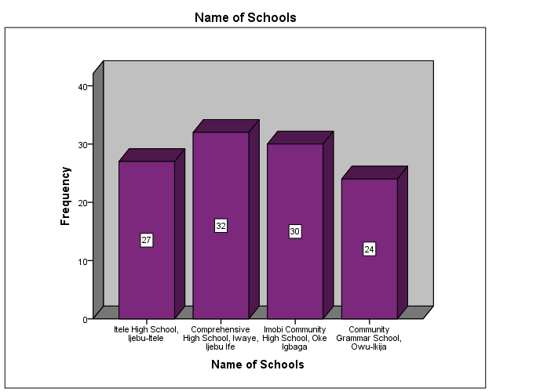 From the above chat,Comprehensive High School, Iwaye, Ijebu-Ife recorded the highest number of responses with 32 (28.3%), indicating the largest representation in the data. In contrast, Community Grammar School, Owu-Ikija had the lowest number of responses with 24 (21.2%). Imobi Community High School, Oke Igbaga and Itele High School, Ijebu-Itele had 30 (26.5%) and 27 (23.9%) responses respectively.

**Chart 2:**

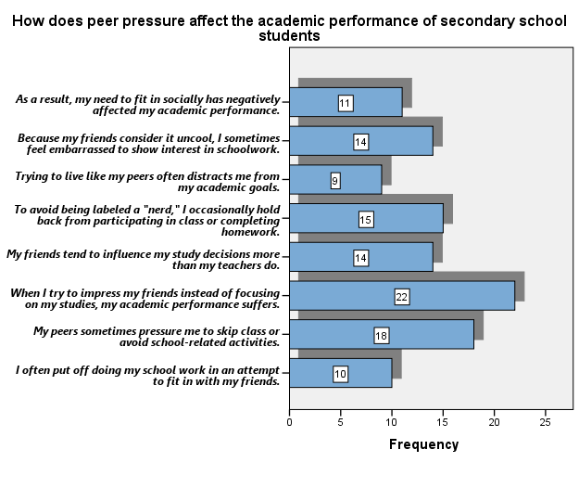

The chart above presents responses to a set of statements exploring how peer pressure influences the academic performance of secondary school students. The majority of respondents, 22 (19.5%), agreed that when they try to impress their friends instead of focusing on their studies, their academic performance suffers. This suggests that peer influence can indeed harm academic performance for some students. This was followed by 18 respondents (15.9%) who indicated that their peers sometimes pressure them to skip class or avoid school-related activities. This shows that peer pressure is noticeable in this context, though it is still not overwhelming.

Similarly, 15 (13.3%) of the respondents agreed that they avoid participating in class or completing homework to avoid being labeled a "nerd." This reflects how peer pressure affects students' willingness to engage academically. Additionally, 14 students (12.4%) agreed that their friends tend to influence their study decisions more than their teachers. This shows that social factors, such as peer opinions, may override educational guidance in some cases.

Another 14 respondents (12.4%) also agreed that because their friends consider it uncool, they sometimes feel embarrassed to show interest in schoolwork. This emphasizes how peer pressure can affect students' attitudes toward their education. In the same vein, 11 respondents (9.7%) agreed that their need to fit in socially has negatively affected their academic performance. This confirms that social pressures can indeed have a negative academic impact.

Likewise, 10 respondents (8.8%) agreed that they often put off doing their schoolwork in an attempt to fit in with their friends. This shows that only a few students procrastinate or delay their schoolwork due to peer pressure. Lastly, 9 respondents (8.0%) agreed that their peers often distract them from their academic goals. This relatively lower percentage suggests that peer influence is less about general distraction and more about specific academic behaviors (e.g., skipping classes or avoiding schoolwork).

**Chart 3:**

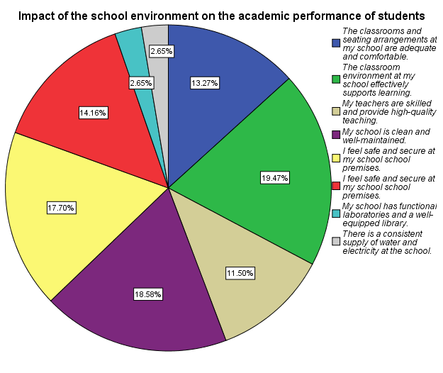

The chart above illustrates how various aspects of the school environment affect the academic performance of secondary school students. The majority of respondents, 22 (19.5%), agreed that the classroom environment at their school effectively supports learning. This indicates that many students perceive their learning environment positively, which is essential for academic engagement and success. Following closely, 21 respondents (18.6%) believe their school is clean and well-maintained. This suggests that a clean and orderly environment likely contributes to better students focus and overall well-being. Another 20 students (17.7%) reported feeling safe and secure on school premises. This underscores the importance of safety, as a secure environment enhances students’ ability to concentrate and actively participate in learning. Additionally, 16 respondents (14.2%) agreed that there are sufficient textbooks and educational resources available. This implies that access to learning materials plays a supportive role in academic achievement. 15 students (13.3%) stated that the classrooms and seating arrangements are adequate and comfortable. This suggests that physical comfort in learning spaces can influence student attention and stamina during lessons.

Meanwhile, 13 respondents (11.5%) agreed that their teachers are skilled and provide high-quality instruction. Although not the lowest, this relatively modest percentage may indicate concerns about teaching quality or students’ perception of it, which is critical given the central role of teachers in education. In contrast, only 3 students (2.7%) reported that their school has functional laboratories and a well-equipped library. This low figure highlights a significant shortfall in essential academic infrastructure needed for science and research-based learning.

Lastly, 3 respondents (2.7%) also agreed that there is a consistent supply of water and electricity at the school. These points to a major deficiency in basic utilities, which can negatively impact the overall learning experience and comfort of students.

**Chart 4:**

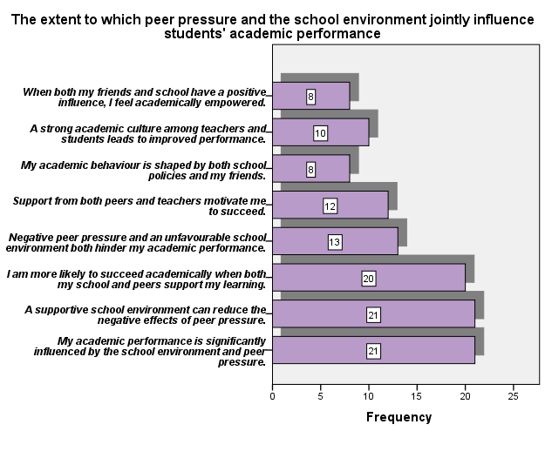

The chart above illustrates the extent to which peer pressure and the school environment jointly influence students' academic performance. The majority of the respondents (21) agreed that their academic performance is significantly affected by both the school environment and peer pressure. This suggests a strong perceived connection between these two factors and academic outcomes. Most students believe that these influences together shape their academic success. Another group of 21 respondents indicated that a supportive school environment can help reduce the negative effects of peer pressure. This highlights the critical role schools play in buffering the adverse impact of peer influences, acting as a protective factor. Additionally, 20 respondents stated that they are more likely to succeed academically when both their school and peers support their learning. This emphasizes that dual support—both from the school environment and peer relationships—fosters academic achievement.

Similarly, 13 respondents reported that negative peer pressure combined with an unfavorable school environment hinders their academic performance. This demonstrates students' awareness that negative influences from both peers and the school climate can jointly derail their academic progress. Another 12 percent of respondents agreed that encouragement from both peers and teachers motivates them to succeed. This implies that academic motivation is closely linked to support from both authority figures and peer groups, underscoring the synergistic effect of positive relationships.

Likewise, 10 respondents believe that a strong academic culture shared by both teachers and students leads to improved performance. This suggests that students thrive in an environment where academic achievement is a shared value. In conclusion, only 8 percent of respondents felt that their academic behavior is shaped by both school policies and their peers. Another 8 percent noted that formal rules and informal peer norms together influence their academic behavior. This implies that when both friends and the school environment exert a positive influence, students feel more academically empowered.

**5. Discussion of the Findings**

The study revealed that 90.3% of respondents experienced some degree of peer pressure, with many reporting efforts to impress their friends at the expense of academic focus. This finding aligns with prior research by Allen and Brown (2016) and Casey et al. (2010), who explored adolescents’ heightened sensitivity to social rewards. Their work supports the conclusion that peer approval often motivates students, sometimes to the detriment of their academic priorities.

Further evidence of the adverse academic effects of peer pressure comes from Mordi and Onoyase (2025) and Abbas et al. (2025), who identified a negative correlation between peer influence and academic performance. These studies echo the current findings, reinforcing the idea that peer dynamics can distract students from educational goals.

The study also highlights the ubiquity and complexity of peer pressure, noting that many students do not perceive it as overt or coercive but still feel its effects. This observation is consistent with Garcia et al. (2017), who describe peer influence as often subtle, manifesting through mechanisms like emotional contagion.

Regarding the school environment, the study found that classroom cleanliness, safety, and general environment were viewed most positively by students. In contrast, infrastructure and teaching quality received less favorable evaluations. This pattern is well supported by Okoi et al. (2022) and Sangodapo and Ola (2023), who noted that physical factors such as noise levels, location, and cleanliness significantly influence academic performance. Similarly, Mangut (2023) and Ozuluonye et al. (2023) discussed the negative impact of poor infrastructure, inadequate facilities, and overcrowded classrooms, which supports the respondents’ concerns about the lack of functional laboratories, libraries, and utilities.

Notably, only 11.5% of respondents emphasized teaching quality, indicating concerns about instructional effectiveness. This aligns with the findings of Pervin et al. (2021) and Luo et al. (2024), who stressed the importance of effective teaching methods and positive teacher-student relationships for academic success. These insights suggest that instructional quality may warrant greater attention in the educational context under study.

Finally, the study explored the interplay between peer influence and the school environment, concluding that academic performance is shaped by their interaction. This conclusion is supported by Chala and Asefa (2023) and Mordi (2022), who examined how peer pressure interacts with psychological variables such as self-efficacy and anxiety, demonstrating that it rarely acts in isolation. Ojukwu (2020) similarly highlighted the harmful effects of unsafe school environments, including bullying and substance abuse, further validating the importance of cleanliness and safety. Additionally, the meta-analysis by Lei et al. (2016) supports the idea that supportive social dynamics—both peer-related and institutional—promote better academic outcomes, while negative or poorly developed environments hinder them.

**Conclusion and Recommendations**

The study found that, depending on the type of peer interactions, peer pressure can have both beneficial and negative effects on students' academic behaviour. Positive peer pressure can encourage students to associate themselves with high-achieving peers, improve their study habits, participate actively in class, and pursue academic greatness. On the other hand, unfavourable peer pressure might result in disengagement, absenteeism, or the adoption of unhelpful habits that impede academic progress. Peer pressure's dual character emphasises how it can be used in educational contexts as a resource and a risk.

The study underlined the significance of the school environment in influencing academic success in addition to peer pressure. Students' academic success was discovered to be directly impacted by important elements like the availability of sufficient learning resources, the quality of the teacher-student connection, and the state of the school's infrastructure. Effective learning and the welfare of students are made possible by a school environment that is safe, supportive, and well-resourced. Crucially, a complex and dynamic link that further affects academic achievement was shown in the interaction between peer pressure and the school environment. To improve student achievement, these findings highlight the necessity for educators, parents, and legislators to actively cultivate supportive peer networks and make investments in high-quality, encouraging learning settings.

**5.2. Recommendations**

**The following are the recommended strategies for enhancing peer influence, the school environment, and students’ academic performance**

1. **Establish peer mentorship programs** rather than encouraging rivalry and unhealthy peer pressure, schools should implement mentorship programs in which high-achieving students positively support and influence their peers. This fosters collaboration and promotes shared academic development.
2. **Improve the school environment**: The school environment has a significant impact on students’ morale and concentration, it is vital to maintain clean, safe, and orderly premises. A well-managed environment enhances focus and cultivates a more positive attitude towards learning.
3. **Address infrastructure deficiencies**: Essential facilities such as science laboratories, libraries, and utilities should be upgraded. These resources are vital for hands-on, experiential learning and must be functional and easily accessible to all students.
4. **Promote continuous professional development for teachers**: With teaching quality reportedly as low as 11.5%, it is crucial that schools invest in ongoing professional development for educators. Strengthening teachers’ skills and instructional strategies is key to improving student engagement and overall academic outcomes.
5. **Enhance classroom comfort and learning resources:** To support student comfort and academic success, classrooms should be equipped with appropriate learning materials, including up-to-date textbooks, ergonomic seating, and other essential educational tools.
6. **Foster a positive peer culture through: Counseling**: Schools should offer regular counseling sessions and awareness programs addressing peer pressure. These services equip students with the resilience to resist negative influences and empower them to make informed academic and personal choices.
7. **Implement regular feedback mechanisms:** Establish systems for students to consistently provide feedback regarding their social experiences and learning environment. Such mechanisms enable school administrators to take timely, data-informed actions that enhance student well-being and academic performance.

**References**

Abbas, S., Shahzad, A., Shahid, E., & Basharat, A. (2025). Parenting styles and peer

pressure in relation to academic performance among adolescents. *Research Journal of Psychology, 3*(1), 23–32. <https://doi.org/10.59075/rjs.v3i1.42>

Akrofi Baafi, R. K. (2020). Teacher-student relationship and student learning outcomes

in senior public secondary schools in Ghana. *European Journal of Education Studies, 6* (12). <https://oapub.org/edu/index.php/ejes/article/view/2869>

Alhassan, A., Aminu-Maska, M., & Ibrahim, B. (2024). Gender differences and peer

pressure as correlates of psychological well-being of senior secondary school adolescents in North-West, Nigeria. *Ilorin Journal of Education*. <https://ije.unilorinedu.sch.ng/index.php/ije/article/view/109>

Allen, J. P., & Brown, B. B. (2016). Peer pressure and adolescent behavior.

*Developmental Psychology, 52*(5), 873–887. <https://doi.org/10.1037/dev0000083>

Brown, B. B. (2020). Peer relationships in adolescence. *Current Directions in*

*Psychological Science, 29*(3), 200–207. <https://doi.org/10.1177/0963721419862100>

Casey, B. J., Jones, R. M., & Hare, T. A. (2010). The adolescent brain. *Cerebral Cortex,*

*20*(3), 473–484. <https://doi.org/10.1093/cercor/bhp118>

Chala, L., & Asefa, D. (2023). Self-efficacy and peer pressure: Their impact on students’

academic achievement. *Journal of Science, Technology and Arts Research, 12*(4), 115–128. <https://doi.org/10.20372/star.v12i4.09>

Cialdini, R. B., & Goldstein, N. J. (2004). Social influence: Compliance and conformity.

*Annual Review of Psychology, 55*(1), 591–621. <https://doi.org/10.1146/annurev.psych.55.090902.142015>

Cornell, D., & Huang, F. (2016). Authoritative school climate and high school student risk

behavior: A cross-sectional multi-level analysis of student self-reports. *Journal of Youth and Adolescence, 45*(11), 2246–2259. https://doi.org/10.1007/s10964-016-0532-4

Garcia, J. R., Tripp, M., & Dinsmore, D. (2017). The subtle influence of peer pressure:

How group norms shape individual behavior. *Psychology of Social Influence, 18*(2), 225–240. <https://doi.org/10.1016/j.psyneuen.2017.01.005>

Ifeanyi, A. R. (2023). Influence of peer pressure on achievement and retention of biology

concepts among senior secondary school students in Kaduna State. *ATBU Journal of Science, Technology and Education, 11*(1), 45–52. <https://www.atbuftejoste.com.ng/index.php/joste/article/view/1513>

Johnson, D. W., Johnson, R. T., & Tjosvold, D. (2019). Peer pressure and group

dynamics: Implications for behavior in adolescents. *Journal of Social Psychology, 59*(6), 703–715. <https://doi.org/10.1080/00224545.2019.1580173>

Lei, H., Cui, Y., & Chiu, M. M. (2016). Affective teacher–student relationships and

students' externalizing behavior problems: A meta-analysis. *Frontiers in Psychology, 7*, 1311. <https://doi.org/10.3389/fpsyg.2016.01311>

Liu, J. (2023). The effect of peer relationship on academic performance in high school

students. *Lecture Notes in Education Psychology and Public Media, 13*, 136–144. <https://www.ewadirect.com/proceedings/lnep/article/view/5160>

Luo, Y., Yu, X., Tang, Y., & Zhang, H. (2024). Teacher–student relationship and

academic achievement among adolescents: A moderated mediation model. *Psychology in the Schools*. <https://doi.org/10.1002/pits.23377>

Mangut, P. J., Anikoh, O. V., & Gik, B. J. (2023). Influence of school environment on

academic performance of public secondary school students in Jos South Local Government Area of Plateau State, Nigeria. *International Journal of Economics and Development Policy, 5*(1). <https://gsujournals.com.ng/ijedp/index.php/ijedp/article/view/68>

Mordi, C. (2022). Self–esteem, peer pressure, examination anxiety and academic

performance of senior secondary students in Delta North Senatorial District, Nigeria. *European Journal of Special Education Research*. <https://oapub.org/edu/index.php/ejse/article/view/4733>

Mordi, P., & Onoyase, A. (2025). Self–esteem, peer pressure, examination anxiety and

academic performance of senior secondary students in Delta North Senatorial District, Nigeria. *European Journal of Special Education Research*. <https://oapub.org/edu/index.php/ejse/article/view/4733>

Nwamadi, L. (2022). Influence of peer pressure on secondary school students’ academic

performance in English language in Omuma LGA of Rivers State. *Advance Journal of Education and Social Sciences, 7*(5), 63–70. <https://aspjournals.org/ajess/index.php/ajess/article/view/63>

Ojukwu, M. O. (2020). Effect of insecurity of school environment on the academic

performance of secondary school students in Imo State. *International Journal of Education and Literacy Studies, 8*(3), 12–16. <https://journals.aiac.org.au/index.php/IJELS/article/view/3115>

Okoi, B. J., Okoi, C. E., & Eteng, S. (2022). Influence of school environment on

academic performance of secondary school students in Calabar Metropolis, Cross River State, Nigeria. *Journal of Social Sciences and Management Studies, 1*(3), 12–16. <https://www.jescae.com/index.php/jssms/article/view/96>

Oladiji, A. (2023). Influence of peer pressure on adolescents’ misbehaviour among

secondary school students in Osogbo Local Government Area of Osun State. *Journal Plus Education, 32*(1). <https://www.uav.ro/jour/index.php/jpe/article/view/1797>

Ozuluonye, C. G., Obiageli, O. P., & Ekweogu, L. B. (2023). Influence of school

environment on academic performance of students in public secondary schools in Enugu Education Zone. *African Journal of Educational Management, Teaching and Entrepreneurship Studies, 8*(2), 96–104. <https://ajemates.org/index.php/ajemates/article/view/227>

Pervin, M. M., Ferdowsh, N., & Munni, I. J. (2021). Teacher-student interactions and

academic performance of students. *Dhaka University Journal of Biological Sciences, 30*(1), 87–93. <https://doi.org/10.3329/dujbs.v30i1.51812>

Ryan, A. M., & Shim, S. S. (2018). Peer influence on academic performance: The role of

friends and peer groups. *Journal of Educational Psychology, 110*(2), 146–158. <https://doi.org/10.1037/edu0000235>

Saka, A., & Abdullahi, I. (2022). Impact of peer pressure and gender as predictors of social

media usage and academic performance among school-going adolescents in Wukari Educational Zone, Nigeria. *Asian Journal of Sociological Research, 5*(1), 242–248. <https://journalsociology.com/index.php/AJSR/article/view/68>

Sangodapo, A., & Ola, A. A. (2023). Effect of school environmental factors on academic

development of secondary school students in Boripe Local Government Area of Osun State. *International Journal for Innovation Education and Research, 8*(12). <https://doi.org/10.31686/ijier.vol8.iss12.2828>

Sarfika, R., et al. (2024). Peer pressure and academic stress among junior high school

students: A cross-sectional study. *Frontiers of Nursing, 11*(2), 191–199.

Steinberg, L., & Monahan, K. C. (2007). Age differences in resistance to peer influence.

*Developmental Psychology, 43*(6), 1531-1543. <https://doi.org/10.1037/0012-1649.43.6.1531>

Thapa, A., Cohen, J., Guffey, S., & Higgins-D’Alessandro, A. (2013). A Review of

School Climate Research. Review of Educational Research, 83, 357-385.  
<https://doi.org/10.3102/0034654313483907>

U.S. Department of Education. (2014). *Guiding principles: A resource guide for* *improving*

*school climate and discipline*. <https://resources.finalsite.net/images/v1569586812/resanet/de3t1qdoh1ifaf1etz6o/GuidingPrinciples.pdf>

Wang, M. T., & Degol, J. L. (2016). School climate: A review of the construct,

measurement, and impact on student outcomes. *Educational Psychology Review, 28*(2), 315–352. https://doi.org/10.1007/s10648-015-9319-

Xu, Z. Z., & Qi, C. X. (2019). The Relationship between Teacher-Student Relationship

and Academic Achievement: The Mediating Role of Self-Efficacy. *Eurasia Journal of Mathematics, Science and Technology Educati*on, 15, Article No: em1758. https://doi.org/10.29333/ejmste/105610