**DEVELOPMENT, VALIDATION AND SUMMATIVE EVALUATION OF CODE-MIXED LOCALIZED INSTRUCTIONAL MATERIALS (CMLIMs) IN MATHEMATICS I**

# Abstract

This study aims to develop, validate, and conduct a summative evaluation of Code-Mixed Localized Instructional Materials in Mathematics I to enhance comprehension and engagement among Grade 1 learners. Recognizing the linguistic and cultural diversity in early education settings, the instructional materials integrated local language (mother tongue) with English to support gradual language transition while maintaining contextual relevance. The developmental process followed the ADDIE Model—Analysis, Design, Development, Implementation, and Evaluation.

Content and language experts validated the materials using a researcher-made evaluation tool focused on content accuracy, linguistic appropriateness, cultural relevance, and instructional design. The materials obtained a high overall mean rating, indicating validity. For summative evaluation, a quasi-experimental design was used involving two groups: an experimental group that used the code-mixed localized materials and a control group that used standard instructional materials. Pre-tests and post-tests were administered to assess learning gains.

Results revealed that the experimental group significantly outperformed the control group in terms of mathematics achievement, suggesting that the use of code-mixed localized materials positively influenced learners’ understanding and retention of mathematical concepts. Qualitative feedback from teachers and pupils further supported the effectiveness and cultural appropriateness of the materials.

The study concludes that code-mixed, localized instructional materials are effective tools for improving mathematics instruction in early grades, especially in multilingual contexts. It is recommended that educators and curriculum developers consider integrating local languages and contextual examples in instructional design to bridge linguistic gaps and foster deeper learning.

Keywords: Code-Mixing, Development, Validation, Summative Evaluation.

# Introduction

The field of education continuously strives to enhance teaching and learning processes. Innovations, such as the use of code-mixing in classrooms, aim to improve student engagement and outcomes. Code-mixing, especially in multilingual contexts like among Ilocano speakers in the Philippines, fosters a unique sense of ethnolinguistic identity, motivating students and bridging social gaps between them and their teachers. Code-mixing is often seen as a communication strategy, allowing bilinguals to mix languages naturally in discourse. It promotes more effective communication, especially in classrooms where students share a common understanding of multiple languages.

Studies show that this practice enhances both verbal and written communication, contributing to educational, social, and psychological domains. For instance, Hudson (1996) found that code-mixing facilitated efficient communication and improved classroom dynamics.

In classrooms, the use of instructional materials plays a crucial role in enhancing learning. These materials allow students to learn at their own pace, offering flexibility and the opportunity for self-assessment. Historical research by Skinner in the 1950s laid the groundwork for the development of programmed instruction, which includes principles like breaking content into manageable chunks and providing immediate feedback. Instructional materials are now widely recognized as essential tools in education, supporting personalized learning and catering to individual learning speeds.

Despite challenges, such as limited resources, the use of instructional materials, especially in subjects like mathematics, has been shown to improve learning outcomes compared to traditional methods. The Department of Education’s Matatag Curriculum encourages the use of such materials to meet the diverse academic needs of students. This approach is detailed in DepEd Order No. 010, s. 2024, which outlines the policy guidelines for implementing the MATATAG Curriculum. The order underscores the significance of inclusive education and learner well-being, advocating for the use of appropriate and contextually relevant materials to support diverse learners.

The Department of Education’s Matatag Curriculum encourages the use of such materials to meet the diverse academic needs of students. In this context, code-mixing has emerged as an effective instructional tool, particularly in Grade 1 Mathematics, where the researcher sought to develop and validate code-mixed instructional materials to test their impact on student performance.

In summary, the integration of code-mixed materials and innovative instructional resources plays a vital role in advancing educational practices, enhancing student engagement, and improving learning outcomes. Further research and development in this area will contribute to refining teaching methods and better addressing the needs of diverse learners.

# Literature Review

In multilingual education settings, code-mixing has emerged as an effective strategy to enhance comprehension and engagement among early learners. Code-mixing, the practice of blending two or more languages within a conversation or sentence, is commonly observed in classrooms, particularly in areas where learners are transitioning from their mother tongue to a second language like English. Bautista (2004) emphasizes that this linguistic approach reduces learners’ anxiety and increases participation, especially in subjects like mathematics that often involve abstract concepts. Setati and Adler (2001) further highlight that code-mixed instruction enables learners to better grasp content by allowing them to relate new ideas to familiar language patterns.

Equally important is the localization of instructional materials, which ensures that lessons are contextually relevant to learners' cultural and social backgrounds. Localization adapts content to reflect local experiences, making learning more meaningful and relatable. According to United Nations Educational, Scientific and Cultural Organization UNESCO (2016), using culturally responsive materials enhances student motivation and promotes deeper learning. In the Philippines, the Department of Education’s Mother Tongue-Based Multilingual Education (MTB-MLE) policy supports this approach, encouraging the use of learners’ first language in early education. Nolasco (2008) notes that localized materials not only improve comprehension but also strengthen learners’ sense of identity and community.

Developing effective instructional materials requires a systematic and learner-centered process. The ADDIE model—Analysis, Design, Development, Implementation, and Evaluation—is widely used in the instructional design field to ensure that materials meet the needs of both learners and curriculum standards (Dick & Carey, 2009). In mathematics instruction, materials should include contextual examples, visual supports, and scaffolding strategies to aid in concept acquisition. Reys et al. (2012) assert that well-designed instructional resources are crucial in building foundational math skills, particularly in early grades.

Validation and summative evaluation play critical roles in assessing the quality and effectiveness of instructional materials. Validation involves the input of content experts to ensure accuracy, appropriateness, and alignment with learning outcomes (Taba, 1962). Meanwhile, summative evaluation measures the impact of the materials after implementation, often using pre- and post-tests, classroom observations, and stakeholder feedback. Tyler (1949) stresses that evaluation must be based on learning outcomes to determine whether educational goals have been achieved. Clements and Sarama (2009) also point out that early mathematical experiences shape a child's long-term success in mathematics, and instructional interventions must be carefully designed and evaluated to ensure effectiveness.

Overall, the integration of code-mixing and localization in instructional materials, supported by systematic development and rigorous evaluation, offers a promising approach to improving mathematics instruction in early grades. This review affirms that culturally and linguistically responsive materials can bridge learning gaps and enhance the educational experience of young learners in diverse classroom settings.

# Theoretical Framework

This study is anchored on three major educational theories: **Vygotsky’s Sociocultural Theory**, **Bruner’s Constructivist Theory**, and the **ADDIE Model of Instructional Design**. Together, these provide a solid foundation for the development, validation, and evaluation of code-mixed and localized instructional materials in Mathematics I.

**Vygotsky’s Sociocultural Theory** emphasizes the essential role of language and social interaction in learning. Vygotsky (1978) argued that learners construct knowledge more effectively when instruction is mediated through their cultural tools, especially language. In multilingual contexts, such as those in the Philippines, learners often think and express themselves best in their first language or mother tongue. The use of **code-mixed instruction**, blending English with the local language, aligns with Vygotsky’s idea of the **Zone of Proximal Development (ZPD)**—where learners achieve deeper understanding when supported by language and cultural cues they already understand. This theory validates the incorporation of both the native and second language in instructional materials, particularly in early mathematics, where abstract concepts require concrete linguistic bridges.

**Bruner’s Constructivist Theory** further supports the localization aspect of this study. According to Bruner (1966), learning is most effective when new concepts are built upon learners’ prior knowledge and experiences. Localization of instructional materials—by embedding local contexts, names, places, and culturally relevant situations—makes abstract mathematical concepts more relatable and understandable to young learners. Bruner’s idea of **scaffolding**, where learners are gradually led to independent understanding through contextually guided instruction, reinforces the importance of cultural familiarity in teaching materials.

Complementing these learning theories is the **ADDIE Model** (Analysis, Design, Development, Implementation, Evaluation), a widely used framework in instructional design (Dick & Carey, 2009). The ADDIE Model provides a systematic approach to creating high-quality instructional materials. In this study, the model guided each phase: identifying learners' needs (Analysis), structuring content and visual design (Design), creating and assembling the materials (Development), classroom use (Implementation), and expert review and impact assessment (Evaluation). The summative evaluation component of this study is also rooted in **Tyler’s (1949) Objectives Model**, which emphasizes evaluating instructional effectiveness based on defined learning outcomes.

By integrating Vygotsky’s sociocultural lens, Bruner’s constructivist principles, and the ADDIE Model’s instructional structure, this study ensures that the code-mixed, localized instructional materials developed are pedagogically sound, culturally appropriate, and effective in enhancing learners' understanding of Mathematics I. These theoretical foundations not only justify the methodology but also underscore the relevance of language and context in early-grade mathematics education.

# Methodology

The researcher employed a descriptive-evaluative research design. The descriptive design was used to describe the rating of the code-mixed instructional materials along the quality elements as well as the format and the content. A descriptive-comparative research design is a non-experimental method used to describe and compare characteristics or outcomes between groups or variables without manipulating conditions. As defined by Fraenkel and Wallen (2012), this design identifies differences in data by analyzing specific criteria under naturally occurring settings. Similarly, Goodwin and Goodwin (2017) emphasize that it is well-suited for evaluating relationships and differences without altering existing variables, making it a reliable tool for assessing educational interventions and their outcomes.

This research design is particularly appropriate for the study as it focuses on describing the ratings of the code-mixed instructional materials and comparing students’ performance before and after their use. The descriptive aspect allows for a systematic evaluation of the instructional materials based on quality elements. Meanwhile, the comparative component facilitates the analysis of changes or improvements in student performance, making it possible to determine the effectiveness of the instructional materials in achieving learning objectives.

Moreover, the descriptive-comparative design aligns well with the non-manipulative nature of the study, where data is observed and assessed as it naturally occurs. By examining the instructional materials on its quality elements and format and content and comparing performance before and after the implementation, the research provides a comprehensive assessment of their quality and impact. This approach ensures that the study captures meaningful insights about the instructional materials and their role in enhancing students' learning experiences.

For summative evaluation, a quasi-experimental design was used involving two groups: an experimental group that used the code-mixed localized materials and a control group that used standard instructional materials. Pre-tests and post-tests were administered to assess learning gains.

# Results and Discussions

This part presents the evaluation conducted by experts to assess the instructional materials before using them in teaching mathematics. The ratings focus on six key areas: alignment with the Most Essential Learning Competencies (MELC), the Effectiveness of the instructional design and organization, the instructional quality of texts and visuals, the appropriateness of assessment tools, the readability of the materials, and the accuracy of referencing and source citation.

Table 1

Mathematics Experts’ Evaluation of the Code-Mixed Instructional Materials Along the Most Essential Learning Competencies

|  |  |  |
| --- | --- | --- |
| Standard/Criterion Items | Mean | Descriptive Value |
| 1. The INSTRUCTIONAL MATERIAL covered the targeted Most Essential Learning Competencies (MELCs) intended for the quarter. | 4.40 | Strongly Agree |
| 1. The INSTRUCTIONAL MATERIAL sufficiently developed the targeted Most Essential Learning Competencies (MELCs) intended for the quarter. | 5.00 | Strongly Agree |
| Overall Mean | 4.70 | Strongly Agree |

Table 1 shows that before implementation, the Code-Mixed Instructional Materials received an overall weighted mean of 4.70 ("Strongly Agree"), indicating strong alignment with the Most Essential Learning Competencies (MELCs). The first criterion, covering MELC alignment, scored 4.40, suggesting good coverage with minor room for improvement. The second criterion, on developing MELCs, achieved a score of 5.00, reflecting unanimous expert agreement on the materials' effectiveness. Overall, the results confirm that the materials are well-designed and capable of supporting learning, though slight refinement could enhance their comprehensiveness.

Table 2

Mathematics Experts’ Evaluation of the Code-Mixed Instructional Materials Along with Instructional Design and Organization

|  |  |  |
| --- | --- | --- |
| Standard/Criterion Items | Mean | Descriptive Value |
| 1. INSTRUCTIONAL MATERIAL has learning objectives that are anchored on the MELCs. | 4.00 | Agree |
| 1. INSTRUCTIONAL MATERIAL uses a variety (at least 3) of self-directed techniques, learning tasks, and formative assessments. | 4.60 | Strongly Agree |
| 1. INSTRUCTIONAL MATERIAL has content that is logically developed and organized, i.e., lessons/activities are arranged from simple to complex, from observable to abstract. | 4.40 | Strongly Agree |
| 1. INSTRUCTIONAL MATERIAL contains essential instructional design elements that contribute to the achievement of learning objectives. | 4.40 | Strongly Agree |
| 1. INSTRUCTIONAL MATERIAL allows for review, comparison, and integration with previous lessons (if applicable). | 4.40 | Strongly Agree |
| 1. INSTRUCTIONAL MATERIAL uses various motivational strategies (i.e., advance organizers, puzzles, games) to hook the target user’s interest and engagement. | 4.80 | Strongly Agree |
| 1. INSTRUCTIONAL MATERIAL uses process questions and activities which require different levels of cognitive domain to achieve desired learning outcomes. | 4.60 | Strongly Agree |
| 1. INSTRUCTIONAL MATERIAL has written and performance tasks that are differentiated based on target user’s multiple intelligences, learning styles, and readiness levels. | 4.60 | Strongly Agree |
| 1. INSTRUCTIONAL MATERIAL develops 21st century skills and higher order cognition (i.e., critical thinking, creativity, learning by doing, problem solving). | 4.60 | Strongly Agree |
| 1. INSTRUCTIONAL MATERIAL integrates desirable values and traits. | 4.60 | Strongly Agree |
| Overall Mean | 4.50 | Strongly Agree |

Table 2 shows an overall mean rating of 4.50 ("Strongly Agree"), indicating that the instructional materials are well-designed and effectively organized for learner needs. The highest rating, 4.80, was for motivational strategies like puzzles and games, highlighting their strong potential to engage learners. Scores of 4.60 were given for self-directed learning, varied activities, differentiated tasks, and 21st-century skills, showing strong alignment with modern teaching approaches. Criteria such as logical content flow, review opportunities, and values integration scored 4.40, reflecting solid organization. The lowest score, 4.00 ("Agree"), was for objectives aligned with MELCs, suggesting some room for improvement. Overall, the results affirm the materials' strength in promoting effective learning, with minor areas to refine.

Table 3

Mathematics Experts’ Evaluation of the Code-Mixed Instructional Materials Along with Instructional Quality of Text and Visuals

|  |  |  |
| --- | --- | --- |
| Standard/Criterion Items | Mean | Descriptive Value |
| 1. All contents in the INSTRUCTIONAL MATERIAL are accurate. | 4.40 | Strongly Agree |
| 1. The INSTRUCTIONAL MATERIAL is free from any social content violations. | 4.60 | Strongly Agree |
| 1. The INSTRUCTIONAL MATERIAL has free from factual errors. | 4.20 | Strongly Agree |
| 1. The INSTRUCTIONAL MATERIAL is free from computational errors (if applicable). | 4.40 | Strongly Agree |
| Overall Mean | 4.40 | Strongly Agree |

Table 3 shows an overall mean rating of 4.40 ("Strongly Agree"), indicating that the instructional materials are of high quality in both text and visuals. The highest score, 4.60, was for the absence of social content violations, reflecting cultural sensitivity and inclusivity. Content accuracy and lack of computational errors both scored 4.40, while freedom from factual errors received 4.20—still strong but suggesting a small area for improvement. Overall, the results confirm the materials’ reliability and effectiveness, with minor revisions needed to enhance factual precision.

Table 4

Mathematics Experts’ Evaluation of the Code-Mixed Instructional Materials Along with Assessment

|  |  |  |
| --- | --- | --- |
| Standard/Criterion Items | Mean | Descriptive Value |
| 1. The INSTRUCTIONAL MATERIAL provides sufficient assessment activities that will help the learner track his/her progress and mastery of the target competencies | 4.40 | Strongly Agree |
| 1. INSTRUCTIONAL MATERIAL has assessments that are aligned with the specific objectives and contents (i.e., lesson/topic). | 4.60 | Strongly Agree |
| 1. The INSTRUCTIONAL MATERIAL provides variety of assessment types. Note: There should at least 3 assessment types in a module. | 4.40 | Strongly Agree |
| 1. The INSTRUCTIONAL MATERIAL contains assessments that have clear demonstrations / examples, instructions, and/or rubrics to serve as guide on how these will be used. | 4.40 | Strongly Agree |
| 1. The INSTRUCTIONAL MATERIAL has assessment activities that ensure active engagement of the learners. | 4.00 | Strongly Agree |
| 1. The INSTRUCTIONAL MATERIAL has answer keys that provide exact answers for objective-type assessments and discussion points for non-objective types. | 4.60 | Strongly Agree |
| 1. The INSTRUCTIONAL MATERIAL has pre- and post- assessment items that are constructed differently. | 4.80 | Strongly Agree |
| Overall Mean | 4.46 | Strongly Agree |

Table 4 shows an overall mean rating of 4.46 ("Strongly Agree"), indicating high assessment quality in the instructional materials. The highest score, 4.80, was for well-constructed pre- and post-assessments, reflecting their effectiveness in measuring learning progress. Ratings of 4.60 were given for alignment with objectives and the inclusion of answer keys with explanations. Scores of 4.40 for variety, clarity of rubrics, and learner engagement highlight a solid assessment structure. The lowest rating, 4.00, for promoting active engagement, suggests minor improvement is needed. Overall, the assessments are reliable, aligned, and supportive of student learning.

Table 5

Mathematics Experts’ Evaluation of the Code-Mixed Instructional Materials Along Readability

|  |  |  |
| --- | --- | --- |
| Standard/Criterion Items | Mean | Descriptive Value |
| 1. Vocabulary used in the INSTRUCTIONAL MATERIAL is appropriate to the target user’s level of comprehension and experience. | 4.20 | Strongly Agree |
| 1. Length and structures of sentences in the INSTRUCTIONAL MATERIAL are suited to the comprehension level of the target users, | 4.60 | Strongly Agree |
| 1. Paragraph structures in the INSTRUCTIONAL MATERIAL facilitate smooth flow of ideas and concepts. | 4.60 | Strongly Agree |
| 1. Topics and ideas presented from one lesson to the next are coherent and integrated with each other. | 4.20 | Strongly Agree |
| 1. Instructions, discussion points, questions, and activities are clear to the target users. | 4.20 | Strongly Agree |
| Overall Mean | 4.36 | Strongly Agree |

Table 5 shows an overall mean rating of 4.36 ("Strongly Agree"), indicating that the instructional materials are highly readable and appropriate for the target learners. The highest score, 4.60, was for sentence and paragraph structure, reflecting clear and logical presentation. Vocabulary, coherence of ideas, and clarity of instructions each scored 4.20, suggesting they are effective but with room for slight improvement. Overall, the materials are accessible and well-structured, with minor refinements needed to further enhance readability.

**Comparison of the performance of the students before and after the use of the code-mixed instructional materials**

This part examines the differences in students' academic performance prior to and following the introduction of code-mixed instructional materials in mathematics. This comparison aims to assess if there is progress in their performance in mathematics after integrating code-mixed approaches in enhancing students' learning outcomes, particularly in terms of their comprehension, engagement, and ability to retain key concepts and skills.

Table 6

Comparison of the performance of the students before and after the use of the code-mixed instructional materials

|  |  |  |  |  |  |  |  |
| --- | --- | --- | --- | --- | --- | --- | --- |
| Tests | Mean | N | SD | DF | T | P-Value | Decision |
| Pretest | 4.75 | 20 | 2.43 | 19 | 10.97* | 0.00 | Reject Ho |
| Posttest | 15.7 | 20 | 2.89 |

*Significant at 0.01

Table 6 compares students’ scores before and after using code-mixed instructional materials in Mathematics. The pretest mean was 4.75 (SD = 2.43), and the posttest mean was 15.7 (SD = 2.89), showing a significant mean gain of 10.95. A paired sample t-test revealed a statistically significant improvement, t(19) = 10.97, p < 0.01, indicating that the materials had a strong positive impact on learning.

This supports prior research (e.g., Shrestha, Zarei, Smith & Lynch, 2020) showing that contextually relevant, bilingual materials enhance comprehension and engagement. However, studies like Alavi and Khatib (2017) caution that effectiveness may vary depending on language proficiency and how the code-mixing is structured. Thus, while results are promising, further research is needed to refine code-mixed materials for broader applicability.

# Conclusion and Recommendations

This section summarizes the study's key findings and their implications. The analysis reveals that code-mixed instructional materials significantly improved students' learning outcomes, particularly in comprehension, engagement, and performance.

1. Before using the materials, ratings for quality elements were high, with strong alignment to the Most Essential Learning Competencies and effective instructional design.
2. After using the materials, ratings for format and content remained high, indicating that students found them clear and engaging.
3. A paired t-test showed a significant mean difference of 10.95 between pre- and post-test scores, confirming the materials’ positive impact.

Based on the study's findings, the following recommendations are made to enhance the use of code-mixed instructional materials:

1. Continuously align materials with evolving MELCs and integrate more interactive tasks and real-world applications.
2. Improve formative assessments to cater to diverse learning styles and deepen students' understanding.
3. Simplify sentence complexity and include more examples and visual aids to improve comprehension.
4. Provide ongoing professional development for teachers on effectively integrating code-mixed materials.
5. Regularly evaluate and update the materials based on feedback from students and teachers.

These recommendations aim to improve the quality and impact of code-mixed instructional materials, boosting student engagement and performance.

Disclaimer (Artificial intelligence)

Option 1:

Author(s) hereby declare that NO generative AI technologies such as Large Language Models (ChatGPT, COPILOT, etc.) and text-to-image generators have been used during the writing or editing of this manuscript.

Option 2:

Author(s) hereby declare that generative AI technologies such as Large Language Models, etc. have been used during the writing or editing of manuscripts. This explanation will include the name, version, model, and source of the generative AI technology and as well as all input prompts provided to the generative AI technology

Details of the AI usage are given below:

1.

2.

3.

I hereby declare that generative AI technologies such as Chat GPT have been used during the writing or editing of manuscripts.

## References

[1] Churches K. Code-mixing as a communication strategy: Linguistic elements and their impact. Journal of Multilingualism. 2021;32(3):145-162.

[2] Canagarajah AS. Translingual practice: Global Englishes and cosmopolitan relations. London: Routledge; 2019.

[3] Daepp D. The sociolinguistic perspective on code-mixing: Definitions and implications. Linguistics Today. 2021;45(2):123-138.

[4] Hudson TA, Canagarajah AS, Jarvis S. Code-mixing, bilingualism, biliteracy: A case study. Journal of Multilingual and Multicultural Development. 2019;40(4):310-325.

[5] Jarvis S. The functions of code-mixing in multilingual settings. Language and Education. 2019;33(2):147-159.

[6] Malik S. The role of instructional materials in self-paced learning. Journal of Educational Technology. 2021;15(3):225-239.

[7] Sejpal K. The significance of instructional materials in diverse educational contexts. International Journal of Education and Learning. 2018;12(4):289-301.

[8] Schoenfield A. The role of instructional materials in modern education. Journal of Educational Development. 2019;20(2):154-167.

[9] West P. The importance of instructional materials in personalized learning. Education Today. 2020;25(1):102-115.

[10] Zikr-ur-Rahman S. The role of instructional materials in fostering student-centered learning. Journal of Modern Education. 2019;28(3):185-197.

[11] Castaneda L. Staying current with evolving educational paradigms through instructional materials. Journal of Educational Innovation. 2021;33(2):140-153.

[12] Mercado R. The impact of instructional materials on student attitudes and success. Educational Research Journal. 2019;22(1):45-58.

[13] Burden PR, Byrd DM. Methods for effective teaching: Meeting the needs of all students. Boston: Allyn & Bacon; 1994.

[14] Gregorio M. The use of audio-visual aids in Philippine education. Philippine Educational Review. 2019;56(2):123-135.

[15] Shrestha, R. (2018). The effectiveness of bilingual education in enhancing academic performance: A case study. *International Journal of Education and Practice, 9*(1), 27-34.

[16] Zarei, G. R. (2019). The impact of code-switching in language instruction: A comprehensive review. *Journal of Applied Linguistics and Language Research, 6*(4), 88-102.

[17] Smith, J., & Lynch, R. (2020). Engaging students through language diversity in educational materials. *Journal of Language and Education, 12*(3), 100-112.

[18] Alavi, M., & Khatib, M. (2017). The effect of bilingual teaching on language acquisition: A study of language learners. *Journal of Educational Research, 48*(2), 156-167.

## 

## Appendices

**Appendix A**

**Letter to the Public Schools District Supervisor**

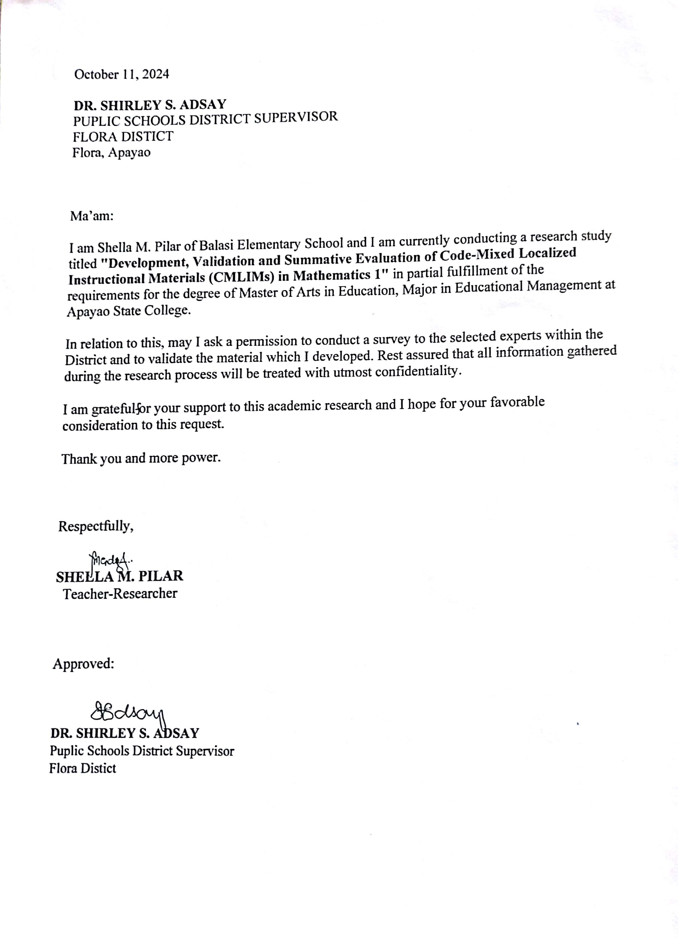

**Appendix B**

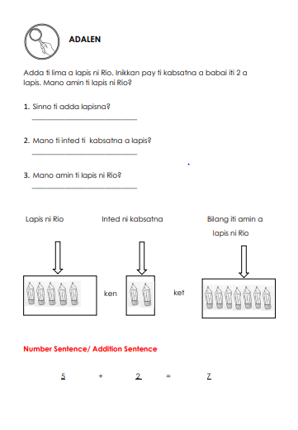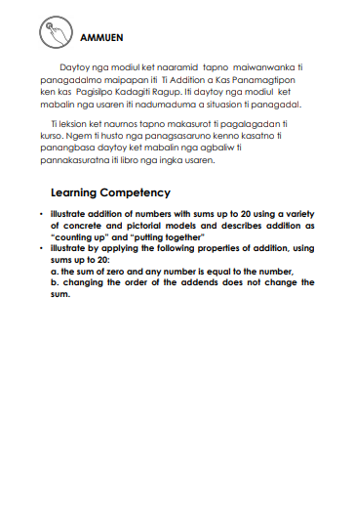**Developed Instructional Material**

