***Case report***

**Tuberculous Constrictive Pericarditis Presenting as Isolated Pleural Effusion: A Diagnostic Role for Transthoracic Echocardiography**

**Abstract**

**Aims:** To highlight the diagnostic role of transthoracic echocardiography (TTE) in tuberculous constrictive pericarditis (CP) presenting atypically as isolated pleural effusion, and to emphasize the importance of early multimodal imaging in TB-endemic regions.

**Presentation of Case**: A 36-year-old man with no comorbidities presented with progressive dyspnea and bilateral pleural effusion. Initial workup (CT, pleural biopsy) was inconclusive. TTE revealed classic CP features: pericardial thickening, septal bounce, and hepatic vein expiratory reversal. Cardiac MRI confirmed the diagnosis. The patient improved with anti-tuberculosis therapy and was referred for pericardiectomy.

**Discussion:** CP remains a diagnostic challenge due to nonspecific symptoms. In TB-endemic areas, tuberculosis is a leading cause. TTE’s Mayo Clinic criteria (septal shift, medial e′ ≥ 9 cm/s, hepatic vein reversal) achieved 97% specificity, obviating invasive tests. MRI further differentiated CP from restrictive cardiomyopathy.

**Conclusion:** CP should be considered in patients with unexplained pleural effusion in TB-endemic regions. TTE is a critical first-line tool, and early intervention improves outcomes.

*Keywords: Constrictive pericarditis, tuberculosis, pleural effusion, echocardiography, cardiac MRI*

1. **Introduction**

Constrictive pericarditis (CP) results from long-standing inflammation of the pericardium, leading to pericardial thickening, fibrosis, and sometimes calcification, which restricts diastolic filling of the heart. Clinically, CP mimics other causes of right-sided heart failure, particularly restrictive cardiomyopathy, posing diagnostic challenges[1,2]. Common causes in developed countries include prior cardiac surgery, radiation therapy, and idiopathic pericarditis. In contrast, tuberculosis (TB) remains a predominant cause in low- and middle-income countries[3] .

1. **Case Presentation**

A 36-year-old man, without known comorbidities, presented with progressive exertional dyspnea and intermittent chest discomfort evolving over more than a year. He also reported chronic fatigue but denied fever, weight loss, or night sweats.

Physical examination showed elevated jugular venous pressure and decreased breath sounds bilaterally. There was no peripheral edema or ascites.

A chest X-ray showed bilateral pleural effusion (Figure 1), and ECG was unremarkable.

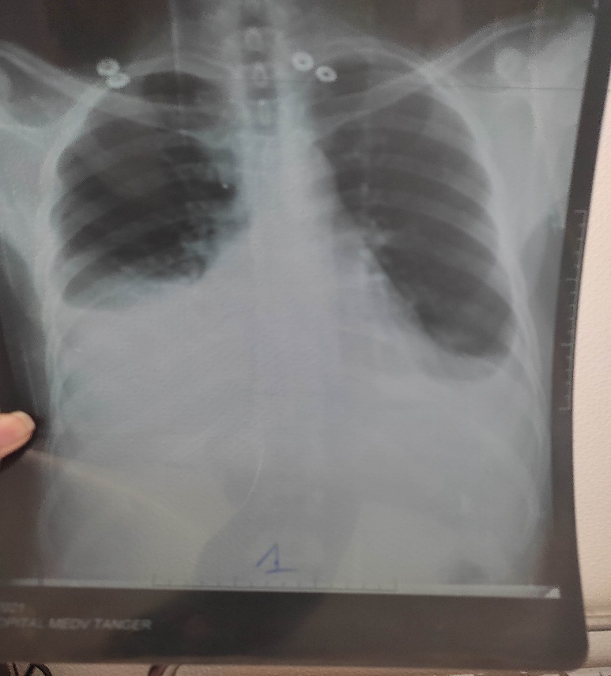

Figure 1: Chest X ray showing bilateral pleural effusion

Blood tests showed normal inflammatory markers and no evidence of active infection. Pleural fluid analysis confirmed a transudate, and microbiologic workup, including GeneXpert MTB/RIF and Ziehl-Neelsen staining, was negative on both sputum and pleural fluid.

Thoracic CT scan, bronchoscopy, and pleural biopsy yielded no conclusive diagnosis. Despite symptomatic treatment, the patient's dyspnea persisted. A cardiology referral was made for further evaluation.

Transthoracic echocardiography (TTE) demonstrated multiple features consistent with chronic constrictive pericarditis (Figure 2: A, B):

* Pericardial thickening,
* Respiratory variation in mitral and tricuspid inflow velocities (>25%),
* Septal bounce,
* Preserved medial mitral annular e′ velocity,
* Expiratory diastolic flow reversal in hepatic veins.

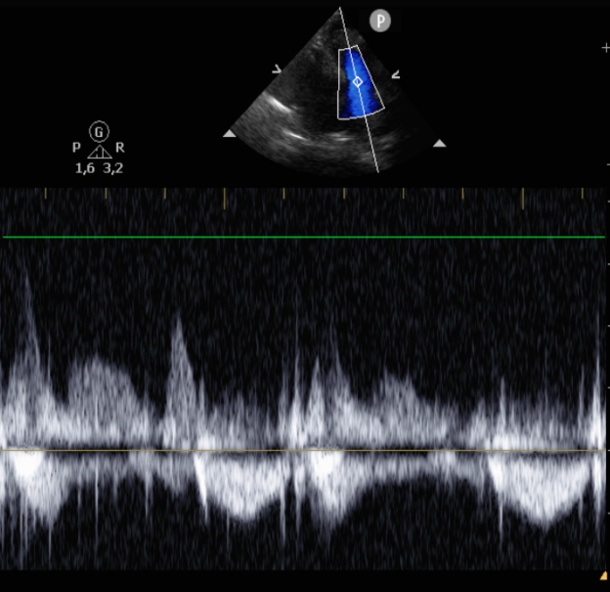 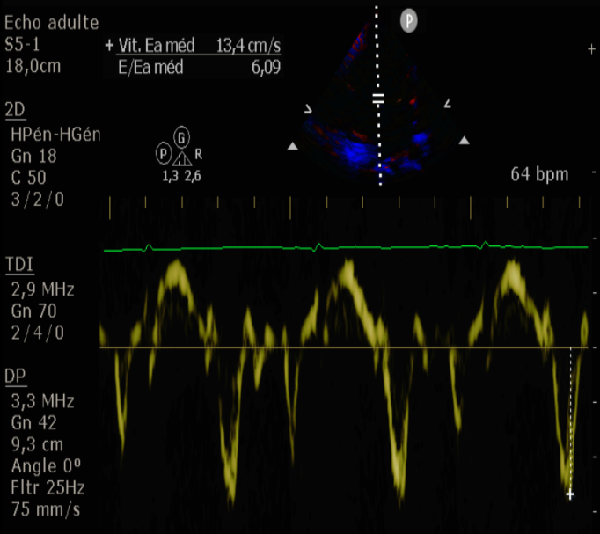

**B**

**A**

Figure 2: TTE images: (A) Hepatic vein expiratory diastolic flow reversal; (B) Preserved medial mitral annular e′ velocity.

Cardiac MRI confirmed the echocardiographic findings, showing a thickened pericardium with constrictive physiology and no myocardial infiltration or fibrosis.

The patient was started on anti-tuberculosis therapy along with corticosteroids, resulting in significant clinical improvement. He was referred then for elective pericardiectomy.

1. **Discussion**

Constrictive pericarditis (CP) is an uncommon but potentially reversible cause of heart failure. It is characterized by a restrictive, inelastic pericardium that limits cardiac filling, resulting in signs and symptoms of right heart failure such as dyspnea on exertion, increased venous pressure, and peripheral edema[1,2]. Diagnosing CP remains challenging due to its nonspecific symptoms and similarities with other conditions like restrictive cardiomyopathy, pulmonary hypertension, and cirrhosis [2].

**Etiology and Atypical Presentation**

In TB-endemic regions, tuberculosis remains a leading cause of CP, whereas idiopathic, post-surgical, and radiation-induced causes predominate in developed countries [3]. Our patient presented atypically, with chronic bilateral pleural effusion as the main manifestation. While pleural effusions in CP are classically exudative, transudative effusions may occur as a result of elevated right atrial pressure impairing lymphatic drainage [4]. This underscores the need for cardiac evaluation in cases of recurrent, unexplained, or bilateral pleural effusion.  
The atypical nature of our patient’s presentation, with isolated bilateral pleural effusion and no overt signs of pericardial disease, contributed to a diagnostic delay of nearly one year. Multiple pulmonary investigations were performed, including pulmonary CT, pleural biopsy, and bronchoscopy, all of which were inconclusive. The pleural fluid was transudative, inflammatory markers were negative, and microbiologic analysis for tuberculosis in both sputum and pleural fluid was negative. This highlights the diagnostic challenge posed by subacute or silent constrictive pericarditis, and the need to consider it in the differential diagnosis of chronic pleural effusion of unknown cause, especially in TB-endemic areas.

**Diagnostic Challenges and Role of Imaging**

On physical examination, jugular venous distension was noted, a hallmark of systemic venous congestion, though no peripheral edema or ascites were present. This variability in clinical expression reflects differences in disease chronicity, pericardial compliance, and right ventricular adaptation [5].

Transthoracic echocardiography (TTE) was pivotal in our diagnostic process. It revealed the following features:

* Pericardial thickening,
* Respiratory variation in mitral and tricuspid inflow velocities,
* Septal bounce,
* Preserved or increased medial mitral annular e′ velocity,
* Expiratory diastolic flow reversal in hepatic veins.

These findings align with the Mayo Clinic diagnostic criteria[6], which include:

1. Respiration-dependent septal shift,
2. Medial mitral e′ velocity ≥ 9 cm/s,
3. Hepatic vein diastolic reversal ratio ≥ 0.79.



Table 1: The Mayo clinic TTE diagnostic criteria of CP

Meeting any two of these criteria yields a sensitivity of 87% and specificity of 91%. When all three are present, specificity rises to 97%, though sensitivity decreases to 64% [6]. Our patient fulfilled all three criteria.

Additional echocardiographic findings in CP include pericardial calcification, dilated hepatic veins, distended inferior vena cava with blunted respiratory variation, and in some cases, premature pulmonic valve opening due to elevated right ventricular early diastolic pressure[7].

Cardiac MRI (CMR) provided additional confirmation of pericardial thickening and constrictive physiology, with no signs of myocardial infiltration or fibrosis. CMR is especially valuable for differentiating CP from restrictive cardiomyopathy and detecting active pericardial inflammation, guiding the therapeutic decision between medical therapy and surgical intervention[8].

**Differential Diagnosis and Management**

The main differential diagnosis is restrictive cardiomyopathy, which may closely mimic CP. However, key differentiators include:

* Preserved or increased medial mitral annular e′ velocity in CP (reduced in restrictive cardiomyopathy) [9],
* Respiratory variation in mitral inflow velocities (present in CP, absent in restrictive forms) [5,7,10].

**Treatment Approaches**  
The management of constrictive pericarditis depends largely on its etiology and stage—whether inflammatory or fibrotic. In tuberculous pericarditis, standard anti-tuberculosis therapy remains the cornerstone of treatment, and corticosteroids may be added in selected cases, particularly in HIV-negative patients, to reduce inflammation and prevent progression to constriction[3,5]. When the disease becomes chronic and fibrotic, surgical pericardiectomy is the definitive therapy, ideally performed before irreversible myocardial damage occurs. Total or subtotal pericardiectomy via median sternotomy is generally preferred, although surgery carries higher risk in patients with advanced heart failure or myocardial atrophy, emphasizing the importance of early referral[5,6,11]. In our case, the patient responded favorably to medical therapy, suggesting a subacute inflammatory phase of tuberculous pericarditis, he then was deferred for subtotal pericardiotomy.

**Clinical Implications**

This case highlights the importance of a multimodal diagnostic approach, with echocardiography as the first-line tool, supported by CMR in ambiguous or complex cases. In TB-endemic regions, clinicians should maintain a high index of suspicion for CP in patients with atypical signs of right heart failure. Early recognition and appropriate management are crucial to avoid misdiagnosis, prevent progression, and improve patient outcomes.

1. **Conclusion**

In tuberculosis-endemic regions, constrictive pericarditis should be considered in patients presenting with unexplained pleural effusion and signs of right heart failure. Transthoracic echocardiography remains a critical and accessible tool for diagnosis. Early identification and timely management—both medical and surgical—can significantly improve prognosis. This case underscores the importance of clinical vigilance and echocardiographic expertise in diagnosing this challenging entity.

**CONSENT**

All authors declare that ‘written informed consent was obtained from the patient (or other approved parties) for publication of this case report and accompanying images. A copy of the written consent is available for review by the Editorial office/Chief Editor/Editorial Board members of this journal.

References

1. Brown MT, McDowell AC, Clements SD, Dressler DD: Here’s the rub: A case of constrictive pericarditis in an adult with cystic fibrosis. Respir Med Case Rep. 2021, 33:101434. 10.1016/j.rmcr.2021.101434

2. Little WC, Freeman GL: Pericardial Disease. Circulation. 2006, 113:1622–32. 10.1161/CIRCULATIONAHA.105.561514

3. Mayosi BM, Burgess LJ, Doubell AF: Tuberculous Pericarditis. Circulation. 2005, 112:3608–16. 10.1161/CIRCULATIONAHA.105.543066

4. Kyriakakis’ ’Charles, Herbst ’ ’Philip, Doubell’ ’Anton: Constrictive pericarditis – prevalence, causes and clinical presentation. Accessed: June 13, 2025. https://www.escardio.org/Journals/E-Journal-of-Cardiology-Practice/Volume-15/Constrictive-pericarditis-prevalence-causes-and-clinical-presentation?utm_source=chatgpt.com.

5. Imazio M, Brucato A, Trinchero R, Adler Y: Diagnosis and management of pericardial diseases. Nat Rev Cardiol. 2009, 6:743–51. 10.1038/nrcardio.2009.185

6. Welch TD, Ling LH, Espinosa RE, et al.: Echocardiographic Diagnosis of Constrictive Pericarditis. Circ Cardiovasc Imaging. 2014, 7:526–34. 10.1161/CIRCIMAGING.113.001613

7. Libby P, Bonow RO, Mann DL, Tomaselli GF, Bhatt DL, Solomon SD, Braunwald E, editors: Braunwald’s heart disease: a textbook of cardiovascular medicine. 12. Edition. Elsevier: Philadelphia, PA; 2022.

8. Bogaert J, Francone M: Cardiovascular magnetic resonance in pericardial diseases. J Cardiovasc Magn Reson. 2009, 11:14. 10.1186/1532-429X-11-14

9. Sengupta PP, Krishnamoorthy VK, Abhayaratna WP, et al.: Disparate Patterns of Left Ventricular Mechanics Differentiate Constrictive Pericarditis From Restrictive Cardiomyopathy. JACC Cardiovasc Imaging. 2008, 1:29–38. 10.1016/j.jcmg.2007.10.006

10. Syed FF, Schaff HV, Oh JK: Constrictive pericarditis—a curable diastolic heart failure. Nat Rev Cardiol. 2014, 11:530–44. 10.1038/nrcardio.2014.100

11. Schwefer M, Aschenbach R, Heidemann J, Mey C, Lapp H: Constrictive pericarditis, still a diagnostic challenge: comprehensive review of clinical management. Eur J Cardiothorac Surg. 2009, 36:502–10. 10.1016/j.ejcts.2009.03.004