Original Research Article
Genetic variability and interrelationship among traits of okra (Abelmoschus esculentus L. Moench)

ABSTRACT
Knowledge of interrelationship among traits can aid effective selection among variable genotypes. Fifteen okra genotypes were evaluated in randomized complete blocks with three replications in year 2020 late season. Components of genetic variability among the genotypes were investigated, as well as the extent and pattern of relationship among ten agronomic and yield-related traits. Genotype mean squares were significant for flowering, branching, and pod-related traits, indicating the possibility of effective selection. Broad-sense heritability (%) was high for pod length (74.20), flowering (70.50), ridges/pod (68.80), pod weight (54.00), and pod width (42.30), and these traits could be improved in early generations. High genetic distance estimates were obtained between pairs of genotypes, indicating the possibility of improvement through heterosis. Step-wise regression analysis revealed significant influence of ridges/pod, branching, and pods/plant on pod weight with R² values of 19.50, 25.50, and 32.40 respectively, suggesting the possibility of their simultaneous improvement with pod weight. Biplot analysis revealed distinct trait profiles of the okra genotypes, and associated Iwo Nla, NH47-45, NHIK 103, NHIK 177, NHMB-1, and NHP 68 with ridges/pod and pod weight. The significant correlation between ridges/pod and pod weight can be exploited for simultaneous improvement of the two traits using associated accessions.
Keywords: Biplot, Genetics, Heatmap, Selection and Variability.
INTRODUCTION
Cultivated okra (Abelmoschus esculentus L. Moench) is an important fruit vegetable belonging to family Malvaceae. It is popular as a source of nutrition, industrial raw materials, and substances of medicinal value against fever, catarrh, and genito-urinary disorders among others (Des et al., 2012). The crop has been found adapted to a wide range of environmental conditions especially in the tropics and warm temperate zones (Walling et al., 2020). According to Walling et al. (2020), cultivated okra can yield up to 10-15 ton/ha under good management. However, the production observed is much less due to identified constraints, the chief of which is related to genetic materials (i.e. use of genetically-poor planting materials). Thus, it is essential that research efforts are directed towards improving the productivity of existing cultivars to meet the growing demand for the crop.

Yield is a polygenic trait that is directly or indirectly dependent on many other traits. Information on the extent of variability for yield and related traits, and the inter-relationship among key agronomic traits are essential to formulating effective strategies for breeding high-yielding genotypes of the crop. Therefore, this study assessed the components of genetic variability among, and investigated the extent and pattern of relationship among ten agronomic and yield-related traits of okra with a view to providing information for future improvement of cultivated okra.

MATERIALS AND METHOD
The research was conducted at the Teaching and Research Farm of the Department of Crop Production and Horticulture, School of Agriculture, Lagos State Polytechnic, Ikorodu. Fifteen genotypes of okra were used for the study. Seeds were obtained from National Horticulture Research Institute, NIHORT, Ibadan, Oyo State, Nigeria. The names of the genotypes were Benue local, 12u1, IWO, MHK199, NHCaPi145, NHIK103, NHIK177, NHIK7, NHLP3, NHP68, NH47-4, NH47-45, NHCaP2/44, and NHCaP2/51. The land was tilled manually using hoes, since the land has been under cultivation. Planting was done on the flat land. The genotypes were laid out in randomized complete block design with three replications. A single-row plot method was used. Each row was 2.5 m long and rows were spaced 0.6 m apart. Seeds were soaked in water prior to planting, to hasten germination and emergence. Two seeds were sown per hole at inter- and intra-row spacing of 0.6 m and 0.5 m respectively. Seedlings were thinned to one plant per stand at two weeks after sowing (WAS), to give a plant population density of 33,333 plants per hectare. At three WAS, NPK 15:15:15 was applied at the rate of 333 kg/ha at the base of the plants. Weeds were controlled manually as and when due.

Data were taken on number of days to 50% flowering, plant height (cm), stem girth (mm), number of leaves per plant, number of branches per plant, number of pods per plant, pod length (cm), pod width (cm), number of ridges per pod, and pod weight (kg). Data obtained were subjected to analysis of variance using ‘proc glm’ and genetic components were estimated via ‘proc varcomp’ (SAS Inst., 2011). Euclidean genetic distance estimates between paired genotypes as well as the heat map to visually display the distances were obtained in the R Environment. The relationship among traits was investigated through simple correlation (Pearson) analysis while genotype association with traits was investigated using the multidimensional preference analysis in SAS (SAS Inst., 2011). Stepwise regression analysis was performed using the ‘olsrr’ package in R (R Core Team, 2021).

RESULTS AND DISCUSSION
The summary of analysis of variance among okra genotypes for the measured traits is shown in Table 1. Genotype mean squares were significant (p ≤ 0.05 or p ≤ 0.01) for number of days to 50% flowering, number of branches per plant, pod length, pod width, number of ridges per pod, and pod weight. This is an indication of the existence of adequate genetic variability for effective selection to improve the traits. Agboruwo et al. (2019), Oyetunde and Ariyo (2017), and Das et al. (2012) reported significant genotype mean squares for various traits of okra including number of days to flowering, plant height, numbers of leaves and branches per plant, pod length and width, number of fruits per plant, number of ridges per pod, and pod weight.

Table 1: Mean squares from analysis of variance of 15 okra accessions evaluated for measured traits
SOV | DF | DTF | PHT | STG | NOL | NOB | NOP | PDL | PDW | NOR | PDWT
Block | 2 | 245.000 | 409.110 | 2.907 | 46.200* | 2.703 | 0.047 | 1482.990** | 39.860 | 0.667 | 0.001
Accession | 14 | 834.710** | 457.320 | 18.649 | 7.000 | 5.270* | 0.766 | 2310.450** | 242.560** | 14.160** | 0.013**
Residual | 28 | 102.360 | 316.440 | 15.637 | 6.945 | 1.969 | 0.727 | 240.490 | 75.794 | 1.8599 | 0.003
*, ** - significant at 5 and 1 % probability respectively; SOV – source of variation; DF – degrees of freedom; DTF – number of days to 50% flowering; PHT – plant height; STG – stem girth; NOL – number of leaves per plant; NOB – number of branches per plant; NOP – number of pods per plant; PDL – pod length; PDW – pod width; NOR – number of ridges per oid; PDWT – pod weight

Estimates of genotypic, phenotypic and environmental variances were obtained for all the measured traits providing sufficient evidence that all the traits were influenced by both genotype and environment, though at different levels (Table 2). Genotypic variance ranged from 0.003 for pod weight to 689.986 for pod length while phenotypic variance was lowest (0.006) and highest (930.474) for the same traits, respectively. There was close correspondence between genotypic and phenotypic variances for DTF (244.119 and 346.476 respectively), PDL (689.986 and 930.474 respectively), NOR (4.099 and 5.959 respectively), and PDWT (0.003 and 0.006) indicating superior influence of genotype over environment in the expression of the traits. Phenotypic co-efficient of variation (PCV) was consistently higher than the genotypic counterparts (GCVs). However, GCV values were close to PCV values for the DTF, PDL, PDW, NOR, and PDWT which emphasizes the important role of the genotype in phenotypic expression of the traits (Oyetunde and Ariyo 2015; Guddadamath et al., 2011).

Table 2: Genetic components of selected traits of okra
Component | DTF | PHT | STG | NOL | NOB | NOP | PDL | PDW | NOR | PDWT
σ²e | 102.357 | 316.440 | 15.637 | 6.945 | 1.969 | 0.727 | 240.488 | 75.794 | 1.860 | 0.003
σ²g | 244.119 | 46.960 | 1.004 | 0.018 | 1.099 | 0.013 | 689.986 | 55.589 | 4.099 | 0.003
σ²p | 346.476 | 363.400 | 16.641 | 6.963 | 3.068 | 0.740 | 930.474 | 131.383 | 5.959 | 0.006
ECV | 23.899 | 44.462 | 42.466 | 32.637 | 57.322 | 43.641 | 23.681 | 39.110 | 24.790 | 100.961
GCV | 36.908 | 17.128 | 10.760 | 1.680 | 42.818 | 5.814 | 40.111 | 33.493 | 36.802 | 109.696
PCV | 43.970 | 47.647 | 43.808 | 32.680 | 71.548 | 44.025 | 46.580 | 51.491 | 44.372 | 149.321
H_{B} (%) | 70.50 | 12.90 | 6.00 | 0.30 | 35.80 | 1.70 | 74.20 | 42.30 | 68.80 | 54.00
GA | 27.017 | 5.075 | 0.507 | 0.014 | 1.292 | 0.031 | 46.597 | 9.991 | 3.459 | 0.088
GA as % of mean | 63.819 | 12.684 | 5.445 | 0.178 | 52.785 | 1.582 | 71.154 | 44.880 | 62.876 | 165.928
σ²e, σ²g and σ²p – environmental, genotypic and phenotypic variances respectively; ECV, GCV, and PCV – environmental, genotypic and phenotypic coefficients of variation respectively; H_{B} – broad-sense heritability; GA – genetic advance.

Broad-sense heritability estimates ranged from 0.30% for number of leaves per plant to 74.20% for pod length. The higher the heritability estimate for a trait, the closer the estimate phenotypic expression is to the genetic potential. Thus, pod length, number of days to 50% flowering and number of ridges per plant ranked top in reflecting the genotypic potential of genotypes for the traits. The moderately high heritability estimates (68.80-74.20%) for number of days to 50% flowering, pod length, and number of ridges per plant coupled with the moderate and closely-associated GCV and PCV estimates suggest that these traits could be the focus of selection for advancement of the genotypes (Walling et al. 2020).

Table 3: Estimates of Euclidean genetic distance between paired okra genotypes based on measured traits
ID | Genotype | 1 | 2 | 3 | 4 | 5 | 6 | 7 | 8 | 9 | 10 | 11 | 12 | 13 | 14 | 15
1 | Benue Local | 0.00 | 29.39 | 16.96 | 21.31 | 9.64 | 20.30 | 86.71 | 56.90 | 61.17 | 27.28 | 21.99 | 19.49 | 47.19 | 21.72 | 21.97
2 | I2U1 |  | 0.00 | 28.86 | 29.63 | 28.85 | 27.48 | 98.88 | 62.29 | 70.67 | 27.82 | 37.39 | 21.02 | 20.86 | 16.78 | 38.25
3 | IWO |  |  | 0.00 | 23.59 | 8.81 | 22.44 | 81.39 | 55.01 | 56.76 | 27.85 | 20.60 | 27.72 | 48.35 | 22.22 | 14.45
4 | MHK199 |  |  |  | 0.00 | 21.27 | 9.89 | 73.53 | 38.95 | 45.85 | 12.04 | 14.39 | 32.10 | 48.94 | 17.38 | 35.86
5 | NH47-4 |  |  |  |  | 0.00 | 20.63 | 83.62 | 55.87 | 58.75 | 27.51 | 20.39 | 22.64 | 48.09 | 21.92 | 16.06
6 | NH47-45 |  |  |  |  |  | 0.00 | 75.99 | 40.34 | 47.78 | 8.51 | 13.74 | 30.17 | 47.07 | 12.66 | 35.27
7 | NHCaP2/44 |  |  |  |  |  |  | 0.00 | 44.90 | 29.72 | 74.41 | 66.15 | 103.22 | 118.13 | 84.69 | 88.98
8 | NHCaP2/51 |  |  |  |  |  |  |  | 0.00 | 17.51 | 36.00 | 36.63 | 69.61 | 79.65 | 48.41 | 67.37
9 | NHCaPi145 |  |  |  |  |  |  |  |  | 0.00 | 45.25 | 39.69 | 76.36 | 89.51 | 56.28 | 67.00
10 | NHIK103 |  |  |  |  |  |  |  |  |  | 0.00 | 17.69 | 35.11 | 46.24 | 13.25 | 41.46
11 | NHIK177 |  |  |  |  |  |  |  |  |  |  | 0.00 | 37.92 | 57.63 | 22.71 | 31.87
12 | NHIK7 |  |  |  |  |  |  |  |  |  |  |  | 0.00 | 32.76 | 24.80 | 30.94
13 | NHLP3 |  |  |  |  |  |  |  |  |  |  |  |  | 0.00 | 36.08 | 55.01
14 | NHNB-1 |  |  |  |  |  |  |  |  |  |  |  |  |  | 0.00 | 34.66
15 | NHP68 |  |  |  |  |  |  |  |  |  |  |  |  |  |  | 0.00

Figure 1 is a heat map demonstration of the genetic distance (Table 3) between paired okra genotypes. Substantial estimates of genetic distance were observed between paired genotypes and ranged from 8.51 between NHIK103 and NH47-45 (darkest brown colour on the heat map) to 118.13 between NHCaP2/44 and NHLP3 (darkest blue colour on the heat map). The ten highest genetic distance estimates (≥ 80.00) featured NHCaP2/44 paired with NHP68, NHNB-1, NHLP3, NHIk7, Iwo Nla, Benue Local, NH47-4 and I2UI. Heterosis could be exploited in the improvement of number of days to 50% flowering, number of branches per plant, pod length, pod width, number of ridges per pod, and pod weight using and other pairs using NHCaP2/44 with any of the mentioned genotypes.

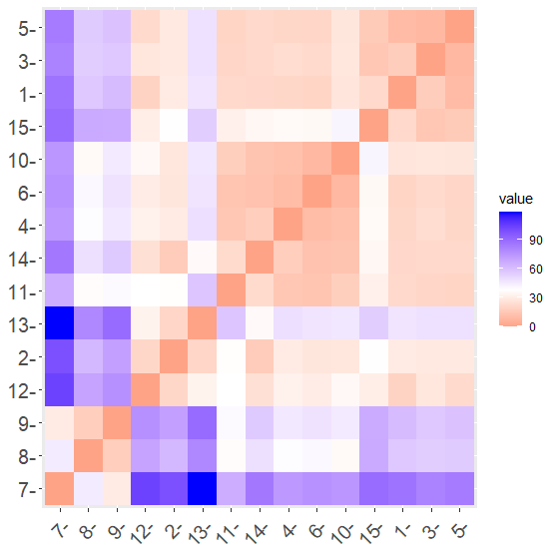
Figure 1: Heatmap of visual display of the Euclideam distances between paired genotypes of Okra (IDs on Table 3)

Useful levels of association were observed among the measured traits as presented in Table 4. Number of days to 50% flowering had positive and significant (P ≤ 0.01) with pod length (r= 0.891), pod width (r= 0.837), and number of ridges per pod (r= 0.889). Also, positive and significant (P ≤ 0.01) correlation was observed in the relationship of pod length with pod width (r= 0.770) and number of ridges per pod (r= 0.808). Additionally, pod width shared positive and significant (P ≤ 0.05/0.01) correlation with number of ridges per pod (r= 0.902) and pod weight (0.570) while number of ridges per pod had positive and significant (P ≤ 0.05) association with pod weight (r= 0.556). Significant level of association between paired traits is an indication of possible simultaneous improvement of such traits, and can also serve as selection criteria for improvement of target traits. Thus, there is possibility of simultaneous improvement of flowering time with pod characters such as length, width, and number of ridges. There is also possibility of improving number of ridges per pod with pod length, pod width, and pod weight.

Table 4: Correlation coefficients among paired traits of okra
Trait | PHT | STG | NOL | NOB | NOP | PDL | PDW | NOR | PDWT
Number of days to 50% flowering (DTF) | -0.271 | -0.023 | -0.262 | 0.027 | -0.115 | 0.891** | 0.837** | 0.889** | 0.334
Plant height (PHT) |  | 0.114 | 0.201 | 0.014 | -0.06 | -0.111 | -0.22 | -0.094 | -0.26
Stem girth (STG) |  |  | 0.071 | 0.471 | -0.375 | 0.076 | 0.19 | 0.029 | 0.26
Number of leaves per plant (NOL) |  |  |  | -0.099 | 0.15 | -0.168 | 0.075 | -0.006 | 0.306
Number of branches per plant (NOB) |  |  |  |  | -0.372 | 0.206 | 0.279 | 0.159 | 0.307
Number of pods per plant (NOP) |  |  |  |  |  | -0.235 | 0.053 | 0.032 | 0.356
Pod length (PDL) |  |  |  |  |  |  | 0.770** | 0.808** | 0.357
Pod width (PDW) |  |  |  |  |  |  |  | 0.902** | 0.570*
Number of ridges per pod (NOR) |  |  |  |  |  |  |  |  | 0.556*
*, ** - significant at 5 and 1% probability respectively

Stepwise regression analysis of variability in pod weight revealed number of ridges per pod and numbers of branches and pods per plant as the major contributors, with a joint contribution of 32.4% (Table 5). Number of ridges per pod, number of branched per plant and number of pods per plant accounted for 19.6, 5.9, and 6.9% of the observed variation in that order. This explains that number of ridges per pod is the major factor determining pod weight in okra. The high variation in pod weight that is due to number of ridges per pod is in tandem with the significant association between the two traits. Number of ridges per pod thus has an important role in breeding for pod weight of okra. Adeniji and Aremu (2007) observed similar relationship between number of ridges per pod and seed yield of okra.

Table 5: Summary of stepwise regression analysis of other measured traits on pod weight of okra
Step | Variable | Estimate | Standard error | Partial R² | Model R² | P value
 | Intercept | -0.113 | 0.041 | - | - | 0.009
1 | Number of ridges/pod† | 0.015 | 0.006 | 0.196 | 0.196 | 0.001
2 | Number of branches/plant | 0.015 | 0.012 | 0.059 | 0.255 | 0.019
3 | Number of pods/plant | 0.025 | 0.004 | 0.069 | 0.324 | 0.048
Prediction equation: y = 0.015X₁ + 0. 015X₂ + 0.025X₃ - 0.113 where y = pod weight and X₁, X₂ and X₃ = number of ridges per pod, number of branches per plant, and number of pods per plant respectively; † selected in the forward selection.

The biplot (Figure 2) analysis reliably (with efficiency of 84.09%) profiled the evaluated okra genotypes for measured traits. Genotypes Benue Local, I2UI, MHK199, NH47-4, NHCaPi145, and NHLP3 were associated with number of days to flowering, pod length, and number of branches per plant while Iwo Nla, NH47-45, NHIK103, NHIK177, NHNB-1, and NHP68 were associated with pod width, number of ridges per pod, and pod weight. Furthermore, NHCaPi145 was associated with number of leaves per plant and number of pods per plant while genotypes NHCaP2/44 and NHCaP2/51 were associated with plant height and stem girth. The different trait profiles of the genotypes suggest the possibility of developing superior hybrids with broad genetic base from planned selection of parents. The significant correlation between number of ridges per plant and pod weight can be exploited for simultaneous improvement of the two traits using associated accessions.

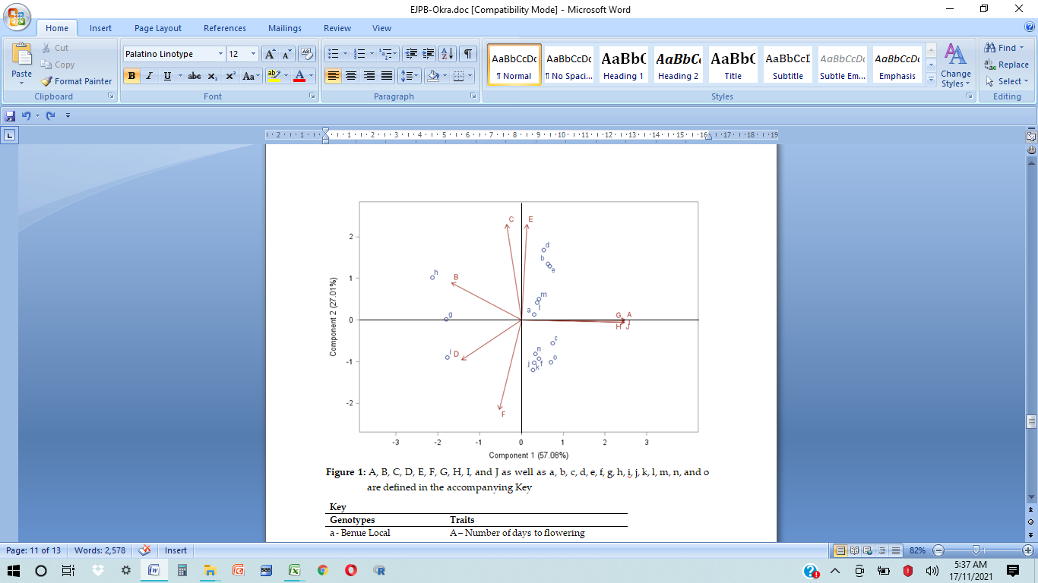
Key
Genotypes | Traits
a - Benue Local | A – Number of days to flowering
b - I2U1 | B – Plant height
c – IWO | C – Stem girth
d - MHK199 | D – Number of leaves per plant
e - NH47-4 | E – Number of branches per plant
f - NH47-45 | F – Number of pods per plant
g - NHCaP2/44 | G – Pod length
h - NHCaP2/51 | H – Pod width
i - NHCaPi145 | I – Number of ridges per plant
j - NHIK103 | J – Pod weight
k - NHIK177
l - NHIK7
m - NHLP3
n - NHNB-1
o - NHP68

Figure 2: Biplot of the association of okra genotypes with measured traits. A, B, C, D,
E, F, G, H, I, and J as well as a, b, c, d, e, f, g, h, i, j, k, l, m, n, and o are
defined in the accompanying Key
CONCLUSION
There was sufficient genetic variability among the okra genotypes for successful selection. Euclidean genetic distance estimates between paired genotypes were high, and indicated the possibility of improvement through heterosis. Number of ridges per pod, number of branches and pods per plant contributed significantly to pod weight and could be simultaneously improved with pod weight. Genotypes Iwo Nla, NH47-45, NHIK 103, NHIK 177, NHMB-1, and NHP 68 which were associated with number of ridges and pod weight should be targeted to exploit the significant correlation between the traits for simultaneous improvement.

REFERENCES
Adeniji, O. T. and Aremu, C. O. 2007. Interrelationship among characters and path analysis for pod yield components in West African Okra (Abelmoschus callei (A. Chev). Journal of Agronomy, 6: 162-166. Retrieved from http://dx.doi.org/10.3923/ja.2007.162.166.
Agbowuro, G. O., Salami, A. E., Awoyemi, S. O., Ogunwale, G. I., Kehinde-Fadare, A. F. and Olajide, O. O. 2019. Genetic Variations, Heritability and Genetic Advance Studies among Okra Accessions grown in different Agro-ecological Zones in Nigeria. International Journal of Food Science and Agriculture, 3(1): 130-135. Retrieved from http://dx.doi.org/10.26855/ijfsa.2019.03.001.
Akotkar, P. K., De, D. K. and Pal, A. K. 2010. Genetic variability and diversity in okra (Abelmoschus esculentus L. Moench). Electronic Journal of Plant Breeding, 1(4): 393-398.
Das, D., Chattopadhyay, A., Chattopadhyay, S. B., Dutta, S and Hazra, P. 2012. Genetic parameters and path analysis of yield and its components in okra at different sowing dates in the Gangetic plains of eastern India. African Journal of Biotechnology, 11(95): 16132-16141.
Guddadamath, S., Mohankumar, H. D. and Salimath, P. M. 2011. Genetic analysis of segregating populations for yield in okra [Abelmoschus esculentus (L) Moench]. Karnataka Journal of Agricultural Sciences, 24(2): 114-117.
Nwangburuka, C. C., Denton, O. A., Kehinde, O. B., Ojo, D. K. and Popoola, A. R. 2012. Genetic variability and heritability in cultivated okra [Abelmoschus esculentus (L.) Moench]. Spanish Journal of Agricultural Research, 10(1): 123-129. Retrieved from http://dx.doi.org/10.5424/sjar/2012101-021-11.
Oyetunde, O. A. and Ariyo, O. J. 2017. Character Association in Okra Hybrids Established at Different Planting Dates. International Journal of Vegetable Science, 23(6): 584-597. Retrieved from http://dx.doi.org/10.1080/19315260.2017.1323815.
Oyetunde, O. A. and Ariyo, O. J. 2015. Genetics of seed yield and related traits in biparental crosses of okra, Abelmoschus esculentus (L.) Moench. Nigerian Journal of Genetics 28: 8-14. Retrieved from http://dx.doi.org/10.1016/j.nigjg.2015.06.002.
SAS Institute. 2012. SAS System for Windows. Release 9.4. SAS Institute Inc.: Cary, NC, USA.
Walling, N., Kanaujia, S. P., Alila, P., Sharma, M. B. and Ozukum, C. 2020. Genetic variability and correlation studies in okra (Abelmoschus esculentus L. Moench) genotypes under foothill conditions of Nagaland. International Journal of Recent Scientific Research, 11(02): 37651-37654.

